

Deep Learning Framework for Galaxy Morphology Classification and Analysis
Prepared By
Name: ID No.:
Name: ID No.:
Submitted in fulfillment of the requirements for the degree Master of Science in Artificial Intelligence
At
College of Informatics
Midocean University
UAE
Supervisor Name: Dr. Mohamed Eassa
College of Informatics, Midocean University, Comoros
Email:

Acknowledgements

We would like to thank our supervisor, Dr. Mohamed Essa, for his continuous guidance and valuable feedback throughout this research. His expertise in both artificial intelligence and galaxy studies has greatly influenced the direction of this work. His comments challenged us to think more critically and approach the research from a scientific perspective rather than a purely technical one.

We are also thankful to the faculty members at the College of Informatics, Midocean University, for providing a supportive academic environment that inspired independent thinking and research development.

Finally, we would like to express our appreciation to our families for their patience, encouragement, and support during this journey.

Abstract

Classification of galaxy morphology continues to be one of the essential topics in astrophysics, as the galaxy shape allows obtaining information about the galaxy formation process and its evolution. Due to the increasing availability of data on galaxies obtained from SDSS and DECaLS surveys, the amount of galaxy images has considerably increased. In this regard, manual visual classification becomes increasingly ineffective in the case of extensive research, highlighting the increasing relevance of automation through the use of deep learning algorithms.

Earlier works have shown that deep learning models can demonstrate good results in galaxy image classification. At the same time, many of them focus on classification accuracy, while other essential factors, such as interpretability, robustness, and prediction uncertainty, may be considered separately.

This paper proposes a framework based on deep learning techniques for galaxy morphology classification with the use of Galaxy10 DECaLS as a base dataset. The model will be evaluated according to its accuracy and F1-score values. This research will also assess the model's robustness by subjecting input images to certain manipulations and observing the results of predicting model's behavior under different visualization conditions. Monte Carlo Dropout will be used to estimate prediction uncertainty, and Grad-CAM will help understand the influence of image regions on prediction.

This paper's primary goal is not only the creation of an accurate classification algorithm but also building a robust and interpretable methodological approach for working with astronomical images.

Contents
i
Acknowledgements ii
Abstract iii
List of Abbreviations iv
List of Figures v
List of Tables vi
Chapter 1: Introduction 1
1.1 Overview 1
1.2 Problem Definition 3
1.3 Thesis Objectives 4
1.4 Thesis Contribution 5
1.5 Thesis Organization 5
Chapter 2: Background and Related Work 6
2.1 Introduction 6
2.2 Background 7
2.3 Related work 12
2.4 Related Work Summary 18
Chapter 3: Proposed Approach (Methodology) 21
Chapter 4: Experimental Results and Discussion 22
Chapter 5: Conclusion and Future Work 23
References 24

List of Abbreviations
- AI: Artificial Intelligence.
- CNN: Convolutional Neural Network.
- DL: Deep Learning.
- DECaLS: Dark Energy Camera Legacy Survey.
- GAN: Generative Adversarial Network.
- Grad-CAM: Gradient-weighted Class Activation Mapping.
- MCD: Monte Carlo Dropout.
- ML: Machine Learning.
- RA: Right Ascension.
- SDSS: Sloan Digital Sky Survey.
- XAI: Explainable Artificial Intelligence.
- F1-score: Harmonic mean of precision and recall.
- ViT: Vision Transformer.
- VGG19: Visual Geometry Group 19.
- DCGAN: Deep Convolutional Generative Adversarial Network.
- CvT: Convolutional Vision Transformer.
- S-PLUS: Southern Photometric Local Universe Survey.
- CANDELS: Cosmic Assembly Near-infrared Deep Extragalactic Legacy Survey.
- S0: Lenticular Galaxy.

List of Figures
Figure 1.1: Example of galaxy morphology complexity relevant to automated galaxy classification studies 1
Figure 2.1: Hubble morphological classification scheme illustrating elliptical, spiral, and barred spiral galaxies 7
Figure 2.2: Example galaxy images from different morphological classes used in automated classification studies 9
Figure 2.3: Schematic overview of a deep learning pipeline for galaxy morphology classification 10
Figure 2.4: Example of a saliency map highlighting discriminative regions in galaxy morphology classification 13

List of Tables
Table 2.1: Comparison of related studies in galaxy morphology classification 19

Chapter 1: Introduction

1.1 Overview
Galaxy morphology classification is an important field of investigation in astrophysics due to the fact that morphology provides significant information about the evolution of a galaxy. As a result of developing astrophysical research, it has been proven that parameters like morphology, light distribution, spiral arms, and bulge provide some clues regarding the history and the nature of galaxies. That is why galaxy morphology classification remains one of the most important tasks in astrophysics [1].
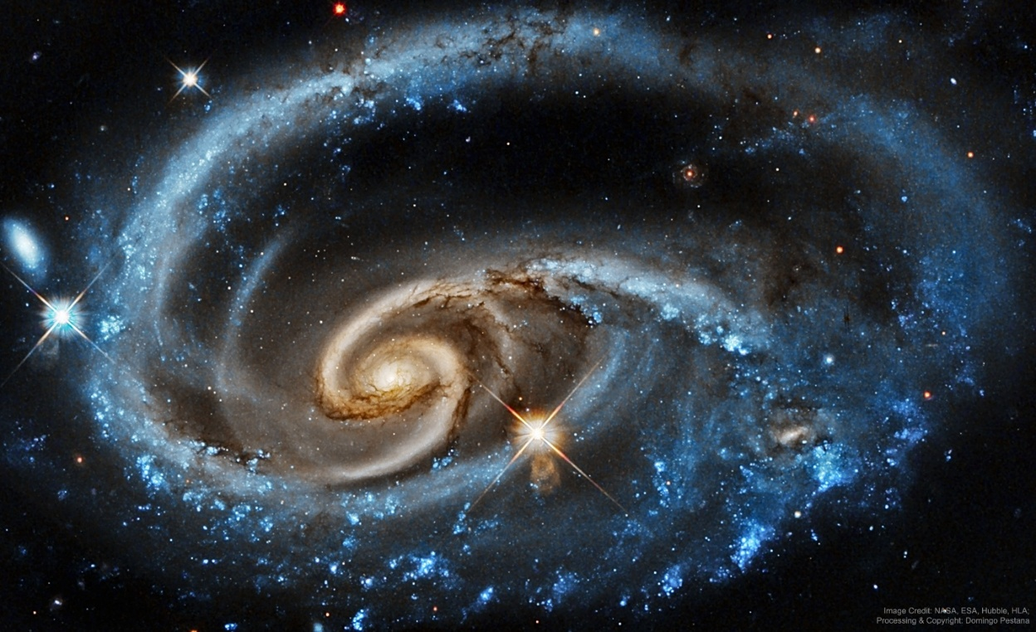
Figure 1.1: Example of galaxy morphology complexity relevant to automated galaxy classification studies.
As shown in Figure 1.1, there is significant variation within galaxy images. There are cases where galaxies show very distinguishable structures while others may be more complex or less distinct. There could be differences in the form, direction, brightness, or internal properties of the galaxies that may make classification difficult, especially when the lines between different types of galaxies are blurred.
Traditionally, the classification of galaxies was done manually using visual inspection by astronomers. Although this technique helped advance morphological study, it was labor-intensive and required a lot of time. With recent advances in astronomy leading to the creation of massive surveys like the SDSS and DECaLS, the number of available galaxy images has greatly increased. This makes manual classification less feasible [1].
As a result, there has been a lot more interest in machine learning techniques in recent times. The use of deep learning and convolutional neural networks (CNNs) shows promise for galaxy classification because they have the ability to learn features from unprocessed images. Several past studies have shown promising results, showing that CNN models perform similarly to humans [2].
Moreover, there is a parallel need to evaluate beyond just classification accuracy. For scientific uses, the fact that the model classifies accurately in most cases is not enough. There is a need for scientists to understand if the model focuses on important aspects of galactic structures, if its prediction remains consistent under changes in imaging, and if the model's confidence can be justified in cases where galaxy images are ambiguous. This has led to explainability and robustness being significant considerations in modern studies of galaxy morphology classification [3].
The current study explores galaxy morphology classification in terms of deep learning with emphasis placed on both predictability and other aspects like robustness, uncertainty estimation, and interpretability. The primary data source for this analysis will be the Galaxy10 DECaLS galaxy morphology dataset because of its availability in labeled form to conduct supervised deep learning experiments. In doing so, it is intended to investigate the extent to which all the mentioned aspects can be utilized in creating an effective solution for automated galaxy morphology classification.
Some recent publications have explored several ways of classifying galaxies using deep learning, namely semi-supervised learning techniques, augmentation-driven approaches, and transformer architectures. These ideas, undoubtedly, are promising, yet they will not be considered in the current thesis. The goal of the research is to construct a holistic framework for galaxy morphology classification considering predictive ability, interpretability, robustness, and uncertainty estimation.
In particular, in such a context, the value of deep learning model application in astronomical studies cannot be reduced only to high prediction capability. The use of such models can bring additional benefits like a better understanding of the process behind their decisions, stability in different image settings, and, finally, the representation of the uncertainty associated with galaxy structure classification. Therefore, galaxy morphology classification in the thesis will be addressed from the angle of its performance, reliability, and interpretability.

1.2 Problem Definition
Many deep learning studies have applied deep learning for galaxy morphology classification, yet the majority of them pay attention only to accuracy and F1-score measures. Though these measures provide certain information, they do not cover all the aspects important for scientific analysis.

One of these aspects is interpretability. For example, it would be interesting to see how deep learning model interprets galaxy morphology. When classifying the galaxy as spiral, one wants to check that this result is based on spiral structure and central bulge rather than any other feature present in the image.

The second issue refers to variability of galaxy images observed with different conditions. Differences in illumination, noise, contrasts and so on can influence the picture significantly. Therefore, the classification performed by the model will demonstrate poor results in case the image is altered in any way. Scientific applications require robust and reliable prediction even for changed images.

Uncertainty may also become a critical factor for galaxy morphology classification since some galaxies may lack morphological features while the others can contain features corresponding to several classes. As a result, labeling only by final class may be not enough. The more helpful information the model provides about the uncertainty degree, the more confident in its predictions the scientist will be.

Based on the above, the main problem considered in this thesis can be formulated as follows: current deep learning solutions for galaxy morphology classification provide accurate predictions but fail to provide a unified framework for classification, which includes interpretability, robustness, and prediction uncertainty.

It means that there is a significant difference between achieving high classification accuracy and creating a reliable classification model, which explains its decisions and prediction uncertainty degree. Therefore, a more complex solution should be suggested that will satisfy all three criteria at once.

Thus, the first research question of this study is:

What solution can provide robust galaxy morphology classification using deep learning and be interpretable, robust, and uncertainty-aware at the same time?

For testing the solution, the Galaxy10 DECaLS dataset is used as a primary source of labeled images suitable for deep learning experiments.

1.3 Thesis Objectives
The main objectives of this research are as follows:

- Develop and evaluate deep learning models for galaxy morphology classification using labeled astronomical images.
- Examine how well these models can distinguish between different galaxy classes using standard evaluation measures such as accuracy and F1-score.
- Study model robustness by applying controlled perturbations to the input images and observing how classification performance changes under different visual conditions.
- Estimate prediction uncertainty using Monte Carlo Dropout, in order to better understand how confident the model is when classifying difficult or ambiguous galaxy images.
- Apply explainable artificial intelligence techniques, especially Grad-CAM, to investigate whether the model focuses on meaningful morphological structures when making classification decisions.
- Build an integrated framework that combines predictive performance, robustness, uncertainty estimation, and interpretability for more reliable galaxy morphology classification.

1.4 Thesis Contribution
This research makes the following contributions to the study of galaxy morphology classification:
- Presents a deep learning framework for galaxy morphology classification using a structured and practical evaluation setting.
- Evaluates model performance using standard classification measures such as accuracy and F1-score, in order to provide a clear view of predictive performance across galaxy classes.
- Studies model robustness by testing how classification performance changes when the input images are affected by controlled perturbations such as noise, blur, and brightness variation.
- Incorporates uncertainty estimation through Monte Carlo Dropout, which helps show how confident the model is when dealing with difficult or ambiguous galaxy images.
- Applies Grad-CAM to support interpretability and to examine whether the model focuses on meaningful galaxy structures during classification.
- Brings classification performance, robustness analysis, uncertainty estimation, and interpretability together in one integrated framework for more reliable galaxy morphology classification.

1.5 Thesis Organization
The rest of this thesis is organized as follows.
Chapter 2 discusses the theoretical background and relevant research areas.
Chapter 3 presents the proposed methodology.
Chapter 4 analyzes the experimental results.
Chapter 5 concludes the study and suggests directions for future work.

References
[1] [Walmsley, M., et al., 2022] Walmsley, M., Lintott, C., Galloway, M., et al. “Galaxy Zoo DECaLS: Detailed visual morphology measurements from volunteers and deep learning for 314,000 galaxies”, Monthly Notices of the Royal Astronomical Society 509(3), pp. 3966–3988, 2022. DOI:10.1093/mnras/stab2093

