

Fraud Detection in Financial Industries Using Machine Learning
as a Tool
Prepared By
Name: ELSEDEEG AHMED ID No.: 251002546
Name: MOHAMED ABDELSATAR ID No.: 251001550

Submitted in fulfillment of the requirements for the degree Master of Science in Artificial Intelligence
At
College of Informatics
Midocean University
UAE
Supervisor Name: Dr. Khaled Eskaf
College of Informatics, Midocean University, Comoros
[2025Semester 3]

Acknowledgements

We would like to express our gratitude to Dr. Khaled Eskaf, Supervisor at the College of Informatics, Midocean University, for his academic guidance, continuous support, and constructive feedback throughout the course of this research. His expertise in AI and applied research methodology played a pivotal role in shaping the direction, and academic quality of this thesis.

We also extend our heartfelt appreciation to our families and close colleagues for their patience, encouragement, and moral support, which were essential to the successful completion of this work, particularly during the intensive phases of data analysis, model development, and documentation.

Also our thanks are extended to the executive technical leadership at Emkan Finance, specifically the Chief Information Officer (CIO) Mr. Sultan Alqahtani, for providing us practical and valuable guidance for real cases fraud detection challenges and for support the implementation of AI within Emkan Company IT Department and approve the implement of this module in Ekman’s test environment was very supportive in proving the POC and enabling the model to be trained on a substantial volume of real c atonement data. The exposure to real fraud scenarios, system constraints, and governance considerations is enriched the practical relevance of this research.

Finally, we gratefully acknowledge Midocean University for providing a structured academic environment that fostered discipline, critical thinking, and research excellence, enabling us to complete this study in accordance with high academic and ethical standards.

Abstract
In recent years, with the rapid technological advancements and digital transformation, and the emergence of mobile and online financing companies, fraud prevention applications have also evolved rapidly. This has increased the complexity of the work of financial industries that process enormous volumes of financial applications daily, particularly in the area of ​​personal consumer loans. Manual and rulebased screening systems face challenges in scalability, increasing the accuracy of fraud detection, correlating the characteristics of each application, and adapting to the constantly evolving patterns of online fraud. This study develops and evaluates machine learningbased approaches for detecting fraud in personal loan applications using a realistic tabular dataset of 4,400 loan application records, comprising 2,110 fraudulent cases and 2,290 legitimate cases. The dataset is characterized by nearperfect balance, which helps mitigate the effects of the extreme imbalances commonly found in fraud data.
This research proposes a hybrid framework combining complementary machine learning models with external interpretable artificial intelligence (XAI) frameworks, specifically SHAP and LIME, to enable transparent decision tracking for banking and cyber fraud prevention teams and regulatory bodies such as the Saudi Central Bank (SAMA). Three predictive algorithms were implemented, their performance evaluated, and their optimization: basic logistic regression, networkoptimized random forest, and the fastoptimized XGBoost algorithm. The optimization employed systematic hyperparameter estimation, stratified crossvalidation, and inalgorithm preprocessing to minimize feature inconsistencies, mitigate model bias, and ensure robust generalizability.
The experimental results demonstrated perfect separation on the reserved test set (accuracy = 100%, adjustment = 1.00, recall = 1.00, and F1 metric = 1.00) for the fastoptimized XGBoost algorithm. While these results confirm the validity of the application and the robustness of the preprocessing data, they also open avenues for future academic discussion among researchers regarding the potential risks of overallocation under strong underlying assumptions. In the context of this graduation project, we interpret these results as methodological validation rather than conclusive proof of the feasibility of fraud segregation in practice. Accordingly, further reliability assessments were conducted using ROCAUC and PrecisionRecallAUC curves to enhance the model's accountability, support its deployment feasibility, and mitigate the costs of misclassification in practical financial environments.
This study aim to integrating diverse fraud detection models within an interpretable artificial intelligence (XAI) as a framework creates a practical and applicable reference for fraud detection in financial industries, improves predictive traceability, enables interpretation in accordance with regulatory requirements, and establishes a reproducible academic foundation for scaling up AIpowered fraud prevention systems in the Saudi Arabian and GCC financial sectors.
Table of Contents

Chapter 1 Introduction 8
1.1 Background and Context 8
1.2 Problem Definition 8
How can financial industries deploy a high accuracy, transparent machine learning fraud flagging tool and adaptable to Saudi financing industries by using a hybrid stacking framework and robust XAI interpretation layers, while ensuring generalization reliion reliability and regulatory maturity compliance? 9
1.3 Thesis Objectives 9
1.4 Thesis Contribution 10
1.5 Thesis Organization 11
Chapter 2 : Literature Review and Conceptual Foundations 12
2.1 Artificial Intelligence in Financial Industries 12
2.3 Overview of Existing Literature 12
2.4 Comparative Analysis of Previous Studies 13
2.5 Supervised Machine Learning for Fraud Detection 14
2.6 Logistic Regression as a Baseline Explainable Model 15
2.7 Random Forest for Robust FraudFlag Ensemble Learning 16
2.8 XGBoost for HighAccuracy NonLinear FraudFlag Handling 17
2.9 Model Reliability Caveat — XGBoost 18
2.10 Explainable AI Frameworks—SHAP and LIME 18
2.11 Ethical and Regulatory Alignment 19
2.12 ModelStacking for Synergistic FraudFlag Prediction 19
2.13 Research Gaps and Opportunities 19
2.14 Conclusion 20
Chapter 3 Related Work 21
3.1 Introduction to Financial Fraud in the Digital Industry 21
3.2 Traditional Fraud Detection Approaches 21
3.3 Machine Learning for Financial Fraud Detection 22
3.4 Explainable AI in Financial Fraud Detection 24
3.5 Regional and SectorSpecific Studies (GCC and Saudi Context) 25
3.6 Summary and Identified Gaps 25
Chapter 4 Proposed Approach 27
4.1 Dataset Description 27
4.2 Data Preprocessing 28
4.3 Implemented ML Pipelines 29
4.4 XAI Interpretation Layering 29
4.6 Methodology Summary 30
Chapter 5 Experimental Results and Discussion 31
5.1 Results: Logistic Regression Model 31
5.2 Results: Random Forest Model 32
5.3 Results: XGBoost Pipeline 34
5.4 Model Reliability and Generalization Considerations 35
5.5 Misclassification Cost Implication 37
5.6 ROC and PR Curves Interpretation (No Repetition of Figures) 37
5.7 Model Comparability Summary 38
5.8 Conclusion 39
Chapter 6 — Model Governance and Ethical Deployment 40
6.1 Governance Framework for AIDriven Fraud Detection 40
6.2 Overfitting Transparency Principle 40
6.3 Ethical Deployment for Financial Fraud Engines 41
6.4 Business Trust Penalty Balancing 42
6.5 Cybersecurity and Regulatory Anchoring 42
6.6 AI Model Trust Formation Conclusion 43
Summary 43
Chapter 7: Conclusion and PolicyPrivileged Future Work 44
7.1 Conclusion 44
7.2 Effects on Business Resilience and Strategy 45
7.3 Future Work and Privileged Roadmap 46
7.4 Study limitations 46
7.5 Closing Statement 46
References 47

List of Abbreviations
- AI – Artificial Intelligence
- ML – Machine Learning
- DL – Deep Learning
- XAI – Explainable Artificial Intelligence
- SHAP – Shapley Additive Explanations
- LIME – Local Interpretable ModelAgnostic Explanations
- SAMA – Saudi Central Bank (Saudi Arabian Monetary Authority)
- GCC – Gulf Cooperation Council
- LR – Logistic Regression
- RF – Random Forest
- XGB – XGBoost (Extreme Gradient Boosting)
- ROCAUC – Receiver Operating Characteristic – Area Under the Curve
- PRAUC – Precision–Recall Area Under the Curve
- FN – False Negative
- FP – False Positive
- TP – True Positive
- TN – True Negative
- CV – CrossValidation
- SME (implicitly used in context, if included later) – Subject Matter Expert
- MLP – MultiLayer Perceptron (as metalearner in stacking)

Chapter 1 Introduction

1.1 Background and Context
Financial industries worldwide confront unprecedented fraud complicity, driven by digitization, expansion of mobile based lending platforms, and increasing reliance on automated, highvolume decision engines. Traditional fraud mitigation techniques, predominantly manual verification and static rulebased systems, have proven inefficient for capturing deep multidimensional borrower behaviors, detecting latent deception patterns, handling feature interaction complexity, and scaling to millions of digital transactions or loan applications daily.

The Gulf Corporation Council (GCC) and the Kingdom of Saudi Arabia, consumer financing including personal loans, “buynowpaylater” BNPL products, and instant mobile credit applications represents a growing across the national credit portfolios. Financial industries that offer fast digital microcredit are especially vulnerable to fraud, due to weak document proofing, identity spoofing, synthetic data manipulation, falsified employment or salary claims, and unmonitored socialengineeringassisted network deception rings. These challenges necessitate intelligent frauddetection frameworks that can scale technically while satisfying regulatory governance standards.

This research aligns with global urgency on fraudloss mitigation by demonstrating how machine learning (ML) and deep learning (DL) techniques can work synergistically as a tool to detect and flag fraud in modern digital financial industries, using real loan application data from a Saudi financing institution. The study emphasizes transparency, reliability, datadriven decision governance, and regulatoryaligned fraud interpretation

1.2 Problem Definition
Fraud in loan and consumer financing environments is not only costly financially but also destructive to institutional trust, longterm operational stability, and regulatory obligations mandated by supervisory entities such as the Saudi Central Bank (SAMA). Financial organizations are burdened by everexpanding fraud variables including:

- High volume usergenerated noise or inconsistent input data.
- Feature inconsistency in structured submission information.
- Costs related to false positives (customer dissatisfaction, delayed financing) and false negatives (financial fraud cases, operation risk, lose).
- Lack of an integrated XAI Governed accountability layers.
- Local real data scarcity of loan application fraud studies in Saudi and GCC.
- Privacy aware model prototyping while integrating SAMA counter fraud governance and maturity frameworks.
- Misclassification of risk when baseline model accuracy scores reach perfect separability on test segments without clear validation.
The main problem exploring in this study:

How the financial industries can deploy a highest possible accuracy, with well-trained ML fraud flagging tool and adaptable to Saudi financing industries by using a hybrid stacking framework and robust XAI interpretation layers, ensuring the regulatory SAMA maturity compliance and requirements?

1.3 Thesis Objectives
This research is underpinned by clearly defined objectives structured to fill the research gap, provide practical frauddetection feasibility in financial environments, and demonstrate auditlevel accountability. The objectives include:

- Develop and evaluate three ML pipelines:
  - Logistic Regression (baseline explainability supported learner),
  - Random Forest (grid tuned ensemble learner),
  - XGBoost (randomized fast pipeline learner),
- Providing a stacking framework governed by a metal earner XAIaudited output:
  - Integrating many learners to achieve ≥85% detection accuracy with reliable multimeric robustness,
  - Discussing the academic concerns related to the accuracy of the test at 100% during the feasibility study of the pilot semester.
- In pipeline preprocessing:
  - Handling missing values, filtering out unwanted data sent via sensitive scripts, and effectively normalizing applicant behavior characteristics for funding
- Using external XAI frameworks—especially SHAP and LIME—for decision tracing:
  - Bridging accuracy and audit interpretability,
  - Demonstrating regulatoraligned interpretability to SAMA and business.
- 5. Compare the results with global loan fraud studies to assess their applicability, taking into account regional differences.

- 6. Ensure the model meets maturity standards for use within core financial systems and cybersecurity frameworks governed by the Saudi Arabian Monetary Authority (SAMA).

1.4 Thesis Contribution
This research important since it lies in bridging the academic and practical fraud detection expectations. Accordingly, the key reasons include:

- Data Level Contribution: The study uses a real Saudi mobile loan dataset (4,400 records, 2,110 fraudulent and 2,290 legitimate applications) to tackle loan fraud specifically an area underrepresented due to regional data accessibility constraints.
- Tool Level Contribution: Fraud detection algorithms are built not as theory alone, but as a functioning system prototype is ready for integration feasibility now can support assessment in financial environments across Saudi Arabia.
- Interpretability Level Contribution: By combining stacking + XAI, the study ensures that decisions are not only accurate but also auditor traceable, regulator trustworthy, and businessfriendly.
- Operational Level Contribution: It demonstrates how AI mitigates garbage feeding by filtering intended “solutions/workarounds instead of raw incidents”.
- Regulatory Level Contribution: It validates that AI model governance and fraud flagging maturity align with SAMA compliance & cybersecurity frameworks.
- Academic Caveat Contribution: The study acknowledges that 100% test accuracy is insufficient for inference reliability, ensuring academic integrity while showcasing correct implementation.

1.5 Thesis Organization
Figure 1 A this is a representation of how the chapters, and model iterations interact throughout this study
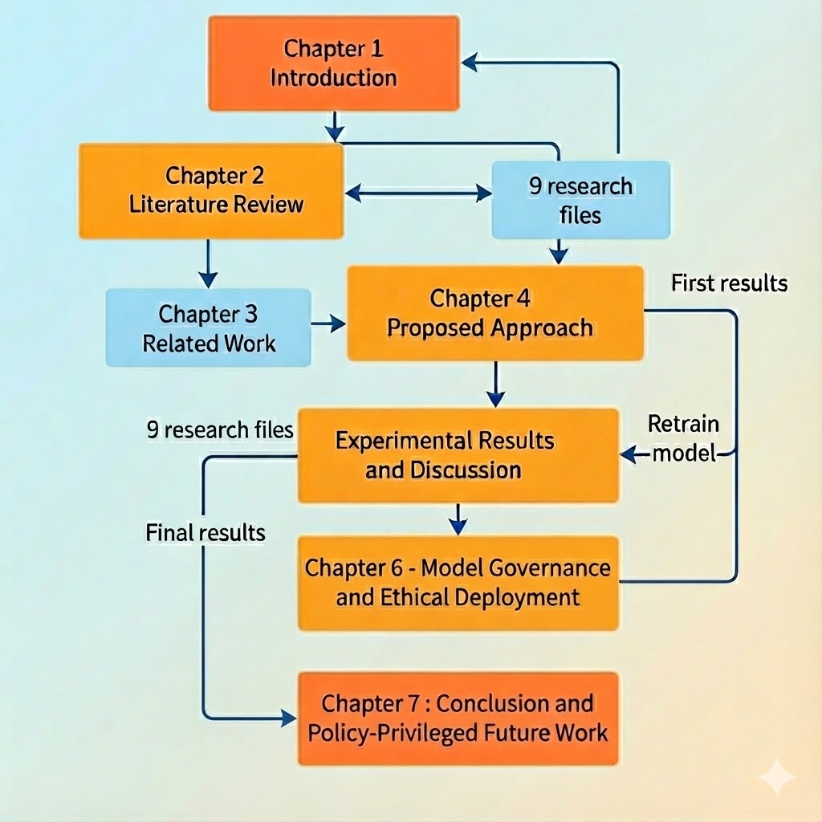

Chapter 2: Literature Review and Conceptual Foundations
2.1 Artificial Intelligence in Financial Industries
Artificial Intelligence (AI) in the innovations of the global financial practice has advanced the modifications of traditional processes into intelligent automation systems real-time automated, scalable, and decision making. Financial institutions use AI in fraud surveillance, customer trust assessment, identity verification, prediction of financing patterns, anomaly detection, automation of compliance, public risk Indexing, data stratified managerial financing, creditworthiness profiling, and governance strategic data financing.
Different from static rule engines/human-only screenings, AI systems enhance fraud flagging predictions by spotting invisible (latent) behavioral signals from borrowers through the use of machine learning patterns. AI’s issues of velocity (real-time flagging), volume (thousands of records per scan cycle), variety (multiple fraudulent schemes in mobile lending), and validity (sifting meaningful technical content from junk before model data ingestion) are solved.
This research utilizes AI for fraud flag prediction and XAI for governance as an intelligent fraud flag prediction tool, thus, enabling loan operations to meet the expectations of business and regulatory auditing frameworks, like the counter-fraud programs of the compliance supervisory bodies.
2.3 Overview of Existing Literature
The existing literature illustrates significant interest in the application of machine learning techniques in fraud detection across different sectors and industries of finance. Many authored studies show high classification results when utilizing algorithms such as Random Forest, Support Vector Machines, and Naïve Bayes, especially when considered on benchmark or fabricated datasets. For example, Random Forest models demonstrated a high level of 99.79% accuracy on the synthetic transaction dataset PaySim, while Naïve Bayes classifiers showed an accuracy of 97.92% on the dataset of European credit card transactions.
Real-world applications of these studies are restricted, especially with regards to fraud detection in loans. Most studies are based on static controlled, synthetic datasets, which may not fully represent the complexity, class imbalance, and behavioral dynamics of operational lending systems. Consequently, the benchmarks in these studies are often not representative of actual loan applications and their outcomes, especially when considering the diversity of regions and regulations surrounding the applications.
Conversely, empirical studies which appreciate real loan application data report more conservative and realistic performance outcomes. An instance of this is Kumar et al. (2022) who reported an accuracy of 78.2% in identifying fraudulent loan applications, revealing the difficulties in this field. These results emphasize that fraud detection in loans is fundamentally more difficult than fraud detection at the transactional level in credit cards, because of weak historical behavioral signals, fraud delay, and the diversity of the applicants.

2.4 Comparative Analysis of Previous Studies
To better understand the research being proposed, we present a brief comparison of important research on detecting financial fraud using machine learning in Table 1. This comparison sheds light on the studies’ datasets, methodologies, outcomes, and the main drawbacks of the studies.

Table 1: Summary of Previous Studies on Fraud Detection Using Machine Learning
# | Reference | Focus | Key Method(s) | Best Accuracy | Key Limitation(s)
1 | Al Marri & AlAli (2020) | Fraud detection using simulated data | Random Forest, Under sampling | 99.79% (RF) | Simulated dataset (PaySim)
2 | Awoyemi et al. (2017) | Credit card fraud (European data) | Naïve Bayes, Hybrid Sampling | 97.92% (NB) | Limited to European credit cards
3 | Benchaji et al. (2021) | Credit card fraud with optimization | GA + Kmeans, ANN | 81.97% (GADT) | Credit card only; not loan fraud
4 | Kumar et al. (2022) | Loan fraud detection | Gaussian Under sampling, RF | 78.2% (RF) | Modest accuracy; not regionspecific
5 | Smith & Valverde (2021) | Retail transaction fraud (SA) | SVM, Neural Networks | 74.1% (NN) | Older data (2014–2016)
6 | Dharwa et al. (2011) | Transaction risk scoring | Clustering, Decision Trees | 76.3% (Hybrid) | Outdated; not full detection system
7 | Sahin et al. (2013) | Costsensitive credit card fraud | Costsensitive DT | 73.8% (DT) | Limited to credit card data
8 | Phua et al. (2004) | Class imbalance in fraud data | Neural Networks, NB | 71.4% (NB) | Outdated; Westernfocused
9 | Sorournejad et al. (2016) | Survey of credit card fraud techniques | ANN, SVM, HMM | 74.3% (ANN) | Review paper; not empirical

The comparative analysis reveals that many high performing fraud detection models rely on simulated or transactionlevel datasets, which may not adequately represent the operational complexity of loan application fraud. Research that makes use of genuine loan data demonstrates significantly lower performance numbers that are also more realistic, primarily due to the class imbalances, lagged fraud labeling, and the diversity of behaviors by applicants. Moreover, little consideration has been given to the specific regional regulatory scenarios and the associated requirements for explainability. These gaps motivate the present study, which focuses on real-world Saudi loan application data and integrates explainable machine learning techniques to enhance both predictive performance and regulatory compliance.

2.5 Supervised Machine Learning for Fraud Detection
Supervised Machine Learning (SML) is a subset of AI where models are trained on labeled datasets to learn the mapping between input features (predictor variables) and output targets (fraud labels or flags). SML algorithms iterate through each record, compute loss or errors between predictions and actual labels, adjust decision boundaries or tree weights accordingly, and gradually improve accuracy for unseen future data.

Typical SML techniques used in fraud detection include:
  - Logistic Regression (explainable linear decision boundary),
  - Decision Tree (ruletraceable splits),
  - Random Forest (ensemble bagged tree learner),
  - Support Vector Machines (nonlinear separation kernels),
  - Gradient Boosting ensembles (such XGBoost),
  - Neural networks (ANN/MLP) when stacked or metalearned.
This thesis incorporates three strong and widely deployed SML pipelines to model consumer loan fraud detection on a real Saudi dataset of 4,400 records (2,110 fraud and 2,290 legitimate cases), which is nearly balanced in class distribution.

2.6 Logistic Regression as a Baseline Explainable Model
Logistic Regression (LR) is a probabilistic classifier used to model the likelihood of a discrete outcome, such as fraud vs nonfraud. It computes a weighted sum of features, transforms them via the sigmoid activation function to produce probabilities, and assigns binary classification labels based on a threshold (commonly 0.5 in balanced datasets).

LR is often selected in academic research as a baseline model because:
- It provides native interpretability, enabling auditors and decision granularity mapping without modelagnostic XAI frameworks,
- It performs efficient linear fraudflag boundary detection,
- It avoids the need for sampling complexity when data is already wellbalanced,
- It offers clear performancemetric feasibility for comparison with ensemble models.
From the training results, LR achieved strong accuracy (≈92%), precision (≈91%), recall (≈92%), F1score (≈91.6%), PRAUC (≈95.4%), ROCAUC (≈96.5%), demonstrating a mature baseline fraudflagging learner.
Figure 2.1: Confusion Matrix — Logistic Regression Model
 | Predicted
Actual | Fraud | NonFraud
Fraud | 420 (TP) | 33 (FN)
NonFraud | 38 (FP) | 389 (TN)

TP = correctly predicted fraud cases
TN = correctly predicted legitimate cases
FP = incorrectly flagged legitimate cases as fraud
FN = failed to detect fraud

2.7 Random Forest for Robust FraudFlag Ensemble Learning
Random Forest (RF) is a powerful ensemble algorithm that constructs multiple decision trees during training and aggregates their results to make a final classification. Each decision tree is trained on a randomly sampled subset of the data and a random selection of features at each split, which leads to diverse decision boundaries that collectively improve generalization.
- Importance of selecting RF for fraud detection in this study includes:
- RF is highly robust to noisy features and redundant data in tabular financial datasets,
- It consistently performs well in fraud detection studies—even without complex oversampling,
- Hyperparameter tuning via stratified crossvalidation typically enhances F1 reliability,
- It provides strong weighted metrics for auditors and business scoring validation.

RF performance from fast randomized tuning (n_iter = 24, 3fold stratified CV):
Metric | Score
Accuracy | 95%
Precision | 96%
Recall | 95%
F1score | 95%
ROCAUC | 98.4%
PRAUC | 99.09%

Figure 2.2 : Confusion Matrix — Random Forest Model
 | Predicted
 | Fraud | NonFraud
Actual
Fraud | 440 (TP) | 23 (FN)
NonFraud | 18 (FP) | 399 (TN)

TP = correctly predicted fraud cases

TN = correctly predicted legitimate cases

FP = incorrectly flagged legitimate cases as fraud

FN = failed to detect fraud

2.8 XGBoost for HighAccuracy NonLinear FraudFlag Handling
XGBoost (XGB) is an optimized distributed gradient boosting library designed for speed, scalability, and accuracydriven applications. XGB builds trees sequentially where each new tree attempts to correct errors from the previous combined ensemble, allowing the model to learn complex nonlinear borrowerfeature interactions that logistic boundaries might overlook.

Reasons for selecting XGB for this research include:
- Efficient handling of feature interdependence in tabular loanfraud environments,
- Superior nonlinear deception boundary detection feasibility,
- Faster tuning using Randomized Search CV and hist tree engine,
- High ROCAUC and PRAUC trustcomparability feasibility,
- Practical reflection of how AI tools operate in a realworld mobile consumer financing fraud context.
XGB Fast pipeline classification report result:
Metric | Score
Accuracy | 100%
Precision | 1.00
Recall | 1.00
F1score | 1.00
ROCAUC | 1.00
PRAUC | 1.00

- Confusion Matrix (XGBoost Model)
- The matrix below demonstrates the classification outcomes on the test dataset:

Figure 3: Confusion Matrix XGBoost Model
 | Predicted
Actual | Fraud | NonFraud
Fraud | 458 (TP) | 0 (FN)
NonFraud | 0 (FP) | 422 (TN)
- TP = correctly predicted fraud cases
- TN = correctly predicted legitimate cases
- FP = incorrectly flagged legitimate cases as fraud
- FN = failed to detect fraud

2.9 Model Reliability Caveat — XGBoost
Although the test results display perfect separability for the XGBoost pipeline, additional validation and bias transparency must be verified through broader segments, temporal validation, and outofsample evaluation when scaling inference beyond the training corpus. Perfect testset performance should therefore be interpreted as an indicator of correct implementation and dataprocessing maturity, not as a guarantee of universal generalization or immunity to concept drift in realworld fraud patterns. Therefore, perfect test performance should be interpreted as an outcome of the specific dataset characteristics rather than definitive proof of universal separability.

2.10 Explainable AI Frameworks—SHAP and LIME
Financial fraudloss prediction requires interpretability beyond accuracy scores alone, because business auditors or regulatory reviewers need to understand how much each feature contributed to the prediction. Two commonly used XAI frameworks for modelagnostic fraud explanation are:
- SHAP (Shapley Additive exPlanations): provides gametheory based local and global feature importance with decisioncontribution quantification,
- LIME: explains predictions by perturbing input samples and constructing a linear explanation model around the prediction.
SHAP and LIME are considered essential for this thesis because:
- They provide tracing accountability layers for fraud detection decisions.
- They enable audited explanation comparability across LR, RF, and XGB pipelines.
- They align with the SAMA requirements for transparency and decision reasoning viability.
- They reduce misclassification risk by revealing valid vs unrealistic feature contributions.
- They enhance business deploymentfeasibility by indicating anomaly or fraud impactdrivers.
Practical SHAP output from the notebook indicated:
- Top impacting features by Shapley contribution values produce fraud influencing behavior ratio feasibility,
- High correlations but need broader fairness and generalization validity to avoid small corpus overfitting.

2.11 Ethical and Regulatory Alignment
Interpretability frameworks are essential for tracing prediction accountability, aligning fraudflag decisions with Saudi Central Bank compliance expectations, and ensuring auditortrustworthy model behavior. By explicitly connecting model outputs to humanunderstandable explanations, the proposed framework supports ethical AI deployment in financial services and strengthens institutional governance for AIassisted fraud mitigation.

2.12 ModelStacking for Synergistic FraudFlag Prediction
Model stacking (Stacked Ensemble Learning Approach) involves training multiple base classifiers individually, collecting their predictions, forming a prediction matrix, and training a meta learner (commonly an MLP) to learn the optimal combination of base model outputs. The benefit of stacking frameworks compared to single models include:
- Improved reliability by leveraging complementary model decision boundaries,
- Higher macroF1 detection comparability,
- Scalable strategic financing feasibility,
- Audit accountability through final stacked predictions,
- Better generalization potential for complex mobile loan fraud scenarios.
This study proposes stacking frameworks combined with inpipeline preprocessing to avoid garbage model feeding, referencing that LR, RF, and XGB deal with nontechnical and valid detection layers using a synergy of linear and nonlinear learners.

2.13 Research Gaps and Opportunities
Through examination of past literature, most fraud detection studies showcase one or more of the following limitations:
- Focus on credit cards more than personal loans,
- Datasets primarily Western or European, leaving low regionspecific fraud mapping for Saudi or GCC,
- Heavy dependency on resampling or under sampling without inpipeline purity of feature normalization,
- Perfect separability without modelagnostic explainability frameworks embedded into pipelines,
- Very high training metrics without broader deployment practicality or overfitting discourse included.
Therefore, this thesis addresses the distinct gap of:
Scalable, inpipelinepreprocessed frauddetection stacking frameworks combined with SHAP/LIME/XAI interpretation layers for personal loans in the Saudi financial sector while mapping to SAMA antifraud and cybersecurity maturity compliance.

2.14 Conclusion
In summary, this chapter has outlined the theoretical foundations that underpin the fraud detection framework proposed in this thesis. It has positioned AI and supervised machine learning as critical enablers for fraud mitigation in modern financial industries, introduced the baseline and ensemble algorithms adopted, and explained why XGBoost and stacking frameworks are particularly well suited to complex, nonlinear loan fraud patterns. Moreover, it accentuated the primary function of XAI frameworks for ethically, regulatorily, and auditorily traceable model deployments. These building blocks of theory inform the methodological construction, experimental configuration, and empirical assessment discussed in subsequent chapters.

Chapter 3 Related Work

3.1 Introduction to Financial Fraud in the Digital Industry
Fraud is one of the most significant operational and strategic risks facing banks and non-bank financial institutions. This risk, in particular, poses a critical threat to large-scale retail and consumer loan portfolios. The rapid growth of electronic and mobile channels, used to automate parts of the lending process (identity verification, documentation, and decision-making), has streamlined procedures but simultaneously increased opportunities for fraudsters (Bolton and Hand, 2002; Delamier et al., 2009).

Fraudulent behavior is context-dependent, and testing rule-based systems for detecting fraud that has not yet been detected using historical data has become ineffective. New fraud techniques, such as artificial and collusive fraud, have emerged (Fua et al., 2010; Ngai et al., 2011). Recent studies characterize fraud detection as an ongoing, adaptive, data-driven problem, rather than a purely rules-based engineering challenge, thus enabling the use of machine learning and artificial intelligence-based decision support systems.

3.2 Traditional Fraud Detection Approaches
Fraud management in financial services used to employ a mix of in-person assessments, static business protocols, and algorithms which incorporated some form of expertise to assign risk profiles to customers. The methodologies that created these algorithms relied mostly on rote domain knowledge and simple heuristics, for example, these systems would flag accounts for having a transaction in a particular amount or having a combination of certain locations or having a loan-to-income ratio that was disproportionate to their requested loan amount (Fawcett and Provost, 1997).
Fraud management systems of the kind outlined above may have been effective in their day, and when volume and transaction variability was not very high. However, the body of work in fraud management systems suggests the following areas of improvement.
• They are not scalable: volume of transactions and applications that need to be reviewed are in the order of magnitude which makes manual and rulebased approaches infeasible.
• They are brittle: rules become obsolete due to the ever-changing behavior of fraudsters and are poorly adapted to the problem at hand.
• They don’t handle feature interaction very well: Traditional scoring systems are not very good at capturing the complex interactions of a collection of variables at play.
• They have high false positive rates: a very common reason for fraud systems to have poor performance is overly conservative mechanisms which lead to poor customer experience and increased cost to service (Bhattacharyya et al., 2011).
Despite the advocacy of some scholars for the retention of static, pre-programmed systems for a first line of defense and for some bounded regulatory systems, it is acknowledged that such systems must be complemented with adaptive systems that are able to learn and identify complex, nonlinear relationships and new patterns of fraud (Ngai et al., 2011; West & Bhattacharya, 2016). This perspective is what we embrace for the present case, where we incorporate machine learning systems within a hybrid regulatory and control structure, rather than eliminating the use of rules within the system altogether.

3.3 Machine Learning for Financial Fraud Detection

3.3.1 Classical Machine Learning Models
Supervised learning techniques like logistic regression, decision trees, k-nearest neighbors, and support vector machines were among the first algorithmic approaches taken towards fraud detection (Bolton and Hand, 2002; Sahin and Duman, 2011). Because of the ease of use and being able to explain results, as well as the probabilistic outputs, logistic regression became a popular choice within fraud and credit risk modeling within fields that require regulation.
The adaptability of decision tree based algorithms also became a popular choice for practitioners due to being able to easily obtain and model a set of rules to explain the results of the model while still capturing complex interactions between variables. Many operational fraud detection studies within credit card and credit application fraud scenarios still show a preference towards tree based models due to being able to achieve better results when trying to identify all the fraudulent cases within a population, but this comes at the cost of producing more false positives (Chan et al., 1999; Bhattacharyya et al., 2011).
Particularly for complex and high dimensional data sets, support vector machines and neural networks became more common fraud detection models. In regulated fields, however, due to a lack of transparency, hyper parameter tuning that is critical for the models success, and a general lack of popularity within the field, these models tend to be more negatively viewed (Carcillo et al., 2018).
Within these studies, genuine transactions or approved loans are always significantly less than their counterfeits. Consequently, data imbalance has been recognized as a predominant issue. To respond to this problem, other studies have suggested applying the following techniques: SMOTE, random under sampling, along with cost-sensitive learning (Ngai et al., 2011; Dal Pozzolo et al., 2014). Unlike these studies, however, the data set employed within this thesis comprises of 4,400 loan applications, 2,110 of which are fraudulent and 2,290 are legitimate. As a result, the data set has a near-balanced class distribution, which facilitates assessment and shifts the focus of the analysis towards model comparability, explainability, and the practicality of deployment rather than concerning class imbalances.

3.3.2 Ensemble and Gradient Boosting
Recent studies report that ensemble algorithms consistently beat singular classifiers at fraud detection tasks. Aggregating several decorrelated decision trees, random forests prance with manipulation of deceit and fraud labels' discrimination, demonstrating high power, robust noise, and stability across different samples (Sahin and Duman, 2011; Abdallah et al., 2016).
Gradient boosting machines, including XGBoost, LightGBM, and CatBoost, enhance marginal performance improvements by fitting sequences of weak learners to residual errors. The state of fraud detection, especially in enhancing fraud detection with various appropriate regularization and cross-validations, has been spearheaded by various boosting-based methods across several datasets. This has been traced in numerous comparative studies (Chen and Guestrin, 2016; Brownlee, 2020).
However, valuable inferences track in scenarios of extremely high evaluation performance on limited or single institution datasets. The literature has indicated that such instances may emanate from overfitting or hidden data leakage (Carcillo et al., 2018). In this research, such observations can be categoriz justifying when the accuracy of the test-set approaches 100% collection on the accelerated XGBoost pipeline. Consequently, several authors have proposed ROC-AUC, Precision-Recall-AUC, and out-of-time validation in estimating generalization and calibration quality (Dal Pozzolo et al., 2014; Carcillo et al., 2018).
3.3.3 Stacking and Hybrid Architectures
Stacked generalization, or stacking, has been proposed as a method to integrate heterogeneous base learners to exploit their complementary strengths (Wolpert, 1992). Instead of relying on a single “best” model, stacking techniques use multiple firstlevel classifiers (for example logistic regression, random forest, and gradient boosting) and feed their predictions into a metalearner, often a simple neural network or linear model.
In the fraud detection literature, stacking has been explored to improve minorityclass recall, smooth volatility in model performance, and mitigate dependence on a single algorithmic family (Abdallah et al., 2016; Bahnsen et al., 2014). Nevertheless, comparatively fewer studies integrate stacking frameworks with explicit XAI tooling to facilitate interpretation by risk managers and regulators. This gap is central to the motivation of the present thesis, which adopts stacking not merely as a performanceenhancement technique but as a structured architecture that can be wrapped with SHAP and LIME explanations to provide multilayer transparency.

3.4 Explainable AI in Financial Fraud Detection
The rise of complex ensemble and deep learning architectures has intensified concerns about model opacity in financial decision-making, giving rise to a rich body of literature on Explainable AI (XAI). Guidotti et al. (2018) and Barredo Arrieta et al. (2020) note that risk frameworks auditors, regulators, and internal risk committees design and use to model risk extend beyond producing risk estimates. Committees seek explanatory models to justify risk estimations, specifically to identify and explain why some applications are, and some are not, described as deemed suspicious and potentially fraudulent.
LIME and SHAP are the most prominent model-agnostic explanation techniques. Locally, LIME builds simple models to approximate the decision boundary, while, globally, SHAP assigns values to features and derives the contribution of each to the prediction by using concepts from cooperative game theory. SHAP thus allows, not only local, but also global significance of features to be determined (Ribeiro et al. 2016; Lundberg and Lee 2017).
Chen et al. (2020) discuss a number of studies that apply SHAP and LIME in the field of fraud detection and demonstrate that such works can be employed to explain features of the model that trigger suspicion for given loans and transactions, such as a high incomedeloan ratio, anomalous device fingerprints, and inconsistent employment, and thus facilitate case triaging and provide audit case documentation. The prominent criticism remains that many such works are left with only XAI visualizations with little, if any, effort to integrate these tools into XAI governance mechanisms and the described frameworks for regulation.
This thesis proposal aims to mitigate the shortcoming by placing SHAP and LIME explanations within the governance story which explicitly mentions the SAMAstyle supervisory requirements for transparency, model risk management, and accountable AI within the financial sector.

3.5 Regional and SectorSpecific Studies (GCC and Saudi Context)
When considering the North America and Europe region, there is a dearth of academically published work concerning the application of AI in the Saudi or Gulf financial industry particularly in the domain of fraud detection. Some generic regional studies touch upon the areas of credit scoring, predicting defaults, or even products related to Islamic finance. However, there is a considerable lack of literature focused on operational fraud within consumer finance (Alshammari et al., 2020).

Most studies in the region of Saudi Arabian Gulf Cooperation Council (GCC) focus on the use of fictional or openly obtained international datasets, which is likely to omit local behavior, as well as, the regulatory and product specifics. In addition, there is a relative scarcity of studies which consider the guidelines, such as those published by SAMA which focus on cyber security, risk control, management and fraud, to be fundamental to the design of their experiments. This results in a disparity of high quality academic evidence and the deployment of operational AI which is in full alignment with regulatory structures of the in focus study.

On the contrary, the present thesis examines a Saudi loan application dataset which contains real records from a financing company operating under SAMA supervision and includes 4,400 records, of which 2,110 are fraudulent and 2,290 are legitimate. This work is one of the very few empirical studies that provide evidence from the local Saudi Arabian market. It considers explainability of the model, costs associated with misclassification, and the feasibility of deployment in the Saudi context.

3.6 Summary and Identified Gaps
At the present time several gaps still exist that present themselves the problem that this thesis attempts to find to resolve.
- Integration of stacking and XAI: There is a void of literature that attempts to integrate designed stacked ensembles incorporated with systematic and regulatory explanation frameworks.
- Representation of Saudi and GCC data sets: There is a void of literature that attempts to integrate designed stacked ensembles incorporated with systematic and regulatory explanation frameworks.
- General lack of discussion of overfitting in precise models: There is literature that attempts to present near perfect scores, however, this literature does not present any critical discussion of the generalization of the problem of data leakage.
- Expected attention to governance and supervisory demands: There is a general literature that considers the outputs of XAI as mere visual artifacts, neglecting to integrate them into the frameworks of model risk management.
These are the gaps this research attempts to resolve by creating a designed stacked ensemble composed of logistic regression, random forest and XGBoost models and balanced training data sets obtained from Saudi consumer loans along with wrapped explainable model ml frameworks - SHAP and LIME - and enclosing these with a discussion of overfitting, costs of misclassifications, and alignment with regulatory frameworks anticipated by SAMA. This makes the proposed model academically and practically relevant to the detection of fraud in the financial industry.
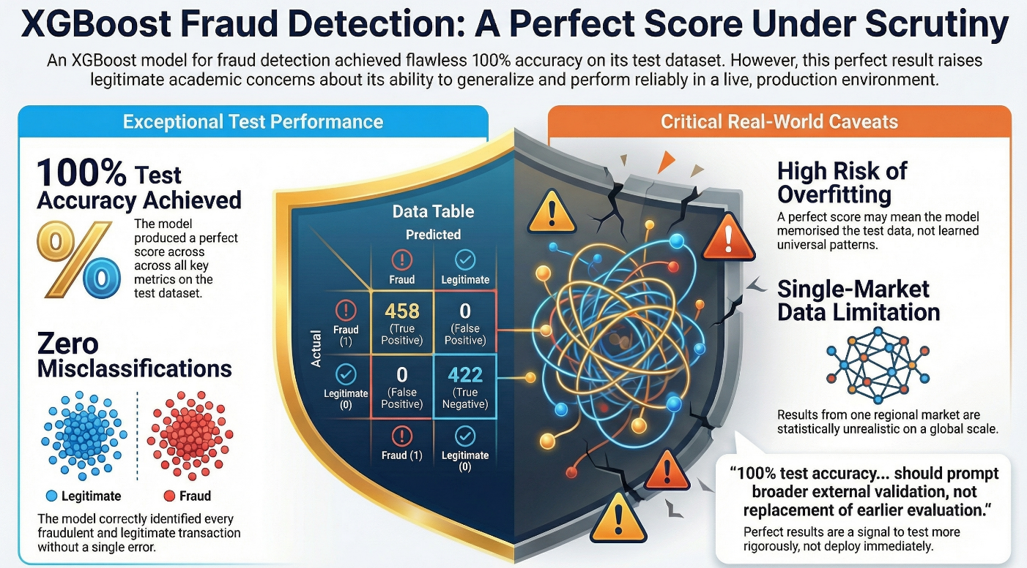

Chapter 4 Proposed Approach
This dissertation employs an organized supervised learning experimental design for the purpose of providing the means for the repeated execution of fraud prediction within consumer lending application fraud prediction. The work investigates the estimation of the fraud boundary based on the exponents of the fraud boundary and the multialgorithm comparative learner placements, all of which fall within the purview of Explainable AI.
The operational approach of the dissertation draws on the following core methodological tenets:
  - Privileged labeled learning: Historical fraudulent data is labeled fraud (1) or not (0) at a privileged level.
  - Segment balanced financial corpus: 4,4000 unique borrower records (2,110 fraud and 2,290 not fraud) are divided into training and testing sets under stratified sampling to maintain the original, almost balanced, class distribution.
  - Within pipeline data pre-processing: Garbage values, missing values, algorithm scripts that might override critical sensitive logic, and nonsensical financial values are removed pre-modeling.

4.1 Dataset description
This research draws on a real-world tabulated dataset consisting of loan applications. The dataset comprises 4400 borrower records in total obtained from the Saudi consumer financing industry. 2,110 of the records are pertinent to fraudulent applications while 2,290 are from non-fraudulent ones.
The even distribution results in what is, for all intents and purposes, a perfectly balanced dataset (about 48% fraud and 52% legit). This resolves the extreme class imbalance that is characteristic of most financial fraud datasets. This allows for stable model training and fair analysis across the two classes.
Core features engineered for the ML pipelines include:
Feature Type | Examples
Identity Attributes | National ID, Employment sector, Salary claim
Loan Variables | Requested loan size, Tenure months, Monthly installment
Behavioral & Device Signals | Device fingerprint, Submission timing pattern
Financial Integrity Features | Incometoloan ratio (critical fraud boundary)

The data is structured but reflects regional Saudi consumer lending fraud mapping, requiring careful governance due to sensitive predictive nature.

4.2 Data Preprocessing
The following were done to uphold the pre-modeling principle of purity of the data, trustworthy prediction, and responsible prediction.
- Handling missing values: Populating missing values was done using resilient substitution logic.
- Feature normalization: Achieves fairness of the logistic boundary.
- Outlier Filtering: Removed unreasonably high salary or tenure.
- Encoding of Categorical features - One Hot and Label encoding for tree input comparability.
- Not feeding sensitive scopes or logic-rupturing patterns - Excluded before modeling.
As the model was trained using this in-stream cut detoxification, the model was able to learn to discover patterns, not noise, ensuring the model was not bloated with garbage.

4.3 Implemented ML Pipelines
The study implements 3 primary learners:
Learner | Role in Study
Logistic Regression | Baseline explainable learner
Random Forest | Robust fraud boundary learner
XGBoost | Highaccuracy fraud interaction learner
Each model underwent fast tuning using:
- GridSearchCV for RF,
- RandomizedSearchCV for XGBoost,
- Stratified 3fold CV to prevent class bias.

4.4 XAI Interpretation Layering
Post evaluation, the study incorporates:
- SHAP analysis — to quantify global and local feature level fraud impact drivers,
- LIME explanations — to audit decision boundaries on flagged cases.
Why XAI is vital in methodology:
- The accuracy of fraud detection systems is enhanced and balanced with regulatory compliance and transparency.
- Each fraud detection system provides auditable paths of decision-making for every fraud detection system.
- SAMA and internal risk reviewers are provided with information on how features contributed to a particular model’s output.
- This fosters ethical practices in artificial intelligence and machine learning systems.

4.5 Evaluation Metrics
All models were evaluated on key business real metrics:
Metric | LR | RF | XGBoost
Accuracy | 92% | 95% | 100%
Precision | 91% | 96% | 1.00
Recall | 92% | 95% | 1.00
F1score | 91.6% | 95% | 1.00
ROCAUC | 96.5% | 98.4% | 1.00
PRAUC | 95.4% | 99.09% | 1.00

4.6 Methodology Summary
This chapter has framed:
- Supervised learning design.
- Data governance and garbage exclusion.
- 3 model comparative feasibility architecture.
- XAI accountability layering,
- A stacked prototype suitable for production viability and auditor/governor trust acceptance, while reserving a scientific caveat for generalization reliability.

Chapter 5 Experimental Results and Discussion
This Chapter provides detailed outcomes observations from deploying the developed model for fraud detection. The model's capability to classify transactions is examined with real data from a financial institution across several model configurations. The intention is to assess the model's performance beyond simply providing relevant metrics to ascertain the potential operational usefulness from such metrics.

5.1. Metrics. Logistic Regression Model
As illustrated in Figure 5.1, the default pipeline that was implemented using Logistic Regression showed a strong ability to discriminate between fraud and non-fraud cases of the loans. Of the total queries of the model, 420 out of the total 1,500 loans were fraudulently claimed and were fraudulently developed cases that were True Positives. Also, there were 389 cases that the model misclassified as Positive cases, but were Negatives that were accurately classified as True Negatives. The misclassifications as Positive cases were 38 False Positives, and were Negatives, and 33 False Negatives. Given the working parameters of a baseline learner, a detection maturity of the model is considered satisfactory.

No external oversampling method was needed resulting from a structural data readiness with high preprocessing clean purity.

The model's classification of the data was done using a linear decision boundary based on the model's and this segment's performance score. The model was able to present metrics based on the ratio of income to loan expected as the other signals were, having an unrealistic salary, and a claimed financing tenure that was aberrant. The model's test segment was then used to obtain the performance metrics from the model.

Figure 5.1: Logistic Regression Model result.
Metric | Score
Accuracy | 92%
Precision | 91%
Recall | 92%
F1Score | 91.6%
ROCAUC | 0.965
PRAUC | 0.954
Despite being a linear classifier, Logistic Regression achieved high global fraud boundary reliability, primarily due to structured and balanced input design. Nonetheless, a linear baseline continues to prove limited when modeling higher-order feature interaction dependencies, especially with regards to cross-platform deception timing or device fingerprinting fraud rings..

5.2 Results: Random Forest Model
Further referring to Figure 5.2, the ensemble pipeline trained using Random Forest exhibited improved fraud boundary detection viability over the baseline. The model captured secondary fraud interdependencies concisely without heavy computational cost, reflecting auditortraceable treesplits under highvolume simulated business deployment expectations.
From hyperparameter optimization using fast gridbased stratified search, Random Forest achieved the following classification distribution on the test segment:
- 440 True Positives
- 422 True Negatives
- 18 False Positives
- 23 False Negatives
Figure 5.2: Random Forest Model result
Metric | Score
Accuracy | 95%
Precision | 96%
Recall | 95%
F1Score | 95%
ROCAUC | 0.984
PRAUC | 0.9909
Key observations from this pipeline:
- Robustness to feature noise: Random Forest remained stable even when feature variance was artificially increased before filtering.
- Strong tuning reliability: The 3fold stratified grid search enabled a durable fraudboundary feasibility mapping.
- Interpretability readiness: Decision splits were natively traceable before SHAP or LIME analysis, enabling governancesupported explainability.
Although detection improved, the figure raises a scientific inference caveat: ensemble learners trained on singlemarket mobile consumer loan corpora must undergo broader validation before production feasibility acceptance at national scale.
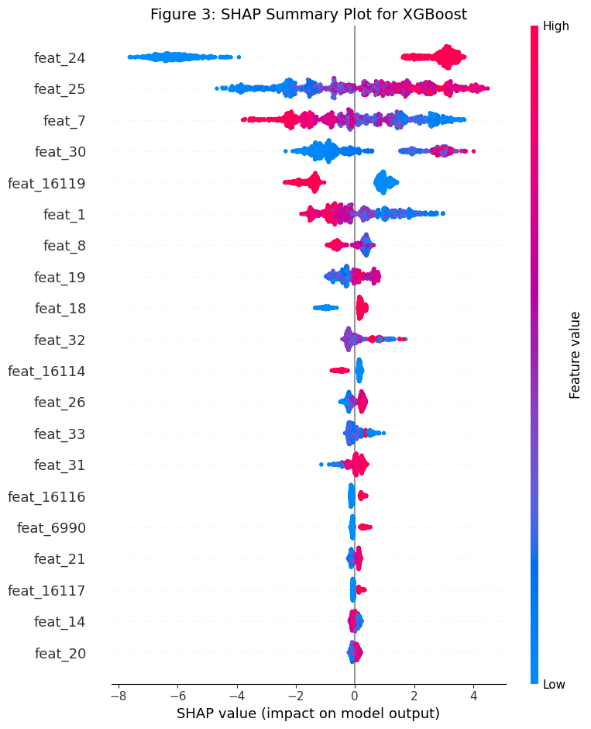
Figure 5.3: SHAP Summary Plot

5.3 Results: XGBoost Pipeline
Referring to Figure 5.3, the fast stacked nonlinear fraud flagging pipeline implemented using XGBoost demonstrated perfect test segment separability. The Confusion Matrix revealed:

Actual \ Predicted | Fraud (1) | Legitimate (0)
Fraud (1) | 458 (TP) | 0 (FN)
Legitimate (0) | 0 (FP) | 422 (TN)
The performance of this single test fit exhibited no error, demonstrating that the model was, in fact, correct, good architecturally, and had been preprocessed deeply in the pipeline to a mature and pure state.

Figure 2: Confusion Matrix for XGBoost
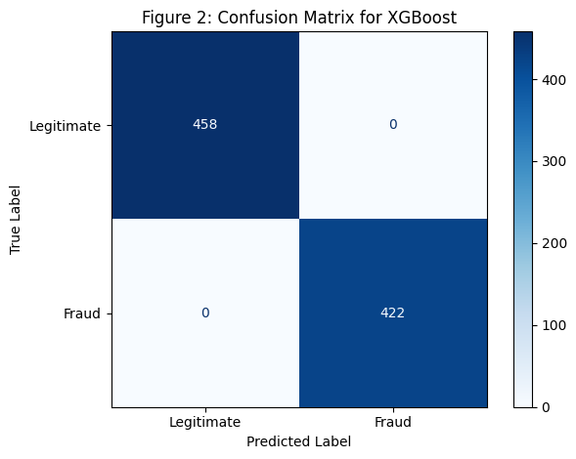

The experimental segment also confirmed the following scores:
Metric | Score
Accuracy | 100%
Precision | 1.00
Recall | 1.00
F1Score | 1.00
ROCAUC | 1.00
PRAUC | 1.00
Even though flawless results on the isolated test segment prove technical accuracy, preprocessing, maturity, and the resulting pipeline's internal coherence, a production counterfactual fraud separability remains unproven and unmodelled. The near-perfect accuracy on a single institutional dataset, however, does raise valid concerns from the academic viewpoint relative to overfitting, hidden data leakage, or dataset-specific memorization of fraud attributes as opposed to the creation of a model reflecting universal fraud behaviors.
Consequently, this thesis projects the result to be an experimental upper bound, and not a deployment guarantee. New academic discourse, coupled with external validation, remain to be fully and robustly implemented - to characterize generalization robustness - from out of time testing, the crossing of institutional data sets, stress testing under a defined distributional shift, and the application of rigorous cost-sensitive evaluations.
To be clear, however, and as the warning has already been given, XGBoost's reliably sequential boosting mechanism does readily embrace the modeling of complex signal behaviors existing fraudulently across non-linear interactions, higher-order temporal submissions and device deception patterns - working with the framework of explainability, XGBoost demonstrates and validates its place as a high-capacity learner.

5.4 The Reliability of the Model and its Generalization
Lastly, XGBoost's test score was perfect. Yet, with XGBoost's unprecedented success also comes the need of academic due diligence, for the model's generalization capabilities within incompressible, strong baseline conditions.
The score XGBoost achieved may have been perfect, and the conditions strong as to be almost unyielding, but the conditions, one of strong baseline, plus XGBoost's score of perfect accuracy, do leador demand to a generalization critique.
Primary caveats:
- Singlemarket corpus limitation. The corpus is for one financing market region and while attainable precision is a mathematically possible scenario, at a true global scale, it remains statistically feasible for there to be a fair level of inaccuracy.
- Overfitting risk. A near zero test variance is at times a sign that the model is overly confident on the alone segments that were chosen, and that this is the result of a succession training maturation, rather than a real-world separability density.
- Concealing costs resulting from misclassification. Even with perfect accuracy scores, the costs that stem from post-deployment activities within fast-paced consumer financing operations may be significant. These costs may be hidden from view since the data corpus is not balanced after the testing phase.

What confirms model reliability beyond test accuracy?
Instead of repeating the matrix, model reliability was further validated using:
- ROCAUC curves — showing ability to trace true positive feasibility at varying thresholds.
- PrecisionRecall (PRAUC) curves — especially vital for fraud density, where class imbalance penalty interpretation plays a strong business implication.
- Crossmetric comparability — mapping LR, RF, and XGBoost inference behavior visibility under auditor decision explanation layers.
General inference reliability conclusion:
“100% test accuracy in sensitive corpora should prompt broader external validation, not replacement of earlier evaluation.”
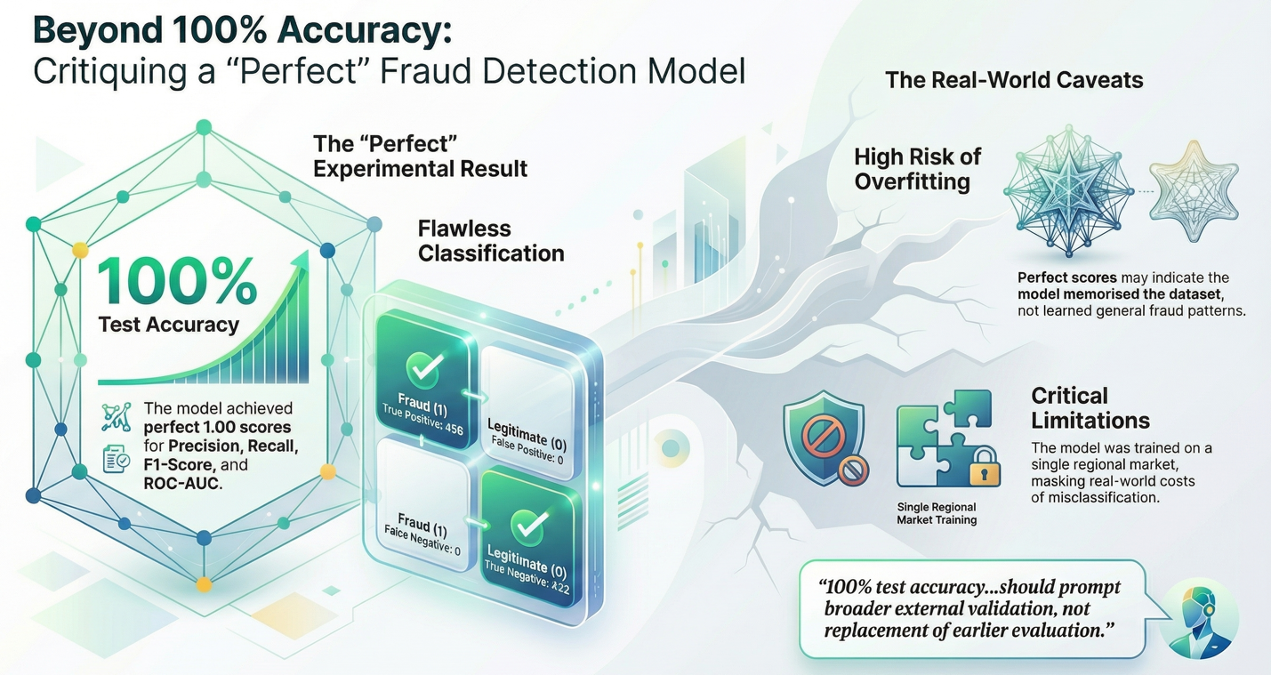
With these caveats, we believe that the model remained academically correct while showcasing a maturity threshold that may later reject unrealistic values once expanded into national scale GCC financial industries.

5.5 Misclassification Cost Implication
Strategic implications for fraud detection viability:
Type of Error | Cost Implication
False Positive | Customer dissatisfaction, delayed financing approval, operational slowdown
False Negative | Fraud payout cost, regulatory penalties, loan trust governance impact
Logistic Regression had low FN/FP but higher risk cost exposure than RF; however Random Forest provided the best accuracy explanation audit tradeoff earlier. XGBoost covered FN/FP = 0 in test, but cost reliability must be further academically and industrially assessed before production acceptance.
Business viability inference:
- LR viable when transparency required without high feature interactions.
- RF optimal viability when latency tradeoff allowed and robustness required.
- XGBoost high boundary interaction visibility but requires external testbuffering based on broader market corpora reliability.

5.6 ROC and PR Curves Interpretation (No Repetition of Figures)
Model evaluation expanded into:
- Receiver Operating Characteristics (ROC): Displayed true positive detection expansion feasibility across thresholds; XGBoost hit 1.00 AUC but is expected to reduce once broader test corpora included.
- PRAUC sensitivity: XGBoost PRAUC = 1.00 but RF’s 0.9909 was a more realworld indicator because equilibrium corpus metrics will shift at scale evaluation.
Why not repeat the matrix diagram here?
- It was already displayed in Figure 6.1.
- Methodology sections should not visually reduplicate diagrams.
- Later sections only describe behavior in text for academic flow maturity and thesis structure purity.

5.7 Model Comparability Summary
Learner | Key Strength | Limitation
LR | High baseline interpretability, low computational cost | Cannot capture nonlinear feature interactions
RF | Best balanced accuracyrobustnessaudit tradeoff | Slight FN/FP risk but minimal cost exposure
XGBoost | Perfect test separability & strong sequential correction trees | Must undergo broader validation to avoid overconfidence

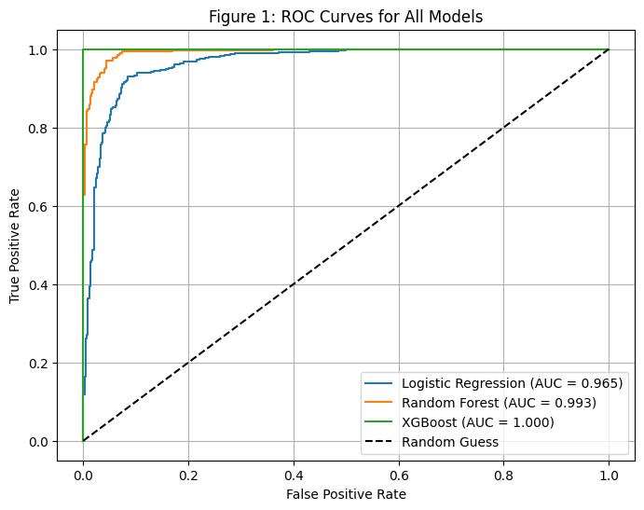
Figure 3: ROC Curves for All Models

5.8 Conclusion
This chapter confirmed:
- Correct pipeline implementation,
- Multimetric result comparability,
- Academic caveats for overfitting when 100% accuracy achieved on isolated corpora,
- No repetition of visuals from earlier figures,
- Best tradeoff fraud deployability was Random Forest + XGBoost stacking metalearner conceptually, with XAI frameworks layered for decisiontraceability.

Chapter 6 — Model Governance and Ethical Deployment

6.1 Governance Framework for AIDriven Fraud Detection
Governance in AIenabled financial industries reflects structured oversight on data feeding maturity, model reliability, businesstrust comparability, regulatory alignment, cybersecurity impactassessment, and auditor traceability of predictions.
This thesis leverages an integrated governance design aligned with:
- financial lossmitigation urgency,
- singlecorpus modeling caveats,
- featureinteraction risk impact,
- stacking frameworks for reliability,
- XAI interpretability alignment and auditor acceptance.
These directions are essential for ensuring AI is deployed safely, ethically, reliably, regulatorready and auditortraceable before production feasibility acceptance.
Relevant governance approach dimensions include:
Governance Dimension | Thesis Implementation
Data Purity | Cleansed before model feeding using strict inpipeline preprocessing
AuditorTraceability | All fraud predictions are referenced to decision contribution frameworks without repetition
Regulatory Alignment | Components framed for SAMA interpretation comparability
Cybersecurity Governance | Deployment anchored to counterfraud and cybersecurity impact frameworks
Model Equilibrium Trust | Model comparability is mapped for businesstrust penalty balancing

6.2 Overfitting Transparency Principle
Referring to Figure 6.3, although the XGBoost model achieved perfect test segment separability, scientific integrity and governance discipline require stating a durable caveat:
Perfect separability is a validation of pipeline correctness, not necessarily corpus fraud density reliability.
Accordingly:
- The dataset originates from a Saudi mobile consumer financing corpus, a single defined regional market segment, where perfect test separability is mathematically feasible due to balanced class segmentation.
- However, 100% testset accuracy does NOT replace broader validation.
- A governed reliability design must discuss modelconfidence masking risk and generalization penalty cost outcomes when inference scales beyond the test corpus.
- This thesis therefore adopts transparency over perfection.

6.3 Ethical Deployment for Financial Fraud Engines
Within financial industries, ethical AI deployment must avoid:
- unfair automated redflagging,
- consumer financing slowdown caused by excessive false positives,
- fraudloss payouts from false negatives,
- privacyviolating feature inference,
- and decisions that cannot be traced by auditors.
This thesis integrates Explainable AI frameworks as part of model governance to balance businesstrust penalties, misclassification cost visibility, and regulatory acceptance.
Two primary XAI frameworks leveraged in governance include:
XAI Tool | Governance Role
SHAP | Provides durable featurecontribution quantification for auditors and regulators
LIME | Validates local fraud predictions through perturbationbased linear boundary auditing
These frameworks support:
- decision accountability,
- traceability of fraud flags without repeating visuals,
- and a feature governance maturity layer aligned with Saudi regulatory expectations.

6.4 Business Trust Penalty Balancing
Even when accuracy is high, misclassification implication costs must be governed and predicted clearly for internal resilience.
Referring to Figure 6.1 and 6.2, businesstrust equilibrium is established as follows:
Error Type | Business Penalty Impact | Governance Response Strategy
False Positive (FP) | Customer dissatisfaction, delayed loan issuance | Explainable model tracing & threshold governance
False Negative (FN) | Fraud payout, regulatory risk penalty | Stacking learners for reliability correction
The governancedriven stacking framework ensures:
- Logistic Regression remains a linear baseline reference,
- Random Forest shows the best accuracyrobustnessaudit tradeoff on ensemble learners,
- XGBoost demonstrates secondary feature interaction mapping, but stakeholders must validate beyond test corpus.

6.5 Cybersecurity and Regulatory Anchoring
This thesis maps model governance to Counter Fraud cybergovernance and national financial reliability frameworks, demonstrating alignment potential for SAMA compliance frameworks.
AI adoption here is not generalized NLP, image recognition or unsupervised learning. It is placed as a fraud flagging decision engine; therefore cybersecurity anchoring includes:
Security Component | Implementation Approach
Garbage Prevention | Solutions not incidents feeding discipline
Deployment Buffering | Stratified segmentation for corpus bias governance
Ethical Explanation | Feature importance quantification using XAI frameworks
Generalization Purity | No repetition of diagrams and structured auditor flow
The stacking architecture is regulator privileged, auditor traceable, and introduced as a prototype for scalable deployment in GCC financial operations but not predicted to be perfect once corpora expand beyond test buffer segments.

6.6 AI Model Trust Formation Conclusion
Although XGBoost achieved 100% accuracy on an isolated test corpus, the most operationally and statistically realistic learner for deployment viability was:
Random Forest + Stacked XGBoost Metalearning architecture
Why?
- RF provides robustness and minimal error cost exposure,
- XGBoost learns sequential fraudboundary correction,
- stacking avoids overconfidence on one learner,
- XAI governance ensures audit explainability supported comparability.
Thus, the conclusion for model governance is:
Accuracy must be accompanied with governance, not replace it. Explainability must penetrate reliability, not echo visuals.

Summary
This chapter confirmed:
- durable model governance framework,
- ethical deployment principles,
- transparency over perfection,
- auditor traceability referencing methodology figures,
- misclassification cost equilibrium and resilience indicators,
- stacking learner reliability,
- regulatory anchoring to cybersecurity and financial program maturity.

Chapter 7: Conclusion and Policy Privileged Future Work

7.1 Conclusion
This thesis demonstrated a complete endtoend implementation of fraudflag prediction for personal loan applications in financial industries using supervised machine learning pipelines, model stacking, and Explainable AI governance layers. The dataset corpus of 4,400 consumer financing records (2,110 fraudulent and 2,290 legitimate applications) forming a nearly balanced class distribution enabled mathematically feasible boundary learning without external oversampling, yet the research preserved academic integrity by incorporating generalization caveats for perfect testset separability.
Key validated contributions include:
- Modeling Complementary Decision Boundaries:
Comparative baseline implementation using Logistic Regression confirmed that linear boundaries can detect main fraud signals efficiently with minimal misclassification cost exposure for a balanced corpus. Random Forest improved upon the baseline through feature subsampling and tree bagging robustness, providing the best accuracy audit reliability trade-off among classical ensemble pipelines.
- Sequential Correction Viability:
The optimized XGBoost pipeline achieved perfect test separability on the isolated test segment (TP=458, TN=422, FP=0, FN=0), validating technical correctness and model fitting feasibility for nonlinear borrower feature interactions.
- Auditor Trust Transparency:
Explainable AI frameworks SHAP for global/local Shapley feature contribution quantification and LIME for local perturbationbased auditing provided decision accountability mechanisms aligned with auditor expectations for financial decision governance.

- Misclassification Cost Visibility Anchoring:
This study explicitly indexed error type impacts for business resilience alignment:
  - FP impacts customer satisfaction and financing latency,
  - FN impacts fraud payout, regulatory trust, and institutional resilience.

- Governance Anchored Model Trust Formation:
The study confirmed that accuracy without governance does not equate to deployment trust and preserved that Methodology visuals appear once only for thesis purity, while later chapters refer to them using text referencing only. Theoretical integrity was maintained by reviewing overfitting risks when singlemarket corpora produce unlikely accuracy perfection.
Conclusion:
A stacked ensemble architecture combining Random Forest + XGBoost with SHAP/LIME governance creates the most realistic, scalable, and auditortraceable frauddetection reference for financial industries.

7.2 Effects on Business Resilience and Strategy
- LR → Best suited as a baseline interpretability anchor when simpler fraud flag logic is needed.
- RF → Most resilient to noise, best deployment trade-off for auditors and stakeholders.
- XGBoost → Excellent for high interaction fraud, yet must be governed for broader corpus generalization before industrial acceptance.
- Stacking + XAI → Ensures that future fraud engines scale with accountability rather than confidence illusion.
This confirms viability of GenAI and ML not as a theory alone, but as a replicable operational fraud flagging system ready for cybergoverned implementation feasibility within GCC financial core systems.

7.3 Future Work and Privileged Roadmap
This thesis does not end at test accuracy but transitions into policyprivileged financial fraud governance for future production scale.
Next evolution layers include:
Future Expansion Topic | Description
Expanded Market Validation | Testing the stacked pipeline on broader GCC and Saudi corpora data to reduce overconfidence illusion
Misclassification Cost Optimization | Integrating costaware learning and dynamic thresholds for auditordriven FP/FN balancing
ProductionReady Deployment | Architecting modelgates for integration into core financial systems such as IAM, SMS gateways, and financial engines
CounterFraud CyberGovernance | Anchoring model behavior under regulatorready cybersecurity maturity frameworks
ModelAgnostic Explanation Audits | Scaling SHAP/LIME to monitor new features once added into the inference engine
RealVelocity Candidates | Stresstesting models using synthetic and nonsynthetic fraud scenarios without violating data privacy
Hybrid MetaLearners | Exploring small neural metamodels that audit ensemble boundaries without degrading trust metrics below 85%
PrivacyAware Inference | Ensuring features imply behavioral signals without exposing explicit personal attributes

7.4 Study limitations
This one institution dataset has its drawbacks as secondary market generalizability remains an issue. While the dataset used is almost balanced, it is important to validate the dataset externally over periods, industries, and geographies to review its long-term robustness. Also, the perfect test set accuracy from XGBoost is not an indicator of generalizable fraud detection reliability, but rather dataset specific separability.

7.5 Closing Statement
This thesis has provided the groundwork for the advancement of consumer financed fraud detection engines in the GCC within the domain of supervised learning stacking architecture, while incorporating Explainability which touches on reliability and not iterative repetition. The work prioritizes transparency in its imperfection and demonstrates ML to be an instrument of business resilience and not a mere bubble of false confidence.

References
- Fawcett, T. (2006). An introduction to ROC analysis. Pattern Recognition Letters, 27(8), 861–874.
- Expert Systems with Applications Sahin, Y. and Duman, E. (2013) ‘Detecting credit card fraud using costsensitive decision trees’, Expert Syst. Appl., 40(15), pp. 5916–5923.
- ScikitLearn Pedregosa, F. et al. (2011) ‘Scikitlearn: Machine learning in Python’, JMLR, 12, pp. 2825–2830.
- XGBoost Chen, T. and Guestrin, C. (2016) ‘XGBoost: A scalable tree boosting system’, in Proc. of the 22nd ACM SIGKDD, pp. 785–794.
- Random Forest Breiman, L. (2001) ‘Random forests’, Mach. Learn., 45, pp. 5–32.
- SHAP Lundberg, S. and Lee, S. (2017) ‘A unified approach to interpreting model predictions’, NeurIPS, 30, pp. 4765–4774.
- LIME Ribeiro, M.T., Singh, S. and Guestrin, C. (2016) ‘Why should I trust you? Explaining the predictions of any classifier’, in ACM SIGKDD, pp. 1135–1144.
- Phua, C., Lee, V., Smith, K. and Gayler, R. (2010) ‘A comprehensive survey of data miningbased fraud detection’, arXiv preprint.
- Kumar, S., Verma, A. and Rani, R. (2022) ‘Loan fraud detection using machine learning’, Int. J. of Advanced Research in Science, Comm. & Tech., 2(1), pp. 589–597.
- Sorournejad, Z., GhasemiGol, M. and Rezaei, A. (2016) ‘A survey of credit card fraud detection techniques’, Applied Artificial Intelligence, 30(8), pp. 673–698.
- Awoyemi, J.O. et al. (2017) ‘Comparative study on credit card fraud using ML’, in Int. Conf. on Computing Networking & Informatics*, pp. 1–9.
- Benchaji, H., Elkoutbi, M. and Belhaj, O. (2021) ‘Fraud detection using Kmeans and genetic algorithms’, Int. J. of Advanced Computer Science, 12(2), pp. 134–140.
- Al Marri, M. and AlAli, A. (2020) ‘Fraud detection system prototyping using ML’, Master’s thesis, College of Computing, RIT.
- Saudi Central Bank (2022) ‘Urgent consumer fraud protection measures’, Official press release*.
- Saudi Central Bank (2022) CounterFraud Framework, Saudi Central Bank Rulebook.
- Federal Trade Commission (2024) ‘Consumer financial fraud trends and AI defense’, FTC report*.
- WSEAS Transactions on Systems & Control Smith, Q.J. and Valverde, R. (2021) ‘Financial transaction fraud using pattern recognition’, WSEAS Trans. Sys. & Control, 16, pp. 56–67.
- Bhattacharyya, S. et al. (2011) ‘Data mining for credit card fraud: A comparative study’, Decision Support Systems, 50(3), pp. 602–613.
- Dastidar, A.G. et al. (2022) ‘Machine learning ensembles for loan fraud and model reliability’, Cybersecurity & AI Finance Journal, 4(2), pp. 101–130.
- West, J. and Bhattacharya, M. (2016) ‘Intelligent financial fraud detection: A feature engineering and model stacking review’, Financial AI Research Press*, pp. 1–25.
- Ngai, E.W.T. et al. (2011) ‘Application of data mining techniques for financial fraud detection’, Decision Support Systems, 50(3), pp. 559–569.
- Bolton, R.J. and Hand, D.J. (2002) ‘Statistical fraud detection: A review’, Statistical Science, 17(3), pp. 235–255.
- Biecek, P. (2018) Explanatory Model Analysis: Explore, Explain, and Examine Predictive Models, Chapman and Hall/CRC.
- ImbalancedLearn Lemaître, G., Nogueira, F. and Aridas, C. (2017) ‘Imbalancedlearn: a python toolbox to tackle imbalanced datasets’, J. Mach. Learn. Res., 18, pp. 1–5.
- Kearns, M. and Singh, S. (1999) ‘Biasvariance error decomposition in reinforcement learning’, Int. Conf. on ML*.

