

Deep Learning Framework for Galaxy Morphology Classification and Analysis
Prepared By
Name: Ahmad Yousef Alkahlout ID No.: 253000753
Name: Mohmmed Taleb Mohammed ID No.: 252000097
AI-21%
Submitted in fulfillment of the requirements for the degree Master of Science in Artificial Intelligence
At
College of Informatics
Midocean University
UAE
Supervisor Name: Dr. Mohamed Essa
College of Informatics, Midocean University, Comoros
Email: 253000753@st.midocean.edu.km / 252000097@st.midocean.edu.km

Acknowledgements

We would like to thank our supervisor, Dr. Mohamed Essa, for his continuous guidance and valuable feedback throughout this research. His expertise in both artificial intelligence and galaxy studies has greatly influenced the direction of this work. His comments challenged us to think more critically and approach the research from a scientific perspective rather than a purely technical one.

We are also thankful to the faculty members at the College of Informatics, Midocean University, for providing a supportive academic environment that inspired independent thinking and research development.

Finally, we would like to express our appreciation to our families for their patience, encouragement, and support during this journey.

Abstract

Classification of galaxy morphology continues to be one of the essential topics in astrophysics, as the galaxy shape allows obtaining information about the galaxy formation process and its evolution. Due to the increasing availability of data on galaxies obtained from SDSS and DECaLS surveys, the amount of galaxy images has considerably increased. In this regard, manual visual classification becomes increasingly ineffective in the case of extensive research, highlighting the increasing relevance of automation through the use of deep learning algorithms.

Earlier works have shown that deep learning models can demonstrate good results in galaxy image classification. At the same time, many of them focus on classification accuracy, while other essential factors, such as interpretability, robustness, and prediction uncertainty, may be considered separately.

This paper proposes a framework based on deep learning techniques for galaxy morphology classification with the use of Galaxy10 DECaLS as a base dataset. The model will be evaluated according to its accuracy and F1-score values. This research will also assess the model's robustness by subjecting input images to certain manipulations and observing the results of predicting model's behavior under different visualization conditions. Monte Carlo Dropout will be used to estimate prediction uncertainty, and Grad-CAM will help understand the influence of image regions on prediction.

This paper's primary goal is not only the creation of an accurate classification algorithm but also building a robust and interpretable methodological approach for working with astronomical images.

Contents
i
Acknowledgements ii
Abstract iii
List of Abbreviations iv
List of Figures v
List of Tables vi
Chapter 1: Introduction 1
1.1 Overview 1
1.2 Problem Definition 3
1.3 Thesis Objectives 4
1.4 Thesis Contribution 5
1.5 Thesis Organization 5
Chapter 2: Background and Related Work 6
2.1 Introduction 6
2.2 Background 7
2.3 Related work 12
2.4 Related Work Summary 18
Chapter 3: Proposed Approach (Methodology) 21
Chapter 4: Experimental Results and Discussion 22
Chapter 5: Conclusion and Future Work 23
References 24

List of Abbreviations
- AI: Artificial Intelligence.
- CNN: Convolutional Neural Network.
- DL: Deep Learning.
- DECaLS: Dark Energy Camera Legacy Survey.
- GAN: Generative Adversarial Network.
- Grad-CAM: Gradient-weighted Class Activation Mapping.
- MCD: Monte Carlo Dropout.
- ML: Machine Learning.
- RA: Right Ascension.
- SDSS: Sloan Digital Sky Survey.
- XAI: Explainable Artificial Intelligence.
- F1-score: Harmonic mean of precision and recall.
- ViT: Vision Transformer.
- VGG19: Visual Geometry Group 19.
- DCGAN: Deep Convolutional Generative Adversarial Network.
- CvT: Convolutional Vision Transformer.
- S-PLUS: Southern Photometric Local Universe Survey.
- CANDELS: Cosmic Assembly Near-infrared Deep Extragalactic Legacy Survey.
- S0: Lenticular Galaxy.

List of Figures
Figure 1.1: Example of galaxy morphology complexity relevant to automated galaxy classification studies 1
Figure 2.1: Hubble morphological classification scheme illustrating elliptical, spiral, and barred spiral galaxies 7
Figure 2.2: Example galaxy images from different morphological classes used in automated classification studies 9
Figure 2.3: Schematic overview of a deep learning pipeline for galaxy morphology classification 10
Figure 2.4: Example of a saliency map highlighting discriminative regions in galaxy morphology classification 13

List of Tables
Table 2.1: Comparison of related studies in galaxy morphology classification 19

Chapter 1: Introduction

1.1 Overview
Galaxy morphology classification is an important field of investigation in astrophysics due to the fact that morphology provides significant information about the evolution of a galaxy. As a result of developing astrophysical research, it has been proven that parameters like morphology, light distribution, spiral arms, and bulge provide some clues regarding the history and the nature of galaxies. That is why galaxy morphology classification remains one of the most important tasks in astrophysics [1].
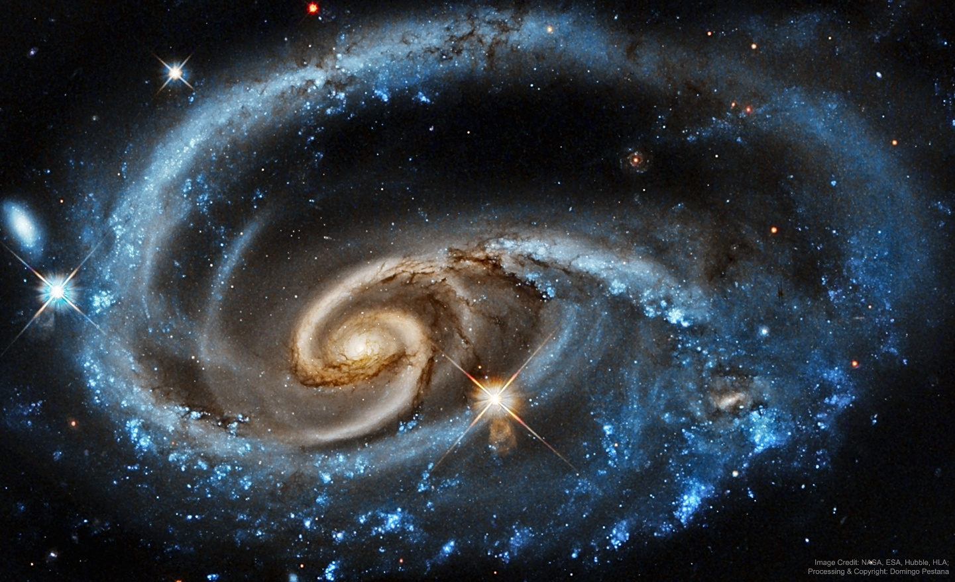
Figure 1.1: Example of galaxy morphology complexity relevant to automated galaxy classification studies. Source: NASA/Hubble
As shown in Figure 1.1, there is significant variation within galaxy images. There are cases where galaxies show very distinguishable structures while others may be more complex or less distinct. There could be differences in the form, direction, brightness, or internal properties of the galaxies that may make classification difficult, especially when the lines between different types of galaxies are blurred.

Traditionally, the classification of galaxies was done manually using visual inspection by astronomers. Although this technique helped advance morphological study, it was labor-intensive and required a lot of time. With recent advances in astronomy leading to the creation of massive surveys like the SDSS and DECaLS, the number of available galaxy images has greatly increased. This makes manual classification less feasible [1].
As a result, there has been a lot more interest in machine learning techniques in recent times. The use of deep learning and convolutional neural networks (CNNs) shows promise for galaxy classification because they have the ability to learn features from unprocessed images. Several past studies have shown promising results, showing that CNN models perform similarly to humans [2].
Moreover, there is a parallel need to evaluate beyond just classification accuracy. For scientific uses, the fact that the model classifies accurately in most cases is not enough. There is a need for scientists to understand if the model focuses on important aspects of galactic structures, if its prediction remains consistent under changes in imaging, and if the model's confidence can be justified in cases where galaxy images are ambiguous. This has led to explainability and robustness being significant considerations in modern studies of galaxy morphology classification [3].
The current study explores galaxy morphology classification in terms of deep learning with emphasis placed on both predictability and other aspects like robustness, uncertainty estimation, and interpretability. The primary data source for this analysis will be the Galaxy10 DECaLS galaxy morphology dataset because of its availability in labeled form to conduct supervised deep learning experiments. In doing so, it is intended to investigate the extent to which all the mentioned aspects can be utilized in creating an effective solution for automated galaxy morphology classification.
Some recent publications have explored several ways of classifying galaxies using deep learning, namely semi-supervised learning techniques, augmentation-driven approaches, and transformer architectures. These ideas, undoubtedly, are promising, yet they will not be considered in the current thesis. The goal of the research is to construct a holistic framework for galaxy morphology classification considering predictive ability, interpretability, robustness, and uncertainty estimation.
In particular, in such a context, the value of deep learning model application in astronomical studies cannot be reduced only to high prediction capability. The use of such models can bring additional benefits like a better understanding of the process behind their decisions, stability in different image settings, and, finally, the representation of the uncertainty associated with galaxy structure classification. Therefore, galaxy morphology classification in the thesis will be addressed from the angle of its performance, reliability, and interpretability.

1.2 Problem Definition
Many deep learning studies have applied deep learning for galaxy morphology classification, yet the majority of them pay attention only to accuracy and F1-score measures. Though these measures provide certain information, they do not cover all the aspects important for scientific analysis.

One of these aspects is interpretability. For example, it would be interesting to see how deep learning model interprets galaxy morphology. When classifying the galaxy as spiral, one wants to check that this result is based on spiral structure and central bulge rather than any other feature present in the image.

The second issue refers to variability of galaxy images observed with different conditions. Differences in illumination, noise, contrasts and so on can influence the picture significantly. Therefore, the classification performed by the model will demonstrate poor results in case the image is altered in any way. Scientific applications require robust and reliable prediction even for changed images.

Uncertainty may also become a critical factor for galaxy morphology classification since some galaxies may lack morphological features while the others can contain features corresponding to several classes. As a result, labeling only by final class may be not enough. The more helpful information the model provides about the uncertainty degree, the more confident in its predictions the scientist will be.

Based on the above, the main problem considered in this thesis can be formulated as follows: current deep learning solutions for galaxy morphology classification provide accurate predictions but fail to provide a unified framework for classification, which includes interpretability, robustness, and prediction uncertainty.

It means that there is a significant difference between achieving high classification accuracy and creating a reliable classification model, which explains its decisions and prediction uncertainty degree. Therefore, a more complex solution should be suggested that will satisfy all three criteria at once.

Thus, the first research question of this study is:

What solution can provide robust galaxy morphology classification using deep learning and be interpretable, robust, and uncertainty-aware at the same time?

For testing the solution, the Galaxy10 DECaLS dataset is used as a primary source of labeled images suitable for deep learning experiments.

1.3 Thesis Objectives
The main objectives of this research are as follows:

- Develop and evaluate deep learning models for galaxy morphology classification using labeled astronomical images.
- Examine how well these models can distinguish between different galaxy classes using standard evaluation measures such as accuracy and F1-score.
- Study model robustness by applying controlled perturbations to the input images and observing how classification performance changes under different visual conditions.
- Estimate prediction uncertainty using Monte Carlo Dropout, in order to better understand how confident the model is when classifying difficult or ambiguous galaxy images.
- Apply explainable artificial intelligence techniques, especially Grad-CAM, to investigate whether the model focuses on meaningful morphological structures when making classification decisions.
- Build an integrated framework that combines predictive performance, robustness, uncertainty estimation, and interpretability for more reliable galaxy morphology classification.

1.4 Thesis Contribution
This research makes the following contributions to the study of galaxy morphology classification:
- Presents a deep learning framework for galaxy morphology classification using a structured and practical evaluation setting.
- Evaluates model performance using standard classification measures such as accuracy and F1-score, in order to provide a clear view of predictive performance across galaxy classes.
- Studies model robustness by testing how classification performance changes when the input images are affected by controlled perturbations such as noise, blur, and brightness variation.
- Incorporates uncertainty estimation through Monte Carlo Dropout, which helps show how confident the model is when dealing with difficult or ambiguous galaxy images.
- Applies Grad-CAM to support interpretability and to examine whether the model focuses on meaningful galaxy structures during classification.
- Brings classification performance, robustness analysis, uncertainty estimation, and interpretability together in one integrated framework for more reliable galaxy morphology classification.

1.5 Thesis Organization
The rest of this thesis is organized as follows.
Chapter 2 discusses the theoretical background and relevant research areas.
Chapter 3 presents the proposed methodology.
Chapter 4 analyzes the experimental results.
Chapter 5 concludes the study and suggests directions for future work.

Chapter 2: Background and Related Work

2.1 Introduction
The following section gives a brief introduction of the background information and previous works about galaxy morphology classification using deep learning approaches. First, this section introduces some basic terminologies in terms of galaxy morphology classification along with its history from visual inspection to the application of automatic methods. Then, various existing studies that use deep learning to process galaxy images are presented briefly.

As mentioned in Chapter 1, there is an increased number of works done in recent years regarding galaxy morphology classification thanks to the availability of large-scale image databases due to astronomical surveys. In parallel with the increasing number of works, deep learning models, specifically convolutional neural networks, have proven their ability to capture meaningful features of images, thus they become a promising choice for galaxy morphology classification.

However, at the same time, most existing works concentrate on accuracy of galaxy morphologies classification. Although accuracy is one of the crucial criteria in evaluating any classification model, in scientific domains, other aspects including generalization capabilities, uncertainty quantification, and explainability are also very important in applying deep learning algorithms.

Therefore, in addition to focusing on performance measures, this chapter will discuss previous approaches in detail in terms of methodology, datasets used, and evaluation metrics in order to identify their advantages and disadvantages as well as potential research gaps for future investigations.

2.2 Background
Galaxy morphology studies date back to the early 20th century when Hubble proposed one of the first galaxy classification schemes [4]. According to this classification, galaxies were divided into several basic morphological types like elliptical, spiral, and irregular galaxies. Hubble's contribution laid the groundwork for further exploration and research of galaxy morphology and development.

An illustrative representation of the Hubble galaxy classification scheme can be found in Figure 2.1. It illustrates the connection between elliptical galaxies and the two basic branches of spiral galaxies – normal spirals and barred spirals. Later, de Vaucouleurs elaborated Hubble's classification by introducing more categories, including S0 lenticular galaxies and other morphological distinctions [5].

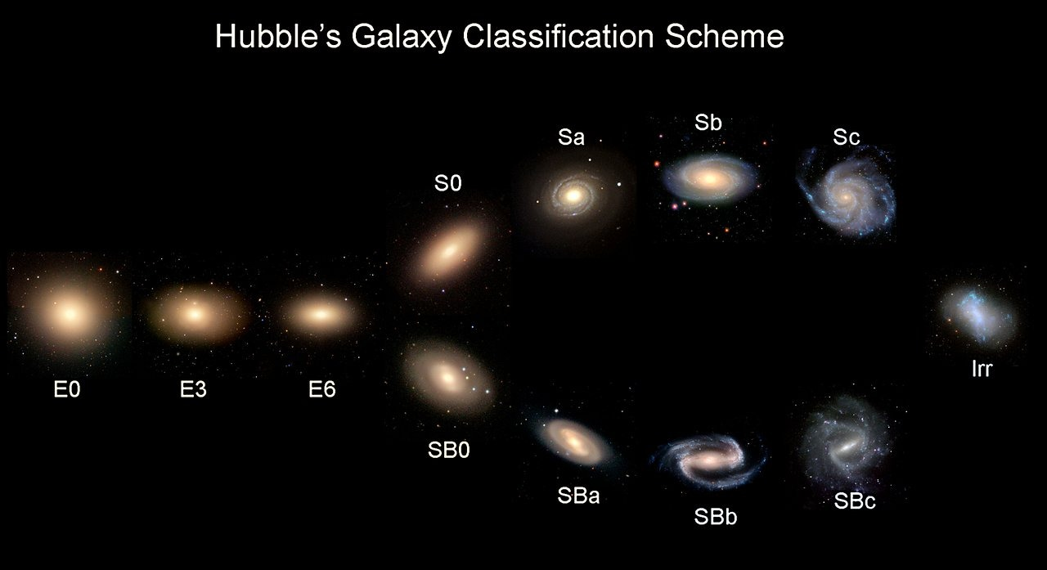
Figure 2.1: Hubble morphological classification scheme illustrating elliptical, spiral, and barred spiral galaxies. Source: Adapted from Hubble (1936) [4]
For many years, the process of galaxy classification was based on the manual visual analysis of galaxy images until recently. It relied on the judgement of astronomers who identified the basic structural features of galaxies and assigned them particular classification labels. Even though this traditional method of galaxy classification remains valid to some extent, it became impractical due to the increasing number of galaxy observations.

The issue of manually classifying large amounts of galaxy images became evident with the rise of modern surveys. The Sloan Digital Sky Survey (SDSS) produced a large quantity of images that could not be classified manually easily and efficiently [6]. As an alternative solution, the Galaxy Zoo project was initiated. It provided an opportunity for the public to participate in galaxy classification. It demonstrated that citizen science could be used to classify large volumes of galaxy images.

However, the volume of astronomical data kept increasing due to surveys like the Dark Energy Camera Legacy Survey (DECaLS). Therefore, the problem of automated galaxy classification became even more urgent and encouraged researchers to adopt deep learning methods to address it.

In this regard, artificial intelligence, machine learning, and deep learning became important approaches in the domain of astronomical image analysis. Machine learning algorithms allow improving the model from the training data, whereas deep learning implies using multilayer neural networks to extract complex patterns. Both approaches can be useful in addressing the problem of galaxy morphology classification since galaxy images contain complicated visual information that cannot be encoded manually. This can be seen in the wide visual variation between different galaxy classes, as illustrated in Figure 2.2.

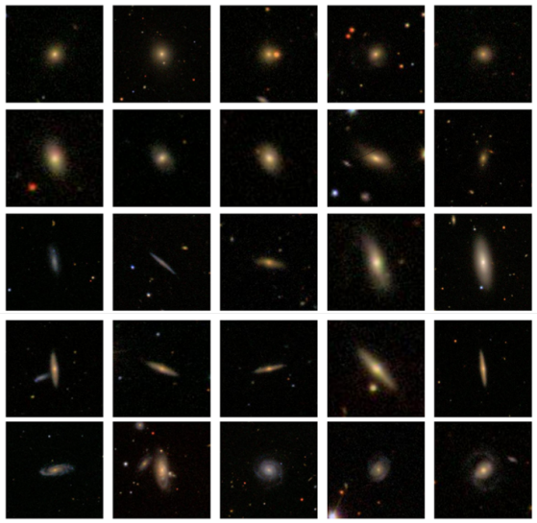
Figure 2.2: Example galaxy images from different morphological classes used in automated classification studies. Source: Adapted from Zhu et al. (2019) [19]
Figure 2.2 shows examples of galaxy images from different morphological classes. These examples help illustrate the visual diversity of galaxy structures and explain why automated classification is a challenging image analysis task. Differences in shape, brightness distribution, and structural details make deep learning methods especially useful for learning patterns directly from image data.

From the perspective of computer vision, the classification of galaxy morphology is a typical image classification problem. The objective of the task is to detect particular morphological patterns from labelled galaxy images. Deep learning models like CNNs can be particularly helpful in this case, as they enable identifying and learning the visual structure of galaxy images automatically.
Prior to deep learning, most of the automated galaxy classification methods relied on handcrafted features like colour, brightness, or shape information. However, despite the usefulness of these approaches, they had certain limitations, as they could not capture all the morphological peculiarities of galaxy images properly.

With CNNs becoming increasingly popular in astronomy, galaxy classification models showed promising results in this regard. Specifically, it was proved previously that CNN-based approaches could achieve classification accuracy comparable to that of humans. For instance, Dieleman et al. [2] achieved impressive results in predicting galaxy morphologies from images.

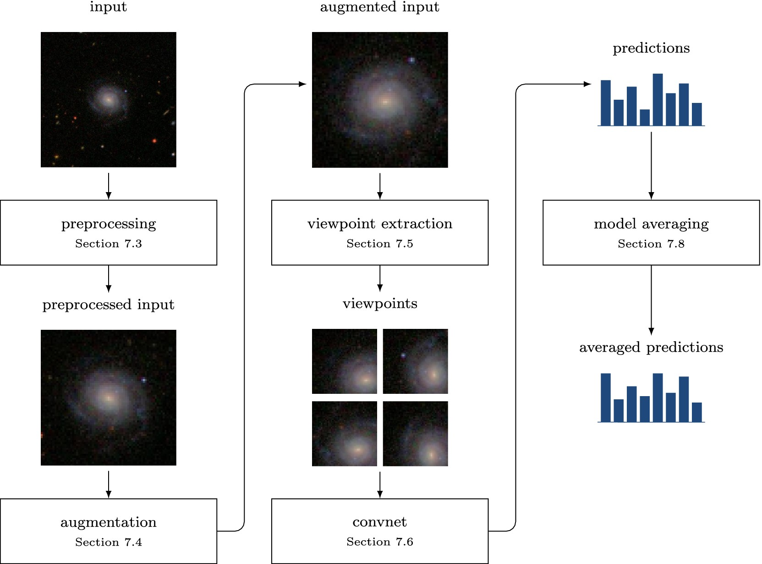
Figure 2.3: Schematic overview of a deep learning pipeline for galaxy morphology classification. Source: Adapted from Dieleman et al. (2015) [2]
Figure 2.3 presents a general deep learning pipeline for galaxy morphology classification. It shows how galaxy images can be processed through a sequence of learning steps, starting from the input image, and ending with the final predicted class. This kind of pipeline helps explain how deep learning models are applied in practice to extract visual patterns and support automated classification.

In addition to standard CNN-based approaches, researchers have explored other techniques in galaxy morphology classification. One of the most common directions is transfer learning, where pretrained models are adapted to galaxy images to improve performance, especially when labelled data are limited. Another direction is the use of transformer-based models and attention mechanisms, which may help the model capture wider relationships across the image and recognize more complex structures. Some studies have also examined semi-supervised learning, where both labelled and unlabelled data are used to reduce the dependence on manual annotation. Together, these approaches show that current research in this area is not limited to one technique but is gradually expanding toward different learning strategies for handling complex astronomical images.

In recent years, research in computer vision has continued to move beyond standard CNN models toward more advanced architectures that can capture both local image details and wider global relationships. This is especially relevant in galaxy morphology classification, where some visual patterns are small and localized, while others depend on the overall structure of the galaxy. For this reason, recent vision architectures may offer a useful direction for building classification models that are not only accurate, but also better suited to complex astronomical images.

Over recent years, researchers have started to pay greater attention to the interpretability of deep learning models. Therefore, explainable artificial intelligence (XAI) gained popularity in various scientific domains. One of the key advantages of XAI methods is that they allow showing the areas in the image that have the greatest impact on the model decision [3]. In the scientific community, it is essential for the explanation of model predictions.

2.3 Related work
The reviewed literature shows strong progress in galaxy morphology classification. However, most previous studies tend to emphasize one main aspect at a time. Some focus mainly on classification accuracy, others examine interpretability, while a smaller number discuss uncertainty or data limitations. This makes it important to review these studies not only as performance benchmarks, but also as separate contributions that reveal the need for a more integrated framework.
Walmsley et al. (2022) [1] Walmsley investigated the morphological classification of galaxies on a larger scale using machine learning techniques on current astronomical datasets. The use of the Galaxy Zoo DECaLS dataset allowed the researchers to utilize morphological classifications provided by many citizen scientists. The authors developed a deep learning model called Zoobot, which integrates convolutional neural network and probability approaches to estimate the entire distribution of answers provided by volunteers for about 300,000 galaxies. The model provided good agreement with human classification efforts and demonstrated good prediction accuracy, even regarding complicated morphological patterns. The main advantage of the investigation under analysis is the creation of one of the biggest morphological catalogs created using deep learning techniques. However, the use of volunteer-generated answers can be considered the main disadvantage of the methodology employed in this research.

Dieleman et al. (2015) [2] In their paper, Dieleman et al. proposed a deep learning framework for galaxy morphological classification using rotation-invariant CNNs. The study applied images from the Galaxy Zoo data set and was aimed at developing new CNN architecture which would allow classifying galaxies irrespective of their rotational orientation. With the introduction of rotation symmetry to the architecture of the network, it was able to better learn the morphological patterns, including spiral arms and bulge characteristics of galaxies, directly from the pixel-level data. According to the authors, the proposed method reached human-like accuracy levels in morphological classification, achieving about 91% of prediction accuracy. An obvious advantage of this approach is in its ability to handle rotational variability, characteristic of many astronomical images. However, as compared to standard CNN models, additional complexity arises due to the introduction of the new property.

Bhambra et al. (2022) [3] conducted a research on the explainability of deep learning models which were used in the classification of galaxies based on their morphology. In this research, different explainable artificial intelligence approaches such as Grad-CAM and saliency maps were used to illustrate image areas that contributed towards the prediction made by deep learning models. Through galaxy images obtained from large sky surveys such as Galaxy Zoo and DECaLS, it was shown that deep neural networks were able to recognize different morphological structures within galaxies such as spiral arms, galactic core structures, and even asymmetry. This research illustrates that using explainability techniques, it is possible to learn more about the internal functioning of deep learning models.
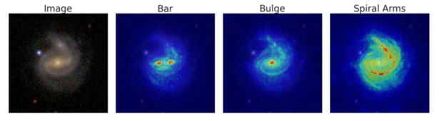
Figure 2.4: Example of a saliency map highlighting discriminative regions in galaxy morphology classification.
Source: Adapted from Bhambra et al. (2022) [3].

As shown in Figure 2.4, saliency maps highlight the regions of the galaxy image that contribute most strongly to the model's prediction. In many cases, the visualization confirms that the neural network focuses on key morphological structures such as spiral arms, bars, or the central bulge. This provides an additional layer of reliability by allowing astronomers to verify whether the classification decision is based on meaningful physical features. In this thesis, a similar explainability approach will be used to evaluate whether the proposed deep learning framework focuses on relevant morphological structures when classifying galaxy images.

Domínguez Sánchez et al. (2018) [7] researched the application of deep convolutional neural networks in improving the accuracy of galaxy morphology classification using images captured by the Sloan Digital Sky Survey (SDSS). The model they created aimed at being able to recognize the important attributes used to differentiate between certain types of galaxies like elliptical and spiral galaxies. With the aid of the large number of images provided by the SDSS survey, the CNN model managed to classify the images with a success rate of about 95%. One of the strengths of the work done by Dominizes Sanches is that their CNN does not have to rely on any pre-defined feature set to be able to learn important morphological characteristics since these can be learned from pixels alone.
Luo et al. (2025) [8] examined problems related to galaxy morphological classification in situations when there are not many labeled samples available – a frequent situation in the field of astrophysics. They developed an innovative semi-supervised deep learning algorithm that uses convolutional neural network and GAN models. In this case, the experiments were conducted using the Galaxy10 DECaLS dataset, and the classification accuracy obtained was around 84%. One positive point about this study is the reduced need for big fully labeled samples due to the simultaneous application of both labeled and unlabeled data. Such an innovation will be particularly beneficial in astronomy due to the time consumption involved in the process of labeling. On the other hand, one drawback of such an algorithm is its instability.

Yao et al. (2024) [9] focused on improving galaxy morphology classification through data augmentation when there is limited data for training. In this study, the Galaxy10 DECaLS dataset was used, in which a few-shot-learning-inspired augmentation technique was applied to enhance image diversity within the training set. This research indicated that with their augmentation technique, the robustness of their models could be increased to achieve up to 95% accuracy rate. One major advantage of this research is that they managed to show that augmentation can be effective without requiring changes to the core classification problem. On the other hand, one major limitation of this study is that overuse of augmentation or unrealistic augmentation might lead to spurious patterns.

Le et al. (2024) [10] carried out a comparative study of several deep learning models for galaxy morphology classification. The researchers employed the Galaxy10 DECaLS dataset to test customized CNN algorithms against the transfer learning algorithm models like ResNet and EfficientNet. It is demonstrated that the EfficientNet model produced an accuracy score of about 87%, which is considered among the best-performing models tested in the paper. The main advantage of this study lies in the fact that it presents a comparative analysis between several architectures under identical experimental conditions. On the other hand, the experimental research was limited to the utilization of just one dataset, implying its potential applicability to other astronomical survey data.

Xie et al. (2024) [11] investigated the problem of galaxy morphology classification using a deep convolutional neural network built upon the VGG19 model. The experiment was carried out on the Galaxy10 DECaLS dataset, which offers annotated images of galaxies collected from extensive astrophysical observations. With the use of transfer learning, the researchers managed to implement the VGG19 model to learn hierarchical visual features that allow discrimination between various types of galaxies. As a result, the proposed model attained an accuracy level of around 84.5%, confirming that conventional deep CNN models can provide adequate performance in this task. At the same time, the researchers found that models such as VGG19 have numerous parameters that lead to overfitting problems.

Cheng (2022) [12] explored the use of ViT in classifying galaxies according to morphology. In his study, the researcher used the Galaxy10 DECaLS dataset to find out if transformer architecture can capture global patterns better than other types of traditional CNNs. The suggested model used self-attention for highlighting significant parts of the galaxy, achieving an accuracy of about 86%. An advantage in this research was a finding showing that transformer models could indeed learn dependencies from the whole image rather than focusing only on local areas. However, one drawback was the need for a lot of training data.

Cao et al. (2024) [13] came up with a combination approach to deep learning where the researcher merged CNNs with elements from transformers to classify the morphology of galaxies. For this research, Cao used galaxy images from the Galaxy Zoo database. Specifically, CvT architecture was used because the model integrates local feature detection in CNNs and global feature detection in transformer architectures. The achieved accuracy was around 98%, thus making it one of the most effective models among those that have been reviewed in this analysis. One strength of this research paper is that it uses both architectural designs, hence can detect patterns in galaxies using a wide range of approaches. However, the improvement made in the model makes it complex, thus requiring more computational resources.

Urechiatu et al. (2024) [14] focused on the potential usefulness of convolutional neural networks (CNNs) in improving automated classifications of galaxy morphology. For the experiment, the authors used a dataset consisting of 10,000 images of galaxies taken from the Galaxy Zoo 2 database, which is known to contain labeled images provided by many volunteers. Specifically, to build the algorithm, the authors came up with a CNN architecture which they expected to be able to distinguish morphological traits better and applied a number of methods to preprocess and augment data. As a result, the accuracy in classification reached 92%. However, despite high effectiveness in recognizing simple structures of galaxies, the models failed to work properly when dealing with complicated morphologies.

Bom et al. (2024) [15] explores the ability of deep learning to assist with morphological classification of galactic objects based on images obtained via the S-PLUS sky survey. In addition to this information source, the research also makes use of morphological catalogs created within the scope of other large astronomical studies. For this purpose, the authors propose developing a CNN that learns morphology-related features based on the input image. Namely, it learns features related to the core morphology of the galaxy, its brightness profile, and whether there is any sign of spiral structure formation. As a result, this allows the neural network to recognize different types of galaxies correctly. According to the experimental findings, the accuracy of this network ranges from 92% to 95%. Thus, CNNs prove efficient at solving such problems under appropriate training conditions. On the other hand, one should consider that observation conditions might affect the prediction made. The presence of noise and variable intensity, as well as imaging artifacts, might influence CNN operation in this case.

Wei et al. (2024) [16] investigated galaxy morphology classification using transformer architecture. The experiments were based on the Galaxy10 DECaLS dataset which includes annotated galaxy pictures obtained through comprehensive astronomical surveys. The used architecture included Vision Transformer (ViT) which was responsible for discovering global structural patterns in galaxy images using self-attention. According to the findings of the research, the classification accuracy amounted to around 94%, thus implying the feasibility of implementing transformer-based algorithms in this regard. One of the key advantages of using this technique in galaxy morphology classification includes the ability of the algorithm to detect long-term dependencies in the data which can help analyse complicated structures. On the other hand, transformer architectures need massive training sets to work properly.

Almeida et al. (2024) [17] explored the use of transfer learning to improve galaxy morphology classification using deep convolutional neural networks. This research utilized data from the Galaxy Zoo project, which contains images labeled using massive citizen scientist inputs for galaxy morphology. Using the transfer learning method, fine-tuning the pre-trained ResNet model allowed the neural network to learn to recognize the differences between galaxy morphologies, such as spirals and ellipticals. Based on the study findings, the transfer learning method used yielded an average of about 92% accuracy, showing the usefulness of transfer learning with large datasets of natural images to improve results in astrophysics. However, one challenge in performing such transfer learning is the class imbalance in the dataset since morphological differences will be harder to learn by the neural network.

Zhang et al. (2024) [18] explored the utilization of a new machine learning approach to classify galaxy morphology. This novel technique was a combination of the convolutional neural network and attention mechanisms. The Galaxy10 DECaLS dataset was used, containing labeled galaxy images obtained from various astronomical researches. The use of the attention mechanism made it possible for the model to focus more on the key features in the images. The precision score achieved in the study was around 96%, which shows that the technique might improve classification effectiveness.

2.4 Related Work Summary
The studies reviewed in this chapter show that deep learning has become a valuable tool in galaxy morphology classification. Different approaches have been used, including traditional CNN models, transfer learning, semi-supervised learning, attention-based methods, and transformer-based architectures. In general, these studies show that deep learning can achieve strong performance when it is applied to large astronomical image datasets.

At the same time, the reviewed studies also show that each approach has its own strengths and limitations. Some studies focused on improving classification accuracy, while others gave more attention to issues such as interpretability, uncertainty estimation, or the effect of limited training data. In many cases, these aspects were studied separately rather than as part of one complete framework.

Table 2.1 provides a comparison of the main studies discussed in this chapter, including the methods used, the datasets, the reported performance, and their relation to the current research.

Table 2.1: Comparison of related studies in galaxy morphology classification

Ref | Author | Year | Technique Used | Accuracy | Dataset | Comparison with This Research
[1] | Walmsley et al. | 2022 | Bayesian Deep Learning (Zoobot) | Not explicitly reported | Galaxy Zoo / DECaLS | Reference for uncertainty-aware galaxy classification
[2] | Dieleman et al. | 2015 | Rotation-Invariant CNN | ~91% | Galaxy Zoo | Baseline CNN architecture for morphology prediction
[3] | Bhambra et al. | 2022 | Grad-CAM & Saliency Mapping | Not focus of study | Galaxy Zoo / DECaLS | Reference study for explainable AI evaluation
[7] | Domínguez Sánchez et al | 2018 | Deep Convolutional Neural Network (CNN) | ~95% | SDSS Galaxy Dataset | Deep learning benchmark for galaxy morphology classification
[8] | Luo et al. | 2025 | Semi-supervised Learning (GAN-based) | ~84% | Galaxy10 DECaLS | Semi-supervised learning reference under limited labels
[9] | Yao et al. | 2024 | DCGAN Data Augmentation | Up to ~95% | Galaxy10 DECaLS | Data augmentation reference for improving model generalization
[10] | Le et al. | 2025 | EfficientNetB5 Transfer Learning | ~87% | Galaxy10 DECaLS | Transfer learning architecture benchmark
[11] | Xie et al. | 2024 | VGG19 Transfer Learning | ~84.5% | Galaxy10 DECaLS | CNN transfer learning baseline comparison
[12] | Cheng | 2022 | Vision Transformer | ~86% | Galaxy10 DECaLS | Transformer-based architecture comparison
[13] | Cao et al. | 2024 | Convolutional Vision Transformer (CvT) | ~98% | Galaxy Zoo CANDELS | Hybrid CNN–Transformer performance benchmark
[14] | Urechiatu et al. | 2024 | Convolutional Neural Network (CNN) | ~92% | Galaxy Zoo 2 | CNN-based classification improvement reference
[15] | Bom et al. | 2024 | Deep Neural Network (CNN-based) | ~92–95% | S-PLUS astronomical survey | Baseline CNN architecture for morphology prediction
[16] | Wei et al. | 2024 | Vision Transformer (ViT) | ~94% | Galaxy10 DECaLS | Transformer-based architecture comparison
[17] | Almeida et al. | 2024 | Transfer Learning (ResNet CNN) | ~92% | Galaxy Zoo | Deep learning benchmark for galaxy morphology classification
[18] | Zhang et al. | 2024 | CNN with Attention Mechanism | ~96% | Galaxy10 DECaLS | CNN with attention mechanism benchmark
Although recent studies have reported promising results in galaxy morphology classification, several important challenges remain. Many existing models achieve good accuracy, but they do not always provide enough information about how stable their predictions are when image conditions change. In addition, interpretability and uncertainty estimation are still not fully included in many classification frameworks.

Another issue is that some studies depend heavily on large, labelled datasets, while future astronomical surveys may continue to produce data at a scale that makes full labelling difficult. Differences in image quality, brightness, noise, and observational conditions can also affect model performance and reliability.

For these reasons, there is still a need for a framework that does more than classify galaxy images accurately. A more useful approach should also consider robustness, uncertainty, and interpretability together. This is the main gap that motivates the current research, which aims to study galaxy morphology classification through a framework that combines these important aspects in one setting.

Therefore, this thesis aims to study galaxy morphology classification through an integrated deep learning framework that combines predictive performance, robustness analysis, uncertainty estimation, and interpretability in one setting.

Chapter 3: Proposed Approach (Methodology)

Chapter 4: Experimental Results and Discussion

Chapter 5: Conclusion and Future Work

References
[1] [Walmsley, M., et al., 2022] Walmsley, M., Lintott, C., Galloway, M., et al. “Galaxy Zoo DECaLS: Detailed visual morphology measurements from volunteers and deep learning for 314,000 galaxies”, Monthly Notices of the Royal Astronomical Society 509(3), pp. 3966–3988, 2022. DOI:10.1093/mnras/stab2093

[2] [Dieleman, S., et al., 2015] Dieleman, S., Willett, K. W., and Dambre, J.
“Rotation-invariant convolutional neural networks for galaxy morphology prediction”
Monthly Notices of the Royal Astronomical Society 450(2), pp. 1441–1459, 2015. DOI:10.1093/mnras/stv632

[3] [Bhambra, P., et al., 2022] Bhambra, P., Joachimi, B., and Lahav, O.
“Explaining deep learning of galaxy morphology with saliency mapping”
Monthly Notices of the Royal Astronomical Society 511(4), pp. 5032–5041, 2022.
DOI:10.1093/mnras/stac368

[4] [Hubble, E., 1936] Hubble, E.
“The Realm of the Nebulae”
Yale University Press, 1936.

[5] [de Vaucouleurs, G., 1959] de Vaucouleurs, G.
“Classification and Morphology of External Galaxies”
Handbuch der Physik 53, pp. 275–310, 1959.
DOI:10.1007/978-3-642-45952-8_12

[6] [Lintott, C. J., et al., 2008] Lintott, C. J., Schawinski, K., Slosar, A., et al.
“Galaxy Zoo: morphologies derived from visual inspection of galaxies from the Sloan Digital Sky Survey”
Monthly Notices of the Royal Astronomical Society 389(3), pp. 1179–1189, 2008. DOI:10.1111/j.1365-2966.2008.13689.x

[7] [Domínguez Sánchez, H., et al., 2018] Domínguez Sánchez, H., Huertas-Company, M., Bernardi, M., Tuccillo, D., and Fischer, J. L.
“Improving galaxy morphologies for SDSS with Deep Learning”
Monthly Notices of the Royal Astronomical Society 476(3), pp. 3661–3676, 2018.
DOI:10.1093/mnras/sty338

[8] [Luo, Z., et al., 2025] Luo, Z., Chen, J., Chen, Z., et al.
“Galaxy Morphology Classification via Deep Semi-supervised Learning with Limited Labeled Data”
The Astrophysical Journal Supplement Series 267(2), Article 45, 2025.
DOI:10.3847/1538-4365/ad1f0c

[9] [Yao, H., et al., 2024] Yao, H., Liu, Y., and Zhao, D.
“A Galaxy Image Augmentation Method Based on Few-shot Learning”
Research in Astronomy and Astrophysics 24(3), Article 035005, 2024.
DOI:10.1088/1674-4527/acf92c

[10] [Le, T., et al., 2025] Le, T., Ibrahim, N., Nguyen, T., et al.
“Enhanced Comparative Analysis of Pretrained and Custom Deep Convolutional Neural Networks for Galaxy Morphology Classification”
Engineering Proceedings 89(1), Article 36, 2025.
DOI:10.3390/engproc2025089036

[11] [Xie, Y., et al., 2024] Xie, Y., Zhang, H., and Wang, L. “Galaxy Morphology Classification Based on VGG19 Deep Convolutional Neural Network”
Astrophysics and Space Science, Article 369, 2024.
DOI:10.1007/s10509-024-04124-8

[12] [Cheng, T., 2022] Cheng, T.
“Vision Transformer Applications for Galaxy Morphology Classification”
The Astrophysical Journal 935, Article 34, 2022.
DOI:10.3847/1538-4357/ac6a52

[13] [Cao, J., et al., 2024] Cao, J., Wu, H., Zhang, Y., et al.
“Galaxy morphology classification based on Convolutional Vision Transformer”
Astronomy & Astrophysics 683, A44, 2024.
DOI:10.1051/0004-6361/202348544

[14] [Urechiatu, R., et al., 2024] Urechiatu, R., and Frincu, M.
“Improved Galaxy Morphology Classification with Convolutional Neural Networks”
Universe 10(6), Article 230, 2024.
DOI:10.3390/universe10060230

[15] [Bom, C. R., et al., 2024] Bom, C. R., Mendes de Oliveira, C., Rembold, S. B., et al.
“An extended catalogue of galaxy morphology using deep learning in the S-PLUS survey”
Monthly Notices of the Royal Astronomical Society 528(3), pp. 4188–4203, 2024.
DOI:10.1093/mnras/stae277

[16] [Wei, Y., et al., 2024] Wei, Y., Zhang, H., and Liu, Q.
“Galaxy morphology classification using Vision Transformer architectures”
Astronomy and Computing 48, Article 100827, 2024.
DOI: 10.1016/j.ascom.2024.100827

[17] [Almeida, J., et al., 2024] Almeida, J., Rodrigues, F., and Silva, P.
“Transfer Learning for Galaxy Morphology Classification using Deep Convolutional Networks”
Astrophysics and Space Science 369, pp. 101–110, 2024.
DOI:10.1007/s10509-024-04175-x

[18] [Zhang, Y., et al., 2024] Zhang, Y., Li, H., Chen, X., and Wang, J.
“Attention-based Deep Learning Framework for Galaxy Morphology Classification”
Astronomy and Computing 47, Article 100810, 2024.
DOI: 10.1016/j.ascom.2024.100810

[19] [Zhu, X.-P., et al., 2019] Zhu, X.-P., Dai, J.-M., Bian, C.-J., Chen, Y., Chen, S., and Hu, C.
“Galaxy morphology classification with deep convolutional neural networks”
Astrophysics and Space Science 364, Article 55, 2019.
DOI:10.1007/s10509-019-3540-1

