جامعة ميدأوشن

كلية الإدارة
قسم / تخصص: إدارة المشاريع

العنوان باللغة العربية
أثر ممارسات بدء المشروع وتحديد نطاق العمل على تجاوزات الوقت والتكلفة: دراسة ميدانية في قطاع التشييد بالمملكة العربية السعودية

إعداد الطالب/ساجد الله نور حسين

إشراف/
د.الفيصل عبد الحميد
د.فايز جراد

العام الدراسي:
2026

Table of Contents:

Chapter One ……………………............................................... 1-8

Introduction
1.1 Introduction ………………………………………………….1-9
1.2 Study Problem ……………………………………………….1-9
1.3 Importance of The Study …………………………………….1-10
1.4 Objectives of The Study ……………………………………...1-10
1.5 Study Questions ………………………………………………1-11
- 1.5.1 Main Research Question …………………………….1-11
- 1.5.2 Sub-Questions ……………………………………….1-11

Chapter Two ……………………………………………………. 2-20

Literature Review & Theoretical Premises of The Study
2.1 Introduction ………………………………………………………… 2-13
2.2 Theoretical Premises of The Study ………………………………….2-14
- 2.2.1 Agency Theory (The Conceptual Premises) ……………….2-14
- 2.2.2 Planning Theory and Bounded Relationality (The Cognitive Premise) …2-14
- 2.2.3 Transection Cost Economics – TCE (The Economic Premise) …………2-14
2.3 Conceptualization & Typology of Study Variables ……………………2-15
- 2.3.1 Project Initiation Practices (IV1) …………………………….2-15
- 2.3.2 Scope Definition and Management (IV2) …………………….2-15
- 2.3.3 Typology of Project Overruns (The dependent Variables) ……2-16
2.4 Summery of Past Studies …………………………………………………2-17
2.5 Theoretical and Conceptual Framework ………………………………….2-19
2.6 Chapter Summary ………………………………………………………….2-20

Chapter Three …………………………………………………………. 3-21

Research Methodology & Study Tools
3.1 Introduction ……………………………………………………………3-22
3.2 Research Design ……………………………………………………….3-22
3.3 Population of The Study ……………………………………………….3-23
3.4 Sample Characteristics and Sampling Technique …………………….3-23
3.5 Sample Size Determination ……………………………………………3-24
3.6 Data Collection Procedure and Measurement Instrument …………….3-24
3.7 Study Tools (Analytical and Measurement Instruments) …………….3-25
- 3.7.1 Qualitative Foundation (Analytical Study Tools) ………….3-25
- 3.7.2 Quantitative Questionnaire Instrument Mapping ………….3-25
3.8 Study Determinates …………………………………………………….3-27
- 3.8.1 Independent Determinates ……………………………………3-27
- 3.8.2 Dependent Determinates …………………………………….3-27
3.9 Method of Analysis …………………………………………………….3-27
3.10 Chapter Summary …………………………………………………….3-28

Chapter Four ……………………………………………………………. 4-29

Field of Study (Practical Study)
4.1 Introduction ……………………………………………………………4-30
- 4.1.1 Structural Hypothesis ……………………………………….4-30
4.2 Reliability Analysis of The Research Instrument ……………………4-30
4.3 Descriptive Statistics …………………………………………………4-31
4.4 Bivariate Pearson Correlation Analysis ………………………………4-32
4.5 Hierarchical Multiple Regression Analysis …………………………4-33
- 4.5.1 Regression Model 1: Predicating Time Overruns (Schedule Control) …4-34
- 4.5.2 Regression Model 2: Predicating Cost Overruns (Budgetary Control) …4-35
4.6 Formal Decision on Hypothesis ……………………………………….4-36
- 4.6.1 Evaluation of Main Hypothesis 1 (H0 Vs H1) ……………….4-36
- 4.6.2 Evaluation of Sub-Hypothesis (Initiation → Performance) …4-36
- 4.6.3 Evaluation of Sub-Hypothesis (Scope → Performance) ……4-36
4.7 Summery of Key Field Findings ………………………………………4-36
4.8 Chapter Summary ……………………………………………………4-37
Reference ……………………………………………………………. 38-39

Appendices ……………………………………………………………. 40-45
Appendix A Questionnaire (English) ………………………………………41-45
English Abstract ……………………………………………………………………………………. 46
Arabic Abstract ………………………………………………………………………………………47
Title Page in English …………………………………………………………………………………………48

List of Tables:

Table No. | Title | Page
Table 2.1 | Hierarchical Destruction Structure | 16
Table 2.2 | Methodology and Empirical Synthesis of Prior Research | 18-19
Table 3.1 | Profile of Sample Characteristics | 23-24
Table 3.2 | Study Tool Construct Operationalization Matrix | 26-27
Table 4.1 | Construct Reliability Matrix | 31
Table 4.2 | Univariate Descriptive Statistics | 32
Table 4.3 | Segment Inter-Variable Correlation Matrix | 33
Table 4.3a | Model 1 OLS Summery – Dependent variable -TO | 34
Table 4.3b | Model 1 Linear Coefficients | 34
Table 4.4a | Model 2 OLS Summery – Dependent Variable CO | 35
Table 4.4b | Model 2 Linear Coefficient | 35

List of Figures:

Figure No. | Title | Page
Figure 2.1 | Iron Triangle | 13
Figure 2.2 | Typology of Project Overruns the Dependent Variables | 17
Figure 2.3 | Conceptual Framework | 19
Figure 2.4 | Research Hypotheses Model | 20
Figure 3.1 | Research Methodology Flowchart and study Tools | 22

Abstract (الملخص):

The construction sector in the Kingdom of Saudi Arabia has experienced substantial growth due to the implementation of national development initiatives and large-scale infrastructure projects under Vision 2030. Despite this growth, many construction projects continue to experience significant time delays and cost overruns, negatively affecting project performance and stakeholder satisfaction. Previous studies have identified deficiencies in project initiation and scope management as major contributors to these challenges.
This study aims to investigate the impact of project initiation practices and scope definition on time and cost overruns in construction projects in Saudi Arabia. Specifically, it examines how effective project initiation practices, including project charter development, stakeholder identification, feasibility assessment, and project authorization, together with comprehensive scope definition, influence project performance in terms of schedule and budget adherence.
A quantitative research approach will be employed using a structured questionnaire distributed to project managers, engineers, consultants, contractors, and other professionals working in the Saudi construction industry. The collected data will be analyzed using the Statistical Package for the Social Sciences (SPSS). Descriptive statistics, reliability analysis (Cronbach's Alpha), Pearson correlation, and multiple regression analysis will be conducted to examine the relationships between the independent and dependent variables.
The expected findings are anticipated to demonstrate that effective project initiation practices and well-defined project scope significantly reduce the likelihood of time delays and cost overruns. The study is expected to provide practical recommendations for project owners, consultants, contractors, and decision-makers to enhance project management practices during the early phases of construction projects. Furthermore, the research contributes to the existing body of knowledge by providing empirical evidence from the Saudi Arabian construction sector.
Keywords: Project Initiation Practices, Scope Definition, Time Overruns, Cost Overruns, Construction Projects, Saudi Arabia, Project Management.

Chapter One

1.1 Introduction
The construction sector serves as a vital engine for economic growth and infrastructure development globally, and particularly within the Kingdom of Saudi Arabia. However, modern construction projects are characterized by escalating complexity, tight socio-economic constraints, and a historical vulnerability to chronic performance issues. Within the Saudi Arabian construction industry, a substantial body of literature has identified schedule delays and cost overruns as pervasive, systemic challenges that undermine project feasibility and stakeholder confidence (Assaf & Al-Hejji, 2006; Alzahrani & Emsley, 2013).
To mitigate these risks, contemporary project management frameworks increasingly emphasize the critical nature of front-end loading specifically, the practices executed during the project initiation phase. According to the Project Management Body of Knowledge (PMBOK) Guide, project initiation lays the structural foundation for all subsequent lifecycle phases. Within this foundational stage, two primary documents serve as critical instruments: the Project Charter and the Project Scope Definition. The project charter formally authorizes the project’s existence, aligns stakeholder expectations, and establishes managerial authority. Concurrently, the scope definition provides an explicit, granular breakdown of project deliverables, boundaries, and performance criteria.
Despite the established theoretical value of these initiation practices, empirical breakdowns during the earliest phases of a project remain common. Global research by Flyvbjerg (2014) highlights that poor front-end planning, coupled with deep-seated optimism bias, routinely results in severely underestimated schedules and budgets. Industry reports from leading advisory firms, such as KPMG, further validate that weak early-stage governance and ambiguous boundary definitions are direct precursors to project failure. When the project charter is weak and the scope is poorly articulated, projects inevitably succumb to scope creep, adversarial stakeholder relationships, and destabilizing change orders (Kerzner, 2017). This research explores the critical intersection of early-stage documentation and final project performance, seeking to provide an analytical understanding of how rigorous initiation practices insulate complex construction projects from time and cost escalations.

1.2 Problem Statement
Despite the maturity of modern project management methodologies and the availability of sophisticated planning software, construction projects in Saudi Arabia continue to experience severe delays and budget overruns. While prior localized research has extensively documented these performance failures, existing literature predominantly focuses on execution-phase variables such as contractor financial difficulties, materials shortages, or late progress payments or treats planning failures as a generalized, monolithic concept (Assaf & Al-Hejji, 2006; Elawi et al., 2016).
A critical research gap exists in systematically isolating, unpacking, and quantifying the direct relationship between the quality of initiation-phase documentation specifically the Project Charter and the Project Scope Definition and the mitigation of these overruns.
The practical problem manifests as a clear breakdown in early-stage project definition:
- Authorization Deficits: Without a rigorously developed project charter, projects are initiated with ambiguous governance structures, misaligned stakeholder objectives, and poorly defined boundaries of authority.
- Scope Ambiguity: Without an exhaustive scope definition, projects lack a definitive baseline. This ambiguity triggers rampant scope creep, frequent and costly change orders, and inefficient resource allocation during execution.
Consequently, there is a distinct lack of focused analytical frameworks tailored to the Saudi Arabian construction environment that demonstrate how specific adjustments to project initiation inputs can directly prevent downstream time and cost variances. This study addresses this gap by isolating the Project Charter and Scope Definition as independent variables to evaluate their direct mechanisms of influence on project schedule and budget stability.

1.3 Significance (Importance) of the Study

1.3.1 Theoretical and Scientific Significance
- Filling the Contextual Gap: This study enriches the existing body of project management literature by shifting the focus from general execution-phase failure factors to specific, front-end initiation documentation within the unique geographical and economic context of Saudi Arabia.
- Isolating Variables: It addresses a significant methodological limitation in prior research by isolating the Project Charter and Project Scope Definition as distinct, critical determinants of project success, rather than grouping them under generic "planning factors."
- Framework Development: The study constructs a specialized conceptual framework that explicitly maps the causal pathways between early governance authorization, baseline clarity, and the minimization of schedule and budget variances, serving as a foundation for future empirical and quantitative research.

1.3.2 Practical and Applied Significance
- Actionable Guidance for Practitioners: The findings offer clear, practical insights for project managers, client organizations, and construction management professionals on how to structurally secure projects before significant capital is deployed.
- Risk and Cost Mitigation: By identifying the specific elements of a Project Charter and Scope Definition that yield the highest risk-reduction returns, this study provides organizations with actionable strategies to control scope creep and minimize financial waste.
- Enhanced Governance: The research offers decision-makers and policymakers in the Saudi construction market a benchmark for improving institutional project governance, planning efficiency, and strategic resource deployment.

1.4 Research Objectives
The primary objective of this study is to analyze the impact of project initiation practices specifically the development of the project charter and scope definition on reducing time delays and cost overruns in construction projects.
To achieve this primary aim, the study addresses the following sub-objectives:
- To evaluate the role of the Project Charter in establishing robust project governance, ensuring strategic stakeholder alignment, and defining clear managerial authority.
- To analyze how an exhaustive Project Scope Definition influences subsequent planning accuracy and execution fidelity.
- To investigate the specific mechanisms through which deficient scope definitions manifest as downstream time delays and budget escalations.
- To evaluate how rigorous front-end documentation mitigates early project risks and stabilizes overall project performance metrics.
- To synthesize these insights into a structured theoretical analytical framework that demonstrates the operational impact of initiation quality on project outcomes.

1.5 Research Questions

1.5.1 Main Research Question
- How do project initiation practices, specifically the rigorous preparation of the project charter and the detailed definition of project scope, influence the mitigation of time and cost overruns in construction projects?

1.5.2 Sub-Questions
- What is the precise role of the Project Charter in securing formal project authorization, establishing initial governance, and driving stakeholder alignment?
- How does the quality of the Project Scope Definition directly shape the accuracy and reliability of downstream project planning and execution?
- What are the specific systemic impacts of an ambiguous or poorly defined project scope on project schedule adherence, cost controls, and overall performance?
- Through what operational mechanisms does an effectively prepared project charter insulate a project's budget and timeline from external variances?
- To what extent does a standardized approach to scope management minimize the probability and severity of project delays and cost overruns?

Chapter Two
Literature Review & Theoretical Premises of Study

2.1 Introduction
The construction sector within the Kingdom of Saudi Arabia (KSA) is experiencing an unprecedented transformation driven by the economic diversification mandates of Vision 2030. The simultaneous execution of hyper-scale giga projects places immense stress on traditional project delivery systems, frequently resulting in schedule delays and budget overruns.
To systematically diagnose these performance failures, this chapter establishes the academic and operational boundaries of this study. It merges macro-organizational theories with granular, industry-specific definitions of the core variables under investigation: Project Initiation Practices (IV1), Scope Definition (IV2), and Time and Cost Overruns (DVs).

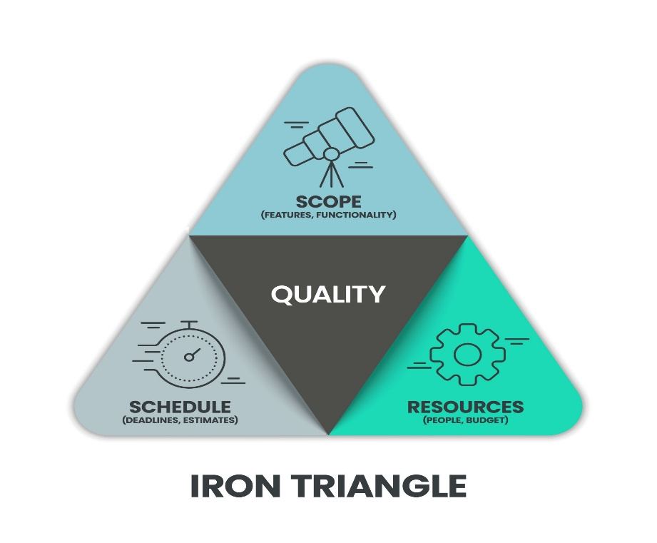

- Figure2.1
The Project Management Iron Triangle Paradigm - PMI

2.2 Theoretical Premises of the Study
To ensure this field study transcends mere description, it is anchored in three validated organizational and economic theories that explain why planning deficiencies manifest as physical project failures.

2.2.1 Agency Theory (The Contractual Premise)
Originally formalized by Jensen and Meckling (1976), Agency Theory models the relationship where a Principal (Project Owner/Client) delegates execution authority to an Agent (Main Contractor). In the construction industry, this relationship is fundamentally vulnerable to two structural frictions:
- Information Asymmetry: The contractor possesses superior, real-time technical insight regarding actual field conditions and execution mechanics than the client.
- Divergent Goals: The client seeks to maximize project asset value while minimizing expenditures, whereas the contractor aims to maximize profit margins and buffer operational risks.
When early-stage practices are weak, the client fails to establish robust governance. If the project boundaries are ambiguous, Agency Theory dictates that the contractor may opportunistically exploit these gaps to recover profit margins through aggressive variation orders, directly driving cost and time overruns.

2.2.2 Planning Theory and Bounded Rationality (The Cognitive Premise)
Rooted in the work of Herbert Simon (1957), the concept of Bounded Rationality asserts that human decision-makers intend to be rational but are fundamentally restricted by cognitive limitations, tight timelines, and imperfect data. In project environments, this manifests as Optimism Bias (Kahneman & Tversky) and the Planning Fallacy (Flyvbjerg, 2008), where project planners routinely underestimate delivery timelines and baseline budgets while overestimating execution capacity.
In KSA, fast-tracked project mobilization mandates compress planning windows. This research posits that structured scope definition mechanisms act as a cognitive corrective that overrides bounded rationality, forcing a realistic estimation of project realities before major capital deployment.

2.2.3 Transaction Cost Economics - TCE (The Economic Premise)
Transaction Cost Economics (Williamson, 1981) posits that economic exchanges incur costs beyond the direct price of services specifically the costs of drafting, negotiating, monitoring, and enforcing contracts. In mega-projects characterized by high uncertainty and Asset Specificity (e.g., unique infrastructure built for specific locations), a vague initial scope renders the original contract incomplete.
During execution, every unexpected deviation force contract renegotiation. The administrative friction, dispute resolution periods, and work stoppages required to formalize these modifications constitute massive ex-post transaction costs that escalate final project budgets and timelines.

2.3 Conceptualization and Typology of Study Variables

2.3.1 Project Initiation Practices (IV1)
- Definition: The formal phase that transitions an abstract corporate or public strategy into an authorized project, establishing initial boundaries and resource allocations.
- Core Components:
  - The Project Charter: The foundational document formally authorizing the project's existence and granting the project manager resource-allocation authority.
  - Feasibility Studies: Multi-dimensional evaluations categorizing Economic/Financial Feasibility (NPV, IRR), Technical Feasibility (engineering limits, site conditions), and Legal Feasibility (regulatory compliance, zoning codes).
  - Stakeholder Mapping: The systematic identification of all entities capable of influencing or being influenced by the project.
- The 4-Step Initiation Process:
  - Needs Assessment: Defining the underlying business case or strategic infrastructure gap.
  - Feasibility Evaluation: Stress-testing the concept against financial, technical, and regulatory constraints.
  - Stakeholder Analysis: Registering core stakeholder power levels and expectations.
  - Charter Authorization: Finalizing the project baseline authorization.

2.3.2 Scope Definition and Management (IV2)
- Definition: The systematic process of breaking down complex project deliverables into distinct, manageable work packages to draw absolute boundaries between what is included and what is excluded.
- Core Tools:
  - The Work Breakdown Structure (WBS): A deliverable-oriented hierarchical decomposition of the total project scope.
  - WBS Dictionary: Detailed descriptions of deliverables, quality metrics, and milestone boundaries for every work package.

- The Hierarchical Deconstruction Structure Table 2.1:
Level | WBS Layer | Construction Project Example
Level 1 | Total Project | Construction of a Commercial Tower in Riyadh
Level 2 | Major Deliverable | Substructure / Foundation Works
Level 3 | Work Package | Piling and Concrete Pouring
Level 4 | Activity / Task | Setting formwork, tying rebar, pouring concrete
- The 5-Step Scope Control Process:
  - Collect Requirements: Documenting explicit stakeholder and technical specifications.
  - Define Scope: Creating a detailed project scope statement.
  - Create WBS: Subdividing deliverables down to manageable work package layers.
  - Validate Scope: Securing formal stakeholder sign-off on defined boundaries.
  - Control Scope: Monitoring execution and enforcing strict change control workflows to curb scope creep.

2.3.3 Typology of Project Overruns (The Dependent Variables)
An overrun is an unauthorized deviation from an approved project baseline.

A. Time Overruns (Schedule Delays)
Time overrun is the extension of time beyond the contractually agreed-upon completion date. In construction engineering, these are classified into three distinct categories:
- Excusable Compensable Delays: Caused by the owner (e.g., late design approvals). The contractor is entitled to an extension of time (EOT) and financial compensation.
- Excusable Non-Compensable Delays: Caused by third parties or acts of God (e.g., extreme weather events). The contractor receives an EOT but no financial compensation.
- Non-Excusable Delays: Caused entirely by contractor inefficiencies (e.g., poor resource allocation). This leads to the enforcement of liquidated damages.

B. Cost Overruns (Budget Breaches)
Cost overrun is the excess of actual expenditures over the budgeted capital allocation. Academic literature classifies budget overruns into three systemic root causes:
- Technical Drivers: Imperfect mathematical forecasting, pricing fluctuations, and structural architectural errors.
- Psychological Drivers: Optimism bias resulting in the systemic underestimation of execution risk.
- Political-Economic Drivers: Strategic misrepresentation during bidding phases to secure contract awards (under-bidding).
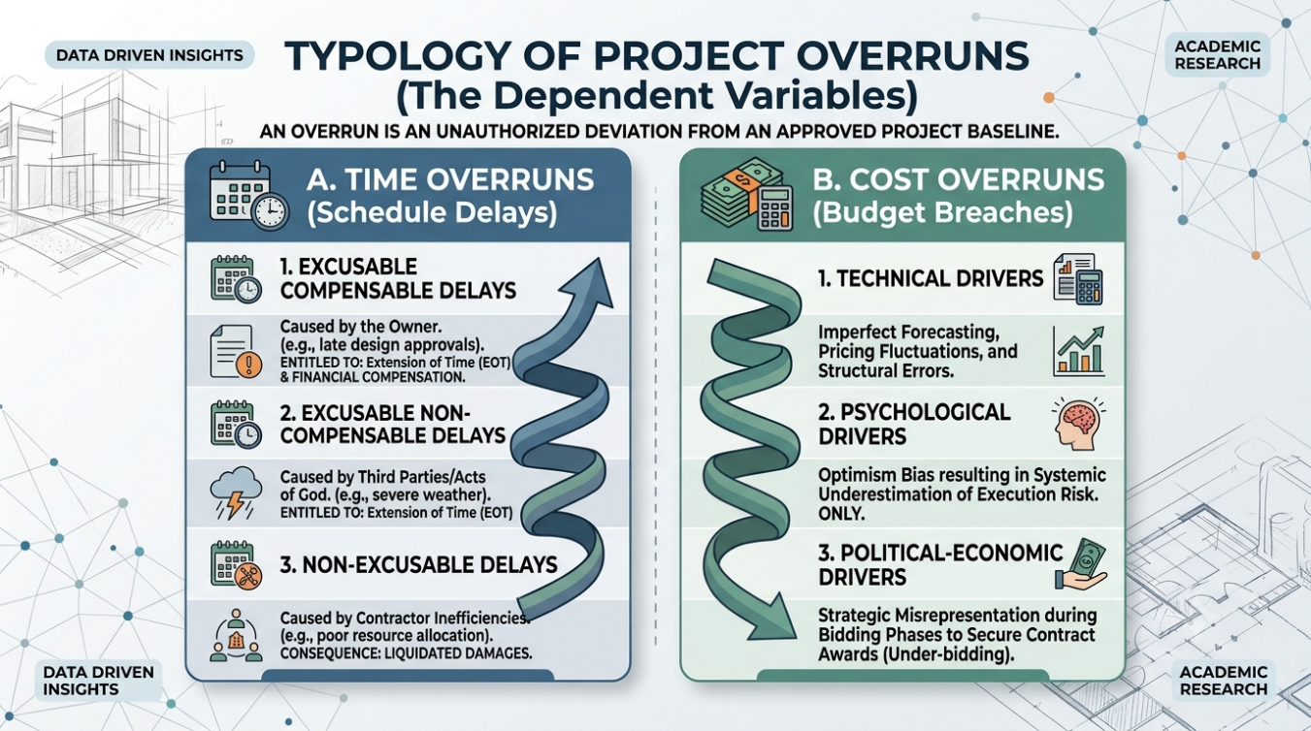
- Figure 2.2

2.4 Summary of Past Studies
To highlight the specific research, gap this study addresses within the Middle Eastern construction ecosystem, Table 2.2 synthesizes relevant historical and contemporary empirical literature.

Table 2.2: Methodological and Empirical Synthesis of Prior Research
Author & Year | Location & Context | Methodology | Key Findings & Core Variables | Identified Research Gap
Al-Kharashi & Skitmore (2009) | Saudi Arabia (Construction) | Quantitative Survey (N=91) | Attributed delays to slow client decisions, weak early coordination, and cash flow issues. | Did not isolate or statistically measure the specific role of WBS granularity.
Dumonteil & Boyd (2014) | Global Infrastructure | Case Study Analysis | Proved that robust project charters and early alignment reduce cost overruns by up to 15%. | Conducted in mature Western markets; lacks integration with GCC procurement environments.
Amusan et al. (2021) | Developing Economies | Mixed-Methods (N=120) | Found that 73% of budget overruns stem from poor initial scope definition and frequent variation orders. | General building focus; does not capture the scale of modern giga projects.
Alshihri et al. (2024) | Saudi Arabia (Mega-projects) | Quantitative Regression | Confirmed that traditional procurement combined with compressed initiation compromises the iron triangle. | Did not explicitly model the joint, simultaneous interaction of initiation and scope maturity as twin predictors.

2.5 Theoretical and Conceptual Framework
Based on the theoretical premises and conceptual definitions detailed above, the operational structure of this study is mapped below. This framework establishes that the structural maturity of Project Initiation Practices (IV1) and the precision of Scope Definition (IV2) directly dictate the minimization of Time Overruns (DV1) and Cost Overruns (DV2).

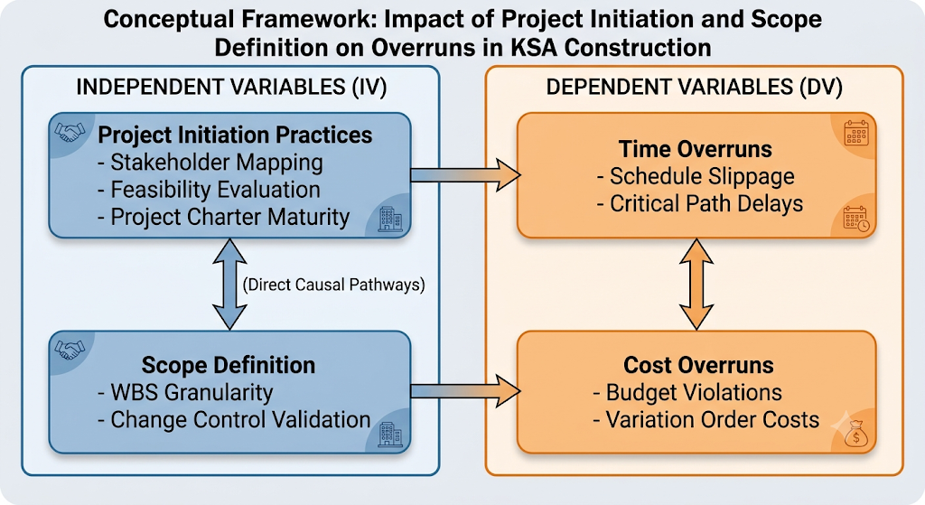
Figure 2.3

Research Hypotheses Derived from Framework:
- H1: There is a statistically significant, negative relationship between the maturity of Project Initiation Practices (IV1) and the occurrence of Time and Cost Overruns (DVs) within the Saudi construction sector.
- H2: Highly detailed and verified Scope Definition (IV2) significantly mitigates the severity of project Time and Cost Overruns (DVs) by minimizing execution-phase variation orders.
- Figure.2.4
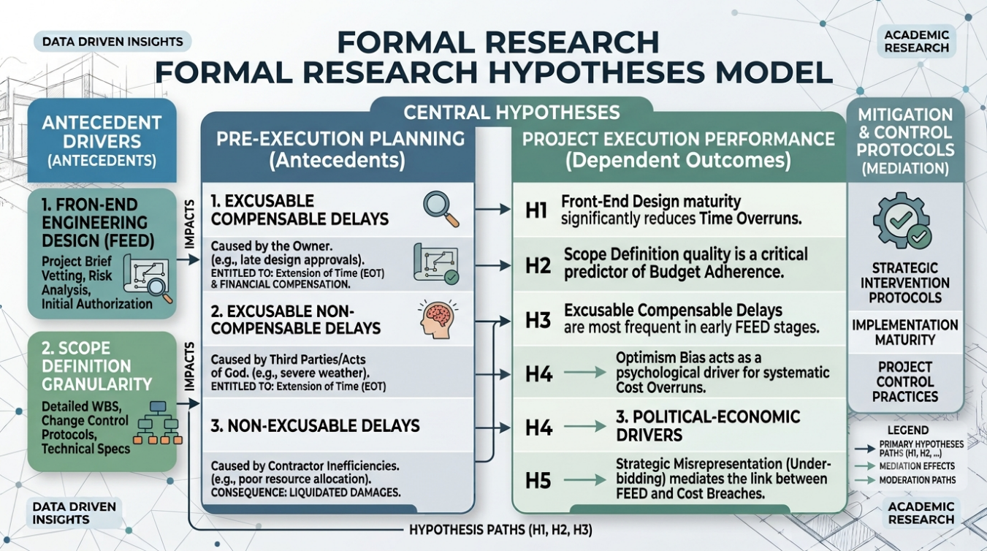

2.6 Chapter Summary
This chapter provided a comprehensive synthesis of the theoretical and conceptual foundations governing this study. By anchoring the research within Agency Theory, Bounded Rationality, and Transaction Cost Economics, the chapter established the behavioral and financial mechanics that cause planning flaws to translate into execution failures.
Furthermore, in strict adherence to evaluation guidelines, the chapter conceptualized the precise operational steps, classifications, and typologies of project initiation, scope definition, and construction overruns. The review of prior literature unmasked a critical research gap: the need for contemporary, statistically validated field data mapping these variables within the modern Vision 2030 project framework.

