Page Allocation
Linux uses the Buddy algorithm to effectively allocate and deallocate blocks of pages. The page allocation code
Attempts to allocate a block of one or more physical pages. Pages are allocated in blocks which are powers of 2 in size. That means that it can allocate a block 1 page, 2 pages, 4 pages and so on. So long as there are enough free pages in the system to grant this request ( 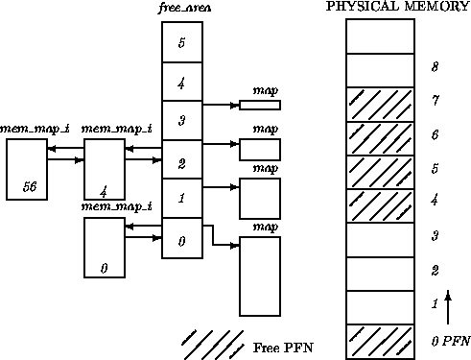 ) the allocation code will search the free_area for a block of pages of the size requested. Each element of the free_area has a map of the allocated and free blocks of pages for that sized block. For example, element 2 of the array has a memory map that describes free and allocated blocks each of 4 pages long.
The allocation algorithm first searches for blocks of pages of the size requested. It follows the chain of free pages that is queued on the list element of the free_area data structure. If no blocks of pages of the requested size are free, blocks of the next size (which is twice that of the size requested) are looked for. This process continues until all of the free_area has been searched or until a block of pages has been found. If the block of pages found is larger than that requested it must be broken down until there is a block of the right size. Because the blocks are each a power of 2 pages big then this breaking down process is easy as you simply break the blocks in half. The free blocks are queued on the appropriate queue and the allocated block of pages is returned to the caller.

Figure: The free_area data structure
For example, in Figure if a block of 2 pages was requested, the first block of 4 pages (starting at PFN 4) would be broken into two 2 page blocks. The first, starting at PFN 4 would be returned to the caller as the allocated pages and the second block, starting at PFN 6 would be queued as a free block of 2 pages onto element 1 of the free_area array.

Paging in Operating System

Paging is a memory management scheme that eliminates the need for contiguous allocation of physical memory. The process of retrieving processes in the form of pages from the secondary storage into the main memory is known as paging. The basic purpose of paging is to separate each procedure into pages. Additionally, frames will be used to split the main memory.This scheme permits the physical address space of a process to be non – contiguous.
Let us look some important terminologies:
- Logical Address or Virtual Address (represented in bits): An address generated by the CPU
- Logical Address Space or Virtual Address Space( represented in words or bytes): The set of all logical addresses generated by a program
- Physical Address (represented in bits): An address actually available on memory unit
- Physical Address Space (represented in words or bytes): The set of all physical addresses corresponding to the logical addresses

- The Physical Address Space is conceptually divided into a number of fixed-size blocks, called frames.
- The Logical address Space is also splitted into fixed-size blocks, called pages.
- Page Size = Frame Size
Let us consider an example:
- Physical Address = 12 bits, then Physical Address Space = 4 K words
- Logical Address = 13 bits, then Logical Address Space = 8 K words
- Page size = frame size = 1 K words (assumption)
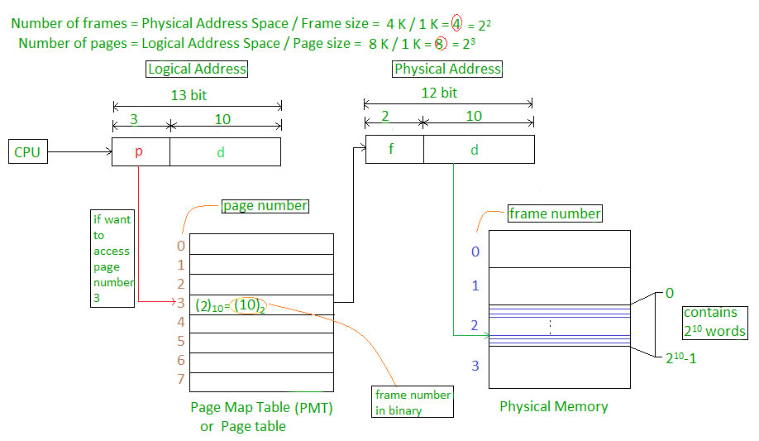 Address generated by CPU is divided into
- Page number(p): Number of bits required to represent the pages in Logical Address Space or Page number
- Page offset(d): Number of bits required to represent particular word in a page or page size of Logical Address Space or word number of a page or page offset.
Physical Address is divided into
- Frame number(f): Number of bits required to represent the frame of Physical Address Space or Frame number.
- Frame offset(d): Number of bits required to represent particular word in a frame or frame size of Physical Address Space or word number of a frame or frame offset.
The hardware implementation of page table can be done by using dedicated registers. But the usage of register for the page table is satisfactory only if page table is small. If page table contain large number of entries then we can use TLB(translation Look-aside buffer), a special, small, fast look up hardware cache.
- The TLB is associative, high speed memory.
- Each entry in TLB consists of two parts: a tag and a value.
- When this memory is used, then an item is compared with all tags simultaneously.If the item is found, then corresponding value is returned.

Free Frames Example

Written by:
Abdulrahman A Harbi
Academic # 221000560

