Lesson summary: Supply and its determinants

In this lesson summary review and remind yourself of the key terms, graphs, and calculations used in the analysis of supply. Topics include the distinction between supply and quantity supplied, the law of supply, and the determinants of supply.

The law of supply
The law of supply states that there is a positive relationship between price and quantity supplied, leading to an upward-sloping supply curve. Sellers like to make money, and higher prices mean more money!
For example, let’s say that fishermen notice the price of tuna rising. Because higher prices will make them more money, fishermen spend more time and effort catching tuna. As a result, as the price rises, the quantity of tuna supplied increases.

The determinants of supply
Factors that influence producer supply cause the market supply curve to shift. For example, one of the determinants of supply in the market for tuna is the availability and the price of fishing permits. If more fishing permits are made available and the permit fee is lowered, we can expect more fisherman to enter the market; as a result, the supply of tuna will likely increase. Now, at every price, a greater quantity of tuna will be supplied to the market.
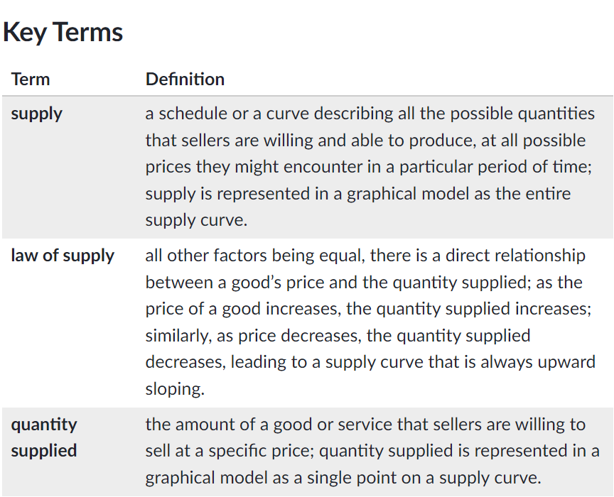
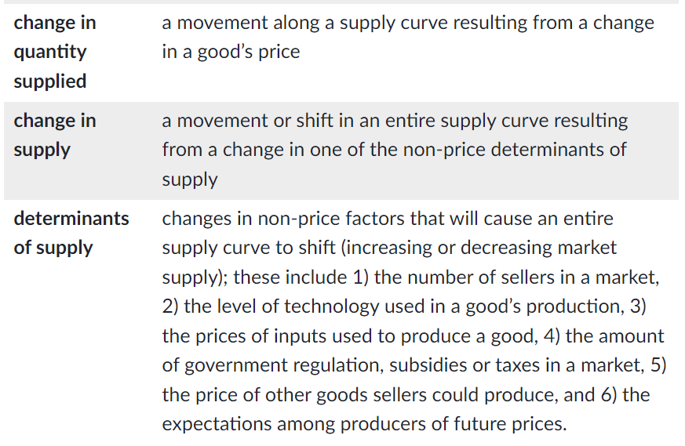

Key Graphical Models
The supply curve demonstrates the relationship between a good’s price and the quantity producers are willing and able to supply. The upward sloping line demonstrates this direct relationship: as the price rises, the quantity supplied increases; as price decreases, quantity supplied decreases.



