Chapter 3: Research Methodology
3.1 Introduction to the Chapter
This chapter presents the methodology adopted in this study to develop and evaluate the proposed email intelligence system. It describes the research workflow beginning with dataset preparation and preprocessing, followed by the automatic labeling strategy, dataset partitioning, implementation of the baseline models, development of the proposed DistilBERT multi-task model, experimental settings, and evaluation metrics.
The adopted methodology was designed to ensure that all models were trained and evaluated under the same experimental conditions, allowing a fair comparison between the traditional machine learning approaches and the proposed deep learning model.
Figure 3.1 Research Methodology Workflow
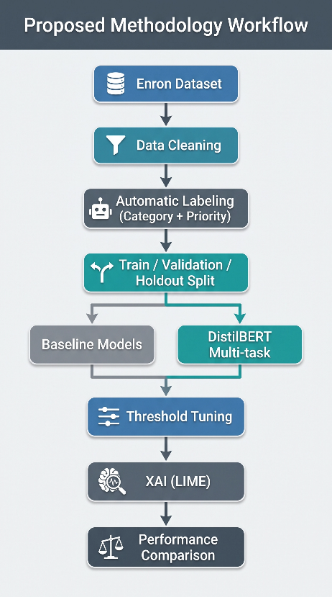
Figure 3.1: Overall research methodology followed in this study, beginning with data preparation and ending with the final evaluation and model comparison.

3.2 Research Methodology
Figure 3.1 illustrates the overall workflow adopted throughout this study. The methodology begins with collecting and preparing the email dataset, followed by automatic data labeling for both category and priority prediction. The prepared dataset is then divided into training, validation, and independent holdout subsets.
Two baseline machine learning models are implemented first to establish reference performance levels. Subsequently, the proposed DistilBERT multi-task model is trained using the same dataset. After training, threshold tuning is applied to optimize multi-label category prediction, followed by Explainable Artificial Intelligence (LIME) to interpret model decisions. Finally, all models are evaluated using identical performance metrics to provide a fair comparison.
This framework ensures that each experimental stage builds upon the previous one while maintaining consistency throughout the entire study.
Table (3.1) Research Methodology Stages
Stage | Description
Dataset Preparation | Load and preprocess the Enron email dataset
Data Cleaning | Remove duplicates and invalid emails
Automatic Labeling | Generate category and priority labels
Dataset Splitting | Create Train, Validation, and Holdout sets
Baseline Models | Logistic Regression and Linear SVM
Proposed Model | DistilBERT Multi-task Learning
Threshold Tuning | Optimize category decision threshold
Explainability | LIME-based prediction interpretation
Final Comparison | Compare all experimental results
Table 3.1 summarizes the main stages of the research methodology followed in this study. Each stage contributes to the development, optimization, evaluation, and interpretation of the proposed email classification system before the final comparison with the baseline models.

3.3 Dataset Description
The quality of any machine learning model depends largely on the quality of the dataset used during training and evaluation. Therefore, selecting an appropriate dataset was an essential step in this study to ensure that the proposed model could learn meaningful patterns related to both email categorization and priority prediction.
This study used the Enron Email Dataset, one of the most widely adopted benchmark datasets in email classification and natural language processing research. The dataset contains a large collection of real corporate emails exchanged among employees of the Enron Corporation before the company's collapse. Since the emails represent authentic business communications, they include a wide variety of administrative requests, legal discussions, financial communications, meeting arrangements, human resources issues, and other organizational activities.
The diversity of the dataset makes it suitable for evaluating intelligent email management systems because it reflects realistic organizational communication scenarios rather than artificially generated text.
Although the original dataset contains more than half a million email messages, several preprocessing steps were required before it became suitable for training deep learning models. Duplicate emails, incomplete records, and very short messages were removed to improve data quality and reduce noise. Additional preprocessing operations were then applied to prepare the data for the automatic labeling process described in the following sections.
Table (3.2): Characteristics of the Enron Email Dataset
Attribute | Description
Dataset Name | Enron Email Dataset
Data Type | Real corporate email messages
Language | English
Original Dataset Size | Approximately 517,000 emails
Final Cleaned Dataset | 190,280 emails
Input Feature | Cleaned email text (Subject + Body)
Category Labels | Administration, Financial, HR, Legal, Market, Other
Priority Labels | High, Normal, Low
Table 3.2 summarizes the main characteristics of the dataset used throughout this study. After preprocessing and cleaning, the final dataset consisted of 190,280 high-quality email messages that were subsequently labeled and divided into training, validation, and holdout subsets for model development and evaluation.
The next figure shows the dataset preparation pipeline illustrating the transformation of the original Enron dataset into the cleaned dataset used for model development
Figure 3.2: Dataset Preparation Pipeline
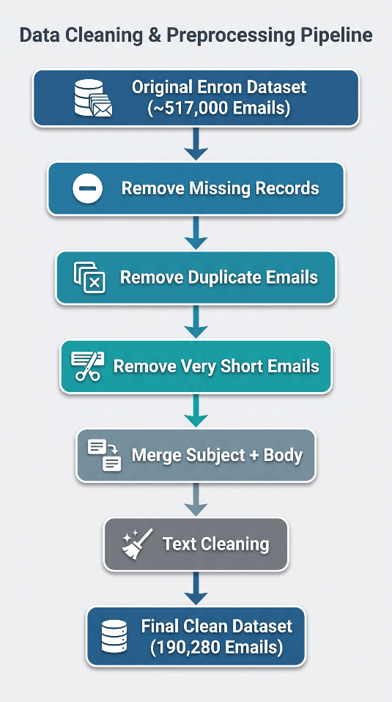
Figure 3.2 illustrates the main preprocessing pipeline applied to the original Enron dataset. Each stage was designed to improve data quality before the automatic labeling process.
These preprocessing operations reduced noise, removed redundant information, and produced a cleaner dataset suitable for both traditional machine learning algorithms and the proposed DistilBERT multi-task model
3.4 Data Preprocessing
The original Enron Email Dataset required several preprocessing steps before it could be used for training and evaluation. Since the raw dataset contains duplicate messages, incomplete records, formatting inconsistencies, and emails with little textual information, a comprehensive preprocessing pipeline was implemented to improve data quality and prepare the emails for automatic labeling and model training.
The preprocessing stage focused on reducing noise while preserving the semantic information contained in each email. These operations also ensured consistency between the traditional machine learning models and the proposed DistilBERT multi-task model, as both models were trained using the same cleaned dataset.
Figure (3.3) illustrates the complete preprocessing pipeline applied in this study
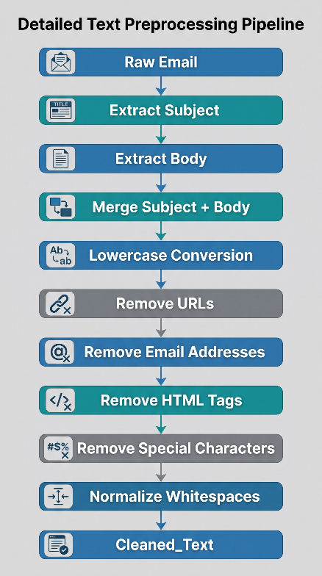
Figure 3.3 shows the text preprocessing pipeline applied to each email before labeling and model training.
After combining the subject and body of each email into a single text field, several text normalization operations were performed. These operations removed unnecessary formatting and standardized the textual representation while preserving the semantic content of the messages. The resulting cleaned text served as the input for both the baseline models and the proposed DistilBERT model.
3.4.1 Data Cleaning
The data cleaning process aimed to remove records that could negatively affect the learning process. Duplicate emails were eliminated to avoid repeated training samples, while records containing insufficient textual information were excluded because they do not provide meaningful semantic features for classification.
Messages with extremely short content were also removed since they usually consisted of signatures, greetings, or incomplete information that could introduce unnecessary noise into the learning process.
Table 3.3 summarizes the data cleaning process.
Cleaning Step | Description
Remove duplicate emails | Eliminated duplicate email records
Remove missing values | Removed incomplete records
Remove short emails | Excluded emails containing fewer than five words
Merge Subject and Body | Combined both fields into a unified text
Text normalization | Removed URLs, HTML tags, punctuation, and unnecessary spaces
Final cleaned dataset | 190,280 email messages
Table 3.3 summarizes the preprocessing operations performed on the original dataset before labeling and model training. These cleaning steps improved data consistency, reduced redundancy, and produced a high-quality dataset suitable for subsequent machine learning and deep learning experiments.
3.4.2 Text Normalization
Following the cleaning process, the remaining email texts were normalized to create a consistent textual representation across the entire dataset. The normalization process reduced variations caused by formatting differences while preserving the linguistic information required for classification.
The main normalization operations included:
- Converting all text to lowercase.
- Removing HTML tags.
- Removing URLs and email addresses.
- Removing unnecessary punctuation and special characters.
- Removing repeated whitespace characters.
- Merging the email subject and body into a single text field.
These operations reduced irrelevant textual variations without changing the semantic meaning of the emails, allowing the models to focus on meaningful contextual information.
Figure (3.4): Example of Text Preprocessing
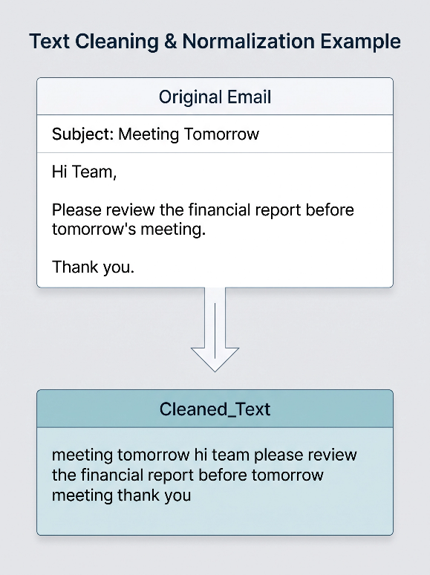
Figure 3.4 shows an example that illustrates the transformation of a raw email into the normalized text used as model input.
3.5 Data Labeling Strategy
Since the Enron Email Dataset does not provide predefined labels for either email categories or priority levels, an automatic labeling strategy was developed to generate the target variables required for supervised learning.
The labeling process consisted of two independent tasks. The first task assigned one or more functional categories to each email, while the second task assigned a single priority level. This approach enabled the creation of a multi-task learning dataset capable of supporting both category classification and priority prediction within a unified framework. Figure 3.5 illustrates the overall labeling workflow adopted in this study.
Figure (3.5): Automatic Labeling Workflow.
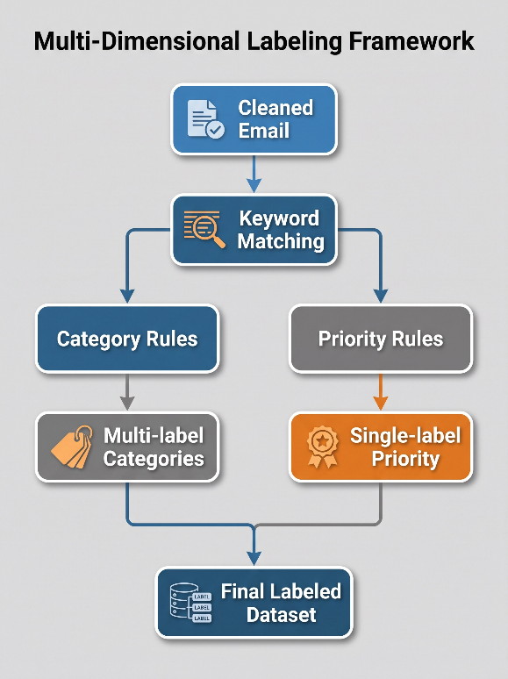
Figure 3.5 shows the automatic labeling workflow used to generate category and priority labels for the cleaned email dataset.

The labeling strategy was implemented using a rule-based approach supported by domain-specific keyword dictionaries. Each incoming email was analyzed after preprocessing, and predefined keyword sets were used to determine the corresponding category labels and priority level.
Unlike manual annotation, this automated approach enabled the efficient labeling of a large-scale dataset while ensuring consistent application of the labeling rules across all email messages.
3.5.1 Category Labeling
The category labeling process was designed as a multi-label classification problem because a single email may simultaneously discuss more than one organizational topic.
Six functional categories were defined based on the objectives of the proposed email management system:
- Administration
- Financial
- Human Resources (HR)
- Legal
- Market
- Other
Each category was represented by a collection of representative keywords and expressions. During labeling, an email was assigned to every category whose keywords appeared within the cleaned text. Consequently, one email could receive multiple category labels if it contained evidence of multiple topics.
Table (3.4): Category Labels Used in the Study
Category | Description
Administration | Administrative requests, meetings, approvals, scheduling
Financial | Budget, invoices, payments, accounting, expenses
HR | Recruitment, leave requests, employee matters
Legal | Contracts, regulations, compliance, legal issues
Market | Marketing, customers, sales, campaigns
Other | Emails not matching any predefined category
Table 3.4 presents the six functional categories adopted in this study. These categories were selected to represent common organizational communication topics frequently encountered in enterprise email systems.
3.5.2 Priority Labeling
Unlike category prediction, priority prediction was formulated as a single-label multiclass classification problem because each email should belong to only one priority level.
Three priority levels were defined:
- High
- Normal
- Low
Priority assignment was performed using a predefined set of urgency-related keywords and expressions. Emails containing terms indicating urgency, immediate action, deadlines, or critical situations were labeled as High priority. Emails without urgency indicators but containing routine business communications were labeled as Normal, while informational or non-urgent communications were assigned the Low priority level.
Table (3.5): Priority Levels
Priority | Description
High | Immediate attention required
Normal | Routine business communication
Low | Informational or non-urgent messages
Table 3.5 summarizes the three priority levels used during automatic labeling. These labels were later used as the target classes for the priority classification task.
3.5.3 Label Distribution
After completing the automatic labeling process, each email contained two target variables:
- One multi-label category vector.
- One priority label.
The resulting labeled dataset served as the foundation for all subsequent experiments, including the baseline machine learning models, the proposed DistilBERT multi-task model, threshold tuning, and the final evaluation presented in Chapter 4.
Figure (3.6): Structure of the Final Labeled Dataset
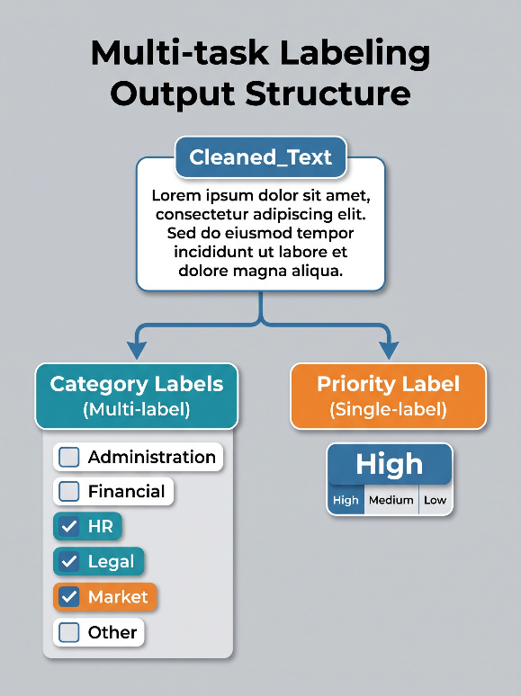
Figure 3.6 shows the structure of the labeled dataset, showing the input text together with the generated category and priority labels.
Distribution of Category and Priority Labels
After completing the automatic labeling process, the distribution of the category labels was analyzed to understand the balance of the dataset before model training. Since the study addresses a multi-label classification problem, a single email may belong to more than one category. Therefore, the total number of category labels exceeds the total number of email messages. Table 3.6 presents the distribution of category labels in the labeled dataset.

Table (3.6(: Category Distribution
Category | Count | Percentage
Administration | 191,461 | 37.05%
Market | 129,694 | 25.10%
Other | 76,125 | 14.73%
Financial | 64,386 | 12.46%
Legal | 33,383 | 6.46%
HR | 21,706 | 4.20%
As shown in Table 3.6, the Administration category represents the largest proportion of the labeled data (37.05%), followed by Market (25.10%). In contrast, HR and Legal appear less frequently, accounting for only 4.20% and 6.46% of the category labels, respectively. This distribution indicates that the dataset is naturally imbalanced, which reflects the characteristics of real-world email communication rather than an artificially balanced dataset. Such imbalance was taken into consideration during the experimental design and evaluation process.
Figure (3.7): Distribution of Category Labels
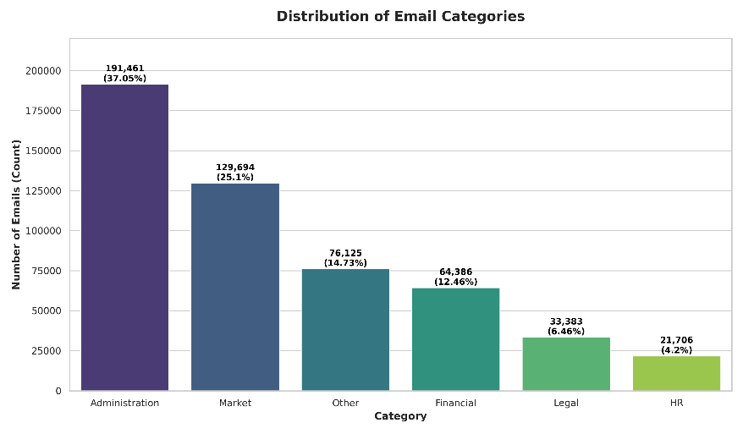
Figure 3.7 shows the distribution of category labels after the automatic labeling process. The figure illustrates the variation in category frequencies, with Administration representing the largest share of labeled emails and HR the smallest, highlighting the inherent class imbalance addressed during model evaluation.
In addition to category labels, the distribution of priority labels was also examined to understand the proportion of High-, Normal-, and Low-priority emails. Since priority is treated as a single-label classification task, each email is assigned exactly one priority level. The distribution of priority labels is presented in Table 3.7.
Table (3.7): Priority Distribution
Priority | Count | Percentage
Normal | 262,387 | 50.78%
Low | 189,612 | 36.69%
High | 64,756 | 12.53%
Table 3.7 shows the distribution of priority labels across the labeled email dataset. The predominance of Normal priority emails and the relatively small proportion of High priority emails demonstrate the natural imbalance of the priority classification task, motivating the use of evaluation metrics beyond overall accuracy, such as Macro F1-score and High-priority Recall.
Figure (3.8): Distribution of Priority Labels
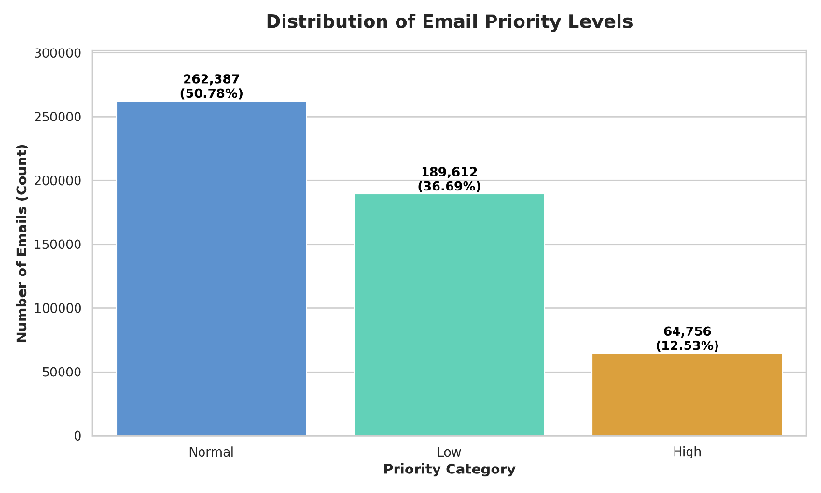
3.6 Dataset Splitting
After completing the automatic labeling process, the cleaned dataset was prepared for model development. To reduce computational cost while maintaining representative data distributions, a stratified sample of 50,000 email messages was selected from the final cleaned dataset.
The sampled dataset was then divided into three independent subsets to support model training, hyperparameter tuning, and unbiased evaluation.
A stratified sampling strategy was adopted to preserve the distribution of both category and priority labels across all subsets.
The dataset was partitioned as follows:
- Training Set (70%) for learning the model parameters.
- Validation Set (10%) for model selection and threshold tuning.
- Holdout Test Set (20%) for the final performance evaluation.
This experimental protocol ensures that the test data remain completely unseen during both training and model optimization, thereby providing an unbiased estimate of the model's generalization capability.
Table (3.9): Dataset Partitioning
Dataset | Number of Emails | Percentage | Purpose
Training Set | 35,000 | 70% | Model training
Validation Set | 5,000 | 10% | Model selection and threshold tuning
Holdout Test Set | 10,000 | 20% | Final model evaluation
Total Sample | 50,000 | 100% | Experimental dataset
Table 3.9 presents the final partitioning of the experimental dataset used throughout this study. The validation set was reserved for model selection and threshold optimization, whereas the holdout test set remained completely independent and was used only once to assess the final performance of the proposed model.
Figure (3.9): Dataset Partitioning Strategy
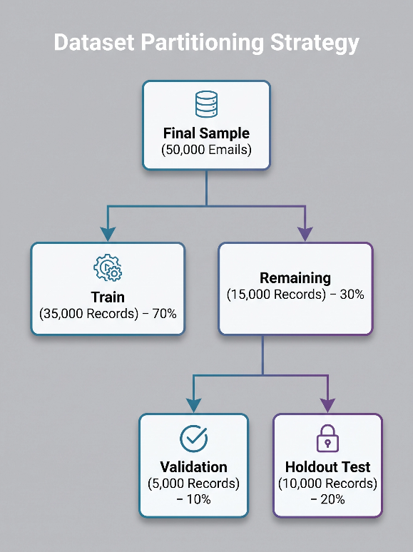
Figure 3.9 presents the dataset partitioning strategy adopted for training, validation, and final evaluation
3.6.1 Stratified Sampling
Since the dataset exhibits class imbalance in both category and priority labels, a simple random split could produce subsets with inconsistent label distributions. To address this issue, stratified sampling was employed during dataset partitioning.
The stratification process was performed using the combined Category–Priority labels to preserve the joint distribution of both prediction tasks across the training, validation, and holdout datasets. This approach ensured that each subset contained representative samples of all label combinations, thereby reducing sampling bias and improving the reliability of the experimental results.
Maintaining similar label distributions across the three subsets also contributes to a fair comparison between the baseline models and the proposed DistilBERT multi-task model, as all experiments were conducted using identical data partitions.

Figure (3.10): Stratified Sampling Concept
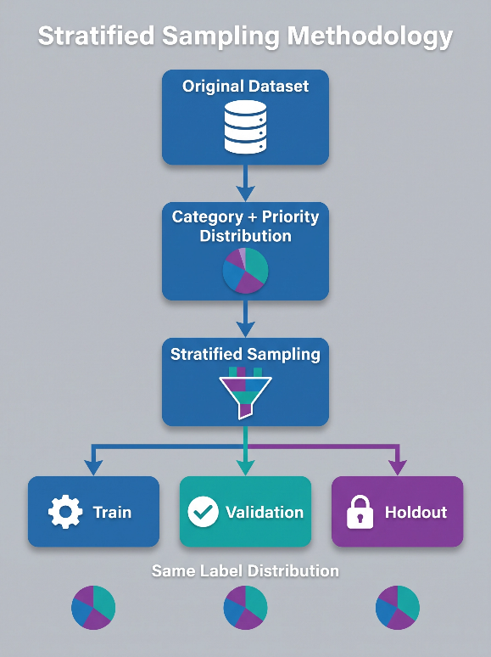
Figure 3.10 illustrates the stratified sampling process used to preserve the distribution of category and priority labels across all dataset partitions.
3.7 Baseline Models
Before developing the proposed deep learning model, two traditional machine learning models were implemented to establish baseline performance for comparison. These models provide a reference point for evaluating the effectiveness of the proposed DistilBERT multi-task architecture.
Both baseline models were trained using the same training dataset and evaluated under the same experimental conditions adopted throughout this study. This ensured that any performance differences observed during the final evaluation were attributable to the learning approach rather than differences in the experimental setup.
The baseline models employed the TF-IDF (Term Frequency–Inverse Document Frequency) representation to convert email texts into numerical feature vectors suitable for machine learning algorithms.

Figure (3.11): Presenting the overall baseline modeling workflow.
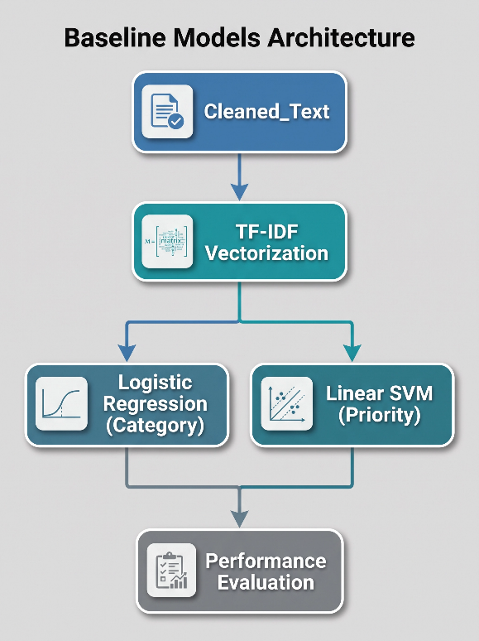
Figure 3.11 shows the workflow of the baseline machine learning models used in comparison with the proposed DistilBERT model.
3.7.1 Text Representation Using TF-IDF
The baseline models used the TF-IDF representation to transform textual data into numerical feature vectors. TF-IDF assigns weights to words according to their importance within individual documents relative to the entire corpus. Frequently occurring words across many documents receive lower weights, whereas more informative words receive higher weights.
To maintain consistency across experiments, the TF-IDF vocabulary was limited to the 20,000 most informative terms extracted from the training dataset. This feature representation was used as the input for both baseline models.
Table (3.10): TF-IDF Configuration
Parameter | Value
Representation Method | TF-IDF
Maximum Vocabulary Size | 20,000
Input Text | Cleaned_Text
Output | Sparse Feature Vectors
Table 3.10 summarizes the TF-IDF configuration adopted for the baseline models. The same feature extraction settings were applied throughout all baseline experiments to ensure consistency and fairness during comparison.
3.7.2 Logistic Regression for Category Classification
The first baseline model was Logistic Regression, which was employed to perform the email category classification task.
Since emails may belong to multiple categories simultaneously, the classification problem was formulated as a multi-label classification task. A One-vs-Rest (OvR) strategy was adopted, allowing an independent binary classifier to be trained for each category.
Each classifier estimated the probability that an email belonged to its corresponding category, and the final category predictions were obtained by applying a predefined decision threshold.
Figure (3.12): illustrates the classification pipeline.
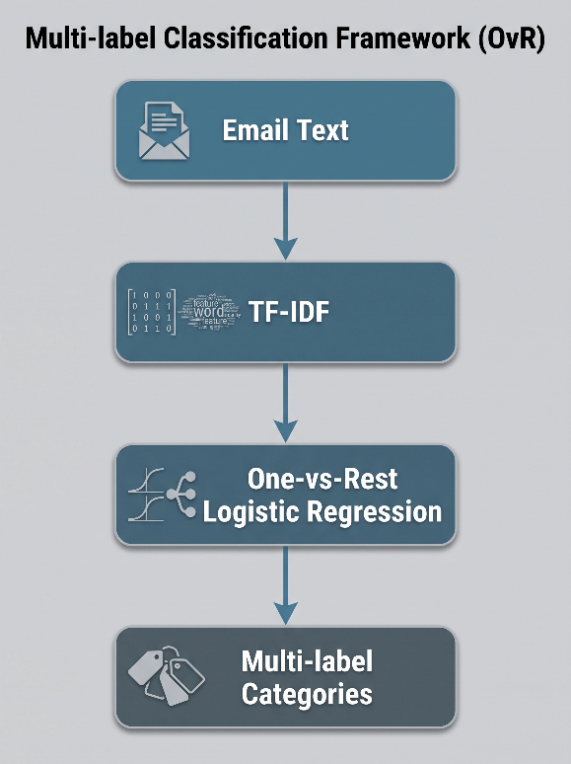
Figure 3.12 shows the logistic regression pipeline for multi-label email category classification.
3.7.3 Linear SVM for Priority Classification
The second baseline model was Linear Support Vector Machine (Linear SVM), which was used for priority prediction.
Unlike category classification, priority prediction is a single-label multiclass classification problem because each email is assigned only one priority level. The Linear SVM classifier determines the optimal separating hyperplanes between priority classes based on the TF-IDF feature representation.
This model was selected because Linear SVM has consistently demonstrated strong performance in high-dimensional text classification tasks while maintaining computational efficiency.
Figure (3.13): illustrates the priority classification pipeline
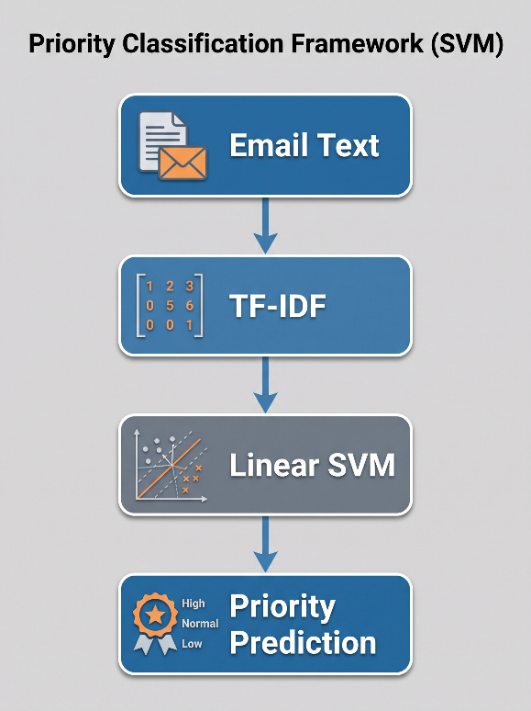
Figure 3.13 shows the linear SVM workflow for email priority classification.
3.7.4 Experimental Settings
Both baseline models were trained using the identical training dataset and evaluated using the validation and holdout datasets described earlier. The same preprocessing pipeline and evaluation metrics were applied to both models to ensure a fair comparison with the proposed DistilBERT model presented in the following section.
The baseline experiments served as performance benchmarks against which the proposed multi-task learning model was evaluated in Chapter 4.
Figure (3.14): Overall Research Methodology
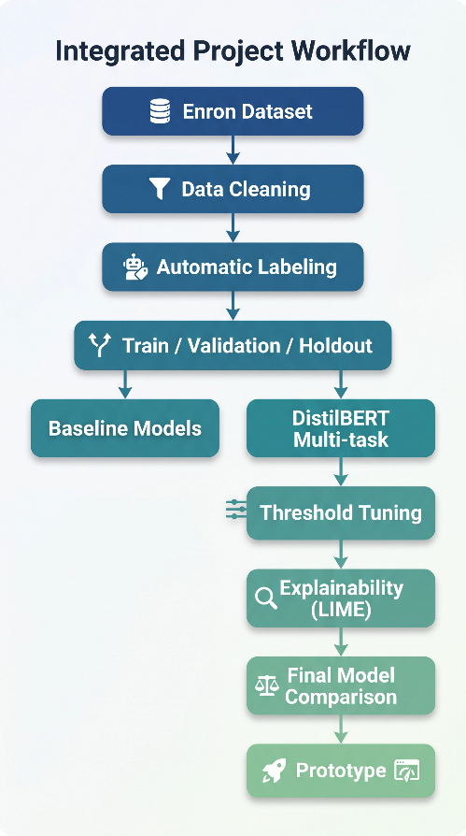
Figure 3.14 summarizes the complete research methodology followed in this study, beginning with dataset preparation and preprocessing, followed by automatic labeling, dataset partitioning, implementation of the baseline models and the proposed DistilBERT multi-task model, threshold optimization, explainability using LIME, final model comparison, and prototype development.

