The actual value of professional certifications in the IT sector:
“A comparative analytical study of professional skills and behaviours”

Prepared By:
MESHAAL ALMUTAIRI

Table of Contents
Abstract: 3
Introduction: 4
Background: 5
- The growth of the IT sector and, correspondingly, the importance of
professional certifications: 5
- Issues with the value/system related to professional certification: 5
- What makes evaluating the impact of professional certifications so important? 5
Research Objectives: 7
Research scope 7
Literature Review 8
Research Methodology 9
First: Data collection tools: 10
Second: Study Sample: 10
Third: Data analysis methods: 10
Fourth: Research ethics: 10
Gantt chart: 11
References: 13

Abstract:
The Professional certifications in IT have become an important component of professional growth for employees and job seekers in this fast-paced sector. As the importance of actual skills and practical skills growths, queries arise about the
efficiency of professional certifications in improving professional performance and organizational behaviours within work environments. This research purposes to provide a comparative analytical study between individuals who have gained internationally recognized professional certifications, such as CompTIA, Cisco, AWS, and PMP, and those who have not, in the context of technical skills, professional behaviour,
and teamwork.
The research depends on on quantitative and qualitative methodology through the design of targeted questionnaires and semi-structured interviews with a diverse sample of IT employees in Saudi Arabia. It will also depend on on a review
of current literature addressing the relationship between professional certifications and career growth, with the object of gaining a deeper understanding of the actual impact of these certifications in the practical environment, away from theoretical perceptions or commercial marketing.
The outcomes of this research are expected to guide training and human resources organizations toward more informed decisions about investment in professional certification programs. It will also help decision-makers in the education and employment sectors understand the actual value of these certifications in sponsoring professional skill and excellence in the job market.

Introduction:
Information technology area is undergoing fast growth in terms of tools, skills, and job standards, making it imperative for those working in the field to keep pace with these changes. Through growing race in the job market, professional certifications have become a prominent means of confirming practical skill and professional excellence, as these certifications offer official training paths covering multiple areas such as networking, cybersecurity, cloud computing, project management, and
others.
However, queries remain about the true value of these certifications and whether they are an exact measure of professional skills and behaviours in the workplace, or just a marketing tool to improve resumes. In this context, this research methodically examines the Relationship between professional certifications and real professional performance in the IT sector by comparing individuals who have gained these certifications with those who have not in several areas, including practical skill, professional commitment, and the ability to interact with work teams.
This subject is a contemporary issue that deserves study and investigation, especially given the trend among many individuals and organizations to invest in professional certification programs without enough scientific evidence to support their effectiveness in preparation. Hence the importance of this research, which try to find to provide a
deeper understanding of the value of these certifications from a practical and professional perspective.

Background:
- The growth of the IT sector and, correspondingly, the importance of professional certifications:
Over the past few decades, the IT sector has experienced tremendous growth, which resulted in increased reliance on specialized knowledge and technical proficiency.
Subsequently, various professional spaces, particularly those demanding technical skill sets such as networking, cybersecurity, and data and systems management, have set out to define a standard to assess such proficiency. As such, professional certifications emerged during the new millennium and became a standard recognized worldwide for technical and professional competence. The popular certifications, focusing on an operating system, network, or services, include the CompTIA certifications, Cisco certifications, AWS certifications for cloud computing, and PMP certification for technical project management. Normally, the professional certifications are obtained through formal exams to test students’ theoretical and
practical knowledge.
- Issues with the value/system related to professional certification:
Although professional certifications have been adopted globally and have certainly enhanced theoretical acquisition and knowledge documentation in the workplace, there are still numerous discussions regarding its impact on practical performance and professional conduct of IT professionals. Research shows mixed results: whereas some researchers acknowledge the positive effect of professional certification on worker performance and the likelihood of promotion in formal and relational settings, others imply that such merely theoretical studying cannot fully apprehend the actual conditions of practice. Empirical phenomenon demonstrates that, true, some professional experience is indeed gained in the workplace and cannot be formally assessed through the certification system. These discussions and the effect of professional certification on performance undoubtedly have an impact on the hiring policies and practices of technical organizations, which is why it is vital to scientifically investigate whether certification-based difference with a practical set of skills does exist. Hence, the significance of competent analysis is to uncover whether restricted professional expertise and conduct may be attributed to the acquisition of professional certifications in the first place.
- What makes evaluating the impact of professional certifications so important?
Evaluating the impact of professional certifications is essential both academically and practically. Technical institutions require reliable background Check and solid fact – based information to facilitate professional education and make decisions in investments and training. Furthermore, the justification of professional practices implies increasing employee performance and proficiency and adapting educational policies to the contemporary demands of the global market. In this case, we see a clear motive for why it is relevant to develop a structured comparative framework to uncover the true effect of IT professional certifications by comparing practical technical expertise and professional conduct.

Problem Statement:
Professional certifications are more than ever greatly under the microscope and in some cases have become important – even mission critical – for employers to confidently gauge their ability of doing your job and readiness of their role working alongside with academic or just like any other grad. Nevertheless, the efficacy of such certifications for enhancing on-the-job performance as well as for adoption of techniques and behaviours common to professionals with or without certification is disputed. In a small team in the real world of needing to iterate quickly, you build something that does not yet exist and crashes many times as it goes up. two. times. the application of new research to old problems for which i had no domain expertise…. but that's not quite good enough to tell you.
So, this last which here really opens at the very fundamental way is kind of a jabber, just requires confirmations except if a specialist can carry out his responsibility appropriately and expertly. Well, or is it a cheap trick
that make the job placements better? It asks a much more basic question – can professional certificates at all capture the knowledge and professionalism? Job Alerts — or just an excuse to bump job intake and fill up the books with more people on our database with no further
contribution downstream output?
Nowadays, certification is a dime-a-dozen for the role and it has absolutely trounced genuine degrees of similar or softer skillsets that are only now hardening from decades of on-the-job experience. On top of
that there are certain certifications that are very reputable, and some that are not so well respected at all, adding to the confusion.
Indeed, while many studies have examined the effects of different certification rules such as the before mentioned for employment and wage effects, most of results are purely quantitative or they compare
only in behaviour also certificates with experience. Therefore, there is a requirement for the creation of an education and human capital investment decision support system in the form of a more complete and relative analysis aggregator to understand how workplace behaviours match professional skills over professional qualifications.

Research Objectives:
Exploring the real benefit of professional certifications within the information technology industry by looking at the impact they have on actual technical skills, professional behaviours and employability as opposed to academic qualifications and job experience.
From this general objective comes the following objectives:
  - The arising of analysing the effects of professional certifications on hands-on skills and professional behaviours within information technology workforce.
- Notes: This study explores the viewpoints of employers and employees to ascertain whether they believe professional certifications are more valuable than an academic background or worker experience.
  - How relevant are the skills tested in professional certifications with those demanded by the technical job market.
  - To explore how differences in individual behavioural traits (including motivation, teamwork and flexibility) relate to perceived value professional certification holders
  - Suggested the development of a holistic analytical tool, comprising academic qualification, professional certification and behaviour competency for more realistic evaluation of professional competence.
  - Suggest practical tips for employers, professionals and academic institutions to help them in maximizing the
potential of their professional certifications in career advancements.

Research scope:
This project aims to empirically analyse the worth over and above of professional certifications which provide an abridged

image on their inexplicit relationships with key elements critical to the IT sector such as technical competencies, professional behaviours and employment prospects. We did a systematic study comparing performance efficiency, professional readiness and behavioural traits in working environment of individuals certified (like CompTIA, Cisco, AWS etc.) vs. not certified with the help of detailed research on global IT service providers like IBM Global Business Services and Cognizant Technologies Solutions keeping 500 employees sample data from tier 1-Tech cities of India.
The study is topical to the professional setting in the Kingdom of Saudi Arabia while aiming at a sample from IT sector employees, fresh graduates and employers. The study also represents another set of variables like: type of certification, years of experience, academic qualifications and motivation, and career planning.
This is by no means a serious academic or scientific investigation into each certificate, nor does this cover the performance of institutions that provide these trainings. Instead, it looks at examining the actual effect of professional certificates in enhancing individual ability and professional practices towards developing more practical employment as well as training policies.

Literature Review:
functional certifications and have enjoyed limited appeal however since the mid-1990s professional certifications in IT have gained popularity used as a

practical measure of an IT worker demonstrating preparedness for the job market also it could be considered as the business desire for healthcare
information security and patient privacy protection technologies continued to grow. Employment and professional outcome of these certifications, versus academic degrees and real-world experience has been discussed in the Academic literature.
It is of substantial interest to discuss that many technical organizations hiring has considered a few professional certifications as part of the hiring criteria but not just holding those professional certifications could determine the professional competence, experience do have and then there come organizational behaviours too and equally important roles while working in the environment. Similar research by Tannian and Coston (2021) in the field of cybersecurity reported that specialized certifications are common initial recruitment screening methods, but not necessarily indicative of high actual performance.
On the contrary, studies such as Wynn and Liang (2019) who addressed the reasons of individuals in needing to get professional certifications indicated at an elevated manner that self-motivation and career planning are critical facets of this matter representative the behavioural dimension in career path construction. However, a study from Fisher and Gonzalez (2020) showed that academics, experience, and certification more generally produce better job performance outcomes when used together instead of any one in isolation. At the other end of this continuum, research (e.g. Atkinson, 2018) has also demonstrated a mismatch between some certificates which on paper cover the theoretical knowledge but employers equally demand practical skills and professional behaviours raising concern for a single certificate being sufficient as standalone development tool. Some standardization is required to obtain evidence of competence and professionalism, which professional certification provides the minimum level, but professionals are also judged by multiple standards in which credentialing varies including academic qualifications, work experience, cognitive performance tools such as motivation, cooperation and job flexibility that are difficult to measure in a standardized manner. The clear departure from this between a logical landing point of such holistic research to determine true insights, and the gap in concepts or methodologies reported elsewhere in previous studies.

Research Methodology:
In general, this research adopts an analytical descriptive approach by taking a comparative approach for the combination of qualitative and quantitative data (mixed methods) to explore actual valuation of professional certifications in the IT sector.
This is the process employed since this allows the most valid study of certificate

holders versus non-holders with regard to technical skills, professional behaviours, and career advancement.
First: Data collection tools:
- Questionnaire:
An e-Questionnaire will be set up for two purpose groups:
  - IT professionals (certified and non-certified).
  - Recruiters and human resources managers.
  - Object: the object of this research is quantification.
  - What certifications that they received
  - Their judgment on the effect of certifications on job performance.
  - The capabilities and behaviours that accompany certification holders.
  - What employers think of these certifications in terms of employability value.

- Semi-structured interviews:
  - These are held among a group of deans and senior specialist trainers in technical schools with the assistance of their own selected sample to get deeper qualitative understanding about:
  - Actual recruitment criteria.
  - Preferences between certificates and experience.
  - Insights into the performance and professional behaviours of certificate holders
Second: Study Sample:
Sample Selection and data Collection:
  - A purposive sample - educated workers of different fields of IT in the Kingdom of Saudi Arabia with the consideration of years of practice in this field.
  - We plan for a sample size of approximately 100–150 survey participants and 5–10 qualitative interviews.
Third: Data analysis methods:
Quantitative data:
  - Statistical software like SPSS, Excel for mean, standard deviation, and correlation between the variables using test such as Chi-square and T-test.
  - Thematic analysis to identify behavioural patterns and attitudes towards certificates by various decision-makers.

Fourth: Research ethics:
  - Ensuring that the privacy of participants and their identity is protected.
  - Everyone will be required to sign a consent form.
  - Data will only be used for research and not personal information about individuals given out.

Expected Outcomes:

Such a study can further enhance our comprehension of the true worth of professional certifications in IT relative to academia and job experience. Below are some of them expected outcomes:
- Specific areas of practical specializations such as networking, cybersecurity and cloud computing identify clear gap in technical skills between those with professional certifications and those without.
- How professional certifications influence workplace behaviours i.e. commitment, teamwork and flexibility, relative to those without any professional certifications.
- Tracking the extent to which employers across industries view professional certifications as a leading indicator of competence… relative to their views on experience and academic background.
The extent that certification content measures up to the skills demanded in the Labor market, which would facilitate determining how reality-compatible these certifications actually are as a means of qualification.
- Suggesting an integrated model to evaluate professional readiness (which more realistically connects certification, high achievement and behavioural traits)
- Offer feasible policy suggestions to institutions and leaders in education, training, and employment aimed at encouraging more equitable approaches to institutional selection with respect to hiring for IT roles.
These results are key in closing the academic shortcomings of traditional education systems and industry demands for an evolving IT, as well as a reference to design training programs and carry out qualification.

Gantt chart:

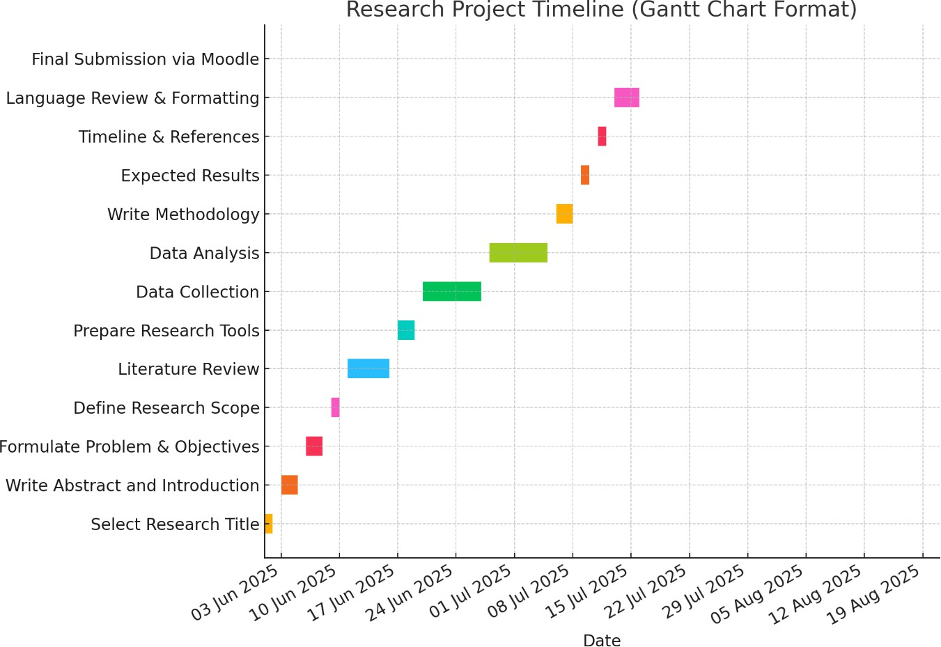

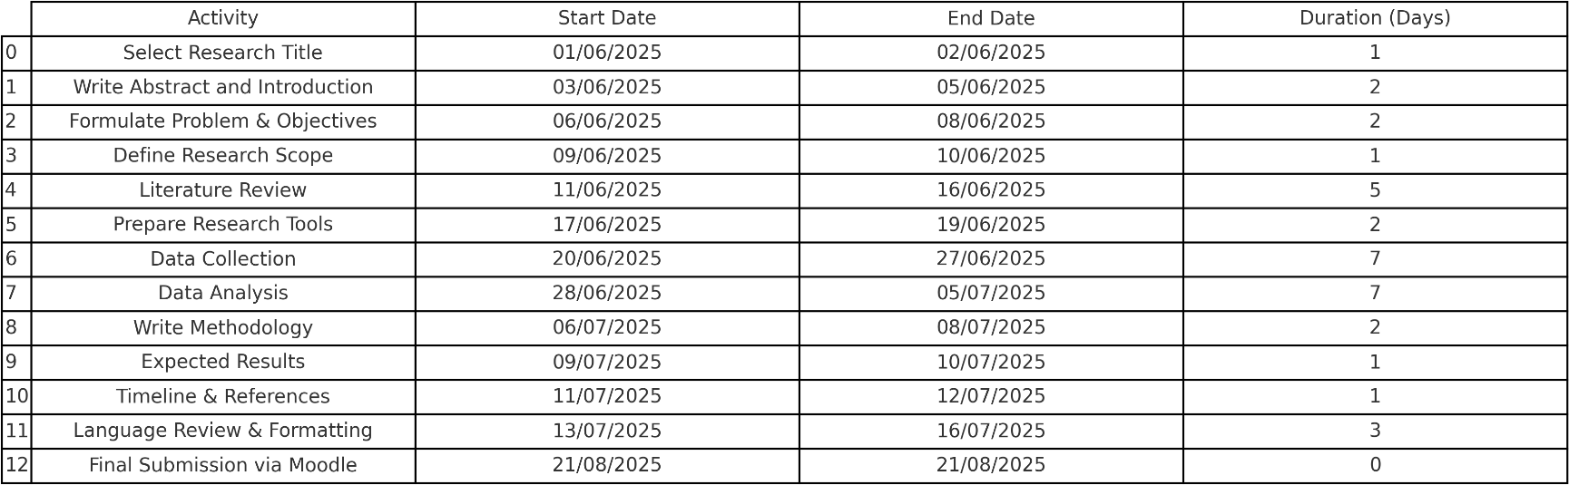

References:
- Hees, M. (2009). The value of IT certifications: Employer and employee perspectives. Journal of Information Technology Education, 8, 141–156.
- Tannian, J., & Coston, A. (2021). Credential creep in cybersecurity: Analyzing the market value of security certifications. In Proceedings of the IEEE International Conference on Cybersecurity and Protection of Digital Services (pp. 87–92).
- Wynn, M., & Liang, Y. (2019). Motivational factors behind IT certification attainment: A behavioral study. Information Systems Research, 30(2), 203–220.
- Fisher, D., & Gonzalez, R. (2020). Bridging the skills gap: The role of certification and experience in IT hiring. Human Resource Development International, 23(1), 72–88.
- Atkinson, R. D. (2018). Certifying competency: The regulation of professional IT credentials. Tech Policy Journal, 5(4), 55–68.
- CompTIA. (2024). IT industry outlook 2024. Retrieved July 30,
2025, from https://www.comptia.org/content/research/it-industry-outlook-2024
- Cisco Learning Network. (n.d.). Certifications overview.
Retrieved July 28, 2025, from
https://learningnetwork.cisco.com/s/certifications
- Project Management Institute (PMI). (n.d.). PMI certifications.
Retrieved July 25, 2025, from
https://www.pmi.org/certifications

