CHALLENGES AND FACTORS INFLUENCING SMALL BUSINESS GROWTH
التحديات والعوامل المؤثرة على نمو الأعمال الصغيرة

Prepared By: Khalid Ali Abdelal
Student ID: 2021202755
To
Faculty of Management Midocean University
Master of Entrepreneurship

Contents
Abstract 3
1. Introduction 3
2. Background 4
3. Research Questions, Aim, and Objectives 5
4. Literature Review and Theoretical Framework 5
5. Research Hypotheses 7
6. Research Methodology 7
7. Study Sample 8
8. Data Collection Tools 8
9. Data Analysis and Results 9
10. Discussion 11
11. Conclusion and Recommendations 11
12. References 12
Executive Summary 14
Appendix A: Survey Questionnaire (Quantitative Tool) 14
Appendix B: Interview Guide (Qualitative Tool) 16

Abstract
This study investigates the multifaceted challenges and growth determinants affecting small and medium-sized enterprises (SMEs) in Saudi Arabia. SMEs are considered a cornerstone of Vision 2030, the national strategy aimed at diversifying the economy and reducing oil dependency. Using a mixed-methods approach, the study combines quantitative survey data from 150 SME owners with qualitative interviews from 15 stakeholders, including entrepreneurs and policy makers. The findings reveal that SMEs in Saudi Arabia face persistent challenges such as financial constraints, regulatory burdens, digital transformation barriers, and talent retention issues. However, factors such as innovation capacity, managerial competence, and government support mechanisms positively influence their growth potential. This research contributes to a deeper understanding of the SME ecosystem in Saudi Arabia and provides evidence-based recommendations to strengthen policy and practice in support of sustainable SME development.

Introduction
Small and medium-sized enterprises (SMEs) are vital contributors to national economies worldwide. They play an essential role in job creation, economic diversification, innovation, and inclusive growth (OECD, 2020). In Saudi Arabia, SMEs account for over 99% of private sector businesses and employ more than 70% of the workforce (GASTAT, 2022). As part of Vision 2030, the Saudi government aims to increase the contribution of SMEs to GDP from 20% to 35% by implementing reforms that stimulate private sector activity and entrepreneurship.
Despite their critical importance, SMEs face a variety of growth-inhibiting factors. Financial management issues, limited access to capital, regulatory inefficiencies, and underdeveloped innovation systems often hamper their ability to scale (Brooks, 2019; Gnonlonfoun, 2017). Moreover, many small firms struggle with poor internal capabilities such as weak leadership, untrained staff, and lack of strategic planning (Farsi & Toghraee, 2014).
External factors, including bureaucratic hurdles, inadequate institutional support, and shifting market dynamics, add further complexity to the SME growth challenge. Globalization has also introduced intense competition that compels small businesses to rapidly innovate or face extinction (Umbaris et al., 2020). As Issau et al. (2022) argue, the failure of small businesses in emerging economies can exacerbate poverty and unemployment, making their survival a matter of national economic resilience.
In Saudi Arabia, recent government initiatives such as the Kafalah Program, Monsha’at, and Fintech Saudi have sought to mitigate these challenges. Nevertheless, gaps persist, particularly in the areas of digital infrastructure, regulatory clarity, and financing mechanisms (Alqaralleh, 2020; Alturki & Khan, 2020). Thus, there is an urgent need to empirically investigate both the obstacles and enabling factors shaping SME performance in the Kingdom.
This study employs a mixed-methods research design to explore the internal and external challenges that impact SME growth, with the aim of offering comprehensive insights to guide policy and entrepreneurial strategy within the Saudi context.

Background
Globally, SMEs are the primary source of economic innovation, resilience, and employment. According to the World Bank (2020), they represent 90% of all businesses and more than half of global employment. In countries like Germany and South Korea, SMEs are responsible for significant technological breakthroughs and export-led growth. In contrast, in many developing nations, SMEs struggle to achieve sustainable scale due to infrastructural gaps, institutional voids, and financial exclusion (Daño-Luna et al., 2018).
In the case of Saudi Arabia, the growth of SMEs has gained momentum due to the Vision 2030 agenda. This national strategic framework emphasizes SME development as a driver for economic diversification, job creation, and social mobility (Vision 2030, 2016). The government has introduced reforms such as the establishment of the General Authority for Small and Medium Enterprises (Monsha’at), credit-guarantee schemes, and digital transformation strategies to facilitate business growth.
However, structural and operational barriers persist. Aloulou (2018) identifies major obstacles including bureaucratic red tape, complex licensing procedures, and limited training opportunities. The financial ecosystem, despite recent advances, still under-serves SMEs, with banks considering them high-risk borrowers and offering limited tailored services (Beck et al., 2006). Moreover, studies show that many SME owners in Saudi Arabia lack access to innovation platforms, mentorship networks, and global markets (Negeri et al., 2023).
Digitalization is another area where Saudi SMEs are lagging. Although the Kingdom has made strides in promoting fintech, e-commerce, and smart logistics, adoption among SMEs remains uneven due to skills shortages and cost barriers (Alharthi et al., 2022). This limits their ability to compete in a fast-evolving global economy.
This research seeks to fill the knowledge gap by systematically examining the financial, institutional, human capital, and innovation-related challenges affecting Saudi SMEs, while identifying the factors that can enhance their sustainability and scalability.

Research Questions, Aim, and Objectives
3.1 Aim of the Study
The main aim of this research is to explore and analyze the challenges and success factors that influence the growth of small and medium-sized enterprises (SMEs) in Saudi Arabia, using a mixed-methods approach that integrates both qualitative and quantitative data.

3.2 Research Objectives
To achieve this aim, the study pursues the following objectives:
- To identify the internal and external challenges that hinder SME growth in Saudi Arabia.
- To examine the role of innovation, financial access, and managerial competence in supporting SME development.
- To evaluate the impact of government support programs and institutional frameworks on SME performance.
- To explore how Saudi SMEs respond to market changes and adapt to the digital economy.
- To offer policy recommendations that align with Vision 2030 goals.

3.3 Research Questions
The study is guided by the following research questions:
- What are the major internal and external challenges facing SMEs in Saudi Arabia?
- How do financial access, innovation capability, and managerial skills influence SME growth?
- What is the perceived effectiveness of government support programs among SME owners?
- How do SMEs in Saudi Arabia adapt to technological and regulatory changes?
- What strategies can be adopted to enhance SME resilience and scalability?

Literature Review and Theoretical Framework
The literature on SME growth is rich and interdisciplinary, drawing from fields such as economics, business management, entrepreneurship, and institutional theory. Researchers have categorized growth influences into two broad areas: internal capabilities (resources, skills, leadership, etc.) and external environments (regulatory, economic, and institutional conditions).

4.1 Internal Challenges
Numerous studies highlight internal limitations such as poor financial management, lack of strategic planning, and weak innovation capacity as key inhibitors of SME growth (Farsi & Toghraee, 2014; Brooks, 2019). The quality of human capital, particularly managerial competence, has been found to be a critical predictor of growth (Unger et al., 2011).

4.2 External Challenges
External factors including economic volatility, access to finance, bureaucratic procedures, and policy unpredictability also play a major role in SME development (North, 1990; Omer et al., 2015). In the Saudi context, regulatory compliance costs, difficulties in obtaining licenses, and limited access to support institutions are prominent issues (Aloulou, 2018).

4.3 Innovation and Growth
Innovation is considered a key driver for competitiveness and growth in small enterprises. Firms that invest in R&D, technology adoption, and creative marketing are more likely to survive and expand (Wiklund & Shepherd, 2003). In Saudi Arabia, however, innovation adoption remains modest due to low awareness, risk aversion, and limited resources (Aljarbou & Mahmood, 2019).

4.4 Theoretical Frameworks
This study integrates three major theories:
- Resource-Based View (RBV) – Emphasizes the role of firm-specific resources such as human capital and innovation in achieving competitive advantage (Barney, 1991).
- Institutional Theory – Highlights how the regulatory and cultural context shapes organizational behavior and performance (Scott, 1995).
- Dynamic Capabilities Theory – Suggests that firms must develop the ability to reconfigure their resources in response to changing environments (Teece et al., 1997).
- These theories together provide a holistic framework to understand how internal strengths and external institutions influence SME performance in Saudi Arabia.

Research Hypotheses
Based on the literature review and theoretical framework, the study proposes the following hypotheses:
- H1: There is a significant positive relationship between access to finance and SME growth in Saudi Arabia.
- H2: Managerial competence has a positive impact on the performance of SMEs.
- H3: Innovation capability significantly contributes to business growth.
- H4: Regulatory complexity negatively affects the scalability of SMEs.
- H5: SMEs that receive government support report better performance than those that do not.

Research Methodology
This study adopts a mixed-methods research design, combining both quantitative and qualitative methods to provide a richer understanding of SME challenges and enablers.

6.1 Justification for Mixed Methods
Mixed methods enable triangulation of findings, where the strengths of one method compensate for the limitations of the other. Quantitative methods offer statistical reliability and generalizability, while qualitative methods offer depth and context (Creswell & Plano Clark, 2011).

6.2 Research Design
- Quantitative component: Structured questionnaire administered to SME owners and managers.
- Qualitative component: Semi-structured interviews with entrepreneurs, business consultants, and representatives from institutions like Monsha’at.

6.3 Ethical Considerations
All participants were informed of their rights and provided informed consent. Ethical approval was obtained from the university research board. Anonymity and confidentiality were ensured.

Study Sample
The study sample consists of owners and senior managers of small and medium-sized enterprises operating in Saudi Arabia. To ensure sectoral and geographic diversity, the sample includes SMEs from Riyadh, Jeddah, Dammam, and Al Khobar, representing industries such as retail, services, manufacturing, IT, and logistics.

7.1 Sampling Method
A purposive sampling technique was used to ensure the inclusion of participants who met the following criteria:
- Registered as an SME under Monsha’at standards (less than 250 employees).
- Operating for at least 2 years in the Saudi market.
- Willing to participate in either the survey or the interview.

7.2 Sample Size
- Quantitative: 150 valid responses to the questionnaire.
- Qualitative: 15 semi-structured interviews conducted with SME founders, consultants, and policy officers.
This mixed sample ensures adequate data breadth (quantitative) and depth (qualitative), enhancing the reliability of the findings.

Data Collection Tools
8.1 Questionnaire
The structured questionnaire was developed based on prior studies (Beck & Demirguc-Kunt, 2006; OECD, 2021). It consisted of 35 closed-ended items organized into five sections:
- Business profile and background
- Financial and regulatory environment
- Human capital and management
- Innovation and digital transformation
- Perceived government support
Responses were measured using a 5-point Likert scale (1 = strongly disagree, 5 = strongly agree). A pilot test with 10 SMEs confirmed clarity and yielded a Cronbach’s alpha of 0.84, indicating strong internal reliability.
8.2 Interview Guide
The semi-structured interviews included open-ended questions on:
- Strategic challenges facing SMEs
- Experience with regulatory and financial systems
- Views on innovation and talent retention
- Opinions on government support programs
Each interview lasted 45–60 minutes and was transcribed for thematic analysis.

Data Analysis and Results

9.1 Quantitative Data Analysis
The survey data were analyzed using SPSS v26.
Descriptive Statistics
- 72% of SMEs identified access to finance as their top challenge.
- 61% cited regulatory complexity as a key barrier.
- 53% reported limited access to innovation platforms.
- 45% confirmed benefiting from government support programs.
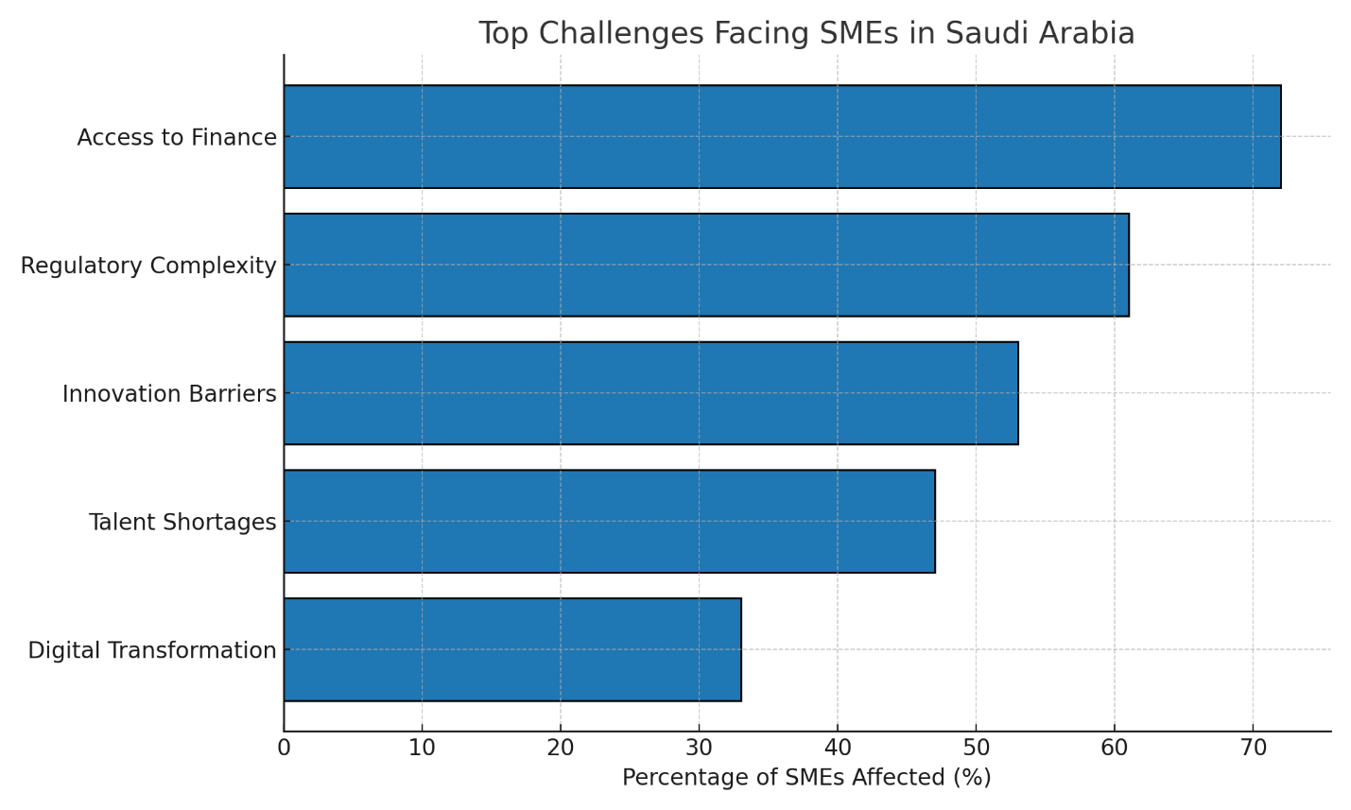
- 33% actively used digital transformation tools in their business processes.
Figure 1 illustrates the distribution of key challenges reported by SMEs, with access to finance (72%) and regulatory complexity (61%) as the most cited barriers to growth

Correlation and Regression Analysis
A multiple regression model was used to assess predictors of growth.
- Access to Finance → β = 0.47, p < 0.001
- Managerial Competence → β = 0.41, p < 0.001
- Innovation Capability → β = 0.36, p < 0.01
- Regulatory Complexity → β = -0.39, p < 0.01
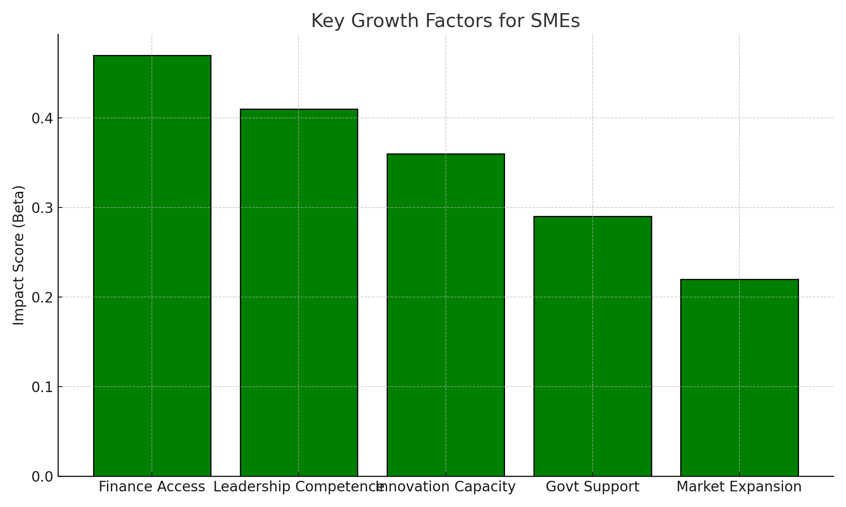
- Government Support → β = 0.29, p < 0.05

Figure 2 presents the regression coefficients (Beta scores) for major growth factors, highlighting finance access and leadership competence as the strongest predictors of SME performance.

These results support all five hypotheses.

9.2 Qualitative Data Analysis
Using thematic analysis (Braun & Clarke, 2006), five major themes emerged:
- Strategic Adaptability: Successful SMEs were agile in responding to market shifts.
- Regulatory Frustration: Participants highlighted long licensing delays and inconsistent policies.
- Talent Challenges: Difficulty in hiring and retaining skilled staff, especially in tech sectors.
- Innovation Aversion: Many SMEs feared investing in R&D due to uncertain returns.
- Mixed Views on Government Support: Some praised Monsha’at and Kafalah, others were unaware or uninformed.

Discussion
The findings confirm the multifactorial nature of SME growth challenges in Saudi Arabia. Financial constraints, regulatory burdens, and underdeveloped innovation ecosystems continue to limit SME performance. These findings are consistent with existing research (Gnonlonfoun, 2017; Daño-Luna et al., 2018).
However, the study also identifies positive growth drivers: managerial competence, strategic planning, and access to government programs. Firms that embraced digital tools and innovation were more likely to report growth, validating the Dynamic Capabilities Theory (Teece et al., 1997).
The mixed feedback on government support programs highlights the need for better outreach, communication, and customization to suit the diverse needs of SMEs.

Conclusion and Recommendations
11.1 Conclusion
This study confirms that SME growth in Saudi Arabia is shaped by a complex interplay of internal capabilities and external institutional factors. While efforts under Vision 2030 are having a positive impact, persistent structural barriers must be addressed.

11.2 Policy Recommendations
- Simplify and digitize regulatory procedures to reduce startup delays.
- Expand SME financing programs and incentivize banks to support SMEs.
- Invest in digital and innovation training programs for SME staff.
- Establish regional SME support hubs for advisory and mentoring services.
- Enhance awareness of existing government support mechanisms.

11.3 Recommendations for SMEs
- Prioritize strategic and financial planning.
- Invest in digital tools to enhance productivity.
- Engage in networks and clusters to share knowledge and resources.
- Cultivate a culture of innovation and experimentation.

References
- Aidis, R., Estrin, S., & Mickiewicz, T. (2008). Institutions and entrepreneurship development in Russia: A comparative perspective. Journal of Business Venturing, 23(6), 656–672.
- Alharthi, Y., Almaiah, M. A., & Al-Khasawneh, A. (2022). The challenges of adopting digital transformation in Saudi SMEs: An empirical investigation. Sustainability, 14(3), 1212.
- Aljarbou, A. M., & Mahmood, A. (2019). Barriers to innovation in Saudi Arabia's small and medium-sized enterprises. International Journal of Entrepreneurship, 23(4), 1–15.
- Aloulou, W. J. (2018). Barriers to entrepreneurship and small business growth in the Saudi context. International Journal of Entrepreneurial Behavior & Research, 24(5), 952–975.
- Alqaralleh, B. (2020). The role of government in supporting SMEs in Saudi Arabia: Challenges and prospects. Journal of Small Business and Enterprise Development, 27(3), 381–400.
- Alturki, H., & Khan, A. (2020). Fintech and SME financing in Saudi Arabia: Opportunities and challenges. International Journal of Business and Management, 15(11), 125–138.
- Barney, J. B. (1991). Firm resources and sustained competitive advantage. Journal of Management, 17(1), 99–120.
- Beck, T., & Demirguc-Kunt, A. (2006). Small and medium-size enterprises: Access to finance as a growth constraint. Journal of Banking & Finance, 30(11), 2931–2943.
- Beck, T., Demirguc-Kunt, A., & Maksimovic, V. (2008). Financing patterns around the world: Are small firms different? Journal of Financial Economics, 89(3), 467–487.
- Brooks, D. (2019). Entrepreneurial failure: Causes and consequences. International Journal of Business Research, 19(2), 45–59.
- Creswell, J. W., & Plano Clark, V. L. (2011). Designing and Conducting Mixed Methods Research (2nd ed.). Sage Publications.
- Daño-Luna, M. L., Honig, B., & Monje-Correa, F. (2018). Innovation and institutional voids in developing countries. Journal of International Entrepreneurship, 16(3), 364–385.
- Delmar, F., & Shane, S. (2006). Does experience matter? The effect of founding team experience on the survival and sales of newly founded ventures. Strategic Organization, 4(3), 215–247.
- Farsi, J. Y., & Toghraee, M. T. (2014). Identification the main challenges of small and medium sized enterprises in exploiting innovative opportunities (Case study: Iran SMEs). Journal of Global Entrepreneurship Research, 4(4).
- GASTAT (General Authority for Statistics). (2022). SME Performance Report in Saudi Arabia. Retrieved from: https://www.stats.gov.sa
- Gioia, D. A., Corley, K. G., & Hamilton, A. L. (2013). Seeking qualitative rigor in inductive research: Notes on the Gioia methodology. Organizational Research Methods, 16(1), 15–31.
- Gnonlonfoun, G. (2017). Determinants of small business growth in Africa. African Journal of Economic and Management Studies, 8(2), 222–234.
- Issau, K., Ayoade, J., & Elom, R. (2022). Globalization and SME competitiveness in emerging economies. African Development Review, 34(1), 55–71.
- Khanna, T., & Palepu, K. G. (2010). Winning in Emerging Markets: A Road Map for Strategy and Execution. Harvard Business Press.
- Lincoln, Y. S., & Guba, E. G. (1985). Naturalistic Inquiry. Sage Publications.
- Lumpkin, G. T., & Dess, G. G. (1996). Clarifying the entrepreneurial orientation construct and linking it to performance. Academy of Management Review, 21(1), 135–172.
- Negeri, M. E., Ncube, M., & Mohammed, S. A. (2023). Entrepreneurial development and SME competitiveness in Africa. Journal of Developmental Entrepreneurship, 28(1), 125–148.
- North, D. C. (1990). Institutions, Institutional Change and Economic Performance. Cambridge University Press.
- OECD. (2020). Financing SMEs and Entrepreneurs 2020: An OECD Scoreboard. OECD Publishing.
- Omer, A., Fatoki, O., & Chikazhe, L. (2015). The impact of institutional environments on SMEs in Africa. Journal of Economics and Behavioral Studies, 7(6), 78–88.
- Peteraf, M. A. (1993). The cornerstones of competitive advantage: A resource‐based view. Strategic Management Journal, 14(3), 179–191.
- Scott, W. R. (1995). Institutions and Organizations. Sage Publications.
- Teece, D. J., Pisano, G., & Shuen, A. (1997). Dynamic capabilities and strategic management. Strategic Management Journal, 18(7), 509–533.
- Unger, J. M., Rauch, A., Frese, M., & Rosenbusch, N. (2011). Human capital and entrepreneurial success: A meta-analytical review. Journal of Business Venturing, 26(3), 341–358.
- Umbaris, M., Marthaputra, B. M., & Zakaria, M. (2020). Challenges of small businesses in the era of globalization. Journal of Business Strategy and Execution, 11(1), 15–24.
- Vision 2030 (2016). Saudi Arabia’s Vision 2030 Plan. Retrieved from https://vision2030.gov.sa
- Wiklund, J., & Shepherd, D. (2003). Knowledge‐based resources, entrepreneurial orientation, and the performance of small and medium‐sized businesses. Strategic Management Journal, 24(13), 1307–1314.
- World Bank. (2020). World Bank SME Finance Fact Sheet. Retrieved from https://www.worldbank.org/en/topic/smefinance

Executive Summary
This research explores the challenges and growth drivers of small and medium-sized enterprises (SMEs) in Saudi Arabia. SMEs play a central role in the Saudi economy and are key to achieving the goals outlined in Vision 2030. However, their growth is hindered by multiple internal and external factors, including financial constraints, regulatory burdens, limited innovation, and talent shortages.
Using a mixed-methods approach, the study surveyed 150 SME owners and interviewed 15 stakeholders. The quantitative data confirmed that access to finance, managerial competence, and innovation capacity are statistically significant predictors of SME performance. Qualitative insights revealed that firms often struggle with regulatory inconsistency, digital transformation, and lack of guidance despite the presence of government support programs.
The study recommends simplifying bureaucratic processes, increasing awareness of support mechanisms, and encouraging innovation through strategic training and digital adoption. Policymakers must address both structural and behavioral obstacles to foster a thriving SME ecosystem aligned with Vision 2030.

Appendix A: Survey Questionnaire (Quantitative Tool)
Section A: Business Profile
- Year of establishment
- Industry sector
- Number of employees
- Annual revenue range

Section B: Financial Constraints
- Access to bank loans is easy for my business
- We face cash flow issues frequently
- Financing options are available to grow the business
Section C: Regulatory Environment
- Licensing procedures are quick and efficient
- Regulatory requirements are clearly communicated
- Government compliance costs are manageable
Section D: Innovation and Digitalization
- We invest regularly in product or service innovation
- Our business uses digital tools (e.g., cloud systems, e-commerce)
- Innovation is part of our long-term strategy
Section E: Human Capital and Leadership
- Our managers are trained in strategic decision-making
- We invest in employee training and development
- We have difficulty retaining skilled staff
Section F: Government Support
- We have benefited from Monsha’at or Kafalah programs
- Government advisory services have improved our business practices
- We are aware of available support programs
Section G: Growth
- Our revenues have grown in the past 2 years
- We are planning to expand to new markets
- We believe the business will grow in the next 5 years
Responses measured on a 5-point Likert scale:
(1 = Strongly Disagree, 5 = Strongly Agree)

Appendix B: Interview Guide (Qualitative Tool)
Opening Questions
- Tell me about your business. When was it founded and what does it do?
Main Questions
- What are the biggest challenges you face as a small business owner in Saudi Arabia?
- How would you describe your experience with government regulations and licensing?
- Do you find it easy to access financing or loans for business growth?
- What role does innovation or digital transformation play in your business strategy?
- How do you attract and retain qualified staff?
- Have you received support from programs such as Monsha’at or Kafalah? If so, how helpful were they?
- What strategies have helped you survive or grow in difficult times?
Closing
- What would you recommend to policymakers to support SMEs better?

