Lesson summary: Market equilibrium, disequilibrium, and changes in equilibrium

In this lesson summary review and remind yourself of the key terms and graphs used in the analysis of markets. Topics include how to use a market model to predict how price and quantity change in a market when demand changes, supply changes, or both supply and demand change.

In a competitive market, demand for and supply of a good or service determine the equilibrium price.

Equilibrium
MARKETS: Equilibrium is achieved at the price at which quantities demanded and supplied are equal. We can represent a market in equilibrium in a graph by showing the combined price and quantity at which the supply and demand curves intersect.
For example, imagine that sellers of a good X are willing to sell 500 units of this good at a price of
$ 5 dollar per unit. If buyers are willing to buy 500 units of this good X at that price, this market would be in equilibrium at the price of , 5 and at the quantity of $ 5 and at the quantity of 500 units.

Disequilibrium
Whenever markets experience imbalances—creating disequilibrium prices, surpluses, and shortages—market forces drive prices toward equilibrium.
A surplus exists when the price is above equilibrium, which encourages sellers to lower their prices to eliminate the surplus.
A shortage will exist at any price below equilibrium, which leads to the price of the good increasing.
For example, imagine the price of a good Y is currently $ 6 dollar per unit. People only want to buy 400 cans units of the good Y, but the sellers are willing to sell 600 units at that price. This creates a surplus because there are unsold units. Sellers will lower their prices to attract buyers for their unsold units of the good Y.

Changes in equilibrium
Changes in the determinants of supply and/or demand result in a new equilibrium price and quantity. When there is a change in supply or demand, the old price will no longer be an equilibrium. Instead, there will be a shortage or surplus, and price will subsequently adjust until there is a new equilibrium.
For example, suppose there is a sudden invasion of aggressive unicorns. There will be more people who want to buy unicorn repellent at all possible prices, causing demand to increase. At the original price, there will be a shortage of unicorn repellant, signaling sellers to increase the price until the quantity supplied and quantity demanded are once again equal.
We can summarize the changes in equilibrium with the following table:
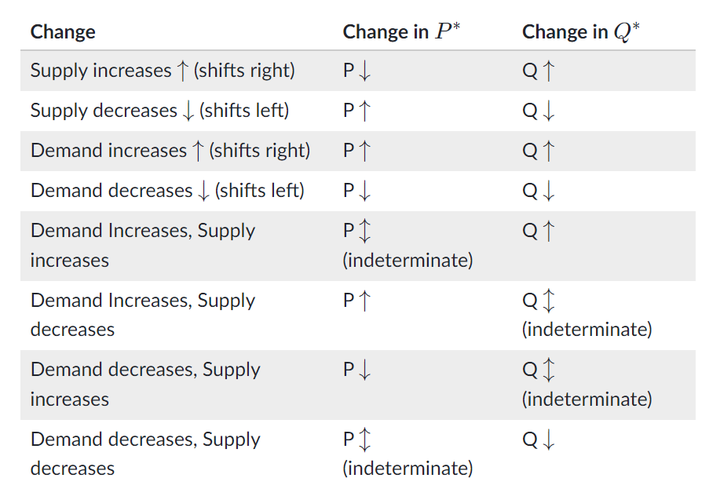
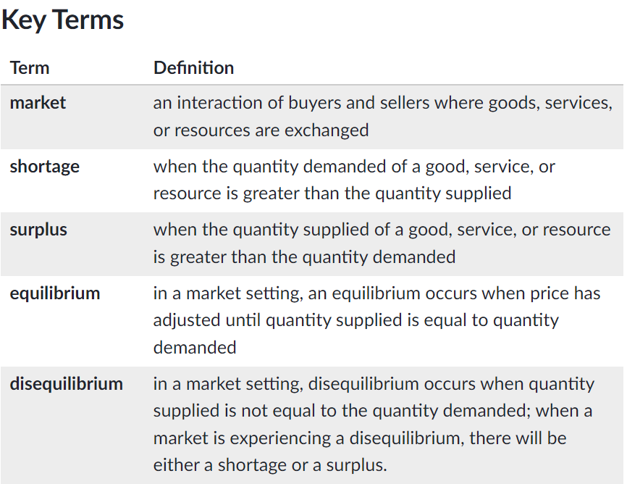
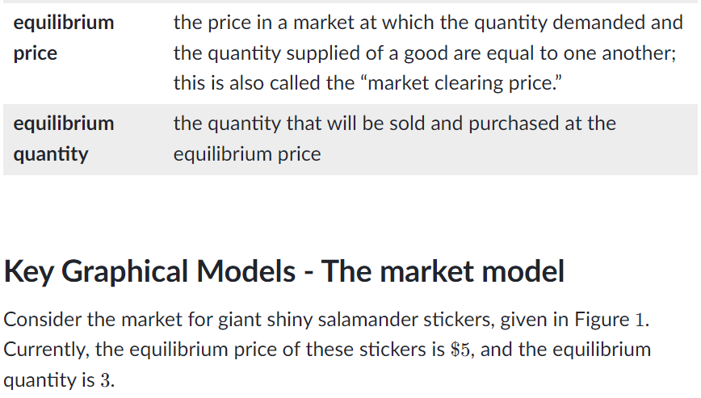
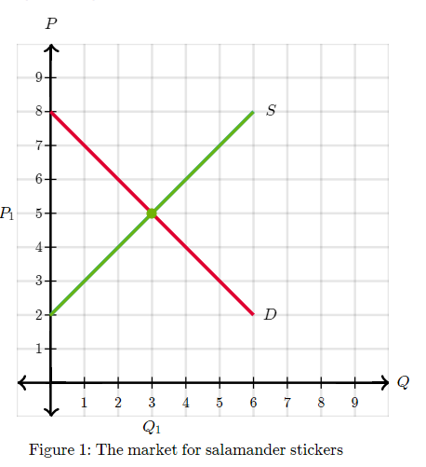
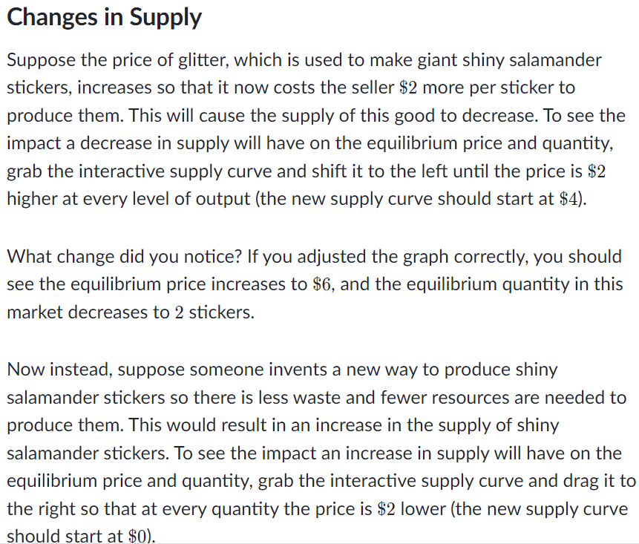
How did you do? If you adjusted the graph correctly, you should see the equilibrium price decreases to $ 4 and equilibrium quantity increases to 444 stickers.

Changes in demand
Suppose a famous, trendsetting actress starts wearing giant shiny salamander stickers, which makes them instantly the must-have accessory. This would cause the demand for this good to increase. To see the impact on equilibrium price and quantity in the market from an increase in demand, grab the demand curve Figure 2 and shift it to the right to represent an increase in demand.
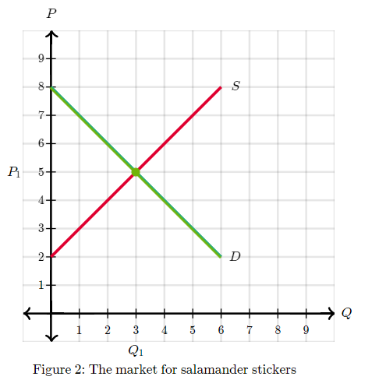

Changes in both demand and supply
When both supply and demand change at the same time, the impact on equilibrium price and quantity cannot be determined for certain without knowing which changed by a greater amount.
Suppose shiny salamander stickers fall out of popularity, and therefore the demand for them decreases. At the same time, the price of glitter goes up, which leads to a decrease in supply.
On the one hand, the decrease in demand should make price decrease and quantity demanded decrease.On the other hand, the decrease in supply should also make price __increase and quantity demanded decrease. That means we know for certain that the quantity of giant shiny salamander stickers will decrease. But what will happen to price?
In Figure 3, we see a decrease in supply and a decrease in demand. The effect on quantity is easy to determine (quantity will definitely decrease). On the other hand, it is hard to tell if the equilibrium price has increased, decreased, or stays the same. Because we cannot say which of these has happened with certainty, we say that the price change is indeterminate or ambiguous.
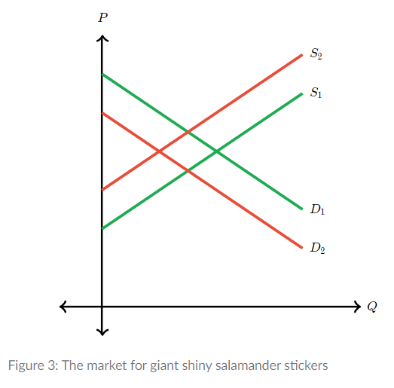

Of course, when modeling changes in a graph it is possible to see changes in both equilibrium price and quantity when shifting both demand and supply (depending on how much each curve shifts). In the interactive graph below, move both demand and supply in different directions. Each time, move the equilibrium point to the new intersection of demand and supply. Try to create new equilibria at which:
- Price is higher and quantity is higher
- Price is higher and quantity is lower
- Price is lower and quantity is higher
- Price is lower and quantity is lower



