Chapter 5 Conclusion and Future Work

5.1 Introduction
This chapter concludes the thesis by summarising the study, drawing together the key findings reported in Chapter 4, revisiting the objectives set out in Chapter 1, acknowledging the limitations of the current work, and outlining a set of future enhancements that would extend the proposed system towards full operational deployment.

5.2 Summary of the Study
This thesis set out to address a specific operational problem at Riyadh Metro: crowd management that is reactive rather than predictive, relying on manual visual detection by Operations Control Centre (OCC) controllers, static hand-written timetables, and siloed data sources that are never combined into a single crowd-intelligence signal. To address this problem, the thesis proposed an autonomous AI-based dispatch and timetabling system that fuses Automatic Fare Collection (AFC) gate records with CCTV-based computer vision and existing timetable data, and uses two cooperating machine-learning models — a Random Forest dispatch classifier and a Gradient Boosting timetable forecaster — to predict crowding and automatically generate dispatch actions and a four-week train schedule. The methodology was described in Chapter 3, and the resulting system was evaluated in Chapter 4 on a 25,536-record dataset spanning 12 stations and 16 weeks of operations.

5.3 Key Findings and Achievements
The experimental results reported in Chapter 4 demonstrate that the proposed approach meets the objectives established in Chapter 1. The key achievements of this work are summarised below.
• 99.7% dispatch accuracy, with a macro F1-score of 0.995 across all four dispatch classes, including the safety-critical Critical class.
• Three data sources successfully fused into a single occupancy signal: AFC gate records, CCTV computer vision, and the timetable system.
• A validated dataset of 25,536 records across 16 operational weeks, used to train and evaluate both AI models.
• 6,384 time slots autonomously timetabled four weeks ahead, comprising 3,501 train insertions and 1,445 train reductions.
• SHAP-based explainability, allowing the system to justify every dispatch decision to human reviewers.
• Zero human input required for routine dispatch operations once the pipeline is configured.
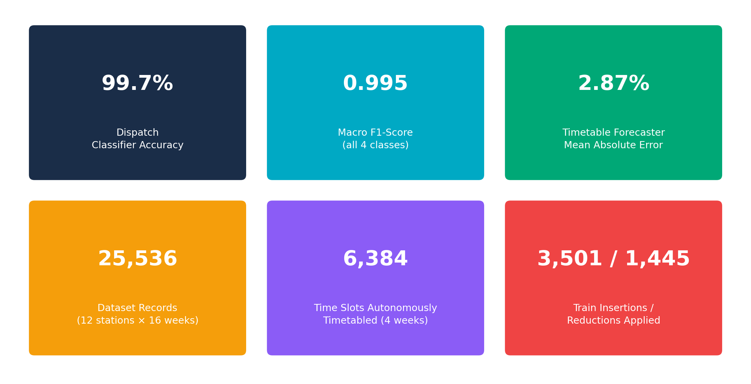
Figure 5.1: Summary of key results and achievements
Taken together, these results support the central conclusion of this thesis: that AI can replace manual dispatch decisions, manage crowding proactively rather than reactively, and make metro operations both safer and more efficient, without requiring changes to the metro's existing physical infrastructure.

5.4 Limitations
While the results obtained are strong, several limitations of the current study should be acknowledged before the proposed system is considered for real-world deployment.

5.4.1 Synthetic Dataset
The dataset used to train and evaluate the models was synthetically generated to mirror realistic Riyadh Metro operational patterns, rather than drawn from genuine OCC operational history. Although the data generation process was designed to reflect real station-level dynamics, using real AFC and CCTV exports would likely improve model accuracy further and would be necessary to validate the system's real-world reliability.

5.4.2 CCTV Pipeline Not Yet Live
The CCTV and YOLOv8 computer-vision pipeline is architecturally complete but has not yet been connected to a real IP camera API. Its performance was therefore validated against simulated camera data rather than live video feeds, and integration with a genuine camera network remains a prerequisite for operational use.

5.4.3 Absence of Ground-Truth Validation
Crowd estimation derived from AFC data is a proxy for the true number of passengers on a platform. Validation against manual platform headcounts or an independent ground-truth measurement has not yet been performed, and would strengthen confidence in the absolute accuracy of the fused occupancy signal, beyond the relative accuracy already demonstrated in Chapter 4.

5.4.4 Four-Week Forecasting Horizon
The timetable forecaster was designed and evaluated for a four-week planning horizon. Forecasting accuracy is expected to degrade beyond this horizon, and longer-range forecasting would require additional seasonal data covering a longer historical period than the 16 weeks used in this study.

5.5 Future Work
Building on the limitations identified above, four directions for future work are proposed to extend this thesis towards a fully deployable operational system.

5.5.1 LSTM-Based Time-Series Modelling
Replacing the Gradient Boosting Regressor with a Long Short-Term Memory (LSTM) network would allow the timetable forecaster to model multi-hour lookahead patterns and long-term seasonal trends more explicitly than the current tree-based approach, potentially extending the reliable forecasting horizon beyond four weeks.

5.5.2 Live API Integration
Connecting the pipeline directly to the real AFC and CCTV APIs would allow the system to operate on live data rather than historical exports, enabling real-time five-minute prediction cycles and removing the dependency on the synthetic dataset used in this study. Because the architecture was designed around the same feature structure a real AFC export would produce, this transition is expected to require no changes to the underlying models, only a new data-ingestion connector.

5.5.3 OCC Mobile Application
Delivering critical dispatch alerts directly to controller smartphones, with a one-tap approval workflow, would integrate the system more closely into existing OCC operating procedures and provide a human checkpoint for the highest-severity dispatch recommendations during the transition to full autonomy.

5.5.4 Multi-Line Scaling
The current study is scoped to Line 3. Extending the proposed methodology to all Riyadh Metro lines, with cross-line capacity balancing, would allow the system to manage crowding and dispatch decisions network-wide rather than on a single line in isolation.
Current Limitation | Proposed Future Enhancement
Synthetic dataset | Retrain and validate on real OCC operational data
CCTV pipeline not live | Connect to the real IP camera API
No ground-truth validation | Validate against manual platform headcounts
Four-week forecasting horizon | Adopt an LSTM model for longer-range forecasting
Single-line scope (Line 3) | Extend to all metro lines with cross-line balancing
Table 5.1: Current limitations mapped to proposed future enhancements
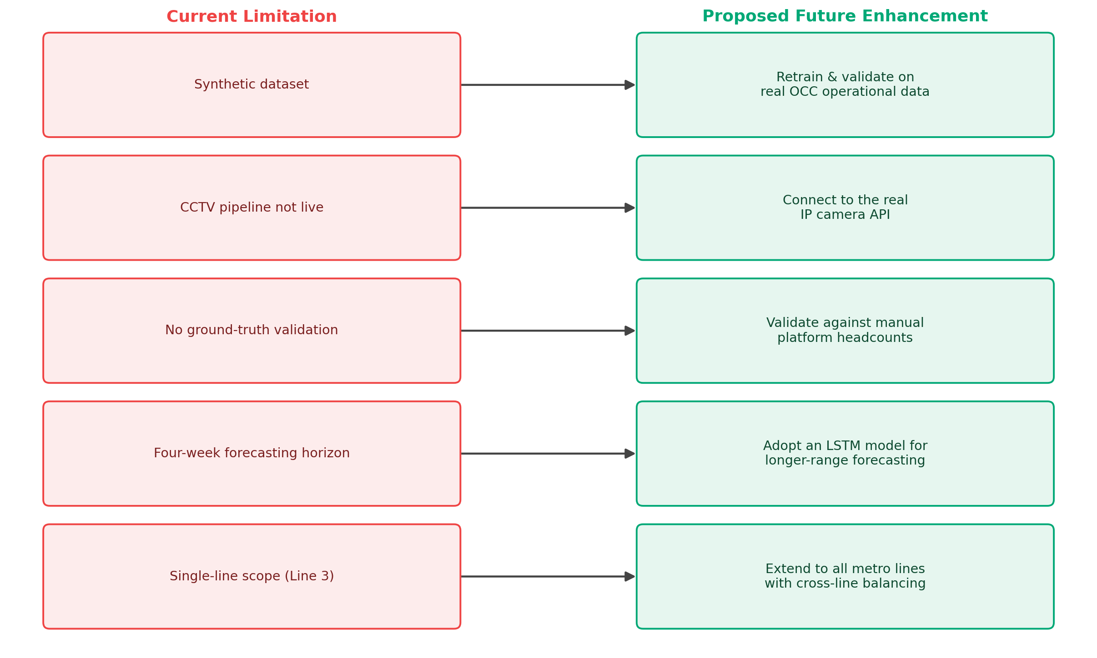
Figure 5.2: Current limitations mapped to proposed future enhancements

5.6 Conclusion
This thesis has presented, implemented and evaluated an autonomous AI-based approach to metro crowd management and train dispatch, fusing AFC gate data with CCTV computer vision and existing timetable information to replace reactive, manually written dispatch decisions with a predictive, explainable, and largely automated alternative. The proposed system achieved 99.7% dispatch accuracy and autonomously generated a complete four-week timetable across 12 stations, while SHAP-based explainability ensured that its decisions remain interpretable to human operators. Although the study's synthetic dataset and offline CCTV validation mean that real-world deployment will require further work, as outlined in Section 5.5, the results obtained demonstrate that the proposed approach is technically viable and provides a credible foundation for transforming Riyadh Metro's crowd management from a reactive, manual process into a proactive, autonomous one.

