
Midocean University
Faculty of Management
Department / Business Administration

Research Title
The Role of PMO in Infrastructure Projects in Saudi Arabia
Alignment with Vision 2030
A Case Study of Al Madinah Infrastructure Projects

Prepared by: Hamza Abbas
Academic ID No: 243001549

Supervision:
Dr. Al-Faisal Abdul Hamid
Dr. Fayez Jirad

Academic Year:
2025

Copyright notice
The copyright is owned by Midocean University because everything that is contained and included in this study belongs to the university. These cannot be reproduced, reused, or published without the prior permission of the university.

Abstract
This research discusses how Project Management Offices (PMOs) take center stage when administering infrastructure initiatives in Al Madinah, Saudi Arabia, and how infrastructure projects in this country will help achieve the objectives of Vision 2030. Vision 2030 will decrease the oil-dependent nature of Saudi Arabian economy as well as diversifying it by means of economic sectors like urban development, sustainability and technological innovation. The paper identifies some of the distinctive issues Al Madinah, a sacred city that is experiencing a surge in urban development, faces, in terms of the ongoing rapid population growth and urban sprawl because of its status as a destination city of the Hajj pilgrimage and one of the Umrah pilgrimages.
The research examines the activities of PMOs in Al Madinah with respect to their organizational structure, governance, resource management, stakeholder coordination and digital tool and sustainability integration. The combination of mixed methods (document review, survey of 306 professionals) provides data that suggests that PMOs have the vital task of making sure that infrastructure projects are ready in line with Vision 2030. The research notes the difficulties of achieving the dual objective of increasing urban growth and maintaining culture, as well as managing the interests of various stakeholders in the project, whereas the research defines practices helping in implementing projects successfully.
The key results are that good governance structure, effective stakeholder involvement, and the adoption of digital technologies including Building Information Modeling (BIM) are paramount to the success of PMO. There is also the emphasis on integration of sustainability practices which is evident in the study though there are challenges related to the perceived cost of the practice. Through these insights, the paper has provided suggestions regarding how to develop PMO practices in Al Madinah, such as establishing decision making to ensure its formality, digital tools use, and sustainability issue importance in project planning.
The study will be of significant value in providing practical suggestions and adding to the body of knowledge on transportation infrastructure project management practices in the mid-sized cities and offer direction on how to go about enhancing the efficiencies of infrastructure project management in line with Vision 2030 objectives of the Kingdom of Saudi Arabia.
Keywords: Project Management Offices (PMOs), Infrastructural Projects, Al Madinah, Vision 2030, Governance, Stakeholders Mobilization, Digital Technology, Sustainability, Urban Development.
Acknowledgments
I am truly grateful to Midocean University for its constant support and supervision during the research. Special thanks go to my academic mentors, Dr. Al-Faisal Abdul Hamid and Dr. Fayez Jirad, for their critical feedback, constructive criticisms, and kind services that molded this project.
I want to express my sincere appreciation to many experts from across the departments and institutions of Al Madinah who voluntarily devoted their time and expertise, leading to exhaustive knowledge of the research issue. Their willingness to contribute their professional expertise has been instrumental to the successful completion of this research project.
I also want to thank my relatives and friends who have been a constant inspiration with their encouragement. It has been their trust in my potential that has motivated me throughout.
Finally, I would wish to recognize the administrative and academic members of the Faculty of Management, Midocean University, whose diligence and commitment ensured academic life was smoothened.
This research is a result of efforts by many individuals, and I appreciate each of them for their collaboration.

Table of content

Chapter 1 (General Framework of the Study) 12
1.1 Introduction 13
1.2 Research Problem 15
1.3 Significance of the Study 16
1.4 Research Objectives 17
1.4.1 Primary Objective: 17
1.4.2 Sub-objectives: 17
1.5 Research Questions 18
1.6 Research Hypotheses 19
1.7 Theoretical Model 20
1.8 Research Gap 21
1.9 Chapter Summary 22
Chapter 2 (Literature Review) 23
2.1 Introduction 24
2.2 Dependent Variable: 25
2.2.1 Alignment of Infrastructure Projects with Vision 2030: 25
2.3 Independent Variables: 26
2.3.1 PMO Governance: 26
2.3.2 Stakeholder Coordination: 26
2.3.3 Digital Tool Utilization: 27
2.3.4 Sustainability Practices: 27
2.4 Previous Studies 28
2.5 Theoretical Framework 32
2.6 Research Gap and Contribution 32

List of Tables
Table 1-2: Summary for literature reviews……………………………………………….32

List of Figures
Figure 1-1: Madinah Undergoing Projects ……………………………..….……………..16
Figure 1-2: Dependent and Independent Variables……………………………………….27

List of terminology
- PMO (Project Management Office)
A centralized unit within an organization responsible for overseeing and standardizing project management practices to ensure that projects align with organizational goals and are completed on time, within budget, and to the desired quality standards.
- Vision 2030
Saudi Arabia's long-term strategic framework aimed at diversifying the Kingdom’s economy, reducing reliance on oil, and positioning the country as a global leader in multiple sectors including infrastructure, technology, tourism, and culture.
- Infrastructure Projects
Large-scale projects designed to enhance the physical and organizational structures needed for the functioning of a society, such as transportation networks, utilities, and urban development.
- Urbanization
The process by which more of a population moves from rural to urban areas, leading to the growth and expansion of cities.
- Al Madinah
A city in Saudi Arabia, known as one of the holiest cities in Islam, and a significant site for pilgrimage, which presents unique challenges for infrastructure development.
- Stakeholder Coordination
The process of managing and aligning the interests of all parties involved in a project, such as government bodies, contractors, religious authorities, and local communities.

- Sustainability
The practice of managing resources in such a way that meets current needs without compromising the ability of future generations to meet their own needs, particularly in relation to environmental, social, and economic factors.
- Governance Framework
The structure of policies, procedures, and guidelines that direct the management and execution of projects, ensuring transparency, accountability, and alignment with broader strategic objectives.
- Digital Tool Utilization
The adoption and integration of digital technologies such as Building Information Modeling (BIM), project management software, and cloud-based platforms to improve efficiency, communication, and monitoring of projects.
- Economic Diversification
A strategic effort to reduce dependency on a single economic sector (like oil) by promoting other sectors such as technology, tourism, and infrastructure to create a more balanced economy.
- Project Alignment with Vision 2030
Ensuring that infrastructure projects and other initiatives are in sync with the long-term goals and objectives of Saudi Arabia’s Vision 2030, including economic diversification, sustainability, and technological advancement.
- Resource Management
The process of planning, allocating, and managing the resources (financial, human, material) is needed to achieve project goals efficiently and effectively.
- Regulatory Compliance
The process of ensuring that all aspects of a project comply with relevant laws, regulations, and standards set by governmental bodies or industry-specific authorities.
- Building Information Modeling (BIM)
A digital representation of physical and functional characteristics of a building or infrastructure, used for planning, design, construction, and operation, enhancing project efficiency and reducing errors.
- Stakeholder Engagement
Actively including stakeholders in decision-making, making sure that their interests are considered, and keeping them updated and involved at every stage of the project's lifecycle.
- Urban Growth
Urban areas' growth and development as a result of rising economic activity and population, which calls for improved infrastructure to meet growing demands.
- Strategic Goals
Long-term goals like economic growth, technological innovation, and sustainability that direct organizational procedures and project direction.
- Cultural Preservation
The endeavor to preserve and safeguard a community's or region's cultural heritage, values, and customs while it develops and modernizes.
- Risk Management
The procedure for locating, evaluating, and managing risks that might have an impact on a project's successful completion.
- Public-Private Partnerships (PPP)
Partnerships between the public and private sectors to finance, construct, and run infrastructure projects with the goal of utilizing each sector's advantages.

List of abbreviations
- PMO - Project Management Office
- BIM - Building Information Modeling
- PPP - Public-Private Partnership
- Vision 2030 - Saudi Arabia’s Vision 2030
- KSA - Kingdom of Saudi Arabia
- GDP - Gross Domestic Product
- S.M.A.R.T. - Specific, Measurable, Achievable, Relevant, Time-bound
- SOP - Standard Operating Procedure
- KMO - Kaiser-Meyer-Olkin
- IRB - Institutional Review Board
- EFA - Exploratory Factor Analysis
- SPI - Standardized Performance Index
- AES - Advanced Encryption Standard
- ISO - International Organization for Standardization
- CVI - Content Validity Index
- Krejcie & Morgan - Krejcie and Morgan Sampling Table

Chapter 1
(General Framework of the Study)

1.1 Introduction
Vision 2030 is the dream big strategic initiative of the Kingdom of Saudi Arabia to spur economic diversification and modernization efforts and improve the international competitiveness of the Kingdom. It established a plan to help the Kingdom decrease its oil dependency and commit to a higher non-oil output that consists of technology, sustainability, tourism, culture, and infrastructure among others. The Vision will have the objective to improve the level of life of the citizens by promoting employment, sustainable ways of life, and innovation, and make Saudi Arabia a global leader in developing infrastructure.
A major foundation of vision 2030 is the establishment of infrastructural systems especially within the cities. The Kingdom is also going overboard with the megaprojects to modernize the cities and putting up smart urban centers that can support the upward burgeoning population. The great cities including Riyadh, Jeddah and Dammam have already caught the attention given to them through the mega projects they are undergoing, however little appreciation has been given to the mid-sized cities such as Al Madinah.
Al Madinah is one of the most sacred places in the Islamic religion; this is because millions of pilgrims visit the city every year during Hajj and Umrah. This has its own special requirements on infrastructure such as transport networks, infrastructure, dwelling, and community resources. Given that the city is rapidly urbanizing and its population is increasing, there is a huge concern in trying to upkeep and extend infrastructure and at the same time managing to maintain the religious and cultural heritage of the city. To meet these demands, it is important to have good management of the infrastructure projects.
The Project Management Offices (PMOs) play a vital role in integrating infrastructure projects with the broader aims of the Kingdom regarding Vision 2030. PMOs gain focus in the supervision and standardizations of project implementation, where they are measured time, cost, and quality standards, in addition to being in line with the strategic plans of the country. Nonetheless, the contribution of PMOs in small cities with less research such as Al Madinah is under-researched.
This paper discusses the place of PMOs in dealing in infrastructure projects within Al Madinah, their functionalities, how they manage to conform to the specific environment of the city and how they structure infrastructure projects according to the plans of the Vision 2030. This is because by addressing each of these areas, which are the challenges, governance structures, digital transformation, dynamics of stakeholders, and sustainability integration, the research will be able to deliver perceptive knowledge into the effectiveness of PMO in smaller city situations.
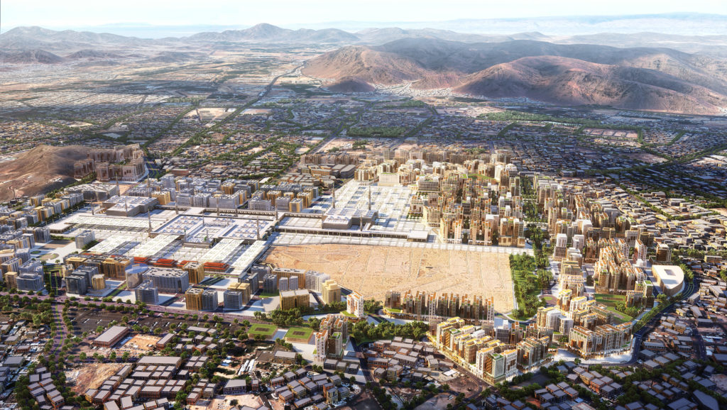
Figure 1-1: Madinah Undergoing Projects

1.2 Research Problem
The goal of Saudi Arabia's Vision 2030 is to establish the Kingdom as a global leader in many fields, including infrastructure. Large-scale infrastructure projects are necessary to realize the ambitious vision, which calls for improved service delivery, jobs, and sustainable urbanization in the Kingdom's cities.
PMOs are becoming increasingly significant institutional entities to make sure that infrastructure projects get done in an effective and harmonious manner with national aspirations. They institutionalize project management practices, exercise direction, and ensure that projects get implemented in accordance with planned schedules, budget, and quality standards.
While other research has focused on the role of PMO in mega-projects such as NEOM and Red Sea Project, little is understood concerning PMO's specific role in mid-size cities, especially those with religious, cultural, and regulatory constraints. Al Madinah stands out due to its religious significance, which attracts millions of pilgrims each year. The city also suffers from problems of fast urbanization, pressure on its infrastructure, as well as conflicting jurisdiction between religious and municipal governments.
The gap this study aims to address is the lack of empirical research for PMO operation in such distinctive urban settings. In addition, there is a paucity of correct knowledge of how PMOs in Al Madinah can align infrastructure projects with Vision 2030 goals, for instance, economic diversification, sustainability, and technological innovation. This study has the objective of adding to the world of knowledge by examining the challenges faced by PMOs in this respect and determining how they can expand their practice to support the strategic objectives of Vision 2030.

1.3 Significance of the Study

1.3.1 Scientific Significance
This study is a contribution to the limited literature on PMOs in Saudi Arabia's urban development, notably for Al Madinah's infrastructure projects. It fills a gap by offering perspectives on organizational structure, functions, and effectiveness of PMOs in small cities, specifically within the context of Vision 2030. It also advances the horizon of PMO research by incorporating quantitative analysis in addition to qualitative analysis to ensure full understanding of how PMOs enable the strategic goals of urban modernization, economic diversification, and sustainability.
Furthermore, the study contributes to existing models by incorporating the specific challenges faced in Al Madinah, which include regulatory barriers, resource dispersal, and coordination difficulties across various stakeholders. The outcome of the study will enrich academic literature on how PMOs function in rapidly developing cities within emerging economies and can be extended as a model for other cities within similar contexts.
1.3.2 Practical Significance
Practically, the research offers crucial recommendations on how to improve PMOs practices in Al Madinah infrastructure projects. By exposing the fact that PMOs are faced with challenges such as lack of resources, misalignment of stakeholders, and digital tool implementation, the research will offer policymakers, urban planners, and project managers real-world recommendations. These recommendations will help ensure improved management of infrastructure projects so that they align with Vision 2030's general goals, for instance, sustainability and innovation using technology.
Besides, the results of this research can be applied to other regions of the world with similar demographic and economic status. The research will deliver valuable recommendations to the improvement of PMO practices, stakeholder engagement strategies, and utilization of digital tools and sophisticated project management techniques in similar urban development projects.

1.4 Research Objectives

1.4.1 Primary Objective:
The primary objective of this study is to quantify the role and effectiveness of PMOs in managing infrastructure projects in Al Madinah and make such projects serve Vision 2030 goals, specifically economic diversification, sustainability, and technological innovation.

1.4.2 Sub-objectives:
- Organizational Structure and Key Functions of PMOs:
in order to investigate the fundamental roles that PMOs play in managing infrastructure projects in Al Madinah, as well as their organizational structure. This will involve taking into account their decision-making, resource allocation, and governance structure.
- Mechanisms for Alignment with Vision 2030:
To identify the mechanisms applied by PMOs to ensure that infrastructure projects align with Vision 2030's vision, e.g., incorporating digital tools, sustainability practices, and technology innovation into project planning and project execution.
- Challenges Faced by PMOs:
To determine the difficulties that PMOs in Al Madinah encounter, including a lack of resources, intricate stakeholder coordination, adherence to regulations, and striking a balance between religious preservation and fast urbanization.
- Recommendations for Enhancing PMO Effectiveness:
To provide prescriptive recommendations for improving the Al Madinah PMO practices, focusing on building governance structures, stakeholder engagement, and implementing new project management tools to link infrastructure projects to Vision 2030.

1.5 Research Questions
Main Research Question:
How do PMOs contribute to aligning infrastructure projects in Al Madinah with the goals of Vision 2030, and what are the challenges and opportunities in managing these projects?
Sub-questions:
- Where does the PMO stand in the management of infrastructure projects in Al Madinah, that is, in the case of urban expansion and religious tourism?
- How do the PMOs ensure alignment of Al Madinah infrastructure projects with the strategic priorities of Vision 2030, such as economic diversification, sustainability, and innovation?
- What are the top challenges for PMOs in managing infrastructure projects in Al Madinah, and how can they be mitigated?
- How are PMOs assisting in the successful delivery of infrastructure projects on time, cost, and quality, and what are the practices put in place to harmonize with Vision 2030?

1.6 Research Hypotheses
There exists no statistical significance between the performance of PMO and alignment of Al Madinah infrastructure projects with Vision 2030 goals.
Sub-hypotheses:
- H₀-1: There exists no statistical significance between PMO governance and time performance of Al Madinah infrastructure projects.
- H₀-2: There exists no statistical significance between PMO resource management and cost performance of Al Madinah infrastructure projects.
- H₀-3: No statistical relationship exists between PMO stakeholder coordination and quality of infrastructure projects in Al Madinah infrastructure projects.
- H₀-4: No statistical relationship exists between digital tool adoption by PMOs and alignment of infrastructure projects with Vision 2030 sustainability goals.

1.7 Theoretical Model
Theoretical model of the study serves as a visual representation of the theoretical relationships between the key components of the research. The model illustrates how PMO success influences the alignment of infrastructure projects with Vision 2030 objectives, especially regarding time, cost, quality, and sustainability.
Essentially, the role of the PMO is to manage that projects are delivered on time, within cost and scope, and to high-quality expectations. PMOs are tasked with resource allocation, risk reduction, and project guidance through governance and support. However, PMOs' alignment with Vision 2030 requires PMOs to champion long-term goals of economic diversification, technological innovation, and environmental sustainability.
The model also includes digital tools as a mediator of PMO performance and project alignment. Increased adoption of digital technologies—like Building Information Modeling (BIM), project management information systems, and real-time monitoring systems—has been established to enhance PMO effectiveness by facilitating better data collection, communication, and decision-making.
The model can be represented as follows:
- PMO Governance → Ensures project goal alignment with Vision 2030 goals.
- Resource Management → PMOs must optimize resource usage to deliver project objectives on cost and timelines.
- Digital Tools → Enhance communication, monitoring, and decision-making effectiveness, leading to better project alignment.
- Time, Cost, and Quality → Major parameters that are managed by PMOs to enable the successful delivery of infrastructure projects.
- Vision 2030 Alignment → The general aim of this study is to analyze how PMOs ensure that infrastructure projects are aligned with the goals of economic diversification, sustainability, and technological innovation in accordance with Vision 2030.

1.8 Research Gap
Despite a wide body of literature on Project Management Offices (PMOs) and their roles in large-scale projects, there is very little empirical evidence for PMOs applied to smaller, city-level infrastructure projects within the strategic goal of Saudi Arabia's Vision 2030. Although much of the extant research on PMOs has focused on mega-projects and country-level projects, fewer studies have been devoted to how PMOs function in medium-scale cities like Al Madinah, where concerns such as religious tourism, urbanization, and economic growth intersect.
The existing literature concentrates primarily on national-scale infrastructure ventures and underemphasizes the hardships PMOs in smaller cities must undergo, namely resource scarcity, stakeholder diversity, regulatory complexity, and integrating recent technologies to align infrastructure ventures with Vision 2030's diversification and sustainability policies.
Furthermore, most of the existing literature has been concerned with theoretical models and frameworks for PMOs without corroboration with practical, empirical evidence of their operation on a ground-level basis. The purpose of this research is to fill this gap by providing city-specific evidence about the PMO practices implemented in Al Madinah and determining their effectiveness in project management as well as ensuring alignment with Vision 2030's overall goals.
Yet another significant gap is the utilization of digital tools in PMO practice. While digital technologies like BIM, project management software, and cloud-based solutions are becoming more a part of modern-day project management, their impact on the performance of Saudi Arabian PMOs has not been studied extensively so far. This study intends to explore how the incorporation of such technologies can advance the PMO with respect to infrastructure project management and aligning the same with Vision 2030's sustainability, economic, and technological goals.
In filling these gaps, this research will create relevant insights regarding how PMOs contribute to making the infrastructure projects successful and fulfill their role in providing the national strategic goals as outlined in Vision 2030, particularly at the city level.

1.9 Chapter Summary
Chapter 1 provided a clear overview of the research paradigm beginning with the introduction to Saudi Arabia's Vision 2030 and the emphasis on infrastructure development. The chapter set up the research problem with the focus on the comparatively uncharted role of PMOs in infrastructure projects in Al Madinah and how they enable the national vision of Vision 2030.
We established the research aims, questions, and hypotheses, the foundation upon which this research is based. The chapter also outlined the conceptual model, connecting PMO success to key project performance indicators such as time, cost, and quality, and how they subsequently result in Vision 2030 alignment. Besides, the research gap was defined, whereby it outlined the absence of empirical studies on PMOs at the city level and the need for practical evidence in the Saudi Arabian context of infrastructure development.
In summary, the chapter offers an introductory overview of the practices and challenges of PMOs in coordinating infrastructure projects in Al Madinah. The next chapter will be devoted to the literature review, where we examine the existing literature on PMO practices, Vision 2030, and the challenges of coordinating giant infrastructure projects in Saudi Arabia. We shall also review the theoretical paradigms informing the research, setting the stage for the methodology and analysis of data in the subsequent chapters.

Chapter 2
(Literature Review)

2.1 Introduction
Effective utilization of infrastructure projects has also become a major aspect of modern economies. Vision 2030 is the current change happening in Saudi Arabia and there exists critical challenges and opportunities in managing the infrastructure, particularly the Kingdom as it attempts the diversification of its economy and the modernization of urban centers. The focus of these initiatives is the execution of large infrastructure projects to improve the life of the cities, make it sustainable and adapt to new technological advances. Project Management Offices (PMOs) are crucial in the management of such projects, to ensure timely delivery, within financial irreproachable limits, and in accordance with national interests.
Although majority of research on PMOs were based on mega projects in cities such as Riyadh, Jeddah and Dammam, there has been a critical gap in the comprehending of PMOs in mid-sized cities especially where they have peculiar features like Al Madinah. Al Madinah is one of the most sacred cities of Islam and is facing peculiar problems in its infrastructure development as millions of religious Muslims come to visit the city every year during Hajj and Umrah. This religious meaning creates challenges to urban planning, in which modernization needs to take into consideration of the cultural and religious values of a city.
PMOs within Al Madinah should be able to overcome these complexities and ensure that the infrastructure developments not only respond to the expanding needs of the city but also to those of the greater picture of Vision 2030, such as diversifying the economy, sustainability, and the incorporation of technology. Although PMOs are significant as far as this context is concerned, empirical studies that have concentrated on their participation in the infrastructure projects taking place in Al Madinah especially in light to overcome the challenges presented by urbanization, religious tourism and management of resources are lacking.
This paper seeks to address this research gap by exploring PMOs in Al Madinah levels in relation to the handling of infrastructure projects and integrating them with the strategic objectives of vision 2030. It will delve into the way these offices can provide a solution to the distinct issues of urban development, coordination of stakeholders and sustainability in addition to making certain that projects are culturally aware and in line with national development goals. The study will add value to the existing literature through this research by giving the knowledge on how PMOs work-in mid-sized cities experiencing complex cultural, religious, and urbanization issues and provide recommendations on how to make PMOs very effective in such contexts.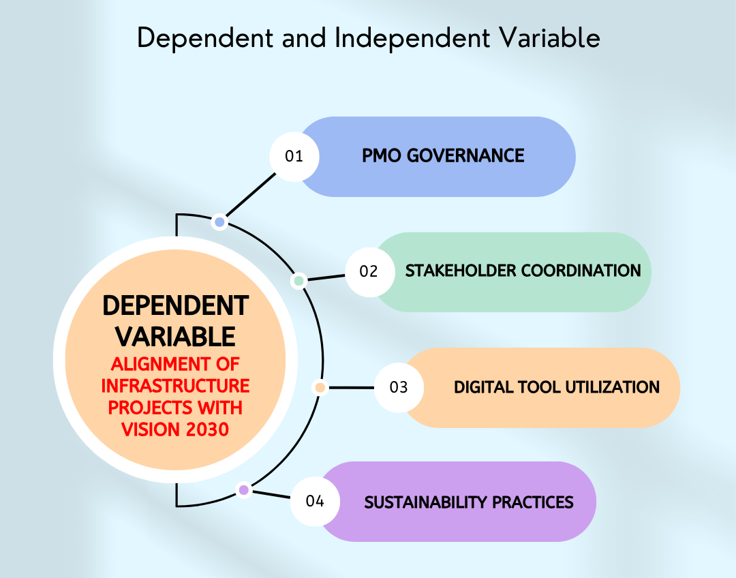
Figure 1-2: Dependent and Independent Variables

2.2 Dependent Variable:

2.2.1 Alignment of Infrastructure Projects with Vision 2030:
The degree to which Al Madinah's infrastructure projects complement the strategic goals delineated in Saudi Arabia's Vision 2030 is the dependent variable. This variable focuses on how well Al Madinah's infrastructure projects are supported by PMOs (Project Management Offices), especially when it comes to areas like technological innovation, sustainability, and economic diversification. Assessing how infrastructure projects are managed to guarantee they support national development goals—such as lowering reliance on oil, boosting non-oil sectors, and encouraging sustainable and innovative infrastructure—is how the alignment is determined. In the context of this study, successful alignment with Vision 2030 is a crucial measure of PMO effectiveness.

2.3 Independent Variables:

2.3.1 PMO Governance:
- Definition: PMO governance is the term used to describe the organized procedures, standards, and frameworks that direct PMO operations in infrastructure project management. It covers PMO role clarity, resource allocation, risk management techniques, and decision-making processes. In keeping with the larger goals of Vision 2030, governance makes sure that projects are carried out in accordance with the set standards, schedules, and budgets.
- Importance: Since transparent and efficient governance frameworks promote efficient project execution and reduce risks, governance is essential to project success. To ensure that projects satisfy the needs of both growth and cultural preservation, governance structures in Al Madinah must adjust to the difficulties presented by the city's fast urbanization and religious tourism.
- Impact on Dependent Variable: By keeping attention on important strategic objectives like sustainability, technological innovation, and economic diversification, clearly defined governance guarantees that infrastructure projects are in line with Vision 2030. Additionally, it contributes to successful project outcomes by reducing delays and cost overruns.

2.3.2 Stakeholder Coordination:
- Definition: Stakeholder coordination describes the procedures used by PMOs to oversee the participation and interests of different stakeholders in infrastructure projects. These parties include local communities, contractors, religious leaders, government agencies, and business associates. A more seamless project execution results from effective coordination, which guarantees that everyone's objectives are in line.
- Significance: Because of Al Madinah's distinct fusion of governmental, religious, and private sector interests, stakeholder coordination is especially difficult there. Conflicts, inefficiencies, and delays may result from these stakeholders' misleading. PMOs must thus successfully manage these connections to guarantee that everyone contributes to the project's success.
- Impact on Dependent Variable: By ensuring that all project participants contribute to shared objectives like sustainability, innovation, and economic diversification, effective stakeholder coordination has a direct impact on how well infrastructure projects align with Vision 2030. It helps prevent delays and guarantees that the project will be completed on schedule, within budget, and in accordance with the goals of national development.

2.3.3 Digital Tool Utilization:
- Definition:
Digital Tool Use refers to the extent to which PMOs adopt and leverage innovative digital technologies to maximize project management and delivery. These tools include Building Information Modeling (BIM), cloud computing-based project management software, real-time tracking, among other digital innovations for simplifying project planning, tracking, and decision-making.
- Significance:
The application of digital tools enhances transparency, efficiency, and collaboration between stakeholders, particularly in large-scale infrastructure projects. In Al Madinah, the adoption of digital tools should be embraced in handling advanced projects, as it enables timely tracking of progress, budget, and schedules, and helps the projects achieve the high quality needed by Vision 2030.
- Impact on Dependent Variable:
Virtual tools enhance coordination of infrastructure projects with Vision 2030 by ensuring greater efficiency in project handling, innovation, and proper implementation of projects as per the Vision 2030 visions of sustainability and technology. The tools allow PMOs to make decisions based on information, improving the quality of project results and alignment of national objectives.

2.3.4 Sustainability Practices:
- Definition:
Sustainability Practices refer to the integration of sustainable and green practices within infrastructure projects. These practices encompass the use of green technologies, energy-efficient design, and environmentally friendly materials. Sustainability also includes minimizing the environmental impact of the construction activity and ensuring that projects meet local and international environmental laws.

- Significance:
One of the most significant pillars of Vision 2030 is sustainability, which emphasizes environmental protection and reducing the Kingdom's carbon footprint. Since urbanization in Al Madinah is increasing at a very rapid pace, embracing sustainability practices is essential so that urban growth does not harm the religious and cultural heritage of the city, as well as the long-term environmental sustainability of the region.
- Dependent Variable:
Sustainability practice has a direct function of ensuring infrastructure projects are aligned with Vision 2030 to ensure that they are aligned with the Kingdom's environmental goals. Green technology adoption and sustainable building guarantee that infrastructure projects are future-proof and in line with the vision of having a sustainable and diversified economy.

2.4 Previous Studies
PMO literature is vast, with many studies tackling different dimensions such as governance, resource allocation, stakeholder management, and integration of information technology. However, much of this research has either been focused on large projects or developed economies, leaving a literature gap on how PMOs deal with issues in mid-sized cities, particularly in Saudi Arabia. Below is a detailed overview of key studies on PMOs.

Kwak & Anbari (2009)
This is a seminal work in the study of PMOs' roles in managing large projects. Kwak & Anbari (2009) argued that PMOs are the centers of project knowledge, delivering standardized project management processes to ensure successful project delivery. They concluded that PMOs are significant organizations that centralize decision-making and manage risks so that projects can proceed to meet organizational goals. However, their studies were primarily focused on large, global infrastructural projects, without an analysis of the specific concerns that PMOs in small cities or regions with unique requirements such as religious tourism or rapid urbanization must contend with.

Pinto (2017)
Pinto (2017) expounded the governance role of PMOs, focusing on their essential role of directing the projects, aligning the projects with organizational strategy, and adequately managing risks. He also placed a focus on the importance of PMOs defining roles and responsibility, decision-making, and risk management to ensure that projects are completed successfully. Pinto's research, although useful, largely talks of PMOs in the context of mega-projects and misses out on the problems faced by mid-sized municipalities or smaller territorial units with their complex stakeholder relationships and multiple conflicting interests.

Shenhar et al. (2016)
Shenhar et al. (2016) focused on the strategic relevance of PMOs within the framework of the emerging economies. Their research pointed to the reality that PMOs contribute to aligning the projects with long-term national goals such as sustainability, diversification of the economy, and innovation in technology. The authors believed PMOs played a key role in ensuring mega projects were completed on time and within budget but also as per overall strategic objectives. Their study is not particularly focused on small cities or regions like Al Madinah, where there are urbanization forces and cultural dynamics involved in infrastructure project management.

Batra (2020)
Batra (2020) wrote about the evolving role of PMOs to manage India's smart city projects. He argued that PMOs have become more strategically oriented in scope, with their function aimed at coordinating national development strategies with infrastructure projects, for example, technological innovation and city sustainability. This shift from management by operations to influence by strategy is also evident with Saudi Arabia's Vision 2030, where PMOs will be leading the drive towards sustainability and innovation within mega infrastructure projects. Nevertheless, Batra's research was targeted towards India's smart cities and did not do research specifically on the issues of PMOs in religiously significant cities like Al Madinah.

Alfahad & Almutairi (2024)
Alfahad & Almutairi (2024) researched the adoption rate of digital tools by PMOs in Saudi Arabia. They found out that BIM and Oracle Primavera are able to enhance project management practices but have been adopted at a slow rate. They explained that this was due to technological barriers, a lack of technical understanding, and stakeholder resistance to change. These are particularly the case in Al Madinah, whose adoption of digital means is hindered by limited resources, slow progress in technological development, and struggling to train stakeholders on emerging digital platforms.

Almohaimeed (2024)
Almohaimeed (2024) discussed the problems that PMOs encounter in Saudi Arabia infrastructure projects, particularly in coordinating stakeholders and resources. Almohaimeed understood that PMOs often encounter problems with the distribution of resources like trained manpower and equipment, which affects project timeliness and cost. Moreover, managing the interests of different stakeholders such as government bodies, contractors, and communities remains problematic. Although Almohaimeed's study provided an overview of the operations of PMOs in Saudi Arabia, it did not specifically focus on mid-sized cities like Al Madinah where religious and cultural values add additional complexity to stakeholder coordination.

Alzahrani & Alshammari (2024)
On a local scale, Alzahrani & Alshammari (2024) discussed the specific issues of PMOs in Al Madinah, which highlighted the dual challenge of managing urban development while maintaining the religious and cultural heritage of the city. The authors stressed that adequate coordination of religious leaders, local government, and private contractors is necessary to ensure that infrastructure projects satisfy both functional and cultural requirements. This study is highly relevant to this research, but the study failed to address how PMOs can leverage modern tools or sustainability strategies to enhance project delivery.

Harrison & Lock (2017)
Harrison & Lock (2017) discussed in depth PMO challenges, such as resource management and stakeholder coordination, in a large-scale infrastructure project context. They highlighted the role of PMOs in ensuring the success of projects by effective governance and risk control. In their research, there was no mention of PMO challenges in Saudi Arabia, where regulatory, cultural, and religious considerations play an important role in the successful management of projects.
The following table summarizes key studies in literature, highlighting their focus, findings, and limitations.
Table 1-2: Summary for literature reviews
Author(s) | Year | Study Focus | Key Findings | Limitations
Kwak & Anbari | 2009 | Role of PMOs in global infrastructure projects | PMOs centralize project knowledge, standardize processes, and manage risks. | Focused on large-scale projects, did not address challenges in smaller cities.
Pinto | 2017 | Governance in PMOs | PMOs are critical for aligning projects with organizational goals, managing risks. | Did not explore the challenges faced by PMOs in mid-sized cities.
Shenhar et al. | 2016 | Strategic role of PMOs in emerging economies | PMOs help align projects with long-term national development goals. | Lack of focus on smaller cities with unique challenges like Al Madinah.
Batra | 2020 | Role of PMOs in smart city initiatives | PMOs align projects with national goals such as sustainability and innovation. | Focused on India, did not address cultural and religious challenges.
Alfahad & Almutairi | 2024 | Adoption of digital tools by PMOs in Saudi Arabia | Slow adoption of digital tools due to technological barriers and resistance. | Did not explore how PMOs can overcome challenges in religious cities like Al Madinah.
Almohaimeed | 2024 | Resource and stakeholder management in Saudi PMOs | PMOs face resource allocation challenges and stakeholder coordination issues. | Focused on larger projects, not mid-sized cities with unique demands.
Alzahrani & Alshammari | 2024 | PMO challenges in Al Madinah | Balancing urban growth with cultural and religious preservation is a challenge. | Did not explore integration of digital tools or sustainability practices.
Harrison & Lock | 2017 | Global challenges faced by PMOs | PMOs manage risks, governance, and resource allocation; stakeholder coordination is difficult. | Focused on global projects, not on the context of Saudi Arabia.

2.5 Theoretical Framework
There are several theoretical frameworks that are applied to the study of PMOs and their purpose in handling infrastructure projects:
- Project Management Theory: It is indispensable to comprehend the working purpose of PMOs and it includes the consideration of how they govern the plan of implementation of the projects, their performance, and their completion (Pinto, 2017).
- Strategic Alignment Model (SAM): This model will assist in the evaluation of how PMOs have aligned their projects with the greater strategic aims of Vision 2030 with infrastructure projects enabling the achievement of the Kingdom economic diversification and sustainability (Henderson & Venkatraman, 1993).
- Triple Constraint Theory: This aspect of time, cost, and quality balance is critical in addressing how PMOs facilitate the successful implementation of project delivery, and at the same time manages these constraints (Pinto, 2017).
- Stakeholder Theory: The theory helps to resolve the issue of dealing with the interests of various stakeholders on big projects. It is more especially applicable in Al Madinah where the PMOs should liaise among the religious authorities, the state organs, and contractors (Freeman, 1984).

2.6 Research Gap and Contribution
Despite the vast amount of literature on PMOs, most studies focus on mega-projects or the developed world, and the literature is less inclined to talk about the special needs and challenges that PMOs face in mid-city settings, especially in emerging economies like Saudi Arabia. Most of the research focuses on mega-projects, with no idea how PMOs in smaller cities like Al Madinah would manage issues like rapid urbanization, religious tourism, and cultural heritage protection.
This study aims to bridge this gap by considering the role of PMO in the context of Al Madinah. It will look at how PMOs handle infrastructure projects, handle stakeholders, utilize digital tools, and implement sustainability methods to achieve Vision 2030 targets. Through the case of PMOs in this specific context, this study will be able to generate useful insight into how these offices can handle projects in medium-sized cities with their specific cultural and religious orientations.
Literature review highlights the crucial role of PMOs in managing large-scale infrastructure projects and how crucial they are in coordinating such projects with national goals, in this case, Saudi Arabia's Vision 2030. While significant research has been done on PMOs in large-scale projects, there is vast research deficiency in areas related to mid-scale cities like Al Madinah. This research attempts to bridge this gap by providing empirical evidence about the practices of PMOs in Al Madinah in relation to their specific challenges and how they align infrastructure projects with the bigger pictures of Vision 2030. Based on a robust theoretical framework and from empirical findings, the research will enhance knowledge of PMOs' contribution to national developmental goals, particularly from medium-sized urban areas.

