النَّشـــاطــات البــرمجيَّــة الأسبــوعيَّـــة - 6
الاسم: | زينـــب جعفـــر العبــدالعــال | الشهر: | أغسطــــس | السنة: | 2023
التَّـــاريــخ: 12/08/2023
python CODE – SNIPPET – (Reverse string using for loop)
Description: Write a Python program that takes a string as input and reverses it without using any built-in string reversal functions. Your program should output the reversed string.
def rev_for_loop(s):
z = ''
for c in s:
z = c + z # appending chars in reverse order
return z

input_str = str(input("Input: "))

if __name__ == "__main__":
print('Reverse String using for loop =', rev_for_loop(input_str))

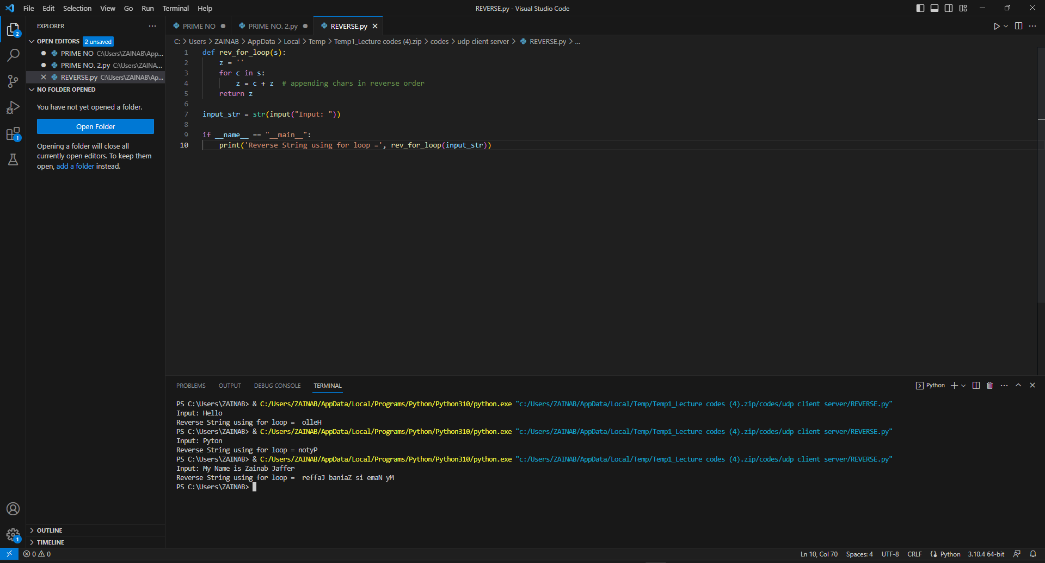

PYTHON CODE - SNIPPET – (Reverse string using WHILE loop)
Description: Write a Python program that takes a string as input and reverses it without using any built-in string reversal functions. Your program should output the reversed string.
def rev_while_loop(Z):
zj = ''
length = len(Z) - 1
while length >= 0:
zj = zj + Z[length]
length = length - 1
return zj

input_str = str(input("Input: "))

if __name__ == "__main__":
print("Reverse String using while loop =", rev_while_loop(input_str))

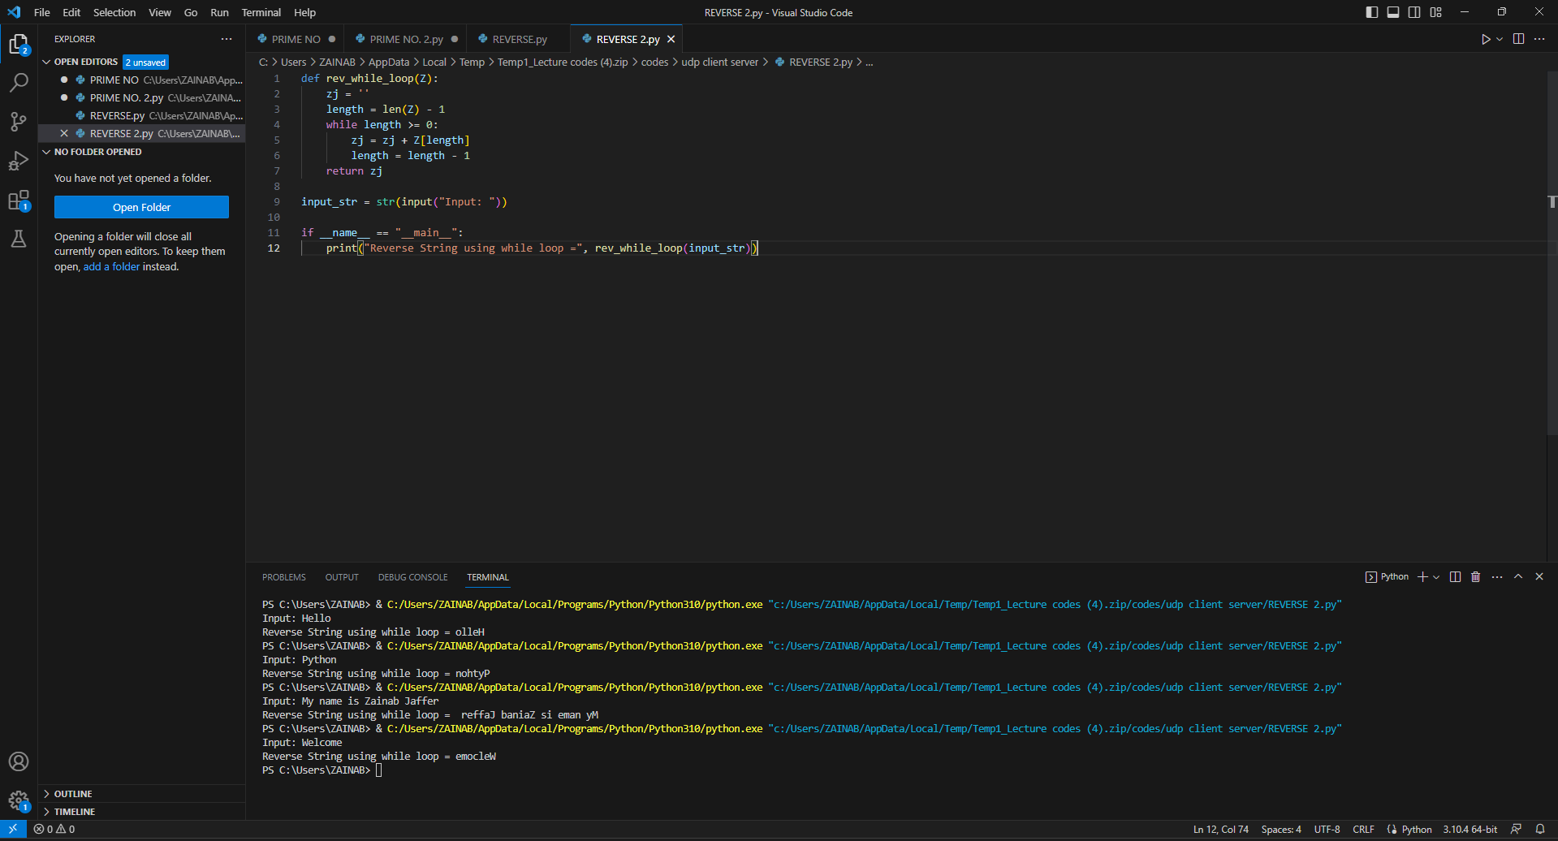

UNI ID
213000602
ZAINAB JAFFER I. AL ABDULAL

