

Pneumonia Classification from Chest X-ray Images Using CNN
Prepared By
Name: Hussam alden Abushalha ID No.: 253002964
Name: Abdulaziz Dhafer Al Obud ID No.:253001366

Submitted in fulfillment of the requirements for the degree Master of Science in Artificial Intelligence
At
College of Informatics
Midocean University
UAE
Supervisor Name: DR. Hager Salah
Collage of Informatics, Midocean University, Comoros
Email:………………….

Contents
1
List of Abbreviations 5
Chapter 1: Introduction 6
1.1 Problem Definition 6
1.2 Thesis Objectives 6
1.3 Thesis Contributions 7
1.4 Thesis Organization 7
Chapter 2: Background and Literature Review 8
2.1 Background 8
2.1.1 Artificial Intelligence (AI) 8
2.1.2 Machine Learning 8
2.1.3 Types of Machine Learning 9
2.1.4 Convolutional Neural Networks 9
2.1.5 DenseNet 9
2.1.6 ResNet 10
2.1.7 EfficientNet 10
2.1.8 MobileNet 10
2.1.9 Vision Transformer (ViT) 11
2.1.10 Swin Transformer 11
2.2 Related Work 11
2.3 Comparative Summary 14
Chapter 3: Methodology 17
3.1 Introduction 17
3.2 Proposed Framework 19
3.3 Dataset Description 19
3.4 Dataset Splitting 20
3.5 3.5 Pre-trained CNN Models 21
3.6 Transformer Models 21
3.6.1 Vision Transformer 21
3.6.2 Swin Transformer 22
3.7 Preprocessing and Augmentation 24
3.8 Models and Transfer Learning 24
3.9 Proposed Hybrid Model 25
3.10 Evaluation Metrics 25
Chapter 4: Results and Discussion 26
4.1 Experimental Setup 26
4.2 Results 28
4.2.1 Overall Performance 28
4.2.2 Per-Class Performance 30
4.2.3 Confusion Matrices and ROC Curves 31
4.2.4 Effect of Patient-Level Data Leakage 33
4.2.5 System Implementation 35
4.3 Discussion of Results 36
Chapter 5: Conclusion and Future Work 37
References 39

List of Abbreviations
CNN: Convolutional Neural Network
DenseNet: Densely Connected Neural Network
ResNet: Residual Network
EfficientNet: Efficient Neural Network
MobileNet: Mobile Neural Network
ViT: Vision Transformer
Swin Transformer (Swin): Shifted Window Transformer
GRU: Gated Recurrent Unit
SNN: Spiking Neural Network
MLP: Multi-Layer Perceptron
Acc: Accuracy
Rec: Recall
F1: F1 Score
MCC: Matthews Correlation Coefficient
SL: Supervised Learning
UL: Unsupervised Learning

Chapter 1: Introduction

1.1 Problem Definition
Pneumonia can be considered one of the most severe diseases affecting the respiratory system around the world. According to public health records, death rates occur in higher amounts among children younger than five and people over 65 years old. What's more, the gap between their outcomes and those in resource-abundant countries is growing every year as access to specialists becomes harder. Although achieving a correct diagnosis during the early stages of the infection is unlikely, it remains a crucial step that can significantly influence the chances of recovery. Chest radiography is used as a primary method owing to its effectiveness and affordability. However, the interpretation of the obtained data might suffer due to the subjectivity of specialists' perception. The same X-ray may lead to different conclusions from various specialists, resulting in delays and the potential for overlooking the illness. In addition, staffing issues make X-ray image analysis even slower. Therefore, there is a need for a solution that works fast and objectively with daily patient volume. It should not depend on specialists [25].
The problem with visual diagnostics is that disease indicators are usually difficult to detect. Therefore, researchers primarily apply deep learning algorithms as their main approach. Researchers primarily apply deep learning algorithms as their main approach. Multiple authors have shown that accuracy in pneumonia detection can exceed 98% (Buriboev et al., 2025; Ahmed et al., 2023). DenseNet, ResNet, and EfficientNet were identified as the neural networks capable of recognizing relevant features within medical images. The principle of utilizing artificial intelligence technologies to diagnose a condition is obvious; it helps identify important patterns that a specialist may overlook while being exhausted. At the same time, the results received from the computer will be reproducible. This way, the present research aims to create a neural network for recognizing pneumonia signs using machine learning [25].

1.2 Thesis Objectives
The main objective of this thesis is to create an end-to-end classifier for pneumonia that takes chest X-rays as input and predicts outputs through a deep learning approach. Some additional objectives can be derived from this primary aim. One is to increase the accuracy by using current CNN architectures together with transfer learning. Another objective is to use data augmentation as a regularizer to reduce the generalization gap. The performance of the developed classifier will be evaluated using four traditional metrics: accuracy, precision, recall, and F1-score. The main objective of this thesis is to create an end-to-end classifier for pneumonia that takes chest X-rays as input and predicts outputs through a deep learning approach. Some additional objectives can be derived from this primary aim. One is to increase the accuracy by using current CNN architectures together with transfer learning. Another objective is to use data augmentation as a regularizer to reduce the generalization gap. The performance of the developed classifier will be evaluated using four traditional metrics: accuracy, precision, recall, and F1-score.

1.3 Thesis Contributions
Developed and evaluated by deep learning models for automated pneumonia classification from chest X-ray images using transfer learning.
Compared the performance of three pre-trained CNN models (MobileNetV2, EfficientNetB0, and ResNet50) and two transformer-based models (Vision Transformer and Swin Transformer).
Proposed a hybrid CNN–Transformer model that combines EfficientNetB0 and Swin Transformer to exploit both local and global feature representations.
Demonstrated that the proposed hybrid model achieved competitive performance, with an accuracy of 97.01% on a patient-disjoint test set, ahead of all three convolutional baselines but not significantly different from the best single transformer (p = 0.524).
Developed a prototype web application to explain the practical deployment of the trained models for pneumonia prediction from chest X-ray images.

1.4 Thesis Organization
Chapter 1: It contains the Introduction, Problem Definition, and Thesis Objectives. It also includes the thesis objectives and the chapter structure.
Chapter 2: Background and Literature Review provides the background and reviews studies on pneumonia classification using deep learning techniques.
Chapter 3: Methodology. It includes overall dataset preprocessing techniques and the proposed models, the experimental setup, and evaluation metrics.
Chapter 4: Results and Discussion displays the experimental results. It compares the performance of the developed models and discusses the results.
Chapter 5: Future Work summarizes the results and discusses the study for future research

Chapter 2: Background and Literature Review

2.1 Background

2.1.1 Artificial Intelligence (AI)
AI refers to a branch of computer science dedicated to making machines perform functions usually requiring human intelligence. These include inference, object recognition, decision making, etc. The essence is that AI relies heavily on algorithms and mathematics, allowing machines to analyze large amounts of data, derive structure, and then predict or make decisions based on that structure [23].
AI includes many more specific directions. Machine learning belongs to this direction, as does deep learning. Additionally, there is computer vision and natural language processing.

2.1.2 Machine Learning
It refers to the subfield of artificial intelligence dedicated to learning models from many examples rather than programming them through if/then conditions. The model is given data to train on and creates its rules based on those examples. As a result, its performance increases the more relevant data it processes, which is different from the approach of programming. [24]

2.1.3 Types of Machine Learning

2.1.3.1 Supervised Learning
Supervised learning relies on having the true answers to examples given to a model. It sees both the input data and the corresponding output and aims to achieve the same mapping. The model generalizes, i.e., applies to inputs not seen during training to produce the correct output [24].

2.1.3.2 Unsupervised Learning
Unsupervised learning lacks answers or labels. The model is only provided with raw data, and its task is to derive any structure it finds in the data, such as clusters, dependencies, or density distributions. There is no indication for a model of what the outputs should look like [24].

2.1.4 Convolutional Neural Networks
A CNN is a deep learning model for data structured on grids, for instance, images. Developed by LeCun et al. CNN became popular in computer vision tasks. A unique property of CNNs is that the model derives features on its own, i.e., a human doesn't have to specify which visual cues are important; instead, the algorithm learns them from labeled data [16].
There are three kinds of layers in CNN. Convolutional layers scan the input data to derive features, while pooling layers reduce the number of features and decrease the dimensionality. Then fully connected layers produce the output. Since the initial layers learn basic patterns (lines, textures) while deeper ones combine them into more complex shapes, the CNN establishes a hierarchy of vision, making it highly efficient in medical imaging tasks such as pneumonia detection from chest X-rays [16].

2.1.5 DenseNet
The DenseNet proposed by Huang et al. in 2017 is a type of CNN where each layer receives as input not just the output from the previous layer but also the outputs from every single layer from the previous block. This helps to avoid redundancy, makes feature reuse much more frequent, avoids the issue of vanishing gradients, and makes the model more computationally efficient. DenseNets are used successfully in various image classification tasks, including pneumonia detection from chest X-rays in medicine. From an architectural point of view, DenseNets alternate dense blocks, where layers are densely interconnected with transition layers using convolution and pooling to shrink the feature maps [25].

2.1.6 ResNet
ResNet is a deep CNN designed to solve a specific problem: difficulty training deep networks. To alleviate that problem, ResNet introduces residual connections, which help the network learn the difference between its input and output. In practice, residual connections make it possible to propagate backpropagation more efficiently. That allows the model to have hundreds of layers and learn complex hierarchies. Currently, ResNets are used almost by default in computer vision and in medicine as well. [26]
The ResNet architecture comprises convolutional layers arranged in residual blocks, with skip connections within the blocks, and a fully connected head at the end that produces the output [26].

2.1.7 EfficientNet
EfficientNet represents yet another family of CNNs that scales up the model using an alternative strategy. Specifically, whereas traditional CNNs scale up either the number of layers (depth), the width of each layer, or the input image resolution, EfficientNet scales up all of them proportionally in one go [27].
That provides a good balance of performance and model parameters because the efficiency increase is maximized with such scaling. EfficientNet performed well on various image classification benchmarks, including medical image classification, where pneumonia detection was achieved. The network utilizes MBConv and SE modules together with convolutions in its blocks [27].

2.1.8 MobileNet
is a lightweight CNN for devices that are not powerful enough for heavy training, e.g., smartphones. This model's lightness comes from using convolutions. Convolution is split into two simpler operations: first performing depthwise convolution on each channel independently. Then applying pointwise convolution to aggregate the channels [26].

2.1.9 Vision Transformer (ViT)
ViT uses the Transformer model architecture, initially created for text processing, for image tasks. Instead of processing an image with convolutions as CNNs do, ViT splits an image into a grid and treats each cell as a token in a sequence. Therefore, the first layer computes the attention across the whole sequence (image) [20].
This method includes several key steps. The patch embedding converts pixels into vectors representing patches. Transformer encoder blocks process the sequence and learn its attention. Attention and feedback in the subnetwork take turns, adding spatial context to tokens. The last classification head produces the desired output. ViTs have proven to achieve high performance on the most common computer vision tasks, and their variants are now used for medical imaging [20].

2.1.10 Swin Transformer
The main difference between Swin Transformer and ViT is how attention is calculated in Swin Transformer. While ViT attends to the whole image, Swin Transformer calculates attention separately within windows in the input image. Furthermore, these windows shift from layer to layer, enabling communication between adjacent windows. As a result, the representation in Swin Transformer acquires a hierarchy, i.e., each layer analyzes the image at progressively lower spatial resolutions as in CNN. [19]
A Swin Transformer architecture starts with splitting the image into patches and linear embedding, followed by several Swin blocks. Swin blocks consist of W-MSA, SW-MSA, and feedforward MLP modules [19].

2.2 Related Work
Singh et al. [1] Implemented a ViT using the pre-trained DeiT_Base_Patch16_224 version and several CNN-based baseline algorithms (AlexNet, VGG, ResNet, DenseNet, and InceptionNet), which were evaluated in the same setting to ensure a fair comparison. The dataset in use is a public dataset of pneumonia chest X-rays from Kaggle. It contains 5,863 pediatric chest X-ray images acquired at Guangzhou Women and Children’s Medical Center, split evenly among training (80%), testing (10%), and validation (10%) splits. ViT explains superior performance compared to CNNs, achieving an accuracy of 97.61%, a sensitivity of 95%, a specificity of 98%, an AUC of 0.96, and an MCC of approximately 0.94.
Mustapha et al. [2] tested a hybrid deep learning model combining a CNN backbone with modified Swin Transformer blocks compared to CNN-only and pure ViT approaches. The dataset is a public Chest X-ray Pneumonia dataset from Kaggle. The proposed CNN-ViT achieves an accuracy of 98.72%, better than either CNN-only or pure ViT architectures tested.
Shomsomi et al. [3] Investigated two deep learning approaches: MobileNetV2 CNN architecture and ViT, each using two different training strategies. The two strategies include: keeping the entire network architecture frozen except for the classification head during training (baseline) and training some inner layers (fine-tuning). The dataset is a public Chest X-ray Pneumonia dataset from Kaggle. At the same time, the results confirmed a significant performance gap between the two architectures during fine-tuning. MobileNetV2 achieved 97.63% without fine-tuning but dropped to 97.41% with fine-tuning. This indicates a negligible impact of fine-tuning on CNN-based architectures. The highest accuracy of 98.59% and F1-score of 0.99 was found for the initialized ViT.
Kareem et al. [4] developed a federated-learning approach for pneumonia detection using pretrained CNN models. In the proposed approach, healthcare institutions train models locally on their own distributed data and share only model updates rather than the images themselves, which preserves privacy. Evaluated under this scheme, ResNet-50 reached 93% test accuracy — lower than typical centralized studies on public benchmarks, but achieved without pooling patient data.
Alshanketi et al. [5] experimented with VGG, ResNet and ViT architectures across three publicly available collections: the Chest X-Ray Pneumonia dataset from Kaggle, BRAX and CheXpert. The study focused on strategies for handling class imbalance, comparing transfer learning, data augmentation, balanced class weighting and semi-supervised learning. ViT achieved 97.61% accuracy on the Kaggle dataset, although performance declined on the other two collections, indicating that results obtained on one benchmark do not transfer automatically to another.
Slimi et al. [6] proposed an attention-guided deep-learning architecture combining four components: convolutional layers for spatial feature extraction, a gated recurrent mechanism to capture dependencies across features, spike-based neural processing intended to mimic biological efficiency and improve noise tolerance, and an attention mechanism that highlights clinically relevant regions of the image. Evaluated on a publicly available chest X-ray dataset, the model reached 99.35% accuracy with strong precision, recall and F1-score.
Yanar et al. [7] proposed a feature-level ensemble architecture called the Pneumonia Ensemble Learning Model (PELM). The approach fuses the feature representations of four pretrained networks — InceptionV3, VGG16, ResNet50 and ViT — extracted before their classification layers and combined into a single representation passed to a shared classifier. The ensemble outperformed each of its individual components.
Hofmeister et al. [8] took a more sceptical approach to evaluation. They trained a convolutional model to diagnose pneumonia and assessed it on two prospective cohorts totalling 430 patients, in which the reference diagnosis was established afterwards by a multidisciplinary expert panel using multimodal clinical data rather than by radiologists reading the radiograph alone. Under this stricter reference the model reached an area under the ROC curve of 0.74, far below the values typically reported when deep-learning systems are benchmarked against radiologist interpretation, although its accuracy remained comparable to that of the radiologists themselves and significantly higher than that of emergency physicians. The authors concluded that the clinical relevance of such models may have been systematically overestimated by weak reference standards — a conclusion closely related to the evaluation problem examined in Section 4.2.4 of this thesis.
Buriboev et al. [9] applied a modified contrast-limited adaptive histogram equalization (CLAHE) technique to enhance chest X-ray image quality before classification. The approach was combined with a CNN classifier and evaluated on the Chest X-Ray Pneumonia dataset, reaching 98.7% accuracy and showing that improving input quality can raise performance independently of the architecture.
Saber et al. [10] proposed a multi-scale transformer framework integrating lung segmentation and pneumonia detection from chest X-rays. The method combines a transformer-enhanced TransUNet segmentation stage with pretrained ResNet backbones producing multi-scale features, followed by a transformer module. The reported results are a Dice score of 95.68% for segmentation and classification accuracies of 93.75% on the Kermany dataset and 96.04% on the Cohen dataset.
Bundea et al. [11] Implemented more DenseNet-based models (DenseNet121, DenseNet169, and DenseNet201) to classify chest X-ray images using a supervised learning approach. The algorithms were tested on the public Chest X-Ray Pneumonia dataset from Kaggle and evaluated according to standard parameters such as accuracy, sensitivity, and specificity. In addition, all architecture variants were designed and evaluated in the same way, using the same dataset and data processing procedure. It was found that the best model achieved an accuracy rate of up to 97%.
An et al. [12] Developed a framework for a deep CNN, including EfficientNetB0 and DenseNet121, along with attention mechanisms for detecting pneumonia. This CNN utilizes multi-head self-attention and channel-attention feature fusion to improve feature extraction from chest X-rays. The testing and training of this architecture were done on a chest X-ray dataset including cases of both pneumonia and normal cases in a supervised manner. The performance of the above architecture has shown an accuracy of 95.19%, a precision of 98.38%, a recall of 93.84%, a specificity of 97.43%, and an area under the receiver operating characteristic (ROC) curve of 0.956.
Usman et al. [13] compared a convolutional network developed from scratch against a pretrained ResNet-50 using transfer learning, evaluated on the RSNA pneumonia dataset. The pretrained model performed better than the network trained from scratch, reinforcing the value of transfer learning when the available medical dataset is small relative to the capacity of the network.
Ahmed et al. [14] built a deep CNN for the joint multiclass diagnosis of pneumonia, COVID-19 and tuberculosis from chest X-ray images. The reported accuracy of around 98.7% is used to argue that a single deep network can carry a broader diagnostic load than binary pneumonia screening alone.
Al Reshan et al. [15] proposed a CNN-based classifier for pneumonia versus normal chest X-rays built around the MobileNet architecture. Their data consisted of both healthy and pneumonia-affected films, preprocessed with normalization and enhancement before classification, and the approach reached approximately 95% accuracy.

2.3 Comparative Summary
Table 2.1: Summary of previous studies on pneumonia detection
Study | CNN Models | Dataset(s) | Public / Private | Classification Task | Best Accuracy | Best Performer
Singh et al. (2024) | ViT (DeiT_Base_Patch16_224); CNN baselines: AlexNet, VGG, ResNet, DenseNet, InceptionNet | Kaggle Chest X-ray Pneumonia | Public | Binary: normal vs. pneumonia | 97.61% | Vision Transformer (ViT)
Mustapha et al. (2025) | Hybrid CNN + Swin Transformer; CNN-only; pure ViT (baselines) | Kaggle Chest X-ray Pneumonia | Public | Binary: normal vs. pneumonia | 98.72% | Hybrid CNN-ViT (Swin Transformer)
Shomsomi et al. (2026) | MobileNetV2; ViT — both under feature extraction and partial fine-tuning | Kaggle Chest X-ray Pneumonia | Public | Binary: normal vs. pneumonia | 98.59% (ViT, fine-tuned) | ViT with partial fine-tuning
Kareem et al. (2023) | Pretrained CNNs in federated learning (ResNet-50) | Multi-institutional distributed CXR data | Private | Binary: normal vs. pneumonia | 93% | Federated ResNet-50
Alshanketi et al. (2025) | VGG; ResNet; ViT | Kaggle CXR; BRAX; CheXpert | Public | Binary; class imbalance across 3 datasets | 97.61% (ViT on Kaggle) | ViT — on Kaggle dataset
Slimi et al. (2025) | CNN + GRU + spiking layer + attention | Public chest X-ray dataset | Public | Binary: normal vs. pneumonia | 99.35% | Attention-guided hybrid
Yanar et al. (2025) | PELM ensemble: InceptionV3 + VGG16 + ResNet50 + ViT | Public chest X-ray benchmarks | Public | Binary: normal vs. pneumonia | Best among all tested | PELM ensemble
Hofmeister et al. (2024) | CNN vs. multimodal expert reference | Two prospective cohorts (n = 430) | Clinical | Binary; prospective clinical validation | AUC 0.74 | CNN ≈ radiologists
Buriboev et al. (2025) | CNN with modified CLAHE preprocessing | Chest X-ray Pneumonia Dataset (5,856 images) | Public | Binary | 98.7% | CNN + adaptive contrast
Saber et al. (2025) | TransUNet segmentation + ResNet multi-scale transformer | Kermany; Cohen | Public | Binary | 96.04% (Cohen); 93.75% (Kermany) | Transformer + ResNet pipeline
Bundea et al. (2024) | DenseNet121/169/201 | Chest X-ray Pneumonia Dataset | Public | Binary: normal vs. pneumonia | 97% | DenseNet
An et al. (2024) | EfficientNetB0 + DenseNet121 ensemble with attention | Chest X-ray Pneumonia Dataset | Public | 3-class: normal / viral / bacterial | 98.4% | Ensemble with attention
Usman et al. (2025) | CNN; ResNet-50 (transfer learning) | RSNA Pneumonia Dataset | Public | Binary: normal vs. pneumonia | 96.2% | ResNet-50
Ahmed et al. (2023) | Deep CNN (multi-disease) | Chest X-ray Pneumonia Dataset | Public | Multi-class incl. COVID-19 | 98.7% | Deep CNN
Al Reshan et al. (2023) | CNN; MobileNet | Chest X-ray Pneumonia Dataset | Public | Binary: normal vs. pneumonia | ~95% | MobileNet

Chapter 3: Methodology

3.1 Introduction
The methodology for improving a framework for automated pneumonia detection from chest X-ray images is outlined. This includes the study design workflow, image preprocessing, model implementation, training, and performance evaluation. All components are presented in detail to demonstrate how the proposed system was designed and utilized throughout the research. The rapid development of deep learning has transformed the field of medical image analysis by enabling more accurate and efficient diagnostic systems. Although convolutional neural networks (CNNs) have long been the dominant approach for image classification, transformer-based models have recently attracted considerable attention because of their ability to model long-range relationships within an image using self-attention. This capability allows them to capture both fine local details and broader contextual information, making them highly suitable for chest X-ray interpretation. To investigate the effectiveness of transformer architecture, this research employs two state-of-the-art models, ViT and Swin Transformer. Both models are adapted for the binary classification of chest X-ray images into normal and pneumonia categories. Rather than training the networks from scratch, transfer learning is adopted by fine-tuning models pre-trained on large-scale image datasets. This strategy improves learning efficiency and often leads to better performance when the available medical dataset is relatively limited. The dataset is processed to ensure consistency across all input images. All images are resized to the required input dimensions and normalized before data augmentation techniques, including random rotation, zooming, and horizontal flipping, are applied. These preprocessing procedures increase the diversity of the training samples and enhance model robustness. and help reduce overfitting; the implementation is supported in the local GPU workstation environment with PyTorch as the primary deep learning framework. Additional libraries are utilized for image processing, data management, visualization, and statistical analysis to ensure fair comparison. All transformer models are trained using identical experimental settings and hyperparameters whenever applicable. The effectiveness of the proposed models is assessed through several standard evaluation metrics, including accuracy, precision, recall, F1-score, the confusion matrix, the receiver operating characteristic (ROC) curve, and the area under the ROC curve (AUC). These measures provide a comprehensive evaluation of classification performance and simplify a meaningful comparison between the two transformer-based approaches. Figure 3.1 summarizes the overall research methodology implemented in this study. The framework is organized into six main stages: (1) data collection, (2) data preprocessing, (3) dataset splitting, (4) model training, (5) training configuration, and (6) model evaluation. These stages clarify the complete pipeline followed to develop and evaluate the proposed deep learning models for pneumonia detection from chest X-ray images. The methodology presented in this figure is an overview, and each stage is explained.

3.2 Proposed Framework
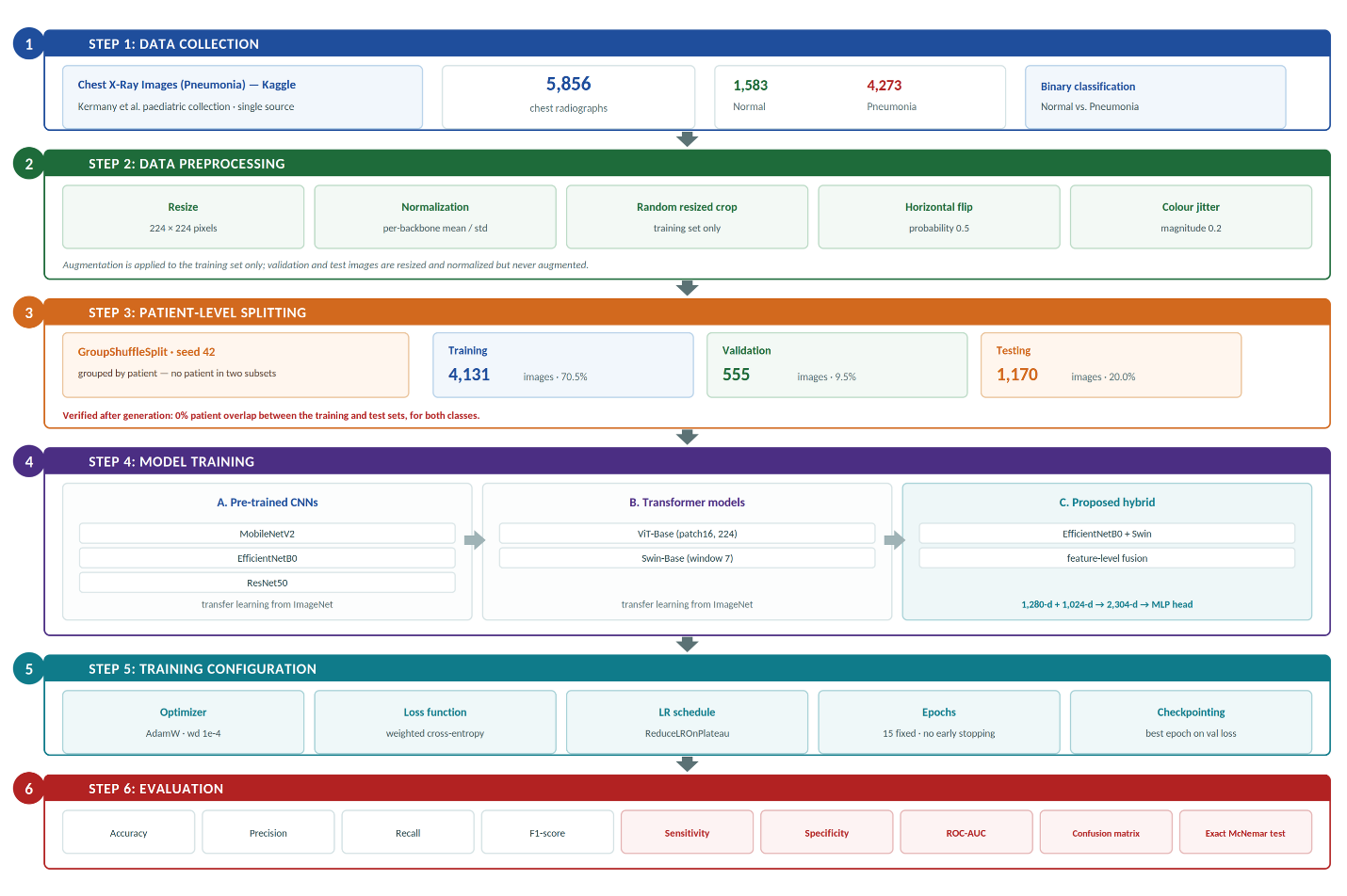
Figure 3.1: Overview of the proposed research framework

\

3.3 Dataset Description
This research is based on the publicly available Chest X-Ray Images (Pneumonia) dataset hosted on Kaggle, derived from the paediatric chest radiograph collection described by Kermany et al. The complete collection was used: 5,856 images in two categories, 1,583 Normal and 4,273 Pneumonia. The dataset is widely used in the literature to develop and evaluate deep-learning models for automated pneumonia detection, which makes results obtained on it comparable, at least in principle, with published work. All images were resized to 224 × 224 pixels to match the input requirements of the selected architectures, and the classification task is binary: distinguishing healthy (Normal) chest X-rays from those showing signs of pneumonia.

3.4 Dataset Splitting
The chest X-ray dataset was divided into three subsets: approximately 70% for training, 10% for validation and 20% for testing. Training was used to learn the model parameters, validation to monitor training performance and select the best epoch, and testing was reserved for the final evaluation of the models on unseen data. The split was generated once with a fixed random seed of 42 and stored on disk, so that all six models were trained and evaluated on exactly the same images.
An important property of this split is that it is grouped by patient rather than by file. The Kaggle collection contains several radiographs of the same child — 4,273 pneumonia images come from 1,844 patients, an average of 2.3 images each — so a naive file-level split scatters images of one patient across the training and test sets, allowing a model to be evaluated on a patient it has already studied. To prevent this, the split was performed with scikit-learn's GroupShuffleSplit using the patient identifier encoded in each file name as the grouping variable, so that every image belonging to one patient is assigned to exactly one subset. Because whole patients move together, the resulting proportions land close to, rather than exactly on, 70/10/20. After generation the split was verified: no patient in the test set appears in the training set, for either class. Section 4.2.4 quantifies how much this decision changes the measured results.
Table 3.1 reports the number of images per class in each subset.
Table 3.1: Number of images per class in each data subset
Dataset | Normal | Pneumonia | Total
Training | 1,114 | 3,017 | 4,131
Validation | 155 | 400 | 555
Testing | 314 | 856 | 1,170
Total | 1,583 | 4,273 | 5,856

3.5 Pre-trained CNN Models
    - MobileNetV:2
MobileNetV2 is a lightweight 53-layer deep CNN model with fewer parameters and an input size of 224×224. This is based on the concept of depth-wise separable convolutions: a single filter for each input channel, and it combines the outputs using pointwise convolution
    - EfficientNetB0:
is a CNN developed to provide high classification accuracy while keeping the model computationally efficient by increasing only the network width. This design allows the model to learn image features effectively using fewer parameters than many traditional CNN models.
    - ResNet50:
is a CNN architecture in the ResNet50 (Residual Networks) family, a series of models designed to address the challenges associated with training deep neural networks.

3.6 Transformer Models

3.6.1 Vision Transformer
The Vision Transformer (ViT) is a transformer-based deep learning architecture designed for image classification. Traditional CNNs apply convolutional filters to extract features from images. ViT views an image as a sequence of small fixed-size patches. All image patches are mapped to a vector representation and passed to the transformer encoder along with positional embeddings. This design allows the model to learn long-range relationships between different parts of an image through self-attention. The size of the chest X-ray images is resized to 224 × 224 pixels to fit the input size of the ViT architecture. Each image was then divided into non-overlapping patches. These patches were then transformed into patch embeddings. Positional embeddings were added to preserve the spatial arrangement of the patches before the transformer encoder processed them. The transformer encoder consists of multiple layers of multi-head self-attention (MHSA) and multi-layer perceptron blocks. The self-attention mechanism enables the model to learn relationships among image patches based on their spatial distance and to capture both local image details and global contextual information. This capability is particularly valuable in medical image analysis; transfer learning was employed by initializing the Vision Transformer with pre-trained ImageNet weights. The original classification layer was retained with a binary classification head for the two target classes: Normal and Pneumonia. During training, the network parameters were fine-tuned using the chest X-ray dataset to adapt the learned visual representations to the pneumonia detection task. The overall workflow of the Vision Transformer used in this study is illustrated in Figure 3.2: the image-patching process, the transformer encoder, and the final classification stage.
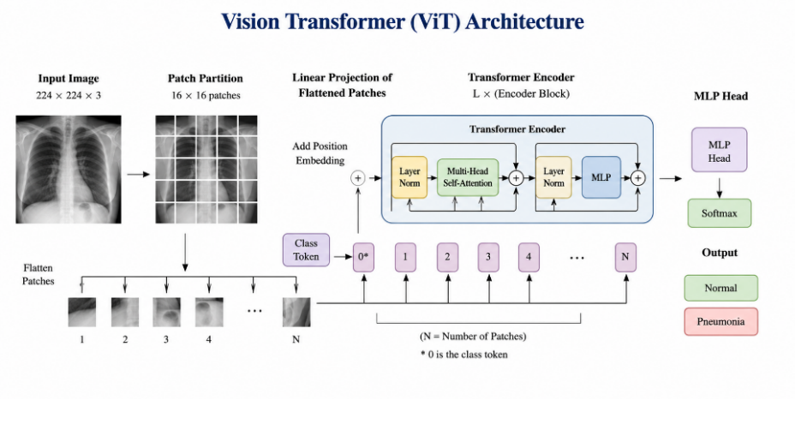
Figure 3.2: Architecture of the Vision Transformer

3.6.2 Swin Transformer
Swin Transformer is a hierarchical vision transformer architecture that aims to improve the efficiency of transformer models for computer vision tasks. Unlike ViT, which computes self-attention on all image patches, Swin Transformer computes self-attention in local windows. It shifts the windows from one layer to the next, allowing information to be communicated between adjacent areas while reducing computational complexity. The chest X-ray images were resized to 224 by 224 pixels and were then provided to the Swin Transformer as input. The images were sectioned into non-overlapping patches feature embeddings were extracted. These embeddings were then processed through multiple stages of the Swin Transformer. Local self-attention and shifted windows allowed the model to learn detailed features from particular areas while also capturing more general information across the entire chest X-ray image.
The Swin Transformer is characterized by its hierarchical structure; adjacent patches are progressively merged as the network creates feature representations at varying scales. This is especially useful for pneumonia detection, where the size, appearance, and position of abnormalities in chest X-ray images can differ. This helps the model to pick out small patterns and relatively large patterns around pneumonia.”
The Swin Transformer was initialized with weights pre-trained on ImageNet, and the original classification layer was replaced with a binary classification head for the two desired classes, Normal and Pneumonia. Then, the model was fine-tuned on the chest X-ray training dataset to adjust the previously learned visual features to the task of classifying pneumonia.
The complete Swin Transformer architecture used in this study is shown in Figure 3.3, which illustrates the main stages of the model, including image partition, shifted window self-attention, hierarchical feature extraction, and the final classification stage.
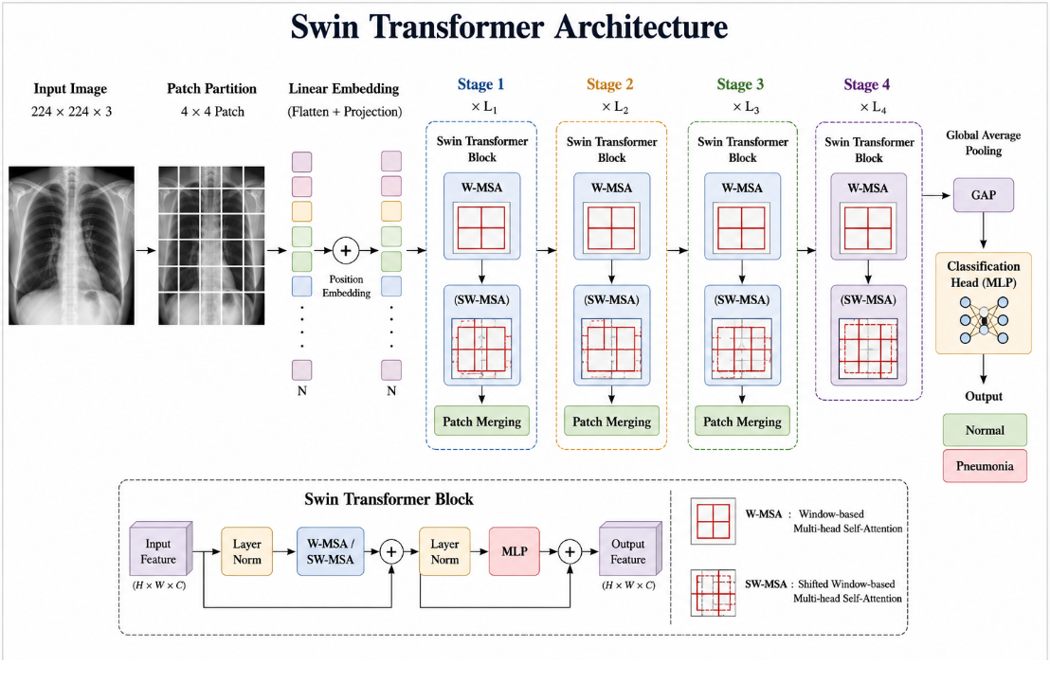
Figure 3.3: Architecture of the Swin Transformer

3.7 Preprocessing and Augmentation
The original chest X-rays varied in size and resolution; all images were resized to 224 × 224 pixels to match the input requirements of the convolutional and transformer architectures. Pixel values were normalized using the statistics each pre-trained backbone expects, and the evaluation transform used the crop ratio associated with each checkpoint. Data augmentation was applied to the training set only and consisted of a random resized crop, a random horizontal flip with probability 0.5, and colour jitter of magnitude 0.2. The validation and testing sets were resized and normalized but not augmented, so that evaluation reflected performance on unmodified images under consistent conditions. Horizontal flipping mirrors a radiograph and therefore reverses anatomical laterality; it was retained because the task is binary presence-or-absence classification rather than localization, so the models are never required to reason about which side an abnormality lies on, but a model intended to report the affected lobe would need this augmentation removed.

3.8 Models and Transfer Learning
Rather than training networks from scratch, transfer learning was used throughout: each model was initialized with weights pre-trained on the large-scale ImageNet dataset, and its original classification layer was replaced with a binary head for the Normal and Pneumonia classes. The network was then fine-tuned on the chest X-ray training set to adapt the learned visual representations to the pneumonia-detection task. Five models were evaluated: three convolutional networks (MobileNetV2, EfficientNetB0 and ResNet50) and two transformer models (ViT and the Swin Transformer). All five were implemented in PyTorch using the timm library and are identified here by their exact checkpoint names so that the experiments can be reproduced: mobilenetv2_100, efficientnet_b0 and resnet50 for the convolutional family, and vit_base_patch16_224 and swin_base_patch4_window7_224 for the transformers. The five baselines were fine-tuned end-to-end, with no layers frozen, for a fixed 15 epochs.

3.9 Proposed Hybrid Model
Based on the individual baselines, a hybrid model was designed to combine the complementary strengths of the two families. Convolutional networks are strong at capturing local texture, while transformer models are strong at modeling global context through self-attention. The proposed hybrid uses two parallel backbones, EfficientNetB0 and the Swin Transformer, to process the same input image. Each backbone produces a pooled feature vector (1,280 dimensions from EfficientNetB0 and 1,024 from the Swin Transformer), and the two vectors are concatenated into a single 2,304-dimensional representation. This fused vector is passed to a compact classification head consisting of a dense layer with ReLU activation, dropout for regularization, and a final SoftMax layer over the two classes. To make training efficient and stable, the hybrid is warm-started from the already fine-tuned EfficientNetB0 and Swin checkpoints; the fusion head is trained first with the backbones frozen, after which the whole network is fine-tuned end-to-end at a low learning rate. Figure 3.4 illustrates the architecture of the proposed hybrid model.
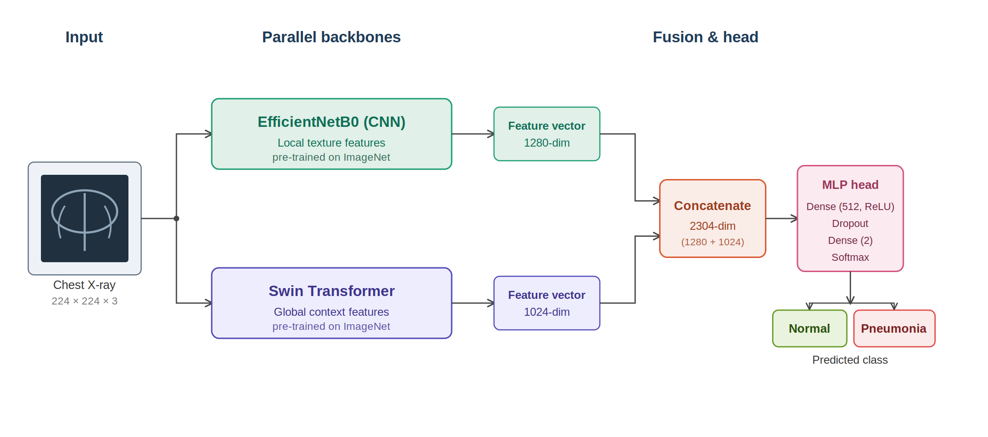
Figure 3.4: Architecture of the proposed CNN–Transformer hybrid model

3.10 Evaluation Metrics

Accuracy
Accuracy is an evaluation metric that measures the proportion of correctly classified cases out of the total number of instances in a dataset. [13]
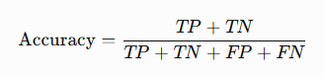

Precision
Precision is a metric that measures the proportion of correctly predicted positive cases out of all cases the model predicts as positive. [14]
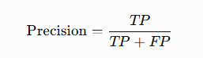

Recall
Recall is a metric that measures a model's ability to identify all actual positive cases in a dataset correctly. [14]
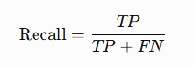

F1 Score
The F1-score is a metric that combines precision and recall into a single
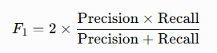

Chapter 4: Results and Discussion

4.1 Experimental Setup
The experiments were carried out locally under Windows 11 in a Python environment managed with Anaconda, on a workstation with an Intel Core i9-13900H processor and 32 GB of memory, using an NVIDIA GeForce RTX 5060 Laptop GPU with 8 GB of video memory. All six models — the five baselines and the proposed hybrid — were implemented in PyTorch using the timm library, which supplied the ImageNet pre-trained checkpoints. Training used a batch size of 32 for a fixed 15 epochs with the AdamW optimizer (weight decay 1e-4), a ReduceLROnPlateau schedule that cut the learning rate by a factor of 0.3 after two epochs without improvement, and cross-entropy loss weighted by inverse class frequency (1.854 for Normal and 0.685 for Pneumonia) to compensate for the class imbalance. Automatic mixed precision was enabled on the GPU. The learning rate was the one setting not held constant: the convolutional networks were trained at 1e-4 and the transformers at 3e-5, on the standard reasoning that transformer backbones are more sensitive to large updates during fine-tuning. A single random seed of 42 was set for Python, NumPy and PyTorch, covering both the dataset split and weight initialization.
Validation loss was monitored after every epoch and the weights of the best epoch restored before evaluation; the selected epochs were 9 for MobileNetV2, 11 for EfficientNetB0, 11 for ResNet50, 14 for ViT, 14 for Swin, and the fifth epoch of the second stage for the hybrid. It should be stated plainly that this is best-checkpoint selection rather than early stopping: the early-stopping option in the training code was disabled and every model completed its full schedule. NumPy, Pandas, Matplotlib, scikit-learn and seaborn were used for data handling, evaluation and visualization, and statsmodels for the McNemar test.
Table 4.1: Experimental configuration
Parameter | Value
Programming Language | Python 3.13
Framework | PyTorch 2.11 (CUDA 12.8) with timm
Models | MobileNetV2, EfficientNetB0, ResNet50, ViT-Base, Swin-Base, Hybrid
Image Size | 224 × 224
Batch Size | 32
Epochs | 15 (fixed); 3 + 8 for the hybrid
Optimizer | AdamW, weight decay 1e-4
Loss Function | Cross-entropy weighted by class frequency (1.854 / 0.685)
Data Split | 70/10/20, patient-disjoint (GroupShuffleSplit), seed 42
Early Stopping | Not used; best-epoch weights restored on validation loss
Evaluation Metrics | Accuracy, Precision, Recall, F1-score, Sensitivity, Specificity, ROC-AUC, McNemar test

4.2 Results

4.2.1 Overall Performance
Table 4.2 reports the overall performance of the evaluated models in terms of accuracy, precision, recall, F1-score and the area under the ROC curve (AUC), measured on the patient-disjoint test set of 1,170 images. The two transformer models tied for the highest accuracy at 97.35%, each classifying 1,139 of the 1,170 test images correctly. The three convolutional networks formed a distinctly lower group: ResNet50 at 95.38%, EfficientNetB0 at 95.13% and MobileNetV2 at 94.87%. The proposed hybrid reached 97.01%, above every convolutional model but below both transformers. The Swin Transformer obtained the highest AUC of any model at 0.9962, followed by ViT at 0.9948 and the hybrid at 0.9946.
These differences are large enough to separate the two architecture families. The Wilson 95% confidence interval for either transformer is 96.26–98.13%, while EfficientNetB0's is 93.74–96.22% and MobileNetV2's 93.45–96.00%; the transformer interval does not overlap the interval of any convolutional model. Within each family the models cannot be separated: ViT and Swin are tied outright, and the three convolutional networks sit within half a percentage point of one another. The correct reading is therefore that the architecture family matters on this task while the specific choice within a family does not.
To test whether the difference between the proposed hybrid and the strongest single model was statistically meaningful, McNemar's test was applied to the paired predictions of the hybrid and ViT on the same test set, using the exact binomial form because the number of discordant pairs is small. Of the 1,170 test images the two models agreed on 1,148 and disagreed on 22: the hybrid was uniquely correct on nine and ViT on thirteen. The test returns p = 0.524, well above the 0.05 threshold, so the four-image advantage held by ViT is not statistically significant. The hybrid is therefore neither significantly better nor significantly worse than the best single model, and there is no measure on which it leads.
Table 4.2: Overall performance of the evaluated models
Approach | Model | Accuracy | Precision | Recall | F1-score | AUC
Pre-trained CNN | MobileNetV2 | 0.9487 | 0.9511 | 0.9487 | 0.9493 | 0.9866
Pre-trained CNN | EfficientNetB0 | 0.9513 | 0.9551 | 0.9513 | 0.9521 | 0.9925
Pre-trained CNN | ResNet50 | 0.9538 | 0.9566 | 0.9538 | 0.9545 | 0.9896
Transformer | ViT | 0.9735 | 0.9734 | 0.9735 | 0.9735 | 0.9948
Transformer | Swin | 0.9735 | 0.9736 | 0.9735 | 0.9735 | 0.9962
Proposed | Hybrid (EfficientNetB0 + Swin) | 0.9701 | 0.9706 | 0.9701 | 0.9702 | 0.9946
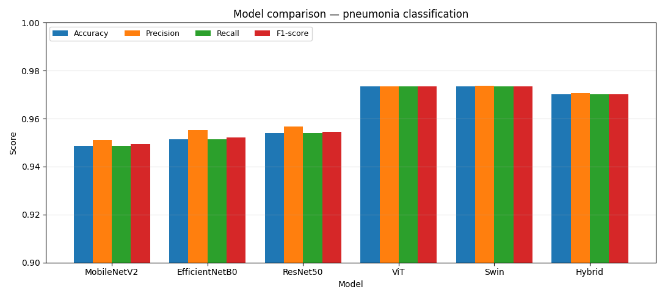
Figure 4.1: Accuracy, precision, recall and F1-score across all models
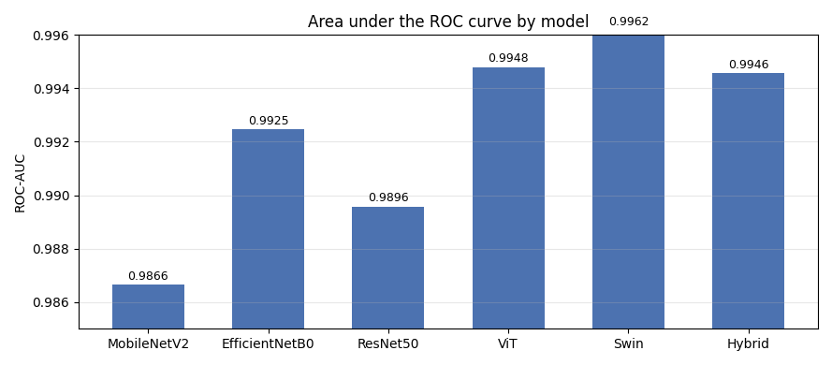
Figure 4.2: Area under the ROC curve by model

4.2.2 Per-Class Performance
Table 4.3 presents a per-class breakdown of precision, recall and F1-score for the Normal and Pneumonia classes, and the asymmetry of the dataset shows clearly. Precision on the Pneumonia class is high for every model, between 0.98 and 0.99, because a prediction of pneumonia is usually correct when pneumonia accounts for three quarters of the images; precision on the Normal class is markedly lower, between 0.87 and 0.95, because the smaller class absorbs proportionally more of the false positives. The two transformers are the most balanced of the six, each reaching 0.95 on all three Normal-class measures against 0.87 to 0.88 for the convolutional networks.
Restating these results as sensitivity and specificity, with the Pneumonia class treated as positive, brings out the difference that matters most clinically. The Vision Transformer missed 14 of the 856 pneumonia cases and the Swin Transformer 17, giving sensitivities of 0.984 and 0.980. The three convolutional networks missed between 42 and 47, giving sensitivities between 0.945 and 0.951. In absolute terms a convolutional model overlooks roughly three times as many pneumonia cases as a transformer on the same images. Comparing MobileNetV2 with ViT, accuracy differs by 2.5 percentage points, but the number of pneumonia cases overlooked falls from 43 to 14 — a difference that would matter far more in a screening setting than the accuracy figures alone suggest. Specificity runs the other way but by a much smaller margin, with EfficientNetB0 highest at 0.968 and ViT and MobileNetV2 lowest at 0.946.

Table 4.3: Per-class performance of the evaluated models
Approach | Model | Class | Precision | Recall | F1-score
Pre-trained CNN | MobileNetV2 | Normal | 0.87 | 0.95 | 0.91
Pre-trained CNN |  | Pneumonia | 0.98 | 0.95 | 0.96
Pre-trained CNN | EfficientNetB0 | Normal | 0.87 | 0.97 | 0.91
Pre-trained CNN |  | Pneumonia | 0.99 | 0.95 | 0.97
Pre-trained CNN | ResNet50 | Normal | 0.88 | 0.96 | 0.92
Pre-trained CNN |  | Pneumonia | 0.99 | 0.95 | 0.97
Transformer | ViT | Normal | 0.95 | 0.95 | 0.95
Transformer |  | Pneumonia | 0.98 | 0.98 | 0.98
Transformer | Swin | Normal | 0.95 | 0.96 | 0.95
Transformer |  | Pneumonia | 0.98 | 0.98 | 0.98
Proposed | Hybrid | Normal | 0.93 | 0.96 | 0.95
Proposed |  | Pneumonia | 0.99 | 0.97 | 0.98

4.2.3 Confusion Matrices and ROC Curves
The confusion matrices in Figure 4.3 compare the predicted labels with the true labels for each model on the held-out test set of 1,170 images. In every case the diagonal entries are substantially larger than the off-diagonal entries. The Vision Transformer correctly classified 297 of 314 Normal cases and 842 of 856 Pneumonia cases, giving 17 false positives and 14 false negatives. Swin recorded 14 and 17, and the proposed hybrid 12 and 23. The convolutional networks show the same shape with markedly more missed pneumonia: MobileNetV2 17 and 43, ResNet50 12 and 42, and EfficientNetB0 10 and 47 — the fewest false positives of any model and the most false negatives. Figure 4.4 shows the corresponding ROC curves, each of which rises steeply towards the top-left corner and remains well above the chance diagonal; the area under the curve exceeds 0.986 for every model and reaches its highest value, 0.996, for Swin.
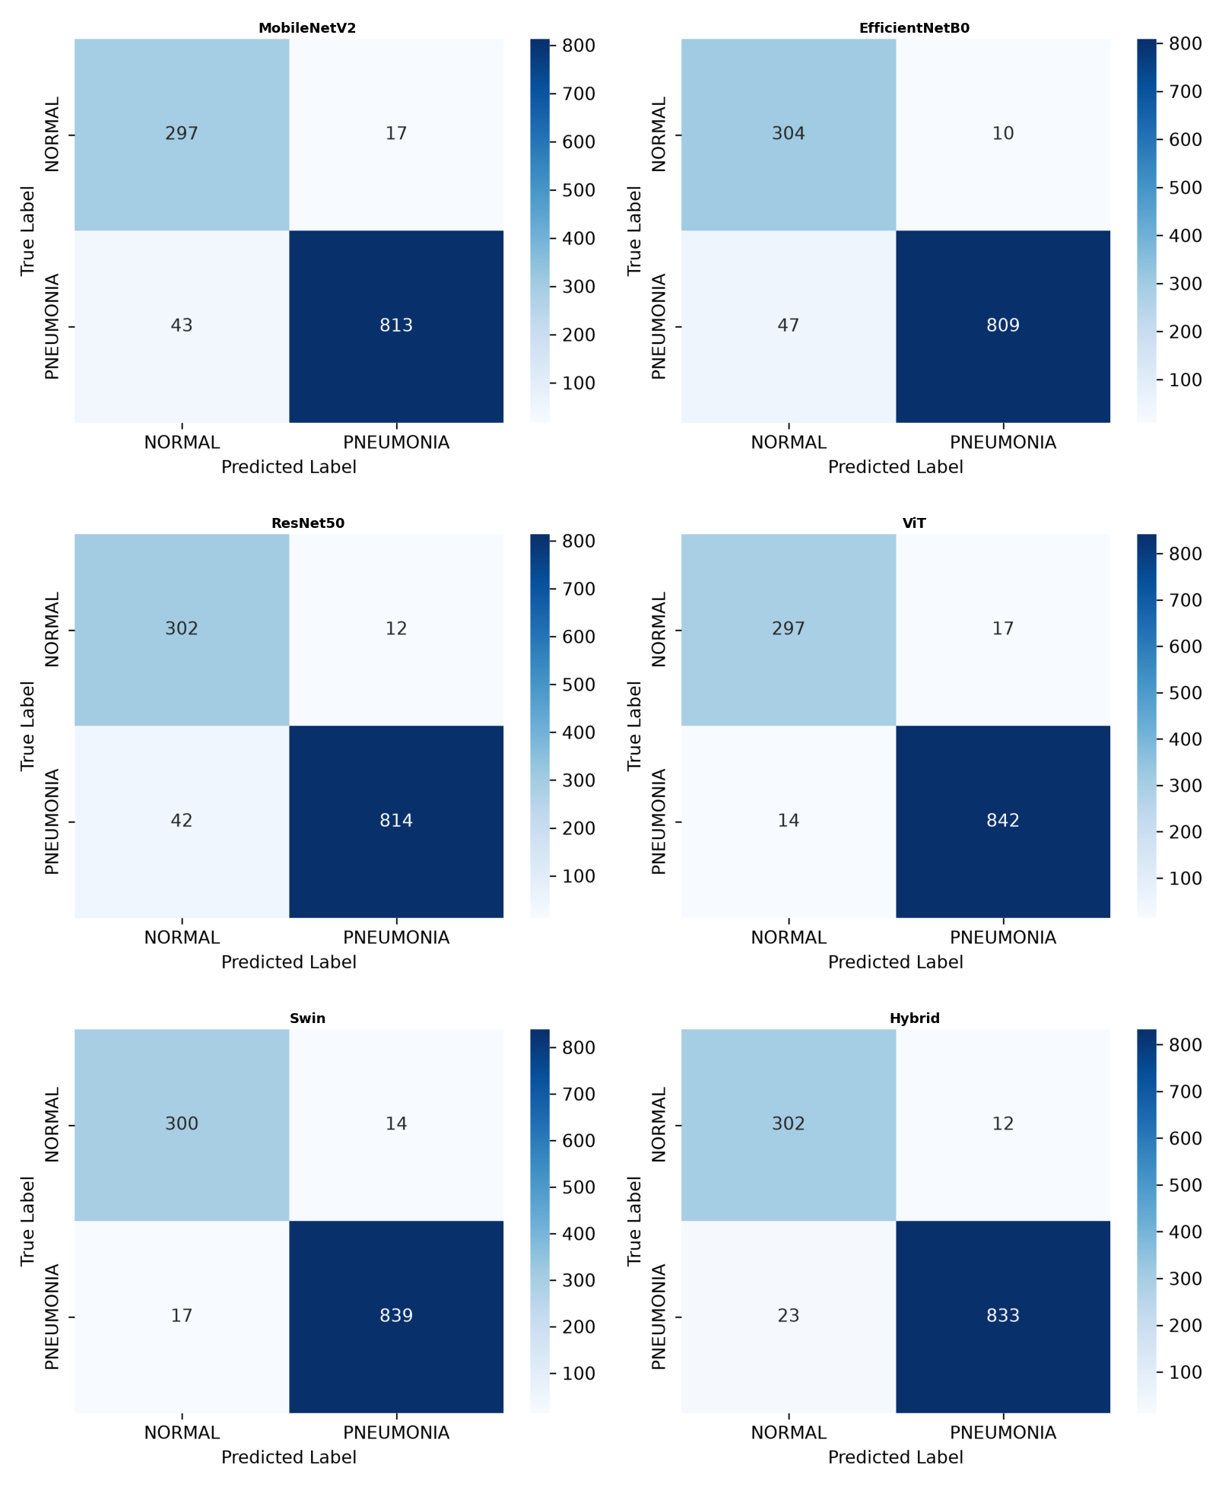
Figure 4.3: Confusion matrices of the evaluated models
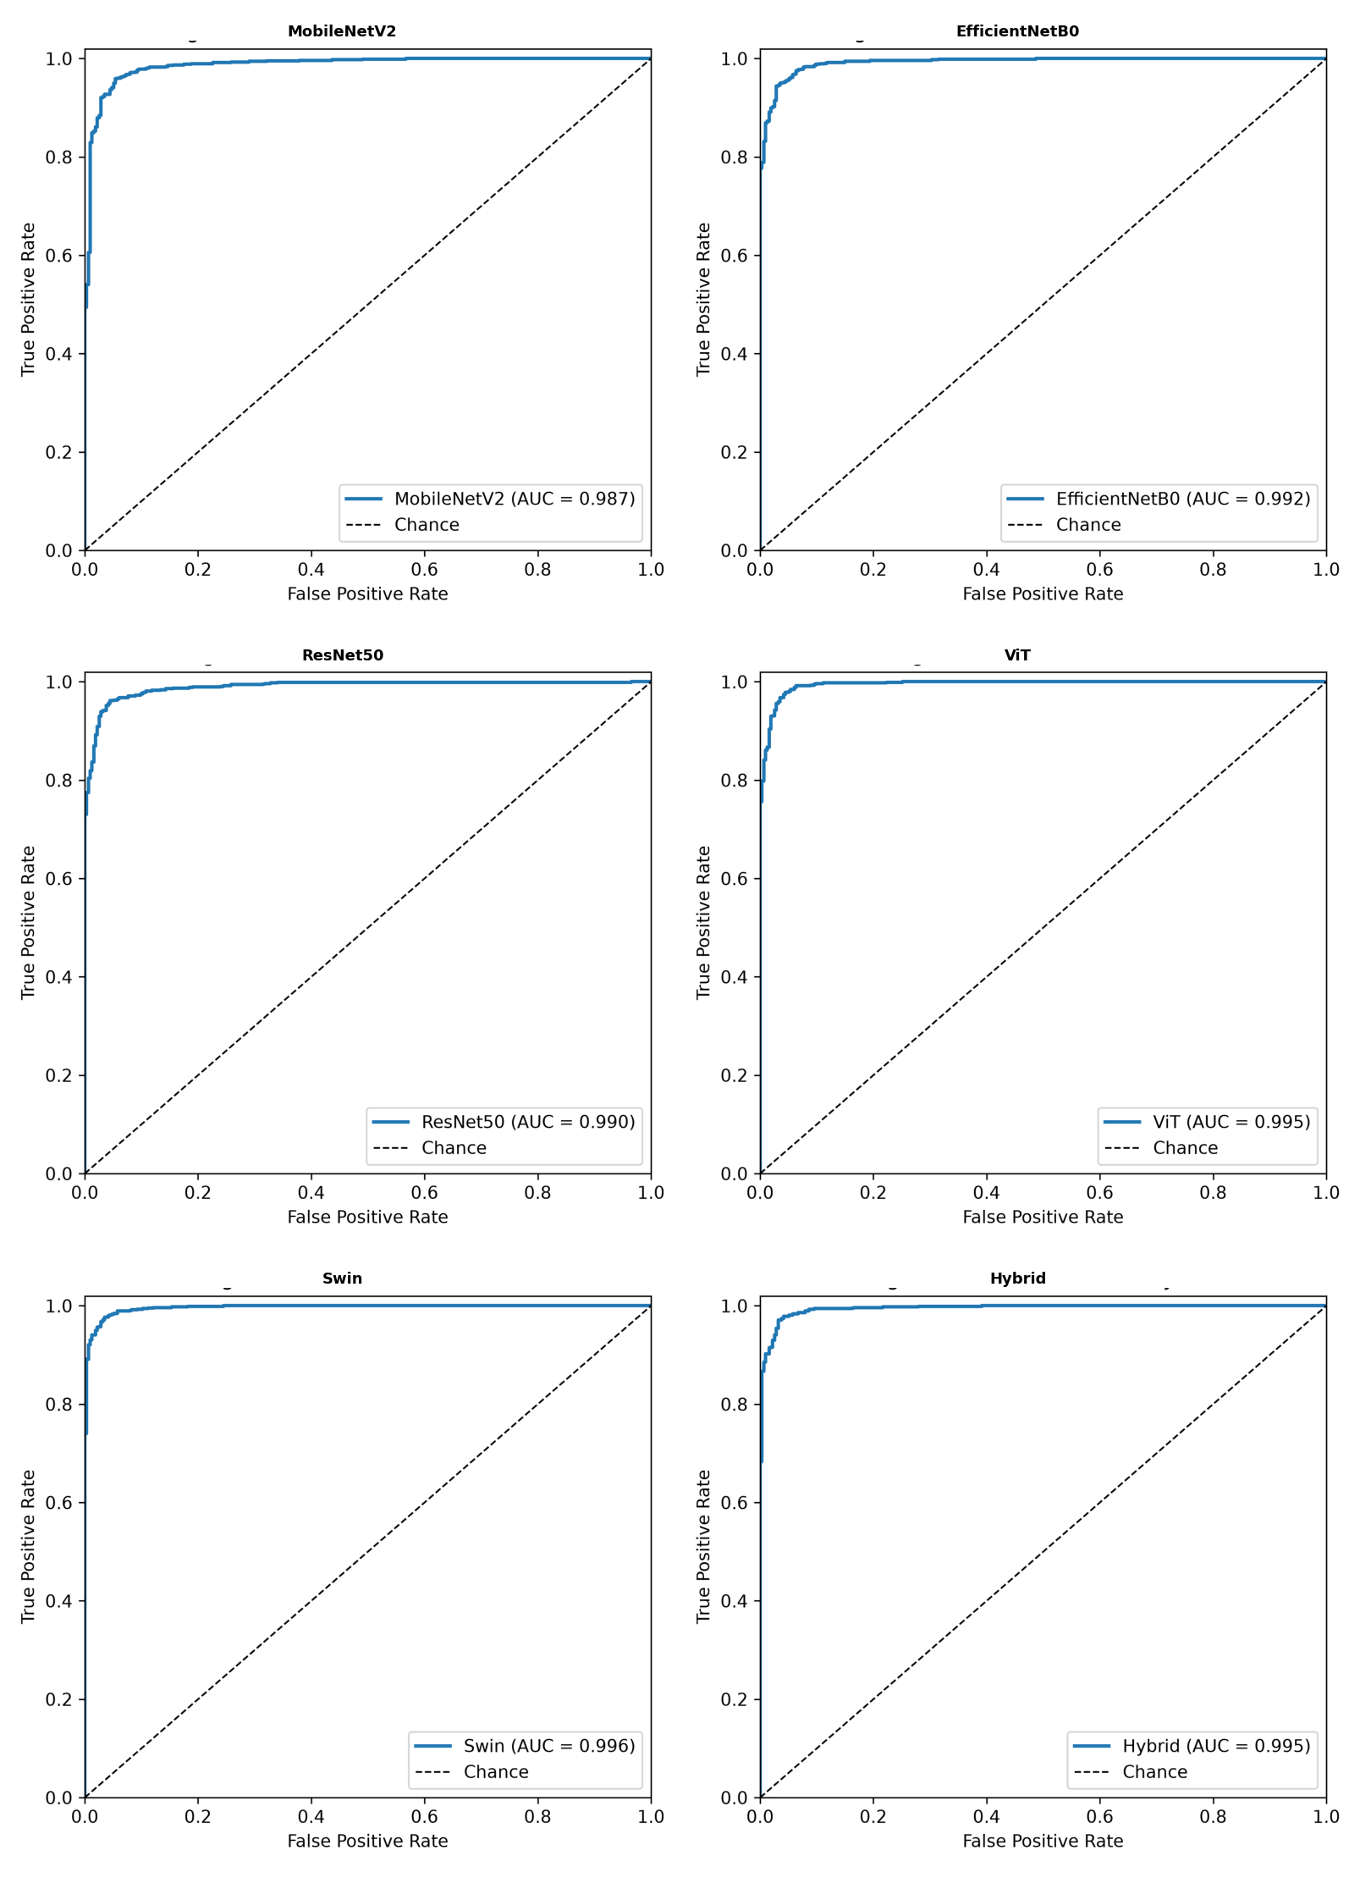
Figure 4.4: ROC curves of the evaluated models

4.2.4 Effect of Patient-Level Data Leakage
The results reported above were obtained on a patient-disjoint split. To quantify what patient overlap costs in measured performance, the entire experiment was also run on a file-level split of the same 5,856 images, in which images were assigned to subsets individually without regard to which patient they came from — the strategy used by much of the published work on this benchmark. Under that split, 74.2% of pneumonia test images came from a patient who also appeared in the training set; the Normal class, being close to one image per patient, showed only 5.0% overlap.
The effect is systematic and it is not uniform across architectures. All three convolutional networks scored higher under the file-level split — MobileNetV2 by 0.95 points, ResNet50 by 1.04 and EfficientNetB0 by 1.54 — while the two transformers and the hybrid scored slightly lower. The false-negative counts diverge more sharply still: removing the overlap roughly doubled the number of pneumonia cases the convolutional networks missed, from 32–38 to 42–47, while the transformers improved from 24–35 to 14–17. A plausible reading is that convolutional networks, whose receptive fields emphasize local texture, benefit disproportionately from having seen another radiograph of the same chest, whereas attention-based models rely more on global structure that transfers between patients. This is offered as a hypothesis rather than a demonstration: the two runs use different test images as well as different splitting strategies, and each figure comes from a single training run, so the comparison confounds the leakage effect with sampling and run-to-run variation.
Table 4.4: Measured performance under a file-level split and a patient-disjoint split of the same dataset
Model | Accuracy (file-level) | Accuracy (patient-disjoint) | Difference | FN (file-level) | FN (disjoint)
MobileNetV2 | 95.82% | 94.87% | −0.95 | 38 | 43
EfficientNetB0 | 96.67% | 95.13% | −1.54 | 32 | 47
ResNet50 | 96.42% | 95.38% | −1.04 | 35 | 42
ViT | 97.18% | 97.35% | +0.17 | 24 | 14
Swin | 96.42% | 97.35% | +0.93 | 35 | 17
Hybrid | 96.59% | 97.01% | +0.42 | 33 | 23
The practical conclusion is firmer than the mechanistic one. Under the file-level split the six models appeared nearly indistinguishable, with every confidence interval overlapping every other; under the patient-disjoint split a clear gap opens between the transformer and convolutional families. A comparison drawn on the leaky split would therefore have supported the wrong conclusion about which architectures suit this task. This finding echoes that of Hofmeister et al. [8], who showed that benchmarking against a weak reference standard inflates apparent diagnostic performance; here the weak element is the splitting protocol rather than the reference diagnosis, but the lesson is the same. Patient-grouped splitting should be treated as a minimum requirement for work on this benchmark rather than as a refinement.

4.2.5 System Implementation
To evaluate the practical applicability of the trained models, a lightweight web application was developed to serve them for interactive use. The application runs locally and presents a simple interface in which the user selects one of the trained models, uploads a chest X-ray image, and receives a prediction. For each image, the system returns the predicted class (normal or pneumonia), the model's confidence, a per-class probability breakdown, and the inference time. The trained model weights are loaded on demand and cached so that switching between models and classifying successive images is fast. This converts the trained models into a usable decision-support prototype and clarifies how the approach could be integrated into a screening workflow. Figure 4.5 shows the interface classifying a pneumonia case. The application is a research and educational prototype and is not a certified medical device; any clinical use would require validation and regulatory approval, and a qualified radiologist should always confirm predictions.
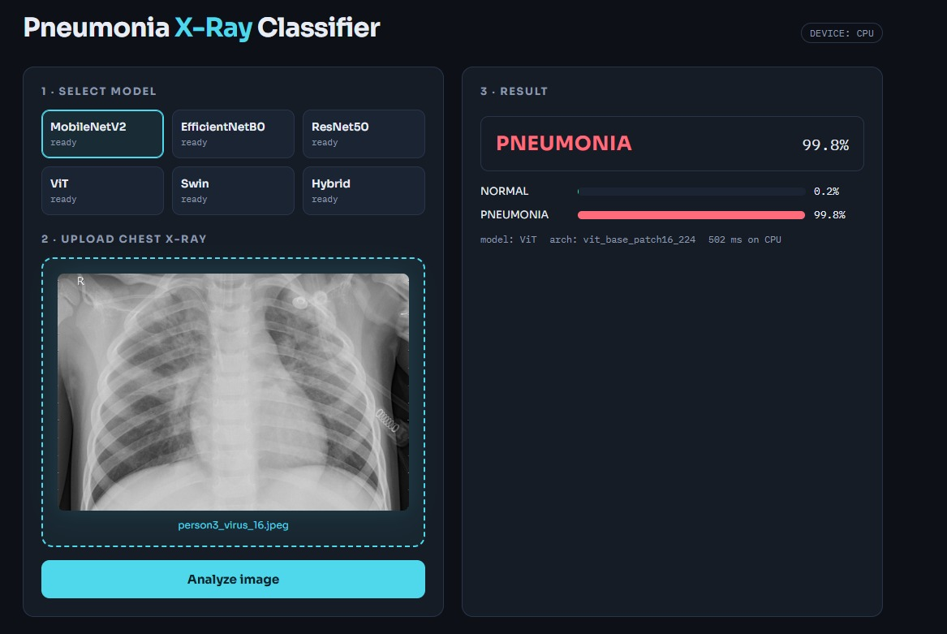
Figure 4.5: The web application classifying a chest X-ray image

4.3 Discussion of Results
This study developed and compared five deep-learning models for the automated detection of pneumonia from chest X-ray images and proposed a hybrid model that fuses convolutional and transformer features. All six models achieved high classification performance, which can be attributed to transfer learning, allowing the networks to reuse feature representations learned from large-scale image datasets, and to the preprocessing, normalization and augmentation that improved the quality and diversity of the training data.
The clearest result is the gap between the two architecture families. The transformer models tied at 97.35% accuracy, roughly two percentage points ahead of every convolutional network, and missed a third as many pneumonia cases. This is the only difference in the study whose confidence intervals separate, and it is consistent with the self-attention mechanism, which relates distant regions of an image directly and so captures local detail and global context together — a combination that suits a condition whose signs may appear anywhere in the lung fields. Within each family the differences are negligible.
The result concerning the proposed hybrid is a negative one, and it is reported as such. At 97.01% the hybrid outperformed all three convolutional networks by a clear margin, so the fusion did carry the convolutional branch well beyond what EfficientNetB0 achieved alone at 95.13%. But it did not reach either transformer, and an exact McNemar test placed its difference from ViT at p = 0.524. Fusing a convolutional branch into a transformer therefore bought nothing over the transformer alone, at roughly twice the parameter count and inference cost. This stands in contrast to the pattern in the wider literature, where hybrid and ensemble designs are frequently reported as superior to their components without an accompanying significance test.
The second contribution of this work is methodological. Repeating the entire experiment on a file-level split of the same images — in which 74% of pneumonia test images shared a patient with the training set — raised convolutional accuracy by up to 1.5 points and closed the gap between the two families entirely. A study using that protocol would have concluded that the architecture choice does not matter, which the leakage-free results show to be wrong. The value of this thesis therefore lies less in a performance gain than in the conditions under which the comparison was made: a common protocol, a patient-disjoint split verified free of leakage, an explicit significance test, and a direct measurement of what a weaker protocol would have cost.
Several limitations qualify these findings. All models were trained and evaluated on a single paediatric dataset from one centre, so performance on adult radiographs or on images from other institutions is unknown, and patient-level separation within one centre is a much weaker guarantee than external validation. Results come from a single training run per model, so run-to-run variance is unquantified. The decision threshold was left at the default of 0.5 rather than tuned to reflect the higher cost of a false negative. No explainability method was applied, so there is no evidence that predictions rest on clinically meaningful image regions. And only one CNN–transformer pairing and one fusion strategy were tested.

Chapter 5: Conclusion and Future Work
This thesis found that transformer-based models outperform convolutional networks for pneumonia classification on chest radiographs, and that fusing the two families into a hybrid did not improve on the transformer alone. Several directions follow from these findings and from the limitations set out above. The most pressing is external validation: the models should be re-evaluated on larger multi-centre datasets spanning different equipment, patient populations and image quality, and on adult as well as paediatric cohorts, so that generalization can be assessed rather than assumed. The evaluation itself should also be strengthened, with repeated runs across several random seeds to quantify variance, DeLong's test for comparing AUC values, and threshold tuning that reflects the higher cost of a false negative in screening.
Explainability should be treated as a requirement rather than an enhancement. Methods such as Grad-CAM or SHAP would show which regions of an image drive each prediction, allowing clinicians to judge whether the model attends to plausible findings. Prospective comparison against radiologist readings, on cases where ground truth is established independently — as in the protocol used by Hofmeister et al. [8] — would be the natural step after that.
On the modelling side, the hybrid design space deserves fuller exploration. Only one backbone pairing and one fusion strategy were tested here; alternatives such as pairing the convolutional branch with ViT rather than Swin, attention-based rather than concatenation-based fusion, or joint training from scratch would establish whether the ceiling observed in this work is a property of the dataset or of the particular fusion adopted. Extending the task beyond binary classification, to distinguish bacterial from viral pneumonia or to screen for multiple lung pathologies, would broaden the clinical value of the approach. Finally, the web prototype should be developed into a properly engineered decision-support system with authentication, audit logging, de-identification and PACS integration before it is placed in front of any clinical user.

References
[1] Singh, S., Kumar, M., Kumar, A., Verma, B. K., Abhishek, K., & Selvarajan, S. (2024). Efficient pneumonia detection using Vision Transformers on chest X-rays. Scientific Reports, 14, 2487. https://doi.org/10.1038/s41598-024-52703-2
[2] Mustapha, B., Zhou, Y., Shan, C., & Xiao, Z. (2025). Enhanced pneumonia detection in chest X-rays using hybrid convolutional and vision transformer networks. Current Medical Imaging, 21, e15734056326685. https://doi.org/10.2174/0115734056326685250101113959
[3] Shomsomi, M., Triawan, W., & Purwadi. (2026). Classification of pneumonia using CNN and vision transformer. Journal of Artificial Intelligence and Engineering Applications (JAIEA), 5(2), 2495–2504. https://doi.org/10.59934/jaiea.v5i2.1906
[4] Kareem, A., Liu, H., & Velisavljevic, V. (2023). A federated learning framework for pneumonia image detection using distributed data. Healthcare Analytics, 4, 100204. https://doi.org/10.1016/j.health.2023.100204
[5] Alshanketi, F., Alharbi, A., Kuruvilla, M., Mahzoon, V., Siddiqui, S. T., Rana, N., & Tahir, A. (2025). Pneumonia detection from chest X-ray images using deep learning and transfer learning for imbalanced datasets. Journal of Imaging Informatics in Medicine, 38(4), 2021–2040. https://doi.org/10.1007/s10278-024-01334-0
[6] Slimi, H., Balti, A., Abid, S., & Sayadi, M. (2025). Trustworthy pneumonia detection in chest X-ray imaging through attention-guided deep learning. Scientific Reports, 15, 40029. https://doi.org/10.1038/s41598-025-23664-x
[7] Yanar, E., Hardalaç, F., & Ayturan, K. (2025). PELM: A deep learning model for early detection of pneumonia in chest radiography. Applied Sciences, 15(12), 6487. https://doi.org/10.3390/app15126487
[8] Hofmeister, J., Garin, N., Montet, X., Scheffler, M., Platon, A., Poletti, P.-A., Stirnemann, J., Debray, M.-P., Claessens, Y.-E., Duval, X., & Prendki, V. (2024). Validating the accuracy of deep learning for the diagnosis of pneumonia on chest x-ray against a robust multimodal reference diagnosis: A post hoc analysis of two prospective studies. European Radiology Experimental, 8, 20. https://doi.org/10.1186/s41747-023-00416-y
[9] Buriboev, A. S., Abduvaitov, A., & Jeon, H. S. (2025). Binary classification of pneumonia in chest X-ray images using modified contrast-limited adaptive histogram equalization algorithm. Sensors, 25(13), 3976. https://doi.org/10.3390/s25133976
[10] Saber, A., Fateh, A., Parhami, P., Siahkarzadeh, A., Fateh, M., & Ferdowsi, S. (2025). Efficient and accurate pneumonia detection using a novel multi-scale transformer approach. Sensors, 25(23), 7233. https://doi.org/10.3390/s25237233
[11] Bundea, M., & Danciu, G. M. (2024). Pneumonia image classification using DenseNet architecture. Information, 15(10), 611. https://doi.org/10.3390/info15100611
[12] An, Q., Chen, W., & Shao, W. (2024). A deep convolutional neural network for pneumonia detection in X-ray images with attention ensemble. Diagnostics, 14(4), 390. https://doi.org/10.3390/diagnostics14040390
[13] Usman, C., Rehman, S. U., Ali, A., Khan, A. M., & Ahmad, B. (2025). Pneumonia disease detection using chest X-rays and machine learning. Algorithms, 18(2), 82. https://doi.org/10.3390/a18020082
[14] Ahmed, M. S., Rahman, A., AlGhamdi, F., AlDakheel, S., Hakami, H., AlJumah, A., AlIbrahim, Z., Youldash, M., Alam Khan, M. A., & Basheer Ahmed, M. I. (2023). Joint diagnosis of pneumonia, COVID-19, and tuberculosis from chest X-ray images: A deep learning approach. Diagnostics, 13(15), 2562. https://doi.org/10.3390/diagnostics13152562
[15] Al Reshan, M. S., Gill, K. S., Anand, V., Gupta, S., Alshahrani, H. M., AlSulaiman, A. A., & Shaikh, A. (2023). Detection of pneumonia from chest X-ray images utilizing MobileNet model. Healthcare, 11(11), 1561. https://doi.org/10.3390/healthcare11111561
[16] LeCun, Y., Bottou, L., Bengio, Y., & Haffner, P. (1998). Gradient-based learning applied to document recognition. Proceedings of the IEEE.
[17] Huang, G., Liu, Z., Van Der Maaten, L., & Weinberger, K. Q. (2017). Densely Connected Convolutional Networks. CVPR.
[18] He, K., Zhang, X., Ren, S., & Sun, J. (2016). Deep Residual Learning for Image Recognition. CVPR.
[19] Tan, M., & Le, Q. V. (2019). EfficientNet: Rethinking Model Scaling for Convolutional Neural Networks. ICML.
[20] Dosovitskiy, A., et al. (2020). An Image is Worth 16×16 Words: Transformers for Image Recognition at Scale. arXiv:2010.11929.
[21] Sokolova, M., & Lapalme, G. (2009). A systematic analysis of performance measures for classification tasks. Information Processing & Management.
[22] Powers, D. M. W. (2011). Evaluation: From Precision, Recall and F-measure to ROC, Informedness, Markedness & Correlation. Journal of Machine Learning Technologies.
[23] Russell, S., & Norvig, P. (2021). Artificial Intelligence: A Modern Approach (4th ed.). Pearson.
[24] Mitchell, T. M. (1997). Machine Learning. McGraw-Hill.
[25] World Health Organization (WHO). (2023). Pneumonia. https://www.who.int/news-room/fact-sheets/detail/pneumonia
[26] Howard, A. G., et al. (2017). MobileNets: Efficient Convolutional Neural Networks for Mobile Vision Applications.
[27] Liu, Z., et al. (2021). Swin Transformer: Hierarchical Vision Transformer using Shifted Windows. Proceedings of the IEEE/CVF International Conference on Computer Vision (ICCV).
[28] Kermany, D. S., Goldbaum, M., Cai, W., Valentim, C. C. S., Liang, H., Baxter, S. L., McKeown, A., Yang, G., Wu, X., Yan, F., Dong, J., Prasadha, M. K., Pei, J., Ting, M. Y. L., Zhu, J., Li, C., Hewett, S., Dong, J., Ziyar, I., … Zhang, K. (2018). Identifying medical diagnoses and treatable diseases by image-based deep learning. Cell, 172(5), 1122–1131.e9. https://doi.org/10.1016/j.cell.2018.02.010
[29] Mooney, P. (2018). Chest X-ray images (pneumonia) [Data set]. Kaggle. https://www.kaggle.com/datasets/paultimothymooney/chest-xray-pneumonia
[30] McNemar, Q. (1947). Note on the sampling error of the difference between correlated proportions or percentages. Psychometrika, 12(2), 153–157. https://doi.org/10.1007/BF02295996
[31] Wilson, E. B. (1927). Probable inference, the law of succession, and statistical inference. Journal of the American Statistical Association, 22(158), 209–212. https://doi.org/10.1080/01621459.1927.10502953
[32] DeLong, E. R., DeLong, D. M., & Clarke-Pearson, D. L. (1988). Comparing the areas under two or more correlated receiver operating characteristic curves: A nonparametric approach. Biometrics, 44(3), 837–845. https://doi.org/10.2307/2531595
[33] Selvaraju, R. R., Cogswell, M., Das, A., Vedantam, R., Parikh, D., & Batra, D. (2017). Grad-CAM: Visual explanations from deep networks via gradient-based localization. Proceedings of the IEEE International Conference on Computer Vision (ICCV), 618–626. https://doi.org/10.1109/ICCV.2017.74
[34] Lundberg, S. M., & Lee, S.-I. (2017). A unified approach to interpreting model predictions. Advances in Neural Information Processing Systems (NeurIPS), 30, 4765–4774.
[35] Sandler, M., Howard, A., Zhu, M., Zhmoginov, A., & Chen, L.-C. (2018). MobileNetV2: Inverted residuals and linear bottlenecks. Proceedings of the IEEE Conference on Computer Vision and Pattern Recognition (CVPR), 4510–4520.

