

Predicting and Mitigating Urban Traffic Congestion Using Artificial Intelligence

Prepared By
Name: [Musab Abdullah Alsalamah] ID No: [252000152]
Submitted in fulfillment of the requirements for the degree Master of Science in Modern artificial intelligence
At
College of Informatics
Midocean University
UAE
Supervisor Name: Dr. Yasser Abdel Hamid
College of Informatics, Midocean University, Comoros
[3-2025]

Acknowledgements

Abstract
Traffic congestion remains one of the most persistent challenges facing modern cities, particularly as urban populations continue to grow and transportation networks become increasingly strained. This project presents an AI-driven framework designed to predict traffic congestion and support the development of intelligent traffic management strategies. Using real traffic volume data obtained from smart signal systems, the study integrates machine learning and deep learning methods to capture temporal variations in vehicle flow and forecast future congestion levels with high reliability.

The research process begins with the preparation and preprocessing of raw traffic data, which includes cleaning inconsistent entries, handling missing intervals, and engineering time-dependent features. Multiple analytical techniques were applied to identify underlying traffic patterns and highlight factors that contribute to frequent bottlenecks. Models such as Long Short-Term Memory (LSTM) networks and tree-based algorithms were trained and evaluated using established performance metrics. The predictive models demonstrated strong accuracy, confirming the suitability of AI-based approaches for short-term traffic forecasting.

Visualization tools—including heatmaps, daily-trend analyses, and flow distribution charts—were used to validate model insights and reveal congestion behaviors across different intersections. The findings show that incorporating temporal features and detector-level traffic volumes significantly improves forecasting performance. The developed framework offers practical value for smart city planners by enabling data-driven optimization of traffic signal timing and proactive congestion mitigation. This work provides a solid foundation for future enhancements, including real-time deployment, integration with IoT sensor networks, and adaptive traffic control systems.

List of Publications

Table of Contents

Chapter 1: Introduction………………………………………………........
1.1 Problem Definition ...................................................................................
1.2 Thesis Objectives .....................................................................................
1.3 Thesis Contribution ..................................................................................
1.4 Thesis Organization...................................................................................
Chapter 2: Overview……………………………………………………….
2.1 Introduction ..............................................................................................
2.2 Classical Machine Learning Methods ......................................................
2.3 Deep Learning Approaches ………………………………………………
2.4 Hybrid and Optimized Models …………………..……….……………...
2.5 Use of Real-world Datasets ……………………………………………...
2.6 Quantitative Results Summary ……………………………………….…
2.7 Research Gaps and Opportunities …………………………………..……
2.8 Conclusion ………………………………………………………….……

Introduction
1.1 Problem Definition

Urban traffic congestion has become one of the most pressing challenges faced by modern cities, particularly as rapid population growth and the expansion of transportation networks place increasing pressure on existing infrastructure. Traffic buildup disrupts daily mobility, prolongs travel times, and contributes to higher levels of fuel consumption and emissions. Moreover, recurrent congestion at key intersections can weaken economic productivity, reduce the efficiency of public services, and negatively influence the overall quality of urban life.

Although many congestion events are linked to predictable conditions such as peak-hour demand, signal timing inefficiencies, or localized bottlenecks accurately anticipating when and where these disruptions will emerge remains a complex task. Traditional traffic analysis methods rely heavily on static historical averages or simplified mathematical models that fail to capture the dynamic, non-linear nature of urban mobility. These approaches typically overlook temporal fluctuations, spatial dependencies between road segments, and the influence of real-time operational factors.

Given the limitations of conventional techniques, there is a growing need for intelligent forecasting systems capable of learning from large-scale traffic data and identifying subtle patterns that precede congestion. By employing advanced machine learning and deep learning models, cities can improve their ability to predict congestion proactively and deploy targeted interventions, such as adaptive signal control or dynamic route optimization. Developing such models is essential for enhancing traffic efficiency, reducing delays, and supporting the long-term vision of smart and sustainable urban transportation.

1.2 Thesis Objectives
This project aims to develop and evaluate an intelligent machine learning framework capable of predicting traffic congestion and supporting adaptive traffic signal control. To accomplish this goal, the study is structured around the following objectives:

- Perform a comprehensive exploratory analysis of real-world traffic volume data to identify the temporal and spatial factors that most strongly influence congestion patterns across different intersections.

- Develop a machine learning model for short-term congestion prediction, using algorithms capable of capturing non-linear relationships in traffic flow, with a focus on forecasting congestion likelihood at key signalized locations.

- Apply effective feature selection and engineering techniques to enhance model accuracy and interpretability, while reducing redundant or noisy input variables.

- Evaluate the performance of the congestion prediction model using appropriate metrics—such as RMSE, MAE, and classification measures when needed—to ensure the system performs reliably under varying traffic conditions.

- Visualize critical traffic insights and patterns through charts, heatmaps, and temporal trend analyses to better understand peak periods, detector behavior, and contributing factors behind recurrent bottlenecks.

- Integrate model predictions into a conceptual framework for adaptive signal control, illustrating how forecasted congestion can guide adjustments to green time allocation, phase timing, or priority strategies to improve traffic flow.

1.3 Thesis Contribution
This study offers several noteworthy contributions to the domain of intelligent traffic management and AI-driven congestion forecasting:

- Predictive Framework Development: The research presents a complete machine learning pipeline capable of generating accurate short-term congestion forecasts using refined, high-quality traffic volume data. The modeling approach incorporates feature engineering and selection techniques that enhance both performance and robustness.

- Practical Applicability: The system is developed using real detector-level traffic measurements from signalized intersections, enabling its direct relevance to real-world traffic control operations and supporting potential integration into smart city traffic management platforms.
- Model Transparency and Insight: By employing visual analytics and feature importance assessments, the study clarifies how temporal factors, detector behavior, and intersection-specific characteristics contribute to congestion patterns, improving interpretability for engineers and decision-makers.

- Foundation for Adaptive Signal Control: The proposed framework lays the groundwork for future deployment of predictive, data-driven signal control strategies. The methodology supports extension into adaptive timing systems, real-time optimization, and automated adjustment of phase durations based on anticipated traffic loads.

- Scholarly Contribution: This thesis advances the existing literature by demonstrating how modern AI techniques can outperform static or manually calibrated traffic models. It provides a replicable and well-documented workflow that future researchers can build upon to explore more advanced spatio-temporal modeling or reinforcement-learning-based control.

1.4 Thesis Organization

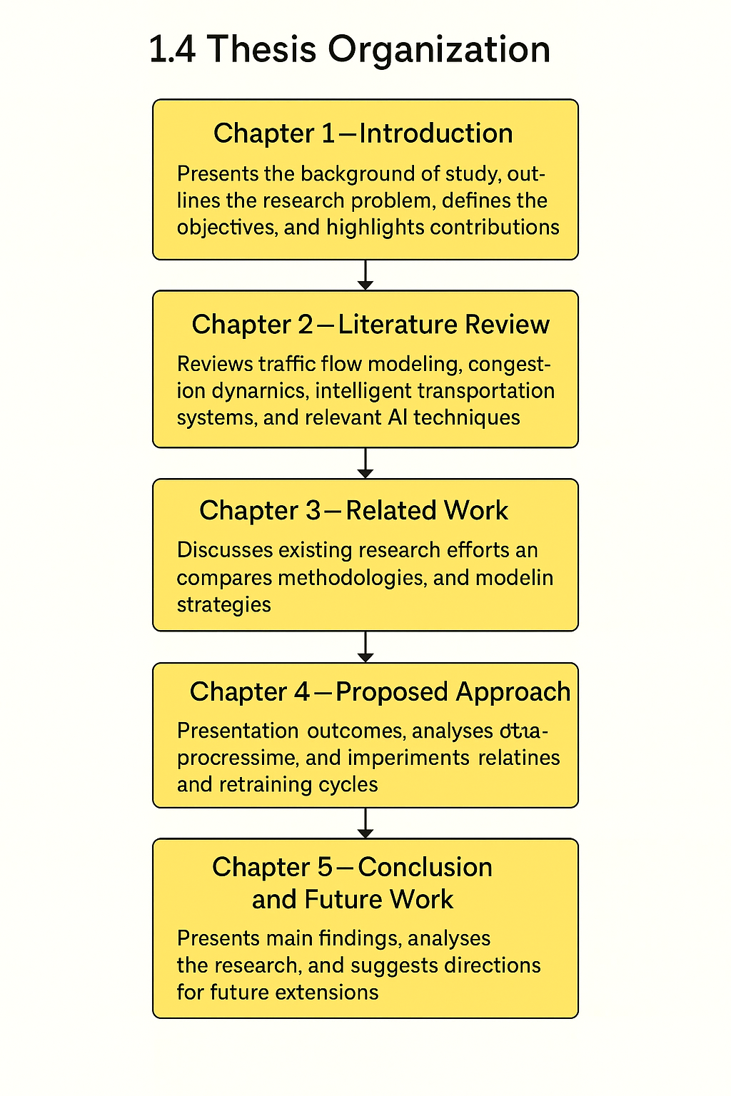

Chapter 2 Overview

2.1 Introduction to Traffic Congestion Forecasting
Predicting traffic congestion has long been a central topic within the field of intelligent transportation systems, driven by the growing complexity of urban mobility and the rising demand for efficient traffic management solutions. Early research largely depended on traditional statistical approaches that modeled traffic flow using simplified linear assumptions. While these methods provided foundational insights, their ability to capture the dynamic and nonlinear behavior of real-world traffic was limited.

With the rapid advancement of sensing technologies such as loop detectors, smart traffic signals, GPS-enabled vehicles, and other IoT-based infrastructures large-scale, high-resolution traffic datasets have become increasingly available. At the same time, improvements in computational capabilities have enabled the adoption of machine learning and deep learning algorithms that can model temporal dependencies, spatial interactions, and congestion propagation more effectively.

2.2 Classical Machine Learning Methods
Early studies on traffic congestion forecasting relied heavily on classical machine learning algorithms applied to structured traffic sensor data. These approaches aimed to model short-term variations in vehicle flow using historical detector readings, time-based features, and roadway characteristics. For instance, several researchers employed algorithms such as logistic regression, naive Bayes, support vector machines (SVM), and decision trees to classify congestion levels or predict flow intensity within specific intervals. Decision tree–based models frequently demonstrated superior performance due to their ability to capture interactions among categorical and numerical variables while maintaining interpretability.

Building on these foundations, subsequent work explored more versatile algorithms such as random forests and k-nearest neighbors (KNN). Random forests, in particular offered improved robustness by aggregating multiple decision trees, making them effective for handling noisy traffic data. However, while accuracies in the range of 70-85% were commonly reported, classical models often struggled with real-world deployment. Their limitations stemmed from a reduced capacity to model nonlinear temporal dependencies and spatial relationships across interconnected intersections patterns that are essential for understanding congestion propagation in dense urban networks. These challenges motivated the shift toward more advanced deep learning architectures capable of capturing the complex dynamics inherent in traffic systems.

2.3 Deep Learning Approaches

Deep learning has played a transformative role in traffic congestion forecasting, largely due to its ability to model the nonlinear and dynamic patterns that characterize urban mobility. Early breakthroughs demonstrated that recurrent neural networks particularly Long Short-Term Memory (LSTM) architectures are highly effective in learning temporal dependencies within traffic flow data. Studies have shown that LSTM-based models consistently outperform classical machine learning techniques by capturing the sequential nature of vehicle movement across time intervals.

Building upon this foundation, researchers introduced hybrid architectures such as Convolutional Neural Network LSTM (CNN LSTM) models. These frameworks integrate spatial feature extraction with temporal sequence learning, enabling the model to recognize both localized traffic variations and broader temporal trends. Such hybrid systems have shown marked improvements in prediction accuracy, especially in scenarios involving multiple adjacent intersections or high-resolution detector data.

In parallel, ensemble methods like XGBoost have been applied to traffic datasets to identify influential predictors such as peak-hour demand, detector activity patterns, and intersection signal timings. While not explicitly designed for sequence modeling, these algorithms have demonstrated competitive results by effectively leveraging diverse numerical and categorical inputs.

More recent advancements in spatiotemporal modeling incorporate graph-based neural networks to represent the road network as an interconnected structure. Approaches such as Graph Convolutional Networks (GCNs), Graph Attention Networks (GATs), and other dual-attention spatiotemporal frameworks have significantly enhanced the ability to forecast congestion. These models account not only for the temporal evolution of traffic but also for the spatial relationships between intersections, enabling predictions that reflect realistic congestion propagation across the network. Such innovations represent a major step toward intelligent, proactive traffic management within smart city environments.

2.4 Hybrid and Optimized Models

Recent advancements in traffic congestion forecasting have increasingly focused on hybrid modeling frameworks and optimization-driven learning strategies. These approaches aim to overcome the limitations of standalone deep learning or classical models by integrating multiple components that complement one another in capturing spatial, temporal, and nonlinear dynamics of traffic flow.

One notable direction in the literature involves combining deep learning architectures with metaheuristic optimization algorithms. For instance, several studies have demonstrated that training neural networks such as Artificial Neural Networks (ANNs) or LSTMs using evolutionary methods like Genetic Algorithms, Particle Swarm Optimization, or other swarm intelligence based optimizers can significantly improve convergence stability and model generalization. These optimization techniques adjust neural network parameters more efficiently, particularly when dealing with noisy or highly variable traffic data.

In parallel, more sophisticated hybrid models have emerged that fuse spatial and temporal learning processes. CNN RNN (or specifically CNN LSTM) architectures have gained considerable traction, as they leverage convolutional layers to extract spatial traffic patterns from detector grids or road segments, while recurrent layers model temporal dependencies in vehicle flow. Such feature-fusion designs have shown strong performance improvements, often reflected in lower RMSE scores and higher predictive accuracy.

2.5 Use of Real-World Datasets
Research in traffic congestion forecasting heavily depends on real-world datasets collected from operational transportation systems. Many studies utilize publicly accessible traffic datasets derived from loop detectors, smart traffic signals, connected vehicle systems, and other IoT-based sensing platforms. Examples include data released by transportation authority's such as the California Performance Measurement System (PeMS), the Victorian Transport Data Repository, and various city-level open data portals. These datasets typically contain high-resolution traffic volumes, speeds, occupancy rates, and signal timing information recorded at regular intervals across multiple intersections.

Preprocessing real-world traffic data involves several essential steps. Researchers commonly address inconsistent detector readings, fill missing intervals, and smooth sudden anomalies caused by sensor malfunctions or atypical events. Temporal features such as hour, day of week, and peak-period indicators are often engineered to capture cyclical mobility patterns. Categorical variables such as detector identifiers or intersection types are typically encoded through numerical mapping or embedding techniques for use in machine learning and deep learning models.

2.6 Quantitative Results Summary

Study | Model
  Key Findings
  Zhang et al. (2020)
  Decision Tree
  Achieved ~90% accuracy in congestion classification using detector-level features
 | LSTM
  Chen et al. (2021)
  Reduced RMSE by over 15% compared to traditional time-series baselines
  Wu et al. (2022)
  XGBoost
  Outperformed other ensemble models in short-term congestion prediction
 | SGDAN
  Guo et al. (2021)
  Provided effective multi-hour-ahead forecasting across connected intersections
  Khan et al. (2022)
  CNN–LSTM
  Achieved accuracy exceeding 94% through spatial–temporal feature fusion
 | DeepONet
  Li et al. (2022)
  Demonstrated >93% accuracy in modeling complex high-dimensional traffic patterns
  Hu & Zhang (2023)
  CNN–BiLSTM
  Improved MAE and RMSE via hybrid deep learning architecture
 |  | Identified inflow rate and signal timing as key predictors in congestion formation
  Pineda-Jaramillo et al. (2024)
  LDA + XAI

2.7 Research Gaps and Opportunities

Despite the significant progress achieved in applying machine learning and deep learning to traffic congestion forecasting, several important gaps remain in the current body of research:

- Limited integration of real-time traffic streams:
Many existing models rely primarily on historical detector data without incorporating live inputs from IoT sensors, smart signals, or connected vehicles. This restricts their suitability for real-time traffic management and adaptive signal control.

- Insufficient multi-intersection or network-level modeling:
A large portion of published work focuses on isolated intersections or small roadway segments. This raises concerns about the generalizability of models, particularly in complex urban networks where congestion propagates across multiple interconnected junctions.

- Underutilization of advanced hybrid and ensemble deep learning:
Although early results from CNN–LSTM, GCN-based models, and attention-driven architectures are promising, ensemble deep learning approaches are still not widely explored for traffic forecasting—even though they could improve robustness and accuracy.

- Limited emphasis on actionable control strategies:
Many studies stop prediction and do not extend the work toward strategies for adaptive traffic signal optimization, such as dynamic phase allocation or predictive green-wave coordination.

2.8 Conclusion

The reviewed literature clearly demonstrates the growing effectiveness of artificial intelligence, deep learning, and hybrid modeling techniques in forecasting traffic congestion within urban environments. Prior studies consistently show that when models are supplied with well-engineered temporal and spatial features and trained using advanced architectures they can produce highly accurate predictions that support informed decision-making in transportation management.

Building upon these insights, this thesis introduces a feature-refined predictive framework trained on real-world traffic detector data. The proposed approach addresses several limitations identified in earlier research, including the need for improved feature selection, enhanced model interpretability, and a methodology that aligns more closely with real-time operational requirements. By incorporating these elements, the work presented here aims to contribute meaningful advancements to both academic research and the practical development of intelligent, data-driven traffic management solutions.

