 | Midocean Journal for Research and Studies  https://  e-ISSN: | 
An AI-Based Early Warning System for Academic Risk Prediction Using Machine Learning and Learning Management System Data
Marya Mohammed Bawazir– Hala Haytham Hajjar
ORCID ID: 253000692 - ORCID ID: 253001456
Specialization – College – University Affiliation – Country (Font Size 12)
Email (Font Size 12 in Black)
Dr. (Name) (ORCID ID) Specialization, College, University, Country, Email:

Abstract:
The increasing adoption of Learning Management Systems (LMSs) has generated large volumes of educational data that can be utilized to identify academically at-risk students at an early stage. This study proposes an AI-based Early Warning System for predicting students’ academic performance using a private educational dataset collected from a Learning Management System in Saudi Arabia. The main objectives are to investigate the effects of feature selection and class balancing on predictive performance, compare traditional and ensemble machine learning models, and identify the most effective model for early academic risk prediction.
The proposed framework includes data preprocessing, stratified train-test splitting, feature selection using Random Forest feature importance, class balancing using the Synthetic Minority Oversampling Technique (SMOTE), hyperparameter optimization using Grid Search with Stratified Cross-Validation, and model evaluation. The dataset contains 1,395 student records described by 17 academic and behavioral features. The original prediction task was transformed into a four-class classification problem comprising Excellent, Good, Pass, and Fail.
Eight supervised machine learning models were evaluated under four experimental configurations using full and selected feature sets, with and without SMOTE. The results showed that XGBoost consistently achieved the best predictive performance, attaining an accuracy of 82.80%, precision of 83.00%, recall of 82.80%, and an F1-score of 82.46%. Feature selection reduced model complexity while maintaining competitive performance, whereas SMOTE improved class balance and supported the recognition of minority classes. These findings demonstrate the potential of the proposed framework to support early identification and timely intervention for academically at-risk students within the Saudi educational context.
Keywords: Early Warning System; Academic Risk Prediction; Learning Management System; Machine Learning; Feature Selection; SMOTE; Grid Search; XGBoost.

1. Introduction:
Improving the quality of education has become a strategic priority worldwide. In Vision 2030 of Saudi Arabia, the transformation of the education system involves integrating advanced technologies to enhance teaching, learning, and educational outcomes. This transformation has been supported through platforms such as Madrasati, the national learning platform serving K–12 education, and Classera, an LMS used by educational institutions to manage learning activities, assessments, communication, and student engagement. Six million students benefited from Madrasati during the 2020–2021 academic year, and nearly 98% accessed the platform of digital learning across the Kingdom (Boni). Classera illustrates the growing use of integrated LMS that provide detailed academic and behavioral data suitable for learning analytics and student-performance prediction (Alhujayri, 2024).
LMS have evolved content to become valuable sources of educational data. It collects students' academic and behavioral information, including attendance, assignments, examinations, participation, and interactions with learning resources. These data provide educational institutions with information that can help to monitor students' progress and support evidence-based educational decisions (Romero & Ventura, 2020)
Despite these advances, student assessment in many educational settings still uses traditional evaluation methods such as examinations, assignments, and instructors' observations. While these methods measure academic achievement, they often provide retrospective evaluations and cannot effectively utilize the large amount of data generated by LMS platforms. Consequently, it will be a challenge to identify at-risk students in the early stage (Alwarthan et al., 2022; Romero & Ventura, 2020)AI, particularly ML, has emerged as an effective solution for educational prediction tasks. By analyzing historical LMS data, ML models can identify hidden learning patterns, predict students' academic performance, and support early intervention strategies that improve learning outcomes. As a result, AI has become an important component of Educational Data Mining and Learning Analytics(Baker et al., 2016; Romero & Ventura, 2020).
Although numerous studies have applied machine learning techniques to predict student performance, most have relied on public datasets or data collected from institutions outside Saudi Arabia. However, relatively limited research has investigated prediction models using private datasets from Saudi LMS education (Alwarthan et al., 2022; Romero & Ventura, 2020) To address these challenges, we propose an AI-Based Early Warning System for predicting students’ academic risk using educational Private data extracted from KSA LMS. The proposed framework integrates data preprocessing, using RF for feature selection, class balancing using the Oversampling Technique (SMOTE), supervised ML algorithms, and Grid Search-based hyperparameter optimization.
2 Previous Studies: Several studies have developed and applied machine learning models to improve students' academic performance through early prediction.

CR-NODE was proposed by Bettahi et al(Bettahi et al., 2025), where continuous time was combined with completion-specific features to predict early dropout behavior. The dataset consists of longitudinal interactions recorded in the Canvas Learning Management System at a large public university spanning several terms. In the dataset, there are 100,878 students’ enrollments that have final grades, out of which we filtered 89,734 temporal interactions meeting the minimum observations requirement. Data preprocessing was performed to ensure temporal consistency and data quality. They used six different baseline methods (Logistic Regression, RF, XGBoost, Gradient Boosting, LSTM, and Basic Neural ODE) to compare CR-NODE and set comprehensive performance benchmarks. The results showed that CR-NODE had the best balance between the rates of true positives and true negatives. XAI was used to understand model predictions.

Ujkani et al. (Ujkani et al., 2024) proposed a hybrid model based on CNN, LSTM, and XGBoost to predict students' academic success. The study used the Open University Learning Analytics Dataset (OULAD), which includes 32,593 students. Data preprocessing involved missing value handling, feature engineering, data integration, and data splitting. The proposed model was compared with several ML and DL models, and XAI was employed to interpret the predictions. The results demonstrated that the proposed model achieved the highest accuracy of 94%.

The proposed RADAR system by Embarak et al(Embarak & Hawarna, 2024)used statistical analysis and ML algorithms to identify patterns and trends in the data that indicate a student was at risk of falling behind or dropping out. A dataset of the students from a particular school district was taken to build the system; the information was gathered and processed properly through feature integration, data cleansing, and feature selection. In this case, PAP can help in evaluating the ability of the student to continue studying in the future, as well as predicting the level of his/her success. With the help of such a comparison, Embarak et al. can emphasize the limitations of these methods. The machine learning system incorporating XAI can process multiple kinds of data and take into account other factors associated with the risks posed to students.

Macfadyen (Macfadyen & Dawson, 2010)described how LMS data might be used to forecast the academic performance of students and determine which ones need extra help. The data sample for this research was obtained from the Blackboard Vista Learning Management System (LMS) at the University of British Columbia in Canada. The data sample contained logs of student activities such as participation in discussions, completion of assessments, sending emails, interactions, and frequency of logging into the LMS. Major predictors of student performance were established; they included participation in discussions, messaging, performance in tests/ quizzes, and frequency of logging into the LMS. Data cleaning was conducted, which entailed the elimination of observations that had missing values and structuring for predictive modeling (PM). The regression model (RM) technique was adopted for developing the predictive model (PM) for academic success using activity data from the LMS. According to the findings, activity data of students from the Learning Management System can be used to make accurate predictions regarding their performance. The regression model was able to explain more than 30% of the variance in the final grade. Additionally, the logistic regression model accurately predicted 81% of the failures.
Queiroga et al.(Queiroga et al., 2022)presented a research paper that aimed to predict academically at-risk secondary school students using machine learning and learning analytics. The study also emphasized the importance of using previous academic performance as a predictor of future academic performance. The database for this study was sourced from the National Administration of Public Education (ANEP) of Uruguay that covered the educational life journey of students from primary school to secondary school spanning 2015-2020. This included information on 258,440 students, encompassing their grades, attendance, demographics, and other features. Data preprocessing was also undertaken prior to modeling. Data preprocessing entailed the cleansing of data, integration of databases for multiple education systems, conversion of the database into a time series database, and derivation of additional attributes. Data mining methodology. Machine learning algorithms such as RF, DT, AdaBoost, LR, NB, and MLP were investigated. However, the latter model was preferred since it had a better performance and was more interpretable. From the analysis, it is clear that the ML models have done remarkably well through achieving a very high accuracy rate when predicting at-risk students. The AUROC and F1 scores produced a result above 0.90 and 0.88, respectively.

Bagunaid (Bagunaid et al., 2024)introduced E-FedCloud, an AI-based e-learning system. The method was intended to predict student performance and identify potential difficulties that students may face. To enhance the performance of the students as well as Shannon entropy, which allowed secured data access. The application of deep reinforcement learning was achieved by using a method called ID2QN, which was used to predict the performance of students and categorize them according to their level of risk, such as students that might drop out of school, poor performers, and students that may fail the class were used to create personal recommendations for each student.

The OULAD dataset comprising 32,593 students taking 22 courses was used as a training dataset. The dataset comprised demographic information, performance information, and learning behaviors data. Preprocessing techniques were performed before using the modeling procedure.
These include data cleansing, feature selection, multiple sources' data integration, and preparing behavioral, academic and demographic variables. In addition, various machine learning algorithms and deep learning algorithms were used. As a result, ID2QN Deep Reinforcement Learning algorithm was chosen for predicting academic performance to classify students based on the level of their involvement and the customization recommendation system. In terms of securing the collected data, federated learning and Cycle-GAN were applied. It is worth mentioning that the E-FedCloud framework exhibited a high prediction capability of identifying students who might experience difficulties. The accuracy of the model equaled almost 97%, and the F1-score equaled 95%.

Johora (Johora et al., 2025)developed an XML approach to predict the academic performance of undergraduate students in Bangladesh. In this research, a dataset consisting of 872 samples was created. It included demographic, academic, and behavioral data of the students. Preprocessing steps were followed, including handling of the missing data, elimination of the unimportant columns, and conversion of the categorical variables to numeric values using one-hot encoding. To overcome the class imbalance problem, SMOTE was used, and feature scaling was done. After that, several ML approaches were implemented. They included RF, GB, XGBoost, SVM, KNN, DT, and LR. As it can be seen, it was proved that stacking ensemble model is better in terms of its performance. In order to interpret the model and see what features play a key role in achieving success among students, SHAP and LIME methods were implemented in this research project. It should be noted that the highest accuracy reached 86.38% in terms of stacking ensemble model.

Christou et al. (Christou et al., 2023)have proposed a Machine Learning technique to forecast students’ future grades and study time based on past educational data. In this paper, the authors propose a feature selection and construction method called FSC4RBF which is implemented by Radial Basis Function Neural Networks using grammatical evolution. The data used in this study was collected from different departments of the University of Ioannina, Greece such as Physics, Philosophy, Primary Education, History, Mathematics, and Chemistry, which included students' educational data such as grades, course details, and study time. Preprocessing includes organizing and transforming student’s academic record data into suitable input features for machine learning models. Feature engineering helps in predicting accurate results. Comparison among different ML methods like DT, Bayesian Network, SVM, and various Neural Networks indicates that proposed (FSC4RBF) gives the best results. It obtained the lowest mean square error in most regression tasks and the highest accuracy in all classification tasks.

Realinho et al.(Realinho et al., 2022)) introduced a study in which a public higher education dataset containing 4424 student records with demographic, socioeconomic, macroeconomic, and academic features was developed to predict student dropout and academic success. The data were collected from multiple institutional sources, merged, cleaned, and preprocessed to support machine learning classification tasks. Several ML techniques were applied to analyse student performance and identify at-risk students. The study used a public dataset from the Polytechnic Institute of Portalegre, Portugal, containing 4424 student records with 35 attributes. The dataset included demographic, macroeconomic, socioeconomic, and academic performance data from enrollment until the end of the first and second semesters. Data collected from multiple sources, such as academic systems, national databases, The data were then combined into one single dataset. Data cleaning was done by eliminating duplicates, managing missing data, managing outliers, renaming the variable names, and selecting suitable features. The study applied RF, XGBoost, LightGBM, and CatBoost after performing data integration, preprocessing, and feature importance analysis using permutation feature importance. The project did not include the results about specific accuracy since the main goal was presentation and analysis of the dataset, but not the development of a single ML model. Nonetheless, the presented dataset allows predicting student drop-out and student achievement and can be used for benchmarking ML models and building learning analytics systems.

The employment of AI techniques to predict student academic performance within the BL environment of SEU was first done by Hamadneh (Hamadneh et al., 2022)). The study sought to identify the major determinants of student academic achievement and develop a PD for student academic performance. Data for this study were extracted from the Blackboard LMS. The data contained the following predictors: type of study, participation in live lectures, exam results, and completion of assignments. Final exam marks were the target variable. Various data preprocessing techniques were employed. These techniques included descriptive statistics, correlation, multicollinearity test, and regression analysis, which used ordinary least squares, fixed-effects, and random-effects models. To determine the quality of the data and the key factors that determine students' academic success, the following procedures were followed. The researchers subsequently built a PD using the artificial neural network technique. The ANN in this case is a multilayer perceptron, whose input nodes are four, hidden nodes are ten, and the output node is one, which represents the final grade. The results indicated that the proposed hybrid neural network model achieved strong predictive performance with low prediction error.

The project of Skittou et al (Skittou et al., 2023)developed an early warning system that took into account a number of socio-cultural, structural, and educational factors that have a direct impact on a student’s decision to drop out of school. They worked on an original database by aggregating data from several operational systems. The number of pupils in the study population is 125354, including 59384 girls. A considerable number of properties are deemed highly important for defining a student who is likely to drop out or not. dedicated to this issue, which reflected their approach of seeking exhaustiveness and precision in the choice of dropout indicators. The model they built performed very well, particularly with the KNN, with an accuracy rate of over 99.5% for the training set and over 99.3% for the test set. The database used is built specifically for this project's preprocessing; they used mainly ML analysis methods specialized in classification. Hence, the use of the best-known and most efficient methods for this aspect of analysis: SVM, RF, SGD, and KNN. The results are visualized using a Django application they developed for this purpose, and we show how this can be useful for educational planning.

David Bañeres et al. (Bañeres et al., 2020)created a new system with multiple contributions. The Gradual At-Risk (GAR) model was the first contribution, a predictive model. Such a model predicted students' chances of failing a course based solely on their grades. Using the dataset in a data mart, a thorough analysis of the model was carried out on the entire collection of university courses. They can see that, starting with the fall semester of 2016, the number of training registries rises every semester (20161). For every course and semester, they suggested a way to find the optimal classifier and training set. KNN, DT, NB, SVM, LR, Hierarchical Mixed models, and Neural Network models. The second is a technique to establish a cutoff point for classifying a course's trained GAR model as high- or low-quality. In an actual classroom, the GAR model gave students feedback according to their risk level. As a result, a teacher cannot afford to give a student incorrect advice or a message. The EWS uses GAR to modify the kind of message that is sent to the student. The third contribution involved using the EWS in two courses in an actual classroom. In terms of dashboards and feedback, the GAR model was utilized to give teachers and students useful information. They examine how well at-risk students are identified in such a real-world learning environment and how this affects the courses' final performance. Two undergraduate courses were used to test the system, and the results demonstrated a high level of accuracy in identifying students who were at risk.

Albreiki, Balqis, et al. (Albreiki et al., 2021) stress the use of a customized rule-based system with the Risk Flag to identify and visualize at-risk students early in the course delivery. The dataset was gathered from an undergraduate programming course at the United Arab Emirates University's College of Information Technology. The information shows how well students performed in the introductory programming course during the academic years 2016–2017 (fall and spring), 2017–2018 (fall and spring), and 2018–2019 (fall and spring). The data was pre-processed to make it readable for the ML methods. A Python script was used to combine the files into a single CSV file, and min-max normalization was used to normalize the marks. The averaged value of the same coursework components was used to replace the missing values, which were handled using imputation techniques. Time-wise, the results are still inefficient, and there are a lot of false predictions. They suggest a tailored rule-based model that provides at-risk students with prompt identification. It also helps the teacher identify the at-risk students and provide prompt intervention by visualizing them.

With various ML algorithms, Khan, Ijaz, et al. (Khan et al., 2021)created a set of prediction models. The student academic records for a course taught at Buraimi University College, Sultanate of Oman, are used in the dataset.. Three semesters are covered by the training dataset. The training dataset contains 151 instances with one prediction class and ten prediction features. Students are categorized as "Low" or "High" based on the prediction. Data cleaning: The noise is either eliminated or minimized using a variety of methods. The training dataset contains 151 instances after the noisy instances are eliminated. WEKA, an open-source program with a variety of algorithms for data pre-processing, classification, clustering, regression, and association rules, was created at the University of Waikato in New Zealand. Four popular machine learning algorithms were chosen. They selected KNN, which is implemented as IBk in WEKA, from lazy algorithms. In WEKA, RepTree is a DT implementation. In a similar vein, they selected NV as the fourth algorithm and Multilayer Perceptron, a class of Artificial Neural Networks. The models were evaluated using 10-fold cross-validation. The proposed model successfully identified academically at-risk students by the sixth week of the semester, providing timely intervention and supporting both instructors and students. The improvement of the struggling students served as a gauge for the overall effects. Four out of five students were able to produce an end result that was acceptable. From the beginning of the course, students' performance is closely monitored as part of the supportive measures. Additionally, a series of preventive measures is implemented to provide extra support to students who are having difficulty.

Akçapınar et al.(Akçapınar et al., 2019)) studied 76 students enrolled in the Computer Hardware course in the Department of Computer Education and Instructional Technology at a state university in Turkey. The students' ages ranged from 21 to 23 years, with 41 women and 35 men. Data collected about the students' learning processes at the end of the term included 3803 sessions, 119,921 page visits, 4566 written texts, 62 discussion forum questions, 297 responses, 8601 evaluations, and 3937 tags used to label written messages. Both final term academic achievement scores and interaction among students data from the virtual classroom were taken into account in the analysis. They used two different preprocessing methods. These included techniques for data transformation and feature selection. The CN2 (86%) and kNN (86%) algorithms achieved the highest classification accuracy, and the Gini index was used to select the best features. According to the results of the study, at the end of the term, the kNN algorithm had an 89% accuracy rate in predicting students who would not succeed.

Table 1 Of The Reviewed Papers
Paper | Year | Models | Limitation | Dataset | Type | The best model | Result
(Bettahi et al., 2025) | 2025 | CR-NODE  LR, RF, XGBoost, Gradient Boosting, LSTM, and Basic Neural ODE | It focuses exclusively on predictive accuracy without evaluating whether deployment actually improves student outcomes. | large public university Dataset. | Private -Need request-. | CR-NODE | CR-NODE achieves the best balance
(Ujkani et al., 2024) | 2024 | RF Classifier, Gradient Boosting Classifier, KNN, Multi-Layer Perceptron (Neural Network), First Custom Neural Network Architecture, Second Custom Neural Network Architecture, XAI, and LSTM. | The dataset used in this study is from a pre-pandemic period; it is important to acknowledge the broader context of how the COVID-19 pandemic may have altered students’ habits, motivations, and learning behaviors. | Open University Learning Analytics Dataset | Public https://analyse.kmi.open.ac.uk/open_dataset | Custom Neural Network Architecture | The proposed models performed with the best accuracy of up to 94% compared to models for predicting students’ success
(Embarak & Hawarna, 2024) | 2024 | Data analysis, ML, feature selection, XAI, RADAR | The study relied on a specific dataset from a specific computing major, which may limit the generalizability of the findings to other situations. | Students from a school district Dataset. | Private | RADAR system | The RADAR system can help at-risk students receive better support and direction
(Macfadyen & Dawson, 2010) | 2010 | Correlation analysis, Regression model, LR, Network analysis | Applied to one course only, a small dataset, not a full AI model, limited generalization | LMS dataset from Blackboard (student activity, messages, logins, assessments) | Private | LR model | Predicted at-risk students with 81% accuracy and explained 30% of the variation in final grades
(Queiroga et al., 2022) | 2022 | RF, DT, AdaBoost, MLP, NB, LR | Needs annual data preprocessing and retraining; results based on Uruguay data only; one model showed bias and weak performance. | Nationwide K-12 dataset (Uruguay), 258,440 students; demographic data, grades, absences, social welfare, school data (2015–2020) | Private | RF | Achieved high performance (AUROC > 0.90, F1 > 0.88) and successfully predicted at-risk and dropout students early
(Bagunaid et al., 2024)) | 2024 | ID2QN (Deep Reinforcement Learning), MV-MOC Clustering, Att-CapsNet (DL), Federated Learning (CGAN), TSE (Entropy), LWEA + Blockchain | High computational complexity; requires multi-modal biometric data; privacy concerns; tested mainly on the OULAD dataset | OULAD dataset (32,593 students, 22 courses); demographic, academic, and behavioural LMS data | Public No Access | ID2QN (Improved Duelling Deep Q Network) | Achieved ~97% accuracy and ~95% F1-score; outperformed PCT, MST-FaDe, Fuzzy SVM, and AISAR; effectively predicted at-risk students early
(Johora et al., 2025) | 2025 | RF, Gradient Boosting, XGBoost, SVC, KNN, DT, LR, Stacking Ensemble, SHAP, LIME | Small dataset (872 students) from Bangladesh only; limited generalizability; based on survey data | 872 undergraduate students from multiple universities; demographic, academic, and behavioural features (31 features) | Private | Stacking Ensemble (RF + GB + SVC) | Achieved 86.38% accuracy; SHAP and LIME identified key factors such as attendance affecting student performance
(Christou et al., 2023) | 2023 | RBF Neural Network, SVM, DT, Bayesian Network, Neural Networks | Data from one university only; limited generalization | Student academic records from several departments, University of Ioannina | Private | Feature selection and construction method for RBF network | Achieved the highest accuracy and the lowest error compared with other models in predicting grades and dropout
(Realinho et al., 2022) | 2022 | Random Forest, XGBoost, LightGBM, CatBoost | An imbalanced dataset, limited to one institution, and mainly focused on dataset description rather than proposing a strong predictive model. | Student Dropout and Academic Success Dataset – Polytechnic Institute of Portalegre | Public No Access | Not specified | Identified the most important factors for dropout prediction, such as grades, approved courses, tuition status, and course type
(Hamadneh et al., 2022) | 2022 | ANN, Multilayer Perceptron Neural Network, Multilayer Perceptron Neural Network with Firefly Algorithm | Limited to one university, a small dataset, and a few features | Dataset from the Blackboard Learning Management System at the Saudi Electronic University | Private | Neural Network trained by Firefly Algorithm | Achieved strong prediction performance with a root mean square error of 0.39 and identified midterm exams, assignments, attendance, and study mode as key factors
(Skittou et al., 2023) | 2023 | SVM, Random Forest, SGD, and KNN. | Lack interfaces for administration and data manipulation in dynamic and interactive ways, because aggregating data from several operational systems | The database used is built specifically for this project by aggregating data from several operational systems | Private- Need to request access from the author | (KNN) algorithm | Visualized using a Django application we developed for this purpose, and we show how this can be useful for educational planning.
(Bañeres et al., 2020)et al., 2020) | 2020 | DT, NB, SVM, LR, Hierarchical Mixed models, KNN, Neural Network models | When the assessment process is changed regarding the number of assessment activities or the contents of the activities, the model is invalid for the course. | This model has been tested using data available in an institutional data mart, where curated data from six semesters are available. | Private | Gradual At-Risk (GAR) model | The model showed a high accuracy in correctly detecting at-risk students.
(Albreiki et al., 2021) | 2021 | Statistical and ML techniques | The results still lack efficiency in terms of time and have high false predictions. In this study, we propose a customized rule-based model that offers timely identification for at-risk students. | The data was collected from a programming course taught for undergraduate students at the College of Information Technology (CIT), United Arab Emirates University (UAEU). | Private -Need request-. | Customized rule-based system (RBS) | It visualizes the at-risk students to support the educator in recognizing these students and offering timely intervention.
(Khan et al., 2021) | 2021 | ML algorithms  KNN  RepTree  DT  (MLP)  (ANN) | The training dataset of a course may comprise a low number of total instances due to limitations on classroom size. | The student's academic records for a course taught at Buraimi University College (BUC), | Private -Need request-. | Developed a set of prediction models | The prediction model appeared constructive and helpful for both the instructor and the students.
(Akçapınar et al., 2019) | 2019 | Prediction model  Classification model | Transferability and generalizability of prediction models into the different courses are still limited. | The study was conducted at a state university in Turkey with 76 students in online learning activities for a period of 14 weeks | Private -Need request- | (KNN) | The kNN algorithm accurately predicted unsuccessful students at the end of the term with a rate of 89%.

3. Methodology: This section presents the methodology adopted to design, implement and evaluate the proposed framework, AI-Based Early Warning System for Academic Risk Detection in education.
Figure 1 shows the main steps of the proposed framework to identify the risk of academic achievement using a private educational dataset collected from LMS. The proposed framework includes many steps: data collection, data preprocessing, feature engineering, train-test splitting, class balancing using SMOTE, machine learning model training, hyperparameter tuning, model evaluation, and student risk classification.:

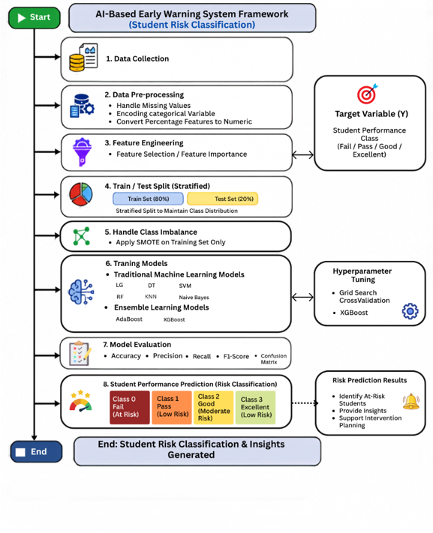
Figure 1 . Proposed AI-Based Early Warning Framework
The steps will be detailed as follows:

4.1 Dataset Description
We used a private educational dataset collected from an LMS. The dataset contains 1,395 student records represented by 17 educational attributes: participation, assessments, attendance, and student engagement. The feature selection experiments, the ten highest-ranked features (HomeWorks, Absence, Interactive Contents, AVG Participations %, Contents Participation %, HomeWorks Participation %, Virtual Classrooms, Discussion Rooms Participation %, Virtual Classrooms Participation %, and No. Active Courses), while the remaining seven features (Interactive Contents, Discussion Rooms, Mailbox Participation %, Exams Participation %, Exams, Teachers' Messages, and Student Login %) were excluded based on their low importance scores, such as participation, assessments, attendance, and engagement measures. Table 2 The target variable represents students' academic performance and classifies each student into one of the following four categories: Excellent, Good, Pass and Fail.
Table 2. Distribution of Student Performance Classes.
Class | Number of Students | Percentage
Good | 725 | 51.97
Excellent | 322 | 23.08
Fail | 241 | 17.28
Pass | 107 | 7.67

4.2 Data Preprocessing
The data preprocessing is an important step in this process. It ensures the preparation of data for further analysis and improves its quality prior to modeling. The preprocessing includes the following steps:
- Clean data set: Remove percentage % symbols from some features.
- Encoding categorical variables into numerical representations to ensure compatibility with ML algorithms.

4.3 Data Splitting
The dataset was divided into 80% training data and 20% testing data using the Stratified Train-Test Split technique. Stratified sampling was adopted to preserve the original distribution of the four academic performance categories in both subsets, ensuring a fair evaluation of the developed models.

4.4 Handling imbalance dataset using SMOTE:
Synthetic Minority Oversampling Technique (SMOTE) is a data balancing technique proposed as an improvement of the class imbalance problem. As opposed to replicating the samples that belong to the minority class, SMOTE creates synthetic samples by interpolating between the neighbors from the minority class(Ujkani et al., 2024)
A synthetic sample is generated according to the following formula:
$x_{new}=x_{i}+λ\left(x_{nn}-x_{i}\right)$,
Where :$x_{i}$ refers to its nearest neighbor, $x_{nn}$ refers to its nearest neighbor, and $λ$is refers to a random number between 0 and 1.
4.5 Feature Selection
Feature selection was evaluated to determine which educational features made significant contributions in predicting the students' academic performance. Elimination of the less important variables makes the prediction process easier and less complicated. The steps involved in the feature selection include:
- Feature Importance is a technique used to measure the contribution of each feature to a machine learning model's predictions by assigning an importance score to every feature. Features with higher scores have a greater influence on the model's predictive performance.

4.6 Optimization Models
Model optimization is an essential step in developing robust and high-performing machine learning models. Appropriate hyperparameter selection can significantly improve prediction accuracy, enhance model generalization, and reduce the risk of overfitting. Various optimization techniques have been proposed to identify the optimal hyperparameter configuration for machine learning models. In this study, Grid Search combined with Stratified Cross-Validation was employed to systematically optimize the selected machine learning models prior to the final evaluation.

4.6.1 Grid Search
Grid Search is an exhaustive hyperparameter optimization technique that systematically evaluates all possible combinations of predefined hyperparameter values within a specified search space. The objective is to identify the hyperparameter configuration that achieves the best predictive performance based on a predefined evaluation metric(Bishop & Nasrabadi, 2006)

4.6.2 Stratified Cross-Validation
Cross-validation is a resampling technique used to estimate the generalization capability of machine learning models by partitioning the training dataset into multiple folds. During each iteration, one fold is used for validation, while the remaining folds are used for training. This procedure is repeated until every fold has been used once for validation. The overall model performance is calculated as the average evaluation score across all folds(Bishop & Nasrabadi, 2006).
The average cross-validation score is computed as follows:

CV=k1​i=1∑k​Mi​

where:
- k is the number of folds.
- Mi​ is the evaluation metric obtained from i the fold.
- CV represents the average cross-validation score.

4.6.3 Hyperparameter Optimization Procedure
In this study, Grid Search with Stratified 3-fold Cross-Validation was applied to optimize the hyperparameters of the selected machine learning models. Stratified cross-validation preserves the original class distribution within each fold, making it suitable for the imbalanced multi-class educational dataset used in this research. Hyperparameter optimization was performed after data preprocessing, feature selection (when applicable), and class balancing using SMOTE. The weighted F1-score was adopted as the optimization criterion because it provides a balanced evaluation for imbalanced multi-class classification problems. After identifying the optimal hyperparameter configuration, the optimized models were retrained using the entire training dataset before being evaluated on the independent testing dataset.
The hyperparameter search space explored during the optimization process is summarized in Table 3.

Table 3 Hyperparameter Search Space Used for Grid Search Optimization
Model | Hyperparameter Search Space
Decision Tree | criterion = {gini, entropy}; max_depth = {5, 10, 15, 20, None}; min_samples_split = {2, 5, 10}; min_samples_leaf = {1, 2, 4}; class_weight = {None, balanced}
Random Forest | n_estimators = {100, 200}; criterion = {gini, entropy}; max_depth = {10, 20, None}; min_samples_split = {2, 5}; min_samples_leaf = {1, 2}; max_features = {sqrt, log2}; class_weight = {None, balanced}
XGBoost | n_estimators = {100, 200}; learning_rate = {0.01, 0.05, 0.1}; max_depth = {3, 5, 7}; subsample = {0.8, 1.0}; colsample_bytree = {0.8, 1.0}

Table 3summarizes the hyperparameter search space explored during the Grid Search optimization process for the selected machine learning models. The optimal hyperparameter configuration for each model was automatically selected using Stratified 3-fold Cross-Validation based on the weighted F1-score. The selected hyperparameter values were subsequently used to retrain the optimized models before conducting the final performance evaluation.

4.6 Machine Learning Models

It is a branch of AI that focuses on creating algorithms that, without explicit programming, enable computers to recognize patterns in data and perform better. It can be used to predict or classify new data after being trained on historical data. Because it allows for examining massive amounts of data of students and finding their performance, ML is crucial to educational data mining and learning analytics. (Pattern Recognition and ML)(Bishop & Nasrabadi, 2006)
Six traditional classification algorithms were investigated in this study:
- DT: It is a supervised learning algorithm that uses a tree structure to represent decisions. A feature is represented by each internal node, a decision rule by each branch, and a class label by each leaf node. DT are frequently used in classification problems because they are simple to understand (Hastie, 2009)
- RF: Many DT are combined in the RF groups learning technique to increase prediction accuracy and decrease overfitting.it is subset of the dataset is used to train each tree in the forest, and the final prediction is produced by adding up all of the trees' predictions (Hastie, 2009)
- KNN: It uses the classes of a data point's closest neighbors in the feature space to predict the data point's class. It uses Euclidean distance, and other distance metrics are used by the algorithm to determine similarity (Bishop & Nasrabadi, 2006)
- SVM: It is a supervised learning algorithm for tasks involving regression and classification. To find the best hyperplane that divides data points from various classes, with the greatest margin, is how it operates (Bishop & Nasrabadi, 2006).
- NB: It is an algorithm of classification. It makes the assumption that features are conditionally independent, it makes computation easier, and enables the model to work great even with massive datasets(Studies, 2024)
- LR: is a supervised machine learning algorithm used for classification tasks. It estimates the probability that an instance belongs to a particular class using the logistic (sigmoid) function.

These models represent different statistical, probabilistic, distance-based, and tree-based learning approaches, providing a comprehensive comparison of classical machine learning techniques for predicting students' academic performance.

4.7 Ensemble Learning Models

Ensemble learning is a type of machine learning approach wherein a combination of several base learners is employed in order to enhance the accuracy of predictions as opposed to employing only one learner model. Instead of depending on a single classifier, an ensemble approach involves using the output of several learners in order to achieve better accuracy and efficiency of the process (Bañeres et al., 2020; Hastie et al., 2009).

The widely used boosting algorithms include AdaBoost and XGBoost , which were considered in this paper.
1- AdaBoost
One of the oldest and most successful boosting algorithms is called Adaptive Boosting (AdaBoost). Introduced by Freund & Schapire (1997), this method builds a composite strong classifier by combining weak classifiers iteratively and by modifying sample weights at each iteration.
H(x)=sign(m=1∑M​αm​hm​(x)
Which $H\left(x\right)$ refers to the final prediction, $h_{m}\left(x\right)$is the output of the $m^{th}$weak classifier, and $α_{m}$It shows the importance applied to that classifier.

2- XGBoost
Extreme Gradient Boosting (XGBoost) is one of the modern implementations of the Gradient Boosting algorithm, which was invented to enhance efficiency and increase accuracy in predictions. The algorithm builds an ensemble of decision trees sequentially in such a way that the next tree minimizes the residual errors made by the preceding ones. Different from other boosting algorithms, XGBoost uses the regularized approach to avoid overfitting and preserve predictive performance (Bañeres et al., 2020)
The output of XGBoost is calculated as a sum of the outputs of all decision trees:
$${\hat{y}}_{i}=\sum_{k=1}^{K}{f_{k}}\left(x_{i}\right)$$
where
${\hat{y}}_{i}$ refers to the predicted output, $K$ It refers to the total number of prediction trees used, $f_{k}\left(x_{i}\right)$ Refers to the output of the $k^{th}$decision tree.
The objective function of XGBoost is composed of two parts: the training loss and the regularization part.

4.8 Model Evaluation Metrics
The optimized models were retrained using the best hyperparameter values obtained through Grid Search and then evaluated on the testing dataset. The evaluation was performed using the same performance metrics adopted throughout this study, including:

1. Accuracy: It is the percentage of correctly predicted cases among all of the model's predictions.
Accuracy = TP+TN / FP+FNTP+TN​
Where: TP = True Positives, TN = True Negatives, FP = False Positives, FN = False Negatives. It is simple and intuitive; however, not deal with imbalanced datasets(Hastie et al., 2009).

2. Precision: It is the percentage of correctly predicted positive cases among all predicted positive cases.
Precision = TP/ FP + TP​
where it is important when the cost of false positives is high(Hastie et al., 2009).

3. Recall: It is sometimes referred to as sensitivity, which gauges how well the model can identify real positive examples.
Recall=TP/ FN+TP​
When there is a positive case (like a student who is at risk), recall is very important(Hastie et al., 2009).

4. F1-Score: When working with imbalanced datasets, the F1-score—which is the harmonic mean of precision and recall—offers a fair assessment of model performance.
F1-Score=2×Precision×Recall​ / Precision + Recall
This is especially helpful when you have datasets that aren't balanced, and you need both precision and recall (Hastie et al., 2009).

5. Confusion Matrix: A confusion matrix is a table used to evaluate the performance of a classification model by comparing the predicted labels with the actual labels. It provides a detailed summary of prediction outcomes, including True Positives (TP), True Negatives (TN), False Positives (FP), and False Negatives (FN), and serves as the basis for calculating evaluation metrics such as accuracy, precision, recall, and F1-score.

4. Results and Discussion:
4.1 Experimental Setup
Experiments were run using Google Colab. Python 3 used as an implementation environment. The performance was evaluated on a private dataset that consists of 1,395 student instances and includes 17 academic and behavioral features. For data preprocessing, Pandas and NumPy libraries were used, while the ML models were built using the Scikit-learn framework and the XGB library. To conduct a fair experiment, we split the dataset into 80% train and 20% test using stratified sampling. Feature selection was applied in two experimental settings to investigate the impact of reducing the input feature set on model performance. To address the class imbalance problem, the SMOTE was applied to the training set in the two experiments. To ensure a fair comparison, all machine learning models were optimized using Grid Search with cross-validation.

4.2 Class Distribution
From the information represented in Figure 2 It is clear that the distribution of data in the four academic performance classes was imbalanced. The percentage of the Good class constituted 51.97% while the Pass class constituted only 7.67%. The rest of the data was related to Excellent and Fail classes (23.08% and 17.28%). The problem of imbalance was solved using SMOTE. In the SMOTE-oversampled training dataset, there were equal numbers of observations in each class, meaning that the dataset was balanced.
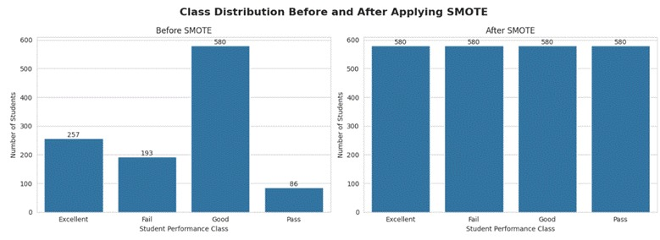
Figure 2 . Distribution of Student Performance Classes with SMOTE.
4.3 Feature Importance Analysis
The analysis of feature importance was implemented to understand which factors are more important in the prediction of student academic performance. An RF classifier was used for the evaluation of the relative importance of each input variable. From the feature importance results shown Figure 3, the highest importance in the prediction of student academic performance includes Homework, Absence, and Interactive Contents. Other participation variables, such as Average Participation Percentage, Contents Participation Percentage, and Homework Participation Percentage, are also demonstrated highly important. In contrast, Teacher Messages and Student Login Percentage had limited importance; these features contributed minimally to the model's predictive capability.
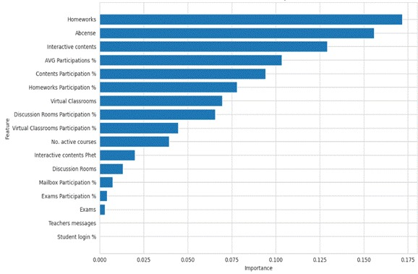
Figure 3. Random Forest Feature Importance Ranking.
4.4 Experimental Configurations
In order to examine the effect of feature selection and class balancing on the performance of the prediction model, two experimental setups were created and tested separately. The two experimental setups were implemented for comparison of the impact of both preprocessing steps individually and together.
The following table describes the two experimental setups in brief:
- Result Without applying SMOTE: Full Feature Set+ Selected Featur.
- Result With applying SMOTE: Full Feature Set+ Selected Featur.
Each experiment was conducted under similar conditions using the same machine learning models and the same evaluation criteria for comparison.

4.5 Results without Applying SMOTE

Table 4 shows the results of Applying Traditional and Ensemble Learning Models Using Full and Selected Features without SMOTE.
First, we can see that with full features. DT achieved the highest performance percentage, with 80.65 ACC; the RF achieved 79.21 ACC. In contrast, the lowest performance across all evaluation metrics was NV. For the ensemble learning models, XGB achieved the highest accuracy of 82.44, whereas AB achieved an accuracy of 74.91%.
Second, the same models were evaluated with the selected feature set. DT and RF both achieved an accuracy of 81.00ACC. The lowest performance across all evaluation metrics was NV, while SVM and NB showed marginal performance gains. In contrast, LG, KNN, and AB exhibited unchanged performance across the full and selected feature configurations.
Overall, XGB achieved the highest overall performance in both cases, with an accuracy of 82.44% using the full feature set and 82.08% using the selected feature set.

Table 4 Results of Applying Optimized Traditional and Ensemble Learning Models Using Full and Selected Features without SMOTE.
Configuration | Approach | Model | Accuracy | Precision | Recall | F1-Score
Full Features | Traditional ML | LR | 70.97 | 72.36 | 70.97 | 69.85
Full Features | Traditional ML | SVM | 75.27 | 75.23 | 75.27 | 73.88
Full Features | Traditional ML | KNN | 76.70 | 76.64 | 76.70 | 75.55
Full Features | Traditional ML | DT | 80.65 | 80.20 | 80.65 | 80.21
Full Features | Traditional ML | RF | 79.21 | 79.64 | 79.21 | 77.86
Full Features | Traditional ML | NB | 14.34 | 35.52 | 14.34 | 10.89
Full Features | Ensemble Learning | AB | 74.91 | 74.85 | 74.91 | 73.12
Full Features | Ensemble Learning | XGB | 82.44 | 82.93 | 82.44 | 81.81
Selected Features | Traditional ML | LR | 70.97 | 72.36 | 70.97 | 69.85
Selected Features | Traditional ML | SVM | 75.63 | 75.46 | 75.63 | 74.47
Selected Features | Traditional ML | KNN | 76.70 | 76.64 | 76.70 | 75.55
Selected Features | Traditional ML | DT | 81.00 | 80.63 | 81.00 | 80.55
Selected Features | Traditional ML | RF | 81.00 | 82.12 | 81.00 | 79.85
Selected Features | Traditional ML | NB | 15.77 | 43.32 | 15.77 | 14.98
Selected Features | Ensemble Learning | AB | 74.91 | 74.85 | 74.91 | 73.12
Selected Features | Ensemble Learning | XGB | 82.08 | 81.99 | 82.08 | 81.46

The confusion matrix of Figure 5 and Figure 4 Show additional understanding of the classification ability of the model. Based on each class (Excellent, Good, Pass, and Fail). We can see that XGB and DT get the best accuracies. The color intensity in each confusion matrix represents the number of observations assigned to each class, with darker colors indicating larger counts. XGB achieved the highest number of correctly classified observations, followed by DT and RF, as reflected by the strong concentration of values along the main diagonal. However, NB recorded the largest number of misclassified observations, while LR, SVM, and KNN showed moderate classification performance with greater confusion between neighboring classes.

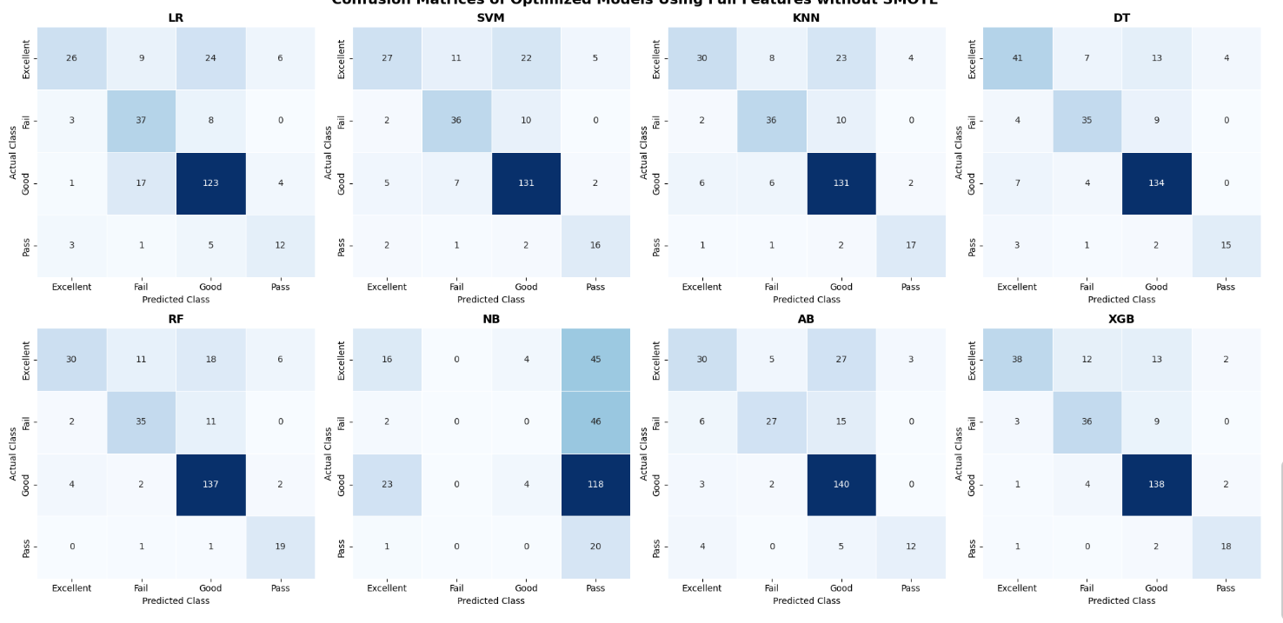
Figure 4 Confusion Matrices of the Optimized Traditional and Ensemble Learning Models without SMOTE-full feature.

Full feature without applying SMOTE
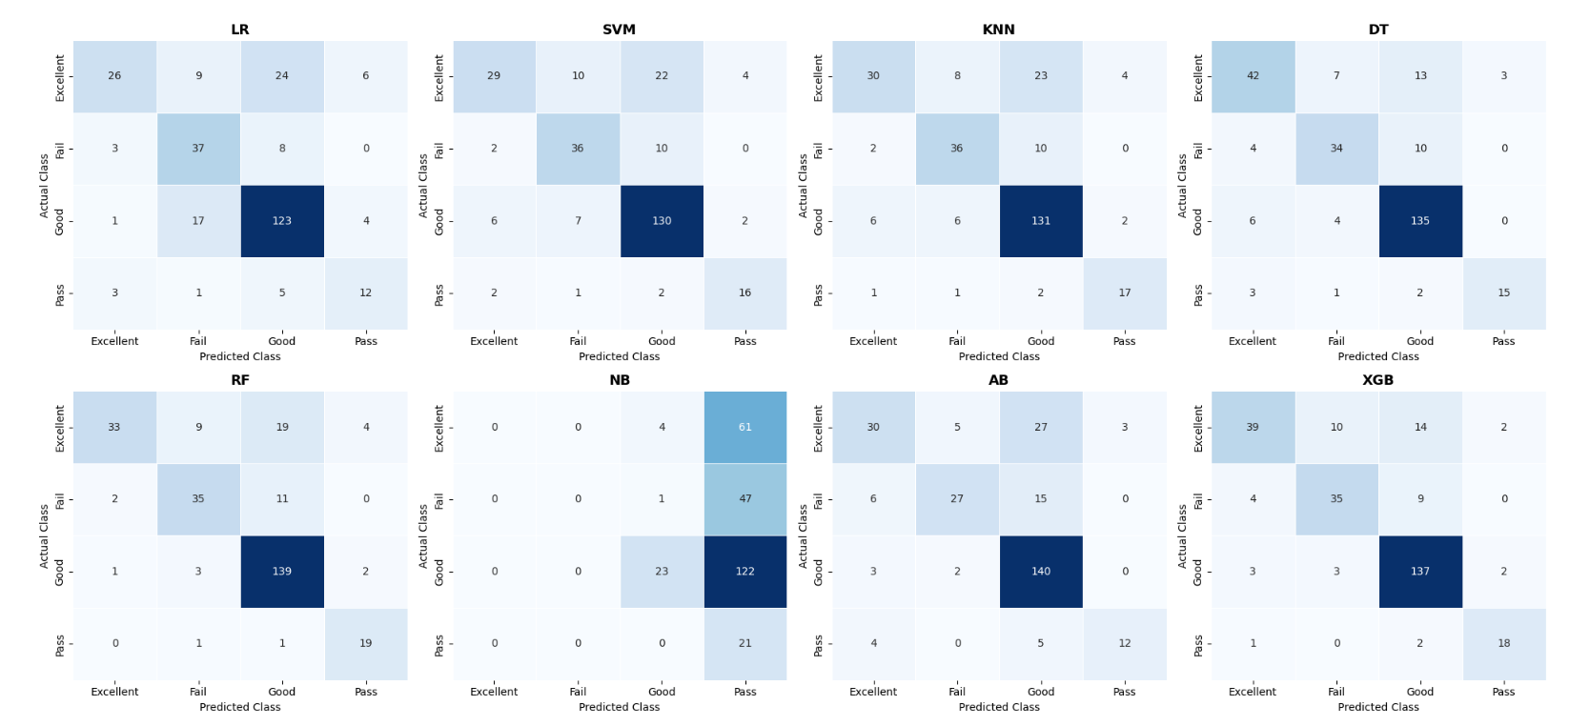
Figure 5 Confusion Matrices of the Optimized Traditional and Ensemble Learning Models without SMOTE-selected features.

Selected feature without applying SMOTE

4.6 Results with Applying SMOTE.

Table 5 Shows the results of Applying Traditional and Ensemble Learning Models Using Full and Selected Features with SMOTE.
First, after applying SMOTE, we evaluated traditional and ensemble ML models using the full feature set. Among the traditional models, RF achieved the highest performance percentage (accuracy of 81.00%, precision of 81.89%, recall of 81.00%, and F1-score of 80.66%). DT also achieved the second- highest performance percentage ( 79.21% accuracy, 79.92% precision, 79.21% recall, and 79.36% F1-score). In ensemble learning, XGB achieved the best overall performance percentage ( 82.80% accuracy, 83.00% precision, 82.80% recall, and 82.46% F1-score). In contrast, NV recorded the lowest results across the evaluation metrics.
Second, using the selected feature set after applying SMOTE, the same models were evaluated. RF achieved (accuracy of 80.29%, precision of 80.38%, recall of 80.29%, and F1-score of 79.87%), while DT achieved( 79.57% accuracy, 80.39% precision, 79.57% recall, and 79.78% F1-score). For the ensemble learning models, XGB the highest performance with (82.80% accuracy, 83.00% precision, 82.80% recall, and 82.46% F1-score). AB achieved ( 73.84% accuracy, 74.11% precision, 73.84% recall, and 73.03% F1-score), whereas NV produced the lowest performance in this configuration.
Overall, XGB achieved the highest overall performance in both cases, with an accuracy of 82.80% using the full feature set and 82.80% using the selected feature set.

Table 5 Results of Applying Optimized Traditional and Ensemble Learning Models Using Full and Selected Features with SMOTE.
Configuration | Approach | Model | Accuracy | Precision | Recall | F1-Score
Full Features | Traditional ML | LR | 64.16 | 69.51 | 64.16 | 64.19
Full Features | Traditional ML | SVM | 74.19 | 74.62 | 74.19 | 73.61
Full Features | Traditional ML | KNN | 77.42 | 77.47 | 77.42 | 77.21
Full Features | Traditional ML | DT | 79.21 | 79.92 | 79.21 | 79.36
Full Features | Traditional ML | RF | 81.00 | 81.89 | 81.00 | 80.66
Full Features | Traditional ML | NB | 17.56 | 49.84 | 17.56 | 17.18
Full Features | Ensemble Learning | AB | 72.40 | 72.12 | 72.40 | 71.27
Full Features | Ensemble Learning | XGB | 82.80 | 83.00 | 82.80 | 82.46
Selected Features | Traditional ML | LR | 64.16 | 69.51 | 64.16 | 64.19
Selected Features | Traditional ML | SVM | 72.76 | 72.92 | 72.76 | 72.25
Selected Features | Traditional ML | KNN | 77.42 | 77.47 | 77.42 | 77.21
Selected Features | Traditional ML | DT | 79.57 | 80.39 | 79.57 | 79.78
Selected Features | Traditional ML | RF | 80.29 | 80.38 | 80.29 | 79.87
Selected Features | Traditional ML | NB | 16.49 | 43.94 | 16.49 | 16.02
Selected Features | Ensemble Learning | AB | 73.84 | 74.11 | 73.84 | 73.03
Selected Features | Ensemble Learning | XGB | 82.80 | 83.00 | 82.80 | 82.46

Figure 6 and Figure 7 The confusion matrices demonstrate that applying SMOTE improved the classification balance across the four classes. Figure X illustrates the classification performance of the traditional ML and ensemble learning models. Based on (Excellent, Good, Pass, and Fail), XGB achieved the highest performance, the second highest performance RF and DT. The darker diagonal values show a higher number of correctly classified. In contrast, NV recorded the highest number of misclassified observations, whereas LR, SVM, KNN, and AB showed moderate classification performance.

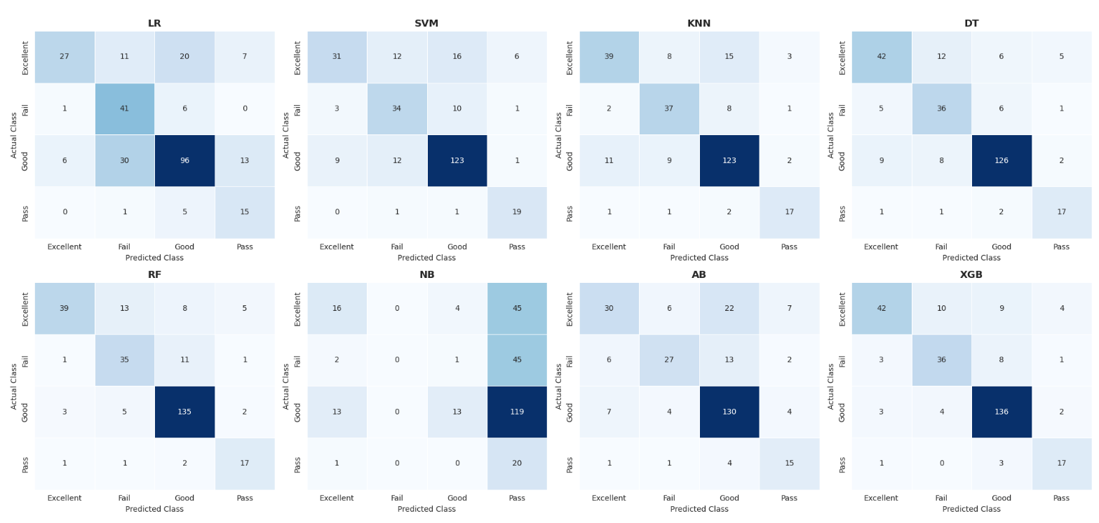
Figure 6 Confusion Matrices of the Optimized Traditional and Ensemble Learning Models with SMOTE-full feature.
Full feature with applying SMOTE
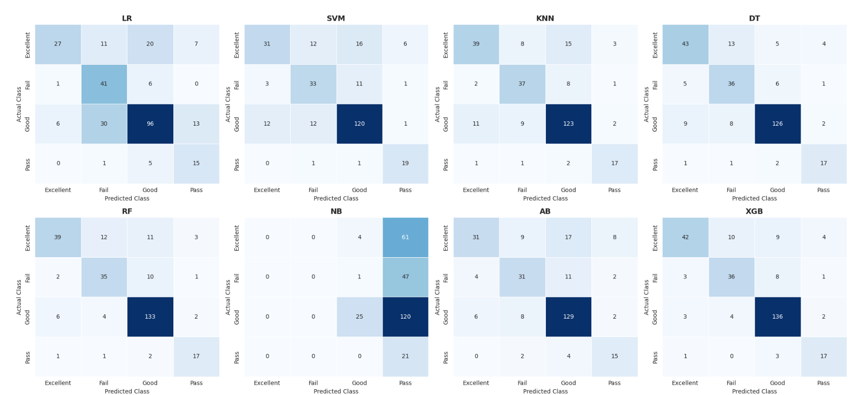
Figure 7 Confusion Matrices of the Optimized Traditional and Ensemble Learning Models with SMOTE-full feature.
Selected feature with applying SMOTE

Discussion

Figure 8 Compares the accuracy of eight machine learning models across all experimental configurations using the optimized hyperparameters identified through Grid Search: full features + selected features without SMOTE, full features + selected features with SMOTE. Overall, the results show that the effect of SMOTE and feature selection varied depending on the learning algorithm.
XGB achieved the highest accuracy in all configurations, with performance percentage 82.08%of ACC to 82.80% of ACC, stable performance regardless of the feature set or the use of SMOTE. DT and RF also demonstrated competitive results, with accuracies close to 80%. RF benefited from SMOTE when the full feature set was used, whereas DT showed better performance without SMOTE.
KNN produced consistent results across all settings, with only a small improvement after applying SMOTE. In contrast, LR, SVM, and AB showed the lowest rate of accuracy after SMOTE was applied. NV remained the lowest-performing model in all configurations, although its accuracy improved slightly when SMOTE was used.
Feature selection caused marginal changes in most models. Reducing the number of features may help simplify the models without affecting their performance. However, the findings also show that SMOTE did not consistently improve accuracy across all models. Its main contribution is more likely related to improving the recognition of minority classes and producing more balanced predictions, which should also be examined through recall, F1-score, and the confusion matrices.
In all experimental setups, XGB demonstrated better results compared to other ML algorithms and achieved the best overall predictive efficiency of models.

Figure 8 Accuracy comparison of Optimized machine learning models using full and selected feature sets with and without SMOTE.
5. Conclusion: This study proposed an AI-based Early Warning System for predicting students' academic performance using a private Learning Management System (LMS) dataset collected in Saudi Arabia. The proposed framework integrates data preprocessing, feature selection using Random Forest feature importance, class balancing using SMOTE, hyperparameter optimization using Grid Search with Stratified Cross-Validation, and machine learning model evaluation.
Eight machine learning models were evaluated under four experimental configurations. The results demonstrated that XGBoost achieved the best predictive performance, obtaining an accuracy of 82.80%, outperforming the other evaluated models. Feature selection successfully identified the most influential educational features while reducing model complexity, and SMOTE improved the balance of minority classes and enhanced model robustness.
Although the proposed framework achieved promising results, its generalizability is limited by the use of a private dataset from a single educational institution. Future work will focus on validating the proposed framework using larger and more diverse educational datasets, investigating advanced deep learning techniques, and integrating the developed Early Warning System into Learning Management Systems to provide real-time academic risk prediction and timely intervention.

References list:
Akçapınar, G., Altun, A., & Aşkar, P. (2019). Using learning analytics to develop early-warning system for at-risk students. International Journal of Educational Technology in Higher Education, 16(1), 40.
Albreiki, B., Habuza, T., Shuqfa, Z., Serhani, M. A., Zaki, N., & Harous, S. (2021). Customized rule-based model to identify at-risk students and propose rational remedial actions. Big Data and Cognitive Computing, 5(4), 71.
Alhujayri, I. A. (2024). Transforming teaching through Classera: Insights from Saudi Arabian secondary schools. Journal of Language and Cultural Education, 12(1).
Alwarthan, S. A., Aslam, N., & Khan, I. U. (2022). Predicting student academic performance at higher education using data mining: a systematic review. Applied Computational Intelligence and Soft Computing, 2022(1), 8924028.
Bagunaid, W., Chilamkurti, N., Shahraki, A. S., & Bamashmos, S. (2024). Visual data and pattern analysis for smart education: a robust DRL-based early warning system for student performance prediction. Future Internet, 16(6), 206.
Baker, R. S., Martin, T., & Rossi, L. M. (2016). Educational data mining and learning analytics. The Wiley handbook of cognition and assessment: Frameworks, methodologies, and applications, 379–396.
Bañeres, D., Rodríguez, M. E., Guerrero-Roldán, A. E., & Karadeniz, A. (2020). An early warning system to detect at-risk students in online higher education. Applied Sciences, 10(13), 4427.
Bettahi, A., Harroud, H., & Belouadha, F.-Z. (2025). Early Student Risk Detection Using CR-NODE: A Completion-Focused Temporal Approach with Explainable AI. Algorithms, 18(12), 781.
Bishop, C. M., & Nasrabadi, N. M. (2006). Pattern recognition and machine learning (Vol. 4). Springer.
Boni, A. Saudi Arabia's Digital and Distance Education.
Christou, V., Tsoulos, I., Loupas, V., Tzallas, A. T., Gogos, C., Karvelis, P. S., Antoniadis, N., Glavas, E., & Giannakeas, N. (2023). Performance and early drop prediction for higher education students using machine learning. Expert Systems with Applications, 225, 120079.
Embarak, O. H., & Hawarna, S. (2024). Automated AI-driven system for early detection of at-risk students. Procedia Computer Science, 231, 151–160.
Hamadneh, N. N., Atawneh, S., Khan, W. A., Almejalli, K. A., & Alhomoud, A. (2022). Using artificial intelligence to predict students’ academic performance in blended learning. Sustainability, 14(18), 11642.
Hastie, T. (2009). The elements of statistical learning: data mining, inference, and prediction. In: springer.
Hastie, T., Tibshirani, R., & Friedman, J. (2009). The elements of statistical learning. In: Springer series in statistics New-York.
Johora, F. T., Hasan, M. N., Rajbongshi, A., Ashrafuzzaman, M., & Akter, F. (2025). An explainable AI-based approach for predicting undergraduate students academic performance. Array, 26, 100384.
Khan, I., Ahmad, A. R., Jabeur, N., & Mahdi, M. N. (2021). An artificial intelligence approach to monitor student performance and devise preventive measures. Smart Learning Environments, 8(1), 17.
Macfadyen, L. P., & Dawson, S. (2010). Mining LMS data to develop an “early warning system” for educators: A proof of concept. Computers & education, 54(2), 588–599.
Queiroga, E. M., Batista Machado, M. F., Paragarino, V. R., Primo, T. T., & Cechinel, C. (2022). Early prediction of at-risk students in secondary education: A countrywide k-12 learning analytics initiative in uruguay. Information, 13(9), 401.
Realinho, V., Machado, J., Baptista, L., & Martins, M. V. (2022). Predicting student dropout and academic success. Data, 7(11), 146.
Romero, C., & Ventura, S. (2020). Educational data mining and learning analytics: An updated survey. Wiley interdisciplinary reviews: Data mining and knowledge discovery, 10(3), e1355.
Skittou, M., Merrouchi, M., & Gadi, T. (2023). Development of an early warning system to support educational planning process by identifying at-risk students. IEEE access, 12, 2260–2271.
Studies, S. U. S. o. I. (2024). Data Science vs. Machine Learning. Syracuse University. Retrieved july 4 from https://ischool.syracuse.edu/data-science-vs-machine-learning/
Ujkani, B., Minkovska, D., & Hinov, N. (2024). Course success prediction and early identification of at-risk students using explainable artificial intelligence. Electronics, 13(21), 4157.

