Chapter 3 Proposed Approach (Methodology)

3.1 Overview of the Proposed Approach
This chapter presents the methodology developed to address the crowd-management limitations identified in Chapter 2. The proposed approach replaces the manual, reactive dispatch process currently used at Riyadh Metro stations with an autonomous, data-driven system that predicts platform crowding before it occurs and automatically generates the train dispatch and timetabling decisions required to manage it. The methodology is organised around three integrated data streams — Automatic Fare Collection (AFC) gate records, CCTV-based computer vision, and the existing timetable/operations system — which are fused into a single occupancy signal and processed by two cooperating machine-learning models: a real-time dispatch classifier and a medium-term timetable forecaster. The remainder of this chapter describes the system architecture, the data sources and dataset used to develop and validate the models, the data-fusion technique, the design and configuration of each AI model, the autonomous decision logic used to translate model output into operational actions, and the explainability mechanism used to justify the system's decisions.

3.2 System Architecture
The proposed system follows a pipeline architecture consisting of six stages, illustrated conceptually in Table 3.1: data acquisition from the AFC gates, computer-vision-based headcount extraction from CCTV footage, retrieval of the current timetable and incident status, fusion of the AFC and CCTV signals into a single occupancy measure, processing of that measure by the two AI models, and generation of an updated four-week timetable. The design goal is full automation: once configured, the pipeline requires zero manual data entry or operator intervention to produce dispatch decisions and timetable updates.
Stage | Function | Output
1. AFC Gates | Entry/exit passenger counts per hour, per station | Entry and exit counts
2. CCTV + YOLOv8 | Vision-based platform headcount per zone (A/B/C) | Zone-level density scores
3. Timetable System | Scheduled trains and active incidents | Planned capacity and incident context
4. Data Fusion | Combine AFC and CCTV signals (60% / 40% weighting) | Fused occupancy signal
5. AI Models | Random Forest classifier and Gradient Boosting regressor | Dispatch action and demand forecast
6. Timetable Output | Autonomous timetable generation | Four-week train schedule
Table 3.1: Six-stage pipeline architecture of the proposed system

3.3 Data Sources
Three complementary data sources are integrated to construct a complete picture of station-level crowding. Each source captures information the others cannot, and combining them is central to the accuracy of the proposed models.

3.3.1 AFC Gate Data
The Automatic Fare Collection system records passenger entries and exits at each gate. From these records, four derived features are computed for every station-hour: entries (afc_entries), exits (afc_exits), net flow (afc_net_flow, entries minus exits), cumulative occupancy (afc_cum_occupancy, a running total across the operating day), and occupancy rate (afc_occupancy_rate, expressed as a percentage of station capacity). AFC data is precise for counting gate transactions but cannot directly measure how many passengers remain on the platform, since some passengers board or leave without triggering a corresponding gate event.

3.3.2 CCTV and YOLOv8 Computer Vision
To overcome the limitation of AFC-only estimation, the proposed approach adds a YOLOv8-based computer-vision pipeline. IP cameras covering platform zones A (front), B (middle) and C (rear) capture a frame every 30 seconds. Each frame is processed by a YOLOv8 person-detection model, producing a headcount (cctv_headcount) and a per-zone density score (cctv_density_zone_a, cctv_density_zone_b, cctv_density_zone_c), together with a detection-confidence value (cctv_confidence). Unlike AFC gates, CCTV directly measures how many people are physically present on the platform at a given moment, and continues to function even when a fare gate malfunctions. When the CCTV feed is unavailable, the system automatically falls back to AFC-only estimation.

3.3.3 Timetable and Operational Data
The existing timetable system supplies contextual information: the number of scheduled trains (scheduled_trains), the load factor per train (demand_per_train), and operational disruption data, including incident type (incident_type), incident severity (incident_severity, ranging from Low to Critical) and accumulated delay in minutes (delay_minutes). This context allows the models to distinguish ordinary demand fluctuations from crowding caused by service disruptions.
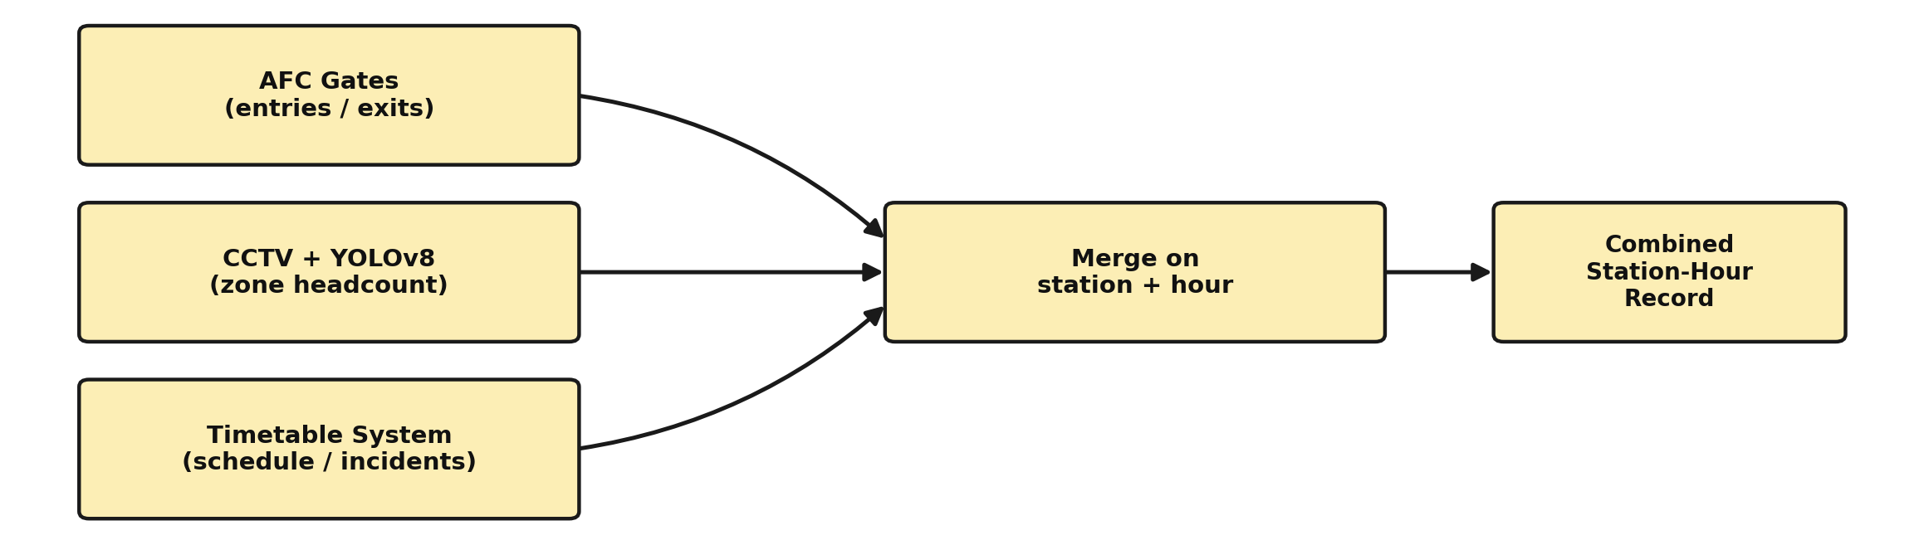
Figure 3.1: Three-source data collection pipeline

3.4 Dataset Description

3.4.1 Data Cleaning and Preprocessing
Before the fused dataset could be used for modelling, a systematic data-cleaning pass was applied to the merged AFC, CCTV and timetable records. A data-quality check first scanned every column for missing values and confirmed the target variables (trains_dispatched, crowd_level) were fully populated. The only missing values found were in the CCTV-derived columns, corresponding to station-hours where a camera was offline or reporting only partial coverage.
These CCTV gaps were resolved using an AFC-based fallback rule: cctv_headcount was filled from afc_cum_occupancy, and the three zone-density columns (cctv_density_zone_a/b/c) were filled from afc_occupancy_rate, scaled by 1.00, 0.90 and 0.80 respectively to approximate the expected front-to-rear density gradient on the platform. This ensured every station-hour retained a usable crowd signal even when the vision pipeline was unavailable, consistent with the fallback behaviour described in Section 3.3.2. Categorical fields (such as station code and incident type) were then encoded using a One-Hot Encoder, while numeric fields were passed through unchanged, producing a fully numeric feature matrix ready for model training. Figure 3.2 summarises this workflow.
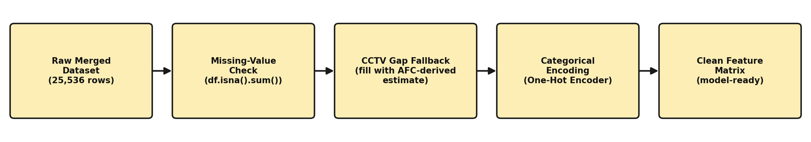
Figure 3.2: Data cleaning and preprocessing workflow

3.4.2 Dataset Description
The models were developed and validated using a dataset covering Line 3 operations across 12 stations over 16 weeks (January–April 2026), sampled hourly between 05:00 and 23:00 (19 operating hours per day). The resulting dataset contains 25,536 records, each describing one station at one hour on one day, across 34 combined AFC, CCTV, timetable and derived features. Table 3.2 summarises the distribution of the target crowd-level classes, and Table 3.3 summarises the distribution of the corresponding dispatch actions.
Crowd Level | Number of Records
Low | 11,517
Medium | 5,007
High | 1,757
Critical | 7,255
Table 3.2: Distribution of crowd-level classes in the dataset
Dispatch Action | Number of Records
0 extra trains | 10,713
1 extra train | 5,402
2 extra trains | 1,932
3 extra trains | 7,489
Table 3.3: Distribution of dispatch-action classes in the dataset
As Table 3.3 shows, the dataset exhibits pronounced class imbalance: the majority of station-hours require no additional trains, while the “three extra trains” (Critical) class is nonetheless well represented. This imbalance is addressed during model training using balanced class weighting, described in Section 3.6.1, so that the classifier does not under-predict the safety-critical Critical class.

3.5 Data Fusion Methodology
AFC and CCTV signals are combined into a single fused occupancy measure rather than being modelled separately, so that the downstream AI models receive one consistent crowding signal per station-hour. The fusion formula adopted in this study is:
fused_occupancy = 0.60 × AFC_occupancy + 0.40 × CCTV_headcount
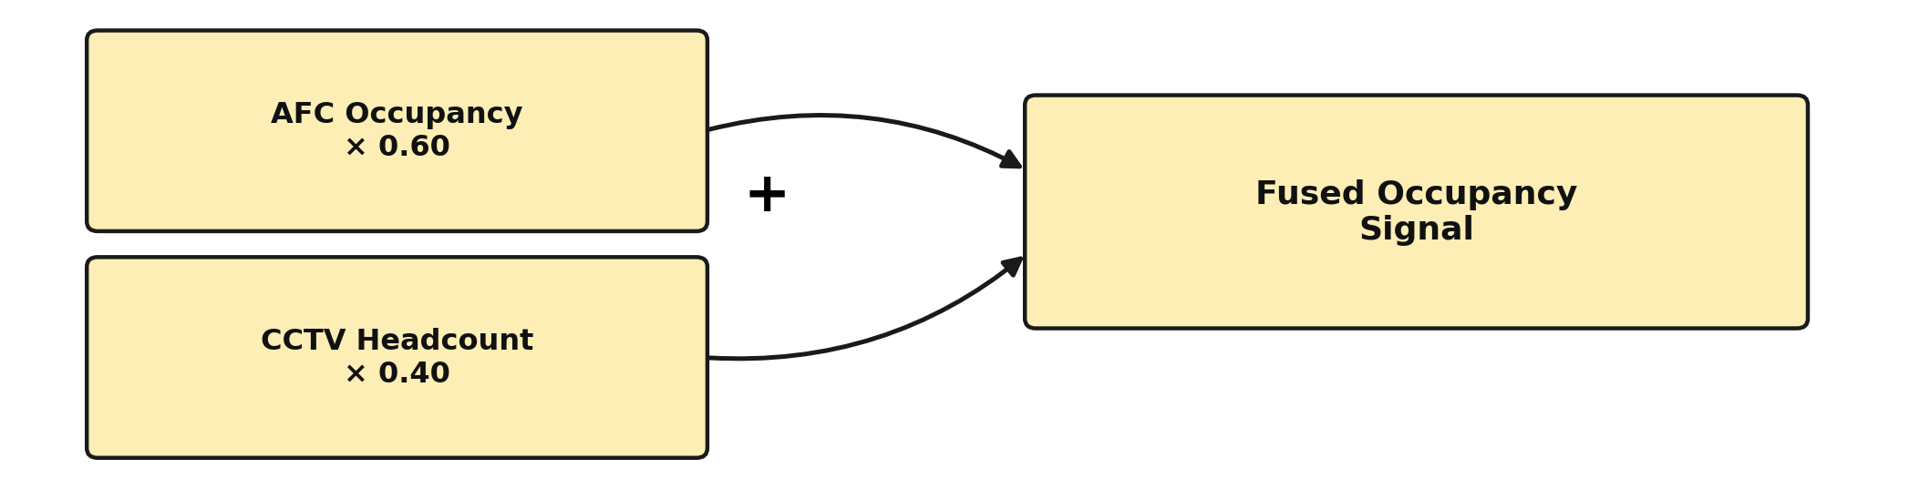
Figure 3.3: Weighted data fusion formula
The 60/40 weighting reflects the relative reliability of the two sources: AFC provides an exact count of gate transactions and is weighted more heavily, while CCTV contributes a corrective signal that captures passengers not reflected in gate counts and platform-side density that AFC cannot observe directly. This fused value is the primary input feature used by both AI models described in Section 3.6.

3.6 Proposed AI Models
Two cooperating models form the core of the proposed methodology: a real-time dispatch classifier that decides how many extra trains are needed immediately, and a medium-term forecaster that plans the timetable for the coming weeks. The two models are trained and operate independently but share the same fused input features, and their outputs are combined to produce a fully autonomous four-week schedule.
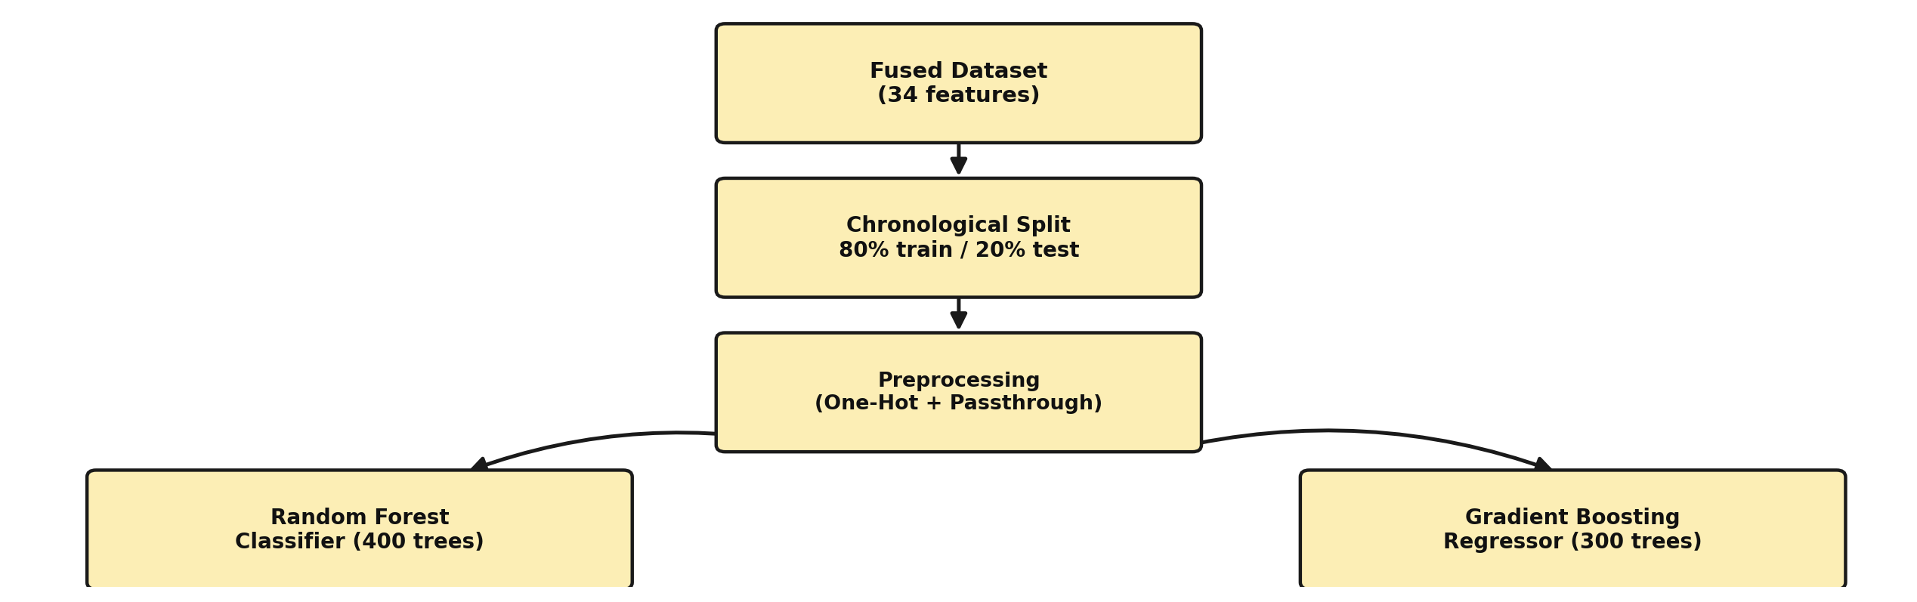
Figure 3.4: Model training pipeline for both AI models

3.6.1 Model 1: Dispatch Classifier
The dispatch classifier is implemented as a Random Forest Classifier with 400 estimators. Class weighting is set to balanced_subsample to compensate for the class imbalance described in Section 3.4, ensuring that the minority “Critical” class (three extra trains) is not systematically under-predicted. The target variable is categorical, taking one of four values corresponding to zero, one, two or three additional trains. The dataset is split chronologically, using an 80/20 time-based split so that the model is evaluated on data that occurs after its training period, rather than on data drawn at random from across the full timeframe.

3.6.2 Model 2: Timetable Forecaster
The timetable forecaster is implemented as a Gradient Boosting Regressor with 300 estimators, a maximum tree depth of 4, and a learning rate of 0.05. Its target variable is the continuous fused_occupancy_rate, and its forecasting horizon is the next four weeks. The forecaster is retrained on a weekly cycle (every Sunday at 02:00), allowing the timetable to adapt to recent demand patterns while still providing operators with a stable four-week planning window.
Parameter | Model 1: Dispatch Classifier | Model 2: Timetable Forecaster
Algorithm | Random Forest Classifier | Gradient Boosting Regressor
Estimators | 400 trees | 300 trees
Other settings | Class weight: balanced_subsample | Max depth: 4; learning rate: 0.05
Target variable | 0 / 1 / 2 / 3 extra trains | fused_occupancy_rate
Evaluation split | Time-based 80/20 | —
Forecast horizon | Immediate (current hour) | Next 4 weeks
Retraining cycle | — | Weekly (Sunday, 02:00)
Table 3.4: Configuration of the two proposed AI models

3.7 Autonomous Decision Rules and Timetable Generation
The output of the dispatch classifier is translated into an operational action using a fixed set of occupancy-based decision rules, summarised in Table 3.5. These rules determine both the number of trains to add or remove and the corresponding headway adjustment, allowing the system to respond proportionally to predicted demand without any operator input.
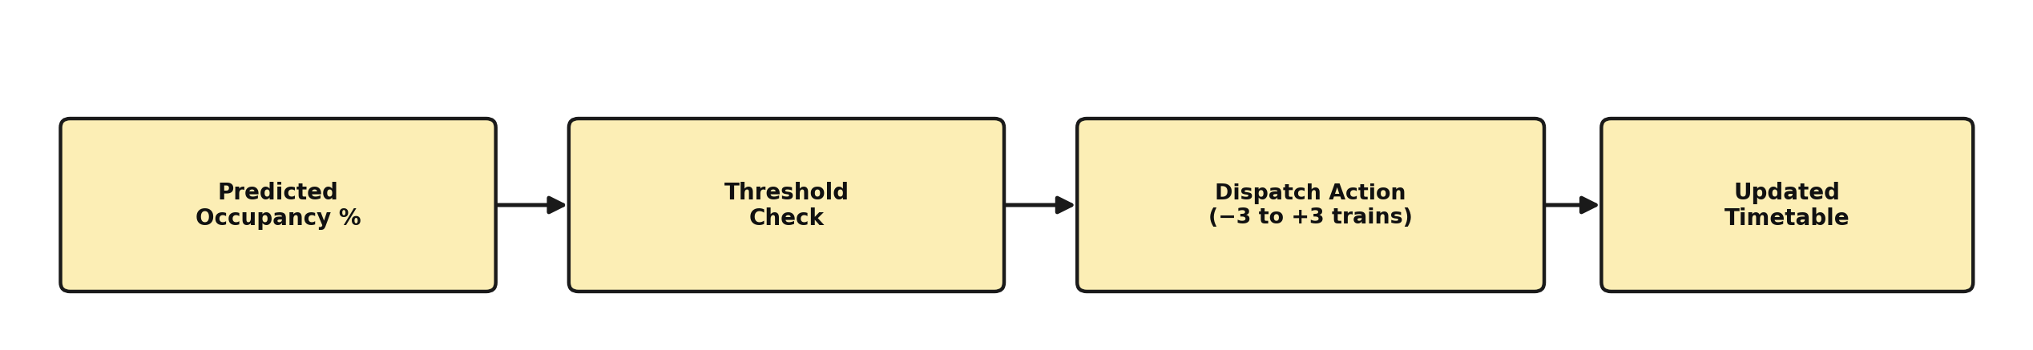
Figure 3.5: Autonomous decision-rule application flow
Predicted Occupancy | Level | AI Action | Headway Adjustment
Below 30% | Low | Remove 1 train | +3 min headway
30% – 58% | Normal | Keep schedule | No change
58% – 78% | Elevated | Add 1 train | −2 min headway
78% – 92% | High | Add 2 trains | −4 min headway
Above 92% | Critical | Add 3 trains | −6 min headway
Table 3.5: Autonomous decision rules mapping predicted occupancy to dispatch action
Applying these rules across the four-week forecast horizon for all 12 stations produces a complete, autonomously generated timetable. In validation, this process computed 6,384 individual time slots, resulting in 3,501 train insertions and 1,445 train reductions, with 1,822 slots flagged as Critical alerts. The overall forecast error achieved by the timetable forecaster was 2.87% mean absolute error (MAE) on occupancy rate, which is considered sufficiently accurate for weekly operational planning.

3.8 Model Explainability
Because operational decisions of this kind require operator trust and accountability, the proposed methodology incorporates SHapley Additive exPlanations (SHAP) analysis to interpret the dispatch classifier's decisions. SHAP values quantify the contribution of each input feature to a given prediction, allowing the system to justify why a particular dispatch action was recommended. Across all dispatch classes, SHAP analysis confirms that fused_occupancy_rate and delay_minutes are consistently the two strongest predictors, which aligns with operational intuition and supports the credibility of the model's decisions to human reviewers.

3.9 Summary
This chapter has presented the proposed methodology for autonomous crowd-aware metro dispatch. Three data sources — AFC gates, CCTV computer vision, and the timetable system — are combined through a weighted fusion formula into a single occupancy signal. This signal drives two cooperating models: a Random Forest dispatch classifier that recommends immediate train-insertion actions, and a Gradient Boosting timetable forecaster that plans four weeks ahead. A fixed set of decision rules converts model output into concrete dispatch actions and headway adjustments, and SHAP-based explainability provides transparency into the reasoning behind each decision. Chapter 4 presents the results obtained by applying this methodology to the dataset described in Section 3.4.

