جامعة ميدأوشن

كلية الإدارة
إدارة المشاريع ماجستير

عنوان البحث

أثر تطبيق ضبط الرواسب على أداء مشاريع الإنشاء في ولاية كوينزلاند

إعداد الطالب / هزار نبيل خلوف
251001995

إشراف/
د.الفيصل عبد الحميد
د.فايز جراد

العام الدراسي:
2025

Midocean University
Faculty of Management
Master of Project Management

Research Title

The impact of Sediment Control implementation on the performance of construction projects in Queensland

Prepared by:
Hazar Nabeel Khallouf
251001995

Supervised by:
Dr. Alfaisal Abdelhameed Mohamed
Dr. Fayez Ali Jrad

Year:
2025

حقوق الطباعة
حقوق الطباعة تمتلكها جامعة ميدأوشن. حيث إن جميع المواد والمحتويات الواردة في هذا البحث هي
ملك للجامعة، ولا يجوز استخدامها أو إعادة نشرها أو توزيعها بدون إذن مسبق من جامعة
ميدأوشن
الباحث

الملخّص
تلعب صناعة البناء دورًا محوريًا في ولاية كوينزلاند – أستراليا، إلا أن هذه المشاريع قد تواجه العديد من التحديات البيئية مثل جريان الرواسب وتآكل التربة نتيجة للظروف البيئية المختلفة. تهدف هذه الدراسة إلى تحليل تأثير تطبيق ضوابط الرواسب على الأداء العام لمشاريع البناء من حيث التكلفة والوقت والجودة والفوائد طويلة الأمد والتخطيط والإدارة في كوينزلاند.

سيتم استخدام منهجية البحث المزدوج (الكمّي والنوعي) في هذه الدراسة لتحليل كيفية تأثير التشريعات والمتطلبات الخاصة بضوابط الرواسب على أداء مشاريع البناء، من خلال استبيان كمّي ومقابلات ومناقشات نوعية مع المختصين في المجال.

ستُبرز النتائج التحديات المحتملة التي قد تواجه مشاريع البناء أثناء الالتزام بالتشريعات الخاصة بضوابط الرواسب في ولاية كوينزلاند، بالإضافة إلى توضيح تأثيرها على التكلفة والوقت والجودة والفوائد طويلة الأمد والتخطيط والإدارة.

ونظرًا لندرة الدراسات التي تناولت هذه الجوانب، تسعى هذه الدراسة إلى تقديم فهم واضح لهذه التحديات لجميع العاملين في قطاع البناء، مثل المهندسين ومديري المشاريع والمقاولين.

الكلمات المفتاحية: ضوابط الرواسب، مشاريع البناء، أداء المشاريع، التحديات البيئية، كوينزلاند

Abstract:
Construction industry plays a pivot role in Queensland, Australia, but these projects may face multiple environmental challenges such as sediment runoff and erosion due to environmental circumstances. This research will investigate the effect of sediment control implementation on the key performance of construction projects cost, time, quality and long-term benefits and planning and management in Queensland. A mixed-methods approach will be used in this research to study how sediment control legislations and requirements impact the performance of construction projects, through conducting quantitative survey and qualitative interviews and discussions.
The findings will outline the potential challenges that might occur during construction projects while complying with the state of Queensland’s sediment control legislations. In addition to highlight the changes on cost, time, quality and long-term benefits and planning and management of construction projects.
There are limited studies discussing these issues and challenges, however, this research will provide a clear understanding to these challenges for everyone involved in the construction industry such as, engineers, project managers and contractors.

Keywords: Sediment control, construction projects, project performance, environmental challenges, Queensland.

Acknowledgement

This work is dedicated to the people who have been the foundation of my strength and the reason behind my perseverance.
To my beloved parents, whose unconditional love, guidance, and prayers have accompanied me through every stage of my life. Your sacrifices and constant encouragement have been the light that guided my path, and your belief in me has inspired me to keep moving forward, even when the road was difficult. Everything I have achieved reflects your love and support.
To my dear husband, whose patience, understanding, and unwavering support have been my greatest comfort throughout this journey. Thank you for believing in me, for standing by my side through long nights of study and research, and for always reminding me that I can achieve my dreams. Your presence has made this accomplishment possible.
And to my precious son, who fills my life with joy and purpose. You are my greatest inspiration and the reason I strive to be better every day. May this achievement remind you that dedication, faith, and hard work can turn dreams into reality.
Finally, I dedicate this research to my faculty members who have been sharing experience and knowledge with us during the entire journey.

Researcher

List of Figures
Page | Content
10 | Figure 1.1: Queensland, Australia map
11 | Figure 1.1: Total construction spending figures for the 2023–2024 financial year  (Australian Bureau of Statistics ABS,2024)
11 | Figure: 1.2 Stormwater Inlet Trap
12 | Figure: 1.3 Woven sediment fence
13 | Figure 1.4: Construction Project key performance
13 | Figure 1.5: Problem statement
18 | Figure 1.6: Theoretical research areas
20 | Figure 2.2.1: (From source) Examples of cleaning-up costs (sediment impacting drainage infrastructure assets)
20 | Figure 2.2.2: (From source) Examples of cleaning-up costs (sediment impacting drainage infrastructure assets and waterways)
21 | Figure 2.2.3: (From source) Overall ESC compliance rating for multiple sites in seven LGAs with SEQ for the years 2013 and 2022
24 | Figure 2.2.4: Field monitoring
25 | Figure 2.2.5: Sampling stations
26 | Figure 2.3: Research theoretical framework summary diagram
36 | Figure 4.1.: Dependent and Independent variable
37 | Figure 4.2.1.1: First question
39 | Figure 4.2.1.2: Second question
40 | Figure 4.2.1.3: Third question 36
42 | Figure 4.2.1.4: Forth question 38
45 | Figure 4.2.1.5: Fifth question 41
47 | Figure 4.2.2.1: First question 43
48 | Figure 4.2.2.2: Second question
49 | Figure 4.2.2.3: Third question
50 | Figure 4.2.2.4: Fourth question
51 | Figure 4.2.3.1: First question
52 | Figure 4.2.3.2: Second question
53 | Figure 4.2.3.3: Third question
54 | Figure 4.2.3.4: Forth question
55 | Figure 4.2.4.1: First question
56 | Figure 4.2.4.2: Second question
57 | Figure 4.2.4.3: Third question
58 | Figure 4.2.5.1: First question
59 | Figure 4.2.5.2: Second question
60 | Figure 4.2.5.3: Third question
71 | Figure 4.8.: Recommendations chart
72 | Figure 4.9.1: Sediment runoff risk
List of Tables
32 | Table 3.2.4.1: Sample distribution in the demographic characteristics
73 | Table 4.9.3: GIS Data used

List of terminology
Definition (according to PMI and PMBOK® Guide) | Term
The amount by which actual project costs exceed the planned or budgeted costs. | Cost overrun
Measures and processes used to minimize or eliminate environmental impacts from project activities, ensuring compliance with environmental standards. | Environmental control
The process by which soil and rock are removed from the earth’s surface by wind, water, or human activity and transported elsewhere. | Erosion
A technique that involves examining or measuring project work to verify whether it meets established requirements and standards. | Inspection
A body of laws or regulations enacted by a government to guide and control activities such as environmental protection or construction practices. | Legislations
Outcomes that extend beyond the project’s completion, providing continued value or sustainability over time. | Long-term benefits
The total financial resources required to complete a project, including labour, materials, equipment, and overheads. | Project cost
The series of phases that a project passes through from initiation to closure. | Project life cycle
The measurement of how effectively a project achieves its objectives in terms of cost, time, quality, and scope. | Project performance
A state in northeastern Australia known for its tropical climate, where environmental factors such as heavy rainfall influence construction practices. | Queensland
Water that flows over land surfaces and can carry sediments, pollutants, or debris into nearby water bodies. | Runoff
Solid material, typically soil or organic matter, that is transported and deposited by water, wind, or gravity. | Sediment
Practices designed to prevent sediment from leaving construction sites and entering drainage systems or waterways. | Sediment control
Any individual, group, or organization that may affect or be affected by a project’s decisions, activities, or outcomes. | Stakeholder
Structures designed to capture sediment, debris, or pollutants from stormwater before it enters drainage or natural water systems. | Stormwater traps
Meeting present needs without compromising the ability of future generations to meet their own needs; ensuring environmental, social, and economic balance. | Sustainable
A deviation from the planned project schedule that results in tasks or milestones being completed later than intended. | Time delay
The uppermost layer of soil, rich in organic material, which is crucial for vegetation growth and often disturbed during construction. | Topsoil
Plant life or ground cover that helps stabilize soil and reduce erosion on construction sites. | Vegetation
A temporary barrier made of woven geotextile fabric used to capture sediment and control runoff on construction sites. | Woven sediment fence

Chapter one
Introduction

Introduction:
Queensland is a large state and considered as the second largest state in Australia with a total area of approximately 1,729,742 km^2. The estimated resident population of Queensland on 31 March 2025, the preliminary estimate was 5,647,468 persons, representing about 20.5% of Australia’s total population. (Australian Bureau of Statistics).


Figure 1.1.1: Queensland, Australia map
(Worldatlas graphic maps)
With large land area and a significant population, construction projects and infrastructure development represent a huge sector in the state of Queensland, Australia, and there are continuous future plans and ongoing expansion in this field. According to the Australian Infrastructure Budget Monitor 2024-25, Queensland ranked fifth among Australian states and territories for its proportion of government spending on infrastructure, with 14.6% of its budget allocated for 2024-25. However, Queensland is known for its tropical climate and experiences a wet season with heavy rainfall through out the year. This can result in water pollution, as the uncontrolled movement of sediments can run off into rivers, waterways, creeks, and drainage systems, causing contamination, harming aquatic life, and generating considerable economic costs.

Figure 1.1.2: Total construction spending figures for the 2023–2024 financial year
(Australian Bureau of Statistics ABS,2024)
The Queensland Government has adopted a strict regulatory approach to addressing this issue and has enforced specific requirements on construction projects. The IECA Best Practice Erosion and Sediment Control Guidelines (2008) serve as the primary reference for all regulations related to sediment control on construction sites. Sediment control focus on minimizing the entrance of polluted material to the water ways to protect the environment from any possible damage that could happen due to construction activities. This shall be under the Queensland sediment control guidelines and regulations. For example, to do that, it is common in Queensland to use the Woven sediment fence in buildings construction sites to trap the sediment and allow water through, or the stormwater inlet traps which used in large duty and infrastruction construction sites.
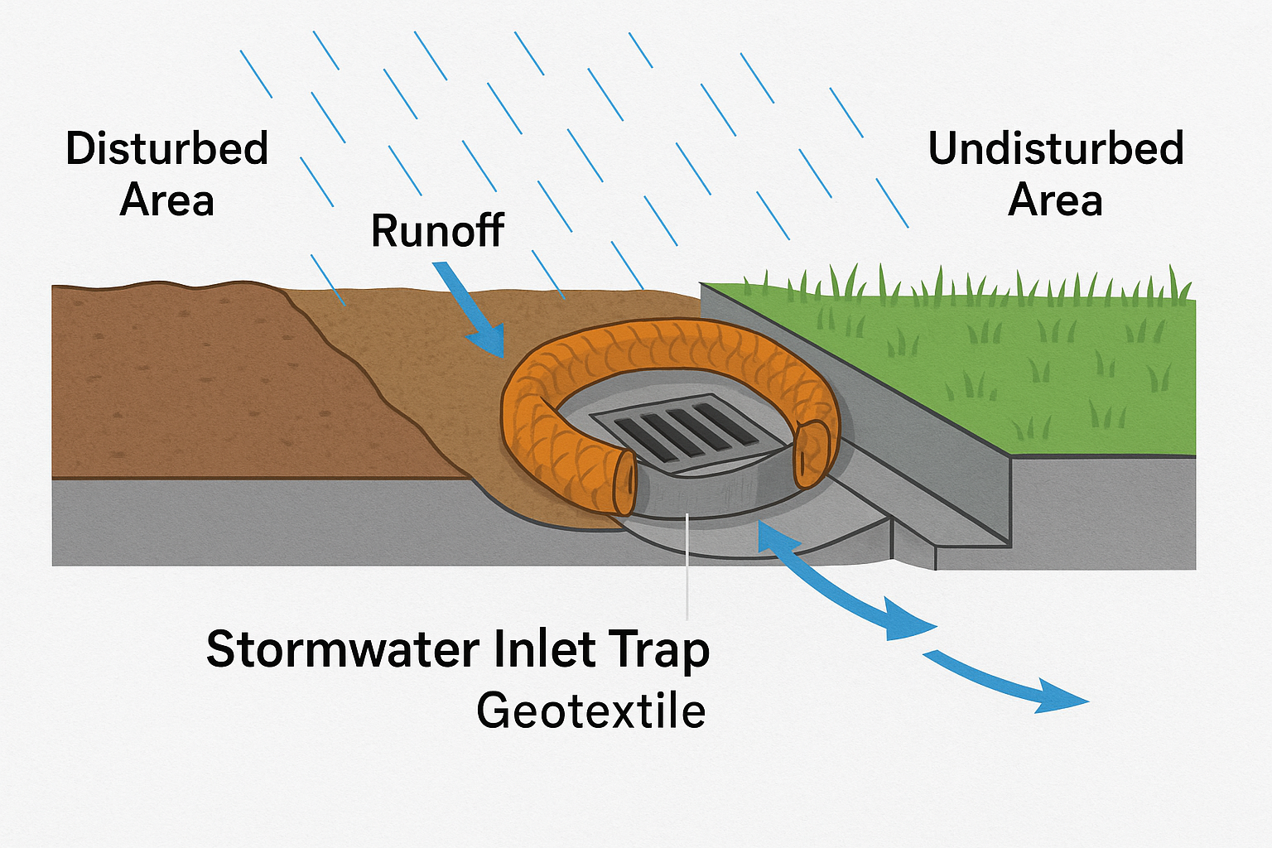

Figure 1.1.3: Stormwater Inlet Trap
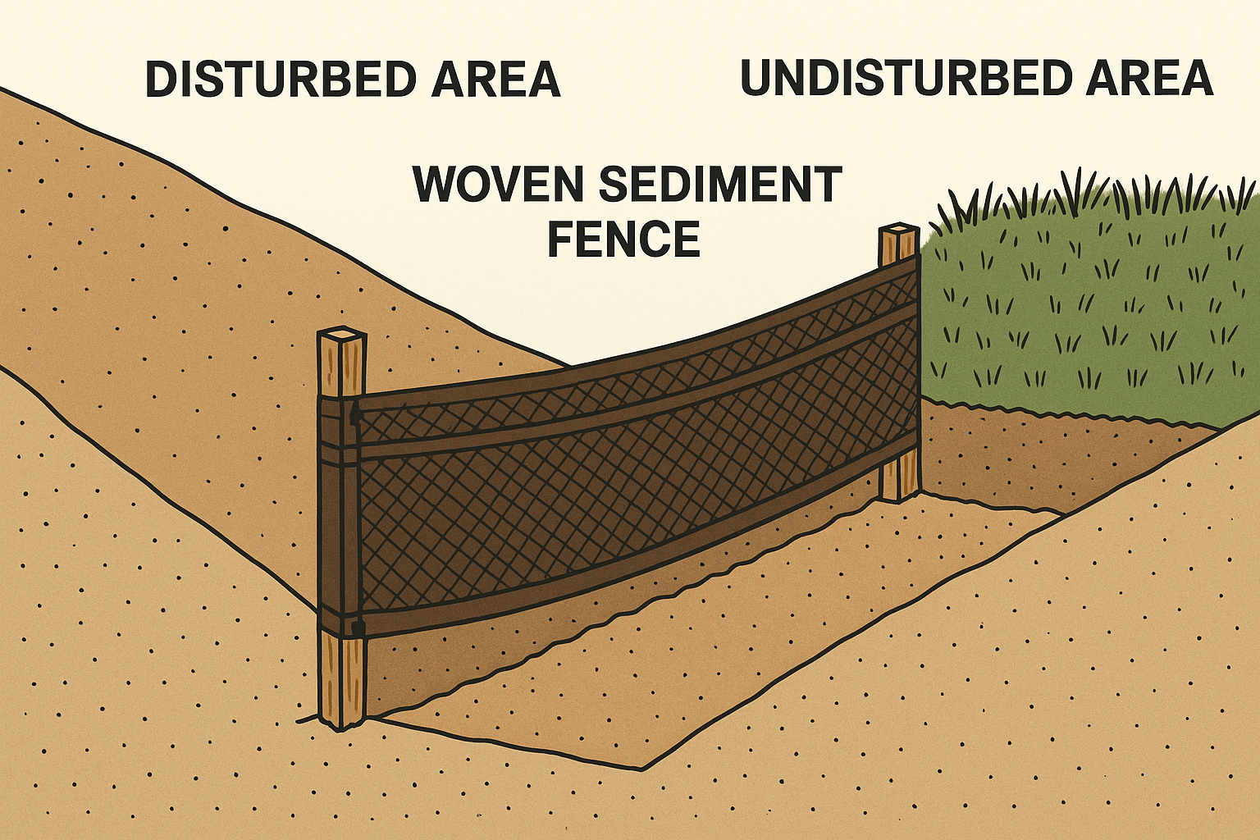

Figure 1.1.4: Woven sediment fence
Furthermore, construction project performance is often challenged when complying with sediment control plans and Queensland regulations. Cost is one of the most critical concerns for clients, stakeholders, engineers, and contractors, and adherence to the state’s regulations for sediment control can significantly increase the cost of projects. Potential and unexpected delays may occur throughout the project timeline while attempting to implement and maintain the sediment control plan.
The management plan of any construction project is crucial and may be considered the most important foundation before commencing work. However, construction activities cannot begin before obtaining an approved sediment control plan from the authorities. Additionally, site opening or project commencement can be paused or require modifications. Typically, pre-rain and post-rain inspections are carried out by the Department of Environment, Tourism, Science and Innovation, and missing such inspections for any reason can create disruptions in the project’s management plan.
There is no doubt that such environmental control practices aim to promote more sustainable future and improve environmental outcomes, not only but also, contibutes in long-term durability of infrastructure development. However, in the construction field, these practices may also negatively influence the delivery quality of projects, as some environmental requirements can lead to rushed rework or delays in certain structural activities to comply with environmental regulations.
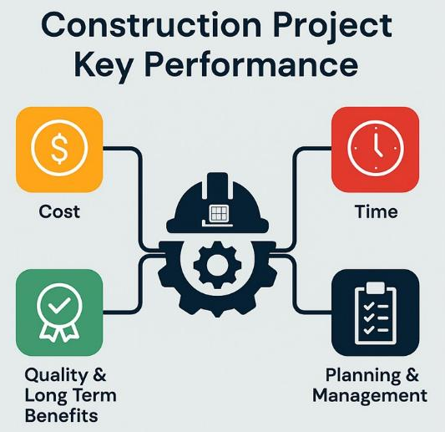
Figure 1.1.5: Construction Project key performance
This research aims to examine and investigate the potential challenges that may arise during construction projects as a result of complying with the state of Queensland’s sediment control regulations, and to highlight the issues associated with their implementation on the key performance of construction projects.

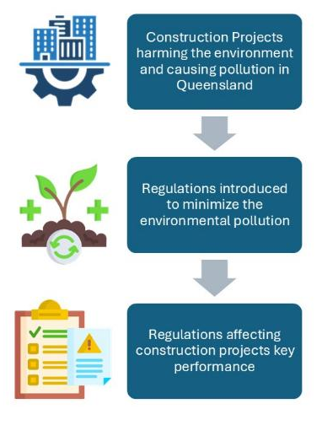
1.2. Problem Statement:
Construction projects play a major role in the economic growth of Queensland, but they can also cause harm and damage to topsoil and natural vegetation areas, especially during the wet season. The uncontrolled movement of sediments, silt, cement, mud, or other pollutants may be washed away from construction sites and carried through external and stormwater drainage systems, causing pollution to rivers, creeks, wetlands, and waterways. Therefore, the Queensland Government and local councils have implemented strict regulations to control such substances and minimize the risk of environmental pollution, based on the IECA Best Practice Erosion and Sediment Control Guidelines (2008).

Figure 1.2.1: Problem statement
While these regulations are essential to ensure a sustainable working environment, they have created significant challenges for the engineering community by impacting the performance factors of construction project delivery. Upholding the standards of sediment control may increase project costs, cause unexpected delays, and affect the quality and sequencing of work. The management and planning of construction projects may become more complex due to the need to coordinate approvals, inspections, and sediment control activities alongside other environmental requirements.
This research seeks to address the lack of understanding of how sediment control regulations affect the performance factors of construction projects, namely cost, time, quality and long-term benefits, and project planning and management. Despite the importance of sediment control in the construction field, there is limited academic research exploring these impacts, and this study aims to highlight and address that gap.

1.3. Significance of the research:
This research is important because it bridges a critical gap in both the academic and practical understanding of how applying sediment control plans and regulations affects the performance factors of construction projects in Queensland, Australia. Despite the importance of sediment control in achieving sustainable outcomes and protecting both the environment and structural elements in the long term, there are limited studies addressing its effect on performance factors such as cost, time, quality, long-term benefits, and project planning and management.
By presenting this research, valuable and relevant concepts will be explored. Understanding how sediment control measures influence project performance will enable engineers and stakeholders to improve project planning, enhance quality, produce more accurate cost and time estimations, and strengthen overall project management. Furthermore, this research will support local authorities and councils in reviewing their environmental regulations and guidelines to ensure they are more achievable and practical without compromising the quality of project delivery. Overall, the study aims to support the protection of Queensland’s natural ecosystems while sustaining the growth of infrastructure development.

1.3.1 Academic Significance:
- Highlights the impact of sediment control on the performance of construction projects specifically cost, time, quality, and planning and management in Queensland, providing a foundation for future research as very few studies currently address this topic.
- Contributes to both project management and environmental engineering by linking theories of project delivery quality with sustainable construction outcomes.
- Gather and present potential challenges in applying sediment control on construction projects to support future academic studies.

1.3.2 Practical Significance:
- Support the infrastructure industry involving engineers, contractors and project managers by presenting the most common problems and challenges during the implementation of sediment control, to help avoid them in future projects and enable better planning.
- Provides a clearer understanding of how complying with sediment regulations can increase project costs or cause unexpected delays, letting stakeholder plan projects more effectively.
- Offer local authorities and councils, ideas that may lead to adjustments in some rules and regulations of sediment control to achieve better quality in construction projects.

1.4. Objectives of the study:
The aim of this study is to investigate how implementing sediment control regulations can impact construction projects in Queensland, by studying the cost, time, quality and project management.
- Cost
- Analysing how far will the sediment control increase the cost of construction projects by comparing the cost of the project with and without applying these regulations.
- Presenting the cost overrun in construction projects due to sediment control applications by comparing the planned cost vs the actual cost of construction projects.
- Time
- Evaluating how sediment control affects construction projects schedules by highlighting the unexpected delays causing schedule disruptions.
- Quality and long-term benefits
- Measuring the quality of performing structural activities such as task orders or rushed work during the project while applying sediment control.
- Exploring how sediment control activities such as protecting the subgrade in construction projects contributes to long-term infrastructure development and protecting structural elements.
- Project planning and management
- Presenting how sediment control takes a part in planning and managing the project before starting construction by initiating approvals and regulatory documentation.
- Investigating the increase in complexity in construction projects due sediment control hold points.

1.5. Research questions:
The main question of this research is how sediment control regulations affect the performance factors of construction projects in Queensland, Australia, namely cost, time, quality and long-term benefits, and project planning and management. The following are some questions that will be answered and discussed in this research.
- How far does implementing sediment control raise up the cost of construction projects in Queensland?
- How does the cost differ between the planned and actual in construction projects that apply sediment control?
- How will the difference between the planned and actual cost cause cost overrun in construction projects?
- What is the direct cost of implementing sediment control to construction projects in Queensland?
- What is the in direct cost of implementing sediment control to construction projects in Queensland?
- What are the challenges that stakeholders face in Queensland while scheduling construction projects?
- How will applying sediment control cause unexpected delays and schedule disruptions in construction projects in Queensland?
- How many working days should stakeholders allow for sediment control implication?
- How to measure the quality of performing structural activities among with applying sediment control in construction projects in Queensland?
- How sediment control contributes to long-term infrastructure development and protecting structural elements in construction projects in Queensland?
- What are the short-term benefits of sediment control?
- What are the long- term benefits of sediment control?
- How can the sediment control affect the plan and management of construction projects?
- To what extend may the sediment control regulation increase the complexity of construction projects in Queensland?
- Is planning for sediment control to be implemented at construction site considered complicated?

1.6. Research Hypotheses:
This research has multiple hypotheses that are listed as follows:
- Cost:
- The total cost of construction projects in Queensland will be higher by 10% to 15$ after applying sediment control compared to projects that do not apply these measures.
- Planned and actual cost will differ in construction projects after implementing sediment control regulations.
- Time:
- The implementation of sediment control regulations will cause unexpected delays and disruptions in the schedule of construction projects in Queensland.

- Quality and Long-Term Benefits:
- The quality of some structural and civil activities in construction projects will be lower by following sediment control rules and regulations which cause interruptions and rushed civil tasks.
- The long-term durability of structural elements will improve by applying proper sediment and control plan in construction projects.

- Project Planning and Management:
- A lot of effort must be done while initiating the management plan of construction projects with sediment control.
- The execution of sediment control requirements raises up the construction projects’ complexity due to the significant number of approvals and inspections needed throughout the project’s life cycle.

1.7. Theoretical Model:
To ensure the accuracy of the research hypothesis, I generated a model of measuring the effect of sediment control implementation on the key performance of construction projects, which are cost, time, quality and planning.
The main areas that the research will be covering are as follows:
- Cost.
- Time.
- Quality and long-term benefits.
- Project planning and management.

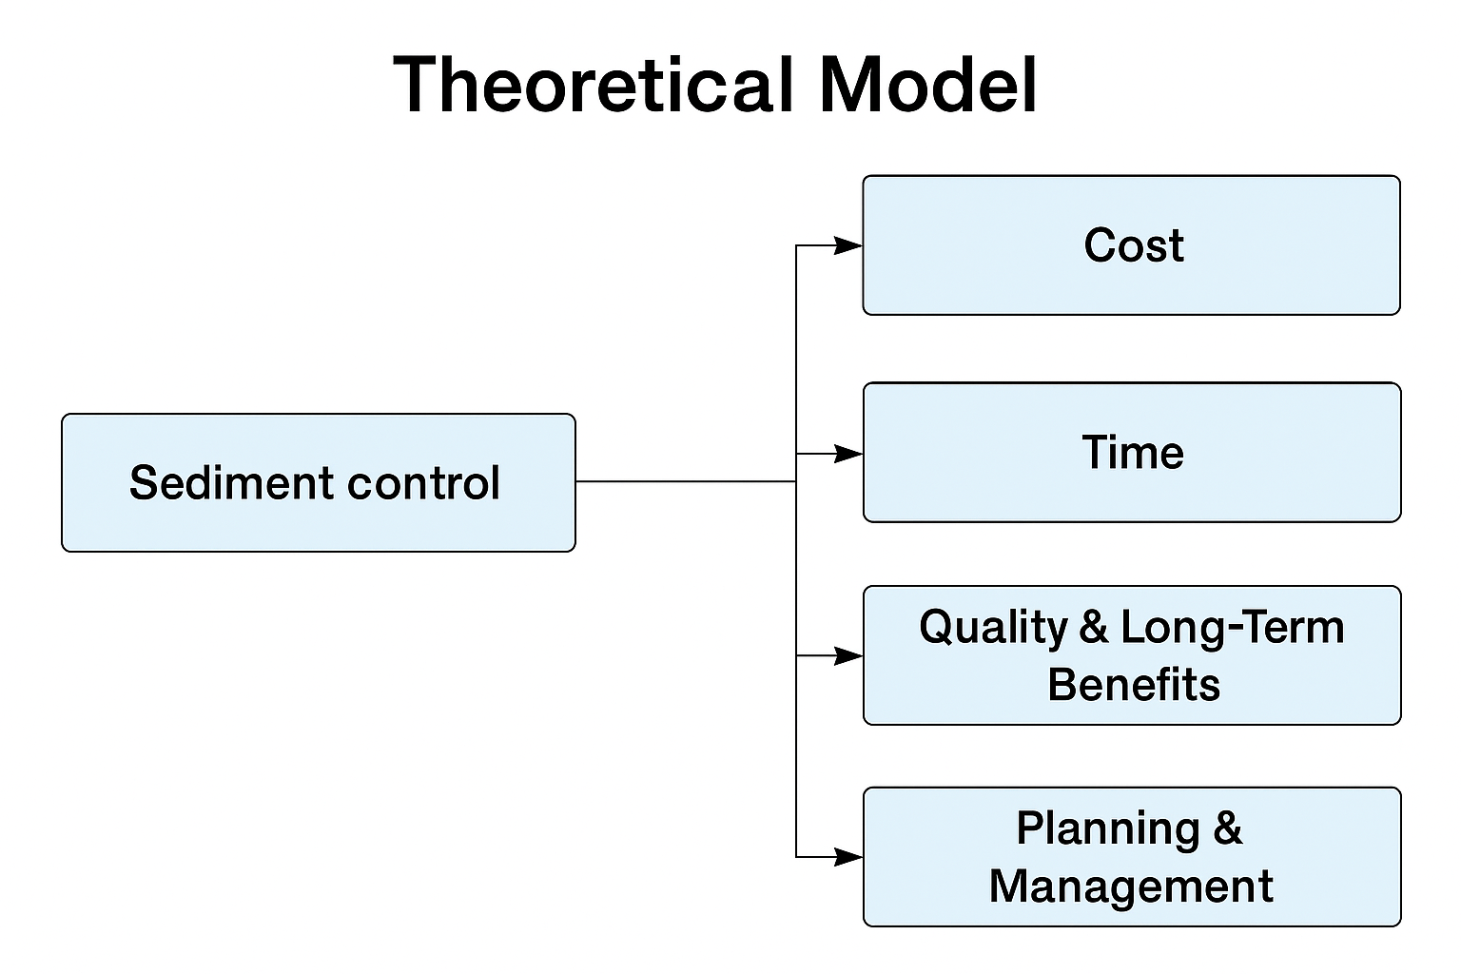
Figure 1.7.1: Theoretical research areas

Despite the challenges and obstacles that the research is discussing, yet it isn’t enough to explain all the aspects related to the effect of sediment control on construction projects’ key performance. But it might be a start to further research and studies to other researchers and engineering professions. It is crucial to mention that the researcher has worked in construction projects and currently working in one of the local government councils in Queensland, which means that this research is reflecting a personal professional experience, such as deep understanding to the obstacles happening in construction projects due to environmental control.

1.8. Conclusion:
In this chapter, the general ideas of this research are presented to give a picture of the aim of this research and reasons for choosing this title. Also, the research problem among with the hypothesis and questions were discussed briefly with some figures to presents the model of this study and its significance to the construction industry.

Chapter two:
Literature Review

2.1. Introduction
Despite the rareness of the studies discussing the effect of sediment control implementation on the construction project performance in Queensland, there are some studies that investigated general environmental control and its effect on key performance elements separately. Also, there are some studies that focused on certain areas within Queensland due to weather circumstances in these areas.
This research is summarizing these studies and highlighting the relevant aspects to sediment control effect. However, the results of some literature reviews may differ from my findings depending on the approach.
It is important for the reader to know that the data was gathered from multiple construction project with different scope of work, thus the finding might not be reliable as needed compared to officially published studies and statistics.

2.2. Literature Review:
1- The Economic Cost of Erosion and Sediment Loss from Construction Sites in South East Queensland. (Griffith University & IECA Australasia, 2015)
This study is discussing a main source of water pollution which is sedimentation cause by construction activities and unfollowed environmental regulations. It is also highlighting the cost of sediment loss and benefits gained from applying sediment and erosion control during construction activities like cost savings. The study presented accurate statistics gathered from governmental sectors resources about the annual sediment contribution form construction activities in Queensland and other states. For instance, one of the discussed problems was the blocked stormwater drainage due to sediment which could have been avoided and costed nothing if sediment control was followed earlier during construction process. The following tables are presenting an example of the costs for cleaning up drainage infrastructure.
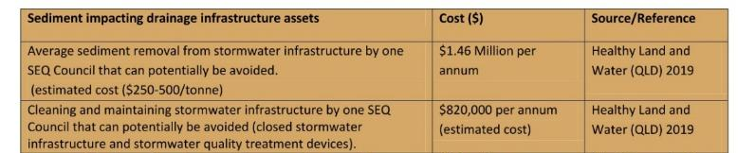
Figure 2.2.1: (From source) Examples of cleaning-up costs (sediment impacting drainage infrastructure assets)
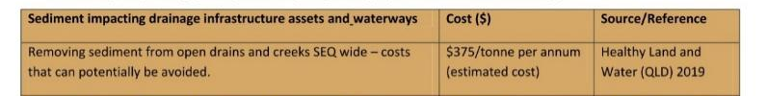
Figure 2.2.2: (From source) Examples of cleaning-up costs (sediment impacting drainage infrastructure assets and waterways)

2- Review of Erosion and Sediment Control in South East Queensland. (Water by Design, 2023) — research/discussion paper synthesizing recent findings and practice in SEQ.
This research is comparing the previous and current compliances to the implementation of sediment and erosion regulations in construction sites. Also, it discussed that the rates of applying sediment and erosion control previously were very low which caused significant pollution to the waterways due to construction activities in the area of South East Queensland. The main goal from this research was to determine whether the construction industry related to lands development was applying and practicing environmental control efficiently to minimize the harm of sediments on waterways.
In 2013, Healthy land & Water initiated six local governments areas (LGAs) for urban development industry, this was done to investigate whether construction sites are following the sediment and erosion control legislations or not in South East Queensland. The following figure was taken from this study presenting the results of an examination of 57 sites, detailing the percentages to which these sites were applying erosion and sediment control across South East Queensland.
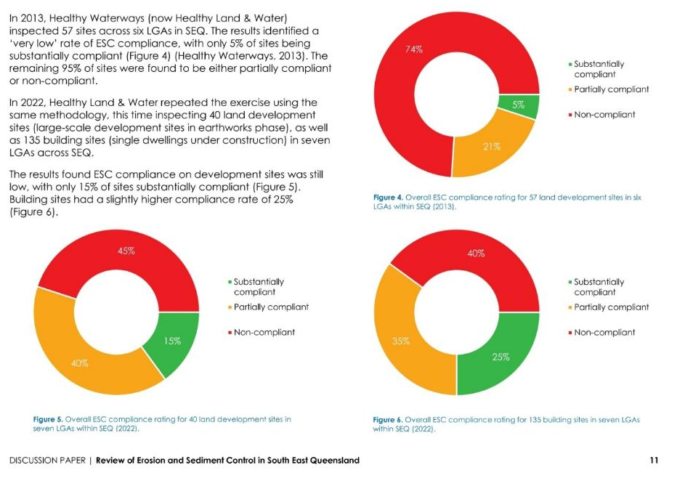
Figure 2.2.3: (From source) Overall ESC compliance rating for multiple sites in seven LGAs with SEQ for the years 2013 and 2022
Additionally, the study mentioned the reasons of having such low percentage in applying sediment and erosion control legislation across multiple urban and construction industries after spending a decade gathering information from stakeholders and other involved parties through workshops, surveys, interviews and other methods. The study mentioned that main reason was due “the lack of enforcement action taken by regulatory authorities”. Not only but also, the lack of consistency among applying the erosion and sediment control between the local governments areas which caused confusion in the construction industry. The study was concluded by suggesting multiple recommendations and suggestions to improve the erosions and sediment planning phase as follows.
• Mandate in policy and development conditions that all ESC plans be prepared by a suitably qualified person, such as a CPESC (at least for sites over a certain area or risk level)
• Resource an experienced local government officer to review plans.
• Standardise Erosion Hazard Assessment forms.
• Standardise conditions for development approvals. For example, conditions should:
- Allow ESC plans to adapt to various development stages whilst ensuring best practice measures are implemented and
maintained.
- Reference compliance with the most up-to-date State Planning Policy 2017 Stormwater Management Design Objectives (SMDO’s), the International Erosion Control Association’s Best Practice Erosion & Sediment Control (IECA, 2008), DES Procedural Guides and other relevant documents.
- Include performance-based conditions, such as discharge water quality objectives (50mg/L) as per the State Planning Policy 2017 SMDOs.
- Require the involvement of a suitably qualified independent third party to plan, implement/oversee, monitor, report and adapt ESC on development sites.

3- Sediment Basin Water Quality on a Large Highway Construction Project. (IECA Australasia Conference Paper, 2023) — monitored turbidity/TSS under different basin management approaches.

This study is discussing a very efficient procedure in sediment control implications during highway construction which is the sedimentation basis. It presented how this procedure helps capturing tones of sediments that might be washed into the waterways because of highway construction activities. Usually, highway construction causes a significant amount of pollution to the waterways due to the exposed soil and land layers. The study showed a water experiment that is done by collecting water samples from the basin inlets and outlets to check the number of polluted particles due to construction activities.

4- Turf for Erosion and Sediment Control -Construction of an Australian National Demonstration Facility. (International Turfgrass Society Research Journal, 12. Holborn, S. & Pearce, W. 2013).

This study discussed a natural solution that controls sediment and erosion designed and operated by Queensland based demonstration facility. The facility studied and tested the turf’s efficiency and its ability to give the soil more stability compared to the regular sediment and erosion control like fences and blankets during rainfall. As mentioned in the study, four main areas were examined as follows:

- Hydraulic roughness of different turfgrass types.
- Measurement of the sediment trapping capability of Turfgrass.
- Assessment of the ability of higher flows to tunnel under turf sod of differing establishment age.
- Rates of root development, including seasonal effects on root development.

5- Bungles, Blowouts and Boondoggles: Why Australia’s infrastructure projects cost more than they should. (The center for independent studies, 2023)
This report is focusing on showing how infrastructure projects in Australia are recently costing more due to several factors like labours, poor planning, and strict environmental and safety regulations to follow. The study documented how environmental legislations contributes to higher cost in the construction industry across Australia compared to the USA. It was mentioned in the study, “Australia has robust environmental regulations to protect the natural environment and biodiversity. Compliance with these regulations can involve additional assessments, mitigation measures, and monitoring”. Even though these standards are costing more in the construction field, they are serving an important purpose which is achieving environmental control and sustainability.
6- Erosion and sediment control — WSUD during the construction phase. In Sustainable Urban Water Blueprints (pp. 145–166). (Rowlands, L. 2019)
This study is examining how much sediment control is taking a place in the construction industry especially the land development phase compared to other phases, also how insufficient sediment control practices can affect the environment and infrastructure projects. It also highlights how environmental sediment control practices align with WSUD principles during the planning phase of construction projects results achieving sediment control efficiently.
7- Quantifying sediment export from an urban development site: Heron Park, western Australia. (Oldham, C.E., Eynon, F., & Ocampo, C.J. 2020)
This study is discussing the approach of developing solutions that will prevent sediment runoff from building sites activities in Heron Park, Western Australia. The aim of the study was to quantify the amount of sediment particles that leave the construction sites and how can the implementation of sediment and erosion control help reduce it. The research was based on using field monitoring, sediment samples and hydrological analysis to see the movement of the runoff and to quantify sediment concentration to evaluate the efficiency of basins and drainage systems. The following figure shows the monitoring approach for the project.
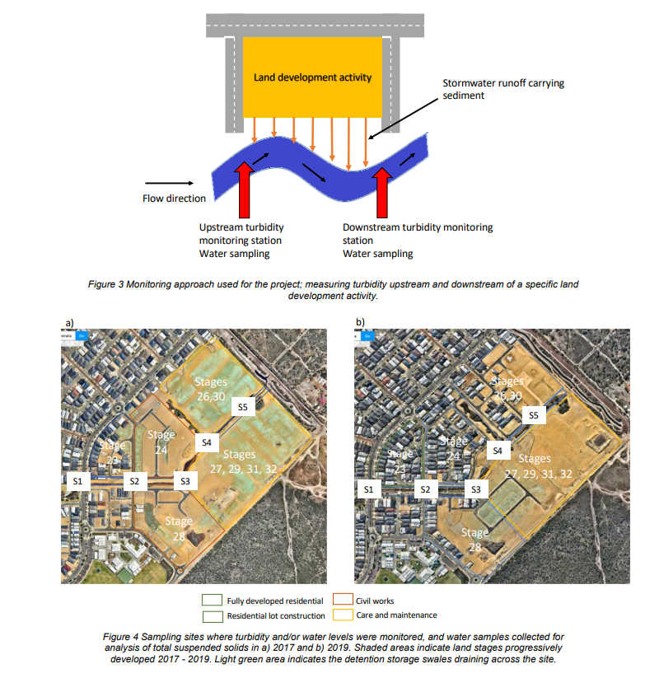
Figure 2.2.4: Field monitoring
The findings of this study showed that the major reason of sediment pollution is caused by construction sites and infrastructural developments, especially during rainfall and storm events. And because of the low efficiency of some drainage systems and maintenance, large amount of fine sediments are being moved to waterways and pollute them, which was higher than recommended in the best-practice ESC guidelines. In addition, the study showed that the sediment control procedures were effective when taking the soil type, rainfall density and construction staging into consideration. The following figure is showing one location in two-time frames (2017 and 2019) for the concentration of sediment loads.

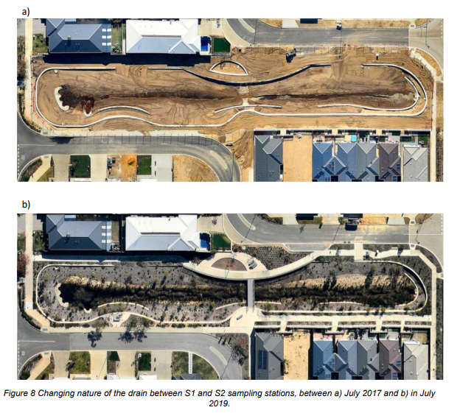
Figure 2.2.5: Sampling stations
2.2.1 Conclusion from Previous Studies:
1- The sediment control regulations play a pivot role in Queensland government sectors.
2- The government updates the regulations of environmental control all the time which creates conflicts and confusion among stakeholders in construction sites.
3- There are different sediment control procedures to follow depending on the construction type.
4- Failing to follow compliances to the implementation of sediment and erosion regulations in construction sites may cost the government a fortune to maintain the polluted areas and waterways.
5- It is more common now to follow environmental control legislation than before which can reduce harm to the environment as well as saving money.
6- There plenty of sufficient natural environmental control solutions that help trapping sediment life turfgrass which proved to be a better solution than the old fashion ones on the long-term side.
7- a lot of standards and requirements in the safety and environmental control are the reason why infrastructure projects are costing more and more, however, achieving these standards is giving more sustainable future in the construction field.
8- Alot of waterways pollution could be minimized through following the correct procedure in applying sediment control such as a proper installation of drainage system.
2.2.2 Recommendations based on Previous Studies:
1- Engineers and project managers should focus on achieving sediment control efficiently through integrating sediment control into early cost planning and scheduling during construction projects.
2- More natural sediment control solutions are worth to consider due to its long-term efficiency and lower future maintenance cost.
3- Applying sediment control procedures will save money and cut the expenses paid on fixing the topsoil by the government.
4- The local authorities and councils should be more precise and consistent during the inspections and approvals for any environmental control plan to avoid confusion among stakeholders.
5- Minimising the exposed areas during infrastructure projects result in having less disturbance in the soil which will reduce the sedimentation and any environmental practices.
6- The government might consider updating the environmental control and have a discussion with all construction parties to set consistent standards for future projects.
7- All parties involved in construction project should work on strengthening the early stages for planning sediment or environmental control.
8- The gap between the government environmental team and engineers should be filled with coordination among both teams.
9- Perhaps adding more trainings and webinar to the construction team will help avoid common problems related to sediment control implementation.
10- Focus on adding digital tools that will help in setting inspections and obtaining approvals.

2.3. Research Theoretical Framework:
This research is discussing different theoretical perspectives in the construction management, sediment control, regulations and rules compliance and the keys of construction project’s performance. The main goal of this theoretical framework is to create an academic and conceptual foundations which will explain the impact of sediment control on the performance of construction projects in the state of Queensland in Australia, targeting cost, time, quality and ling term benefits, and project planning and management. It will also synthesise theories, principles and findings to establish a model that summarise the relationships between both independent and dependent variables in this research.
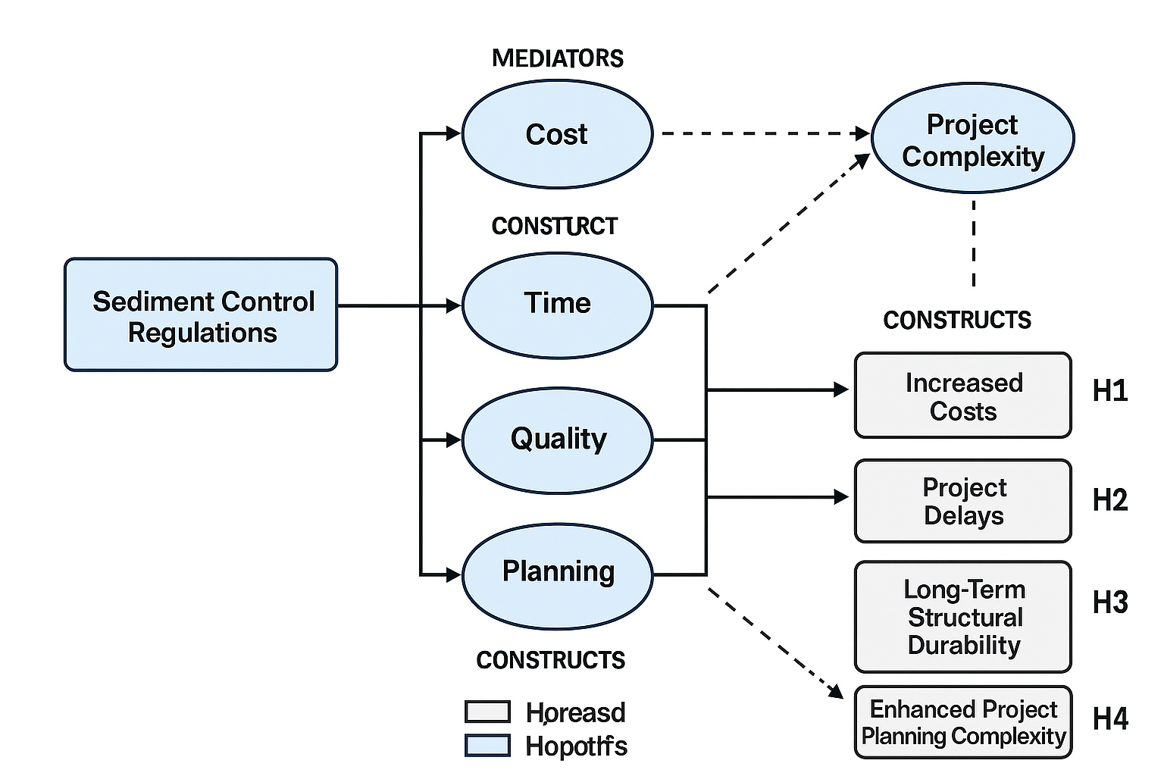
Figure 2.3: Research theoretical framework summary diagram

2.3.1 Sediment Control as a Regulatory and Environmental Framework
The sediment control requirements were established under Queensland environmental legislation which included three main regulations that will form the independent variable of this research as follows:
- Environmental Protection Act (1994).
- Local government development conditions.
- Best-practice guidelines (IECA, 2018).
The following theoretical basis assumptions align with Regulatory Compliance Theory, which explains that the more rules and regulations needed to be achieved in sediment control, the more administrative and operational burdens.
- More environmental and sediment legislation leads to higher compliance needs and requirements.
- Acquiescing affect construction activities, resources, project plan and overall project complexity.
- Increased environmental regulations will lead to more documentation, inspections and approvals in construction projects.
2.3.2 Cost overrun theory
The cost factor in construction projects key performance is addressed in the cost overrun theory, which means that any changes in sediment control requirements, environmental legislations, and hidden or conditions from the original budget of the project will often lead to cost overrun.
According to the literature and research hypotheses that were mentioned earlier, sediment control influences the cost of construction project through the following:
- Materials such as, geofabric, silt fencing and sediment basins.
- Manpower and equipment hire.
- Rework and additional structural activities due to failure in achieving environmental inspections.
- Temporary or additional work which was not included in project’s tender.
The study (Rowlands, 2019; CIS, 2023) confirm that environmental compliance contributes to 10–18% secondary cost impacts which support the research hypothesis of planned and actual cost that may differ in construction projects after implementing sediment control regulations.
2.3.3 Time and delay theory
The time factor of the key performance aligns with Project Delay Theory that explains the time extension of the project’s critical path due to additional environmental activities. The following points will explain the sediment control contribution to delays in construction projects:
- Additional activities such as installation.
- Work stops due to weather conditions or non-compliance.
- Additional time for work approvals or inspection’s requests.
2.3.4 Quality and long-term benefits framework
The quality factor of the key performance is based on the Long-term Asset performance theory that reflects the improvements on the lifecycle and stability of the construction project due to sediment control implications. These implications enhance the quality factor through the following:
- Protecting the foundations from erosion.
- Keeping the drainage systems and retaining walls stable.
- Reduce sediment that may affect the quality of certain structural elements.
- More future jobs available in the engineering/environmental field.
On the other hand, there are some negative impacts that might happen in construction projects due to poor planning or lack of sediment control plan such as:
- Site access restrictions.
- Speeding up some structural activities to meet environmental control.
Therefore, there are mixed effects expected to be among negative impacts and long-term benefits.
2.3.5 Construction project planning and management theory
The planning side of this research is explained in Project Complexity Theory. This theory shows that the more documentation, tasks, approvals and inspections, the more challenging will be to coordinate and plan the project. The sediment control will increase the complexity of the project by the following:
- Plans and strategies to achieve sediment control under the state legislations.
- Regular inspections based on the type of the project.
- Obtaining documents and approvals.
- Filling the gap between the environmental team and project engineers.
2.3.6 Conceptual relationship
The proposal of the theoretical model for this research is as follows:
- Independent Variable which includes all the legislations and laws for sediment control implementation.
- Dependent Variable includes the four key performance of construction projects which are:
- Cost.
- Time.
- Quality and long-term benefits.
- Project planning and management.
Thus, the theoretical framework assumption is that sediment control rules and regulations will impact the four key performance of construction projects.
2.3.7 Theoretical contribution of this research
This research highlights a clear understanding of the effect of sediment control on construction projects through the following:
- Measuring the impact on the cost of the project.
- Addressing operational challenges and disruptions.
- Listing the long-term benefits and negative impacts on construction projects.
- Discussing the planning and managing disruptions and confusions.
The research is giving detailed understanding to these effects and highlighting all the aspects that could affect the key performance of construction projects.

2.4. Conclusion:
This chapter presented a comprehensive review of previous studies involving sediment control practices. Not only but also, presented the effect of their implication on construction projects in Queensland. It also discussed in detail the theoretical framework of the research. Illustrating the theories related to each element of the key performance of a construction project.

