

Title

AI Impact on Crowd Management Using CCTV Footage in Riyadh Metro Operations

Prepared By
Name: Waleed Abdelgawad ID No.: 253002839
Submitted in fulfillment of the requirements for the degree Master of Science in Artificial Intelligence
At
Collage of Informatics
Midocean University
UAE
Supervisor Name: …Dr.Amjad Qataish…………..
College of Informatics, Midocean University, Comoros
Email:…………………….

Acknowledgements

Special thanks to Dr.Amjad Qataish

Abstract

List of Publications

Table of Contents

List of Abbreviations viii
List of Figures ix
List of Tables x
Chapter 5: Experimental Results and Discussion 10
Chapter 1: Introduction and Overview............................................................................... 1
1.2 Problem Definition ................................................................................... 2
1.3 Thesis Objectives ..................................................................................... 3
1.4 Thesis Contribution .................................................................................. 4
1.5 Thesis Organization................................................................................... 5
Chapter 2: Background and Related Works……... 31
2.1 Introduction
2.2 Artificial Intelligence in Metro Systems
2.3 Computer Vision and CCTV Analytics
2.4 Machine Learning and Deep Learning Techniques
2.5 Explainable AI and Decision Support
2.6 Crowd Management Challenges in Metro Systems
Chapter 3: Proposed Approach ............................................................... 78
4.1 Introduction ............................................................................................ 78

Chapter 4: Experimental Results and Discussion ................................... 86
Chapter 5: Conclusion and Future Work .............................................. 127
7.1 Important Features ............................................................................... 127
7.3 Future Work ....................................................................................... 129
References .................................................................................................. 130

Chapter 1 Introduction

1.1 Overview

Urban transportation systems are experiencing rapid growth as cities expand and populations increase. Metro systems have become an essential component of public transportation due to their ability to efficiently transport large numbers of passengers. However, high passenger volumes during peak hours, special events, and national holidays often lead to overcrowding in metro stations and platforms. Managing these large crowds is a significant challenge for transportation authorities because overcrowding can pose safety risks, disrupt operations, and reduce passenger comfort.

Traditionally, crowd management in metro systems relies heavily on manual observation using closed-circuit television (CCTV) systems and the presence of operational staff in stations. While CCTV infrastructure enables continuous monitoring of passenger movement, video stream analysis is typically performed by human operators. This manual approach has several limitations, including delayed response times and the difficulty of monitoring multiple video feeds simultaneously.

Recent advancements in artificial intelligence (AI), particularly in computer vision and deep learning, offer new opportunities to improve crowd monitoring and management. AI-based video analytics can automatically process CCTV footage to detect crowd density, monitor movement patterns, and identify abnormal situations in real time. These technologies have the potential to support metro operators in making faster and more informed operational decisions.

The Riyadh Metro system represents one of the largest public transportation projects in the Middle East and is equipped with a comprehensive CCTV infrastructure. However, the current use of CCTV is mainly limited to manual monitoring and post-incident analysis. This research investigates how AI-based analytics can enhance the effectiveness of crowd management in Riyadh Metro operations and support safer and more efficient metro services.

1.2 Problem Definition
Despite the availability of extensive CCTV systems in modern metro networks, the process of monitoring and interpreting video data still relies primarily on human observation. Human operators must continuously monitor multiple camera feeds to identify potential crowd congestion or safety incidents. This task becomes increasingly difficult as the number of cameras and passengers increases.
Manual monitoring often results in delayed detection of crowd congestion and reduced situational awareness for operations control centers. In high-density environments such as metro platforms, delays in identifying abnormal crowd movement can pose safety risks, cause operational inefficiencies, and lead to passenger discomfort. Furthermore, human monitoring is limited by attention span, fatigue, and the inability to process large volumes of visual data simultaneously.
Although artificial intelligence technologies can automatically analyze video streams and detect patterns related to crowd density and movement, integrating them into metro operations is still evolving. Several concerns remain regarding system reliability, operational usability, privacy protection, and governance of AI-driven surveillance systems.
Therefore, there is a need to systematically investigate the potential role of AI-based CCTV analytics in supporting crowd management within metro environments, particularly in the context of Riyadh Metro operations.

1.3 Thesis Objectives
The primary objective of this thesis is to examine the impact of artificial intelligence on crowd management in Riyadh Metro operations using CCTV footage.
The specific objectives of this research are:
- To analyze how AI-based CCTV analytics can improve monitoring and operational awareness in metro environments.
- To evaluate the effectiveness of AI techniques in detecting crowd density, movement patterns, and potential congestion in real time.
- To assess the operational benefits and technical limitations associated with AI-enabled crowd monitoring systems.
- To examine ethical, privacy, and governance considerations related to the deployment of AI-based surveillance technologies in public transportation.
- To develop a practical framework that supports the responsible integration of AI-driven crowd monitoring systems into metro operational environments.

1.4 Thesis Contribution
This research is expected to contribute to both academic research and practical metro operations. From an academic perspective, the study provides insights into the application of artificial intelligence and computer vision technologies in intelligent transportation systems and crowd analysis.
From an operational perspective, the research will examine how AI technologies can support metro operators in improving crowd monitoring and decision-making processes. The findings will help identify key challenges associated with implementing AI-based surveillance systems, including technical integration, system reliability, and governance considerations.
In addition, the research aims to propose a practical framework for transportation authorities to guide the implementation of AI-enabled crowd-monitoring systems. This framework will consider operational requirements, ethical considerations, and long-term sustainability within metro environments.

1.5 Thesis Organization
This thesis is organized into several chapters to present the research in a structured manner.
Chapter 1 introduces the research topic, including background, problem definition, objectives, and the study's expected contributions.
Chapter 2 presents a review of the existing literature on crowd management, computer vision techniques, artificial intelligence applications in surveillance, and intelligent transportation systems.
Chapter 3 describes the research methodology used in this study, including the mixed-methods approach, data sources, and analytical techniques for evaluating AI-based crowd-monitoring systems.
Chapter 4 presents the analysis and findings from the research, including evaluations of AI models and their effectiveness in detecting crowd congestion.
Chapter 5 discusses the implications of the research findings and introduces the proposed framework for integrating AI-based crowd monitoring systems into metro operations.
Chapter 6 concludes the thesis by summarizing the key findings, outlining the study's limitations, and suggesting directions for future research.

Chapter 2 Background and Related Work

2.1 Introduction
Urban metro systems have become a fundamental component of modern transportation infrastructure, particularly in rapidly growing cities. With increasing passenger numbers, managing crowd flows efficiently and safely has become a critical operational requirement. Traditional crowd-monitoring approaches, which rely on manual observation and conventional CCTV systems, are often reactive and limited in their ability to predict congestion before it occurs.
In recent years, Artificial Intelligence (AI) has introduced new capabilities that enable metro operators to move from reactive monitoring to proactive, data-driven decision-making. By leveraging computer vision, machine learning, and deep learning, AI systems can analyze real-time video streams, detect crowd patterns, and issue early warnings of potential risks. This chapter presents the foundational AI concepts relevant to metro systems, followed by a review of related work in AI-based crowd management.

2.2 Artificial Intelligence in Metro Systems
Artificial Intelligence refers to computational systems that can perform tasks that typically require human intelligence, such as pattern recognition, decision-making, and prediction. In the context of metro systems, AI is primarily applied to improve operational efficiency, enhance passenger safety, and support real-time decision-making.
Unlike traditional systems that depend on predefined rules, AI systems learn from historical and real-time data. This allows them to identify patterns in passenger movement, detect anomalies, and predict congestion levels. In metro environments such as Riyadh Metro, where passenger flow can vary significantly depending on time, events, or disruptions, AI provides a scalable solution to handle dynamic conditions

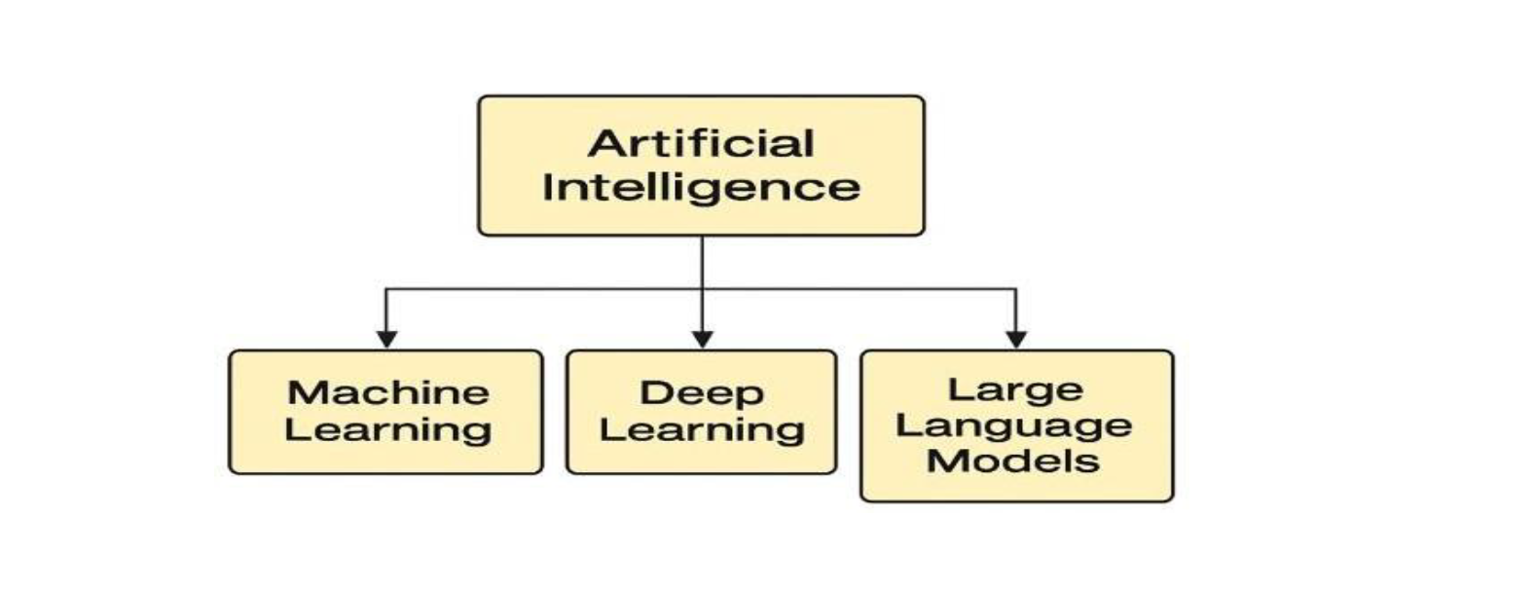
2.3 Computer Vision and CCTV Analytics
Computer vision is one of the most important AI technologies used in crowd management. It enables machines to interpret and analyze visual data obtained from CCTV cameras. Modern AI-enabled CCTV systems are no longer limited to passive recording; instead, they actively process video streams to extract meaningful information.
Through techniques such as object detection, crowd density estimation, and motion tracking, computer vision systems can:
- Count the number of passengers in a specific area
- Detecting overcrowding situations
- Track movement patterns within stations and platforms
- Identify abnormal behavior or safety risks

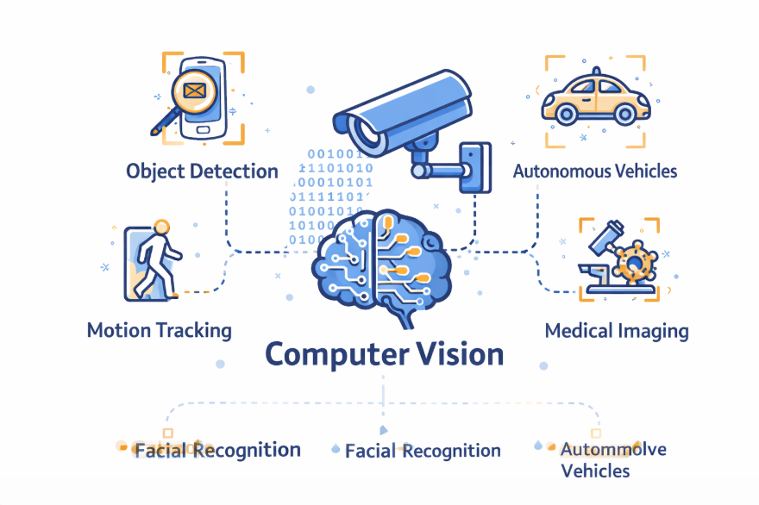

2.4 Machine Learning and Deep Learning Techniques
Machine Learning (ML) is a subset of AI that focuses on learning patterns from data without explicit programming. In metro systems, ML models can analyze historical passenger data to predict future crowd conditions.
Deep Learning (DL), a more advanced branch of ML, relies on neural networks with multiple layers to capture complex patterns in large datasets. In crowd management applications, DL models are widely used due to their high accuracy in processing visual data.
Common techniques include:
- Convolutional Neural Networks (CNNs): Used for image processing and crowd density estimation
- Recurrent Neural Networks (RNNs): Used for analyzing time-based patterns such as passenger flow over time
- Hybrid Models: Combining multiple approaches to improve prediction accuracy
These techniques enable metro systems to move beyond simple monitoring toward predictive analytics, which is essential for proactive crowd management.

2.5 Explainable AI and Decision Support
While AI models can achieve high accuracy, their decisions are often difficult to interpret. In critical environments such as metro systems, transparency is essential. This is where Explainable AI (XAI) becomes important.
Explainable AI provides insights into how and why a model produces certain predictions. For example, it can explain which factors contributed to the detection of a congestion event. This improves trust among operators and supports better decision-making.
In metro operations, XAI plays a key role in:
- Enhancing operators’ confidence in AI systems
- Supporting accountability and governance
- Ensuring compliance with safety and ethical standards

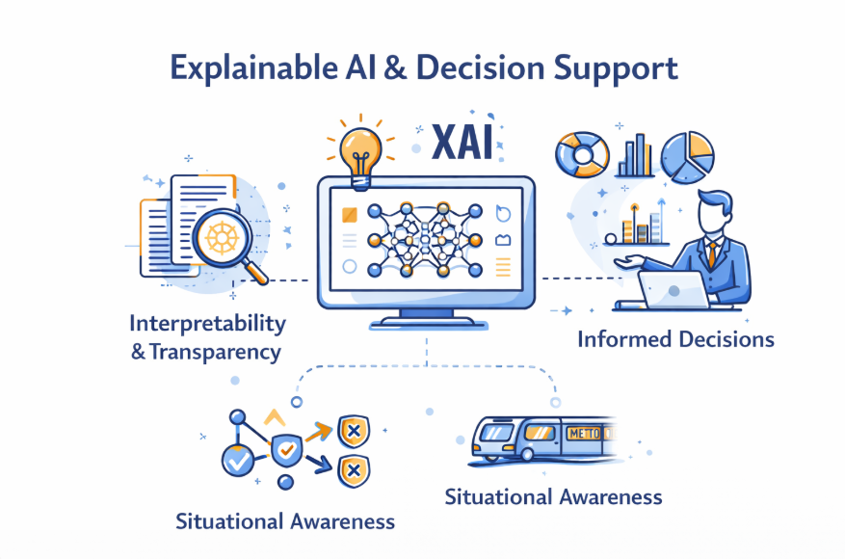

2.6 Crowd Management Challenges in Metro Systems
Metro environments are complex and dynamic. Several challenges make crowd management difficult:
- High passenger density during peak hours
- Limited physical space in stations and platforms
- Unpredictable events such as delays or emergencies
- Human limitations in monitoring multiple CCTV feeds simultaneously

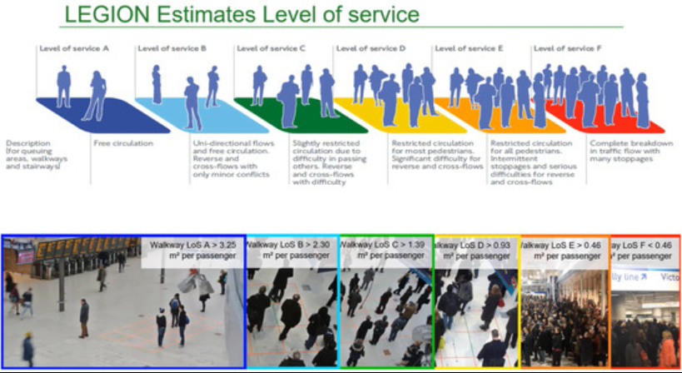

Chapter 4 Proposed Approach (Methodology)

Chapter 5: Experimental Results and Discussion

Chapter 6 Conclusion and Future Work

References

