

Midocean University

College of Management

Graduation Project

Benefits of Artificial intelligence
in Supply Chain Management

Prepared By:

Mohannad Sameer Mohammed Malaikah

241001497

Supervised by

Dr. Asmaa Abo Anza

Dr. Abdulrahim Nadir Abdulrahim Ismail

2024

Abstract

This study examines the transformative impact of Artificial Intelligence (AI) on supply chain management (SCM) in Saudi Arabia, focusing on how AI can enhance efficiency, responsiveness, and cost-effectiveness. Utilizing a structured questionnaire, data were collected from a diverse sample of participants to analyze perceptions of AI’s role in SCM. The findings indicate that AI-driven predictive analytics significantly improve demand forecasting, allowing companies to optimize inventory levels and reduce stockouts and overstock situations. Additionally, automation facilitated by AI minimizes human error and streamlines key processes such as order fulfillment and logistics, with a majority of respondents recognizing its positive impact on operational efficiency. AI-powered solutions also enhance real-time supply chain visibility, allowing for proactive decision-making and faster response to disruptions, with 70% of participants affirming the benefits of enhanced visibility. Furthermore, AI’s ability to assess supplier performance and risks strengthens supplier management, supporting sustainable practices and contributing to overall supply chain resilience. To maximize these benefits, the study recommends investing in robust data infrastructure, beginning with small-scale AI pilot programs before scaling up, and fostering cross-departmental collaboration to ensure alignment in AI implementation. It also suggests prioritizing change management to support employee adaptation to AI tools and leveraging external expertise to ensure best practices. By adopting these strategies, Saudi Arabian companies can achieve a more agile, efficient, and data-driven SCM approach that enhances customer satisfaction and offers a competitive advantage.

Chapter One

INTRODUCTION

This study aims to investigate how artificial intelligence (AI) is revolutionizing supply chain management (SCM). Organizations are looking for creative ways to increase productivity, cut expenses, and boost customer satisfaction as global markets grow more competitive and complex. The goal of this study is to determine how artificial intelligence (AI) tools like automation, machine learning, and predictive analytics can improve a range of supply chain functions, from demand forecasting and logistics to inventory and procurement management.

Supply chain management (SCM) is one of the industries that artificial intelligence (AI) is revolutionizing. Businesses can gain a competitive edge, increase efficiency, and save costs by incorporating AI into supply chain management. The numerous advantages of artificial intelligence (AI) in supply chain management are examined in this essay, which touches on topics like demand forecasting, inventory control, logistics, and customer support.

Precise demand forecasting is essential to efficient supply chain administration. Conventional techniques frequently depend on human intuition and historical data, which can be sluggish and prone to errors. On the other hand, artificial intelligence (AI) uses sophisticated algorithms and machine learning to examine enormous volumes of data from numerous sources, including social media, market trends, and economic indicators. As a result, AI systems are better able to recognize patterns and forecast demand.

Businesses can optimize inventory levels, minimize stockouts and overstock scenarios, and improve customer satisfaction with better demand forecasting. AI, for example, can forecast seasonal demand ups and downs, allowing companies to modify their production and inventory plans appropriately. By being proactive, we reduce waste, holding costs, and guarantee that our products are available when and where they are needed.

  - THE PROBLEM OF THE STUDY

Organizations are looking for creative ways to boost productivity, cut expenses, and enhance decision-making as global supply chains grow more intricate. With automation, data analysis, and predictive modeling, artificial intelligence (AI) offers a promising chance to transform supply chain management (SCM).

Even though incorporating AI into supply chain management has potential advantages, many businesses struggle with implementation, scalability, and obtaining measurable returns on investment. The study's objectives are to examine the particular advantages of AI in supply chain management, pinpoint obstacles to its uptake, and assess how it affects operational efficiency.

    - INTRODUCTION TO AI IN SUPPLY CHAIN MANAGEMENT

Artificial intelligence is revolutionizing many industries, supply chain management most notably. Modern supply chains are so complex that creative solutions are required. AI technologies greatly improve operations for organizations. These developments lower expenses while increasing efficiency. Applications of AI include automation and predictive analytics. Businesses use AI to analyze data in real time. Better demand forecasting is made possible by this. Improved forecasting lowers the likelihood of overstock and stockouts. Distribution and logistics can be made more efficient with AI. Artificial intelligence (AI) finds patterns in large datasets that humans might miss. AI also helps with improved inventory control. On the basis of past performance and trends, it forecasts the ideal stock levels. Businesses can react quickly to changes in the market thanks to AI. Better decision-making procedures are yet another important advantage. AI solutions give supply chain managers useful information. As a result, there is an improvement in supply chain network collaboration. Stakeholder communication is facilitated by AI-driven platforms. They dismantle the silos that usually impede productivity. AI can also improve the management of supplier relationships. Based on the analysis of supplier performance data, companies are able to make wise decisions. All things considered, supply chain management has advanced significantly with the use of AI. It gives organizations the ability to handle the challenges of international trade. In conclusion, AI is essential to contemporary supply chains—it is not merely an option.

    - PREDICTIVE ANALYTICS AND DEMAND FORECASTING

Predictive analytics is one of the main benefits of AI for supply chain management. Using historical data, predictive analytics projects future demand. Businesses are able to effectively anticipate customer needs thanks to this capability. Organizations can improve their forecasting models by utilizing machine learning algorithms. These models are flexible enough to change with the market. Consequently, companies are able to maximize their stock levels. Cash flow is enhanced and carrying costs are reduced by this optimization. Predicting demand accurately is crucial to keeping customers happy. It lessens the possibility of surplus inventory and stockouts. Predictive analytics also makes it possible to plan production schedules more effectively. Businesses are able to match their production procedures to demand forecasts. The efficiency of operations is improved by this alignment. Businesses are able to match their production procedures to demand forecasts. The efficiency of operations is improved by this alignment. Trends and seasonality are just two of the variables that AI-driven forecasts can take into account. Additionally, they can take into account outside factors like economic indicators. This all-encompassing method improves prediction accuracy. Improved forecasting skills result in an advantage over competitors. Businesses are able to react to changes in the market faster. Businesses can also customize their products to fit the preferences of their clients. Supply chain agility is fostered by predictive analytics. In the end, long-term success depends on using AI for demand forecasting. Businesses that use these technologies are more competitive in the market. Data-driven insights will become more and more important in supply chain management in the future.

    - AUTOMATION AND OPERATIONAL EFFICIENCY

Another important advantage of AI for supply chain management is automation. Organizations can improve their operational efficiency by automating repetitive tasks. Employees can now concentrate on strategic initiatives thanks to this change. Order processing and invoicing are made more efficient by robotic process automation, or RPA. Robotics in warehousing can also be optimized by AI. Automated systems improve accuracy and decrease human error. For inventory integrity to be maintained, this accuracy is essential. AI-driven automation also expedites order fulfillment. Higher customer satisfaction is a direct result of faster processing. Workflows can be analyzed by AI technologies to find bottlenecks. Through the resolution of these obstructions, establishments can augment their output. Furthermore, automated systems are capable of continuous operation. Throughput can be raised thanks to this capability without c Proactive problem-solving is facilitated by this monitoring. AI-powered predictive maintenance can cut down on equipment downtime. Companies are able to optimize their asset utilization as a result. Automation of the supply chain must incorporate AI. It facilitates scalability in addition to efficiency. Businesses can grow without experiencing appreciable cost increases. In conclusion, supply chain operations are being revolutionized by automation enabled by AI. It sets companies up for long-term success in a cutthroat market.

    - ENHANCING VISIBILITY AND TRANSPARENCY

Transparency and visibility are essential elements of efficient supply chain management. AI improves visibility by giving data on supply chain activities in real time. Organizations are able to precisely track inventory levels thanks to this transparency. Additionally, it permits shipment tracking all the way through the logistics process. AI is able to compile information from many sources to present a comprehensive picture. This all-encompassing viewpoint facilitates the identification of possible disruptions. Preventive interruption management is essential to sustaining service levels. Increased transparency helps partners in the supply chain build trust. More open information sharing between businesses fosters better teamwork. Platforms powered by AI can make it easier for stakeholders to share data. Strategic planning and collaborative decision-making depend on this sharing. Moreover, real-time visibility helps ensure that regulations are followed. Businesses can make sure they abide by the law and environmental regulations. Product traceability is further enhanced by improved tracking capabilities. This traceability is especially crucial for the food and pharmaceutical industries. Customers are calling for greater openness regarding the source of products. AI enables businesses to successfully meet these demands. To sum up, artificial intelligence greatly improves supply chain visibility. This enhancement improves customer relations while simultaneously increasing operational performance.

    - CHALLENGES AND FUTURE DIRECTIONS

Even with all of the advantages, supply chain management presents difficulties when integrating AI. The integration of AI technologies with current systems is a significant challenge. Organizations frequently struggle with data compatibility. Furthermore, there can be a significant upfront cost associated with AI technologies. Companies have to balance the expenses and possible profits. In terms of AI capabilities, there is also a skills gap in the workforce. It could be difficult for businesses to find qualified employees to oversee AI systems. Furthermore, ethical questions about the application of AI are becoming more and more important. Businesses need to make sure AI applications are applied appropriately. Trust is largely dependent on transparency in AI decision-making processes. Regulations must advance along with AI technology. Legislators must consider how artificial intelligence will affect supply chains. The application of AI in supply chain management appears to have a bright future. Further improvements in capabilities will come from ongoing machine learning advancements. Businesses that use AI will probably have a competitive advantage. Artificial Intelligence (AI) combined with blockchain technology could improve supply chain resilience. All things considered, supply chains will continue to experience the process of integrating AI. Businesses need to stay flexible and adjust to new trends. In conclusion, supply chain management could greatly benefit from artificial intelligence (AI), despite certain obstacles. Adopting these technologies is necessary for success in the future.

  - THE IMPORTANCE AND OBJECTIVES OF THE STUDY

For both practical and scientific reasons, it is essential to research the advantages of artificial intelligence (AI) in supply chain management. In terms of science, it deepens our comprehension of how AI technologies can improve predictive analytics, optimize complex systems, and strengthen decision-making. In practice, supply chain AI integration boosts responsiveness to market demands, lowers costs, and increases efficiency—all of which stimulate innovation and competition. This research is essential for companies looking to prosper in a market that is changing quickly because AI can help organizations better manage risks, streamline operations, and improve customer satisfaction.

    - IMPORTANCE OF THE STUDY ON AI IN SUPPLY CHAIN MANAGEMENT

Supply chain management (SCM) and artificial intelligence (AI) integration have become increasingly important developments in contemporary business operations. This study examines the many advantages of artificial intelligence (AI), highlighting how it can boost productivity, cut expenses, and facilitate better decision-making. Traditional management techniques frequently fail to meet contemporary challenges as global supply chains get more intricate. Artificial intelligence (AI) technologies offer advanced tools to manage these complexities, such as machine learning and predictive analytics. Businesses looking to gain a competitive edge in a market that is changing quickly must comprehend the impact of AI in supply chain management. The study also emphasizes how AI can improve customer satisfaction, inventory management, and operational efficiency. The goal of the research is to provide stakeholders with useful insights by exploring these facets. The results of this study have the potential to guide investment strategies and policy decisions within the logistics industry. Moreover, this study lays the groundwork for upcoming investigations into AI applications in various business domains. These revelations have implications for wider economic and environmental issues in addition to their immediate business benefits.

    - OBJECTIVES OF THE STUDY

Finding the most significant advantages that artificial intelligence (AI) technologies can offer supply chain management is the main goal of this research. In particular, the study aims to examine how AI improves operational effectiveness, allowing businesses to react quickly to market demands. Evaluating AI's contribution to cost reduction—particularly via better demand planning and forecasting—is another important objective. The study also intends to investigate how AI affects risk management, assisting businesses in foreseeing interruptions and minimizing possible losses. Through an analysis of these facets, the study will offer a thorough synopsis of AI's revolutionary possibilities in supply chain management. The study also aims to explore how AI may affect workforce dynamics, including shifts in job roles and skill sets that are necessary. Organizations hoping to use AI responsibly and sustainably must comprehend these dynamics. The study also attempts to evaluate case studies of effective supply chain AI integration, offering actual instances of optimal procedures. This goal is essential for directing companies in the successful adoption of AI technologies. The study's ultimate goal is to add to the larger conversation about supply chain management's use of emerging technologies.

    - METHODOLOGY OF THE STUDY

The study uses a mixed-methods approach, combining quantitative and qualitative research techniques, to accomplish these goals. Industry experts will receive surveys to collect information on the use of AI in supply chains and the perceived advantages of the technology. Furthermore, in-depth interviews with important stakeholders will offer qualitative perspectives on the difficulties and achievements encountered in the integration of AI. In order to place study results within a larger academic context, the research will also examine the body of literature already written about AI in SCM. A statistical analysis of the data will be conducted to find patterns and connections between performance metrics and the use of AI. This approach will guarantee a thorough comprehension of the various aspects of AI technologies' influence. In addition, case studies from various industries will be looked at to show how AI can be used practically in supply chain settings. Triangulating data is made possible by the mixed-methods approach, which increases the validity of the results. In order to give a comprehensive picture of AI's role in SCM, the research combines quantitative data with qualitative narratives. This exacting process is intended to produce insights that policymakers and practitioners can use to improve their work.

    - IMPLICATIONS OF THE STUDY

The study's implications are extensive and have the potential to impact organizational strategy decisions. The study promotes corporate investment in AI by outlining the advantages of AI in supply chain management. The results may cause a paradigm shift in the way businesses handle supply chain difficulties, encouraging creativity and adaptability. The study also emphasizes how crucial it is to keep learning and adapting in the face of technological advancements. Businesses need to be proactive in utilizing new tools and approaches as AI develops further. The knowledge acquired may also be used to improve training and development initiatives, guaranteeing that workers have the skills they need. Making the most of your investments in AI requires taking a proactive stance. The study might also act as a springboard for more investigation into the moral ramifications of artificial intelligence in supply chains. Fostering trust and transparency in AI applications requires addressing these factors. The study's implications highlight the transformative potential of artificial intelligence in reshaping supply chain dynamics.

  - QUESTIONS ABOUT THE STUDY

    - ENHANCED DEMAND FORECASTING

Demand forecasting is greatly enhanced by artificial intelligence, and it is essential for efficient supply chain management. Inaccuracies arise from the use of basic algorithms and historical data in traditional methods. AI, on the other hand, analyzes enormous datasets and finds patterns and trends using machine learning algorithms. This makes it possible to predict customer demand more precisely. Improved forecasting lessens the possibility of stockouts or overstocking, which can result in lower sales or unnecessary inventory expenses. AI systems are more accurate when they take into account outside variables like seasonality and market trends. Businesses are able to react to shifts in customer behavior faster. AI is capable of dynamically adapting forecasts through real-time data processing. Businesses can optimize inventory levels and cut waste and storage expenses thanks to this agility. Furthermore, precise forecasting improves efficiency by matching production schedules to actual demand. Businesses that make sure their products are available when needed can enhance their customer service. Proactively cultivating stronger customer relationships is the goal. Improved labor and logistical allocation is made possible by enhanced demand forecasting. AI increases overall profitability by reducing forecast errors. In supply chain operations, the application of AI to forecasting has emerged as a competitive differentiator. Businesses that use AI are better equipped to handle erratic market conditions. Improved demand forecasting ultimately results in a more resilient supply chain. What are the study's primary goals? Regarding supply chain management, how is artificial intelligence defined in this study? Why is supply chain management so important in today's business world? What particular technologies are included in this study's AI category? How has supply chain operations historically incorporated AI?
    - IMPROVED INVENTORY MANAGEMENT

With real-time visibility and control over stock levels, artificial intelligence (AI) revolutionizes inventory management. Data silos are a common problem for traditional inventory systems, which results in inefficiencies. Supply chain data can be integrated by AI solutions, providing a comprehensive inventory picture. Reorder point optimization and the identification of slow-moving items are made easier by this integration. Businesses can use demand forecasts to predict inventory needs by utilizing predictive analytics. AI can also reduce human error and effort by automating inventory replenishment procedures. While taking lead times and supplier performance into account, intelligent algorithms can recommend the ideal stock levels. This improves cash flow management and lowers carrying costs. Better service standards and fewer stockouts are advantageous to businesses. AI is also capable of tracking inventory turnover rates, which offers information about how well a product is performing. Companies are able to make data-driven choices about markdowns and promotions. Simulating various inventory scenarios is a useful tool for strategic planning. Increased operational efficiency can be achieved by businesses through improved inventory level accuracy. AI facilitates improved supplier collaboration as well, which results in supply chains that are more synchronized. Consequently, organizations can enhance their overall flexibility to adapt to shifts in the market. Improved inventory control has a major impact on client satisfaction. Which are the main advantages of AI that the study emphasizes? How does AI improve the accuracy of demand forecasting? How can artificial intelligence enhance inventory control? What part does AI play in optimizing logistics? How does artificial intelligence help cut costs in supply chain management?

    - OPTIMIZED SUPPLY CHAIN OPERATIONS

AI uses automation and sophisticated analytics to help optimize supply chain processes. Artificial Intelligence (AI) detects inefficiencies and bottlenecks by evaluating historical and current data. Processes are optimized as a result, and operating expenses are decreased. AI, for example, can optimize shipping routes to reduce delivery times and expenses. Decisions made automatically allow for quicker reactions to supply chain interruptions. AI systems can also evaluate supplier performance, which aids companies in making wise sourcing choices. AI-powered predictive maintenance can stop equipment breakdowns and guarantee smooth operation. Businesses can improve visibility throughout the whole supply chain by utilizing AI. Improved stakeholder collaboration is facilitated by this transparency. AI can improve data collection and analysis by facilitating the integration of new technologies, like the Internet of Things. Optimized operations also result in lower carbon footprints, which supports sustainability objectives. AI-powered simulations enable businesses to experiment with various scenarios prior to going live. This method of reducing risk is very helpful in erratic markets. Organizations benefit from increased responsiveness and efficiency as they integrate AI. The end result is a supply chain that is more flexible and able to adjust to changes. Improved competitive advantage is the ultimate result of supply chain operations that are optimized. Which noteworthy case studies were part of the research? How did Business A integrate AI into its supply chain successfully? Which quantifiable results of the AI integration were reported? In what way do the examples show how scalable AI solutions are? What difficulties did businesses run into when putting AI technologies into practice?

    - ENHANCED CUSTOMER EXPERIENCE

Artificial intelligence is a key component of supply chain management that improves customer experience. Artificial Intelligence directly affects customer satisfaction through increasing order accuracy and fulfillment speed. Intelligent chatbots are able to respond to client inquiries immediately and offer real-time support. AI-powered personalization makes recommendations more suited to the tastes and behavior of the user. This promotes loyalty in addition to increasing sales. Proactive service offerings are made possible by predictive analytics' ability to forecast customer needs. Businesses can inform clients about order statuses and anticipated delivery times, for example. Improved tracking systems lessen customers' anxiety by giving them visibility into their orders. AI is also capable of streamlining return procedures and improving their usability. Customers consequently have smooth interactions with brands. Moreover, AI assists businesses in identifying areas for improvement by evaluating customer feedback. Improvements to the products and services are driven by this ongoing feedback loop. In the end, artificial intelligence helps to establish dependable brand relationships and consumer trust. Positive client experiences encourage referrals and repeat business. Businesses that use AI to improve customer experiences have a major competitive advantage. Higher revenue and a larger market share are directly correlated with higher customer satisfaction. Which upcoming supply chain AI trends are being discussed? How could supply chain strategies be affected by AI advancements? What effects does AI have on supply chain workforce dynamics? How can companies get ready for these developments? What moral questions are brought up by artificial intelligence in supply chains?

    - STRATEGIC DECISION-MAKING

AI enables businesses to decide strategically by using thorough data analysis. Real-time processing of massive amounts of data yields insightful information about consumer behavior and market trends. Key performance indicators are presented on AI-driven dashboards, facilitating well-informed decision-making. This data-driven strategy lessens the need for guesswork and intuition. Through the assessment of multiple scenarios, businesses can effectively plan ahead for upcoming obstacles. AI enables businesses to respond proactively by spotting new risks and opportunities. Better decision-making procedures result in better resource allocation and financial performance. Businesses can match their supply chain plans to more general corporate goals. AI also makes scenario planning easier, which helps companies get ready for unforeseen disruptions. In a market that is getting more and more unstable, this foresight is vital. Businesses can make their supply chains more efficient. Based on data insights, businesses can optimize their supply chain networks. AI provides analysis of possible synergies in mergers and acquisitions, which is part of its role in strategic planning. AI-enabled businesses are better equipped to innovate and compete. Sustainable growth is fueled by the incorporation of AI into decision-making processes. Consequently, businesses can prosper in intricate and ever-changing settings, guaranteeing sustained prosperity. What findings does the study make regarding AI's overall effects? What suggestions are given to businesses thinking about implementing AI? How should businesses assess whether implementing AI is working? Which sectors stand to gain the most from artificial intelligence in supply chain management? What avenues for further research does the study recommend?

  - ASSUMPTIONS ABOUT THE STUDY

    - INTRODUCTION TO ASSUMPTIONS STUDY OF AI IN SUPPLY CHAIN MANAGEMENT

Supply chain management is seeing a revolution thanks to artificial intelligence. Improved decision-making and operational efficiency are made possible by the incorporation of AI technologies. Businesses are using AI more and more to instantly analyze enormous volumes of data. Improved inventory control and demand forecasting are made possible by this capability. Compared to conventional techniques, AI-driven systems are more accurate at predicting consumer behavior. Consequently, companies can streamline their supply chains to cut expenses and raise service standards. AI also improves supply chain visibility, allowing for proactive reactions to interruptions. Businesses that use AI frequently report increased agility and responsiveness. Gaining a competitive advantage in the market may result from these advantages. AI's capacity to analyze large, complicated data sets also helps to spot patterns that guide strategic planning. The increasing use of AI tools is a sign that operations are becoming more data-driven. But applying AI also necessitates giving careful thought to the supporting technologies. To realize the full potential of AI, organizations need to invest in both talent and infrastructure. By doing this, they can guarantee the adaptability and resilience of their supply chain. AI implementation can result in long-term cost savings and increased efficiency. All things considered, supply chain management has a lot of potential for using AI.

    - RISK MANAGEMENT AND RESILIENCE

AI is also essential for improving supply chain risk management. Organizations can analyze data to identify potential risks before they escalate by implementing machine learning algorithms. Resilience of the supply chain depends on this predictive capacity. AI is able to keep an eye out for irregularities that could point to disruptions, like delays in logistics or supplier failures. Artificial intelligence helps businesses prepare ahead of time by delivering early warnings. This preemptive strategy lessens the effects of unanticipated events. AI technologies can also help with assessing the performance and dependability of suppliers. With the help of this knowledge, businesses can lessen their reliance on a single source and diversify their supplier base. Diversification of this kind is crucial in an increasingly globalized economy to reduce geopolitical risks. AI can also help with compliance monitoring, which makes sure businesses follow rules and guidelines. This improves reputation while lowering the possibility of legal repercussions. The incorporation of artificial intelligence into risk management ultimately results in a stronger supply chain. Businesses that use these technologies are better equipped to handle ambiguities and keep things running smoothly.

  - THE SCIENTIFIC THEORY FOLLOWED TO PREPARE THE RESEARCH

A methodical approach based on several scientific theories is required to prepare a research study on the advantages of artificial intelligence (AI) in supply chain management. The systems theory, which holds that organizations are intricate systems made up of interconnected components, is one fundamental theory. This viewpoint enables researchers to examine how AI can improve these interrelated supply chain elements, including logistics, demand forecasting, and inventory management. The technology acceptance model (TAM), which looks at how people adopt and use new technologies, is also very important because it clarifies the factors that affect supply chains' adoption of AI tools. The study would start with a comprehensive review of the literature to find previous research on AI applications, approaches, and results in supply chain settings. A mixed-methods approach could then be used, integrating qualitative information from interviews with industry experts with quantitative data, such as performance metrics before and after AI implementation. The findings' validity and depth are improved by this two-pronged approach. Additionally, case studies of businesses that have effectively incorporated AI into their supply chains will be used in the study to provide best practices and useful insights. Key performance indicators (KPIs) like cost reduction, efficiency enhancement, and customer satisfaction would be the main focus of data analysis. The ultimate goal of the research is to present a thorough understanding, supported by theoretical frameworks and empirical data, of how AI can revolutionize supply chain management.

Chapter Two

  - PREVIOUS STUDIES

As numerous studies have demonstrated, artificial intelligence (AI) is becoming more widely acknowledged for its revolutionary advantages in supply chain management (SCM). Demand forecasting is a crucial area for development; AI algorithms examine enormous volumes of past data, industry trends, and customer behavior to make remarkably accurate predictions about future demand, which helps companies minimize stockouts and maximize inventory levels. By using real-time data and predictive analytics, AI also improves supply chain visibility, allowing businesses to anticipate possible disruptions and take proactive measures to address them. Through fuel consumption reduction and routing optimization, machine learning models further simplify logistics and transportation management, resulting in cost savings and increased efficiency. Routine. AI-driven robotics and intelligent systems that automate repetitive tasks reduce human error, expedite processing, and free up staff members to concentrate on more strategic work. Additionally, by evaluating performance indicators and detecting hazards, AI helps firms choose and retain top-notch suppliers, facilitating improved supplier relationship management. When AI is combined with Internet of Things (IoT) devices, a networked ecosystem is created that continuously monitors assets, improving operational efficiency and enabling prompt decision-making. Additionally, AI-driven analytics offer useful information that supports strategic planning and enables businesses to quickly adjust to shifting market conditions. Research has demonstrated that businesses using AI in their supply chains see notable increases in service quality, cost savings, and general competitiveness, reaffirming the technology's importance. (Fig. 1).
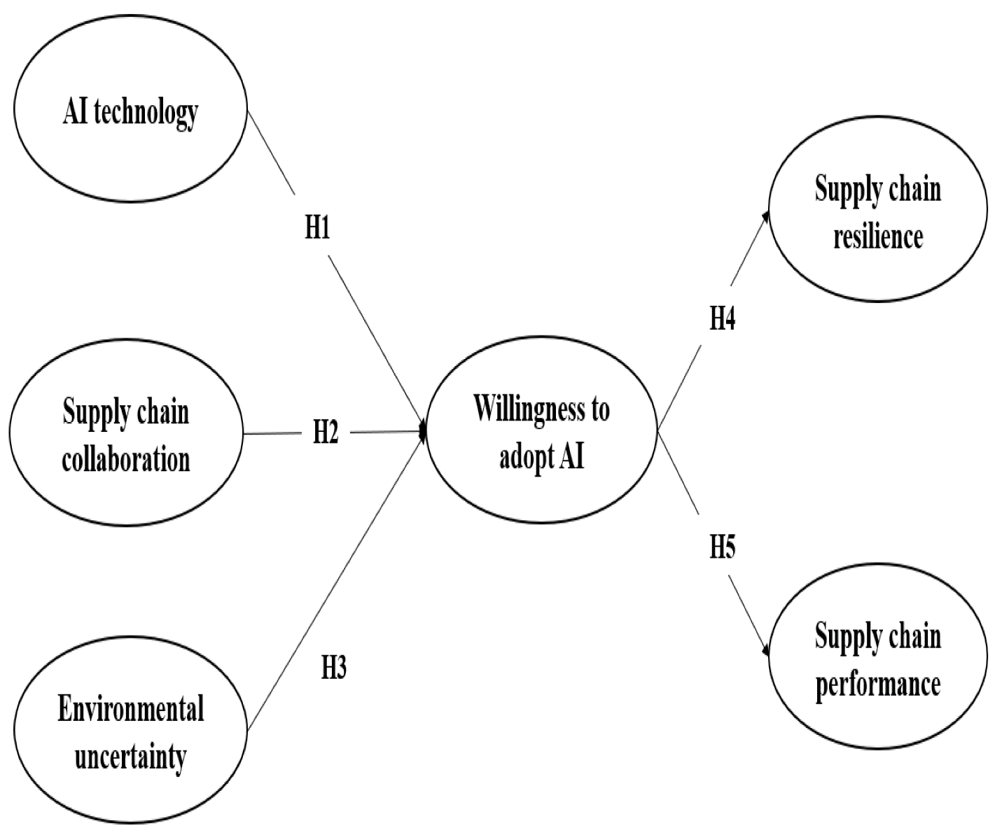

Figure.1 Summarized of Willingness to adopt AI.

A STUDY PUBLISHED BY THE RESEARCHER " Baha M. Mohsen" THIS IS A SUMMARY OF THE SCIENTIFIC PAPER

Abstract
Many facets of corporate operations could be revolutionized by artificial intelligence (AI). Artificial intelligence (AI) can be used to evaluate data, forecast demand, improve logistics and transit routes, and spot in efficiencies in the chain of supply. This may result in shorter lead times, lower costs, and better ability to adapt to shifts in demand. Using the Scopus database, this paper examines and evaluates the applications of artificial intelligence (AI) in supply chain management (SCM). The goal is to close the existing research gap on the effects of AI on supply chain management (SCM) performance. This includes identifying AI techniques that can improve SCM performance, SCM subfields that have a high potential for AI application, the effects of AI application on SCM performance, and how the performance can be explained from an agile-lean perspective. The Scopus database was used to list and categorize the nations and areas that are currently engaged in research on the effects of AI on SCM performance, subject matter, and document types.
Keywords
Artificial Intelligence, Supply Chain Management, Performance, Scopus
Database.

  - THEORETICAL FRAMEWORK OF THE STUDY

ARTIFICIAL INTELLIGENCE APPLICATIONS IN SUPPLY CHAIN MANAGEMENT " Mehrdokht Pournader" THIS IS A SUMMARY OF THE SCIENTIFIC PAPER

Abstract
This paper presents a systematic review of studies related to artificial intelligence (AI) applications in supply chain management (SCM). Our systematic search of the related literature identifies 150 journal articles published between 1998 and 2020. A thorough bibliometric analysis is completed to develop the past and present state of this literature. A co-citation analysis on this pool of articles provides an understanding of the clusters of knowledge that constitute this research area. To further direct our discussions, we develop and validate an AI taxonomy which we use as a scale to conduct our bibliometric and co-citation analyses. The proposed taxonomy consists of three research categories of (a) sensing and interacting, (b) learning, and (c) decision making. These categories collectively establish the basis for present and future research on the application of AI methods in SCM literature and practice. Our analysis of the primary research clusters finds that learning methods are slowly getting momentum and sensing and interacting methods offer an emerging area of research. Finally, we provide a roadmap into future studies on AI applications in SCM. Our analysis underpins the importance of behavioral considerations in future studies. (Fig. 2).

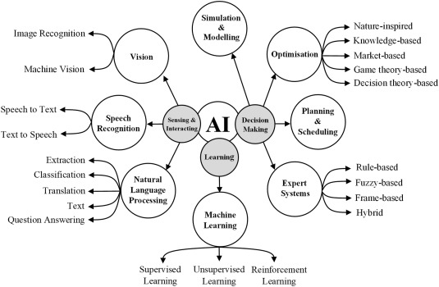
Figure.2 Summarized of Artificial intelligence applications in supply chain management.

