Background
Chapter 2:

2.1 Introduction
This document outlines the development plan for an AI-powered voice agent designed to handle customer inquiries about Saudi Arabian labor law. The core idea is straightforward: replace the rigid, menu-driven IVR systems that government call centers currently rely on with a conversational AI agent that people can simply talk to, in Arabic, through a web browser.
At its heart, the system brings together three technical components. First, an Automatic Speech Recognition (ASR) module takes the caller’s spoken Arabic and converts it to text. Second, a Retrieval-Augmented Generation (RAG) pipeline looks up the most relevant sections of labor law and feeds them to a language model, which then crafts an accurate, context-grounded answer. Third, a Text-to-Speech (TTS) engine reads that answer back in natural-sounding Arabic.
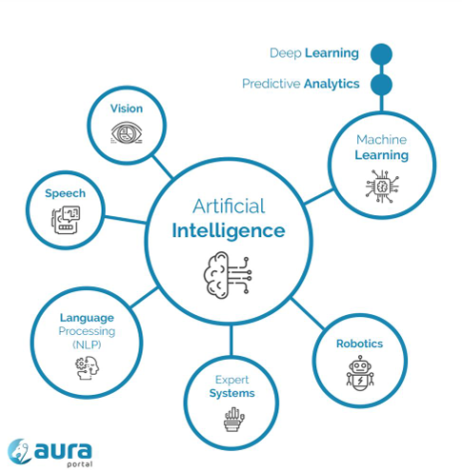
A deliberate design decision here is that every component in this stack is open-source and self-hosted. There is no reliance on commercial cloud APIs. This matters for two reasons: it gives us complete control over data privacy and system behavior, and it satisfies the academic requirements of a master’s thesis, where being able to inspect, explain, and reproduce the full technical pipeline is essential.

2.2 Artificial Intelligence (AI).
Artificial intelligence is the science and engineering of making intelligent machines especially intelligent computer programs.
— John McCarthy |Stanford University
Artificial intelligence is the ability of a digital computer or computer controlled robot to perform tasks commonly associated with intelligent beings.
— Encyclopedia Britannica
Artificial intelligence refers to systems capable of performing tasks that normally require human intelligence, such as learning reasoning and decision-making.
— Britannica |Academic summaries
2.3 Machine Learning (ML)
intelligence that enables computers to learn from data and improve their performance on tasks without being explicitly programmed.
2.3.1 Supervised Learning
Supervised Learning is a type of machine learning where models are trained using labelled data meaning each input is paired with a known correct output allowing the model to learn the relationship between inputs and outputs.
2.3.2 Unsupervised Learning
Unsupervised Learning is a type of machine learning that works with unlabeled data where the model automatically discovers patterns structures or relationships within the data without prior guidance.
2.3.3 Reinforcement Learning
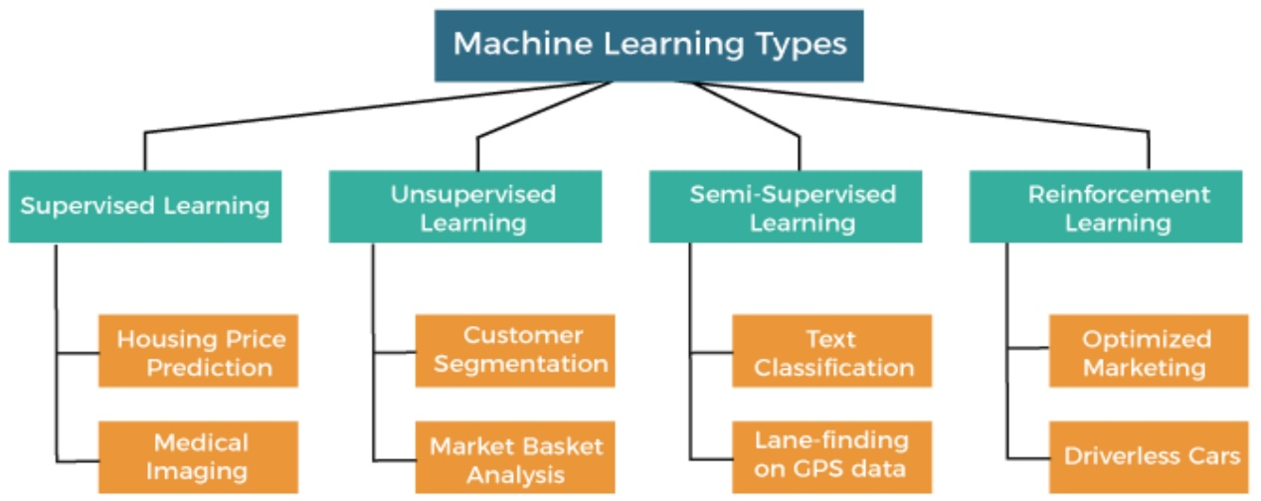
Reinforcement Learning is a type of machine learning where an agent learns by interacting with an environment and receiving feedback in the form of rewards or penalties in order to maximize cumulative rewards over time

2.4 Deep Learning DL
DL is a method that allows computers to learn on their own from large amounts of examples in a way that is similar to how humans learn from experience. The system makes mistakes at first learns from them and gradually improves its performance over time without being explicitly programmed with every rule.
2.5 Large Language Models LLMs
Large Language Models (LLMs) are deep learning models trained on vast amounts of textual data to understand generate and manipulate natural language enabling them to perform a wide range of language related tasks such as text generation translation summarization and question answering.

Retrieval Augmented Generation RAG 2.6
RAG is a framework that enhances LLMs by retrieving relevant information from external knowledge sources and incorporating it into the text generation process enabling more accurate up to date and context-grounded responses.
2.6.1 Naive RAG
Naive RAG is The system finds some related text and sends it directly to the model to answer Think of it like Opening the first page you find in a book and answering from it.
2.6.2 Advanced RAG
Advanced RAG The system makes the question clearer, selects better results, removes noise, then answers. Think of it like Searching the book carefully choosing the best pages, then answering.
2.6.3 Modular RAG
Modular RAG The system chooses different ways to search depending on the question Think of it like Having a team: one searches, one checks one explains.
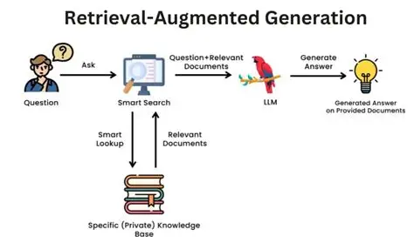

2.7 Automatic Speech Recognition ASR
ASR is what allows a system to turn spoken audio into written text. The idea is straightforward: the system listens to the speech signal and produces a transcript that can be stored searched or processed like any other text
2.8 Text-to-Speech TTS
TTS is a technology that converts written text into spoken audio that sounds natural. It relies on speech synthesis models to allow machines to communicate with humans through voice.

2.9 Word Error Rate WER
WER is a commonly used metric for evaluating the accuracy of ASR systems. It measures the proportion of word level errors by comparing a systems transcription with a reference ground truth transcript.
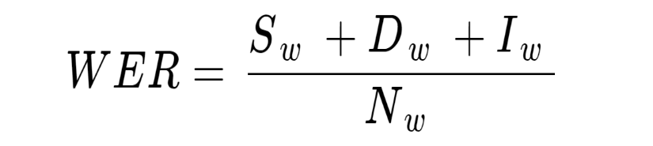

2.10 Mean Opinion Score MOS
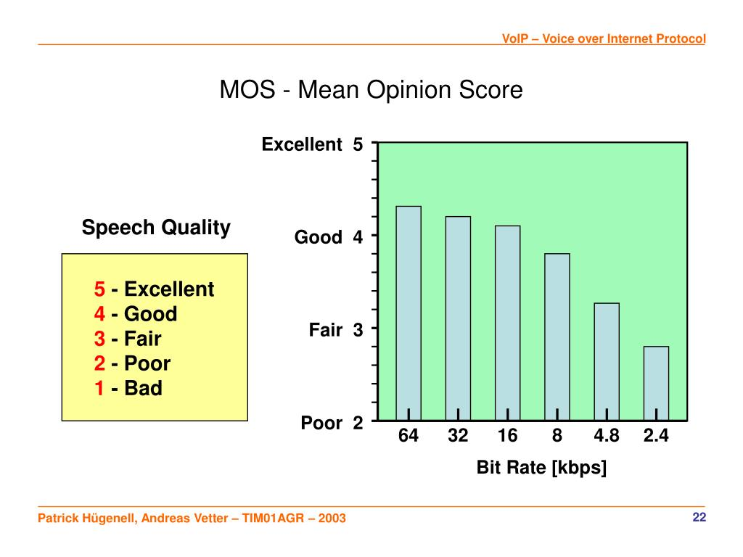
Instead of relying on an automatic score MOS reflects how real listeners judge audio quality. In practice, several people listen to speech samples rate them often on a 1 (bad) to 5 (excellent) scale and the final MOS is simply the average of those ratings.

2.11 Role of AI in the Voice Agent System
Artificial Intelligence is an important part of this project because it helps system understand and respond to users in real time. First the system uses ASR to convert speech into text. Then NLP and NLU are used to understand what the user wants. After that a LLM generates a suitable response and Retrieval Augmented Generation RAG helps make the response more accurate by using relevant data. Finally TTS converts the response back into speech which makes the interaction feel more natural.

References
McCarthy, J. (2004). What is artificial intelligence? Stanford University.
Retrieved from http://jmc.stanford.edu/artificial-intelligence/what-is-ai/index.html

Encyclopaedia Britannica. (2026). Artificial intelligence.
Retrieved from https://www.britannica.com/technology/artificial-intelligence

Encyclopaedia Britannica. (2026). Artificial Intelligence (AI): At a glance.
Retrieved from https://www.britannica.com/technology/Artificial-Intelligence-AI-At-a-Glance-2235722

2.3 Samuel, A. L. (1959). Some studies in machine learning using the game of checkers.
IBM Journal of Research and Development, 3(3), 210–229.
IBM. (2026). What is supervised learning?
Retrieved from https://www.ibm.com/think/topics/supervised-learning

IBM. (2026). What is unsupervised learning?
Retrieved from https://www.ibm.com/think/topics/unsupervised-learning

IBM. (2026). What is reinforcement learning.
https://www.ibm.com/think/topics/reinforcement-learning
IBM. (2026). What is deep learning.
https://www.ibm.com/think/topics/deep-learning

IBM. (2026). What are large language models (LLMs)?
https://www.ibm.com/think/topics/large-language-models
IBM. (2026). What is retrieval augmented generation (RAG)?
https://www.ibm.com/think/topics/retrieval-augmented-generation

Lewis, P., et al. (2020). Retrieval-augmented generation for knowledge-intensive NLP tasks.
https://en.wikipedia.org/wiki/Retrieval-augmented_generation

Poligenko, V., & Maslov, I. (2025).
Naive RAG, Advanced RAG, and Modular RAG architectures.
https://www.devstark.com/blog/naive-rag-advanced-rag-and-modular-rag-architectures/

International Telecommunication Union (ITU-T). (2016).
Recommendation P.800.1: Mean Opinion Score (MOS) terminology.
https://www.itu.int/rec/T-REC-P.800.1

IBM. (2026). What is speech recognition.
https://www.ibm.com/think/topics/speech-recognition

IBM. (2026). What is text to speech.
https://www.ibm.com/think/topics/text-to-speech

International Telecommunication Union (ITU-T). (2003).
Recommendation P.10/G.100: Vocabulary for performance and quality of service.
https://www.itu.int/rec/T-REC-P.10

