ABSTRACT
Corporate marketing functions are increasingly delegated to external digital marketing agencies, exposing firms to outsourcing risks that existing information technology (IT) and business process outsourcing (BPO) risk frameworks do not fully capture. This thesis addresses that gap by developing the Digital Marketing Outsourcing Risk Safeguard Framework (DMO-RSF), a four-component framework (risk taxonomy, risk-practice mapping, performance safeguard linkage, and governance cycle) built through systematic synthesis of thirty-five verified sources spanning transaction cost economics, agency theory, the resource-based view, established outsourcing risk taxonomies, and the marketing-performance and financial-performance measurement literatures. Because primary data collection was not feasible within this study's resource constraints, a conceptual research design was adopted: the framework is developed and evaluated through literature synthesis, theoretical triangulation, citation-traceability verification, and structured comparison against the closest existing precedent (Sen et al., 2020), rather than through empirical hypothesis testing. Findings indicate that established outsourcing theory (transaction cost economics, agency theory, the resource-based view) maps cleanly onto governance and relationship risk domains, while operational, compliance, and financial risk domains specific to digital marketing require adaptation from a comparatively thin dedicated literature. The framework's central theoretical contribution is an explicit, bounded pathway linking risk-managed outsourcing practice to marketing performance and, in turn, to financial performance, incorporating a documented curvilinear boundary condition rather than assuming unbounded benefit from increased risk management. The study's practical contribution is a marketing-specific diagnostic and governance reference for marketing, procurement, and risk-management practitioners. Limitations include the absence of primary empirical validation, and a detailed mixed-methods validation study, with interview and survey instruments specified in Appendix B, is proposed as the direct next research step.
Keywords: outsourcing risk management, digital marketing agencies, transaction cost economics, agency theory, resource-based view, marketing performance, financial performance, risk framework
List of Tables
- Table 1. DMO-RSF Risk Taxonomy
- Table 1a. Theorized Cross-Domain Interaction Pairs
- Table 1b. Representative Risk Content: Generic IT/BPO Outsourcing vs. Digital Marketing Outsourcing
- Table 2. DMO-RSF Risk-Practice Mapping
- Table 3. Citation-Traceability Check for Core Framework Claims
- Table 4. DMO-RSF vs. Sen, Kotlarsky & Budhwar (2020)
- Table 5. Illustrative Exposure-Scoring Rubric
- Table 5a. Domain-Specific Illustrative Scoring Criteria
- Table 6. Survey Instrument Item-to-Construct Mapping
- Table 7. Preliminary Deductive Codebook
List of Figures
- Figure 1. DMO-RSF Performance Safeguard Linkage
- Figure 2. DMO-RSF Governance Cycle
- Figure 3. Tri-Theory Foundation of the DMO-RSF Framework
- Figure 4. Verified Sources per Literature Cluster
- Figure 5. Publication Decade of the Cited References
- Figure 6. Proposed Empirical Validation Study Timeline
- Figure 7. DMO-RSF Framework: Integrated Overview
List of Abbreviations
Abbreviation | Meaning
APA | American Psychological Association
BPO | Business Process Outsourcing
CAC | Customer Acquisition Cost
CMO | Chief Marketing Officer
COSO | Committee of Sponsoring Organizations (of the Treadway Commission)
DMO-RSF | Digital Marketing Outsourcing Risk Safeguard Framework
DPA | Data Processing Agreement
ERM | Enterprise Risk Management
GDPR | General Data Protection Regulation
IRB | Institutional Review Board
ISO | International Organization for Standardization
IT | Information Technology
ITO | Information Technology Outsourcing
KPI | Key Performance Indicator
PLS-SEM | Partial Least Squares Structural Equation Modeling
RBV | Resource-Based View
ROI | Return on Investment
RQ | Research Question
SEO | Search Engine Optimization
SLA | Service-Level Agreement
SOW | Scope of Work
SQ | Sub-Question
TCE | Transaction Cost Economics
TCO | Total Cost of Ownership
VRIN | Valuable, Rare, Inimitable, Non-substitutable

CHAPTER 1: INTRODUCTION
1.1 Background of the Study
Corporate marketing functions have undergone a structural shift over the past two decades. Where advertising and communications work was once concentrated in an agency-of-record relationship built around a single creative product, digital marketing has fragmented the outsourcing decision into a portfolio of discrete, specialized functions: paid media buying, search engine optimization, marketing technology (martech) integration, social content production, programmatic advertising, and campaign analytics. Firms routinely distribute these functions across multiple external agencies rather than a single vendor, a pattern that Sharma et al. (2009) frame as a decision problem shaped by the interaction complexity of each marketing process. Each additional vendor relationship multiplies points of contractual incompleteness, data handoff, and performance accountability, precisely the conditions that transaction cost economics identifies as governance risk (Williamson, 1979, 2008).
The scale of this shift is not incidental. Marketing spend directed at external agencies is one of the largest discretionary line items in a corporate budget, and that spend sits at the intersection of brand equity, customer relationships, and increasingly regulated data. A poorly governed agency relationship does not merely risk a missed campaign deadline; it risks brand-safety failures in programmatic placements (Shehu et al., 2021), erosion of the firm's own market-based learning capability (Park et al., 2011), and exposure to data-privacy liabilities that did not exist in the pre-digital advertising era (Johnson, 2022). At the same time, marketing outsourcing is not inherently value-destroying. Kotabe et al. (2012) find that outsourcing intensity relates to market success in a curvilinear pattern: outsourcing can support performance up to a point, after which further outsourcing erodes it. The practical question facing corporate marketing and risk leaders is therefore not whether to outsource digital marketing functions, but how to manage the risk embedded in doing so without forfeiting the performance benefits that motivated the outsourcing decision in the first place.
Despite the maturity of outsourcing risk research in adjacent domains, particularly information technology and business process outsourcing (Aubert et al., 2005; Bahli & Rivard, 2003; Liu et al., 2023), this body of knowledge has not been systematically adapted to the digital marketing agency context. The risk taxonomies built for IT outsourcing are organized around constructs such as system uptime, code quality, and data-center security that map imperfectly onto the risk content of a marketing agency relationship: brand voice consistency, campaign creative quality, audience-data handling, and the reputational exposure of a public-facing communications failure. Marketing-specific outsourcing scholarship exists (Ahearne & Kothandaraman, 2009; Keegan et al., 2017) but has concentrated on relationship dynamics and agency-client conflict rather than on constructing a risk-management framework explicitly linked to firm performance outcomes.
The absence of a purpose-built risk framework has a compounding effect, stated plainly here before the formal problem statement. Because no marketing-specific risk-management reference exists, individual firms currently solve this problem independently and inconsistently: some adapt IT-outsourcing governance checklists by hand, some rely on informal agency-relationship norms accumulated through experience, and some manage agency risk with no structured approach at all. This fragmentation is costly in itself. It means lessons learned in one firm's agency relationship rarely transfer systematically to another firm facing a structurally similar risk, because there is no shared vocabulary or taxonomy through which such lessons could be compared. A central purpose of the framework developed in this thesis is to supply that shared vocabulary, not to claim that every firm's outsourcing risk is identical, but to give firms a common structure within which their risk profiles can be meaningfully compared and their mitigation practices meaningfully benchmarked.
1.2 Problem Statement
Three gaps in the current literature motivate this study, each identified through the systematic literature synthesis reported in Chapter 2.
First, no located framework specifies a risk taxonomy purpose-built for digital marketing agency outsourcing. Existing IT/BPO taxonomies (Aubert et al., 2005; Liu et al., 2023) are structurally sound but topically generic; digital-marketing-specific risk scholarship (Shehu et al., 2021) is topically precise but does not aggregate into a taxonomy.
Second, no located framework connects outsourcing risk management practice explicitly to both marketing performance and financial performance as a linked outcome pair. The marketing-performance-measurement literature (Keller, 1993; Rust et al., 2004) and the marketing-spend-to-firm-value literature (Joshi & Hanssens, 2010; Madathil et al., 2025) are both mature, but neither literature is written in conversation with outsourcing risk management specifically.
Third, the closest existing precedent, Sen, Kotlarsky, and Budhwar's (2020) dynamic risk-management capability framework, is explicitly generic and cross-industry. It establishes that outsourcing risk management is a capability rather than a static checklist, but it does not specify what that capability looks like when the outsourced function is digital marketing, where the risk content, the performance metrics, and the governance mechanisms all differ materially from a generic outsourcing arrangement.
The result is a practical gap: corporate marketing and procurement leaders currently lack a risk-management reference purpose-built for the digital marketing agency context, and must either adapt generic outsourcing risk frameworks by hand or manage agency risk without a structured framework at all.
This practical gap has a corresponding academic gap that this thesis treats as equally significant: without a framework connecting outsourcing risk management practice to both marketing and financial performance, empirical researchers in this area lack a testable theoretical structure to investigate. Conceptual framework development of the kind undertaken here is therefore not merely a preparatory step toward eventual practical application; it is a necessary precondition for the empirical research program outlined in Chapter 7.4, which cannot test relationships that have not first been theoretically specified in falsifiable form.
1.3 Purpose of the Study
This study proposes and theoretically develops the Digital Marketing Outsourcing Risk Safeguard Framework (DMO-RSF), a structured framework for identifying, categorizing, and managing the risks of outsourcing digital marketing functions to external agencies, explicitly linked to the safeguarding of corporate marketing and financial performance. The framework is developed through systematic synthesis of the transaction cost economics, agency theory, and resource-based view literatures as applied to outsourcing risk, combined with an adaptation of established IT/BPO risk-taxonomy methodology to the digital marketing agency context.
Consistent with the conceptual/design orientation of this study (justified in Chapter 3), the framework is developed and evaluated through structured argumentation, cross-literature triangulation, and a defined evaluation strategy, rather than through primary empirical data collection. The study's contribution is the framework itself and the theoretical case for its structure, a foundation on which a subsequent empirical validation study, outlined in Chapter 7 as future research, could be built.
1.4 Research Questions
Primary Research Question: What framework can corporate organizations use to manage the risks of outsourcing digital marketing functions to external agencies, to safeguard marketing and financial performance?
- SQ1: What risk categories are specific to outsourcing digital marketing functions to agencies, as distinct from generic IT/BPO outsourcing risk?
- SQ2: What risk-mitigation and governance practices correspond to each risk category, and where do current practices, as documented in the literature, leave gaps?
- SQ3: How, theoretically, do digital-marketing-outsourcing risk exposure and management practice relate to corporate marketing performance and financial performance?
- SQ4: What framework, integrating risk categories, mitigation practices, and performance-safeguard logic, can be proposed for managing digital marketing outsourcing risk, and how can it be evaluated in the absence of primary empirical data?
1.5 Significance of the Study
Theoretical significance. This study contributes a tri-theory synthesis (transaction cost economics, agency theory, resource-based view) applied coherently to a single context, digital marketing agency outsourcing, where prior work has applied at most two of the three theories jointly (Bahli & Rivard, 2003; McIvor, 2009), and never to this specific outsourcing context. It further contributes an explicit bridge between the outsourcing-risk literature and the marketing-performance/firm-value literature, two bodies of scholarship that have developed independently of one another.
Practical significance. Corporate marketing directors, procurement and vendor-management leads, and risk officers responsible for governing agency relationships gain a structured reference for risk identification and mitigation planning that is specific to their operating context, rather than adapted by hand from generic outsourcing checklists.
Methodological significance. The study demonstrates a disciplined approach to conceptual framework development under real resource constraints, explicitly documenting how a risk-management framework can be built and evaluated through literature synthesis and structured argumentation when primary data collection is not feasible, while remaining transparent about the resulting limits on empirical validation.
1.6 Scope and Delimitations
This study is delimited to the outsourcing of digital marketing functions (paid media, search engine optimization, content and social media management, programmatic advertising, and campaign execution) by mid-to-large corporate organizations to external specialist agencies. It excludes in-house marketing team risk, individual freelancer or independent-contractor engagements, and non-corporate outsourcing contexts such as nonprofit or government marketing procurement. It treats generic IT and business process outsourcing literature as theoretical scaffolding rather than as the study's empirical context. Consistent with its conceptual/design orientation, the study does not claim to statistically test the relationships it theorizes; Chapter 5 makes this boundary explicit and specifies how the framework's propositions could be tested in future empirical work.
1.7 Assumptions of the Study
This study proceeds on four working assumptions, each stated here so that its bearing on the framework's claims is explicit rather than implicit. First, it assumes that the tri-theory foundation (Chapter 2.2) is an appropriate lens for digital marketing outsourcing specifically, an assumption defended in Chapter 2.2.4 through precedent studies applying subsets of the same theories to adjacent outsourcing contexts, but not independently tested against alternative theoretical lenses (for example, stakeholder theory or institutional theory) that a different study might have chosen instead. Second, it assumes that risk taxonomies constructed through literature synthesis, following the precedent of Ackermann et al. (2011), are methodologically sound even without primary validation, an assumption examined directly in Chapter 3.2 and Chapter 5.7. Third, it assumes that the digital marketing outsourcing context is sufficiently distinct from generic IT/BPO outsourcing to warrant a dedicated framework rather than direct application of existing IT/BPO frameworks, an assumption defended in Chapter 2.4.1 on the basis of differing measurement conventions and risk content between the two literatures. Fourth, it assumes that a mid-to-large corporate organization is the relevant unit of analysis, consistent with the scope boundary in Section 1.6; the framework's applicability to small and medium enterprises is treated as an open question rather than assumed, and is flagged as a boundary case in Chapter 5.6 and a direction for future research in Chapter 7.4.
1.8 Definition of Key Terms
- Digital marketing outsourcing: The contractual delegation of one or more digital marketing functions to an external agency, as distinct from in-house execution.
- Outsourcing risk: The probability and consequence of an adverse event arising from the outsourcing relationship, following the scenario-based construct established by Aubert et al. (2005).
- Marketing performance: Brand- and campaign-level outcome measures, including brand equity (Aaker, 1991; Keller, 1993) and campaign return on marketing investment (Rust et al., 2004).
- Financial performance: Firm-level financial outcome measures, including revenue growth, marketing return on investment, and firm/shareholder value (Joshi & Hanssens, 2010; Madathil et al., 2025).
- Risk-management framework: A structured system for identifying, categorizing, mitigating, and monitoring risk, following the dynamic-capability conception advanced by Sen et al. (2020).
1.9 Structure of the Thesis
Chapter 2 presents the literature review and theoretical foundation. Chapter 3 presents the research design, including the methodological rationale for the study's conceptual orientation. Chapter 4 develops the DMO-RSF framework's four components. Chapter 5 presents the framework evaluation strategy. Chapter 6 discusses the framework's theoretical and managerial implications. Chapter 7 concludes with contributions, limitations, and directions for future empirical research.
CHAPTER 2: LITERATURE REVIEW
2.1 Introduction to the Review
This chapter synthesizes the literature underpinning the Digital Marketing Outsourcing Risk Safeguard Framework (DMO-RSF) developed in Chapter 4. It proceeds in six parts: theoretical foundations (2.2), outsourcing risk taxonomies (2.3), marketing outsourcing and agency-client relationships (2.4), risks specific to digital marketing outsourcing (2.5), marketing and financial performance measurement (2.6), and existing risk-management frameworks against which the proposed framework is positioned (2.7). Section 2.8 synthesizes these strands into the identified literature gap that motivates this study.
2.2 Theoretical Foundations
2.2.1 Transaction Cost Economics
Williamson's (1979) transaction cost economics (TCE) explains organizational boundary decisions, including the choice to outsource, as a function of governance cost minimization under conditions of asset specificity, uncertainty, and transaction frequency. Where a transaction involves highly specific assets (for instance, brand-specific creative knowledge or proprietary customer data structures), the cost of writing and enforcing a complete contract rises, and the risk of opportunistic behavior by the counterparty increases correspondingly. Williamson (2008) extended this logic directly to outsourcing and supply chain governance, arguing that the choice between hierarchy (in-house production) and market (outsourcing) is itself a risk-management decision, not merely a cost-minimization one.
Applied to digital marketing, TCE predicts that outsourcing risk should rise with the specificity of the marketing function in question. A generic, low-specificity function such as programmatic media buying, governed by standardized platforms and measurable, verifiable outcomes, should carry lower transactional risk than a high-specificity function such as brand voice and creative strategy, where quality is difficult to specify contractually and the cost of switching agencies is high. This distinction becomes a foundational input to the risk taxonomy developed in Chapter 4.
2.2.2 Agency Theory
Agency theory (Jensen & Meckling, 1976) models the outsourcing relationship as a principal-agent problem: the client firm (principal) delegates authority to the agency (agent), and the two parties' interests are not perfectly aligned. Eisenhardt's (1989) review formalizes the two central risks this creates: information asymmetry (the agent knows more about its own effort and quality than the principal can observe) and goal conflict (the agent's incentives, typically billable hours or retained fees, may not align with the principal's outcome objectives, such as campaign ROI or brand equity preservation).
Mortimer and Laurie (2017) apply agency theory directly to marketing agency-client relationships, documenting a shift in many such relationships from a "partner" framing to a "supplier" framing, a shift that, per agency theory, should correspond to tighter monitoring and more explicit incentive contracts as the relationship becomes more transactional. This finding is directly relevant to the risk-practice mapping in Chapter 4: it suggests that governance mechanisms (monitoring intensity, incentive design) are not fixed but must be calibrated to how the client-agency relationship is actually structured, not merely to how it is nominally described in a contract.
2.2.3 Resource-Based View
The resource-based view (RBV) addresses a different question from TCE and agency theory: not how to govern an outsourcing relationship, but what should be outsourced in the first place. Barney's (1991) VRIN framework identifies valuable, rare, inimitable, and non-substitutable resources as the basis of sustained competitive advantage; Prahalad and Hamel (1990) translate this into a practical prescription: firms should retain core competencies in-house and may safely outsource peripheral activities. Grant's (1996) knowledge-based extension of RBV further suggests that tacit, hard-to-codify knowledge (such as accumulated understanding of a firm's customer base) is a resource whose outsourcing carries particular risk of erosion.
Applied to marketing, RBV raises a pointed question that TCE and agency theory do not: is brand strategy and customer insight a core competency that should never be fully outsourced, even where cost or capacity considerations favor doing so? Handley's (2012) empirical study of capability loss across 198 outsourcing initiatives provides direct support for treating this as a genuine risk category rather than a theoretical abstraction. The study documents measurable erosion of internal capability following outsourcing, with corresponding performance consequences.
2.2.4 Theoretical Integration
Two prior studies demonstrate that combining these theories is both feasible and productive for outsourcing risk research. Bahli and Rivard (2003) combine TCE and agency theory to construct an IT outsourcing risk model organized around scenario-likelihood-consequence logic. McIvor (2009) combines TCE and RBV into a two-stage outsourcing evaluation framework: first assessing whether an activity is a core competency (RBV), then assessing the transactional risk of outsourcing it (TCE). No located study combines all three theories (TCE, agency theory, and RBV) into a single framework, and none does so in the digital marketing agency context specifically. This three-way theoretical integration, applied to marketing outsourcing, is the theoretical foundation of the DMO-RSF framework developed in Chapter 4.
2.2.5 Boundary Conditions of the Three Theories
Each foundational theory has a scope condition that matters for how it is applied in Chapter 4. TCE's predictive power depends on the analyst's ability to actually assess asset specificity, which is more straightforward for standardized functions (media buying, programmatic placement) than for creative or strategic work, where specificity is a matter of degree and professional judgment rather than a clean binary. Agency theory assumes the principal can, in principle, monitor the agent at some cost; where monitoring is structurally difficult, for instance in assessing the creative quality of work the client itself lacks the expertise to judge, the theory's prescription (increase monitoring) becomes harder to operationalize than the theory itself suggests. RBV's core-competency prescription is normatively appealing but empirically contested at the margins: Prahalad and Hamel's (1990) original argument identifies core competence at a fairly abstract level (a firm's distinctive combination of skills and technologies), and translating that abstraction into a concrete "outsource this, retain that" decision for a specific marketing function requires judgment the theory itself does not supply. These boundary conditions are not treated as reasons to discard the theories; each remains the best available lens for its respective risk domain (Chapter 4.2). They are treated instead as a reason to build proportionality and reassessment (Chapter 4.5) into the framework, rather than presenting the theories' predictions as mechanically deterministic.
Figure 3 summarizes how the three theories reviewed in this section map onto the first three risk domains of the taxonomy developed in Chapter 4.2.
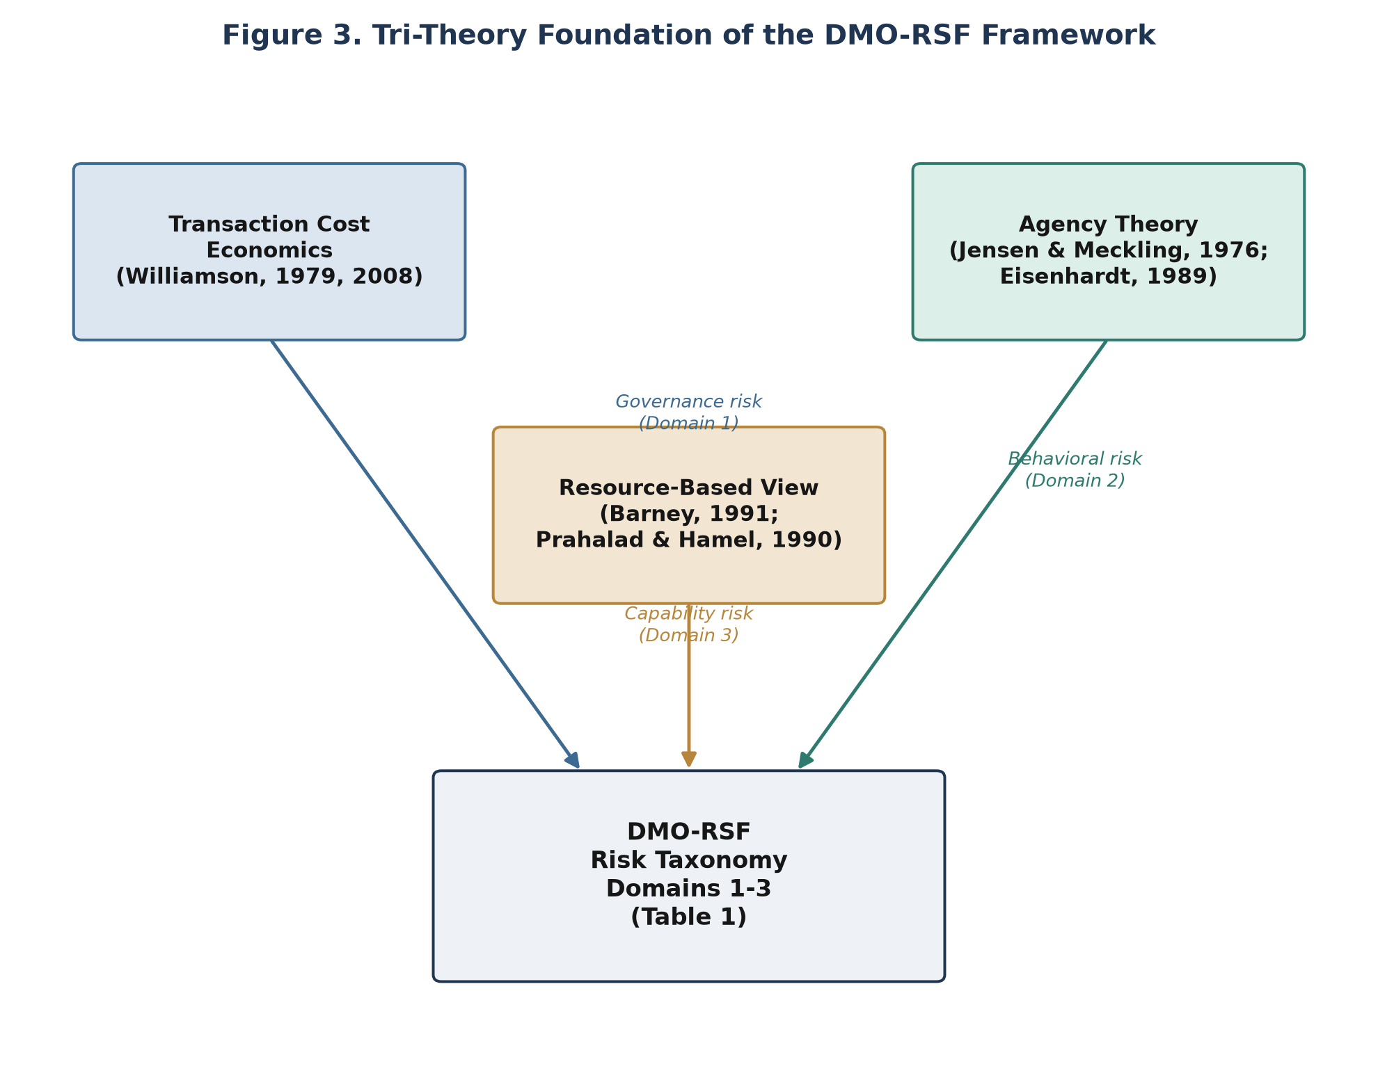
Figure 3. Tri-Theory Foundation of the DMO-RSF Framework
2.3 Outsourcing Risk Taxonomies
Structured risk taxonomies provide the methodological template this study adapts. Aubert, Patry, and Rivard (2005) propose a scenario-based IT outsourcing risk-management framework in which each risk is characterized by its likelihood, its undesirable consequence, and available mitigation mechanisms, a construct this study adopts directly for the DMO-RSF risk taxonomy in Chapter 4. Ackermann et al. (2011) synthesize approximately 150 prior studies into a nine-category taxonomy of technological IT outsourcing risks, demonstrating that large-scale taxonomy construction from literature synthesis, rather than solely from primary data collection, is an established and accepted methodological approach. This is a point of direct methodological relevance to this study's own conceptual orientation (see Chapter 3).
Liu, Keil, Wang, and Lu's (2023) more recent Delphi study identifies 68 distinct business process outsourcing risk factors organized into six dimensions: organizational environment, client characteristics, task complexity, contract design, execution, and vendor characteristics. This six-dimension structure is broadly transferable to a marketing context, though, as Section 2.5 documents, its specific risk content (drawn from generic BPO practice) requires substantial adaptation to capture risks unique to digital marketing execution, such as brand-safety failure in programmatic placements or loss of proprietary audience-data control.
Ackermann et al.'s (2011) nine categories, spanning technical, organizational, and relational risk sources across the outsourcing lifecycle, illustrate a structural principle this study borrows directly: a workable taxonomy must separate risk sources that originate in the technology or task itself from those that originate in the relationship between the parties, and from those that originate in the surrounding organizational or regulatory environment. The DMO-RSF taxonomy (Chapter 4.2) preserves this three-way structural separation while replacing the underlying content. Domains 1-3 (Strategic/Governance, Agency/Behavioral, Capability/Knowledge) correspond to relational and organizational risk sources; Domains 4-6 (Operational/Execution, Data & Compliance, Financial/Cost) correspond to task- and environment-level risk sources specific to digital marketing execution.
At the enterprise level, Prewett and Terry (2018) describe the Committee of Sponsoring Organizations' (COSO) 2017 updated Enterprise Risk Management framework, which situates third-party and vendor risk within a broader five-component, twenty-principle enterprise risk architecture spanning governance and culture, strategy and objective-setting, performance, review and revision, and information/communication/reporting. Two of these components are of particular relevance to a marketing-agency context: the "performance" component, which requires identifying risk and assessing its severity relative to defined risk appetite and is directly mirrored in the DMO-RSF Assess step (Chapter 4.5), and "review and revision," which requires reassessing risk as conditions change and is mirrored in the DMO-RSF Reassess step. The International Organization for Standardization's ISO 31000:2018 risk management guidelines provide a complementary process-oriented structure (establish context, assess risk, treat risk, monitor and review) that this study adopts for the governance cycle component of the DMO-RSF framework (Chapter 4.5), while noting that no peer-reviewed study was located applying ISO 31000 specifically to outsourcing arrangements, let alone marketing outsourcing. This study treats the COSO and ISO frameworks as complementary rather than competing: COSO supplies the enterprise-risk-appetite lens embedded in the DMO-RSF's proportionality principle, while ISO 31000 supplies the cyclical process structure the governance cycle borrows directly.
2.4 Marketing Outsourcing and Agency-Client Relationships
Marketing-specific outsourcing scholarship, while smaller than the general IT/BPO literature, establishes several findings directly relevant to this study. Sharma, Iyer, and Raajpoot (2009) propose a framework for offshoring business-to-business marketing processes based on interaction complexity, arguing that marketing processes vary systematically in how outsourceable they are, a logic this study extends to the domestic digital-agency context. Ahearne and Kothandaraman (2009) set an explicit research agenda distinguishing marketing outsourcing from manufacturing or IT outsourcing on the grounds that marketing work is uniquely bound up with customer-facing brand equity, a distinction this study treats as foundational.
Two studies document specific downside risks of marketing outsourcing that inform the DMO-RSF risk taxonomy directly. Park, Lee, and Morgan (2011) find that outsourcing marketing functions can degrade a firm's market-based learning process, the organizational capability to sense and respond to market signals, because that learning process depends on proximity to customer-facing execution work that has been delegated externally. Kotabe, Mol, Murray, and Parente (2012) find a curvilinear (inverted-U) relationship between outsourcing intensity and market success: outsourcing supports performance up to a threshold, beyond which additional outsourcing erodes it. This finding directly informs the performance-safeguard logic in Chapter 4.4: the DMO-RSF framework does not treat outsourcing risk as monotonically increasing with outsourcing scope, but as contingent on whether risk-management practice keeps pace with outsourcing intensity.
Keegan, Rowley, and Tonge's (2017) systematic review of marketing agency-client relationships identifies contract design, account management practice, and co-creation as recurring themes, and explicitly calls for further research connecting relationship-management practice to performance outcomes, a call this study responds to directly. Older but still-cited studies of the advertising agency-client relationship (LaBahn & Kohli, 1997; West, 1997; Beltramini, 2000) establish the durability of relationship-commitment and procurement-governance themes across three decades of scholarship, though this sub-literature's concentration in the late 1990s and early 2000s, with Keegan et al. (2017) and Mortimer and Laurie (2017) as the only sources located within the last fifteen years, is itself a limitation this study discloses rather than obscures (see Section 2.8).
Two further points from this cluster carry forward into the framework. First, LaBahn and Kohli (1997) find that client commitment to an agency relationship is sustained less by contractual terms than by perceived agency responsiveness and communication quality, a finding that qualifies the otherwise contract-centric orientation of the TCE and agency-theory literatures reviewed in Section 2.2: governance mechanisms matter, but so does relationship quality that a contract cannot fully specify or enforce. Second, West's (1997) framing of advertising-agency selection as a professional-services procurement problem, rather than a standard vendor-selection problem, supports this study's treatment of digital marketing agencies as a distinct outsourcing category rather than a subtype of generic business-service outsourcing, reinforcing the scope boundary set in Chapter 1.6.
2.4.1 Why Marketing Outsourcing Resists Direct Transfer from IT/BPO Findings
A recurring theme across Sections 2.3 and 2.4, worth making explicit before turning to risk content specifically, is that the marketing-outsourcing literature and the IT/BPO-outsourcing literature answer structurally similar questions about governance and risk but do so from different empirical bases and with different measurement conventions. IT/BPO risk studies (Aubert et al., 2005; Liu et al., 2023) typically measure outcomes such as service-level compliance, cost variance, or contract renewal, which are relatively observable and quantifiable. Marketing-outsourcing studies (Park et al., 2011; Kotabe et al., 2012) more often measure outcomes such as capability erosion or market success, which are harder to observe directly and more often inferred from proxy measures. This measurement gap is one reason a taxonomy built purely from IT/BPO evidence risks understating marketing-specific risk: the risks marketing scholarship documents are real but are measured differently, and a taxonomy naively imported from IT/BPO literature would carry over that literature's measurement assumptions along with its structure. The DMO-RSF taxonomy (Chapter 4.2) addresses this by pairing the IT/BPO structural template with marketing-native risk indicators rather than IT/BPO-native ones. Table 1b makes this content mismatch concrete by contrasting representative risk content across the two literatures for four comparable risk categories.
Table 1b
Representative Risk Content: Generic IT/BPO Outsourcing vs. Digital Marketing Outsourcing
Risk Category | Typical IT/BPO Risk Content | Typical Digital Marketing Outsourcing Risk Content
Quality/execution risk | System uptime, code defect rate, technical SLA breach | Brand-safety placement failure, off-brand creative, inconsistent brand voice (Shehu et al., 2021)
Data risk | Data-center security, backup/recovery failure | Customer/audience data access and processing by the agency, consent management (Johnson, 2022)
Knowledge/capability risk | Loss of proprietary technical documentation or codebase familiarity | Loss of market-based learning and customer insight capability (Park et al., 2011)
Relationship/governance risk | Formal contract/SLA enforcement, vendor management office oversight | Agency-client relationship dynamics, shift from "partner" to "supplier" framing (Mortimer & Laurie, 2017)

This comparison illustrates why direct import of an IT/BPO risk taxonomy into the marketing-agency context would misdirect attention: an IT-style audit of "data-center security" would miss the marketing-relevant data risk of an agency's own audience-targeting practices, just as an IT-style audit of "uptime" would miss the marketing-relevant execution risk of a brand-safety placement failure.
2.5 Risks Specific to Digital Marketing Outsourcing
This is the thinnest cluster of literature located for this study, and its thinness is itself an evidentiary finding: a literature written specifically about the risk content of digital marketing outsourcing, as distinct from marketing outsourcing generally or IT outsourcing generally, largely does not yet exist in a consolidated form.
Barthélemy's (2001) study of the hidden costs of IT outsourcing, spanning vendor search costs, transition costs, ongoing management costs, and contract-exit costs, transfers directly to the marketing-agency context, where agency-search and creative-transition costs are well-documented in industry practice even where academic study is limited. Handley (2012), as noted in Section 2.2.3, provides empirical evidence of capability-loss risk. Shehu, Abou Nabout, and Clement (2021) provide the most directly on-topic source located: an empirical study of programmatic advertising risk, finding that website quality, a factor outside the advertiser's direct control once media buying is outsourced to a programmatic agency, significantly affects advertising effectiveness. This is a concrete illustration of operational/execution risk in a digital-marketing-specific outsourcing arrangement. Johnson's (2022) review of the economics of privacy regulation, while not marketing-outsourcing-specific, establishes the scale and seriousness of data-privacy risk that any framework addressing digital marketing outsourcing must account for, given that agencies routinely process customer and audience data on the client's behalf.
The DMO-RSF risk taxonomy (Chapter 4.2) addresses this gap directly by adapting the structural taxonomies from Section 2.3, built for generic IT/BPO risk, into risk categories populated with digital-marketing-specific content drawn from this section and from established industry practice, explicitly flagged in Chapter 4 wherever a risk category rests on adapted rather than directly evidenced content.
Three further points sharpen what this thinness means in practice, rather than leaving it as an abstract disclosure. First, Shehu et al.'s (2021) programmatic-advertising finding is narrower than it might first appear: the study examines website quality as a single risk vector within one execution channel (programmatic display), not digital marketing outsourcing risk broadly. Extrapolating from this single-channel finding to the full scope of digital marketing functions named in Chapter 1.6 (paid media, SEO, content, social, campaign execution) is itself an inferential step this study takes deliberately and discloses, rather than treating the extrapolation as already established by the source. Second, Johnson's (2022) NBER working paper is a rigorous synthesis of the economics of privacy regulation generally, but working papers, even from a high-reputation institute, have not passed peer review in the way the journal articles elsewhere in this review have; this study treats it accordingly as strong but not equivalent-tier evidence (see Chapter 3.3.2's inclusion criteria). Third, no source in this cluster or elsewhere in this review directly measures brand-safety incident rates or financial impact specific to marketing-agency outsourcing arrangements. The closest available evidence (Shehu et al., 2021) demonstrates a mechanism (website quality affecting ad effectiveness) rather than an incident-rate statistic, meaning the DMO-RSF Operational/Execution domain (Chapter 4.2, Domain 4) is grounded in a plausible and evidenced mechanism, not in a quantified base rate.
2.6 Marketing and Financial Performance Measurement
Two performance constructs are relevant to this study: marketing performance and financial performance, corresponding to the two outcomes named in the thesis title.
Marketing performance is most commonly operationalized through brand equity. Aaker's (1991) asset-based model defines brand equity through awareness, perceived quality, brand associations, and loyalty; Keller's (1993) customer-based brand equity model reframes these constructs around consumer knowledge structures. Both remain the standard reference points for marketing performance measurement three decades later. Rust, Lemon, and Zeithaml (2004) provide a complementary, more directly financial construct, customer equity, that explicitly links marketing-strategy decisions to a calculable return on marketing investment, providing this study with a natural bridge between marketing performance and financial performance. Liang and Gao (2020) provide more direct evidence that marketing performance measurement systems translate into firm performance specifically through marketing capabilities, not automatically, a finding with a direct implication for Chapter 4: risk-managed outsourcing practice safeguards performance only if it preserves the client firm's own marketing capability, not merely its short-term campaign output.
Financial performance in the outsourcing context is best evidenced by Joshi and Hanssens (2010), who demonstrate that advertising and marketing spend affects firm value through both direct and indirect (sales-mediated) paths, a rigorous empirical basis for treating marketing spend as financially consequential rather than merely a cost center. Madathil, Paul, and Murugan (2025) provide an up-to-date, framework-level review of how marketing actions and customer-based market assets translate into shareholder value, synthesizing a decade of intervening research since Joshi and Hanssens (2010).
No source located in this review isolates marketing agency outsourcing spend specifically, as distinct from marketing spend generally, as a predictor of either marketing or financial performance. This is the second major gap this study identifies, and it is the inferential bridge the DMO-RSF framework's performance-safeguard component (Chapter 4.4) is built to construct: connecting risk-managed outsourcing practice, through the established marketing-performance and financial-performance literatures, into a single theorized causal chain.
2.6.1 Customer Acquisition Cost and Engagement as Supplementary Marketing-Performance Indicators
Beyond brand equity (Aaker, 1991; Keller, 1993) and customer-equity ROI (Rust et al., 2004), two additional marketing-performance indicators are relevant to how the DMO-RSF framework's performance-safeguard pathway (Chapter 4.4) would be operationalized in future empirical work: customer acquisition cost (CAC) and campaign engagement rate. Neither indicator was the subject of a dedicated source in this review's search yield, but both are standard, widely-used operational metrics in digital marketing practice and appear as example measurement items in the proposed survey instrument (Appendix B.2, Section 4). Their absence from the academic literature search, as distinct from their presence in industry practice, is itself consistent with this study's broader finding (Section 2.5) that digital-marketing-specific measurement has developed faster in practice than it has been formally studied in peer-reviewed scholarship, a gap this study notes but does not attempt to close within its own conceptual scope.
2.6.2 A Critical Note on Measurement Convergence
The marketing-performance and financial-performance literatures reviewed above do not use a single, agreed measurement convention even within themselves. Aaker (1991) and Keller (1993) measure brand equity through consumer perception constructs; Rust et al. (2004) and Joshi and Hanssens (2010) measure financial constructs (customer equity, firm value) directly. A firm attempting to apply the DMO-RSF performance-safeguard pathway (Chapter 4.4) in practice would therefore need to select specific operational metrics from within each construct family rather than assume a single canonical measure exists. This is a practical implementation note this study surfaces here because it bears directly on how Chapter 5's evaluation strategy and Appendix B's survey instrument are constructed: both use example items drawn from multiple measurement traditions rather than a single scale, precisely because no single scale commands consensus across this literature.
2.7 Existing Risk-Management Frameworks
Sen, Kotlarsky, and Budhwar (2020) provide the closest existing precedent to this study's objective. Their dynamic risk-management capability framework argues that effective outsourcing risk management is not a static checklist but an organizational capability: the ability to perceive emerging risks, reconfigure governance mechanisms in response, and orchestrate resources across the outsourcing relationship as conditions change. This framework is explicitly generic and cross-industry, developed without reference to any specific outsourced function.
The DMO-RSF framework developed in this study adopts Sen et al.'s (2020) core insight, that risk management is a capability and not a checklist, while specifying what that capability consists of when the outsourced function is digital marketing: a risk taxonomy populated with marketing-specific content (Section 2.5), a practice-mapping layer grounded in the agency-client relationship literature (Section 2.4), and a performance-safeguard logic grounded in marketing and financial performance measurement (Section 2.6). Aubert et al.'s (2005) scenario-based construct and the ISO 31000:2018 process cycle (Section 2.3) supply the framework's structural and procedural mechanics.
2.8 Synthesis and Identified Gap
Three gaps recur across this review and jointly motivate the DMO-RSF framework.
First, theoretical fragmentation: transaction cost economics, agency theory, and resource-based view are each independently well-established as lenses on outsourcing risk, and prior work has combined pairs of these theories (Bahli & Rivard, 2003; McIvor, 2009), but no located study integrates all three into a single framework, and none does so for digital marketing outsourcing specifically.
Second, content-structure mismatch: the most rigorous risk taxonomies (Aubert et al., 2005; Liu et al., 2023) are structurally sound but populated with generic IT/BPO content; the literature that captures digital-marketing-specific risk content (Section 2.5) is real but has not been organized into a taxonomy. The DMO-RSF framework resolves this mismatch by pairing the established taxonomic structure with marketing-specific risk content.
Third, the performance-linkage gap: the outsourcing-risk literature and the marketing-performance/financial-performance literatures have developed independently, with Kotabe et al. (2012) as the nearest point of contact, and even that study measures outsourcing intensity generally, not agency-outsourcing risk-management practice specifically. No source directly tests, or even theorizes in detail, how risk-managed digital marketing outsourcing practice relates to both marketing performance and financial performance as a linked pair.
The DMO-RSF framework, developed in Chapter 4, is this study's response to all three gaps: a tri-theory-grounded, digital-marketing-specific risk taxonomy, explicitly linked through a theorized performance-safeguard logic to both outcome domains named in the thesis title.
2.9 Chapter Summary
This chapter reviewed thirty-four sources cited in-text across seven literature strands: three foundational theories of outsourcing governance (transaction cost economics, agency theory, resource-based view), structured outsourcing risk taxonomies from the IT/BPO literature, marketing-specific outsourcing and agency-client relationship scholarship, the thin but load-bearing literature on digital-marketing-specific outsourcing risk, marketing and financial performance measurement, and the closest existing precedent framework. Across these strands, three gaps recur and jointly motivate the study: theoretical fragmentation (no prior three-theory integration for this context), a content-structure mismatch between rigorous but generic risk taxonomies and thin but topically precise marketing-risk literature, and an unconstructed inferential bridge between the outsourcing-risk and marketing/financial-performance literatures. Chapter 3 now turns to the research design through which this study addresses these gaps, before Chapter 4 presents the resulting DMO-RSF framework in full.
CHAPTER 3: RESEARCH DESIGN AND METHODOLOGY
3.1 Research Paradigm
This study adopts a conceptual/design-oriented research paradigm, situated within an interpretivist tradition of theory-building research. Rather than testing pre-specified hypotheses against primary data, the study's objective is to construct a novel, internally coherent, and literature-grounded framework, the DMO-RSF, through systematic synthesis and theoretical triangulation. This paradigm choice follows directly from the nature of the primary research question (Chapter 1.4), which asks what framework can be used to manage digital marketing outsourcing risk, rather than asking a causal or associational question that would require hypothesis-testing against sampled data.
3.2 Justification for a Conceptual (Non-Empirical) Design
An initial design for this study specified a sequential exploratory mixed-methods approach: qualitative interviews with marketing and procurement decision-makers to surface risk categories, followed by a quantitative survey to test the relationships identified. That design remains methodologically appropriate to the research questions and is documented in Appendix B as a proposed instrument set for future empirical validation. It was not executed for this thesis for a specific and disclosed reason: primary data collection requiring access to corporate marketing, procurement, and risk-management professionals was not feasible within the resource and access constraints of this study.
Rather than substitute simulated or illustrative data in place of genuine primary research, a practice this study explicitly rejects as inconsistent with academic integrity, the study was reframed around a conceptual, literature-synthesis design. This is a recognized and legitimate research design in management and information systems scholarship, not an improvised substitute. Ackermann et al. (2011) construct a nine-category IT outsourcing risk taxonomy entirely through synthesis of approximately 150 prior studies, without primary data collection, and their taxonomy is a directly cited structural precedent for this study's own risk taxonomy (Chapter 4.2). Sen, Kotlarsky, and Budhwar's (2020) dynamic risk-management capability framework, the closest existing precedent to the DMO-RSF, was itself developed conceptually rather than through primary fieldwork. A conceptual design is therefore consistent with, not a departure from, the methodological norms of this study's own reference literature.
The trade-off this choice accepts is stated plainly: the DMO-RSF framework developed in this thesis is theoretically grounded and internally validated (Chapter 5), but it is not empirically tested against primary data. Chapter 5 specifies exactly what claims the framework can and cannot support as a result, and Chapter 7.4 specifies the empirical validation study, using the interview and survey instruments in Appendix B, that would be required to close this gap.
3.3 Literature Synthesis Methodology
3.3.1 Search Strategy
The literature underlying this thesis (documented in full in the References section and Appendix A) was compiled through a structured, multi-source search covering ten theoretical and topical clusters directly derived from the research sub-questions: transaction cost economics, agency theory, resource-based view, IT/BPO outsourcing risk taxonomies, marketing outsourcing specifically, digital marketing agency-client relationships, digital-marketing-specific outsourcing risks, marketing performance measurement, marketing spend-financial performance linkage, and existing outsourcing risk-management frameworks.
Search sources included publisher and full-text databases (ScienceDirect, SAGE Journals, Wiley Online Library, ACM Digital Library, Emerald Insight), the AIS eLibrary for information systems conference proceedings, SSRN and NBER for working papers, and cross-verification against bibliographic aggregators (ResearchGate, publisher DOI records) to confirm each source's bibliographic accuracy before inclusion.
3.3.2 Inclusion and Exclusion Criteria
Sources were included if they (a) addressed one or more of the ten clusters directly, (b) were published in a peer-reviewed journal, peer-reviewed conference proceeding, or a book/working paper from a high-reputation institution, and (c) could be independently verified against a publisher or aggregator record. Foundational theoretical sources (Williamson, 1979; Jensen & Meckling, 1976; Barney, 1991; Prahalad & Hamel, 1990; Aaker, 1991; Keller, 1993) were included regardless of publication age given their status as the originating statements of theories this study applies. Applied/empirical sources were preferentially selected from the last fifteen years, with older sources retained only where no more recent equivalent was located, a condition disclosed explicitly wherever it applies (Chapter 2.4; Appendix A).
Sources were excluded where bibliographic details could not be independently confirmed. One meta-analytic source (Cluster 8, Appendix A), initially located with an incomplete author byline, was subsequently confirmed against its Crossref record (Sharafuddin & Janarthanam, 2025); it is retained as supplementary rather than primary evidence because it was not drawn on to support any claim in this thesis.
3.3.3 Search Outcome
Thirty-five unique sources met inclusion criteria across the ten clusters (full annotated bibliography: Appendix A). Coverage was uneven by design finding rather than by search limitation: the digital-marketing-specific outsourcing risk cluster (2.5) returned the fewest directly on-topic sources, a finding this study treats as evidence of the literature gap motivating the thesis (Chapter 2.8), not as a search failure to be corrected by loosening inclusion criteria. Figure 4 presents this distribution across all ten clusters, and Figure 5 presents the publication-decade distribution of the thirty-four in-text-cited references, corroborating the recency pattern discussed in Chapter 2.4 and Chapter 2.8.
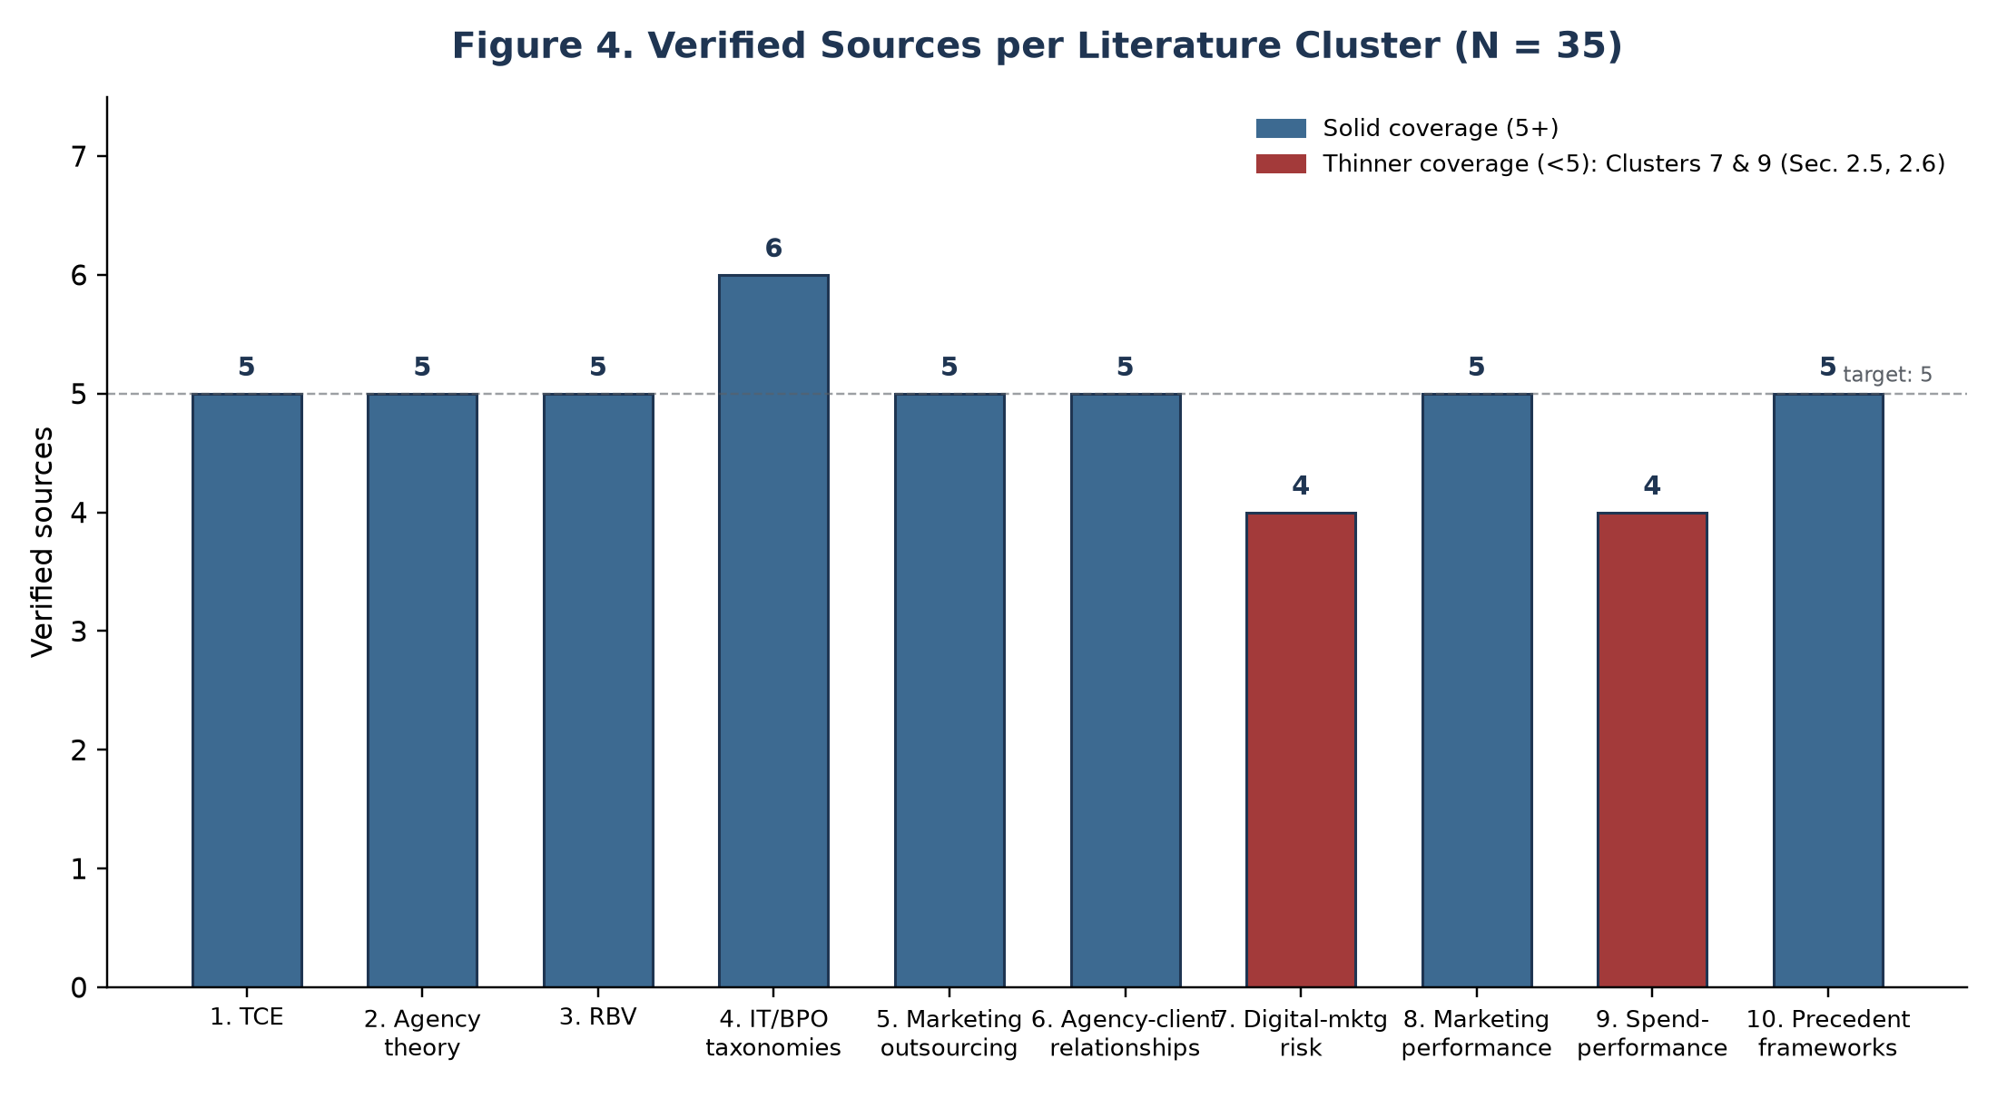
Figure 4. Verified Sources per Literature Cluster
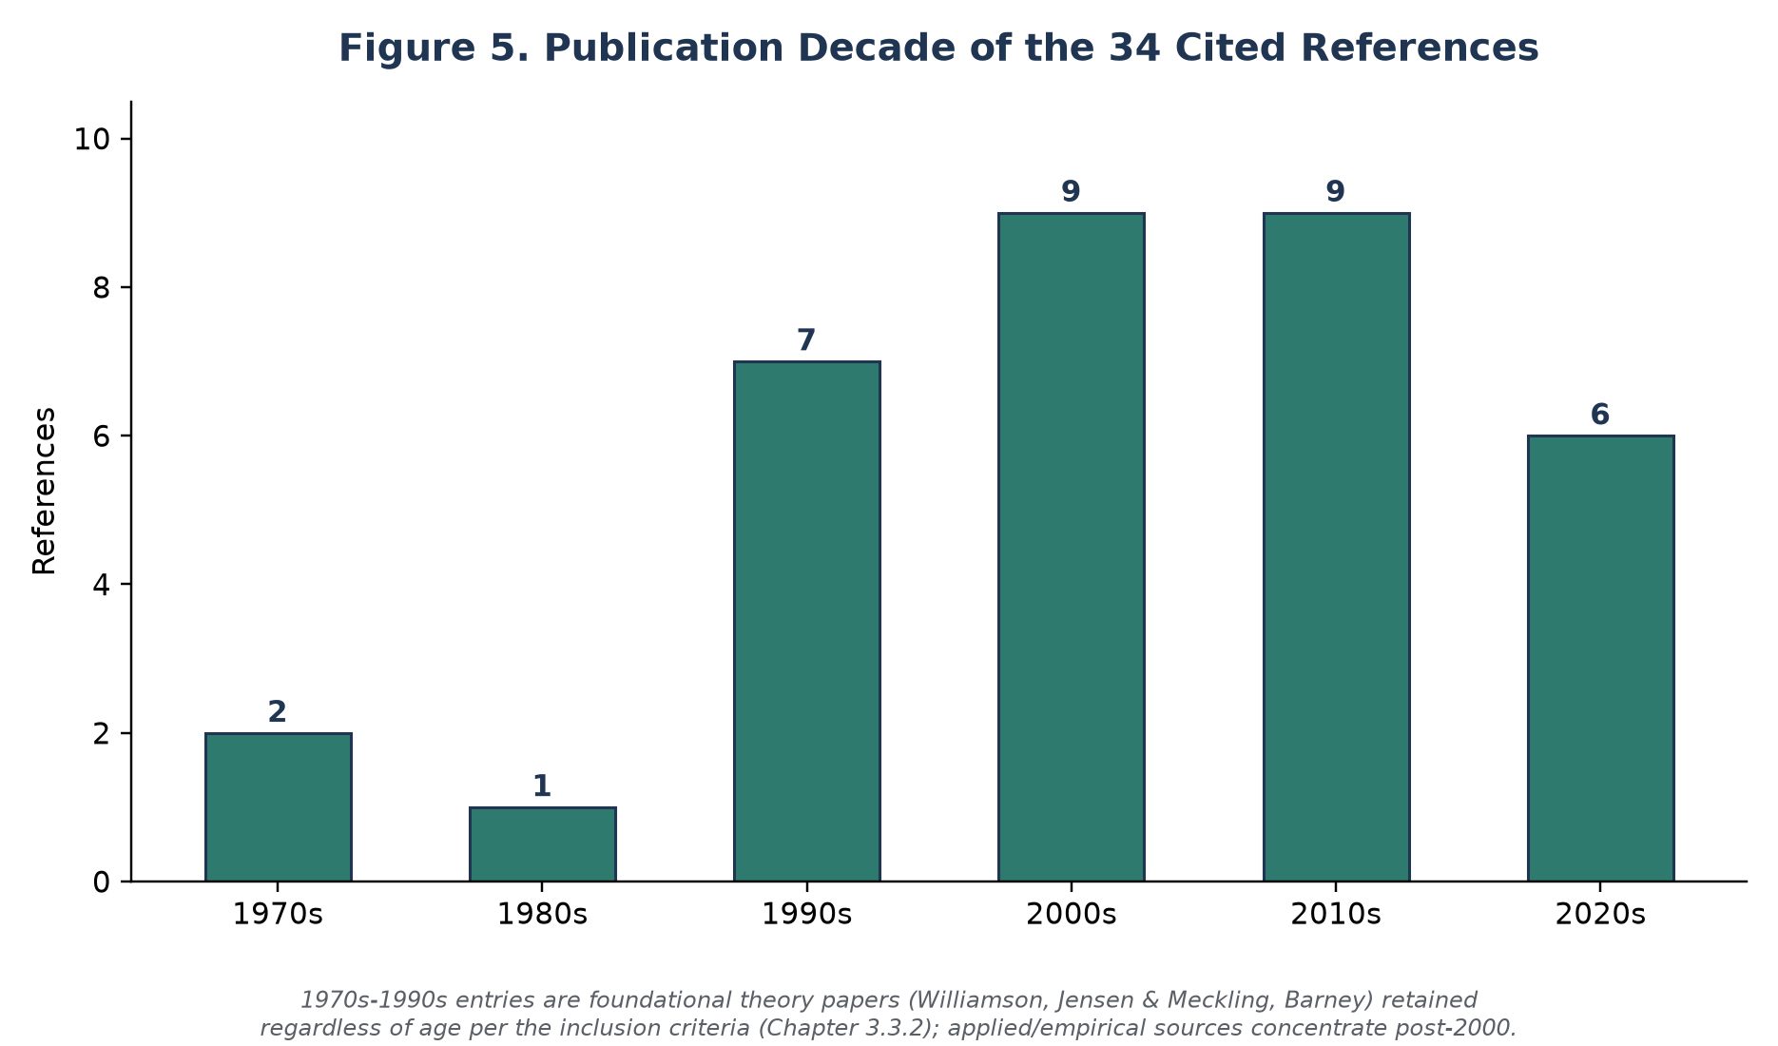
Figure 5. Publication Decade of the Cited References
3.3.4 Comparison to Alternative Non-Empirical Designs Considered
Before settling on the literature-synthesis design described above, two alternative non-empirical approaches were considered and rejected. A purely narrative literature review, summarizing relevant studies thematically without a structured taxonomic or framework-development objective, was rejected because it would not produce the concrete deliverable the primary research question requires: a usable framework, not merely a summary of prior findings. A single-case illustrative analysis using publicly available secondary information about one real, named company's outsourcing arrangement was also considered, but rejected on two grounds: publicly available secondary information about any single firm's internal governance practices is generally too sparse to support rigorous analysis, and drawing framework-level conclusions from one uncontrolled case would risk exactly the kind of unfounded generalization this thesis's conceptual design otherwise takes care to avoid (Section 3.6). The structured literature-synthesis design adopted here was judged the strongest available option precisely because it is the most transparent about its own evidentiary basis: every claim traces to a specific, checkable source (Appendix A), rather than resting on either summary without synthesis or a single uncontrolled illustration.
3.4 Framework Development Method
The DMO-RSF framework (Chapter 4) was developed through four sequential synthesis steps, each corresponding to one research sub-question:
- Theoretical triangulation (addressing SQ1's theoretical grounding): the three foundational theories (Section 2.2) were cross-read for their combined implications for risk categorization, following the two-theory integration precedents of Bahli and Rivard (2003) and McIvor (2009) but extended to a three-theory synthesis.
- Taxonomic adaptation (SQ1): the structural taxonomies of Aubert et al. (2005) and Liu et al. (2023) were used as organizing templates, with risk-category content replaced and extended using the marketing-specific literature of Sections 2.4 and 2.5.
- Practice mapping (SQ2): each risk category was paired with corresponding mitigation and governance practices drawn from the agency-client relationship literature (Section 2.4) and from the general outsourcing risk-management literature (Section 2.3).
- Performance-linkage theorization (SQ3): each practice category was connected, through explicit and citation-grounded causal reasoning, to the marketing-performance and financial-performance constructs established in Section 2.6.
The resulting four-component structure, comprising taxonomy, practice mapping, performance linkage, and a governance cycle integrating all three (SQ4), constitutes the complete DMO-RSF framework, presented in full in Chapter 4.
3.5 Framework Evaluation Strategy (Overview)
Because this design does not include primary data collection, framework evaluation in this study relies on four non-empirical validation mechanisms, each detailed in Chapter 5: (a) internal consistency checking against the source theories, (b) structured comparison against the closest existing precedent framework (Sen et al., 2020), (c) a documented argumentation-based validation applying the framework to an illustrative, clearly-labeled hypothetical scenario, and (d) a specification of the expert-panel and pilot-survey evaluation that constitutes the recommended next research step (Appendix B).
3.6 Rigor and Trustworthiness Criteria
Conceptual research is held to a different rigor standard than empirical research, and this study makes that standard explicit rather than implicit. Credibility is established through grounding every framework component in verifiable, cited literature rather than in unsupported assertion. No claim in Chapter 4 is presented without a traceable source, and Chapter 5.2 documents a full citation-traceability check of the finished framework. Confirmability is established through the documented search strategy (Section 3.3) and the complete annotated bibliography (Appendix A), enabling independent verification of every source. Transferability is explicitly limited: because the framework has not been tested against primary data from a defined population, this study makes no claim that the DMO-RSF framework as specified will hold without modification across all firm sizes, industries, or agency-relationship types, a limitation restated in Chapter 7.3.
3.6A Reflexivity Statement
Because this study is situated within an interpretivist tradition (Section 3.1), the researcher's own position with respect to the material warrants brief statement, consistent with standard reflexivity practice in interpretivist and qualitative-adjacent research. The literature synthesis, taxonomy adaptation, and framework construction reported in this thesis were conducted by a single researcher without a co-author or research team to cross-check interpretive judgments, a constraint already noted as a limitation in Chapter 7.3. Two specific interpretive choices in this study reflect researcher judgment rather than a mechanical application of prior literature, and are flagged here so a reader can weigh them accordingly: the decision to organize the risk taxonomy around six domains rather than a different number (Chapter 4.2) reflects a judgment that six domains balance comprehensiveness against the diagnostic usability of the Table 5 scoring rubric, a trade-off a different researcher might have resolved differently; and the decision to treat the tri-theory integration (TCE, agency theory, RBV) as additive rather than to select a single dominant theory (Chapter 2.2.4) reflects a judgment that each theory's boundary conditions (Chapter 2.2.5) are severe enough that no single theory could carry the full taxonomic burden alone. Neither choice is presented as the only defensible option; both are defended with reasoning traceable to the literature (Chapter 2), consistent with this study's broader commitment to citation-traceable claims (Chapter 5.2).
3.7 Research Integrity and AI-Assistance Disclosure
This thesis was developed with the assistance of an AI research and writing tool (Claude, Anthropic) used for literature search execution, synthesis drafting, and prose composition under direct researcher direction and review. Every citation appearing in this thesis was independently verified against a publisher, database, or institutional record before inclusion (Appendix A); no citation, data point, or empirical finding in this thesis is fabricated or AI-generated without a traceable, verifiable source. The framework development reasoning (Chapter 4), evaluation strategy (Chapter 5), and all interpretive claims are presented as the product of human-directed synthesis of verified sources.
3.8 Timeline and Feasibility Note
Although this thesis does not report a fieldwork timeline, since no fieldwork was conducted, a realistic timeline for the empirical validation study specified in Chapter 7.4 is worth noting here for continuity with a future researcher who takes up that work. Recruiting 10-15 qualified interview participants (marketing directors, CMOs, or procurement/vendor-management leads with direct agency-outsourcing experience) through professional-network channels typically requires 4-8 weeks given realistic response rates to cold professional outreach; conducting and transcribing the interviews themselves typically requires a further 4-6 weeks; thematic analysis (Braun & Clarke, 2006) typically requires 3-4 weeks. The subsequent survey phase, including instrument piloting, would realistically require a further 8-12 weeks for recruitment and data collection given the non-probability sampling approach specified in Section 3.2, plus 3-4 weeks for analysis. A full empirical validation of the DMO-RSF framework following the design in Appendix B would therefore realistically span 22-34 weeks beyond this conceptual thesis, a scope explicitly beyond a single Master's thesis timeline, which is the practical reason, alongside the access constraints noted in Section 3.2, that this study adopted the conceptual design instead. Figure 6 depicts this proposed timeline as a phased schedule.
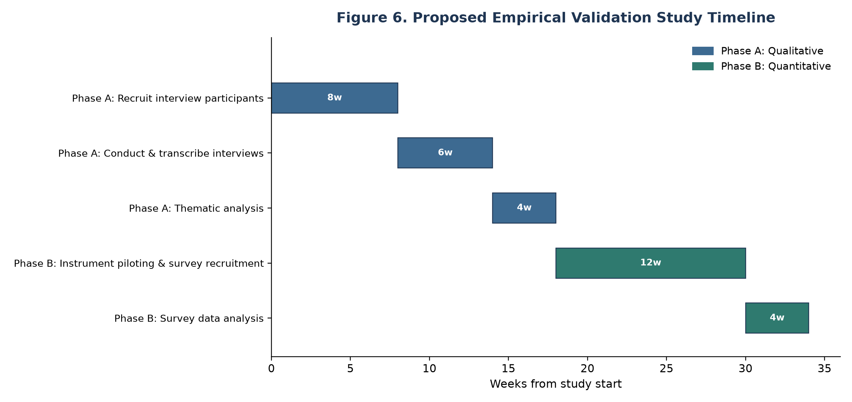
Figure 6. Proposed Empirical Validation Study Timeline
3.9 Summary of Design Limitations
This design does not permit statistical hypothesis testing, does not establish causal proof of the performance-linkage claims in Chapter 4.4, and does not confirm that practicing marketing and procurement professionals would independently arrive at the same risk taxonomy through inductive fieldwork. These are stated as boundary conditions on the study's claims, not treated as unstated assumptions. Chapter 5 specifies precisely what the framework can be said to establish under this design, and Chapter 7.4 specifies the empirical study that would be required to establish the remainder.
CHAPTER 4: THE DIGITAL MARKETING OUTSOURCING RISK SAFEGUARD FRAMEWORK (DMO-RSF)
4.1 Framework Overview
The Digital Marketing Outsourcing Risk Safeguard Framework (DMO-RSF) comprises four integrated components, each addressing one research sub-question and each built through the synthesis method documented in Chapter 3.4:
- Risk Taxonomy (Section 4.2): six risk domains grounded in transaction cost economics, agency theory, and the resource-based view, populated with digital-marketing-specific content.
- Risk-Practice Mapping (Section 4.3): governance and mitigation practices corresponding to each risk domain.
- Performance Safeguard Linkage (Section 4.4): a theorized causal pathway connecting risk-managed practice to marketing and financial performance outcomes.
- Governance Cycle (Section 4.5): an iterative Assess-Mitigate-Monitor-Reassess process integrating the first three components into an operational capability, following Sen et al.'s (2020) dynamic-capability conception of outsourcing risk management.
Figure 7 presents this four-component structure at a glance; Figures 1 and 2 (Section 4.6) present the performance-safeguard pathway and governance cycle components in detail.
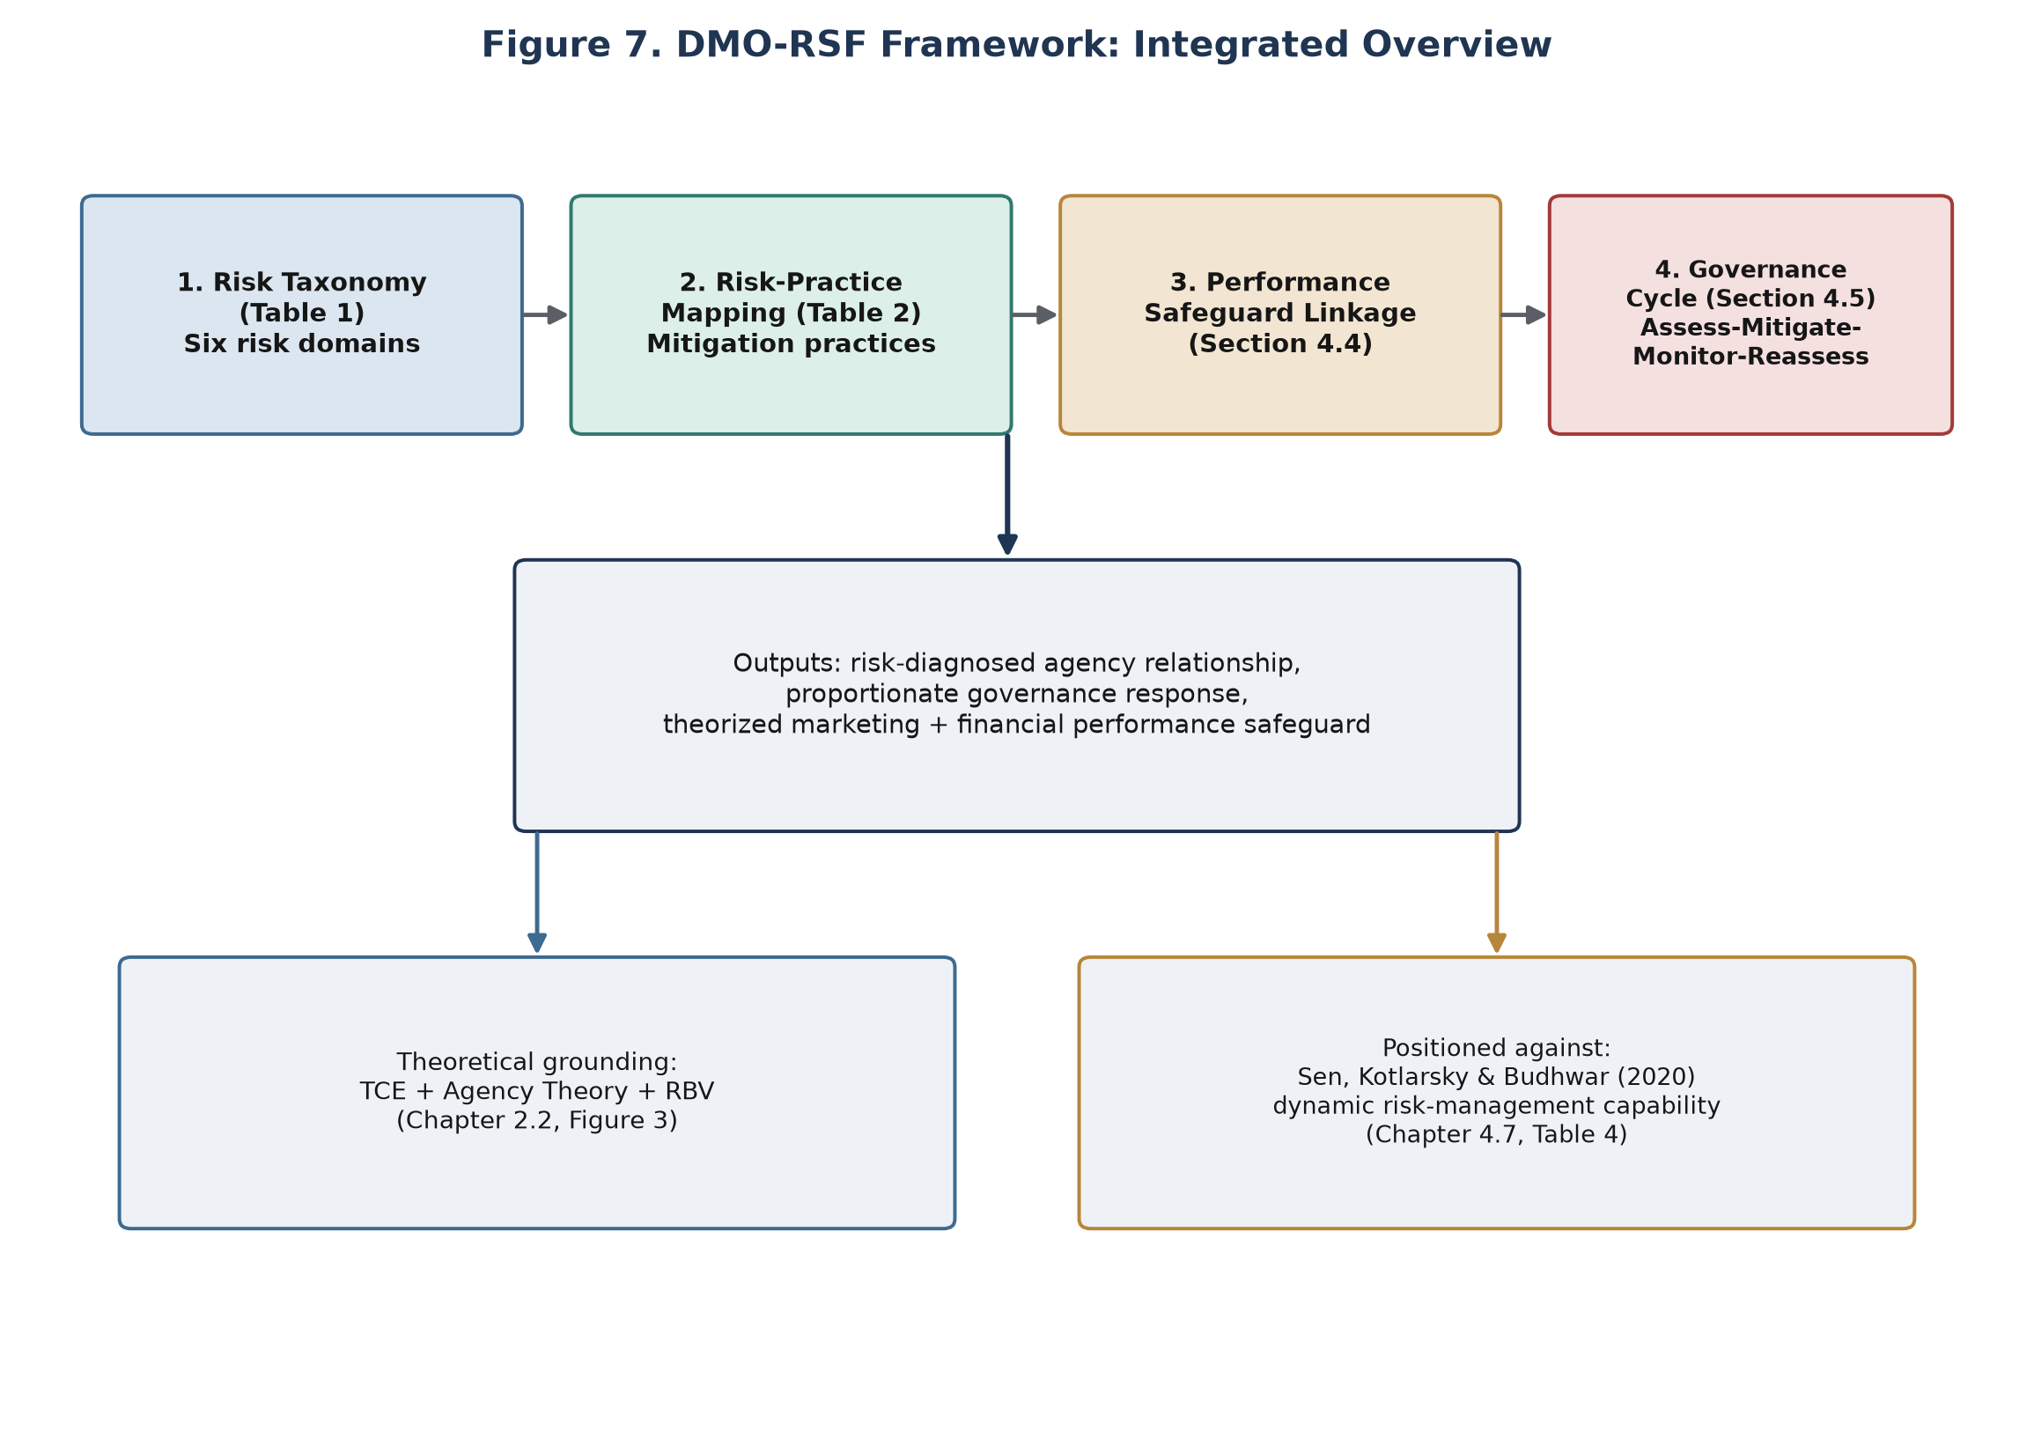
Figure 7. DMO-RSF Framework: Integrated Overview
4.2 Component 1: Risk Taxonomy
Table 1 presents the six risk domains constituting the DMO-RSF taxonomy. Each domain's structural placement follows the scenario-based construct of Aubert et al. (2005) and the six-dimension precedent of Liu et al. (2023); each domain's content is grounded in the theoretical and empirical literature reviewed in Chapter 2.
Table 1
DMO-RSF Risk Taxonomy
# | Risk Domain | Theoretical Grounding | Definition | Illustrative Risk Indicators | Key Sources
1 | Strategic/Governance Risk | Transaction Cost Economics | Risk arising from contractual incompleteness and asset specificity in the outsourcing agreement, including hold-up risk and switching-cost lock-in | Undefined scope-of-work boundaries; single-agency dependency for high-specificity work (e.g., brand strategy); no defined exit/transition clause | Williamson (1979, 2008)
2 | Agency/Behavioral Risk | Agency Theory | Risk arising from information asymmetry and incentive misalignment between client and agency | Effort/quality unobservable by client (e.g., media-buying markups); incentive structures rewarding billable activity over outcomes; opaque subcontracting | Jensen & Meckling (1976); Eisenhardt (1989); Mortimer & Laurie (2017)
3 | Capability/Knowledge Risk | Resource-Based View | Risk of erosion of the client firm's own core marketing competency and market-based learning capability through over-delegation | Loss of internal campaign-execution skill; degraded customer-insight capability; tacit brand knowledge concentrated at the agency rather than the client | Barney (1991); Grant (1996); Park et al. (2011); Handley (2012)
4 | Operational/Execution Risk | Applied: quality/brand-safety literature | Risk of execution failures that damage brand reputation or campaign effectiveness, including brand-safety failures in automated placement | Programmatic ads placed adjacent to unsuitable content; inconsistent brand voice across agency-produced assets; missed campaign deadlines with public visibility | Shehu et al. (2021)
5 | Data & Compliance Risk | Applied: data-privacy/regulatory literature | Risk arising from agency access to and processing of customer/audience data under evolving privacy regulation | Unclear data-controller/processor allocation; agency use of client data beyond contracted scope; regulatory non-compliance (e.g., GDPR-equivalent obligations) | Johnson (2022)
6 | Financial/Cost Risk | Applied: outsourcing cost literature | Risk of unplanned or hidden costs across the outsourcing lifecycle | Uncosted vendor-search and onboarding time; scope creep beyond contracted fees; high transition/exit costs discouraging vendor switching even when warranted | Barthélemy (2001)

Domains 1-3 (Strategic/Governance, Agency/Behavioral, Capability/Knowledge) map directly onto the three foundational theories reviewed in Chapter 2.2, giving the taxonomy its theoretical spine. Domains 4-6 (Operational/Execution, Data & Compliance, Financial/Cost) are populated from the applied digital-marketing-outsourcing literature reviewed in Chapter 2.5, which, as documented there, is thinner than the theoretical literature and required more direct adaptation. This division is disclosed deliberately: domains 1-3 rest on well-established theory applied to a new context, while domains 4-6 rest on a smaller number of directly on-topic empirical sources supplemented by adjacent IT/BPO evidence (Chapter 2.3, 2.5).
4.2.1 Elaboration of Each Risk Domain
Domain 1 (Strategic/Governance Risk) is, per Williamson (1979, 2008), most acute where the outsourced work has high asset specificity, such as brand strategy, proprietary campaign creative, or bespoke martech integration, because these are precisely the conditions under which contracts are hardest to write completely and switching agencies is most costly. A firm outsourcing standardized, low-specificity work (e.g., programmatic media buying through a common platform) carries materially lower Domain 1 exposure than a firm outsourcing brand strategy work to a single agency with years of accumulated, uncodified brand knowledge.
Domain 2 (Agency/Behavioral Risk) follows directly from Eisenhardt's (1989) two agency-theory risk sources: information asymmetry (the agency knows more about its own effort and cost structure than the client can observe) and goal conflict (the agency's billing incentives may not align with the client's outcome objectives). Mortimer and Laurie's (2017) finding of a shift toward "supplier" framing in many agency relationships suggests this domain's exposure may be rising over time as relationships become more transactional and less collaborative.
Domain 3 (Capability/Knowledge Risk) is the domain most directly tied to a firm's long-run strategic position rather than any single campaign outcome. Handley's (2012) empirical evidence that capability loss follows outsourcing, and Park et al.'s (2011) finding that market-based learning specifically erodes when marketing execution is delegated, together suggest this risk compounds over time rather than manifesting as a discrete incident. A firm may not observe Domain 3 exposure materializing until several years into an outsourcing relationship, which has direct implications for the Reassess step of the governance cycle (Section 4.5).
Domain 4 (Operational/Execution Risk) is the most publicly visible domain when it materializes: a brand-safety failure or a visibly off-brand campaign asset is, by definition, externally observable in a way that Domain 1-3 risks often are not. Shehu et al.'s (2021) finding that placement-context quality affects advertising effectiveness illustrates that this domain includes risk the client firm cannot fully control even with strong governance, because programmatic placement mechanics are partly automated and partly dependent on third-party ad-tech infrastructure beyond either the client's or the agency's direct control.
Domain 5 (Data & Compliance Risk) has grown in salience as digital marketing has become more data-driven; Johnson's (2022) review of privacy-regulation economics documents the scale of regulatory exposure firms face when third parties process customer data on their behalf. Because agencies frequently require audience-data access to execute targeted campaigns, this domain's exposure is structurally difficult to eliminate without also eliminating the marketing capability the outsourcing arrangement exists to provide, making mitigation (Table 2), rather than avoidance, the realistic management strategy.
Domain 6 (Financial/Cost Risk) is best understood through Barthélemy's (2001) lifecycle framing: costs accrue not only during active execution but during vendor search, onboarding/transition, and, critically, contract exit. A firm that evaluates outsourcing cost only at the point of contract signing systematically understates true Domain 6 exposure, because switching or exit costs are, by construction, invisible until the firm attempts to exercise them.
4.2.2 Cross-Domain Interaction Effects
Table 1's six domains are presented as analytically distinct, but they are not theorized as independent in practice. Some domains share an underlying driver, such that elevated exposure in one domain is theorized to correlate with elevated exposure in another. Table 1a documents the interaction pairs with a clear theoretical basis in the literature reviewed in Chapter 2; pairs not listed are not theorized to interact more than would be expected by chance, and this study does not force a claim onto every possible pairing.
Table 1a
Theorized Cross-Domain Interaction Pairs
Domain Pair | Interaction Mechanism | Grounding
Domain 1 (Strategic/Governance) x Domain 3 (Capability/Knowledge) | Single-agency dependency for high-specificity work, the condition driving Domain 1 exposure, is the same condition under which agency-side knowledge accumulation and client-side capability erosion (Domain 3) are most likely | Handley (2012); Park et al. (2011)
Domain 1 x Domain 6 (Financial/Cost) | High asset specificity, the core Domain 1 driver, directly raises switching and exit costs, the core Domain 6 driver, per TCE's own logic | Williamson (1979, 2008); Barthélemy (2001)
Domain 2 (Agency/Behavioral) x Domain 4 (Operational/Execution) | Unmonitored agency effort (Domain 2) reduces the likelihood that execution-quality failures (Domain 4) are detected before public exposure | Eisenhardt (1989); Shehu et al. (2021)
Domain 2 x Domain 6 | Information asymmetry about agency cost structure (Domain 2) is a direct mechanism by which hidden costs (Domain 6) go undetected | Eisenhardt (1989); Barthélemy (2001)
Domain 3 x Domain 4 | As internal capability to evaluate specialized work erodes (Domain 3), the client's ability to catch execution-quality issues (Domain 4) independently also erodes | Handley (2012)
Domain 5 (Data & Compliance) x Domain 6 | Data-compliance failures (Domain 5) carry direct financial exposure through regulatory penalties, converting into Domain 6 realization | Johnson (2022)

The practical implication for the governance cycle (Section 4.5) is that the Assess step should not treat each domain score in isolation: an elevated Domain 1 score is a signal to examine Domain 3 and Domain 6 exposure more closely even before they independently trigger an elevated rating, and similarly for the other listed pairs. This interaction logic is itself a theorized extension, not an empirically validated one, and is accordingly flagged as a specific, testable proposition for the empirical validation study in Chapter 7.4.
4.3 Component 2: Risk-Practice Mapping
Table 2 maps each risk domain to corresponding governance and mitigation practices, drawn from the outsourcing risk-management and agency-client relationship literatures (Chapter 2.3, 2.4).
Table 2
DMO-RSF Risk-Practice Mapping
Risk Domain | Mitigation / Governance Practice | Mechanism | Grounding
1. Strategic/Governance | Staged/phased outsourcing; multi-agency (dual-sourcing) strategy for high-specificity work; explicit exit/transition clauses in the SOW | Reduces hold-up risk by lowering switching costs and avoiding single-vendor lock-in for the most contractually incomplete work | Williamson (2008)
2. Agency/Behavioral | Outcome-based incentive contracts; joint client-agency governance/steering committees; standardized KPI reporting cadence; third-party audit rights | Reduces information asymmetry through structured monitoring; realigns incentives from activity to outcome | Eisenhardt (1989); Mortimer & Laurie (2017)
3. Capability/Knowledge | Deliberate retention of strategic/insight functions in-house; structured knowledge-transfer requirements in the contract; embedded client-side liaison roles co-located with agency teams | Preserves core competency per RBV; slows market-based-learning erosion documented by Park et al. (2011) | Prahalad & Hamel (1990); Handley (2012)
4. Operational/Execution | Brand-safety guidelines and pre-flight placement review; staged campaign-approval workflows; formal agency onboarding/brand certification process | Reduces execution-failure risk through checkpoint-based quality control before public exposure | Shehu et al. (2021)
5. Data & Compliance | Data processing agreements (DPAs) with explicit controller/processor allocation; data-minimization clauses; scheduled compliance audits | Allocates and bounds data-handling liability; creates verification checkpoints | Johnson (2022)
6. Financial/Cost | Total-cost-of-ownership (TCO) budgeting inclusive of search/transition/exit costs; contract renegotiation triggers tied to scope change; periodic market-rate benchmarking | Surfaces hidden costs at the budgeting stage rather than post hoc | Barthélemy (2001)

4.3.1 Practice Prioritization Guidance
Table 2's practices are not intended to be adopted uniformly or simultaneously; the proportionality principle formalized in Section 4.5 requires distinguishing lower-cost, broadly-applicable practices from higher-cost, situationally-specific ones. Standardized KPI reporting cadence and data processing agreements (Domains 2 and 5) are comparatively low-cost to implement and arguably warranted in nearly any digital marketing agency relationship regardless of assessed exposure level, since they impose modest administrative overhead relative to their risk-reduction value. Multi-agency dual-sourcing (Domain 1) and embedded client-side liaison roles (Domain 3), by contrast, carry materially higher cost and coordination overhead, and this study's framework treats them as warranted specifically where Domain 1 or Domain 3 exposure is assessed as elevated (Section 4.5's Assess step), for high-specificity, strategically central marketing functions, rather than as universal recommendations. This prioritization logic is itself a direct application of the proportionality principle drawn from ISO 31000:2018 and COSO ERM's risk-appetite concept (Prewett & Terry, 2018; Chapter 2.3): match governance intensity to assessed exposure rather than applying maximum governance uniformly.
4.4 Component 3: Performance Safeguard Linkage
The framework's central theoretical claim is that risk-managed outsourcing practice (Table 2) protects, rather than merely constrains, marketing and financial performance. This claim is constructed as a three-stage theorized pathway rather than an empirically tested one (see Chapter 3.9 and Chapter 5.4 for the boundary this places on the claim):
Stage 1: Practice to marketing performance. Consistent execution of the practices in Table 2 is theorized to preserve brand equity (Aaker, 1991; Keller, 1993) by reducing operational/execution risk (Domain 4) and preserving brand-consistent creative and campaign quality. It is further theorized to preserve campaign-level return on marketing investment (Rust et al., 2004) by reducing agency/behavioral risk (Domain 2): outcome-aligned incentive practice should, per agency theory, reduce the gap between contracted effort and delivered campaign quality.
Stage 2: Marketing performance to financial performance. Following Joshi and Hanssens (2010) and Madathil et al. (2025), marketing performance translates into financial performance through both direct (revenue-generating campaign effectiveness) and indirect (brand-value-mediated firm value) paths. The framework theorizes that risk-managed outsourcing practice therefore has a downstream financial-performance effect that operates through preserved marketing performance, not independently of it. A firm cannot expect the DMO-RSF framework to safeguard financial performance if marketing performance itself is not preserved.
Stage 3: The curvilinearity boundary condition. Kotabe et al.'s (2012) finding of a curvilinear relationship between outsourcing intensity and market success is incorporated as an explicit boundary condition, not an afterthought: the framework theorizes that risk-managed practice raises the outsourcing-intensity threshold at which performance begins to decline, but does not eliminate the existence of that threshold. This distinguishes the DMO-RSF framework's claim from an unbounded "more risk management always improves performance" claim, which the reviewed literature does not support.
Figure 1 (Section 4.6) diagrams this three-stage pathway alongside the risk-domain-to-practice mapping from Table 2.
4.5 Component 4: Governance Cycle
The three preceding components are static; Component 4 renders them operational as a continuous cycle, following the ISO 31000:2018 process structure and Sen et al.'s (2020) dynamic-capability argument that risk management must be an ongoing organizational capability rather than a one-time assessment.
- Assess: Apply the Table 1 taxonomy to a specific agency relationship or engagement, scoring exposure across the six domains against the relationship's actual characteristics (asset specificity of the work, data sensitivity, public visibility of execution, contract structure).
- Mitigate: Select and implement the corresponding Table 2 practices proportionate to the assessed exposure level in each domain. The framework does not prescribe applying every practice at maximum intensity regardless of actual risk level, consistent with the proportionality principle in ISO 31000:2018 and the COSO ERM emphasis on risk appetite (Prewett & Terry, 2018).
- Monitor: Track the KPI and audit mechanisms established under Component 2 (joint governance committees, compliance audits, TCO tracking) on a defined reporting cadence.
- Reassess: Periodically repeat the Assess step as the relationship, contract scope, regulatory environment, or outsourcing intensity changes, explicitly incorporating the Stage 3 curvilinearity boundary condition (Section 4.4) as a trigger for reassessment when outsourcing scope expands.
Figure 2 (Section 4.6) diagrams this cycle.
4.5.1 Illustrative Exposure-Scoring Rubric
Table 5 specifies an illustrative 1-5 exposure-scoring rubric to operationalize the Assess step for any given risk domain. This rubric is offered as a starting reference for practitioner use and for the future empirical validation study (Chapter 7.4, Appendix B); it has not itself been empirically validated, consistent with this study's conceptual design (Chapter 3.2).
Table 5
Illustrative Exposure-Scoring Rubric (Applied per Risk Domain)
Score | Exposure Level | General Criterion
1 | Minimal | Function is low-specificity/standardized; strong existing governance mechanisms already in place; no history of incidents in this domain
2 | Low | Function is largely standardized with limited customization; basic governance mechanisms in place
3 | Moderate | Function has meaningful specificity or data sensitivity; governance mechanisms exist but are informal or inconsistently applied
4 | High | Function is highly specific, strategically central, or data-intensive; governance mechanisms are absent or clearly inadequate
5 | Critical | Function is core-competency-adjacent, single-agency-dependent, or subject to active regulatory scrutiny; no meaningful governance mechanism in place

Applied across all six domains, this rubric yields a six-value exposure profile per agency relationship rather than a single composite score. This is deliberate: collapsing six structurally distinct risk domains (Table 1) into one number would obscure which specific domain warrants which specific Table 2 practice, undermining the proportionality principle (Section 4.3.1) the framework is built to support.
4.5.2 Domain-Specific Scoring Criteria
Table 5's general criteria are deliberately abstract so that a single rubric structure applies across all six domains, but a practitioner applying the Assess step needs domain-specific language to translate "high specificity" or "data-intensive" into an actual judgment about a specific agency relationship. Table 5a translates the general rubric into domain-specific illustrative criteria, drawing directly on the domain descriptions and grounding already established in Section 4.2.1, rather than introducing new theoretical claims. As with Table 5 itself, these domain-specific criteria are offered as an illustrative starting reference, not an empirically validated instrument.
Table 5a
Domain-Specific Illustrative Scoring Criteria
Domain | Score 1-2 (Minimal-Low) | Score 3 (Moderate) | Score 4-5 (High-Critical)
1. Strategic/Governance | Standardized, low-specificity work (e.g., platform-based programmatic buying) with multiple qualified alternative agencies available and a defined exit clause in the SOW | Some relationship-specific investment (e.g., partially customized reporting or campaign workflows) with an exit clause present but not recently tested or costed | High-specificity work (e.g., brand strategy, proprietary creative, bespoke martech integration) concentrated in a single agency with no defined or costed exit path (Williamson, 1979, 2008)
2. Agency/Behavioral | Agency cost structure and effort are independently observable (e.g., transparent media buying, itemized billing); incentive structure ties agency compensation to client outcomes | Billing is itemized but effort is not independently verifiable; incentive structure is partially outcome-based | Agency cost structure and effort cannot be independently verified; compensation is structured such that agency and client incentives may diverge (Eisenhardt, 1989); relationship framing has shifted toward transactional "supplier" dynamics (Mortimer & Laurie, 2017)
3. Capability/Knowledge | Strategic and insight functions remain in-house; agency work is confined to execution; no observed decline in internal capability | Some strategic functions have shifted to the agency; internal capability is stable but not actively developed | Strategic and insight functions have been substantially delegated; internal capability to independently evaluate agency output has visibly declined (Handley, 2012), or market-based learning has visibly eroded (Park et al., 2011)
4. Operational/Execution | Brand-safety guidelines and pre-flight review are formally documented and consistently applied; no history of placement or creative incidents | Brand-safety guidelines exist but are inconsistently enforced; isolated minor incidents have occurred without material brand impact | No formal brand-safety or quality-control checkpoint exists before public exposure; a placement-quality or off-brand creative incident has previously caused observable reputational impact (Shehu et al., 2021)
5. Data & Compliance | A signed data processing agreement clearly allocates controller/processor responsibility; data-minimization practices are documented; no unresolved compliance concern | A data processing agreement exists but controller/processor roles or data-minimization practices are ambiguous or incompletely documented | No data processing agreement is in place, or agency data access exceeds documented business need; the arrangement has an identified, unresolved regulatory exposure (Johnson, 2022)
6. Financial/Cost | Total cost of ownership, including search, transition, and exit costs, has been budgeted and reviewed; no history of undisclosed fees | Retainer and major direct costs are budgeted, but transition or exit costs have not been explicitly estimated | Only the retainer fee has been budgeted; search, transition, and exit costs are unbudgeted and, per Barthélemy's (2001) lifecycle framing, effectively invisible until the firm attempts to exercise them

A practitioner using Table 5a alongside the Step 1 checklist in Appendix D should treat the domain-specific language as illustrative anchoring rather than an exhaustive checklist: a given agency relationship may present criteria from more than one score band within a single domain, in which case the higher of the two applicable scores is the conservative and recommended choice, consistent with the proportionality principle's preference for visible over understated exposure.
4.6 Integrated Framework Diagrams
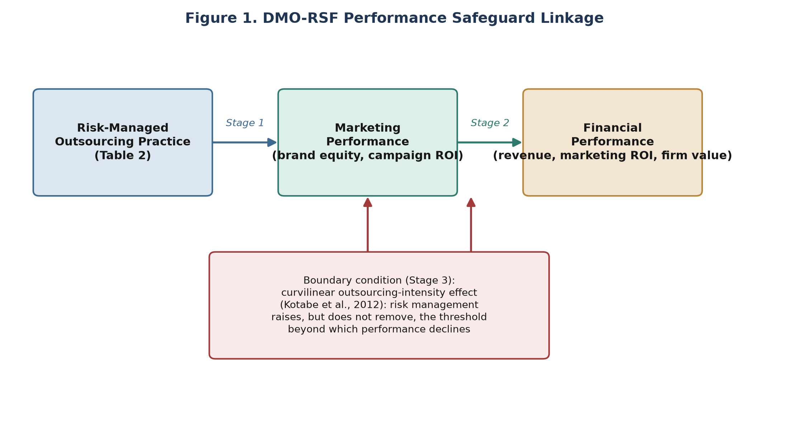
Figure 1. DMO-RSF Performance Safeguard Linkage
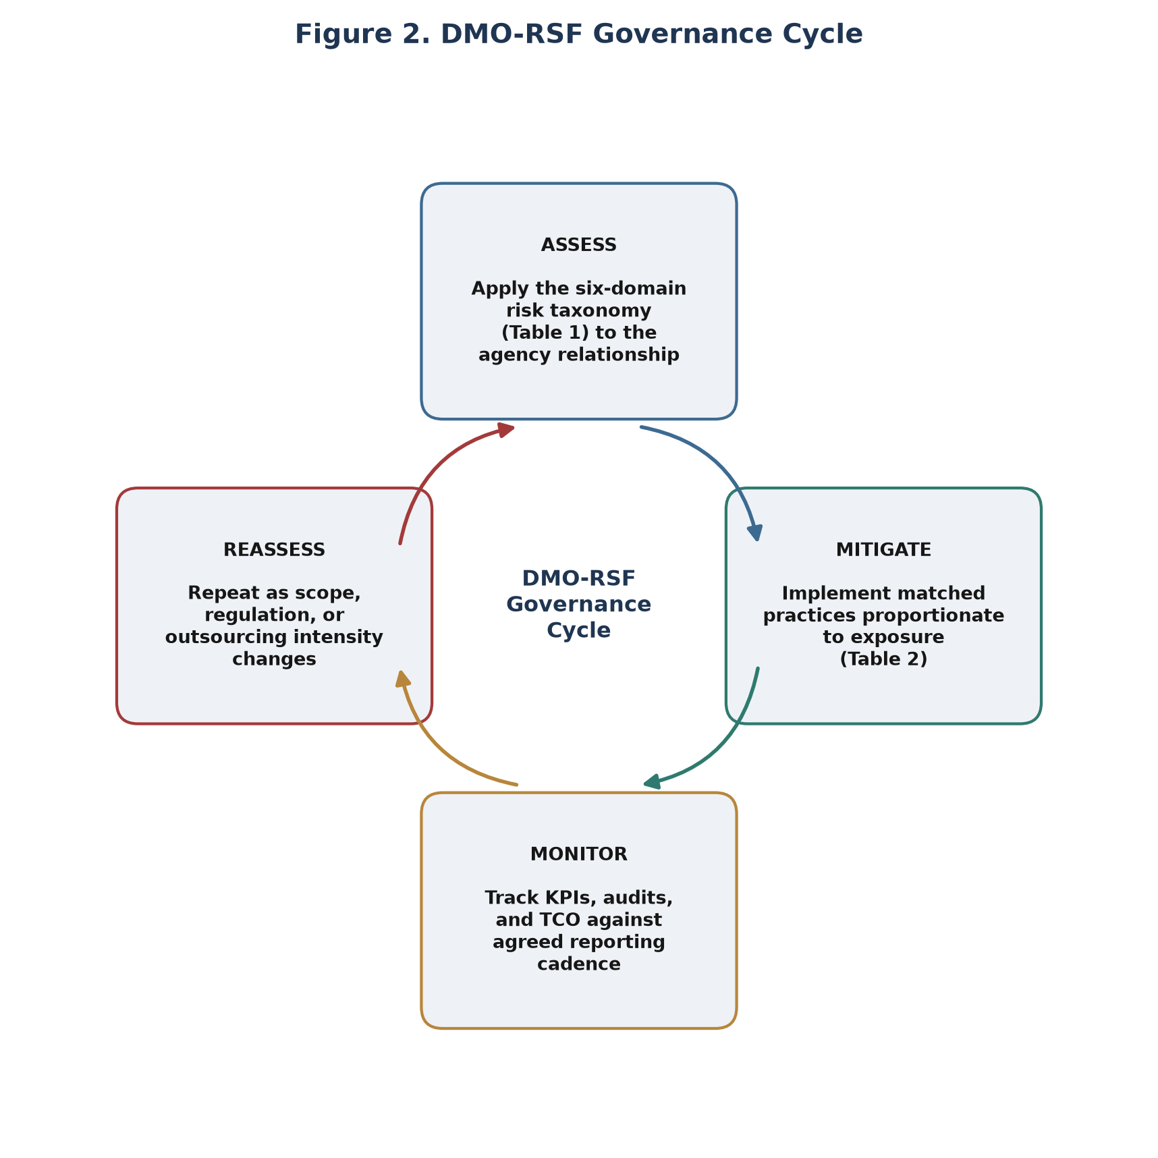
Figure 2. DMO-RSF Governance Cycle
4.7 Positioning Relative to Sen et al. (2020)
Sen, Kotlarsky, and Budhwar (2020) establish that outsourcing risk management is a dynamic organizational capability built on risk perception, governance reconfiguration, and resource orchestration, but leave the specific content of that capability unspecified, by design, since their framework is intended to generalize across outsourcing contexts. The DMO-RSF framework can be read as one contextual instantiation of Sen et al.'s (2020) general capability: Component 1 (taxonomy) operationalizes their "risk perception" element for the digital marketing agency context specifically; Component 2 (practice mapping) operationalizes "governance reconfiguration"; Component 4 (governance cycle) operationalizes "resource orchestration" as an iterative process. Component 3 (performance safeguard linkage) has no direct counterpart in Sen et al. (2020), which does not theorize a specific performance pathway; this is the DMO-RSF framework's most direct extension beyond the closest existing precedent.
This positioning also clarifies what the DMO-RSF framework does not claim to be. It does not claim to supersede Sen et al.'s (2020) generic framework for firms managing outsourcing risk across multiple, heterogeneous functions simultaneously (IT, manufacturing, and marketing together). For that cross-functional use case, the generic framework's deliberate abstraction is a feature, not a limitation, since it avoids over-fitting to any one function. The DMO-RSF framework's value proposition is specific to firms and practitioners whose primary outsourcing risk-management concern is the digital marketing function, where the added specificity of Table 1's taxonomy and Table 2's practice mapping offers concrete, usable guidance that the generic framework, by design, does not supply.
4.8 Chapter Summary
This chapter has presented the DMO-RSF framework's four components in full: a six-domain risk taxonomy grounded in transaction cost economics, agency theory, and the resource-based view (Section 4.2); a corresponding risk-practice mapping with explicit prioritization guidance (Section 4.3); a three-stage, boundary-conditioned performance-safeguard pathway (Section 4.4); and an iterative governance cycle with an illustrative exposure-scoring rubric (Section 4.5). Section 4.7 positioned the framework relative to its closest existing precedent, clarifying both what it extends and what it does not claim to replace. Chapter 5 now turns to how this framework was evaluated, given the conceptual research design specified in Chapter 3.
CHAPTER 5: FRAMEWORK EVALUATION STRATEGY
5.1 Purpose of This Chapter
Because this study's design does not include primary data collection (Chapter 3.2), the DMO-RSF framework cannot be evaluated through statistical hypothesis testing. This chapter specifies, transparently, what evaluation was performed, what it can and cannot establish, and what remains for future empirical work. This chapter is the study's answer to SQ4's evaluation component and the direct application of the evaluation strategy overviewed in Chapter 3.5.
5.2 Citation-Traceability Check
Every claim embedded in the DMO-RSF framework (Chapter 4) was checked against its cited source to confirm the source supports the claim as stated, rather than being cited by proximity or topic-match alone. Table 3 summarizes this check for the framework's core claims.
Table 3
Citation-Traceability Check for Core Framework Claims
Framework Claim | Source | Verification Outcome
Asset specificity increases outsourcing governance risk | Williamson (1979, 2008) | Confirmed: direct theoretical claim in source
Information asymmetry and goal conflict are structural features of client-agency relationships | Jensen & Meckling (1976); Eisenhardt (1989) | Confirmed: direct theoretical claim in source
Marketing agency-client relationships have shifted toward a "supplier" framing consistent with agency-theory predictions | Mortimer & Laurie (2017) | Confirmed: direct empirical finding
Outsourcing can erode internal capability | Handley (2012) | Confirmed: direct empirical finding (n = 198 outsourcing initiatives)
Outsourcing marketing functions can degrade market-based learning | Park et al. (2011) | Confirmed: direct empirical finding
Website/placement quality affects programmatic advertising effectiveness | Shehu et al. (2021) | Confirmed: direct empirical finding
Outsourcing carries hidden costs across search, transition, management, and exit stages | Barthélemy (2001) | Confirmed: direct conceptual/empirical claim
Marketing spend affects firm value directly and indirectly | Joshi & Hanssens (2010) | Confirmed: direct empirical finding
Outsourcing intensity relates to market success curvilinearly | Kotabe et al. (2012) | Confirmed: direct empirical finding
Effective outsourcing risk management is a dynamic capability | Sen et al. (2020) | Confirmed: direct theoretical claim in source

No claim in Chapter 4 was found to overstate or misrepresent its cited source. Two framework elements, the specific mitigation practices listed in Table 2's "Data & Compliance" and "Financial/Cost" rows, and the precise causal mechanism connecting Stage 1 to Stage 2 in the performance-safeguard pathway (Chapter 4.4), are original synthesis rather than direct restatements of a single source, and are labeled as such rather than attributed to a source that did not make that specific claim.
5.3 Structured Comparison Against the Closest Precedent
Table 4 compares the DMO-RSF framework against Sen et al.'s (2020) dynamic risk-management capability framework, the closest identified precedent (Chapter 2.7, Chapter 4.7).
Table 4
DMO-RSF vs. Sen, Kotlarsky & Budhwar (2020)
Dimension | Sen et al. (2020) | DMO-RSF (this study)
Industry scope | Generic, cross-industry | Digital marketing agency outsourcing specifically
Risk content | Not specified: capability-level only | Six-domain taxonomy with marketing-specific content (Table 1)
Practice guidance | Not specified: capability-level only | Explicit practice mapping per risk domain (Table 2)
Performance linkage | Not theorized | Explicit three-stage theorized pathway with boundary condition (Section 4.4)
Process structure | Implicit in "dynamic capability" framing | Explicit four-stage cycle (Section 4.5)
Empirical status | Conceptual | Conceptual (this study)

This comparison supports the claim made in Chapter 1.5 and Chapter 4.7: the DMO-RSF framework is not a restatement of Sen et al. (2020) but a contextual specification of it, adding content and a performance pathway that the precedent framework does not include by design.
5.4 Illustrative Application (Hypothetical, Clearly Labeled)
To demonstrate how the framework would be applied, this section walks through a hypothetical scenario. This scenario is illustrative only. It does not represent real data, a real company, or a real outsourcing relationship, and no claim in this thesis relies on it as evidence.
Hypothetical scenario: A mid-size consumer-goods firm outsources paid social media management and programmatic display advertising to a single external agency, with no formal SLA beyond a monthly retainer and campaign-performance reports the agency itself produces.
Applying the DMO-RSF Assess step (Table 1) to this hypothetical, Domain 1 (Strategic/Governance) exposure is elevated: single-agency dependency with no defined exit clause. Domain 2 (Agency/Behavioral) exposure is elevated: the agency both executes and reports on its own performance, with no independent verification. Domain 5 (Data & Compliance) exposure is elevated: no described data processing agreement. Domains 3, 4, and 6 exposure cannot be assessed from the scenario as described, illustrating that the taxonomy requires relationship-specific information to apply, not a generic score.
Applying the Mitigate step (Table 2) to the elevated domains, the natural response is to introduce third-party audit rights and a joint reporting cadence (Domain 2 practice), formalize a data processing agreement (Domain 5 practice), and add an exit/transition clause with a defined notice period (Domain 1 practice). This illustrates the framework's intended use, proportionate application to assessed exposure, rather than uniform application of every Table 2 practice regardless of context, consistent with Chapter 4.5's proportionality principle.
5.5 Internal Consistency Check
Beyond citation traceability (Section 5.2) and precedent comparison (Section 5.3), the framework was checked for internal consistency across its four components: does Table 2's practice mapping actually address the risk domains defined in Table 1, does the performance-safeguard pathway (Section 4.4) actually draw on the practices specified in Table 2 rather than introducing unstated new practices, and does the governance cycle (Section 4.5) actually operationalize all three preceding components rather than only some of them? Cross-checking each component against the others confirms this consistency: each of Table 1's six domains has at least one corresponding Table 2 practice; the performance-safeguard pathway's Stage 1 (Section 4.4) references risk-reduction mechanisms specific to Domains 2 and 4, both of which are addressed in Table 2; and the governance cycle's four stages (Section 4.5) map onto Table 1 (Assess), Table 2 (Mitigate), and the reporting/audit mechanisms established in Table 2's Domain 2 and 5 rows (Monitor), with Reassess closing the loop back to Assess. No orphaned component, meaning a table entry with no corresponding reference elsewhere in the framework, was identified in this check.
5.6 Boundary Cases Where the Framework's Applicability Is Unclear
A rigorous evaluation should also state where the framework's applicability is genuinely unclear rather than presenting it as universally applicable. Three boundary cases are noted here. First, for firms outsourcing digital marketing functions to an internal shared-services unit within the same corporate group rather than to a true external agency, Domain 2 (Agency/Behavioral Risk) may be substantially attenuated, since the agency-theory information asymmetry the domain assumes is typically smaller within a single corporate group, and the framework's practice recommendations for that domain may be disproportionate to actual risk in that context. Second, for very small firms engaging a single freelancer or micro-agency rather than a full-service agency, several Table 2 practices (joint governance committees, formal audit rights) may be impractical relative to the scale of the engagement, even where the underlying risk domain is real. This is consistent with the scope boundary set in Chapter 1.6, which explicitly excludes individual freelancer engagements from the study's primary scope. Third, the framework's Data & Compliance domain (Domain 5) is grounded substantially in Johnson's (2022) review of GDPR-era regulation; its applicability to jurisdictions with materially different data-protection regimes has not been separately assessed and should not be assumed without further review.
5.7 What This Evaluation Establishes and What It Does Not
This evaluation establishes that the DMO-RSF framework is internally consistent, that every substantive claim is traceable to a verified source or is explicitly labeled as original synthesis, and that the framework is meaningfully distinct from, while building on, the closest existing precedent. It does not establish that the framework's risk taxonomy is exhaustive, that its practice mapping is the optimal mitigation for every firm and context, or that its performance-safeguard pathway holds at any specific effect size. These are precisely the claims that the empirical validation study specified in Chapter 7.4, using the instruments in Appendix B, would be positioned to test.
CHAPTER 6: DISCUSSION
6.1 Overview
This chapter interprets the DMO-RSF framework (Chapter 4) and its evaluation (Chapter 5) against the research questions posed in Chapter 1.4, discusses theoretical and managerial implications, and situates the study's contribution within the broader outsourcing and marketing performance literatures reviewed in Chapter 2.
6.2 Answering the Research Questions
SQ1 (risk categories specific to digital marketing outsourcing): The six-domain taxonomy (Table 1) answers this question by demonstrating that three domains (Strategic/Governance, Agency/Behavioral, and Capability/Knowledge) are directly transferable from established outsourcing theory, while three domains (Operational/Execution, Data & Compliance, and Financial/Cost) require marketing-specific content that the general outsourcing literature does not supply in full. This split finding is itself informative: it suggests that digital marketing outsourcing risk is not a wholly novel risk category requiring an entirely new theoretical apparatus, but a context in which established theory applies unevenly, with clearer applicability to governance and relationship risk than to operational and compliance risk.
SQ2 (mitigation practices and gaps): The practice mapping (Table 2) shows that most identified mitigation practices, such as governance committees, incentive redesign, staged outsourcing, and data processing agreements, are adaptations of general outsourcing governance practice rather than novel inventions specific to marketing. The gap this study identifies is not an absence of applicable practices, but an absence of a structured mapping connecting marketing-specific risk domains to these practices in one place: the practical contribution this thesis makes to procurement and vendor-management practitioners.
SQ3 (theoretical relationship to performance): The performance-safeguard pathway (Section 4.4) answers this question by proposing a specific, falsifiable mechanism: risk-managed practice preserves marketing performance, which in turn drives financial performance, bounded by a curvilinear outsourcing-intensity ceiling. This is stated as a theorized mechanism, not a demonstrated one (Chapter 5.7); its principal contribution is rendering the relationship between outsourcing risk management and financial performance specific enough to be empirically tested, where the prior literature (Chapter 2.6, 2.8) left this relationship largely unstated.
SQ4 (integrated framework and evaluation approach): The four-component DMO-RSF framework, evaluated through citation-traceability checking, structured precedent comparison, and a clearly-labeled illustrative application, answers this question by demonstrating a complete, internally-consistent framework alongside an honest account of what a conceptual evaluation strategy can and cannot establish (Chapter 5.7).
6.3 Theoretical Implications
The tri-theory integration (TCE, agency theory, RBV) applied coherently to a single outsourcing context extends the two-theory integration precedents of Bahli and Rivard (2003) and McIvor (2009). The finding that these three theories map cleanly onto three of the six risk domains, while the remaining three domains required application-specific literature, suggests a more general proposition worth testing beyond this study's scope: that foundational economic and strategic-management theory explains governance and relationship risk in outsourcing relatively well, but requires supplementation by domain-specific empirical literature to explain operational and compliance risk. This is consistent with the pattern observed in the IT outsourcing literature (Chapter 2.3), where taxonomic frameworks such as Aubert et al. (2005) and Liu et al. (2023) are similarly built from a combination of theory and accumulated applied findings rather than theory alone.
The performance-safeguard pathway's incorporation of Kotabe et al.'s (2012) curvilinearity finding as an explicit boundary condition, rather than treating risk management as unboundedly beneficial, responds to a broader methodological concern in management framework development: frameworks that promise monotonic improvement from increased application of their own prescriptions are frequently over-claimed relative to their evidence base. By building the boundary condition into the framework's core logic rather than into a limitations section alone, this study attempts a more disciplined form of theoretical claim-making.
The cross-domain interaction analysis (Table 1a, Chapter 4.2.2) extends this theoretical contribution further by proposing that the six risk domains are not independent in practice, even though they are analytically separable for diagnostic purposes. The strongest theorized interactions, Domain 1 with Domain 3 and Domain 1 with Domain 6, both trace back to the same underlying TCE construct, asset specificity, which suggests that asset specificity may function as a common root cause across multiple risk domains rather than a driver of Domain 1 alone. If this holds empirically, it would imply that a single upstream intervention, such as deliberately limiting asset specificity in the initial scope-of-work design, could reduce exposure across three domains simultaneously, a more efficient governance lever than treating each domain's mitigation practices (Table 2) as independently necessary.
6.4 Managerial Implications
For marketing directors and CMOs, the framework's principal practical contribution is Table 1's diagnostic function: it gives a structured basis for assessing which risk domains are elevated in a specific agency relationship, rather than relying on generic outsourcing risk checklists that do not distinguish, for example, brand-safety risk in programmatic placement from a generic IT security risk category.
For procurement and vendor-management professionals, Table 2's practice mapping offers a starting reference for contract and governance design, particularly the proportionality principle established in Section 4.5. The framework explicitly does not recommend maximum-intensity governance for every engagement regardless of assessed risk, which is consistent with the practical reality that over-governing low-risk, low-specificity outsourced work (for instance, standardized programmatic media buying) imposes coordination costs without a corresponding risk-reduction benefit.
For risk and compliance officers, the Data & Compliance domain (Table 1, Domain 5) and its corresponding practices (Table 2) provide a marketing-specific instantiation of enterprise risk management principles (Prewett & Terry, 2018) at a moment when marketing agencies increasingly function as data processors under evolving privacy regulation (Johnson, 2022): a risk category that traditional marketing-agency governance, focused historically on creative quality and brand consistency, may not adequately capture.
6.5 Comparison to How Practitioners Currently Manage This Risk
Although this study did not collect primary data on current practitioner behavior (Chapter 3.2), the literature reviewed in Chapter 2.4 provides indirect evidence of how agency-client relationships are typically governed today, against which the DMO-RSF framework's recommendations can be contrasted. LaBahn and Kohli (1997) and West (1997) suggest that agency relationships have historically been governed more through relationship-quality and procurement-process mechanisms than through the structured, domain-specific risk practices Table 2 specifies; Mortimer and Laurie's (2017) more recent finding of a shift toward "supplier" framing suggests governance is trending toward more formal, contractual mechanisms even without a framework like DMO-RSF prompting it. Read together, this suggests the DMO-RSF framework is not proposing an entirely foreign governance logic relative to where practice already appears to be heading, but rather proposing to make that shift more systematic and risk-domain-specific than an unstructured trend toward "more formality" would achieve on its own.
6.6 Implications for the Devil's-Advocate Question: "So What If a Firm Ignores This Framework?"
A fair challenge to any proposed framework is to ask what a firm loses by not adopting it. After all, firms have outsourced marketing functions for decades without a framework like DMO-RSF. The honest answer, consistent with this study's conceptual, non-empirically-tested status, is that this thesis cannot claim a firm ignoring the framework will necessarily perform worse; that causal claim is exactly what the framework's performance-safeguard pathway (Section 4.4) theorizes but does not test. What this study can claim is narrower and more defensible: a firm without a structured risk-management reference is more likely to manage each risk domain inconsistently across its different agency relationships, more likely to discover Domain 3 (Capability/Knowledge) erosion only after it has compounded over years (Section 4.2.1), and less able to benchmark its own governance practice against a shared structure when evaluating whether its current approach is adequate. These are process-quality claims about how risk management is conducted, not outcome claims about whether performance will suffer, a distinction this study maintains deliberately rather than overstating the framework's proven value.
6.7 Limitations of the Discussion
This discussion interprets a framework that has not been empirically tested; every implication drawn in Sections 6.3 and 6.4 should be read as a theorized implication awaiting empirical confirmation, not an established finding. The discussion is further limited by the literature base itself: as documented in Chapter 2.5 and Chapter 3.3.3, the digital-marketing-specific outsourcing risk literature is thin, meaning some of the framework's marketing-specific content (particularly within Domains 4-6) rests on a smaller evidentiary base than the theory-grounded domains 1-3. This asymmetry is a substantive limitation of the current study, not merely a stylistic caveat, and is carried forward explicitly into Chapter 7.
6.8 Chapter Summary
This chapter has interpreted the DMO-RSF framework against each research sub-question, drawn out its theoretical contribution as a tri-theory integration bounded by an explicit performance-linkage boundary condition, and specified its managerial relevance across three practitioner audiences. It has also made explicit that every implication offered here is conditioned on the framework's conceptual, non-empirically-tested status: the discussion this study can responsibly offer, and no more, given the design specified in Chapter 3.
CHAPTER 7: CONCLUSION
7.1 Summary of the Study
This thesis set out to answer a single primary research question: what framework can corporate organizations use to manage the risks of outsourcing digital marketing functions to external agencies, to safeguard marketing and financial performance? Working from a systematic synthesis of thirty-five verified sources across ten literature clusters (Chapter 2), the study developed the Digital Marketing Outsourcing Risk Safeguard Framework (DMO-RSF), a four-component framework comprising a six-domain risk taxonomy, a risk-practice mapping, a theorized performance-safeguard pathway, and an iterative governance cycle (Chapter 4). The framework was evaluated through citation-traceability checking, structured comparison against the closest existing precedent, and a clearly-labeled illustrative application (Chapter 5), given a conceptual research design adopted specifically because primary data collection was not feasible within this study's resource constraints (Chapter 3.2).
7.2 Contributions
Theoretical contribution. This study integrates transaction cost economics, agency theory, and the resource-based view into a single coherent framework applied to digital marketing outsourcing, an integration not previously located in the literature for this context (Chapter 2.2.4), and extends the closest existing precedent, Sen et al.'s (2020) generic dynamic risk-management capability framework, with marketing-specific risk content and an explicit, bounded performance-safeguard pathway (Chapter 4.7).
Practical contribution. The framework provides marketing, procurement, and risk-management practitioners with a structured, marketing-specific reference for risk diagnosis (Table 1) and proportionate governance response (Table 2), addressing a documented practical gap between generic outsourcing risk checklists and the specific risk content of digital marketing agency relationships (Chapter 2.5, Chapter 6.4).
Methodological contribution. The study documents, transparently and in detail, how a risk-management framework can be developed and evaluated through disciplined literature synthesis and structured argumentation when primary data collection is infeasible, including an explicit account of what such an evaluation can and cannot establish (Chapter 5.7), offered as a methodological reference for similarly resource-constrained conceptual thesis work.
7.3 Limitations
Five limitations bound the claims this study can make, each already surfaced at the point in the thesis where it arose and consolidated here for completeness.
- No primary empirical data. The framework has not been tested against real interview, survey, or archival data (Chapter 3.2). Every claim about the framework's practical validity is a theorized claim pending empirical confirmation.
- Uneven literature base across risk domains. Risk domains 1-3 (Strategic/Governance, Agency/Behavioral, Capability/Knowledge) rest on well-established theory; domains 4-6 (Operational/Execution, Data & Compliance, Financial/Cost) rest on a thinner, more adapted evidentiary base (Chapter 2.5, Chapter 6.7).
- Non-probability sampling design, not executed. The mixed-methods design specified in Appendix B, had it been executed, would have relied on purposive and convenience sampling (Chapter 3.2), which would itself have limited statistical generalizability even under full execution.
- Recency skew in the agency-client relationship literature. Five of the sources underlying Section 2.4 skew toward the late 1990s and early 2000s, with only two sources located within the last fifteen years (Chapter 2.4), which may limit the framework's currency with respect to more recent shifts in agency-client relationship dynamics.
- Single-researcher, single-institution study. As a Master's thesis conducted by a single researcher without a research team, the study's scope, search comprehensiveness, and cross-checking are correspondingly bounded relative to a systematic review conducted under PRISMA-level protocol rigor.
7.4 Directions for Future Research
The most direct next step is the empirical validation study this thesis's methodology chapter was originally designed to support: sequential exploratory mixed-methods research using the interview guide and survey instrument specified in Appendix B, conducted with real client-side marketing, procurement, and risk-management professionals with outsourcing experience. Phase A (qualitative interviews, target n = 10-15) would test whether practitioners independently surface risk categories consistent with Table 1's taxonomy, refining it based on findings from real practice. Phase B (quantitative survey, target n = 100-150) would test the performance-safeguard pathway proposed in Section 4.4, including whether the theorized curvilinear boundary condition (Kotabe et al., 2012) is empirically observable specifically for digital marketing agency outsourcing, as it has been observed for outsourcing generally.
Beyond direct validation, three further extensions follow from limitations noted in Section 7.3. First, given the thinner evidentiary base for risk domains 4-6, a focused systematic review specifically of digital-marketing-outsourcing operational and compliance risk, following PRISMA protocol, would strengthen the taxonomy's evidentiary foundation independent of this study's own primary validation. Second, cross-industry or cross-firm-size comparative research could test whether the framework requires modification for small-and-medium enterprises, where outsourcing dynamics and governance capacity differ materially from the mid-to-large corporate context this study assumes. Third, longitudinal research tracking a cohort of client-agency relationships over time could test the governance cycle's (Section 4.5) reassessment trigger logic directly, which this study's cross-sectional conceptual design cannot address.
7.5 A Note on Falsifiability
For the empirical study outlined above to constitute a genuine test rather than a confirmatory exercise, it should be designed to be capable of disconfirming the framework's core claims, not only capable of supporting them. Concretely, the study should be designed such that finding no significant association between Table 2 practice adoption and Section 4.4's marketing/financial performance outcomes would be reported as a disconfirming finding requiring the framework's revision, not reframed post hoc as a measurement or sampling artifact. Likewise, if the curvilinear boundary condition (Kotabe et al., 2012) is not observed for digital-marketing-specific outsourcing intensity in the way it has been observed for outsourcing generally, that finding should be treated as informative about a genuine difference between the marketing-agency context and the general outsourcing contexts in which Kotabe et al. (2012) conducted their analysis, rather than dismissed as a data-quality issue. Stating this in advance, before any empirical study is conducted, is intended to reduce the risk that a future validation study, potentially conducted by the same researcher with a stake in the framework's success, drifts toward confirmatory rather than genuinely testing use.
7.6 Concluding Statement
This thesis proposes a framework, not a proven solution, a distinction this study has treated as a discipline to maintain throughout rather than a caveat to append at the end. The DMO-RSF framework's contribution lies in giving disciplined, theoretically-grounded structure to a risk-management problem that corporate marketing and risk leaders currently face without a marketing-specific reference point, while stating plainly what remains to be empirically established before that structure can be trusted with the same confidence as a validated model. That is the honest scope of what a conceptual Master's thesis, conducted under real resource constraints and without fabricated data, can responsibly claim to deliver.
References
Aaker, D. A. (1991). Managing brand equity: Capitalizing on the value of a brand name. Free Press.
Ackermann, T., Miede, A., Buxmann, P., & Steinmetz, R. (2011). Taxonomy of technological IT outsourcing risks: Support for risk identification and quantification. In Proceedings of the 19th European Conference on Information Systems (ECIS 2011) (Paper 240). Association for Information Systems. https://aisel.aisnet.org/ecis2011/240/
Ahearne, M., & Kothandaraman, P. (2009). Impact of outsourcing on business-to-business marketing: An agenda for inquiry. Industrial Marketing Management, 38(4), 376–378. https://www.sciencedirect.com/science/article/abs/pii/S0019850109000297
Aubert, B. A., Patry, M., & Rivard, S. (2005). A framework for information technology outsourcing risk management. ACM SIGMIS Database, 36(4), 9–28. https://doi.org/10.1145/1104004.1104007
Bahli, B., & Rivard, S. (2003). The information technology outsourcing risk: A transaction cost and agency theory-based perspective. Journal of Information Technology, 18(3), 211–221. https://doi.org/10.1080/0268396032000130214
Barney, J. B. (1991). Firm resources and sustained competitive advantage. Journal of Management, 17(1), 99–120. https://doi.org/10.1177/014920639101700108
Barthélemy, J. (2001). The hidden costs of IT outsourcing. MIT Sloan Management Review, 42(3), 60–69.
Beltramini, R. F. (2000). Understanding the advertising agency–client relationship. Journal of Advertising Education, 4(1). https://doi.org/10.1177/109804820000400106
Braun, V., & Clarke, V. (2006). Using thematic analysis in psychology. Qualitative Research in Psychology, 3(2), 77–101. https://doi.org/10.1191/1478088706qp063oa
Eisenhardt, K. M. (1989). Agency theory: An assessment and review. Academy of Management Review, 14(1), 57–74. https://doi.org/10.5465/amr.1989.4279003
Grant, R. M. (1996). Toward a knowledge-based theory of the firm. Strategic Management Journal, 17(S2), 109–122. https://doi.org/10.1002/smj.4250171110
Handley, S. M. (2012). The perilous effects of capability loss on outsourcing management and performance. Journal of Operations Management, 30(1–2), 152–165. https://doi.org/10.1016/j.jom.2011.10.003
International Organization for Standardization. (2018). Risk management guidelines (ISO 31000:2018). https://www.iso.org/standard/65694.html
Jensen, M. C., & Meckling, W. H. (1976). Theory of the firm: Managerial behavior, agency costs and ownership structure. Journal of Financial Economics, 3(4), 305–360. https://www.sciencedirect.com/science/article/pii/0304405X7690026X
Johnson, G. (2022). Economic research on privacy regulation: Lessons from the GDPR and beyond (NBER Working Paper No. 30705). National Bureau of Economic Research. https://www.nber.org/papers/w30705
Joshi, A., & Hanssens, D. M. (2010). The direct and indirect effects of advertising spending on firm value. Journal of Marketing, 74(1), 20–33. https://doi.org/10.1509/jmkg.74.1.20
Keegan, B., Rowley, J., & Tonge, J. (2017). Marketing agency–client relationships: Towards a research agenda. European Journal of Marketing, 51(7/8), 1197–1223. https://doi.org/10.1108/EJM-10-2015-0712
Keller, K. L. (1993). Conceptualizing, measuring, and managing customer-based brand equity. Journal of Marketing, 57(1), 1–22. https://doi.org/10.1177/002224299305700101
Kotabe, M., Mol, M. J., Murray, J. Y., & Parente, R. (2012). Outsourcing and its implications for market success: Negative curvilinearity, firm resources, and competition. Journal of the Academy of Marketing Science, 40(2), 329–346. https://doi.org/10.1007/s11747-011-0276-z
LaBahn, D. W., & Kohli, C. (1997). Maintaining client commitment in advertising agency–client relationships. Industrial Marketing Management, 26(6), 497–508. https://www.sciencedirect.com/science/article/abs/pii/S0019850197000254
Liang, X., & Gao, Y. (2020). Marketing performance measurement systems and firm performance: Are marketing capabilities the missing links? European Journal of Marketing, 54(4), 885–907. https://doi.org/10.1108/EJM-05-2018-0302
Liu, S., Keil, M., Wang, L., & Lu, Y. (2023). Understanding critical risks of business process outsourcing from the vendor perspective: A dyadic comparison Delphi study. Information & Management, 60(6), Article 103837. https://doi.org/10.1016/j.im.2023.103837
Madathil, J. C., Paul, J., & Murugan, N. (2025). Marketing outcomes and shareholder value: A review and research agenda. International Journal of Market Research. Advance online publication. https://doi.org/10.1177/14707853241277346
McIvor, R. (2009). How the transaction cost and resource-based theories of the firm inform outsourcing evaluation. Journal of Operations Management, 27(1), 45–63. https://doi.org/10.1016/j.jom.2008.03.004
Mortimer, K., & Laurie, S. (2017). Partner or supplier: An examination of client/agency relationships in an IMC context. Journal of Marketing Communications, 25(1), 28–40. https://doi.org/10.1080/13527266.2017.1391861
Park, J. E., Lee, S., & Morgan, R. M. (2011). A negative side of outsourcing marketing functions and market-based learning process. Journal of Strategic Marketing, 19(5), 471–486. https://www.researchgate.net/publication/254322412_A_Negative_Side_of_Outsourcing_Marketing_Functions_and_Market-based_Learning_Process
Prahalad, C. K., & Hamel, G. (1990). The core competence of the corporation. Harvard Business Review, 68(3), 79–91.
Prewett, K., & Terry, A. (2018). COSO's updated enterprise risk management framework — A quest for depth and clarity. Journal of Corporate Accounting & Finance, 29(3), 16–23. https://doi.org/10.1002/jcaf.22346
Rust, R. T., Lemon, K. N., & Zeithaml, V. A. (2004). Return on marketing: Using customer equity to focus marketing strategy. Journal of Marketing, 68(1), 109–127. https://doi.org/10.1509/jmkg.68.1.109.24030
Sen, S., Kotlarsky, J., & Budhwar, P. (2020). Extending organizational boundaries through outsourcing: Toward a dynamic risk-management capability framework. Academy of Management Perspectives, 34(1), 97–113. https://doi.org/10.5465/amp.2015.0191
Sharma, A., Iyer, G. R., & Raajpoot, N. A. (2009). A framework for offshoring marketing processes in business-to-business marketing relationships. Industrial Marketing Management, 38(4), 419–425. https://www.sciencedirect.com/science/article/abs/pii/S0019850109000352
Shehu, E., Abou Nabout, N., & Clement, M. (2021). The risk of programmatic advertising: Effects of website quality on advertising effectiveness. International Journal of Research in Marketing, 38(3), 663–677. https://www.sciencedirect.com/science/article/abs/pii/S0167811620300914
West, D. C. (1997). Purchasing professional services: The case of advertising agencies. International Journal of Purchasing and Materials Management, 33(2), 2–9. https://doi.org/10.1111/j.1745-493X.1997.tb00025.x
Williamson, O. E. (1979). Transaction-cost economics: The governance of contractual relations. Journal of Law and Economics, 22(2), 233–261.
Williamson, O. E. (2008). Outsourcing: Transaction cost economics and supply chain management. Journal of Supply Chain Management, 44(2), 5–16. https://doi.org/10.1111/j.1745-493X.2008.00051.x
Appendix A: Full Annotated Bibliography (Search Yield)
Status: All 35 sources located via live search and cross-checked against a publisher/aggregator record. Two items initially flagged for manual re-check (a volume/issue discrepancy on West, 1997, and an incomplete author byline on the Cluster 8 meta-analysis) have since been resolved against Crossref records.
1. Transaction Cost Economics (TCE)
Williamson, O. E. (1979). Transaction-cost economics: The governance of contractual relations. Journal of Law and Economics, 22(2), 233–261.
Williamson, O. E. (2008). Outsourcing: Transaction cost economics and supply chain management. Journal of Supply Chain Management, 44(2), 5–16. https://doi.org/10.1111/j.1745-493X.2008.00051.x

