

A Deep Learning Framework for Early Classification of Chronic Kidney Disease Using Structured Clinical Data

Prepared By
Name: Nasser Naim Qanabta ID No.: 251003169

Submitted in fulfillment of the requirements for the degree Master of Science in Artificial Intelligence
At
Collage of Informatics
Midocean University
UAE
Supervisor Name: Wesam Ahmed
Collage of Informatics, Midocean University, Comoros
Email: wesamahmed@midocean.edu.km

Acknowledgements

Special thanks to Dr. Wesam Ahmed for her guidance and support during this research.

Abstract

List of Publications

Table of Contents
Acknowledgements iii
Abstract iv
List of Publications iv
Table of Contents v
List of Abbreviations vi
List of Figures vii
List of Tables viii
Chapter 1 Introduction 1
1.1 Problem Definition 2
1.2 Thesis Objectives 3
1.3 Thesis Contribution 3
1.4 Thesis Organization 4
Chapter 2 Overview 5
2.1 Introduction 5
2.2 The Role of Artificial Intelligence in Healthcare 6
2.3 Machine Learning for CKD Classification 7
2.4 Deep Learning for CKD Classification 10
2.5 Explainable AI with SHAP 11
2.6 Evaluation Metrics and Confusion Matrix 12
References 14
References 14

List of Abbreviations
- AI: Artificial Intelligence
- ANN: Artificial Neural Networks
- AUC: Area Under the Curve
- CKD: Chronic Kidney Disease
- DL: Deep Learning
- DNN: Deep Neural Network
- ML: Machine Learning
- RF: Random Forest
- ROC: Receiver Operating Characteristic
- SHAP: SHapley Additive exPlanations
- XAI: Explainable Artificial Intelligence
- RF: Random Forest
- SVM: Support Vector Machine
- XGBoost: Extreme Gradient Boosting
- TP: True Positive
- TN: True Negative
- FP: False Positive
- FN: False Negative

List of Figures
2.1 Worldwide age-standardized CKD prevalence per 100,000 populations ……..… | 6
2.2 Core AI technologies between ML, DL and their role in CKD classification …...… | 7

List of Tables
2.3 Comparison of ML Models for CKD Classification ………………………… 9
2.4 DL Model Comparison ……………………………………………… 11

Chapter 1 Introduction
Chronic Kidney Disease (CKD) is a long-term and progressive condition defined by the irreversible deterioration of kidney function over time [1]. As kidney function declines, the body loses its ability to efficiently eliminate waste products, regulate fluid and electrolyte balance, and maintain blood pressure control [2]. The early stages of CKD are often asymptomatic, making timely diagnosis difficult [3]. According to recent global estimates, over 850 million individuals are affected by some form of kidney disease, including CKD, making it a more prevalent condition than diabetes or cardiovascular disease [4]. The disease is tightly linked to common chronic conditions such as hypertension and diabetes, and its burden is amplified by an aging population and increasing incidence of metabolic disorders [5]. CKD not only leads to the risk of developing End-Stage Renal Disease (ESRD), which requires dialysis or kidney transplantation, but also substantially raises the risk of cardiovascular events, which are the leading cause of mortality in these patients [6].
The economic and social burdens associated with CKD are enormous. Late-stage detection leads to costly interventions and poor patient outcomes [7]. This makes early and accurate classification of CKD a pressing global health priority. Conventional clinical practices often rely on simple threshold-based assessments using laboratory indicators like serum creatinine or glomerular filtration rate (GFR), which may not adequately capture early disease patterns. Therefore, there is a growing need for advanced, data-driven solutions that can identify CKD in its early phases using patterns and relationships hidden within complex clinical data.
Artificial Intelligence (AI) has emerged as a powerful enabler of predictive and personalized medicine [8]. In healthcare, AI methods are used to process vast amounts of structured and unstructured data, such as lab reports, electronic health records (EHRs), and clinical histories, to assist in disease diagnosis and prognosis [9]. One of the most promising branches of AI is Machine Learning (ML), which empowers models to learn from historical data and detect complex patterns [10]. ML has already been successfully applied in various areas of healthcare including cancer detection, cardiovascular risk prediction, and medical imaging analysis [11].
Deep Learning (DL), a subfield of ML, goes a step further by employing artificial neural networks composed of multiple hidden layers to automatically extract high-level features from raw input data [12]. DL models have demonstrated exceptional performance in detecting subtle, nonlinear relationships among clinical features that traditional models may overlook [13]. In the context of CKD, DL models are particularly advantageous because the disease involves many interacting variables, such as creatinine level, hemoglobin, blood pressure, and comorbidities. Deep Neural Networks (DNNs), a type of DL model, can process this multi-dimensional data and yield high classification accuracy when properly trained [14].
Despite their power, DL models are often criticized for their lack of transparency, commonly referred to as the "black box" problem [15]. In clinical environments, where decisions affect lives, it is essential to understand why a model made a particular prediction [16]. This is where Explainable Artificial Intelligence (XAI) becomes essential. XAI includes a set of tools and methods that help interpret and visualize the behavior of AI systems. In medical AI, one of the most widely adopted XAI methods is SHAP (SHapley Additive exPlanations), which assigns a contribution value to each input feature in a model prediction [17]. SHAP allows clinicians to identify which patient variables most strongly influence the classification result, enabling more informed, evidence-based decisions.
The integration of DL and XAI in CKD diagnosis holds great promise. It can help detect CKD earlier than conventional approaches and do so in a way that clinicians can understand and trust. By developing a deep learning-based classification model, this research aims to contribute to closing the diagnostic gap in CKD care. More importantly, by incorporating explainability through SHAP, the model output becomes transparent and actionable, which are essential characteristics for real-world clinical adoption.
This thesis focuses specifically on building a transparent and accurate model to classify the presence of CKD (Yes/No) using a publicly available, large-scale clinical dataset. The research does not attempt to predict disease progression or stage classification, but rather concentrates on binary classification to identify at-risk patients at an early stage, thus supporting early intervention strategies

Problem Definition
Chronic Kidney Disease (CKD) poses a significant global healthcare challenge, primarily due to its asymptomatic nature during early stages, leading to substantial underdiagnosis. With over 850 million individuals affected worldwide, many patients remain undiagnosed until CKD progresses to advanced stages (e.g., stages G4 or G5), where treatment options, such as dialysis or transplantation, become costly, limited, and less effective [1]. This diagnostic delay often stems from reliance on traditional clinical methods that utilize fixed thresholds for individual biomarkers, such as serum creatinine or estimated glomerular filtration rate (eGFR) [2]. These conventional methods frequently fail to capture the complex interdependencies among critical clinical variables—including hemoglobin levels, blood pressure, and comorbidities such as diabetes and hypertension—which vary significantly across diverse populations and ethnicities [3].
The exponential growth of electronic health record (EHR) data offers an unprecedented opportunity to develop intelligent, scalable, and accurate solutions for the early detection of CKD [4]. Traditional statistical and rule-based systems typically struggle to generalize effectively across heterogeneous patient cohorts or detect subtle, nonlinear patterns that indicate early-stage CKD risk. Additionally, these systems often lack transparency, significantly limiting their utility and acceptance in clinical decision-making scenarios, where interpretability and trust are paramount [5].
This research addresses this critical diagnostic gap by developing an advanced binary classification model (CKD vs. non-CKD) utilizing a publicly available, large-scale clinical dataset encompassing laboratory results, vital signs, and patient demographics [6]. By leveraging state-of-the-art Artificial Intelligence (AI) methodologies, particularly deep learning (DL) models, and integrating explainable AI (XAI) techniques such as SHAP (SHapley Additive exPlanations), the study aims to provide accurate, transparent, and clinically actionable predictions. Ultimately, this approach supports proactive medical interventions, facilitates timely treatment decisions, and significantly improves patient outcomes [7].

Thesis Objectives
This research aims to develop an advanced artificial intelligence (AI) framework for the early detection of Chronic Kidney Disease (CKD) by integrating deep learning (DL) and explainable AI (XAI) techniques. The study is designed to utilize real-world clinical data to ensure practical applicability and clinical relevance.
The primary objectives of this thesis are:
- To design and implement a hybrid deep learning model that combines:
  - Transformer-based architecture: To capture complex feature interactions within structured clinical data, leveraging the model's strength in handling sequential and high-dimensional inputs.
  - Traditional Deep Neural Network (DNN) components: For hierarchical feature extraction and improved model capacity.
- To conduct a comprehensive performance evaluation by:
  - Benchmarking the proposed model against established classical machine learning classifiers, such as XGBoost and Random Forest, using the same dataset.
  - Employing multiple evaluation metrics, including accuracy, precision, recall, F1-score, and Area Under the Receiver Operating Characteristic Curve (AUC-ROC), to ensure robust and clinically meaningful assessment.
- To ensure clinical interpretability and trustworthiness by:
  - Applying SHAP (SHapley Additive exPlanations): To identify and visualize the most important predictive features influencing model decisions.
  - Generating patient-specific explanations for individual predictions (e.g., "Elevated serum creatinine and low hemoglobin contributed 70% to the high-risk prediction"), thus supporting evidence-based clinical decision-making.
By achieving these objectives, this research seeks to bridge the gap between predictive accuracy and interpretability, providing a transparent and effective tool for early CKD classification in real-world healthcare settings.

Thesis Contribution
This thesis makes the following key contributions:
- Development and implementation of multiple deep learning architectures (including Deep Neural Networks and Transformer-based models) for binary classification of CKD using real-world, large-scale structured clinical data.
- Comprehensive benchmarking of deep learning models against traditional machine learning classifiers (such as Support Vector Machine, Random Forest, and XGBoost) to provide a robust empirical comparison of performance in CKD detection.
- Integration of explainable AI techniques, specifically SHAP (SHapley Additive exPlanations), to enhance model transparency by identifying the most influential clinical features and generating both global and patient-specific explanations for model predictions.
- Demonstration of the practical feasibility and clinical value of explainable AI models in supporting evidence-based decision-making and improving clinician trust in automated CKD screening tools.
By addressing these aspects, this research contributes a transparent, accurate, and clinically relevant AI framework for early CKD detection, paving the way for more effective and trustworthy AI integration in healthcare.

Thesis Organization
The remainder of the thesis is structured as follows:
- Chapter 2 provides a comprehensive review of the literature and foundational concepts related to this research. It begins by highlighting the clinical and societal impact of Chronic Kidney Disease (CKD) and the challenges in its early detection. The chapter then introduces the role of Artificial Intelligence (AI) in healthcare, with a focus on machine learning (ML) and deep learning (DL) models used in CKD classification. It describes the specific algorithms employed (SVM, Random Forest, XGBoost, DNNs, Transformer-based models), elaborates on their mathematical foundations, and presents the rationale for their selection. The chapter also explains the use of SHAP (SHapley Additive exPlanations) as the primary explainability tool, and concludes with a detailed overview of evaluation metrics and confusion matrix analysis used to assess model performance.

Chapter 2 Overview

2.1 Introduction
Chronic Kidney Disease (CKD) is a progressive, irreversible condition characterized by the gradual deterioration of kidney function over months or years. The kidneys play crucial roles, including filtering waste products and excess fluids from the blood, regulating electrolyte and acid-base balance, maintaining blood pressure, and producing hormones vital for bone health and erythropoiesis [1]. When CKD develops, these essential functions become compromised, resulting in toxin accumulation, fluid imbalance, anemia, metabolic bone disorders, and increased cardiovascular risk [2]. Clinically, CKD severity is classified into five stages (G1–G5), based on the estimated glomerular filtration rate (eGFR). Stage G1 represents normal or elevated GFR, whereas Stage G5, commonly referred to as End-Stage Renal Disease (ESRD), indicates severe kidney failure (eGFR < 15 mL/min/1.73m²) [3].
Globally, CKD constitutes a significant public health issue. Recent estimates indicate that CKD affects over 850 million individuals worldwide, surpassing the prevalence of diseases such as diabetes or cardiovascular conditions [4]. Often termed a "silent killer," CKD remains asymptomatic in its early stages (G1–G3), leading to widespread underdiagnosis and delayed intervention. Consequently, many patients receive diagnoses only after progressing to advanced stages, when complications—including ESRD requiring dialysis or kidney transplantation and severe cardiovascular events—dramatically escalate [5].
The economic and social burdens associated with CKD are substantial. According to the Global Burden of Disease Study (2017), CKD ranked as the 12th leading cause of death worldwide, with projections suggesting it will ascend to become the fifth leading cause by 2040 [6]. Management of late-stage CKD, encompassing hospitalizations, dialysis, and transplantation, imposes immense financial strains on healthcare systems, particularly within low- and middle-income countries [7].
Figure 2.1 illustrates the worldwide age-standardized prevalence of CKD per 100,000 populations as of 2016. This map emphasizes significant regional disparities, highlighting variations driven by factors such as healthcare accessibility, prevalence of risk factors (e.g., hypertension, diabetes, and obesity), population demographics, and levels of socioeconomic development. Notably, countries within sub-Saharan Africa, parts of Central America, and South Asia bear a disproportionately high CKD burden, whereas many high-income regions demonstrate comparatively lower prevalence rates. These geographic disparities underscore global inequalities in CKD detection, treatment, and prevention—challenges exacerbated in resource-limited settings [8].
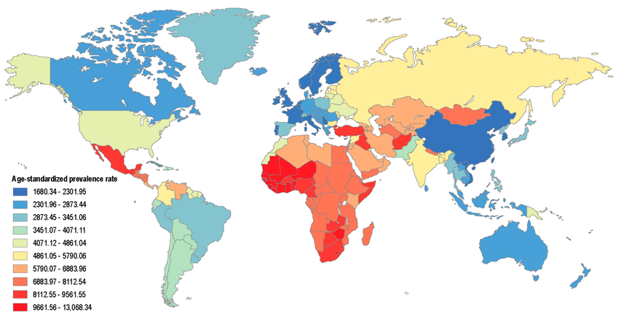
Fig. 2.1: Worldwide age-standardized CKD prevalence per 100,000 populations [8].

2.2 The Role of Artificial Intelligence in Healthcare
Artificial Intelligence (AI) refers to computational systems capable of performing tasks that typically require human intelligence, including reasoning, learning, and problem-solving [10]. AI's transformative role in healthcare is fueled by the explosion of digital health data—ranging from structured electronic health records (EHRs) to imaging, laboratory values, and genomics . Traditional statistical approaches struggle to process and extract insights from this heterogeneous, high-dimensional data. AI, through its subfields of machine learning (ML) and deep learning (DL), offers more flexible and scalable solutions [11].
Applications of AI in medicine include early disease detection, treatment recommendation, clinical decision support, medical image interpretation, and patient risk stratification. In the context of CKD, AI can be used to develop models that identify hidden patterns in clinical variables such as blood pressure, hemoglobin, serum creatinine, and comorbidities, enabling timely diagnosis and better patient management.
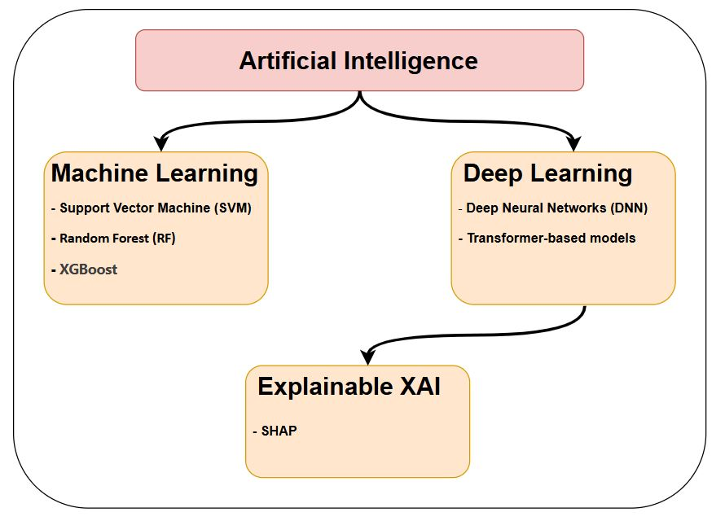
Fig. 2.2: Core AI technologies between ML, DL and their role in CKD classification.

2.3 Machine Learning for CKD Classification
Machine Learning (ML) is a subset of AI that involves training algorithms to learn from labeled data and make predictions or classifications[10]. In CKD classification, ML helps predict whether a patient has CKD based on historical clinical data. This process uses supervised learning, which includes two main phases:
- Training Phase: The algorithm is trained on a dataset where the outcome (CKD or Not CKD) is known.
- Testing/Validation Phase: The trained model is tested on new data to evaluate its accuracy.
Key ML Models Used:
- Support Vector Machine (SVM): Creates a decision boundary called a hyperplane to separate classes (CKD vs. non-CKD). For non-linear problems, SVM applies kernels like Radial Basis Function (RBF). A support vector classifier can be defined by the following function:

$$f\left(x\right)=β_{0}+\sum_{i∈S}{α_{i}K\left(x_{i},x\right)}$$
Where:
- 𝛽𝑜= Bias
- S= Set of observations
- α= Model parameters that have to be learned
- K: Kernel (e.g., RBF)
Margin (M) is the distance between the separating hyperplane and the closest data point:
$M= \frac{2}{||ω||}$

Hinge Loss Function used for training:
Loss(y,$f\left(x\right))=max⁡(0, 1-y.f\left(x\right))$
- Random Forest (RF): is an ensemble learning method that constructs multiple decision trees during the training phase, each built independently from a random subset of the dataset using a bootstrapping method (sampling with replacement). Each individual decision tree makes predictions independently, and the final classification decision is determined through a majority voting mechanism or by averaging the predictions for regression tasks. By aggregating the results of these independently trained trees, RF significantly enhances predictive accuracy and reduces the risk of overfitting compared to single-tree classifiers [20]. The prediction function of RF can be mathematically represented as follows:
$$f^{'}= \frac{1}{B} \sum_{b=1}^{B}{f_{b}}(x)$$
Where:
  - B: Total number of trees
  - $f_{b}\left(x\right)$: Output of the b-th decision tree
The diversity among trees is enhanced by randomly selecting a subset of features at each split within the tree. This randomness ensures low correlation among the individual trees, enhancing the overall robustness and stability of the model [21, 22].
- XGBoost (Extreme Gradient Boosting): Is an optimized implementation of gradient boosting that sequentially builds decision trees. Unlike Random Forests, XGBoost improves predictions iteratively by training each subsequent tree to correct the residual errors of the preceding trees. XGBoost applies a gradient descent algorithm with second-order Taylor expansion, which uses both the first and second derivatives of the loss function, significantly improving convergence speed and accuracy [23].
Mathematically, the XGBoost objective function can be described as follows:
$$Obj= \sum_{i=1}^{n}{l(y_{i} ,y_{i}^{^}})+ \sum_{K=1}^{K}{Ω(f_{k} })$$

Where:
  - l: Loss function (e.g., logistic)
  - 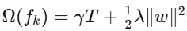: Regularization to reduce overfitting

This iterative, residual-based learning approach enables XGBoost to effectively capture complex, nonlinear relationships in structured data, making it suitable for clinical classification tasks such as CKD detection [24, 25].

Model Selection Justification
We prioritized SVM for its effectiveness in high-dimensional spaces and its clear margin interpretation. RF was chosen for its robustness to noisy clinical data and its inherent ability to handle missing values, which are common challenges in EHR data. XGBoost was selected for its consistently superior performance and high computational efficiency on structured tabular data, establishing a powerful modern baseline for comparison.
Table 2.3: Comparison of ML Models for CKD Classification
Model | Strengths | Weaknesses | Clinical Relevance
SVM | Clear margin interpretation kernel tricks | Sensitive to hyperparameters | Interpretable decision rules
RF | Handles missing data  feature importance | Slower inference | Identifies key biomarkers
XGBoost | Best accuracy  handles imbalanced data | Requires tuning | Scalable for large datasets

2.4 Deep Learning for CKD Classification
Deep Learning (DL) uses artificial neural networks with multiple layers to learn abstract representations from data. It is effective in capturing complex, non-linear relationships in clinical datasets.
DL Models Used:
- Deep Neural Networks (DNN): Consist of multiple hidden layers that transform input features into high-level patterns. The network learns weights and biases through backpropagation to minimize prediction error.
- Transformer-Based Models: Utilize attention mechanisms to weigh the importance of different features in the data. Originally designed for NLP, transformers are now applied to tabular healthcare data due to their ability to model feature interactions and long-range dependencies. The core mechanism is the self-attention function:
$$Attention\left(Q,K,V\right)=softmax\left(\frac{QK^{t}}{\sqrt{d_{k}}}\right)V$$
Where:
- $Q,K,V$: Query, Key, Value matrices derived from input
- $d_{k}$: Dimension of the key vectors
These models offer high flexibility and performance in learning patterns across patient variables and timelines.

DL vs. ML Trade-offs
DL models (e.g., DNNs) excel at capturing complex interactions but are computationally expensive and less interpretable. Their "data-hungry" nature means they require large datasets to perform well and avoid overfitting, where the model learns the training data too well but fails to generalize to new data. We include them to benchmark against ML, as on moderately sized datasets, well-tuned tree-based methods like XGBoost can sometimes outperform them.

Table 2.4: DL Model Comparison
Model | Advantages | Limitations | When to Use
DNN | Learns non-linear hierarchies | Requires large data | Complex feature interactions
TabTransformer | Handles categorical relationships | High computational cost | High-cardinality categorical data

2.5 Explainable AI with SHAP
Explainable Artificial Intelligence (XAI) refers to methods that make the predictions of machine learning models interpretable and transparent. One widely used approach is SHAP (SHapley Additive exPlanations), grounded in cooperative game theory[17].
SHAP Key Characteristics:
- Model-Agnostic: Applicable to any black-box model (RF, DNN, XGBoost, etc.)
- Local Interpretability: Explains predictions for individual instances, showing which features contributed to a single patient's risk score.
- Global Interpretability: Ranks features by average contribution across the dataset, revealing the most important factors the model has learned overall.
SHAP computes the contribution of each feature by comparing the prediction with and without the feature using Shapley values. The formula for SHAP value of a feature $i$ is:

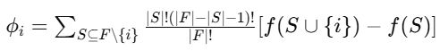
Where:
- F: Set of all features
- S: Subset of features excluding
- $f(S)$: Model prediction based on subset
This approach is crucial for clinical acceptance, as it allows practitioners to trace AI decisions to specific clinical variables.

2.6 Evaluation Metrics and Confusion Matrix
To evaluate the performance of ML/DL models in classifying CKD, we use the following metrics derived from the confusion matrix:
- True Positive (TP): Patient has CKD and the model correctly predicts CKD.
- True Negative (TN): Patient does not have CKD and the model correctly predicts non-CKD.
- False Positive (FP): Patient does not have CKD but the model predicts CKD.
- False Negative (FN): Patient has CKD but the model predicts non-CKD.
A confusion matrix allows us to compute multiple evaluation metrics that provide a more comprehensive picture of a model’s performance. Below are the key metrics derived from confusion matrix data:
 | Predicted Positive | Predicted Negative
Actual Positive | TP | FN
Actual Negative | FP | TN
True Positive (TP): Cases where the model correctly predicts the positive class.
False Positive (FP): Cases where the model incorrectly predicts the positive class (Type 1 error).
True Negative (TN): Cases where the model correctly predicts the negative class.
False Negative (FN): Cases where the model incorrectly predicts the negative class (Type 2 error).

Evaluation Metrics:
Accuracy: Overall correctness of the model.
Accuracy = $\frac{TP+TN}{TP+TN+FP+FN}$
- Precision: Measures how many of the positive predictions were actually correct. This metric is particularly important when minimizing false positives is crucial such as how many predicted CKD cases were actually CKD.
Precision = $\frac{TP}{TP+FP}$
- Recall (Sensitivity): Shows how well the model identifies all relevant positive cases. It is important in scenarios where missing a positive case is costly, like diagnosing diseases.
Recall = $\frac{TP}{TP+FN}$
- F1-Score: The harmonic mean of precision and recall, providing a balance between both metrics.
F1 = $2× \frac{Precision × Recall}{Precision + Recall}$
- Specificity: Measures how well the model identifies negative cases. It’s especially relevant in medical diagnosis, where we want to avoid false positives. Such as ability to correctly identify non-CKD cases.
Specificity = $\frac{TN}{TN+FP}$
- AUC-ROC: Measures the model's ability to discriminate between classes across all probability thresholds.
These metrics provide a comprehensive view of model performance, especially important when dealing with class imbalance such as in medical datasets.

2.7 Summary
This chapter provided a detailed background on CKD and its impact, followed by a comprehensive explanation of the machine learning and deep learning approaches used in this research. It described the classification task, relevant models (SVM, RF, XGBoost, DNNs, Transformers), and the explainability technique SHAP. Mathematical formulations were presented for SVM, Random Forest, XGBoost, Transformer attention, and SHAP, along with evaluation metrics and their practical meaning. The confusion matrix structure was included to illustrate classification performance. The chapter also emphasized the importance of using transparent AI solutions in clinical settings.
The next chapter will describe the methodology used to preprocess the data, train models, and validate results.

References

References
- National Institute of Diabetes and Digestive and Kidney Diseases (NIDDK). (2018). What is chronic kidney disease? U.S. Department of Health and Human Services.
- Sarnak, M. J., Levey, A. S., Schoolwerth, A. C., Coresh, J., Culleton, B., Hamm, L. L., ... & Kasiske, B. (2003). Kidney disease as a risk factor for development of cardiovascular disease: a statement from the American Heart Association Councils on Kidney in Cardiovascular Disease, High Blood Pressure Research, Clinical Cardiology, and Epidemiology and Prevention. Circulation, 108(17), 2154-2169.
- Chen, T. K., Knicely, D. H., & Grams, M. E. (2019). Chronic kidney disease diagnosis and management: A review. JAMA, 322(13), 1294–1304.
- Jager, K. J., Kovesdy, C., Langham, R., Rosenberg, M., Jha, V., & Zoccali, C. (2019). A single number for advocacy and communication—worldwide more than 850 million individuals have kidney diseases. Kidney International, 96(5), 1048–1050.
- GBD Chronic Kidney Disease Collaboration. (2020). Global, regional, and national burden of chronic kidney disease, 1990–2017: a systematic analysis for the Global Burden of Disease Study 2017. The Lancet, 395(10225), 709–733.
- Go, A. S., Chertow, G. M., Fan, D., McCulloch, C. E., & Hsu, C. Y. (2004). Chronic kidney disease and the risks of death, cardiovascular events, and hospitalization. New England Journal of Medicine, 351(13), 1296–1305.
- Kent, S., Jha, V., & Caskey, F. (2023). Global economic burden associated with chronic kidney disease: A pragmatic review of medical costs for the Inside CKD research programme. Advances in Therapy, 40(11), 4725-4743.
- Bikbov, B., Purcell, C. A., Levey, A. S., Smith, M., Abdoli, A., Abebe, M., ... & Vos, T. (2020). Global, regional, and national burden of chronic kidney disease, 1990–2017: A systematic analysis for the Global Burden of Disease Study 2017. The Lancet, 395(10225), 709–733. https://doi.org/10.1016/S0140-6736(20)30045-3
- Topol, E. J. (2019). High-performance medicine: The convergence of human and artificial intelligence. Nature Medicine, 25(1), 44–56.
- Davenport, T., & Kalakota, R. (2019). The potential for artificial intelligence in healthcare. Future Healthcare Journal, 6(2), 94–98.
- Russell, S. J., & Norvig, P. (2020). Artificial intelligence: A modern approach (4th ed.). Pearson.
- Esteva, A., Robicquet, A., Ramsundar, B., Kuleshov, V., DePristo, M., Chou, K., ... & Dean, J. (2019). A guide to deep learning in healthcare. Nature Medicine, 25(1), 24-29.
- LeCun, Y., Bengio, Y., & Hinton, G. (2015). Deep learning. Nature, 521(7553), 436–444.
- Ravì, D., Wong, C., Deligianni, F., Berthelot, M., Andreu-Perez, J., Lo, B., & Yang, G. Z. (2017). Deep learning for health informatics. IEEE Journal of Biomedical and Health Informatics, 21(1), 4-21.
- Saif, D., Sarhan, A. M., & Elshennawy, N. M. (2024). Deep-kidney: an effective deep learning framework for chronic kidney disease prediction. Health Information Science and Systems, 12(3).
- Holzinger, A., Langs, G., Denk, H., Zatloukal, K., & Müller, H. (2019). Causability and explainability of artificial intelligence in medicine. Wiley Interdisciplinary Reviews: Data Mining and Knowledge Discovery, 9(4), e1312.
- Amann, J., Blasimme, A., Vayena, E., Frey, D., & Madai, V. I. (2020). Explainability for artificial intelligence in healthcare: a multidisciplinary perspective. BMC Medical Informatics and Decision Making, 20(1), 310.
- Lundberg, S. M., & Lee, S. I. (2017). A unified approach to interpreting model predictions. In Advances in Neural Information Processing Systems, 30.
- Kidney Disease: Improving Global Outcomes (KDIGO) CKD Work Group. (2024). KDIGO 2024 Clinical Practice Guideline for the Evaluation and Management of Chronic Kidney Disease. Kidney International, 105(4S), S117–S314.
- Sabanayagam, C., Banu, R., Lim, C., et al. (2025). Artificial intelligence in chronic kidney disease management: a scoping review. Theranostics, 15(10), 4566–4578.
- LeCun, Y., Bengio, Y., & Hinton, G. (2015). Deep learning. Nature, 521(7553), 436–444. https://doi.org/10.1038/nature14539
- Goodfellow, I., Bengio, Y., & Courville, A. (2016). Deep learning. MIT press.
- Vaswani, A., Shazeer, N., Parmar, N., Uszkoreit, J., Jones, L., Gomez, A. N., Kaiser, Ł., & Polosukhin, I. (2017). Attention is all you need. Advances in Neural Information Processing Systems, 30, 5998–6008.
- Song, X., Wu, Y., & Yan, Y. (2023). TabTransformer: Tabular Data Modeling Using Contextual Attention. arXiv preprint arXiv:2012.06678. https://arxiv.org/abs/2012.06678
- Lundberg, S. M., & Lee, S.-I. (2017). A unified approach to interpreting model predictions. Advances in Neural Information Processing Systems, 30, 4765–4774.
- Molnar, C. (2022). Interpretable machine learning: A Guide for Making Black Box Models Explainable. Independently published.

