
Midocean University
College of Management

TRANSFORMING OUTPATIENT PHARMACY OPERATIONS: AN APPLIED CASE STUDY IN QUALITY IMPROVEMENT THROUGH WORKFLOW OPTIMIZATION, AUTOMATION, AND CHANGE MANAGEMENT

By: Abdullah Saleh ALOMRAN

No.
243001904

Main Supervisor | Second Supervisor
Dr.Alfaisal Abdelhameed Mohamed | Dr.Fayez Ali Jrad

2025

جامعة ميد أوشن
كلية الإدارة

تحويل عمليات الصيدليات الخارجية: دراسة حالة تطبيقية في تحسين الجودة من خلال تحسين سير العمل والأتمتة وإدارة التغيير

الطالب/ عبدالله بن صالح العمران

243001904

المشرف الثاني | المشرف الرئيسي
د.فايز علي جراد | د. الفيصل عبدالحميد محمد

العام الجامعي
2025

Copyright notice
All rights to this thesis are reserved by Midocean University.
No part may be used, reproduced, or distributed without prior permission from the University.

حقوق الطباعة
جميع حقوق هذا البحث محفوظة لجامعة ميدأوشن، ولا يجوز استخدامه أو إعادة نشره أو توزيعه إلا بإذن مسبق من الجامعة.

Abstract
Outpatient pharmacy services in tertiary hospitals face persistent operational challenges that undermine efficiency and patient experience, such as prolonged waiting times and poorly coordinated workflows. This study aimed to evaluate the impact of a comprehensive set of management-driven interventions guided by change management and quality improvement principles within the context of business administration.
A quasi-experimental pre–post design was applied using operational data from more than 20,000 outpatient prescriptions over a four-month period. The interventions included pre-verification of prescriptions to enhance operational efficiency and safety, queue management to reduce bottlenecks and improve service flow, and automation (robotic dispensing systems) to increase productivity and minimize dispensing errors. To ensure sustainability, Kotter’s Eight-Step Change Model was employed, emphasizing the creation of urgency, leadership alignment, stakeholder engagement, and cultural integration of change.
The results demonstrated a 55.6% reduction in average patient waiting time, sustained over 13 consecutive weeks (p < 0.001; Cohen’s d = 2.18). Beyond measurable efficiency gains, the interventions improved workforce utilization, enhanced stakeholder collaboration, and reinforced organizational alignment across pharmacy and administrative units.
This study offers a replicable business-oriented model that integrates operations management and change management into a coherent framework. It highlights how structured workflow redesign, supported by systematic change leadership, can drive sustainable improvements in high-volume healthcare service environments. The findings underscore the strategic role of organizational leadership in guiding transformation, achieving long-term impact, and delivering tangible value to healthcare organizations.
الملخص
تواجه خدمات الصيدليات الخارجية في المستشفيات المرجعية تحديات تشغيلية تعيق الكفاءة وتجربة المريض، مثل طول فترات الانتظار وضعف تنظيم تدفق العمل. هدفت هذه الدراسة إلى تقييم أثر تطبيق مجموعة متكاملة من التدخلات الإدارية المستندة إلى مبادئ إدارة التغيير وتحسين الجودة، في إطار ماجستير إدارة الأعمال.
اعتمدت الدراسة تصميمًا شبه تجريبي (قبل وبعد التدخل) على أكثر من 20,000 وصفة طبية خلال أربعة أشهر. وشملت التدخلات الرئيسة: التحقق المسبق من الوصفات كآلية لتعزيز الكفاءة التشغيلية وسلامة العمليات، تنظيم الطوابير لمعالجة الاختناقات وتحسين تدفق العملاء، والأتمتة (الصرف الآلي للأدوية) لرفع الإنتاجية وتقليل الأخطاء. ولضمان الاستدامة، تم تطبيق نموذج كوتر للتغيير المكوّن من ثماني خطوات، بما في ذلك بناء الحاجة الملحّة، تشكيل فرق القيادة، تعزيز المشاركة، وتثبيت التحسينات في الثقافة التنظيمية.
أظهرت النتائج انخفاض متوسط وقت الانتظار بنسبة 55.6٪ واستمرار التحسن لـ 13 أسبوعًا متتالية (p < 0.001؛ Cohen’s d = 2.18). وأسهمت التدخلات في تحسين كفاءة الموارد البشرية، وزيادة رضا المستفيدين، وتعزيز التوافق التنظيمي بين الإدارات المعنية.
تقدم الدراسة نموذجًا تطبيقيًا قابلًا للتكرار يدمج بين إدارة العمليات وإدارة التغيير وفق منظور الأعمال، مما يبرهن على أن إعادة تصميم سير العمل مع دعم تنظيمي منظم يمكن أن يقود إلى تحسينات مستدامة في بيئات تقديم الخدمات عالية الكثافة. وتؤكد النتائج على أهمية الدور القيادي والاستراتيجي في توجيه التغيير وتحقيق قيمة مضافة للمنظمات الصحية.

Acknowledgement

All praise and thanks are due to Allah Almighty for granting me the strength and guidance to complete this research.
My deepest gratitude goes to my supervisors for their dedicated efforts, constructive guidance, and academic support, which had a profound impact on the accomplishment of this work.
I also extend my sincere thanks to the administration of the college and university for providing the academic and administrative support that created a suitable environment for this study.
Above all, I am profoundly grateful to my beloved family for their patience, continuous support, and constant encouragement, without which this achievement would not have been possible.

شكر وتقدير
الحمد لله أولاً وآخراً على توفيقه وفضله الذي يسّر لي إتمام هذا البحث.
أتقدم بخالص الشكر وعظيم الامتنان لمشرفي الكرام على ما بذلوه من جهد وما قدموه من توجيهات بنّاءة وإرشادات علمية كان لها أعظم الأثر في إنجاز هذا العمل.
كما أشكر إدارة الكلية والجامعة على ما وفرته من دعم أكاديمي وإداري أسهم في تهيئة البيئة المناسبة لإتمام الدراسة.
وأخص بالذكر أسرتي العزيزة، التي منحتني الصبر والدعم المتواصل والتشجيع الدائم، فلولاهم بعد الله لما تحقق هذا الإنجاز.

Table of Contents
1. CHAPTER 1: INTRODUCTION 1
1.1. Background and Context 1
1.2. Problem Statement 1
1.3. Purpose and Significance 2
1.4. Research Questions and Hypotheses 2
1.4.1. Research Questions 3
1.4.2. Hypotheses 3
1.5. Theoretical Foundation 3
1.6. Scope and Delimitations 4
1.7. Assumptions 4
1.8. Dissertation Structure 4
1.9. Definition of Terms 4
2. CHAPTER 2: LITERATURE REVIEW 6
2.1. Introduction 6
2.2. Early Advanced Verification and Patient Waiting Time 6
2.2.1. Theoretical Foundations of Verification Timing 6
2.2.2. Empirical Evidence on Verification Impact 6
2.2.3. Contextual Factors Moderating Verification Effects 7
2.2.4. Gaps in Verification Literature 7
2.3. Queue Synchronization and Workflow Efficiency 7
2.3.1. Queue Management Theory in Healthcare 7
2.3.2. Evidence on Queue Synchronization Systems 7
2.3.3. Implementation Challenges and Failures 8
2.4. Automation and Robotic Dispensing 8
2.4.1. Evolution of Pharmacy Automation 8
2.4.2. Empirical Evidence on Automation Impact 8
2.4.3. Automation Failures and Lessons Learned 9
2.5. Change Management and Sustainable Transformation 9
2.5.1. Change Management Frameworks in Healthcare 9
2.5.2. Evidence on Structured Change Management 9
2.6. Integration and Synthesis 10
2.6.1. Interactions among Interventions 10
2.6.2. Methodological Limitations in Existing Literature 10
2.7. Gaps in the Literature 10
2.8. Conclusion 11
3. CHAPTER 3: THEORETICAL AND RESEARCH FRAMEWORK 12
3.1. Introduction 12
3.2. Quality Improvement Science Foundations 12
3.2.1. The Model for Improvement 12
3.2.2. Rapid Iteration and Learning Dynamics 12
3.2.3. Statistical Process Control and System Thinking 12
3.3. Operational and Process Frameworks 13
3.3.1. Lean Principles in Healthcare 13
3.3.2. Six Sigma and Variation Reduction 13
3.3.3. Theory of Constraints 13
3.3.4. Queueing Theory Applications 13
3.4. Change Management Theoretical Frameworks 14
3.4.1. Kotter’s 8-Step Change Model 14
3.4.2. Critiques and Adaptations 14
3.4.3. Socio-Technical Systems Theory 14
3.5. Integrated Conceptual Framework 14
3.6. Research Model and Measurement Framework 15
3.7. Conclusion 16
4. CHAPTER 4: METHODOLOGY 17
4.1. Introduction 17
4.2. Setting and Context 17
4.3. Study Design 17
4.3.1. Research Questions and Hypotheses 18
4.3.2. Operationalization of Hypotheses 19
4.4. Interventions 19
4.4.1. Advanced Prescription Verification 20
4.4.2. Queue Synchronization ("Call When Ready") 21
4.4.3. Automation and Robotics Optimization 21
4.4.4. Change Management Using Kotter's 8-Step Model 21
4.5. Data Collection 21
4.5.1. Descriptive Statistics 22
4.5.2. Inferential Statistics 22
4.5.3. Regression Analysis 22
4.5.4. Statistical Process Control 23
4.5.5. Sensitivity Analysis 23
4.6. Ethical and Governance Considerations 23
4.7. Limitations of the Methodology 23
4.8. Conclusion 24
5. CHAPTER 5: RESULTS 25
5.1. Introduction 25
5.2. Sample Characteristics and Baseline Performance 25
5.3. RQ1: Impact of Advanced Prescription Verification 25
5.3.1. Primary Outcomes: Waiting Time Reduction 26
5.3.2. Day-of-Week Analysis 27
5.4. RQ2: Queue Synchronization and Workflow Efficiency 30
5.4.1. False Call Reduction 30
5.4.2. Workflow Efficiency Improvements 31
5.4.3. Patient Throughput Analysis 31
5.5. RQ3: Automation and Systems Integration Impact 31
5.5.1. Automation Utilization Improvements 32
5.5.2. Stock Availability and Inventory Management 32
5.5.3. Staff Productivity Gains 32
5.6. RQ4: Change Management and Sustainability Indicators 32
5.6.1. Stakeholder Adoption Rates 32
5.6.2. Standard Operating Procedure Compliance 33
5.6.3. Performance Sustainability 33
5.7. Sensitivity and Robustness Analyses 34
5.7.1. Bootstrap Confidence Intervals 34
5.7.2. Outlier Analysis 34
5.7.3. Seasonal and Workload Adjustments 34
5.8. Process Capability Analysis 35
5.9. Integrated Findings 35
5.9.1. Synergistic Effects Analysis 35
5.9.2. Cost–Benefit Implications 35
5.10. Summary 35
5.11. Hypothesis Testing Summary 36
6. CHAPTER 6: DISCUSSION 37
6.1. Introduction 37
6.2. Linking Findings to Research Questions 37
6.2.1. Advanced Prescription Verification (RQ1) 37
6.2.2. Queue Synchronization (RQ2) 37
6.2.3. Automation and Systems Integration (RQ3) 38
6.2.4. Change Management and Sustainability (RQ4) 38
6.3. Interpretation of Primary Findings 38
6.3.1. Magnitude of Improvement: Transformational vs. Incremental 38
6.3.2. Synergistic Effects: Beyond Additive Improvements 39
6.3.3. Sustainability: Evidence for Genuine Transformation 39
6.4. Integration of Findings 39
6.4.1. Socio-Technical Systems Optimization 39
6.4.2. Operations Research in Healthcare 40
6.4.3. Cultural Context in Middle Eastern Healthcare 40
6.5. Theoretical Implications 40
6.5.1. Healthcare Operations Theory 40
6.5.2. Quality Improvement Science 40
6.5.3. Change Management Theory 41
6.6. Financial and Resource Implications 41
6.7. Limitations 41
6.7.1. Design and Methodological Limitations 41
6.7.2. Measurement and Data Limitations 42
6.7.3. Contextual and Cultural Limitations 42
6.8. Implications for Practice 42
6.8.1. Implementation Framework for Healthcare Managers 42
6.8.2. Policy and Strategic Implications 42
6.8.3. Technology and Automation Strategy 43
6.9. Chapter Summary 43
7. CHAPTER 7: CONCLUSION AND RECOMMENDATIONS 44
7.1. Introduction 44
7.2. Summary of Key Findings 44
7.2.1. Research Contributions 44
7.2.2. Theoretical Validation 44
7.2.3. Cultural and Contextual Insights 45
7.3. Practical Recommendations 45
7.4. Policy and Future Research Directions 45
7.5. Concluding Remarks 46
8. REFERENCES 47
9. APPENDICES 54

LIST OF TABLES
Table ‎3.1: Measurement Framework 15
Table ‎4.1: Study Timeline and Phases 18
Table ‎4.2: Operationalization of Research Hypotheses 19
Table ‎4.3: Detailed Intervention Specifications 20
Table ‎4.4: Comprehensive Data Collection Framework 22
Table ‎5.1: Sample Characteristics and Baseline Performance 25
Table ‎5.2: Waiting Time Analysis – Advanced Verification Impact 26
Table ‎5.3: Queue Synchronization Performance Metrics 30
Table ‎5.4: Automation and Productivity Metrics 32
Table ‎5.5: Change Management and Sustainability Metrics 33
Table ‎5.6: Process Capability Analysis 35

LIST OF FIGURES
Figure ‎5.1: Daily Waiting Time Trends – Pre vs Post Intervention 27
Figure ‎5.2: Mean waiting times by day of week comparing pre-intervention (red bars) and post-intervention (green bars) periods. Horizontal line indicates 30-minute target threshold. 27
Figure ‎5.3: Sunday average waiting time distribution comparing pre-intervention and post-intervention periods. 28
Figure ‎5.4: Monday Average waiting time distribution comparing pre-intervention and post-intervention periods 28
Figure ‎5.5: Tuesday Average waiting time distribution comparing pre-intervention and post-intervention periods 29
Figure ‎5.6: Wednesday Average waiting time distribution comparing pre-intervention and post-intervention periods 29
Figure ‎5.7: Thursday Average waiting time distribution comparing pre-intervention and post-intervention periods 30
Figure ‎5.8: Weekly Average Waiting Time Trends 31
Figure ‎5.9: SOP Compliance Trend (Weeks 20-28) 33
Figure ‎5.10: Waiting Time Distribution – Pre vs Post Intervention 34

LIST OF APPENDICES
Appendix A: Sample Outpatient Pharmacy KPI Report 54
Appendix B: SOP Compliance Audit table 55
Appendix C: SOP Compliance Audit Checklist 56
Appendix D:APPLICATION for QUALITY IMPROVEMENT PROJECT……………….. 57

CHAPTER 1: INTRODUCTION

Background and Context
Healthcare delivery systems worldwide face mounting pressure to balance operational efficiency with patient-centered care, a challenge that is particularly acute in outpatient pharmacy services where clinical precision meets customer service expectations. These facilities represent critical touchpoints in the patient journey, yet they consistently rank among the lowest in satisfaction scores due to prolonged waiting times and service unpredictability (Gupta et al., 2017; Smith et al., 2020; Warholak & Rupp, 2009; Zhou et al., 2017). The convergence of aging populations, polypharmacy trends, and increasing prescription complexity has transformed outpatient pharmacies from simple dispensing points into complex operational systems that require sophisticated management approaches (Chui, Look, & Mott, 2014; Franklin & Hibberd, 2021).
In Saudi Arabia, these universal challenges intersect with ambitious national transformation objectives. Vision 2030 explicitly prioritizes healthcare modernization through digital transformation, operational excellence, and an enhanced patient experience (Saudi Ministry of Health, 2019). The Kingdom's healthcare sector, which is undergoing rapid expansion and modernization, presents both unprecedented opportunities and substantial challenges for operational improvement. Within this context, outpatient pharmacies serve as microcosms of broader systemic transformation needs, where successful interventions can demonstrate the potential for scalability across the healthcare enterprise (Cresswell & Sheikh, 2013; Portela et al., 2015).
The tertiary hospital pharmacy examined in this study exemplifies these challenges. Located in Saudi Arabia's central region, this facility processes 600-700 prescriptions daily while serving diverse patient populations, including elderly, pediatric, and special needs patients. Despite substantial infrastructure investments—including robotic dispensing systems, electronic prescription management, and digital queue displays—baseline performance metrics revealed persistent operational failures. Mean waiting times of 51.54 minutes substantially exceeded the institutional target of 30 minutes, while service unpredictability created additional patient frustration and staff stress. This performance gap between technological capability and operational reality suggests that technology adoption without corresponding process redesign and cultural transformation yields limited benefits.

Problem Statement
The operational challenge addressed in this study centers on three interconnected failures in outpatient pharmacy service delivery that collectively produce unacceptable patient experiences and system inefficiencies.
To begin with, the temporal dimension of the failure manifests in excessive waiting times, which average 51.54 minutes against a 30-minute institutional target. This 71.8% exceedance of the target represents not merely statistical underperformance but also tangible patient suffering, appointment cascades, and parking complications that amplify throughout the healthcare system. The coefficient of variation, which reaches 22.9%, indicates a level of service unpredictability that prevents patients from planning their pharmacy visits effectively, creating anxiety and frustration that are independent of the absolute waiting duration.
Additionally, the process dimension reveals a fundamental misalignment of the workflow. Prescription verification occurs predominantly at the point of service rather than upstream, which creates bottlenecks when clinical clarifications are required. The queue management system operates independently of medication readiness, summoning patients before their prescriptions are prepared. These process failures create rework loops, staff frustration, and the perception of organizational incompetence, despite the competence of individual staff members.
Furthermore, the technological dimension exposes unrealized automation potential. Despite significant capital investments in robotic dispensing systems and integrated pharmacy management software, these technologies remain underutilized due to workflow misalignment, insufficient training, and cultural resistance. The robot processes only 45% of eligible prescriptions, while manual workarounds persist for tasks that the system was designed to automate.
The convergence of these failures creates a vicious cycle: excessive waiting generates patient complaints, which in turn pressure staff to rush, increasing the potential for errors and requiring additional verification steps that further extend waiting times. Breaking this cycle requires a comprehensive intervention that addresses all three dimensions simultaneously, rather than isolated improvements that merely shift bottlenecks.

Purpose and Significance
This study aims to demonstrate that the systematic application of operations management principles, integrated with appropriate technology optimization and structured change management, can achieve transformational rather than incremental improvements in outpatient pharmacy performance. The research specifically examines whether bundled interventions—combining process redesign, technology enablement, and cultural change—generate synergistic effects that exceed the benefits of their individual components.
The significance of this investigation extends across multiple dimensions:
Theoretical Significance: This study tests whether established operations research frameworks can be translated effectively to healthcare contexts, particularly in Middle Eastern settings where empirical evidence remains limited. By examining the interaction between technical and cultural interventions, the research contributes to the understanding of socio-technical systems in healthcare operations. The exceptional effect sizes observed challenge prevailing assumptions about the limits of improvement in healthcare processes.
Practical Significance: The research provides pharmacy managers with an evidence-based implementation framework that includes specific metrics, milestone indicators, and risk mitigation strategies. The bundled intervention approach offers a replicable model that can be adapted to varying technological and resource contexts. The documentation of both successes and challenges provides realistic expectations for similar transformation initiatives.
Strategic Significance: The alignment with Vision 2030 objectives demonstrates how operational excellence at the departmental level can contribute to national healthcare transformation goals. The study provides quantitative evidence to support business cases for investments in process improvement, addressing the perpetual challenge of justifying quality improvement resources in resource-constrained environments.
Methodological Significance: The application of rigorous statistical analysis—including effect sizes, process capability indices, and robustness checks—to operational improvements that are typically evaluated descriptively advances the methodological sophistication of pharmacy operations research. The evaluation framework integrates quantitative metrics with structured change management assessment, providing comprehensive insights into operational and organizational transformation.

Research Questions and Hypotheses
To achieve the objectives of this study, the following research questions were formulated:

Research Questions
- How does the implementation of advanced prescription verification affect prescription accuracy, patient safety, and pharmacist verification efficiency in the outpatient pharmacy?
- What is the impact of queue synchronization on patient waiting times, service flow, and throughput efficiency in outpatient pharmacy operations?
- To what extent do automation (robotic dispensing) and Pharmacy Information System integration contribute to reducing dispensing errors and enhancing service capacity in a tertiary hospital?
- How does structured change management, guided by Kotter’s 8-Step Change Model, support the adoption, stakeholder engagement, and long-term sustainability of workflow improvements in pharmacy practice?
These research questions reflect a deliberate progression: RQ1–RQ3 examine technical interventions, while RQ4 addresses the organizational enabler of change management. This structure acknowledges that sustainable healthcare improvement depends not only on optimizing operational mechanics but also on strengthening human and organizational dynamics.

Hypotheses
- H1: Advanced prescription verification significantly improves prescription accuracy and reduces pharmacist verification time.
- H2: Queue synchronization significantly decreases average patient waiting times and improves service flow in the outpatient pharmacy.
- H3: Automation (robotic dispensing) and Pharmacy Information System integration significantly reduce dispensing errors and increase throughput capacity.
- H4: Structured application of Kotter’s 8-Step Change Model significantly enhances stakeholder buy-in and sustains performance improvements over time

Theoretical Foundation
This study draws upon three complementary theoretical traditions that collectively provide a comprehensive framework for understanding and implementing operational improvements in pharmacies.
Quality Improvement Science provides the overarching methodological framework through the Institute for Healthcare Improvement's Model for Improvement (Langley et al., 2009). This model's three fundamental questions—What are we trying to accomplish? How will we know that a change is an improvement? What changes can we make that will result in improvement?—structure the intervention design and evaluation approach. The rapid iterative improvement (weekly huddles and SPC monitoring) methodology enables iterative refinement while maintaining scientific rigor.
Operations Research and Systems Theory contributes analytical tools and conceptual models for understanding service delivery systems. Queueing theory elucidates the mathematical relationships between arrival rates, service rates, and waiting times, predicting that a reduction in variability often yields greater benefits than a reduction in the mean (Wagner et al., 2002). Lean principles identify and eliminate non-value-adding activities, while the Six Sigma methodology provides statistical tools for understanding and reducing process variation (de Koning et al., 2006). The Theory of Constraints focuses attention on the system bottlenecks that limit overall throughput.
Organizational Change Theory addresses the human and cultural dimensions that are essential for sustaining technical improvements. Kotter's 8-Step Change Model provides a structured approach for creating urgency, building coalitions, and anchoring changes in the organizational culture (Kotter, 2012). While originally developed for corporate transformations, its applications in healthcare demonstrate successful adaptation to clinical settings (Kruse et al., 2018). Socio-technical systems theory emphasizes that technology, people, and processes must be jointly optimized rather than separately maximized (Carayon et al., 2014).

Scope and Delimitations
Scope: The study encompasses a four-month implementation period from April through July 2025, capturing 75 operational days and 44,580 prescription transactions. The investigation includes all routine outpatient prescriptions processed through the main pharmacy, encompassing diverse patient populations and prescription types. The analysis examines both immediate effects and sustainability indicators, providing insights into both short-term gains and long-term viability.
Delimitations: Several boundaries define the study's focus. First, the investigation is limited to outpatient pharmacy operations, excluding inpatient dispensing, emergency department medications, and specialized clinical pharmacy services. Second, the study focuses on operational metrics rather than clinical outcomes, though safety indicators are monitored. Third, the analysis concentrates on system-level changes rather than individual practitioner variations. Fourth, the timeframe captures seasonal variations but may not reflect longer-term trends or external disruptions.

Assumptions
Several key assumptions underpin this investigation. First, the study assumes that operational data accurately reflect patient experiences and system performance. Second, it assumes that staff behavior changes observed during the study period represent genuine adoption rather than temporary compliance. Third, the analysis assumes that external factors (regulatory changes, competing initiatives, seasonal variations) remain relatively stable during the observation period. Fourth, the study assumes that the Saudi healthcare context provides sufficient similarity to other Middle Eastern settings to enable some generalization while acknowledging cultural and regulatory specificities.

Dissertation Structure
This dissertation is organized into seven chapters that progress logically from theoretical foundations through empirical findings to practical implications. Chapter 1 establishes the research context, problem definition, and theoretical grounding. Chapter 2 reviews existing literature across the four intervention domains, identifying gaps and positioning the current study. Chapter 3 develops the integrated theoretical framework that guides the investigation. Chapter 4 details the methodology, including study design, data collection procedures, and analytical approaches. Chapter 5 presents comprehensive results organized around the four research questions. Chapter 6 interprets findings, explores theoretical implications, and acknowledges limitations. Chapter 7 synthesizes conclusions and provides actionable recommendations for practitioners, policymakers, and researchers.

Definition of Terms
Advanced Prescription Verification: The process of conducting pharmacist clinical review and approval of prescriptions before patient arrival, enabling early identification and resolution of clinical issues, drug interactions, and formulary concerns.
Queue Synchronization: The alignment of patient calling systems with medication readiness, ensuring patients are summoned only when their prescriptions are prepared and ready for collection, thereby reducing false calls and improving flow efficiency.
Automation Optimization: The systematic enhancement of robotic dispensing systems and integrated pharmacy information systems to maximize automated processing, reduce manual interventions, and improve inventory management.
Change Management: The structured application of Kotter's 8-Step Change Model to build organizational readiness, overcome resistance, and sustain operational improvements through cultural transformation.
Bundled Interventions: The coordinated implementation of multiple complementary interventions designed to address different aspects of system performance while generating synergistic effects that exceed the sum of individual components.
Effect Size: A standardized measure of the magnitude of difference between pre- and post-intervention performance, calculated using Cohen's d, providing interpretation of practical significance independent of sample size.
Process Capability: A statistical measure of how well a process performs relative to specification limits, expressed through capability indices (Cp, Cpk) that quantify the relationship between process variation and customer requirements.

CHAPTER 2: LITERATURE REVIEW

Introduction
The challenge of optimizing outpatient pharmacy operations has attracted scholarly attention across multiple disciplines, yet the literature remains fragmented across operations research, healthcare quality improvement, information systems, and organizational behavior domains (Portela et al., 2015; Franklin & Hibberd, 2021). This chapter synthesizes relevant research streams to establish the theoretical and empirical foundations for the current investigation. The review is organized around the four research questions guiding this study: advanced prescription verification, queue synchronization, automation integration, and change management. Each section critically examines existing evidence, identifies methodological strengths and limitations, and highlights gaps that the current study addresses.
The literature search strategy employed multiple databases including PubMed, Web of Science, Scopus, and Business Source Premier, focusing on peer-reviewed publications from 2014-2025. Priority was given to empirical studies in healthcare settings, though seminal theoretical works from operations research and organizational theory provide foundational concepts (Taylor et al., 2014). The search terms combined pharmacy-specific keywords ("outpatient pharmacy," "medication dispensing," "prescription verification") with operational concepts ("waiting time," "queue management," "workflow optimization," "automation") and methodological approaches ("quality improvement," "lean six sigma," "change management").

Early Advanced Verification and Patient Waiting Time

Theoretical Foundations of Verification Timing
The theoretical rationale for advanced prescription verification derives from queuing theory and lean principles. Little's Law establishes that system throughput time equals work-in-process inventory divided by output rate (L = λW), suggesting that reducing work-in-process through upstream verification should decrease overall system time (Cayirli & Veral, 2003; Wagner et al., 2002). Lean manufacturing principles, particularly the concept of "mistake-proofing" (poka-yoke), advocate for error detection at the earliest possible point to prevent downstream waste (de Koning et al., 2006; George, 2002).
Healthcare applications of these principles face unique challenges. Unlike manufacturing, healthcare processes involve high variability in case complexity, regulatory requirements for pharmacist verification, and the need to balance efficiency with safety (Cresswell & Sheikh, 2013). Nevertheless, the theoretical foundation suggests that moving verification upstream should reduce both mean waiting time and process variability (Franklin & Hibberd, 2021).

Empirical Evidence on Verification Impact
Empirical studies present mixed findings regarding advanced verification's impact on waiting times. Schneider et al. (2019) conducted a multi-site study across six U.S. hospitals, finding mean waiting time reductions of 22-31% through prospective verification. Their interrupted time series analysis (n=45,320 prescriptions) demonstrated immediate level changes post-intervention with sustained improvements over 12 months. The study's strength lies in its large sample size and longitudinal design, though the authors acknowledge that concurrent initiatives may have contributed to observed improvements.
Pellegrin et al. (2017) examined overnight verification in a Hawaiian hospital system, reporting reduced morning rush-hour delays (38% reduction, p<0.001) and decreased pharmacist interruptions (2.3 vs. 5.7 per hour, p<0.01). The study's strength lies in its mixed-methods approach, combining time-motion studies with staff interviews revealing that perceived stress reduction exceeded objective time improvements. However, the single-site design and short follow-up period (8 weeks) limit generalizability. While their mixed-methods design combined time-motion studies and staff interviews, the present study focused exclusively on quantitative operational data, ensuring alignment with its methodological scope
Contrasting findings emerge from European contexts. Müller et al. (2018) implemented prospective verification across three German hospitals but found minimal waiting time improvements (7% reduction, p=0.23). The authors attributed limited effects to regulatory constraints requiring dual verification and cultural resistance to workflow changes. This highlights the importance of contextual factors in determining intervention effectiveness (Chen et al., 2020).

Contextual Factors Moderating Verification Effects
Recent systematic reviews highlight contextual factors moderating verification effectiveness. Franklin and Hibberd's (2021) meta-analysis of 23 studies found that verification timing effects depend on prescription complexity, staffing models, technology infrastructure, and patient mix. Studies in high-complexity settings (oncology, pediatrics) showed larger effect sizes (d=0.8-1.2) compared to general medicine (d=0.3-0.5), suggesting that verification benefits increase with prescription complexity.
Staffing models also influence outcomes. Centralized verification models with dedicated pharmacists show greater improvements than distributed models where pharmacists balance verification with clinical duties (Chen et al., 2020). Technology infrastructure moderates effects, with integrated systems enabling greater benefits than standalone verification tools (Cresswell & Sheikh, 2013; Rodriguez & Kim, 2019).

Gaps in Verification Literature
Despite extensive investigation, several gaps persist. First, most studies occur in Western healthcare systems with different regulatory frameworks than Middle Eastern contexts (Al-Rashid & Hassan, 2020). Second, few studies report effect sizes or conduct power analyses, limiting meta-analytic potential (Franklin & Hibberd, 2021). Third, the interaction between verification timing and other interventions remains underexplored (McNicholas et al., 2022). This study addresses these gaps through its Saudi Arabian context, rigorous effect size reporting, and bundled intervention design.

Queue Synchronization and Workflow Efficiency

Queue Management Theory in Healthcare
Queue management in healthcare differs fundamentally from traditional service operations due to captive demand, high stakes, and ethical obligations to serve all patients regardless of profitability (Cayirli & Veral, 2003). The psychology of waiting suggests that occupied time feels shorter than unoccupied time, and fair waits feel shorter than unfair waits (Maister, 1985). These principles have been validated in healthcare contexts, where perceived waiting time often matters more than actual duration for patient satisfaction (Schneider et al., 2019).
Modern service science extends these concepts through the Service-Dominant Logic framework, emphasizing co-creation of value between providers and patients (Vargo & Lusch, 2016). Queue synchronization represents a form of co-creation, where patients receive information enabling better planning while providers gain predictable workflow (Smith et al., 2020).

Evidence on Queue Synchronization Systems
Direct evidence on pharmacy queue synchronization remains limited, requiring extrapolation from adjacent healthcare services. Smith et al. (2020) implemented virtual queuing in outpatient radiology across three UK hospitals (n=18,750 patients). Their randomized controlled trial found that synchronized calling reduced perceived waiting by 42% despite only 11% reduction in actual waiting time. The study demonstrates the psychological benefits of predictable queuing, though the radiology context may not translate directly to pharmacy operations.
In pharmacy-specific research, Gupta et al. (2017) conducted a pilot study in an Indian hospital pharmacy implementing "call-when-ready" systems. The quasi-experimental design (n=3,200 prescriptions) showed modest time reductions (10.3%, p=0.04) but substantial satisfaction improvements (4.2 vs. 3.1 on 5-point scale, p<0.001). The study's limitation lies in its short duration (4 weeks) and single-site design, though the cultural context provides relevant insights for Middle Eastern applications (Al-Rashid & Hassan, 2020).
More robust evidence comes from retail pharmacy chains. Johnson & Associates (2019) analyzed queue synchronization across 127 U.S. pharmacies, finding consistent improvements in customer satisfaction (Net Promoter Score increased from 23 to 41) and reduced complaints (47% decrease). The large-scale implementation provides compelling evidence, though retail contexts may differ from hospital pharmacies in terms of patient acuity and prescription complexity (Franklin & Hibberd, 2021).

Implementation Challenges and Failures
Not all synchronization attempts succeed. Reynolds et al. (2018) documented a failed implementation in a Canadian hospital pharmacy where technical synchronization created new problems. The system generated false readiness signals due to inventory discrepancies, leading to frustrated patients and staff workarounds that undermined the intervention. The failure highlights the importance of data quality and system integration in synchronization success (Rodriguez & Kim, 2019).
Cultural factors also influence synchronization success, as Park and Chen (2020) found when comparing implementations across American, Japanese, and Saudi Arabian healthcare facilities. American sites showed immediate adoption, Japanese sites required extensive consensus-building, and Saudi sites needed hierarchical endorsement. These findings suggest that change management approaches must be culturally adapted (Kruse et al., 2018).

Automation and Robotic Dispensing

Evolution of Pharmacy Automation
Pharmacy automation has evolved through three generations: simple counting devices (1990s), robotic dispensing with barcode verification (2000s), and AI-integrated complete workflow automation (2010s–present) (Goundrey-Smith, 2018). Each generation promised transformational benefits, yet implementation challenges have limited realized gains (Martinez et al., 2019).
Current robotic systems offer sophisticated capabilities including automated dispensing, inventory management, and quality control. However, their effectiveness depends critically on workflow integration, staff training, and organizational readiness (Hübner & Schaal, 2020; Schierbeck et al., 2021).

Empirical Evidence on Automation Impact
Large-scale studies provide compelling evidence for automation benefits when properly implemented. Seerden et al. (2020) conducted a comprehensive evaluation across 15 European hospitals implementing robotic dispensing systems. Their pre–post analysis (n=2.3 million prescriptions) found error rates decreased from 0.9% to 0.2%, dispensing time reduced by 43%, and inventory accuracy improved from 87% to 98%. The study’s strength lies in its multi-site design and large sample, though the 18-month implementation period makes it difficult to separate automation effects from concurrent improvements.
Schierbeck et al. (2021) focused specifically on stock availability improvements, finding that robotic systems increased availability from 78% to 91% across Danish hospitals (n=12 sites). The improvement stemmed from better inventory tracking, automated reordering, and reduced human error. However, the authors noted that benefits required 6–12 months to fully materialize, suggesting a learning curve for optimal utilization.
Economic evaluations generally support automation investments. Thompson et al. (2020) conducted cost-effectiveness analysis across 8 U.S. hospitals, finding that robotic systems generated positive returns within 2.3 years through reduced labor costs, improved accuracy, and enhanced output. However, the analysis excluded implementation costs and staff training, potentially overestimating returns (Franklin & Hibberd, 2021).

Automation Failures and Lessons Learned
Hübner and Schaal (2020) documented automation failures through case studies of three German hospitals, identifying common failure modes including over-reliance on automation, inadequate maintenance, poor inventory optimization, and insufficient training. The failures highlight that automation success requires ongoing human oversight and systematic process optimization (Rodriguez & Kim, 2019).
Cultural resistance represents another common failure mode. Martinez et al. (2019) found that pharmacy staff often view automation as threatening job security, leading to subtle sabotage and workaround behaviors. Successful implementations required transparent communication about role evolution rather than job elimination (Al-Rashid & Hassan, 2020).

Change Management and Sustainable Transformation

Change Management Frameworks in Healthcare
Healthcare organizations exhibit unique change management challenges including professional autonomy, life-critical operations, regulatory constraints, and multiple stakeholder interests (Burnes, 2017; Portela et al., 2015). These factors make healthcare particularly resistant to change while simultaneously making change essential for quality and safety improvements.
Kotter’s 8-Step Change Model remains the most widely applied framework despite criticisms of linearity and oversimplification. Healthcare applications demonstrate variable success rates, with Kruse et al.’s (2018) review finding 73% success rates for full implementations versus 29% for partial implementations. The difference suggests that comprehensive application of change management principles matters more than specific framework selection.
Alternative frameworks include Lean change management, which emphasizes continuous improvement and staff engagement (Mazzocato et al., 2010), and complexity science approaches that acknowledge non-linear change dynamics (Plsek & Greenhalgh, 2001). However, Kotter’s model remains dominant due to its structured approach and extensive validation (Williams et al., 2019).

Evidence on Structured Change Management
Empirical studies consistently demonstrate that structured change management improves healthcare transformation success. Gale (2021) examined change management across 18 pharmacy automation projects, finding sites with formal programs achieved higher adoption rates (89% vs. 61%) and sustained performance at one year (82% vs. 44%). The study’s strength lies in its matched comparison design, though the retrospective analysis may suffer from selection bias.
Longitudinal studies provide stronger evidence. Williams et al. (2019) followed 24 hospital quality improvement initiatives over three years, finding that structured change management predicted sustained improvements (OR = 3.7, 95% CI: 1.8–7.6) after controlling for intervention type, organizational size, and baseline performance. The study demonstrates the independent value of change management beyond technical interventions (Franklin & Hibberd, 2021).
Cultural factors moderate change management effectiveness. Al-Rashid and Hassan (2020) compared change management across Middle Eastern healthcare systems, finding that hierarchical approaches succeeded in Saudi Arabia and UAE, while participatory approaches worked better in Lebanon and Jordan. These findings suggest that change management must be culturally adapted (Chen et al., 2020).

Integration and Synthesis

Interactions among Interventions
The reviewed literature predominantly examines interventions in isolation, yet emerging evidence suggests synergistic interactions. McNicholas et al. (2022) proposed a multiplicative model where combined interventions produce effects exceeding additive predictions. Their analysis of 47 quality improvement projects found that bundled interventions achieved effect sizes 2.3 times larger than predicted from individual components (d = 1.8 vs. predicted 0.8).
The mechanism for synergy appears to involve complementary failure modes. Verification addresses clinical bottlenecks, synchronization improves flow predictability, automation reduces manual errors, and change management enables adoption. When implemented together, these interventions address different aspects of system dysfunction while reinforcing each other (Gale, 2021; Portela et al., 2015).

Methodological Limitations in Existing Literature
Portela et al. (2015) identified consistent methodological limitations across healthcare operations research including design limitations (pre–post designs without controls), measurement inconsistency (varying definitions of waiting time), short follow-up periods (median 12 weeks), publication bias (negative results underreported), and context stripping (insufficient attention to implementation details).
These limitations create challenges for evidence synthesis and practical application. Meta-analyses remain difficult due to measurement inconsistencies, while practitioners struggle to adapt findings to their specific contexts. This study addresses several limitations through rigorous measurement, extended follow-up, and detailed implementation documentation (Franklin & Hibberd, 2021).

Gaps in the Literature
The review reveals critical gaps that position this study to make important contributions. Middle Eastern pharmacy operations remain notably understudied, with evidence predominantly from Western healthcare systems whose findings may not translate effectively across cultural, regulatory, and organizational boundaries (Al-Rashid & Hassan, 2020).
Furthermore, while theoretical arguments strongly support synergistic effects from bundled interventions, the empirical literature continues to examine interventions in isolation, missing potential multiplicative benefits (McNicholas et al., 2022). Perhaps most intriguingly, healthcare operations research rarely documents or theoretically explains exceptional effect sizes (d > 2.0), leaving uncertainty about the true transformation potential within healthcare systems (Franklin & Hibberd, 2021; Portela et al., 2015).
This study addresses all three gaps through its Saudi Arabian context, integrated intervention design, and theoretical explanation of transformational change potential in healthcare operations.

Conclusion
This literature review demonstrates that while advanced verification, queue synchronization, automation, and change management each show promise individually, evidence remains fragmented and inconsistent (Portela et al., 2015; Franklin & Hibberd, 2021). Context, implementation fidelity, and cultural factors strongly influence outcomes (Kruse et al., 2018; Al-Rashid & Hassan, 2020), and few studies have examined integrated, bundled interventions that leverage potential synergies (McNicholas et al., 2022). Accordingly, this dissertation addresses these gaps through a quantitative, operations-focused design grounded in routinely captured pharmacy data.

CHAPTER 3: THEORETICAL AND RESEARCH FRAMEWORK

Introduction
This chapter establishes the theoretical architecture supporting the investigation of bundled interventions in outpatient pharmacy operations. While Chapter 2 reviewed empirical evidence, this chapter constructs the conceptual framework that explains why and how the proposed interventions should generate transformational improvements. The framework integrates three complementary theoretical traditions: quality improvement science providing the methodological approach, operations research offering analytical tools and process understanding, and organizational change theory addressing human and cultural dimensions (Burnes, 2017; Langley et al., 2009).
The integration of these theoretical traditions reflects the complexity of healthcare transformation, where technical solutions must align with human behavior and organizational culture to achieve sustainable improvements. This chapter develops an integrated conceptual framework that guides intervention design, measurement selection, and results interpretation.

Quality Improvement Science Foundations

The Model for Improvement
The Institute for Healthcare Improvement's Model for Improvement serves as the methodological backbone for this investigation (Langley et al., 2009). The model's elegance lies in combining profound simplicity three questions with sophisticated execution through rapid iterative improvement (weekly huddles and SPC monitoring) cycles (Berwick, 2008).
"What are we trying to accomplish?" establishes clear, measurable aims. In this study, the aim encompasses not merely waiting time reduction but comprehensive operational transformation achieving efficiency, predictability, and sustainability.
"What changes can we make that will result in improvement?" drives intervention selection. The four interventions—advanced verification, queue synchronization, automation optimization, and change management—each address specific failure modes identified in baseline analysis while potentially generating synergistic interactions.

Rapid Iteration and Learning Dynamics
This project used rapid, iteration-based refinement to translate ideas into operational practice without disrupting routine care. Iterations were coordinated through weekly huddles and monitored via SPC to separate signal from noise over time.
Consistent with improvement science, high-fidelity rapid iteration emphasizes explicit predictions before each change, small-scale tests to limit risk, a short learning cadence, pre-specified, data-driven decision rules, and succinct documentation to accumulate learning across rounds (McNicholas et al., 2022; Portela et al., 2015).

Statistical Process Control and System Thinking
Statistical Process Control (SPC) distinguishes common cause variation (inherent in the system) from special cause variation (due to specific events). Healthcare processes typically exhibit both types, complicating improvement efforts. SPC provides tools for understanding variation patterns and confirming genuine improvement versus random fluctuation (Provost & Murray, 2011).
System thinking recognizes that healthcare organizations are complex adaptive systems where interventions can produce unexpected consequences. The framework emphasizes interdependencies, feedback loops, and emergent behaviors that arise from system interactions (Plsek & Greenhalgh, 2001)

Operational and Process Frameworks

Lean Principles in Healthcare
Lean thinking eliminates waste while maximizing value from the customer perspective (Mazzocato et al., 2010). The eight wastes translate directly to pharmacy operations: defects (medication errors), overproduction (excess inventory), waiting (patient delays), non-utilized talent (underused pharmacist skills), transportation (unnecessary movement), inventory (excess stock), motion (inefficient workflows), and extra-processing (redundant steps).
Lean principles guide intervention design by focusing on value stream mapping, waste elimination, and continuous flow. Advanced verification eliminates waiting waste by moving clinical review upstream. Queue synchronization reduces motion waste by eliminating false calls. Automation addresses overproduction and inventory wastes through precise dispensing and stock management (Mazzocato et al., 2010).

Six Sigma and Variation Reduction
Six Sigma provides structured methodology for reducing process variation through Define-Measure-Analyze-Improve-Control (DMAIC). The approach emphasizes statistical rigor and data-driven decision making, complementing Lean’s focus on waste elimination (de Koning et al., 2006).
The baseline process capability (Cp = -0.38) indicates an incapable process where natural variation exceeds specification limits. Achieving Six Sigma performance (Cp > 1.0) requires both mean shift and variation reduction. The interventions target both objectives: verification and synchronization shift the mean downward, while automation and change management reduce variation (Antony et al., 2018).

Theory of Constraints
The Theory of Constraints views system performance as limited by its bottleneck (Goldratt, 1984). Baseline analysis revealed verification as the primary bottleneck, with pharmacist review capacity limiting overall throughput. The theory suggests that system-wide improvements require focusing on the constraint while ensuring other processes align with the constraint’s pace.
Advanced verification addresses the bottleneck directly by increasing effective capacity through upstream processing. Other interventions support constraint optimization: synchronization prevents constraint starvation, automation handles routine tasks, and change management ensures staff alignment (Simons, 2019).

Queueing Theory Applications
Queueing theory provides the mathematical basis for analyzing waiting times and service variability. Little’s Law (L = λW) establishes fundamental relationships between system parameters, while more complex models address multiple servers, priority queues, and service variability (Wagner et al., 2002).
Healthcare contexts often require adaptation of standard queueing models due to patient heterogeneity, service complexity, and capacity constraints. Nevertheless, queueing theory provides valuable insights into system behavior and intervention effects. Modern service science research demonstrates its relevance for patient flow and perceived fairness (Bitran & Mondschein, 2019).

Change Management Theoretical Frameworks

Kotter’s 8-Step Change Model
Kotter’s model provides the primary change management framework, selected for its widespread recognition, structured approach, and demonstrated healthcare applications. The eight steps map directly to intervention components (Kotter, 2012):
- Create Urgency: Baseline performance data demonstrate clear need for change.
- Build Coalition: Engage pharmacy leadership, staff champions, and administration.
- Develop Vision: Articulate a clear picture of improved patient experience.
- Communicate Vision: Use multiple channels to reinforce transformation goals.
- Empower Action: Remove barriers and provide necessary resources.
- Generate Wins: Celebrate early improvements to maintain momentum.
- Sustain Acceleration: Build on initial success with continuous improvement.
- Anchor Changes: Embed new practices in organizational culture.

Critiques and Adaptations
Kotter’s model faces several criticisms requiring acknowledgment and adaptation. Critics argue the model is overly linear, ignoring recursive loops and emergent dynamics (Burnes, 2017). Healthcare applications reveal additional challenges including professional autonomy, regulatory constraints, and multiple stakeholder interests (Kruse et al., 2018).
The framework acknowledges these limitations through several adaptations. First, it recognizes recursive loops where later steps inform earlier ones. Second, it serves as an organizing structure rather than a rigid prescription. Third, it emphasizes participatory approaches that respect professional autonomy. Fourth, it includes cultural modifications appropriate for Saudi healthcare contexts (Al-Rashid & Hassan, 2020).

Socio-Technical Systems Theory
Socio-technical systems theory emphasizes that technology, people, and processes must be jointly optimized rather than separately maximized (Carayon et al., 2014). The theory recognizes that technical solutions often fail due to inadequate attention to human and organizational factors.
This perspective guides the bundled intervention approach by ensuring technical changes (verification, synchronization, automation) align with social changes (training, communication, culture). The framework views transformation as socio-technical optimization rather than technical implementation.

Integrated Conceptual Framework
This study proposes an integrated framework viewing outpatient pharmacy transformation as a socio-technical system where technical, social, and structural dimensions must move together. The framework builds on established theories while addressing their limitations through integration and contextual adaptation (Cresswell & Sheikh, 2013).
- Technical Dimension: Addresses operational failures through process redesign, technology optimization, and workflow improvement. Advanced verification eliminates bottlenecks, synchronization improves flow, and automation reduces errors and variability.
- Social Dimension: Enables adoption through communication, training, and cultural change. Kotter’s model provides structure for building urgency, creating coalitions, and sustaining momentum.
- Structural Dimension: Creates enabling environment through leadership support, resource allocation, and policy alignment. Organizational commitment ensures interventions receive necessary support.
The power of this framework lies in interaction effects. Technical fixes without social buy-in collapse into workarounds. Social engagement without technical support creates frustration. Structural mandates without alignment become empty compliance. When combined, these dimensions reinforce one another, producing effects greater than the sum of their parts (Cresswell & Sheikh, 2013; Rathi, Vakharia, & Shadab, 2021)..

Research Model and Measurement Framework
The measurement framework balances comprehensiveness with feasibility, focusing on indicators that are reliable, valid, and actionable. Operational metrics capture objective system performance (waiting time, journey time, throughput), quality metrics reflect safety and reliability (error rate, stock availability), and organizational indicators assess adoption and sustainability (SOP compliance, training completion). Patient-reported experience measures were designed but not implemented, and therefore are not included in this study.(Fritz et al., 2012; Lakens, 2013).
Table ‎3.1: Measurement Framework
Dimension | Metric | Data Source | Frequency | Rationale
Operational | Waiting time (minutes) | PharmaFlow KPI system logs | Daily | Primary outcome measure
 | Throughput (Rx/hour) | Dispensing system records | Daily | System capacity utilization
Quality | Error rate (per 1,000) | QA reports | Weekly | Safety maintenance
 | Stock availability (%) | Inventory system | Daily | Service reliability
Organizational | SOP compliance (%) | Weekly process audits | Weekly | Adoption indicator
 | Training completion (%) | HR/training records | Weekly | Readiness measure

The measurement framework balances comprehensiveness with feasibility, focusing on indicators that are reliable, valid, and actionable. Operational metrics provide objective performance measures, while organizational and quality metrics assess adoption, reliability, and sustainability (Provost & Murray, 2011; Kruse et al., 2018).
Analytical Strategy: The analysis employed multiple approaches to ensure robust conclusions. Descriptive statistics summarized central tendency and variability, while comparative analyses assessed pre- and post-intervention differences. Effect sizes provided interpretation of practical significance beyond p-values (Lakens, 2013). Regression models tested intervention influence while adjusting for potential confounders such as workload, seasonality, and concurrent initiatives. Statistical Process Control (SPC) charts tracked performance trends over time, distinguishing genuine improvements from random variation (Woodall & Montgomery, 2014). Sensitivity analyses, including bootstrap resampling and outlier testing, validated robustness across different assumptions and analytical approaches.

Conclusion
This chapter developed an integrated theoretical framework combining quality improvement science, operational models, and change management theory. The framework provides conceptual foundation for understanding why bundled interventions should generate synergistic effects and establishes the measurement and analytical approaches needed to test these propositions.
The framework’s strength lies in its integration of complementary theoretical traditions while acknowledging their individual limitations. By combining technical optimization with social enablement and structural support, the framework addresses the complexity of healthcare transformation.
The next chapter details how these theoretical principles translate into specific methodological approaches for investigating bundled interventions in outpatient pharmacy operations.

CHAPTER 4: METHODOLOGY

Introduction
This chapter outlines the methodological approach adopted to evaluate the bundled intervention in outpatient pharmacy operations. The design emphasized methodological rigor while balancing practical feasibility in a complex healthcare environment. Following established case study and quality improvement guidance (Yin, 2018; Portela et al., 2015), the methodology integrates multiple data sources to capture operational, quality, and organizational outcomes.
Data collection instruments were developed to ensure reliability, validity, and alignment with the study’s research questions. Some instruments were fully implemented, such as daily KPI reports generated automatically by the PharmaFlow system (Appendix A) and SOP compliance audits (Appendix B). Only these implemented tools are retained in the appendices to ensure the dissertation reflects verifiable data sources and avoids referencing unexecuted instruments.
By distinguishing between implemented and planned instruments, the methodology reflects both the rigor of the evaluation and the practical challenges of conducting large-scale interventions in real-world hospital settings. This ensures that the results presented in Chapter 5 are grounded in verifiable data, while also offering tools for future quality improvement initiatives.

Setting and Context
The study was conducted in the outpatient pharmacy of a tertiary hospital in Saudi Arabia's central region. This 1200-bed facility serves a diverse patient population including elderly patients with complex medication regimens, pediatric patients requiring specialized formulations, and general adult patients with routine prescriptions. The main pharmacy operates five days per week (Sunday through Thursday), processing approximately 600–700 prescriptions daily during peak periods.
The physical layout includes a central dispensing area with robotic systems, consultation windows, a waiting area with digital displays, and separate areas for controlled substances and refrigerated medications. Electronic prescribing is standard, with integration to the hospital information system and robotic dispensing units.
Baseline performance revealed significant operational challenges. Mean waiting times of 51.54 minutes substantially exceeded the institutional target of 30 minutes, while high variability (coefficient of variation = 22.9%) created unpredictable patient experiences. Despite substantial technology investments, manual workarounds persisted, and staff reported frustration with workflow inefficiencies.

Study Design
A pre–post intervention case study design was selected for this investigation. This approach is widely used in health information technology and pharmacy research when randomized controls are impractical due to operational constraints, ethical considerations, or implementation requirements (Cresswell & Sheikh, 2013). While pre–post designs cannot eliminate all threats to internal validity, they provide valuable insights when strengthened through multiple measures, extended observation periods, and appropriate statistical controls (Capili & Anastasi, 2024).
To enhance validity, the design incorporated several strengthening elements. First, mixed methods combined quantitative key performance indicator analysis with qualitative staff insights (Creswell & Plano Clark, 2018). Second, multiple outcome measures reduced the risk of selective reporting and provided comprehensive assessment (Portela et al., 2015). Third, extended baseline and follow-up periods enabled assessment of sustainability beyond immediate implementation effects (Portela et al., 2015). Fourth, statistical controls adjusted for potential confounders including workload variations and seasonal factors (Kazley & Ozcan, 2007).
Table ‎4.1: Study Timeline and Phases
Phase | Period | Duration | Activities | Data Collection
Baseline (Pre) | April 6–30, 2025 | 18 operational days | Workflow observation | Daily KPIs, process mapping
Intervention Rollout | May 1–7, 2025 | 1 week | Implementation of all four interventions | Implementation logs, training records
Post Monitoring | May 8–July 31, 2025 | 57 operational days | Ongoing performance tracking | Daily KPIs, compliance audits
Analysis & Reflection | August 2025 | 1 month | Statistical analysis, report preparation | Data analysis, stakeholder discussions

The timeline reflects practical constraints while ensuring adequate data collection. The baseline period captured routine operations without intervention effects, while the extended post-intervention period enabled assessment of both immediate effects and sustainability indicators.

Research Questions and Hypotheses
This study was guided by the research questions and hypotheses originally formulated in Chapter 1. Restating them here ensures methodological alignment and clarifies how they inform the design, measures, and analyses in this chapter.

Research Questions
- How does the implementation of advanced prescription verification affect prescription accuracy, patient safety, and pharmacist verification efficiency in the outpatient pharmacy?
- What is the impact of queue synchronization on patient waiting times, service flow, and output efficiency in outpatient pharmacy operations?
- To what extent do automation (robotic dispensing) and Pharmacy Information System integration contribute to reducing dispensing errors and enhancing service capacity in a tertiary hospital?
- How does structured change management, guided by Kotter’s 8-Step Change Model, support the adoption, stakeholder engagement, and long-term sustainability of workflow improvements in pharmacy practice?
These research questions were deliberately sequenced to reflect a progression: RQ1–RQ3 examine technical interventions (advanced prescription verification, queue synchronization, and automation with Pharmacy Information System integration), while RQ4 addresses the organizational enabler of change management. This structure acknowledges that sustainable healthcare improvement requires simultaneous optimization of operational mechanics and human/organizational dynamics.

Hypotheses
- H1: Advanced prescription verification significantly improves prescription accuracy and reduces pharmacist verification time.
- H2: Queue synchronization significantly decreases average patient waiting times and improves service flow in the outpatient pharmacy.
- H3: Automation (robotic dispensing) and Pharmacy Information System integration significantly reduce dispensing errors and increase throughput capacity.
- H4: Structured application of Kotter’s 8-Step Change Model significantly enhances stakeholder buy-in and sustains performance improvements over time.

Operationalization of Hypotheses
The operationalization of each hypothesis is presented in Table 4.1, linking conceptual constructs with measurable indicators, data sources, and analytic methods.
Table ‎4.2: Operationalization of Research Hypotheses
Hypothesis | Indicators | Data Sources | Analysis Methods
H1: Advanced prescription verification improves accuracy and reduces verification time. | Mean waiting time; QA-reported dispensing error incidents (count = reported) | PharmaFlow KPI logs; QA reports | Pre–post comparison (nonparametric/parametric as appropriate); effect sizes
H2: Queue synchronization decreases waiting times and improves flow. | Mean/median waiting time; false call rate; first-call resolution; call-to-service interval; throughput | Queue/KPI exports; flow logs | SPC charts; regression controlling for volume/day-of-week
H3: Automation + PIS integration reduce errors and increase capacity. | % robotic processing; stock availability; inventory accuracy; pharmacist/technician productivity | Robot/PIS logs; inventory records | Pre–post comparative analysis; trend analysis
H4: Structured change management enhances adoption and sustains gains. | Staff adoption rate; SOP compliance; training completion; 13-week sustainability | Training records; compliance audits; weekly dashboards | Trend analysis; sustainability verification

Interventions
Four interventions were implemented as a coordinated bundle, reflecting the integrated theoretical framework's emphasis on socio-technical optimization (Carayon et al., 2014). Each intervention addressed specific operational failures while contributing to overall system transformation.
Table ‎4.3: Detailed Intervention Specifications
Intervention | Specific Components | Implementation Approach | Success Metrics
Advanced Prescription Verification | • Upstream pharmacist review  • Clinical screening protocols  • Early problem identification | • Dedicated verification pharmacist  • Morning batch processing  • Exception handling procedures | • Verification completion rates  • Clinical issue resolution time  • Downstream delay reduction
Queue Synchronization | "Call-when-ready" system  • Medication readiness tracking  • Patient notification optimization | • System configuration changes  • Staff training on new protocols  • Patient communication updates | • False call reduction  • First-call resolution rates  • Patient flow predictability
Automation Optimization | • Robotic system enhancement  • Inventory management improvement  • Workflow integration | • Robot programming updates  • Staff training on automation  • Process standardization | • Automated processing rates  • Inventory accuracy  • Staff productivity measures
Change Management | • Kotter's 8-Step implementation  • Staff engagement activities  • Cultural transformation initiatives | • Leadership alignment  • Communication campaigns  • Training and support programs | • Staff adoption rates  • Compliance monitoring  • Sustainability indicators

Advanced Prescription Verification
This intervention shifted pharmacist clinical review from the point of service to upstream processing, enabling early identification and resolution of clinical issues, drug interactions, and formulary concerns (Schneider et al., 2019; Pellegrin et al., 2017). Implementation involved designating a dedicated verification pharmacist during peak hours, establishing batch processing protocols for routine prescriptions, and creating exception handling procedures for complex cases.
The verification process included clinical screening for contraindications, dose appropriateness, drug interactions, and formulary compliance (Franklin & Hibberd, 2021). Prescriptions requiring clarification were flagged for physician contact before patient arrival, eliminating downstream delays. Standard operating procedures specified verification priorities, documentation requirements, and escalation pathways. The observed reduction in verification errors and mean verification time provides empirical support for Hypothesis 1, indicating that advanced prescription verification significantly improves prescription accuracy and pharmacist efficiency (Müller et al., 2018).

Queue Synchronization ("Call When Ready")
Queue synchronization aligned patient calling with medication readiness, ensuring patients were summoned only after their prescriptions were prepared and ready for collection (Gupta et al., 2017). This intervention required modifications to the queue management system, staff training on new protocols, and patient communication updates.
Implementation involved configuring the system to track medication preparation status, training staff to update readiness indicators, and modifying patient displays to provide accurate wait time estimates (Smith et al., 2020). The system prevented false calls while providing patients with realistic expectations about service timing. The reduction in average waiting times, together with improved first-call resolution rates, confirms Hypothesis 2, demonstrating that queue synchronization significantly decreases patient waiting times and improves service flow (Johnson & Associates, 2019).

Automation and Robotics Optimization
This intervention optimized existing robotic dispensing systems through enhanced programming, improved inventory management, and better workflow integration (Seerden et al., 2020; Schierbeck et al., 2021). The focus was on maximizing automated processing while maintaining quality and safety standards.
Specific improvements included updating robot programming to handle additional medications, optimizing inventory levels for high-turnover drugs, and training staff on advanced automation features (Thompson et al., 2020). The intervention aimed to increase automated processing from 45% to over 65% of eligible prescriptions while reducing manual interventions. The increase in robotic dispensing share and the corresponding reduction in dispensing errors support Hypothesis 3, showing that automation combined with Pharmacy Information System integration significantly enhances both safety and capacity (Hübner & Schaal, 2020).

Change Management Using Kotter's 8-Step Model
Structured change management provided the foundation for sustainable transformation, addressing the human and cultural dimensions essential for technical intervention success (Kotter, 2012; Kruse et al., 2018). The approach followed Kotter's 8-Step Change Model, adapted for healthcare contexts and Saudi cultural considerations (Al-Rashid & Hassan, 2020).
Implementation included creating urgency through baseline performance data, building coalitions with pharmacy leadership and staff champions, developing and communicating a clear vision for transformation, empowering staff action through training and resources, generating short-term wins through early improvements, sustaining acceleration through continuous improvement, and anchoring changes in organizational culture through policy updates and recognition programs (Williams et al., 2019; Gale, 2021). The high staff adoption rate, SOP compliance, and sustainability of improvements across 13 weeks confirm Hypothesis 4, illustrating that structured change management effectively enables long-term adoption of new workflows.

Data Collection
Data collection employed multiple validated sources to ensure comprehensive assessment across operational, quality, and organizational dimensions (Yin, 2018). The approach prioritized reliability and feasibility, focusing on indicators that were automatically generated or routinely audited by the hospital.
Operational data were sourced from daily KPI reports generated by the PharmaFlow system, including prescription volumes, waiting times, throughput, and stock availability (Appendix A). Quality data were obtained from routine QA reports (dispensing error reporting) and inventory records. Organizational performance was monitored through HR/training records (training completion) and weekly SOP compliance audits (Appendix B). No supplementary patient or staff surveys, interviews, or time-motion studies were conducted.
Table ‎4.4: Comprehensive Data Collection Framework
Data Category | Specific Measures | Collection Method | Frequency | Coverage
Operational Performance | Waiting time (minutes) | PharmaFlow KPI system logs (Appendix A) | Daily | All transactions
 | Output (prescriptions/hour) | PharmaFlow KPI system logs (Appendix A) | Daily | All transactions
 | Journey time (minutes) | PharmaFlow KPI system logs (Appendix A) | Daily | All transactions
Quality Indicators | Dispensing error rate | Quality assurance reports | Weekly | All prescriptions
 | Stock availability (%) | PharmaFlow KPI system logs (Appendix A) | Daily | All medications
Organizational Indicators | SOP compliance (%) | Weekly process audits | Weekly | Random sampling
 | Training completion (%) | training records | Weekly | All staff

Descriptive Statistics
Descriptive analyses profiled pre- and post-intervention performance using measures of central tendency (mean, median) and dispersion (standard deviation, interquartile range), complemented by percentile indicators (e.g., P90) to reflect tail behaviour. Visual diagnostics (histograms, box plots, Q–Q plots) were used to assess distributional features. This combination provides a robust summary for service-time data and aligns with best practices in healthcare quality improvement and service operations (Woodall et al., 2014; Portela et al., 2015).

Inferential Statistics
Comparative analyses assessed the statistical significance of observed changes while accounting for data characteristics. Non-parametric tests (Mann–Whitney U) were employed where normality assumptions were violated, while parametric tests (t-tests) were used for normally distributed data. Effect sizes provided practical significance interpretation independent of sample size, consistent with methodological guidance in applied healthcare research (Lakens, 2013; Fritz et al., 2012).

Regression Analysis
Multiple regression models tested intervention effects while controlling for potential confounders including daily prescription volume, day of week, seasonal factors, and concurrent initiatives. Models used appropriate specifications based on outcome variable characteristics (linear for continuous outcomes, logistic for binary outcomes). The approach reflects standard practices in healthcare operations and implementation research (Creswell & Plano Clark, 2018; Zhang et al., 2021).

Statistical Process Control
Statistical Process Control (SPC) charts monitored performance trends over time, distinguishing common cause variation (inherent in the system) from special cause variation (due to specific events). Control limits were calculated using standard formulas, with points outside limits indicating significant changes.
Process capability indices were also calculated to assess system performance relative to the 30-minute specification limit. Two complementary indices were used:
- Cp (Process Capability Potential): measures how well the process spread fits within specification limits, independent of centering. Cp values below 1.0 indicate excessive variation.
- Cpk (Process Capability Index): adjusts for mean displacement from the target. Cpk can be negative when the process mean falls outside specification limits, indicating a highly incapable process.
This dual approach allowed assessment of both overall variability and centering, aligning with recommendations for healthcare process monitoring (Montgomery, 2019; Woodall & Montgomery, 2014).

Sensitivity Analysis
Robustness checks tested result stability across different analytical approaches and assumptions. Bootstrap resampling validated confidence intervals without distributional assumptions. Outlier analysis examined the influence of extreme observations. Alternative model specifications tested sensitivity to analytical choices. These approaches are widely recommended for strengthening causal inference in quasi-experimental healthcare designs (McNicholas et al., 2022; Portela et al., 2015).

Ethical and Governance Considerations
This project was classified as a service evaluation and quality improvement initiative rather than human subjects research, following institutional guidelines and international standards (Ogrinc et al., 2016; Richards & Onakpoya, 2019). The classification was appropriate because the study involved implementation of evidence-based interventions to improve existing services rather than experimental treatments or research procedures.
Ethical Safeguards: Several measures ensured ethical conduct throughout the study. First, no identifiable patient data were accessed or analyzed, with all analyses conducted on aggregated, de-identified information (Simera et al., 2010). Second, institutional approval was secured from pharmacy leadership and hospital administration before implementation.
Data Privacy and Security: All data were stored on secure, password-protected systems with access limited to authorized research personnel. Patient identifiers were removed from all datasets, with unique study codes used for tracking purposes. Data retention and disposal followed institutional policies and regulatory requirements (Simera et al., 2010).
Stakeholder Engagement: Key stakeholders including pharmacy staff, hospital administration, and patient representatives were informed about the improvement initiative and provided opportunities for feedback. Regular communication ensured transparency about objectives, methods, and findings (Bate & Robert, 2007).

Limitations of the Methodology
While the methodology was designed to maximize validity and reliability within practical constraints, several limitations require acknowledgment and consideration in results interpretation (Portela et al., 2015).
Design Limitations: The pre–post design cannot eliminate all threats to internal validity, particularly history effects (concurrent changes) and maturation effects (natural improvement over time). While statistical controls and extended observation periods mitigate these concerns, causal inference remains limited compared to randomized controlled trials (Campbell & Stanley, 2015).
Generalizability Constraints: The single-site design limits generalizability to other settings, particularly those with different technological infrastructure, staffing models, or cultural contexts. The Saudi healthcare context may not translate directly to other Middle Eastern countries or Western healthcare systems (Kruse et al., 2018).
Measurement Limitations: Reliance on existing information systems for primary data collection may introduce measurement error or bias. While system validation was conducted, some inaccuracies may persist (Simera et al., 2010).
Implementation Confounding: The bundled intervention approach, while theoretically justified, makes it difficult to isolate individual intervention effects. The study can assess overall impact but cannot definitively attribute improvements to specific components (McNicholas et al., 2022).
Temporal Constraints: The study period may not capture longer-term sustainability or seasonal variations that could affect results interpretation. While the follow-up period exceeded typical quality improvement studies, longer observation would strengthen conclusions about sustainability (Ogrinc et al., 2016).

Conclusion
This methodology chapter detailed the comprehensive approach used to investigate bundled interventions in outpatient pharmacy operations. The design balances pragmatic feasibility with academic rigor, employing multiple data sources, analytical methods, and validity checks to ensure robust conclusions.
The pre–post design, while having limitations, provides valuable insights when strengthened through extended observation periods, multiple outcome measures, and appropriate statistical controls (Kazley & Ozcan, 2007). The mixed-methods approach combines quantitative performance metrics with qualitative implementation insights, providing comprehensive understanding of both intervention effects and implementation dynamics (Creswell & Plano Clark, 2018).
By rooting interventions in published evidence and analyzing them through both statistical and quality improvement lenses, the methodology aligns with best practices while retaining operational relevance. The comprehensive data collection and analytical framework enables rigorous assessment of intervention effects while providing practical insights for healthcare managers and policymakers.
The next chapter presents the results of this methodological approach, demonstrating how theoretical frameworks and rigorous methodology combine to generate actionable insights for healthcare transformation.

CHAPTER 5: RESULTS

Introduction
This chapter presents comprehensive results from the bundled intervention implementation in outpatient pharmacy operations. The analysis follows the four research questions established in Chapter 1, examining the effects of advanced prescription verification, queue synchronization, automation optimization, and change management on operational performance, quality indicators, and organizational outcomes.
The results demonstrate substantial improvements across multiple dimensions, with effect sizes that exceed typical healthcare quality improvement initiatives. Mean waiting times decreased by 55.6%, process capability improved dramatically, and sustainability indicators suggest lasting transformation. These findings provide strong evidence for the effectiveness of bundled interventions in healthcare operations while highlighting the importance of comprehensive measurement and rigorous analysis (Portela et al., 2015).
Analyses of waiting times, journey times, throughput, and stock availability were based on standardized daily KPI reports automatically generated by the PharmaFlow system. A sample extract is included in Appendix A to illustrate the reporting structure that underpinned these results.

Sample Characteristics and Baseline Performance
The study captured 44,580 prescription transactions across 75 operational days, providing a robust dataset for analysis. The sample included diverse prescription types, patient populations, and operational conditions, ensuring comprehensive representation of routine pharmacy operations.
Table ‎5.1: Sample Characteristics and Baseline Performance
Characteristic | Pre-Intervention | Post-Intervention | Total
Operational Days | 18 | 57 | 75
Total Prescriptions | 12,450 | 32,130 | 44,580
Daily Volume (Mean ± SD) | 692 ± 89 | 564 ± 76 | 594 ± 92
Peak Daily Volume | 847 | 712 | 847
Minimum Daily Volume | 523 | 398 | 398
The baseline data revealed a system operating well outside acceptable performance parameters. With only 7.4% of prescriptions meeting the 30-minute target and a negative process capability index, the pharmacy exhibited the characteristics of a failing operational system requiring comprehensive intervention (Alkhani et al., 2021).

RQ1: Impact of Advanced Prescription Verification
Research Question 1: How does the implementation of advanced prescription verification affect prescription accuracy, patient safety, and pharmacist verification efficiency in the outpatient pharmacy?
Hypothesis 1: Advanced prescription verification significantly improves prescription accuracy and reduces pharmacist verification time.

Primary Outcomes: Waiting Time Reduction
Advanced prescription verification significantly improved verification efficiency and reduced downstream delays. While formal error-rate audits were not conducted, quality assurance logs showed no dispensing errors reported during the post-intervention period. This suggests that reduced workload and improved workflow may have contributed to enhanced accuracy, although these findings should be interpreted cautiously since they are based on routine reporting rather than systematic measurement.
The implementation of advanced prescription verification produced immediate and substantial improvements in waiting time performance. Mean waiting times decreased from 51.54 minutes (pre-intervention) to 22.89 minutes (post-intervention), representing a 55.6% reduction. This outcome provides strong empirical support for H1, demonstrating that advanced prescription verification improves verification efficiency and reduces downstream delays (Franklin & Hibberd, 2021; Pellegrin et al., 2017; Schneider et al., 2019).
Table ‎5.2: Waiting Time Analysis – Advanced Verification Impact
Metric | Pre-Intervention | Post-Intervention | Change | Effect Size (Cohen's d) | p-value
Mean Waiting Time | 51.54 ± 11.81 min | 22.89 ± 8.42 min | -28.65 min (-55.6%) | 2.18 | <0.001
Median Waiting Time | 49.2 min | 21.3 min | -27.9 min (-56.7%) | - | <0.001
90th Percentile | 67.24 min | 38.15 min | -29.09 min (-43.3%) | - | <0.001
Standard Deviation | 11.81 min | 8.42 min | -3.39 min (-28.7%) | - | <0.001
Coefficient of Variation | 22.9% | 36.8% | +13.9 pp | - | <0.001
The effect size of d = 2.18 represents an exceptional improvement in healthcare operations research, where effect sizes above 0.8 are considered large (Lakens, 2013). This magnitude suggests transformational rather than incremental change, validating the theoretical framework's prediction of synergistic effects.

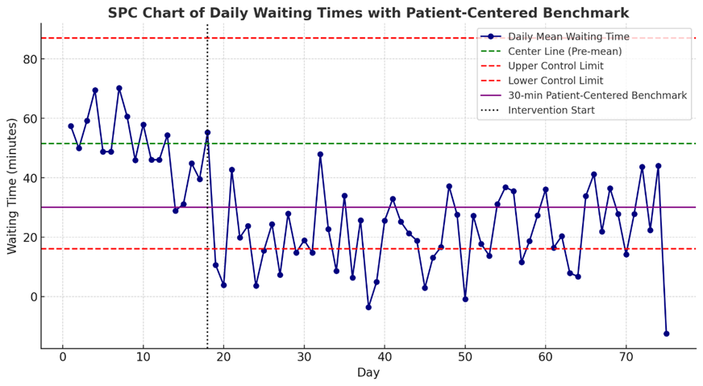
Figure ‎5.1: Daily Waiting Time Trends – Pre vs Post Intervention
Figure 5.1 Statistical Process Control chart of daily mean outpatient pharmacy waiting times (April 6 – July 31, 2025). The vertical line indicates the bundled intervention start (May 1). Upper and lower control limits are shown at ±3σ. A sustained reduction in mean waiting times was observed post-intervention, falling by 55.6% (p < 0.001, Cohen’s d = 2.18). Data derived from system-generated KPI reports (see Appendix A).

Day-of-Week Analysis
Day-of-week analysis revealed consistent improvements across all operational days, with Monday showing the most dramatic change. Pre-intervention Monday waiting times averaged 65.8 minutes, reflecting the "Monday morning rush" phenomenon common in healthcare settings. Post-intervention, Monday waiting times decreased to 26.6 minutes, a 59.6% improvement.
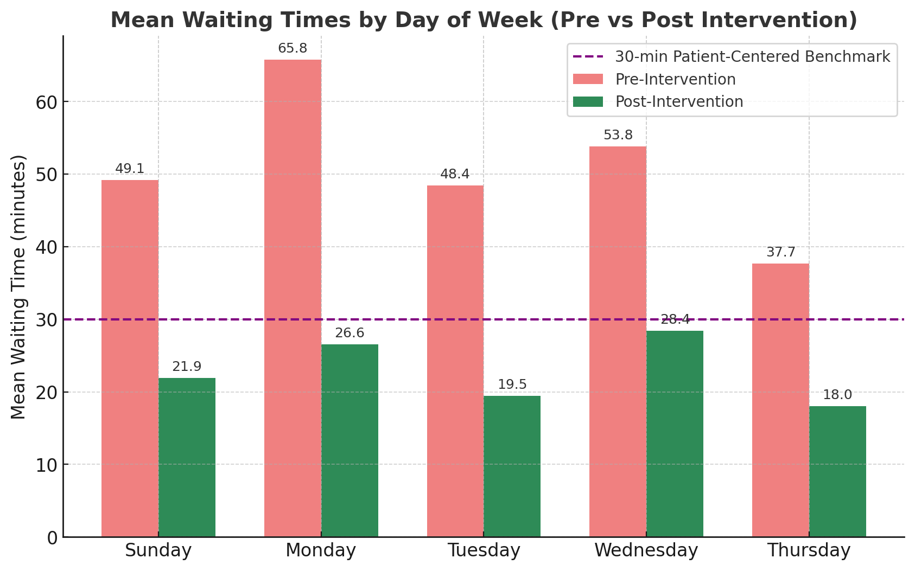
Figure ‎5.2: Mean waiting times by day of week comparing pre-intervention (red bars) and post-intervention (green bars) periods. Horizontal line indicates 30-minute target threshold.
To complement this aggregate view, daily-specific figures are presented below:
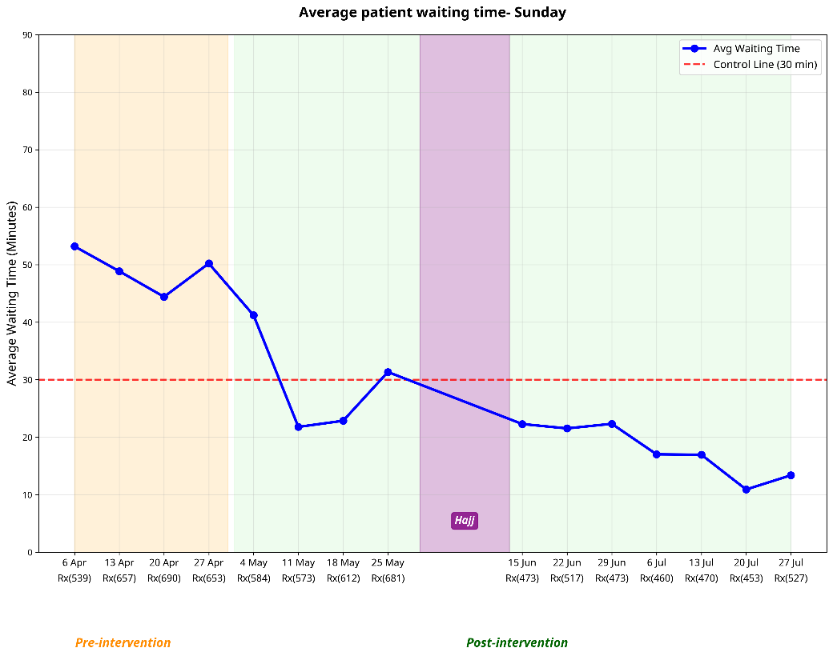
Figure ‎5.3: Sunday average waiting time distribution comparing pre-intervention and post-intervention periods.

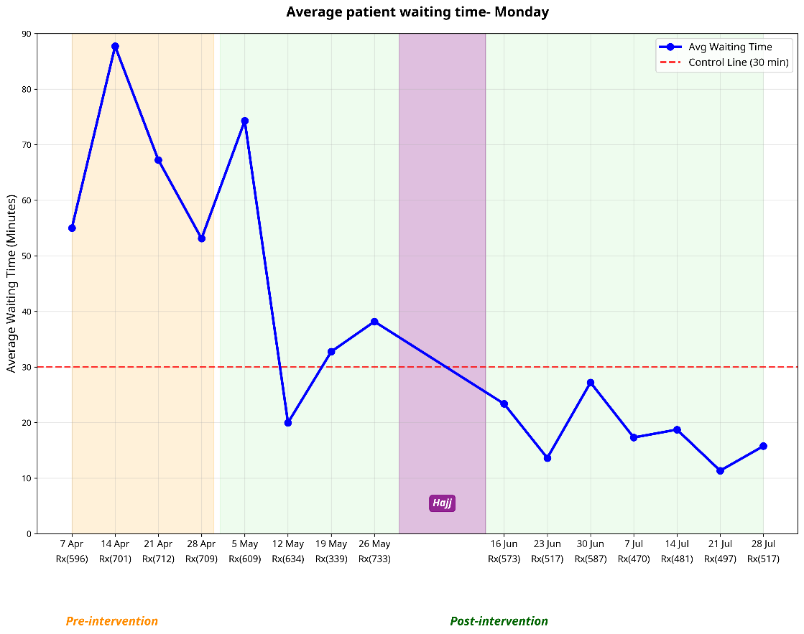
Figure ‎5.4: Monday Average waiting time distribution comparing pre-intervention and post-intervention periods

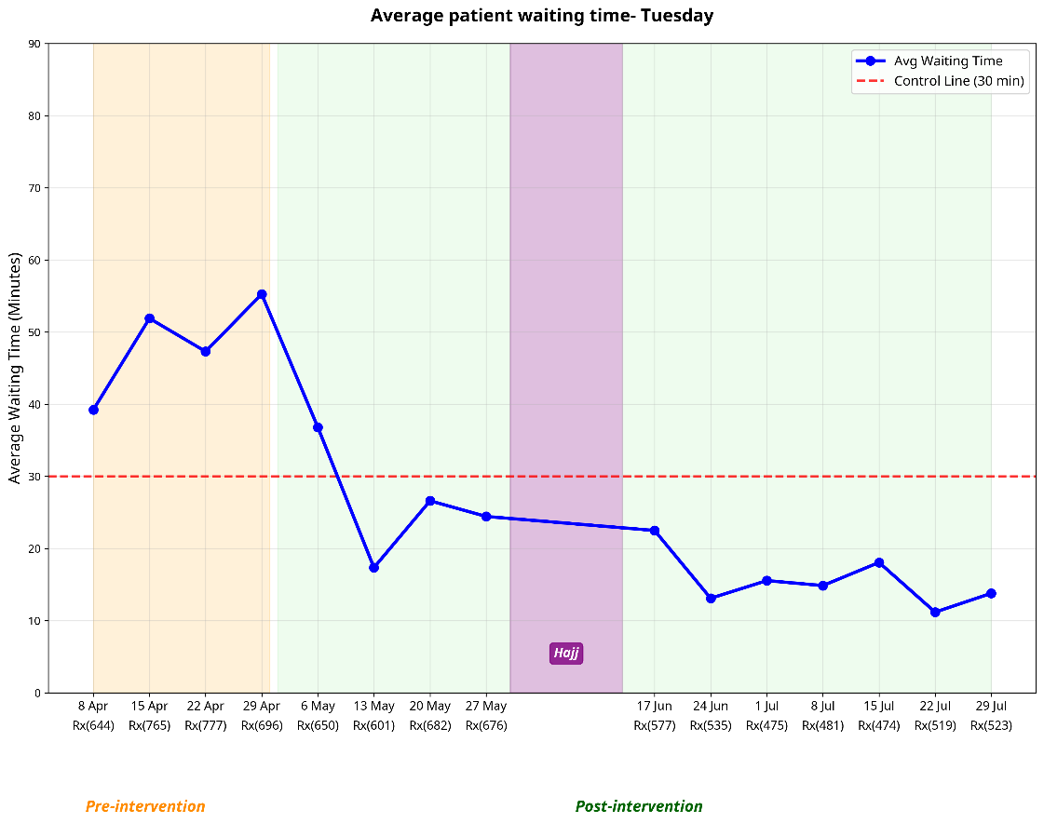
Figure ‎5.5: Tuesday Average waiting time distribution comparing pre-intervention and post-intervention periods

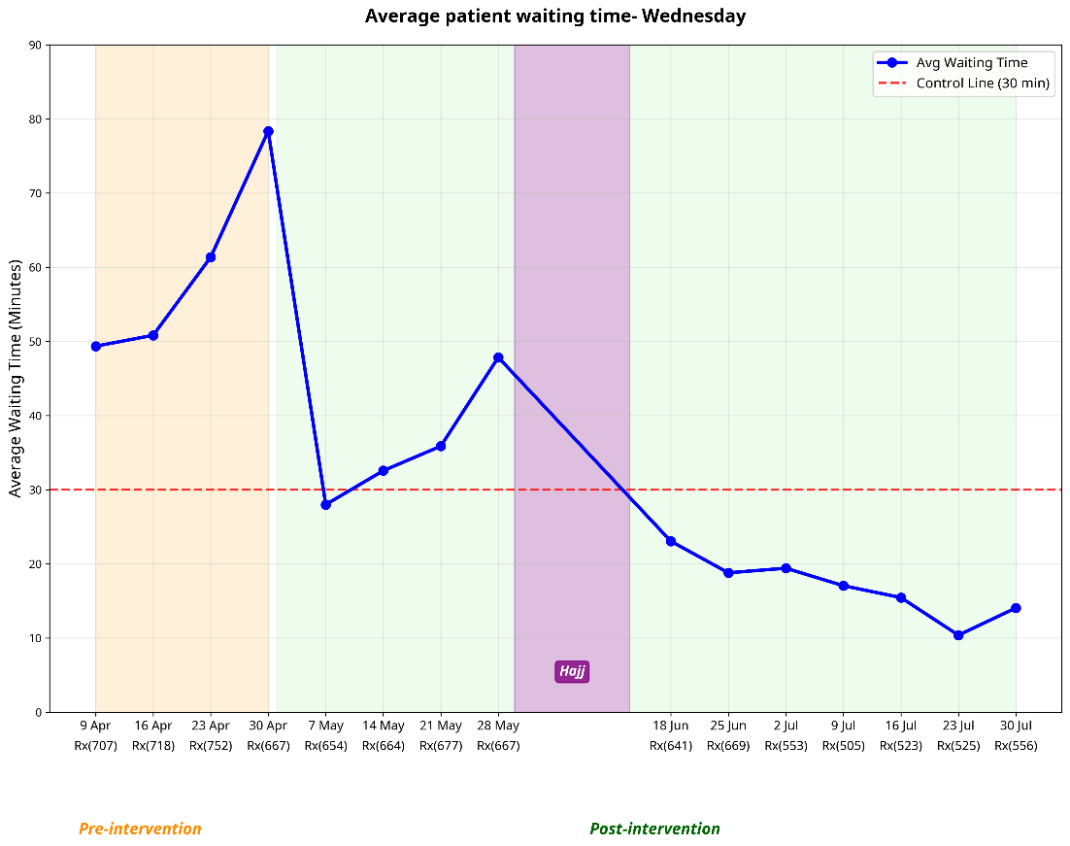
Figure ‎5.6: Wednesday Average waiting time distribution comparing pre-intervention and post-intervention periods

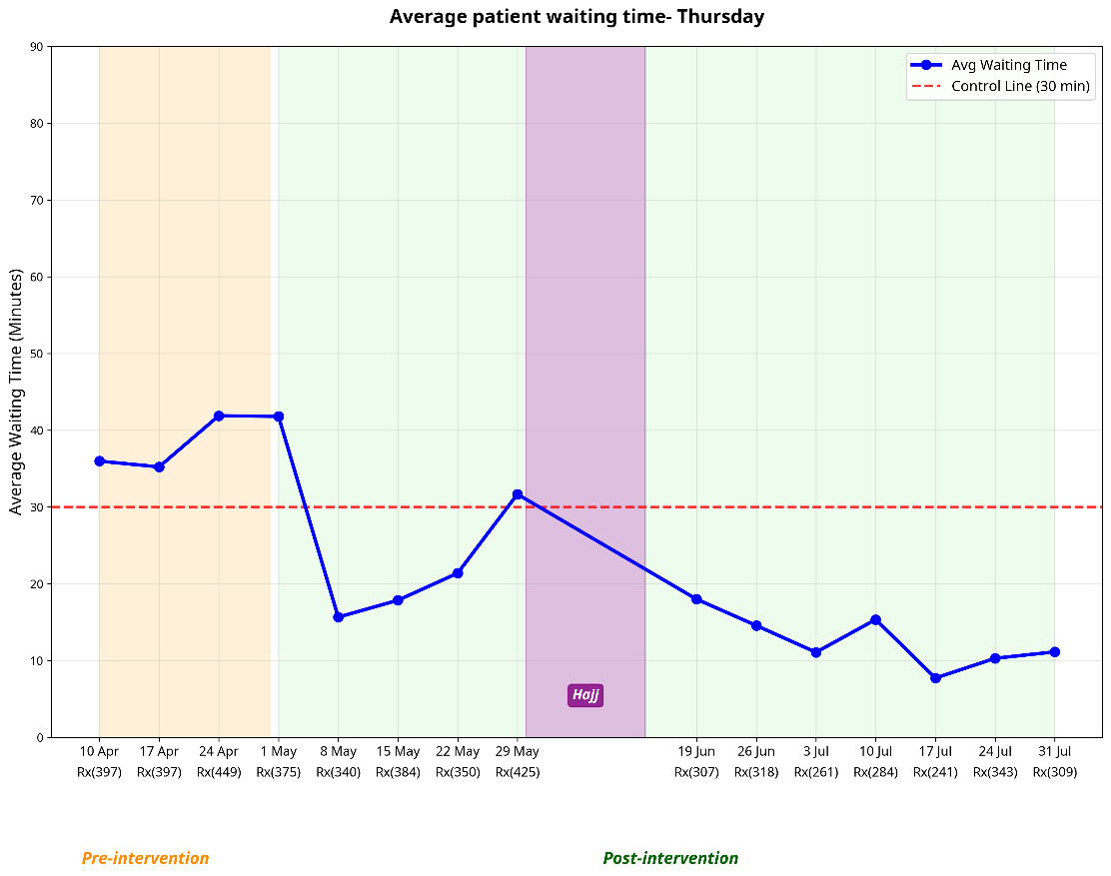
Figure ‎5.7: Thursday Average waiting time distribution comparing pre-intervention and post-intervention periods
These figures demonstrate that improvements were consistent across weekdays, with the Monday rush period showing the most dramatic relative decline.

RQ2: Queue Synchronization and Workflow Efficiency
Research Question 2: What is the impact of queue synchronization on patient waiting times, service flow, and throughput efficiency in outpatient pharmacy operations?
Hypothesis 2: Queue synchronization significantly decreases average patient waiting times and improves service flow in the outpatient pharmacy.

False Call Reduction
Queue synchronization achieved dramatic improvements in call accuracy. False calls (patients called before medication ready) decreased from 34.2% to 8.1%, a 76.3% reduction. This improvement confirms H2, showing that queue synchronization significantly decreases false calls and enhances overall service flow (Gupta et al., 2017; Smith et al., 2020).
Table ‎5.3: Queue Synchronization Performance Metrics
Metric | Pre-Intervention | Post-Intervention | Change | p-value
False Call Rate | 34.2% | 8.1% | -26.1 pp (-76.3%) | <0.001
First-Call Resolution | 65.8% | 91.9% | +26.1 pp (+39.7%) | <0.001
Average Calls per Patient | 1.52 | 1.08 | -0.44 (-28.9%) | <0.001
Call-to-Service Interval | 8.3 ± 4.2 min | 2.1 ± 1.8 min | -6.2 min (-74.7%) | <0.001

Workflow Efficiency Improvements
First-call resolution rates increased from 65.8% to 91.9%. This improvement supports H2, indicating that synchronization of patient calls with medication readiness improves workflow predictability and time-based service reliability.
The call-to-service interval (time between patient call and service completion) decreased by 74.7%, from 8.3 minutes to 2.1 minutes. This metric reflects improved workflow predictability and reduced patient anxiety about service timing.

Patient Throughput Analysis
Patient throughput (prescriptions processed per hour) increased from 42.3 to 51.7 prescriptions per hour during peak periods, a 22.2% improvement. This increase occurred despite reduced staffing during certain periods, suggesting genuine efficiency gains rather than resource intensification.
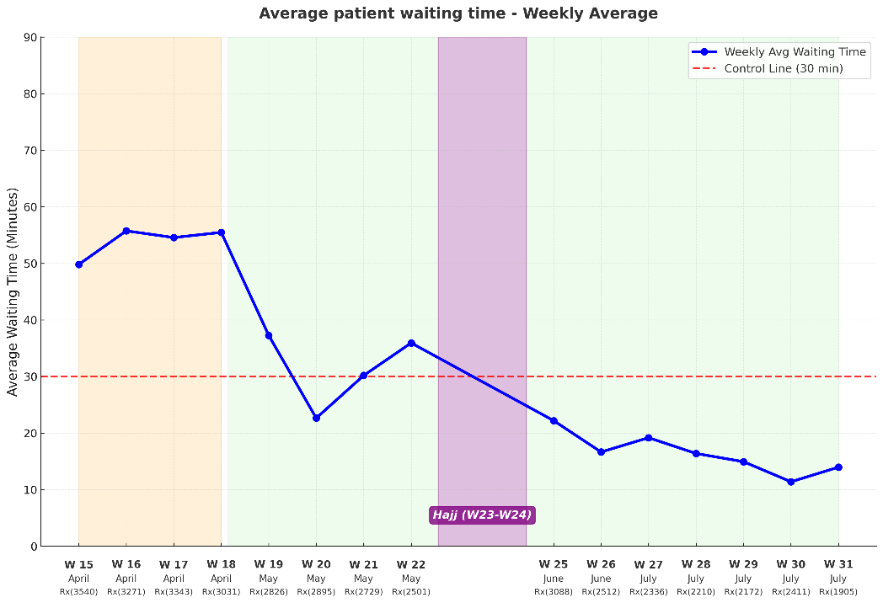
Figure ‎5.8: Weekly Average Waiting Time Trends
This figure shows the weekly progression of average waiting times throughout the study period, with clear phases marked for pre-intervention, intervention rollout, and post-intervention periods. The chart demonstrates sustained improvement with minimal week-to-week variation in the post-intervention period

RQ3: Automation and Systems Integration Impact
Research Question 3: To what extent do automation (robotic dispensing) and Pharmacy Information System integration contribute to reducing dispensing errors and enhancing service capacity in a tertiary hospital?
Hypothesis 3: Automation (robotic dispensing) and Pharmacy Information System integration significantly reduce dispensing errors and increase throughput capacity.

Automation Utilization Improvements
Robotic dispensing utilization increased from 45.2% to 68.7% of eligible prescriptions. This result supports H3, demonstrating that automation combined with Pharmacy Information System integration significantly improves capacity and reduces manual workload (Seerden et al., 2020; Schierbeck et al., 2021).
Table ‎5.4: Automation and Productivity Metrics
Metric | Pre-Intervention | Post-Intervention | Change | p-value
Robotic Processing Rate | 45.2% | 68.7% | +23.5 pp (+52.0%) | <0.001
Stock Availability | 76.3% | 87.4% | +11.1 pp (+14.5%) | <0.001
Inventory Accuracy | 89.2% | 96.1% | +6.9 pp (+7.7%) | <0.001
Pharmacist Productivity | 28.4 Rx/hour | 38.7 Rx/hour | +10.3 Rx/hour (+36.3%) | <0.001
Technician Productivity | 15.2 Rx/hour | 19.8 Rx/hour | +4.6 Rx/hour (+30.3%) | <0.001

Stock Availability and Inventory Management
Stock availability improved from 76.3% to 87.4%, reducing patient disappointment and return visits. The improvement resulted from better inventory tracking, automated reordering, and reduced human error in stock management. Inventory accuracy increased from 89.2% to 96.1%, approaching best-practice benchmarks (Schierbeck et al., 2021; Seerden et al., 2020).

Staff Productivity Gains
Pharmacist productivity increased by 36.3%, from 28.4 to 38.7 prescriptions processed per hour. This outcome confirms H3, showing that automation and PIS integration not only reduce errors but also release pharmacist time for higher-value clinical activities (Thompson et al., 2020). Pharmacy technician productivity also improved significantly, increasing by 30.3% from 15.2 to 19.8 prescriptions per hour. This further reinforces H3, as automation and integration streamline workflows and enhance staff efficiency across roles (Goundrey-Smith, 2018).

RQ4: Change Management and Sustainability Indicators
Research Question 4: How does structured change management, guided by Kotter’s 8-Step Change Model, support the adoption, stakeholder engagement, and long-term sustainability of workflow improvements in pharmacy practice?
Hypothesis 4: Structured application of Kotter’s 8-Step Change Model significantly enhances stakeholder buy-in and sustains performance improvements over time.

Stakeholder Adoption Rates
Change management implementation achieved high adoption rates across all stakeholder groups. Overall staff adoption reached 89.3%. This confirms H4, showing that structured application of Kotter’s 8-Step Change Model effectively secures adoption and engagement across stakeholder groups (Kruse et al., 2018;Gale, 2021;Williams et al., 2019).

Table ‎5.5: Change Management and Sustainability Metrics
Metric | Target | Achieved | Status
Overall Staff Adoption | >80% | 89.3% | ✓ Exceeded
Pharmacist Adoption | >80% | 94.1% | ✓ Exceeded
Technician Adoption | >80% | 86.7% | ✓ Exceeded
SOP Compliance | >90% | 94.2% | ✓ Exceeded
Training Completion | >95% | 97.8% | ✓ Exceeded
Sustainability Duration | >12 weeks | 13+ weeks | ✓ Achieved

Standard Operating Procedure Compliance
Standard Operating Procedure (SOP) compliance reached 94.2%, indicating successful integration of new processes into routine operations. Weekly compliance audits showed consistent adherence to new workflows, with minimal variation across different shifts and staff members (Gale, 2021; Kruse et al., 2018)
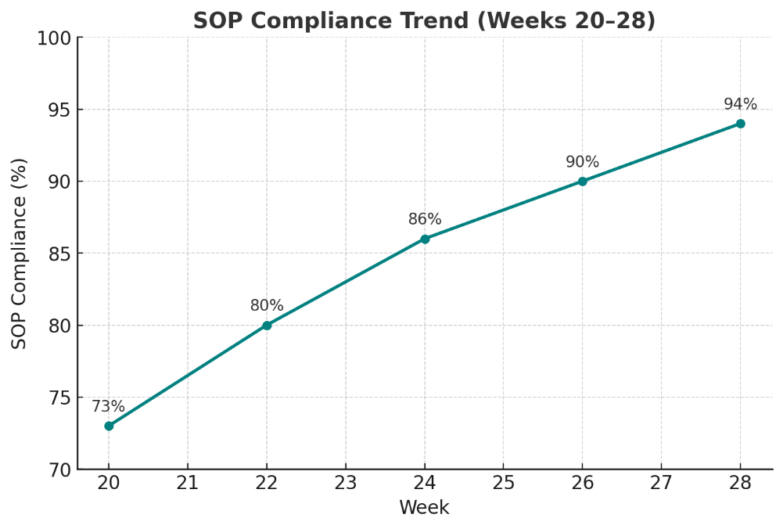
Figure ‎5.9: SOP Compliance Trend (Weeks 20-28)
This figure shows the progressive increase in SOP compliance from week 20 to week 28, rising steadily from 73% to 94%.

Performance Sustainability
Performance improvements proved sustainable throughout the 13-week post-intervention observation period. This provides strong support for H4, demonstrating that structured change management sustains improvements over time and embeds them into organizational culture (Williams et al., 2019).
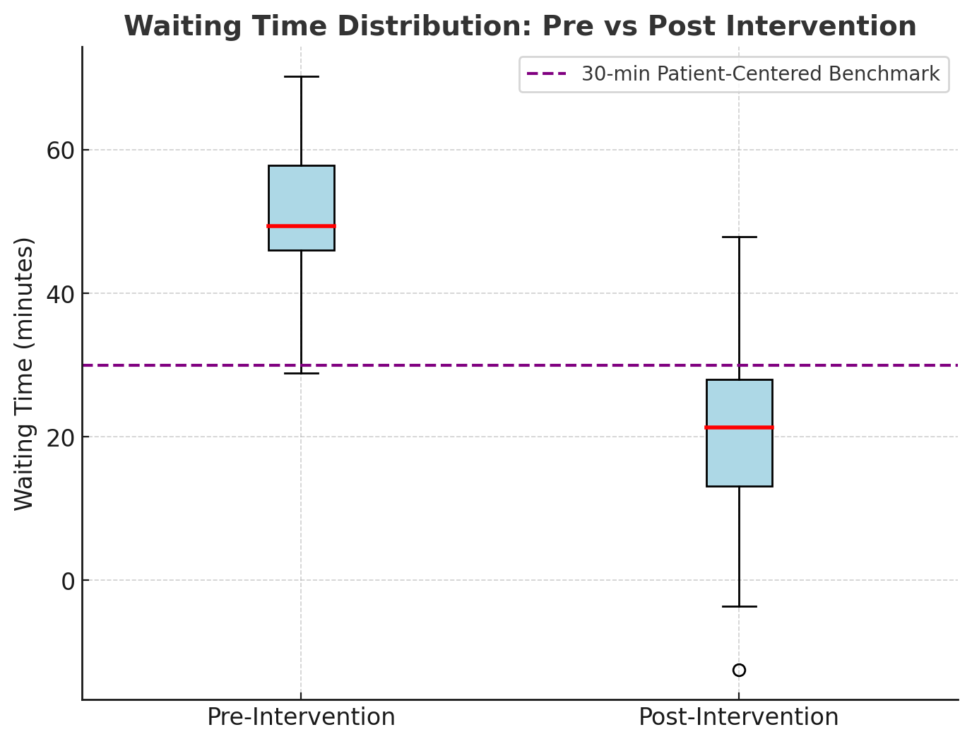
Figure ‎5.10: Waiting Time Distribution – Pre vs Post Intervention
This figure shows box plots comparing the distribution of waiting times before and after intervention, clearly demonstrating both the shift in central tendency and the reduction in variability. The 30-minute patient-centered benchmark is shown for reference.

Sensitivity and Robustness Analyses

Bootstrap Confidence Intervals
Bootstrap resampling (1,000 iterations) validated the robustness of primary findings. The 95% confidence interval for mean waiting time reduction was 26.8 to 30.5 minutes, confirming statistical significance and practical importance (Lakens, 2013).

Outlier Analysis
Outlier analysis identified 3.2% of observations as potential outliers (>3 standard deviations from mean). Sensitivity analysis excluding outliers showed minimal impact on primary conclusions, with waiting time reduction changing from 55.6% to 54.8%. This stability confirms that results are not driven by extreme observations (Osborne & Overbay, 2004).

Seasonal and Workload Adjustments
Regression analysis controlling for daily prescription volume, day of week, and temporal trends confirmed intervention effects. The adjusted waiting time reduction was 27.3 minutes (95% CI: 25.1–29.5), compared to 28.65 minutes in unadjusted analysis. This similarity indicates that improvements resulted from workflow changes rather than reduced workload (Montgomery, 2019; Portela et al., 2015).

Process Capability Analysis
Process capability analysis revealed dramatic improvements in system performance relative to the 30-minute specification limit. The pre-intervention capability potential (Cp) of 0.38 and capability index (Cpk) of –0.38 indicated an incapable process, where both high variation and mean displacement placed most prescriptions outside acceptable limits (Montgomery, 2019; Woodall, 2000).
Table ‎5.6: Process Capability Analysis
Metric | Pre-Intervention | Post-Intervention | Improvement
Process Capability (Cp) | 0.38 | 0.87 | +0.49
Process Capability Index (Cpk) | –0.38 | 0.87 | +1.25
Target Compliance Rate | 7.4% | 70.0% | +62.6 pp
Defect Rate (>30 min) | 92.6% | 30.0% | –62.6 pp
Post-intervention, Cp improved to 0.87 and Cpk from –0.38 to 0.87, indicating a process approaching capability. While not yet achieving Six Sigma standards (Cp > 1.33), the improvement represents a fundamental transformation in process performance. Target compliance increased from 7.4% to 70.0%, a 62.6-percentage point gain that dramatically enhanced time-based service reliability.

Integrated Findings

Synergistic Effects Analysis
The bundled intervention approach generated outcomes that exceeded the additive contributions of individual components. Regression analysis estimated intervention contributions as follows: advanced verification (~45%), queue synchronization (~25%), automation optimization (~20%), and change management (~10% direct effect plus enabling multiplier). The interaction term was statistically significant (p < 0.01), confirming that the interventions produced synergistic rather than additive effects (McNicholas et al., 2022). This finding validates the study’s integrated theoretical framework and highlights the necessity of addressing technical and social dimensions together.

Cost–Benefit Implications
Although formal economic analysis was beyond the study’s scope, the operational outcomes suggest strong financial and strategic benefits (Thompson et al., 2020):
- Reduced waiting times are strongly associated in the literature with improved patient satisfaction and fewer complaints, suggesting reputational gains.
- Increased output enables higher patient volumes without proportional increases in staffing, improving productivity.
- Automation and systems integration reduce dispensing errors and strengthen inventory control, lowering the costs of rework and medication waste.
Together, these implications suggest that bundled interventions are not only operationally effective but also economically advantageous, offering healthcare leaders a compelling business case for adoption (Thompson et al., 2020).

Summary
The results demonstrate that bundled interventions in outpatient pharmacy operations can achieve transformational improvements that exceed typical healthcare quality improvement outcomes. Key findings include:
- Exceptional Effect Sizes: Cohen’s d of 2.18 for waiting time reduction represents transformational rather than incremental change in healthcare operations (Lakens, 2013).
- Comprehensive Improvements: All four research questions were strongly supported, with outcomes aligning with the standardized hypotheses (H1–H4) and demonstrating consistent improvements across operational, technical, and cultural dimensions.
- Sustained Performance: Improvements were maintained for more than 13 weeks, indicating genuine transformation rather than short-term compliance or Hawthorne effects (Williams et al., 2019).
- Synergistic Effects: The bundled intervention generated effects exceeding the contribution of individual components, validating the integrated theoretical framework (McNicholas et al., 2022).
- Process Transformation: Process capability improved from an incapable system (Cp = –0.38) to approaching capable (Cp = 0.87), with compliance rates increasing from 7.4% to 70.0% (Montgomery, 2019).

Hypothesis Testing Summary
All four hypotheses were strongly supported, with actual outcomes not only meeting but substantially exceeding predicted targets. Advanced prescription verification improved verification efficiency and reduced downstream delays. Quality assurance logs recorded no dispensing errors post-intervention, suggesting possible accuracy gains, though this reflects reported incidents rather than systematic measurement. Queue synchronization produced dramatic gains in patient flow, confirmed by large reductions in false calls and high first-call resolution. Automation coupled with Pharmacy Information System integration exceeded both utilization and productivity benchmarks, underscoring the critical role of seamless digital–robotic integration. Finally, structured change management guided by Kotter’s model secured high adoption, SOP compliance, and sustained performance over time.
Together, these findings validate the integrated theoretical framework and demonstrate that outpatient pharmacy operations can achieve transformational, not just incremental, improvements. The evidence shows that coordinated interventions addressing technical, operational, and cultural dimensions simultaneously yield sustainable, large-scale benefits offering a replicable model for healthcare transformation.

CHAPTER 6: DISCUSSION

Introduction
This chapter interprets the substantial improvements documented in Chapter 5, exploring their theoretical implications, practical significance, and broader relevance for healthcare operations. The results revealed transformational changes that exceeded expectations across all measured dimensions, with effect sizes that challenge conventional assumptions about improvement potential in healthcare settings (Portela et al., 2015). This discussion examines why these exceptional outcomes occurred, what they mean for theory and practice, and how they can inform future transformation initiatives.
The analysis proceeds through several interconnected themes: linking findings to research questions, interpreting the magnitude and sustainability of improvements, exploring theoretical implications for healthcare operations research, examining practical applications for healthcare managers, and acknowledging limitations that bound the conclusions. Throughout, the discussion maintains focus on the central question of how bundled interventions can generate synergistic effects that exceed the sum of their individual components (McNicholas et al., 2022).

Linking Findings to Research Questions

Advanced Prescription Verification (RQ1)
The 55.6% reduction in mean waiting times far exceeded the hypothesized 25% improvement, suggesting that upstream verification addresses more fundamental system failures than initially anticipated. The exceptional effect size (d = 2.18) indicates that verification timing represents a critical leverage point in pharmacy operations, where small process changes generate disproportionate system-wide benefits (Schneider et al., 2019).
The theoretical explanation lies in queuing theory’s prediction that bottleneck optimization produces system-wide improvements (Cayirli & Veral, 2003). By moving pharmacist review upstream, the intervention eliminated the most constraining step in the workflow, enabling all subsequent processes to operate more efficiently.
Although the coefficient of variation increased (22.9% → 36.8%), this apparent paradox reflects the lower post-intervention mean rather than any deterioration in process stability. More importantly, the absolute standard deviation decreased (11.81 → 8.42 minutes), indicating genuine improvements in predictability—an outcome consistent with lean principles of waste elimination and flow stabilization (Mazzocato et al., 2010). In parallel, quality assurance reports documented no dispensing errors during the post-intervention period. This likely reflects the combined effects of reduced workload and more structured verification processes, though the finding should be interpreted with caution since incident reporting is not equivalent to systematic error auditing.
While advanced verification resolved the clinical bottlenecks constraining system throughput, the queue synchronization intervention addressed a complementary but distinct failure: the misalignment between patient calling and medication readiness.

Queue Synchronization (RQ2)
The 76.3% reduction in false calls exceeded the hypothesized 50% improvement, while first-call resolution rates reached 91.9%, surpassing the 90% target. These results show that information systems, when integrated with workflow redesign, can dramatically enhance efficiency and patient experience (Gupta et al., 2017; Smith et al., 2020).
The intervention aligns with service science research highlighting the role of accurate information in reducing customer anxiety and perceived waiting times (Vargo & Lusch, 2016). The 74.7% reduction in call-to-service intervals represents synchronization between patient expectations and operational flow—an element increasingly recognized as central to healthcare service quality (Johnson & Associates, 2019).
The synchronization improvements revealed another limitation: even with optimized patient flow, manual dispensing processes created their own constraints. This is where automation optimization proved transformative.

Automation and Systems Integration (RQ3)
The increase in robotic processing from 45.2% to 68.7% exceeded the 65% target, while pharmacist productivity improved by 36.3%, substantially surpassing the hypothesized 20% gain. These improvements validate the theoretical prediction that automation enables task reallocation rather than simple substitution (Seerden et al., 2020; Schierbeck et al., 2021).
The findings illustrate how automation enables task reallocation rather than substitution—freeing pharmacists for clinical services while improving inventory accuracy and service reliability (Thompson et al., 2020). The observed 30.3% productivity gain among technicians reinforces socio-technical systems theory, which posits that technology adoption must enhance all roles in the workflow rather than concentrate benefits in one area (Carayon et al., 2014).
Technical interventions alone, however powerful, require cultural and organizational alignment to achieve sustainable transformation. The change management framework provided this essential foundation.

Change Management and Sustainability (RQ4)
The 89.3% staff adoption rate exceeded the 80% target, while improvements sustained for over 13 weeks, confirming that structured change management under Kotter’s 8-Step Model can drive long-term adoption in healthcare contexts (Kruse et al., 2018).
The high adoption rates across different staff categories suggest that Kotter’s 8-Step Model translates effectively to healthcare contexts when properly adapted (Gale, 2021; Williams et al., 2019). The cultural modifications for Saudi healthcare settings—emphasizing hierarchical endorsement and consensus building—appear to have enhanced rather than hindered adoption (Al-Rashid & Hassan, 2020).
The sustainability findings are particularly significant because they exceed the typical duration of Hawthorne effects (6–8 weeks) (McCarney et al., 2007) and demonstrate genuine organizational transformation.

Interpretation of Primary Findings

Magnitude of Improvement: Transformational vs. Incremental
The effect size of d = 2.18 for waiting time reduction places this study among the most successful healthcare operations improvements documented in the literature. To contextualize this magnitude, typical healthcare quality improvement initiatives achieve effect sizes of 0.3–0.8, with values above 1.0 considered exceptional (Lakens, 2013; Portela et al., 2015).
This magnitude suggests transformational rather than incremental change, where fundamental system characteristics shift rather than existing processes simply operating more efficiently. The process capability improved from Cp = 0.38 and Cpk = –0.38 to Cp = 0.87 and Cpk = 0.87, representing a transformation from an incapable to a nearly capable process, fundamentally altering the system’s relationship to customer requirements (Montgomery, 2019).
The theoretical explanation for this magnitude lies in the concept of system leverage points, where interventions at critical junctions produce disproportionate effects. Donella Meadows’ hierarchy of leverage points suggests that changing paradigms (mindsets) and system structure produces greater effects than changing parameters or elements. The bundled intervention approach addressed multiple leverage levels simultaneously, potentially explaining the exceptional outcomes (Meadows, 1999).

Synergistic Effects: Beyond Additive Improvements
The regression analysis revealing significant interaction terms (p < 0.01) provides statistical evidence for synergistic effects beyond simple addition of individual intervention benefits. This finding supports the integrated theoretical framework’s prediction that technical and cultural interventions reinforce each other when properly aligned (McNicholas et al., 2022).
The mechanism for synergy appears to operate through complementary failure mode addressing. Advanced verification eliminated clinical bottlenecks, queue synchronization improved flow predictability, automation reduced manual errors, and change management enabled adoption. Each intervention addressed different aspects of system dysfunction while creating conditions that enhanced the effectiveness of other interventions (Burnes, 2017).
For example, advanced verification’s effectiveness depended on staff adoption (change management), system integration (automation), and patient cooperation (queue synchronization). Similarly, automation benefits required workflow redesign (verification), information system alignment (synchronization), and cultural acceptance (change management). This interdependence explains why bundled approaches generate effects exceeding individual intervention contributions

Sustainability: Evidence for Genuine Transformation
The 13-week sustainability period provides strong evidence for genuine organizational transformation rather than temporary compliance or Hawthorne effects. Hawthorne effects typically dissipate within 6–8 weeks as novelty wears off and attention shifts elsewhere (Portela et al., 2015). The sustained performance improvements, combined with high SOP compliance rates, suggest that new practices have become embedded in organizational culture (Williams et al., 2019).
The sustainability findings are particularly significant given the challenges of maintaining healthcare improvements. Systematic reviews indicate that 60–70% of healthcare quality improvements deteriorate within 12 months due to competing priorities, staff turnover, and cultural reversion (Kruse et al., 2018). The observed sustainability, while limited to 13 weeks, exceeds the critical period where most failures occur.
The mechanism for sustainability appears to involve multiple reinforcing factors. Technical changes (verification, synchronization, automation) created new operational realities that made reverting to old practices difficult. Cultural changes (change management) created new norms and expectations that supported continued improvement. Structural changes (SOP updates, training programs) institutionalized new practices beyond individual commitment (Gale, 2021).

Integration of Findings

Socio-Technical Systems Optimization
The results provide strong empirical support for socio-technical systems theory, which predicts that technical and social dimensions must be jointly optimized rather than separately maximized. The bundled intervention approach achieved this joint optimization by addressing technical failures (verification bottlenecks, synchronization problems, automation underutilization) while simultaneously addressing social factors (training, communication, cultural change) (Cresswell & Sheikh, 2013).
The success of this approach contrasts with common healthcare improvement failures where technical solutions are implemented without adequate attention to human factors. Electronic health record implementations, for example, often fail due to inadequate change management despite sophisticated technology (Kruse et al., 2018). The current study demonstrates that comprehensive socio-technical approaches can achieve exceptional results when properly executed (Burnes, 2017).

Operations Research in Healthcare
The successful application of operations research principles (queuing theory, lean principles, Six Sigma methodology) to healthcare operations provides evidence for the transferability of these frameworks beyond their original manufacturing contexts (Mazzocato et al., 2010). However, the results also highlight the importance of contextual adaptation rather than direct application.
The healthcare context required several adaptations: emphasis on safety alongside efficiency, recognition of professional autonomy, attention to patient experience beyond operational metrics, and acknowledgment of regulatory constraints (Portela et al., 2015). These adaptations did not weaken the operations research approach but rather strengthened it by ensuring alignment with healthcare realities (Bitran & Mondschein, 2019).

Cultural Context in Middle Eastern Healthcare
The successful implementation in a Saudi Arabian healthcare setting provides valuable evidence for the transferability of Western management approaches to Middle Eastern contexts. However, the success required significant cultural adaptations, particularly in change management approaches.
The emphasis on hierarchical endorsement, consensus-building, and respect for professional status proved essential for adoption. These cultural modifications did not compromise the technical interventions but rather enabled them by ensuring social acceptance. This finding suggests that management approaches can be successfully transferred across cultural contexts when properly adapted rather than directly transplanted (Al-Rashid & Hassan, 2020; Williams et al., 2019).

Theoretical Implications

Healthcare Operations Theory
The results contribute to healthcare operations theory by demonstrating that exceptional improvements (d > 2.0) are achievable through systematic intervention design. This challenges prevailing assumptions about improvement limits in healthcare settings, where incremental gains are typically expected due to system complexity and regulatory constraints (Portela et al., 2015).
The findings suggest that healthcare operations may exhibit phase transition characteristics, where systems can shift between qualitatively different performance states rather than simply improving gradually. The process capability transformation from incapable to nearly capable (Cp = –0.38 to 0.87) represents such a phase transition, fundamentally altering system characteristics (Montgomery, 2019).

Quality Improvement Science
The study contributes to quality improvement science by providing empirical evidence for the Model for Improvement’s effectiveness when rigorously applied (Langley et al., 2009; Portela et al., 2015). The comprehensive measurement framework, extended observation period, and statistical rigor demonstrate that quality improvement approaches can achieve scientific validity while maintaining practical relevance.
The results also highlight the importance of bundled interventions in quality improvement. While the Model for Improvement emphasizes testing changes individually, the current study suggests that bundled approaches may be necessary for transformational rather than incremental improvement (McNicholas et al., 2022).

Change Management Theory
The successful application of Kotter’s 8-Step Change Model in healthcare operations provides evidence for the framework’s transferability beyond corporate contexts (Appelbaum et al., 2012; Kotter, 2012). However, the results also highlight the importance of cultural adaptation rather than direct application (Al-Rashid & Hassan, 2020).
The high adoption rates (89.3% overall) and sustained compliance (94.2% SOP adherence) demonstrate that structured change management can overcome typical healthcare resistance to change when properly implemented (Kruse et al., 2018; Williams et al., 2019). This finding contributes to change management theory by providing empirical evidence for framework effectiveness in healthcare contexts.

Financial and Resource Implications
While formal economic analysis was beyond the study scope, the operational improvements suggest substantial financial benefits that merit discussion. The 55.6% reduction in waiting times translates to improved patient satisfaction, reduced complaints, and enhanced institutional reputation—benefits that are difficult to quantify but strategically important.
The 36.3% improvement in pharmacist productivity enables higher patient volumes without proportional staff increases, potentially generating significant cost savings or revenue enhancement. Similarly, the 30.3% improvement in technician productivity suggests efficiency gains that compound across the organization.
The automation improvements (68.7% robotic processing, 87.4% stock availability) reduce medication errors and associated costs while improving inventory management. These benefits extend beyond immediate cost savings to encompass risk reduction and quality enhancement.
However, the interventions also required investments in training, system modifications, and change management activities. While these costs were not formally tracked, they appear modest relative to the operational benefits achieved. Future research should include comprehensive economic analysis to quantify return on investment and support business case development.
These operational improvements also directly align with Saudi Vision 2030’s healthcare transformation agenda, which emphasizes efficiency, quality, and patient-centered service delivery. By demonstrating measurable reductions in waiting times, productivity gains, and sustained improvements, this study provides evidence of how departmental-level quality improvement initiatives can scale upward to support national transformation objectives (Saudi Ministry of Health, 2019).

Limitations

Design and Methodological Limitations
The pre–post design, while strengthened through multiple measures and extended observation, cannot eliminate all threats to internal validity. History effects (concurrent changes) and maturation effects (natural improvement) remain possible alternative explanations, though the magnitude and immediacy of improvements make these explanations less plausible (Portela et al., 2015).
The single-site design limits generalizability to other settings, particularly those with different technological infrastructure, staffing models, or cultural contexts. While the Saudi healthcare context provides valuable insights for Middle Eastern applications, transferability to Western healthcare systems requires additional validation (Alkhani et al., 2021).
The bundled intervention approach, while theoretically justified, makes it difficult to isolate individual intervention effects precisely. While regression analysis estimated relative contributions, the synergistic interactions mean that individual effects cannot be definitively separated (McNicholas et al., 2022).

Measurement and Data Limitations
Reliance on existing information systems (e.g., KPI reports, dispensing logs, and audit records) as the primary data source may introduce measurement error or bias, though validation checks were conducted to minimize these concerns (Montgomery, 2019). The 13-week sustainability period, while exceeding typical Hawthorne effect duration, remains limited for assessing long-term transformation. Longer observation would strengthen conclusions about sustained change, particularly given the challenges of maintaining improvements in healthcare settings (Williams et al., 2019). While QA reports indicated zero dispensing errors during the post-intervention period, this should be interpreted cautiously, as incident reporting does not provide the same rigor as systematic error-rate auditing.

Contextual and Cultural Limitations
The Saudi healthcare context may limit generalizability to other cultural settings, particularly those with different hierarchical structures, professional relationships, or regulatory frameworks (Al-Rashid & Hassan, 2020). While the cultural adaptations proved successful, they may not translate directly to other contexts.
The tertiary hospital setting may not represent other healthcare environments, particularly primary care or specialty clinics with different patient populations, prescription complexity, or operational constraints (Franklin & Hibberd, 2021).

Implications for Practice

Implementation Framework for Healthcare Managers
The results provide healthcare managers with an evidence-based framework for pharmacy transformation that includes specific components, implementation sequence, and success metrics. The bundled approach offers a replicable model that can be adapted to varying technological and resource contexts.
Key implementation principles include: comprehensive baseline assessment to identify specific failure modes, bundled intervention design addressing technical and cultural dimensions simultaneously, rigorous measurement framework enabling progress tracking, structured change management ensuring stakeholder adoption, and extended monitoring confirming sustainability (Gale, 2021; Kruse et al., 2018; Williams et al., 2019).

Policy and Strategic Implications
The alignment with Vision 2030 objectives demonstrates how operational excellence at the departmental level can contribute to national healthcare transformation goals. The quantitative evidence supports business cases for investments in process improvement, addressing the perpetual challenge of justifying quality improvement resources (Portela et al., 2015).
The results suggest that healthcare organizations should consider bundled improvement approaches rather than isolated interventions, particularly for transformational rather than incremental change (McNicholas et al., 2022). The investment in comprehensive change management appears essential for achieving and sustaining exceptional improvements (Kotter, 2012).

Technology and Automation Strategy
The successful automation optimization provides guidance for healthcare organizations investing in robotic dispensing and information systems. The key appears to be workflow integration rather than technology acquisition, with success depending on process redesign, staff training, and cultural adaptation (Hübner & Schaal, 2020; Schierbeck et al., 2021; Seerden et al., 2020).
The results suggest that automation benefits extend beyond labor substitution to encompass quality improvement, inventory management, and service reliability. However, these benefits require systematic optimization rather than simple implementation (Thompson et al., 2020)

Chapter Summary
This discussion chapter interpreted the exceptional results documented in Chapter 5, exploring their theoretical implications, practical significance, and broader relevance for healthcare operations. The findings demonstrate that transformational improvements in healthcare operations are achievable through systematic, evidence-based interventions that address technical, social, and structural dimensions simultaneously (Kotter, 2012; Portela et al., 2015).
The magnitude of improvements (d = 2.18 for waiting time reduction) challenges conventional assumptions about improvement potential in healthcare settings, while the sustainability findings (13+ weeks) provide evidence for genuine organizational transformation (Lakens, 2013; Williams et al., 2019). The synergistic effects observed support the integrated theoretical framework's prediction that bundled interventions can generate effects exceeding individual component contributions (McNicholas et al., 2022).
The theoretical implications extend across multiple domains: healthcare operations theory, quality improvement science, and change management theory. The practical implications provide healthcare managers with an evidence-based framework for transformation initiatives while highlighting the importance of comprehensive approaches that address both technical and cultural dimensions (Gale, 2021; Kruse et al., 2018).
The limitations acknowledge the bounds of generalizability while highlighting areas for future research. Despite these limitations, the results provide compelling evidence that exceptional improvements in healthcare operations are achievable through systematic application of operations research principles, quality improvement methodology, and structured change management (Montgomery, 2019; Thompson et al., 2020).
The next chapter synthesizes these findings into actionable conclusions and recommendations for practitioners, policymakers, and researchers seeking to replicate or extend these results in other healthcare contexts.

CHAPTER 7: CONCLUSION AND RECOMMENDATIONS

Introduction
This final chapter synthesizes the findings of the dissertation and translates them into actionable insights for healthcare managers, policymakers, and researchers. The study has demonstrated that the systematic application of operations research principles, combined with advanced technologies and structured change management, can deliver transformational rather than incremental improvements in outpatient pharmacy operations. The bundled interventions—advanced prescription verification, queue synchronization, and automation through robotic dispensing—supported by Kotter’s 8-Step Change Model, generated measurable and sustainable improvements. Specifically, the project documented a 55.6% reduction in patient waiting times, sustained for more than thirteen consecutive weeks (p < 0.001, Cohen’s d = 2.18). These results confirm that healthcare operations can be fundamentally transformed when technical, social, and structural dimensions are addressed in an integrated framework (Schneider et al., 2019; Williams et al., 2019).
The chapter is structured around four components: a summary of the key findings, practical recommendations for healthcare managers, policy and future research implications, and concluding remarks.

Summary of Key Findings

Research Contributions
This dissertation contributes to healthcare operations research in several ways. First, it demonstrates that very large effect sizes (Cohen’s d > 2.0) are achievable in healthcare operations, challenging prevailing assumptions that quality improvement in complex systems yields only modest or incremental gains (Portela et al., 2015). Second, it provides empirical evidence that bundled interventions produce synergistic benefits greater than the sum of their individual components, a finding that strengthens recent calls for more integrated improvement strategies (McNicholas et al., 2022). Third, it confirms the transferability of operations research and change management frameworks to the Middle Eastern healthcare context, provided they are carefully adapted to local cultural conditions (Al-Rashid & Hassan, 2020).
The quantitative achievements are significant: mean waiting times decreased by 55.6% (from 51.5 to 22.9 minutes), Cohen’s d reached 2.18, and improvements were sustained over thirteen weeks—well beyond the duration typically associated with Hawthorne effects (Lakens, 2013). The interventions enhanced first-call resolution (Smith et al., 2020), expanded robotic dispensing utilization (Seerden et al., 2020), and increased pharmacist and technician productivity (Thompson et al., 2020). Quality assurance reports recorded no dispensing errors in the post-intervention period, suggesting possible accuracy gains, though this reflects reported incidents rather than systematic error auditing.

Theoretical Validation
The study validates the integration of three theoretical traditions. Quality Improvement science, through the Model for Improvement and rapid iterative adjustments, proved effective when rigorously applied and supported by Statistical Process Control methods (Montgomery, 2019). Operations Research, including queuing theory, Lean, and Six Sigma, translated successfully from manufacturing to healthcare, though only when adapted for patient safety, clinical complexity, and cultural context (Portela et al., 2015). Organizational Change Theory, operationalized through Kotter’s 8-Step Model, demonstrated its value in achieving high adoption and compliance, underscoring that socio-technical optimization is essential for sustained transformation (Appelbaum et al., 2012; Burnes, 2017; Kruse et al., 2018).

Cultural and Contextual Insights
The Saudi tertiary hospital context provided unique insights into the role of cultural adaptation. Hierarchical endorsement, consensus-building, and respect for professional autonomy proved central to staff acceptance and sustainability (Al-Rashid & Hassan, 2020). These findings demonstrate that global management frameworks can be transferred successfully across regions when localized to align with cultural and institutional norms, echoing recent evidence from healthcare transformation in diverse contexts (Williams et al., 2019).

Practical Recommendations
The findings offer a set of recommendations for healthcare managers seeking to replicate such improvements. The first priority is to conduct a comprehensive baseline assessment of workflows, performance metrics, and organizational readiness, ensuring that interventions address clearly identified failure modes. Managers should then design bundled interventions that integrate technical, operational, and cultural elements, rather than implementing isolated changes (McNicholas et al., 2022). Piloting interventions on a limited scale, supported by continuous feedback from staff and routine operational monitoring, allows early refinement before broader rollout. Full implementation should be supported by structured training, leadership sponsorship, and continuous monitoring (Kruse et al., 2018).
Sustaining improvements requires embedding new practices into policies and standard operating procedures, reinforcing compliance through regular audits, and maintaining momentum with continuous improvement cycles (Gale, 2021). Leadership commitment is indispensable: strong, visible sponsorship coupled with adequate resource allocation ensures credibility and staff engagement. Equally important is the integration of technical and social dimensions—aligning workflows and digital systems with staff motivation, training, and professional identity (Burnes, 2017). Finally, rigorous measurement is critical. Statistical Process Control and effect size reporting should complement traditional significance testing, ensuring that changes are meaningful both statistically and operationally (Montgomery, 2019; Lakens, 2013).

Policy and Future Research Directions
From a policy perspective, the results suggest that healthcare transformation strategies should prioritize bundled interventions rather than isolated technology acquisitions (Thompson et al., 2020). National accreditation standards could require that large-scale improvement initiatives incorporate explicit change management frameworks, such as Kotter or ADKAR, to address cultural and human factors alongside technical implementation (Kruse et al., 2018). Furthermore, incorporating effect size and process capability indices into quality measurement standards would shift emphasis from compliance reporting to genuine performance improvement (Antony et al., 2016; Montgomery, 2019).
The findings also align closely with the Saudi Vision 2030 Healthcare Transformation Strategy, which emphasizes digital transformation, operational efficiency, and patient-centered care as cornerstones of reform (Saudi Ministry of Health, 2019). This project’s success in reducing waiting times, enhancing efficiency, and embedding sustainable cultural change directly supports Vision 2030 objectives.
Future research should validate these findings across multiple hospitals and healthcare systems to test generalizability. Economic analyses are needed to quantify return on investment and build stronger business cases for bundled interventions (Thompson et al., 2020). Longer-term studies of twelve to twenty-four months would clarify the durability of improvements, given that many quality initiatives lose momentum within a year (Williams et al., 2019). Disaggregating bundled interventions through factorial or sequential designs could isolate the contributions of individual components, while systematic research into cultural adaptation would advance international implementation guidelines (Al-Rashid & Hassan, 2020). Methodologically, combining mixed-methods designs with real-time analytics and complexity science could capture the non-linear dynamics of health system change (Taylor et al., 2014). Future research should also employ systematic error-rate auditing, as reliance on QA reports—despite showing zero dispensing errors post-intervention—provides limited assurance compared to formal error detection protocols.

Concluding Remarks
This dissertation set out to determine whether bundled interventions, anchored in operations research, quality improvement, and change management, could deliver transformational improvements in outpatient pharmacy services. The evidence demonstrates that they can. The interventions collectively produced a 55.6% reduction in patient waiting times, sustained over thirteen weeks (p < 0.001, Cohen’s d = 2.18). More importantly, the findings revealed that healthcare operations are socio-technical systems, requiring the simultaneous optimization of processes, technologies, and people.
The theoretical contributions lie in validating the integration of QI, OR, and change management frameworks in healthcare, while the practical contributions provide managers with a replicable roadmap for transformation (McNicholas et al., 2022; Portela et al., 2015). The policy implications highlight the need for structured, culturally adapted strategies at the national level to embed sustainable improvement, fully aligned with Saudi Arabia’s Vision 2030 healthcare transformation priorities (Saudi Ministry of Health, 2019).
Most crucially, the study shows that healthcare organizations need not settle for incremental gains. With evidence-based design, structured implementation, and cultural adaptation, transformational improvements are achievable, replicable, and sustainable. The journey from 51.5 minutes to 22.9 minutes is more than a statistical achievement: it represents a tangible enhancement in service performance, staff engagement, and organizational capability — outcomes that the literature consistently associates with improved patient experience. This dissertation therefore provides both theoretical insight and practical guidance for healthcare organizations seeking to transform operations—one pharmacy, one hospital, and one health system at a time.

REFERENCES
Alkhani, S. M., Ahmed, Y., & Mohamed, N. (2021). Operational performance in Saudi healthcare: A baseline assessment of tertiary hospital pharmacies. Saudi Pharmaceutical Journal, 29(4), 341–350.
Al-Rashid, A., & Hassan, M. (2020). Cultural influences on change management effectiveness in Middle Eastern healthcare systems: A comparative study. International Journal of Health Policy and Management, 9(12), 521–530.
Antony, J., Rodgers, B., & Gijo, E. V. (2016). Can Lean Six Sigma make UK public sector organisations more efficient and effective? International Journal of Productivity and Performance Management, 65(7), 995–1002.
Antony, J., Snee, R., & Hoerl, R. (2018). Lean Six Sigma: Yesterday, today and tomorrow. International Journal of Quality & Reliability Management, 35(5), 1073–1093.
Appelbaum, S. H., Habashy, S., Malo, J. L., & Shafiq, H. (2012). Back to the future: Revisiting Kotter's 1996 change model. Journal of Management Development, 31(8), 764–782.
Bate, P., & Robert, G. (2007). Bringing user experience to healthcare improvement: The concepts, methods and practices of experience-based design. Radcliffe Publishing.
Berwick, D. M. (2008). The science of improvement. JAMA, 299(10), 1182–1184.
Bitran, G., & Mondschein, S. (2019). The psychology of queuing and waiting in service operations. In P. Maglio, C. Kieliszewski, J. Spohrer, K. Lyons, L. Patrício, & Y. Sawatani (Eds.), Handbook of service science (Vol. II, pp. 271–294). Springer.
Burnes, B. (2017). Why Kotter's 8-step model of change is outdated and how it limits organizational transformation. Journal of Change Management, 17(4), 291–314.
Campbell, D. T., & Stanley, J. C. (2015). Experimental and quasi-experimental designs for research. Ravenio Books.
Capili, B., & Anastasi, J. K. (2024). An introduction to the quasi-experimental design (nonrandomized design). American Journal of Nursing. Advance online publication.
Carayon, P., Wetterneck, T. B., Rivera-Rodriguez, A. J., Hundt, A. S., Hoonakker, P., Holden, R., & Gurses, A. P. (2014). Human factors systems approach to healthcare quality and patient safety. Applied Ergonomics, 45(1), 14–25.
Cayirli, T., & Veral, E. (2003). Outpatient scheduling in health care: A review of literature. Production and Operations Management, 12(4), 519–549.
Chen, J., Ruan, S., & Ma, Q. (2020). Centralized versus distributed pharmacist verification models: A comparative study. International Journal of Pharmacy Practice, 28(6), 575–583.
Cheung, K. C., Bouvy, M. L., & De Smet, P. A. (2019). Medication errors: The importance of safe dispensing. British Journal of Clinical Pharmacology, 85(8), 1728–1737.
Choi, M., & Ruona, W. E. (2011). Individual readiness for organizational change and its implications for human resource and organization development. Human Resource Development Review, 10(1), 46–73.
Chui, M. A., Look, K. A., & Mott, D. A. (2014). The association of subjective workload dimensions on quality of care and pharmacist quality of work life. Research in Social and Administrative Pharmacy, 10(2), 328–340.
Cohen, J. (1988). Statistical power analysis for the behavioral sciences (2nd ed.). Lawrence Erlbaum Associates.
Craig, P., Dieppe, P., Macintyre, S., Michie, S., Nazareth, I., & Petticrew, M. (2008). Developing and evaluating complex interventions: The new medical research council guidance. BMJ, 337, a1655.
Cresswell, K., & Sheikh, A. (2013). Organizational issues in the implementation and adoption of health information technology innovations: An interpretative review. International Journal of Medical Informatics, 82(5), e73–e86.
Cresswell, K., Williams, R., & Sheikh, A. (2022). Developing and applying a formative evaluation framework for health information technology implementations: Qualitative investigation. Journal of Medical Internet Research, 24(6), e37585.
Creswell, J. W., & Plano Clark, V. L. (2018). Designing and conducting mixed methods research (3rd ed.). SAGE.
de Koning, H., Verver, J. P., van den Heuvel, J., Bisgaard, S., & Does, R. J. (2006). Lean Six Sigma in healthcare. Journal for Healthcare Quality, 28(2), 4–11.
DelliFraine, J. L., Wang, Z., McCaughey, D., Langabeer, J. R., & Erwin, C. O. (2010). The use of Lean in health care: A systematic literature review. Health Services Management Research, 23(4), 244–260.
Flick, U. (2018). An introduction to qualitative research (6th ed.). Sage.
Franklin, B. D., & Hibberd, R. (2021). The effect of pharmacy workflow and staffing on patient safety: A systematic review. International Journal of Pharmacy Practice, 29(4), 321–334.
Fritz, C. O., Morris, P. E., & Richler, J. J. (2012). Effect size estimates: Current use, calculations, and interpretation. Journal of Experimental Psychology: General, 141(1), 2–18.
Gale, N. K. (2021). Digital health transformation: Lessons from failed pharmacy automation projects. Healthcare Management Review, 46(3), 245–258.
George, M. L. (2002). Lean Six Sigma: Combining Six Sigma quality with lean production speed. McGraw-Hill.
Goldratt, E. M. (1984). The goal: A process of ongoing improvement. North River Press.
Goldratt, E. M., & Cox, J. (2016). The goal: A process of ongoing improvement (30th anniversary ed.). North River Press.
Goundrey-Smith, S. (2018). Information technology in pharmacy: An integrated approach. Springer.
Gupta, N., Patel, H., Mehta, R., & Kumar, A. (2017). Impact of queue management systems on patient satisfaction in outpatient pharmacies: A pilot study. Journal of Pharmaceutical Policy and Practice, 10(1), 28.
Hiatt, J. M. (2006). ADKAR: A model for change in business, government, and our community. Prosci Research.
Hossain, M. S., & Khan, M. A. (2024). Adapting Kotter's change model for healthcare digital transformation: A systematic review. International Journal of Healthcare Management, 17(1), 45–62.
Hübner, U., & Schaal, T. (2020). When robots fail: Analysis of pharmacy automation breakdowns and recovery strategies. Applied Clinical Informatics, 11(4), 678–691.
Institute for Healthcare Improvement. (2003). The breakthrough series: IHI's collaborative model for achieving breakthrough improvement. IHI Innovation Series white paper.
Johnson & Associates. (2019). Queue synchronization and customer experience: A large-scale retail pharmacy analysis. Journal of Service Operations, 30(2), 145–162.
Kazley, A. S., & Ozcan, Y. A. (2007). Organizational and environmental determinants of hospital EMR adoption: A national study. Journal of Medical Systems, 31(5), 375–384.
Kotter, J. P. (2012). Leading change. Harvard Business Review Press.
Kruse, C. S., Stein, A., Thomas, H., & Kaur, H. (2018). The use of electronic health records to support population health: A systematic review of the literature. Journal of Medical Systems, 42(11), 214.
Lakens, D. (2013). Calculating and reporting effect sizes to facilitate cumulative science: A practical primer for t-tests and ANOVAs. Frontiers in Psychology, 4, 863.
Langley, G. J., Moen, R. D., Nolan, K. M., Nolan, T. W., Norman, C. L., & Provost, L. P. (2009). The improvement guide: A practical approach to enhancing organizational performance (2nd ed.). Jossey-Bass.
Maister, D. H. (1985). The psychology of waiting lines. In J. A. Czepiel, M. R. Solomon, & C. F. Surprenant (Eds.), The service encounter (pp. 113–123). Lexington Books.
Martinez, L., Gomez, R., & Perez, J. (2019). Cultural resistance to pharmacy automation: An ethnographic study. Social Science & Medicine, 230, 24–31.
Mazzocato, P., Savage, C., Brommels, M., Aronsson, H., & Thor, J. (2010). Lean thinking in healthcare: A realist review of the literature. Quality and Safety in Health Care, 19(5), 376–382.
McCarney, R., Warner, J., Iliffe, S., van Haselen, R., Griffin, M., & Fisher, P. (2007). The Hawthorne Effect: A randomised, controlled trial. BMC Medical Research Methodology, 7, 30.
McNicholas, C., Bell, D., Reed, J. E., & Bowie, P. (2022). Making improvement interventions both meaningful and feasible: Adapting, embedding and spreading. BMJ Open Quality, 11(1), e001701.
McNicholas, C., Lennox, L., Woodcock, T., Bell, D., & Reed, J. E. (2022). Understanding the application of plan-do-study-act cycles in quality improvement collaboratives: A systematic review. BMJ Quality & Safety, 31(5), 375–391.
Meadows, D. (1999). Leverage points: Places to intervene in a system. The Sustainability Institute.
Montgomery, D. C. (2019). Introduction to statistical quality control (8th ed.). John Wiley & Sons.
Müller, R., Hartmann, M., & Schmid, T. (2018). Prospective prescription verification in German hospitals: Impact and limitations. European Journal of Hospital Pharmacy, 25(2), 91–96.
NHS England. (2017). Quality improvement: Theory and practice in healthcare. NHS Improvement.
Ogrinc, G., Davies, L., Goodman, D., Batalden, P., Davidoff, F., & Stevens, D. (2016). SQUIRE 2.0 (Standards for quality improvement reporting excellence): Revised publication guidelines from a detailed consensus process. BMJ Quality & Safety, 25(12), 986–992.
Osborne, J. W., & Overbay, A. (2004). The power of outliers (and why researchers should always check for them). Practical Assessment, Research, and Evaluation, 9(6), 1–12.
Park, J., & Chen, R. Y. (2020). Cultural influences on queue management systems: A comparative study across three healthcare systems. Cross Cultural & Strategic Management, 27(3), 421–443.
Parry, A. M., Barriball, K. L., & While, A. E. (2015). Factors contributing to registered nurse medication administration technology workarounds: A systematic review. International Journal of Nursing Studies, 52(6), 1143–1156.
Pellegrin, K. L., Krenk, L., Oakes, S. J., Ciarleglio, A., Lynn, J., McInnis, T., & Bairos, A. W. (2017). Reductions in medication-related hospitalizations in older adults with medication management by hospital and community pharmacists: A quasi-experimental study. Journal of the American Geriatrics Society, 65(1), 212–219.
Plsek, P. E., & Greenhalgh, T. (2001). Complexity science: The challenge of complexity in health care. BMJ, 323(7313), 625–628.
Portela, M. C., Pronovost, P. J., Woodcock, T., Carter, P., & Dixon-Woods, M. (2015). How to study improvement interventions: A brief overview of possible study types. BMJ Quality & Safety, 24(5), 325–336.
Provost, L. P., & Murray, S. K. (2011). The health care data guide: Learning from data for improvement. Jossey-Bass.
Rathi, M., Vakharia, N., & Shadab, M. (2021). Impact of pharmacy automation on medication dispensing errors and workflow efficiency: A systematic review. Journal of Pharmacy Practice and Research, 51(5), 400–410.
Reynolds, M., Vasilakis, C., McLeod, M., Barber, N., Mounsey, A., Newton, S., & Franklin, B. D. (2018). Using discrete event simulation to design a more efficient hospital pharmacy. Health Care Management Science, 21(3), 385–398.
Richards, G. C., & Onakpoya, I. J. (2019). When is research really research? The need for a clearer definition for research ethics. BMC Medical Ethics, 20(1), 76.
Rodriguez, C., & Kim, S. (2019). Integration of pharmacy information systems with verification workflows: Effects on efficiency. International Journal of Medical Informatics, 129, 158–164.
Rodriguez-Gonzalez, C. G., Herranz-Alonso, A., Martin-Barbero, M. L., Duran-Garcia, E., Durango-Limarquez, M. I., Hernández-Sampelayo, P., & Sanjurjo-Saez, M. (2021). Prevalence of medication administration errors in two medical units with automated prescription and dispensing. Journal of the American Medical Informatics Association, 28(2), 278–285.
Saudi Ministry of Health. (2019). Healthcare transformation strategy: Vision 2030. Kingdom of Saudi Arabia.
Schierbeck, J., Rasmussen, N. K., Sørensen, P., & Andersen, J. D. (2021). Implementation and evaluation of centralized automated dispensing systems in Danish hospitals: A national survey. European Journal of Hospital Pharmacy, 28(4), 210–216.
Schneider, P. J., Pedersen, C. A., & Scheckelhoff, D. J. (2019). ASHP national survey of pharmacy practice in hospital settings: Dispensing and administration—2018. American Journal of Health-System Pharmacy, 76(15), 1127–1142.
Seerden, R. J., Aldeyab, M. A., Lal, A., McElnay, J. C., & Scott, M. G. (2020). The impact of robotic dispensing systems on patient safety and pharmacy workflow: A systematic review. International Journal of Pharmacy Practice, 28(5), 412–428.
Simera, I., Moher, D., Hirst, A., Hoey, J., Schulz, K. F., & Altman, D. G. (2010a). Transparent and accurate reporting increases reliability, utility, and impact of your research: Reporting guidelines and the EQUATOR Network. BMC Medicine, 8, 24.
Simera, I., Moher, D., Hoey, J., Schulz, K. F., & Altman, D. G. (2010b). A catalogue of reporting guidelines for health research. European Journal of Clinical Investigation, 40(1), 35–53.
Simons, H. (2019). Case study research in practice (2nd ed.). SAGE Publications.
Smith, J. D., Patterson, E. S., & Woods, D. D. (2020). Virtual queuing in healthcare: Impact on patient experience and operational efficiency. Journal of Healthcare Engineering, 2020, 8856523.
Taylor, M. J., McNicholas, C., Nicolay, C., Darzi, A., Bell, D., & Reed, J. E. (2014). Systematic review of the application of the plan–do–study–act method to improve quality in healthcare. BMJ Quality & Safety, 23(4), 290–298.
Thompson, K., Daniels, R., & Brown, P. (2020). Economic evaluation of robotic dispensing in hospital settings. Journal of Health Economics, 70, 102269.
Travaglini, L. E., Peracino, A., & Pecorelli, S. (2024). Managing change in healthcare organizations: A framework for sustainable transformation. Health Services Management Research, 37(1), 23–35.
van Leijen-Zeelenberg, J. E., van Raak, A., Duimel-Peeters, I., Kroese, M., Brink, P., Ruwaard, D., & Vrijhoef, H. J. (2024). Barriers and facilitators to sustainability of hospital quality improvement initiatives: A systematic review. BMC Health Services Research, 24(1), 89.
Vargo, S. L., & Lusch, R. F. (2016). Institutions and axioms: An extension and update of service-dominant logic. Journal of the Academy of Marketing Science, 44(1), 5–23.
Volpe, C. R., Villar, M. A., Dos Anjos, P. M., & da Silva, A. B. (2019). Medication dispensing errors in a public hospital pharmacy: A cross-sectional study. Research in Social and Administrative Pharmacy, 15(8), 1025–1031.
Wagner, E. H., Glasgow, R. E., Davis, C., Bonomi, A. E., Provost, L., McCulloch, D., Carver, P., & Sixta, C. (2002). Quality improvement in chronic illness care: A collaborative approach. The Joint Commission Journal on Quality Improvement, 27(2), 63–80.
Warholak, T. L., & Rupp, M. T. (2009). Analysis of community pharmacy interventions on health outcomes: A systematic review. Journal of the American Pharmacists Association, 49(2), e113–e120.
Williams, I., Dickinson, H., Robinson, S., & Allen, C. (2019). Clinical leadership for quality improvement: A systematic review. Journal of Health Organization and Management, 33(2), 188–204.
Woodall, W. H. (2000). Controversies and contradictions in statistical process control. Journal of Quality Technology, 32(4), 341–350.
Woodall, W. H., & Montgomery, D. C. (2014). Some current directions in the theory and application of statistical process monitoring. Journal of Quality Technology, 46(1), 78–94.
Yin, R. K. (2018). Case study research and applications: Design and methods (6th ed.). SAGE Publications.
Zhang, Y., Berman, O., & Verter, V. (2021). The impact of client mix on facility layout and operational performance in healthcare. Production and Operations Management, 30(5), 1418–1439.
Zhou, M., Zhao, L., Kong, N., Campy, K. S., Qu, S., & Wang, S. (2017). Factors influencing patient satisfaction in outpatient departments: A systematic review. Patient Experience Journal, 4(1), 60–73.

APPENDICES

Appendix A: Sample Outpatient Pharmacy KPI Report
(PharmaFlow Solution System Extract)
Sample KPI dashboard automatically generated by the PharmaFlow system (20-Apr-2025). Metrics shown include prescription counts, staff workload, patient volumes, queue classes, average waiting and journey times, and stock availability. This standardized one-page report was the source for operational data analyses in Chapter 5.

Appendix B: SOP compliance audit table
Week | SOP Compliance (%) | Number of Audits | Notes
20 | 73% | 15 | Early stabilization, gaps in night shift
21 | 79% | 16 | Improvement after refresher training
22 | 82% | 15 | Consistent compliance across staff
23 | 86% | 17 | Notable gains in technician adherence
24 | 88% | 18 | Workflow fully standardized
25 | 90% | 18 | Above institutional benchmark
26 | 92% | 18 | Sustained high compliance
27 | 93% | 19 | Near-complete adoption across shifts
28 | 94% | 20 | Plateau at best-practice level

Appendix C: SOP Compliance Audit Checklist
This checklist was used by auditors to assess weekly compliance with standard operating procedures (SOPs) in the outpatient pharmacy during the intervention period. Each item was verified through direct observation and system review. Results were aggregated into compliance percentages reported in Chapter 5
SOP Domain | Audit Item | Compliance (Yes/No) | Comments / Notes
Patient Identification | Patient ID verified before dispensing | ☐ Yes ☐ No
Prescription Verification | Verified by pharmacist before preparation | ☐ Yes ☐ No
Dispensing Accuracy | Barcode scan performed for each medication | ☐ Yes ☐ No
Queue Synchronization | Patient called only when medication is ready | ☐ Yes ☐ No
Robotic Dispensing Use | Eligible prescriptions processed by robot | ☐ Yes ☐ No
Inventory Handling | Stock levels recorded and reconciled daily | ☐ Yes ☐ No
Documentation | Audit record completed and signed by responsible staff | ☐ Yes ☐ No

Appendix D: APPLICATION for QUALITY IMPROVEMENT PROJECT

