Experimental Results and Comparative Analysis
This section reports classification performance across four models:
ViT (baseline), Swin Transformer, YOLO11n-cls, and an optimized ResNet18. I present per-epoch training dynamics for YOLO, confusion matrices produced by Ultralytics, and cross-model comparisons using Accuracy and weighted Precision/Recall/F1. Swin consistently delivers the strongest metrics on the held-out test set, while YOLO11n-cls achieves competitive Top-1 accuracy.

YOLO11n-cls Training Curves
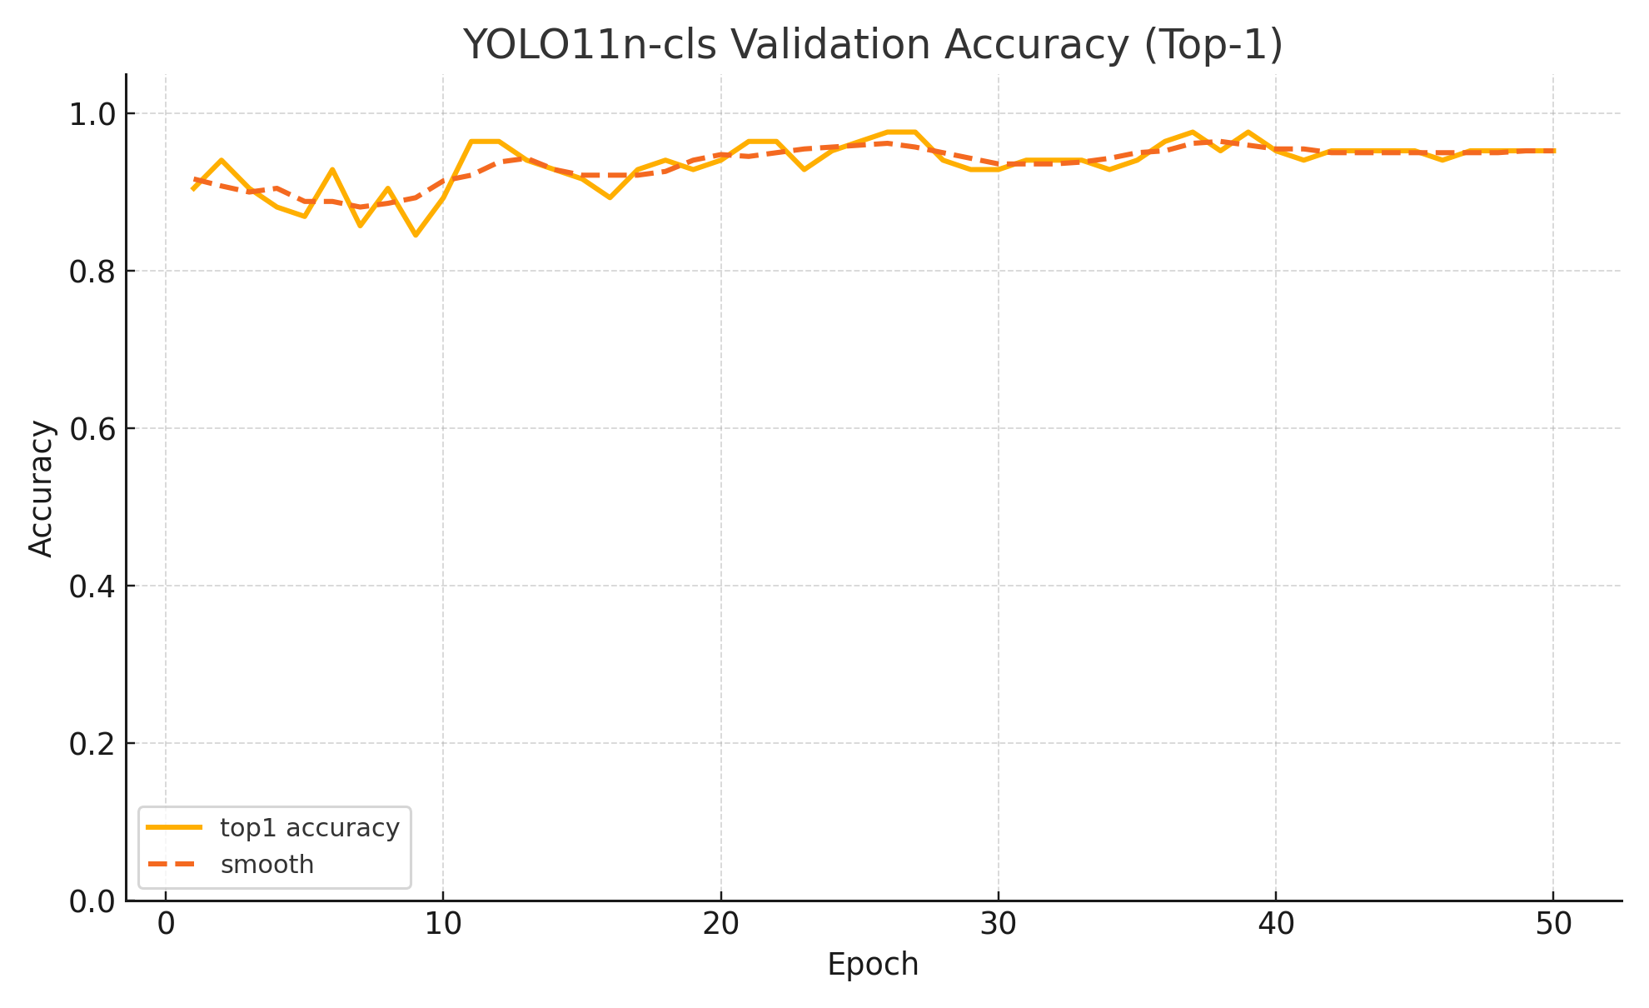
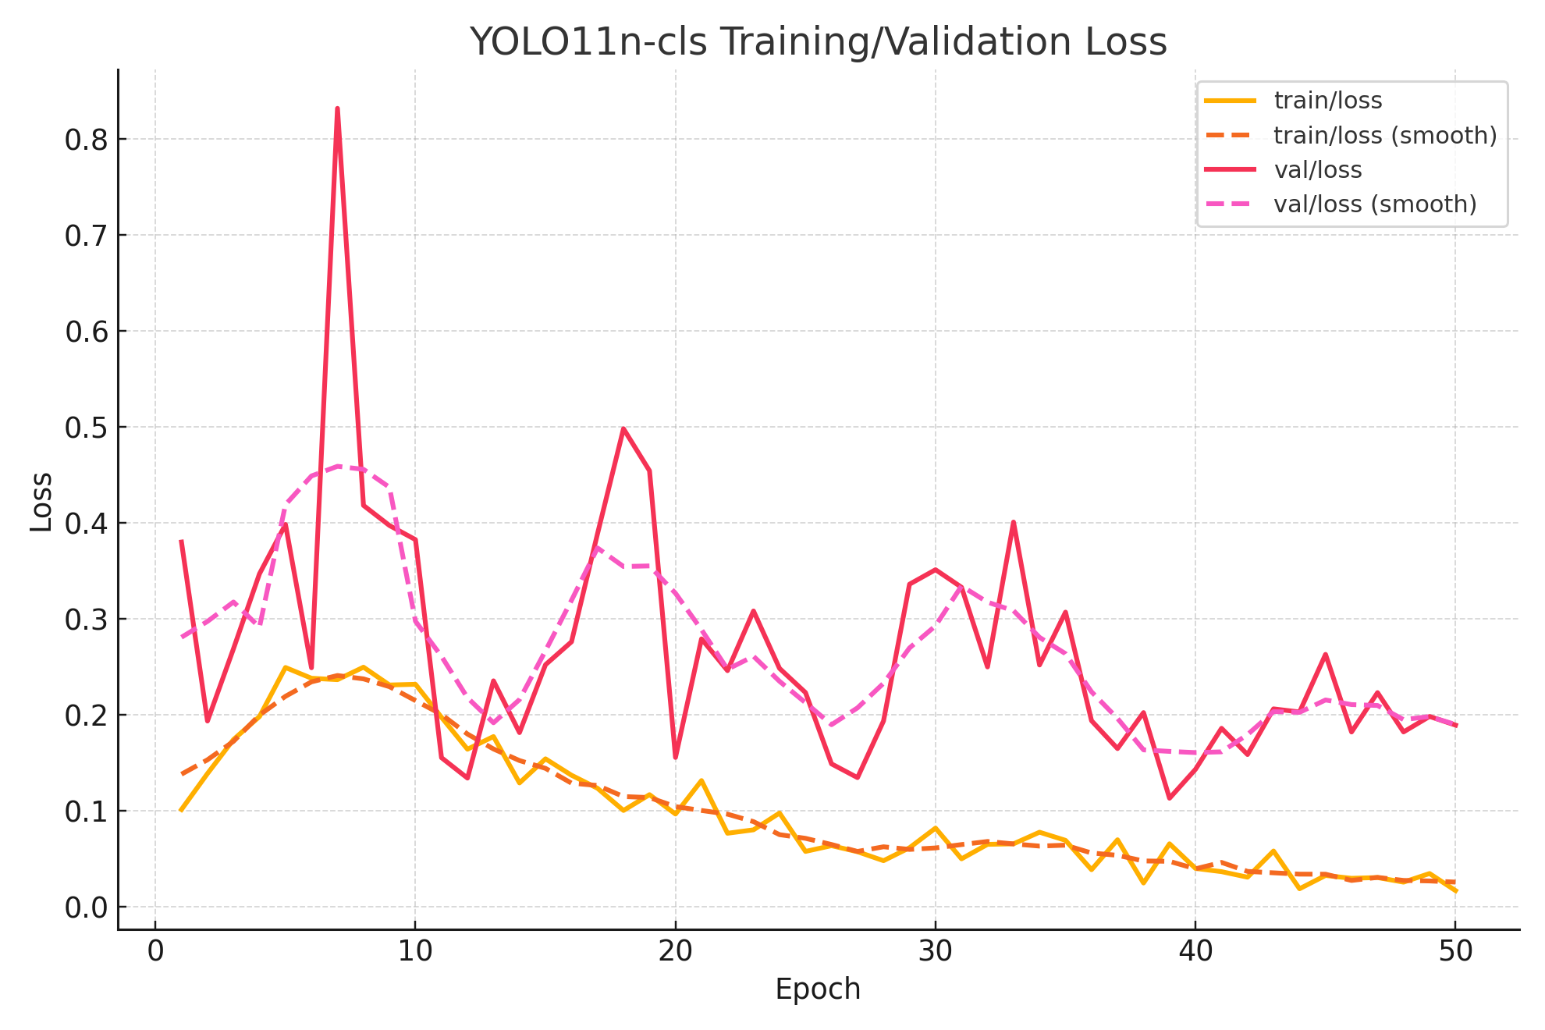

Confusion Matrix


