Next Term Plan
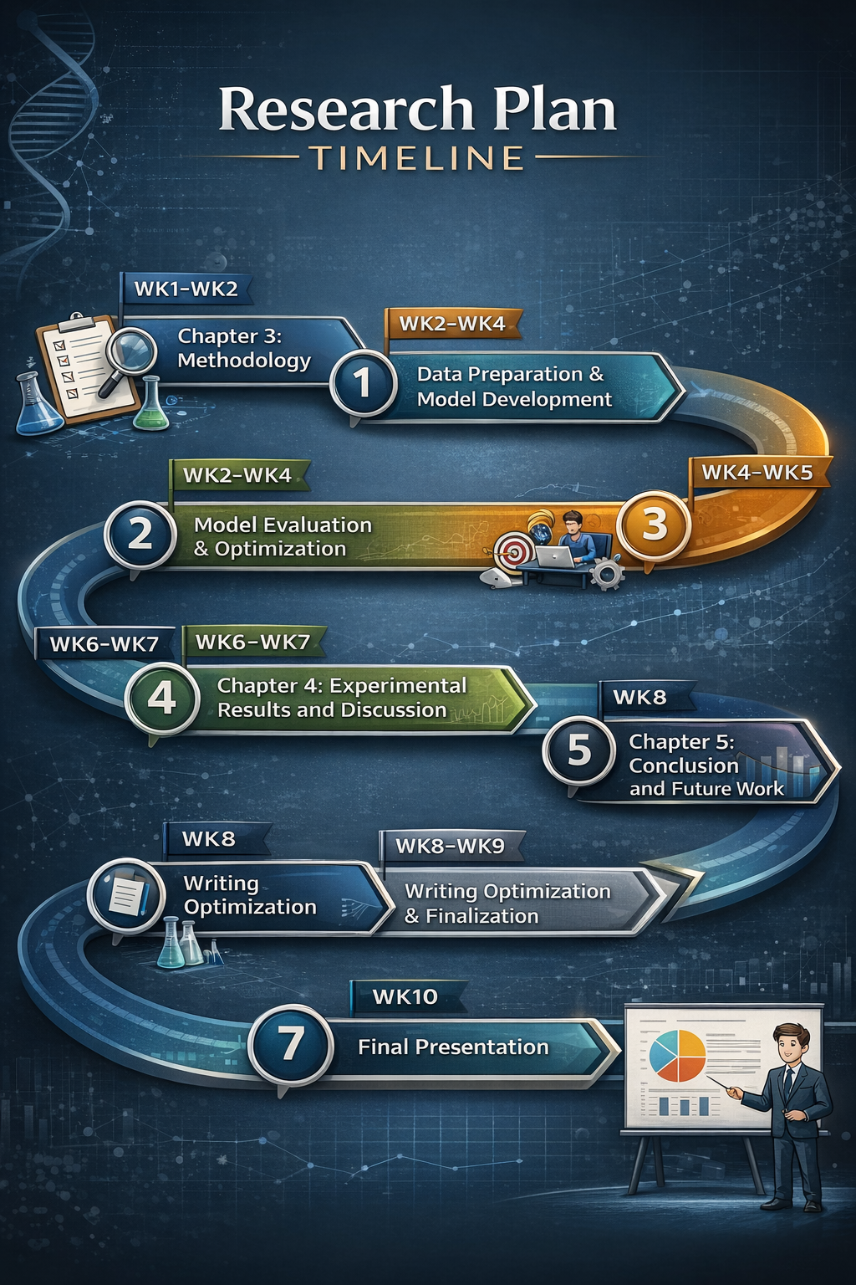
Table (1): Plan and Timeline
Phase1: Chapter 3 – Methodology
- The work will begin with defining the methodology of the research using the UCI Thyroid dataset and the selected machine learning models.
- First, the dataset will be explored to understand its structure and available features. Data cleaning and preprocessing will be performed to handle missing values and ensure consistency. Key laboratory features such as TSH, T3, and T4 will be selected based on their relevance.
- The dataset choice will be justified in terms of benchmarking and reproducibility, and a validation strategy will be defined using a train/test split approach. The methodology will be fully documented, including tools such as Python and Scikit-learn.

Expected Output
Completed Chapter 3 including dataset justification, preprocessing steps, model design, validation approach, and tools.

Challenge
Data quality issues or missing values

Mitigation
Apply preprocessing and remove inconsistent records

Time Frame
Week 1- Week 2
Phase 2: Data Preparation & Model Development
- After completing the methodology, machine learning models will be developed using the cleaned dataset and selected features.
- The dataset will be split (e.g., 80/20), and two models will be trained: Decision Tree Classifier (DT) and Random Forest Classifier (RF). Predictions will be generated from both models, and outputs will be saved for further evaluation.

Expected Output
Trained machine learning models with validated prediction outputs (Decision Tree Classifier (DT) / Random Forest Classifier (RF)).

Challenge
Model instability or low performance

Mitigation
Use simple models and avoid over-complex tuning

Time Frame
Week 2 – Week 5

Phase 3: Model Evaluation & Optimization
- The trained models will be evaluated using standard performance metrics.
- Accuracy, Precision, Recall, and F1-score will be calculated. Confusion matrices and charts will be generated to visualize performance. Based on the comparison, the best-performing model will be selected.
Expected Output
Final Model Evaluation Report including metrics, visualizations, and selected models.

Challenge
Misinterpretation of evaluation metrics

Mitigation
Focus on key metrics (Accuracy, F1-score) and provide clear explanation

Time Frame
Week 5 – Week 6

Phase 4: Chapter 4 – Experimental Results and Discussion
- The evaluation results will be analyzed and written into Chapter 4.
- Results will be presented using tables and charts, followed by interpretation of findings. The results will be compared with the literature from Chapter 2, and the model behavior will be explained clearly. The conceptual framework will also be described within the discussion.
Expected Output
Completed Chapter 4 including results, interpretation, and framework explanation.

Challenge
Weak link to literature

Mitigation
Use direct comparison with cited studies

Time Frame
Week 5 – Week 7

Phase 5: Chapter 5 – Conclusion and Future Work
- The final chapter will summarize the outcomes of the research.
- Key findings will be highlighted, contributions will be clearly stated, and limitations will be discussed, particularly the use of dataset and lack of symptom data. Future work will be proposed accordingly.

Expected Output
Completed Chapter 5 including conclusions, limitations, and contributions.

Challenge
Weak contribution or repetition

Mitigation
Focus on insights, novelty, and practical value

Time Frame
Week 6 – Week 8

Phase 6: Writing Optimization & Finalization
- The full thesis document will be reviewed and refined.
- Writing will be edited to improve clarity and consistency. Formatting will be standardized, and references will be cross-checked. A plagiarism check will be performed, followed by a final review of the complete document.
Expected Output
Final thesis document ready for submission.
Challenge
Time constraints or formatting issues
Mitigation
Prioritize clarity over perfection and use standard formatting
Time Frame
Week 8 – Week 9

Phase 7: Final Presentation
- The final step will focus on preparing for the thesis presentation.
- Slides will be prepared summarizing key sections of the work. The presentation will be practiced, and answers for expected questions will be prepared.
Expected Output
Final presentation slides and full defense readiness.
Challenge
Nervousness or unexpected questions
Mitigation
Practice and prepare standard answers
Time Frame
Week 10

Proposed System Flow
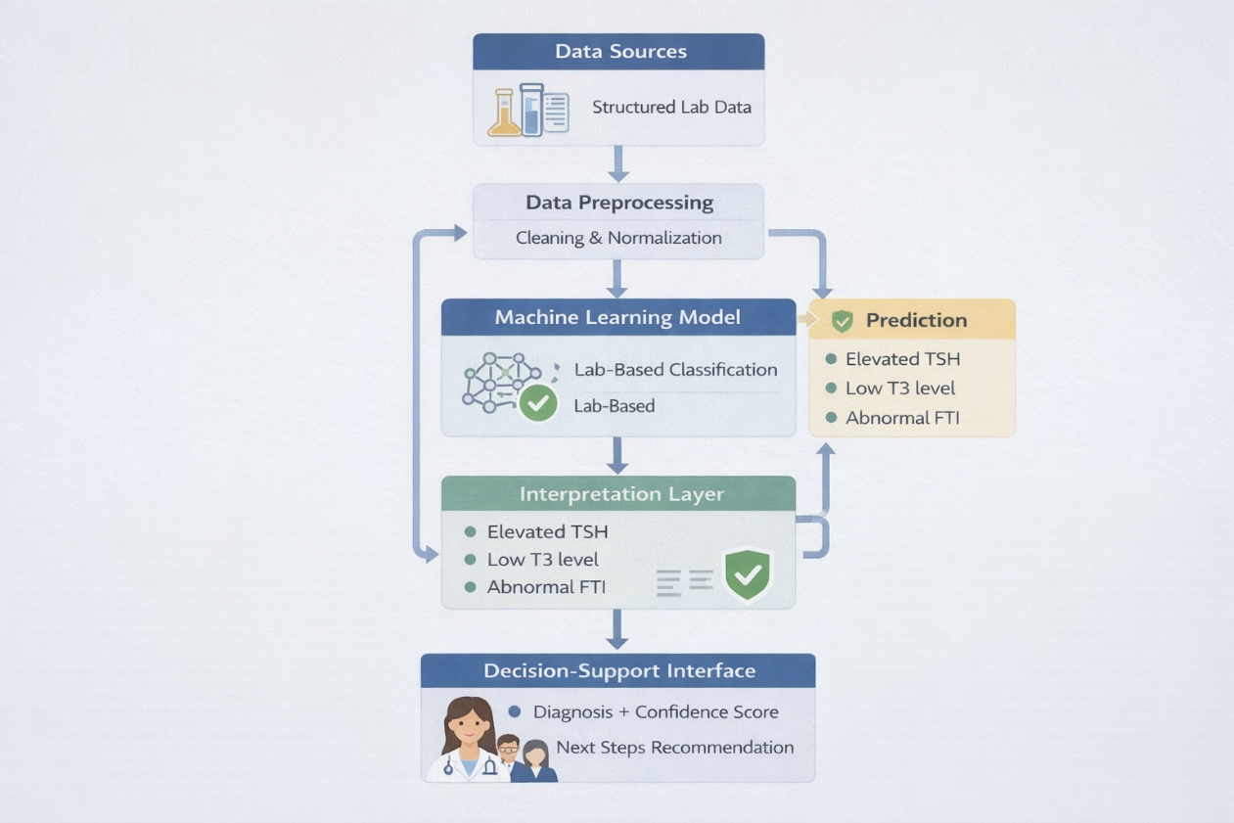
Figure 1: System Flow

In this figure, the overall system flow is shown. Laboratory data is first collected and then prepared through cleaning and normalization. After that, it is processed by a machine learning model to predict the thyroid condition.
An interpretation step is included, where the main laboratory factors influencing the prediction are highlighted. Finally, the results are presented through a decision-support interface, where the diagnosis, confidence level, and suggested next steps are displayed.

