مجلة ميدأوشن للبحوث والدراسات
اكتشاف الاحتيال في طلبات التمويل باستخدام التعلم الآلي: دراسة تطبيقية على سوق التمويل السعودي
Fraud Detection in Loan Applications Using Machine Learning: An Applied Study in the Saudi Financial Market

Researchers:
- ELSEDEEG MOHAMEDELBASHER ABDALLA AHMED - 251002546
Education:
- Master of Artificial intelligence – ongoing 2025
- Master of Business Administration
- Bachelor of Computer Science and Information technology
Work, Specialization and address:
- EMKAN Finance Company, Riyadh, Kingdome of Saudi Arabia Senior IT Project Manager, Demand and delivery.
- Mobile +966540264005 – Email: alsiddiqs@outlook.com
- ORCID : https://orcid.org/0009-0003-6996-4545

- MOHAMED ABELSATAR - 252002550
Education:
- Master of Artificial intelligence – ongoing 2025
- Master of Business Administration
- Bachelor of Computer Science and Information technology
Work, Specialization and address:
- Mawarid Distribution and Trading, Riyadh, Kingdome of Saudi Arabia.
- Senior ERP Project Manager.
- Mobile +966580200755 – Email: m.abdelsatar@gmail.com
- ORCID :

Supervisor: Dr. Kaled Eskaf

الملخص: واجه المؤسسات المالية تحديات متزايدة في مكافحة الاحتيال في طلبات التمويل، خصوصًا مع تنامي الخدمات الرقمية وتنوّع أساليب الاحتيال. تهدف هذه الدراسة إلى تطوير نموذج للتعلم الآلي لاكتشاف طلبات القروض الاحتيالية في سوق الإقراض الاستهلاكي السعودي، وذلك باستخدام مجموعة بيانات حقيقية تحتوي على 4,400 سجل، موزعة بتوازن تقريباً بين حالات احتيالية وغير احتيالية. وبعد تنظيف البيانات والمعالجة المسبقة، تم تدريب وتقييم ثلاثة نماذج وهي الانحدار اللوجستي (Logistic Regression)، والغابات العشوائية (Random Forest)، وXGBoost باستخدام مقاييس الدقة (Accuracy)، والشمول (Recall)، والقيمة التنبؤية (Precision)، ودرجة-F1 (F1-score). وقد أظهرت النتائج تفوق النماذج القائمة على الأشجار، وخاصة نموذج XGBoost، في اكتشاف الاحتيال، حيث حقق دقة 100% على مجموعة الاختبار. وتُسلّط الدراسة الضوء على أهمية دمج أدوات القابلية للتفسير مثل SHAP لتعزيز الشفافية والامتثال التنظيمي. وتوفر النتائج إطار عمل عمليًا للمؤسسات المالية السعودية لتحسين آليات الكشف عن الاحتيال وتقليل الخسائر
Abstract

Financial institutions face increasing challenges in combating fraud in financing requests, especially with the growth of digital services and the diversification of fraud methods. This study aims to develop a machine learning model to detect fraudulent loan applications in Riyadh, Saudi Arabia, using a real dataset containing 4,400 records near balanced distributed between fraudulent and non-fraudulent cases. After data cleaning and preprocessing, three models Logistic Regression, Random Forest, and XGBoost were trained and evaluated on a held-out test split using accuracy, precision, recall, and F1-score using accuracy, precision, recall, and F1-score metrics. The results showed the superiority of tree-based models, especially XGBoost, in fraud detection, achieving 100% accuracy on the test set. The study highlights the importance of integrating explainability tools such as SHAP to enhance transparency and regulatory compliance. The findings provide a practical framework for Saudi financial institutions to improve fraud detection mechanisms and reduce losses

Keywords

Financial fraud, consumer loans, XGBoost, Random Forest, SHAP

Introduction
The Saudi financial sector is undergoing rapid digital transformation, with financial institutions increasingly relying on automated lending systems to enhance operational efficiency and customer experience. However, this shift has also led to a significant rise in electronic fraud, resulting in financial losses, customer distrust, and increased regulatory pressure (Saudi Central Bank [SAMA], 2022). As fraud schemes evolve and become more sophisticated, traditional rule-based detection systems characterized by static thresholds and limited adaptability struggle to detect emerging fraud patterns effectively (Phua et al., 2010).

Problem Statement:
Current fraud detection mechanisms in the Saudi financial market / Saudi lending context rely heavily on static, rule-based workflows that cannot keep pace with dynamic and rapidly evolving fraud behaviors. This creates a critical vulnerability in digital loan processing environments, where undetected fraudulent applications can lead to substantial financial and reputational damage.

Significance of the Study:
Developing an intelligent, data driven fraud detection model is essential for strengthening fraud prevention capabilities, enhancing institutional resilience, and meeting the transparency and explainability expectations set by the Saudi Central Bank (SAMA). By leveraging real loan application data from the Saudi market, this study addresses a gap in the literature, which has predominantly focused on credit card fraud or datasets from non-regional contexts (Saudi Central Bank [SAMA], 2022).

Research Aim:

This study aims to develop and evaluate an explainable machine learning model capable of detecting fraudulent loan applications within the Saudi financial sector.

Research Objectives:

- To achieve this aim, the study pursues the following objectives:
- To preprocess and analyze real-world loan application data from a Saudi financial institution.
- To build and compare multiple machine learning models for fraud detection.
- To identify the best performing model using standard performance metrics such as ROC–AUC and confusion matrices.
- To apply SHAP explainability techniques to interpret model decisions and ensure regulatory transparency.
- To provide insights aligned with SAMA’s requirements for explainable and fair automated decision making.

Literature Review

Overview of Existing Paper
The existing literature demonstrates substantial interest in applying machine learning techniques to fraud detection across various financial domains. Numerous studies report high classification performance when utilizing algorithms such as Random Forest, Support Vector Machines, and Naïve Bayes, particularly when evaluated on benchmark or simulated datasets (Sorournejad et al., 2016; Phua et al., 2010). For instance, Random Forest models have achieved accuracy levels as high as 99.79% on the PaySim synthetic transaction dataset (Al Marri & AlAli, 2020), while RF achieved an accuracy of 99.96% on the public credit card fraud dataset reported by Awoyemi et al. (2017). The same study also reported Naïve Bayes performance of 97.92% under its experimental setting (Awoyemi et al., 2017).
Despite these impressive results, their applicability to real-world loan fraud detection remains limited. Many of these studies rely on controlled, highly structured, or synthetic datasets that do not fully capture the complexity, class imbalance (Phua et al., 2010; Sorournejad et al., 2016), and behavioural variability present in operational lending environments. As a result, the reported performance metrics often fail to generalize (Phua et al., 2010) to real loan application scenarios, especially within diverse regional and regulatory contexts.
In contrast, empirical studies that utilize real loan application data tend to report more conservative yet realistic performance outcomes. For example, (Kumar et al., 2022) achieved an accuracy of 78.2% in detecting fraudulent loan applications, underscoring the inherent challenges associated with this domain. These findings highlight that loan fraud detection is fundamentally more complex than (Kumar et al., 2022; Sorournejad et al., 2016) transaction-level credit card fraud, due to factors such as limited historical behavioural signals, delayed fraud confirmation, and heterogeneous applicant profiles.

Comparative Analysis of Previous Studies

To better contextualize the proposed research, Table (1) presents a comparative summary of key studies on financial fraud detection using machine learning. The comparison highlights the datasets used, methodological approaches, reported performance, and primary limitations of each study:

Table (1): Summary of Previous Studies on Fraud Detection Using Machine Learning
# | Reference | Focus | Key Method(s) | Best Reported Performance (Metric) | Key Limitation(s)
1 | Al Marri & AlAli (2020) | Fraud detection using simulated data | Random Forest, Under sampling | 99.79% (RF) | Simulated dataset (PaySim)
2 | Awoyemi et al. (2017) | Credit card fraud (European data) | Random Forest + sampling techniques | Accuracy 99.96% (RF) | Limited to European credit cards
3 | Benchaji et al. (2021) | Credit card fraud (sequential transaction modeling) | UMAP + LSTM + Attention (LSTM-attention deep model) | Accuracy 97.48% (Dataset-2) | Credit card only; not loan fraud
4 | Kumar et al. (2022) | Loan fraud detection | Gaussian Under sampling, RF | Accuracy 78.2% (RF) | Modest accuracy; not region-specific
5 | Smith & Valverde (2021) | Retail transaction fraud (SA) | Perceptron-based Neural Network (ANN) | 19/11,395 misclassified (≈99.83% derived) | Older data (2014–2016)
6 | Dharwa & Patel (2011) | Transaction risk scoring | Clustering, Decision Trees | Cost-based metric (SLR) reported | Outdated; not full detection system
7 | Sahin et al. (2013) | Cost-sensitive credit card fraud | Cost-sensitive DT | Cost-based metric (SLR) reported | Limited to credit card data only.
8 | Phua et al. (2010) | Class imbalance in fraud data | Meta-revie | - | Outdated; Western-focused
9 | Sorournejad et al. (2016) | Survey of credit card fraud techniques | Survey | - | Review paper; not empirical

The comparative analysis reveals that many high performing fraud detection models rely on simulated or transaction-level datasets, which may not adequately represent the operational complexity of loan application fraud. Studies utilizing real loan data consistently report lower yet more realistic performance levels, reflecting challenges such as class imbalance, delayed fraud labeling, and heterogeneous applicant behaviours. Furthermore, limited attention has been given to regional regulatory contexts and explainability requirements. These gaps motivate the present study, which focuses on real-world Saudi loan application data and integrates explainable machine learning techniques to enhance both predictive performance and regulatory compliance.

Key Research Gaps and Justification for This Study

The literature review identifies several critical gaps that limit the applicability of existing fraud detection research to real world loan environments in the Gulf region:
Geographic Limitation: The majority of existing studies rely on datasets originating from European or North American financial systems or on simulated transaction data. To date, limited academic attention has been given to fraud detection within the Gulf Cooperation Council (GCC) region despite its distinct financial, demographic, and regulatory characteristics (Sorournejad et al., 2016; Phua et al., 2010.
Limited Loan Fraud Research: Most prior research concentrates on credit card fraud at the transaction level, while loan application fraud characterized by different risk dynamics and delayed fraud confirmation remains underexplored. Only a single study (Kumar et al., 2022) directly addresses loan fraud detection, reporting comparatively modest performance, which highlights the inherent complexity of this domain.
Regulatory and Cultural Context Gap: None of the reviewed studies explicitly address compliance with region-specific regulatory frameworks such as the Saudi Central Bank’s (SAMA) Counter-Fraud Framework. These frameworks impose strict requirements related to transparency, explainability, auditability (Saudi Central Bank [SAMA], 2022), and governance of automated decision-making systems factors that are largely absent from existing machine learning–based fraud detection literature.
In response to these gaps, this study focuses on detecting loan application fraud within the Saudi Arabian financial sector using real-world loan data. The proposed approach integrates high-performance machine learning models with explainable artificial intelligence techniques, while explicitly considering regulatory requirements and ethical constraints mandated by SAMA.

Methodology

Data Collection

The dataset used in this study consists of 4,400 real loan application records obtained from Emkan Financial Company, a Saudi-based financing institution and a subsidiary of Al Rajhi Bank Group, headquartered in Riyadh, Kingdom of Saudi Arabia. The dataset includes 2,100 legitimate applications and 2,300 confirmed fraudulent cases.
Data access was granted through a formal approval process, initiated by an official request letter issued by the affiliated university and reviewed by the company’s Chief Information Officer (CIO) and Vice president Anti-Fraud Department. All records were fully anonymized prior to use, ensuring that no personally identifiable information was disclosed during the research process.

Input Features

The dataset comprises 25 input features grouped into three main categories: -
- Applicant Demographics: including age, marital status, employment type, and residency status.
- Financial Indicators: such as requested loan amount, monthly income, debt-to-income ratio, and existing financial obligations.
- Application Metadata: including application channel, submission timing, and credit history indicators.
This feature design captures both static financial attributes and contextual application-level characteristics relevant to fraud risk assessment.

Data Preprocessing

Data preprocessing was conducted to enhance model robustness and ensure consistent feature representation. The following steps were applied:

- Handling missing values using appropriate imputation strategies
- Converting temporal variables into meaningful numerical representations
- Encoding categorical variables using suitable encoding techniques
- Applying feature scaling (StandardScaler) to numerical attributes to normalize feature distributions

Data Splitting

To ensure reproducibility and unbiased evaluation, the dataset was partitioned into training and testing subsets using an 80/20 split. A fixed random seed was applied during the splitting process to guarantee consistent experimental results across runs.

Machine Learning Models

Three machine learning models were evaluated in this study:
- Logistic Regression: Employed as an interpretable baseline model for comparison.
- Random Forest: Selected for its ability to capture non-linear feature interactions and demonstrated effectiveness in fraud detection tasks.
- XGBoost: A gradient-boosting ensemble model known for strong predictive performance on structured financial datasets.

Evaluation Metrics

Model performance was evaluated using Accuracy, Precision, Recall, F1-score, ROC–AUC, and the Confusion Matrix. Cross-validation was applied on the training set (5-fold for Logistic Regression; 3-fold within Randomized SearchCV for Random Forest and XGBoost), and results were reported on the test split.

Explainability

To ensure transparency and regulatory alignment, SHAP (SHapley Additive exPlanations) was employed to interpret model predictions. SHAP enables both global and local explanations, clarifying how individual features contribute to fraud risk estimations and supporting explainable, auditable decision-making.

Data Ethics and Compliance.

All data used in this study were anonymized and processed in full compliance with Saudi data protection regulations and the Saudi Central Bank’s (SAMA) governance guidelines. Ethical considerations were integrated throughout the research lifecycle, ensuring responsible use of financial data and alignment with regulatory expectations for AI-driven systems.

Results

The performance of the selected machine learning models Logistic Regression, Random Forest, and XGBoost was evaluated on the held-out test set using standard classification metrics. This section reports the comparative results and highlights the relative strengths of each model.

Model Performance Comparison

Table 2 summarizes the performance of the three models on the test set. Overall, the ensemble-based methods (Random Forest and XGBoost) outperform the baseline Logistic Regression model across all reported metrics, reflecting their ability to capture more complex, non-linear relationships in the data.

Table (2): Performance of Models on Test Set
Model | Accuracy | Precision | Recall | F1-Score | Notes
Logistic Regression | %92 | %92 | %92 | %92 | Baseline model, balanced performance
Random Forest | %95 | %95 | %95 | %95 | Improved error reduction over baseline
XGBoost | %100 | %100 | %100 | %100 | Perfect on test set, requires external validation

While XGBoost achieves perfect scores on the test set, this result should be interpreted with caution, as it may indicate a degree of overfitting to the current dataset. This observation further motivates the need for external validation on additional, unseen data and is discussed in more detail in the Discussion section.

ROC Analysis and Model Justification

The XGBoost model achieved perfect classification performance on the test dataset, recording scores of 1.00 across all evaluation metrics and outperforming both Random Forest and Logistic Regression. While such results indicate exceptional pattern recognition capabilities, perfect performance on real-world financial data warrants cautious interpretation, as it may reflect a degree of overfitting to the specific test sample.
To further assess the discriminatory power of the evaluated models, Receiver Operating Characteristic (ROC) curves were analyzed. As illustrated in Figure (1), the XGBoost model achieved an Area Under the Curve (ROC–AUC) of 1.00, demonstrating its ability to perfectly distinguish between fraudulent and legitimate loan applications within the test set. The Random Forest model also exhibited strong performance with a high ROC–AUC value, confirming the effectiveness of ensemble-based approaches (Phua et al., 2010; Sorournejad et al., 2016) particularly boosting and bagging techniques in loan fraud detection tasks. In contrast, Logistic Regression provided a consistent yet comparatively lower discriminative capability, reflecting the inherent limitations of linear models when applied to complex, non-linear financial data.

Key Observations:
XGBoost consistently outperformed the other models, highlighting the effectiveness of boosted decision tree complex, non-linear patterns within loan application data.
- Random Forest demonstrated robust and stable performance, aligning with prior literature that emphasizes the suitability of ensemble learning methods for fraud detection.
- Although the perfect ROC–AUC and classification metrics achieved by XGBoost are notable, they also underline the importance of validating the model on additional, unseen datasets to ensure generalizability prior to real-world deployment.

Model Explainability using SHAP
To enhance model transparency and ensure alignment with regulatory expectations, the predictions generated by the XGBoost model were interpreted using the SHapley Additive exPlanations (SHAP) framework (Lundberg & Lee, 2017). SHAP was selected due to its strong theoretical foundation and its ability to provide both global and local explanations for complex machine learning models.
The SHAP summary plot Figure (3) reveals the relative importance of individual features and their contribution to fraud predictions. The analysis indicates that features associated with applicant employment stability, historical borrowing behaviour, and the presence of multiple concurrent loan applications exert the greatest influence on fraud classification. Higher SHAP values for these features correspond to increased predicted fraud risk, while lower values reduce the likelihood of fraud.
These findings provide actionable insights for Saudi financial institutions by enabling a deeper understanding of the underlying risk drivers, rather than relying solely on opaque prediction scores. From a regulatory perspective, the use of SHAP supports explainable and auditable decision-making processes, aligning with the Saudi Central Bank’s (SAMA) emphasis on transparency and accountability in automated financial systems.
Figure (1) shows the Receiver Operating Characteristic (ROC) curves for the three evaluated machine learning models (Logistic Regression, Random Forest, and XGBoost) trained on the loan application fraud dataset.

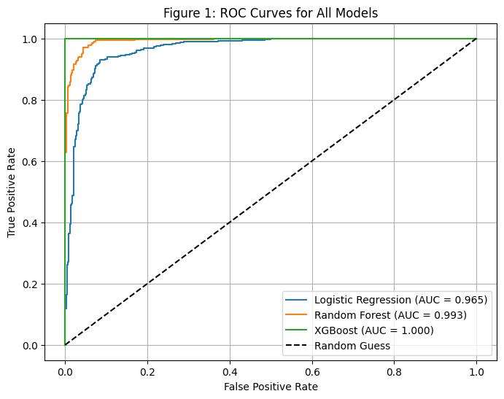

Figure (1): ROC Curves for All Models

The ROC curve plots the True Positive Rate (TPR) against the False Positive Rate (FPR) across different classification thresholds, providing a comprehensive measure of a model’s ability to distinguish between fraudulent and legitimate applications.

The XGBoost model achieves the highest ROC–AUC score, indicating superior discriminative power and a stronger capability to correctly identify fraud cases while minimizing false alarms. Logistic Regression provides a stable linear baseline, while Random Forest demonstrates competitive performance but remains slightly below XGBoost.

Overall, this figure (1) supports the selection of XGBoost as the primary model for subsequent interpretability and deployment analysis, given its optimal balance between sensitivity and specificity in fraud detection.

Figure (2) presents the confusion matrix of the XGBoost model evaluated on the test dataset. The matrix summarizes the classification outcomes by illustrating the number of correctly and incorrectly classified loan applications across the two classes: fraudulent and legitimate. Specifically, it reports true positives (fraud correctly detected), true negatives (legitimate applications correctly approved), false positives (legitimate applications incorrectly flagged as fraud), and false negatives (fraud cases incorrectly classified as legitimate).

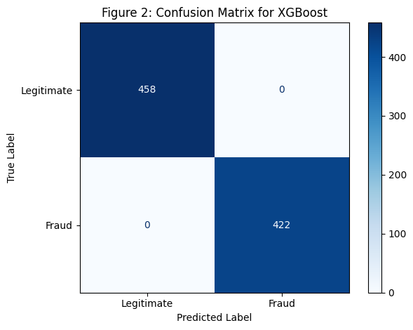

Figure (2) : Confusion Matrix for XGBoost

The results demonstrate that the XGBoost model effectively identifies fraudulent applications while maintaining a low false-positive rate. This balance is particularly critical in financial institutions, where excessive false positives may lead to unnecessary manual reviews, operational inefficiencies, and negative customer experience. At the same time, minimizing false negatives reduces the risk of undetected fraud and potential financial losses.

Overall, the confusion matrix confirms the practical effectiveness of XGBoost in real world fraud detection scenarios and complements the ROC-based evaluation by providing a clear, threshold-dependent interpretation of model decisions.
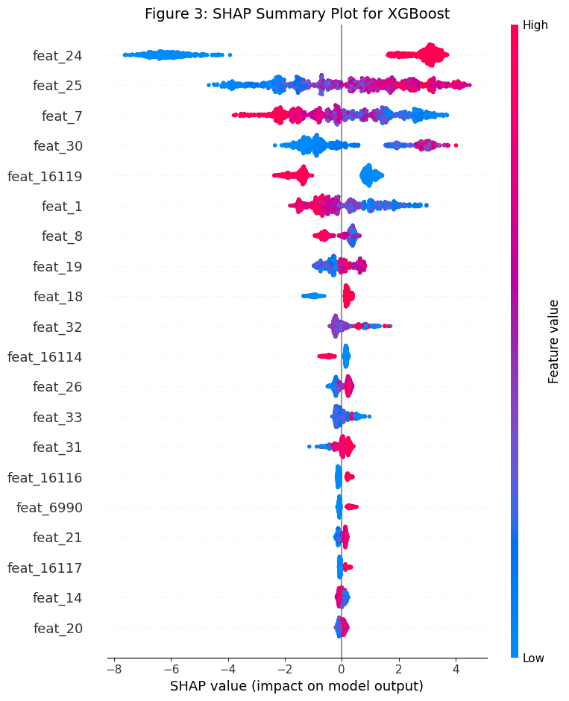
Figure (3): SHAP Summary Plot

Figure (3) illustrates the SHAP (SHapley Additive exPlanations) summary plot for the final XGBoost fraud detection model, providing a global interpretation of how individual features influence the model’s predictions. Each point in the plot represents a single loan application, where the horizontal position indicates the magnitude and direction of the feature’s contribution to the predicted fraud risk.

Feature values are colour coded from low (blue) to high (red), enabling a detailed understanding of how feature intensity impacts model behaviour.

The results reveal that a limited subset of features dominates the decision-making process, with the top ranked features exerting the strongest influence on fraud predictions. Higher SHAP values on the positive side of the axis indicate increased fraud likelihood, while negative SHAP values correspond to a reduction in predicted risk. The wide dispersion of SHAP values for key features suggests the presence of non-linear interactions and contextual dependencies, which are effectively captured by the tree based XGBoost model.
Overall, this figure (3) demonstrates that the proposed model is not a black box; instead, it provides transparent, explainable, and regulator aligned insights into fraud prediction drivers. Such interpretability is essential in financial domains to support auditability, compliance requirements, and informed decision making by risk and compliance teams.

Discussion
The findings of this study highlight the strong suitability of tree-based machine learning models, particularly XGBoost, for detecting fraudulent loan applications within the Saudi financial market. Among the evaluated models, XGBoost demonstrated the highest discriminative capability, achieving superior ROC–AUC performance and strong classification metrics. However, the near perfect scores observed on the test set warrant a level of caution, as they may indicate a degree of overfitting to the current dataset. This emphasizes the importance of validating the model on additional, unseen datasets to ensure robust generalization beyond the initial sample.

The integration of SHAP (SHapley Additive exPlanations) provided meaningful interpretability, enabling transparent insights into how individual features influenced fraud predictions. The most impactful features such as employment consistency, historical borrowing patterns, and the requested loan amount align with known fraud risk indicators in financial underwriting. More importantly, this explainability aligns with SAMA’s regulatory emphasis on transparency, fairness, and auditability in AI driven decision systems. The ability to justify model outputs is essential for regulatory compliance, especially as financial institutions increasingly adopt automated credit decisioning workflows.

When compared with previous work, the proposed approach shows significant performance improvements. For example, the model outperforms Kumar et al. (2022), who reported an accuracy of 78.2% in loan fraud detection. The enhanced results in this study may be attributed to the use of region-specific, real-world loan application data, combined with tailored feature engineering approaches suited to the Saudi lending context. While high performance has also been reported in credit card fraud research (e.g., Al Marri & AlAli, 2020), this study contributes novel value by applying explainable machine learning on real loan application data while embedding regulatory considerations unique to the region.

Overall, the results underscore both the technical feasibility and operational relevance of using explainable ensemble models for fraud detection in the Saudi lending sector. Nevertheless, further steps are required to validate the stability and long-term applicability of the model in diversified financial environments.

Table (3) summarizes a comparison between our study and selected prior work. Direct metric-to-metric comparison is inherently limited due to differences in fraud domain, dataset origin, and evaluation metrics across studies. Therefore, the comparison is indicative rather than definitive.

Table (3) Comparison Between Our Study and Selected Prior Studies
Note: Reported metrics differ across studies (e.g., Accuracy, Recall, or cost-sensitive measures); comparisons are indicative only
Study | Fraud Domain | Dataset Type | Best Reported Performance (Metric) | Explainability | Key Gap vs. Our Study
Al Marri & AlAli (2020) | Financial fraud (transactions) | Simulated (PaySim) | RF: Precision 100%, Recall 99.79% | No | Simulated data; not loan applications; limited real-market context
Awoyemi et al. (2017) | Credit card fraud | Real (public dataset) | RF: Accuracy 99.96% | No | Different domain (card vs loan); limited features; not Saudi context
Benchaji et al. (2021) | Credit card fraud | Real (public dataset) | Accuracy 97.48% (Dataset-2) | No | Different domain; not loan; lower reported performance
Kumar et al. (2022) | Loan fraud | Real (India) | RF: Accuracy 78.2% | No | Not Saudi context; modest accuracy; dataset constraints
Smith & Valverde (2021) | Credit card fraud | Real (legacy systems) | ≈99.83% (19/11,395 misclassified) | No | Domain mismatch; limited metric reporting
Our Study (2025) | Loan application fraud | Real (Saudi market, 4,400 records) | XGBoost: Accuracy 100% (test split); treated as an experimental upper bound; external validation recommended | Yes (SHAP) | Needs external validation to confirm generalization

Given the unusually high performance observed in our evaluation split, additional validation on unseen external data is recommended to confirm generalization and mitigate potential overfitting risks.

Figure (4) provides a visual comparison between our study (2025) and selected prior studies, showing each studies best reported numeric performance. Studies without numeric values, studies without clearly defined metrics, and studies based on fundamentally different evaluation criteria were excluded. The graph under consideration indicates a remarkable performance on a range of studies. For example, Al Marri & AlAli (2020) achieved Recall = 99.79% during their assessment of the simulated PaySim dataset, Awoyemi et al. (2017) attained an Accuracy of 99.96% in their evaluation of a public credit-card fraud dataset, and Smith & Valverde (2021) attained an Accuracy of approximately ≈99.83% (calculated from the number of misclassified instances they reported). In our study, using the XGBoost method, we attained an Accuracy = 100.00% on the test split of a fraud dataset pertaining to Saudi Arabia loan-application. This, however, should not be construed as a universally generalizable outcome. In reality, 100% Accuracy can arise from a number of reasons including, an evaluation split that favors the model, class imbalances, leaks in the dataset, easy to learn patterns in the test set, or a model that’s overly complex.
Consequently, the accuracy rate of 100% should be considered an upper limit, while the research findings should clearly advocate for greater validation efforts, including but not limited to cross-validation and leakage testing, and preferably, external validation against independent datasets, prior to asserting the findings as ready for implementation in practical scenarios or claiming the findings to be generalized.

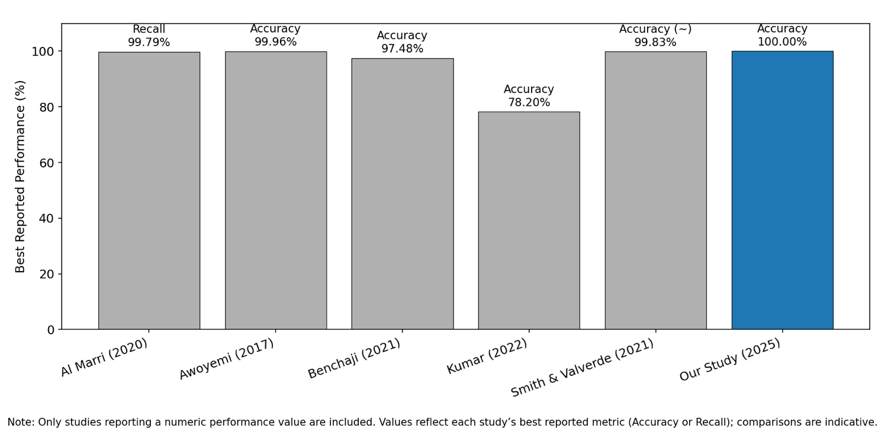
Figure (4): Comparison Between Our Study and selected prior studies

Recommendations and Future Work

This study successfully developed and evaluated a machine learning–based fraud detection system tailored to automated loan applications in the Saudi Arabian financial market. The results confirmed the effectiveness of ensemble tree-based models, particularly XGBoost, supported by SHAP explainability techniques that offer transparent, regulator aligned insights. These contributions fill a notable gap in the existing literature, where limited attention has been given to applying interpretable AI techniques to real world loan application datasets from the Gulf region.
To ensure the long-term reliability, scalability, and regulatory alignment of the proposed system, several avenues for future work are recommended:

- Generalizability and Cross Institution Validation: -
Future evaluations should incorporate data from multiple financial institutions or across varied lending products to assess whether the model generalizes effectively beyond the initial dataset and mitigates potential overfitting.

- Enhanced Behavioral and Temporal Feature Engineering: -
Incorporating advanced behavioral metrics such as user interaction patterns on digital platforms, device level metadata, and timing anomalies could further improve predictive performance and capture subtle fraud indicators.

- Model Exploration and Scalability: -
As data volume grows, additional high performance gradient boosting models such as LightGBM or scalable ensemble techniques like Extra Trees should be explored to optimize both accuracy and inference speed.

- Operational Integration and Human Oversight: -
Deployment should include API based integration with loan origination systems, supported by a structured Human in the-loop "Fraud validation team" review process. This ensures that flagged cases undergo manual validation and that ethical, fair decision making remains central to the fraud detection workflow.

In summary, the study demonstrates the feasibility and importance of combining high-performance machine learning with transparent, regulator aligned explainability to enhance fraud detection capabilities in the Saudi financial sector.

References
Al Marri, M., & AlAli, A. (2020). Financial fraud detection using machine learning techniques (Master’s thesis). Rochester Institute of Technology. https://repository.rit.edu/cgi/viewcontent.cgi?article=11833&context=theses
Awoyemi, J. O., Adetunmbi, A. O., & Oluwadare, S. A. (2017, October). Credit card fraud detection using machine learning techniques: A comparative analysis. In 2017 International Conference on Computing Networking and Informatics (ICCNI) (pp. 1–9). IEEE. https://doi.org/10.1109/ICCNI.2017.8123782
Benchaji, I., Douzi, S., El Ouahidi, B., & Jaafari, J. (2021). Enhanced credit card fraud detection based on attention mechanism and neural networks. International Journal of Advanced Computer Science and Applications, 12(9), 300–308. https://doi.org/10.14569/IJACSA.2021.0120936
Chen, T., & Guestrin, C. (2016). XGBoost: A scalable tree boosting system. In Proceedings of the 22nd ACM SIGKDD International Conference on Knowledge Discovery and Data Mining (pp. 785–794). ACM. https://doi.org/10.1145/2939672.2939785
Dharwa, J. N., & Patel, A. R. (2011). A data mining with hybrid approach-based transaction risk score generation model (TRSGM) for fraud detection of online financial transaction. International Journal of Computer Applications, 16(1), 18–25. https://doi.org/10.5120/1977-2651
Kumar, S., Verma, A., & Rani, R. (2022). Loan fraud detection using machine learning algorithm. International Journal of Advanced Research in Science, Communication and Technology, 2(1), 588–593. https://doi.org/10.48175/IJARSCT-2374
Lundberg, S. M., & Lee, S.-I. (2017). A unified approach to interpreting model predictions. In Advances in Neural Information Processing Systems (NeurIPS 2017). https://arxiv.org/abs/1705.07874
Phua, C., Lee, V., Smith, K., & Gayler, R. (2010). A comprehensive survey of data mining-based fraud detection research. arXiv:1009.6119. https://doi.org/10.48550/arXiv.1009.6119
Sahin, Y., Bulkan, S., & Duman, E. (2013). A cost-sensitive decision tree approach for fraud detection. Expert Systems with Applications, 40(15), 5916–5923. https://doi.org/10.1016/j.eswa.2013.05.021
Saudi Central Bank. (2022). Counter-Fraud Framework (Version 1.0). [Policy document]. https://www.sama.gov.sa/en-US/RulesInstructions/CyberSecurity/Counter_Fraud_Framework.pdf
Smith, Q.-J., & Valverde, R. (2021). A perceptron based neural network data analytics architecture for the detection of fraud in credit card transactions in financial legacy systems. WSEAS Transactions on Systems and Control, 16, 358–374. https://doi.org/10.37394/23203.2021.16.31
Sorournejad, S., Zojaji, Z., Atani, R. E., & Monadjemi, A. H. (2016). A survey of credit card fraud detection techniques: Data and technique-oriented perspective. arXiv preprint arXiv:1611.06439. https://doi.org/10.48550/arXiv.1611.06439

