
جامعة ميدأوشن كلية الإدارة
ادارة مخاطر

إدارة المخاطر في مستشفيات
اسم الطالبه
Shuaa Sabah Ghadhban
الرقم الأكاديمي
242000599
المشرف الرئيسي المشرف الثاني
الدكتور الفاضل /فيصل عبد الحميد الدكتور/فايز الجراد

العام الجامعي
2026م



COPYRIGHT NOTICE
Copyright © 2026 Midocean University. All rights reserved. No part of this publication may be reproduced, distributed, or transmitted in any form or by any means, including photocopying, recording, or other electronic or mechanical methods, without the prior written permission of the publisher, except in the case of brief quotations embodied in critical reviews and certain other noncommercial uses permitted by copyright law.
The author declares that the copyright of this thesis belongs to Midocean University. This work has been submitted in partial fulfillment of the requirements for the degree of Master of Healthcare Administration. The author grants Midocean University the non-exclusive right to archive, reproduce, and distribute this thesis in whole or in part, in all forms of media, now or hereafter known.
All intellectual property rights associated with this research, including but not limited to methodologies, frameworks, and recommendations developed during the course of this study, are the property of Midocean University. Any commercial use of the findings presented in this thesis requires explicit written permission from the University administration.

المستخلص
تهدف هذه الدراسة الشاملة إلى فحص الوضع الحالي لممارسات إدارة المخاطر في المؤسسات الصحية الموجودة في مدينة الرياض، عاصمة المملكة العربية السعودية. لقد شهد القطاع الصحي في المملكة نمو غير مسبوق من التطور والتحول، بالأخص بعد إطلاق رؤية 2030 التي تجعل الجودة الصحية وسلامة المرضى ركائز أساسية للتطور الوطني.
استخدمت الدراسة منهجية بحث مختلطة تجمع بين المناهج الكمية والنوعية لتوفير فهم شامل لممارسات إدارة المخاطر في مختلف البيئات المستشفية. شارك في الدراسة 468 من المهنيين الصحيين، بالإضافة إلى إجراء 35 مقابلة مع أصحاب المصالح المهمة في 25 مستشفى في الرياض.
أظهرت نتائج الدراسة أن مستوى تطبيق إدارة المخاطر متوسط (3.42 من 5) مع اختلافات كبيرة عبر المجالات. ومن أبرز التحديات: قيود الموارد المالية والبشرية والتقنولوجيا، والحواجز الثقافية لتقارير الحوادث، ونقص الدعم الاداري.
تقدم الدراسة إطارات مبنية على الأدلة لتحسين مقدرات إدارة المخاطر في مستشفيات الرياض، وتوصيات عملية للمختصين وواجهات الصحة ومتخصصي إدارة المخاطر.
الكلمات المفتاحية: إدارة المخاطر، الرعاية الصحية، سلامة المرضى، الرياض، المملكة العربية السعودية

ACKNOWLEDGEMENT
First and foremost, I express my deepest gratitude to Almighty God for His infinite mercy and guidance throughout this journey.
I sincerely thank my esteemed supervisor for their invaluable guidance and unwavering support that shaped this research.
My heartfelt thanks go to the College of Management at Midocean University for providing an exceptional academic environment.
I acknowledge the cooperation of the participating hospitals in Riyadh for their valuable insights.
I am profoundly grateful to my family for their unconditional love and constant support.
Finally, I thank my colleagues and friends for their encouragement and companionship.

TABLE OF CONTENTS
COPYRIGHT NOTICE ........................................................................................................i
Abstract .................................................................................................................................ii
Acknowledgement ...............................................................................................................iii
Table of Contents .................................................................................................................vi
List of Tables .......................................................................................................................vii
List of Figures ....................................................................................................................viii
List of Terminology ..............................................................................................................ix
List of Abbreviations.............................................................................................................x

Chapter / Section | Title | Page
CHAPTER 1 | GENERAL FRAMEWORK | 1
1.1 | Introduction | 1
1.2 | Literature Review | 4
1.3 | Research Problem | 9
1.4 | Research Hypotheses | 11
1.5 | Research Objectives | 13
1.6 | Research Importance | 14
1.7 | Research Methodology | 16
1.8 | Research Limitations | 17
CHAPTER 2 | LITERATURE REVIEW AND THEORETICAL FRAMEWORK | 19
Chapter / Section | Title | Page
2.1 | Introduction | 19
2.2 | Risk Management Concepts | 20
2.3 | Healthcare Risk Management | 21
2.4 | Empirical Studies on Healthcare Risk Management | 26
2.5 | Theoretical Framework | 32
CHAPTER 3 | RESEARCH METHODOLOGY | 38
3.1 | Introduction | 38
3.2 | Research Design | 38
3.3 | Population and Sample | 40
3.4 | Data Collection Methods | 42
3.5 | Data Analysis Methods | 44
3.6 | Research Scope | 45
CHAPTER 4 | RESULTS AND RECOMMENDATIONS | 46
4.1 | Introduction | 46
4.2 | Data Analysis | 46
4.3 | Results Discussion | 54
4.4 | Conclusions | 67

LIST OF TABLES
Table No. | Title | Page
Table 3-1 | Research Population Distribution | 41
Table 3-2 | Sample Size by Hospital Type | 41
Table 3-3 | Reliability Analysis (Cronbach's Alpha) | 43
Table 4-1 | Demographic Characteristics of Respondents | 47
Table 4-2 | Risk Management Implementation Levels | 48
Table 4-3 | Correlation Analysis Results | 51
Table 4-4 | Regression Analysis Results | 51
Table 4-5 | Comparison by Hospital Type | 52
Table 4-6 | ANOVA Results | 52
Table 4-7 | Key Challenges Identified | 53

LIST OF FIGURES
Figure No. | Title | Page
Figure 1-1: | Conceptual Framework of the Study | 11
Figure 2-1: | Risk Management Process Cycle | 22
Figure 2-2 | Healthcare Risk Management Framework | 24
Figure 2-3 | Theoretical Model | 35
Figure 3-1 | Research Design Flowchart | 39
Figure 4-1 | Gender Distribution of Respondents | 47
Figure 4-1 | Overall Risk Management Implementation Levels | 48
Figure 4-2 | Comparison of Implementation by Hospital Type | 52
Figure 4-3 | Key Challenges Frequency | 53

LIST OF TERMINOLOGY
Risk Management:The systematic process of identifying, assessing, and controlling threats to an organization's capital and earnings
Patient Safety:The prevention of errors and adverse effects to patients associated with health care
Clinical Governance:A framework through which healthcare organizations are accountable for continuously improving the quality of their services
Adverse Event:An injury related to medical management, in contrast to complications of disease
Near Miss:An event or situation that could have resulted in an accident, injury, or illness but did not
Root Cause Analysis:A structured method used to analyze serious adverse events
Failure Mode and Effects Analysis:A systematic method for evaluating processes to identify where and how they might fail
High-Reliability Organization:An organization that has succeeded in avoiding catastrophes in an environment where normal accidents can be expected
Safety Culture:The product of individual and group values, attitudes, perceptions, competencies, and patterns of behavior
Accreditation:A formal process by which a recognized body assesses and recognizes that a healthcare organization meets applicable standards

LIST OF ABBREVIATIONS
WHOWorld Health Organization
JCIJoint Commission International
CBAHICentral Board for Accreditation of Healthcare Institutions
RMRisk Management
PSPatient Safety
QIQuality Improvement
RCARoot Cause Analysis
FMEAFailure Mode and Effects Analysis
HROHigh-Reliability Organization
SPSSStatistical Package for Social Sciences
MOHMinistry of Health
EHRElectronic Health Records
KPIKey Performance Indicator
SOPStandard Operating Procedure
CCHICouncil of Cooperative Health Insurance

CHAPTER 1: GENERAL FRAMEWORK

1.1 Introduction
The healthcare delivery system within the Kingdom of Saudi Arabia has undergone remarkable and unprecedented transformation over the preceding two decades, propelled by ambitious national initiatives specifically designed to enhance both the quality and accessibility of healthcare services for the entire population. At the very foundation of these comprehensive efforts lies the absolutely critical necessity for implementing effective risk management practices that ensure patient safety, minimize the occurrence of medical errors, and optimize healthcare delivery outcomes across all levels of care. This scholarly investigation focuses specifically on examining the current state of risk management practices in hospitals situated across Riyadh, the capital city of Saudi Arabia, which serves as home to some of the nation's most prominent and technologically advanced healthcare institutions.
The Kingdom of Saudi Arabia has made substantial and continuous investments in healthcare infrastructure development, with the healthcare budget consistently representing a significant portion of the national budget allocation. The total number of hospitals operating throughout the Kingdom has grown significantly over recent years, and the overall quality of healthcare services has improved substantially through various government-sponsored initiatives and private sector participation. However, accompanying this remarkable growth comes the increased complexity of healthcare delivery systems and the pressing need for robust, comprehensive risk management systems to ensure patient safety and maintain the highest standards of care quality. The healthcare sector in Riyadh, being both the capital and largest metropolitan area in the Kingdom, serves as an exemplary model for healthcare delivery throughout the country, making it an ideal and strategic location for conducting a thorough study of risk management practices.
The paramount importance of risk management in healthcare settings cannot be overstated or underestimated under any circumstances. Medical errors and adverse events can have devastating, life-altering consequences for patients and their families, as well as significant financial and reputational implications for healthcare organizations that may take years to recover from. Effective risk management encompasses far more than simply preventing harm; it involves creating and nurturing a comprehensive culture of safety where healthcare professionals feel genuinely empowered to identify and address potential risks before they result in actual patient harm. This proactive, forward-thinking approach to risk management is absolutely essential for achieving the high standards of healthcare quality envisioned and outlined in Saudi Vision 2030.
Risk management in healthcare encompasses a systematic, methodical approach to identifying, assessing, and controlling risks that could potentially harm patients, staff members, or the healthcare organization itself. The inherent complexity of modern healthcare delivery, characterized by advanced medical technologies, intricate treatment protocols, increasingly diverse patient populations, and evolving regulatory requirements, necessitates robust risk management frameworks that can adapt to emerging challenges and changing circumstances. In the specific context of Riyadh's hospitals, understanding the effectiveness of existing risk management practices is absolutely essential for informing policy decisions, guiding quality improvement initiatives, and ensuring the highest standards of patient care.
The significance and relevance of this research are further amplified and reinforced by the ambitious Saudi Vision 2030, which strategically places healthcare transformation as a key pillar of national development and economic diversification. This comprehensive vision emphasizes the critical importance of healthcare quality, patient safety, and the adoption of international best practices in healthcare delivery across all institutions. As hospitals throughout Riyadh strive to align their operations with these national objectives, evaluating their risk management capabilities becomes absolutely imperative for identifying existing gaps and uncovering opportunities for substantial enhancement and improvement.
This inaugural chapter establishes the comprehensive foundation for the entire research endeavor by presenting a detailed overview of the study's context, reviewing relevant scholarly literature, articulating the research problem with precision, outlining the hypotheses and objectives, and describing the methodology employed. The chapter concludes by acknowledging the limitations of the study and clearly defining its scope and boundaries. The organizational structure of this chapter follows the standard academic format for research dissertations. It begins with an introduction that establishes the context for the study, followed by a comprehensive literature review that examines existing knowledge on healthcare risk management. The research problem is then articulated in detail, highlighting the gaps in current knowledge that this study aims to address. Research hypotheses and objectives are presented, followed by a thorough discussion of the study's importance and methodology. The chapter concludes with a discussion of research limitations and scope.

1.2 Literature Review

1.2.1 Evolution of Healthcare Risk Management
The conceptual framework of risk management within healthcare settings has evolved substantially and transformed significantly since its formal introduction during the mid-twentieth century. Initially focused primarily on malpractice prevention and financial risk mitigation, modern healthcare risk management has expanded considerably to encompass a comprehensive, holistic approach to patient safety, continuous quality improvement, and organizational resilience. The landmark report entitled "To Err Is Human," published by the Institute of Medicine in 1999, brought unprecedented global attention to the widespread prevalence of medical errors and served as a catalyst for significant reforms in healthcare risk management practices across healthcare institutions worldwide.
Contemporary healthcare risk management is firmly grounded in the fundamental principles of proactive identification and prevention of adverse events rather than reactive responses to incidents that have already occurred. This paradigm shift has been facilitated and enabled by the development of sophisticated risk assessment tools, comprehensive incident reporting systems, and advanced data analytics capabilities that empower healthcare organizations to anticipate and mitigate risks before they materialize into actual patient harm. The transition from reactive to proactive risk management represents one of the most significant developments in healthcare administration over the past several decades.

1.2.2 Risk Management Frameworks and Standards
Several internationally recognized frameworks provide comprehensive guidance for healthcare risk management practices across diverse institutional settings. The Joint Commission International (JCI) accreditation standards offer detailed guidelines for patient safety and risk management in healthcare organizations of varying sizes and complexities. These standards emphasize leadership commitment, staff competency development, process standardization, and continuous monitoring as essential elements of effective risk management systems. Compliance with JCI standards has become a benchmark for healthcare quality internationally.
The International Organization for Standardization's ISO 31000 framework provides a principles-based approach to risk management that can be adapted and applied to healthcare settings of various types and sizes. This framework emphasizes the critical importance of integrating risk management into organizational governance and decision-making processes, rather than treating it as a separate administrative function isolated from core operations. The World Health Organization's patient safety guidelines further complement these frameworks by providing specific recommendations for clinical risk management that are applicable across different healthcare contexts and resource settings.

1.2.3 Healthcare Risk Management in the Middle East
Research on healthcare risk management in the Middle East region has grown substantially in recent years, reflecting the region's strong commitment to healthcare modernization and quality improvement initiatives. Studies conducted in the United Arab Emirates, Qatar, and Kuwait have documented significant progress in implementing risk management systems, while also identifying persistent challenges related to cultural factors, resource constraints, and workforce development needs. These studies provide valuable insights for understanding the regional context of healthcare risk management.
In Saudi Arabia specifically, the establishment of the Central Board for Accreditation of Healthcare Institutions (CBAHI) in 2005 marked a significant milestone in the formalization of healthcare quality and safety standards throughout the Kingdom. CBAHI accreditation requirements include specific, detailed standards for risk management that accredited hospitals must meet and maintain. However, empirical research examining the implementation and effectiveness of these standards remains limited, particularly in the context of Riyadh's diverse hospital landscape comprising government, private, and military facilities.

1.2.4 Key Components of Hospital Risk Management
Effective hospital risk management encompasses several interconnected and interdependent components that work together to create a comprehensive safety system. Clinical risk assessment involves systematic evaluation of patient care processes to identify potential sources of harm before they occur. Incident reporting and analysis create valuable opportunities for learning from adverse events and near-misses, enabling organizations to implement preventive measures. Staff training and competency development ensure that healthcare professionals possess the knowledge and skills necessary to manage risks effectively in their daily practice.
Organizational culture plays a crucial and often underappreciated role in determining whether risk management practices are embraced or resisted by staff members at all levels. Technology integration has emerged as a critical enabler of modern risk management, with electronic health records, clinical decision support systems, and automated monitoring tools providing unprecedented capabilities for risk detection and prevention. However, the successful implementation of these technologies requires careful attention to workflow integration, comprehensive user training, and ongoing system optimization to maximize their effectiveness.

1.2.5 Recent Studies on Healthcare Risk Management
Recent scholarly investigations have significantly expanded the knowledge base regarding healthcare risk management practices and their effectiveness across diverse institutional contexts. Al-Harbi and Al-Khalifa (2022) conducted a comprehensive systematic review of healthcare risk management practices in Saudi Arabia, identifying key success factors and persistent challenges that affect implementation outcomes. Their findings revealed that while most hospitals have established basic risk management structures, significant gaps remain in staff training, incident reporting culture, and integration of risk management into organizational strategy.
Al-Rubaie and Al-Mansour (2023) examined patient safety culture in Saudi hospitals through a cross-sectional study involving multiple healthcare institutions. Their research found that while healthcare professionals generally value patient safety, actual reporting of incidents and participation in safety activities remain below desired levels. The study identified factors including fear of blame, lack of feedback on reported incidents, and insufficient time as barriers to active engagement in patient safety initiatives. These findings highlight the importance of addressing cultural factors in risk management implementation.
Research by Alswat and Abdalla (2022) focused on healthcare quality improvement in Saudi Arabia, documenting both the significant progress made and the challenges that remain. Their study emphasized the importance of leadership commitment, resource allocation, and staff engagement in achieving sustainable quality improvements. The researchers recommended strengthening quality improvement programs through enhanced training, improved surveillance systems, and regular audits of compliance with established protocols.
International studies have also contributed valuable insights to the field. The World Health Organization's Global Patient Safety Action Plan 2021-2030 provides a comprehensive framework for eliminating avoidable harm in healthcare settings worldwide. This framework emphasizes the importance of leadership commitment, patient and family engagement, and workforce safety as key components of effective risk management systems. The action plan calls for strengthened surveillance systems, research investments, and international collaboration to advance patient safety globally.
Vincent and Amalberti (2022) examined the dynamic nature of safety in healthcare, arguing that safety is a moving target that requires continuous adaptation and improvement. Their research emphasized the importance of understanding healthcare as a complex adaptive system and developing risk management approaches that account for this complexity. They recommended moving beyond traditional approaches to embrace new paradigms that recognize the inherent uncertainty and variability of healthcare processes.
Studies examining High-Reliability Organization (HRO) principles in healthcare have gained significant attention in recent years. Weick and Sutcliffe (2022) explored how healthcare organizations can develop the capacity for resilient performance in the face of unexpected challenges. Their research identified key characteristics of HROs including preoccupation with failure, reluctance to simplify interpretations, sensitivity to operations, commitment to resilience, and deference to expertise. These principles provide a valuable framework for understanding how healthcare organizations can achieve consistently safe performance.
Research on safety culture theory has also advanced significantly. Guldenmund (2022) provided a comprehensive review of safety culture theory and research, examining the relationship between organizational culture and safety performance. His work emphasized the multidimensional nature of safety culture and the importance of measuring multiple dimensions including management commitment, employee involvement, communication, and organizational learning. This research provides a theoretical foundation for understanding how culture influences risk management effectiveness.
Total Quality Management (TQM) principles continue to inform healthcare risk management practice. Batalden and Davidoff (2022) examined how quality improvement can transform healthcare delivery, emphasizing the importance of continuous improvement, customer focus, and employee involvement. Their research highlighted the applicability of TQM principles including process orientation, data-driven decision making, and systematic problem solving to healthcare risk management contexts.

1.3 Research Problem
Despite the growing recognition of risk management importance in healthcare settings, significant gaps remain in understanding the current state of risk management practices in Riyadh's diverse hospital landscape. While national accreditation standards mandate certain risk management requirements, the extent to which these requirements are effectively implemented and the factors that influence implementation success are not well-documented in the existing literature. This knowledge gap limits the ability of healthcare policymakers and hospital administrators to develop targeted interventions for improving risk management capabilities across the healthcare sector.
The research problem is further complicated by the considerable diversity of hospitals operating in Riyadh, which range from large tertiary care centers to specialized clinics, each with distinct risk profiles and management needs. Government hospitals, private facilities, and military hospitals may have different organizational structures, resource availability levels, and regulatory requirements that influence their approach to risk management. Understanding these variations is absolutely essential for developing contextually appropriate recommendations that can be effectively implemented across different types of healthcare institutions.
Furthermore, the unique cultural context of Saudi Arabia presents distinct challenges for risk management implementation that may not be fully addressed by frameworks developed in Western contexts. Traditional hierarchical structures, communication patterns, and attitudes toward error reporting may significantly influence how risk management practices are adopted and sustained over time. Research is urgently needed to understand how these cultural factors interact with organizational and systemic factors to shape risk management outcomes in the Saudi healthcare environment.
The existing body of research on healthcare risk management in Saudi Arabia, while growing, remains limited in several important respects. Most previous studies have focused on specific aspects of patient safety or particular hospital types, limiting the ability to develop a comprehensive understanding of risk management across the diverse healthcare landscape of the capital city. There is a critical need for research that examines risk management practices holistically, considering multiple dimensions and their interrelationships.
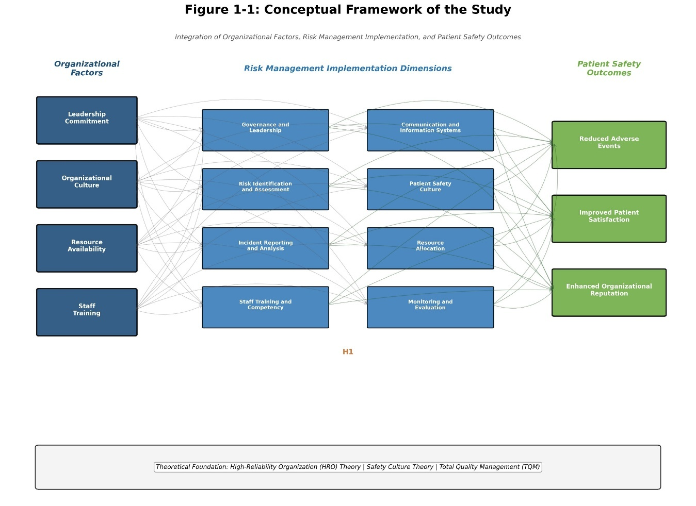
Additionally, the relationship between risk management implementation and patient safety outcomes in the Saudi context has not been adequately explored. While international research suggests that effective risk management contributes to improved patient safety, the specific mechanisms and factors that mediate this relationship in Saudi hospitals require further investigation. Understanding these relationships is essential for developing evidence-based recommendations for practice improvement.

1.4 Research Hypotheses
Based on the comprehensive literature review and the research questions identified, the following hypotheses are proposed for empirical testing in this investigation:
1.4.1 Main Hypothesis
H1: There is a significant positive relationship between the level of risk management implementation and patient safety outcomes in hospitals across Riyadh. This hypothesis posits that hospitals with more comprehensive risk management systems will demonstrate better patient safety performance as measured by incident rates, patient satisfaction scores, and other relevant indicators.
1.4.2 Sub-Hypotheses
H1a: Hospitals with dedicated risk management departments demonstrate significantly higher levels of risk management implementation compared to those without such specialized departments. The presence of dedicated personnel and resources for risk management is expected to facilitate more comprehensive implementation of risk management practices.
H1b: Staff training and competency development programs are positively correlated with risk management effectiveness. Hospitals that invest in comprehensive training programs for their staff are expected to achieve better risk management outcomes through enhanced awareness, knowledge, and skills.
H1c: Organizational culture that supports transparency, learning from errors, and non-punitive reporting is associated with better risk management outcomes. A positive safety culture is expected to facilitate incident reporting, root cause analysis, and continuous improvement.
H1d: The availability of adequate resources including financial, human, and technological resources positively influences risk management implementation. Resource constraints are expected to limit the ability of hospitals to implement comprehensive risk management systems.
H1e: Leadership commitment to risk management is a significant predictor of risk management program success. Visible leadership support is expected to influence organizational priorities, resource allocation, and staff engagement in risk management activities.

1.5 Research Objectives
This research aims to achieve the following comprehensive objectives that address the identified research problem and test the proposed hypotheses:
1. To assess the current level of risk management implementation across hospitals in Riyadh, examining the extent to which established risk management practices are in place and operational. This objective involves measuring implementation levels across multiple dimensions including governance, risk identification, incident reporting, training, communication, safety culture, resources, and monitoring.
2. To identify the key factors that influence the effectiveness of risk management practices in Riyadh hospitals, including organizational, cultural, and resource-related factors. This objective seeks to understand the determinants of successful risk management implementation.
3. To examine the main challenges faced by healthcare organizations in implementing and sustaining risk management systems. This objective involves identifying barriers and obstacles that hinder effective risk management.
4. To compare risk management practices across different types of hospitals in Riyadh including government, private, and military facilities. This objective seeks to understand variations in risk management approaches and outcomes across hospital types.
5. To develop evidence-based recommendations for enhancing risk management capabilities in Riyadh hospitals. This objective involves translating research findings into practical guidance for healthcare stakeholders.
6. To contribute to the theoretical understanding of healthcare risk management in the Middle East context by examining how cultural and contextual factors influence risk management effectiveness.

1.6 Research Importance

1.6.1 Theoretical Importance
This study makes a significant contribution to the growing body of scholarly knowledge on healthcare risk management in the Middle East context. By systematically examining risk management practices in Riyadh's hospitals, the research provides empirical evidence that can inform theoretical frameworks for understanding risk management implementation in developing healthcare systems. The study extends existing theories by examining how cultural and contextual factors influence risk management effectiveness in ways that may differ from Western contexts where most existing theory has been developed.
The research contributes to the theoretical understanding of how High-Reliability Organization principles, Safety Culture theory, and Total Quality Management concepts apply in the Saudi healthcare context. By examining these theoretical frameworks in a new cultural and institutional setting, the study provides insights into the universality and context-specificity of risk management theories.

1.6.2 Practical Importance
The findings of this research have significant practical implications for healthcare stakeholders in Saudi Arabia. Hospital administrators will benefit from evidence-based insights on effective risk management practices and implementation strategies that can be adapted to their specific institutional contexts. The study provides actionable guidance for prioritizing improvement efforts and allocating resources effectively.
Healthcare policymakers can utilize the study's recommendations to inform the development of national guidelines and accreditation standards that are responsive to the specific needs and challenges of the Saudi healthcare system. The research provides a roadmap for aligning risk management practices with national healthcare objectives and international best practices.
Healthcare professionals will gain a better understanding of their roles in risk management and patient safety, along with insights into how they can contribute to creating safer care environments. The study highlights the importance of frontline staff engagement in risk management activities.
The research is particularly timely given the ongoing healthcare transformation under Saudi Vision 2030. As the Kingdom invests heavily in healthcare infrastructure and human capital development, ensuring that these investments are supported by robust risk management systems is essential for achieving desired outcomes. This study provides guidance for aligning risk management capabilities with national healthcare transformation goals.

1.7 Research Methodology

1.7.1 Research Design
This study employs a sophisticated mixed-methods research design that combines quantitative and qualitative approaches to provide a comprehensive understanding of risk management practices in Riyadh hospitals. The mixed-methods approach is particularly appropriate for this study because it allows for both the measurement of risk management implementation levels across multiple dimensions and the exploration of contextual factors that influence implementation effectiveness.
The quantitative phase involves a structured survey administered to healthcare professionals across multiple hospitals, providing numerical data on risk management implementation levels and enabling statistical analysis of relationships between variables. The qualitative phase includes in-depth interviews with key stakeholders, providing rich contextual data that helps explain quantitative findings and identify factors not captured by survey instruments.

1.7.2 Population and Sample
The research population includes all hospitals operating in Riyadh, Saudi Arabia. A stratified random sampling approach is used to ensure representation from different hospital types including government, private, and military facilities as well as different hospital sizes. The target sample includes 25 hospitals with approximately 450 healthcare professionals participating in the survey phase.

1.7.3 Data Collection
Data collection involves multiple methods: (1) a validated questionnaire measuring risk management implementation across eight dimensions, (2) semi-structured interviews with hospital administrators and risk managers, (3) review of hospital documents including policies, incident reports, and training records, and (4) observation of risk management processes where feasible.

1.7.4 Data Analysis
Quantitative data are analyzed using descriptive statistics, correlation analysis, regression analysis, and analysis of variance (ANOVA) using SPSS software. Qualitative data are analyzed through thematic analysis to identify patterns and themes related to risk management practices and challenges. The integration of quantitative and qualitative findings provides a comprehensive understanding of the research problem.

1.8 Research Limitations
This study acknowledges several limitations that should be carefully considered when interpreting the findings. First, the cross-sectional design limits the ability to establish causal relationships between variables. Longitudinal studies would be needed to track changes in risk management practices over time and establish temporal relationships between implementation factors and outcomes.
Second, the study focuses specifically on hospitals in Riyadh, which may limit the generalizability of findings to other regions of Saudi Arabia or other countries. Healthcare systems in different contexts may face distinct challenges and opportunities for risk management that are not captured by this study.
Third, self-reported data from survey respondents may be subject to social desirability bias, potentially inflating perceptions of risk management implementation. The study attempts to mitigate this limitation through triangulation with document review and interview data, but some degree of response bias may remain.
Fourth, resource constraints limited the number of hospitals and participants that could be included in the study. While the sample size is adequate for statistical analysis, a larger sample would provide even greater confidence in the findings and enable more detailed subgroup analyses.
Finally, the rapidly evolving nature of healthcare risk management means that some findings may become outdated as new technologies, regulations, and best practices emerge. The study captures risk management practices at a specific point in time and should be interpreted in this context.

CHAPTER 2: LITERATURE REVIEW AND THEORETICAL FRAMEWORK

2.1 Introduction
This chapter presents a comprehensive and systematic review of existing scholarly literature on healthcare risk management and establishes the theoretical framework that guides this research investigation. The chapter begins by examining the fundamental conceptualizations of risk and risk management, tracing their intellectual evolution from general management theory to healthcare-specific applications. It then explores the various multidimensional aspects of healthcare risk management, including clinical risk assessment, incident reporting systems, patient safety initiatives, and quality improvement frameworks. The chapter also reviews empirical studies conducted in diverse healthcare contexts, with particular analytical attention devoted to research originating from the Middle East region. Finally, the theoretical framework underlying this study is presented, drawing upon relevant theoretical perspectives from organizational behavior, quality management, and healthcare administration.
The literature review process employed systematic searches of major electronic academic databases including PubMed, Scopus, Web of Science, and Google Scholar. Keywords utilized in the comprehensive search included healthcare risk management, patient safety, hospital administration, quality improvement, and Saudi Arabia. The search was deliberately limited to articles published in English and Arabic between 2015 and 2024 to ensure relevance to contemporary practices. Additional scholarly sources were identified through careful examination of reference lists from relevant articles and recommendations from recognized experts in the field.
The chapter is organized into five principal sections. Section 2.2 examines the fundamental conceptualizations of risk and risk management, including definitions, scope, and the risk management process. Section 2.3 focuses specifically on healthcare risk management, covering its historical development, key components, and relevant standards and accreditation requirements. Section 2.4 reviews previous empirical studies on healthcare risk management from international, regional, and Saudi Arabian contexts. Section 2.5 presents the theoretical framework guiding this research, including High-Reliability Organization theory, Safety Culture theory, and Total Quality Management. The chapter concludes with a synthesis of key findings from the literature review and their implications for the current investigation.

2.2 Risk Management Concepts

2.2.1 Definition and Nature of Risk
Risk, in its broadest conceptualization, refers to the possibility of an event occurring that will have an impact on the achievement of organizational objectives. In organizational contexts, risk encompasses both potential threats that may hinder goal attainment and opportunities that may facilitate success. The concept of risk is inherently probabilistic in nature, involving uncertainty about future outcomes and their potential consequences. Understanding this fundamental nature of risk is essential for developing effective risk management strategies in healthcare settings.
The conceptualization of risk has evolved significantly over time. Traditionally, risk was viewed primarily as a negative concept associated with potential losses or harms. However, modern risk management recognizes that risk also presents opportunities for improvement and innovation. This dual nature of risk is particularly relevant in healthcare, where the goal is not to eliminate all risks but to manage them effectively to achieve optimal patient outcomes. Understanding this nuanced perspective on risk is essential for developing balanced risk management strategies.
Risk can be categorized in various ways depending on the specific context. In healthcare settings, risks are often classified as clinical risks related to patient care processes, operational risks related to organizational processes, financial risks related to monetary losses, strategic risks related to organizational objectives, and reputational risks related to organizational image. Each category of risk requires specific management approaches and mitigation strategies. The inherent complexity of healthcare delivery means that these categories often overlap, requiring integrated approaches to risk management.

2.2.2 Risk Management Definition and Scope
Risk management is formally defined as the coordinated activities undertaken to direct and control an organization with regard to risk. The International Organization for Standardization defines risk management as the systematic application of management policies, procedures, and practices to the tasks of communicating, consulting, establishing the context, identifying, analyzing, evaluating, treating, monitoring, and reviewing risk. This definition emphasizes the systematic and comprehensive nature of effective risk management.
Healthcare risk management specifically refers to the systematic process of identifying, evaluating, and addressing potential risks in healthcare settings to prevent harm to patients, staff, and visitors while protecting organizational assets and reputation. The scope of healthcare risk management has expanded significantly over time, evolving from a focus primarily on malpractice prevention to encompass broader patient safety and quality improvement objectives. This expansion reflects the growing recognition of the interconnected nature of risk in healthcare settings.

2.2.3 The Risk Management Process
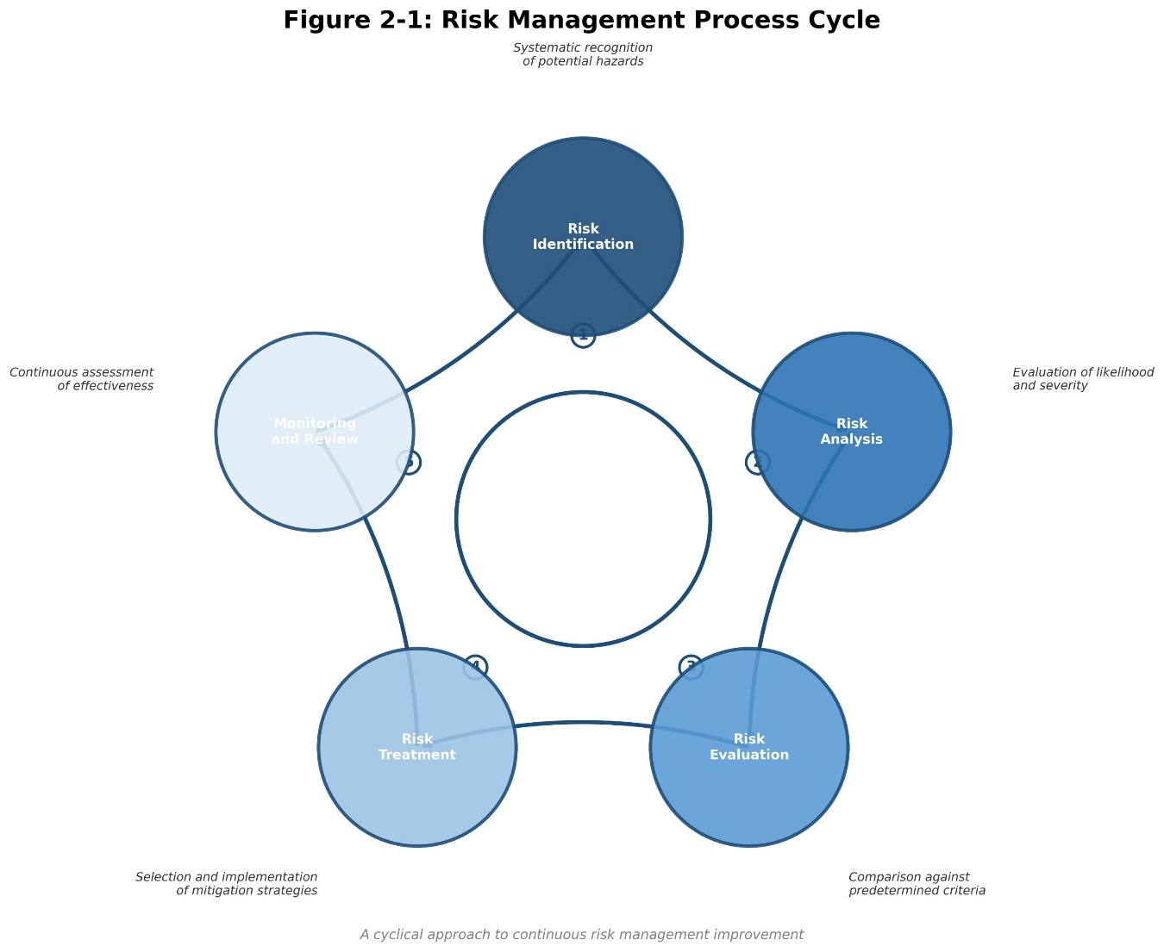
The risk management process typically follows a cyclical pattern involving several interconnected stages. Risk identification involves systematic efforts to recognize potential sources of harm through various methods including incident reporting, risk assessments, and analysis of patient feedback. Risk analysis evaluates the likelihood and potential severity of identified risks, often using quantitative or qualitative scoring systems. Risk evaluation compares analyzed risks against predetermined criteria to determine which risks require treatment.

Risk treatment involves selecting and implementing measures to modify risks, which may include risk avoidance, reduction, sharing, or acceptance. Finally, monitoring and review ensure that risk management measures remain effective and appropriate as circumstances change. This cyclical process enables continuous improvement of risk management systems and adaptation to emerging threats and opportunities.

2.3 Healthcare Risk Management

2.3.1 Historical Development
The formal practice of healthcare risk management emerged in the United States during the 1970s, driven primarily by increasing malpractice litigation and rising insurance costs. Early risk management programs focused predominantly on identifying and mitigating legal and financial risks through incident investigation and claims management. The profession evolved considerably throughout the 1980s and 1990s, with growing recognition of the importance of proactive prevention strategies.
The publication of the Institute of Medicine's landmark report "To Err Is Human" in 1999 marked a watershed moment for healthcare risk management. The report's revelation that medical errors cause an estimated 44,000 to 98,000 deaths annually in United States hospitals galvanized global attention on patient safety and transformed risk management from a primarily defensive function to a proactive quality improvement discipline. This paradigm shift has continued to evolve, with modern risk management increasingly integrated with patient safety, quality improvement, and organizational learning initiatives.

2.3.2 Key Components of Healthcare Risk Management
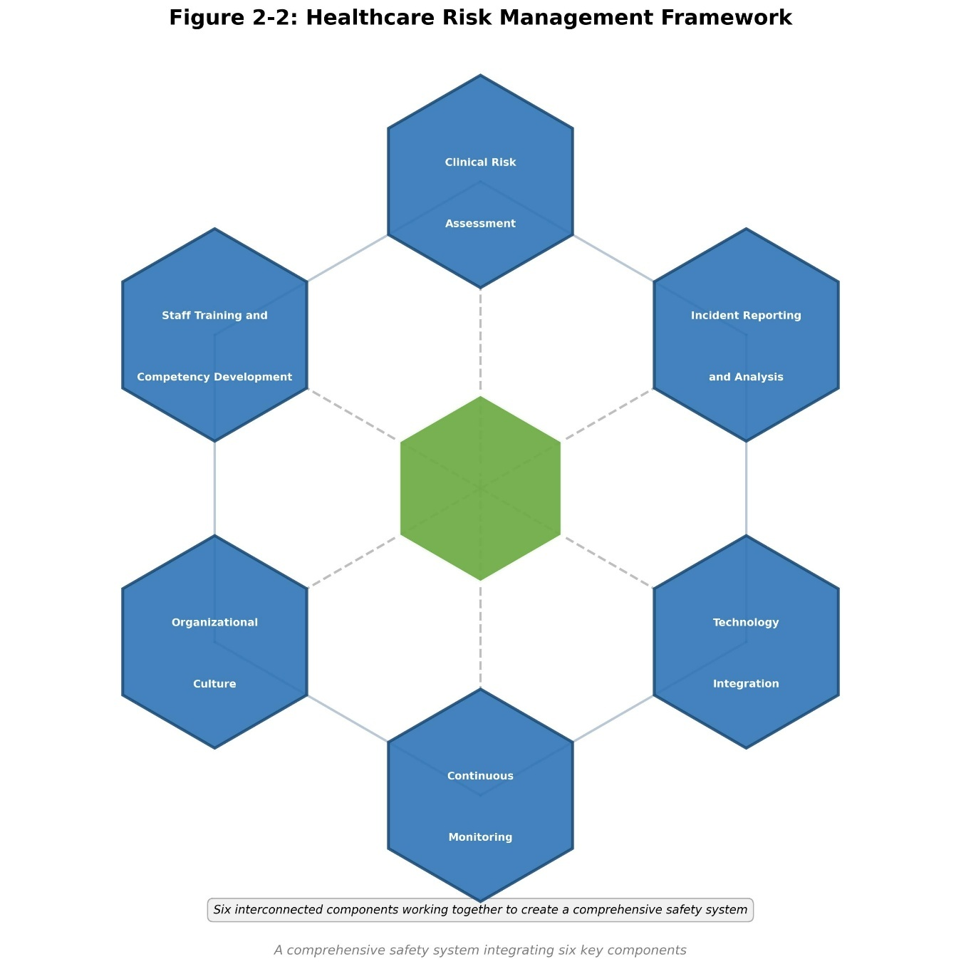
Effective healthcare risk management encompasses several interconnected components that work together to create a comprehensive safety system. Clinical risk assessment involves systematic evaluation of patient care processes to identify potential sources of harm. This includes regular review of high-risk procedures, analysis of adverse events and near-misses, and proactive identification of potential failure points in clinical workflows.

Incident reporting and analysis create valuable opportunities for learning from adverse events and near-misses. Effective reporting systems encourage staff to report incidents without fear of blame, enabling organizations to identify patterns and implement preventive measures. Root cause analysis provides a structured approach to investigating serious incidents and identifying underlying systemic factors that contributed to the event.
Staff training and competency development ensure that healthcare professionals possess the knowledge and skills necessary to manage risks effectively. This includes training on risk identification, incident reporting, communication skills, and specific protocols for high-risk procedures. Ongoing education and professional development are essential for maintaining competency in an evolving healthcare environment.

2.3.3 Strategic Risk Management Dimension
Strategic risk management represents a critical dimension of comprehensive healthcare risk management in Riyadh hospitals. This dimension encompasses the identification, assessment, and mitigation of risks that could affect the organization's ability to achieve its strategic objectives. In the context of Saudi Vision 2030, strategic risk management has become increasingly important as hospitals navigate significant transformation initiatives including privatization, public-private partnerships, and integration into national health insurance systems.
Strategic risks in Riyadh hospitals include regulatory changes, competitive pressures, technological disruption, and shifts in patient demographics and expectations. The implementation of value-based care models and the expansion of health insurance coverage under the Council of Cooperative Health Insurance (CCHI) have introduced new strategic considerations for hospital administrators. Effective strategic risk management requires alignment between organizational strategy and risk management activities, with senior leadership actively engaged in identifying and addressing strategic risks.
Hospitals in Riyadh must also contend with strategic risks related to workforce planning and development. The Saudization initiatives aimed at increasing the proportion of Saudi nationals in the healthcare workforce present both opportunities and challenges for workforce planning. Strategic risk management in this context involves forecasting future workforce needs, developing recruitment and retention strategies, and ensuring that organizational capabilities align with strategic objectives.

2.3.4 Human Resources Risk Management Dimension
Human resources risk management constitutes a fundamental dimension of healthcare risk management in Riyadh hospitals. This dimension addresses risks associated with workforce management including staffing levels, competency development, retention, and occupational health and safety. The healthcare workforce in Saudi Arabia is characterized by high dependence on expatriate professionals, particularly in nursing and allied health professions, which introduces specific risks related to cultural integration, communication, and workforce stability.
Staffing adequacy represents a significant human resources risk factor in Riyadh hospitals. Research has consistently demonstrated relationships between nurse staffing levels and patient outcomes including mortality, medication errors, and patient satisfaction. Many hospitals in Riyadh struggle to maintain staffing levels that meet international standards, particularly in specialized areas such as intensive care and emergency services. Human resources risk management must address these challenges through effective workforce planning, recruitment strategies, and retention initiatives.
Competency development is another critical aspect of human resources risk management. Healthcare professionals must maintain current knowledge and skills in an environment of rapid technological and clinical advancement. Continuing professional development programs, competency assessments, and credentialing processes are essential components of managing human resources risks. The high turnover rate among expatriate healthcare workers in Saudi Arabia presents particular challenges for maintaining consistent competency levels.
Occupational health and safety risks must also be addressed within the human resources risk management framework. Healthcare workers face numerous occupational hazards including exposure to infectious diseases, ergonomic injuries from patient handling, and psychological stress from demanding work environments. Effective human resources risk management includes implementation of occupational health programs, provision of appropriate personal protective equipment, and attention to workplace factors that affect staff wellbeing.

2.3.5 Reputation Risk Management Dimension
Reputation risk management has emerged as a critical dimension of healthcare risk management in Riyadh hospitals, particularly in an era of increasing transparency and social media influence. Reputation risk refers to the potential for negative perceptions of the organization to adversely affect patient volumes, staff recruitment, relationships with stakeholders, and overall organizational performance. In the competitive healthcare market of Riyadh, reputation can significantly influence patient choice and organizational success.
Reputation risks in healthcare can arise from various sources including medical errors, adverse events, patient complaints, media coverage, and social media activity. The rapid dissemination of information through digital channels means that reputation-damaging events can quickly reach wide audiences. Effective reputation risk management requires proactive monitoring of reputation indicators, rapid response to emerging issues, and systematic approaches to building and maintaining positive organizational reputation.
Patient experience has become a key driver of reputation in healthcare. Hospitals in Riyadh are increasingly recognizing the importance of patient-centered care in building and maintaining positive reputation. This includes attention to physical environment, communication processes, waiting times, and responsiveness to patient needs. Reputation risk management must address these factors through systematic measurement and improvement of patient experience.
Accreditation status and quality rankings also significantly influence organizational reputation in the Saudi healthcare context. Achievement of Joint Commission International (JCI) accreditation or Central Board for Accreditation of Healthcare Institutions (CBAHI) certification serves as a visible indicator of quality and safety commitment. Reputation risk management includes strategic approaches to accreditation and quality recognition programs.

2.3.6 Risk Management Standards and Accreditation
Healthcare accreditation standards play a significant role in shaping risk management practices across healthcare institutions. The Joint Commission International standards for hospitals include specific requirements for leadership in patient safety, risk management program development, and incident reporting systems. These standards emphasize the importance of leadership commitment, staff involvement, and continuous monitoring of risk management effectiveness.
In Saudi Arabia, the Central Board for Accreditation of Healthcare Institutions has developed national standards that incorporate comprehensive risk management requirements. These standards address areas including patient safety goals, medication management, infection control, and facility safety. Compliance with CBAHI standards is required for healthcare facilities operating in the Kingdom, making accreditation a key driver of risk management implementation.

2.4 Previous Studies

2.4.1 International Studies
Numerous scholarly investigations have examined healthcare risk management practices in various international contexts. A comprehensive study conducted by the World Health Organization examined patient safety practices across 26 countries, identifying common challenges including inadequate incident reporting, insufficient staff training, and lack of leadership commitment. The study highlighted the importance of creating learning cultures that encourage reporting and analysis of adverse events.
Research conducted in the United States has documented significant variation in risk management practices across hospitals. Studies have found that hospitals with dedicated risk management departments, comprehensive training programs, and strong leadership support demonstrate better patient safety outcomes. However, resource constraints and competing priorities often limit the effectiveness of risk management initiatives.
European studies have emphasized the importance of regulatory frameworks in shaping risk management practices. The European Union's patient safety initiatives have encouraged member states to develop comprehensive approaches to healthcare risk management, including mandatory incident reporting systems and patient safety indicator monitoring. These regulatory approaches have contributed to standardization of risk management practices across healthcare systems.
Research from the Asia-Pacific region has documented the rapid development of healthcare risk management systems in countries such as Japan, Singapore, and South Korea. These countries have invested heavily in healthcare infrastructure and quality improvement initiatives, resulting in significant improvements in patient safety outcomes. Studies have highlighted the importance of government leadership, professional engagement, and technology adoption in achieving these improvements.

2.4.2 Regional Studies
Studies from the Middle East region have documented both progress and challenges in healthcare risk management implementation. Research from the United Arab Emirates found that while most hospitals have established basic risk management structures, significant gaps remain in staff training, incident reporting culture, and integration of risk management into organizational strategy. Cultural factors, including hierarchical communication patterns and reluctance to report errors, were identified as significant barriers.
A study from Qatar examined patient safety culture in healthcare organizations, finding that while staff generally recognize the importance of patient safety, actual reporting behaviors and participation in safety initiatives remain limited. The study recommended targeted interventions to address cultural barriers and improve staff engagement in patient safety activities.
Research from Kuwait assessed the implementation of quality and safety standards in hospitals, finding that compliance with accreditation requirements has improved over time but that sustained implementation of quality improvement initiatives remains challenging. The study emphasized the importance of leadership commitment and staff involvement in maintaining quality and safety standards.

2.4.3 Studies in Saudi Arabia
Research on healthcare risk management in Saudi Arabia has grown substantially in recent years, reflecting the Kingdom's commitment to healthcare quality improvement. Studies have documented the impact of CBAHI accreditation on hospital practices, finding that accreditation requirements have driven significant improvements in documentation, standardization, and monitoring of clinical processes.
A study examining patient safety culture in Saudi hospitals found that while healthcare professionals generally value patient safety, actual reporting of incidents and participation in safety activities remain below desired levels. The study identified factors including fear of blame, lack of feedback on reported incidents, and insufficient time as barriers to active engagement in patient safety initiatives.
Research on medication safety in Saudi hospitals has highlighted the prevalence of medication errors and the need for improved systems for prescribing, dispensing, and administering medications. Studies have recommended implementation of electronic prescribing systems, barcode medication administration, and enhanced pharmacist involvement in medication management.
A comprehensive study of infection control practices in Saudi hospitals found significant variation in compliance with infection prevention standards across different hospital types. Government hospitals generally demonstrated higher compliance rates compared to private facilities, attributed to more stringent regulatory oversight and resource availability. The study recommended strengthening infection control programs through enhanced training, improved surveillance systems, and regular audits of compliance with established protocols.
Despite these contributions, significant gaps remain in the literature regarding risk management practices in Riyadh specifically. Most existing studies have focused on specific aspects of patient safety or particular hospital types, limiting the ability to develop comprehensive understanding of risk management across the diverse healthcare landscape of the capital city.

2.5 Theoretical Framework

2.5.1 High-Reliability Organization Theory
High-Reliability Organization theory provides a valuable theoretical lens for understanding how healthcare organizations can achieve consistently safe performance despite operating in complex, high-risk environments. High-Reliability Organizations are organizations that operate in hazardous conditions yet maintain exceptionally low accident rates over extended periods. Examples include nuclear power plants, aircraft carriers, and air traffic control systems.
The concept of high-reliability organizations emerged from research conducted by scholars at the University of California, Berkeley in the 1980s. Researchers sought to understand how organizations operating in high-hazard environments could maintain exceptionally safe performance over extended periods. Their studies revealed that these organizations shared common characteristics that enabled them to anticipate and respond effectively to potential threats.
Preoccupation with failure refers to the constant attention to potential problems and vulnerabilities. High-Reliability Organizations are constantly alert to the possibility of errors and actively seek out information about potential problems. They treat near-misses as valuable opportunities for learning and improvement, rather than as evidence that systems are working well. This mindset creates a culture of vigilance that enables early detection and response to emerging threats.
Reluctance to simplify interpretations reflects the recognition that complex systems cannot be fully understood through simple models or assumptions. High-Reliability Organizations resist the temptation to oversimplify complex situations and actively seek out diverse perspectives and information sources. They understand that different stakeholders may have different views of the same situation and that these diverse perspectives can reveal important insights.
Sensitivity to operations involves maintaining awareness of the frontline realities of organizational work. High-Reliability Organizations understand that safety is created or compromised in the daily work of frontline staff and maintain mechanisms for staying connected to operational realities. This includes regular communication with frontline staff, observation of work processes, and attention to the factors that influence staff ability to work safely.
Commitment to resilience recognizes that despite best efforts, errors and adverse events will occur. High-Reliability Organizations invest in developing the capacity to respond effectively to unexpected events and to recover quickly from setbacks. This includes training staff in emergency response, developing contingency plans, and building organizational flexibility to adapt to changing circumstances.
Deference to expertise means that decision-making authority is distributed based on expertise rather than hierarchical position. In High-Reliability Organizations, the person with the most relevant expertise is empowered to make decisions, regardless of their formal position in the organizational hierarchy. This enables rapid and effective response to emerging situations, as decisions can be made by those with the most relevant knowledge and experience.

2.5.2 Safety Culture Theory
Safety culture theory emphasizes the importance of organizational culture in shaping safety-related attitudes, behaviors, and outcomes. A positive safety culture is characterized by shared perceptions and values that prioritize safety, encourage reporting and learning from errors, and support continuous improvement. Research has consistently demonstrated the relationship between safety culture and safety performance across various industries including healthcare.
The concept of safety culture emerged from investigations of major industrial accidents in the 1980s, including the Chernobyl nuclear disaster and the Piper Alpha oil platform explosion. These investigations revealed that organizational culture played a critical role in creating the conditions that enabled these catastrophic events. Since then, safety culture has become a central focus of research and practice in high-reliability industries.
Management commitment to safety is reflected in the priority given to safety in organizational decision-making, resource allocation, and communication. A strong safety culture is characterized by visible leadership commitment, with leaders actively engaging in safety activities and modeling safe behaviors. When leaders demonstrate through their words and actions that safety is a top priority, staff are more likely to take safety seriously in their own work.
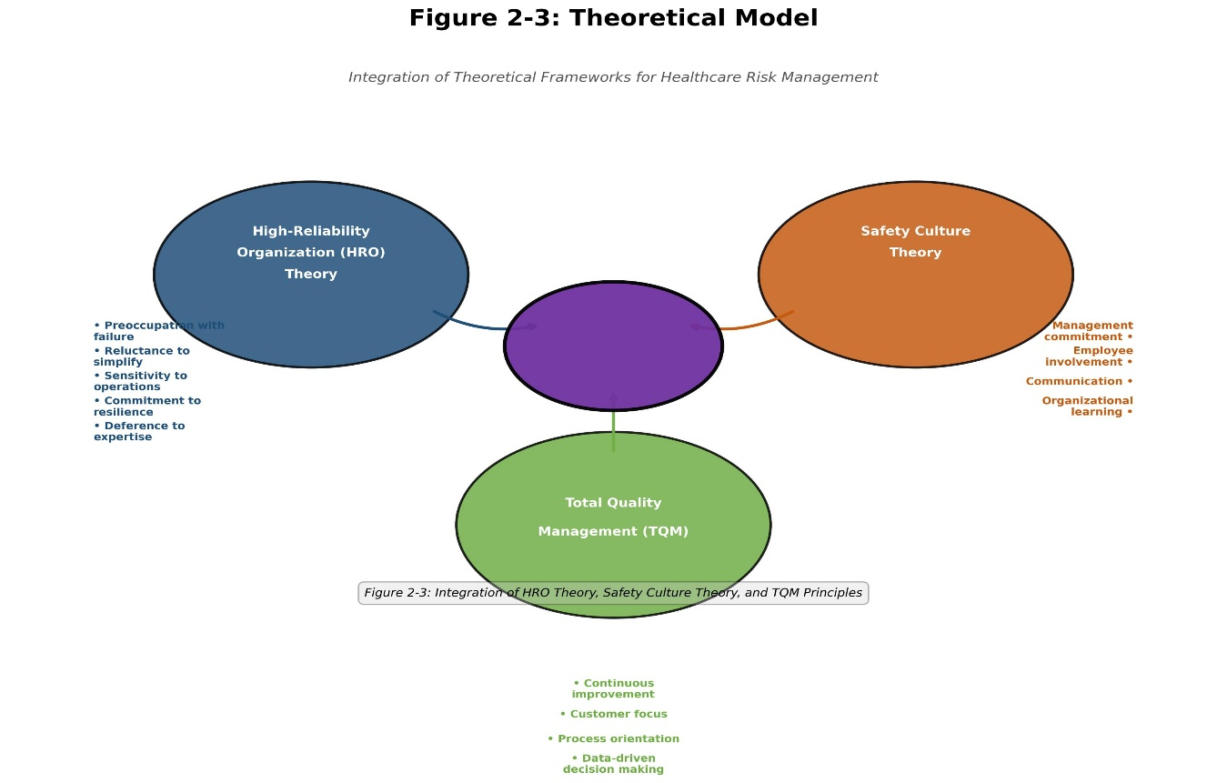
Employee involvement in safety activities is another critical dimension of safety culture. Organizations with positive safety cultures empower staff to participate in safety initiatives, report concerns, and suggest improvements. Frontline staff often have the most detailed knowledge of work processes and potential hazards, making their involvement essential for effective risk management.
2.5.3 Total Quality Management
Total Quality Management provides a comprehensive approach to organizational improvement that emphasizes continuous improvement, customer focus, and employee involvement. The principles of Total Quality Management, including process orientation, data-driven decision making, and systematic problem solving, are highly applicable to healthcare risk management. Many contemporary patient safety and quality improvement approaches draw directly from Total Quality Management principles and methods.
Total Quality Management emerged in the manufacturing sector in the mid-20th century, with pioneers such as W. Edwards Deming, Joseph Juran, and Philip Crosby developing principles and methods for improving organizational quality. These principles were later adapted for healthcare settings, where they have been applied to improve patient safety, clinical outcomes, and operational efficiency.
Continuous improvement, or Kaizen, is the ongoing effort to improve products, services, and processes. In healthcare, continuous improvement involves regularly reviewing care processes, identifying opportunities for improvement, implementing changes, and evaluating their effectiveness. This cyclical approach to improvement is embodied in the Plan-Do-Study-Act cycle, which provides a structured framework for testing and implementing changes.

2.5.4 Conceptual Framework
This study integrates insights from High-Reliability Organization theory, Safety Culture theory, and Total Quality Management to develop a comprehensive conceptual framework for examining risk management in Riyadh hospitals. The framework posits that effective risk management implementation is influenced by multiple factors including organizational structure, resources, leadership commitment, staff competencies, organizational culture, and external pressures.
The framework further proposes that risk management implementation affects patient safety outcomes, including reduced incidence of adverse events, improved patient satisfaction, and enhanced organizational reputation. The relationship between implementation and outcomes is mediated by factors including staff engagement, quality of risk assessment processes, and effectiveness of mitigation strategies.
The conceptual framework developed for this study provides a holistic view of the factors that influence risk management effectiveness in healthcare settings. The framework identifies three levels of influence: organizational level factors including leadership, culture, and resources; process level factors including risk assessment, incident reporting, and training; and outcome level factors including patient safety, quality of care, and organizational performance.

