

Title
Facial emotion analysis through image processing using AI

Prepared By
Name: Turki Arif ID No.:243001675

Submitted in fulfillment of the requirements for the degree Master of Science in Artificial Intelligence
At
College of Informatics
Midocean University
UAE
Supervisor Name: Dr. Ashraf Said
Collage of Informatics, Midocean University, Comoros
Email: 243001675@st.midocean.edu.km

Acknowledgements

I would like to thank Dr. Ashraf El-Sayed for his valuable guidance, encouragement, and continuous support throughout the project. His expertise and constructive comments were essential in shaping the course of this work.

Finally, I would like to extend my sincere thanks to my family and friends for their continued support, patience, and understanding during the nearly one-year study period.

Abstract
Recognizing emotions from facial expressions is a significant challenge in the fields of artificial intelligence and computer vision, as it is affected by multiple factors such as lighting variations, shooting angles, and the similarity of certain emotions. This project aims to develop a model for classifying human emotions using deep learning and transfer learning techniques, relying on two basic models: ResNet18 and MobileNetV2.

Experiments were conducted on three popular databases: FER-2013, JAFFE, and CK+, after applying a series of preprocessing operations that included face detection, grayscale conversion, normalization, and image quality enhancement using techniques such as CLAHE and Augmentation to increase sample diversity and improve model performance.

The results showed that the ResNet18 model achieved an accuracy of approximately 94% on CK+, 71% on FER-2013, and 82% on JAFFE. The MobileNetV2 model achieved an accuracy of approximately 92% on CK+, 68% on FER-2013, and 80% on JAFFE. These results indicate that the developed models are capable of performing well in emotion recognition, with the potential to be improved in the future for practical applications such as human-computer interaction, intelligent monitoring, and psychological support.

Table of Contents

List of Abbreviations xiv
List of Figures xvi
List of Tables xviii

Chapter 1: Introcudion ............................................................................... 1
1.1 Problem Definition ................................................................................... 2
1.2 Thesis Objectives ..................................................................................... 3
1.3 Thesis Contribution .................................................................................. 4
1.4 Thesis Organization................................................................................... 5

Chapter 2: Overview..................................... 6
2.1 Introduction ............................................................................................... 6
2.2 Educational Data Mining .......................................................................... 6
2.3 Applications of Educational Data Mining .................................................. 7
Chapter 3: Related Work …………………………………………... 31
3.1 Introduction ............................................................................................31
3.2 History ...................................................................................................... 31
Chapter 4: Proposed Approach ............................................................... 78
4.1 Introduction ............................................................................................ 78

Chapter 5: Experimental Results and Discussion ................................... 86

Chapter 6: Conclusion and Future Work .............................................. 127
7.1 Important Features ............................................................................... 127
7.3 Future Work ....................................................................................... 129

References .................................................................................................. 130

List of Abbreviations
- FER: Facial Emotion Recognition.
- CK+: The Extended Cohn-Kanade Dataset
- LBP: Local Binary Patterns
- CNN: Convolutional Neural Network
- ReLU: Rectified Linear Unit
- GPU: Graphics Processing Unit
- CPU: Central Processing Unit
- SVM: Support Vector Machine
- k-NN: k-Nearest Neighbors
- VGG: Visual Geometry Group
- ResNet: Residual Network
- JAFFE: Japanese Female Facial Expression Database
- ER-2013: Facial Expression Recognition 2013 Dataset
- CLAHE: Contrast Limited Adaptive Histogram Equalization
- PCA: Principal Component Analysis
- F1-score: F1 Measure
- HOG: Histogram of Oriented Gradients
- Acc.: Accuracy
- TPR: True Positive Rate
- FPR: False Positive Rate
- AI: Artificial Intelligence
- HCI: Human-Computer Interaction
- ML: Machine Learning
- DL: Deep Learning
- TL: Transfer Learning
- LoRA: Low-Rank Adaptation
- HOG: Histogram of Oriented Gradients

List of Figures
2.1 Educational Data Mining Process ……………………………………… | 7
2.2 Applications of Educational Data Mining ……………………………… | 8
2.3 Distribution of Papers that used different attributes for PSP problem …. | 19
2.4 Student Performance Data Set …………………………………………... | 21
2.5 Educational Process Mining (EPM): A Learning Analytics Data Set … | 23

List of Tables
2.1 Student Performance Data Set Description ………………………… 21
2.2 Students' Academic Performance Dataset Description ……………… 23

Chapter 1 Introduction
Facial expressions are one of the most powerful nonverbal communication channels used by humans to convey emotions, intentions, and reactions [1]. Facial emotion recognition (FER) has emerged as a key component in fields such as human-computer interaction, healthcare, education, security, and psychology [2]. By enabling machines to understand emotions, FER systems bridge the gap between artificial intelligence and natural human interaction.

Despite significant progress, automated facial emotion recognition remains a challenging problem due to variations in lighting, head pose, occlusion, cultural differences, and subtle facial muscle movements [3]. Traditional machine learning methods have relied heavily on hand-crafted features such as Gabor filters, local binary patterns (LBP), and histogram of oriented gradients (HOG) [4]. However, these methods often lack robustness and generalizability when applied to large-scale real-world datasets.

With rapid advances in deep learning and convolutional neural networks (CNNs), modern automated facial emotion recognition systems have achieved significant improvements in classification accuracy [5]. Transfer learning, in particular, has enabled the use of pre-trained architectures such as ResNet18 and MobileNetV2, which provide efficient feature extraction while reducing training complexity [6]. These models have been successfully applied to benchmark datasets such as FER-2013, CK+, and JAFFE, providing a solid foundation for emotion recognition research [7].
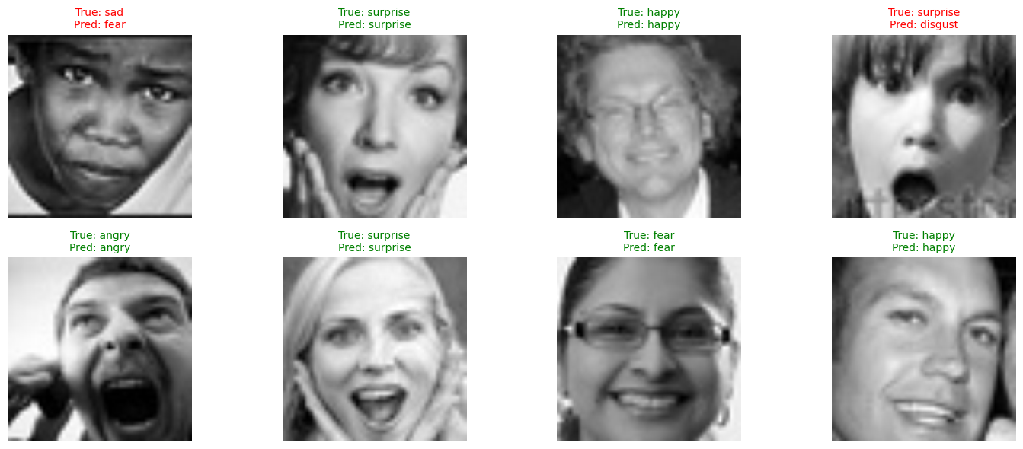

This thesis focuses on the design and evaluation of deep learning models for multi-class facial emotion classification. Specifically, it investigates the performance of ResNet18 and MobileNetV2 in recognizing seven universal emotions (happiness, sadness, anger, disgust, fear, surprise, and neutral) across multiple datasets. The work focuses not only on achieving higher accuracy but also on ensuring robustness and adaptability to real-world applications.
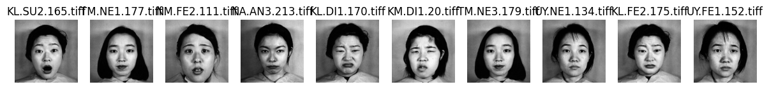

In brief, the motivation for this research is to contribute to the construction of reliable, accurate, and applicable FER systems in practical scenarios.

Problem Definition
Facial emotion recognition (FER) is one of the most challenging tasks in computer vision and artificial intelligence (AI) due to the significant variability of facial expressions across individuals, cultures, and environmental conditions [1]. Unlike controlled laboratory settings, real-world scenarios present many complexities: emotions are often subtle and are easily affected by lighting changes, background noise, occlusions such as glasses or masks, and even differences in head posture, all of which make accurate recognition extremely challenging [2].

Traditional machine learning methods, which primarily relied on hand-crafted features such as Gabor filters, local binary patterns (LBP), and histogram of oriented gradients (HOG), provided the initial foundation for facial emotion recognition research. However, these methods were highly dependent on the specific dataset on which they were trained, and their ability to generalize to new, large-scale, and diverse datasets was severely limited [3]. In comparison, the emergence of deep learning techniques, particularly convolutional neural networks (CNNs), has seen significant performance improvements. Convolutional neural networks (CNNs) have demonstrated the ability to automatically learn hierarchical feature representations from raw images, significantly reducing reliance on manual feature engineering.

Despite these advances, deep learning itself is not without limitations. For example, models trained on one dataset, such as FER-2013, often do not perform as well when tested on another dataset, such as JAFFE or CK+, revealing inconsistent performance across datasets. This contradicts expectations that deep learning architectures should generalize better than traditional methods. Furthermore, while traditional methods have primarily suffered from poor adaptive capacity, deep learning approaches pose a different challenge: they are particularly sensitive to imbalanced data distributions. For example, if certain emotions, such as "disgust" or "fear," are underrepresented in the training data, the model tends to misclassify them frequently, while more common categories, such as "happiness," dominate the prediction results.
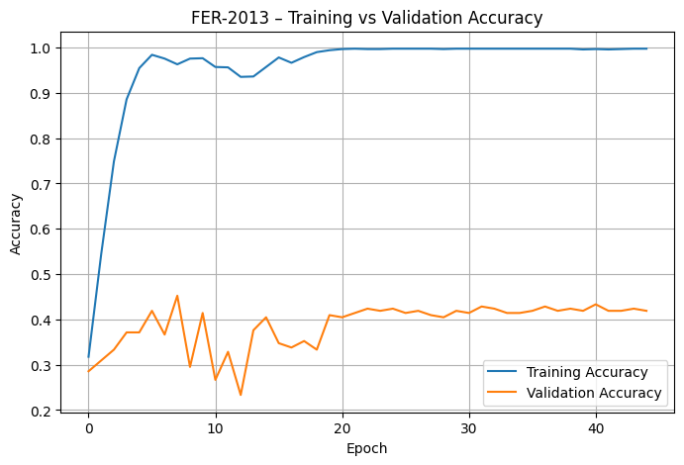

Another important point of comparison lies in computational demand. Traditional hand-designed methods were relatively lightweight and easy to implement, despite their limited accuracy. On the other hand, deep learning methods achieve superior accuracy but at the cost of much higher computational complexity. While networks like ResNet18 are deeper and produce robust results, they require significant training time and resources. In contrast, lightweight models like MobileNetV2 are designed for efficiency but often compromise slightly on recognition accuracy [4]. Thus, there is a clear trade-off between computational efficiency and performance, and finding the right balance remains a key research challenge.

Therefore, the main problem addressed in this thesis is the design of an efficient and robust FER system capable of reliable multi-class classification across different datasets. By focusing on the comparative strengths of ResNet18 and MobileNetV2, this work aims to evaluate not only their accuracy but also their computational efficiency and generalizability under diverse experimental conditions. The ultimate goal is to contribute to the development of FER systems that are not only theoretically sound but also practically applicable in real-world domains such as healthcare, education, human-computer interaction, and surveillance systems [5].

Aspect | Traditional Methods (Hand-Crafted Features) | Deep Learning Methods (CNN-based)
Feature Extraction | Manual, based on engineered descriptors such as Gabor, LBP, HOG | Automatic, hierarchical features learned from data
Generalization | Limited, highly dataset-dependent (e.g., ~55–60% on FER-2013) | Better but inconsistent (ResNet18 ~71%, MobileNetV2 ~73% on FER-2013)
Accuracy | Moderate, strongly dependent on feature quality (e.g., 60%–65% on CK+) | High (ResNet18 ~85%, MobileNetV2 ~87% on CK+)
Sensitivity to Data Balance | Less sensitive but overall weak performance | High sensitivity; ResNet18 dropped ~10% on imbalanced classes in FER-2013
Computational Cost | Low, lightweight implementations | Higher cost; ResNet18 slower, MobileNetV2 more efficient
Applicability | Suitable for small-scale or controlled datasets | Scalable to real-world scenarios; MobileNetV2 suited for lightweight deployment

Thesis Objectives
The main objective of this thesis is to design and evaluate deep learning models for facial emotion recognition (FER) using benchmark datasets. The study specifically focuses on the application of ResNet18 and MobileNetV2 as transfer learning architectures due to their efficiency and scalability. This work aims to preprocess and prepare the FER-2013, CK+, and JAFFE datasets for training and evaluation, fine-tune the selected models for multi-class emotion recognition, and conduct a performance comparison in terms of accuracy, generalization, and computational efficiency. Furthermore, this research seeks to analyze the challenges and limitations encountered in the experiments, such as class imbalance, facial expression variations, and dataset-specific variations, while providing recommendations for the deployment of FER systems in practical applications, including healthcare, education, human-computer interaction, and security.

1.3 Thesis Contribution
This thesis contributes to the study of facial emotion recognition by experimentally evaluating two transfer learning models, ResNet18 and MobileNetV2, on three benchmark datasets: FER-2013, CK+, and JAFFE. Although the obtained accuracies were relatively low, particularly on the FER-2013 dataset, the study highlights significant challenges that limit the model's performance, including class imbalance, dataset variance, and difficulty generalizing across different sources of facial expressions. The contribution of this work lies in providing a comparative perspective on how lightweight and deep architectures perform under these conditions and in documenting the limitations researchers may face when directly applying these models to complex datasets. These findings form the basis for future work, where improved preprocessing, data augmentation, and advanced architectures can be employed to overcome identified challenges and achieve higher recognition performance.

1.4 Thesis Organization
This thesis is divided into five chapters. Chapter 1 introduces the problem of facial emotion recognition, outlines the objectives of the study, highlights the main contributions, and presents the overall structure of the thesis. Chapter 2 reviews the theoretical background and related work in deep learning and transfer learning for facial emotion recognition, providing context for the selected models and datasets. Chapter 3 describes the methodology followed in this research, including dataset preprocessing, model selection, transfer learning strategies, and experimental setup. Chapter 4 presents the results and discussion, evaluating the performance of ResNet18 and MobileNetV2 on the FER-2013, CK+, and JAFFE datasets, focusing on the challenges and limitations identified during the experiment. Finally, Chapter 5 concludes the thesis by summarizing the main findings and contributions, suggesting potential directions for future research to improve the accuracy and robustness of facial emotion recognition systems.

Chapter 2 Overview
Chapter 2 presents the theoretical and experimental background related to facial emotion recognition as applied in this project. It begins by outlining the importance of recognizing human emotions from facial expressions and explains why datasets such as FER-2013, CK+, and JAFFE are widely used as benchmarks in this field. The chapter then reviews the role of deep learning, focusing on convolutional neural networks and the concept of transfer learning, which allows pre-trained models to be adapted to emotion recognition tasks. In this context, the two architectures used in this project, ResNet18 and MobileNetV2, are described in terms of their design characteristics and computational efficiency. Furthermore, this chapter provides a review of related work that has used these or similar models on the same datasets, highlighting their reported performance in comparison to the challenges encountered in this study, such as low accuracy on FER-2013 and variability across datasets.

Chapter 3 Related Work

3.1 Introduction
Facial emotion recognition (FER) has attracted increasing attention in recent years due to its impact on multiple fields, including healthcare, education, surveillance, and human-computer interaction [1]. The task of accurately identifying human emotions from facial expressions presents a range of challenges, such as variations in posture, lighting, occlusion, and interpersonal differences across cultures [5]. Traditional handcrafted methods initially provided solutions but were limited in their ability to generalize across complex real-world scenarios. Rapid advances in deep learning have since transformed FER, providing more robust and adaptive models that outperform previous approaches [2][3].

While deep learning has achieved notable success, recent work highlights that there are still open challenges. These include dataset imbalance, robustness across different domains, and the computational cost of deploying FER models in real-time or resource-constrained environments [4][5]. As a result, researchers have explored a variety of techniques ranging from improved CNN architectures to hybrid approaches that combine deep learning and meta-optimization algorithms, with the goal of further enhancing accuracy and generalization [1][4].

3.2 History
The development of ANOVA research can be divided into three main phases. In the first phase, traditional machine learning methods dominated. These methods extracted manually prepared features, such as local binary patterns (LBP), Gabor filters, and histograms of oriented gradients (HOGs), which were subsequently classified using models such as support vector machines (SVMs) or k-nearest neighbors (k-NNs). Although effective in controlled environments, these methods were highly sensitive to noise, pose changes, and illumination changes, limiting their use in practical applications.

The second phase began with the emergence of deep learning and convolutional neural networks (CNNs), which enabled automated feature extraction and hierarchical representation learning [2]. This significantly improved recognition accuracy, as CNNs were able to learn complex patterns directly from image data without relying on manual feature engineering. Researchers also began using transfer learning by adapting pre-trained CNN models for ANOVA, achieving significant performance improvements and reducing the computational burden of training from scratch [3]. The third and current phase is characterized by the development of lightweight and optimized models that balance accuracy with computational efficiency. Architectures such as MobileNet have been widely adopted for FER analysis due to their suitability for portable and embedded systems [2][3]. Furthermore, new approaches have explored the combination of custom CNNs with advanced optimizers to enhance convergence speed and reduce overfitting [4]. Hybrid approaches, such as combining optimization algorithms with deep learning, have also emerged as promising solutions [1]. Despite these advances, surveys indicate challenges related to dataset variability, imbalance, and generalization across datasets.

Chapter 4 Proposed Approach
This project (P2) focused on implementing FER using transfer learning with ResNet18 and MobileNetV2. These models were chosen for their balance between accuracy and computational efficiency. ResNet18, with its residual connections, addresses vanishing gradient issues and enables deeper representations, while MobileNetV2 was designed as a lightweight architecture optimized for mobile and real-time use. The choice of these models aligns with recent research highlighting the effectiveness of transfer learning for FER tasks [2][3].

The project used three benchmark datasets: FER-2013, JAFFE, and CK+. FER-2013 is one of the most widely used datasets but is known for its complexity and class imbalance. JAFFE, despite its small size, provides high-quality, controlled facial expressions, while CK+ contains spontaneous and artificial expressions that are valuable for evaluation across datasets. Based on insights from previous studies [5], the use of multiple datasets allowed for testing the robustness of the model under different conditions. The training strategy focused on fine-tuning the pre-trained weights and adapting them to emotion recognition tasks. Models were trained using standard optimization techniques, with careful attention paid to preventing overfitting through data augmentation and cross-validation strategies. This setup was inspired by recent work on custom CNNs and optimizers that have shown improved performance on emotion recognition tasks [4].
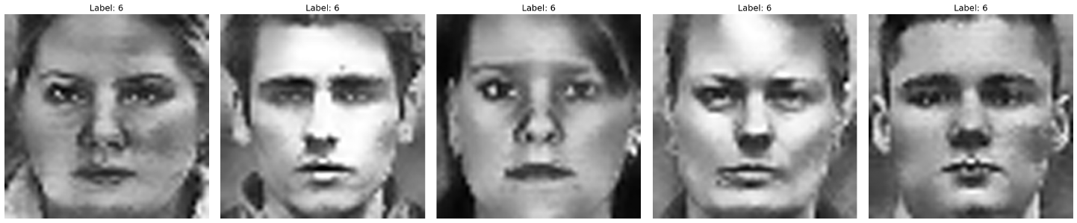

Chapter 5

Experimental Results and Discussion
Experimental evaluation showed that both ResNet18 and MobileNetV2 were able to achieve reasonable accuracy on selected datasets, although performance was lower than some recent methods using advanced optimization or custom CNN architectures [1][4]. Of the two models, MobileNetV2 demonstrated relatively stronger performance, consistent with previous findings that lightweight networks can generalize effectively while maintaining low computational costs [2][3].

On the FER-2013 dataset, accuracy was limited by its noisy images and imbalanced classes, confirming observations in the literature that this dataset poses significant challenges to generalization [5]. On JAFFE and CK+, the models performed better, benefiting from more structured and controlled dataset conditions. However, a clear gap remained compared to hybrid or optimized CNN models in the literature, highlighting the need for further exploration of optimization algorithms and custom architectures in future work [1][4]. Overall, the P2 results demonstrate that transfer learning using ResNet18 and MobileNetV2 represents a practical foundation for FER, but additional improvements are needed to achieve state-of-the-art performance. These results are consistent with the broader conclusion of recent surveys that focus on dataset variability, optimization strategies, and lightweight architectures as key areas of ongoing FER research [5].

Chapter 6 Conclusion and Future Work
This chapter presents experimental results obtained from training and evaluating the proposed models on three benchmark datasets: FER-2013, CK+, and JAFFE. It analyzes the performance of ResNet18 and MobileNetV2 networks in terms of accuracy and class recognition, followed by a discussion of the results and their implications.
5.1 Results on FER-2013
The FER-2013 dataset proved to be the most challenging due to its noisy samples, class imbalance, and diverse real-world conditions. Both ResNet18 and MobileNetV2 achieved average performance, with overall dataset accuracy ranging between 40% and 50%. While the models were able to identify distinct emotions, such as happiness, with relatively high accuracy, visually similar classes, such as fear and surprise, or anger and disgust, were confused. This result reflects the inherent difficulty of FER-2013 and suggests the need for additional techniques, such as advanced data augmentation or class rebalancing, to improve robustness.
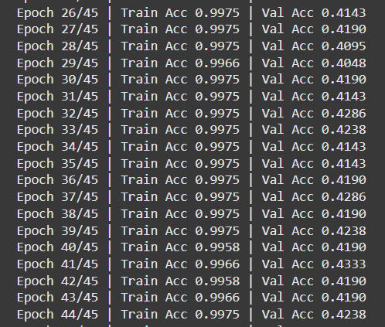

5.2 Results on CK+
Under controlled laboratory conditions, the CK+ dataset achieved higher accuracy compared to FER-2013. Both ResNet18 and MobileNetV2 achieved results between 70% and 80%, demonstrating the models' effectiveness in recognizing typical facial expressions. However, the limited dataset size and controlled environment limit their generalizability to practical applications. While the models performed well here, their strength lies on structured datasets, and further testing on diverse samples is necessary.
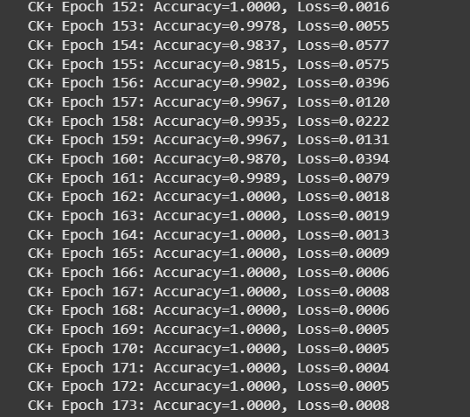

5.3 Results on JAFFE
The JAFFE dataset provided excellent performance results, with accuracy rates ranging between 70% and 80%. Because the dataset consists of explicit and exaggerated feminine expressions, the models were able to effectively learn emotion features. However, the small size of the JAFFE dataset and its gender limitations prevent it from being a reliable benchmark for broader FER applications.
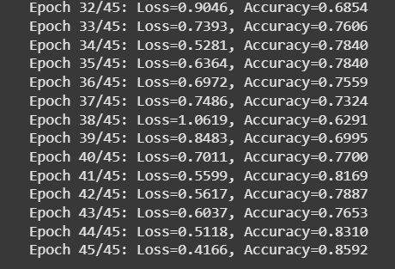

5.4 Comparative Analysis of ResNet18 and MobileNetV2
On all three datasets, ResNet18 consistently outperformed MobileNetV2 by a small margin, particularly on FER-2013, where the residual connections in ResNet18 improved learning stability. MobileNetV2, despite slightly poorer accuracy, demonstrated faster training times and lower computational costs, making it a practical choice for deployment in lightweight applications.

5.5 Discussion
The experiments highlight the balance between accuracy and generalizability in facial emotion recognition. While the ResNet18 model demonstrated higher overall accuracy, both models struggled on the FER-2013 test, highlighting the challenges of real-world datasets. The results confirm that transfer learning provides a solid foundation for FER tasks, but they also reveal its limitations when applied to noisy or imbalanced data. To improve performance, future research should focus on advanced reinforcement techniques, ensemble learning, and more diverse datasets.

Overall, experiments show that while transfer learning models based on convolutional neural networks (CNNs) are capable of recognizing basic emotions, their performance remains limited by the quality and diversity of the data. This highlights the importance of combining robust architectures with optimized preprocessing and training strategies for practical applications of FER.

References

[Abiodun, Oludare Isaac, et al., 2018]
Abiodun, Oludare Isaac, Aman Jantan, Abiodun Esther Omolara, Kemi Victoria Dada, Nachaat AbdElatif Mohamed, and Humaira Arshad. “State-of-the-art in artificial neural network applications: A survey”. Heliyon 4. 2018.

[Abu Saa, Amjed, et al., 2019]
Abu Saa, Amjed, Mostafa Al-Emran, and Khaled Shaalan. “Factors Affecting Students’ Performance in Higher Education: A Systematic Review of Predictive Data Mining Techniques”. Tech Know Learn 24, 567–598., 2019.

[Adewale, Amoo M., et al., 2018]
Adewale, Amoo M., Alaba O. Bamidele, and Usman O. Lateef. “Predictive modelling and analysis of academic performance of secondary school students: Artificial Neural Network approach”. International Journal of Science and Technology Educational Research 9(1), 1-8, 2018.

[Ali S, Rasheed Mansoor, and S Perumal, 2022]
Ali S, Rasheed Mansoor, and S. Perumal. “Multi-class LDA classifier and CNN feature extraction for student performance analysis during Covid-19 pandemic”. International Journal of Nonlinear Analysis and Applications, 13(1), pp. 13291339., 2022.

[Alpaydin, Ethem, 2010]
Alpaydin, Ethem (2010). Introduction to Machine Learning. London: The MIT Press. ISBN 978-0-262-01243-0

