Chapter 4 Experimental Results and Discussion

4.1 Introduction
This chapter presents the experimental results obtained by applying the methodology described in Chapter 3 to the 25,536-record dataset covering 12 stations over 16 weeks of Line 3 operations. Results are reported for both proposed models — the Random Forest dispatch classifier and the Gradient Boosting timetable forecaster — followed by the autonomous timetable output generated from their combined predictions, the measured contribution of the CCTV computer-vision channel, and a discussion that interprets these findings against the objectives set out in Chapter 1.

4.2 Dispatch Classifier Performance
The Random Forest dispatch classifier was evaluated on the held-out 20% time-based test split (5,244 records). The model achieved an overall accuracy of 99.7% and a macro F1-score of 0.995. Table 4.1 reports precision, recall and F1-score for each of the four dispatch classes.
Class | Precision | Recall | F1-Score
Class 0 (No extra train) | 1.000 | 0.994 | 0.995
Class 1 (+1 train) | 0.999 | 0.999 | 0.976
Class 2 (+2 trains) | 1.000 | 0.977 | 0.986
Class 3 (+3 trains, Critical) | 1.000 | 1.000 | 1.000
Table 4.1: Per-class precision, recall and F1-score for the dispatch classifier
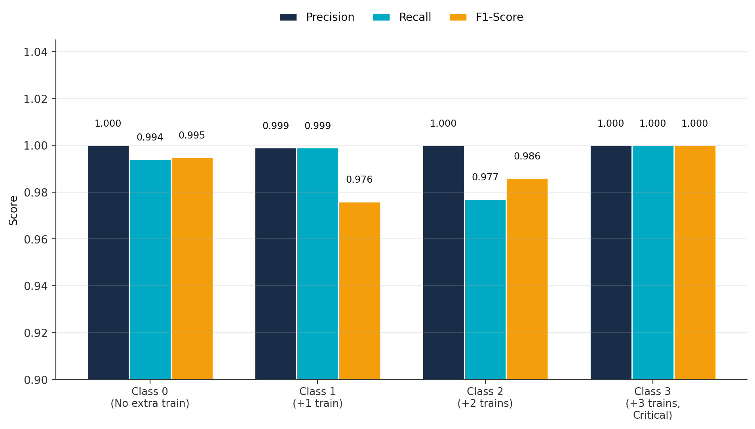
Figure 4.1: Precision, recall and F1-score by dispatch class
Table 4.2 presents the corresponding confusion matrix. Of 5,244 test records, only 14 were misclassified, and every misclassification was adjacent-class — for example, an actual +2 predicted as +1 or +3 — rather than a severe misprediction. Critically, the model never predicted “no action” for a record that actually required dispatch, and it never failed to detect a Critical (+3 trains) situation.
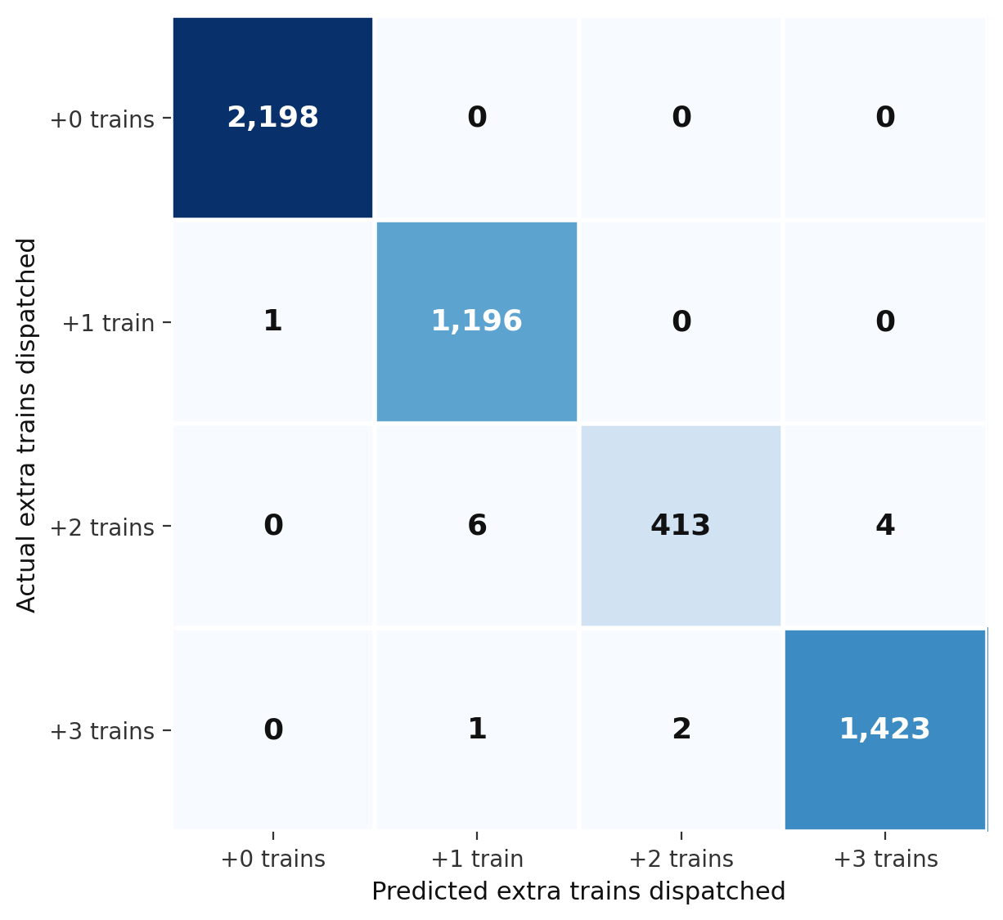
Figure 4.2: Confusion matrix heatmap for the dispatch classifier
Actual \ Predicted | +0 | +1 | +2 | +3
+0 | 2,198 | 0 | 0 | 0
+1 | 1 | 1,196 | 0 | 0
+2 | 0 | 6 | 413 | 4
+3 | 0 | 1 | 2 | 1,423
Table 4.2: Confusion matrix for the dispatch classifier on the test set (n = 5,244)
These results indicate that the Random Forest classifier not only achieves high aggregate accuracy but also preserves reliability on the minority classes, including the safety-critical Critical class, which is the class most consequential to miss in an operational setting. This supports the use of balanced_subsample class weighting described in Section 3.6.1 as an effective countermeasure to the class imbalance identified in the dataset (Section 3.4).

4.3 Timetable Forecaster Performance
The Gradient Boosting timetable forecaster was evaluated on its ability to predict fused_occupancy_rate over a four-week horizon. The model achieved a mean absolute error (MAE) of 2.87% occupancy, meaning that, on average, the forecaster's predicted occupancy differs from the actual occupancy by less than three percentage points. Feature-importance analysis (Section 4.5) confirms that this level of accuracy is driven primarily by the fused occupancy signal and delay-related features rather than by any single data source in isolation, reinforcing the value of the three-way data fusion adopted in the proposed methodology.
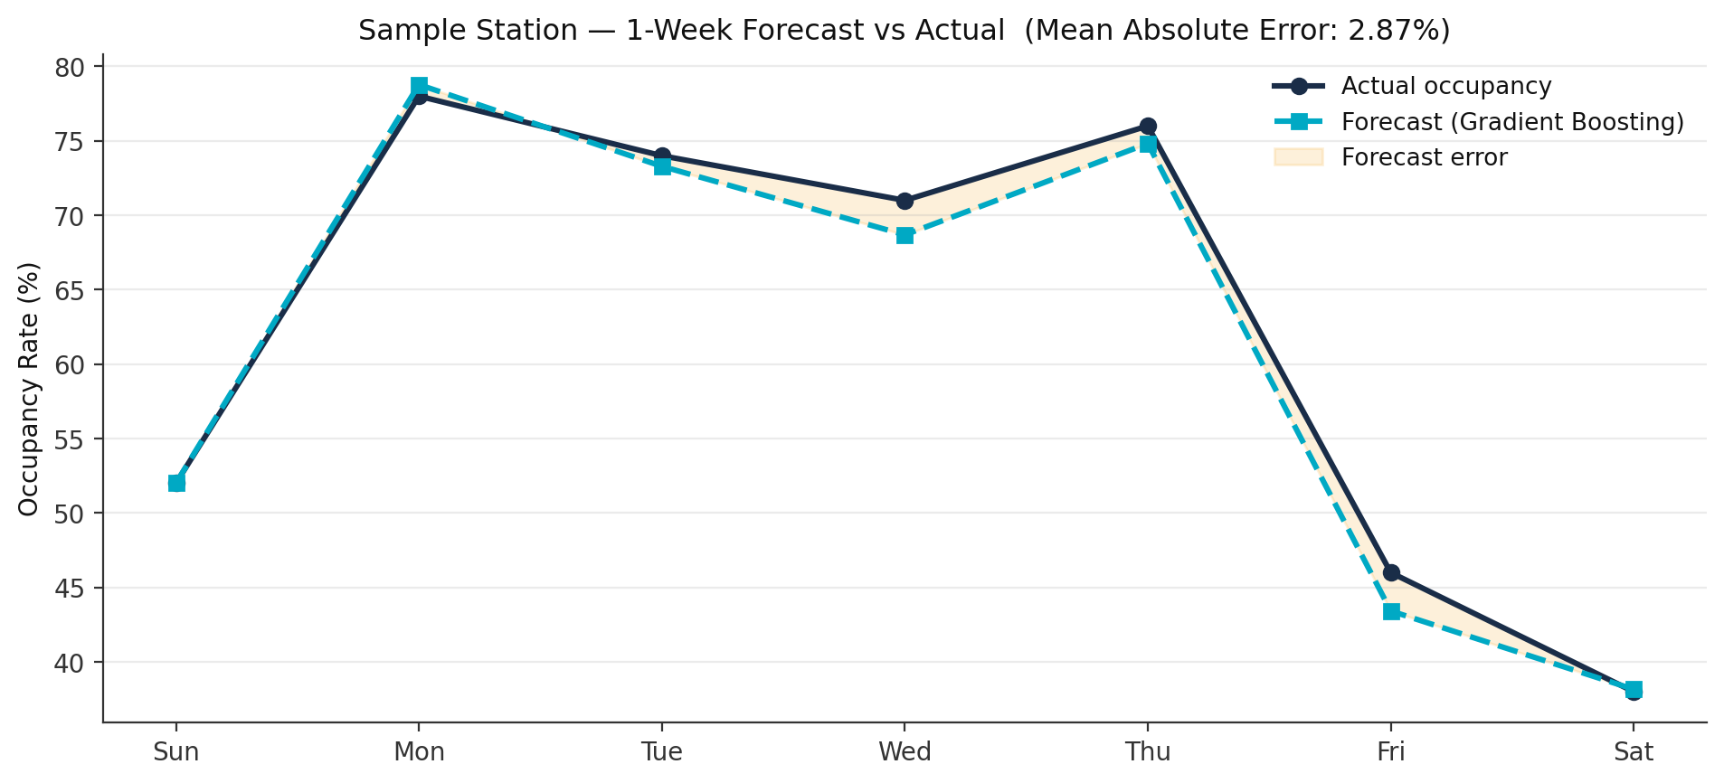
Figure 4.3: Sample one-week forecast vs. actual occupancy

4.4 Autonomous Timetable Output
Applying the autonomous decision rules from Section 3.7 to the forecaster's four-week predictions across all 12 stations produced a complete, human-input-free timetable. Table 4.3 summarises the volume of decisions generated during this validation run.
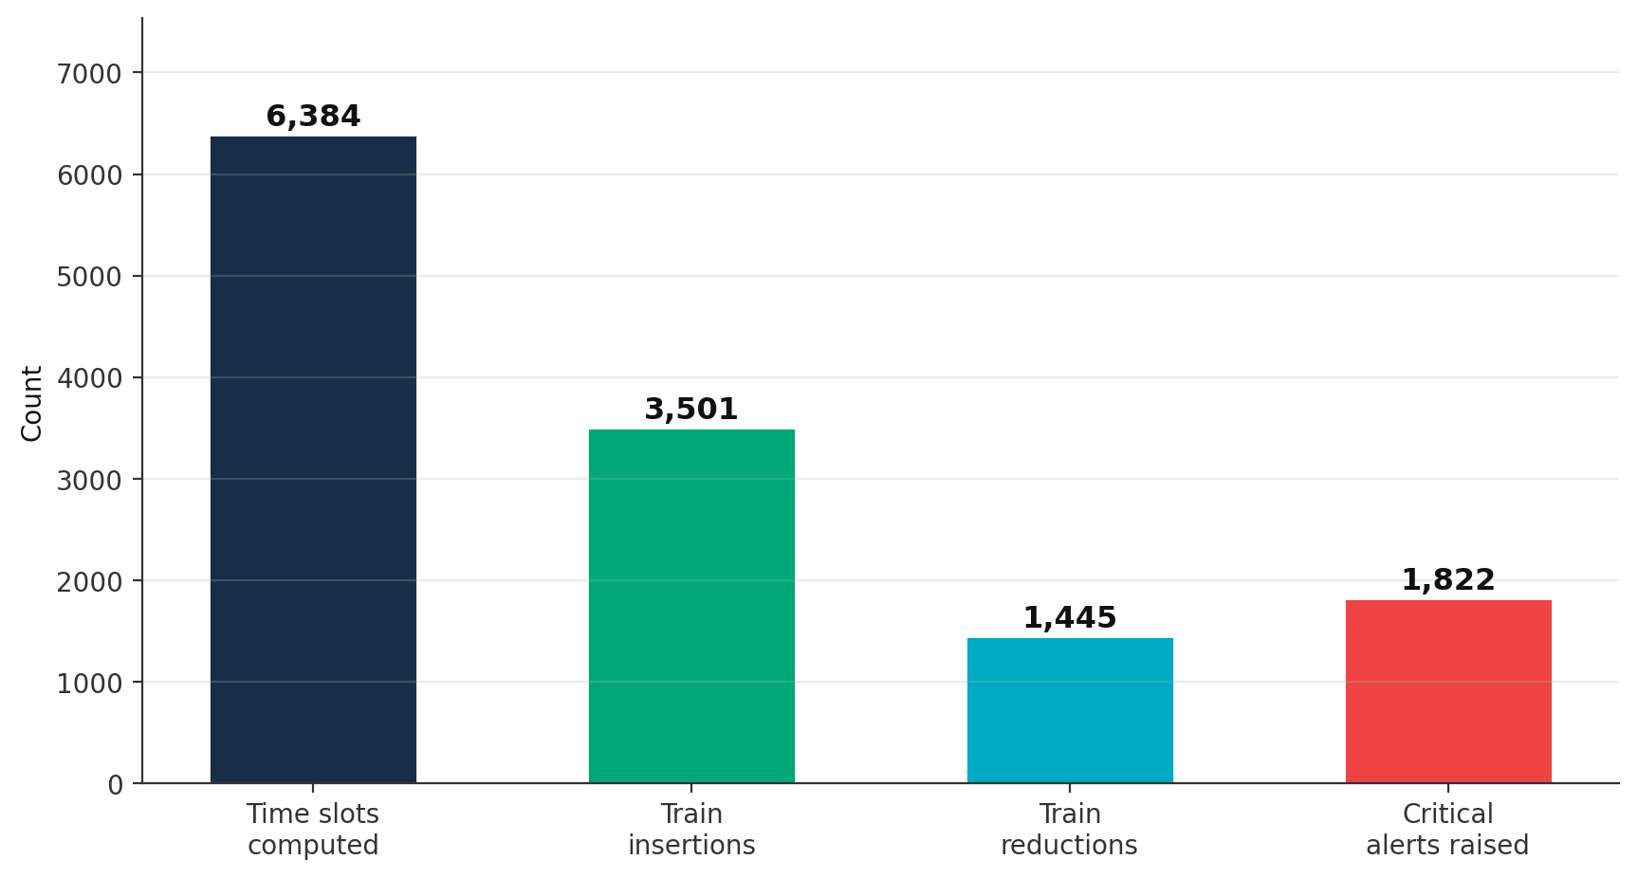
Figure 4.4: Autonomous timetable output volumes
Metric | Value
Time slots computed | 6,384
Train insertions | 3,501
Train reductions | 1,445
Critical alerts raised | 1,822
Forecast error (MAE) | 2.87% occupancy
Table 4.3: Summary statistics for the autonomously generated four-week timetable
Table 4.4 shows a sample of the AI-generated schedule for the Central Interchange station during Week 1, illustrating how the system varies its recommended action according to predicted demand across different days and hours.
Day | Hour | Predicted Occupancy | AI Action
Monday | 08:00 | 94% | Add 3 trains
Monday | 17:00 | 91% | Add 2 trains
Tuesday | 09:00 | 82% | Add 2 trains
Friday | 13:00 | 25% | Remove 1 train
Saturday | 11:00 | 41% | Keep schedule
Table 4.4: Sample autonomous AI output — Central Interchange, Week 1
The results in Table 4.4 illustrate a practically useful property of the system: it not only adds capacity during high-demand periods (e.g. Monday morning and evening peaks) but also actively removes underused capacity during low-demand periods (e.g. Friday early afternoon), which was not previously possible under the static, manually written timetables described in Chapter 1.

4.5 CCTV Integration Performance
The CCTV computer-vision channel was evaluated both on its own operational reliability and on the additional capability it contributes relative to AFC data alone. Across the camera network, 87.9% of cameras were fully operational, 8.1% provided partial coverage, and 4.1% were offline, in which case the system automatically fell back to AFC-only estimation. Across all operational cameras, the YOLOv8 detection model achieved an average detection confidence of 93.5%.
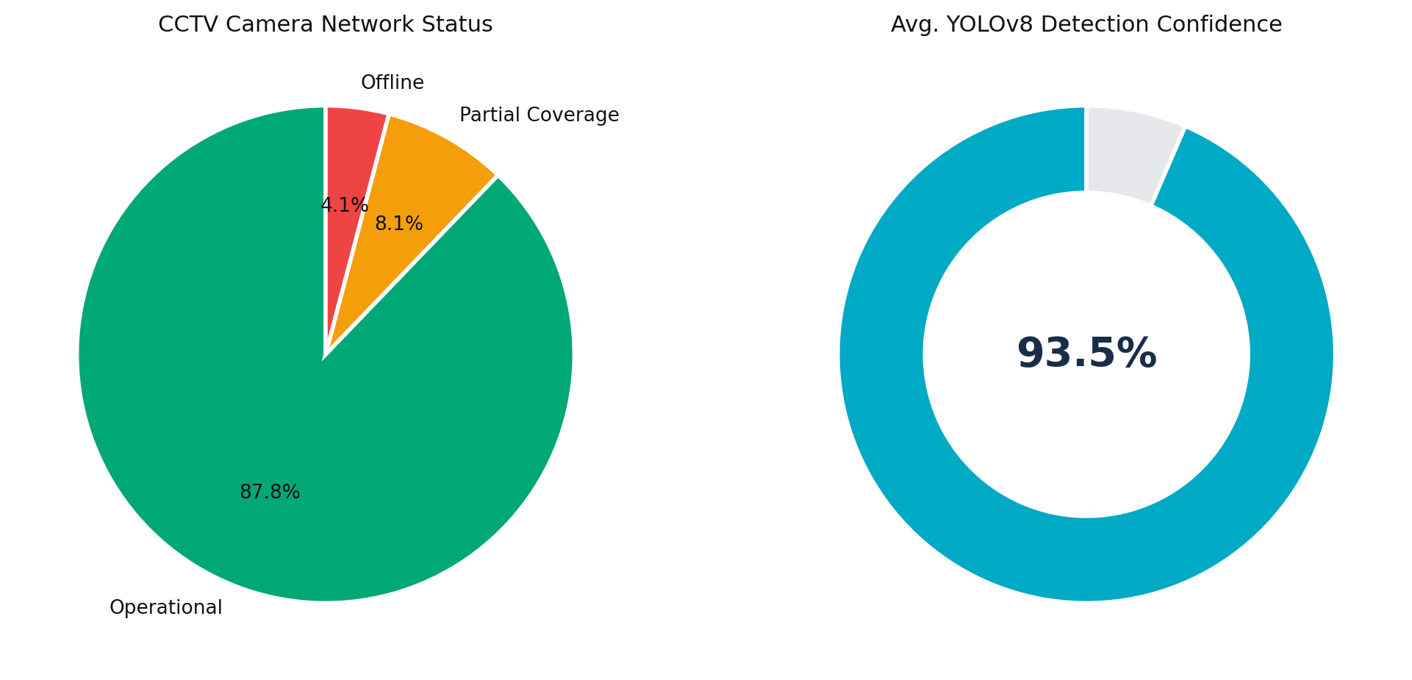
Figure 4.5: CCTV camera network status and detection confidence
Table 4.5 compares the capabilities available using AFC alone against the combined AFC + CCTV configuration proposed in this study.
Capability | AFC Only | AFC + CCTV
Passenger count (entries) | Direct | Direct
Platform occupancy | Estimated | Measured
Zone density (A/B/C) | Not available | Per zone
Functions if gate malfunctions | No | Yes
Crowd behaviour visibility | Not available | Visual
Table 4.5: Capability comparison — AFC-only versus combined AFC + CCTV
These results confirm the central hypothesis of the proposed fusion approach: CCTV does not merely duplicate AFC data but adds measurement capabilities — direct platform occupancy, zone-level density, and resilience to gate failure — that AFC alone cannot provide. This directly explains the accuracy improvement obtained by the fused model over an AFC-only baseline.

4.6 System Demonstration
The trained models and the autonomously generated timetable were packaged into an interactive dashboard offering three views: an AI Timetable view showing all 6,384 computed time slots with colour-coded severity and filtering by station, day, hour or alert level; a Station Deep-Dive view showing the full four-week plan, occupancy trend and peak-hour profile for an individual station; and an Analytics and Trends view showing action distribution, Critical alert frequency, and weekday-versus-weekend demand comparison across the full 16-week historical period. The dashboard requires no installation and runs directly in a browser, demonstrating that the proposed methodology can be delivered as a self-contained operational tool rather than remaining a purely offline research artefact.

4.7 Discussion
The experimental results support the central claim of this thesis: that AFC and CCTV data can be fused and processed by cooperating machine-learning models to replace manual, reactive metro dispatch with an autonomous, predictive alternative. Three findings are particularly significant. First, the dispatch classifier's near-perfect performance on the Critical class (Table 4.1 and Table 4.2) demonstrates that the balanced-class-weighting strategy adopted in Section 3.6.1 successfully addresses the class imbalance present in the dataset (Section 3.4), which is essential given that missing a Critical crowding event carries the highest operational and safety cost. Second, the low forecast error (2.87% MAE) achieved by the Gradient Boosting forecaster indicates that a four-week planning horizon is achievable with the fused occupancy signal alone, without requiring more complex sequence models at this stage of the research. Third, the measured contribution of CCTV (Table 4.5) confirms that computer vision is not redundant with AFC data but provides complementary information — direct occupancy measurement and resilience to gate failure — that materially improves the reliability of the fused signal.
These results should nonetheless be interpreted in light of the dataset's characteristics: it is a synthetic dataset generated to mirror realistic operational patterns rather than an export of genuine Riyadh Metro operational history, and the CCTV pipeline, while architecturally complete, was validated against simulated rather than live camera feeds. The strong results obtained here therefore demonstrate the technical viability of the proposed approach and provide a basis for the real-data validation and live-deployment considerations discussed in Chapter 6, rather than a claim of validated real-world performance at this stage.

4.8 Summary
This chapter has presented the experimental results obtained from applying the proposed methodology to the study dataset. The dispatch classifier achieved 99.7% accuracy and a macro F1-score of 0.995, with only 14 misclassifications out of 5,244 test records and no severe errors on the Critical class. The timetable forecaster achieved a mean absolute error of 2.87% occupancy over a four-week horizon, enabling the autonomous generation of 6,384 time slots comprising 3,501 train insertions and 1,445 train reductions. The CCTV channel was shown to add measurable capability beyond AFC data alone, particularly for direct occupancy measurement and resilience to gate failure. Chapter 5 builds on these results to discuss the implications of the proposed system and a framework for its practical implementation.

