Addressing the Imbalanced Distribution of Shops and Services Within Cities Using Artificial Intelligence Techniques

Chapter One: Introduction
Under the leadership of the Custodian of the Two Holy Mosques, King Salman bin Abdulaziz Al Saud, the Kingdom of Saudi Arabia embarked on a transformative journey toward a promising and bright future with the launch of Saudi Vision 2030. Initiated by His Royal Highness Prince Mohammed bin Salman, Crown Prince and Prime Minister, in 2016, the Vision places citizen empowerment, economic diversification, and global leadership at its core. Its three primary pillars are: a vibrant society, a thriving economy, and an ambitious nation (Vision 2030, n.d.).
Saudi cities are currently experiencing a boom in all service sectors, including a diversity of commercial outlets and increased market competitiveness. There has been a significant rise in the number of shops opened in Riyadh providing essential, recreational, and medical services. According to the latest statistics from the General Authority for Statistics, the number of commercial licenses in Riyadh grew by [Insert Percentage]% between 2016 and 2024. This increase fosters high competition in quality, breaks monopolies, and ultimately enhances the quality of life for citizens.
However, these outlets must be distributed in a balanced manner based on strategic supply-and-demand objectives to serve the population effectively, reduce urban chaos, and ensure sustainability. Currently, many neighborhoods suffer from imbalanced distribution; one street may host multiple pharmacies and supermarkets, while other areas lack basic services.
Therefore, this study aims to develop smart solutions using AI tools to regulate the distribution of services. This ensures that the needs of all citizens are met, contributing to a higher quality of life, reduced traffic congestion, resource sustainability, and the prevention of haphazard urban expansion.

Background
Cities, particularly metropolises, face challenges due to rapid population growth and urban sprawl. Urban planning theories, such as Sustainable Development Theory, emphasize designing cities that are environmentally friendly, economically efficient, and socially equitable (Wheeler, 1996). Global shifts toward digital transformation have resulted in a "Big Data" revolution. Licenses, census data, and construction permits are now digital, allowing for integration with Fourth Industrial Revolution (4IR) tools, specifically Artificial Intelligence, to modernize urban planning systems.

Problem Statement
The primary issue is the imbalanced spatial distribution of shops and services. Currently, private sector distribution depends on individual corporate strategies—some prioritize high-density areas while others target new neighborhoods. This lack of coordination leads to:
- A decline in the quality of life.
- Increased traffic congestion.
- Inefficient resource management and "urban sprawl."
- Service gaps in underserved neighborhoods.

Research Objectives
General Objective: To study the impact of balanced service distribution using data and AI on enhancing urban quality of life, moving from traditional planning to data-driven urban planning.
Sub-Objectives:
- Enhance the quality of life.
- Reduce traffic congestion within cities.
- Achieve resource sustainability.
- Minimize haphazard urban expansion.
- Create new opportunities for the private sector to diversify the economy.
- Achieve self-sufficiency across various sectors.
Specific Objectives:
- Define the general framework for AI-based urban service planning.
- Analyze the key challenges in the current distribution model.
- Evaluate the impact of imbalanced distribution on quality of life.
- Propose mechanisms and regulations for optimizing service distribution.

Research Scope
This study is limited to the impact of balanced service distribution in Riyadh, Saudi Arabia, from 2016 to 2024. It utilizes data regarding municipal licenses, population density, and building permits to determine actual needs using AI tools.

Chapter Two: Literature Review
The current decade has seen a paradigm shift in using AI and data for predictive modeling and decision-making. This review examines studies regarding AI’s role in improving commercial activity decisions and spatial distribution.
- Effectiveness of AI in Business: Research confirms that AI contributes significantly to improving decision-making based on actual market needs (Douaioui, 2024).

Research Methodology
The research relies on Data Analysis fed into AI models to predict the suitability of specific commercial activities for certain areas or to identify investment opportunities. A simulation model will be designed for validation.
Data Sources:
- Municipal commercial licenses.
- Neighborhood population data (Census).
- Municipal building permits.
- Geographic/Geospatial maps (GIS).
Algorithms & Tools: Analysis is conducted using the Python programming language, utilizing the following algorithms:
- Random Forest: For classification and identifying key distribution factors.
- LSTM (Long Short-Term Memory): For time-series forecasting of population growth and service demand.

Gant

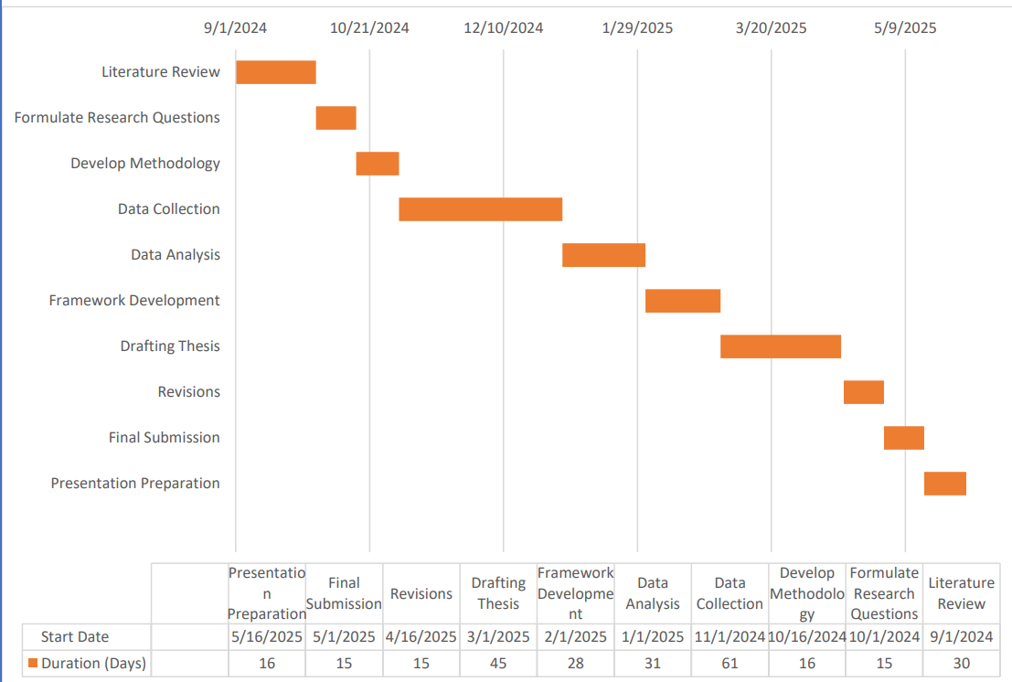

References
2030, S. V. (n.d.). Overview. Retrieved from Saudi Vision 2030: https://www.vision2030.gov.sa/ar/overview
Kaoutar Douaioui, R. O. (2024). Machine Learning and Deep Learning Models for Demand Forecasting in Supply Chain Management: A Critical Review. Applied System Innovation, https://www.google.com/search?q=https://www.semanticscholar.org/paper/Machine-Learning-and-Deep-Learning-Models-for-Douaioui-Oucheikh/413b55de42a697ea3d1fd60d3989461c465e5b3d.
Wheeler, S. (1996). Sustainable Urban Development: A Literature Review and Analysis. Berkeley: Institute of Urban and Regional Development.

