
Master’s thesis written in the
Collegium of Media and Digital Marketing
under scientific supervision of
Dr. Mohamed Owais

The Impact of Influencer Marketing on Sales and Consumer Purchasing Behavior: An Analytical Study on ElcOutlet Home Appliances Store

Researcher: Manal Bahari
2023-2024

Table Of Contents
Chapter 1 - Introduction and Literature Review
1.1 Introduction………………………………………………………..……4
1.2 Literature Review…………………………………………………..……6
1.3 Study Problem………………………………………………………..….12
1.4 Research Questions………………………………………………………12
1.5 Importance of the Study……………………………………………….…13
1.6 Study Objectives………………………………………………………….13
1.7 Study Concepts……………………………………………………………14
Chapter 2 - Theoretical Framework
2.1 Influencer Marketing and Its Impact on Sales…………………………….17
2.2 Consumer Behaviour and Trust in Influencers……………………………18
2.3 The Role of Social Media Platforms………………………………………19
2.4 Long-term Impact of Influencer Marketing……………………………….,19
2.5 Analysing Campaign Data………………………………………………….20
Chapter 3 - Research Methodology……………………………………………..21
3.1 Study Hypotheses……………………………………………………………21
3.2 Data Collection Tools……………………………………………………...…22
3.3 Study Scope……………………………………………………………….….22
3.4 Study Population……………………………………………………………..23
3.5 Study Sample………………………………………………………………...23
Chapter 4 - Data Analysis and Results
4.1 Descriptive Statistics…………………………………………………………24
4.2 Time Series Analysis…………………………………………………………27
4.3 Influencer Profile Analysis…………………………………………………..28
4.4 Impact of Influencer Campaigns on Weekly Sales Performance………………………29
4.5 Impact of Influencer Campaigns on Product Categories………………………………31
4.6 ROI Analysis……………………………………………………………....34
4.7 Conclusion ………………………………………………………...…….…25

- Chapter 1 - Introduction and Literature Review.
In today’s digital age, influencer marketing has emerged as a pivotal tool for businesses to connect with and engage their target audiences. This form of marketing involves collaboration between brands and individuals with a significant online presence, commonly known as influencers. These influencers utilize their platforms, primarily social media, to promote products or services by sharing authentic opinions and personal experiences. Their ability to create relatable content has reshaped the way businesses approach their marketing strategies, making influencer marketing one of the fastest-growing trends in the digital world.

Over the past decade, influencer marketing has witnessed remarkable growth as businesses increasingly recognize its potential to forge personal connections with consumers. Unlike traditional advertisements, such as television commercials or magazine ads, which often feel impersonal or overly promotional, influencer marketing thrives on authenticity and relatability. Consumers today are drawn to influencers who provide detailed insights into products, demonstrating how these items fit into their daily lives. This authenticity makes influencers appear more trustworthy, and their recommendations often carry more weight than traditional advertising.

Influencers come in various types, ranging from mega influencers with millions of followers to micro and nano influencers who cater to niche audiences. While large-scale influencers have the ability to reach extensive audiences, micro and nano influencers often foster deeper connections with their followers, creating a sense of community and trust. Businesses strategically select influencers based on factors such as audience size, engagement rates, and relevance to their target market. These collaborations are not only about promoting products but also about creating meaningful connections that resonate with consumers and drive purchasing decisions.

The rise of influencer marketing reflects broader shifts in consumer behavior, where people increasingly rely on social proof and peer recommendations rather than traditional advertising methods. By partnering with influencers, companies can tap into established communities and benefit from the trust influencers have built with their audiences. This dynamic has proven especially effective in sectors such as fashion, beauty, technology, and lifestyle, where consumer decisions are often influenced by personal experiences and reviews.

This research aims to explore the factors influencing the effectiveness of influencer marketing, its growing importance in the digital landscape, and its impact on consumer behavior and purchasing decisions. By examining these dynamics, the study seeks to provide businesses with valuable insights into optimizing their marketing strategies to better reach and engage their target audiences. Understanding the nuances of influencer marketing can help companies not only boost their sales but also establish lasting relationships with consumers in an increasingly competitive market.

  - Literature Review.
Previous research plays an essential role as a valuable scientific resource for researchers exploring various topics. In this study, we have collected a selection of studies related to the research subject, particularly focusing on influencer marketing, as it is a key aspect of our research focus.
- In a study by Bhagyashree and Pushpalatha, Impact of Influencer Marketing on Consumer Buying Behavior. they explored the impact of influencer marketing on consumer buying behavior. The study involved 115 participants and found that 71.3% of them were influenced by recommendations from influencers when making purchases. The research also showed that product quality was the most important factor for 61.7% of the participants when deciding to buy a product recommended by an influencer. Additionally, 73.9% of the participants trusted the recommendations given by influencers, showing that trust plays a key role in how consumers make buying decisions. (Bhagyashree & Pushpalatha, 2024)
- The impact of influencer marketing on consumer behavior effectiveness on increasing brand awareness improving brand perception and driving sales by Hake, Nath, & Kumavat The researchers examined how influencer marketing affects consumer behavior, particularly in increasing brand awareness, improving brand perception, and driving sales. The study, based on a sample of 500 participants, found that influencer marketing exposure had a strong positive effect on brand awareness (r=0.75), brand perception (r=0.68), and purchase behavior (r=0.45). The findings show that influencer marketing is an effective tool for increasing sales and improving consumer engagement with brands, especially on platforms like Instagram, which was used by 80% of the respondents. (Hake, Nath, & Kumavat, 2023).

- . (Agung, Darma, & Mahyuni, 2021). Dose Influencer Marketing Really Improve Sustainable Brand Awareness and Sales? Throughout this study, researchers explored whether influencer marketing improves sustainable brand awareness and sales, particularly for start -up businesses. The study, which was conducted in Denpasar City using qualitative methods, found that influencer marketing does help in temporarily increasing brand awareness. However, the effects are often short-lived due to factors such as the high volume of influencer collaborations and the monotony of some promotional strategies. The researchers concluded that while influencer marketing is useful, it needs to be combined with other marketing strategies to achieve optimal, long -lasting results

- Study by venciute et al. 2023 The role of influencer–follower congruence in the relationship between influencer marketing and purchase behavior, researchers examined how the congruence between influencers and their followers affects purchase behavior. The study surveyed over 7,500 individuals to measure their perception of influencer credibility, usefulness of content, and congruence with the influencer. The results showed that when there is strong congruence between an influencer and their followers, the impact of the influencer’s content and experience on purchase behavior is significantly higher. However, factors like trustworthiness and attractiveness did not show a strong direct effect on purchase decisions in this study. (Venciūtė et al., 2023).

- The Influence of Hedonic Motivation and Influencer Marketing on Purchasing Decisions with FOMO as A Mediating Variable ,by Solaiman & Pangaribuan, This study explores how hedonic motivation (the desire for pleasure) influencer marketing, and Fear of Missing Out (FOMO) affect online shopping decisions. It finds that both hedonic motivation and influencer marketing directly influence purchases, while FOMO plays a key role in indirectly affecting these decisions, especially with limited time offers. The research suggests that marketers can effectively use these insights to create strategies that appeal to consumers' emotions and sense of urgency, but they should also be mindful of the ethical implications of using FOMO in their marketing tactics. (Solaiman & Pangaribuan, 2023).

- Using online opinion leaders to promote the hedonic and utilitarian value of products and services, by Lin, Bruning, & Swarna.
Research shows that online opinion leaders, like influencers, play a crucial role in promoting products and services. Companies need to carefully select which opinion leaders to collaborate with and understand how to effectively work with them to highlight both the enjoyable (hedonic) and practical (utilitarian) aspects of their offerings. The article outlines a five-stage planning process for these partnerships, which includes setting campaign goals, identifying suitable influencers, aligning them with the right products, motivating them appropriately, and coordinating their efforts throughout the campaign. (Lin, Bruning, & Swarna, 2023).

- Govindan & Alotaibi , Impact of influencers on consumers behavior empirical study. Research indicates that marketing through digital platforms achieves higher success rates compared to other platforms. However, simply conducting online marketing is not sufficient; consumer opinions must be considered, and products or services should be adjusted to meet the needs of a wide audience. Understanding consumer behavior and how it is influenced by influencer marketing is crucial information for companies aiming to grow and develop. The survey results show that there are still customers who do not fully trust influencers and what they promote, even though influencer marketing is a successful tool in today’s generation. To build consumer trust, influencers should adopt new methods that assure customers of the trustworthiness of the products or services they promote, by offering guarantees to support purchasing decisions. (Govindan & Alotaibi, 2021).

- Influencer Marketing: How Message Value and Credibility Affect Consumer Trust of Branded Content on Social Media by Lou & Yuan. This study aims to understand how influencer marketing affects consumers through social media. It proposes an integrated model for the social media influencer value, showing that both the value of influencer generated advertising and influencer credibility positively impact consumer trust in branded content, which subsequently increases brand awareness and purchase intentions. The results demonstrated that informational content value, trustworthiness, and similarity to influencers play a significant role in building followers’ trust in branded content, which in turn influences purchasing decisions. The research employed Partial Least Squares (PLS) path modeling and an online survey among social media users who followed at least one influencer. (Lou & Yuan, 2019).

- Does Influencer Marketing Really Improve Sustainable Brand Awareness and Sales? This research aims to assess the effectiveness of influencer marketing in enhancing sustainable brand awareness and sales, especially for start-up businesses. The study was conducted in Denpasar City using a qualitative methodology involving in-depth interviews with start-up business owners in various fields. The results indicated that influencer marketing positively affects brand awareness, but this effect is temporary. To achieve sustainable results, businesses need to adopt additional strategies alongside influencer marketing, such as improving product presentation and carefully selecting appropriate influencers. (Agung, Darma, & Mahyuni, 2021).

- The Influence of Influencer Marketing in Increasing Brand Awareness and Sales for SMEs, Researchers in this paper explored the impact of influencer marketing on increasing brand awareness and sales for Small and Medium-Sized Enterprises (SMEs) in the digital era. The study emphasized the significance of influencer marketing as a highly effective tool for reaching target audiences and enhancing brand visibility. Using qualitative literature analysis, the authors concluded that influencer marketing enables SMEs to access new markets, increase sales, and build strong customer relationships. The findings highlighted the importance of influencer credibility and the alignment of influencers’ values with the brand to foster trust and drive purchase decisions. The study recommends that SMEs carefully select influencers to ensure that their audience resonates with the brand’s values and objectives. Agustian et al. (2023).

- Influencer Marketing on Instagram: Effects of Promotional Posts on Purchasing Behavior of Consumers ,In this study the researchers explored the effects of influencer marketing on Instagram on consumers’ purchasing behavior. The results revealed a significant positive correlation between influencer marketing and purchasing behavior. (Khan, Iqbal, & Lodhi, 2021).

- The effects Of Content And Influencer Marketing On Purchasing Decisions Of Fashion Ergo Company, During this study the researchers examined the effects of content marketing and influencer marketing on consumer purchasing decisions, particularly in the fashion industry. The study focused on the Erigo Company and involved 100 respondents selected through purposive sampling. Using path analysis, the results showed that both content marketing and influencer marketing have a significant positive impact on consumer behavior and purchasing decisions. Specifically, influencer marketing proved to have a direct influence on purchasing behavior, with 80.8% of the variance in consumer behavior explained by influencer activities on social media platforms like Instagram. Additionally, the study found that content marketing played a crucial role in engaging consumers, affecting purchasing decisions through its ability to create value and build customer trust. (Yodi, Widyastuti, & Noor, 2020).

- . (Jin et al., 2019) Instafamous and social media influencer marketing, this study explores the comparison between traditional celebrities and Instagram influencers (“Instafamous”) in terms of their impact on consumers’ purchase intentions. It examines how the type of celebrity affects trustworthiness, brand attitude, and envy among consumers. The findings reveal that Instagram influencers generate higher trust, envy, and social presence compared to traditional celebrities. Social presence mediates the effects on envy and brand attitude

- Influencer Impact: Examining the Effect of Influencers on Consumer Behavior and Purchase, (Mishra & Ashfaq, 2023) this research examines the role of social media influencers in shaping consumer behavior and purchase decisions. The research demonstrates that influencers positively affect consumer purchase intentions by enhancing trust and credibility in their messaging. Influencers’ personal traits, such as attractiveness and credibility, amplify their impact. Using primary data from a survey, the study reveals that a significant proportion of consumers rely on influencers’ opinions when making purchasing decisions.

- . (Johansen & Guldvik, 2017). Influencer Marketing and Purchase Intentions This study examined the impact of influencer marketing on consumers’ purchase intentions using the Theory of Reasoned Action as a framework. The objective was to understand the effectiveness of influencer marketing compared to traditional online advertising through an online survey involving 180 participants. The findings showed that influencer marketing positively influences consumers’ “attitude toward the behavior” but does not have a direct effect on purchase intention, nor is influencer marketing more effective than traditional online advertising in increasing purchase intentions. The study encourages further research on the impact of influencer marketing to explore this field in more depth

- The Impact of Influencer Marketing on Consumers’ Attitudes This study explored the impact of influencer marketing on consumer attitudes, focusing on understanding the factors that affect Swedish millennials’ attitudes towards influencer marketing on platforms like Instagram and blogs. The researchers gathered data through focus groups with millennial participants, and the data were analyzed by categorizing response patterns and recurring discussion topics. The findings revealed that millennial attitudes are influenced by several factors, including the alignment of promotional messages with the influencer’s style and the level of credibility and trustworthiness of the messages. ( Grafström, Jakobsson, & Wiede, 2018).

  - Comment On Previous Studies.
The previous studies can be grouped into two main areas. The first set looks at how influencer marketing helps improve sales, showing how influencer campaigns can increase brand awareness and revenue.
The second set focuses on the factors that make influencer marketing successful, such as authenticity, audience interaction, and the influencer’s credibility and reach. Although these studies offer useful insights into influencer marketing, there are still areas that haven’t been fully explored. Many of the studies concentrate on short-term sales or individual factors, but there is less understanding of how these factors work together or their long-term effects on customer behavior. Additionally, not much has been studied about how influencer marketing might affect different industries in different ways.
These gaps highlight the need for more research on influencer marketing, especially to better understand how brands can use influencers effectively for long-term growth. This was one of the main reasons we chose this topic, aiming to add to the current knowledge in this area.

  - Study problem.
Influencer marketing in Saudi Arabia has seen significant growth, establishing itself as a key digital marketing strategy. According to a report by Al-Qarar Center for Media Studies, over 75% of marketers allocate budgets for influencer marketing, with plans to increase spending in the coming years. However, the market faces notable challenges, such as a decline in audience trust. The report highlights that 40% of consumers stop following influencers due to untrustworthy promotions, while only 77% of consumers engage with ads that align with their personal interests

Furthermore, a report from Munhna emphasizes that selecting the right influencer is critical, as genuine content and alignment with audience interests are pivotal for the success of marketing campaigns

This research seeks to analyze the impact of influencer marketing campaigns on the sales of Alec Outlet for home appliances. By studying a campaign featuring three influencers, the study aims to assess how this strategy influences purchasing decisions and boosts sales. It also examines the challenges brands face in building trust and ensuring a sustainable return on investment

Research Questions.
What is the impact of influencer marketing on sales and consumer purchasing behavior?
    - Sub-questions.
- What are the key factors in influencer marketing that contribute to increased sales?
- How does the size of an influencer’s audience (mega, mid-tier, or nano) affect sales?
- How does consumer trust in influencers impact their purchasing decisions?

  - Importance of the Study.

- Scientific Importance:
This study contributes to the growing body of literature on influencer marketing by providing empirical evidence on its impact on sales and consumer purchasing behavior. It explores the dynamics of different influencer types and their effectiveness, thereby enhancing academic understanding of the factors that drive successful marketing strategies. The findings will fill existing research gaps and can serve as a foundation for future studies in the field of marketing.
- Practical Importance:
The insights gained from this study will be valuable for businesses looking to optimize their influencer marketing strategies. By identifying which types of influencers and platforms yield the highest sales conversions, companies can allocate their marketing resources more effectively. The research will provide actionable recommendations for enhancing influencer partnerships, leading to improved sales performance and a better understanding of consumer behavior in response to influencer marketing.

  - Study Objectives.

This study aims to investigate the impact of influencer marketing on increasing sales in local stores, specifically focusing on the sales performance of ElcOutlet. By understanding how several factors influence sales performance, the research seeks to provide insights that can help businesses leverage influencer marketing effectively. Among the objectives of the research are the following:
- To identify the key factors that directly contribute to increased sales through influencer marketing.
- To evaluate the impact of several types of influences (mega, mid-tier, and nano) on sales performance.
- To assess the role of consumer trust in influencers in product sales.
- To explore the influence of social media platforms on the effectiveness of influencer marketing campaigns.
- To provide local stores like ElecOutlet with data-driven recommendations for optimizing influencer marketing strategies to increase sales.

  - Study Concepts.

The concepts of this study include three main concepts that will be divided and explained in detail, along with their relevant sub-concepts. These concepts are:
- Influencer Marketing: “Influencer marketing is a strategy that relies on collaboration with individuals who have considerable influence over their audience on social media. These influencers are known for their ability to impact their followers’ purchasing decisions through recommendations, reviews, and the content they share.” (Bin Salim, 2024, p. 3)

- Marketing: Marketing has multiple definitions that vary according to the intellectual evolution of marketing, which may expand to include modern variables in this field. Undoubtedly, one of the most debated definitions is the one provided by the Definition Committee of the American Marketing Association (AMA), which states: ‘Marketing is the set of functions that deal with the flow of goods and services from the producer to the final consumer’ (Al-Jaafari, 2019, p. 9). Another definition is from the Marketing Society of the United Kingdom, which states: ‘Marketing is the management process responsible for identifying, anticipating, and satisfying consumer needs efficiently and profitably’ (Cannon, 1986, p. 2). I conclude with one of the most widely accepted definitions, that of Philip Kotler, one of today’s leading marketing scholars, who defined it as: ‘The efforts made by individuals and groups within a specific administrative and social framework to meet their needs and desires by generating, providing, and exchanging products with others’” (Talat Asaad, 2022).

- Influencers:
  - Definition According to Influence:
Influencers are individuals who possess a unique ability to impact consumer behavior through their credibility and strong relationships with their audience, making them a bridge between brands and consumers.
  - Definition According to Function:
Influencers are people who use social media platforms to create content that includes recommendations, reviews, or firsthand experiences, which makes them an effective marketing tool for brands.
  - Definition According to Their Role in Marketing:
Influencers are a key component of digital marketing strategies, where marketers utilize them to promote products or services through advertising campaigns that leverage their credibility and influence over consumers.
  - Definition According to Type:
Influencers can be categorized into diverse types based on their follower count:
- Mega Influencers: Individuals with a large following, often exceeding one million, and are typically celebrities or public figures.
- Mid-tier Influencers: Those with a following between 100,000 and one million, often specializing in specific niches.
- Micro Influencers: Individuals with a smaller following (ranging from 1,000 to 100,000), who tend to have high engagement rates with their audience.
- Nano Influencers: Those with fewer than 1,000 followers often possess considerable influence within their local communities or specific niches.
- Sales:
Sales refer to the exchange of goods or services for money, which is a critical component for the financial success of any business. Understanding the factors that influence sales performance is vital for companies looking to optimize their marketing efforts.

- Sales Performance:
This involves measuring the effectiveness of sales strategies and tactics in generating revenue, including the analysis of sales data and metrics to assess outcomes.

- Consumer Behavior:
Consumer behavior is defined as the activities individuals engage in while selecting, purchasing, and using goods and services to satisfy their desires and meet their needs. Thus, consumer behavior is the collection of activities and actions that consumers undertake while searching for the goods and services they require to fulfill their needs and wants. This includes evaluating, acquiring, using, and disposing of these goods and services, along with the decision-making processes that accompany these actions (Al-Juraishi, K. 2006, p. 44).

- Consumption:
Consumption can be defined as the process of acquiring a product, using it, and then disposing of the surplus. Final consumption, therefore, refers to the use of production for final consumption, which involves the utilization or enjoyment of goods and services to satisfy consumption purposes. This kind of consumption leaves no remaining product that can fulfill any other need. (Al-Juraishi, K. 2006, p. 44).

- Final Consumer:
The final consumer is the person who purchases a good or service with the aim of satisfying a need or desire for themselves or for members of their family.

- Chapter 2 - Theoretical Framework.
Based on a comprehensive review of existing literature on influencer marketing and its impact on sales and consumer behavior, this theoretical framework explores various dimensions of influencer marketing and its role in enhancing sales performance and shaping consumer behavior. Influencer marketing has been widely recognized as a powerful tool in digital marketing, especially in building brand awareness and enhancing consumer engagement (Abidin, 2016; De Veirman et al., 2017).
2.1 Influencer Marketing and Its Impact on Sales.
Influencer marketing is rooted in the personal connection that influencers establish with their audience. This approach leverages individuals with substantial social media followings to endorse products or services. Research has shown that the success of influencer marketing is attributed to influencers’ ability to foster trust through genuine and reliable content, which subsequently boosts brand credibility and drives sales (Lou & Yuan, 2019; Ki & Kim, 2019).
Influencer marketing campaigns generally fall into two categories: paid and unpaid. In paid campaigns, companies pay influencers to promote their products, while unpaid collaborations may involve product exchanges or brand partnerships without direct financial compensation (Evans et al., 2017). This flexibility allows businesses to select strategies that align with their marketing goals, offering a tailored approach to reach target audiences effectively (Glucksman, 2017).
The Social Influence Theory can explain the influence of social media figures on consumer purchasing decisions. This theory posits that people are influenced by individuals they consider credible sources of information. In this sense, influencers serve as “opinion leaders,” providing guidance that helps shape consumer choices. This effect is often seen as a form of social proof, where consumers rely on influencer recommendations, often leading to stronger purchase intentions (Casaló et al., 2018; Weimann, 2019).

2.2 Consumer Behavior and Trust in Influencers.
Consumer behavior is a crucial factor in the effectiveness of influencer marketing campaigns. Studies highlight that influencer marketing influences consumer actions by nurturing relationships built on trust (Jin et al., 2019). When consumers perceive influencers as trustworthy, they are more inclined to make purchasing decisions based on these influencers’ recommendations (Freberg et al., 2011; Sokolova & Kefi, 2020).
The decision-making process in this context is influenced by the continuous engagement between influencers and their followers. Influencers often share personal stories and experiences with the products, presenting them in a manner that solidifies consumer trust, which in turn leads to higher conversion rates and increased sales (Lim et al., 2017; De Veirman et al., 2017).
Additionally, the psychological concept of social proof plays a significant role in this process. When followers observe others engaging positively with a product endorsed by an influencer, they are more likely to be persuaded to do the same. This ripple effect amplifies the reach and effectiveness of marketing campaigns, demonstrating how consumer behavior and influencer credibility intertwine to drive sales and brand awareness.

2.3 The Role of Social Media Platforms.
Social media platforms, including Instagram, YouTube, and Facebook, are central to the success of influencer marketing. These platforms allow influencers to create engaging multimedia content that resonates with their followers, thereby enhancing the reach and effectiveness of marketing efforts (Khamis et al., 2017). Social media also provides analytics tools that help brands monitor the success of influencer campaigns through key performance indicators (KPIs) such as engagement rates, views, and conversions (Stubb et al., 2019).
Moreover, these platforms facilitate two-way communication between brands and their audiences, fostering stronger customer relationships and increasing brand loyalty. The interactive nature of social media allows marketers to gain real-time feedback and adapt their strategies to meet the evolving needs of consumers. Features such as live streaming, stories, and polls create opportunities for direct engagement, making marketing campaigns more dynamic and personalized.

Additionally, social media algorithms ensure targeted content delivery, allowing brands to reach specific demographics based on user behavior, preferences, and location. This level of precision not only optimizes advertising budgets but also increases the likelihood of conversions, making social media an indispensable tool in digital marketing strategies.

2.4 Long-term Impact of Influencer Marketing.
In addition to its immediate impact on sales, influencer marketing generates significant long-term benefits by fostering consumer loyalty. Continuous engagement between influencers and their audience cultivates strong, enduring relationships, increasing the likelihood that consumers will consistently choose and advocate for the same brand over time (Schouten et al., 2020).

This sustained connection not only enhances brand loyalty but also contributes to creating a community of dedicated consumers who actively promote the brand within their social circles. As a result, influencer marketing helps build emotional bonds between consumers and brands, which are crucial for sustainable growth in competitive markets.

Furthermore, the authentic and relatable content shared by influencers reinforces positive brand perception. Over time, this trust-driven relationship encourages consumers to identify with the brand’s values and messaging, turning them into long-term advocates. These effects demonstrate how influencer marketing serves as a powerful tool not just for short-term conversions but also for cultivating lasting brand equity.

2.5 Analyzing Campaign Data.
Data analysis plays an essential role in the success of influencer marketing. Companies can utilize advanced analytics to track metrics such as reach, engagement rates, and conversions, allowing them to refine their strategies for improved results. Effective data analysis enables businesses to make data-driven decisions that maximize the return on investment in influencer marketing campaigns (Hudders et al., 2021).

Figure 1.1 The influence of influencers on consumers’ purchase intentions

- Chapter 3 - Research Methodology.
The objectives of the study are achieved by monitoring the change in sales for ElecOutlet with the launch of influencer marketing campaigns. Therefore, the quantitative analytical approach was chosen, and the field of the study is survey-based, relying on data collection and analysis through content analysis to gather sufficient information about the campaigns and their impact on increasing sales.

  - Study Hypotheses.
The study has two variables: one independent and one dependent, and their relationship:
- Independent variable: Influencer marketing campaigns.
- Dependent variable: Sales of local stores.
- Relationship between the two variables: When the independent variable (influencer marketing campaigns) becomes more effective, the dependent variable (sales of local stores) increases in a direct relationship.
- The study assumes a positive and significant relationship between the increase in sales and the use of influencer marketing campaigns in local stores.
- The study assumes a positive and significant relationship between the increase in the number of visitors to both the online and physical stores when using influencer marketing campaigns.
- The study assumes a positive and significant relationship between changes in consumer behavior and the use of influencer marketing in local stores.

  - Data Collection Tools.
Given the nature of this study, both primary and secondary sources will be utilized.
The primary sources will involve direct data collection related to the research objectives. Specifically, this will include:
- Sales Data from the Physical Store: Analyzing the sales performance of the physical store during and after influencer marketing campaigns.
- Data from the Online Store: Gathering website traffic, conversion rates, and online sales metrics from the store’s backend, as well as analyzing user behavior.
To analyze the collected sales data, tools such as Excel and Power BI will be used. These tools will help in organizing, visualizing, and deriving insights from both in-store and online store sales data.
The secondary sources will provide the theoretical framework. These will include:
- Previous studies and relevant literature in the field of influencer marketing and its impact on sales.
- Any scientifically recognized sources such as reference books, academic journals, and other credible publications that support the theoretical foundation of the study.

  - Study Scope.
The study will cover the spatial and temporal scope, as well as the study population for the sample under investigation, which is Elcoutlet Home Appliances Store.
- Spatial Scope: The store is in Jeddah, Saudi Arabia, and serves customers across all cities in the Kingdom through shipping and delivery companies.
- Temporal Scope: The study will monitor the sales performance of the store and the effect of the digital influencer marketing campaigns. The sales data is from December 27, 2023, to October 15, 2024.
  - Study Population.

The study population consists of all sales recorded by ElcOutlet Home Appliances Store during the influencer marketing campaign, whether from the physical store or through the online store. The primary focus of the study is to analyze the sales data generated during the campaign to assess the impact of influencer marketing on overall sales performance.
In this campaign, all three influencers exclusively used Snapchat to promote the store and its products. The influencers represent different levels of influence:
- Mega Influencer: Has a very large audience.
- Two Macro Influencer that have a moderate number of followers.

Sales data from the physical store will be gathered from the store’s POS (Point of Sale) system, while online sales data will be collected from the store’s e-commerce system. The analysis of this data will be conducted using Excel, focusing solely on the sales performance across both the physical and online stores.
  - Study Sample.
The study sample comprises the sales data collected during the influencer marketing campaign, sourced from both the physical store and the online store. The analysis will focus on the sales directly impacted by the promotion of products through Snapchat by the three influencers.
- Physical Store Sales: Includes all sales made in the physical store during the campaign period. Data will be extracted from the store’s POS system, and the analysis will focus on the daily sales and the specific products that were promoted by the influencers.
- Online Store Sales: Includes all orders placed through the online store during the campaign period. The analysis will focus on the overall sales performance of the products that were actively promoted by the influencers.
- Influencer Performance: the performance of the three influencers will be evaluated based on the sales data in Excel, focusing on the products they promoted. This includes analyzing sales trends and identifying any noticeable increases in product sales related to the influencers’ promotions.

- Chapter 4 - Data Analysis and Results.
This chapter presents a comprehensive analysis of sales data from Elcoutlet, a Jeddah-based electronics retailer, spanning December 27, 2023, to October 15, 2024. Our primary goal is to evaluate the impact of influencer marketing campaigns on the store's sales performance. By examining this relationship, we aim to understand how these marketing strategies influence sales across various product categories and channels.
To facilitate our analysis, we've categorized products into four distinct groups: Personal Care Appliances, Coffee Machines, Home Appliances, and Miscellaneous Electronics. This classification allows for a deeper exploration of the potential effects of influencer marketing on different product types. However, it's crucial to acknowledge that these impacts can be influenced by various factors, including market trends and consumer behavior.
The dataset, which includes daily sales figures for each category, offers valuable insights into the potential effects of influencer marketing on both online and in-store sales. While the data reveals intriguing patterns, further research is necessary to draw definitive conclusions.
Key areas of analysis:
- Descriptive Statistics: Overall sales performance and category-specific trends.
- Time Series Analysis: Identification of trends and sales variations.
- Influencer Profile Analysis: Sales figures before and after influencer campaigns.
- Impact of Influencer Campaigns on Weekly Sales Performance: Relationship between influencer metrics (e.g., follower count) and sales.
- Impact of Influencer Campaigns on Product Categories.
- ROI Analysis: Evaluation of the financial effectiveness of each influencer campaign.

By delving into these areas, we aim to provide actionable insights into the effectiveness of influencer marketing strategies for Elcoutlet and identify potential areas for optimization in future campaigns. It's important to note that the results may vary due to numerous factors influencing consumer behavior.
4.1 Descriptive Statistics.
This section we will examine key statistics including total sales, average daily sales, and sales distribution across product categories and sales channels. These descriptive measures will provide a foundational understanding of Elcoutlet's sales patterns and performance during the study period.
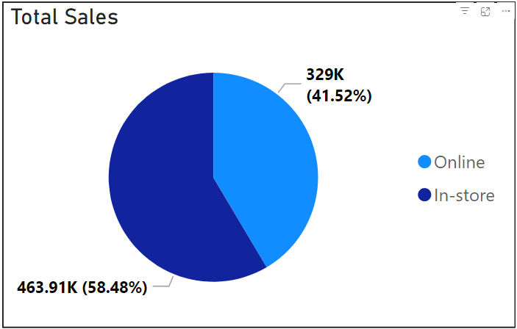
Figure 3.1 Total Sales for Elcoutlet (Dec 2023 - Oct 2024)

The chart above is showing the total sales for the entire period which is approximately 793K SAR. Also, it shows the total sales distribution between two channels: online and in-store. Online sales account for 329K SAR, which is 41.52% of the total. In-store sales are higher, at 463.91K SAR, making up 58.48% of the total.
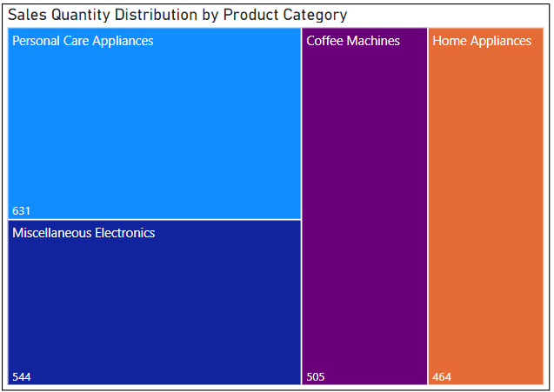
Figure 3.2 Sales Quantity Distribution by Product Category for Elcoutlet (Dec 2023 - Oct 2022)

The chart above shows the sales quantity distribution across four product categories. Personal Care Appliances lead with 631 units, followed by Miscellaneous Electronics at 544 units. Coffee Machines account for 505 units, and Home Appliances have the lowest sales at 464 units. This indicates a higher consumer demand for Personal Care Appliances.
Table 4.1 Summary of Daily Sales Statistics for Elcoutlet (Dec 2023 - Oct 2024)
Metric | Value
Average Daily Sales | 2,754 SAR
Minimum Daily Sales | 90 SAR
Maximum Daily Sales | 13,623 SAR
Standard Deviation of Daily Sales | 2,319 SAR

The average daily sales at Elcoutlet were 2,754 SAR. Sales peaked at 13,623 SAR and could be influenced by an effective influencer campaign. In the following section, we will analyze which specific influencer contributed to this impact. The minimum sales were 90 SAR due to holidays. Showing variability in performance, with a standard deviation of 2,319 SAR.
4.2 Time Series Analysis
This section explores the time series analysis of Elcoutlet's sales data, focusing on trends and seasonality patterns. By examining daily sales, we aim to identify underlying trends and cyclical patterns within the dataset. This analysis will help uncover the influence of marketing efforts, including influencer campaigns.

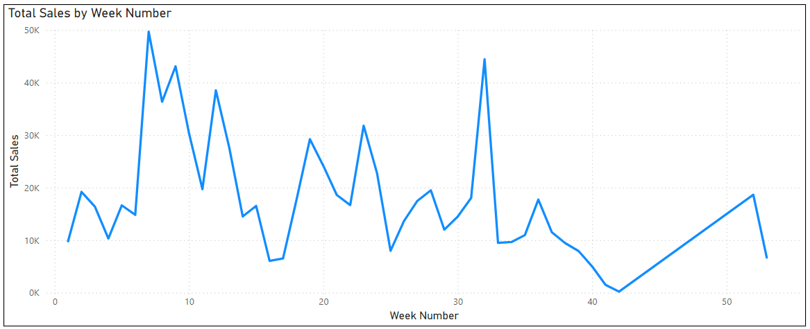
Figure 4.3 Weekly Sales Trend for Elcoutlet (Dec 2023 - Oct 2024)

4.3 Influencer Profile Analysis
This section examines the specific influencer marketing campaigns conducted by Elcoutlet during the study period from December 27, 2023, to October 15, 2024. We will analyze the details of three influencer campaigns, including the influencers' profiles, their reach, campaign costs, and the platforms used. This analysis aims to provide insights into how these campaigns may have impacted Elcoutlet's sales performance across different product categories and sales channels. By examining the relationship between these campaigns and the sales data presented in the previous sections, we seek to understand the effectiveness of influencer marketing as a strategy for Elcoutlet. This investigation will help illuminate the potential influence of influencer campaigns on consumer behavior and sales.
Table 4.2 Influencer Campaign Details for Elcoutlet.
Influencer name | Influencer social media ID | Number of followers | Campaign date | Campaign cost | Platform used
Shouq | r_al5224 | 282K | 10/02/2024 | 5000 SAR | Snapchat
Abdulkhaleq | aboud.hq | 2.49M | 02/06/2024 | 10000 SAR | Snapchat
Abu Abeer | ahmad_alghalib | 659K | 03/08/2024 | 2000 SAR | Snapchat

This table presents key information about the three influencers engaged by Elcoutlet for their marketing campaigns. For our analysis, we will categorize these influencers based on their follower count:
- Mega Influencer: Abdulkhaleq (aboud.hq) with 2.49 million followers.
- Macro Influencer 1: Shouq (r_al5224) with 282,000 followers.
- Macro Influencer 2: Abu Abeer (ahmad_alghalib) with 659,000 followers.
All campaigns were conducted on Snapchat, a popular social media platform. The campaign dates span from February to August 2024, with costs ranging from 2,000 SAR to 10,000 SAR.
It's important to note the distinct content focus of each influencer:
- Macro Influencer 1 (Shouq) primarily advertises Jeddah markets and shops.
- The Mega Influencer (Abdulkhaleq) is a personal blogger who shares his daily activities with his nephews.
- Macro Influencer 2 (Abu Abeer) is also a personal blogger who incorporates advertising into his content.
Having presented the influencers' details and campaign data, we will now analyze Elcoutlet's sales data to investigate trends in relation to these marketing campaigns. We'll examine the Weekly Sales Trend shown in Figure 2.3, focusing on identifying significant changes or spikes in sales that coincide with or follow the campaign dates of our three influencers. We'll analyze sales patterns across product categories and sales channels to determine the impact of these influencer marketing campaigns.
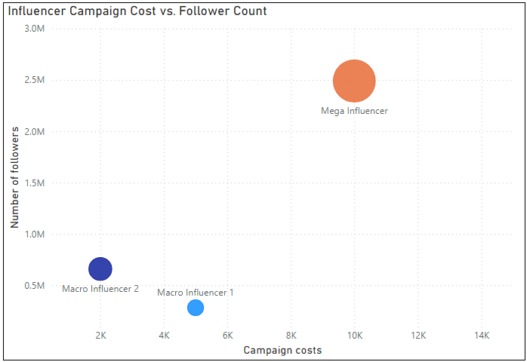
Figure 4.4: Influencer Campaign Cost vs. Followers Count

The scatter plot shows how followers count relate to campaign costs for different influencers. The biggest circle, labeled "Mega Influencer", sits at the top right, which makes sense given their large following. What's interesting is that one of the smaller circles, "Macro Influencer 1", is further right than you might expect based on its size. This is because that Influencer focuses on promoting specific businesses, possibly making it more valuable to advertisers despite having fewer followers than "Macro Influencer 2."
4.4 Impact of Influencer Campaigns on Weekly Sales Performance
In this part of our study we're looking into how influencer marketing campaigns, over time have affected sales outcomes. Our goal is to find any connections or cause and effect links between the sales data and the activities of these campaigns. We'll be checking when influencer campaigns line up with spikes in sales to see if there's a connection.
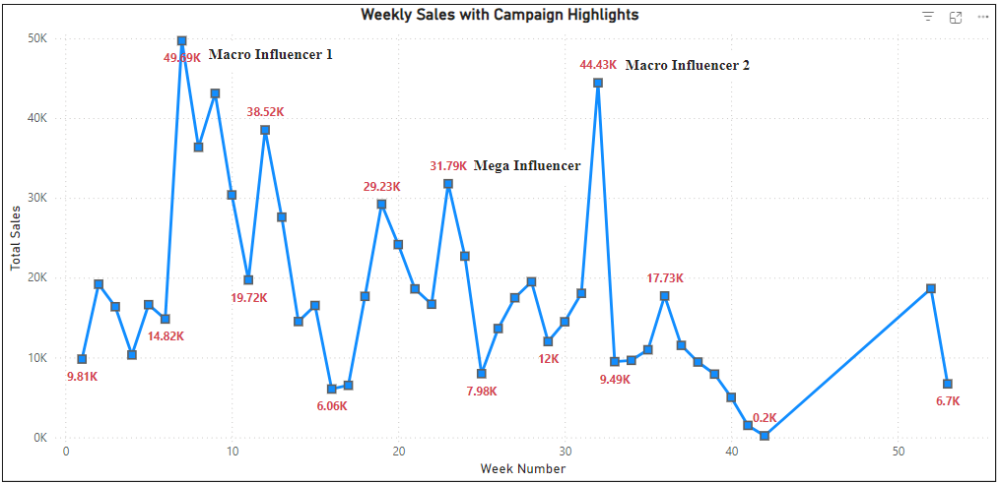
Figure 4.4: Weekly Sales with Campaign Highlights

The chart above illustrates the relationship between influencer marketing campaigns and sales performance over a 52-week period. Three distinct influencer campaigns are highlighted: Macro Influencer 1, Macro Influencer 2, and a Mega Influencer.
- Macro Influencer 1, who is Shouq, had the best results even though she has the least followers. Her campaign made the weekly sales go up to about 49.19K, which was the highest. This shows that having more followers doesn't always mean better results. Shouq is good at advertising for shops and stores in Jeddah. This is probably why her campaign helped increase sales more than the others. It's not just about how many followers you have, but also about knowing your audience and what they like to buy.
- The Mega Influencer, Abdulkhaleq, has the most followers compared to the other influencers in the study. His campaign did increase sales to 31.79K, which is a lot. But surprisingly, this wasn't as high as the sales from the Macro Influencers' campaigns. Abdulkhaleq usually does personal blogs with his nephews. So, when he advertised for an electronics retailer, it might not have worked as well. His followers probably weren't expecting to see this kind of ad from him. This shows that having the most followers doesn't always mean you'll get the best sales. What's also important is if the ad fits with what the influencer usually posts and what their followers like to see.

- Macro Influencer 2, Abu Abeer, helped increase sales to 44.43K, the second highest in the study. He's a personal blogger whose followers trust his ads because he's always honest about them. This trust probably explains why his campaign worked so well, even with fewer followers than the Mega Influencer. It shows that having loyal, trusting followers can be more effective for sales than just having many followers.
4.5 Impact of Influencer Campaigns on Product Categories
We've looked at how influencer campaigns affected total weekly sales. Now, we need to look closer at how they affected different product types and sales channels. To do this, we'll look at sales for three weeks around each influencer campaign: one week before, the week of the campaign, and one week after. We'll check how sales changed for each product category (Personal Care Appliances, Coffee Machines, Home Appliances, and Miscellaneous Electronics). This will help us understand which products were most affected by the influencer marketing.

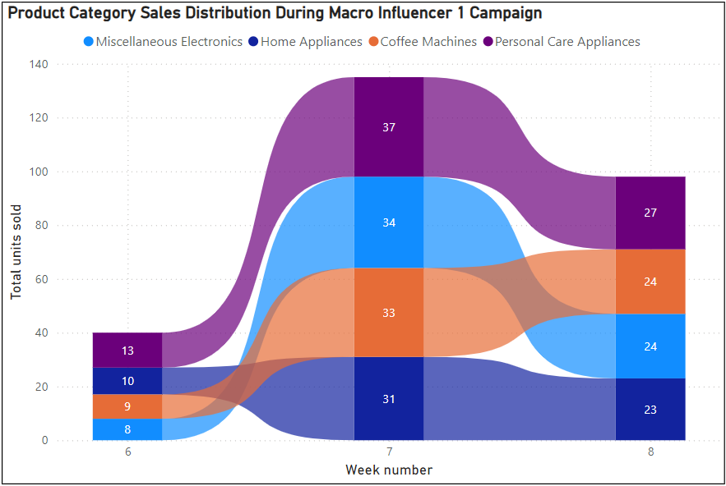
Figure 4.5: Product Sales Distribution: Macro Influencer 1 Effect
The chart above shows the sales distribution across product categories before, during, and after Macro Influencer 1's campaign. Sales increased significantly for all categories during week 7 (campaign week), indicating the campaign's overall success. Notably, sales were relatively balanced across categories. Personal Care Appliances, which includes women's products like hair dryers and straighteners, saw the highest sales at 37 units. This balanced growth across categories, with a slight edge for Personal Care Appliances, demonstrates the campaign's effectiveness in boosting sales across Elcoutlet's product range.
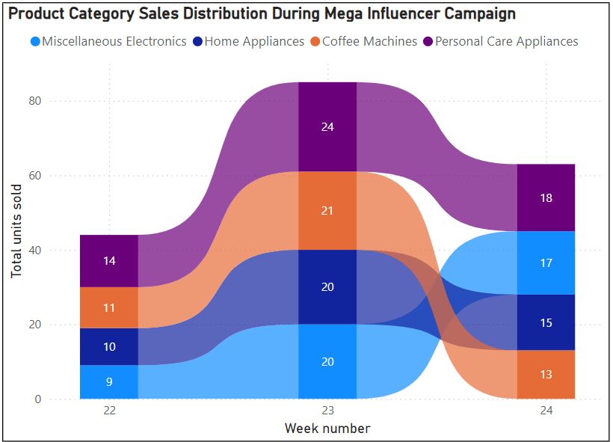
Figure 4.6: Product Sales Distribution: Mega Influencer Effect

The chart above shows how different product types sold during the Mega Influencer campaign in weeks 22-24. In week 23, which when the campaign happened, sales went up for all product types. But no product type sold a lot more than the others. All product types sold about the same amount. There's nothing special or surprising to point out in this chart. It just shows that sales went up during the campaign week, and all product types benefited about equally.

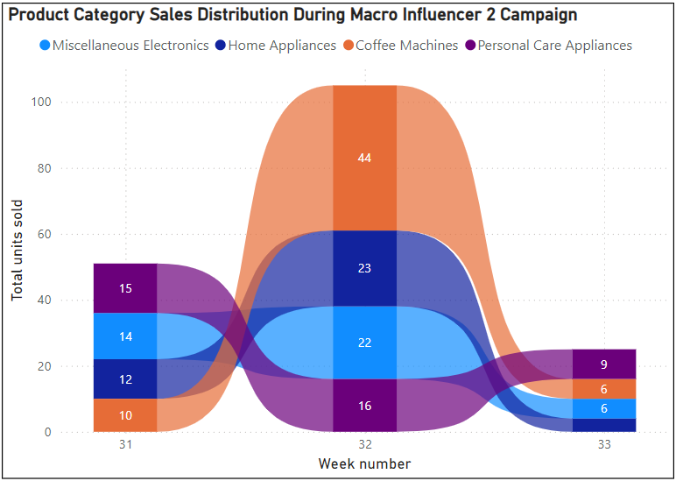
Figure 4.7: Product Sales Distribution: Macro Influencer 2 Effect
This chart shows the product category sales during the Macro Influencer 2 campaign, which was led by Abu Abeer. The most notable feature is the significant increase in Coffee Machine sales during week 32, which jumped to 44 units from 10 units in the previous week. This spike aligns with Abu Abeer's focus on coffee machines in his campaign. The strong performance of coffee machines suggests that Abu Abeer's campaign resonated well with his audience, which likely consists mostly of young people. Other product categories also saw increases, but not as dramatically as coffee machines.
4.6 ROI Analysis
When analyzing the Return, on Investment (ROI) for every influencer campaign the sales from the week before starting the campaign were considered as a starting point. Then we compared these sales with the sales made during the campaign week to figure out how much they increased. We found the increase by subtracting the campaign expenses from the increased sales. Finally, the ROI percentage was determined by dividing the increase, by the campaign costs and then multiplying by 100. The approach evaluated the effects of every influencer campaign by considering both the increase, in sales and the expenses incurred.

Table 4.3 Influencer Campaign ROI analysis.
Influencer ID | Influencer Name | Followers | Campaign Cost (SAR) | Sales Increase (SAR) | Net Increase (SAR) | ROI
Macro Influencer 1 | Shouq | 282K | 5,000 | 34,870 | 29,870 | 597%
Mega Influencer | Abdulkhaleq | 2.49M | 10,000 | 15,109 | 5,109 | 51%
Macro Influencer 2 | Abu Abeer | 659K | 2,000 | 26,377 | 24,377 | 1219%

Table above provides a detailed breakdown of the ROI for three influencer campaigns. The data reveals significant variations in the effectiveness of different influencer tiers:
- Macro Influencer 2 yielded the highest ROI of 1219%, despite not generating higher sales compared to Macro Influencer 1. This indicates that the lower cost of the campaign, coupled with a significant sales increase, resulted in a higher ROI.
- Macro Influencer 1 also generated a strong ROI of 597%, demonstrating the potential of this tier to deliver significant returns. This means that for every 1 Saudi Riyal spent on the campaign, the net return was 5.97 Saudi Riyals.
- Mega Influencer had the lowest ROI of 51% and the lowest sales during the campaign week. This suggests that while mega-influencers have a large following, they may not always translate to higher ROI or sales.

Conclusion

This study highlights the significant role of influencer marketing in shaping consumer behavior and driving sales, particularly within the Saudi Arabian context. By analyzing the sales performance of Elcoutlet, it is evident that influencer marketing is an effective tool for engaging audiences and enhancing brand visibility. However, its effectiveness is not uniform and depends on several key factors, such as the type of influencer, the alignment between their audience and the brand’s target market, and the quality of campaign execution.

The results revealed that macro influencers achieved the highest return on investment (ROI), despite having fewer followers compared to mega influencers. This finding underscores the importance of audience alignment, authenticity, and relevance over sheer follower count. Influencers who created genuine and relatable content resonated more effectively with their audience, leading to higher sales and consumer trust. The study also highlighted the potential of influencer marketing to boost specific product categories, such as personal care appliances and coffee machines, demonstrating the strategic value of tailoring campaigns to product-specific audiences.

While the short-term benefits of influencer marketing, such as increased sales and brand awareness, are clear, this study also emphasizes the need for businesses to adopt a long-term perspective. Relying solely on influencer marketing may lead to temporary spikes in sales but might not guarantee sustained growth. To achieve lasting results, companies should integrate influencer marketing with other complementary strategies, such as enhancing customer experience, improving product quality, and using data-driven insights to refine campaign strategies.

Furthermore, this study emphasizes the importance of leveraging analytics to measure campaign effectiveness and optimize resource allocation. By analyzing metrics such as engagement rates, conversion rates, and ROI, businesses can better understand what works and focus on building stronger influencer partnerships. This data-driven approach will not only maximize returns but also foster long-term consumer loyalty and brand equity.

Overall, the findings of this research contribute to a deeper understanding of influencer marketing’s impact on sales and consumer behavior. It serves as a valuable resource for businesses aiming to enhance their marketing strategies in a competitive market. With the rapid evolution of digital marketing, influencer marketing, when executed strategically, has the potential to remain a cornerstone for achieving sustainable growth, bridging the gap between brands and consumers, and driving both immediate and long-term success

References:
- Abidin, C. (2016). Visibility labour: Engaging with influencers and microcelebrities on social media. Media International Australia, 161(1), 86-100.
- Agung, N. F. A., Darma, G. S., & Mahyuni, L. P. (2021). Does influencer marketing really improve sustainable brand awareness and sales? Inovbiz: https://doi.org/10.35314/inovbiz.v9i1.1889
- Al-Juraishi, K. (2006). Consumer Behavior.
- Bhagyashree, L., & Pushpalatha, S. (2024). Impact of influencer marketing on consumer buying behaviour. International Journal of Current Science, 14(2), 77-86.
- Casaló, L. V., Flavián, C., & Ibáñez-Sánchez, S. (2018). Influencers on Instagram: Antecedents and consequences of opinion leadership. Journal of Business Research, 117, 510-519.
- De Veirman, M., Cauberghe, V., & Hudders, L. (2017). Marketing through Instagram influencers: The impact of number of followers and product divergence on brand attitude. International Journal of Advertising, 36(5), 798-828.
- Evans, N. J., Phua, J., Lim, J., & Jun, H. (2017). Disclosing Instagram influencer advertising: The effects of disclosure language on advertising recognition, attitudes, and behavioral intent. Journal of Interactive Advertising, 17(2), 138-149.
- Freberg, K., Graham, K., McGaughey, K., & Freberg, L. A. (2011). Who are the social media influencers? A study of public perceptions of personality. Public Relations Review, 37(1), 90-92.
- Glucksman, M. (2017). The rise of social media influencer marketing on lifestyle branding: A case study of Lucie Fink. Elon Journal of Undergraduate Research in Communications, 8(2), 77-87.
- Govindan, P., & Alotaibi, I. (2023). Title of the article. Journal Name, volume(issue), page range. https://doi.org/XXXXXX
- Grafström, J., Jakobsson, L., & Wiede, P. (2018). The Impact of Influencer Marketing on Consumers’ Attitudes: A Qualitative Study on What Reasons Affect Millennials’ Attitudes by Influencer Marketing in Sweden. Bachelor’s thesis, Jönköping University, Sweden.
- Hake, C., Nath, U., & Kumavat, R. (2023). The impact of influencer marketing on consumer behaviour: Effectiveness on increasing brand awareness, improving brand perception, and driving sales. Rabindra Bharati Journal of Philosophy,
- Hudders, L., De Jans, S., & De Veirman, M. (2021). The commercialization of social media stars: A literature review and conceptual framework on the strategic use of social media influencers. International Journal of Advertising, 40(3), 327-375.
- Jin, S. V., Muqaddam, A., & Ryu, E. (2019). Instafamous and social media influencer marketing. Marketing Intelligence & Planning. https://doi.org/10.1108/MIP-09-2018-0375 .
- Jin, S. V., Muqaddam, A., & Ryu, E. (2019). Instafamous and social media influencer marketing. Marketing Intelligence & Planning, 37(5), 567-579.
- Johansen, I. K., & Guldvik, C. S. (2017). Influencer Marketing and Purchase Intentions: How Does Influencer Marketing Affect Purchase Intentions? Master’s thesis, Norwegian School of Economics, Bergen, Norway.
- Khamis, S., Ang, L., & Welling, R. (2017). Self-branding, ‘micro-celebrity’ and the rise of social media influencers. Celebrity Studies, 8(2), 191-208.
- Khan, M. R., Iqbal, M., & Lodhi, A. J. (2021). Influencer marketing on Instagram: Effects of promotional posts on purchasing behavior of consumers. Journal of Political Studies, 28(1), 119-132.
- Ki, C. W., & Kim, Y. K. (2019). The mechanism by which social media influencers persuade consumers: The role of consumers’ desire to mimic. Psychology & Marketing, 36(10), 905-922.
- Lim, X. J., Cheah, J.-H., & Wong, M. W. (2017). The Impact of Influencer Marketing and Social Media Influencers on Consumers. Journal of Research in Interactive Marketing, 12(1), 61-79.
- Lin, H.-C., Bruning, P. F., & Swarna, H. (2023). Title of the article. Journal Name, volume(issue), page range. https://doi.org/XXXXXX
- Lou, C., & Yuan, S. (2019). Influencer marketing: How message value and credibility affect consumer trust of branded content on social media. Journal of Interactive Advertising, 19(1), 58-73. https://doi.org/10.1080/15252019.2018.1533501
- Lou, C., & Yuan, S. (2019). Influencer marketing: How message value and credibility affect consumer trust of branded content on social media. Journal of Interactive Advertising, 19(1), 58-73.
- Mishra, S., & Ashfaq, R. (2023). Influencer Impact: Examining the Effect of Influencers on Consumer Behavior and Purchase. Traditional Journal of Multidisciplinary Sciences, 1(1), 55-72.
- Sokolova, K., & Kefi, H. (2020). Instagram and YouTube bloggers promote it, why should I buy? How credibility and parasocial interaction influence purchase intentions. Journal of Retailing and Consumer Services, 53, 101742.
- Solaiman, S., & Pangaribuan, C. H. (2023). Title of the article. Journal Name, volume(issue), page range. https://doi.org/XXXXXX
- Stubb, C., Nyström, A.-G., & Colliander, J. (2019). Influencer marketing: The impact of disclosing sponsorship compensation justification on sponsored content effectiveness. Journal of Communication Management, 23(2), 109-122.
- Tom Cannon (1986) explains in Basic Marketing: Principles and Practice Venciūtė, D., Mackevičienė, I., Kušlys, M., & Correia, R. F. (2023). The role of influencer-follower congruence in the relationship between influencer marketing and purchase behaviour. Journal of Retailing and Consumer Services, 75, 103506. https://doi.org/10.1016/j.jretconser.2023.103506.
- Yodi, H.P., Widyastuti, S., & Noor, L.S. (2020). The effects of content and influencer marketing on purchasing decisions of fashion Erigo Company. Dinasti International Journal of Economics, Finance & Accounting, 1(2), 345-357. https://doi.org/10.38035/DIJEFA

