Lesson summary: The circular flow and GDP
In this lesson summary review and remind yourself of the key terms and calculations used in describing the output of an economy. Key topics include the expenditures approach, income approach, and value added approach to calculating GDP and why imports are subtracted from GDP.

To know how much of good X a nation produced last year, we can use one of our key macroeconomic measures, gross domestic product (GDP), to figure this out.
GDP can be measured in three different ways: the value-added approach, the income approach (how much is earned as income on resources used to make stuff), and the expenditures approach (how much is spent on stuff). However, you will likely run into the expenditures approach the most as you progress through this course.
A model called the circular flow diagram illustrates how the expenditures approach and the income approach must equal each other, with goods and services flowing in one direction and income flowing in the opposite direction, in a closed loop.

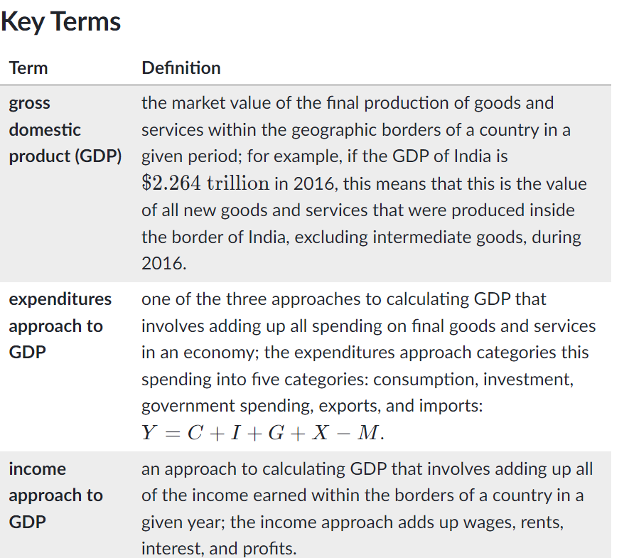
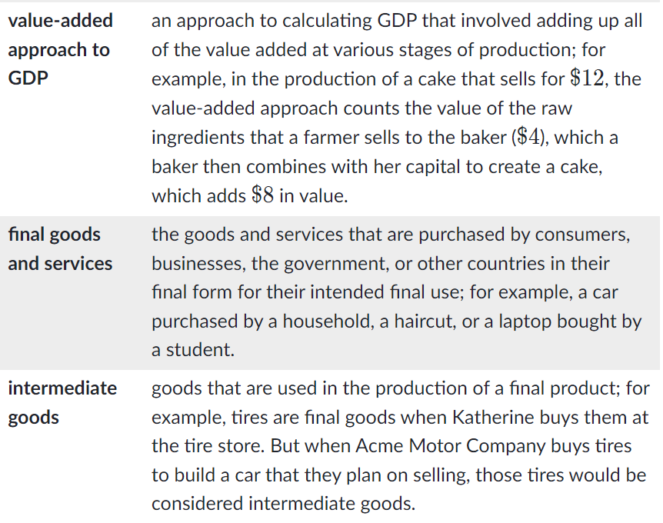
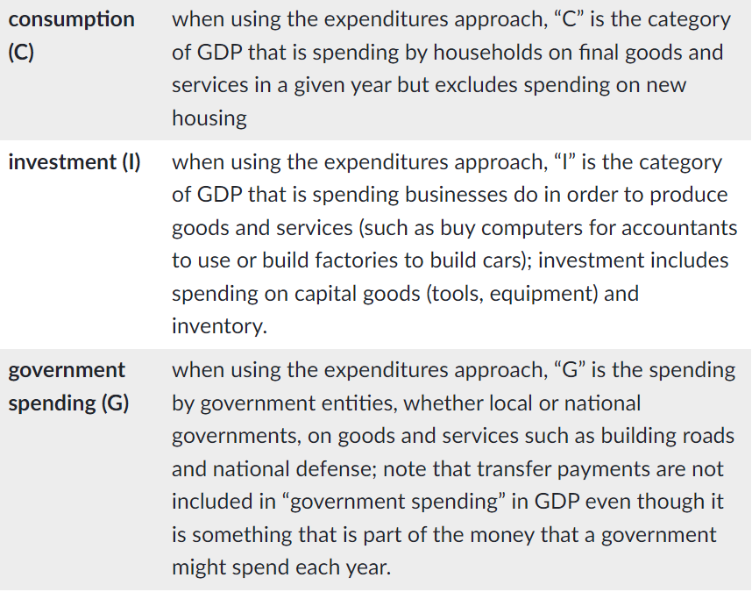
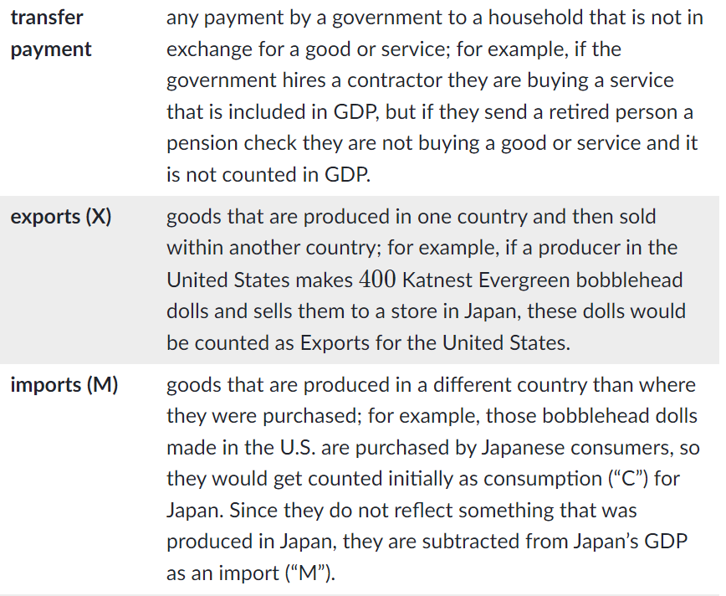
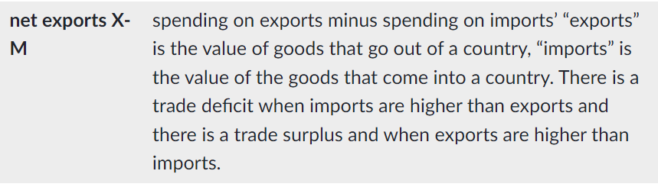

Key Takeaways

Gross Domestic Product (GDP)
Gross domestic product (GDP) is a measure of the final output of a nation’s economy. GDP measures the total value of all new goods and services produced in an economy in a given year.
For example, in 2016 GDP in Japan was $4.939 trillion. This means that during 2016, Japan produced goods and services within its geographic borders that were sold for
$4.939 trillion.
GDP can be measured using:
1) the expenditures approach,
2) the income approach, or
3) the value-added approach.
The three approaches are equivalent—regardless of which approach you use you should end up with the same value.

The circular flow diagram
GDP can be represented by the circular flow diagram as a flow of income going in one direction and expenditures on goods, services, and resources going in the opposite direction. In this diagram, households buy goods and services from businesses and businesses buy resources from households.
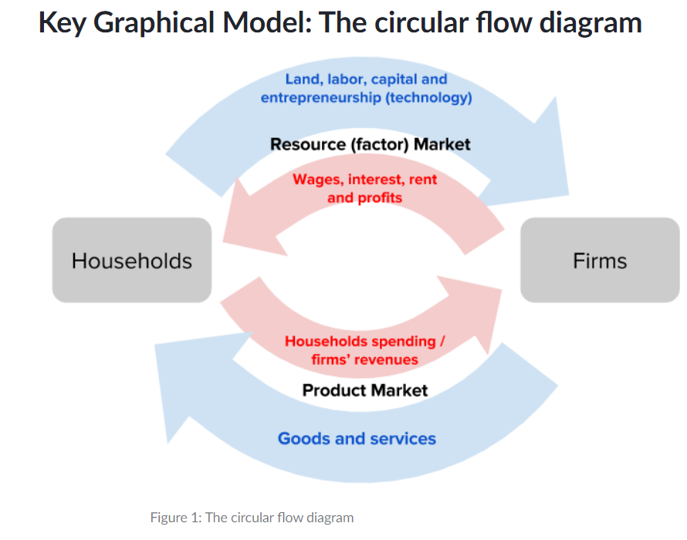
The circular flow diagram illustrates the equivalence of the income approach and expenditures approach to calculating national income. In this diagram, goods, services, and resources move clockwise, and money (income from the sale of the goods, services, and resources) moves counterclockwise.
Individuals purchase goods and services from businesses, and their expenditures (the money they spend) go to businesses. Firms purchases resources, such as labor from households, and the money they pay for these resources go to households.

Key Mathematical Model: Two approaches to measuring GDP

The expenditures approach
GDP can be calculated using the expenditures approach using the following equation:
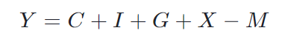
Each component is described in the table below:
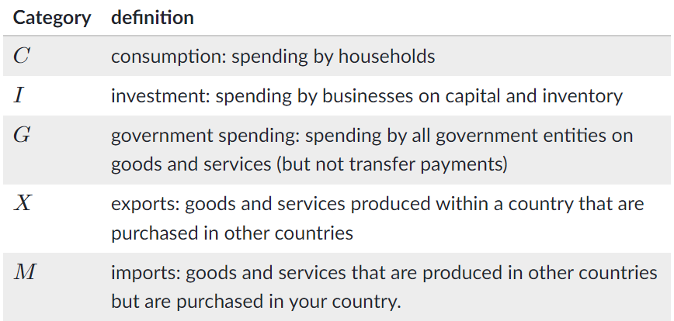
For example, in 2016: Households in a nation spent
$200 million on newly-produced goods and services. $ 40 million
was spent by businesses on adding goods to their inventories and on new equipment to produce goods. The government spent a total
$ 35 million on goods and services. Additionally, businesses produced $ 10 million in goods and services that they sold overseas. Of all the goods and services purchased in the economy, $ 15 million were imported from overseas. Therefore, Fredonia’s GDP would be calculated as:
Y= $200+$40+$35+$10−$15= $260 million

The income approach
GDP can be calculated using the income approach using the following equation:
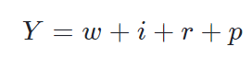
Where each category refers to the income received from supplying one of the four economic resources:
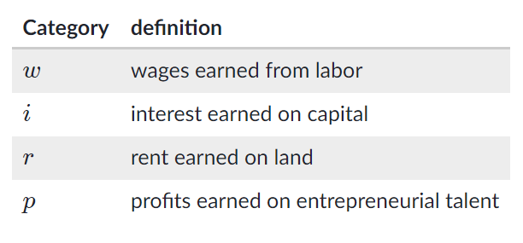
Exp: In 2016, $ 190 million was income earned on labor. $ 25 million was earned in interest payments. $ 30 million is earned on rents collected and $ 15 million earned in profits. Therefore, the nation’s GDP is calculated as :
Y= $190+$25+$30+$15

