

AI-Based Construction Site Safety Monitoring System
Prepared By
Name: Mohammed Ali Alhawshabi ID No.: 261002622
Name: Mohammed Omar Baatiyyah ID No.: 261002493
Submitted in fulfillment of the requirements for the degree Master of Science in Artificial Intelligence
At
College of Informatics
Midocean University
UAE
Supervisor Name: Dr. Mohamed Eassa
College of Informatics, Midocean University, Comoros
Email: 261002493@st.midocean.edu.km
Email: 261002622@st.midocean.edu.km

Acknowledgements

We would like to thank our supervisor, Dr. Mohamed Essa, for his continuous guidance and valuable feedback throughout this research. His expertise in both artificial intelligence and galaxy studies has greatly influenced the direction of this work. His comments challenged us to think more critically and approach the research from a scientific perspective rather than a purely technical one.

We are also thankful to the faculty members at the College of Informatics, Midocean University, for providing a supportive academic environment that inspired independent thinking and research development.

Finally, we would like to express our appreciation to our families for their patience, encouragement, and support during this journey.

Abstract

As it is known that construction sites are inherently dangerous, containing numerous sharp tools that can lead to injuries of varying severity. Preventing such injuries is often difficult due to a multitude of factors, including the failure to wear protective equipment on construction sites. One of the most important methods for monitoring and ensuring workers on construction sites is a visual inspection by the site supervisor to verify that all workers are wearing appropriate protective gear. Checking the use of protective gear at construction sites is extremely important and requires significant human intervention, not only when workers enter the site but also during their daily work hours.

To ensure worker protection, the system uses artificial intelligence to check whether workers are wearing adequate protective gear. Additionally, it monitors worker movements, and in the event of an injury, it immediately alerts paramedics to expedite the rescue operation.

In large and crowded construction sites, it is difficult to monitor everyone at the same time, which may require more personnel for monitoring, thus increasing the cost. In addition, artificial intelligence helps in detecting cases of accident immediately and quickly, which contributes to saving lives more and faster. This study proves that the machine is not just a means of sorting files, but can also effectively prevent fatalities by shifting monitoring from a reactive to a proactive approach as much as possible, where achieving zero dangerous incidents is the primary goal.

Contents
i
Acknowledgements ii
Abstract iii
List of Abbreviations iv
List of Figures v
List of Tables vi
Chapter 1: Introduction 1
1.1 Overview 1
1.2 Problem Definition 3
1.3 Thesis Objectives 4
1.4 Thesis Contribution 5
1.5 Thesis Organization 5
Chapter 2: Background and Related Work 6
2.1 Introduction 6
2.2 Background 7
2.3 Related work 12
2.4 Related Work Summary 18
Chapter 3: Proposed Approach (Methodology) 21
Chapter 4: Experimental Results and Discussion 22
Chapter 5: Conclusion and Future Work 23
References 24

List of Abbreviations
- AI: Artificial Intelligence.
- CNN: Convolutional Neural Network.
- DL: Deep Learning.
- DECaLS: Dark Energy Camera Legacy Survey.
- GAN: Generative Adversarial Network.
- Grad-CAM: Gradient-weighted Class Activation Mapping.
- MCD: Monte Carlo Dropout.
- ML: Machine Learning.
- RA: Right Ascension.
- SDSS: Sloan Digital Sky Survey.
- XAI: Explainable Artificial Intelligence.
- F1-score: Harmonic mean of precision and recall.
- ViT: Vision Transformer.
- VGG19: Visual Geometry Group 19.
- DCGAN: Deep Convolutional Generative Adversarial Network.
- CvT: Convolutional Vision Transformer.
- S-PLUS: Southern Photometric Local Universe Survey.
- CANDELS: Cosmic Assembly Near-infrared Deep Extragalactic Legacy Survey.
- S0: Lenticular Galaxy.

List of Figures
Figure 1.1: Example of Body PPE need to be worn on construction site 1

List of Tables
Table 2.1:

Chapter 1: Introduction

1.1 Overview
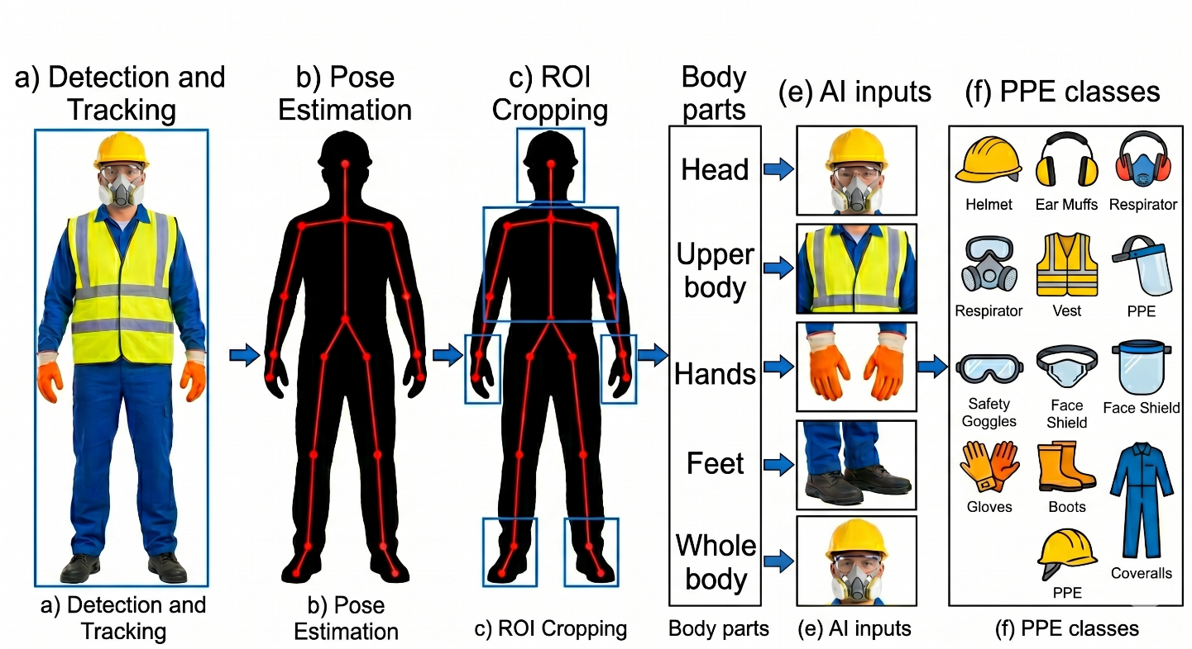
Safety generally relies on visual observation, with supervisors moving around construction sites to monitor workers' behaviour, including any hazardous actions. This method, known as behavioural screening, is useful but faces several challenges in practice. It requires a large team of observers who often rely solely on their understanding of behaviour on construction sites [1][2]. Simply, the human eye cannot see everything around it. This is not a shortcoming of the work or effort, but the sheer size of the construction site must be considered.
Figure 1.1: Example of Body PPE needs to be worn on construction site

The human eye often misidentifies problems, and relying on manual supervision can create safety gaps that human observers may not be able to detect. This is why engineers rely on computer vision technologies to interpret and process closed-circuit television cameras CCTV footage from construction sites.

By enabling machines to analyse and sort CCTV footage, companies can have a monitor on construction sites 24/7 without fatigue or boredom (even in low light). This eliminates the need for intermittent searches by human supervisors and does not impede workflow or speed.

Artificial intelligence can detect, analyse, and identify individuals who do not wear protective gear such as body Armor, gloves, and impact resistant footwear, as well as determine the appropriate equipment for each work environment.
in additions, AI can predict whether a worker on-site has been injured, potentially to faster rescue times compared to human intervention. [1] [2] [14].

However, PPE alone is not enough to protect employees but proactively checking whether a worker is wearing appropriate PPE helps significantly reduce workplace injuries on construction sites and save a life [2].

1.2 Problem Definition
Construction sites are among the most dangerous places where workers are exposed to serious injuries and even fatalities, such as falls from heights or collisions with heavy or dangerous equipment. Most studies indicate that injuries on construction sites result from unsafe actions and behaviors by workers. Therefore, risk management at these sites is extremely important and complex due to the constantly changing behaviors of workers during their shift [15].
To protect construction workers, construction companies require strict guidelines for the use of personal protective equipment (PPE) such as safety vests, goggles, and high-visibility vests. However, ensuring workers consistently wear PPE is a significant challenge, as many disregard safety rules due to discomfort, forgetfulness, or a lack of constant supervision, potentially fast to serious injuries.
Currently, safety rules are applied at construction sites by field safety supervisors. Studies have shown that such an approach is ineffective and has many human flaws because it relies on the human element, which may make mistakes and may not be available at all times when workers are present. Therefore, it is difficult for them to monitor everyone, especially in large and active construction sites. As a result, incorrect practices and violations of safety rules at construction sites may not be discovered.
There is currently a gap in technological solutions that could be better developed through computer vision systems. Some existing systems may be able to determine if a worker is wearing a helmet (stationary objects), others only track the movement of objects, and a few can analyse the worker's dynamic movements. Simply tracking the worker's hand movements is insufficient; it's necessary to know if they are handling a sharp tool and require specific safety systems for such tasks.
Based on what has been mentioned previously, this study will solve the problem of the lack of integration, automation and immediate monitoring, helping the construction sector to provide an automated and intelligent framework that ensures compliance with safety procedures using PPE by immediate detection of physical work injuries or falls, and accurate identification of workers’ interaction with sharp tools to identify and reduce risks before they occur. [1] [2].

1.3 Thesis Objectives
The main objective of this research is to develop a computer vision based intelligent camera monitoring system for improved safety in construction sites. The objectives include:
- To design and train a computer vision model to accurately detect safety helmets and high visibility vests in real-time, based on reliable image data sets.
- To develop a skeleton based action recognition framework for monitoring workers’ postures in real-time and accurately, and for detecting sudden anomalies such as injuries or falls.
- To assess the interaction of construction workers with the environment (man-machine/material) to identify unsafe behaviors before they cause accidents.
- To evaluate the accuracy and speed of the system under different environmental conditions, such as varying lighting.

1.4 Thesis Contribution
Based on previous studies and research, this research offers a practical contribution to the field of safety at construction sites:
1. Unified dual architecture: Most current studies present two separate models for detecting safety devices and detecting object movements, but in our study we propose a single system for both models to process multiple layers of data simultaneously, which helps reduce processing redundancy and provides a more efficient monitoring solution.
2. Aware Hazard Identification: In this study, we will develop the concept of integrating machine with human movement. The study will not only determine whether the worker is wearing appropriate protective clothing, but will also identify if they are near a sharp machine without wearing the appropriate protective clothing, as well as their body position relative to the machine. This will help reduce risks or prevent accidents altogether.
3. Comprehensive Fall and Injury Detection: While most current studies focus on safety system violations, we will examine continuous and sudden body movements, utilizing surveillance video footage to help determine if there is a possibility of a worker falling for any reason and sending medical assistance immediately.
4. A Scalable Template for the Construction Industry: This thesis closes the gap between theoretical AI models and practical safety management, by providing a highly scalable and cost-effective template. This new system changes the industry from reactive safety management (after the accident) to proactive prevention (before the injury) and provides a realistic alternative to manual safety inspections.

1.5 Thesis Organization
The rest of this thesis is organized as follows.
Chapter 2 discusses the theoretical background and relevant research areas.
Chapter 3 presents the proposed methodology.
Chapter 4 analyzes the experimental results.
Chapter 5 concludes the study and suggests directions for future work.

Chapter 2: Background and Related Work
2.1 Introduction
Safety procedures at construction sites began in 1970 by Occupational Safety and Health Administration (OSHA) organization as the construction industry experienced rapid growth and development, safety and protection measures were established at that time because of increasing of construction injuries on world, and based on this, safety was divided into physical safety, operational guidelines, and basic protective equipment. All these standards focus on the safety and health of workers at construction sites, protecting their bodies and lives from injuries, thus emphasizing that human safety is the fundamental requirement.[16]

The typical safety hierarchy at construction sites can be further illustrated in Figure 2.1, which shows the relationship between hazard removal, safety controls, and the last line of defines. Later, Later, safety authorities developed such (OSHA) further developed these frameworks by updating rigorous compliance checklists and implementing penalties for safety violations.[16]
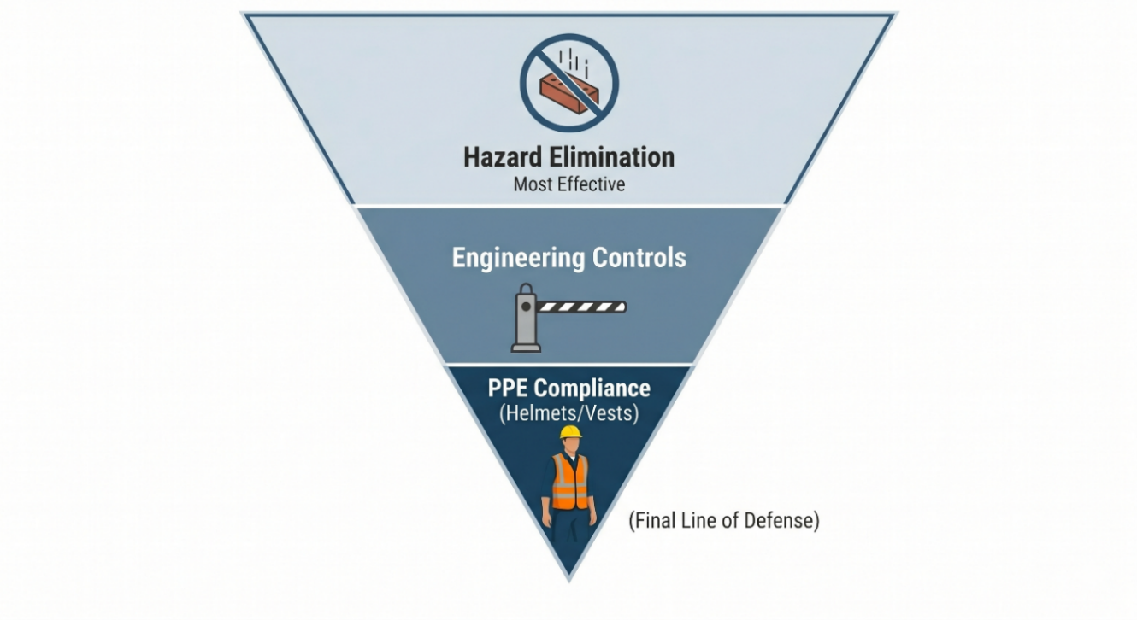
Figure 2.1: PPE needs to be worn on construction site
With the safety systems recommended by international safety organizations for construction sites, safety checks were previously conducted by on site supervisors who would tour construction facilities and visually inspect the availability of safety systems. While these systems have been in use for years, this method remains somewhat effective, it has become impractical due to the sheer volume of work and the scale of construction projects in our time [15].

2.2 Background
Currently, with the increasing growth of construction projects and the growing number of workers and their movement within these projects, safety problems have begun to emerge. These massive sites and industrial cities have begun to generate enormous volumes of work that are difficult to monitor manually effectively [15]. As an alternative solution, the collective safety system was launched, enabling construction contractors to report hazards immediately upon their occurrence. This demonstrates how collective human cooperation contributes to reducing risks.

Because of that, the monitoring of construction sites has continued to expand with the addition of (CCTV) and drones for wide area surveillance. For this reason, the demand for automated safety monitoring has become a matter of interest to researchers in the field of artificial intelligence [15].

From this perspective, the roles of artificial intelligence, machine learning, and deep learning in image and video analysis have become prominent. AI algorithms can analyze, detect, and improve hazard detection at construction sites [15]. Conversely, deep learning can use neural networks to automatically extract complex visual movements and actions. Both methods can be very useful in addressing the problem of adhering to safety standards at construction sites, given that construction site images contain complex visual information that the human eye cannot manually infer, process, and encode. This is evident in the visual contrast between field supervisors when making decisions regarding the implementation of safety systems, as illustrated in the figure 2.2.
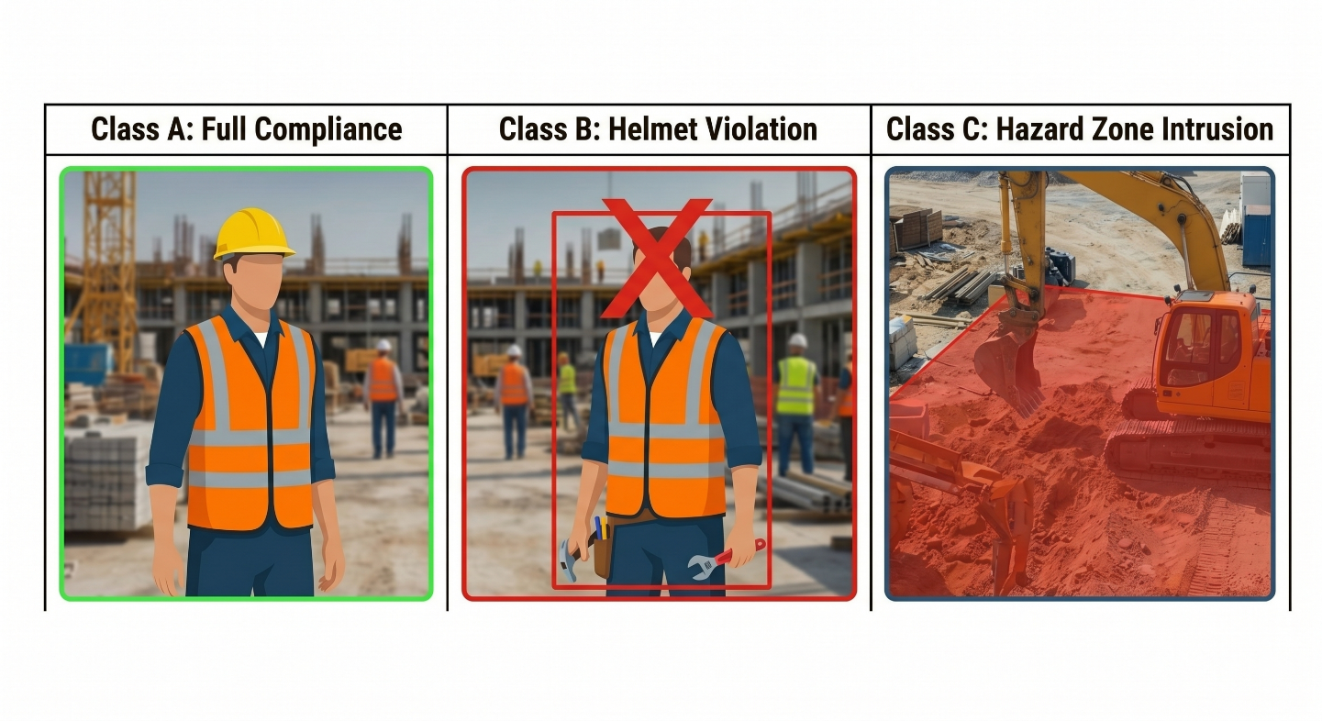
Figure 2.2: showing how AI can detect and analyze the CCTV data

The figure 2.2 illustrates examples of construction site images from the safety category, which visual characteristics such as dust, lighting, and other factors. Detecting safety violations under these conditions presents a big challenge for automated detection through image and video analysis. The different positions and interactions of objects or humans make deep learning techniques highly effective for directly identifying safety violations from detailed image Pixels [1][3].

From a computer vision perspective, site safety detection is a real-world problem for identifying and classifying objects. This study aims to detect different types of safety equipment from classified images used at construction sites. Deep learning systems, such as Convolutional neural networks (CNN), Region based Convolutional Neural Network (R-CNN) using Single Stage Detectors (SSD) that allow the model to detect the humane wear PPE by balancing the speed and accuracy to achieve this goal in this case [1, 3].

Before the deep learning in artificial intelligence, machine learning was used for basic functions such as detecting the color of protective vests, identifying the shapes of protective equipment, and so on using classical machine learning classifiers and use Support Vector Machines (SVM) with Histogram of Oriented Gradients (HOG) by breaking image into gride and direction. Also using Random Forests which depend on Yes or NO to define the color, or using k-Nearest Neighbours (k-NN) by comparing the new image with labeled on database. With these advanced techniques, they faced challenges in determining all outputs from (CCTV) due to environmental conditions and certain limitations in construction sites [1,14].

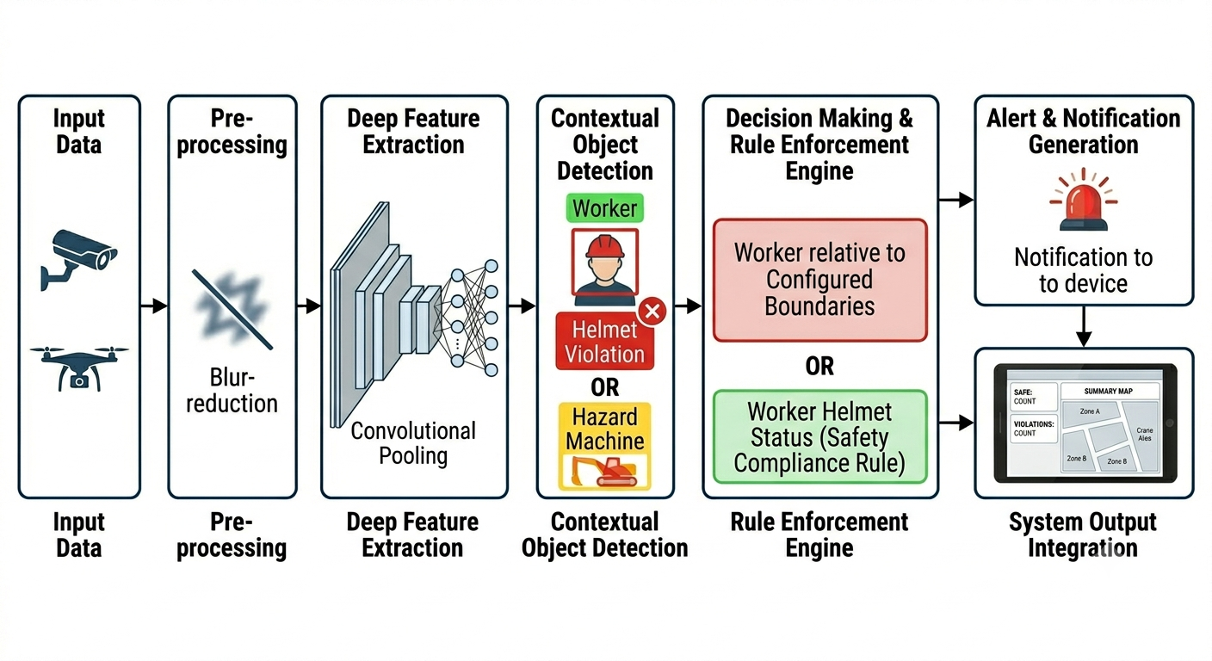
With the growing interest in neural networks (CNN) in industrial automation, safety results have shown remarkable success by developed an integrated framework pairing YOLO (for precise object and safety sign detection) with ST-GCN (for skeleton-based human motion capture) to evaluate real-time situational risks and compliance detection accuracy increased from 61.61% to an impressive 99.11% [2].
Figure 2.3: Schematic overview of a deep learning flow for construction safety monitoring

The figure 2.3 illustrates the process of image processing, content detection, and classification at construction sites through specific steps, starting with camera input and culminating in the identification of expected safety conditions and their corresponding alerts. This example demonstrates how deep learning can be leveraged to extract and utilize data.
In addition to neural network techniques (CNN), other technologies have been discovered in the field of construction safety to detect more the only static objects is image and skeleton based parameterized approaches, which deep learning find the skilton to perform real time worker identity for unsafe behaviors and hazard [1]. Another technique called (Vision Transformers) which can help the model better and more detect and recognize construction sites, such as identifying the relationship between a worker and a heavy crane operating nearby, example the moment a worker holds a ladder and places one foot on the first step is identified as the optimal moment to intercept and warn the worker before they climb too high. In some studies, semi-supervised learning was used, combining some labeled safety datasets and unlabeled continuous (CCTV) footage to reduce reliance on manual classification. Our conclusion here is that current research in this field is gradually and broadly expanding to address complex construction environments [4].

This research combines artificial intelligence (AI) and computer vision to develop an automated system that helps protect construction workers from safety hazards and predicts accidents before they occur.
Using computer vision to analyze images and videos from surveillance cameras greatly facilitates the automated identification of safety equipment on construction sites, eliminating the need for routine manual work.
Deep learning can accurately and continuously identify safety violations and hazardous situations involving workers on construction sites by automatically extracting convolutional neural networks (CNN). Deep learning in AI helps recognize the physical movement patterns of workers, rather than just their standing or stationary state, it can also recognize activities such as climbing ladders, operating machinery, identifying equipment, bending, or falling. The proposed system can determine whether worker behavior is dangerous, normal, or safe.
By depending on a multi dataset, all the objectives of this research can be achieved, which includes a dataset of images of various tools, tool detection, sharp tools, drills and hand saws, and a dataset of large construction vehicles, as combining the different datasets helps to increase the system’s ability to recognize different types at the same time. [9,10,11,12,13].

In recent years, computer vision researchers have completed the development of models and their transition from primitive to advanced stages that serve the field of safety in construction in particular, such as monitoring the movement of workers and the types of safety equipment used, which in turn aim to raise the level of protection of workers in large and complex construction areas and also reach huge industrial cities.

2.3 Related Work
During the writing of this research, safety at construction sites was a major focus for researchers, particularly regarding the behavior of construction workers with hazardous equipment and their disregard for safety regulations. Several machine learning models, including computer vision and deep learning, were presented at the time for automating safety measures and improving the prevention of construction accidents.

[1] Lee et al. (2023) Techniques YOLOv5, YOLO-NAS, OpenPose (COCO), and (ST-GCN) 2.0, dataset CHVG dataset, Objective To identify unsafe interaction behaviors between construction workers and machinery/materials, Results Improved interaction identification accuracy to 85.71% for throwing, 99.11% for operating, and 100% for crossing, Limitation Faces difficulty distinguishing between tasks that use identical motions (e.g., throwing a hammer vs. hammering a nail).
developed a method that integrates YOLO object detection with OpenPose motion capture and Spatial Temporal Graph Convolutional Networks (ST-GCN) to identify the unsafe interaction behaviors of construction workers. Unlike previous studies that focused solely on independent motion recognition, this approach comprehensively factored in the physical and spatial interactions between workers, machinery, materials, and safety signs. Using a self-collected simulation dataset of 5,040 videos from 14 participants, a custom decision algorithm dynamically evaluated the safety risk of each scenario. Experimental results demonstrated substantial performance gains over standalone motion tracking, drastically boosting accuracy to 85.71% for throwing, 99.11% for operating, and reaching a perfect 100% in crossing interaction scenarios.

[2] Rahman et al. (2026) Techniques YOLO11 (YOLO11x), SMOTE balancing, and data augmentation, dataset CHVG and Roboflow dataset , Objective to create an automated real-time Personal Protective Equipment (PPE) compliance detection system, Results Reached a mAP50 of 96.9% and an inference time of 7.3 ms, Limitation Requires high end hardware for low inference time, and only detects main PPE classes, missing smaller tools.
proposed an automated compliance detection system named PPE-EYE that utilizes the YOLO11 deep learning architecture to identify in real-time whether construction workers are wearing vital protective gear. Unlike previous methodologies that suffered from high visual processing latency on the same benchmark, this approach employed dataset balancing via SMOTE, data augmentation, and hyperparameter fine-tuning to optimize site monitoring. Experimental results showed that the optimized YOLO11x model achieved a high mAP50 score of 96.9% with an exceptionally low inference processing time of 7.3 ms.

[3] Nath et al. (2020) Techniques YOLO based DL models, dataset Pictor-v3, Objective Verify hard hat and vest compliance, Results Showed feasibility of real-time PPE detection and the best model achieves 72% accuracy, Limitation PPE categories and no tools or behavior analysis.
presented a deep learning-based system for real-time PPE compliance detection in construction sites. The objective was to verify whether workers were wearing hard hats, safety vests, or both from images and videos. The study was one of the influential works demonstrating the practical use of YOLO based detection for construction safety. The authors developed and compared three different deep learning approaches based on YOLO architecture. One approach detected workers and PPE items separately and then used an additional model to verify compliance. Another approach used a single CNN-based model to detect and classify compliance. The third approach detected workers first and then classified worker-level PPE compliance. The study used jobsite images and videos to evaluate performance under real-world conditions. The results showed that real-time PPE monitoring is feasible using deep learning. The best-performing method achieves 72% accuracy detection performance for hard hat and vest compliance. The study also highlighted the difficulty of detecting PPE under occlusion, distance, and complex backgrounds. The limitation is that the research mainly covered hard hats and vests and did not detect tools, machinery, or unsafe interactions. Still, it is important because it established a practical foundation for real-time PPE compliance monitoring in construction environments.

[4] Ferdous and Ahsan (2022) Techniques YOLOX model, dataset CHVG dataset, Objective Detect PPE classes in construction sites, Results YOLOX-m achieved about 89.84% mAP, Limitation Small dataset and PPE focus only
proposed a YOLO-based architecture for detecting PPE in construction sites. The objective of the study was to create a computer vision system capable of detecting multiple PPE classes and supporting automated compliance monitoring. The study also introduced the CHVG dataset, which includes classes related to many color hard hats, safety vests, safety glasses, persons, and heads. This research relied on comparing and testing different types YOLOX of algorithms under different visual conditions, such as rain, fog, and lighting. This is important because construction sites often present such challenging conditions.
The results of YOLO-m model appeared the highest percentage 89.84%, and the study demonstrated that these models are able to detect objects with greater accuracy under difficult conditions with better results than others regarding safety clothing on construction sites. While useful in this area, they are not effective for tracking worker movements on construction sites. Nevertheless, this study is very important for our current research because it provides a valuable database.

[5] Hayat and Morgado-Dias (2022) Techniques YOLOv3/v4/v5, dataset Hard Hat Workers Dataset, published by MakeML, Objective Detect safety helmets, Results YOLOv5 achieved mAP above 92%, Limitation Helmet only and no other PPE or hazards
Aruther developed an automatic safety helmet detection system for construction safety using YOLO-based deep learning. The main objective was to test YOLO the usefulness of monitoring construction sites. The study compared YOLOv3, YOLOv4, and YOLOv5, using a dataset of safety helmets at construction sites containing approximately 5,000 images, which were divided into groups for learning, training, and testing. The models were evaluated using metrics such as precision, recall, mean Average Precision, and inference speed.
The results showed that YOLO5 achieved excellent performance, exceeding expectations in accuracy 92% and speed for use with CCTV. It also demonstrated good results in both high and low light conditions. However, the study only tested safety helmets and did not test other safety equipment. Therefore, the study is useful as a helmet detection baseline but is limited for a complete construction safety monitoring system.

[6] Wang et al. (2022) Techniques YOLOv5 variants, dataset Color Helmet and Vest (CHV), Objective Compare PPE detection accuracy and speed, Results YOLOv5x high accuracy OLO v5x achieves 81.79% mAP and YOLOv5s faster 10%, Limitation No action, fall, or tool detection.
This study utilized intelligent systems, such YOLOv5 as this used with CCTV on construction sites, to identify safety equipment. The main goal was to develop the advanced system that combines speed and accuracy in processing live images from CCTV and accurately identifies PPE without errors. The researchers trained the system on images of safety equipment at construction sites. Two types of systems were compared: a large system and a small system. The small systems YOLOv5s outperformed the large systems YOLOv5x in terms of identifying risks 10% faster processing speed, while the larger system significantly outperformed the larger system in identifying risks overall approximately 82%. This leads us to conclude that larger systems identify risks more efficiently but more slowly, and vice versa.

[7] Lee et al. (2021) Techniques YOLACT + DeepSORT, dataset AIM, ACID, and MOCSC + combined public image, Objective Detect and track PPE compliance, Results Accuracy around 91.3%, mAP around 66.4%, Limitation No hazardous tool or fall analysis.
This research utilizes computer vision to identify protective equipment at construction sites and track workers around the clock. The aim is to improve workplace safety monitoring at construction sites by identifying safety equipment through surveillance cameras. An algorithm YOLACT was used for object detailing and DeepSORT for tracking worker movements, the results of this study showed 91.3% that the average accuracy was 66.4%, and the study proved that monitoring workers is crucial for achieving safety on construction sites over time and reducing false alarms. This conclusion focused on workers' adherence to safety dress on construction sites, with the exception of detecting heavy and sharp equipment, etc.

[8] Isailovic et al. (2021) Techniques R-CNN, SSD, YOLOv5, dataset Pictor-PPE and Roboflow, Objective Detect industrial PPE compliance, Results YOLOv5 showed 95% accuracy over eight considered PPE types for the real-time face masks compliance 92% accuracy, Limitation Industrial focus, limited construction context.
This research utilized deep learning based object detection technology to monitor compliance with (PPE) use in construction. The study encompassed industrial and construction environments like those used for PPE. The research goal to detect workers on construction site was using the required PPE or not and comparing the performance of several deep learning methods. The method estimating the worker's head area and detecting PPE in construction using models such as Faster R-CNN, MobileNetV2-SSD, and YOLOv5. The dataset included many categories of PPE in construction and general image sources. The evaluation compared the accuracy, recall, and reliability of detection with the models. The results show that the YOLOv5 model performed strongly overall compared to the other models, achieving 95% accuracy with eight types of construction PPE and 92% accuracy for real-time mask compliance, with high accuracy but lower recall in some cases. the model was effective in detecting visible PPE in construction but may miss some items in challenging conditions. The main limitation of the study is its focus on the detection of personal protective equipment (PPE) in construction rather than the broader construction context. The study did not include the detection of tools or vehicles. The study supports the use of YOLO algorithm-based methods for detecting PPE and safety equipment.

[9] Liu et al. (2023) Steady-Unsteady-Fallen Posture Model, Techniques 3D pose estimation, PCA, K-means clustering, and fusion KNN, dataset Custom joint coordinate matrices, Objective Detect fall portents by classifying postures into steady, unsteady, or fallen stages, Results Accuracy around 85.02%, Limitation Struggles in visually complicated environments with occlusion or extreme shooting distances.
This research goal to improve lifesaving capabilities at construction sites by predicting worker falls using computer vision and machine learning. Workers' physical movements and patterns are tracked to detect motion changes that signal a fall risk before an accident occurs. A 3D pose algorithm generates skeletal joints, which are then preprocessed using PCA and K-means clustering. this research achieved accuracy of 85.02% in predicting worker falls.
[10] Chen et al. (2022) Real-Time Edge Processing techniques YOLOX, Anchor to Joint (A2J) Pose Estimation, and lightweight CNNs, Dataset UR Fall Detection, Objective to build a fall prediction system that processes data entirely on CCTV system (like a local camera) better than sending heavy video files to a cloud server, ensuring both privacy and real-time speed, Results the system achieved a processing speed of 4.5 frames per second (FPS) on low power hardware and successfully predicted 75.85% of falls before the subject hit the ground, Limitation the model relies heavily on the depth map data provided by the UR Fall dataset's Kinect cameras. Standard CCTV cameras on a construction site do not capture this depth data, making it difficult to deploy this exact model outdoors.
This study is highly relevant to our thesis because it tackles the computational bottleneck. It proves that you can run a two step process YOLO for object detection with pose estimation locally in real-time. It also highlights why you must train your model to rely purely on 2D visual cues rather than 3D depth sensors.
[11] Akter. (2025) Spatiotemporal Context Tracking, techniques Vision Transformers (ViT) combined with (LSTM) networks, Dataset UR Fall Detection, Objective to monitor worker movements in the work environment and the worker's speed of movement, which allows us to predict before a worker falls, Results by using the Vision Transformer and the LSTM to the model achieved an impressive 98.45% accuracy with an Area Under Curve (AUC) of 0.992, Limitation The framework found it hard to separate actual falls from quick bending movements, which triggered false alarms.
This research it demonstrates that standard CNNs often miss the "context" of a scene by using a Vision Transformer, the AI can understand the relationship between the worker and their environment like recognizing that the worker is near a ledge, the false alarms noted in the limitation section are exactly what we will need to account for when workers on construction site bend down to grab tools.

[12] Koffi , (2025) Improving Dataset Quality for Impact Detection, Techniques 3D Skeleton Extraction (Mediapipe BlazePose) integrate with Machine Learning (Random Forest, SVM) and Deep Learning (CNN, LSTM), Dataset UP-Fall Detection, Objective clean and restructure the dataset by extracting precise 3D skeletal joints and relabelling the exact frames where an impact occurs, Results after cleaning the data and focusing on the skeletal coordinates beter than raw video pixels the researchers achieved over 98% accuracy across multiple deep learning and machine learning algorithms, Limitation on this research only enhanced a small subset of the original dataset (processing just 5 subjects performing 5 scenarios).
we can use this paper in our thesis to justify why we cannot just blindly feed a dataset into a model. It proves that raw datasets like UP-Fall contain noisy or inaccurate labels. On construction safety system, we can reference this study to explain why we are manually defining the pre faller loss of balance using skeleton extraction, beter than relying on the dataset's default timestamps.

[13] Cho & Solak, (2025) Anticipatory Pre-Fall Prediction via Pose Forecasting, Techniques hybrid dynamic graph neural networks (DGNN) and (LSTM), Dataset UR Fall Detection, (URFD) and Berkeley MHAD, Objective to recognizing and analyse the brief "transient state" between stability and an impending fall by forecasting exactly where the worker's skeletal joints would be in future frames, Results the hybrid architecture achieved an exact fall detection accuracy of 98.2%, limitation If the CCTV video feed lags, drops frames, or stutters the LSTM temporal sequence breaks down, causing the future pose predictions to fail entirely.
This study it introduces the concept of "pose forecasting" Most systems look at a frame and ask, Is this person falling? This study changes the question to (Based on the last five frames, where will this person's spine be one second from now). and this study prove that pre-fall detection requires tracking the temporal sequence of the skeleton (LSTM), not just looking at a single static image.

[14] Guo et al. (2018) proposed a skeleton-based real-time identification method that combines computer vision, safety knowledge, and ergonomic theory to identify unsafe behaviors by simplifying high-dimensional dynamic motions into static, parameter-described "leading postures". Unlike traditional video-clip tracking methods that require immense data processing and cause delayed recognition, this non-intrusive approach focuses strictly on key joint coordinates to capture intuitive spatial features. Evaluated in a laboratory experiment with 9 tastes simulating an unsafe ladder-climbing scenario via a Kinect 2.0 camera, the method successfully condensed tracking down to just 6 critical joint parameters to instantly trigger early safety warnings without misjudging safe activity.

[15] Liu et al. (2021) presented a holistic literature review evaluating the status, historical explorations, and ongoing technical challenges of computer vision methods used to monitor the unsafe actions of construction site workers. Unlike experimental studies focused on a single narrow framework, this research comprehensively analyzed the literature from the dual perspectives of individual worker behaviors (such as PPE compliance and postures) and worker-environment interactions. By tracking and mapping data via VOS viewer across a final selected synthesis of 122 high-impact academic publications from 2000 to 2021, the paper successfully established critical research gaps and future development paths for the industry.

Author | Year | Techniques | dataset | Objective | Results | Limitation
[1] Li et al. | 2023 | YOLOv5, YOLO-NAS, OpenPose (COCO), and Spatial Temporal Graph Convolutional Networks (ST-GCN) | CHVG dataset | To identify unsafe interaction behaviors between construction workers and machinery/materials | Improved interaction identification accuracy to 85.71% for throwing, 99.11% for operating, and 100% for crossing | Faces difficulty distinguishing between tasks that use identical motions (e.g., throwing a hammer vs. hammering a nail)
[2]Rahman  et al. | 2026 | YOLO11 (YOLO11x), SMOTE balancing, and data augmentation | CHVG and Roboflow dataset | To create an automated real-time Personal Protective Equipment (PPE) compliance detection system | Reached a mAP50 of 96.9% and an inference time of 7.3 ms | Requires high end hardware for low inference time, and only detects main PPE classes, missing smaller tools
[3] Nath et al. | 2020 | YOLO based DL models | Pictor-v3 | Verify hard hat and vest compliance | Showed feasibility of real-time PPE detection, The best model achieves 72% accuracy | Limited PPE categories; no tools or behavior analysis
[4] Ferdous & Ahsan | 2022 | YOLOX | CHVG dataset | Detect PPE classes in construction sites | YOLOX-m achieved about 89.84% mAP | Small dataset; PPE focus only
[5] Hayat & Morgado-Dias | 2022 | YOLOv3/v4/v5 | Hard Hat Workers Dataset, published by MakeML | Detect safety helmets | YOLOv5 achieved mAP above 92% | Helmet only; no other PPE or hazards
[6] Wang et al. | 2022 | YOLOv5 variants | Color Helmet and Vest (CHV) | Compare PPE detection accuracy and speed | YOLOv5x high accuracy OLO v5x achieves 81.79% mAP; YOLOv5s faster 10% | No action, fall, or tool detection
[7] Lee et al. | 2021 | YOLACT + DeepSORT | AIM, ACID, and MOCSC + combined public image datasets | Detect and track PPE compliance | Accuracy around 91.3%, mAP around 66.4% | No hazardous tool or fall analysis
[8] Isailovic et al. | 2021 | Faster R-CNN, SSD, YOLOv5 | Pictor-PPE and Roboflow dataset | Detect industrial PPE compliance | YOLOv5 showed 95% accuracy over eight considered PPE types for the real-time face masks compliance 92% accuracy | Industrial focus, limited construction context
[9] Xiaoyun Liu | 2023 | 3D pose estimation, PCA, K-means clustering, fusion KNN | Custom dataset (joint coordinate matrices) | Directly detect fall portents by classifying postures into steady, unsteady, or fallen stages | Achieved an 85.02% accuracy rate in classifying the worker's pose status | Difficulties in identifying cases in complex climatic conditions
[10] Chen et al | 2022 | YOLOX, Anchor to Joint (A2J) Pose Estimation, lightweight CNNs | UR Fall Detection | build a fall prediction system that processes data entirely on CCTV system | the model achieved a processing speed of 4.5 frames per second (FPS) on low power hardware and successfully predicted 75.85% of falls before the subject hit the ground | Standard CCTV cameras on a construction site do not capture the depth data, making it difficult to deploy this exact model outdoors
[11] Akter | 2025 | Vision Transformers (ViT) combined with (LSTM) | UR Fall Detection | monitor worker movements in the work environment and the worker's speed of movement, which allows us to predict before a worker falls | using the Vision Transformer and the LSTM to the model achieved an impressive 98.45% accuracy with an Area Under Curve (AUC) of 0.992 | The framework found it hard to separate actual falls from quick bending movements, which triggered false alarms
[12] Koffi | 2025 | 3D Skeleton Extraction, integrate with ML (Random Forest, SVM) and DL (CNN, LSTM) | UP-Fall Detection | clean and restructure the dataset by extracting precise 3D skeletal joints and relabelling the exact frames where an impact occurs | after cleaning the data and focusing on the skeletal coordinates beter than raw video pixels, the researchers achieved over 98% | only enhanced a small subset of the original dataset
[13] Cho & Solak | 2025 | hybrid dynamic graph neural networks (DGNN) and (LSTM) | UR Fall Detection, (URFD) and Berkeley MHAD, | to recognizing and analyse the brief "transient state" between stability and an impending fall | hybrid architecture achieved an exact fall detection accuracy of 98.2% | If the CCTV video feed lags, drops frames, causing the future pose predictions to fail entirely
[14] Guo et al.  1 | 2018 | Depth-image skeletonization, parameterization of leading postures, and Kinect 2.0 | Chinese Accident Case Collection templates and a custom laboratory test with 9 testes | To achieve real time identification of unsafe behaviors by simplifying dynamic motions into static postures | Successfully simplified complex posture tracking down to 6 key joint parameters for instant identification | Limited sample size, hardware interference from outdoor sunlight, and lack of testing on multiple overlapping workers
[15] Liu et al. | 2021 | Bibliometric and content based literature review | 122 relevant academic papers published between 2000 and 2021 | To review the historical explorations, status, and challenges of using computer vision for worker safety | Mapped research hotspots such as object detection, object tracking, and action recognition | Revealed persistent industry wide limitations, including visual occlusion, small object detection errors, and irregular tracking

References
[1] Rahman, A., Ahmed, M. S., AlBugami, K. N., Alabbad, A. Y., AlFantoukh, A. A., Alshaikhahmed, Y. H., Alzahrani, Z. S., Khan, M. A. A., Youldash, M., & Alshahrani, S. M. (2026). PPE-EYE: A Deep Learning Approach to Personal Protective Equipment Compliance Detection. Computers, 15(1), 45
DOI: https://doi.org/10.3390/computers15010045

[2] Li, P., Wu, F., Xue, S., & Guo, L. (2023). Study on the Interaction Behaviors Identification of Construction Workers Based on ST-GCN and YOLO. Sensors, 23(14), 6318
DOI: https://doi.org/10.3390/s23146318

[3] Nath, N. D., & Behzadan, A. H. (2020). “Deep learning for site safety: Real-time detection of personal protective equipment,” Automation in Construction, vol. 112, p. 103085, 2020.
DOI: https://doi.org/10.1016/j.autcon.2020.103085

[4] M. Ferdous and S. M. M. Ahsan, “PPE detector: A YOLO-based architecture to detect personal protective equipment (PPE) for construction sites,” PeerJ Computer Science, vol. 8, e999, 2022.
DOI: https://doi.org/10.7717/peerj-cs.999

[5] A. Hayat and F. Morgado-Dias, “Deep learning-based automatic safety helmet detection system for construction safety,” Applied Sciences, vol. 12, no. 16, p. 8268, 2022.
DOI: https://doi.org/10.3390/app12168268

[6] Z. Wang et al., “Personal protective equipment detection on construction sites using YOLOv5,” cited in related construction PPE detection literature, 2022.
DOI: https://doi.org/10.3390/s21103478

[7] J. Lee et al., “Vision-based framework for real-time detection of PPE on construction sites using YOLACT and DeepSORT,” cited in PPE compliance detection literature, 2021.
DOI: https://doi.org/10.1093/jcde/qwad019

[8] D. Isailovic et al., “Deep learning-based object detection for industrial PPE compliance,” cited in PPE compliance detection literature, 2021.
DOI: https://doi.org/10.1016/j.ssci.2021.105646

[9] X. Liu et al., “Fall-portent detection for construction sites based on computer vision and machine learning,” Engineering, Construction and Architectural Management, 2023.
DOI: https://doi.org/10.1108/ECAM-05-2023-0458

[10] Lin, B.-S., Yu, T., Peng, C.-W., Lin, C.-H., Hsu, H.-K., Lee, I.-J., & Zhang, Z. (2022). Fall Detection System With Artificial Intelligence-Based Edge Computing.
DOI: https://doi.org/10.1109/ACCESS.2021.3140164

[11] Akter, S., Nahar, N., Imam, M. H., & Khandaker, M. U. (2025). A Real-Time Fall Detection Framework Using Vision Transformer and LSTM for Elderly People. The Eurasia Proceedings of Science, Technology, Engineering and Mathematics (EPSTEM), 37, 903-913.
DOI: https://doi.org/10.55549/epstem.1358

[12] Koffi, T. Y., Mourchid, Y., Hindawi, M., & Dupuis, Y. (2025). An improved 3D skeletons UP-Fall dataset: enhancing data quality for efficient impact fall detection. Proceedings of SPIE 13517, Seventeenth International Conference on Machine Vision (ICMV 2024), 135170R.
DOI: https://doi.org/10.1117/12.3055191

[13] Cho, Y., & Solak, G. (2025). Anticipatory Fall Detection in Humans with Hybrid Directed Graph Neural Networks and Long Short-Term Memory. arXiv preprint.
DOI: https://doi.org/10.48550/arXiv.2502.19048

[14] Reference: Guo, H., Yu, Y., Ding, Q., & Skitmore, M. (2018). Image-and-skeleton-based parameterized approach to real-time identification of construction workers' unsafe behaviors. Journal of Construction Engineering and Management, 144(6), 04018042
DOI: https://doi.org/10.3390/computers15010045

[15] Reference: Liu, W., Meng, Q., Li, Z., & Hu, X. (2021). Applications of Computer Vision in Monitoring the Unsafe Behavior of Construction Workers: Current Status and Challenges. Buildings, 11(9), 409.
DOI: https://doi.org/10.3390/buildings11090409

[16 ] Rothstein, M. A. (2020). The Occupational Safety and Health Act at 50: Introduction to the Special Section. American Journal of Public Health, 110, 613-614.
DOI: https://doi.org/10.2105/ajph.2020.305623

