جامعة ميدأوشن

كلية الإدارة
قسم ماجستير ادارة الاعمال

عنوان البحث
تقييم جاهزية المطارات نحو التحول للتشغيل الذكي Smart Airport
Airports Readiness for Transitions to Smart Operations

إعداد الطالبة
سارة الحبابي

إشراف/
أد. الفيصل عبدالحميد محمد
أد. فايز علي جراد

العام الدراسي:
2026

شكر وتقدير

الى أمي العزيزة ..
نبض قلبي الاول ، وسندي الذي لا يميل ، ونور حياتي الذي لا ينطفئ.
إلـيك يامن منحتني القوة قبل الكلمات ، والدعم قبل الطلب ، والدعاء قبل ان أشعر بالحاجة إليه.
إلـيك يامن غرست في قلبي الإصرار ، وفي روحي الطمأنينة ، وفي طريقي الأمل .

كـل خـطوة أنجـزتها ، وكـل إنـجاز أحـققه..
هو امتـداد لجمـالك ، ولـصبرك ، ولعطـائـك الذي لا يـقارن.

أهدـيك هـذا الـعـمل ،
تقديرا لروحك العظيمة، ومحبة تملأ قلبي، وامتنانا لا يحـدّه وصف.
دمـت مصدر فخـري وأمـان قـلبي دائـماً

أتقدم بخالص الشكر وعظيم الامتنان الى كل من ساهم في انجاز هذا البحث ، ووقف بجانبي طوال مرحلة دراستي. أود ان اعبر عن تقديري العميل لجامعة الجميع الذكية Midocean)) وأساتذتي الكرام على ماقدموه من علم وتوجيه والهام ، ولجهودهم المستمرة في دعم مسيرتنا الأكاديمية .
واخص بالشكر مشرفي الاكاديمي الذي منحني من وقته وخبرته ما ساعدني على اتمام هذا العمل بافضل صورة ممكنة .

Table of Contents

Abstract ………………………………………………………………….….4
Introduction……………………………………………………...……….....5
Problem Statement……………………………………………………….…6
Important of Study……………………………………………………….…7
Research Objectives……………………………………………….…….…..8
Research Questions……………………………………………………….…8
Research Hypotheses……………………………………….………………..9
Previous Studies…………………………………………….………….……10
Theoretical Background of the Study
- The concept of smart operations…………………………………………… …..12
- The Concept of Organizational Readiness for Digital Transformations…… …13
- Digital Transformations Theories Used as Bases for this Study………………….14
- Smart Operations in Airports Globally……………………………………… …..15
Research Methodologies………………………………..………………..…..16
Research Instruments………………………………………………………..17
Research Limitations.………………………………………………….….…17
Research Finding and Survey Result………………………..………………19
Conclusion ……………………………………………………..…………..…27
References……………………………………………………..…….…...……28

Abstract

This study assesses the readiness of airports to transition toward smart operations, with a specific focus on King Khalid International Airport (KKIA) in Riyadh. The research is motivated by the increasing adoption of advanced technologies such as Artificial Intelligence (AI), the Internet of Things (IoT), automation, and data analytics within the aviation sector to improve operational efficiency, service quality, and passenger experience.

A mixed-methods approach was employed, combining a structured questionnaire distributed to airport operations personnel with an analysis of relevant industry frameworks and digital transformation strategies. The study examined multiple dimensions of readiness, including technological infrastructure, organizational culture and leadership, workforce digital competence, data governance, stakeholder collaboration, change management, and operational processes.

Findings indicate that KKIA demonstrates a high level of readiness for smart airport transformation, particularly in data-driven operations, cybersecurity, leadership support, workforce capabilities, and operational performance management. However, challenges remain in change management, stakeholder alignment, physical infrastructure constraints, and passenger adoption of digital services.

The study concludes that KKIA possesses the foundational capabilities required for smart operations and is well positioned to advance toward a fully integrated, intelligent, and data-driven airport ecosystem, provided that organizational and ecosystem-related barriers are effectively addressed.

Introduction:

In recent years, the aviation sector has experienced accelerated digital transformation driven by the need to enhance operational efficiency, improve passenger experience, and optimize resource utilization.
Airports worldwide are increasingly adopting smart technologies such as internet of things (IoT) systems, artificial intelligence (AI), advanced data analytics, and automated passenger processing solutions to transition toward smart operations. This shift aligns with global trends in smart mobility and sustainable airport management, aiming to create connected, efficient, and resilient airport ecosystems.
As airports serve as critical national infrastructure, their readiness to implement smart operational systems has become a strategic priority for improving service quality, supporting economic growth and strengthening competitiveness within the global aviation landscape.

Despite the growing interest and investment in smart airport initiatives, the readiness levels among airports vary significantly based on organizational capabilities, technological maturity, workforce skills, and regulatory frameworks. Understanding how prepared airports are for this transformation is essential for developing a clear roadmap and identifying Gaps that may hinder the successful transition towards smart operations.

Problem Statement:

Although smart technologies offer significant opportunities for operational enhancement, many airports face challenges in assessing their readiness to transition towards smart operations.
Current readiness levels remain unclear due to varying degrees of digital infrastructure, inconsistent adaptations of automated systems, limited integration between operational units, and concerns related to data management and cybersecurity.
This uncertainty makes it difficult for airport leaders and policy makers to evaluate whether their existing systems, workforce competencies, and organizational processes are sufficient to support smart operational models.
Therefore, the core problem addressed in this study is the lack of comprehensive assessment of airport readiness for smart operations, which may impede strategic planning, delay digital transformation initiatives, and limit the airport’s ability to meet evolving industry expectations.

Importance of Study:

The significance of this study lies in this contribution to understanding the extent to which airports are prepared to transition toward smart operational models. As global aviation continues to embrace digital transformation, assessing readiness becomes essential for ensuring successful implementation and long-term sustainability of smart technologies.
This study provides valuable insights for airport leaders, policy makers, and operational managers by identifying strengths and weaknesses and capability gaps within current airport system and processes.
Furthermore, the study supports strategic planning by offering evidence-based recommendations that can guide investment decisions, workforce development initiatives, and technology adoption strategies.
By evaluating readiness levels, the research also contributes to enhancing operational efficiency, improving passenger experience, and supporting national and regional digital transformation agendas.
Ultimately, this study aims to advance the understanding of smart airport development and support airports in building resilient, data-driven, and future-ready operational environments.

Research Objectives:

Main Objective
To assess the readiness of airports to transition towards smart operations and identify the key factors that influence successful digital transformation in the aviation sector.

Specific Objectives
- To evaluate the current technological infrastructure and its capability to support smart operational systems within airports.
- To assess organizational readiness, including leadership support, workforce skills, and change management practices related to smart transformation.
- To examine the level of integration and utilization of smart technologies, such as automation, AI, IoT, and data analytics in airport operations.
- To identify gaps, challenges, and barriers that may hinder the transition toward smart operations.
- To propose strategic recommendations that enhance airport readiness and facilitate successful implementation of smart operational initiatives.

Research Questions:
- To what extent is the current technological infrastructure in airports adequate to support the transition toward smart operations.
- What is the level of organizational readiness-including leadership commitment, workforce competencies, and change management practices- for adopting smart operational systems?
- How extensively are smart technologies such as automation, IoT, AI, and data analytics currently integrated into airport operations?
- What are the main challenges and barriers that may limit airport’s readiness for smart operations?
- What strategic actions can enhance airport readiness and facilitate a successful transition toward smart operations?

Research Hypotheses:
- Main Hypothesis:
There is no significant relationship between airport readiness factors and the successful transition toward smart operations.
- Alternative Main Hypothesis:
There is a significant relationship between airport readiness factors and the successful transition toward smart operations.

Specific Hypotheses:
H1:
Technological infrastructure has a significant positive effect on airport readiness for smart operation.
H2:
Organizational readiness, including leadership support and employee digital competencies, has a significant positive effect on the transition toward smart operations.
H3:
The integration of smart technologies (AI. IoT, Automation, analytics) has significant positive impact on operational readiness for smart airport initiatives.
H4:
Challenges and barriers (e..g. cybersecurity, budget constraints, system integration issues) have significant negative affect on airport readiness for smart operations.

Previous studies

- Organizational Readiness & Digital Transformation by Halpern et al.(2021)
This study examines how organizational readiness, innovation culture, airport siza, and ownership affect the pace of digital transformation in airports.
The Key Finding in this study is that organizational readiness has the strongest direct impact on digital change, the degree of organizational readiness refers to the preparation degree of enterprise’s ability to adopt AI.
Innovation acts as mediating factor, meaning readiness drives innovation which then drives digital transformation. It acts as bridge between readiness and digital change.
Airport size affects readiness, while private ownership vs Public shows no difference to readiness or digital progress. This study finds that larger airports adopt digital technologies faster due to greater financial and operational capacity.

- Airport Digital Transformation (DX) Maturity Assessment Model ICAO Working paper (2025) Developed by Incheon International Airport.
This model evaluates readiness across multiple aspects including smart operations, data utilization, digital services, strategic governance and workforce readiness.
As Airports around the world accelerate their digital transformation to enhance operational efficiency and passenger experience, the absence of standardized framework for evaluating digital maturity has become a growing concern. Incheon International Airport recognizes this gap and has developed an airport specific digital transformation (DX) maturity assessment model that enables structured evaluation and benchmarking of digital capabilities across key operational domains.
It provides a Five-Level maturity scale that airports can use to benchmark their smart-operations readiness.
What makes this working paper stand out is its assessment model that is tailored to the unique characteristics of the airport industry and evolving technological trends.

- Smart Airports: Analyzing Digital Transformation (Beijing & Ponta Delgada Cases 2024)
This study also assesses how major and smaller airports transition toward smart capabilities and demonstrates how infrastructure scale, governance, and investment patterns affect readiness to adopt smart operations.
The main objective of this study is to investigate the importance of investing and implementing technology in airports and compare how different sized airports strategically leverage technological advancements to enhance operational efficiency, passenger experience, and overall safety.
The study analyzed and compared growth and improvements made over time for two different airports which are Beijing Capital International Airport and Joao Paulo II Airport .
Highlight if the result was some of the goals sought to achieve were not met due to budget limitation, weak KPI’s, and growth data for each airport.
Examining how policy frameworks and regulatory mechanisms contribute to the implementation of smart airport initiatives will enrich the background knowledge needed to understand the broader ecosystem in which such development take place. Also examining topics like data privacy, data security rules and regulations, and international standards could pinpoint obstacles to implementation and develop strategies for overcoming regulatory hurdles.

Theoretical Background of the Study:

- The concept of smart operations
Smart operations refer to the use of digital technologies, automated systems, and artificial intelligence to enhance the efficiency of airport operational processes, improve safety, and increase the quality of services provided to passengers and operational stakeholders.
Smart operations rely on real-time data analytics, system integration, and autonomous or semi-autonomous decision-making.
Smart operations in general terms combine a manufacturer’s information technology (IT) and operational technology (OT) with artificial intelligence (AI), creating a continuous feedback loop that can help improve operations.
OT data from factory production lines, specialized equipment, and Internet of Things (IoT) sensors mixed with IT data from manufacturing execution systems (MES), enterprise asset management (EAM) systems, and applications for finance, HR, sales, marketing, and the supply chain. the combined data is analyzed using AI, and the resulting insights are fed back into systems that adjust operations automatically. This continuous feedback loop injects automation into the production process, helping boost efficiency and drive continuous improvement.

To sum up, smart operation breaks down the divide between the OT systems that run a manufacturer’s factories and production lines and the IT systems that run the rest of the business. Combine and analyze data from across the company using AI-based analytics, automate low-level tasks.

Smart Airport Operations refers to the application of advanced digital technologies including AI, IoT, Private 5G, biometrics, automation, and real-time analytics to optimize all airport processes such as passenger handling, security screening, baggage operations, airside\landside coordination, and resource management.
These technologies convert the airport into a connected, data-driven ecosystem that enhances safety, efficiency, sustainability, and passenger experience.
Smart Airports are airports that use advanced technology, connected systems, and real-time data to improve processes, communication and efficiency. As passenger numbers rise and the demand for digital services grows, airports face pressure to deliver faster, safer and more seamless experiences.

A smart Airport combines operational excellence with passenger-focused serices by making use of innovations such as IoT, automation, artificial intelligence and private 5G networks. These technologies not only enhance passenger journeys, from check-in to boarding, but also make operations more efficient, secure and sustainable.

Examples of technologies that support smart operations in airports include:

Internet of Things (IoT). | Artificial intelligence and machine learning.
Computer vision. | Robotics.
Smart gates and self-service travel solutions. | Crowd management systems.
Predictive analytics for operational processes. | Integrated monitoring and crisis management systems.
Table 1. technologies that support smart operation in airports

- The concept of organizational readiness for digital transformation
Digital transformation readiness refers to the extent to which human, technical, and organizational capabilities are available to enable an airport to adopt and operate smart technologies effectively.
Readiness includes five key dimensions:
  - Technological readiness
- Availability of digital infrastructure
- System integration
- Availability of analyzable database
- Use of modern, scalable technologies
  - Organizational readiness
- Clarity of strategy and vision
- Existence of transformation leadership policies
- Support top management
  - Human readiness
- Employee skills
- willingness to accept change
- availability of training and technical support
  - operational readiness
- preparedness of processes for smart transformation
- automation potential
- level of manual task repetition
  - security readiness
- data protection
- cybersecurity
- digital identity management

- Digital transformation Theories Used as Basis for this Study
First: the TOE Framework (Technology – Organization - Environment)
This framework is one of the most important theoretical models for assessing transformation readiness and covers:
Technological factors, Organizational factors, Environmental factors (regulations, partners, service, providers, etc.)
This framework is developed in the field of information systems to explain how the adoption and use of new technologies are influenced by various factors, including the characteristics of the technology itself, the organizational context in which it is used, and the external environment in which the organization operates.
The framework has been widely used in research on technology adoption and implementation in organizations, and it has proven to be a valuable tool for understanding the complex interplay between technology, organization, and environment.
One of the strengths of the TOE framework is that it provides a holistic perspective on technology adoption and implementation. Rather than focusing solely on the technology itself or the organizational context, the framework recognizes that both internal and external factors are important in shaping technology adoption and use. This allows to take a more nuanced approach to studying technology adoption, and it helps organizations to better understand the complex interplay of factors that influence technology decisions.

Second: The Digital Maturity Model
This model measures the stages of digital development within an organization, ranging from Limited transformation to Full smart operations.
It focuses on :
Leadership, Digital capabilities, Organizational culture, Processes, Technology.
A Digital Maturity Model (DMM) is structures framework for assessing ho effectively an organization deploys digital, data, platforms, and ecosystem capabilities to create value-today and overtime. It defines a small set of dimensions (e.g.,strategy, customer experience, data\AI, platforms, ways of working, governance) and levels (usually 1-5) with clear, evidence-based criteria.
The assessment produces a baseline, highlights gaps that matter value, and guides a prioritized roadmap.
In plain terms: a DMM turns “we should be more digital” into a practical diagnosis and plan. It shows where you are strong (e.g., modern cloud platforms) where you are behind (e.g., product management or data quality), and which moves will most improve growth, cost, resilience, and speed. Crucially, a good DMM is anchored to business outcomes, not technology for its own sake.

- Smart Operations in Airports Globally

This research study aligns with the global trend toward 5G airports and smart airports, which aim to enhance operational efficiency, improve crowd management, strengthen safety and security, and provide a fully connected and autonomous travel experience.

These efforts also include the integration of predictive analytics to reduce delays, improve scheduling, and manage airport resources more accurately.

Research Methodology:

The methodology used in this Study outlines the overall research design and the procedures used to collect, analyze, and interpret data in this study. Given the complex nature of assessing airport readiness for smart transformation- an area that involves technological, organizational, operational, and regulatory dimensions – a single methodological approach would not sufficiently capture the depth and breadth of the research problem.
Therefore, this study adopts mixed-methods approach, which integrates both quantitative and qualitative methods to achieve a more comprehensive understanding of the phenomenon under investigation.
Mixed-methods research combines the strengths of quantitative and qualitative approaches, allowing measurable patterns as well as contextual explanations that enrich the interpretation of results.
The quantitative component of this study is represented by structured survey distributed to employees within the Operation Department at King Khalid International Airport (KKIA).the survey will provide numerical data that enable the assessment of readiness levels, the identification of significant factors, and the analysis of relationships among variables.
At the same time, the qualitative component will be conducted through document analysis, which includes reviewing official strategies, modernization frameworks, and digital transformation policies issued by organizations such as GACA,IATA, and ACI. This analysis helps contextualize the quantitative findings, offering deeper insights into the policies, standards, and strategic directions shaping smart airport transformation in Saudi Arabia.

By integrating these two forms of data, the mixed-methods approach enhances the validity, reliability, and richness of the study. Quantitative results offer generalizable patterns, while qualitative evidence provides depth, meaning, and alignment with industry standards. This combination allows for holistic examination of airport readiness and ensures that the research findings are grounded in both empirical measurement and real-world documentation. Ultimately, this methodology supports a more accurate and robust assessment of KKIA’s readiness for smart airport transformation.

Research Instruments:

In this study, the primary research instrument is structured questionnaire composed of closed-ended Likert-Scale items (strongly Disagree, Disagree, Neutral, Agree, Strongly Agree). The instrument is designed to quantitively measure airport readiness across multiple dimensions related to transitioning into smart airport operations. A Likert-scale format is selected because it allows respondents to indicate their level of agreement, thereby enabling statistical analysis of attitudes, perceptions, and organizational readiness levels.
The questionnaire aims to assess key readiness factors identified in the literature, including:
Organizational readiness (leadership support, strategy alignment, staff competencies)
Technological readiness (existing digital infrastructure, IoT adoption, data management Ability)
Innovation capability (Openness to new technologies, past digital initiatives)
Operational readiness (process automation, system integration, smart-operation procedures)
These dimensions reflect successful digital and smart-operation transformation in airports.

Research Limitations:

Although this study provides valuable insights into airport’s readiness to transition toward smart operations, several limitations must be acknowledged to contextualize the findings. As with most research relying on perception-based assessments which relies on people’s opinions, feelings, beliefs, or personal judgments rather than on direct measurement or objective data, the results are influenced by the subjective judgments of participants, which may not fully capture the complexity of actual operational readiness. Additionally, the study utilizes a closed-ended Likert-scale questionnaire, meaning it will be effective for quantifying attitudes and benchmarking readiness level, but inherently restricts respondent’s ability to elaborate on nuanced or emerging challenges faced within airport environments. This limitation is due to multifaceted factors that may be entirely measurable through standardized survey items.
Another limitation relates to the sampling approach. The study collects responses from airport professionals who were accessible and willing to participate, which may not fully represent the broader diversity of airports in terms of size, governance structure, technological maturity, or geographical region.
Differences across airports- such as resource availability, regulatory environments, and leadership priorities- can significantly influence readiness for smart operations.
While the findings will offer meaningful patterns and contributions, they should be interpreted with an understanding that generalization may be limited. Future research could benefit from combining quantitive and qualitative techniques, cross-regional comparative analysis, or applying longitudinal designs to better capture the dynamic nature of digital transformation in the aviation sector.

Research Finding and Survey Results:

A survey was conducted and responses were collected from King Khalid International Airports Operation Division , based on 80 responses from participants , the resaults indicate that KKIA demonstrates high level of readiness for smart airport transformation, with particularly strong performance in :
- Data- driven operations and real-time monitoring .
- Cybersecurity and digital infrastructure .
- Leadership support for transformation.
- Workforce digital competence.
- Operational processes and KPI management.
However, several areas require attention to ensure successful implementation of advanced smart airport initiatives:
- Change management disciplines.
- Data quality standardization.
- Physical infrastructure constraints.
- Customer adoption of digital services.
Overall, King Khalid International Airports appears to be transitioning from digital-enabled airport toward a smart, integrated, and data-driven airport ecosystem.

Maturity Ranking:
Using the 5-point Likert maturity assessment (strongly agree, agree, neutral, disagree, strongly disagree) The maturity of each aspect of the survey is as follows:
Rank | Aspect | Maturity Level
1 | Data Governance & Analytics Capability (DG) | Very High
2 | Workforce Digital Competence (WD) | Very High
3 | Process & Operational Readiness (PR) | Very High
4 | Technological Infrastructure (TI) | High
5 | Organizational Culture & Leadership (CL) | High
6 | Customer Orientation & Adoption (CA) | High
7 | Stakeholder Collaboration (SC) | Moderate- High
8 | Change Management (CM) | Moderate- High
9 | Physical Infrastructure (PI) | Moderate- High

- Technological Infrastructure Readiness (TI):
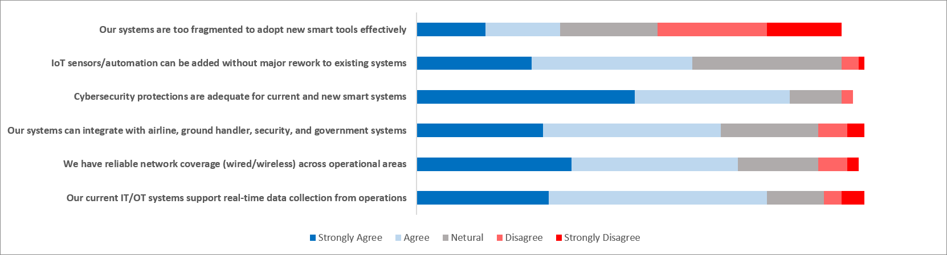
 | Our systems are too fragmented to adopt new smart tools effectively | IoT sensors/automation can be added without major rework to existing systems | Cybersecurity protections are adequate for current and new smart systems | Our systems can integrate with airline, ground handler, security, and government systems | We have reliable network coverage (wired/wireless) across operational areas | Our current IT/OT systems support real-time data collection from operations
Strongly Agree | 12 | 20 | 38 | 22 | 27 | 23
Agree | 13 | 28 | 27 | 31 | 29 | 38
Neutral | 17 | 26 | 9 | 17 | 14 | 10
Disagree | 19 | 3 | 2 | 5 | 5 | 3
Strongly Disagree | 13 | 1 | 0 | 3 | 2 | 4

Strengths: 65 respondents agreed that cybersecurity is adequate, 61 respondents agreed that real-time operational data capability is well established, 56 expressed confidence in network coverage , most of them believes the system can integrated with outside stakeholders.
The gap here in the reverse sentence 25 agreed the system is fragmented, 32 disagreed , and 17 were neutral. this suggests the fragmentation is not critical but remains a concern for about one third of employees.

- Data Governance & Analytics Capability (DG):
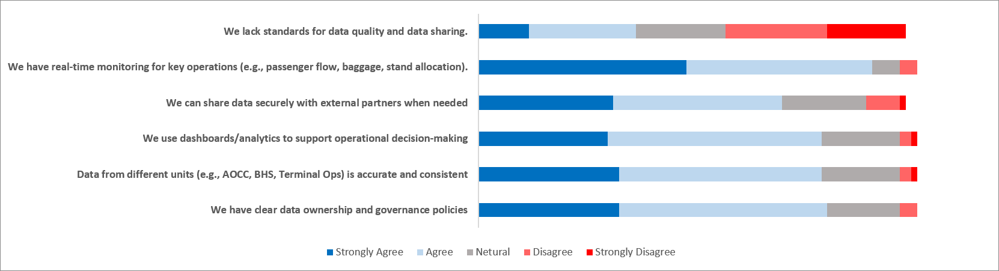
 | We lack standards for data quality and data sharing. | We have real-time monitoring for key operations (e.g., passenger flow, baggage, stand allocation). | We can share data securely with external partners when needed | We use dashboards/analytics to support operational decision-making | Data from different units (e.g., AOCC, BHS, Terminal Ops) is accurate and consistent | We have clear data ownership and governance policies
Strongly Agree | 9 | 37 | 24 | 23 | 25 | 25
Agree | 19 | 33 | 30 | 38 | 36 | 37
Neutral | 16 | 5 | 15 | 14 | 14 | 13
Disagree | 18 | 3 | 6 | 2 | 2 | 3
Strongly Disagree | 14 | 0 | 1 | 1 | 1 | 0

Strengths : strongest dimension in the survey, real-time operational monitoring scored extremely high, reflecting strong operational visibility across airport functions, this is also embedded in decision making as well as data sharing with external stakeholders.
The gap here in the reverse statement as there were mixed responses: 28 agreed about the lack of standards in data quality and sharing , 32 disagreed and 16 neutral. This indicates inconsistent perception regarding data governance maturity.

- Process & Operational Readiness (PR):
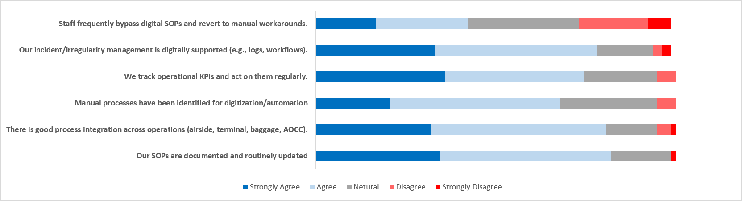
 | Staff frequently bypass digital SOPs and revert to manual workarounds. | Our incident/irregularity management is digitally supported (e.g., logs, workflows). | We track operational KPIs and act on them regularly. | Manual processes have been identified for digitization/automation | There is good process integration across operations (airside, terminal, baggage, AOCC). | Our SOPs are documented and routinely updated
Strongly Agree | 13 | 26 | 28 | 16 | 25 | 27
Agree | 20 | 35 | 30 | 37 | 38 | 37
Neutral | 24 | 12 | 16 | 21 | 11 | 13
Disagree | 15 | 2 | 4 | 4 | 3 | 0
Strongly Disagree | 5 | 2 | 0 | 0 | 1 | 1

Strengths: KPI’s are actively tracked and managed as the agreements exceeded 75% , employees generally recognize manual processes suitable for automation, SOP documentation is strong.
The gap in the reverse sentence is staff frequently bypass digital SOP’s considering the number of agreed and neutral. This suggests that digital compliance is not fully embedded.

- Organizational Culture & Leadership (CL):
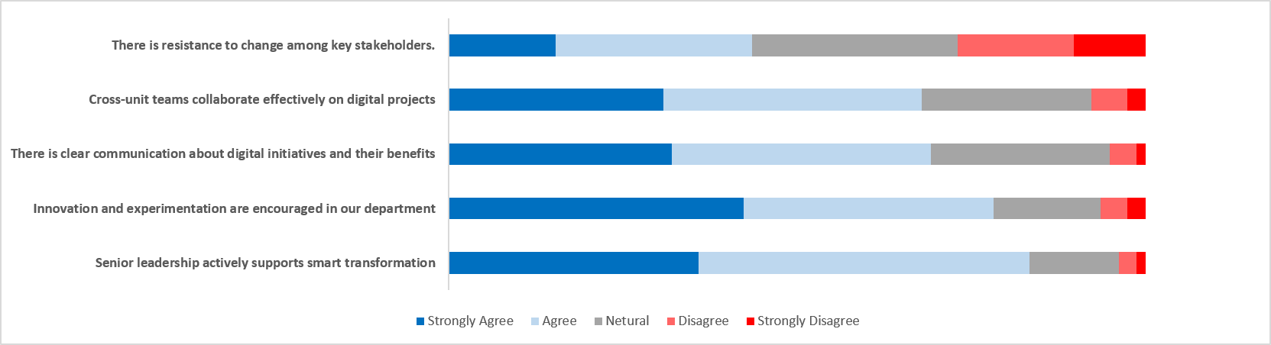
 | There is resistance to change among key stakeholders. | Cross-unit teams collaborate effectively on digital projects | There is clear communication about digital initiatives and their benefits | Innovation and experimentation are encouraged in our department | Senior leadership actively supports smart transformation
Strongly Agree | 12 | 24 | 25 | 33 | 28
Agree | 22 | 29 | 29 | 28 | 37
Neutral | 23 | 19 | 20 | 12 | 10
Disagree | 13 | 4 | 3 | 3 | 2
Strongly Disagree | 8 | 2 | 1 | 2 | 1
Strengths : 65 respondents agreed that senior leadership supports transformation and innovation , communication regarding digital initiatives are viewed positively.
The gap in the statement “there is resistance to change among key stakeholders” is significant as 34 agreed while 21 disagreed. this indicates that leadership is not the problem , stakeholders’ acceptance and willingness to participate across all levels remains the challenge.

- Workforce Digital Competence (WD):
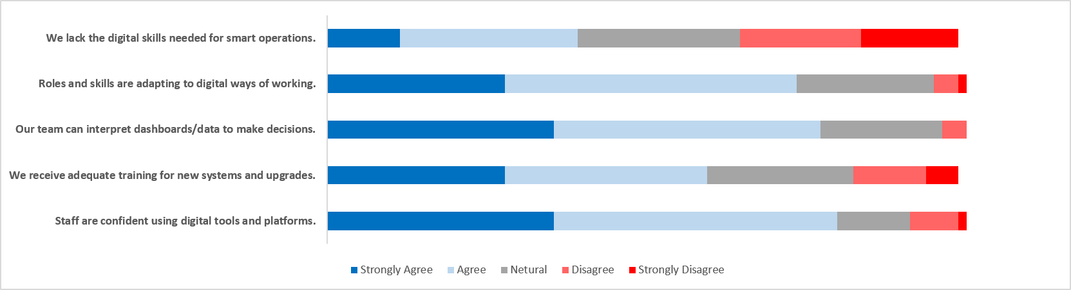

 | Staff are confident using digital tools and platforms. | We receive adequate training for new systems and upgrades. | Our team can interpret dashboards/data to make decisions. | Roles and skills are adapting to digital ways of working. | We lack the digital skills needed for smart operations.
Strongly Agree | 28 | 22 | 28 | 22 | 9
Agree | 35 | 25 | 33 | 36 | 22
Neutral | 9 | 18 | 15 | 17 | 20
Disagree | 6 | 9 | 3 | 3 | 15
Strongly Disagree | 1 | 4 | 0 | 1 | 12

Strengths: staff are highly confident using digital tools as 63 respondents agreed , teams can interpret dashboards and data effectively.
The gap in the reverse statement responses were mixed , while most employees disagree, approximately on third still perceive skill gaps.

- Change Management & Implementation Capability (CM):
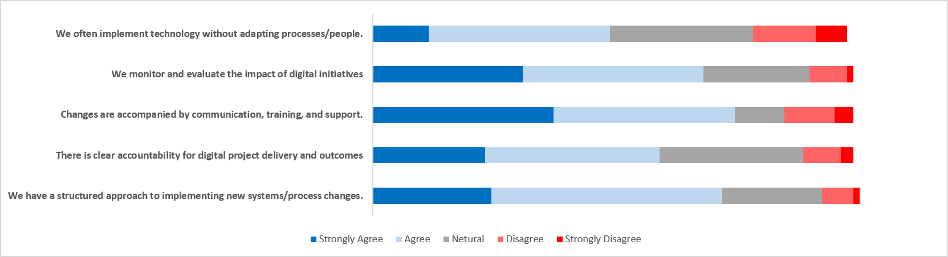

 | We often implement technology without adapting processes/people. | We monitor and evaluate the impact of digital initiatives | Changes are accompanied by communication, training, and support. | There is clear accountability for digital project delivery and outcomes | We have a structured approach to implementing new systems/process changes.
Strongly Agree | 9 | 24 | 29 | 18 | 19
Agree | 29 | 29 | 29 | 28 | 37
Neutral | 23 | 17 | 8 | 23 | 16
Disagree | 10 | 6 | 8 | 6 | 5
Strongly Disagree | 5 | 1 | 3 | 2 | 1

Strengths: digital initiatives are monitored and evaluated , accountability for project delivery is generally clear .
The gap in the reverse statement , there is 38 respondent agrees that implementing technology happens without adapting processes and people which is a warning signal in this study as employees perceive that some transformation efforts focus more on technology than organizational adoption.

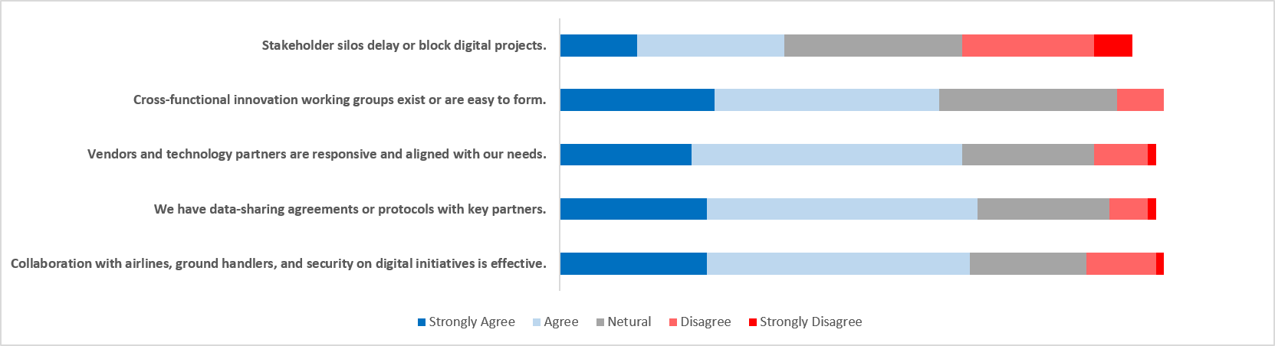
- Stakeholder Collaboration & Ecosystem Integration (SC):

 | Stakeholder silos delay or block digital projects. | Cross‑functional innovation working groups exist or are easy to form. | Vendors and technology partners are responsive and aligned with our needs. | We have data‑sharing agreements or protocols with key partners. | Collaboration with airlines, ground handlers, and security on digital initiatives is effective.
Strongly Agree | 10 | 20 | 17 | 19 | 19
Agree | 19 | 29 | 35 | 35 | 34
Neutral | 23 | 23 | 17 | 17 | 15
Disagree | 17 | 6 | 7 | 5 | 9
Strongly Disagree | 5 | 0 | 1 | 1 | 1

Strengths: responses state that there is strong collaboration with airlines, handlers, and security stakeholders, technology vendors are generally viewed positively.
The gap in the reverse statement 29 respondents agreed that stakeholders’ alignment delay or block digital projects, which indicates that collaboration barriers remain one of the largest transformation risks, meaning technology is integrating faster than organization.

- Physical Infrastructure Readiness (PI):
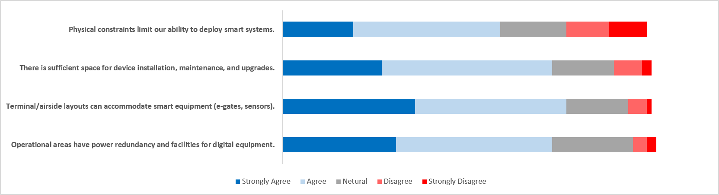
 | Physical constraints limit our ability to deploy smart systems. | There is sufficient space for device installation, maintenance, and upgrades. | Terminal/airside layouts can accommodate smart equipment (e‑gates, sensors). | Operational areas have power redundancy and facilities for digital equipment.
Strongly Agree | 15 | 21 | 28 | 24
Agree | 31 | 36 | 32 | 33
Neutral | 14 | 13 | 13 | 17
Disagree | 9 | 6 | 4 | 3
Strongly Disagree | 8 | 2 | 1 | 2

Strengths: there are positive results about physical infrastructure readiness for installing smart devices, capability of accommodating smart gates , sensors , automation equipment .
The gap is that most of them believe space is generally available for deploying technology, however physical constraints in some critical operational areas limit smart system deployment.

- Customer Orientation & Adoption (CA)
(your perception about passenger\stakeholder readiness)
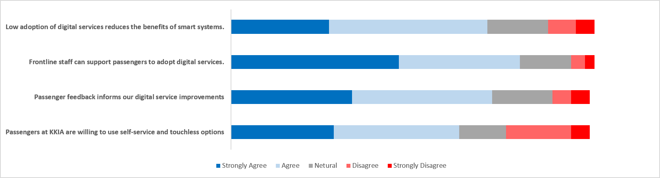

 | Low adoption of digital services reduces the benefits of smart systems. | Frontline staff can support passengers to adopt digital services. | Passenger feedback informs our digital service improvements | Passengers at KKIA are willing to use self‑service and touchless options
Strongly Agree | 21 | 36 | 26 | 22
Agree | 34 | 26 | 30 | 27
Neutral | 13 | 11 | 13 | 10
Disagree | 6 | 3 | 4 | 14
Strongly Disagree | 4 | 2 | 4 | 4

Strengths: staff are confident supporting passengers, and passengers are generally viewed as willing to adopt digital solutions.
The gap in the statement “low adoption of digital services reduces the benefits of smart systems”, receives 55 agrees, this means that technology deployment alone will not deliver value unless passenger utilization also increases.

Conclusion
The survey demonstrates that King Khalid international Airports has already established the critical foundations required for Smart Airport transformation. Technology, data, leadership, and workforce capabilities are largely in place. Future success will depend less on acquiring new technologies and more on integrating stakeholders, addressing infrastructure constraints, strengthening change management practices, and driving passenger adoption of digital services.
KKIA appears ready to move from digital transformation to intelligent airport operations, provided that organizational and ecosystem challenges are addressed alongside technology investments.

References:

- Newcastle University. "Technology-Organization-Environment Framework (TOE)." Open Academic Theories, https://open.ncl.ac.uk/academic-theories/23/technology-organization-environment-framework/.
- Umbrex. “Digital Maturity Model (DMM) Explained.” Umbrex, https://umbrex.com/resources/frameworks/strategy-frameworks/digital-maturity-model/.
- Oracle. "What Are Smart Operations?" Oracle, 2024, https://www.oracle.com/scm/smart-operations/.

