3 Methodology
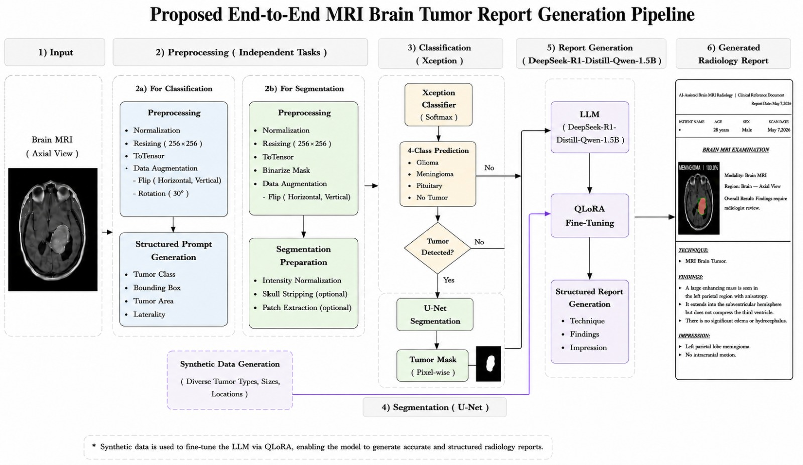
The proposed pipeline integrates three sequential components: classification, segmentation, and report generation. The overall architecture, As shown in Figure 1.
Fig. 1. Overall framework of the proposed system integrating MRI classification, tumor segmentation, and AI-based radiology report generation.

3.1 Input (Datasets)
Three different sets of data were employed in this study. Each set was assigned a unique task in the proposed pipeline, such that one set was used for the classification of brain tumors, another set for the segmentation of tumors, and the final set for generating radiology reports. This ensured that each model was trained with respect to its particular task.

3.1.1 Classification Dataset.
The brain tumor classification dataset was sourced from Kaggle and contains different combinations of the Figshare, SARTAJ, and Br35H datasets [20]. In total, the dataset has 7,023 T1-weighted contrast-enhanced MRI images which are categorized into four classes including glioma (1,621), meningioma (1,645), pituitary tumor (1,757), and no tumor (2,000), As shown in Figure 2. The training set originally provided in the dataset was entirely used to train our models, while the test set was further partitioned using stratified sampling per class. Particularly, 20% of the images from each class in the test set were sampled for validation purposes, and the rest were used as the final test set.
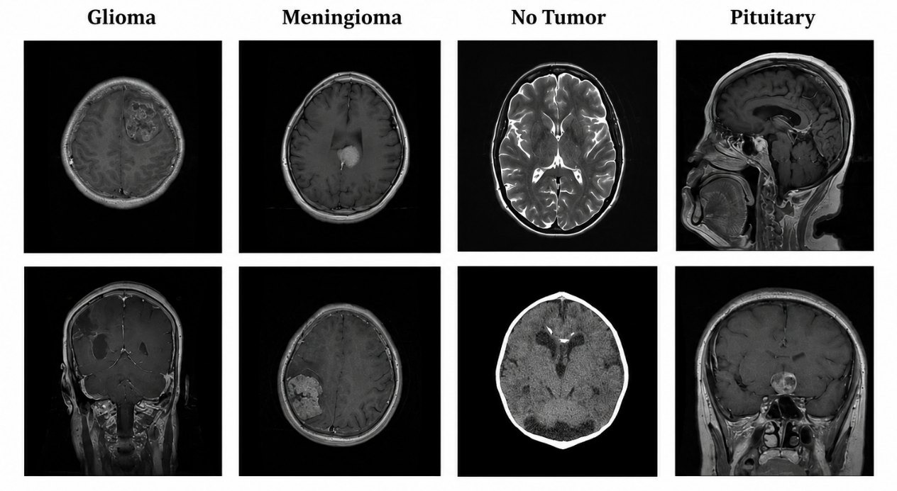

Fig. 2. Sample MRI images from each class: Glioma, Meningioma, No-Tumor, and Pituitary (two per class).

3.1.2 Segmentation Dataset.

A distinct Kaggle dataset was employed for image segmentation, with 3,064 MRI images accompanied by manually labeled binary masks [21]. An 80-20 split between training and validation sets was applied to the dataset. The training process for image segmentation was eparate from that of the classification model. Sample MRI images along with their binary masks, As shown in Figure 3.
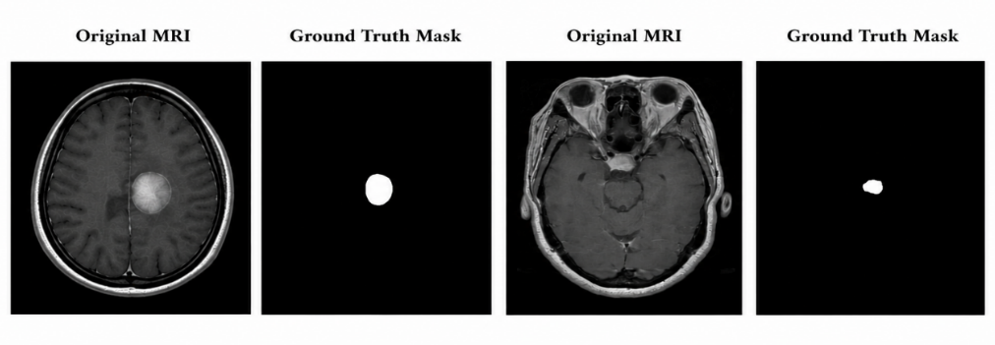

Fig. 3. Samples of Brain tumor segmentation dataset: original MRI and corresponding ground-truth mask (two cases).

3.1.3 Synthetic Dataset for Report Generation.

As the availability of radiology reports publicly available radiology reports are limited due to privacy concerns is limited [22], a synthetic dataset was created by using Google AI Studio along with the Gemini 1.5 Flash language model. The 1,100 samples consist of structured information regarding the tumor (type, bounding box, tumor area mm2, and laterality) along with a radiology report containing three sections including Technique, Findings, and Impression. With a sampling temperature value of 1.0, it was ensured that the generated data would be balanced with linguistic diversity as well as clinical relevance. Restrictions on prompts would make sure there was consistency with tumor types, generation of realistic numerical values, and not copy any number directly. As a result of preprocessing, 1,051 samples were left for training.

3.2 Preprocessing
As the proposed pipeline includes three different modules: tumor classification, tumor segmentation, and radiology report generation, various preprocessing techniques have been employed on each dataset depending on the needs of the particular module. Image standardization and augmentation were the focus of the preprocessing steps taken in regard to the classification dataset to facilitate improved generalization capabilities of the model in predicting the type of tumor. Preprocessing for the segmentation dataset was done with the goal of maintaining consistency between MRI and corresponding masks while improving dataset diversity using synchronized augmentation techniques. As for the radiology report synthetic dataset, text-based preprocessing techniques were necessary.
3.2.1 Preprocessing For Classification Dataset.
The dimensions of all images used for classification tasks were standardized to a size of 256 × 256 pixels. Then, pixel values were normalized based on the mean and standard deviation statistics of the ImageNet dataset, which are as follows:
xₙₒᵣₘ = (x − μ) / σ
With μ = [0.485, 0.456, 0.406] and σ = [0.229, 0.224, 0.225] corresponding to the means and standard deviations of the three color channels of an image, respectively. The normalization ensures compatibility with pretrained models on ImageNet.
In order to minimize the risk of overfitting and increase the generalizability of the model, data augmentation was employed during training time. For every image in the training set, random horizontal and vertical flips were applied with the following probability:
P(flip) = 0.5
This transformation preserves semantic information while adding geometric variation to the training set.
3.2.2 Preprocessing For Segmentation Dataset.
For the segmentation part, data augmentation was employed in a joint manner for both the MRI image and its binary mask. If we consider I to be the input image and M to be the binary mask, then the following was done for data augmentation:
(I’, M’) = T(I, M)
Where T is the operation consisting of horizontal and vertical flips randomly, with a probability of 0.5 for each. The transformation T thus guarantees that there will be no misalignment between the image and the mask. Binarization was carried out using the following formula with threshold value θ equal to 0.5:
Mᵇᵢⁿ(p) = ⎧ 1, if M(p) > 0.5
⎩ 0, otherwise
The reliability of the transformations made can be verified from some example images in Fig. 11.

3.2.3 Synthetic Data Preprocessing.

To ensure that the integrity and quality of data remained acceptable, various preprocessing procedures were applied to the generated radiology reports, including the following: first, elimination of possible errors related to the Markdown and JSON formats to provide the plain text format for the input data; second, elimination of all quantitative information about the number of pixels in the radiology reports, retaining only clinical data; third, verification of the correctness of the ground truth labels associated with the tumor class inside the dataset structure; and fourth, dividing the reports into three typical clinical parts: technique, findings, and impression.

In this way, it was possible to preserve the semantic integrity of the generated reports.

3.3 Ethical and Regulatory Considerations

The pipeline produces a report that has the same structure as a radiologist’s report, and thus falls under AI-assisted clinical decision support tools, posing several key questions related to its implementation. In accordance with U.S. regulations, this tool needs to be cleared through the FDA’s 510(k) or De Novo process, and the agency’s guidelines on “Predetermined Change Control Plans”, dated December 2024 [23], give a basis for updating models after implementation. As per EU regulation, the tool will fall under high-risk AI tools in Articles 6 and Annex III of the EU AI Act (Regulation (EU) 2024/1689) [24].

There are two additional issues that deserve attention in this regard. First, automation bias, which refers to the inclination of healthcare professionals to rely on the output produced by the algorithms without validating its accuracy, is a potential issue, considering the natural language expertise of the algorithmic reports. The present model does not incorporate the classifier confidence scores in the reporting stage, and future implementations must highlight borderline and low confidence scores explicitly. Second, the legal question of accountability for misdiagnoses made by AI systems has not been addressed, and there must be an organizational framework for human sign-off on such reports.

3.4 Model Architecture
Classification Models. Four architectures were used: CNN, ResNet [25], EfficientNet [26] and Xception [27]. The pretrained weight on ImageNet were used as initialization, and end-to-end finetuning was performed for all the models. Finally, the last classification layer was substituted for a fully connected four-class layer using softmax activation.
The choice of these models was done with a view to providing an analysis of the comparative performance of traditional Convolutional Neural Networks and more advanced Deep Learning architectures with diverse design philosophies. In particular, CNN was chosen as a reference model and a benchmark against the rest because it uses basic convolution and pooling layers to classify inputs. ResNet50 was chosen because it makes use of skip connections that allow for efficient training of deeper networks without succumbing to the vanishing gradients problem. Thus, it is very reliable in image classification tasks, including those involving medical images such as the case at hand. EfficientNet-B3 was added because of its compound approach to scaling network size through balancing of depth, width, and resolution to provide optimal performance with minimal computation costs. Finally, Xception was selected as the main model because of the ability of its depth-wise convolutional layers to reduce computations and complexity without impairing feature extraction.

3.4.1 Baseline CNN
The CNN, which serves as our base model, is as depicted in Figure 4 below. It contains several convolution and pooling layers before finally going through the fully connected layers. Convolution can be mathematically defined as follows:
(f ∗ g)(x, y) = ∑ₘ ∑ₙ f(m, n) · g(x − m, y − n) (1)
Where f is the input and g is the convolutional kernel.
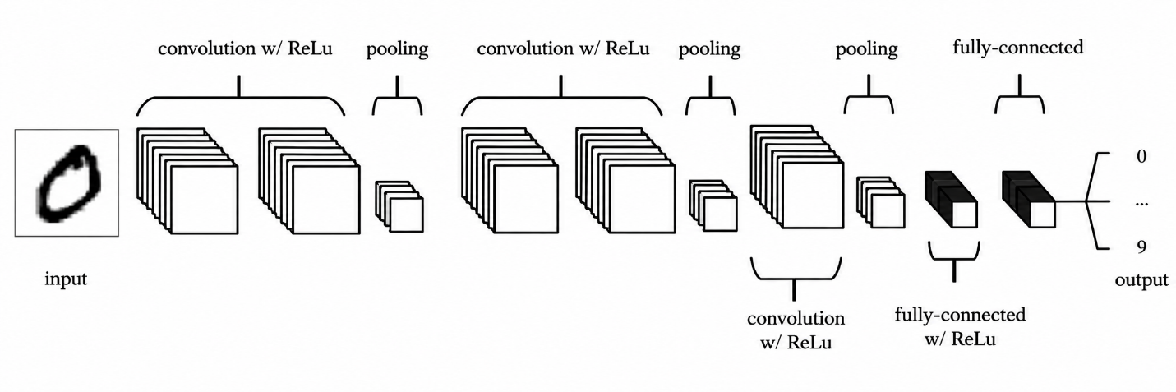
Fig. 4. Baseline CNN architecture used for brain tumor classification.

3.4.2 ResNet50
The ResNet50 model [25] presents residual learning as a solution to the problem of degradation in deep neural networks by training the residual function instead of the required mapping. The central idea of the identity skip connection is represented by:
y = F(x) + x (2)
As illustrated in Figure 5.
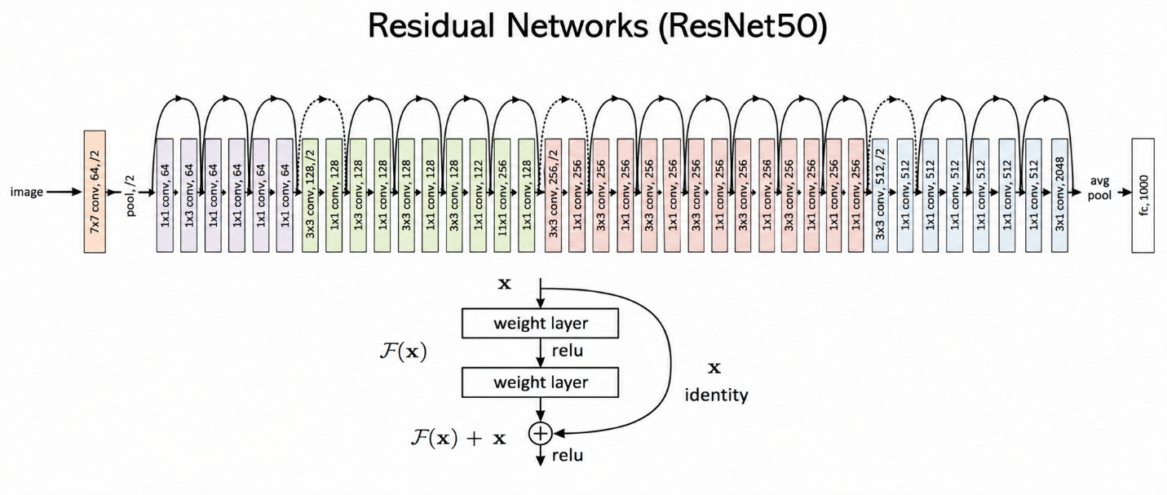
Fig. 5. ResNet50 architecture with residual (skip) connections for deep network training.

3.4.3 EfficientNet-B3
Compound scaling was used in EfficientNet-B3 [26], where network depth, network width, and resolution were scaled uniformly. Compound scaling uses the following equation:
Depth = αϕ, width = βϕ, resolution = γϕ (3)
With the following constrain:
α · β² · γ² ≈ 2 (4)
Figure 6 illustrates the model design that employs five different scaling techniques: baseline scaling, scaling width, scaling depth, scaling resolution, and compound scaling, in which all three scaling methods were performed together for better accuracy and efficiency.
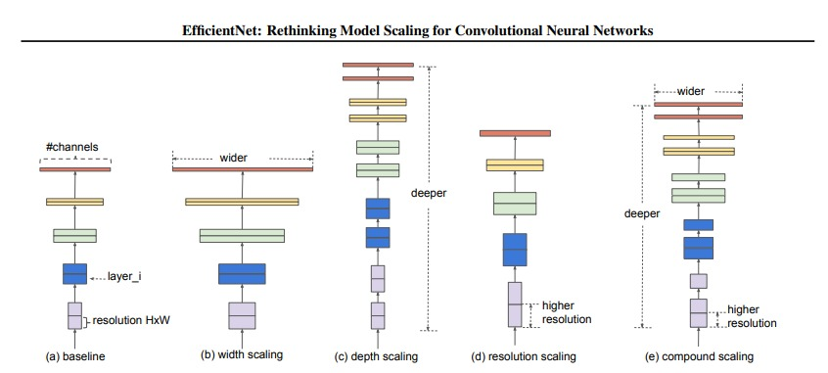
Fig. 6. EfficientNet-B3 architecture illustrating compound scaling of depth, width, and resolution.

3.4.4 Xception (Selected Model)
Xception [27] works on the basis of depthwise separable convolutions where standard convolution can be broken down into depthwise and pointwise computations. The comparison of computational complexity is:
Standard Conv = Dₖ² · M · N (5)
Depthwise Sep. Conv = Dₖ² · M + M · N (6)
It not only facilitates computational process but ensures the representational ability at the same time. As it can be seen from Fig. 7 below, the proposed model, using the Xception architecture, performed better than other models in classifying brain MRI. From the experiments carried out (refer Table VII), the Xception model showed an optimal level of trade-off between computational complexity and classification efficiency.
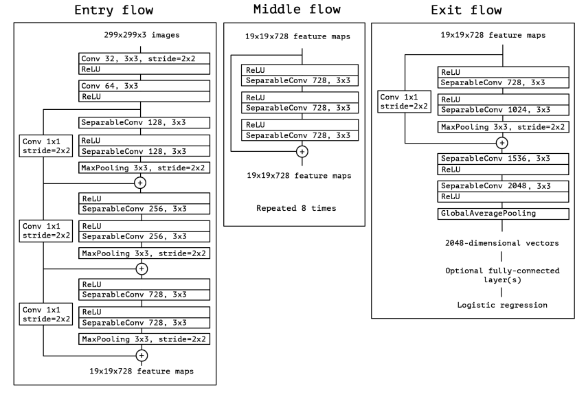
Fig. 7. Xception architecture: entry flow, middle flow (×8), and exit flow.

Segmentation Model. The process of tumor localization was performed using the U-Net [10] architecture, which belongs to the class of fully convolutional networks that have been used in the medical imaging application domain for segmenting images. This network architecture employs an encoder-decoder approach where calculations include context and spatial information. As illustrated in Figure 8.
The application of convolution combined with max-pooling in the encoder part of the model reduces the size spatially while increasing the depth of features. On the other hand, upsampling in the decoder is done by transposed convolution. The skip connections between the encoder and decoder allow keeping spatial information:
y = Concat(Fᴬⁿᶜ, Fᴰᴬᶜ) (7)
For segmentation, the network outputs a pixel-wise probability map using sigmoid or softmax activation. The Dice Loss is defined as:
Dice = 2|P ∩ G| / (|P| + |G|) (8)
where P denotes the predicted mask and G the ground truth mask.
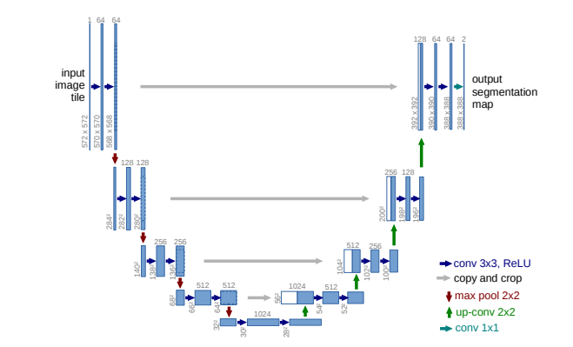
Fig. 8. U-Net architecture (32×32 resolution). Blue boxes: feature maps; white boxes: copied maps; arrows: operations.

Conditional Segmentation Strategy. To improve the efficiency of computations, the task of segmentation is undertaken if there is a possibility of the presence of a tumor according to classification.
Generative Model. Qwen-1.5B, a generative language model created by DeepSeek R1 Distill framework, was fine-tuned via QLoRA [28] on synthetic report dataset. This approach decreases computational costs by representing base model weights with 4-bit NF4 precision and training low-rank adapter matrices for the weights:
W = W₀ + ΔW = W₀ + BA (9)
where W₀ ∈ ℝd×k is the fixed 4-bit representation, B ∈ ℝd×r and A ∈ ℝr×k are learned adapter matrices of rank r, such that r ≪ min(d, k). This model receives structured prompts with information about tumor class, confidence score, bounding box, tumor area, and laterality and outputs structured reports of finding descriptions with the help of Technique, Finding, and Impression schema.
Fine-tuning hyperparameters are summarized in Table II. The full pipeline for generating a report from structured imaging metadata is illustrated in Fig. 9.
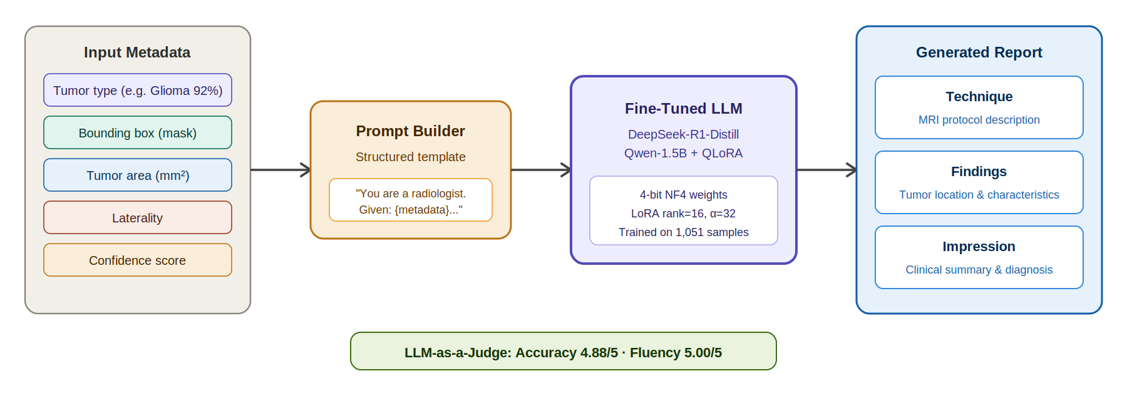
Fig. 9. QLoRA report generation pipeline: structured imaging metadata → fine-tuned DeepSeek model → Technique/Findings/Impression report.
TABLE II. QLORA FINE-TUNING HYPERPARAMETERS
Hyperparameter | Value
Quantization | 4-bit NF4
LoRA rank r | 16
LoRA α | 32
LoRA dropout | 0.05
Learning rate | 2e-4
Batch size | 1
Gradient accumulation | 8
Training epochs | 3
Optimizer | Paged_adam_8bit
Max sequence length | 512

3.5 Training and Evaluation

3.5.1 Training Procedure
Classification Training. The models were optimized using the Adam optimizer (lr = 10⁻⁴, weight decay = 10⁻⁵), along with cosine annealing schedule, batch size of 32, and for 10 epochs. Early stopping with patience of 5 was used according to the validation loss.
The target function was categorical cross-entropy:
ℒᶜˡˢ = −∑Ci=1 Yᵢ log(Ŷᵢ) (10)
Segmentation Training. U-Net was trained for 25 epochs using Adam (lr = 10⁻⁴) and a combined Dice + Binary Cross-Entropy loss:
ℒˢᵉᵍ = ℒᴮᶜᵉ + ℒᴰᴫᶜᵉ, ℒᴰᴫᶜᵉ = 1 − 2(P · G) / (P + G) (11)
where P and G denote predicted and ground-truth masks, respectively.
Evaluation Metrics. Classification: accuracy, precision, recall, and F1-score. Segmentation: Dice coefficient and Intersection over Union (IoU / Jaccard Index):
IoU = (A ∩ B) / (A ∪ B) (12)
Report generation was evaluated using: (1) LLM-as-a-Judge on a 5-point Likert scale (accuracy and fluency); and (2) reference-based NLP metrics (BLEU-4, ROUGE-L, BERTScore-F1) on a held-out subset.

