

Hybrid Machine Learning Framework
for Multi-Class Thyroid Risk Assessment

Prepared By
Name: Ahmed Abdullah ID No: 253000598

Submitted in fulfillment of the requirements for the degree Master of Science in Artificial Intelligence
At
Collage of Informatics
Midocean University
UAE
Supervisor Name: Dr. Amjad Qtaish
Collage of Informatics, Midocean University, Comoros
Email:…………………….

Acknowledgements

Special thanks to Dr. .

Abstract

List of Publications

Table of Contents

List of Abbreviations xiv
List of Figures xvi
List of Tables xviii

Chapter 1: Introduction and Overview............................................................................... 1
1.2 Problem Definition ................................................................................... 2
1.3 Thesis Objectives ..................................................................................... 3
1.4 Thesis Contribution .................................................................................. 4
1.5 Thesis Organization................................................................................... 5

Chapter 2: Background and Related Work …………………………………………... 31

Chapter 3: Proposed Approach ............................................................... 78
4.1 Introduction ............................................................................................ 78

Chapter 4: Experimental Results and Discussion ................................... 86

Chapter 5: Conclusion and Future Work .............................................. 127
7.1 Important Features ............................................................................... 127
7.3 Future Work ....................................................................................... 129

References .................................................................................................. 130

List of Abbreviations
- Acc.: Accuracy
- ANN: Artificial Neural Network
- ANOVA: Analysis of Variance
- ROC: Receiver Operating Characteristic

List of Figures
2.1 Educational Data Mining Process ……………………………………… | 7
2.2 Applications of Educational Data Mining ……………………………… | 8
2.3 Distribution of Papers that used different attributes for PSP problem …. | 19
2.4 Student Performance Data Set …………………………………………... | 21
2.5 Educational Process Mining (EPM): A Learning Analytics Data Set … | 23

List of Tables
2.1 Student Performance Data Set Description ………………………… 21
2.2 Students' Academic Performance Dataset Description ……………… 23

Chapter 1 Introduction

Overview
Thyroid disorders are among the most prevalent endocrine diseases worldwide and represent a significant clinical and public health concern. These disorders affect key physiological functions including metabolic regulation, cardiovascular activity, thermoregulation, and overall energy balance. Because the thyroid gland plays a central role in maintaining systemic physiological stability, even moderate hormonal imbalance may disrupt multiple biological systems simultaneously and produce a wide range of clinical manifestations (Taylor et al., 2022). Early identification of thyroid dysfunction is therefore essential, as untreated thyroid disorders may lead to long-term complications including cardiovascular disease, metabolic disturbances, and reduced quality of life.
In clinical practice, thyroid function is primarily evaluated using biochemical laboratory measurements. Key biomarkers such as Thyroid-Stimulating Hormone (TSH), Triiodothyronine (T3), and Thyroxine (T4), together with derived indicators such as the Free Thyroxine Index (FTI), constitute the principal diagnostic markers used in thyroid assessment (Biondi & Cappola, 2021). However, these biomarkers operate within a complex endocrine feedback mechanism rather than independently. Changes in one hormone often influence or compensate for variations in others, particularly in early or subclinical stages of thyroid dysfunction. Consequently, accurate interpretation of thyroid function requires evaluating the combined behavior of multiple hormonal indicators rather than relying solely on individual threshold values.
Alongside laboratory findings, patients frequently present symptoms such as fatigue, weight fluctuation, palpitations, anxiety, hair loss, and temperature sensitivity. While these symptoms provide useful clinical indications, they are inherently nonspecific and may overlap with several metabolic, cardiovascular, and psychological conditions. As a result, symptom-based assessment alone lacks sufficient diagnostic precision. In conventional clinical workflows, symptom evaluation and laboratory testing are typically considered sequentially rather than within a unified analytical framework.
These challenges have motivated increasing interest in computational approaches capable of analyzing multiple clinical variables simultaneously. Machine learning methods provide powerful analytical tools for modeling complex relationships within medical data. Unlike rule-based diagnostic approaches, supervised learning algorithms can capture nonlinear interactions and multidimensional feature patterns that may not be easily detectable through traditional clinical evaluation (Rajkomar et al., 2022).
Several recent studies have explored the use of machine learning techniques for thyroid disease classification. For example, studies such as Islam et al. (2022), Khan et al. (2021), and Alshamrani et al. (2023) investigated various machine learning algorithms for thyroid disease prediction using clinical datasets. While these approaches demonstrate promising predictive performance, most existing studies remain primarily laboratory-centric and focus mainly on improving classification accuracy. Many of these studies utilize datasets such as the UCI Thyroid Disease dataset, which contain structured clinical and laboratory records suitable for predictive modeling (Dua & Graff, 2019). Recent research has evaluated modern classification algorithms including Random Forest, Support Vector Machine, and Gradient Boosting for multi-class thyroid disease prediction (Islam et al., 2022; Alshamrani et al., 2023). While these approaches demonstrate promising predictive performance, most existing studies remain primarily laboratory-centric and focus mainly on improving classification accuracy.
However, recent literature in clinical decision-support systems emphasizes that predictive models should not only focus on accuracy but also prioritize interpretability, integration of heterogeneous clinical data, and usability in real healthcare environments (Jiang et al., 2022; Sutton et al., 2020). Despite these advances, limited research has investigated how structured symptom information can be systematically integrated with laboratory-based machine learning classification within a unified analytical framework for thyroid disorder risk assessment.
Motivated by this gap, this thesis proposes a hybrid machine learning framework for multi-class thyroid risk assessment in adult patients. The proposed framework integrates structured symptoms encoding with supervised machine learning classification models trained on laboratory biomarkers. The objective is to develop an interpretable and analytically coherent system capable of supporting structured preliminary thyroid risk assessment while maintaining methodological transparency and clinical relevance. Importantly, the proposed framework is intended to support clinical reasoning rather than replace medical expertise.

Problem Definition
The diagnosis and preliminary evaluation of thyroid disorders involve both clinical and analytical challenges. Although clinical guidelines provide reference ranges for biomarkers such as TSH, T3, and T4, interpreting these indicators often requires examining complex relationships among multiple hormonal variables (Biondi & Cappola, 2021). In many cases, borderline laboratory values or partially conflicting hormonal patterns may complicate early diagnosis.
Traditional diagnostic approaches frequently rely on rule-based evaluation in which values exceeding predefined thresholds trigger further medical investigation. While clinically useful, such approaches may not fully capture nonlinear interactions among biochemical indicators. Borderline measurements, partially conflicting laboratory results, and subclinical conditions may introduce uncertainty during early stages of thyroid dysfunction.
Simultaneously, adult patients often present heterogeneous and nonspecific symptom profiles. Symptoms such as fatigue, weight change, palpitations, anxiety, and temperature intolerance may indicate thyroid dysfunction but are not exclusive to thyroid disorders. Consequently, symptom-based evaluation alone lacks sufficient discriminative power. Conversely, excluding symptom information entirely may limit contextual understanding and reduce opportunities for early risk identification.
A structural limitation arises when symptom reporting and laboratory analysis are treated as independent processes. In traditional clinical workflows, symptoms guide clinical suspicion while laboratory tests confirm diagnosis. However, few computational frameworks integrate these two sources of information within a unified analytical architecture capable of systematically analyzing both subjective and objective clinical data.
Existing machine learning studies on thyroid disease prediction have largely focused on laboratory datasets while neglecting structured symptom integration (Islam et al., 2022; Alshamrani et al., 2023). Although these studies demonstrate promising predictive accuracy, they often prioritize model performance over interpretability and integrated system design.
From a system design perspective, this represents an important research gap. An effective analytical framework for thyroid risk assessment should be capable of:
• Encoding structured symptom inputs in quantifiable form
• Modeling laboratory biomarkers using supervised multi-class classification
• Integrating both sources of information within a unified analytical pipeline
• Producing interpretable outputs that support clinical reasoning
Without such integration, risk assessment remains fragmented and may limit the ability to perform consistent preliminary evaluation.
Therefore, the central research problem addressed in this thesis can be stated as follows:
There is a lack of an integrated hybrid machine learning framework that combines structured symptoms encoding with laboratory-based multi-class classification to provide consistent, interpretable, and analytically robust thyroid disorder risk assessment in adult patients.
To address this problem, this research aims to design and evaluate a hybrid machine learning framework capable of integrating heterogeneous clinical inputs while maintaining methodological rigor and practical relevance.

1.3 Thesis Objectives
The primary objective of this thesis is to design and evaluate a hybrid machine learning framework for multi-class thyroid disorder risk assessment in adult patients by integrating laboratory biomarkers with structured symptom information.
To achieve this objective, the study aims to:
- Preprocess and prepare the UCI Thyroid Disease dataset, including data cleaning, feature structuring, and restriction to adult cases.
- Develop supervised machine learning models capable of classifying thyroid conditions into Normal, Hypothyroid, and Hyperthyroid categories.
- Evaluate and compare model performance using standard classification metrics such as accuracy, precision, recall, F1-score, and confusion matrix analysis.
- Design a structured symptom-scoring mechanism based on documented clinical associations between symptoms and thyroid dysfunction.
- Integrate the symptom-based component with laboratory-based classification models within a unified hybrid analytical framework.
- Assess the proposed framework in terms of predictive performance, interpretability, and suitability for structured preliminary risk assessment.

1.4 Thesis Contribution
This thesis contributes to thyroid disorder risk assessment at both theoretical and technical levels.
From a theoretical perspective, the research proposes a conceptual framework that integrates subjective symptom indicators with objective biochemical biomarkers for thyroid disorder classification. This contribution addresses a limitation in existing research where predictive models frequently rely only on laboratory measurements without incorporating structured symptom information.
From a technical perspective, the study develops and evaluates a hybrid machine learning architecture capable of performing multi-class classification of thyroid conditions while integrating a symptom-based scoring mechanism. The proposed framework combines supervised classification models with structured symptom encoding within a unified computational pipeline.
A further contribution lies in the systematic evaluation of multiple machine learning algorithms for distinguishing between normal thyroid function, hypothyroidism, and hyperthyroidism using the UCI Thyroid Disease dataset. In addition to predictive accuracy, the study emphasizes model interpretability and analytical consistency as key design considerations.
Finally, the research demonstrates how heterogeneous clinical inputs can be operationalized within a transparent and interpretable analytical architecture. By emphasizing architectural clarity and explainability, the proposed framework supports clinical reasoning rather than obscuring it.

1.5 Thesis Organization
Chapter 1
Introduces the research background, defines the problem statement, outlines the objectives, and presents the main contributions of the proposed hybrid framework.

Chapter 2
Provides theoretical background and reviews related work, including thyroid physiology, laboratory-based diagnosis, machine learning approaches for thyroid disease prediction, and clinical decision-support systems. The chapter concludes by identifying the research gap motivating the proposed framework.

Chapter 3
Describes the proposed methodology. It presents dataset preparation procedures, preprocessing techniques, model development processes, evaluation strategies, and the design and integration of the symptom-scoring component within the hybrid analytical architecture.
Chapter 4
Presents the experimental results and discussion. It reports model performance metrics, comparative analysis across classification models, and interpretation of the integrated framework’s behavior.
Chapter 5
Concludes the thesis by summarizing the main findings, highlighting research contributions, discussing limitations, and proposing directions for future work.

Chapter 2: Background and Related Work
Thyroid disorders represent a significant clinical concern due to their widespread prevalence and their impact on essential physiological processes such as metabolic regulation, cardiovascular activity, and thermoregulation. Accurate evaluation of thyroid function requires the interpretation of multiple biochemical indicators together with clinical observations, often involving complex relationships among hormonal measurements and patient-reported symptoms. This complexity has motivated increasing interest in computational approaches capable of analyzing multidimensional clinical data. In recent years, machine learning techniques have emerged as promising analytical tools in healthcare, enabling the identification of patterns within medical datasets and supporting disease prediction and diagnostic decision-making. Within the context of thyroid disorders, several studies have applied machine learning models to classify thyroid conditions using laboratory data. Examining the medical details of thyroid disorders together with existing machine learning approaches is therefore essential for understanding current research directions and identifying remaining analytical limitations.

2.1 Thyroid Gland and Thyroid Disorders
Thyroid disorders are common hormone diseases that affect many people worldwide. The thyroid gland plays a major role in regulating metabolic processes and maintaining physiological balance in the human body. Thyroid hormones influence several biological functions including metabolic rate, cardiovascular activity, body temperature regulation, and overall energy balance. Due to this, defects in thyroid hormone production can affect multiple organ systems and lead to a wide range of clinical symptoms (Biondi & Cappola, 2021).
The thyroid gland is in the front part of the neck and produces two primary hormones: thyroxine (T4) and triiodothyronine (T3). These hormones are responsible for regulating metabolism. The secretion of thyroid hormones is controlled by the hypothalamic–pituitary–thyroid (HPT) axis. In this scenario, the hypothalamus releases thyrotropin-releasing hormone (TRH), which increases the pituitary gland to produce thyroid-stimulating hormone (TSH). TSH then increases the thyroid gland to release T3 and T4. The levels of these hormones are regulated through a feedback mechanism that helps maintain hormonal balance (Ross et al., 2016).
Thyroid dysfunction occurs when this regulatory system does not function properly. The two most common forms of thyroid disorders are hypothyroidism and hyperthyroidism. Hypothyroidism occurs when the thyroid gland produces insufficient levels of thyroid hormones. Patients with hypothyroidism may experience symptoms such as fatigue, weight gain, cold intolerance, and dry skin. Hyperthyroidism, on the other hand, occurs when the thyroid gland produces excessive thyroid hormones and may lead to symptoms such as weight loss, palpitations, anxiety, and heat intolerance (Biondi & Cappola, 2021; Chiovato et al., 2023).
To diagnose thyroid disorders medical people, involve laboratory evaluation of several biochemical indicators. Measurements of thyroid-stimulating hormone (TSH), triiodothyronine (T3), and thyroxine (T4) are commonly used to assess thyroid function. In some cases, additional derived indicators such as the Free Thyroxine Index (FTI) are used to improve diagnostic interpretation. Because thyroid hormones operate within a feedback-regulated system, interpreting these biomarkers requires evaluating their relationships rather than examining each measurement independently (Ross et al., 2016).
In addition to laboratory tests, clinical symptoms are often considered during thyroid evaluation. However, many thyroid-related symptoms are not specific to thyroid disorders. Symptoms such as fatigue, weight change, temperature sensitivity, and palpitations may also be associated with other medical conditions. As a result, physicians often rely on a combination of laboratory findings and clinical observations to assess thyroid function (Chiovato et al., 2023).
The interpretation of multiple biochemical indicators together with patient symptoms can be complex, particularly in cases where laboratory values fall near diagnostic thresholds or when symptoms are not clearly defined. These challenges have encouraged the use of computational methods that can analyze multiple clinical variables simultaneously. Recent developments in artificial intelligence and machine learning have shown potential for analyzing medical datasets and supporting disease prediction in healthcare applications (Khan et al., 2024).
Understanding the medical background of thyroid physiology, diagnostic biomarkers, and symptom patterns is therefore important when studying computational approaches for thyroid disease prediction. This background provides the foundation for examining machine learning techniques that may assist in the analysis of thyroid-related clinical data.

2.2 Machine Learning in Healthcare
Machine learning has become an important analytical tool in modern healthcare. It refers to computational techniques that allow computer systems to learn patterns from data and generate predictions or classifications without being explicitly programmed for each specific task. Machine learning algorithms can analyze large medical datasets and identify relationships among clinical variables that may not be easily detectable through conventional statistical methods (Esteva et al., 2021).
In healthcare environments, machine learning is increasingly used to support disease detection, risk prediction, and clinical decision-making. Medical data often contains complex interactions among patient characteristics, laboratory measurements, clinical observations, and historical medical records. Machine learning models can analyze these multidimensional datasets and identify patterns that may assist clinicians in recognizing disease conditions and predicting patient outcomes (Topol, 2023).
One of the key applications of machine learning in healthcare is the development of clinical decision-support systems. These systems are designed to assist healthcare professionals by providing analytical insights based on patient data. Rather than replacing medical expertise, decision-support tools aim to complement clinical reasoning by helping physicians interpret complex information and identify diagnostic patterns. Recently, machine learning systems have been applied to various medical domains, including cardiovascular disease prediction, cancer detection, and endocrine disorder analysis (Khan et al., 2024).
In this case, machine learning techniques provide an opportunity to analyze both biochemical indicators and patient symptoms in a structured manner. Thyroid evaluation often involves interpreting multiple lab indicators with clinical observations, which may introduce analytical complexity in traditional workflows. To address this challenge, computational models can be used to analyze combinations of lab results and symptoms to estimate the likelihood of different thyroid conditions.
The goal of this paper’s framework is to support thyroid risk assessment through clinical symptoms and laboratory indicators integration. It evaluates patient input and produces a structured risk classification that may assist in identifying potential thyroid conditions.

2.3 Machine Learning for Thyroid Disease Prediction
Nowadays, machine learning is getting trendy in healthcare fields to support detection and classification of diseases. In this area, machine learning practices can analyze medical datasets and help identify patterns related to thyroid dysfunction. Thyroid diseases often involve complex relationships between lab results and symptoms, which strengthen machine involvement.
Several studies have applied machine learning algorithms to classify thyroid diseases. Most of these studies use laboratory biomarkers such as thyroid-stimulating hormone (TSH), triiodothyronine (T3), and thyroxine (T4) as the main predictive variables. Different supervised learning algorithms, including decision trees, support vector machines, random forests, and neural networks, have been explored to classify patient conditions into categories such as normal thyroid function, hypothyroidism, and hyperthyroidism (Islam et al., 2022).
Recent researchers focused on improving prediction performance by comparing different machine learning models. Ensemble learning methods and deep learning approaches have been evaluated using structured datasets such as the UCI Thyroid Disease dataset. These studies demonstrate that machine learning models can achieve promising results when applied to thyroid disease classification tasks (Khan et al., 2024).

Despite the technical progress in machine learning applications for thyroid disease prediction, many existing studies focus primarily on lab results without full attention to patient symptoms. In clinical practice, doctors typically consider both lab results and reported symptoms when evaluating thyroid disorders, since symptoms such as fatigue, weight changes, temperature sensitivity...etc.
Also, many studies emphasize prediction accuracy as the main evaluation metric, while factors such as interpretability and clinical usability receive less attention. In medical topics, machine learning models should not only achieve accurate predictions but also provide clear and understandable outputs that support clinical decision-making.

These limitations define the need for approaches that integrating lab results with symptoms to provide a more complete understanding of thyroid-related data. Based on this idea, this study proposes a hybrid decision-support framework that integrates symptom evaluation with machine learning classification of laboratory indicators to support thyroid risk assessment.

2.4 Comments of other researchers
Several researchers have examined thyroid disease from different perspectives, particularly when comparing laboratory-based machine learning approaches with traditional clinical evaluation methods.

Many studies in thyroid disease prediction rely mainly on laboratory biomarkers. For example, Islam et al. (2022) showed that machine learning models can achieve strong classification performance when trained on biochemical indicators such as TSH, T3, and T4. In addition, Alshamrani et al. (2023) demonstrated that different machine learning algorithms can effectively analyze structured thyroid datasets and produce accurate predictions. These findings clearly highlight the value of laboratory data in predictive modeling. However, as also discussed in broader reviews by Shen et al. (2023), many machine learning approaches in endocrine disease prediction remain strongly dependent on structured laboratory data and often lack integration of additional clinical information such as patient symptoms.

From a clinical perspective, other researchers have emphasized the importance of symptom-based evaluation in thyroid diagnosis. Biondi and Cappola (2021) pointed out that thyroid dysfunction involves complex physiological interactions that cannot always be understood through laboratory values alone. Similarly, Chiovato et al. (2023) noted that diagnosis in real clinical practice typically depends on both biochemical measurements and patient symptoms, such as fatigue, weight changes, and temperature sensitivity. This reflects the fact that clinical assessment is inherently multidimensional and cannot rely solely on numerical indicators.

In the broader area of artificial intelligence in healthcare, several studies have highlighted the importance of interpretability and clinical usability. Sutton et al. (2020) emphasized that decision-support systems should provide clear and understandable outputs that align with clinical reasoning. Likewise, Jiang et al. (2022) explained that successful use of artificial intelligence in healthcare depends on how well it integrates into clinical workflows. Sendak et al. (2021) further highlighted that many machine learning models fail in real-world clinical environments due to lack of usability and integration. In addition, Miotto et al. (2021) and Rajkomar et al. (2022) emphasized that machine learning in medicine must balance predictive performance with interpretability and clinical trust.

Overall, these studies show that current research tends to follow two separate directions: laboratory-based machine learning models and clinically driven evaluation approaches. While both perspectives are important, they are often treated independently rather than combined within a single framework. Some studies have incorporated multiple clinical features within machine learning models; however, these approaches typically treat symptom data in a limited or unstructured manner. Existing work does not provide a clear framework that integrates structured symptom evaluation with laboratory-based machine learning classification in a unified and interpretable decision-support system. This separation highlights a clear gap in the literature and suggests the need for approaches that integrate both laboratory data and patient symptoms in a structured and clinically meaningful way.

2.4.1 Analytical Discussion of Previous Research
Building on these observations, it becomes clear that existing research provides valuable contributions but remains fragmented. Laboratory-based machine learning studies, such as Islam et al. (2022) and Alshamrani et al. (2023), demonstrate strong predictive capabilities; however, their reliance on structured numerical inputs limits their ability to represent real clinical scenarios. This limitation is also noted in broader analyses by Shen et al. (2023), where the need for more comprehensive data integration is highlighted.

At the same time, clinical studies such as Biondi and Cappola (2021) and Chiovato et al. (2023) offer a deeper understanding of thyroid disorders by incorporating patient symptoms and physiological context. However, these studies do not provide computational models that can support automated prediction or decision-making.

Furthermore, research in clinical decision-support systems, including Sutton et al. (2020), Sendak et al. (2021), and Jiang et al. (2022), emphasizes that successful AI systems must be interpretable, usable, and integrated into clinical workflows. Despite this, many existing machine learning models still focus mainly on predictive accuracy, as also discussed by Rajkomar et al. (2022) and Miotto et al. (2021).

Based on these limitations, this research adopts a hybrid approach that integrates structured symptom data with laboratory biomarkers within a unified machine learning framework. In addition, the proposed system emphasizes interpretability and clinical relevance, aiming to avoid the common limitations identified in previous studies. By combining these elements, this research seeks to provide a more practical and clinically meaningful solution for thyroid risk assessment.

2.5 Research Gap
The reviewed studies show a clear shift from traditional clinical diagnosis toward machine learning–based approaches. While these studies provide valuable contributions, they also reveal differences in how clinical and laboratory data are used, with limited integration between them.

Ross et al. (2016) offered clinical guidelines for diagnosing hyperthyroidism by looking at biochemical markers like TSH, T3, and T4. Their work set a standard way to assess thyroid function and is still widely used in practice. The study's strength lies in its solid medical basis and clear diagnostic rules. However, it focuses only on clinical methods and doesn’t include computational or predictive models, which limits its use in automated decision-support tools.

Topol (2019) investigated how artificial intelligence fits into modern medicine, stressing the need to combine human knowledge with smart systems. The study points out important ideas like making AI understandable, designing with people in mind, and how AI might be used more in healthcare in the future. Still, it lacks a concrete plan for applying AI to specific diseases like thyroid disorders.

Dua and Graff (2019) introduced the UCI Machine Learning Repository, which offers well-structured datasets often used to build and test machine learning models, including those for predicting thyroid disease. This dataset helps compare and benchmark different algorithms. But it mainly includes lab-based features and misses a structured way to represent patient symptoms, making it less useful for full clinical modeling.

Sutton et al. (2020) reviewed clinical decision-support systems, showing how they can improve healthcare quality and assist doctors. The study stresses the need for systems to be understandable, easy to use, and fit smoothly into clinical routines. Despite these points, it doesn't offer a disease-specific setup or explain how to combine different data types like symptoms and lab results in one system.

Biondi and Cappola (2021) explored how thyroid dysfunction affects health, giving detailed insights into thyroid physiology and disease processes. Their work shows how complex thyroid disorders are and why clinical judgment matters. However, they do not discuss machine learning or predictive models that might aid automated analysis.

Esteva et al. (2021) showcased the potential of deep learning in healthcare, especially for detecting diseases. Their study demonstrated strong results when analyzing medical images. While it highlights AI’s power in healthcare, it focuses mostly on image data and doesn’t cover structured clinical data related to thyroid issues.

Sendak et al. (2021) examined the real-world challenges of applying machine learning in healthcare, pointing out problems like usability, fitting into clinical workflows, and reliability. The study gives practical advice but doesn’t focus on diseases or suggests a structured predictive model for thyroid conditions.

Miotto et al. (2021) reviewed how deep learning is used in healthcare and emphasized the chance to combine different types of medical data. The study stresses that using various data can improve prediction accuracy. Still, it does not offer a clear method for integrating symptom data with lab results.

Islam et al. (2022) compared machine learning algorithms for predicting thyroid disease based on lab markers such as TSH, T3, and T4. Their findings indicate that machine learning models can reach high accuracy. The study’s strong point is its careful comparison of algorithms. Yet it mostly relies on biochemical data and leaves out structured symptom information, which limits its clinical use.

Jiang et al. (2022) reviewed AI’s progress in healthcare, highlighting its promise for better diagnosis and decision-making. The study calls for integrating AI into clinical practice but stays broad and doesn’t focus on specific disease models or combined frameworks.

Rajkomar et al. (2022) discussed machine learning in medicine, focusing on balancing prediction accuracy with interpretability and trust. The study offers important insights on challenges when applying AI clinically. However, it doesn’t propose a detailed framework for merging various types of clinical data for disease prediction.

Alshaamrani et al. (2023) compared machine learning models for thyroid disease prediction, showing that these algorithms can effectively classify thyroid issues using structured data. While confirming the potential of ML, the study mainly centers on lab features and doesn’t include symptom data in a structured way.

Chiovato et al. (2023) reviewed advances in diagnosing and managing thyroid disease, stressing the value of combining lab results with clinical symptoms. The study gives a thorough clinical view of thyroid disorders but doesn’t explore computational or machine learning tools for prediction or decision support.

Shen et al. (2023) systematically reviewed machine learning applications in endocrine diseases, emphasizing the need to combine different data sources for better prediction. They clearly point out the importance of multi-dimensional data analysis. However, most current models still heavily depend on lab data and lack structured ways to integrate symptoms.

Khan et al. (2024) looked at recent machine learning developments for predicting endocrine diseases and showed AI’s potential to improve diagnostic accuracy. The study highlights AI’s growing role in healthcare but doesn’t give enough attention to interpretability or offer a structured way to integrate symptoms and lab data.

# | Study Name | Date | Author Name | Research Focus | Method / Approach | Key Contribution | Identified Limitation
1 | American Thyroid Association Guidelines for Hyperthyroidism | 2016 | Ross et al. | Clinical diagnosis of thyroid disorders | Clinical guidelines using laboratory biomarkers | Established standardized diagnostic protocols using TSH, T3, and T4 indicators | Focuses on clinical diagnosis and does not address computational prediction models
2 | High-Performance Medicine: Human and AI | 2019 | Topol | AI in healthcare | Conceptual framework | Emphasized integration of human expertise with AI | No specific implementation or disease model
3 | UCI Machine Learning Repository | 2019 | Dua & Graff | Dataset for ML research | Data repository | Provides benchmark dataset for thyroid prediction | Lacks structured symptom data
4 | Clinical Decision Support Systems Review | 2020 | Sutton et al. | Decision-support systems | Literature review | Highlighted importance of interpretability and usability | Not specific to thyroid disease or ML models
5 | Subclinical Thyroid Disease | 2021 | Biondi & Cappola | Thyroid physiology and clinical evaluation | Clinical review | Provided deep understanding of thyroid dysfunction and symptoms | No computational or predictive modeling
6 | Deep Learning in Healthcare | 2021 | Esteva et al. | AI in healthcare | Deep learning models | Demonstrated strong performance of AI in disease detection | Focuses mainly on imaging, not structured clinical data
7 | ML Challenges in Healthcare | 2021 | Sendak et al. | ML implementation in healthcare | Analytical review | Identified challenges in real-world deployment | No thyroid-specific application
8 | Deep Learning Review in Healthcare | 2021 | Miotto et al. | AI in healthcare | Literature review | Emphasized importance of multi-source data | No structured integration method proposed
9 | ML for Thyroid Disease Prediction | 2022 | Islam et al. | Thyroid classification | Comparative ML models | Achieved high classification accuracy using lab data | Relying on laboratory biomarkers
10 | AI in Healthcare Review | 2022 | Jiang et al. | AI applications in healthcare | Review study | Highlighted need for clinical integration | No disease-specific framework
11 | Machine Learning in Medicine | 2022 | Rajkomar et al. | ML in clinical practice | Review | Emphasized interpretability and trust | No hybrid modeling approach
12 | ML Comparative Analysis for Thyroid | 2023 | Alshamrani et al. | Thyroid prediction | Comparative ML models | Demonstrated effectiveness of ML algorithms | Focuses mainly on lab-based features
13 | Advances in Thyroid Diagnosis | 2023 | Chiovato et al. | Clinical thyroid diagnosis | Clinical review | Highlighted importance of symptoms + lab | No ML or predictive modeling
14 | ML in Endocrine Diseases | 2023 | Shen et al. | ML applications | Systematic review | Emphasized multi-source data need | Most models are still lab-focused
15 | AI in Endocrine Disease Prediction | 2024 | Khan et al. | ML in endocrine diseases | ML models | Showed potential of AI in prediction | Limited focus on interpretability and integration

2.6 Conceptual Framework and System Illustration
The following mockups give an overview of how patient data is gathered, processed, and turned into a structured thyroid risk assessment.
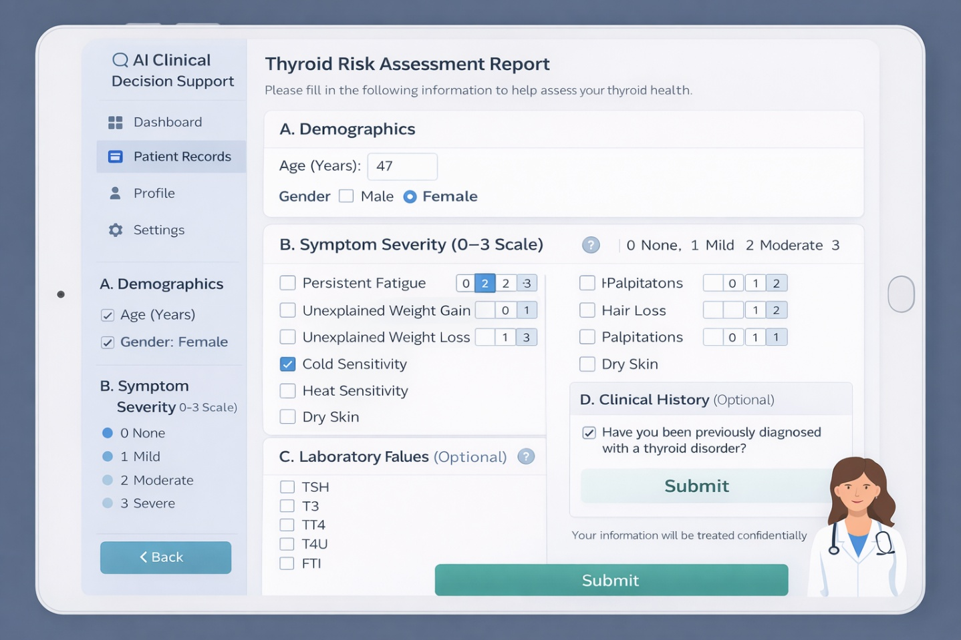
Figure (2.6.1): Assessment Sheet
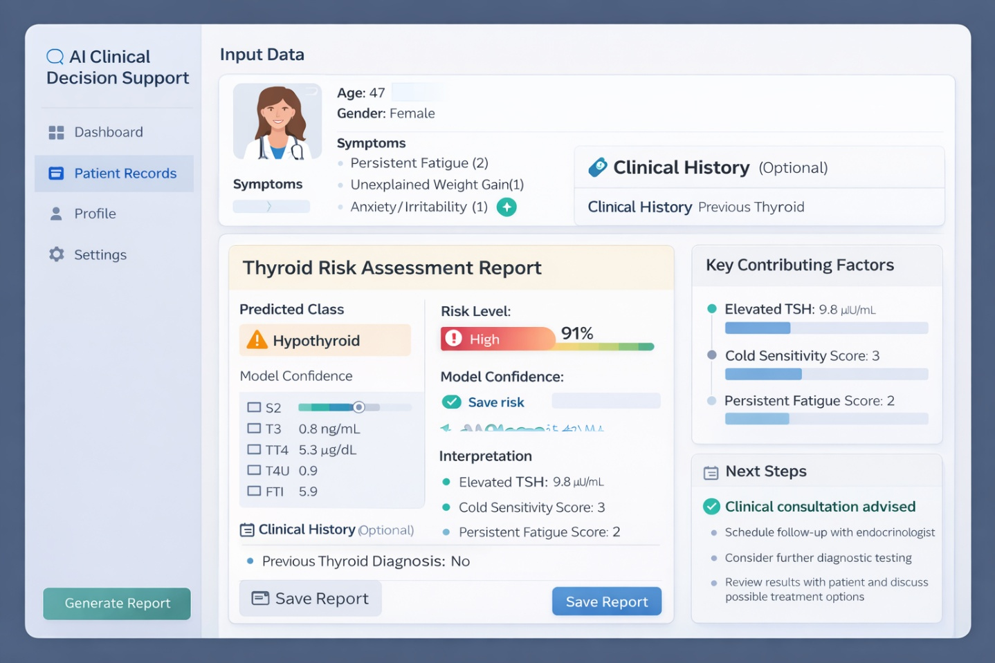
Figure (2.6.2): Assessment Result

The system provides a clinical decision-support tool, guiding users’ step by step through entering their data. As shown in Figure 2.6.1, it begins with basic demographic info like age and gender, which are important for evaluating the thyroid. The main data input is a symptom checklist that includes things like fatigue, weight changes, palpitations, and temperature sensitivity. Each symptom is rated on a scale from 0 (none) to 3 (severe). This setup helps turn subjective symptoms into data that the system can analyze.

Also, users can optionally add lab results such as TSH, T3, T4, and related markers. These reflect the biochemical aspect of thyroid testing and follow usual clinical practices. Putting symptoms and lab data together in one place helps fill a common gap where these are often handled separately. Adding clinical history is optional but gives more context and keeps the system flexible.

Once the data is submitted, the system processes it and generates an output (Figure 2.6.2) that includes the predicted thyroid condition (e.g., hypothyroidism or hyperthyroidism) and a percentage-based risk level, which is more intuitive than a simple label.
The output also provides a clear analysis of findings, linking lab results to clinical symptoms, along with suggested next steps such as consulting a doctor or conducting further tests.

In short, these mockups illustrate the study’s goal of integrating symptom assessment and lab results into a clear, interpretable system. Rather than focusing only on accuracy, the design emphasizes usability, clarity, and clinical relevance, showing how machine learning can support real clinical workflows in a transparent and practical way.

Chapter 3: Proposed Approach (Methodology)

Chapter 4: Experimental Results and Discussion

Chapter 5: Conclusion and Future Work

References

[Alshamrani, M., et al., 2023]
Alshamrani, Mohammed, Abdullah Alqahtani, and Fahad Alzahrani. “Machine learning approaches for thyroid disease prediction: A comparative analysis”. IEEE Access 11. 2023.
https://scholar.google.com/scholar?q=machine+learning+approaches+for+thyroid+disease+prediction+comparative+analysis+2023

[Biondi, B., & Cappola, A., 2021]
Biondi, Bernadette, and Anne R. Cappola. “Subclinical thyroid disease: Clinical relevance and management”. The Lancet Diabetes & Endocrinology 9. 2021.
https://scholar.google.com/scholar?q=Subclinical+thyroid+disease+clinical+relevance+and+management+2021

[Chiovato, L., et al., 2023]
Chiovato, Luca, Francesco Antonelli, and Paolo Vitti. “Thyroid disorders and their management: Recent advances in diagnosis and treatment”. Endocrine Reviews. 2023.
https://scholar.google.com/scholar?q=thyroid+disorders+diagnosis+and+treatment+2023

[Dua, D., & Graff, C., 2019]
Dua, Dheeru, and Casey Graff. “UCI Machine Learning Repository”. University of California, Irvine. 2019.
http://archive.ics.uci.edu/ml

[Esteva, A., et al., 2021]
Esteva, Andre, Alexandre Robicquet, Bharath Ramsundar, et al. “A Guide to Deep Learning in Healthcare”. Nature Medicine 27. 2021.
https://scholar.google.com/scholar?q=guide+to+deep+learning+in+healthcare+2021

[Islam, M. M., et al., 2022]
Islam, Md Mahmudul, Tanvir N. Poly, Buthaina Alsinglawi, Li-Fang Lin, Shu-Chen Chien, Jian-Cheng Liu, and Yu-Chuan Li. “Machine learning approaches for thyroid disease prediction: A comparative study”. Healthcare 10. 2022.
https://www.mdpi.com/2227-9032/10/1/59

[Jiang, F., et al., 2022]
Jiang, Fei, Yong Jiang, Hui Zhi, Yi Dong, Hao Li, Shanshan Ma, Yang Wang, Qiang Dong, Houbing Shen, and Yongjun Wang. “Artificial intelligence in healthcare: Past, present and future”. Stroke and Vascular Neurology 7. 2022.
https://scholar.google.com/scholar?q=Artificial+intelligence+in+healthcare+past+present+and+future+2022

[Khan, M. A., et al., 2024]
Khan, Muhammad A., Saeed Anwar, and Fahad Alghamdi. “Recent Advances in Machine Learning Applications for Endocrine Disease Prediction”. Artificial Intelligence in Medicine. 2024.
https://scholar.google.com/scholar?q=machine+learning+endocrine+disease+prediction+2024

[Miotto, R., et al., 2021]
Miotto, Riccardo, Fei Wang, Shuang Wang, Xiaoqian Jiang, and Joel Dudley. “Deep Learning for Healthcare: Review, Opportunities and Challenges”. Briefings in Bioinformatics 22. 2021.
https://scholar.google.com/scholar?q=deep+learning+for+healthcare+review+opportunities+and+challenges

[Rajkomar, A., et al., 2022]
Rajkomar, Alvin, Jeffrey Dean, and Isaac Kohane. “Machine learning in medicine”. New England Journal of Medicine 380. 2022.
https://scholar.google.com/scholar?q=machine+learning+in+medicine+rajkomar

[Ross, D. S., et al., 2016]
Ross, Douglas S., Henry B. Burch, David S. Cooper, Michael C. Greenlee, Peter Laurberg, Ana Luiza Maia, Scott A. Rivkees, Marvin Samuels, Julie A. Sosa, Marius N. Stan, and Martin A. Walter. “2016 American Thyroid Association guidelines for diagnosis and management of hyperthyroidism and other causes of thyrotoxicosis”. Thyroid 26. 2016.
https://www.liebertpub.com/doi/full/10.1089/thy.2016.0229

[Sendak, M., et al., 2021]
Sendak, Mark, William Gao, Nigel Brajer, and Suresh Balu. “Machine Learning in Health Care: A Critical Appraisal of Challenges and Opportunities”. NPJ Digital Medicine 4. 2021.
https://scholar.google.com/scholar?q=machine+learning+health+care+challenges+opportunities+sendak

[Shen, J., et al., 2023]
Shen, Jian, Yuan Li, and Xiaolin Chen. “Applications of Machine Learning in Endocrine Disease Prediction: A Systematic Review”. Frontiers in Endocrinology 14. 2023.
https://scholar.google.com/scholar?q=machine+learning+endocrine+disease+prediction+review+2023

[Sutton, R. T., et al., 2020]
Sutton, Russell T., David Pincock, Daniel C. Baumgart, David C. Sadowski, Richard N. Fedorak, and Karen I. Kroeker. “An overview of clinical decision support systems: Benefits, risks, and strategies for success”. NPJ Digital Medicine 3. 2020.
https://www.nature.com/articles/s41746-020-0221-y

[Topol, E., 2019]
Topol, Eric J. “High-Performance Medicine: The Convergence of Human and Artificial Intelligence”. Nature Medicine 25. 2019.
https://scholar.google.com/scholar?q=high+performance+medicine+human+artificial+intelligence

