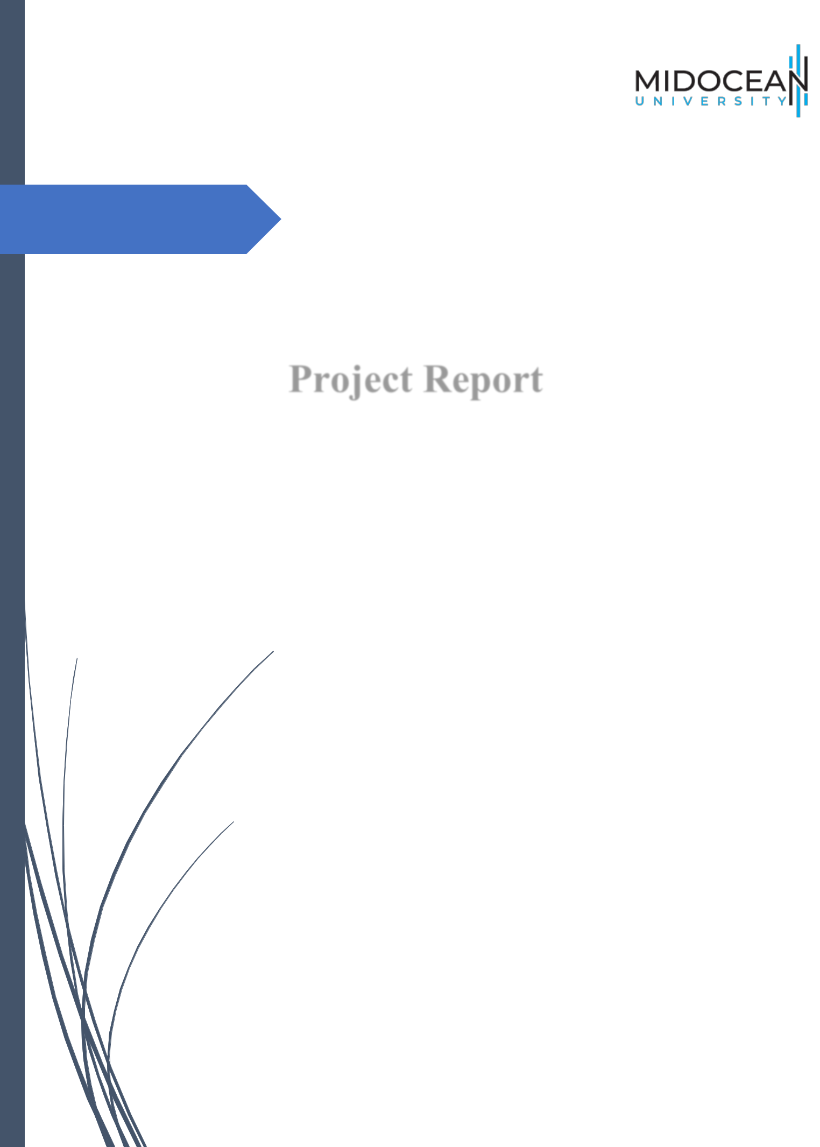

Final Project 2

PMG 697

Project Report
(CH 1 & 2 Only!)

Dr. Al-Faisal Hasan & Dr. Fayez Jarad

MIDOCEAN UNIVERSITY


Midocean University

Faculty of Management

Master of Project Management

Strategic Optimization of Drilling and Completion

Operations to Reduce Construction Costs:

A Case Study of Saudi Aramco Projects in Dhahran

Haitham Al-Haj

ID # 2021202510

Graduation Project - 2

Faculty of Management - Midocean University

Supervisors

Dr. Al-Faisal Hasan & Dr. Fayez Jarad

Faculty member- Faculty of management- Midocean University

25th August 2025


Eng. Haitham Al-Haj



Eng. Haitham Al-Haj

- Chapter 1: Introduction

1.1. Research Background

Normally the operations in the oil and gas sectors are complex and with extra level of uncertainty. Additionally, a big level of investment is needed with a high risk in both HSE and the people who are running the projects. As such type of projects will be run by oil and gas operators, service companies and third parties, cost control will be an important subject to be addressed before, during and post to the project completion as a summary or lesson learned to be avoided in the future. The cost control will need to be closely monitored, but without affecting the quality of the project as well as the HSE factors, as per the global standards and guidelines, which are important to be taken hand in hand. In the drilling operation, the cost discussion will be more important, as it will be as make or break factor, which will determine if the investors can continue funding the current project, or the project will be terminated, and the fund can be allocated for other more secure projects. Referring to (Agbon, 2002), the sustainability of drilling in oil and gas projects, is all about cost effective.
We can notice the increase in the demand for hydrocarbons globally, which results in increasing the number of drilling and explorations for both oil and gas, along with developing the current wells, to have more productivity over its expected life, while maintaining the cost, closely monitored and while introducing new technologies, which will help in increasing the level of operational accuracy, reducing unpredictable risks and uncertainty in operations as well. Using the new technology in tools, as provided by various international service companies, comes with an additional cost, which will increase the amount of money allocated by the operator and investors per project, and result in reducing the percentage of expected revenue and net profit, once the project is completed and production starts. Increasing the funds needed and allocating money per project is not easy to justify and is being accepted by both the oil and gas operators and investors. As a result, a lot of projects, both locally, regionally and internationally, ended up hitting pauses, for further evaluations and justifications, and to decide by the stakeholders, if it was worth extra fund, or not (Aggarwal & Kaldi, 2018).
In the last few decades, the drilling and explorations for hydrocarbons has increased, to fit for the global hunger for energy. As a result, a lot of service companies and contractors proposed their various latest technologies and cutting-edge products, and tools, to make the project cycle shorter, by faster the drilling and completions operations to meet the assigned projects KPIs. On the other hand, the price for this new technology, especially if the provider is a single source for the operator, makes their prices for their service provided and tools more expensive. As a result, it created a challenge for the investors and operators, to balance between the gained efficiency, added value and risk reduction against the extra financial hit from utilizing such high-tech tools, services and solutions (Aggarwal & Kaldi, 2018).
As mentioned above, we have noticed the improving the strategies of decision making and the process, during the various projects for oil and gas drilling and completions, is the best approach, while having an eye on the overall cost involve, safety and the quality for each step, involved to make the projects done and completed as planned, and earlier agreed by various stakeholders teams (Al-Bani et al., 2007).
Another issue came to surface, which is the scarcity of the skilled expertise who can both utilize the new technology, while improving budgets sustainability. As a result of that, we have noticed a lot of inefficient projects, delays in completion as planned, frustration between the team members and increased level of accident, incidents which delay the projects from being finished as per the agreed timeline and lead to misplaced priorities (Oag & Williams, 2000).
As the level of both complexity and trouble shoots has increased, a concern has increased in front of both operators, and stakeholders, and doubts about whether the current type of methods and traditional approaches can last or not (Hossain & Al-Majed, 2015, pp. 227–247).
Dealing with Saudi Aramco various teams, is not easy, as of the list of high standards, proven global success track records, as well he level of expertise, who are both technically and operationally can support any proposal made for various teams in Aramco, to be evaluated, prior to given the right chance to trial test, on a life projects, while calculating both the risk factors as well as investment involved and adding benefits for the overall projects, was not an easy step nor unplanned approach (Ikediashi et al., 2014).
This study summarizes the expertise of the researcher, in the oil and gas sectors, specially dealing with global operators, like Saudi Aramco, on how specific optimizations steps in both drilling and completions can reduce the well construction cost. Additionally, by having a real example of work that was done for both onshore and offshore sites for Saudi Aramco and numerous meetings in all the levels for both introducing new technologies, getting them trial test and approved as per Saudi Aramco standards and contracting guidelines (Shammas, 2000).

1.2. Research Problem

Drilling and completions projects, normally, are known for their difficulties and high level of complexity in their processes. One of the notified costly problems is failure to execute tasks and assigned jobs correctly, at the first time, which can result in several repetitive steps, NPTs and extra cost, per project, more risk exposures and with a level of high probability to either stop the current on-going activities or to terminate the whole project.
Seddeeq et al. (2019) mentioned that minor mistakes, can be major if no control measures were taken, or corrective actions. This can result in delaying the project being completed as planned and extra funds and approvals being needed to cover all the accumulated issues and problems. What we can learn from that is the importance in smooth operations, less mistakes, or minor issues, before it is accumulated and became bigger, resulting in major changes or decisions which can result in a big additional cost or losing the whole investment allocated per drilling and completion project.
We have reviewed all the previous studies both locally and regionally, additional to globally as well. We conclude that, while we found several academic literatures that discussed the efficiency in drilling and the importance of cost management and control, there is a big gap between both the current existing theoretical models and their practical applications, by various groups of operators and specifically, Sudi Aramco. As a result, I have focused on my research to write down my study, aiming to mention and focus on two main gaps, which are: the scarcity of published case studies and the lack of detailed analysis of the optimizations efforts within Saudi Aramco, particularly for projects that focuses on drilling and completions.

1.2.1. Theoretical Gaps

There is a noticeable theoretical gap regarding the implementation of various optimizations strategies that are related to drilling and completion projects for both on and offshore operations. Such gap, can lead to using conventional solution and outdated techniques, while sacrificing the project successes, because of its limitations. Such conventional solutions can keep the cost low, but, while increasing the risk of the operations, reducing the performance level and using unskilled manpower to run the project, which can result in not meeting the overall KPIs, once the project is presented for post implementation evaluation and review (Abdullah et al., 2011).

1.2.2. Practical Gaps (Empirical Gaps)

There are a few field-based research, discussing and presenting the actual time and cost savings resulted from implementing the strategy and skills of optimization in drilling and completion at an early stage. Discussing all the issues that related to operation at the end of the project lifetime, or once the project is completed, might double the cost per operations and late the influence of correction and right decision to be taken by the project manager, stakeholders, and Saudi Aramco various cost control teams.
This study, focusing on sch gaps, by providing a real example that, implementing an early-stage optimization, supported by a continues monitoring, can result in avoiding problems, extra cost, and ensure a smooth operation in a full free risk working environment.

1.3. Research Significance

This study investigates the integration of optimization techniques in the drilling and completion projects, by contributing both theoretical discourse and practical applications (Solares, 2001). It shows how these strategies and techniques can improve planning, budgetary control and create a culture of cost consciousness.

1.3.1. Theoretical Significance

This study offering and proposing a framework for improving well constructions process and activities within Saudi Aramco. It focuses to build a level of proactive techniques in optimization for the drilling and completions projects at Saudi Aramco.

1.3.2. Empirical Significance

This study provides empirical evidence of minimizing the repetitive and main causes for any non-productive time (NPT), lowering the cost per operations, and enhancing and improving the tool and technology reliability per drilling and completion projects.

1.4. Refined Main Research Question
- How can early-detection optimization techniques reduce well construction costs in oil and gas projects while minimizing operational issues, maintaining efficiency, avoiding additional risks, and adhering to budget constraints for Saudi Aramco?
1.4.1. Refined Main Research Sub-Questions
- What is the measurable impact of optimization on the financial performance of oil and gas operations?
- What role does workforce empowerment play in achieving cost and budgetary objectives through optimization?
- What outcomes are observed when cost-conscious organizational habits are integrated with optimization strategies?
1.5. Refined Research Objectives
Overall Goal:
- To make an analysis of how optimization can contribute to reduce well construction costs for Saudi Aramco.
Specific Objectives:
- Assess the relationship between optimization and operational efficiency for Saudi Aramco drilling and completions projects.
- Evaluate the importance of optimization in strengthening budgetary control and to improve the performance of finical for Saudi Aramco drilling and completions projects
- Explore cost-conscious practices in project management, in Saudi Aramco.
1.6. Refined Research Hypotheses

Main Hypothesis (H1):
- The implementation of optimization techniques is positively and significantly associated with reducing operation costs for oil and gas well constructions projects for Saudi Aramco.
Sub-Hypotheses:
- Ha: Optimization techniques lead to savings in oil and gas investments, SA.
- Hb: Positive correlation exists between optimization and improving cost-awareness within SA project management teams.
- Hc: Optimization strategies are closely connected with reduction in cost overrun incidents, within SA.

1.7. Research Model

This study proposes a conceptual model, that tests and examines the relationship between optimization in processes as an independent variable and cost reduction outcomes (the dependent variable) in the oil and gas projects for Saudi Aramco (SA).
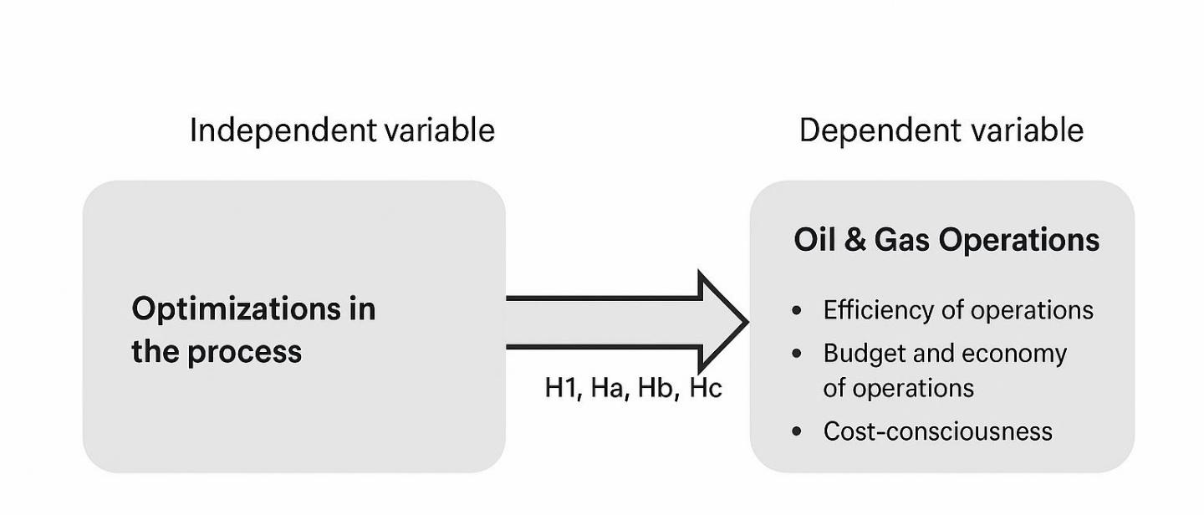

Figure 1. Proposed research model showing the effect of optimization in processes on oil and gas operations (The Researcher, 2025)
1.8. Research Proposed Location

This study took place in Dhahran, which located in the eastern province of Saudi Arabia and known as the head office for Saudi Aramco operations, for drilling and completion projects in the oil and gas for both onshore and offshore working sites.

1.9. | The Project Structure
Table 1. Suggested Research Structure
Chapter |  | Section Title
1 |  | Introduction
2 |  | Literature Review
3 |  | Research Methodology
4 |  | Statistical Analysis
5 |  | Findings, Discussion, and Conclusion

Note. “Suggested Research Structure” (The Researcher, 2025).

- Chapter 2: Literature Review

2.1. Introduction

This chapter begins with the examination of the independent variable, which is optimization strategies, followed by the discussion and presentation for the three dependent variables, which are: cost consciousness, budgetary and economic performance, and operational efficiency.
The data and analysis were made focused on Saudi Aramco’s Dhahran operations, as a pioneer and global lead operator for the oil and gas worldwide sector.

2.2. The Independent Variable

2.2.1. Literature Review- Independent Variable: The Optimization Process

2.2.1.1. Introduction

Drilling and completions operations, facing huge pressure from operators, investors and stakeholders, to reduce its involved cost and amount of funds needed to run its projects, especially prior to production phase. As a result, multiple ways to share the cost has been formed by the operators, to distribute the cost the overall cost involves and funds needed, among variable parties, in a form like joint venture, or partnerships, to reduce the overall financial and operational loads.

As a result, to achieve and secure total optimization across all operations, has been shifted from optional to mandatory, to guarantee sustainability of operation and the continuity of investments and operations with no suspending issues and with ensuring long term resilience. For oil and gas projects for a global lead like Saudi Aramco, it is important to balance between operational integrity and cost reduction.

2.2.1.2. Definition

Optimization mainly focuses on a group of activities, that result in maximizing the outcomes and minimizing waste or losses, from a certain process or a certain project, while keeping in mind all the constraints like resources and their availability, boundaries for the operations and financial limitations of the project. Optimizations link both mathematics, engineering and management, by presenting the most intelligent solution within a well-defined parameter.

2.2.1.3. Development

The process of selecting the most appropriate optimization methodology will require a deep and close look, to identify the main characteristics for the given problem. Commonly used techniques include nonlinear programing, linear programming, dynamic programing and goal programing.

2.2.1.4. Applications and Practical Insights

By reducing drilling time, decreasing rig downtime, and improving drilling and completion performance in challenging work environments, on both on and offshore operational sites, is considered a clear example of optimization in the oil and gas industry. Utilizing various methods like diagnostical analysis, root cause identifications and benchmarking, started to become an improved standard solution, by the project management team. Furthermore, introducing a operational research tools, like Critical Path Method (CRM), Queuing, aligned with improvement in the supply chain techniques, contributes knowingly to managing both workforce and logistics operations. To improve the outcomes in both upstream, downstream and midstream projects, we can still reply on approaches grounded in consumption standards and linear programming.

2.3. The Dependent Variables

2.3.1. Literature Review – First Dependent Variable: Efficiency of Operations

2.3.1.1. Introduction

Managing a high level of operational proficiency in the oil and gas industry can result in achieving extremely competitive advantages between various players. It was noticed that in the sub-optimized operations and working environment, this can frequently lead to resource misallocation, increasing costs, and level of repetitive work as well (Mohamed Khodja et al., 2010).

2.3.1.2. Definition

If we need to explain the relationship between the inputs and outputs, on a certain organizational process, then we need to define the operational efficiency level. We can approach the maximum on operational efficiency when the desired outputs are achieved while minimum time, efforts and cost are utilized per project. It simply focuses on presenting and showing the capacity of a specific organization in utilizing its assets in a productive way, by creating goods or services, eliminating extra unplanned costs, and improving overall performance.

2.3.1.3. Development

Global oil and gas operators, Saudi Aramco for example, are focusing not to save efforts in improving the level of their operational efficiency, additionally to reduce their waste, standardizing their processes, and to optimize their deployment for technology and human capital. A few examples of key levers include production management, logistics, inventory control, and quality assurance. The importance of such elements increases, in a highly competitive environment, with limited resources (Khodja & Bergaya, 2010).

2.3.1.4. Theoretical Framework

By focusing on two models, which are the theory of Swift and the theory of performance, we can have the needed foundation for understanding efficiency. Simply the theory of Swift, focusing on productivity increases by minimizing variation and bottlenecks, while the theory of performance tests the upper limits of performance within a given set of limitations and constraints. These two theories can guide the strategic trade-offs in a complex sector like oil and gas.

2.3.1.5. Dimensions of Operational Efficiency

For oil and gas companies, it is mandatory to improve their operational efficiency. While operational efficiency has a multi-dimensional approach, like flexibility, consistency and productivity. Simply we can define organizational flexibility as its adaptability to various external changes, and we can define consistency as the reliability and steadiness of outcomes overtime. Furthermore, we can increase productivity as a measure to the output yielded per unit input. In the oil and gas industry, it is not easy to master theses three dimensions, and it is critical determinant of competitiveness (Muñoz et al., 2016).

2.3.1.6. Practical Applications and Frameworks

The PPT framework consists of three main elements, which are People, Process and Technology. It basically focuses on the alignment of experts and skilled personnel, streamlined processes and enabling new technologies. By referring to Figure 2, below, we can notice that these elements are interdependent. The PPT framework is used to identify performance gaps, heling in mitigating risks, and used in driving continues improvement.
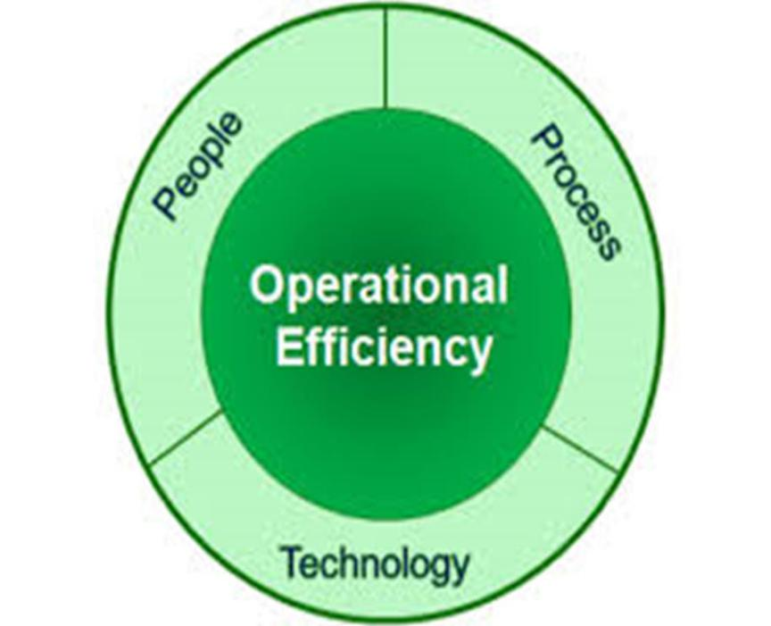

Figure 2. The Three Pillars of Operational Efficiency
Note. This figure shows the key parts of efficiency: people, process, and technology. Based on Mustafa et al. (2021)
2.3.1.7. Practical Strategies to Enhance Operational Efficiency
In order to convert theory into a successful practice, it requires several actionable strategies. Since we are focusing on oil and gas industry, mostly oil and gas firms focus on integrated technologies, the development of workforce and continuity in improvement. Key interventions include:
- Using data for benchmarks and SMART goals to align outcomes and engage staff.
- Automating routine tasks to free up experts for big-picture work.
- Building open communication for feedback, collaboration, and morale.
- Digital tracking to spot inefficiencies and prioritize.
- Encouraging teamwork through meetings and cross-functions.
- Finding bottlenecks via assessments and redesigns.
- Hiring talent and training to cut errors.
- Prioritizing customer service for satisfaction.
- Choosing fitting tech for cost savings and speed.

Table 2. Nine Steps to Improve Operational Efficiency
Step | Description
Step 1 | Use Performance Data to Set Benchmarks
 | and Goals
Step 2 | Implement Automation
Step 3 | Create Open Lines of Communication
Step 4 | Adopt Digital Time Tracking
Step 5 | Encourage Employee Collaboration
Step 6 | Identify Bottlenecks in the Processes
Step 7 | Hire the Right People and Train Them Well
Step 8 | Focus on Service
Step 9 | Choose the Right Technology

Note. Based on Brett and Millheim (1986).

2.3.2. Literature Review – Second Dependent Variable: Budget and Economy of Operations
2.3.2.1. Introduction

Being able to budget oil and gas projects is a critical aspect, to make them sustainable and to be without any delay, especially with increase in operational costs and scarcity of resources. Monitoring financial resources, economic changes in the global, changes in supply and demand through the project’s lifecycle, while allocating all the needed resources on time, are part of the main definitions under budgeting. A comprehensive framework for budgeting is important for decision-making as well as getting the required support from the stakeholders.

2.3.2.2. Definition

With a full detailed and explained budget, including expected and projected revenues over the project lifetime, or on an annual cycle. Simply in the oil and gas projects, including all the listed activities from explorations, drilling, completions, to productions of hydrocarbons. Additional it will include all the supportive activities, and the predictive cost for any corrections once needed to be implemented as well., to reduce the level of uncertainty or waste in time while trouble shooting is made.

2.3.2.3. Development

We can prepare budget either annually or prior to major expenditures per project. It normally consists of direct and indirect costs, fixed and variable expenses, and additionally, the revenue projections over the lifetime of the oil and gas projects, under certain conditions and limitations. Hence, we still need to compare the actual financial performance against the budget as a cost control tool and to help us with timely adjustments and quicker decision making.

2.3.2.4. Theoretical Approaches

Referring to Sarbu (2011), who outlined two main cost estimation models which are:
(a) operating as direct production + fixed + overhead; &
(b) total OPEX as operating + general.
We can use the two above models as a basis for budget construction and a way for financial tracking in our oil and gas projects.

2.3.2.5. Dimensions
To have a form of effective forecasting, better financial control and better managerial accountability per project, we will need to have a way of comprehensives budgeting, which includes forecasts, well drilling and completion budgets, and a projected cash flow, both inflow and outflows.
2.3.2.6. Practical Tools

Projects managers normally using software solutions to facilitate their planning within oil and gas industry. Such software is integrating market analysis, capital expenditure (capex), forecasting, and various scenario modeling, to help and build and improve decision-making processes for the project managers. One example is CCH Tagetik, which is further explained on the table below.

Table 3. CCH Tagetik Planning for Oil and Gas Projects (Alnahash et al., 2020)

Feature |  | Description |  | Benefits to Oil & Gas
Feature |  | Description |  | Projects
 |  | Enables creation and monitoring of |  | Helps control costs and
Budget Management |  | detailed budgets across multiple project |  | Helps control costs and
Budget Management |  | detailed budgets across multiple project |  | avoid budget overruns.
 |  | phases. |  | avoid budget overruns.
Forecasting & |  | Provides dynamic forecasting tools and |  | Supports proactive
Forecasting & |  | what-if scenarios to predict project |  | decision-making and risk
Scenario Analysis |  | what-if scenarios to predict project |  | decision-making and risk
Scenario Analysis |  | outcomes. |  | mitigation.
 |  | Manages assignment of personnel, |  | Optimizes resource
Resource Allocation |  | equipment, and materials based on |  | utilization and reduces
 |  | project needs and availability. |  | downtime.
Risk Assessment & |  | Integrates risk factors and regulatory |  | Ensures safer operations
Risk Assessment & |  | Integrates risk factors and regulatory |  | and adherence to industry
Compliance |  | requirements into the planning process. |  | and adherence to industry
Compliance |  | requirements into the planning process. |  | standards.
Performance |  | Tracks key performance indicators |  | Enables timely
Performance |  | (KPIs) in real time for ongoing project |  | interventions and
Monitoring |  | (KPIs) in real time for ongoing project |  | interventions and
Monitoring |  | evaluation. |  | continuous improvement.
Collaboration & |  | Facilitates communication among teams |  | Enhances coordination and
Workflow |  | and automates approval processes. |  | reduces administrative
Automation |  | and automates approval processes. |  | delays.

As in Table 3, it covers budget management, forecasting, allocation, risk, KPIs, and workflows for better control and efficiency.

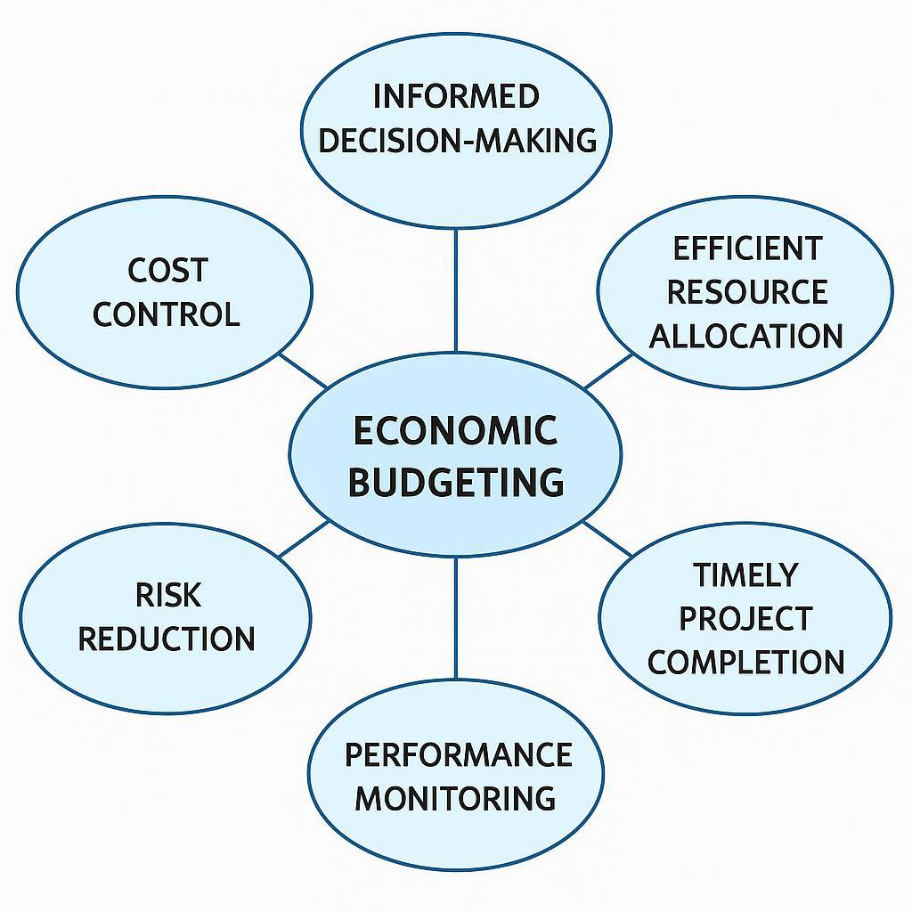

Figure 3. Key Benefits of Economic Budgeting in Projects (Ahmed et al., 2007)
Figure 3 explained the key benefits of the economic budgeting for the oil and gas projects. The benefits of robust economic budgeting include:

- Reduced planning cycle time
- Optimized resource utilization
- Better alignment between financial and operational functions
- Increased the accuracy level and control
- Lowering the total cost of ownership (TCO)
- Modernization of the financial system

Moreover, budgeting enhances internal communication, coordination, motivation, accountability, and strategic execution.

- A shorter planning cycle time
- Optimal use of resources
- Improved coordination between the operational and financial departments
- Better control and accuracy
- A reduced total cost of ownership (TCO)
- The financial system’s modernization
Additionally, budgeting improves accountability, motivation, coordination, internal communication, and strategic execution.

2.3.3. Literature Review-Third Variable: Cost-Consciousness

2.3.3.1. Introduction
If we are looking to represent an organizational culture where various project teams maintain a continues and smooth focus on eliminating waste, exercising various ways for financial discipline, and while utilizing resources in the best way, then we are talking about Cost-consciousness. Cost-consciousness is considered as a critical success factor for every and each oil and gas project, and to guarantee its sustainability, especially for a big investment volume as in oil and gas industry, where its importance and better understanding became more critical (Oag & Williams, 2000).

2.3.3.2. Definition
We can define cost-consciousness as a project team dedication to the sensible use of resources and to avoid unneeded expenses throughout the project lifetime.
2.3.3.3. Development
Once a project team has a clear goal setting mechanism, especially for activities related to budgeting, and team member responsibilities in all the activities which relate to expenses and utilizing resources per projects, as provided by the organization as a high level of awareness and understanding.

2.3.3.4. Theories
It is beyond cost-cutting per project. It is a continues process of improvement with no waste for a sustainable project and adding value while the idea of minimizing expenses over the lifetime of the projects.
2.3.3.5. Dimensions

The process of managing both fixed costs and variable costs by effective control measures of both categories to maintain overall cost control objectives. Simply we can define fixed costs as stable overhead costs, while variable costs as costs which fluctuate within project scope.

2.3.3.6. Applications
By implementing cost-tracking tools, providing financial literacy training, and real-time access to full budgetary information, this is what we meant by practical application principle.

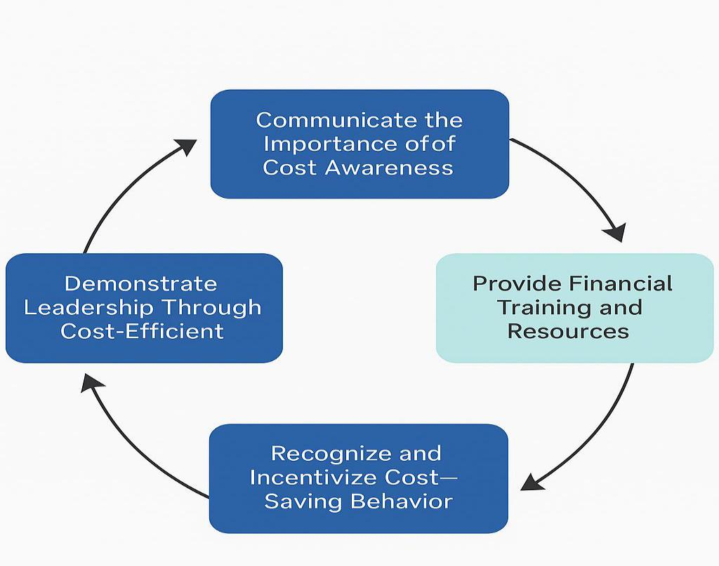
Jenkins and Crockford’s (1975) model (Figure 4) representing practical application as a cycle of communication, training, incentives, improvement, and leadership.

Figure 4. Culture of Cost Consciousness Based on Jenkins and Crockford (1975)

Note. This model shows a cycle for cost-conscious behavior: strategy talk, training, incentives, improvement, and leader examples. Each part builds a lasting culture.
2.4. The Relationship Between the Independent and Dependent Variables

2.4.1. Overview
We can summarize optimization as a strong positive relationship with operational efficiency, budgetary performance and cost-consciousness.
The above relationships influence productivity, profitability, and strategic decision-making within the oil and gas sector, which is considered as one of the highest investment sectors in the industry.

2.4.2. Patterns
By having an early integration of various optimization strategies, the project team can have better performance visibility, reducing the waste per project, and supporting accurate budgeting (Lukawski et al., 2014).
2.4.3. Conflicts
Issues Inadequate initial planning, and delay in applying corrections, will result in frequent challenges arises during the lifetime of the project. Furthermore, minimum stakeholder involvement, and the communication gap between the project team members, will delay taking the right action at the right time.
2.4.4. Gaps
This study aims to address the gap, by empirically examine the relationship between different variables, its synergy effects within Saudi Aramco’s well operations in Dhahran.
2.5. Conclusion
Overall, this study indicates a positive correlation between optimization and the key dependent variables which are operational efficiency, budgetary performance and consciousness in the oil and gas sector. The following chapters of this research will seek to validate theses relationships through case studies from Saudi Aramco. The final goal will be to generate practical, actionable and feasible recommendations for the global oil and gas industry.

End of Chapter One and Two!

Best regards,
Haitham Al-Haj

