

AI-Powered Voice Agent for Saudi Labor Law Inquiries

Prepared By
Name: Hussam Almokayed ID No. 253001038
Name: Fatimah Aldeghaither ID No. 253000292

Submitted in fulfillment of the requirements for the degree Master of Science in Artificial Intelligence
At
College of Informatics, Midocean University, UAE.
Supervisor Name: Dr. Hager Saleh

Table of Contents
Abstract 5
List of Abbreviations 6
Chapter 1: Introduction and Overview 7
1.1 Introduction 7
1.2 Problem Definition 7
1.3 Thesis Objectives 8
1.4 Thesis Contribution 8
1.5 Thesis Organization 9
Chapter 2: Background and Related Work 11
2.1 Introduction and Background 11
2.1.1 Artificial Intelligence (AI) 11
2.1.2 Machine Learning (ML) 11
2.1.3 Deep Learning (DL) 11
2.1.4 Natural Language Processing (NLP) 12
2.1.5 Large Language Models (LLMs) 12
2.1.6 Retrieval-Augmented Generation (RAG) 12
2.1.7 Automatic Speech Recognition (ASR) 12
2.1.8 Text-to-Speech (TTS) 12
2.1.9 Word Error Rate (WER) 12
2.1.10 Role of AI in the Voice Agent System 12
2.2 Related Work 13
Review of Related Work 13
Chapter 3: Methodology and Proposed Framework 18
3.1 Introduction 18
3.2 Dataset Description 21
3.3 Data Collection and Web Scraping 24
3.4 Data Preprocessing 25
3.4.1 Schema Standardization and Data Integration 25
3.4.2 Arabic Text Cleaning and Normalization 26
3.4.3 Archiving and Exclusion of Repealed Articles 27
3.4.4 FAQ Cleaning and Leakage-Safe Splitting 27
3.4.5 Near-Duplicate Detection 28
3.4.6 Text Segmentation and Source Traceability 29
3.5 Knowledge Base and Retrieval System 30
3.5.1 Embedding and Indexing 30
3.5.2 Retrieval Algorithms 30
3.6 Hybrid RAG, Reranking, and Reliability Gate 33
3.7 Answer Generation Module 33
3.7.1 Intent and Reliability Gates 33
3.7.2 Language Models and Prompting Strategy 34
3.7.3 Deterministic Legal Calculation Layer 34
3.8 Deterministic Calculation Triggering Conditions 35
3.9 Calculator and RAG Evidence 36
3.9.1 Reliability Threshold Calibration 37
3.10 Reliability Threshold Calibration Selection Criterion 37
Reliability Gate Decision Process 37
3.11 Voice Processing Layer 38
3.12 Conversational Memory Module 38
Memory Design: Conversation Memory versus Retrieval Memory 39
3.13 Evaluation Methodology 39
3.13.1 Retrieval Evaluation Metrics 39
3.13.2 Answer Generation Metrics 40
3.13.3 Voice and Latency Metrics 42
3.13.4 Statistical Testing and Ablation Metrics 43
3.14 Experimental Setup and Reproducibility 44
3.15 Summary 45
Chapter 4: Results and Discussion 46
4.1 Introduction 46
4.2 Experimental Setup 46
4.2.1 Technical Environment 46
4.2.2 Software Libraries and Versions 47
4.2.3 Data Split and RAG Parameters 48
4.3 Data Preparation Results 51
4.4 Retrieval Evaluation Results 52
4.4.1 Evaluation Sets and Sample Sizes 52
4.4.2 Comparison of Retrieval Methods 52
4.4.3 Final Legal Retrieval Test 53
4.4.4 Supplementary Robustness Check (Auto-Generated Legal Set) 54
4.5 Answer Generation Results 55
4.6 Statistical Evaluation 56
4.7 Voice Layer Results 57
4.8 No-RAG versus RAG Ablation 57
4.9 Latency Results 59
4.10 Deterministic Calculation Layer Implementation Checks 61
4.11 Overall Results Summary 61
4.12 Discussion 63
4.13 Limitations 64
4.14 Summary 64
Chapter 5: Conclusion and Future Work 66
5.1 Conclusion 66
5.2 Contributions 66
5.3 Limitations 67
5.4 Future Work 67
5.5 Closing Remarks 68
References 69
Appendix A: Automated Evaluation Rubric and Judge Prompt 72
Appendix B: Data-Lineage and Deduplication Record 73

Abstract
Uses of new large language models (LLMs) and retrieval-augmented generation (RAG) have made it possible to create question-answering systems that produce contextually appropriate, evidence-based answers. Combined with automatic speech recognition (ASR) and text-to-speech (TTS), these technologies can be used to aid in interactive voice-based assistance in sensitive applications like legal information services. However, their application in Arabic legal contexts remains challenging because dialectal Arabic speech recognition is error-prone, grounding responses in authoritative sources while mitigating hallucinations remains difficult, and spoken interaction requires low response latency.
This thesis presents the design and evaluation of an evidence-grounded Arabic voice agent for Saudi Labor Law inquiries. The proposed system integrates Whisper-based ASR, a versioned knowledge base constructed from the official Saudi Labor Law and materials published by the Ministry of Human Resources and Social Development, hybrid dense and BM25 retrieval, cross-encoder reranking, a reliability gate calibrated using validation data, locally hosted instruction-tuned language models, a deterministic legal-calculation module, and Arabic TTS. The frozen experimental knowledge-base snapshot contained 211 records corresponding to legal articles marked as active and 278 indexed labor-related FAQ records.
On a manually curated legal retrieval test set comprising 24 questions, the final retrieval pipeline achieved Recall@1 = 0.8750, Recall@5 = 0.9583, MRR = 0.9097, and nDCG@5 = 0.9221. Following the application of the reliability gate, ALLaM-7B answered 37 of 45 questions correctly, achieving 82.22% accuracy, compared with 32 of 45 questions, or 71.11%, for Qwen2.5-7B. An exact paired McNemar test indicated that the observed difference was not statistically significant (p = 0.1250). In a 24-question ablation study, incorrect legal citations decreased from 6 out of 24 without retrieval grounding to 1 out of 24 with RAG. The ASR component was evaluated using a controlled synthetic-speech proxy, yielding a word error rate (WER) of 0.209 and a character error rate (CER) of 0.0484. An optimized pipeline resulted in an end-to-end response time of 2.96 seconds, and streaming resulted in the time to first response being 0.82 seconds.
The results indicate that a modular evidence first legal voice assistance system is technically viable for Arabic languages but is not ready for deployment as legal assistance. A greater number of Saudi Arabic speakers and a more diverse sample for evaluation, as well as a fully versioned legal corpus and larger independent test sets are still required prior to deployment.

List of Abbreviations
ADI: Arabic Dialect Identification
AI: Artificial Intelligence
ASR: Automatic Speech Recognition
BM25: Best Matching 25 lexical retrieval algorithm
CER: Character Error Rate
CI: Confidence Interval
CTC: Connectionist Temporal Classification
DL: Deep Learning
FAQ: Frequently Asked Questions
FAISS: Facebook AI Similarity Search
GPU: Graphics Processing Unit
HRSD: Ministry of Human Resources and Social Development
LLM: Large Language Model
ML: Machine Learning
MRR: Mean Reciprocal Rank
nDCG: Normalized Discounted Cumulative Gain
NF4: NormalFloat 4-bit quantization
NLP: Natural Language Processing
NLU: Natural Language Understanding
OOS: Out of Scope
QA: Question Answering
RAG: Retrieval-Augmented Generation
RTF: Real-Time Factor
TTS: Text-to-Speech
TTFR: Time-to-First-Response
WER: Word Error Rate

Chapter 1: Introduction and Overview

1.1 Introduction
AI (Artificial Intelligence) has gained significant importance in the modern digital systems/services. One of the major applications of AI that is currently being used is conversational AI, which allows users to interact with digital systems using natural language, just as they would with a human.
Modern voice agents are now capable of significantly more than what they were in the past, thanks to recent breakthroughs in three key technologies: Automatic Speech Recognition (ASR), Retrieval-Augmented Generation (RAG), and Large Language Models (LLMs) along with Text-to-Speech (TTS). These technologies can be used to allow a system to listen for a verbal input, find evidence to match the input, formulate a natural language response, and provide the answer back in natural language. These are especially important for legal-information services, where the users need to know how to find accurate information and sources that are reliable.
But, creating an Arabic Legal Voice Assistant is still a difficult task. The accuracy of the speech-recognition system is influenced by spoken Arabic variations in speaking styles, and dialects. Legal information should also be based on authoritative sources – any minor error could lead users to incorrect information, and diminish users' trust in the system. For an Arabic legal voice agent, the interaction should be low latency, answer generation must be reliable, evidence retrieval is critical, and speech processing is essential.
The aim of this thesis is to design and test a voice agent for answering queries of Saudi Labor Law in the Arabic language. The proposed system works by integrating ASR, RAG, locally deployed LLM, deterministic legal computation and TTS into a modular pipeline. Generates Arabic responses based on evidence retrieved from official Saudi Labor Law articles and sources from the Ministry of Human Resources and Social Development (HRSD) and not just the internal knowledge of the language model.
Its retrieval effectiveness, automated answer correctness, citation reliability, speech-recognition error and end-to-end response latency are evaluated. It also reviews the role retrieval grounding plays in decreasing the number of unsupported legal citations.

1.2 Problem Definition
Saudi Arabia's labor-law information services have operational and technical difficulties in addressing the frequent queries of the employees and employers. There are a number of repetitive questions such as those relating to employee rights, end-of-service benefits, leave etc., about notice periods and how contracts are terminated. Predefined cases and menus can help with some of the types of questions users ask, but cannot answer all natural language questions.
If a human behind the scenes is available to help answer questions, they can do so but it may depend on the complexity of the question, whether the legal reference is available, and whether the information in the question is consistent. Similarly, rule-based automation tends to be limited to specific intents, and could miss when the user's question does not correspond to menu options. This limitation is significant when users ask questions in legal-information contexts, as they can ask the same question in many different ways, or may not answer questions completely.
Creating an Arabic labour-law voice assistant comes with more challenges at the technical side. Although the spoken Arabic language is very similar, Arabic is known for its regional differences, accents and styles of speech, which make real-time speech recognition difficult. Also, legal answers need to be backed by authoritative and updated sources as responses without a source or that are out of date can lead users to believe inaccurate information. Combining these, namely ASR+retrieval-augmented generation systems, reliability gating, deterministic legal calculation and TTS, is thus a not-trivial system-design problem.
Thus, there is a need for an Arabic real-time voice-based legal information assistant that can listen to voice or written labor-law queries, retrieve appropriate official legal evidence, respond to the query in an appropriate way, and reject queries that do not have appropriate official legal evidence. The aim of this thesis is to solve this need by proposing an AI based Arabic voice-agent system that combines the use of an ASR engine, RAG with a hybrid approach, local LLMs, a calibrated reliability gate, and deterministic legal computations with TTS for Saudi Labor Law inquiries.

1.3 Thesis Objectives
In this study, the goal is to create and test an Arabic voice agent, which can be used to answer questions about the Saudi Labor Law. The goals are to:
1. Develop an evidence-based that has been versioned using articles from the active Saudi Labor Law and Labor-related HRSD FAQ, tracing and cleaning and with explicit controls on leakage.
2. Evaluate the performance of dense, lexical, hybrid and reranked retrieval configurations on a held-out legal question set and report on quality, uncertainty and robustness of the ranking.
3. Compare two local Arabic- proficient LLMs based on the same grounded prompt and the same reliability gate (correct answer rate, correct refuses, citation, and paired statistical testing).
4. Evaluate the voice and deployment layers based on the results of the ASR error rate, latency, Streaming Time to First-Response and the determinant calculator for the deployed legal provisions.

1.4 Thesis Contribution
The present thesis consists of five main contributions:
- An end-to-end Arabic legal voice-agent architecture.
The pipeline answers both spoken and written Saudi Labor Law inquiries and is built as separable modules: automatic speech recognition, Arabic normalization, intent routing, hybrid dense and BM25 retrieval, cross-encoder reranking, reliability-controlled generation, deterministic legal calculation, conversational memory, and Arabic speech synthesis.
- An official Arabic legal dataset, collected and structured from source.
The data are gathered by scraping official Saudi sources: the Saudi Labor Law pages and the FAQ portal of the Ministry of Human Resources and Social Development. Each record is stored either as an article-level legal entry or as a question–answer pair, and every record retains its source URL, document identifier, article number, and original text, so any answer can be traced back to its origin, and the collection can be reproduced.
- A traceable, leakage-aware knowledge base.
The raw dataset is cleaned, normalized, and filtered into a searchable knowledge base. Two forms of each text are kept as below:
  - the original legal wording for citation and a normalized Arabic form for retrieval.
  - Repealed provisions are excluded from the active index, and the indexing, validation, and held-out subsets are kept apart so that test questions never leak into the material the system retrieves from.
- A Reliability-Controlled Answer-or-Refuse Mechanism with a Deterministic Calculation Layer
A reliability threshold, calibrated exclusively on the validation dataset, determines whether the retrieved evidence is sufficiently relevant and reliable to support the generation of an answer. When the available evidence is weak, insufficient, or falls outside the defined scope of the system, the mechanism refuses to answer rather than producing an unsupported response.
For a predefined set of numerical labor entitlements, the system applies a deterministic, rule-based calculation layer that yields consistent and reproducible results across identical queries. The retrieval component subsequently provides the relevant legal provisions required to explain the calculation and to support the result with accurate legal citations.
- A component-level evaluation of the full system.
Each part is measured on its own, not only end-to-end: data preparation, retrieval, reliability gating, answer generation, statistical significance, speech recognition accuracy, latency, and deterministic calculations. A No-RAG-versus-RAG ablation isolates how much the retrieval layer actually contributes.

1.5 Thesis Organization
This Thesis is divided into five chapters, where each Chapter discusses one of the aspects of development and testing of the Arabic voice agent with Artificial Intelligence (AI) for Saudi Labor Law Questions.
The research topic is introduced and the motivation of the development of an Arabic legal voice agent is presented in Chapter 1. It introduces the problem of the research, outlines the purpose, provides a summary of the key findings and outlines the thesis structure.
The background and related work is discussed in chapter 2. It summarizes the fundamental ideas and concepts needed for this study such as Artificial Intelligence, Machine Learning, Deep Learning, Natural Language Processing, Large Language Models, Retrieval-Augmented Generation, Automatic Speech Recognition, Text-To-Speech, and Evaluation Measures. Previous research on Arabic NLP, legal question answering, RAG systems and voice agents is also examined.
The methodology and the proposed framework are discussed in chapter 3. It describes the process of gathering the dataset from official sources, as well as cleaning and normalizing the legal and FAQ records and preparing the knowledge base. It also introduces the retrieval pipeline, the answer-generation module, the reliability gate, the deterministic legal-calculation layer, the conversational memory, the voice-processing layer, the evaluation metrics and the experimental setup.
The Results and discussion of the experimental work is presented in chapter 4. It provides data preparation, retrieval evaluation, answer generation, statistical comparison, voice-layer evaluation, latency analysis, deterministic calculation checks and No-RAG vs RAG ablation results. The meaning of the results and the limitations of the evaluation are also discussed in the chapter.
Finally, the thesis is summarized in Chapter 5 where the key findings and contributions are summarized. It also outlines the drawbacks of the proposed framework and work directions for future research, such as expert legal validation, Saudi-dialect speaker evaluation for the proposed system, wider breadth of legal rules covered, increased test sets, and deployment testing.

Chapter 2: Background and Related Work

2.1 Introduction and Background
The proposed Arabic voice agent consists of various technical components such as speech processing, information retrieval, language generation, legal foundation and speech synthesis. Thus, this chapter outlines the theory and relevant research that are crucial in comprehending the design decisions that inform this thesis.
The chapter starts with a detailed explanation of the fundamental concepts behind Artificial Intelligence (AI), Machine Learning (ML), Deep Learning (DL), and Natural Language Processing (NLP). It then describes the technologies that are directly applied in the proposed system, namely the Large Language Models (LLMs), Retrieval-Augmented Generation (RAG), Automatic Speech Recognition (ASR), Text-to-Speech (TTS) and Word Error Rate (WER). The concepts offer a springboard for the understanding of how the system handles Arabic input, retrieval of legal evidence, the generation of grounded responses, and performance evaluation of voice and text.
It then explains how prior work in the fields of real-time voice agents, Arabic speech recognition, Arabic question answering, legal RAG systems, and low-latency speech synthesis have related to this work. This review outlines the gap in the research that was filled by this thesis, identifying and combining these elements in a voice-agent system for Arabic Saudi Labor Law (AS-LL) based on official legal evidence.

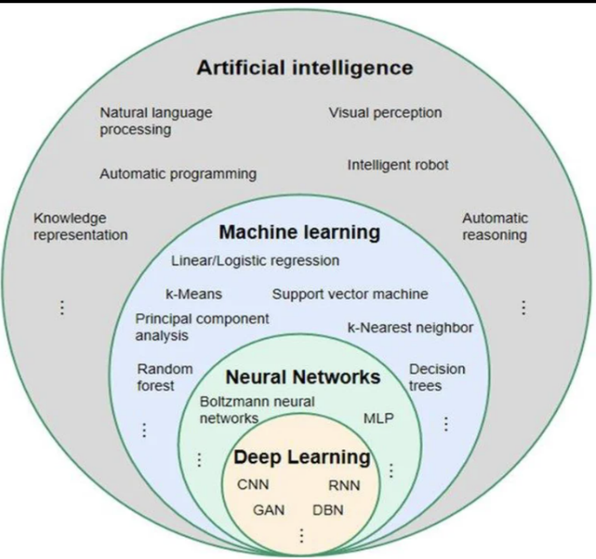
2.1.1 Artificial Intelligence (AI)
Artificial Intelligence (AI) is a branch of computer science that focuses on creating systems that can carry out tasks typically performed by humans with their cognitive abilities like learning, reasoning, solving problems and making decisions [1].

2.1.2 Machine Learning (ML)
Machine Learning (ML) is one of the subfields of AI that helps models learn the patterns from data and make predictions or decisions based on them without any explicit programming for specific tasks. ML methods use statistical learning and optimization algorithm to learn from more data to enhance performance [2].

2.1.3 Deep Learning (DL)
Deep Learning (DL) is one of the subfields of AI that involves the use of deep neural network models with multiple layers that learn hierarchical representations from large scale data. Such models are trained to learn features directly from raw input data, and have demonstrated state-of-the-art results on speech recognition, natural language processing and computer vision applications [3].

2.1.4 Natural Language Processing (NLP)
Natural Language Processing (NLP) is the name given to computational methods that allow computers to manipulate, understand, and create human language using data-driven models and architectures of deep neural networks. Recent advances in NLP have been driven largely by large language models, which have led to significant improvements in tasks such as semantic understanding, dialogue systems, and information retrieval [4].

2.1.5 Large Language Models (LLMs)
Large Language Models (LLMs) are deep learning models built on transformer architectures and trained on large-scale text corpora to comprehend, generate, and manipulate human language. By learning contextual patterns from data, LLMs achieve a wide range of natural language capabilities, including text generation, question answering, and reasoning [5].

2.1.6 Retrieval-Augmented Generation (RAG)
RAG is a hybrid architecture that combines the parametric knowledge embedded in LLMs with non-parametric external knowledge retrieved on the fly from external data stores. This approach facilitates the generation of context-dependent, up-to-date, and veracious responses, particularly for domain-specific or real-time applications [6].

2.1.7 Automatic Speech Recognition (ASR)
Automatic Speech Recognition (ASR) refers to a machine's ability to recognize spoken words and transcribe them into text. ASR relies on deep learning models that learn acoustic and linguistic patterns. State-of-the-art ASR systems are built as end-to-end neural networks trained on large-scale datasets, and they perform well for real-time recognition and multilingual tasks [7].

2.1.8 Text-to-Speech (TTS)
Text-to-Speech (TTS) refers to the ability to convert text into a human-like voice. The nature-sounding speech synthesis is realized by deep learning models and state-of-the-art TTS systems can synthesize nature-sounding voices with natural intonation [8].

2.1.9 Word Error Rate (WER)
WER, which is defined as the number of word errors per 100 words between the predicted and reference transcript, is a common performance metric of ASR systems. The measure takes into consideration the word level substitution, deletion and insertion errors and provides a normalized value [9]. WER has been used in particular for the evaluation of Arabic ASR.

2.1.10 Role of AI in the Voice Agent System
The heart of the system behind the voice agent is artificial intelligence.The most essential part of the system that is used with the voice agent is artificial intelligence. The first step in the system is to convert voice into text, via ASR. The user's intent is then identified using NLP and NLU and the output is generated using a language model. To enable more accurate response, the system employs RAG to fetch information from external knowledge sources, and then the final step is to input the response into TTS to get a natural and human-like response back to the user. AI will thus be an integral part of the system's core operations, connecting users' intentions with system actions. This is not an easy task: The audio stream is first converted into text with the help of the ASR, and with the help of the Natural Language Understanding (NLU) modules the meaning is then extracted from the text. In legal scenarios, this is a critical step, in which the context needs to be understood correctly.

2.2 Related Work

Review of Related Work
The authors in [10] suggested an end-to-end voice processing pipeline for telecommunications customer support and interactive voice response (IVR) systems. They use streaming automatic speech recognition (ASR), retrieval-augmented generation (RAG) for their search on the documents in the RFC collection (faiss search), a 4-bit quantized language model, and real-time text-to-speech (TTS). It was tested with 500 utterances from human subjects in the field of telecommunications, showing an average end to end latency of about 0.94 sec. The study reveals that sentence-level streaming, concurrent processing, retrieval grounding, and quantization can lead to better responsiveness of domain-specific voice agents. The work however, is not on Arabic legal question answering, but on telecommunications.
The authors [11] proposed a speech-language model, SpeechGPT, that enables speech perception and generation in the context of a large language model. The model is based on discrete speech representations and builds an instruction dataset of speech-text pairs, SpeechInstruct. It is trained in three phases, which are modality-adaptation pretraining, cross-modal instruction fine-tuning and chain-of-modality instruction fine-tuning. The study shows the promise of the integration of speech and text in one model and cross-modal instruction following and spoken interaction. But unlike SpeechGPT, it is not aimed at Arabic legal information, RAG based grounding or reliability controlled legal answer generation.
The authors [12] put forward the RAGentA, a multi-agent retrieval-augmented generation system for attributed question answering. The system involves the 4 specialized agents for prediction, document filtering, final answer by citing documents, and answer revision. It is a combination of BM25 sparse retrieval, E5 dense embeddings and Pinecone vector store. This system was tested on a synthetic database of 500 QA pairs, obtained from the FineWeb index. The results indicate that hybrid retrieval achieves an improvement in Recall@20 and the multi-agent architecture increases the faithfulness of the answers over the standard RAG baseline. The focus of this study is relevant in that while it does not focus specifically on the Arabic legal voice assistance, it does highlight attributes, source grounding and faithfulness.
The authors [13] used the fine-tuning technique to improve the OpenAI Whisper model for multi-dialectal Arabic ASR. Five major Arabic dialects were studied: Gulf (Gulf Arabic), Levantine, Iraqi, Egyptian, and Maghrebi. It was trained with Mozilla Common Voice in Arabic and using MASC in dialectal speech. The authors have focused mainly on the Whisper small and compared it to larger Whisper models. They found that by fine-tuning smaller models, one can achieve a significant performance boost in Arabic ASR while, in certain cases, matching performance of larger models which have not been fine-tuned. This work is relevant since it brings into focus the need for assessing the dialectal speech recognition in the voice-agent systems.
The authors [14] gave an overview of the ELYADATA & LIA system for the Arabic speech-processing shared task of NADI 2025. Their research involved two subtasks; spoken Arabic dialect identification and multi-dialectal Arabic ASR. To identify the different dialects, they slightly adapted the Whisper-large-v3 model and tested it on the official test set with the highest accuracy of 79.83%. They were able to retrain SeamlessM4T-v2 Large separately on the eight languages, and obtained an average WER of 38.54% and CER of 14.53% for ASR. The study shows the benefit of using a big pretrained speech model and fine-tuning it with a limited amount of data to enhance the Arabic dialect processing, but it does not cover the legal retrieval or answer generation tasks.
In the study authors [15] have presented a retrieval-augmented generation system for Arabic legal information based on Moroccan Family Code as a case study. The study generated around 2,500 Arabic question-answer pairs and assessed the Arabic legal retrieval performance of multilingual embedding models, such as BGE-M3 and E5, for Arabic legal retrieval. The Arabic legal preprocessing and clause-based segmentation were also highlighted as some of the important legal pre-processing techniques to retain the structure of legal provisions. The results show that using RAG can better serve the legal information in Arabic and decrease the generation of unsupported information. The system is limited, however, to Moroccan family law and excludes Arabic speech interaction, reliability-gated generation and deterministic calculation of legal entitlements, such as those in labour law.
The authors [16] proposed CTC-TTS, a dual-streaming text-to-speech approach designed to reduce latency in LLM-based TTS systems. The method replaces heavy forced-alignment pipelines with a CTC-based aligner and introduces a bi-word interleaving strategy. Two variants were proposed: CTC-TTS-L for higher synthesis quality and CTC-TTS-F for lower latency. The study shows that CTC-based alignment can improve the quality-latency trade-off in streaming speech synthesis. However, the work is focused on TTS and does not address Arabic legal RAG or question answering.
The authors [17] presented CM-TTS, a text-to-speech synthesis system based on consistency models and weighted samplers. The method reduces the number of sampling steps required for speech synthesis and improves real-time generation efficiency without relying on adversarial training or a teacher model. The system was evaluated on speech datasets such as VCTK, LJSpeech, and LibriSpeech. This study is relevant to the voice layer because it addresses efficient speech synthesis, but it is not specific to Arabic, legal information, or retrieval-grounded question answering.
The authors [18] reviewed deep learning-based Arabic question-answering systems. The review discusses extractive, generative, and hybrid QA approaches and highlights Arabic-specific challenges such as complex morphology, orthographic ambiguity, missing diacritics, dialectal variation, and limited domain-specific datasets. It also discusses Arabic and multilingual transformer models, including AraBERT, MARBERT, ArabicT5, mBERT, and XLM-R, as well as datasets such as Arabic-SQuAD, ARCD, and TyDiQA-Arabic. The study is relevant because it identifies the need for Arabic domain-specific QA systems and highlights the potential of retrieval-augmented generation for Arabic QA.
In one of the previous works [19] the authors presented a legal argument reasoning benchmark for Arabic language (ALARB) that was constructed from over 13000 Saudi commercial court cases. Case facts, reasoning, verdicts and cited regulations are included. It is used for verdict prediction, completion of legal arguments or article identification. The study is significant due to the following reasons: Firstly, it gives a benchmark for Saudi legal reasoning, and secondly, it reveals the necessity to have Arabic legal datasets that are based on the real legal language. But, ALARB does not have a voice-agent pipeline, does not offer a labor-law service question answering system, and is not concerned with court-case reasoning.
The author [20] presented NEBRAS, a RAG-based question-answering system for Islamic and legal guidance. The system uses an agentic RAG pipeline, hybrid retrieval, and LLM agents to improve Arabic domain-specific question answering. It was evaluated in Islamic fatwa and university help-desk domains, with results reported using automatic metrics and human evaluation. This work is relevant because it addresses sensitive Arabic guidance using retrieval grounding and agent-based processing. However, it is a master’s thesis and focuses on Islamic/legal guidance rather than Saudi Labor Law voice assistance.
The authors [21] introduced SeamlessM4T, a multilingual and multimodal model supporting ASR, speech-to-text translation, speech-to-speech translation, text-to-text translation, and text-to-speech translation across many languages. Although the system is not designed for legal question answering or RAG-based legal grounding, it is relevant to this thesis because it demonstrates the importance of multilingual speech and text processing in voice-enabled systems.
The authors [22] suggest QU-NLP on the Islamic inheritance reasoning task of QIAS 2025. They trained Fanar-1-9B on their system that they called LoRA, and combined it with a retrieval-augmented generation pipeline. The challenge was to grasp the inheritance situation, determine who was eligible to inherit and apply fixed-share rules, then do accurate calculations. The system has obtained an overall accuracy of 85.8% in final test set. This study is important because it not only addressed the concept of retrieval grounding, but also included rule-governed legal-religious reasoning and numerical computation, but in this study the focus was on Islamic Inheritance and not on Saudi Labor Law.
The authors [23] proposed LLMVoX, an autoregressive streaming TTS system with a lightweight of 30M parameters and LLM-agnostic. To create low-latency speech with the same capabilities as the base LLM. It is based on a multi-queue streaming mechanism to enable continuous speech generation and it was also adapted to Arabic, where the character error rate (CER) was about 8% in the Arabic task. This study is relevant as it helps the design of separating the reasoning process of LLM from TTS, while it does not cover legal retrieval and legal question answering in Arabic.
The authors in [24] did a systematic empirical analysis of various components of an Arabic RAG pipeline on six Arabic datasets. The study quantified the chunking strategies, embedding models, rerankers and language models using RAGAS metrics. These results demonstrated that sentence-aware chunking achieved the best results, and that BGE-M3 and multilingual-E5-large were among the best performing embedding models. The results of this study also show that bge-reranker-v2-m3 can enhance faithfulness when dealing with complex datasets. This paper is quite relevant since it helps in evaluating the components and carefully selecting retrieval and reranking components for Arabic RAG systems.
The reviewed studies are all related to the following topics: low-latency voice pipelines, Arabic dialect ASR, Arabic question answering, Arabic legal RAG, streaming TTS, and component-level RAG optimization. None of the systems reviewed, however, accounts for (officially) Saudi Labor Law and HRSD evidence, Arabic speech interaction, hybrid retrieval with reranking, a validation-calibrated reliability gate, deterministic legal calculation, and component-level evaluation in a single local Arabic legal voice-agent pipeline. This thesis seeks to fill in this gap of integration and evaluation.

Table 2.1. Comparison of the reviewed studies.
Paper | Year | Main contribution | Limitation | Data | Model / method | Reported result
[10] | 2025 | Streaming telecom voice-agent pipeline with RAG, quantized LLM, and real-time TTS | Private telecommunications setting; not Arabic legal QA | 500 human-recorded telecom utterances | T-Transcribe Engine + FAISS RAG + TSLAM-Mini-2B + T-SYNTH | Average end-to-end latency ≈ 0.934 s
[11] | 2023 | Speech perception and generation within a large-language-model architecture | Not designed for Arabic legal grounding or RAG-based legal QA | SpeechInstruct and related speech-text instruction data | LLaMA-based model + discrete speech units | Demonstrated cross-modal speech and text instruction-following abilities
[12] | 2025 | Multi-agent attributed QA with citation and revision agents | Synthetic benchmark; not Arabic legal or voice-based | 500 FineWeb-derived synthetic QA pairs | Falcon-3-10B agents + BM25 + E5 + Pinecone | Hybrid retrieval improved Recall@20; faithfulness improved over standard RAG
[13] | 2025 | Whisper fine-tuning for five major Arabic dialects | Dialectal resources remain limited | Common Voice MSA + MASC dialect data | Whisper-small and Whisper-large-v3 | Fine-tuned smaller Whisper models approached larger-model performance in some settings
[14] | 2025 | Arabic dialect identification and multi-dialect ASR for NADI 2025 | Shared-task setting; substantial ASR error remains | NADI 2025 Arabic speech data | Whisper-large-v3 encoder for ADI; SeamlessM4T-v2 Large for ASR | ADI accuracy 79.83%; ASR WER 38.54%, CER 14.53%
[15] | 2025 | Arabic legal RAG for Moroccan Family Code with clause-based segmentation | Different jurisdiction; no Arabic speech interaction or labor-law calculation | Approximately 2,500 Arabic QA pairs | BGE-M3, E5-large, E5-small + LLM | Legal retrieval and generation evaluation for Moroccan family law
[16] | 2026 | Dual-streaming TTS using CTC alignment and bi-word interleaving | Preprint; TTS-focused and not Arabic legal QA | VoiceAssistant400K / LibriSpeech-based evaluation | CTC-TTS-L and CTC-TTS-F | Improved streaming synthesis trade-off; RTF ≈ 0.05
[17] | 2024 | Consistency-model TTS with weighted samplers for efficient synthesis | Not Arabic-specific and not legal-interaction focused | VCTK, LJSpeech, and LibriTTS/LibriSpeech | Consistency model + weighted sampler | RTF 0.02-0.07 depending on generation steps
[18] | 2025 | Review of deep-learning Arabic QA systems, models, datasets, and challenges | Survey paper; not a new experimental system | Arabic QA datasets surveyed | AraBERT, MARBERT, ArabicT5, mBERT, XLM-R, and other models | Taxonomy of Arabic QA methods and identified research gaps
[19] | 2025 | Saudi Arabic legal reasoning benchmark using authentic court cases | No voice-agent or RAG service pipeline | 13,000+ Saudi commercial court cases | Legal reasoning benchmark tasks for LLMs | Verdict prediction, reasoning-chain completion, and article-identification tasks
[20] | 2025 | Agentic RAG system for Islamic and legal guidance | Master’s thesis; different domain from Saudi Labor Law voice assistance | Custom Islamic fatwa and university help-desk datasets | Hybrid retrieval + LLM agents | BERTScore-F1 = 70.94% in Islamic fatwa evaluation
[21] | 2023 | Unified multilingual and multimodal model supporting ASR, speech translation, text translation, and TTS | Not a legal QA or RAG system | Large multilingual speech and text corpora including SeamlessAlign | SeamlessM4T / UnitY architecture with w2v-BERT 2.0 | Strong multilingual speech and text translation performance across many languages
[22] | 2025 | Fine-tuning plus RAG for Islamic inheritance reasoning | Narrow inheritance domain; multiple-choice task | QIAS 2025 Islamic inheritance reasoning data | Fanar-1-9B + LoRA + RAG | Overall accuracy = 85.8%
[23] | 2025 | Lightweight LLM-agnostic streaming TTS | Not integrated with Arabic legal RAG | Streaming TTS benchmarks, including Arabic adaptation | LLMVoX, 30M parameters | Low-latency streaming TTS with Arabic adaptation
[24] | 2025 | Systematic comparison of Arabic RAG components | Not specific to Saudi legal documents | Six Arabic datasets | Chunking strategies, embedding models, reranker, and generators | Sentence-aware chunking, BGE-M3, multilingual-E5-large, and reranking performed strongly

Chapter 3: Methodology and Proposed Framework

3.1 Introduction
In this chapter, the methodology and suggested framework are presented to develop Arabic voice agent that supports Saudi Labor Law enquiries. The proposed system consists of several well-defined stages of artificial intelligence, such as Automatic Speech Recognition (ASR), Retrieval-Augmented Generation (RAG), Large Language Models (LLMs), deterministic legal calculation, and Text-to-Speech (TTS). The system has been created to handle both verbal and written Arabic queries, and provide legal answers based on accurate sources such as articles of the Saudi Labor Law and the Frequently Asked Questions (FAQs) published by the Ministry of Human Resources and Social Development (HRSD).
The methodology adopted is a evidence based legal question answering. The system will first be provided with relevant legal evidence from a pre-composed knowledge base, and then use the language model to answer legal questions based on that evidence. This retrieved evidence is then used to contextualize the evidence for generating answers and citing the evidence. The idea of this approach is to diminish unsupported production, add factual basis and boost the reliability of the responses in a sensitive legal-information environment.
The framework to be proposed is based on three methodological needs. The first requirement is that the system must be able to process Arabic queries both written and spoken, which require transcription, preprocessing and normalization. Second, the legal responses need to be produced based on the legal evidence retrieved from the database, not just on the result of the LLM's internal memory. Thirdly, the effectiveness of each of the key components needs to be assessed on its own in terms of retrieval effectiveness, answer correctness, speech-recognition accuracy, voice-layer performance, and end-to-end latency.
The proposed architecture is a sequential pipeline architecture that consists of various modules corresponding to the different processing layers: (1) input handling, (2) query processing, (3) intent routing, (4) information retrieval, (5) answer generation, (6) reliability control, (7) deterministic legal calculation, and (8) voice output. The system can be inputted with the user's query in two ways as pointed out in Figure 3.1, via speech and via text. The ASR module translates Arabic speech to text in the case of spoken queries. In the case of written queries, the Arabic one is directly sent to the query-processing stage. The input is then normalised and extracted to enhance the understanding and the identification of query intent.
Once the intent classification is done, legal information seeking queries are passed on to the retrieval module. The retrieval process also involves dense retrieval, hybrid search, and reranking the legal articles and FAQ records from the ChromaDB knowledge base using a cross-encoder method to find the most relevant documents. The retrieved evidence is then fed into the LLM-based generation module to generate an Arabic response grounded in the evidence and provided with legal citations. The generated response is validated by reliability and post-processing in order to make sure it is consistent with the retrieved evidence before sending it back to the user.
A deterministic calculation module for some numerical legal issues, like end-of-service benefits, annual leave entitlement, notice related cases, etc., is also included in the framework. This module is different from the generative responses as it carries out calculations based on predefined rule-based functions on certain articles of the Saudi Labor Law. The retrieved legal evidence is then used in conjunction with the numerical output, to give a clear and explainable response.
Finally, if voice interaction is needed the validated Arabic text response is then converted into speech with the TTS module. This finishes the voice-agent flow and allows for a conversational experience when answering Arabic legal enquiries. Overall, the methodology offers an evidence-informed, modular and evaluable framework for the development of an Arabic legal voice agent which mitigates hallucination risk, enables legal source citations and facilitates text- and speech-oriented interactions.

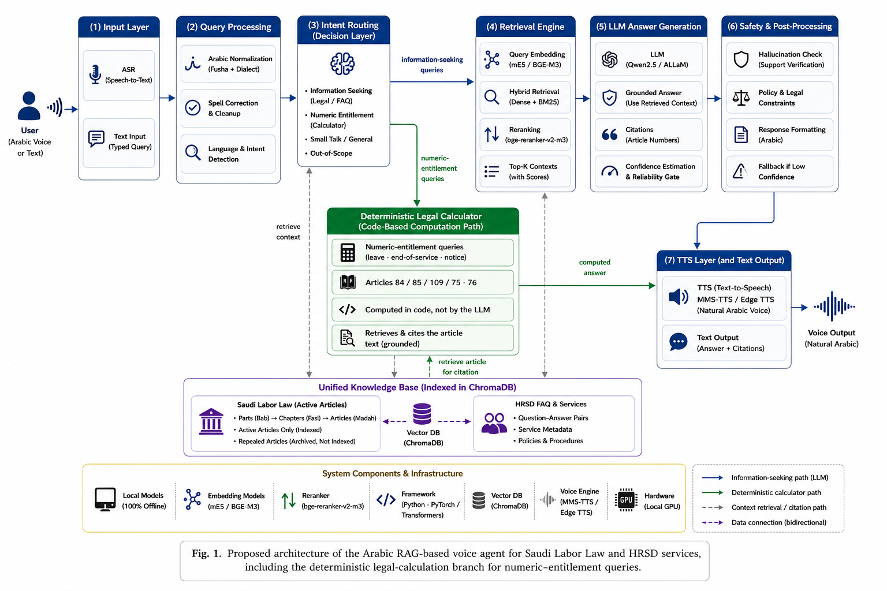.
Figure 3.1. Sequential stages of the proposed Arabic legal voice-agent pipeline.
A proposed framework is shown in Figure 3.1 as a series of inter-related stages, rather than as one monolithic framework. The framework illustrates the data collection, preparation, indexing, retrieval, answer generation and/or deterministic calculation, evaluation, and text and voice measures of the official legal data.
- Step 1: Collecting Official Data. The system gathers articles related to the Saudi Labor Law and HRSD Frequently Asked Questions (FAQs) from the official sources. The sources that the system uses as legal evidence.
- Step 2: Data preparation and knowledge base construction. All collected records are cleaned, normalized, organized, chunked, embedded and stored in a persistent ChromaDB vector database. This stage is for setting up the legal and FAQ information for easy retrieval, yet retaining the source information for citations and traceability.
- Step 3: User Input Handling. The system can receive queries in the form of text or speech in Arabic. Written queries are directly fed into the query processing layer and spoken queries are first converted into text by the ASR module. The resulting text is then “normalized” and sent to the intent-routing stage.
- Step 4: Retrieval and Evidence Selection. The retrieval layer performs dense retrieval and BM25 lexical retrieval, fuses retrieval results with a hybrid score function, and reranks the retrieval results with a cross-encoder to answer legal information-seeking queries. During this stage, the most suitable legal article or FAQ documents are chosen for the answer.
- Step 5: His final step was to the Deterministic Legal Calculation Branch. The query is directed to a specific branch for deterministic calculation if it is classified as an entitlement to a number of days of leave or entitlement for end-of-service benefits, entitlement after resignation, or notice, which are supported by the intent class. This branch involves the calculation through the use of rule-based Python functions based on some articles of the Saudi labor law such as Article (84), Article (85), Article (109), Article (75), and Article (76). The Language Model is used to do nothing to do with arithmetic. The numerical output, however, is instead merged with the retrieved legal evidence, to explain and cite the result.
- Step 6: Answer generation is preceded by the retrieval of evidence that is checked using the reliability gate and safety instructions. If the evidence retrieved is found to be complete enough, the LLM will produce a grounded Arabic response based on the selected context only. When evidence is insufficient, unrelated to the supported domain or when the evidence is outside of the supported domain, a safe refusal is returned, and not an unsupported legal answer.
- Step 7: Voice Output. If the user wants the answer to be spoken, then the validated Arabic answer is sent to the TTS module, which converts it to speech. This will allow for a full Arabic voice interaction in the system.
- Step 8: Assessment of the effects on latency. The effectiveness of the retrieval, accuracy of the response, use of citations, accuracy of the ASR output, accuracy of the voice output, accuracy of the calculation (deterministic), and end-to-end latency are all assessed independently on each major component. The outcome of the evaluation is used to give feedback on areas in which students may need to improve, and to highlight areas to develop further.

3.2 Dataset Description
In this study, the dataset was constructed from two official Saudi sources: the Saudi Labor Law pages and the Ministry of Human Resources and Social Development (HRSD) FAQ portal [25], [26]. The Saudi Labor Law source was extracted at the article level, while the HRSD FAQ source provided service-oriented question-answer content. Each record retained its source URL, source type, original wording, normalized retrieval text, and document identifier to support traceability throughout the pipeline.
The legal corpus contained 249 article records. Status screening retained 211 active articles for indexing, while 38 repealed articles were archived outside the searchable collection to prevent the retrieval of obsolete legal information. The experiments used the archived corpus produced by the data-preparation pipeline rather than an automatically changing live legal source.
The HRSD extraction produced 711 FAQ question-answer rows. Basic cleaning retained 703 usable rows, and domain filtering identified 402 labor-related rows. Leakage and near-duplicate screening left 400 rows for the identifier-based split. These 400 rows came from 399 different question texts, due to one question showing up in two different FAQ source records.
The 70/10/20 split used identifiers gave 278 rows of indexing, 41 rows of validation, and 81 rows of held out. The indexing rows were added to the FAQ Knowledge base that was searchable, and the validation and held-out rows were not added to the index. This question-text deduplication in the held out partition found the same question, "ما هي أهداف برنامج حماية الأجور؟", in faq_id 248 and faq_id 94. A total of 80 unique held-out faq questions were retained in the evaluation manifest and 94 faq questions were removed, leaving faq_id 248 as the only commonly held out question. This was a decision to deduplicate prior to scoring, not based on quality or performance.
Individual evaluation tools were given separate experimental tasks. At the end, there were 24 legal questions, curated by hand, in the final legal retrieval test. 201 automatically generated legal questions were added to a supplementary robustness set, which was only used to assess retrieval robustness. It was not used to set thresholds nor as the main legal retrieval standard.
A different set of 45 questions stratified with a mixed type of questions was used in the paired LLM comparison, not a subset of the 80 FAQ questions. It had a total of 14 FAQ questions, 17 legal questions, 12 out-of-scope questions and 2 small-talk inputs. Each 45 questions were piped through the fixed reliability-gated pipeline. Correct grounded responses and correct safe refusals, by task-specific rubric were counted for the evaluation.

Table 3.1. Dataset construction and cleaning summary.
Source / Stage | Processing step | Records after step | Explanation
Saudi Labor Law | Scraped from official HRSD legal pages | 249 | Article-level legal records collected.
Saudi Labor Law | Active articles retained | 211 | Active articles indexed in the searchable knowledge base.
Saudi Labor Law | Repealed articles archived | 38 | Repealed articles excluded from retrieval to avoid obsolete citations.
HRSD FAQ | Scraped from official HRSD FAQ pages | 711 | Initial question-answer records collected.
HRSD FAQ | Basic cleaning | 703 | Empty, malformed, or unusable records removed.
HRSD FAQ | Domain filtering | 402 | Labor-related FAQ records retained.
HRSD FAQ | Leakage / near-duplicate screening | 400 rows / 399 unique questions | Records prepared for leakage-safe splitting after screening and exact-question review.
HRSD FAQ | Indexing subset | 278 | FAQ records used in the searchable RAG knowledge base.
HRSD FAQ | Validation subset | 41 | FAQ records reserved for validation and threshold calibration.
HRSD FAQ | Held-out FAQ subset | 80 | Unique FAQ questions reserved outside the index for held-out evaluation.
Legal evaluation | Final legal retrieval test | 24 | Manually curated legal questions used as the final retrieval test.
Legal evaluation | Supplementary robustness set | 201 | Auto-generated legal questions used only as a robustness check.
Generation evaluation | Final mixed-type reliability-gated set | 45 | Stratified mixed-type questions used for paired LLM comparison under the fixed reliability-gated pipeline.
Threshold calibration | Validation examples | 56 | 41 validation records combined with 15 out-of-scope examples for Youden’s J calibration.

Table 3.1 presents a summary of the transformations performed to the raw set of records to yield the final set of knowledge base and evaluation. A total of 249 articles were generated from the Saudi Labor Law source, from which 211 articles are active, and 38 articles have been repealed and kept in the archive that is not searchable. A total of 711 question-answer records were produced by the HRSD FAQ source. The remaining 402 labor-related FAQ records were after basic cleaning, domain filtering. The leakage and near duplicate screening then trimmed the FAQ data for leakage safe splitting into 278 indexing rows, 41 validation rows and 80 uniquely held out FAQ questions. The evaluation sets were separated since they were used for different experiments such as retrieval testing, robustness analysis, generation evaluation and threshold calibration experiments. The separation was utilized to ensure that data leakage does not happen and retrieval, robustness, and generation results were not mixed up. The structures of the two sources are not identical. The Saudi Labor Law records are arranged in the form of legal articles which contain article numbers, legal hierarchy, article status, and the text of the article. The HRSD FAQs, on the other hand, are presented in a question and answer format, and contain service related metadata. Hence there are some missing values in some fields due to the lack of common attributes in the two sources. Records used for indexing were kept apart from validation and withheld evaluation questions and tested to minimize the risk of data leakage.
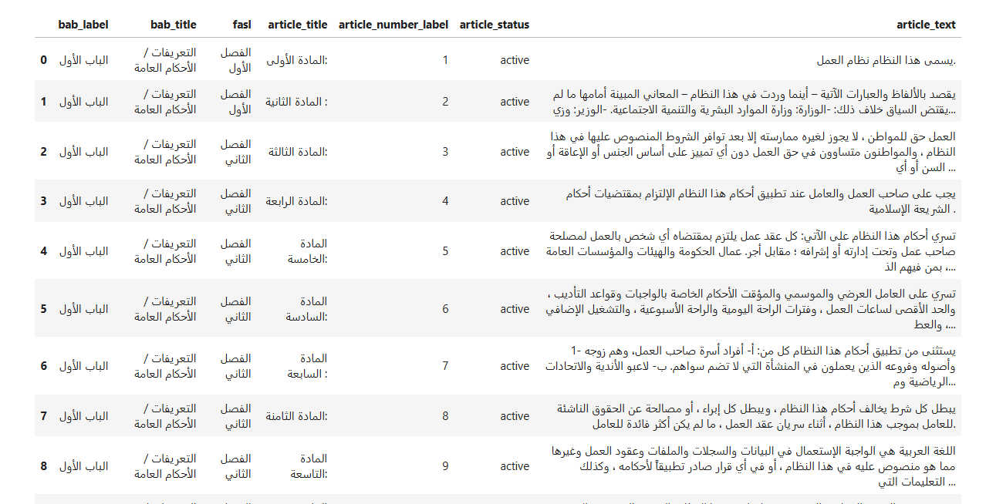
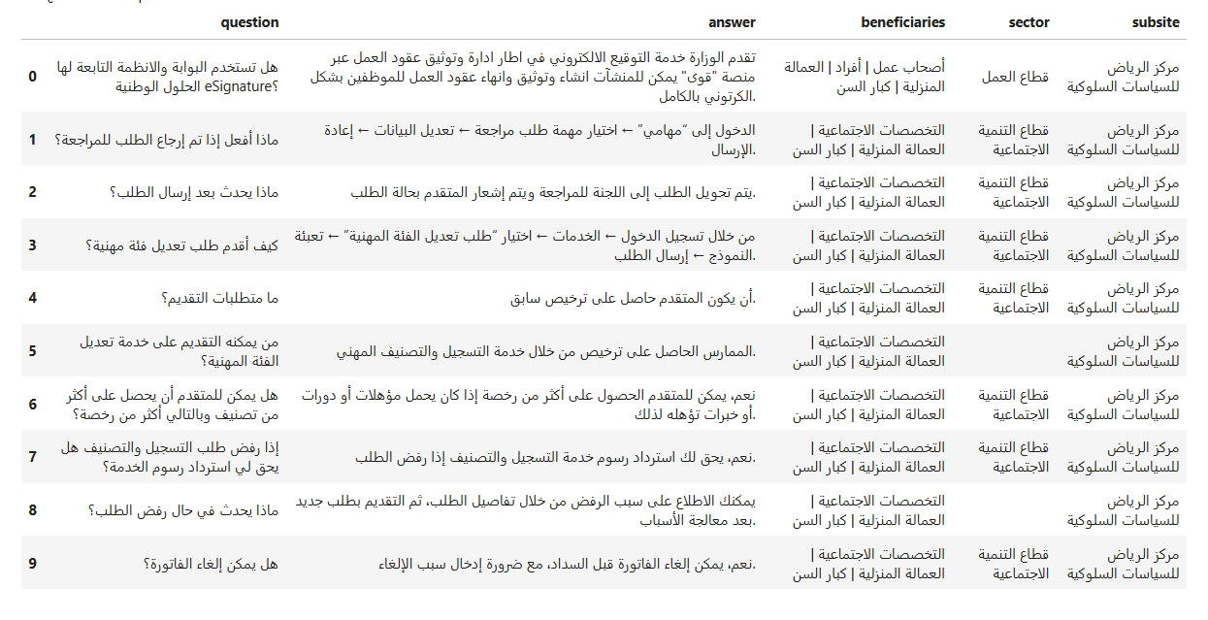
Figure 3.2. Actual screenshots of the structured legal and HRSD FAQ datasets.
Examples of the two structured record types used in this study are given in figure 3.2. The legal-article record includes the article identifier, legal hierarchy, legal status and legal text, while the FAQ record includes the official question, answer and the beneficiaries information and service data. Structured fields were essential for the metadata-based traceability and for re-establishing a retrieved passage back to its source.

3.3 Data Collection and Web Scraping
The raw data were obtained directly from the official site of Saudi Ministry of Human Resources and Social Development (HRSD). The following two types of content were targeted: Saudi Labor Law articles and HRSD FAQ question-answer pages. This guaranteed that the knowledge base did not have to be filtered, preprocessed, or indexed from any other sources, but rather came from authoritative legal and service-information sources.
The data extraction was done via Python with the help of Requests library and BeautifulSoup. The Saudi Labor Law pages were extracted at the article level with maintaining the hierarchy of the law by maintaining part, chapter and article number. The HRSD FAQ pages were duly removed and each question and answer was used as a separate entry along with the available metadata.The data extraction was done via Python with the help of Requests library and BeautifulSoup. The Saudi Labor Law pages were extracted at the article level with maintaining the hierarchy of the law by maintaining part, chapter and article number. The HRSD FAQ pages were duly removed and each question and answer was used as a separate entry along with the available metadata.
The article title in Arabic (e.g. “المادة الحادية والخمسون بعد المائة”) was translated to the corresponding numeric article name (e.g. “the 150th article after 100th”) while maintaining the presence of the “مكرر” marker as appropriate. For instance, if you always used to type “المادة الحادية والثلاثون بعد المائة مكرر”, this would be normalized to “131مكرر”. Later these normalized article identifiers were used for citing, evaluating retrieval and for gold-reference matching.
Table 3.2 shows examples of Arabic article-number normalization used during data preparation.
Raw Article Title (as scraped) | Normalized article_number_label | Note
المادة الحادية عشرة | 11 | Two-digit ordinal (10–19 range)
المادة التاسعة والسبعون | 79 | Units + tens combination (below 100)
المادة الحادية والثلاثون بعد المائة مكرر | 131مكرر | Adds 100; repeated-article marker preserved
المادة التاسعة والعشرون بعد المائتين | 229 | Adds 200

3.4 Data Preprocessing
The data-preprocessing stage prepared the raw scraped records for retrieval. This process included schema standardization, Arabic text normalization, exclusion of repealed articles, FAQ domain filtering, leakage-safe splitting, near-duplicate detection, and text segmentation. Each output was saved and checked before moving to the next stage, which supports reproducibility and allows errors to be traced to their source.

3.4.1 Schema Standardization and Data Integration
The raw files were first standardized into a common schema containing identifiers, source labels, text fields, and metadata fields. Since Saudi Labor Law articles and HRSD FAQ records originally have different structures, the two sources were integrated into a unified table and distinguished using the source_type field. Figure 3.3 presents a sample of the integrated knowledge base.

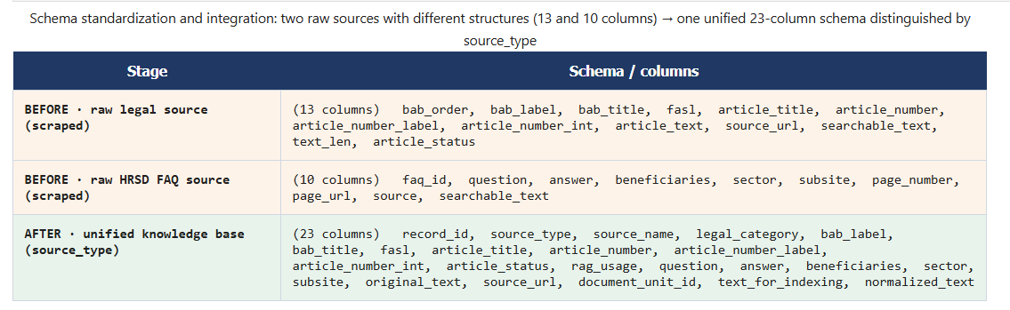
The two sources were integrated into one schema for four reasons:
- First, a unified table allows cleaning, filtering, chunking, embedding, indexing, and retrieval to be applied through one consistent pipeline.
- Second, the system can retrieve evidence from both formal legal articles and practical FAQ entries using the same search process.
- Third, FAQ records reflect how users typically phrase service-oriented questions, while legal articles provide the official legal grounding.
- Fourth, the shared schema preserves source traceability through fields such as record_id, source_type, source_url, original_text, normalized_text, and document_unit_id.

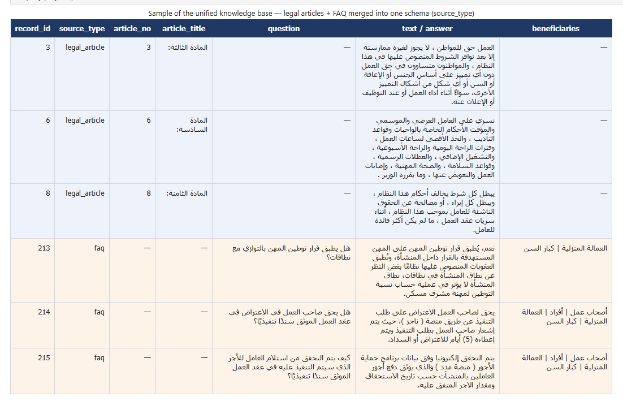
Figure 3.3. Sample of the unified knowledge base showing Saudi Labor Law articles and HRSD FAQ records integrated into a single schema and distinguished by the source_type field.

3.4.2 Arabic Text Cleaning and Normalization
In the preprocessing stage, Arabic text was cleaned and normalized to reduce orthographic variation before indexing. Diacritics and tatweel were removed, common Alef, Yeh, and Ta-marbuta variants were unified, and scraping artifacts and extra whitespace were cleaned. The normalized text was used for retrieval, while the original wording was preserved in a separate field.

This separation is important in the legal domain. The retrieval system benefits from normalized text because it improves matching between user queries and legal records. However, the answer shown to the user must remain faithful to the official source. Therefore, the system uses normalized text for search and preserves the original text for display, citation, and legal traceability.
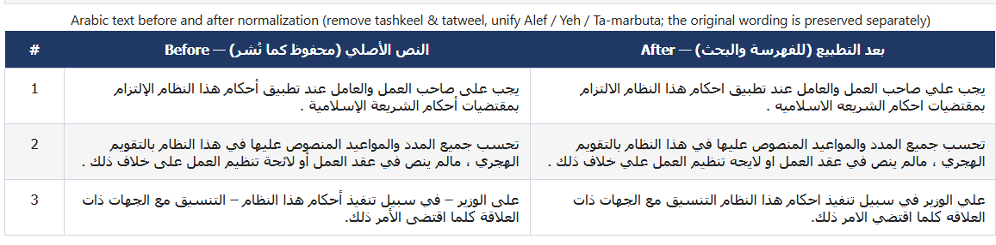
Figure 3.4. A legal-text example before and after Arabic normalization (removal of diacritics and tatweel and unification of the Alef, Yeh, and Ta-marbuta letter forms); the original wording is preserved separately.
Figure 3.4. Example of Arabic legal text before and after normalization, including removal of diacritics and tatweel and unification of Alef, Yeh, and Ta-marbuta letter forms. The original wording is preserved separately for citation and traceability.

3.4.3 Archiving and Exclusion of Repealed Articles
Each legal article was assigned an article_status value indicating whether it was active, repealed, or amended. Only active articles were indexed in the searchable knowledge base, while repealed and inactive articles were archived for auditability but excluded from retrieval, since citing an obsolete legal provision could mislead the user and undermine the reliability of the system.
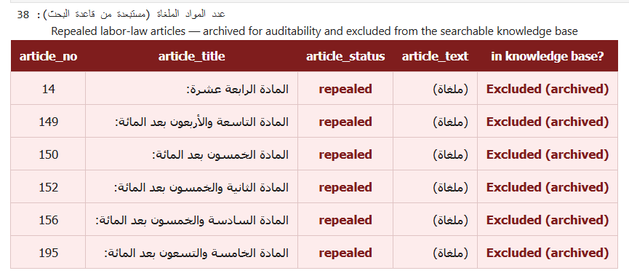
Figure 3.5. Sample of repealed (cancelled) labor-law articles that are archived for auditability and excluded from the searchable knowledge base.

3.4.4 FAQ Cleaning and Leakage-Safe Splitting
The FAQ records were cleaned to remove incomplete, duplicated, noisy, and out-of-domain entries. Only FAQ records related to labor rights, employment contracts, termination, workplace regulations, and employment services were retained. Figure 3.6 presents examples of retained labor-related records alongside excluded out-of-domain records.
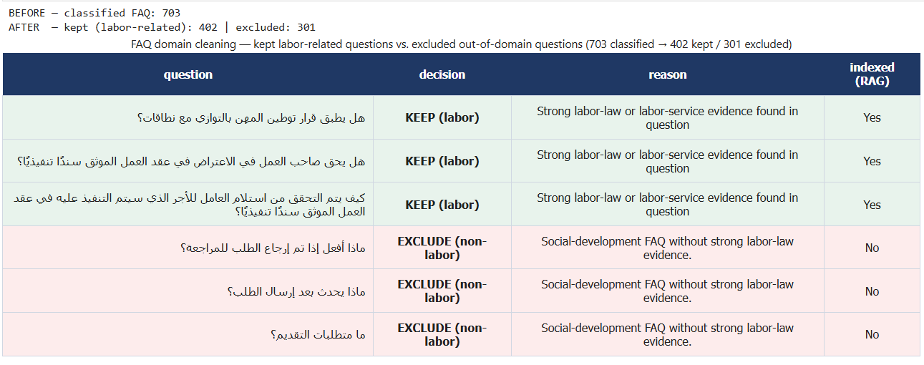
Figure 3.6. FAQ domain cleaning: examples of kept labor-related questions versus excluded out-of-domain questions (703 classified FAQ entries, of which 402 are retained and 301 excluded).
The FAQ records were then separated using an identifier-based 70/10/20 split. The 70% subset was used for indexing in the searchable RAG knowledge base, the 10% subset was used for validation and threshold calibration, and the remaining 20% was retained as held-out test data. The validation subset was used only before the final evaluation, while the test subset remained unseen for threshold selection. The Stage 04 auto-generated legal set was treated separately as a supplementary robustness check and was not used to tune the threshold.
Formally, this leakage-prevention constraint requires the three subsets to be mutually disjoint: D_train ∩ D_val = D_train ∩ D_test = D_val ∩ D_test = ∅, where D_train denotes the 70% training records indexed in the searchable RAG knowledge base, D_val denotes the 10% validation questions used for configuration selection, and D_test denotes the 20% held-out test questions with their gold references used for the final evaluation.
The retained duplicate instance was faq_id 248. The removed instance was faq_id 94 with document_unit_id b0ebcab351b4739f0566a90080daa23d875b475bac36659a0088539697b8a266. The question text was the same for the two records but the source record was different for the FAQ. The held-out analysis is weighted by one canonical instance to avoid the presence of the same user question being scored twice.

3.4.5 Near-Duplicate Detection
TF-IDF character n-grams using cosine similarity was used to obtain the near duplicate records. n-grams of characters were used because they are able to identify overlaps in texts that are not necessarily word-for-word. Duplication with similarity >0.90 was marked as near duplicate candidates and duplication with similarity from 0.85 to 0.90 was marked for manual review. This was done to minimise the chance of having similar records in both indexed and evaluation data [29].
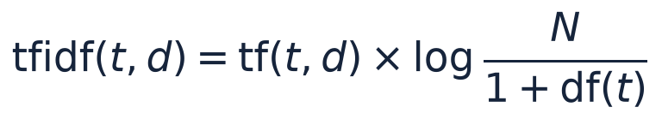
cosine_similarity(x_i, x_j) = (x_i · x_j) / (||x_i|| ||x_j||) (3.1)

3.4.6 Text Segmentation and Source Traceability
To mark where text is found and trace its origins.To identify the location of text and the source of the text.
The data was then cleaned and standardized and the text was divided into retrievable units before it was indexed because the retrieval system does not search over the original documents. The two types of segmentation strategies employed were:
1. Structural Segmentation:
The text was segmented in a structural way, in which it was segmented based on the structure of the source text. One article of the Saudi Labor Law was considered one complete legal unit and one HRSD FAQ question/answer pair was treated as one complete service-information unit. This will ensure that the retrieved text maintains its meaning in the original record, and remains associated with its article number, source type and metadata.
2. Fixed-Size Segmentation:
A fixed size of segmentation was used to compare with. The text was broken up into 500 word chunks that overlap by 80 words between the chunks to minimize the loss of information when content is located close to a chunk boundary. Since Arabic is a morphologically rich language, segmentation has been done at word level, within which legal terms, numbers, or references to articles are split into smaller components which might decrease the accuracy of retrieval.
In the retrieval experiments both strategies were assessed and compared to see their effect on retrieval quality. Structural segmentation was used as the primary method since it left all of the legal and FAQ units intact and fixed-size segmentation gave a baseline to compare against. Every segment was stored with metadata such as source type, article identifier, document category, section reference, parent document identifier and segment identifier for traceability purposes. These fields enabled the traceability of each retrieved field back to its source and enabled citation, error analysis and reproducibility.

Preprocessing Output | Purpose
Cleaned legal articles | Provide standardized active legal records for the knowledge base.
Cleaned HRSD FAQ records | Provide service-oriented question-answer knowledge.
Held-out evaluation set | Support leakage-safe evaluation.
Structural chunks | Preserve article and FAQ boundaries.
Fixed-size chunks | Provide a baseline chunking strategy.
Data-quality and leakage audits | Document preprocessing checks and potential risks.
Table 3.3. Main preprocessing outputs.

3.5 Knowledge Base and Retrieval System
The built knowledge base contains the legal evidence and facts as well as the frequently asked questions that will be used by the answer-generation module. The retrieval system is semantically analyzed, processed, and cross-encoder reranked and BM25 lexically retrieved from the indexed evidence prior to the generation of any answer.

3.5.1 Embedding and Indexing
The semantic-retrieval part transforms the legal articles and FAQ records into dense vector representations with the help of the multilingual embedding model, such as the multilingual-e5-large and the bge-m3 model. These vectors are stored in the persistent vector storage and similarity search system, called ChromaDB.
A BM25 lexical index was created as well as a dense retrieval. BM25 was kept since legal terms, article numbers, and domain-specific expressions are important features in the context of legal search and might not be fully covered by semantic similarity.

3.5.2 Retrieval Algorithms
The retrieval layer contains the following algorithms and retrieval configurations:

- Dense retrieval is the query and each chunk are encoded as a vector by multilingual embedding models and passages are ranked based on cosine similarity to the query. The final experiments evaluated multilingual-e5-large and bge-m3 [30], [31]. Sentence-embedding methods provide a general basis for this independent vector representation [32]. Dense retrieval can identify relevant passages even when the wording of the user query differs from the legal source.
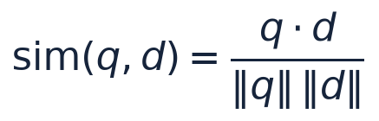
cos(q, d) = (q · d) / (||q|| ||d||) (3.2)
- BM25 is a lexical ranking function that weights query-term frequency by inverse document frequency and normalizes for document length, as defined in Eq. (3.3) [33]. In this study, k1 = 1.5 and b = 0.75. Lexical retrieval is useful for exact legal terminology, article numbers, and expressions that may be weakened by semantic normalization.
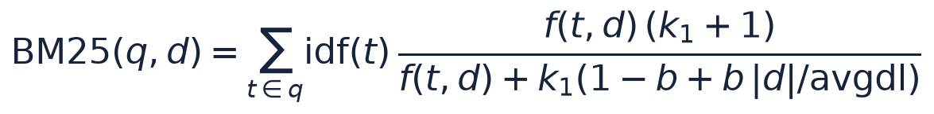
BM25(q, d) = Σ[t∈q] IDF(t) · ((f(t,d)(k1+1)) / (f(t,d) + k1(1 - b + b|d|/avgdl))) (3.3)
- Hybrid retrieval fuses the dense and BM25 scores into a single ranking using a weighted sum controlled by the parameter α, which represents the dense-retrieval weight. The hybrid-score equation combines the normalized semantic and lexical signals so that the two retrieval signals complement one another.
- Cross-encoder reranking re-scores the top hybrid candidates using bge-reranker-v2-m3. Unlike independent query and passage embeddings, a cross-encoder jointly processes each query-passage pair and can provide a more discriminative relevance score [34], [35]. The reranker therefore changes the ordering of the candidates rather than expanding the candidate pool.
The final retrieval configuration used a candidate pool of 50 passages, passing the top five evidence passages to the answer-generation module. The hybrid dense weight was tuned over {0.65, 0.80, 0.90}, and α = 0.80 was adopted in the final configuration, while the reliability gate used the validation-calibrated threshold τ = 0.6503. The numerical comparison of these settings is presented in Chapter 4.
HybridScore(q, d) = α · DenseScore_norm(q, d) + (1 - α) · BM25_norm(q, d) (3.4)
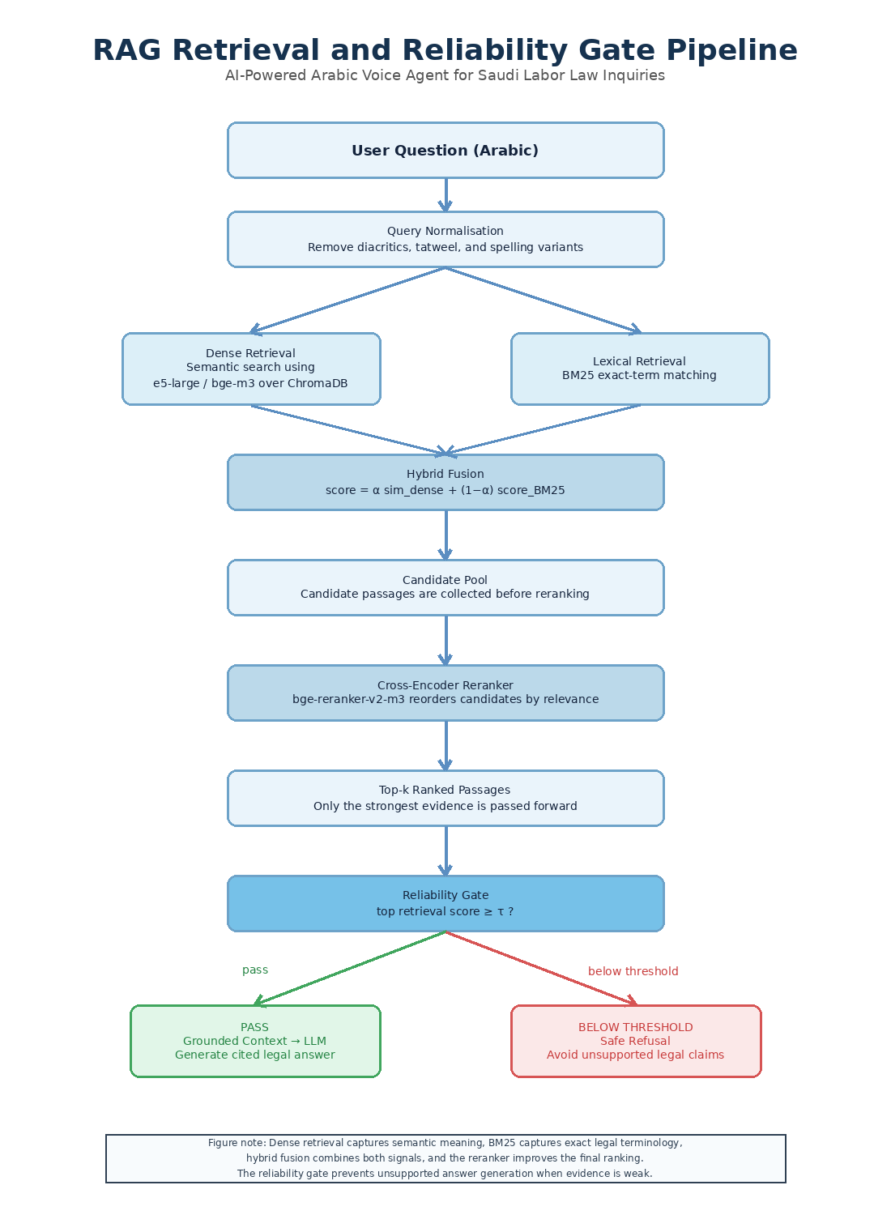
Figure 3.7. Retrieval, reranking, and reliability-gate pipeline used before grounded answer generation.
Figure 3.7 describes the retrieval pipeline. The Arabic query is first normalized to reduce orthographic variation. Dense semantic and BM25 lexical retrieval are then performed as complementary strategies, and their scores are fused through hybrid scoring into a unified candidate ranking. A cross-encoder reranker reorders these candidates according to joint query-passage relevance, after which the top-k evidence passages are selected for answer generation. Finally, the reliability gate checks whether the retrieved evidence is sufficiently strong; if not, the system issues a safe refusal rather than generating an unsupported answer.
Retrieval configurations were compared on the designated validation ablation subset before the final legal test was reported. The selected configuration was structural segmentation, multilingual-e5-large, hybrid retrieval (α = 0.80), and cross-encoder reranking. This is a staged selection process that follows the evaluation process recommended for Arabic RAG pipelines [24] which is component-wise evaluation.

3.6 Hybrid RAG, Reranking, and Reliability Gate
The last retrieval part fuses BM25 lexical matching and dense semantic retrieval. BM25 is able to retain exact terms and article references, and dense retrieval is able to obtain semantic similarity based on other Arabic formulations. The weighted fusion, then, aims to combine complementary signals instead of either one method or the other being sufficient alone [24, 33].
The cross-encoder reorders the top hybrid candidates prior to sending the best 5 candidates to generation. The reliability gate will then compare the maximum retrieval confidence and the fixed threshold. These are independent processes: reranking gives an idea of the relative relevance of the evidence, and the gate decides whether there is enough evidence to give an answer.
If the retrieval confidence is not sufficient, the system will not return an unsupported legal response, rather it will return a safe refusal. In this legal-information environment, this design enables the system to harness the benefits of lexical and semantic retrieval, attain a higher level of evidence prioritization and minimize the production of irrelevant answers.

3.7 Answer Generation Module
The answer generation module generates legal answers in Arabic (in a correct and relevant manner) based on legal evidence retrieved. This is an evidence-based generation process where the Large Language Model (LLM) is not directly queried or accessed from the Knowledge Base or other sources of law or FAQs but rather uses only the chunks of text confirmed by the previous retrieval module. This design will not depend on unsupported internal knowledge and will have minimal chances of legal hallucination. The production process goes through multiple successive steps.
The retrieved evidence is prompted in a constraining manner, recognizing the LLM as an information assistant for the Saudi Labor Law. The prompt should be answered in Arabic, and should only rely on the given Saudi Labor Law or HRSD FAQ context, it should include the article number when present, and it should contain a safe refusal if there is no evidence available. This design applies the evidence-grounding principle of RAG and follows the broader reliability concerns described in RAG research [6], [27].

3.7.1 Intent and Reliability Gates
The intent gate first classifies the user query as a legal-domain question, a conversational input, or an out-of-scope question. Legal questions proceed through the full RAG pipeline, conversational inputs receive controlled responses, and out-of-scope questions are refused to avoid providing unsupported legal guidance.
Before producing a final output, the system applies intent routing and evidence checks. Legal information queries proceed through RAG; numerical-entitlement requests are routed to the deterministic calculator when the required inputs are available; out-of-scope inputs receive safe refusals; and small-talk inputs receive controlled responses. The reliability threshold is applied to retrieval-dependent legal generation, not to the deterministic arithmetic itself. Final post-processing checks response format, cited evidence, and Arabic readability.

3.7.2 Language Models and Prompting Strategy
The generation layer uses local instruction-tuned LLMs, namely ALLaM-7B and Qwen2.5-7B [36], [37], under the same retrieval and prompting protocol. Both models were loaded with 4-bit NF4 quantization, and generation was capped at 160 new tokens to control latency and avoid overly long responses.
The prompt asks the model to answer in Arabic, to use only the retrieved data from the Saudi Labor Law or HRSD FAQ, to include the number of the article (if applicable), and not speculate. When the retrieved evidence is not enough, the model is told to refuse safely and not to give a legal statement that it does not have evidence for.

3.7.3 Deterministic Legal Calculation Layer
Some of the questions of labor law will require calculation, such as calculating the amount of annual leave, calculating end of service award, calculating the compensation for “notice period”. These questions are calculated deterministically, instead of using the LLM for number crunching.
If a numerical-entitlement question is identified, the calculator will retrieve the necessary inputs for the rule(s) implemented. These inputs can vary based on the calculation, such as salary, length of service, length of contract, whether the termination was initiated by the employee or the employer, and wage periodicity and notice already given. If a required value is missing, the system asks a clarification question instead of inventing the value. The numerical result is computed in code and the relevant official article is retrieved for explanation and citation [25].
Computation | Article | Codified Rule
Annual leave | Article 109 | Annual leave entitlement is computed from service duration and prorated when required.
End-of-service award (termination) | Article 84 | The award is computed according to the termination entitlement formula stated in the law.
End-of-service award (resignation) | Article 85 | The resignation case applies the legally defined reduction levels according to service duration.
Notice period | Articles 75-76 | Notice requirements and compensation depend on contract duration type, terminating party, wage periodicity, and the notice actually provided under the applicable amended provisions.
Table 3.4. Legal provisions implemented in the deterministic calculation layer.
Although the numerical result is computed in code, the answer remains grounded because the system retrieves the relevant legal-article text and presents it as supporting evidence. Interpretive questions that do not require calculation continue to follow the standard retrieval and generation pipeline [6]. Figure 3.8 illustrates this hybrid routing, showing how a query is directed either to the deterministic calculator or to the RAG-LLM pipeline.
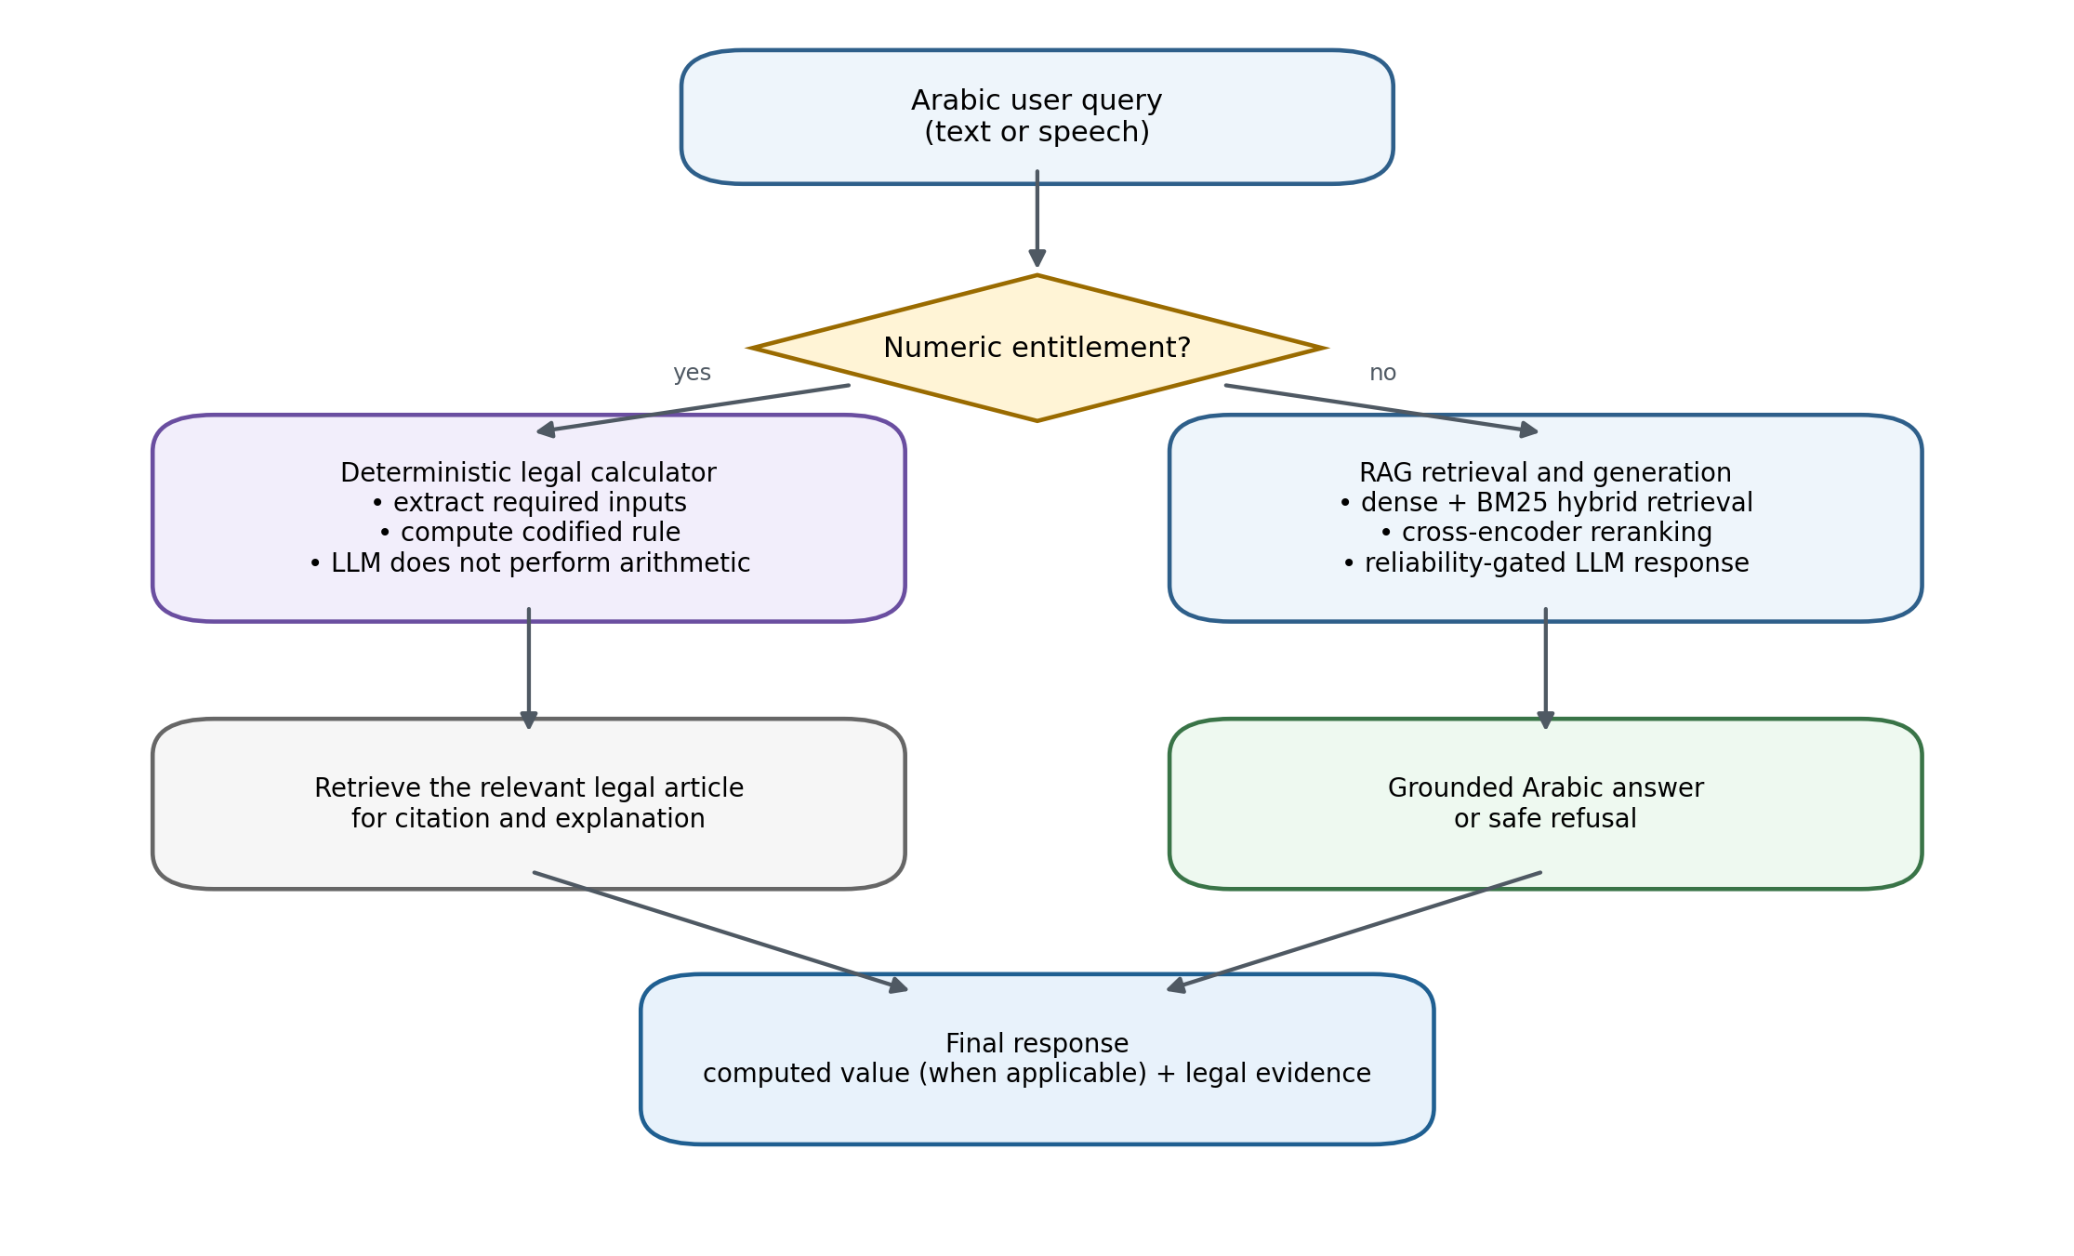
Figure 3.8. Hybrid answer generation: deterministic calculator versus RAG-LLM routing.

3.8 Deterministic Calculation Triggering Conditions
The deterministic calculation layer is not activated for every query that references a legal right, such as end-of-service benefits or annual leave. Instead, an intent-routing step first determines whether the user is requesting a numerical calculation or a general legal explanation.
A query is sent to the deterministic calculator only when three conditions are satisfied. Firstly, it is an expression of an intended calculation involving numbers. Secondly, it relates to an entitlement that has been provided for in the rule set implemented, e.g. annual leave, end of service award, notice compensation, resignation entitlement etc. Third, it provides the information needed to the that rule. In cases where notice is involved, conditions are in addition to the above: the type of contract, the person terminating it, the wage periodicity, and the actual notice. The amended Article 75 does not allow for one "notice period" to be applied to all cases [25].
For questions which require a general legal explanation but do not have enough numerical inputs, it is processed within the RAG-and-LLM pipeline rather than the calculator. It is also possible that if the question involves a calculation, but some of the data is unavailable, then the system prompts the user to specify the missing information instead of doing the calculation with incomplete data [25]. This design helps to avoid the language model from filling in missing values, and will only produce numerical answers when the information is available.
Query type | Example | System action
General legal explanation | What is the end-of-service award? | RAG + LLM explanation
Complete numerical calculation | Calculate end-of-service for 7 years and 6,000 SAR salary. | Calculator + RAG evidence
Missing required inputs | How much is my end-of-service award? | Ask for salary, service duration, and termination type
Out-of-scope question | What is the price of a house in Riyadh? | Safe refusal
Follow-up calculation | What if it was resignation? | Use conversation memory + calculator

3.9 Calculator and RAG Evidence
When using a calculator for numerical legal issues, the calculator will serve different functions and the retrieval layer will serve a different function. The value is calculated by the Python rule and RAG is used to get the corresponding legal article of the rule for traceability. For instance, end-of-service calculation is required by Article 84 and if a resignation fraction is applicable, then Article 85 is required. Notice compensation does not begin until the Contract and Notice Assumptions have been met, only then will Article 75 and Article 76 apply [25]. The LLM only states the verified answer and evidence in natural Arabic, but does not do the arithmetic.
This separation helps reduce the incidence of arithmetic hallucination and provides a legal basis based on official evidence retrieved.
Calculation type | Legal article | Implemented rule
Annual leave entitlement | Article 109 | 21 days annually; 30 days annually after five or more years of service.
End-of-service award | Article 84 | Half-month wage for each of the first five years and one-month wage for each following year.
Resignation entitlement | Article 85 | Applies the resignation fraction according to service duration.
Notice-related calculation | Article 75 | Apply the amended notice rule only after contract type, terminating party, wage periodicity, and actual notice are established.
Selected compensation cases | Article 76 | Compensation in lieu is computed only for the selected, fully specified cases implemented in code.

3.9.1 Reliability Threshold Calibration
The threshold for reliability was determined with the validation split only. The selection of thresholds was not based on the final legal test set or the additional robustness test set. After calibration, the threshold was set in advance of the Stage 05 and Stage 06, to prevent test leakage.
The threshold was chosen with the use of Youden's J statistic, J(τ) = sensitivity(τ) + specificity(τ) − 1 [38]. The risk of unsupported generation was thought to outweigh the risk of the more conservative threshold. On 56 validation examples, the selected value was τ = 0.6503, with J = 0.7805, sensitivity = 0.7805, and specificity = 1.0. This threshold was not selected based on the legal test, which consists of 24 questions nor on the robustness set, which consists of 201 questions.

3.10 Reliability Threshold Calibration Selection Criterion
For each candidate threshold, a confusion matrix was built on the validation set, and sensitivity and specificity were computed from its true-positive, false-negative, true-negative, and false-positive counts; Youden's J was then evaluated at every threshold, and the one maximizing J was selected. The validation set held 41 in-domain positives and 15 out-of-scope negatives. At the selected threshold τ = 0.6503, the confusion matrix was TP = 32, FN = 9, FP = 0, TN = 15, giving sensitivity = 0.7805, specificity = 1.0, and Youden's J = 0.7805. The operating point sits just above the highest out-of-scope retrieval score, so all 15 out-of-scope questions are refused.
J(τ) = Sensitivity(τ) + Specificity(τ) − 1
τ* = arg maxτ J(τ)
During the evaluation in Stage 06, the threshold τ* was kept fixed for all answer generation during Stage 05. This design does not require any tuning of the threshold according to the final results, and allows to evaluate leakage-free.

Reliability Gate Decision Process
The reliability gate is used after retrieval and prior to the generation of the answer, whose purpose is to avoid legal context scenarios in which the language model may return an answer even with low-quality evidence. Best evidence candidates are first selected and a retrieval confidence score is computed. If the score is at or above the calibrated threshold τ = 0.6503, the system sends the query to the LLM otherwise it returns a safe refusal.
G(q) = Pass to LLM, if score(q) ≥ τ; otherwise Safe Refusal
The gate is meant to be a retrieval-implementing security measure, not a legal correctness. If the score is below τ, a safe refusal takes place, otherwise grounded generation is allowed. All the questions in the separate mixed-type generation set were scored as pipeline outcomes (both generated answers and safe refusals).

3.11 Voice Processing Layer
The voice-processing layer enables spoken interaction. It converts the user's speech into text, forwards the transcribed query through the same RAG pipeline used for typed input, and converts the final Arabic response into speech.
Whisper-large-v3 was used as the main ASR model and Whisper-small as the latency-oriented alternative [7]. MMS-TTS-Arabic, from the Massively Multilingual Speech family, was used for the local synthetic-speech proxy [28], while Edge TTS was measured in the runtime latency setting. These conditions are reported separately because synthesis quality, network-dependent runtime, and ASR retranscription do not measure the same property.
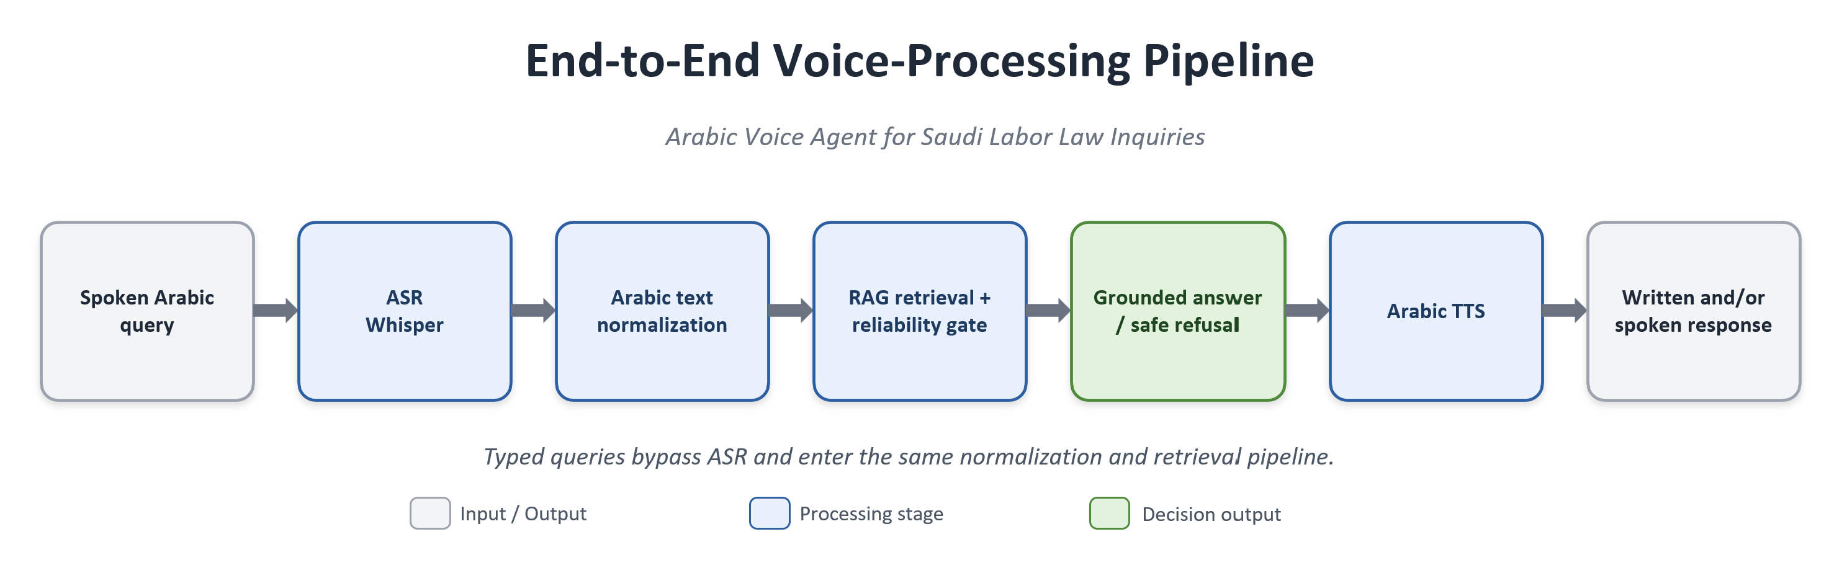
Figure 3.9. End-to-end voice-processing pipeline.
Figure 3.9 describes the voice-processing pipeline step by step:
Step 1: The user submits a spoken Arabic query.
Step 2: The ASR module transcribes the speech into text.
Step 3: The transcribed text is normalized and passed to the retrieval layer.
Step 4: The RAG layer retrieves relevant legal or FAQ evidence.
Step 5: The LLM generates a grounded Arabic answer from the retrieved evidence.
Step 6: The TTS engine synthesizes the final response as Arabic speech.
Step 7: The system returns both written and spoken outputs when voice mode is used.

3.12 Conversational Memory Module
The conversational memory module keeps short-term conversation context to enable multi-turn conversation. It is primarily used for query reformulation: If the user asks a follow-up question, it would be rephrased as an independent legal query before it is retrieved.
The formal definition of query reformulation is given below:
q*_t = Reformulate(q_t, H_(t-1)) (3.5)
q_t represents the latest query being issued by the user, and q*_t is the rewritten query, separated from the conversation history, sent to the retrieval layer, while H_(t-1) is the previous conversation history.
For instance, a question like “Can it be extended?” is elaborated by the previous conversation turn, to which the retrieval layer will get a full legal question. This helps to recall the answer for ambiguous subsequent questions and to anchor the final answer in official sources.

Memory Design: Conversation Memory versus Retrieval Memory
There are two types of memory in the system. The conversation memory is used to keep track of the context of the conversation at a session level, for the current conversation. It is meant to resubstitute follow-up questions and to fill in missing calculation inputs (such as salary, length of service or termination type) if they were supplied previously in the same session.
The second form is external retrieval memory, implemented through ChromaDB. This is not user-specific memory; it is a persistent legal knowledge base containing normalized legal articles and FAQ records stored as embeddings with metadata. The system does not store long-term personal-user profiles.

3.13 Evaluation Methodology
The evaluation was organized by component and experimental role. Retrieval was evaluated using Recall@k, MRR, and nDCG@5. The mixed-type generation comparison used automated rule-based correctness, an unsupported-claim proxy, wrong-citation outcomes, and secondary LLM-as-judge scores. The voice layer used WER and CER, while latency used measured wall-clock time and streamed time-to-first-response. No human or legal-expert adjudicator participated in the reported answer evaluation.
The final legal retrieval test comprised 24 manually curated questions. The 155-question retrieval ablation subset was used only for configuration comparison. The 201 automatically generated legal questions served as a supplementary robustness set, with all metrics computed over all 201 items. The paired generation comparison used a separate 45-question mixed-type set and must not be conflated with the 80 unique held-out FAQ questions.

3.13.1 Retrieval Evaluation Metrics
- Recall@k
Definition: Recall@k measures the proportion of evaluation questions for which the gold legal article appears within the top-k retrieved evidence passages.
Formula:
Recall@k = (1/N) Σ[i=1..N] 1[gold_i ∈ TopK(q_i)]
Use: This metric evaluates whether the retrieval layer retrieves the correct legal article within the evidence window.
- Mean Reciprocal Rank (MRR)
Definition: MRR is the average reciprocal rank of the first correct retrieved passage across the evaluation questions.
Formula:
MRR = (1/N) Σ[i=1..N] 1 / rank_i
Use: This metric evaluates whether the correct legal article is ranked near the top of the retrieved list.
- nDCG@k
Definition: nDCG@k measures normalized ranking quality by rewarding relevant evidence placed at higher ranks [41].
Formula:
DCG@k = Σ[j=1..k] rel_j / log2(j+1); nDCG@k = DCG@k / IDCG@k
Use: This metric evaluates the ranking quality of the retrieved evidence passages.
- Reliability Threshold
Definition: The retrieval-confidence threshold is the lowest score that the answer-generation is enabled when more than the threshold score is achieved.
Formula:
Generate answer if s_top1 ≥ τ; otherwise return a safe refusal.
Use: This decision rule is used to ensure that if the retrieved evidence is weak, it will not be used to provide a legal answer by the LLM.
Since, in this context, each legal question has only one gold document, the Recall@k and MRR metrics are more informative for the single gold retrieval evaluation.

3.13.2 Answer Generation Metrics
- Answer Accuracy
Definition: Answer accuracy is the proportion of all the pipeline answers that are scored as correct by the automated rubric specific to the task. Appropriate answers to the questions in the law or FAQ, appropriate small talk responses, and safe refusal responses, where refusal is appropriate, are all correct answers.
Formula:
Answer Accuracy = Number of correct pipeline outcomes / Number of evaluated questions
Use: This is the same measurement taken across the same 45 questions and gating decisions with the two generation models. It is not legal validation by experts, but a correctness proxy that is automatic.
- Faithfulness
Definition: The degree of faithfulness of the obtained answer based on the retrieved context. The judge gives a score s (where 1 ≤ s ≤ 5); the value s is then scaled to the interval [0,1] with (s − 1) / 4.
Formula:
Normalized score = (s_1–5 − 1) / 4; mean faithfulness = (1/N) Σ[i=1..N] normalized_faithfulness_i
Use: Grounding based on judges, summarized. This measure is secondary, as Qwen2.5-7B-Instruct was also one of the tested generators, and could be influenced by self-preference bias.
- Answer Relevance
Definition: the score given by the judges on a 1–5 scale for the relevance of the response to the user's question. The same transformation, (s − 1) / 4, maps 1, 2, 3, 4, and 5 to 0.00, 0.25, 0.50, 0.75, and 1.00.
Use: The same self-preference limitation applies to the reported answer-relevance value which is the mean of the normalized item-level scores.
- Automated Evaluation Protocol
The rule-depending rubric depended on the type of question: For the legal questions, a grounded response and the required article number were expected, for FAQ questions, support was expected with the retrieved context, for out of scope questions, a safe refusal was expected, and for small-talk inputs an appropriate controlled response was expected. For this task, Qwen2.5-7B-Instruct was judged on faithfulness and answer relevance, both with greedy decoding (do_sample = False) and max_new_tokens = 160, with the model being loaded into 4-bit NF4. The judge prompt is detailed in Appendix A.
- Hallucination Rate
Definition: Hallucination rate is the fraction of generated answers that contain unsupported information or fabricated legal claims.
Formula:
Hallucination Rate = Number of answers with unsupported claims / Number of evaluated answers
Use: This metric quantifies the risk of unsupported legal generation.
- Wrong Citation Rate
Definition: Wrong citation rate is the fraction of generated answers that cite an incorrect or unsupported legal article.
Formula:
Wrong Citation Rate = Number of answers with wrong or unsupported citations / Number of evaluated answers
Use: This metric evaluates citation reliability under both grounded and baseline generation settings.

3.13.3 Voice and Latency Metrics
- Word Error Rate (WER)
Definition: WER measures word-level transcription error in the ASR output.
Formula:
WER = (S + D + I) / N_words
Use: This metric evaluates the quality of Arabic ASR transcription.
- Character Error Rate (CER)
Definition: CER measures character-level transcription error in the ASR output.
Formula:
CER = (S_c + D_c + I_c) / N_characters
Use: This metric captures Arabic spelling and character-level transcription errors.
- TTS Intelligibility Proxy
Definition: The TTS intelligibility proxy synthesizes text into speech, retranscribes the audio, and compares the transcription with the original text.
Formula:
TTS Intelligibility Proxy = WER/CER(original text, ASR retranscription of synthesized speech)
Use: This metric estimates whether the synthesized Arabic speech remains intelligible.
- End-to-End Latency
Definition: End-to-end latency is the measured wall-clock time from user input to the final system response.
Formula:
End-to-End Latency = t_final response - t_user input
Use: This metric evaluates practical usability under real-time interaction.
- Time-to-First-Response (TTFR)
Definition: TTFR is the time until the first streamed response segment reaches the user.
Formula:
TTFR = t_first streamed output - t_user input
Use: This metric evaluates perceived latency when streaming is enabled.

3.13.4 Statistical Testing and Ablation Metrics
- Bootstrap 95% Confidence Interval
Definition: The reported 95% intervals were estimated with 10,000 percentile-bootstrap resamples of the item-level score vector, sampled with replacement. The lower and upper limits are the 2.5th and 97.5th percentiles of the bootstrap distribution. No BCa, bias-correction, or acceleration adjustment was applied [40].
Formula:
95% CI = [P2.5(bootstrap estimates), P97.5(bootstrap estimates)]
Use: This interval quantifies sampling uncertainty around the reported point estimate under the observed evaluation set and resampling procedure.
- McNemar Exact Test
Definition: McNemar's exact test compares two systems evaluated on the same questions using the discordant outcome counts b and c [39]. In this study, b = 6 represented ALLaM-correct/Qwen-incorrect cases and c = 1 represented Qwen-correct/ALLaM-incorrect cases.
Formula:
p = 2 × min{P(X ≤ min(b,c)), P(X ≥ max(b,c))}, where X ~ Binomial(b+c, 0.5)
Use: This test examines whether the difference between two paired systems is statistically significant.
- Ablation Difference
Definition: Ablation difference measures the change in performance after removing or modifying a system component.
Formula:
Δ_metric = metric(full system) - metric(ablated system)
Use: This metric estimates the contribution of components such as RAG, reranking, or latency control.
Module | Metrics Defined
RAG Retrieval | Recall@k, MRR, nDCG@k, reliability decision rule
Answer Generation | Automated rule-based correctness, normalized judge faithfulness and relevance, hallucination proxy, wrong-citation rate
Voice Layer | WER, CER, TTS intelligibility proxy
Latency | End-to-end latency, time-to-first-response
Statistical and Ablation Analysis | 10,000-resample percentile bootstrap, paired exact McNemar test, ablation difference
Table 3.5. Metrics defined for the final experiments. Numerical results are discussed in Chapter 4.

3.14 Experimental Setup and Reproducibility
This workflow was realized in Python, and a pipeline in Jupyter Notebooks was used to stage the process. The intermediate outputs were stored after each of the stages so that the next stage could be rerun without having to run the entire pipeline again. ChromaDB was used to implement the vector database and configuration files were used to store the main retrieval and generation settings.
The embedding, reranking, ASR, and answer generation were embedded using local models. Multilingual-e5-large and bge-m3 were the two main embedding models, bge-reranking-v2-m3 was the reranking model, Whisper-large-v3 was the ASR model, and ALLaM-7B and Qwen2.5-7B were the two generation models. The performance measurement of these components is available in Chapter 4.
Component | Specification
Development platform | Anaconda (conda environment), Jupyter Notebook
Operating system | Windows 11 Pro
Programming language | Python 3.13
Processor (CPU) | AMD Ryzen 9 9950X3D (16-core)
Memory (RAM) | 128 GB
GPU | NVIDIA RTX 5090, 32 GB
CUDA toolkit | 12.8
Deep-learning framework | PyTorch 2.12
Random seed | 42 (fixed across all stochastic components)
Table 3.6. Hardware and software environment used in the experiments.
Library | Version
pandas | 3.0.3
NumPy | 2.4.6
scikit-learn | 1.9.0
BeautifulSoup4 | 4.14.3
Selenium | 4.44.0
Sentence Transformers | 5.5.1
Transformers | 5.12.1
ChromaDB | 1.5.9
PyTorch | 2.12.0
Table 3.7. Principal Python libraries and their versions.

3.15 Summary
This chapter presented the methodology of the proposed Arabic voice agent, covering official data collection, Arabic text preprocessing, leakage-safe splitting, ChromaDB indexing, hybrid retrieval with reranking, guarded answer generation, deterministic legal calculation, voice processing, conversational memory, and evaluation metrics. No experimental results were reported in this chapter; the corresponding numerical findings are presented and discussed in Chapter 4.

Chapter 4: Results and Discussion

4.1 Introduction
The experimental results of the Arabic voice agent (AVA) used for Saudi Labor Law enquiries are summarized in this chapter. The results are organized by the major components of the system data preparation, data retrieval, reliability gating, answer generation, statistical evaluation, voice processing, ablation, latency and deterministic legal calculation. The results are followed by an explanation of what the outcomes are for the proposed system for each component.

4.2 Experimental Setup
This section explains the setup for the experimental evaluation of the proposed system with an explanation of the hardware environment, the software libraries, data split, and RAG configuration. It is important to report all these details because the retrieval result, the model configuration, the environment and the latency have all to do with the generation result, the voice processing result and the retrieval result.

4.2.1 Technical Environment
Experiments were performed on a local Anaconda environment with Python on one workstation with an NVIDIA RTX 5090 GPU. The same random seed was used in each experiment so that the results could be reproduced.
Table 4.1. Technical environment.
Component | Specification
Development platform | Anaconda (conda environment)
Programming language | Python 3.13
Operating system | Windows
GPU | NVIDIA RTX 5090 (CUDA 12.8)
Random seed | 42

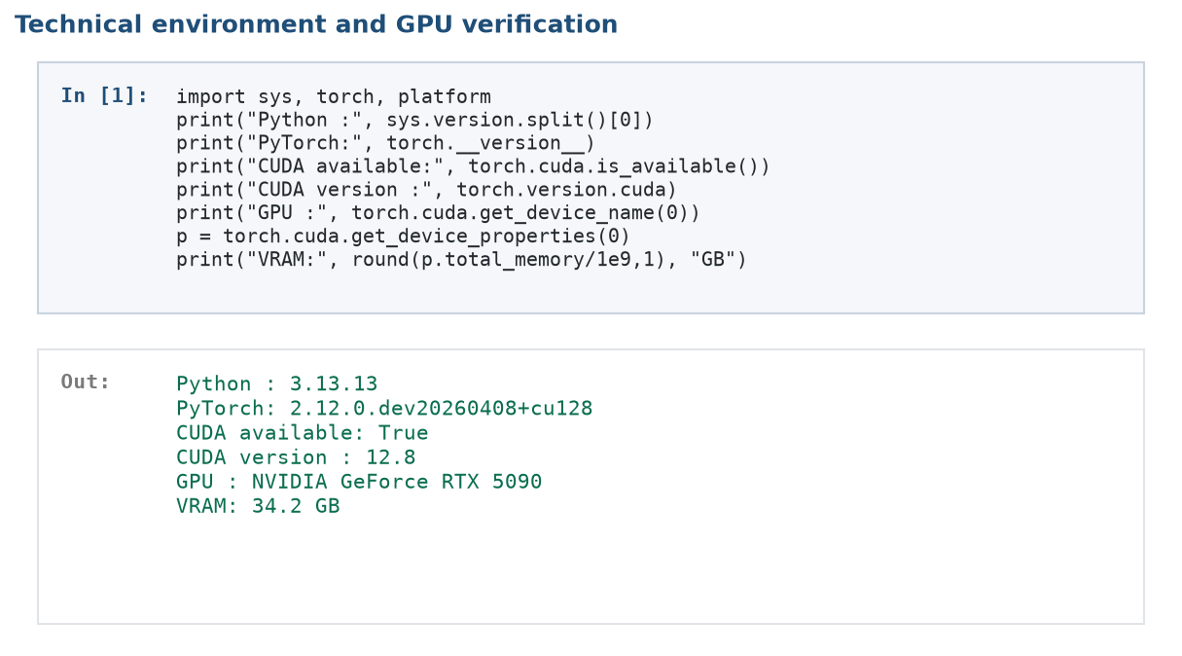
Figure 4.1. Code notebook screenshot: technical environment and GPU verification (Stage 03).
Figure 4.1 presents the notebook output used to verify the execution environment and GPU availability. This verification confirms that the retrieval and generation experiments were executed under the reported hardware setting.

4.2.2 Software Libraries and Versions
The major software libraries used in the experiments are summarized in Table 4.2. The retrieval and generation parts of this system are mainly implemented using PyTorch, Transformers, Sentence-Transformers, and ChromaDB. The bitsandbytes library was used to load the models and jiwer was used to calculate the WER and CER.
Table 4.2. Core libraries and their versions.
Library | Version | Role
PyTorch | 2.12 (CUDA 12.8) | Deep-learning backend
Transformers | 5.12.1 | LLM and ASR loading
Sentence-Transformers | 5.5.1 | Embeddings and reranker
ChromaDB | 1.5.9 | Persistent vector database
rank-bm25 | 0.2.2 | Lexical (BM25) retrieval
bitsandbytes | 0.49.2 | 4-bit model quantization
accelerate | 1.14.0 | Model loading and placement
Gradio | 6.19.0 | Web interface
jiwer | 4.0.0 | WER / CER computation
scikit-learn | 1.9.0 | TF-IDF and evaluation utilities
pandas / numpy | 3.0.3 / 2.4.6 | Data processing
edge-tts | 7.2.8 | Arabic speech synthesis

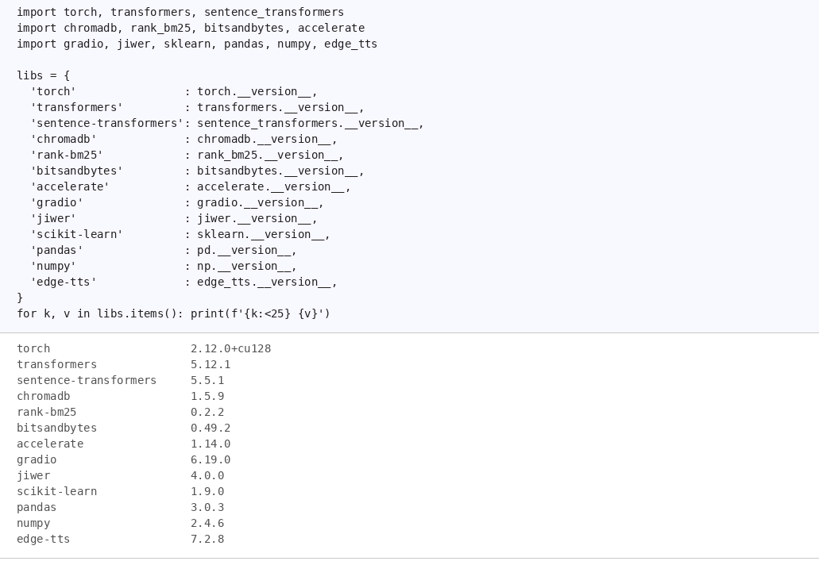
Figure 4.2. Code notebook screenshot: library version check output (Stage 03).
Figure 4.2 presents the library-version check from the notebook. Recording the library versions improves the reproducibility of the experiments and reduces ambiguity when the pipeline is executed on another machine.

4.2.3 Data Split and RAG Parameters
The FAQ data were partitioned into 278 indexing rows, 41 validation rows and 81 raw held-out rows. Two source question texts were held out, one of which was found in two of the source records, which left 80 unique question texts after removing one of them and holding the other. Figure 4.3 presents the raw split output, which means that the total of 81 is the number of rows, not the number of questions that were unique.
Table 4.3. Data split and RAG configuration parameters.
Parameter | Value
Data split (train / validation / test) | 70% / 10% / 20% (leakage-safe, ID-based)
Chunk size (fixed-size baseline) | 500 words
Chunk overlap (fixed-size baseline) | 80 words
Chunking (best configuration) | Structural (article / FAQ boundary)
Number of retrieved documents (top_k) | 5
Candidate pool (candidate_k) | 50
Hybrid weight (α) | 0.80
Embedding models | multilingual-e5-large, bge-m3
Reranker | bge-reranker-v2-m3
Language models | ALLaM-7B-Instruct, Qwen2.5-7B-Instruct (4-bit NF4)
ASR model | Whisper-large-v3
Reliability threshold | 0.6503 (validation-only Youden’s J)

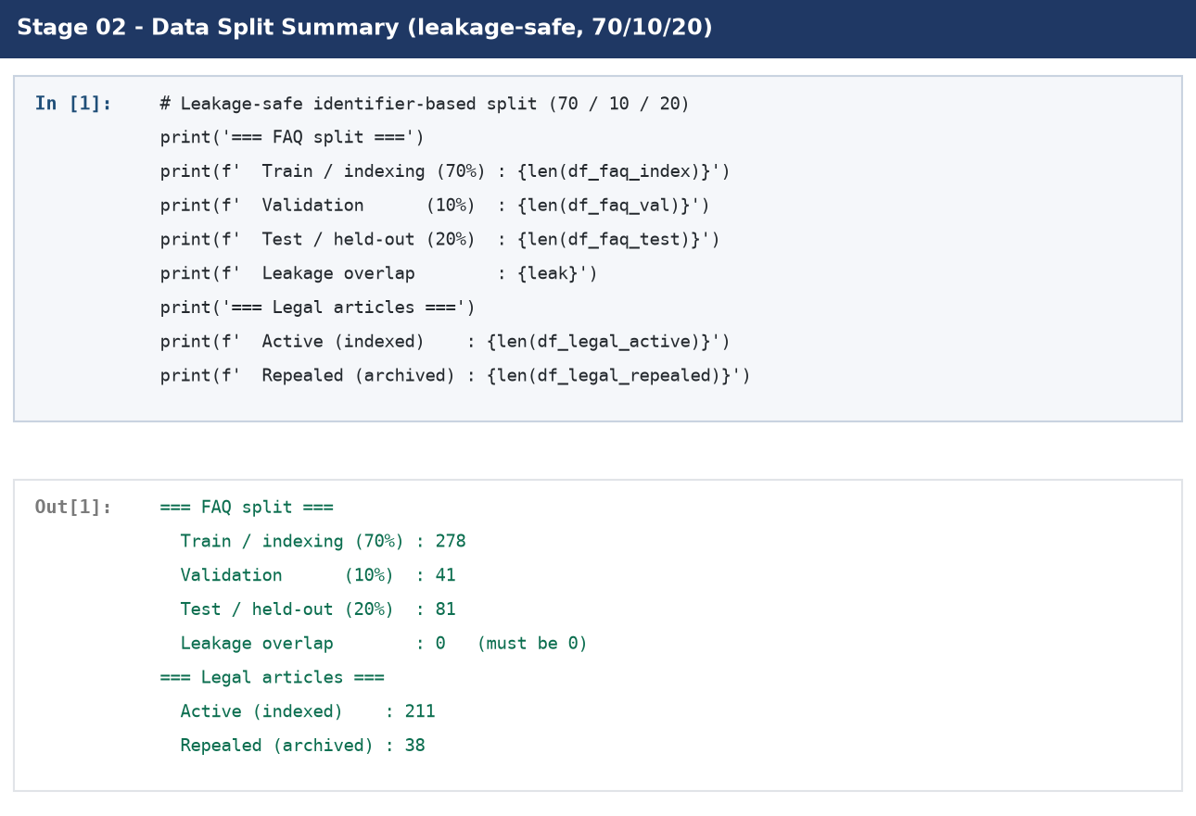
Figure 4.3. Code notebook screenshot: leakage-safe data split summary (Stage 02).
Figure 4.3 presents the raw leakage-safe split output from Stage 02: 278 indexing rows, 41 validation rows, and 81 held-out rows. Subsequent exact question-text deduplication reduced the held-out FAQ resource to 80 unique questions. The figure therefore documents the raw split and is not evidence of an 81-question unique evaluation set.
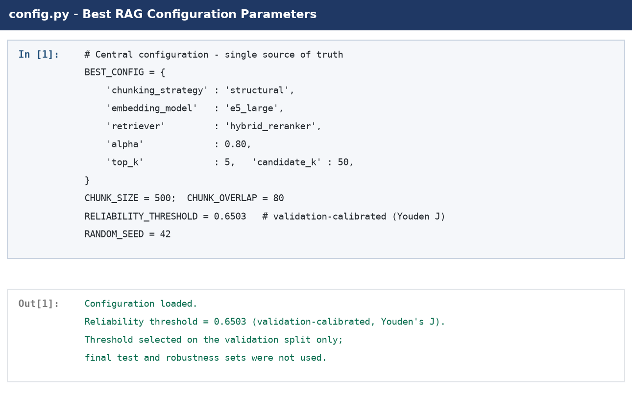
Figure 4.4. Code notebook screenshot: RAG configuration parameters from config.py.
Figure 4.4 presents the main configuration parameters used by the RAG pipeline, including the chunking strategy, retrieval depth, candidate pool size, hybrid weight, embedding models, reranker, language models, ASR model, and reliability threshold.
The important parameters for the proposed Retrieval-Augmented Generation (RAG) pipeline are provided in Figure 4.4. These parameters were chosen due to their effect on the retrieval effectiveness, the accuracy of the retrieved answers, computational efficiency, and reliability of the legal QA system in Arabic. Legal consistency is one of the essential properties for legal domain applications, therefore, not only the coverage of the retrieved evidence but also the relevance and legal validity of the evidence retrieved for the application were taken into account in the configuration process for this application. The crucial step in preparing the knowledge base is the chunking strategy, which defines the way legal documents are divided into chunks that are to be retrieved. Smaller chunks are good for retrieval precision, but can cause loss of important legal context information, while larger chunks maintain legal context between legal provisions but may lead to introducing extraneous information during retrieval. The adopted chunking method thus seeks to achieve the balance between contextual completeness and retrieval specificity, especially in the case of provisions in the Saudi Labor Law that require it to be surrounded by legal explanation. The number of documents retrieved and then ranked depends on the retrieval depth and the number of candidates in the candidate pool: a higher retrieval depth means more documents will be retrieved, but it also means that more documents will be noisy (unrelevant) and have more computational cost, while a shallower retrieval depth would retrieve fewer documents but might miss relevant legal evidence information. These parameters were therefore selected to offer the legal coverage within a reasonable limit and to have responses that were not too long for interactive voice applications. The pipeline also leverages the leverage of dense vector retrieval with the conventional lexical matching by introducing a hybrid weighting parameter that harmonizes semantic similarity with the relevance of keywords. This combination is especially important for Arabic legal texts, because the meaning of legal terms, article numbers and oriented terms needs to be retained with the general meaning. The embedding model maps the Arabic legal documents and the user query into vectors for semantic similarity search and the reranking model is used to reorder the retrieved candidates to find the evidence that is most relevant to the user query. The system optimizes the retrieval process in two stages to deliver more precise retrieval results, and then convey the retrieved high-quality and relevant evidence to the LLM-based generation stage.

4.3 Data Preparation Results
Data-preparation phase transformed official Saudi Labor Law and HRSD FAQ sources to a clean leakage safe knowledge base. Legal articles were retained in a way that they could be indexed, archived articles were archived, FAQ records were filtered by domain, and the prepared articles were converted into chunks that can be retrieved. The final composition table of the prepared data is shown in Table 4.4.
Table 4.4. Knowledge base composition after preparation.
Component | Count | Role
Active legal articles | 211 | Indexed official legal evidence
Repealed articles (archived) | 38 | Excluded from active retrieval
Indexed FAQ records | 278 rows | Service-oriented evidence in the searchable knowledge base
Raw FAQ held-out partition | 81 rows | Raw 20% split output
Unique FAQ held-out resource | 80 questions | One exact duplicate question removed before scoring
Final legal retrieval test | 24 questions | Manually curated final retrieval benchmark
Supplementary robustness set | 201 questions | All items retained; 194 top-five successes
Mixed-type generation comparison | 45 questions | 14 FAQ, 17 legal, 12 out-of-scope, 2 small-talk; 29 answers, 16 refusals

Table 4.4 shows that during the time of this writing, there were 211 active legal articles and 278 indexed FAQ records in the searchable knowledge base. Question-text deduplication reduced the 81 row FAQ held-out partition to 80 unique questions. Finally, there was a mixed-type comparison, which had a set of 45 questions but was fed with a mix of legal, FAQ, out-of-scope and small-talk inputs.
The data structure allows the construction of knowledge bases and their evaluation to be kept apart. The manually curated legal set of 24 questions was used as the main retrieval test and the automatically generated legal set of 201 questions provided as a sub test for robustness checking. There were 81 rows of the held-out partition of the raw FAQ and 80 unique question texts, which were not added to the searchable FAQ. This wasn't the 45 questions that were chosen from that FAQ partition for the final paired LLM comparison. Rather, it employed a distinctively mixed category of 45 questions, 14 of which were FAQ, 17 were legal, 12 were out of scope and 2 were small-talk inputs.
Keeping separate datasets for retrieval evaluation, robustness testing and answer generation evaluation makes sure that each experimental result will reflect the capability of the corresponding system element. By separating the methodology, the strength of the assessment is enhanced, ensuring data does not leak from one part of the methodology to the other, fair comparison across configurations, and a more detailed understanding of the strengths and limitations of each stage of the proposed RAG-based legal assistant.

4.4 Retrieval Evaluation Results
The retrieval evaluation aims to evaluate the ability of proposed RAG pipeline to retrieve relevant legal evidence from the built Saudi Labor Law and HRSD knowledge base. It focused on the consistency of the retrieval of the relevant legal passages for various types of queries as retrieval quality is directly related to the accuracy of the generated answer. This assessment method de-couples the retrieval assessment from the language generation assessment, thus allowing for retrieval performance to be unrelated to language generation behavior.

4.4.1 Evaluation Sets and Sample Sizes
The various data sets were used for various experimental purposes. The 24-question manually curated set was the last legal retrieval test, the 155-question ablation set was used for comparison of retrieval configurations and the full 201-question automatically generated test was used as a supplementary robustness check. There were 81 rows and 80 different question texts in the raw FAQ held-out partition. Instead of picking 45 questions from the FAQ held-out resource, the paired LLM comparison employed a different set of questions of the same size (45).
Table 4.5. Evaluation sets and their roles in the experimental analysis.
Evaluation set | Size | Role
Final legal retrieval test | 24 questions | Manually curated held-out legal set; principal final retrieval result
Retrieval validation ablation subset | 155 questions | Configuration comparison only; not the final test
Supplementary robustness set | 201 questions | Automatically generated stress test; all 201 included, with 194 top-five successes
FAQ held-out resource | 81 raw rows / 80 unique questions | Held outside the FAQ index; one exact duplicate question removed before scoring
Mixed-type paired generation set | 45 questions | 14 FAQ, 17 legal, 12 out-of-scope, 2 small-talk; 29 generated answers and 16 safe refusals

The robustness metrics in Table 4.8 are based on all 201 automatically-generated legal questions. The gold article is in the top 5 answers for 194 queries, so the Recall@5 is 194/201 = 0.9652. A combined set of 218 items, taken from the 24 manual questions, plus just the 194 cases of successful robustness, is not an independent benchmark, since it is missing seven retrieval failures.

4.4.2 Comparison of Retrieval Methods
Several retrieval configurations were evaluated before the final setting was selected. Table 4.6 compares hybrid retrieval with hybrid retrieval followed by cross-encoder reranking on the validation ablation subset. This experiment was used for configuration validation and does not constitute the final legal retrieval test.
Table 4.6. Retrieval-method validation ablation: hybrid vs hybrid + reranker (n = 155).
Method | Recall@1 | Recall@3 | Recall@5 | MRR
Hybrid | 0.8645 | 0.9097 | 0.9226 | 0.8846
Hybrid + Reranker | 0.9161 | 0.9871 | 0.9935 | 0.9508

According to Table 4.6, adding the reranker improved all retrieval metrics. Recall@1 increased from 0.8645 with hybrid retrieval to 0.9161 with hybrid retrieval plus reranking, while MRR increased from 0.8846 to 0.9508. This indicates that the reranker not only retrieved more relevant candidates but also improved the ordering of the retrieved passages, which is particularly crucial in legal RAG since the top-ranked passage is usually the primary evidence used by the answer-generation module.
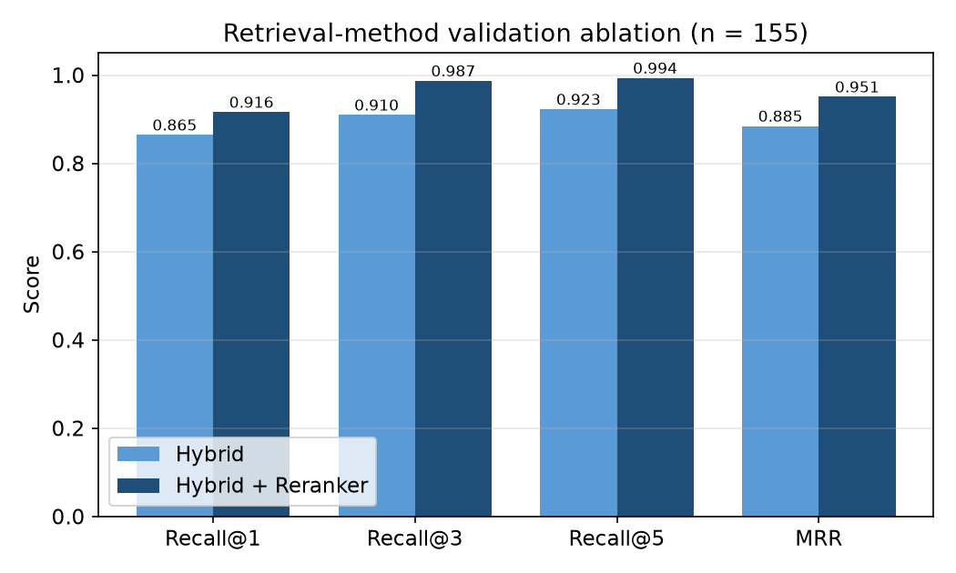
Figure 4.5. Retrieval method comparison on the legal-article task (higher is better).
Figure 4.5 illustrates the improvement achieved by adding the reranker. The figure demonstrates that early-ranking performance, particularly Recall@1 and MRR, improved once the cross-encoder reranker was added to hybrid retrieval.

4.4.3 Final Legal Retrieval Test
After selecting the final retrieval configuration, the system was evaluated on the manually curated, held-out legal test set. The final configuration used structural segmentation, multilingual-e5-large embeddings, hybrid retrieval, and cross-encoder reranking. Table 4.7 presents the final legal retrieval result.
Table 4.7. Final legal retrieval test on the manually curated held-out legal set (n = 24).
Metric | Score
Recall@1 | 0.8750
Recall@3 | 0.9583
Recall@5 | 0.9583
MRR | 0.9097
nDCG@5 | 0.9221
Sample size (n) | 24 (manually curated legal test)

According to Table 4.7, the system retrieved the correct legal article at the first rank for 87.50% of the final legal questions, and the correct article appeared within the top five results for 95.83% of the questions. The MRR value of 0.9097 further demonstrates that the correct article was consistently ranked near the top. These results indicate that the selected retrieval configuration provides strong evidence coverage for the generator. Since the final legal test comprises only 24 manually curated questions, this result is reported cautiously and is supported by the supplementary robustness check.

4.4.4 Supplementary Robustness Check (Auto-Generated Legal Set)
To examine whether retrieval behavior remained stable on a larger sample, the selected retrieval configuration was also evaluated on the auto-generated legal set (n = 201). These questions were generated from legal articles and marked as pending expert review; this experiment is therefore reported only as a supplementary robustness check and not as the final legal test.
Table 4.8. Supplementary robustness check on the auto-generated legal set (n = 201, pending expert review).
Metric | Result
Recall@1 | 0.8358
Recall@3 | 0.9403
Recall@5 | 0.9652
MRR | 0.8902
nDCG@5 | 0.9092

According to Table 4.8, the system achieved Recall@1 = 0.8358 and Recall@5 = 0.9652 on all 201 robustness questions. The Recall@5 result corresponds to 194 successful top-five retrievals and seven failures. These questions were automatically generated and not independently adjudicated by legal experts, so the experiment is interpreted as a supplementary stress test rather than a replacement for the 24-question manually curated test.
Answer-generation performance was first validated using only the validation split, in order to set the minimum retrieval-confidence threshold required for generating legal answers. This calibration step establishes a decision boundary against which retrieved evidence is compared to determine whether it is sufficiently reliable to support answer generation by the LLM.
The fixed threshold was calibrated on 56 validation examples using Youden's J. The selected value, τ = 0.6503, produced J = 0.7805, sensitivity = 0.7805, and specificity = 1.0. Calibration did not use the 24-question final legal test, the 201-question robustness set, or the 45-question generation comparison. This separation reduces threshold-selection leakage, although it does not eliminate uncertainty associated with the modest validation sample.

4.5 Answer Generation Results
Two local 4-bit NF4 language models, ALLaM-7B and Qwen2.5-7B, were compared on the same stratified mixed-type set of 45 questions: 14 FAQ, 17 legal, 12 out-of-scope, and 2 small-talk. The fixed gate allowed generated answers for 29 questions and produced safe refusals for 16. Accuracy was computed over all 45 outcomes, so an appropriate refusal counted as correct when the rubric expected refusal.
Table 4.9. Generation accuracy of the two language models.
Model | Correct outcomes | Accuracy | 95% percentile-bootstrap CI | Hallucination proxy
ALLaM-7B | 37 / 45 | 0.8222 | [0.7111, 0.9333] | 0.0667
Qwen2.5-7B | 32 / 45 | 0.7111 | [0.5778, 0.8444] | 0.0667

According to Table 4.9, ALLaM-7B produced 37 correct pipeline outcomes out of 45 (0.8222), while Qwen2.5-7B produced 32 out of 45 (0.7111). The 95% percentile-bootstrap intervals were [0.7111, 0.9333] and [0.5778, 0.8444], respectively. These values include correct grounded answers, correct controlled responses, and correct safe refusals under the automated rubric.
Both models were evaluated on the same 45 questions; therefore, the comparison was paired. The paired table contained 31 questions answered correctly by both models, 6 correct only for ALLaM-7B, 1 correct only for Qwen2.5-7B, and 7 incorrect for both. Although ALLaM-7B was the more accurate (in its observation), the exact McNemar result does not favor the claim of statistically superior performance.
In this experiment, the five question difference is not statistically significant, and is not distinguishable from paired sampling variation at the conventional 0.05 level. Hence, model selection should take into account for automated correctness, evidence adherence, answer relevance, latency, resource consumption, Arabic quality and constraints of the evaluation procedure.
The outcome suggests that ALLaM-7B is a viable generator in the evaluated setup, but doesn't prove it the best overall compared to Qwen2.5-7B. This comparison is only applied to one prompt, one retrieval configuration, one quantization, and 45 mixed type questions.
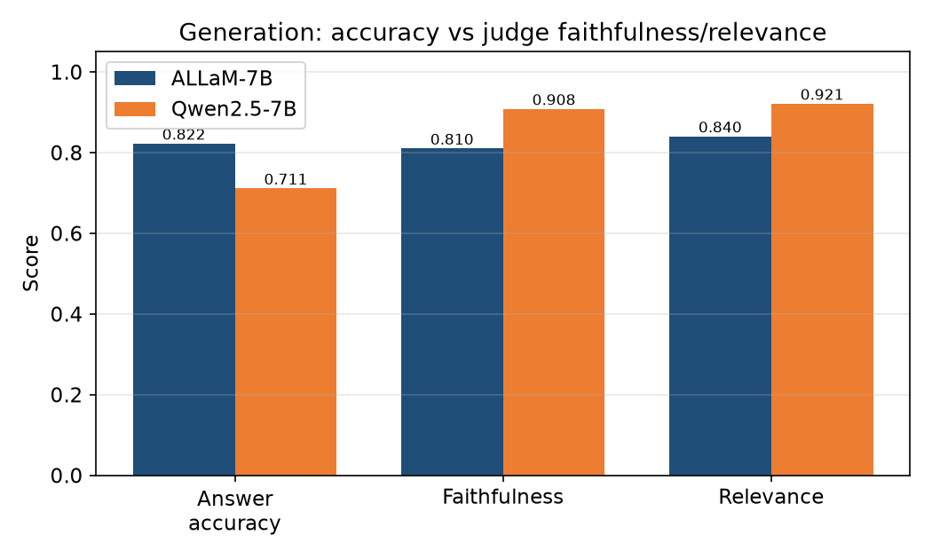
Figure 4.6. Answer accuracy and faithfulness of ALLaM-7B and Qwen2.5-7B.
Figure 4.6 compares the answer accuracy and judge-based faithfulness of the two models, showing that ALLaM-7B achieved higher observed accuracy, while Qwen2.5-7B achieved higher faithfulness and relevance according to the LLM-as-judge evaluation.

4.6 Statistical Evaluation
A paired exact McNemar test was used because ALLaM-7B and Qwen2.5-7B were evaluated on the same 45 questions. The discordant counts were b = 6 and c = 1, with 7 discordant pairs in total. Accuracy uncertainty was estimated by 10,000 percentile-bootstrap resamples. Qwen2.5-7B-Instruct also served as the automated judge for faithfulness and answer relevance, so those judge-based measures are reported as secondary proxies.
Table 4.10. Statistical comparison and faithfulness results.
Measure | ALLaM-7B | Qwen2.5-7B
Answer accuracy | 0.8222 (37/45) | 0.7111 (32/45)
Faithfulness proxy | 0.810 | 0.908
Answer relevance proxy | 0.840 | 0.921
Both correct / both incorrect | 31 / 7 | 31 / 7
Discordant outcomes | b = 6 (ALLaM only correct) | c = 1 (Qwen only correct)
Exact two-sided McNemar p-value | 0.1250 (not significant) | 0.1250 (not significant)
95% percentile-bootstrap CI | [0.7111, 0.9333] | [0.5778, 0.8444]

According to Table 4.10, the exact two-sided McNemar test yielded p = 0.1250. ALLaM-7B therefore achieved the higher observed accuracy, but the experiment did not establish a statistically significant model difference. The paired counts and p-value are reported explicitly to avoid interpreting overlapping confidence intervals as a significance test.
The judge-based scores showed a different pattern: Qwen2.5-7B obtained faithfulness = 0.908 and answer relevance = 0.921, compared with 0.810 and 0.840 for ALLaM-7B. The judge assigned 1–5 ordinal scores that were normalized using (s − 1) / 4 and averaged. Because the judge was Qwen2.5-7B-Instruct and Qwen was also one of the evaluated generators, these values may contain self-preference bias. No human or legal-expert adjudication was performed, so the judge scores cannot be interpreted as independent legal validation.

4.7 Voice Layer Results
The voice layer was evaluated using Word Error Rate (WER) and Character Error Rate (CER). These metrics were computed in Stage 07 to assess the transcription quality of the Arabic speech interface. Table 4.11 presents the voice-layer results.
Table 4.11. Voice-layer error rates (Stage 07).
Metric | Result | Interpretation
ASR WER | 0.209; 95% CI [0.162, 0.264] | About one word in five altered; synthetic-speech proxy
ASR CER | 0.0484; 95% CI [0.0357, 0.0631] | Character-level errors below 5%

According to Table 4.11, the synthetic-speech proxy produced WER = 0.209 and CER = 0.0484. The lower character-level error indicates that some word-level differences involved short orthographic or segmentation changes. The test does not represent natural Saudi-dialect speakers, microphone variability, or background noise and should therefore be interpreted as a controlled proxy only.

4.8 No-RAG versus RAG Ablation
An ablation study was conducted to evaluate the impact of the Retrieval-Augmented Generation (RAG) component of the proposed Arabic legal question-answering system. Ablation analysis is a well-established evaluation method for isolating the contribution of individual system components relative to a baseline. In this experiment, the retrieval component of the proposed architecture was removed to construct a No-RAG baseline in which the model generates responses using only its internal knowledge, without access to retrieved evidence from the Saudi Labor Law.
In the No-RAG setting, the language model received only the user query and generated a response from its parametric knowledge. In contrast, the RAG condition supplied relevant evidence from the Saudi Labor Law and HRSD knowledge base before generation. RAG is designed to ground knowledge-intensive generation in retrieved external evidence [6], and surveys of the approach identify unsupported generation and source attribution as central evaluation concerns [27]. Both conditions used the same language model, prompt family, evaluation questions, and scoring criteria; the manipulated factor was the availability of retrieved legal evidence. The resulting comparison therefore isolates the observed contribution of retrieval under this experimental configuration, without establishing causality beyond the tested sample and controls.
For the purposes of this experiment, the wrong-citation rate (percentage of answers with a wrong or no citation of a legal article) was the primary assessment criterion. The reduction in wrong citations was chosen as a metric because it's a crucial property of legal-domain AI systems: it signifies that the strength of the grounding in the retrieval increases the ability of the model to produce evidence-based answers to legal questions.
The results in Table 4.12 show the impact that retrieval grounding has on the reliability of legal responses. The No-RAG configuration yielded more errors in citations as it accesses its pre-trained knowledge without relying on the evidence base of the Saudi Labor Law at the time of the test. The discovery underscores the critical need for legal proficiency in language models, particularly for complex, domain-specific tasks. The RAG configuration helped to decrease the number of citations errors, by limiting the generation process to the legally retrieved evidence, thus strengthening the retrieval as a reliability mechanism besides being an information-enhancement mechanism. If the context is included in the input, the model will also have less memory dependency and increase the traceability of the answers generated. Hence, the ablations results confirm the main design decision of this research, which is the need to adopt retrieval augmentation to develop a credible Arabic legal assistant. The results reveal that the support of RAG does not just increase the completeness of the answers, but also enriches the legal information given and decreases the chance of misleading users with unsupported legal information.
Table 4.12. Effect of retrieval on wrong legal citation rate.
Metric (n = 24) | Rate
No-RAG correct-citation rate | 0.292
RAG correct-citation rate | 0.208
No-RAG wrong-citation rate | 0.250
RAG wrong-citation rate | 0.042

According to Table 4.12, the wrong-citation rate decreased from 0.250 in the No-RAG condition to 0.042 in the RAG condition, corresponding to 6 of 24 versus 1 of 24 answers. The correct-citation rate was 0.292 without RAG and 0.208 with RAG. The result therefore shows a reduction in harmful citation errors, not an increase in the frequency of correct citations; the paired correctness test was not significant (p = 0.7266).
The ablation is consequently interpreted as an observed citation-safety improvement under the tested sample. Retrieval grounding reduced incorrect or unsupported article references, but the experiment did not demonstrate a statistically significant increase in overall correctness. This distinction is important because a system can cite fewer wrong articles by refusing or omitting citations, so the complete response-outcome distribution should be retained in the experiment archive.
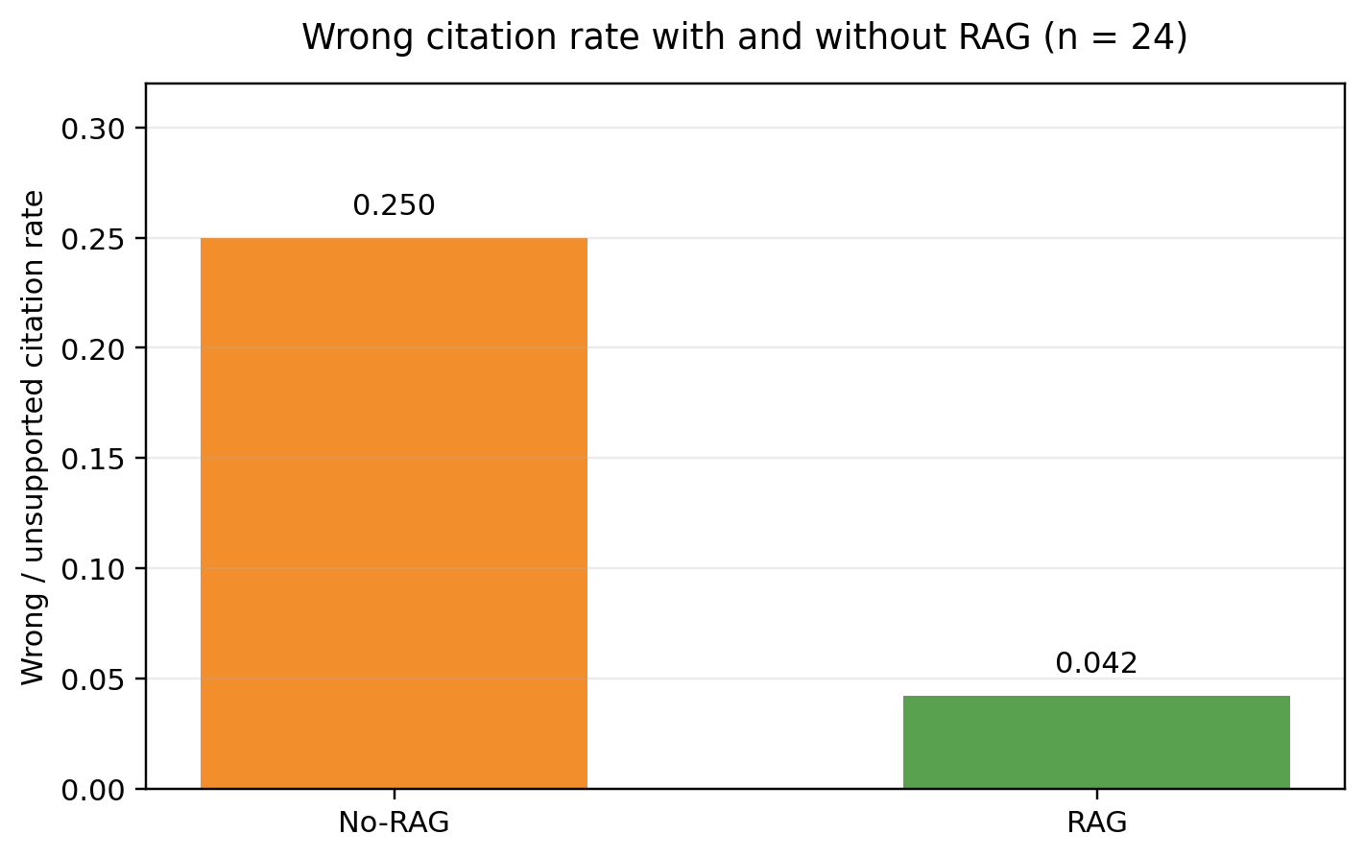
Figure 4.7. Effect of retrieval grounding on the wrong legal-citation rate.
Figure 4.7 presents the reduction in wrong legal-citation rate following the introduction of retrieval grounding, showing that RAG reduced the wrong-citation rate from 0.250 to 0.042 on the 24-question legal ablation sample.

4.9 Latency Results
Latency was measured to determine whether the complete system is practical for voice interaction. Stage 09 measured the main pipeline components, including ASR, retrieval, LLM generation, TTS, full end-to-end latency, optimized latency, and streaming time-to-first-response. Table 4.13 presents the latency breakdown.
Table 4.13. End-to-end latency under three settings.
Component / setting | Time
ASR (Whisper large-v3) | 0.68 s
ASR (Whisper small) | 0.31 s
Retrieval | 0.25 s
LLM generation (full) | 1.88 s
LLM generation (capped) | 1.23 s
TTS (edge-tts) | 1.18 s
Full pipeline (large ASR, full answer) | 3.99 s
Optimized (small ASR, capped tokens) | 2.96 s
Perceived (streaming, time-to-first-response) | 0.82 s

According to Table 4.13, the full pipeline latency was 3.99 seconds. The optimized configuration reduced this to 2.96 seconds by using the faster ASR option together with capped answer generation, and with streaming enabled, the perceived time-to-first-response decreased to 0.82 seconds. The largest delay originated from LLM generation and TTS, while retrieval was comparatively fast at 0.25 seconds, indicating that retrieval is not the main latency bottleneck in the proposed system. The reported values are measured wall clock values from the most recent verified execution, and should not be taken to mean the sum of the rounded component values.
The latency measurements are performed based on wall-clock runtime; small differences between the runs is expected as the load of the GPU, network, device temperature, and variability of the TTS service may influence the runtime. Hence, the latest verified execution is used as a final latency result. The takeout of it is that streaming is the best way to lower the perceived latency.
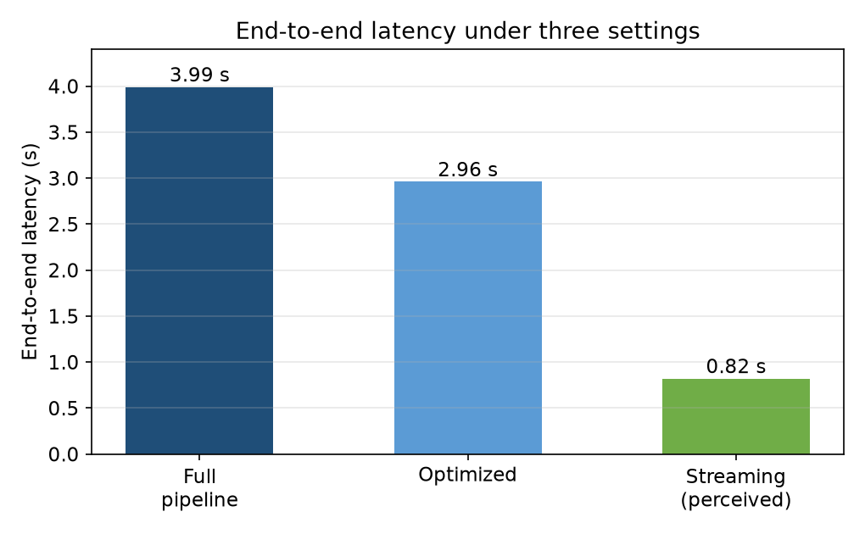
Figure 4.8. End-to-end latency under the three settings.
Figure 4.8 illustrates the latency difference between the full pipeline, the optimized configuration, and streaming, showing that streaming keeps the system responsive even while the complete answer continues to be generated in the background.

4.10 Deterministic Calculation Layer Implementation Checks
The 4.10 DetCLI status is “In Progress”.The status of the 4.10 DetCLI is “In Progress”. The deterministic calculation layer was validated with typical numerical test cases. These checks on implementation confirmed that the Python functions gave the correct values from the codified rules, and that the text for the corresponding articles could be retrieved for citations. They were not legal-expert independent validations. The examples that have been tested, and the assumptions for each output are shown in Table 4.14.
Table 4.14. Representative implementation test cases for the deterministic calculation layer.
Query / assumptions | Article(s) | Computed result
Annual leave for 1.5 years of service | 109 | 31.5 days
End-of-service award: 7 years, employer termination, 6,000 SAR monthly wage | 84 | 27,000 SAR
End-of-service award: 7 years, resignation, 6,000 SAR monthly wage | 84, 85 | 18,000 SAR (two-thirds of the Article 84 award)
Employer terminates an indefinite-term, monthly paid contract after 7 years without the required 60-day notice; wage = 6,000 SAR | 84, 75, 76 | 39,000 SAR (27,000 award + 12,000 notice compensation; unused leave excluded)

Table 4.14 shows that the deterministic layer resulted in the desired values for the examples applied. The 39,000 SAR summary only applies where the employer terminates an indefinite term contract upon payment by the month after 7 years without providing for a notice period under Article 75 and 76: 27,000 SAR + 12,000 SAR for a 60-day notice period. This is not a universal output for all types of dismissals as the type of contract and the party for whom the notice is given, and the frequency of the wages, can vary the applicable rule [25].

4.11 Overall Results Summary
Table 4.15 summarizes the main results of the full system. This table provides a consolidated view and does not replace the detailed analysis presented in the previous sections.
Table 4.15. Overall system performance summary.
Component | Main result | Interpretation
Final legal retrieval | Recall@1 = 0.8750; Recall@5 = 0.9583 (n = 24) | Strong observed top-five coverage; manual test remains small
Robustness retrieval | Recall@5 = 194/201 = 0.9652 | All 201 automatically generated questions included
Generation correctness | ALLaM = 0.8222; Qwen = 0.7111 (n = 45) | Higher observed ALLaM score; no significant paired difference
Reliability gate outcomes | 29 generated answers; 16 safe refusals | Outcomes reported over the independent 45-question mixed-type set
Paired statistical test | b = 6, c = 1; exact p = 0.1250 | No statistically significant model superiority established
Judge-based proxies | Faithfulness 0.810 / 0.908; relevance 0.840 / 0.921 | Qwen judge favored Qwen; self-preference limitation
Voice proxy | WER = 0.209; CER = 0.0484 | Synthetic-speech evaluation; real-speaker testing required
RAG ablation | Wrong citations 0.250 → 0.042 (n = 24) | Observed citation-safety improvement; no significant correctness gain
Latency | 2.96 s complete; 0.82 s streamed TTFR | Environment-specific local-workstation measurement
Calculation layer | Deterministic for selected fully specified rules | Reduces arithmetic hallucination but is not complete legal coverage

Table 4.15 shows that the retrieval layer performs well in the last legal test, where the Recall@1 value is 0.8750 and the Recall@5 value is 0.9583, which is important for the generation module as it uses the retrieved article as an evidence source.
The generation results show that both models, ALLaM-7B and Qwen2.5-7B, are good performers according to the proposed RAG protocol. ALLaM-7B outperformed on the observed answer accuracy, and Qwen2.5-7B on faithfulness and relevance by using a proxy of the LLM-as-judge. Because of the lack of significance for McNemar's test, no model is statistically superior and thus, will not be reported.
The ablation result is the most convincing evidence of the importance of retrieval grounding as it showed that the wrong-citation rate reduced from 0.250 without RAG to 0.042 with RAG. The difference in the correctness was not statistically significant, but this decrease in the number of inaccurate legal citations does have significance for a legal-information assistant.
The voice and latency results indicate that the system is suitable for interactive use under the conditions of its workstations, especially with the use of streaming. The voice evaluation was carried out using synthetic speech, however, the latency values are wall clock values and have to be validated in more deployment settings and with real human speech.

4.12 Discussion
A threshold, the answer-or-refuse threshold, was calibrated using the validation-only calibration prior to the final retrieval, robustness, and generation experiments. This design allows for no direct tuning on the reported test results. It doesn't, however, replace the automated assessment with the legal validation of an expert or eliminate uncertainty that comes from small validation and test sets.
The retrieval results provide answers to the first empirical question, the configuration that was selected as a hybrid and reranked configuration typically placed the correct legal article at the top of evidence list. The result of Recall@5 of 0.9583 on the 24 question final legal test and Recall@5 = 0.9652 on the 201 question robustness set. The results corroborate the selected evidence window, but are to be considered along with the small manual test and the automatically generated robustness questions.
The results of the generation comparison were not consistently superior to each other. The Qwen judge scores were higher for Qwen2.5-7B while the automated correctness was higher for ALLaM-7B. It was not possible to conclude with McNemar's exact test if there is a significant difference in correctness; a judge is not independent of one of the models compared. The study thus presents the observed pattern, but does not pick out the best statistical model.
The No-RAG comparison shows evidence for the safety role of retrieval grounding. The mis-citations decreased from six to one on the 24 legal questions, but there was no increase in the number of correct citations and the correctness comparison was not significant. The main takeaway is that the principal implication of RAG is that it can help minimize unsupported references in a "limited" prompt, but it would be beneficial to have a human review to see if the pattern also applies to legal accuracy and utility in a larger scope of prompts.
The results of the latency experiment indicate that retrieval was not the most significant delay in the tested workstation. Optimized complete response took 2.96 seconds and streaming cut the perceived time to first response to 0.82 seconds. All of these measurements are specific to the environment and the voice test was presented in the form of synthetic speech. All the tests that have been done include real speaker, noisy channel, concurrent user, and deployment network tests prior to claims made while in operation.

4.13 Limitations
  - No legal adjudication imposed by man. The correctness of all reported answers was achieved through task-specific rules and an LLM-as-judge approach. Metrics are automatic proxies and not legal certifications as there was no qualified Saudi Labor Law expert who reviewed the entire answer set.
  - Robustness Questions automatically generated. There was no supplementary set of 201 questions which was automatically generated, and 194 questions were gold evidence in the top five. Of the 201 questions, 201 were included in the metrics but independent legal questions of question wording, ambiguity and gold-article assignment remain to be validated.
  - Synthetic speech evaluation. WER and CER were evaluated using the synthetic speech proxy and are not natural Saudi dialects, spontaneous speech or speaker variances, microphones or background noise.
  - Non-independent LLM judge. There were two models that were considered as generations: Qwen2.5-7B-Instruct, which was used to evaluate faithfulness and relevance, and Qwen2.5-7B. Thus the proxy scores might be subject to self-preference bias.
  - Calculation rules which are limited and version sensitive. The calculator includes certain provisions and relies on legal assumptions and versioning of the sources. It is not a substitute for detailed legal analysis for a case and should be revised as law and/or implementing regulations change.
  - Appropriate assessment and application to a specific context. The 24-question final legal test, 45-question generation comparison, and latency measurements obtained in a single workstation do not provide broad population level or production level conclusions, but rather an exploratory assessment.

4.14 Summary
The retrieval, generation, statistical, voice, citation-ablation, latency and deterministic-calculation results were reported in this chapter. The best retrieval setting had Recall@5 = 0.9583 for the 24 question final legal test and 0.9652 for the 201 question robustness set. ALLaM-7B performs better than Qwen2.5-7B with regards to what it can predict correctly, though the distinction is not statistically significant when compared with each other. The automated and synthetic evaluation and the modest scale of deployment restrict the strength of deployment claims, and RAG's wrong citation rate was reduced from 0.250 to 0.042.

Chapter 5: Conclusion and Future Work

5.1 Conclusion
In this thesis, the design and experimental testing of an Arabic voice agent for information about Saudi Labor Law were described. The system includes ASR—a versioned official evidence base, hybrid dense-and-lexical retrieval, cross-encoder reranking, a fixed reliability gate, local LLM generation, and deterministic legal computation and TTS. The architecture splits the evidence retrieval, probabilistic generation, legal arithmetic and voice processing apart to allow each to be assessed individually.
The knowledge base currently holds 211 legal articles and 278 labor-related FAQ records, of which 38 were not currently retrievable, but were retained in the archive. 278 FAQ indexing rows, 41 validation rows, and 81 raw held-out rows were generated from the FAQ split; 80 unique held-out FAQ question text were generated from the exact question-text deduplication. Three types of generation resources were kept separate (legal, robustness, mixed-type), in order to prevent mixing up experimental roles.
The best retrieval configuration that was selected had Recall@1 = 0.8750, Recall@5 = 0.9583, MRR = 0.9097, and nDCG@5 = 0.9221 on the 24 question legal test that was manually curated. Recall@5 = 0.9652 (194 correct top-5 retrievals) for all 201 automatically generated robustness questions. Separate 45 question mixed-type generation comparison, ALLaM-7B: 0.8222, Qwen2.5-7B: 0.7111, paired exact McNemar test: p = 0.1250.
The ablation experiment also revealed that RAG was able to reduce the rate of wrong citations from 0.250 to 0.042 for 24 legal questions, while the frequency of correct citations and correctness were not significantly improved. The optimized pipeline achieved a complete response time of 2.96 seconds and streamed time-to-first-response of 0.82 seconds in the tested environment. These findings contribute to the argument for the viability of an evidence based local system rather than legality or production readiness.

5.2 Contributions
First, an end-to-end modular spoken and typed Arabic labor-law pipeline for retrieval-grounded generation, safe refusal, deterministic calculation and voice output.
Second, it outlines a procedure for validation instead of calibration that takes place before the final test to ensure the reliability threshold is fixed prior to reported results rather than during the test; thereby decreasing the risk of tuning the threshold on the reported outcome.
Third, it differentiates numerical legal computation from LLM generation and provides evidence of the relevant article as evidence for each numerical computation implemented.
Fourth, it offers a traceable, leakage-aware data pipeline that differentiates rows from the source, unique questions, indexed evidence, validation examples, held-out examples of the FAQ, legal tests and robustness questions, as well as the independent mixed-type generation set.
Fifth, it provides component-level metrics, statistical testing of the paired components, percentile-bootstrap uncertainty, citation ablation, and explicit limitations of automated evaluation.

5.3 Limitations
The drawbacks are that there is no human and human-expert evaluation or adjudication, Qwen acts as both a candidate generator and LLM judge, test sizes are limited in size and manual, robustness questions are automatically generated, robustness questions are synthetically spoken, calculator rules are version-sensitive, and latency is measured from one workstation. The system only offers general legal information and is not tested for customized legal advice or production deployment.

5.4 Future Work
To improve future work, it is recommended to first evaluate the adductions with qualified specialists in the field of Saudi Labor Law which should be evaluated without blind and in accordance with an adjudication rubric, and to check for inter rater agreement. Second, the voice layer should be evaluated on a diverse set of real Saudi speakers, noisy channels, multiple microphones, and dialects. Third, there should be versioning and regression test of the legal corpus and deterministic rules for future statutory/regulatory changes. Fourth, more extensive bivariate assessments should be conducted to evaluate other local models, local prompts and reliability strategies. Last, the user understanding of the service, its accessibility, its security and privacy, and its concurrency should be measured in a realistic service setting during a deployment study.

5.5 Closing Remarks
Finally, the study demonstrates that a modular Arabic voice-agent system is able to retrieve official documents related to Saudi labor law evidence, generate grounded or safely refused responses, compute specific numerical entitlements deterministically, and respond within an interactive latency range, while using local hardware. The most strongly supported conclusion is that wrong citations of the law were less in the sample tested. More sweeping statements about the accuracy of the law, the benefit to the user, and other operational safeguards need to be verified by humans and real-world testing.

References

[1] N. J. Nilsson, The Quest for Artificial Intelligence: A History of Ideas and Achievements. Cambridge, U.K.: Cambridge University Press, 2010.
[2] K. P. Murphy, Probabilistic Machine Learning: An Introduction. Cambridge, MA, USA: MIT Press, 2022.
[3] I. Goodfellow, Y. Bengio, and A. Courville, Deep Learning. Cambridge, MA, USA: MIT Press, 2016.
[4] D. Jurafsky and J. H. Martin, Speech and Language Processing, 3rd ed., draft, 2025.
[5] A. Vaswani et al., “Attention Is All You Need,” in Advances in Neural Information Processing Systems 30, 2017, pp. 5998–6008.
[6] P. Lewis et al., “Retrieval-Augmented Generation for Knowledge-Intensive NLP Tasks,” in Advances in Neural Information Processing Systems 33, 2020, pp. 9459–9474.
[7] A. Radford, J. W. Kim, T. Xu, G. Brockman, C. McLeavey, and I. Sutskever, “Robust Speech Recognition via Large-Scale Weak Supervision,” in Proc. ICML, vol. 202, 2023, pp. 28492–28518.
[8] J. Shen et al., “Natural TTS Synthesis by Conditioning WaveNet on Mel Spectrogram Predictions,” in Proc. IEEE ICASSP, 2018, pp. 4779–4783.
[9] A. C. Morris, V. Maier, and P. Green, “From WER and RIL to MER and WIL: Improved Evaluation Measures for Connected Speech Recognition,” in Proc. Interspeech, 2004, pp. 2765–2768.
[10] V. Ethiraj, A. David, S. Menon, and D. Vijay, “Toward Low-Latency End-to-End Voice Agents for Telecommunications Using Streaming ASR, Quantized LLMs, and Real-Time TTS,” arXiv:2508.04721, 2025.
[11] D. Zhang et al., “SpeechGPT: Empowering Large Language Models with Intrinsic Cross-Modal Conversational Abilities,” in Findings of the Association for Computational Linguistics: EMNLP 2023, pp. 15757–15773, doi: 10.18653/v1/2023.findings-emnlp.1055.
[12] I. Besrour, J. He, T. Schreieder, and M. Färber, “RAGentA: Multi-Agent Retrieval-Augmented Generation for Attributed Question Answering,” arXiv:2506.16988, 2025.
[13] Ö. T. Özyilmaz, M. Coler, and M. Valdenegro-Toro, “Overcoming Data Scarcity in Multi-Dialectal Arabic ASR via Whisper Fine-Tuning,” in Proc. Interspeech 2025, pp. 1158–1162, doi: 10.21437/Interspeech.2025-2260.
[14] H. Elleuch, Y. Saidi, S. Mdhaffar, Y. Estève, and F. Bougares, “ELYADATA & LIA at NADI 2025: ASR and ADI Subtasks,” in Proc. Third Arabic Natural Language Processing Conference: Shared Tasks, 2025, pp. 762–766, doi: 10.18653/v1/2025.arabicnlp-sharedtasks.105.
[15] J. Hrimech, M. Mghari, and Y. Zaz, “Retrieval-Augmented Generation for Arabic Legal Information: The Family Code Case Study,” TELKOMNIKA, vol. 23, no. 6, pp. 1495–1505, 2025, doi: 10.12928/TELKOMNIKA.v23i6.27400.
[16] H. Liu, S. Yusuyin, H. Huang, and Z. Ou, “CTC-TTS: LLM-Based Dual-Streaming Text-to-Speech with CTC Alignment,” arXiv:2602.19574, 2026.
[17] X. Li et al., “CM-TTS: Enhancing Real-Time Text-to-Speech Synthesis Efficiency Through Weighted Samplers and Consistency Models,” in Findings of the Association for Computational Linguistics: NAACL 2024, pp. 3777–3794, doi: 10.18653/v1/2024.findings-naacl.240.
[18] A. Aloqla, R. Khalifa, and W. Alghamdi, “A Review of Question-Answering Systems Using Deep Learning in the Arabic Language,” Engineering, Technology & Applied Science Research, vol. 15, no. 6, pp. 29214–29228, 2025, doi: 10.48084/etasr.14229.
[19] H. Abu Shairah et al., “ALARB: An Arabic Legal Argument Reasoning Benchmark,” in Proc. Third Arabic Natural Language Processing Conference, 2025, pp. 389–406, doi: 10.18653/v1/2025.arabicnlp-main.32.
[20] S. N. Al-Huwari, “NEBRAS: A RAG-Based Question Answering System for Islamic and Legal Guidance,” master’s thesis, Faculty of Graduate Studies, An-Najah National University, Nablus, Palestine, 2025.
[21] Seamless Communication et al., “SeamlessM4T: Massively Multilingual & Multimodal Machine Translation,” arXiv:2308.11596, 2023.
[22] M. AL-Smadi, “QU-NLP at QIAS 2025 Shared Task: A Two-Phase LLM Fine-Tuning and Retrieval-Augmented Generation Approach for Islamic Inheritance Reasoning,” in Proc. Third Arabic Natural Language Processing Conference: Shared Tasks, 2025, pp. 892–898, doi: 10.18653/v1/2025.arabicnlp-sharedtasks.123.
[23] S. Shikhar et al., “LLMVoX: Autoregressive Streaming Text-to-Speech Model for Any LLM,” in Findings of the Association for Computational Linguistics: ACL 2025, pp. 20481–20493, doi: 10.18653/v1/2025.findings-acl.1051.
[24] J. Alsubhi et al., “Optimizing RAG Pipelines for Arabic: A Systematic Analysis of Core Components,” arXiv:2506.06339, 2025.
[25] Kingdom of Saudi Arabia, Labor Law, Royal Decree No. M/51, 23 Sha‘ban 1426 AH (27 September 2005), as amended by Royal Decree No. M/44, 8 Safar 1446 AH (12 August 2024), effective 20 Sha‘ban 1446 AH (19 February 2025), Ministry of Human Resources and Social Development. Accessed: 12 July 2026.
[26] Saudi Ministry of Human Resources and Social Development, “Frequently Asked Questions,” official service-information portal. Accessed: 12 July 2026.
[27] Y. Gao et al., “Retrieval-Augmented Generation for Large Language Models: A Survey,” arXiv:2312.10997, 2024.
[28] V. Pratap et al., “Scaling Speech Technology to 1,000+ Languages,” Journal of Machine Learning Research, vol. 25, pp. 1–52, 2024.
[29] G. Salton and C. Buckley, “Term-Weighting Approaches in Automatic Text Retrieval,” Information Processing & Management, vol. 24, no. 5, pp. 513–523, 1988.
[30] L. Wang, N. Yang, X. Huang, L. Yang, R. Majumder, and F. Wei, “Multilingual E5 Text Embeddings: A Technical Report,” arXiv:2402.05672, 2024.
[31] J. Chen, S. Xiao, P. Zhang, K. Luo, D. Lian, and Z. Liu, “BGE M3-Embedding: Multi-Lingual, Multi-Functionality, Multi-Granularity Text Embeddings Through Self-Knowledge Distillation,” in Findings of the Association for Computational Linguistics: ACL 2024, 2024.
[32] N. Reimers and I. Gurevych, “Sentence-BERT: Sentence Embeddings Using Siamese BERT-Networks,” in Proc. EMNLP-IJCNLP, 2019, pp. 3982–3992.
[33] S. Robertson and H. Zaragoza, “The Probabilistic Relevance Framework: BM25 and Beyond,” Foundations and Trends in Information Retrieval, vol. 3, no. 4, pp. 333–389, 2009.
[34] S. Xiao, Z. Liu, P. Zhang, and N. Muennighoff, “C-Pack: Packaged Resources to Advance General Chinese Embedding,” in Proc. ACM SIGIR, 2024.
[35] R. Nogueira and K. Cho, “Passage Re-Ranking with BERT,” arXiv:1901.04085, 2019.
[36] M. S. Bari et al., “ALLaM: Large Language Models for Arabic and English,” arXiv:2407.15390, 2024.
[37] Qwen Team, “Qwen2.5 Technical Report,” arXiv:2412.15115, 2024.
[38] W. J. Youden, “Index for Rating Diagnostic Tests,” Cancer, vol. 3, no. 1, pp. 32–35, 1950.
[39] Q. McNemar, “Note on the Sampling Error of the Difference Between Correlated Proportions or Percentages,” Psychometrika, vol. 12, no. 2, pp. 153–157, 1947.
[40] B. Efron and R. J. Tibshirani, An Introduction to the Bootstrap. New York, NY, USA: Chapman & Hall, 1993.
[41] K. Järvelin and J. Kekäläinen, “Cumulated Gain-Based Evaluation of IR Techniques,” ACM Transactions on Information Systems, vol. 20, no. 4, pp. 422–446, 2002.

Appendix A: Automated Evaluation Rubric and Judge Prompt
A.1 Rule-Based Correctness Rubric. Legal questions required a grounded answer and the expected article number; FAQ questions required support from the retrieved context; out-of-scope questions required a safe refusal; and small-talk inputs required an appropriate controlled response. No human or legal-expert adjudicator participated in the reported evaluation.
A.2 LLM Judge Configuration. Faithfulness and answer relevance were evaluated using Qwen2.5-7B-Instruct loaded in 4-bit NF4. Decoding was deterministic (do_sample = False) with max_new_tokens = 160. Raw scores from 1 to 5 were normalized with (s − 1) / 4, so the mapped values were 0.00, 0.25, 0.50, 0.75, and 1.00.
A.3 Judge Prompt. The judge was instructed to evaluate the answer only against the retrieved context and to return valid JSON with three fields: faithfulness, answer_relevance, and reason. Faithfulness was scored from 1 to 5 according to whether the answer was supported by the retrieved context. Answer relevance was scored from 1 to 5 according to whether the response directly answered the user question. The reason field contained a short explanation of the assigned scores.
A.4 Judge Limitation. Qwen2.5-7B-Instruct was both an evaluated generator and the judge. Faithfulness and relevance are therefore secondary proxy measures that may be affected by self-preference bias and must not be presented as independent human or legal-expert validation.
A.5 Statistical Procedure. Accuracy intervals used 10,000 percentile-bootstrap resamples with limits at the 2.5th and 97.5th percentiles. No BCa, bias-correction, or acceleration adjustment was applied. The paired exact McNemar table was: both correct = 31, ALLaM only correct = 6, Qwen only correct = 1, both incorrect = 7; exact two-sided p = 0.1250.

Appendix B: Data-Lineage and Deduplication Record
B.1 FAQ Split. The identifier-based split produced 278 indexing rows, 41 validation rows, and 81 raw held-out rows. The raw split therefore contained 400 rows.
B.2 Exact Duplicate. The question “ما هي أهداف برنامج حماية الأجور؟” occurred in faq_id 248 and faq_id 94. faq_id 248 was retained as the canonical evaluation record. faq_id 94 was removed before scoring; its document_unit_id was b0ebcab351b4739f0566a90080daa23d875b475bac36659a0088539697b8a266. The operation was exact question-text deduplication, not a quality exclusion.
B.3 Final FAQ Resource. The 81 raw held-out rows represented 80 unique question texts after deduplication.
B.4 Robustness Set. The supplementary legal robustness set contained 201 automatically generated questions. The gold article appeared within the top five for 194 questions; all metrics were computed over all 201 questions.
B.5 Generation Comparison. The paired generation set was independent of the FAQ held-out resource and contained 45 questions: 14 FAQ, 17 legal, 12 out-of-scope, and 2 small-talk. The fixed gate produced 29 generated answers and 16 safe refusals. Accuracy counted both correct answers and correct refusals.

