Lesson summary: Opportunity cost and the PPC

In this lesson summary, review the key concepts, key terms, and key graphs for understanding opportunity cost and the production possibilities curve.
The Production Possibilities Curve (PPC) is a model used to show the tradeoffs associated with allocating resources between the production of two goods. The PPC can be used to illustrate the concepts of scarcity, opportunity cost, efficiency, inefficiency, economic growth, and contractions.
For example, suppose Carmen splits her time as a carpenter between making tables and building bookshelves. The PPC would show the maximum amount of either tables or bookshelves she could build given her current resources. The shape of the PPC would indicate whether she had increasing or constant opportunity costs.
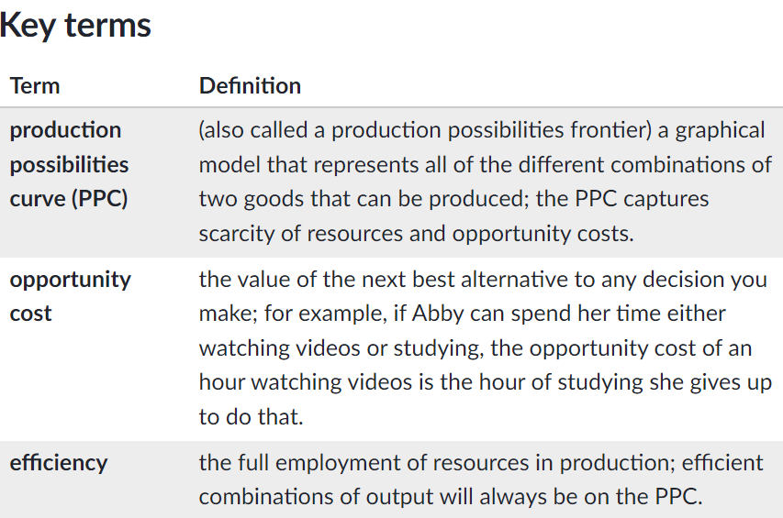
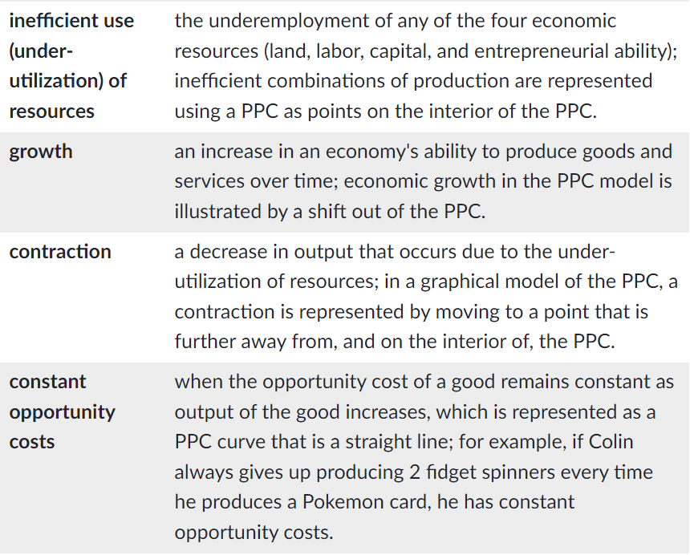
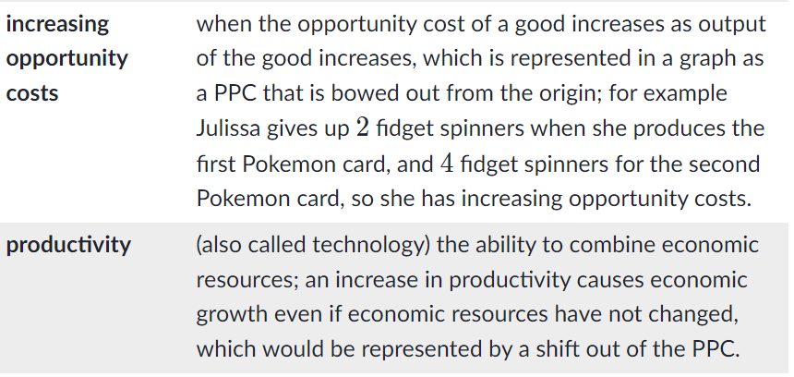
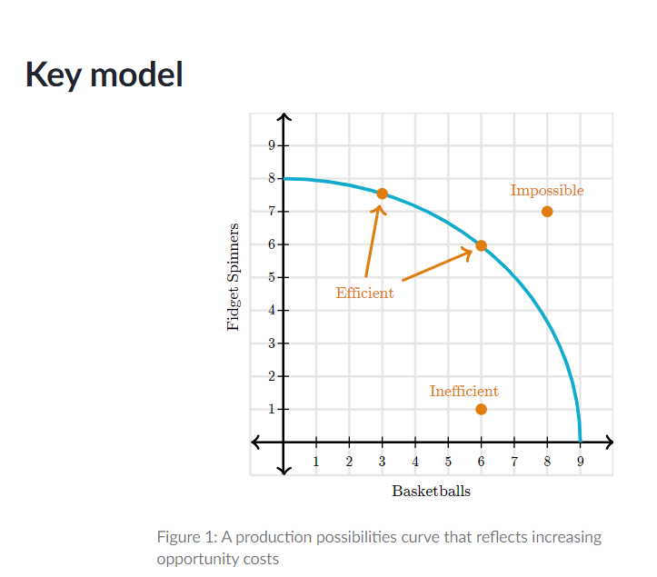
The Production Possibilities Curve (PPC) is a model that captures scarcity and the opportunity costs of choices when faced with the possibility of producing two goods or services. Points on the interior of the PPC are inefficient, points on the PPC are efficient, and points beyond the PPC are unattainable. The opportunity cost of moving from one efficient combination of production to another efficient combination of production is how much of one good is given up in order to get more of the other good.
The shape of the PPC also gives us information on the production technology (in other words, how the resources are combined to produce these goods). The bowed out shape of the PPC in Figure 111 indicates that there are increasing opportunity costs of production.
We can also use the PPC model to illustrate economic growth, which is represented by a shift of the PPC. Figure 222 illustrates an agent that has experienced economic growth. Combinations that were once impossible, such as 6 iPads and 4 watches, are now on the new PPC, thanks to the increase in resources or technology.

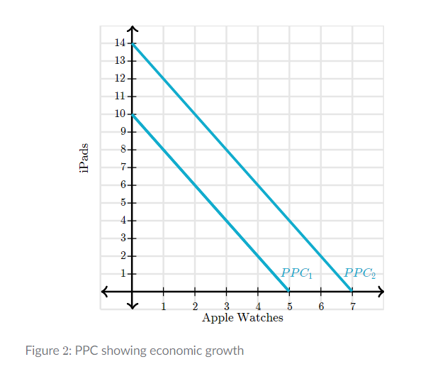

Key Equations and Calculations: Calculating opportunity costs:
To find the opportunity cost of any good X in terms of the units of Y given up, we use the following formula:
Opportunity cost of each unit of good X: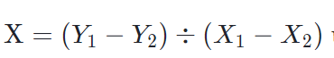
For example, suppose we knew that the following table represented all of the possible combinations of iPads and Apple Watches that could be produced.
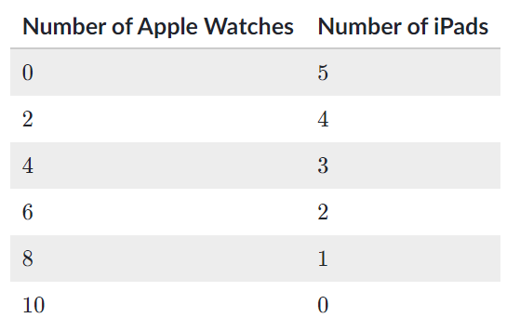
If a producer is producing 6 Apple Watches and Apple Watches and 2 iPads, but wants to make one more iPad, they can instead produce 4 Apple Watches and 3 iPads:
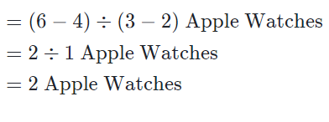
Note that opportunity costs are always expressed in terms of the good that is given up.
We can use the same procedure if given a graph. Figure 333 shows a PPC that has been created from our table. The two points used in this formula are the two efficient points indicated in the graph in Figure 3.



