

Explainable Deep Learning for Bean Leaf Disease Classification Using Attention and Grad-CAM
Prepared By
Name: Lama Al-alsubaie ID No: 252001246

Submitted in fulfillment of the requirements for the degree Master of Science in Artificial Intelligence
At
Collage of Informatics
Midocean University
UAE
Supervisor Name: Khaled Eskaf
Collage of Informatics, Midocean University, Comoros

Acknowledgements

I just want to say thank you to everyone who's helped me with my thesis. My family has been amazing, always being patient and encouraging, even when things got really tough. I'm so grateful to my brother Abdullah, who has been with me every step of the way, always there to lend a hand when I needed it. I really appreciate everything he's done for me. Thanks to all of them, I was able to get through this journey. They've made a big difference, and I'm thankful for their support. My brother Abdullah, in particular, has been a huge help, and I'm so lucky to have him in my life. Anyway, I just wanted to take a moment I would like to extend my sincere appreciation to all those who have supported and assisted me. It means a lot to me. I also want to thank Dr. Khaled Eskaf for her guidance, support and feedback, as they helped immensely to finish this thesis. May they all be blessed by God.

Contents
ii
Acknowledgements iii
List of Abbreviations vi
List of Figures vii
List of Tables viii
List of Equations ix
Abstract x
Chapter 1 Introduction 1
1.1 Overview 1
1.2 Problem Definition 1
1.3 Thesis Objectives 2
1.4 Thesis Contribution 2
1.5 Thesis Organization 3
Chapter 2 Background and Related Work 4
2.1 Introduction 4
2.2 Background 4
2.3 Machine Learning Approaches for Plant Disease Detection 5
2.4 Deep Learning for Plant Disease Classification 9
2.5 Explainable Artificial Intelligence (XAI) 13
2.6 Evaluation Metrics 15
2.7 Related Work 16
2.8 Chapter Summary 22
CHAPTER 3 Proposed Approach 23
3.1 Introduction 23
3.2 Proposed Framework 23
3.3 Dataset Description 25
3.4 Data Preprocessing 25
3.5 Dataset Splitting 26
3.6 Proposed Deep Learning Model 26
3.7 Model Training 27
3.8 Performance Evaluation 28
3.9 Explainability Using Grad-CAM 28
3.10 Experimental Environment 29
3.11 Chapter Summary 29
CHAPTER 4 Results and Discussion 30
4.1 Introduction 30
4.2 Dataset Visualization 30
4.3 Training Performance 31
4.4 Classification Performance 33
4.5 Confusion Matrix Analysis 34
4.6 Explainability Using Grad-CAM 35
4.7 Comparison of the Proposed Model with Previous Studies 36
4.8 Chapter Summary 39
CHAPTER 5 Conclusion and Future Work 40
5.1 Introduction 40
5.2 Summary of the Research 40
5.3 Achievement of Research Objectives 41
5.4 Research Contributions 41
5.5 Research Limitations 42
5.6 Recommendations for Future Work 42
5.7 Practical Implications 43
5.8 Chapter Summary 43
References 45

List of Abbreviations
Acc.: Accuracy
CNN: Convolutional Neural Network
DL: Deep Learning
ML: Machine Learning
XAI: Explainable Artificial Intelligence
Grad-CAM: Gradient-weighted Class Activation Mapping
ViT: Vision Transformer
RF: Random Forest
SVM: Support Vector Machine
KNN: K-Nearest Neighbor
CBAM: Convolutional Block Attention Module
ROC: Receiver Operating Characteristic
AUC: Area Under Curve

List of Figures

Figure 1. General machine learning pipeline for plant disease detection 5
Figure 2. Support Vector Machine (SVM) 6
Figure 3. K-Nearest Neighbor (KNN) 7
Figure 4. Random Forest (RF) 8
Figure 5. Deep Learning pipeline for plant disease detection 10
Figure 6. CNN architecture 11
Figure 7. AlexNet architecture 11
Figure 8 XAI taxonomy[23] 14
Figure 9. Proposed Approach 24
Figure 10. Sample images of the Bean Leaf Disease Dataset 31
Figure 11. Training and Validation Accuracy Curves 32
Figure 12. Confusion Matrix of the Proposed Model 35
Figure 13. Grad-CAM Visualization 36

List of Tables
Table 1 Summary of Previous Studies 20
Table 2 Experimental Environment 24
Table 3 Overall Performance of the Proposed Model 33
Table 4 Comparison of the Proposed Model with Previous Studies 37

List of Equations
Equation 1 Accuracy 15
Equation 2 Precision 15
Equation 3 Recall 15
Equation 4 F1- score 16

Abstract
Bean leaf diseases significantly reduce crop yield and quality, posing a major challenge to sustainable agriculture and precision farming. Accurate and timely disease diagnosis is therefore essential for effective crop management. Although deep learning models have achieved promising classification performance, their black-box nature limits the interpretability of prediction results. This study proposes an explainable deep learning framework for bean leaf disease classification by integrating EfficientNetB0 transfer learning with Gradient-weighted Class Activation Mapping (Grad-CAM).
Experiments were conducted using the publicly available Bean Disease Dataset, which contains 990 RGB images equally distributed among three classes: Angular Leaf Spot (330 images), Bean Rust (330 images), and Healthy leaves (330 images). The dataset was divided into 600 training images (200 per class), 150 validation images (50 per class), and 150 independent testing images (50 per class). The EfficientNetB0 backbone was initialized with ImageNet pre-trained weights, and all backbone layers were frozen during training. The model was trained for 100 epochs using the Adam optimizer with a learning rate of 0.01 and the categorical cross-entropy loss function.
The proposed framework achieved an overall Accuracy of 82.67%, Precision of 86.10%, Recall of 82.67%, and F1-score of 83.06% on the independent test set. Furthermore, Grad-CAM generated visual explanations that highlighted disease-related regions in bean leaf images, improving the transparency and interpretability of the classification process. Although the achieved classification accuracy is lower than that reported in several previous studies, the proposed framework provides an effective combination of automated disease classification and visual explanation, making it a promising explainable decision-support tool for precision agriculture.
Keywords: Bean Leaf Disease Classification; Transfer Learning; EfficientNetB0; Grad-CAM; Explainable Artificial Intelligence (XAI); Bean Rust; Angular Leaf Spot; Precision Agriculture.

Chapter 1 Introduction

1.1 Overview
Plant leaf disease classification is vital for enhancing agricultural productivity and food security. Due to advancements in Deep Learning (DL), automated image-based detection has surpassed traditional manual methods in precision. Despite being originally designed for image recognition tasks, recent developments demonstrate that Convolutional Neural Networks (CNNs), such as ResNet and VGG, can serve as efficient feature extractors for multiple applications, including state estimation, data assimilation, and now weather forecasting, achieving state-of-the-art classification accuracy (Acc) [1]. Furthermore, Attention Mechanisms improve performance by highlighting critical leaf areas, thereby increasing feature representation and reliability [1]. Despite these gains, DL models often function as "black-box" systems, which limits user trust in high-stakes agricultural applications. However, for those who want to know just why their AI is saying what it is saying, Explainable Artificial Intelligence (XAI) methods were created to provide insight into the workings of the models. Recent approaches leverage CNNs integrated with Grad-CAM to produce visual heatmaps that identify disease-affected regions [2]. These methods enhance both transparency and classification performance, making them highly practical for real-world deployment.

1.2 Problem Definition
A correct diagnosis of bean leaf diseases is still a big problem in precision agriculture. The traditional manual diagnosis is time-consuming and subjective, and is prone to human error. Deep learning models have performed well in terms of classification accuracy but these models tend to be black box systems and it is challenging to explain the process by which they make predictions. The first research problem of this study is the lack of trust and interpretability of automated classification of bean leaf disease, especially when deep learning models classify the diseases without providing visual explanations of the region of the disease that affects the classification. Such opacity diminishes users' trust in implementing AI systems for real-world farming use. Thus, an explainable classification framework is needed that not only classifies the diseases with high accuracy but also visually explains the model's predictions to facilitate decision making in precision agriculture.

1.3 Thesis Objectives
In this study, a explainable DL model is constructed based on the use of CNNs and Attention Mechanisms to classify bean leaf disease. The model enables visual heatmaps to be used in transparent predictions by incorporating Grad-CAM. It is very accurate and interpretable, providing a strong solution to precision agriculture.

1.4 Thesis Contribution
The remainder of this thesis is structured as follows:
- Proposing an explainable bean leaf disease classification framework that integrates EfficientNetB0 transfer learning with Grad-CAM to improve the interpretability of deep learning predictions.
- Developing an automated system capable of classifying bean leaf images into three categories: Angular Leaf Spot, Bean Rust, and Healthy leaves, while providing visual localization of disease regions.
- Enhancing the transparency and trustworthiness of automated disease classification by generating Grad-CAM heatmaps that explain the model's prediction decisions.
- Evaluating the proposed framework using comprehensive classification metrics and an independent test set, and comparing its performance with existing deep learning approaches reported in the literature.
- Demonstrating that combining transfer learning with explainable artificial intelligence (XAI) provides a practical and interpretable decision-support framework for precision agriculture, where transparency is as important as predictive performance

1.5 Thesis Organization
The following chapters of this thesis are arranged as follows:
In Chapter 2, the theoretical background and relevant literature are presented. This chapter covers (ML) and (DL) approaches for plant disease detection, introduces the fundamentals of explainable artificial intelligence (XAI), outlines attention mechanisms, and reviews prior studies in this area.
Chapter 3 presents the proposed methodology. It provides details on the dataset, data preprocessing procedures, the architecture of the (DL) model, the incorporation of attention mechanisms, and the application of Grad-CAM for model interpretability.
The chapter 4 presents the results along with their discussion of the experiment. It evaluates tIt assesses the efficiency of the proposed model using established evaluation metrics, compares it with the other existing methods and discusses the results of the visualizations done by explanation methods.
Chapter 5 is the last chapter of the thesis which concludes the thesis by highlighting the main results, discussing the limitations of the study and outlines possible avenues for future research.

Chapter 2 Background and Related Work

2.1 Introduction
This chapter introduces the theory along with studies related for classification of bean leaf disease. It discusses (ML) and (DL) techniques and explain able intelligent systems methods like attention mechanisms and Grad-CAM. Another important aspect of the chapter is that it points out past research and outlines research gaps that this thesis fills.

2.2 Background
Plant disease diagnosis technical systems are based on a chronological series of technical systems, starting with conventional machine learning (ML) algorithms, namely, Support Vector Machines (SVM) and K-Nearest Neighbors (KNN). These methods relied solely on manual feature extraction, and needed the programmed definition of particular color, texture, and geometric properties of bean leaves, which constrained their capacity to address complex environmental variations in images[3].The approach then shifted to (CNNs) that did not require human involvement in the extraction of features because it learned spatial and structural patterns directly utilizing raw input data. To promote the efficiency of diagnostics, Attention Mechanisms were incorporated, directing the computational processes on the pixels representing real pathological infections and ignoring the irrelevant factors. To eliminate the uncertainty of the choices on deep layers, Grad-CAM was used as an Explainable AI (XAI) model; the model of calculating mathematical gradients generated visual heatmaps elucidating the areas on which the model based its classification to ensure that technical outputs remain consistent with the biological aspect of the disease[4].

2.3 Machine Learning Approaches for Plant Disease Detection
2.3.1 Overview of Machine Learning (ML)
A type specific algorithm used for training and learning, which enables computers to assess substantial volumes of data to automatically learn and classify instances in a data set or to make predictions on untested instances. ML techniques have been extensively utilized used in plant disease detection, where the extracted features (colored, textured, and shaped images) are employed to categorize leaf images into healthy or diseased [5]. A typical Machine Learning workflow starts with image acquisition, followed by image preprocessing, feature extraction, and feature classification. It represents the steps necessary for a fully automated diagnosis, as shown in Figure 1.
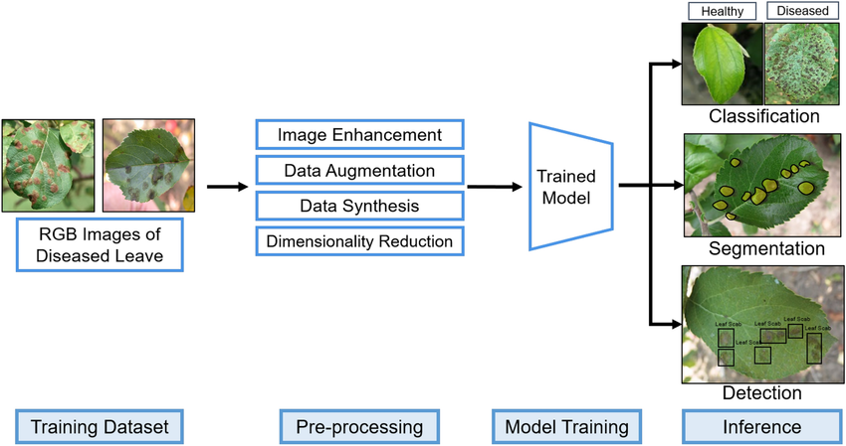
Figure 1. General machine learning pipeline for plant disease detection

Plant disease detection systems based on (ML) approaches have been investigated in recent times, often opting for simplicity and computational efficiency for image analysis. However, such approaches are not particularly suitable for the detection of complex patterns in images that vary significantly.

2.3.2 Traditional Classification Algorithms
2.3.2.1 Support Vector Machine (SVM)
A supervised learning algorithm in which, in order to classify data of different classes in Fig. 2, the optimal hyper-plane is generated.

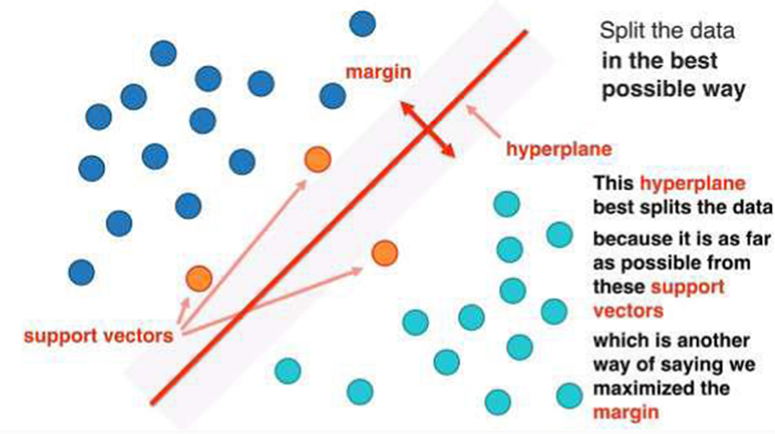
Figure 2. Support Vector Machine (SVM)
SVM has found widespread application in agricultural tasks where it has been used to discriminate between infected and healthy leaf achieving high Acc with small training samples. Its resistance to noises and capability of processing nonlinear data with the help of kernel functions make it popular [5].
2.3.2.2 K-Nearest Neighbor (KNN)
KNN is a non-parametric classification algorithm with a classification of a data point according to the most common classification of its immediate neighbors.
KNN is easy to apply for and does not need a training stage and so is applicable to small data sets. It has been used in detecting plant diseases to categorize leaf images using measures of similarity. Nevertheless, it is extremely sensitive to the selection of kand and susceptible to noisy data and unbalanced datasets [6] as shown in Figure 3.
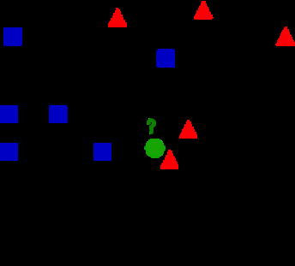
Figure 3. K-Nearest Neighbor (KNN)
2.3.2.3 Random Forest (RF)
Random Forest (RF) is an ensemble learning algorithm, which integrates a number of decision trees in order to enhance classification.
RF is reputed to be a robust model, capable of working with large datasets, and free of overfitting. It has been effectively used in other agricultural classification problems such as plant disease detection and land cover analysis [7] as discussed in Figure 4.

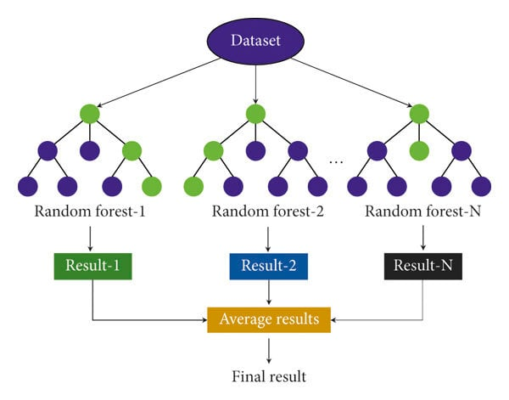
Figure 4. Random Forest (RF)
2.3.3 Limitations of Machine Learning Approaches
Despite the advantages of traditional (ML) techniques, they also have some drawbacks. One of the major drawbacks is their reliance on hand-engineered features, requiring expert knowledge and may not generalise equally well to different datasets and environments [8]. Lighting conditions, background clutter and leaf orientation can significantly affect feature extraction processes.
So far, the models aren’t great at handling multiple infections on a single leaf, or complex disease symptoms that overlap with each other. Performance on these scenarios is typically good in controlled datasets but can decrease severely in real-world use cases. Some of the base algorithms we are using, such as KNN or decision trees, can be pretty finicky when it comes to slightly different input features [9].
In order to detect diseases on bean leaves, such as angular leaf spot and rust, visual inspection is often insufficient. Standard machine learning approaches for image classification, such as convolutional neural networks, typically rely on features learned from large training datasets of images, and may not be sufficient to accurately classify images of diseased leaves.
In this way, while machine learning approaches can provide a minimum of disease detection in plants, there are limitations that lead to the need for more advanced approaches such (DL) which automatically learns features hierarchically in the case of raw images.

2.4 Deep Learning for Plant Disease Classification
2.4.1 Overview of Deep Learning
DL is a branch of (ML) that enables, for the first time, the possibility to learn directly from inputs, through a stack of (at least,) hidden layers that automatically discover hierarchical features from the input data. Traditional image classification methods rely on manual feature engineering for extracting features from images, but (DL) has shown strong ability in learning both simple and complex features directly and automatically from images, which makes DL very suitable for image-related applications such as plant disease images classification [10], [11].
Deep learning has shown great promise in agriculture, in particular by classifying plant diseases by analysing leaf images and identifying the visual symptoms of the disease, such as discolouration, spots and texture.
Deep learning models use a series of layers to learn increasingly abstract features which are more discriminative to classify compared to the conventional machine learning techniques [11], as shown in Figure 5.

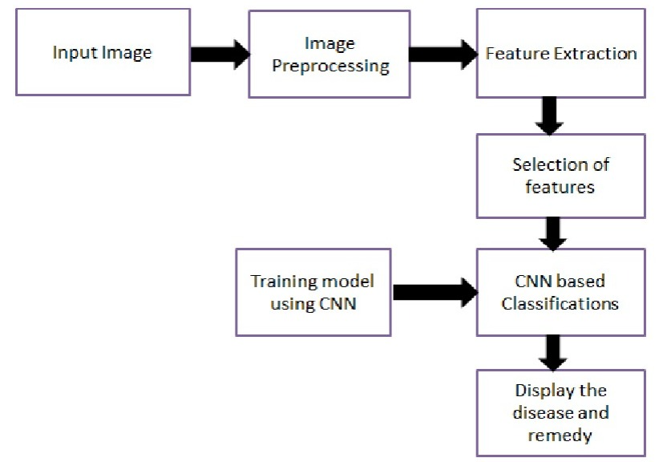
Figure 5. Deep Learning pipeline for plant disease detection

2.4.2 Convolutional Neural Networks (CNNs)
Image classification is a very common deep learning task and the most widely used model class for that task are (CNNs). Common CNNs include a mixture of different layers, like convolutional, pooling, and fully connected layers. These layers combined can automatically extract and learn spatial features from images for the purpose of image classification.[12].
CNN models include two key features: local connectivity and weight sharing, to improve computational efficiency and reduce the number of parameters. In a typical CNN, convolutional layers are assigned to extract features from the input images, while pooling layers are used to downsample feature maps by reducing their spatial dimensions. In the end, fully connected layers are assigned to classify the obtained features in the image [12]. as shown in Fig 6.

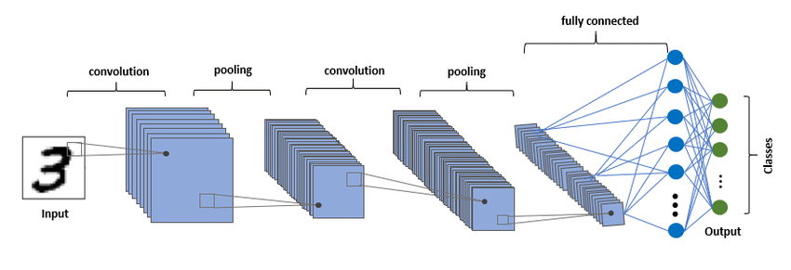
Figure 6. CNN architecture
When applied to plant disease detection, CNNs can detect the slightest visual variations between disease and healthy leaves, which is why they are quite appropriate when detecting bean leaf disease.
2.4.3 CNN Architectures
2.4.3.1 AlexNet
The pioneering work of deep CNN architectures for image classification was first shown by AlexNet, a deep architecture composed of five convolutional layers and three fully connected layers. Key innovations included the use of ReLU activation function and dropout for improving training speed and avoiding overfitting[13]. It showed the power of deep learning when it comes to image recognition at scale as shown Fig. 7.

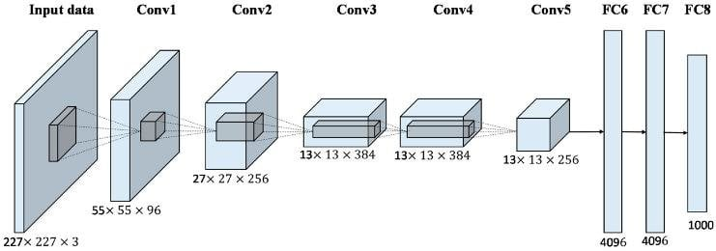
Figure 7. AlexNet architecture
2.4.3.2 VGG
VGG networks further enhanced the AlexNet by adding depth to the network and using small convolutional filters (3x3). VGG16 is one of the models, which has 16 layers and is characterized by simplicity and high results in the image classification task. Nevertheless, they have many parameters, thus making them costly to calculate [13].
2.4.3.3 ResNet
ResNet (Residual Network) proposed the concept of residual learning by introducing skip connections, which enable easier passage of the gradient in the course of training. The innovation solves the vanishing gradient issue and can be used to train very deep networks including ResNet-50 and ResNet-101 [13]. ResNet has demonstrated higher performance in most image classification problems.
2.4.3.4 EfficientNet
EfficientNet is a newly introduced architecture for CNNs that utilizes compound scaling method to increase depth, the network’s width and spatial resolution. EfficientNet is efficient, very accurate and can be used for real-world applications as it has significantly fewer parameters than other architectures [14]. Medical, agricultural image analysis tasks have been extensively examined with EfficientNet.
Since the traditional CNN constructions like VGG use sequential convolutional layers, ResNet uses residual connections to enhance gradient flow. EfficientNet, on the contrary, uses compound scaling and MBConv blocks to provide greater performance with reduced parameters.
2.4.4 Advantages of Deep Learning over Traditional Methods
Compared with traditional (ML) approaches, deep learning has its own advantages and gains particularly notable performance in plant disease classification.
To begin with, deep learning models are able to extract features automatically without manually engineering the features, so there is no need of feature engineering. This enables them to be able to capture more complex patterns and variations of leaf images [15].
Second, deep learning models are more accurate because they can learn hierarchical representations of data. This is particularly important for plant disease where there are fine visual differences that need to be identified and characterised.
Third, (DL) models can be scaled and are able to work with large datasets, enhancing their generalization during real-world applications. Moreover, data augmentation and transfer learning are other methods that can be employed to enhance performance [16].
Lastly, deep learning models are less susceptible to environmental changes like lighting, background, and noise, which are typical issues in agricultural image data.

2.5 Explainable Artificial Intelligence (XAI)
2.5.1 Importance of Explainability in AI
Explainable Artificial Intelligence (XAI), aims at making complex machine learning models more transparent and explainable. While these models achieve high quality and performance, there is an increased need to better understand the decisions made by so called deep neural networks that are considered to be “black boxes” [17]. Such untrustworthiness decreases the adoption in such essential areas as healthcare and agriculture.
XAI can be used to overcome these issues, as it offers information about the manner in which models make predictions and the factors that affect choices. It is also used to identify any biases, enhance reliability, and enable regulatory mandates like explainability and accountability [18]. Consequently, explainability will be crucial to establishing trustful AI systems and facilitating human-AI interaction.
2.5.2 Categories of Explainable AI Techniques
Different categories for existing explainability techniques for machine learning have been defined based on aspects of design, functionality, and purpose (goal) of a method. An additional relevant perspective on how these categories could look like is how methods explain a given model: Are they deeply tailored to the specific model and can only be applied to that single instance? Or are they model-agnostic, i.e., they can explain any model? The current text discusses an XAI categorization by the latter perspective.[18]. Model-specific approaches are specific to a given model (e.g., CNN-based visualization approaches), whereas model-agnostic approaches like LIME and SHAP can be used with any model as shown in Figure 3.
The other significant classification is according to the timing of the explanation:
- Post-hoc methods: used after training.
- Intrinsic methods: inbuilt within the model.
Additionally, explanations can be:
- Global: characterizing the model behavior on the whole.
- Local: explaining individual predictions [19]

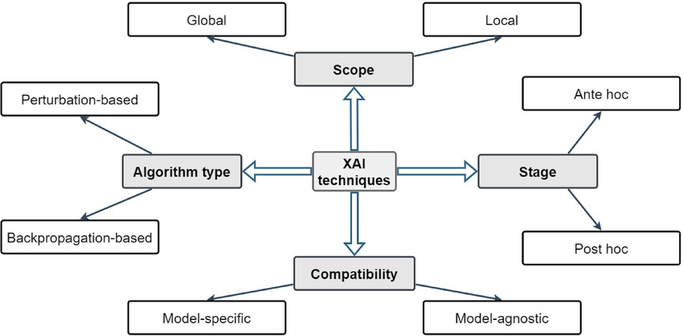
Figure 8 XAI taxonomy[23]

2.5.3 Gradient-weighted Class Activation Mapping (Grad-CAM)
Grad-CAM is a popular XAI methodology in understanding CNN-based models. It produces heatmaps that indicate important areas in an image that aid a particular classification decision [20].
The approach described in the paper calculates the gradients of a target class with respect to the corresponding feature maps of the last convolutional layer and sums them up to acquire a localization map.
Grad-CAM provides intuitive visual explanations by highlighting regions that positively influence predictions .

2.5.4 Applications of Grad-CAM in Image Classification
Grad-CAM has found extensive use in image classification tasks because it can be used to give visual explanations. In an autonomous system, it detects significant objects, whereas in medical imaging, it marks abnormal spots [21].
Grad-CAM can be utilized for classifying plant diseasesto identified infected areas on leaves, enabling users to check model predictions. This enhances the transparency of models, assists with decision-making and adds user trust. It is also useful in rooting out errors in models, which are shown through wrong attention patterns.

2.6 Evaluation Metrics
For assessing the performance of a classification model for plant disease detection, there are some standard metrics, such as classification Acc and some statistical metrics like (Acc), precision, recall, F1-score, which will be utilized to evaluate the performance of the proposed explainable deep learning model for plant disease detection.
(Acc.) is the most common performance measure for classification problems. It measures the (Acc.) of a classifier by dividing the number of Correctly Classified Instances by the total number of instances in the dataset[26]. While (Acc.) provides an overall view of the model performance, it may be insufficient in case of unbalanced dataset, and is defined as:
$$Acc=\frac{TP+TN}{TP+TN+FP+FN} (1)$$

To address the limitations of (Acc) , another measure is used to assess and determine the ratio of true positive samples that are correctly identified to the total number of samples that are positive (prediction) which is critical in avoiding false alarm (when healthy leaves are classified as diseased) [27] :
$$Precision=\frac{TP}{TP+FP} (2)$$

Similarly, Recall (Sensitivity) is used to determine how well the model identifies all the true positive cases, and in such a way that diseased leaves are not missed, to avoid agriculture loss and secure food security [28]:
$$Recall=\frac{TP}{TP+FN} (3)$$

F1-score is the harmonic mean of precision and recall, which offers a fair assessment[29]:
$$F1=\frac{2TP}{2TP+FP+FN} (4)$$
In addition, the performance of the classification at different thresholds is measured by Receiver Operating Characteristic (ROC) curve and Area Under the Curve (AUC). A greater AUC value indicates a better discrimination.
The evaluation metrics will provide a more comprehensive assessment of the overall model performance, in terms of accuracy and reliability in bean leaf disease classification, as well as its interpretation.

2.7 Related Work
DL techniques have emerged as promising approach in many fields including agriculture for plant leaf disease detection and diagnosis. Many DL architectures are used to detect and classify different diseases of plant leaves. In this paper, existing research works are discussed for plant leaf disease detection and classification using DL techniques. The outcomes of these approaches have great potential to automate agricultural diagnostics as agricultural markets are growing day by day.
Gill et al. [26] developed a deep learning recurrent architecture for classification of images of bean leaf diseases. The study used 2,134 images that correspond to three different diseases. The aim of this work is to assess the ability of CNN-based architectures to facilitate early detection of plant diseases. We use standard metrics for evaluating performance and show that the system is capable of accurately recognising disease patterns with an accuracy above 90%.
Singh et al. [27] employed transfer learning on pre-trained CNNs namely MobileNetV2, EfficientNetB6 and NasNet to classify bean leaf diseases using 1295 images. All the networks were trained and tested on the same dataset, however varying the hyperparameters and observing the best results for each network. The results showed that EfficientNetB6 was the strongest model that achieved accuracy of 91.74% and was the most suitable for this real-world dataset.
Serttaş and Deniz [28] applied a CNN based on ResNet50 and using transfer learning for the detection of diseases of bean leaf using a small dataset. The study demonstrated that deep learning models are capable of achieving good results even with limited data. The approach was capable of capturing intricate visual features of the leaf disease that allowed for the identification of the disease. This result shows that transfer learning is an important factor in agricultural image analysis task with an accuracy of 98.33.
The work of Girmaw and Muluneh [29] was proposed to classify common bean leaf diseases (leaf rust and brown leaf spot) using 1,766 images. This work compared the proposed model with some of the pre-trained models and the results were superior. The model was able to learn disease specific features and improve the classification Acc. The evaluation was found to be very consistent across the levels with an (Acc) of 98% (training), 97.2% (validation) and 96% (testing).
Wang et al. [30] A hybrid DL framework is proposed for improving the detection and classification of kidney bean leaf diseases. It combines multiple CNN-based models with conventional (ML) algorithms to effectively enhance the feature representation and improve the classification accuracyThe method is compared to other standard approaches based on single models and outperforms these strongly in experimental results with an (Acc) of 96.26% and F1-score of 0.97.
Fang et al [31] Bean leaf images affected by angular leaf spot and rust diseases were classified using the AlexNet convolutional neural network. The two diseases have visual symptoms similar to each other and therefore are challenging to classify accurately. While there is still room for improvement, some classification accuracy was obtained that has the potential for use in automated disease identification of plant leaf images. More work on the deep neural network could be useful in refining and improving the model’s accuracy for real world images. The plant disease classification reached a precision of 95.4% and a validation accuracy of 78.2%.
Salau et al [32] An end-to-end deep (CNN) architecture called LeafD for diseases in faba bean leaves recognition from scanned faba bean leaves images is proposed in this paper. The scanned faba bean leaves images go through the image preprocessing step which is much critical in terms of achieving high accuracy in image classification. The features which are learned by LeafD model are suitable for identifying and differentiating various diseases accurately and consistently. It is also feasible to apply similar approach for many of agriculture problems such as plant diseases in other crops for improving crop yields. TheLeafD was achieved 98.14% in training accuracy.
The deep learning models proposed by Sahu et al [33] Applies (DL) techniques to the classification of images of bean leaf diseases. A total of 1,296 images were collected, and 3 classes of leaves were used in the experiments, i.e., angular leaf spot, bean rust, and healthy leaves. In addition to disease classification, it is important to understand the part of leaf affected by disease. In order to support this, visualizations of the behavior of a CNN on images of leaves were generated in order to support disease localization. The results from GoogleNet achieved an average accuracy (Acc.) of 95.31%, which exceeded the average accuracy of VGG16.
Abed et al [34] Within work, proposed a robotic vision–based system for the early detection of wheat leaf diseases under uncontrolled conditions using deep learning. Using the U-Net network for leaf segmentation and multiple (CNNs) for classification. Best results were obtained with DenseNet121, achieving 98.31% for the binary case and 91.01% for the multi-class case.
Noviyanto et al [35] a modified implemented architecture of a (CNN) based on DenseNet121 to detect diseases in the leaves of common bean using a dataset that comprises 1,295 images divided into three classes. The implemented model added some more convolutional layers to DenseNet121 to better extract features from images and some improvements to the learning process. Results were compared to other options based on transfer learning and the model obtained the best results, with 96.90% (Acc) and an F1-score of 97%.
Mallick et al[36] deep learning transfer learning approach was used in diseases and pests’ detection from mung bean leaves for the purpose of enhancing classification accuracy using limited dataset. The proposed model was able to identify several diseases as well as performing consistent results in various environmental setting. The average accuracy of the proposed model was 93.65%.
Kursun et al [37] introduced a (DL) framework that integrates U-Net for image segmentation with multiple (CNNs) for the classification of bean leaf diseases, including angular leaf spot and rust. emphasis was given to the image partitioning in order to increase the (Acc) of the classification. The best results (100% classification Acc ) were obtained by using the DenseNet201 model on images of the infected parts that were systematically segmented.
Elfatimi et al [38] A (DL) based architecture implemented using a MobileNet BackBone has been trained and tested to classify the different types of diseases of bean leaves, using a database of 1,296 images. Different variations for implementing an efficient architecture in terms of accuracy and time have been tried, obtaining a training accuracy of over 97% and an accuracy on test images of over 92% for the best model developed in this research work.
Elfatimi et al [39] tested performance of different datasets for distinguishing bean leaf disease using a MobileNet (DL) architecture. We used five different datasets of varying complexity and assessed transfer learning performance for distinguishing between healthy and diseased leaves. The results showed that using higher quality datasets greatly improved model accuracy, with average accuracy above 92%
Mehta et al [40] study, a federated learning–based framework combined with (CNNs) was designed and implemented for the plant disease identification and measurement of bean leaf diseases. In total, four diseases were considered and severity was indicated as a percentage. Experiments using several datasets consistently achieved high accuracy (up to 98%) along with high precision, recall, and F1-score values.

Table 1 Summary of Previous Studies

Ref | Year | Model | Dataset Size | Classes | Explainability | Accuracy | Limitation
Gill et al. [26] | 2023 | Sequential CNN | 2,134 images | 3 | No | 90% | Limited dataset diversity; poor real-world generalization
Singh et al. [27] | 2023 | MobileNetV2, EfficientNetB6, NasNet | 1,295 images | 3 | No | 91.74% | Sensitive to dataset quality
Serttaş & Deniz [28] | 2023 | ResNet50 (TL) | Bean dataset | N/A | No | 98.33% | Small dataset; overfitting risk
Girmaw & Muluneh [29] | 2024 | CNN vs Pre-trained Models | 1,766 images | 3 | No | 96.0% | Limited regional generalization
Wang et al. [30] | 2025 | Hybrid CNN + ML | KBLD dataset | N/A | No | 96.26% | High computational cost
Fang et al. [31] | 2025 | AlexNet | Open dataset | 3 | No | 95.4% | Difficulty distinguishing similar diseases
Salau et al. [32] | 2023 | End-to-end CNN | Custom dataset | N/A | No | 98.14% | Strong dependence on preprocessing
Sahu et al. [33] | 2021 | GoogleNet, VGG16 | 1,296 images | 3 | Yes (Grad-CAM) | 95.31% | Dataset heterogeneity
Abed et al. [34] | 2023 | U-Net + CNN | Wheat dataset | N/A | No | 98.31% | Not evaluated on bean leaves
Noviyanto et al. [35] | 2024 | Modified DenseNet121 | 1,295 images | 3 | No | 96.90% | High computational complexity
Mallick et al. [36] | 2023 | Transfer Learning | Mung bean dataset | N/A | No | 93.65% | Limited generalization
Kursun et al. [37] | 2023 | U-Net + DenseNet201 | 60 images | N/A | No | 100% | Very small dataset; overfitting risk
Elfatimi et al. [38] | 2022 | MobileNet | 1,296 images | 3 | No | 97% (Train), >92% (Test) | Reduced performance in uncontrolled environments
Elfatimi et al. [39] | 2024 | MobileNet (Multi-dataset) | 3 datasets | N/A | No | >92% | Performance varies across datasets
Mehta et al. [40] | 2023 | Federated Learning + CNN | Distributed datasets | 4 | No | 97–98% | Complex implementation; limited dataset transparency
Previous works have reported high classification accuracy for bean leaf disease detection in various deep learning based models, but most of them have been concerned with increasing the classification accuracy; the importance of the model interpretability has been paid relatively less attention. There has been very limited research that has used visual explanation techniques to explain the reason for prediction decisions, thereby limiting the trust of the user in practical agricultural applications. Furthermore, there has been a lack of consistent independent test-set evaluation, which reduces the reliability of the performance evaluation. Thus, the novelty of this study is the combination of both the EfficientNetB0 based transfer learning and the Grad-CAM that provide the accurate classification and visual interpretability, respectively, and the use of an independent test set for the reliable and transparent performance evaluation for precision agriculture

2.8 Chapter Summary
With recent successes in plant disease classification tasks by means of deep learning, it is intriguing to examine how much interpretation capacity these models provide. So far, (CNNs) have been the focus of the majority of works dealing with this problem class. However, also for such promising deep learning approaches the problem of insufficient interpretation ability is still relevant. Particularly, the integration of attention and explanation techniques has so far not been sufficiently addressed.
Transparency is lacking when deep learning is applied to detect diseases of crops. Here we present an easily interpretable deep learning network for bean leaf disease detection that combines a (CNNs) , an attention mechanism and the Grad-CAM method to achieve high accuracy and to provide insight into the results of predictions. In the subsequent chapter this method is described in detail.

CHAPTER 3 Proposed Approach

3.1 Introduction
The methodology used to create the proposed deep learning framework for classification of bean leaf disease is described. The main goal of this research is to create an automated classification of bean leaf images into three classes, namely Angular Leaf Spot, Bean Rust and Healthy leaves. For this purpose, an efficientnetB0 convolutional neural network (CNN) based transfer learning approach was utilized. Furthermore, Gradient-weighted Class Activation Mapping (Grad-CAM) was incorporated into the system for visualization of the model predictions. The methodology proposed includes the following steps: dataset preparation, image preprocessing, dataset splitting, model construction, training, model evaluation and explanation analysis. The key steps in each stage are outlined below.

3.2 Proposed Framework
The proposed framework is a sequential process that starts from image acquisition, continues on to disease characterization and prediction, and culminates to disease visualization. The bean leaf data is loaded and grouped by disease categories. These images are then preprocessed to make them consistent in size and pixel value in order to divide them into training, validation and testing sets. Then, the transfer learning model EfficientNetB0 is built and trained to classify leaf images. Once the model is trained, it is tested with several performance metrics. Last, Grad-CAM is used to draw heatmaps that visualize the image regions identified by the model to make its classification choices. This workflow allows for precise disease diagnosis as well as interpretability of the model.

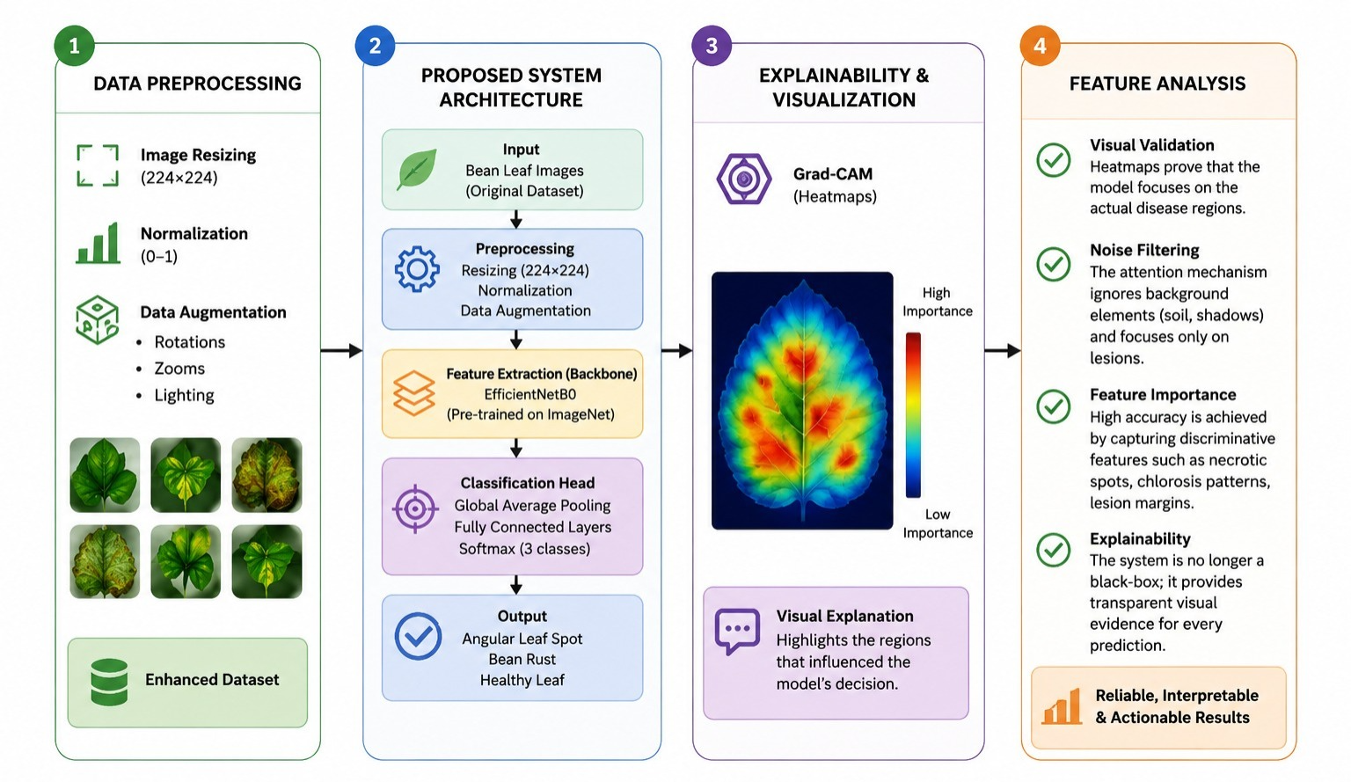
Figure 9. Proposed Approach
Table 2 Experimental Environment

Parameter | Specification
Development Platform | Kaggle Notebook
Operating Environment | Linux
Programming Language | Python 3.10
Deep Learning Framework | TensorFlow 2.x
High-Level API | Keras
Machine Learning Library | Scikit-learn
Image Processing Library | OpenCV
Data Manipulation | NumPy, Pandas
Visualization Library | Matplotlib
Hardware Accelerator | NVIDIA Tesla P100 GPU (Kaggle)
Dataset Source | Kaggle Bean Leaf Disease Dataset bean disease dataset
Total Images | 1,295 RGB images
Classes | Angular Leaf Spot, Bean Rust, Healthy
Train / Validation / Test Split | 70% / 15% / 15% (Stratified)
Random Seed | 42
Input Image Size | 224 × 224 pixels
Image Normalization | Pixel values rescaled to [0,1]
Data Augmentation | Random Rotation, Horizontal Flip, Zoom, Width/Height Shift
Base Model | EfficientNetB0 (ImageNet pre-trained weights)
Transfer Learning Strategy | Feature Extraction
Frozen Layers | All EfficientNetB0 base layers frozen during initial training
Classification Head | GlobalAveragePooling2D → Dense (512, ReLU) → Dropout (0.2) → Dense (3, Softmax)
Optimizer | Adam
Learning Rate | 0.0001
Loss Function | Categorical Cross-Entropy
Batch Size | 32
Epochs | 100
Evaluation Metrics | Accuracy, Precision, Recall, F1-score, Confusion Matrix, Grad-CAM

3.3 Dataset Description
The experiments were carried out with Bean Disease Dataset (BDD) provided by Kaggle.The experiments are performed on the publicly available dataset on Kaggle called Bean Disease Dataset (BDD). The original dataset was recorded by the Makerere AI lab in partnership with the National Crops Resources Research Institute (NaCRRI), Uganda and comprises of RGB images of bean leaves taken under field conditions. These images were taken under a variety of illumination, background, viewing angle and disease severity conditions, and the data set was representative of a practical agricultural environment. There are 990 RGB images which are equally distributed among three classes: Angular Leaf Spot (330 images), Bean Rust (330 images), and Healthy (330 images). However, the original Kaggle data set had been previously split into training, validation, and testing data sets, but they were combined before pre-processing in order to be able to split the data into three sets for this study to conduct the experiments. The images were partitioned in folders that correspond to the different diseases, and then each image was labeled with the corresponding disease class label for supervised learning. Before training, all images were downsampled to reduce their size to 224 × 224 pixels, as this is the size required by the EfficientNetB0 architecture. The dataset was then split into training (70%), validation (15%) and testing (15%) sets through random stratified sampling method, which maintained the distribution of classes in all these sets to ensure reliable evaluation of the model.

3.4 Data Preprocessing
The dimension and number distribution of input images are critical for deep learning, and image preprocessing is an indispensable step of any deep learning application. Hence, some of the preprocessing steps were done prior to the training of the proposed model.
Firstly, every picture was resized to a standard input size of 224 × 224 pixels for EfficientNetB0. Normalizing the dimensions of the image reduces the complexity of the computation and the compatibility of the pre-trained network.
Second, pixel values of all images were scaled to range [0,1] to ensure numerical stability in model training. Normalization speeds up convergence by keeping the input values within a set range.
The images were then preprocessed and converted to TensorFlow datasets suitable for efficient processing during model training.Images were preprocessed and converted to TensorFlow datasets for efficient processing during model training. This pre-processing pipeline not only enhanced the efficiency of training but also kept essential visual features of bean leaf diseases.

3.5 Dataset Splitting
The dataset was split into three independent data sets: training, validation, and test sets for an objective evaluation of the proposed model. The data set is comprised of 330 images per class, with 50 images per class used for validation, 50 images per class used for testing and 200 images per class used for training, giving a total of 600, 150, and 150 images for training, validation and testing respectively. Since the dataset needs to be split into different subsets for each class, the train_test_split() function was used for this purpose with a fixed random state (random_state = 123) to ensure that each class was split equally between the different subsets and that the same random splitting was reproduced. No image was used more than once and there was no data leakage between the training, validation and test sets for each image. The validation set was monitored and validated during training of the model while the independent test set was kept for final validation of the proposed framework.

3.6 Proposed Deep Learning Model
The classification model proposed is based on the state-of-the-art convolutional neural network EfficientNetB0, which offers a good trade-off between accuracy and computational cost. To achieve this, transfer learning was used, which means that pre-trained ImageNet weights were used.
The convolutional layers of EfficientNetB0 were chosen as the main feature extractor. These layers automatically recognized image features at multiple levels such as edges, textures, color patterns, and disease lesions. In the first training phase, the pre-trained layers were frozen to maintain the previous visual representations.
Following feature extraction, a Global Average Pooling layer was introduced to compress the dimension of feature maps obtained through the feature extraction process. To learn high level features of the disease, a fully connected layer using ReLU activation with 512 neurons was then utilized. A Dropout layer, with a dropout rate of 0.2, was added to the model before the last classification layer to reduce over-fitting. The probabilities of the three categories of disease were then outputted from a three neuron Softmax output layer.

This architecture has two parts: Powerful feature extraction part is EfficientNetB0 and Lightweight classification head is designed for bean leaf disease recognition.

3.7 Model Training
Preprocessed RGB images and class labels were used for training the proposed model using supervised learning. For the EfficientNetB0 backbone, the weights were pre-trained on ImageNet, and the weights of all backbone layers were frozen during training. Only the custom classification head, which includes a Global Average Pooling layer, a fully connected layer with 512 neurons (ReLU activation), a Dropout layer (0.2) and a three-class Softmax output layer, was optimized. A batch size of 32 and number of epochs of 100 were used for training. Given a learning rate of 0.01 and a categorical cross-entropy loss function, the Adam optimizer was used because it offers adaptive optimization.The Adam optimizer was employed with a learning rate of 0.01, and was trained with a categorical cross-entropy loss function, while multi-class classification was used. To enhance the model's generalization capability and minimize overfitting, data augmentation techniques were employed during the training process. Also, a ModelCheckpoint callback was used to track the validation accuracy (val_accuracy) and automatically save the model if the validation accuracy increased. The best accuracy achieved during training was 88.67% which was used in the final evaluation. To check for convergence and for learning behaviour, the accuracy and loss curves for training and validation were captured during the training.

3.8 Performance Evaluation
An independent test set of new images was used to test the trained model. The proposed framework was evaluated using the classification performance measures Accuracy, Precision, Recall, and F1 score to get a comprehensive performance of the proposed framework. The test data set had the same number of images in each class (50 images in each class), so both macro-average and weighted-average metrics were computed. The dataset contained equal number of instances in each class which gave equal macro-average and weighted-average, and thus showed unbiased performance of the classifier for all the disease classes. The proposed model was able to obtain an overall accuracy of 82.67%, a macro-average precision of 86.10%, a macro-average recall of 82.67% and a macro-average F1-score of 83.06%. Moreover, a confusion matrix was created to study correctly and incorrectly classified samples belonging to each disease category. This analysis further helped to understand the advantages and disadvantages of the proposed model by determining disease classes that were more susceptible to misclassification.

3.9 Explainability Using Grad-CAM
As the decision-making process of deep learning models is non-obvious, they are usually regarded as black-box systems, and their classification performance is excellent. In order to enhance transparency, this study used Gradient-weighted Class Activation Mapping (Grad-CAM) as an explainable AI method.
Grad-CAM produces heatmaps which highlight the parts of the image that were most important in the decision for the classification. Once the model predicted the disease class, Grad-CAM was used to calculate the importance of the last convolutional feature maps and then the importance values were projected onto the original leaf image. This resulted in heat maps that allowed visualization of the focus of the model on infected areas, instead of irrelevant background data.
Grad-CAM was also used to integrate the proposed framework to improve the interpretability of the framework and to boost the confidence in the classification results.

3.10 Experimental Environment
Proposed framework was realized in Python programming language. The deep learning experiments were carried out using the TensorFlow and Keras libraries, and the image pre-processing and visualization were done using the OpenCV, NumPy, Matplotlib and Scikit-learn libraries. Model training and evaluation were conducted in a GPU-accelerated cloud computing platform which ensured efficient computational performance throughout the experiments.

3.11 Chapter Summary
The complete methodology used in the classification of bean leaf disease using explainable deep learning framework was discussed in this chapter. The chapter summarized the dataset, the preprocessing steps, splitting the dataset, the transfer learning architecture based on EfficientNetB0, the model training procedure, the evaluation methods, and the implementation of the Grad-CAM. This proposed method integrates the accurate diagnosis of disease with visual explainability, giving a reliable framework for intelligent agricultural disease diagnosis. The results from the experiments performed with this approach are reported and analyzed in the next chapter.

CHAPTER 4 Results and Discussion

4.1 Introduction
In this chapter, the experimental results achieved with the proposed explainable deep learning framework for bean leaf disease classification are presented and discussed. The final model has been tested with an independent test set of 150 RGB images, where 50 images are from each of the three classes, namely, Angular Leaf Spot, Bean Rust, and Healthy leaves. Balanced test set is helpful to assess the model's classification performance fairly and unbiasedly across all categories of diseases. The framework proposed in this study was built with the EfficientNetB0 architecture with transfer learning and tested with standard performance metrics such as Accuracy, Precision, Recall and F1-score. Further, the confusion matrix analysis was conducted to understand the performance of the class-wise classification and explore the possible misclassification patterns. To make the proposed framework more transparent and more useful, visual explanations of the model predictions was implemented by Gradient-Weighted Class Activation Mapping (Grad-CAM). Multiple correct and incorrect test images were used for each disease and used for the explainability analysis, to qualitatively assess the disease-symptom attention of the model. The proposed framework effectively works as a dependable decision support tool for the diagnosis of bean leaf disease in precision agriculture, as shown using the combination of quantitative performance evaluation and visual interpretability.

4.2 Dataset Visualization
The bean leaf disease dataset includes three categories of images: healthy leaves and two types of bean leaf disease: Angular Leaf Spot and Bean Rust. The dataset was inspected visually before training the model to ensure the quality of the images collected and the diversity of the images. The data set consists of images taken under varying conditions of the environment, such as variations in illumination, as well as in leaf orientation, background complexity, and severity of disease, as shown in Figure 4.1. The diversity makes it harder to classify and allows the proposed model to learn more abstract visual features.
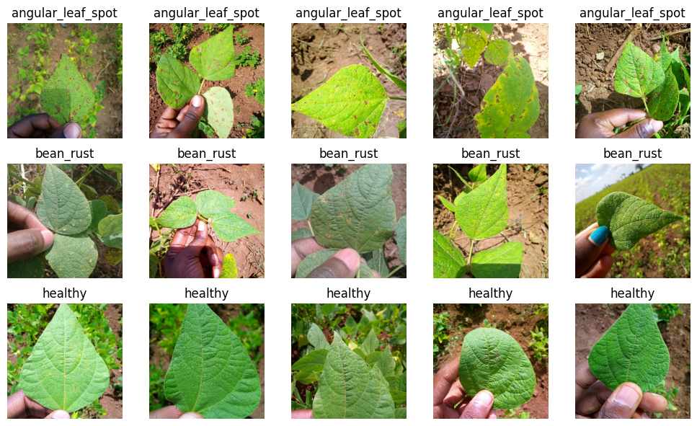
Figure 10. Sample images of the Bean Leaf Disease Dataset

Visualisation of the data shows that every disease class has unique visual properties. The healthy leaves have a smooth green surface with no lesions, Angular Leaf Spot images have irregular brown lesions, and the Bean Rust images have characteristic rusty colored pustules. Such visual differences can offer significant characteristics for automatic disease recognition.

4.3 Training Performance
Both training and validation accuracy along with training and validation loss have been used as monitoring metrics to understand the convergence and generalization capability of the proposed EfficientNetB0 model. The training accuracy gradually improved during the training process, and finally reached about 96%, which means that the model has learned discriminative features from the training images. The accuracy in the early training also increased and reached the peak value of 88.67% at epoch 40, with relatively small changes after that. The training and validation loss curves are shown to demonstrate the learning behavior of the proposed model. The training loss declined consistently but the validation loss fluctuated over training epochs and was generally increasing even though validation accuracy was relatively stable during training. The graph shows signs of moderate overfitting, as the model overfits the training data but the generalization performance stays fairly consistent. Thus, the ModelCheckpoint callback was applied to save the model with the most validation accuracy (88.67%) and it was then applied for the final testing. Overall, the training process shows that transfer learning using EfficientNetB0 was able to extract meaningful disease related features and the checkpoint mechanism avoided selecting a model that was overfitted by later training.
The loss curves also show learning behavior of proposed model. The loss was reduced progressively during training, with the model parameters being optimized by the Adam optimizer. The validation loss also had a downward trend within the initial epochs then levels off, suggesting the model is converging without significant instabilities.
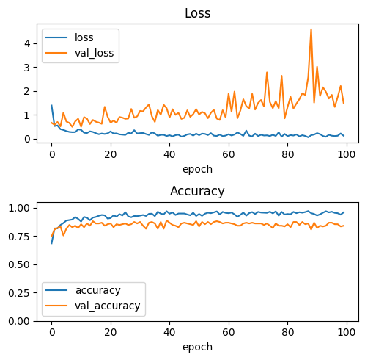
Figure 11. Training and Validation Accuracy Curves

The training process highlights that the transfer learning method with EfficientNetB0 successfully extracted meaningful features related to disease and showed a stable convergence during the optimization process.

4.4 Classification Performance
The best model saved by the ModelCheckpoint callback was tested on an independent test set that contained 150 images, with 50 images per class in each category (Angular Leaf Spot, Bean Rust and Healthy). The classification performance is measured with accuracy, precision, recall and F1 score, macro-average and weighted-average. The test set was perfectly balanced, so there was no difference between the macro-average and the weighted-average.
Table 3 Overall Performance of the Proposed Model

Performance Metric | Value
Accuracy | 82.67%
Precision (Macro/Weighted) | 86.10%
Recall (Macro/Weighted) | 82.67%
F1-score (Macro/Weighted) | 83.06%

Note: Results are based on 150 images (50 images/class) in an independent test set.
As the data set is balanced, macro average and weighted average give the same value. The proposed EfficientNetB0 model was able to obtain an overall classification accuracy of 82.67%, a precision of 86.10%, a recall of 82.67% and an F1-score of 83.06%. From these results, it can be concluded that the proposed framework has achieved good classification accuracy for bean leaf disease recognition. While the predictive ability is below the other studies mentioned above, the key idea of the proposed framework is that the integration of Grad-CAM creates visual explanations of the classification decisions and gives practical precision agriculture applications transparency and interpretability.

4.5 Confusion Matrix Analysis
The detailed analysis of the classification performance on each of the disease categories is depicted in the confusion matrix. It was able to recognize 124 images out of 150 images which is an accuracy of 82.67%.
In the Angular Leaf Spot class, 38 of the 50 images were correctly classified, 11 were incorrectly predicted as a class of Bean Rust and one was predicted as a class of Healthy. This means that the most common disease misidentified as Angular Leaf Spot was Bean Rust.
The class-wise highest recall was obtained with the Bean Rust class of which 47 images were recalled out of 50. The model performed very well with the visual features of Bean Rust as only three images were classified as Angular Leaf Spot.
Amongst Healthy class, 39 out of 50 images were correctly categorized and 11 images were wrongly categorized as Bean Rust.In the Healthy class, 39 images were correctly recognized and 11 images were misclassified as Bean Rust. This indicates that Bean Rust had a relatively large proportion of false-positive predictions which may have been due to some healthy leaf surfaces or illumination patterns being similar to early symptoms of rust. The confusion seen between these two disease categories may also have resulted from the similarity in appearance of lesions caused by both diseases.
In summary, the confusion matrix shows that the proposed model provided acceptable discrimination between the three classes and also reveals the difficulties with similar disease symptoms in real-world imaging conditions.

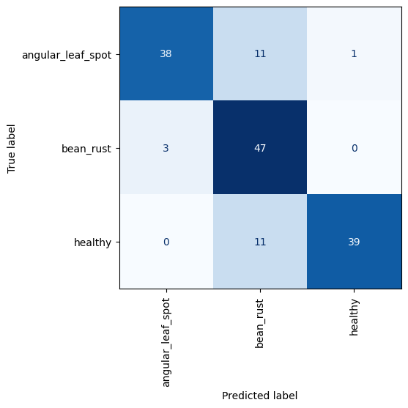
Figure 12. Confusion Matrix of the Proposed Model

4.6 Explainability Using Grad-CAM
Deep learning models often yield high classification accuracy but are not easy to interpret as to how they make a decision. To provide transparency, the Grad-CAM was used to highlight regions of the image that were responsible for the classification decision most strongly.
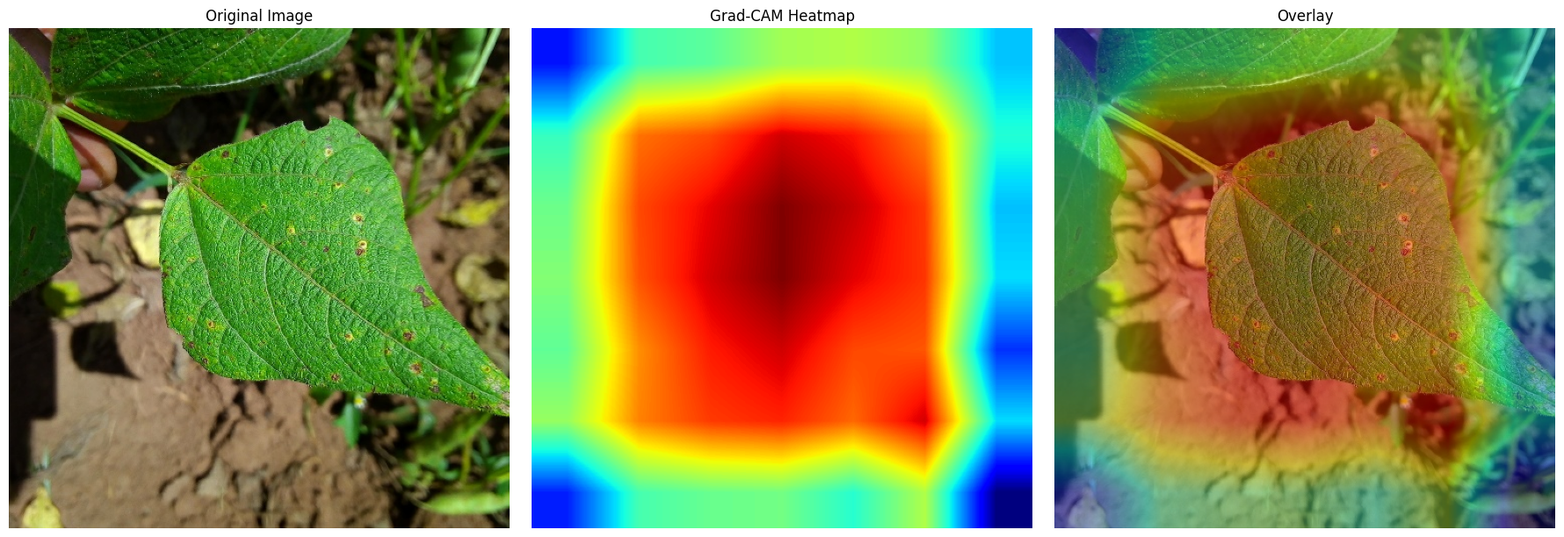
Figure 13. Grad-CAM Visualization

The Grad-CAM heatmaps show that the proposed model pays special attention to infected areas instead of unimportant background information. For disease leaves, the greatest activation values are found in the vicinity of lesions indicating that the model was based on biologically relevant disease symptoms. On the other hand, the disease-free leaves show more even patterns of activation because of the lack of disease features. These observations give confidence to the proposed model and prove that the classifier is based on the relevant visual information and not on background artifacts.

4.7 Comparison of the Proposed Model with Previous Studies
The proposed framework is compared with some of the recent studies related to the classification of bean leaf disease in Table 4. Direct comparisons should be taken with a grain of salt as the studies utilized different datasets, different dataset sizes, different preprocessing methods, different train-test splitting strategies, different network architectures, and different evaluation protocols. As a result, the discrepancies in the classification accuracies reported may not be solely attributed to discrepancies in model performance. While several previous studies reported higher classification accuracies, the proposed framework was able to yield acceptable classification performance (82.67%) and an extra level of interpretability by adopting the Grad-CAM technique. The proposed method does not only use transfer learning/EfficientNetB0 to achieve high accuracy in prediction but also provides visual explanation of the classification decision and uses an independent test set to assess the performance of the model, unlike most previous studies which have focused on accuracy in prediction. These properties enhance the transparency and usefulness of the framework as a decision-support tool in precision agriculture, with less focus on maximum classification accuracy.

Table 4 Comparison of the Proposed Model with Previous Studies
Study | Model | Dataset | Accuracy (%) | Remarks
Gill et al. [26] | CNN-based Deep Learning | 2,134 bean leaf images | 90.00 | Demonstrated the effectiveness of CNNs for early bean leaf disease detection using three disease classes.
Singh et al. [27] | EfficientNetB6 (Transfer Learning) | 1,295 bean leaf images | 91.74 | Compared several pre-trained CNN models and found EfficientNetB6 to achieve the best performance.
Serttaş and Deniz [28] | ResNet50 (Transfer Learning) | Small bean leaf dataset | 98.33 | Achieved excellent classification accuracy using transfer learning despite the limited dataset size.
Noviyanto et al. [35] | Modified DenseNet121 | 1,295 bean leaf images | 96.90 | Improved DenseNet121 by adding convolutional layers, resulting in higher feature extraction capability.
Elfatimi et al. [38] | MobileNet | 1,296 bean leaf images | >92.00 | Developed a lightweight MobileNet-based architecture with high efficiency and good classification performance.
Proposed Study | EfficientNetB0 + Transfer Learning + Grad-CAM | Bean leaf dataset (3 classes) | 82.67 | Provides explainable classification through Grad-CAM and evaluation on an independent test set, improving transparency and supporting practical agricultural decision-making.

The proposed model is compared with five recent deep learning studies on bean leaf disease classification as shown in Table 4. In previous studies, the classification accuracy of the datasets was reported between 90% and 98.33% depending on the dataset characteristics, the preprocessing technique, the network architecture and the experimental setting. For instance, Gill et al. [30] have attained an accuracy above 90% with a CNN based architecture, Singh et al. [31] have reported 91.74% accuracy with EfficientNetB6 via transfer learning. Serttaş and Deniz [32] achieved the best accuracy (98.33%) with ResNet50, while Noviyanto et al. [39] achieved 96.90% with a modified DenseNet121. In the same way, Elfatimi et al. [42] presented that a lightweight MobileNet architecture can obtain the testing accuracy greater than 92%. The classification accuracy of the proposed model was 82.67% overall, less than the accuracy obtained in some studies. In contrast to most of the current methods that emphasize on increasing classification accuracy, the proposed framework combines Grad-CAM to offer the visual explanation of the model's prediction. The explainability functionality allows the user to see which parts of the image are considered infected in making the decision that the model makes, so that the transparency of the model and the user's trust are improved. Furthermore, the various datasets properties, the images quality, the class distribution, the preprocessing used, and the experimental setup make comparisons between datasets difficult. Thus, the proposed framework not only helps in automated disease classification but also makes deep learning models easier to understand when applied to agricultural use.

4.8 Chapter Summary
The experimental results indicate that the proposed framework, which is based on EfficientNetB0, can effectively classify bean leaf diseases with tolerable performance. Using the transfer learning technique, efficient feature extraction was achieved with a lower amount of computation. The overall accuracy of 82.67% attained along with high precision and F1 score shows the soundness of the proposed classifier. Moreover, the Grad-CAM visualisations confirmed that the model focuses on the affected areas of the disease, which enhances the interpretability and trust in the classification process. Few misclassifications between Angular Leaf Spot and Bean Rust were detected because of their similar symptoms, but the performance results show that the proposed method has potential for practical use in intelligent agricultural disease monitoring system.

CHAPTER 5 Conclusion and Future Work

5.1 Introduction
The results of the research carried out on the classification of bean leaf disease by explainable deep learning are summarized in this chapter. In this study, the researchers proposed an EfficientNetB0 based transfer learning model for automatic identification of three classes of bean leaf disease (Angular Leaf Spot, Bean Rust, and Healthy leaves). The framework is based on a combination of disease classification and Gradient-weighted Class Activation Mapping (Grad-CAM) to make the model more interpretable by visualizing the areas of the image that were important for prediction. This chapter provides a synthesis of the research objectives, the key results, the contribution and limitation of this study and recommendations for further research.

5.2 Summary of the Research
Timely and correct identification of plant diseases is crucial to boosting agricultural yields and minimising crop losses. The manual inspection by agricultural experts to diagnose the disease is time-consuming, subjective, and challenging in large-scale farming systems. As a result, the need for intelligent systems that can automatically detect plant diseases with high accuracy in a timely manner is growing.

This study aimed to overcome this challenge, it was decided to use the explainable deep learning framework (EfficientNetB0 transfer learning) for the classification of bean leaf disease. The methodology proposed includes several steps such as the preparation of the dataset, the preprocessing of images, splitting the dataset, developing the model, training, performance evaluation, and finally visual explanation using Grad-CAM. The model was trained with a bean leaf disease dataset with three classes and tested with various performance metrics such as accuracy, precision, recall, f1 score, and confusion matrix.

The experimental results showed that the proposed system could classify the bean leaf diseases with satisfactory performance. The overall test accuracy of the model was 82.67%, with precision at 86.10%, recall at 82.67%, and F1-score at 83.06%, which were very balanced and reliable levels of classification. In addition, Grad-CAM was able to capture the infected areas of the leaf images, giving transparency and boosting the confidence of the model's decisions.

5.3 Achievement of Research Objectives
The first was to create an effective deep learning framework to automatically classify bean leaf diseases. This objective was achieved by using EfficientNetB0 as the backbone network and by using transfer learning to enhance and minimize the computational complexity of feature extraction.
The second goal was to test the performance of the proposed model with several classification metrics. The results achieved showed good performance in all the evaluation measures, proving that the proposed approach was effective.
The third objective was to improve the interpretability of the deep learning model. To achieve this, the use of Grad-CAM was integrated, thereby allowing the visualization from the prediction process and emphasizing the regions of the disease involved in each of the prediction results.
In total, the proposed framework adequately met all of the research goals and gave an accurate and understandable solution of bean leaf disease classification.

5.4 Research Contributions
The study has several contributions to the fields of intelligent agriculture and explainable AI.
Firstly, it introduces a deep learning framework with transfer learning and EfficientNetB0 to automatically classify bean leaf disease. The proposed method not only decreases the amount of manual feature extraction, but also guarantees the reliability of the classification.

Secondly, Explainable AI was used in this study via Grad-CAM. The proposed framework is different from the traditional deep learning models, which are black-box models without visual explanations, in that users can understand the reasoning behind the model's predictions.
Third, application of transfer learning in agricultural image analysis is shown. The proposed model takes advantage of the pre-trained knowledge, thus it can learn efficiently without being trained on an extremely large-sized dataset.
Last, the study adds to the evolution of smart crop monitoring systems to assist farmers and agricultural experts in the earlier and more accurate decision-making process for disease identification.

5.5 Research Limitations
- The classification accuracy (82.67%) is not high compared to the results of some recent state-of-the-art studies on bean leaf disease classification.
- The experiments were performed with a database of only three disease categories, and the proposed framework could be applied to greater agricultural scenarios with more diseases.
- The experiments were conducted with a public dataset on Kaggle that was collected by Makerere AI Lab and the National Crops Resources Research Institute (NaCRRI), Uganda. The labels were not re-checked by plant pathology experts in this study but are widely used for research purposes and this may affect the confidence in the reported performance.
- The proposed framework was only tested in an offline experimental setting, without testing in real time deployments and mobile implementation.
- Explainability was only considered for only one model: Grad-CAM. Other explainable AI methods (e.g., LIME and SHAP) were not tested nor compared.

5.6 Recommendations for Future Work
There are several approaches which may be adopted for the improvement of bean leaf disease classification systems.
Expansion of size and diversity of data sets with other diseases of plants from various geographical and environmental sources could be researched in the future.
To investigate the effectiveness of the architectures for agriculture image classification, recent transformer-based architectures like Vision Transformer (ViT), Swin Transformer, ConvNeXt or EfficientNetV2 can be evaluated and compared to EfficientNetB0.
Further research is needed for developing light weight deep learning models that can be deployed on edge computers, smartphones, and drones, and can be used to diagnose diseases in real time in the fields.
Other EAI methods, such as SHAP, LIME, Score-CAM, Eigen-CAM and Integrated Gradients can be embedded to deliver more in-depth explanations and enhance user trust.
Furthermore, integration of the image-based disease diagnosis with the Internet of Things (IoT) sensors, environment monitoring and cloud computing platforms could provide an opportunity to create intelligent precision agriculture systems that monitor crop health continuously.

5.7 Practical Implications
The proposed framework has some practical applications which we can see in modern agriculture. Automated disease classification systems provide farmers with the ability to detect infected plants early, enabling timely intervention and minimizing crop losses. The visual explanations created by Grad-CAM can be used by agricultural specialists to confirm disease diagnosis and to aid in the field inspection process.
Additionally, the incorporation of the proposed model into mobile applications or smart farming platforms could support precision agriculture by delivering swift and accurate diagnosis of disease, including interpretation, especially in rural settings where expert advice is scarce.

5.8 Chapter Summary
This chapter presented the conclusions of the proposed explainable deep learning framework for bean leaf disease classification. The study demonstrated that EfficientNetB0 combined with transfer learning provides an effective solution for classifying bean leaf diseases, achieving satisfactory classification performance with an overall accuracy of 82.67%. The integration of Grad-CAM enhanced the transparency of the model by identifying the leaf regions responsible for the prediction, thereby improving the interpretability and trustworthiness of the classification process. Although several limitations remain, the proposed framework represents a promising step toward the development of reliable and explainable intelligent agricultural systems. Future research can further enhance the proposed approach by incorporating larger datasets, advanced deep learning architectures, additional explainability methods, and real-time deployment in precision agriculture environments.

References
[1] Wei, K., Chen, B., Zhang, J., Fan, S., Wu, K., Liu, G., & Chen, D. (2022). Explainable Deep Learning Study for Leaf Disease Classification. Agronomy, 12(5), 1035. https://doi.org/10.3390/agronomy12051035
[2] Potharaju, S., Singh, A., Singh, D., Tambe, S. N., Kantipudi, P. M., & Kiranmai, B. (2026). An explainable vision transformer model with transfer learning for accurate bean leaf disease classification. Scientific reports, 16(1), 10402. https://doi.org/10.1038/s41598-026-41723-9
[3] Ahmad, A., Saraswat, D., & El Gamal, A. (2023). A survey on using deep learning techniques for plant disease diagnosis and recommendations for development of appropriate tools. Smart Agricultural Technology, 3, 100083. https://doi.org/10.1016/j.atech.2022.100083
[4] Toda, Y., & Okura, F. (2019). How Convolutional Neural Networks Diagnose Plant Disease. Plant phenomics (Washington, D.C.), 2019, 9237136.
[5] Noi, P. T., & Kappas, M. (2018). Comparison of Random Forest, k-Nearest Neighbor, and Support Vector Machine classifiers for land cover classification using Sentinel-2 imagery. Sensors, 18(1), 18.
[6] Lee, W.‐M. (2019). Supervised learning—Classification using K‐nearest neighbors (KNN). In Python® Machine Learning (pp. 205-220). Wiley.
[7] He, J., Li, Z., & Yin, L. (2025). An Efficient and Accurate Random Forest Node-Splitting Algorithm Based on Dynamic Bayesian Methods. Machine Learning and Knowledge Extraction, 7(3), 70. https://doi.org/10.3390/make7030070
[8] Nyawose, T., Maswanganyi, R. C., & Khumalo, P. (2025). A Review on the Detection of Plant Disease Using Machine Learning and Deep Learning Approaches. Journal of Imaging, 11(10), 326. https://doi.org/10.3390/jimaging11100326
[9] Vaz, J. M., & Balaji, S. (2021). Convolutional neural networks (CNNs): Concepts and applications in pharmacogenomics. Molecular Diversity, 25, 1569–1584.
[10] Saleem, M. H., Potgieter, J., & Arif, K. M. (2019). Plant disease detection and classification by deep learning. Plants, 8(11), 468.
[11] Das, P. K., Rupa, S. S., Pumrin, S., Das, U. C., & Hossen, M. K. (2024). Deep learning for plant disease detection and classification: A systematic analysis and review. Current Applied Science and Technology, 24(4), e0259016. DOI:10.55003/cast.2024.259016
[12] Raj, R., & Kos, A. (2025). An Extensive Study of Convolutional Neural Networks: Applications in Computer Vision for Improved Robotics Perceptions. Sensors (Basel, Switzerland), 25(4), 1033. https://doi.org/10.3390/s25041033
[13] Ashraf, N. (2021). Exploring CNN architectures: AlexNet, VGG, and ResNet. Pakistan Institute of Engineering and Applied Sciences.
[14] Ucan, M., Kaya, B., Aygun, O., Kaya, M., & Alhajj, R. (2025). Comparison of EfficientNet CNN models for multi-label chest X-ray disease diagnosis. PeerJ Computer Science, 11, e2968.
[15] Wang, S., Xu, D., Liang, H., & Bai, Y. (2025). Advances in deep learning applications for plant disease and pest detection: A review. Remote Sensing, 17(4), 698.
[16] Liu, X., Karagoz, G., & Meratnia, N. (2025). Analyzing the Impact of Data Augmentation on the Explainability of Deep Learning-Based Medical Image Classification. Machine Learning and Knowledge Extraction, 7(1), 1.
[17] Patil, D. (2024). Explainable artificial intelligence (XAI): Enhancing transparency and trust in machine learning models. Hurix Digital.
[18] Iseal, S., Owen, J., & Daniel, S. (2023). Techniques and approaches in explainable artificial intelligence (XAI).
[19] Aysel, H. I., Cai, X., & Prugel-Bennett, A. (2025). Explainable artificial intelligence: Advancements and limitations. Applied Sciences, 15(13), 7261.
[20] Selvaraju, R. R., Cogswell, M., Das, A., Vedantam, R., Parikh, D., & Batra, D. (2017). Grad-CAM: Visual explanations from deep networks via gradient-based localization. In Proceedings of the IEEE International Conference on Computer Vision (ICCV) (pp. 618–626). https://doi.org/10.1109/ICCV.2017.74
[21] Talaat, F. M., Gamel, S. A., El-Balka, R. M., Shehata, M., & ZainEldin, H. (2024). Grad-CAM Enabled Breast Cancer Classification with a 3D Inception-ResNet V2: Empowering Radiologists with Explainable Insights. Cancers, 16(21), 3668. https://doi.org/10.3390/cancers16213668
[22] Powers, D. M. W. (2011). Evaluation: From precision, recall and F-measure to ROC, informedness, markedness & correlation. Journal of Machine Learning Technologies, 2(1), 37–63.
[23] Jachymczyk, U., Knap, P., & Lalik, K. (2025). Improved Intelligent Condition Monitoring with Diagnostic Indicator Selection. Sensors, 25(1), 137. https://doi.org/10.3390/s25010137
[24] Varoquaux, G., & Colliot, O. (2023). Evaluating machine learning models and their diagnostic value. In O. Colliot (Ed.), Machine learning for brain disorders (Chap. 20). Humana Press. https://doi.org/10.1007/978-1-0716-3195-9_20
[25] Lipton, Z. C., Elkan, C., & Naryanaswamy, B. (2014). Optimal Thresholding of Classifiers to Maximize F1 Measure. Machine learning and knowledge discovery in databases : European Conference, ECML PKDD ... : proceedings. ECML PKDD (Conference), 8725, 225–239. https://doi.org/10.1007/978-3-662-44851-9_15
[26] Gill, K. S., Anand, V., Gupta, R., & Pahwa, V. (2023). Bean leaf disease classification and visualization using deep learning techniques on sequential model. In 2023 International Conference (pp. 1-6). IEEE.
[27] Singh, V., Chug, A., & Singh, A. P. (2023). Classification of beans leaf diseases using fine-tuned CNN model. Procedia Computer Science, 218, 348–356.
[28] Serttaş, S., & Deniz, E. (2023). Disease detection in bean leaves using deep learning. Communications Faculty of Sciences University of Ankara Series A2-A3 Physical Sciences and Engineering, 65(2), 115–129.
[29] Girmaw, D. W., & Muluneh, T. W. (2024). Deep convolutional neural network model for classifying common bean leaf diseases. Discover Artificial Intelligence, 4, Article 96.
[30] Wang, Y., Wang, Q., Su, Y., Jing, B., & Feng, M. (2025). Detection of kidney bean leaf spot disease based on a hybrid deep learning model. Scientific Reports, 15, Article 11185.
[31] Fang, H., Sun, Y., Kim, T.-H., Xu, J., & Deng, Q. (2025). The role of deep learning in enhancing crop sustainability: A study on AlexNet’s application in detecting bean leaf disease. Frontiers in Plant Science, 16, 1637241.
[32] Salau, A. O., Ali, M., & Zhang, X. (2023). Faba bean disease detection using deep learning techniques. Procedia Computer Science, 218, 344-349.
[33] Sahu, P., Chug, A., Singh, A. P., Singh, D., & Singh, R. P. (2021). Deep learning models for beans crop diseases: Classification and visualization techniques. International Journal of Modern Agriculture, 10(1), 2305–7246.
[34] Abed, S. H., Al-Waisy, A. S., Mohammed, H. J., & Al-Fahdawi, S. (2023). A modern deep learning framework in robot vision for automated bean leaves diseases detection. Multimedia Tools and Applications.
[35] Noviyanto, N., Sunyoto, A., & Ariatmanto, D. (2024). Innovative solutions for bean leaf disease detection using deep learning. In Proceedings of the IEEE International Conference on Artificial Intelligence and Mechatronics Systems (AIMS) (pp. 1–6). IEEE.
[36] Mallick, M. T., Biswas, S., Das, A. K., Saha, H. N., Chakrabarti, A., & Deb, N. (2023). Deep learning based automated disease detection and pest classification in Indian mung bean. Multimedia Tools and Applications, 82, 12017–12041.
[37] Kursun, R., Bastas, K. K., & Koklu, M. (2023). Segmentation of dry bean (Phaseolus vulgaris L.) leaf disease images with U-Net and classification using deep learning algorithms. European Food Research and Technology, 249, 2543–2558.
[38] Elfatimi, E., Eryigit, R., & Elfatimi, L. (2022). Beans leaf diseases classification using MobileNet models. IEEE Access, 10, 1–12.
[39] Elfatimi, E., Eryigit, R., & Shehu, H. A. (2024). Impact of datasets on the effectiveness of MobileNet for beans leaf disease detection. Neural Computing and Applications, 36, 1773–1789.
[40] Mehta, S., Kukreja, V., & Vats, S. (2023). Bean leaf disease diagnosis in the age of federated learning and CNN: A severity analysis approach. In Proceedings of the 2023 Second International Conference on (pp. 1–6). IEEE.

