

Title
Prepared By
Name: Marwa Mohammed AL-Mahmoud ID No: 261000175
Name: Norah Homoud Alharbi ID No: 222000773
Name: Nouf Ayed Alalkabi ID No: 261002271

Submitted in fulfillment of the requirements for the degree Master of Science in Artificial Intelligence
At
Collage of Informatics
Midocean University
UAE
Supervisor Name: DR. Hager Saleh
Collage of Informatics, Midocean University, Comoros
Email:…………………….

Acknowledgements

Special thanks to Dr. Hager Saleh

Abstract

List of Publications

Table of Contents

List of Abbreviations xiv
List of Figures xvi
List of Tables xviii

Chapter 1: Introduction and Overview............................................................................... 1
1.2 Problem Definition ......................................................... 2
1.3 Thesis Objectives ............................................................ 3
1.4 Thesis Contribution ......................................................... 4
1.5 Thesis Organization.......................................................... 5

Chapter 2: Background and Related Work …………………………………………... 31

Chapter 3: Proposed Approach ............................................................... 78
4.1 Introduction ............................................................................................ 78

Chapter 4: Experimental Results and Discussion ................................... 86

Chapter 5: Conclusion and Future Work .............................................. 127
7.1 Important Features ............................................................................... 127
7.3 Future Work ....................................................................................... 129

References .................................................................................................. 130

List of Abbreviations
- Acc.: Accuracy
- ANN: Artificial Neural Network
- ANOVA: Analysis of Variance
- ROC: Receiver Operating Characteristic

List of Figures
2.1 Educational Data Mining Process ……………………………………… | 7
2.2 Applications of Educational Data Mining ……………………………… | 8
2.3 Distribution of Papers that used different attributes for PSP problem …. | 19
2.4 Student Performance Data Set …………………………………………... | 21
2.5 Educational Process Mining (EPM): A Learning Analytics Data Set … | 23

List of Tables
2.1 Student Performance Data Set Description ………………………… 21
2.2 Students' Academic Performance Dataset Description ……………… 23

Chapter 1 Introduction

Overview
Arabic is one of the most widely spoken languages in the world, with millions of speakers distributed across many countries and regions. While Modern Standard Arabic is used as a common written language, people communicate on a day-to-day basis using various dialects that are very different in terms of vocabulary, pronunciation, and expressions. These dialectal variations are a challenge for Natural Language Processing (NLP) applications such as sentiment analysis, machine translation, chatbots, and speech recognition systems. Automatic dialect identification has become an important research area as accurately identifying the dialect of a text can significantly improve the performance of language technologies. Recent advances in Artificial Intelligence (AI), especially Deep Learning models such as BERT-based architectures, have shown promising results in dialect classification tasks. However, these models are typically black boxes, which makes it difficult to understand the rationale behind their predictions. In this context, Explainable Artificial Intelligence (XAI) techniques can be used to explain and interpret the model, allowing researchers and users to understand which linguistic features are relevant for classification decisions. The combination of AI and XAI, therefore, not only has high performance but also improves the credibility of dialect identification systems.

Problem Definition
Arabic dialects are very different from each other across countries and regions, which makes the automatic identification task a complex problem. Traditional language processing approaches often struggle to distinguish between similar dialects due to the common vocabulary and linguistic features. Moreover, several deep learning models provide accurate results, but they lack interpretability, making it difficult for the models to explain their predictions. Therefore, an intelligent and explainable system is required that can accurately identify Arabic dialects and countries and also provide interpretable explanations for its predictions.

Thesis Objectives
Develop an AI-based system for Arabic dialects and country identification from textual data, with an explanation of the prediction using Explainable AI techniques.
Specific Objectives:

- Collect and analyze large scale Arabic dialect dataset.
- Preprocess social media text data for use in machine learning and deep learning.
- Build traditional machine learning algorithms like Logistic Regression, Naïve Bayes and Support Vector Machine (SVM).
- Use transformer-based deep learning models, AraBERT and MARBERT.
- Classify Arabic texts to country level dialects of 18 Arab countries.
- Arabic dialects are classified into the following major regional groups: Gulf, Levantine, Egyptian, Maghrebi, Iraqi, Yemeni, and Sudanese.
- The developed models are evaluated using Accuracy, Precision, Recall and F1-score.
- Apply Explainable AI (XAI) methods such as SHAP and LIME to understand and explain the model predictions.
- Comparison of performance of traditional ML algorithms and transformer based models.
- Propose a framework for Arabic dialect identification for future Arabic Natural Language Processing (NLP) applications.

1.4 Thesis Contribution

1.5 Thesis Organization

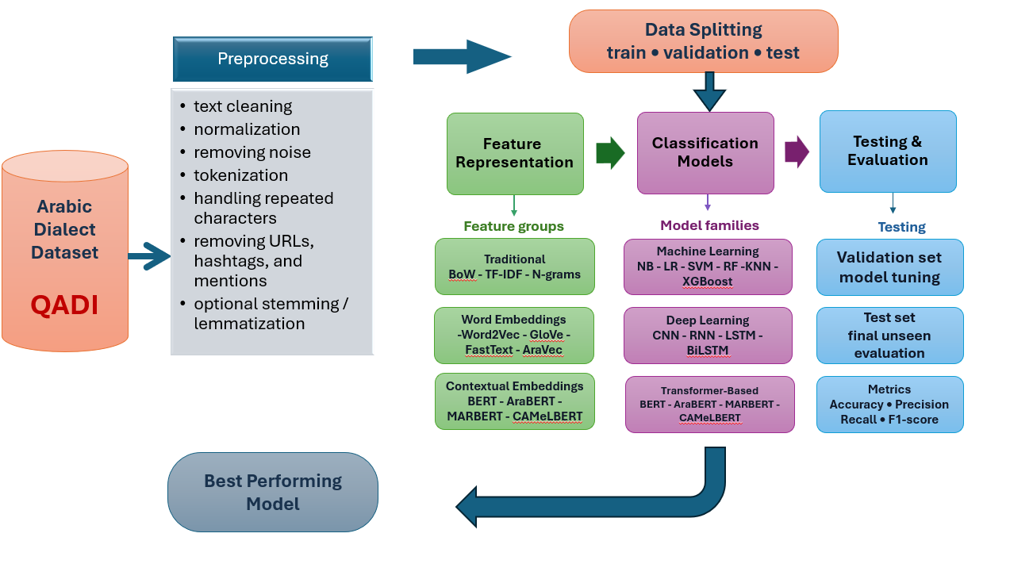

Chapter 2 Background and Related Work

1 Background
Arabic is spoken across a wide range of countries and communities, and its everyday use includes many regional dialects. Although Modern Standard Arabic (MSA) serves as the common form in formal and written contexts, speakers often use local varieties in daily communication. These varieties differ in vocabulary, pronunciation, and common expressions. Such variation creates difficulties for Natural Language Processing (NLP) systems, particularly in applications such as sentiment analysis, machine translation, conversational agents, and speech recognition. For this reason, automatic Arabic dialect identification has received increasing attention. Identifying the dialect of a text can help downstream language technologies select more appropriate linguistic representations. Recent work based on deep learning, including BERT-family models, has improved classification performance. At the same time, the decisions of these models can be difficult to interpret. Explainable Artificial Intelligence (XAI) provides a way to examine the features that contribute to a prediction and can therefore support a clearer interpretation of dialect classification results.

1.2 Natural Language Processing (NLP)
- Data preprocessing is an important stage in preparing text for machine learning and NLP. The aim is to convert raw, unstructured text into a cleaner representation that can be used by the classification models. Common preprocessing operations include removing URLs, HTML tags, emojis, special characters, unnecessary spaces, and other sources of noise (Schütze وآخرون, 2008a).
- Tokenization divides a text into smaller units called tokens. Depending on the method used, these units may be words, subwords, or sentences. The resulting sequence provides the basic input representation required by many NLP algorithms and is commonly used in tasks such as text classification and text analysis .(Schütze وآخرون, 2008a)
- Stop-word removal reduces the number of frequently occurring words that contribute limited information for a particular task. Removing such words can reduce the size of the processed text and, in some applications, make subsequent analysis more efficient (Schütze وآخرون, 2008a)

- Stemming reduces inflected or derived words to a common stem, usually by removing prefixes or suffixes. The purpose is to group related word forms under a shared representation, which can reduce vocabulary size and simplify later processing in information retrieval and NLP systems .(Schütze وآخرون, 2008b)
Stemming
Changing ─────┐
Changed ───────► Chang
Changes ────┤
Change ─────┘

1.3 Text Representation
Text representation converts textual information into numerical forms that machine learning and deep learning algorithms can process. Depending on the representation method, the resulting features may capture word frequency, local context, or semantic relationships. These representations are used in NLP applications such as text classification, sentiment analysis, and machine translation (Schütze وآخرون, 2008a)

    - Bag of Words (BoW)
The Bag of Words (BoW) method represents a document according to the words that occur in it and their frequencies. It does not preserve the original order of the words. Consequently, documents containing the same terms with the same frequencies receive the same representation even when the words appear in different sequences .(Schütze وآخرون, 2008a)
Mathematical Representation
$$d={\left\{tf_{vd}\right\}}_{v∈V}$$
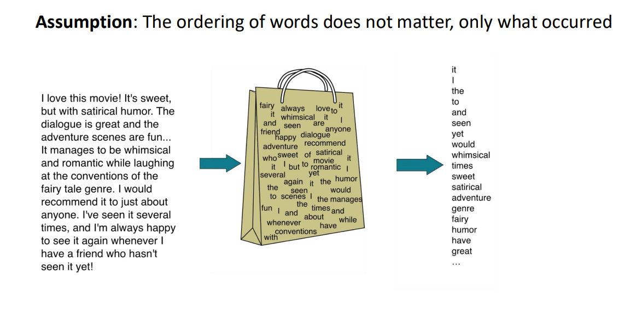
Figure 2.1 BAG of word (Schütze وآخرون, 2008a)‏

1.3.2 Term Frequency–Inverse Document Frequency (TF-IDF)
Term Frequency–Inverse Document Frequency (TF-IDF) assigns a weight to each term according to two factors: how often the term occurs in a particular document and how common the term is across the collection. A word that occurs frequently in one document but appears in relatively few other documents receives a higher weight. This makes TF-IDF useful for representing text in information retrieval and classification tasks (Schütze وآخرون, 2008a)
Mathematical Representation
The Term Frequency (TF) of a term $t$in document $d$is defined as:
$$TF(t,d)=f_{t,d}$$
The Inverse Document Frequency (IDF) is defined as:
$$IDF(t)=log⁡\left(\frac{N}{df_{t}}\right)$$
Finally, the TF-IDF weight is computed as:
$$TF ⁣- ⁣IDF(t,d)=TF(t,d)×IDF(t)$$

1.3.3 N-grams
An N-gram is a contiguous sequence of n words. For example, a sequence containing two words is a bigram, while a sequence containing three words is a trigram. Unlike a simple word-frequency representation, N-grams preserve information about neighboring words and can therefore provide useful local context for NLP tasks .(Schütze وآخرون, 2008a)
The following equations are adapted from [4]:
Equation (1): Chain Rule
$$P(w_{1}^{m})=\prod_{i=1}^{m}{}P(w_{i}∣w_{1}^{i-1})$$
Equation (2): N-gram Approximation
$$P(w_{i}∣w_{1}^{i-1})≈P(w_{i}∣w_{i-n+1}^{i-1})$$
1.3.4 Word2Vec
Word2Vec is a word-embedding approach introduced by Google in 2013 for learning dense numerical representations of words from large text corpora. Words that occur in similar contexts tend to receive similar vector representations, allowing the embeddings to capture useful semantic and syntactic relationships .(Mikolov وآخرون, 2013)
Mathematical Representation
The following equations are reproduced from [6]:
Word2Vec is commonly implemented through two architectures: Continuous Bag-of-Words (CBOW) and Skip-Gram. CBOW uses surrounding context to predict a target word, whereas Skip-Gram starts with a target word and predicts words that occur around it.
Continuous Bag-of-Words
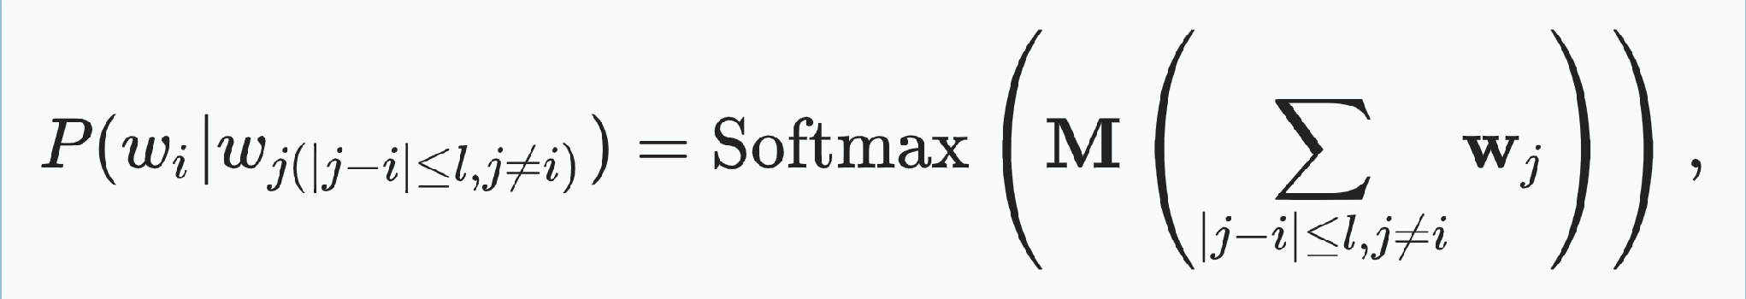

The Skip-Gram architecture predicts surrounding words from a given center word. In this formulation, the model estimates the probability of a context word given the center word, and the associated loss function is used to update the model parameters .(Mikolov وآخرون, 2013)
where $P(w_{j}∣w_{i})$is the probability of context word $w_{j}$given $w_{i}$, and $M$is the weight matrix. The loss function is defined similar to CBOW as
$$L=-\sum_{i}{}\sum_{j(∣j-i∣≤l, j≠i)}{}P(w_{j}∣w_{i}).$$
1.3.5 Global Vectors Algorithm
GloVe (Global Vectors) is an unsupervised word-embedding method developed by Pennington et al. It learns vector representations by using word co-occurrence statistics collected across a corpus. Because the method incorporates global co-occurrence information, words that share similar usage patterns can obtain similar vector representations .(Wüthrich & Merz, 2023)
Mathematical Representation
Objective Function [14]
$$J=\sum_{i,j=1}^{V}{}f(X_{ij}){\left(w_{i}^{T}{\tilde{w}}_{j}+b_{i}+{\tilde{b}}_{j}-log⁡X_{ij}\right)}^{2}$$
Weighting Function
$$f(x)=\{(x/x_{max})^{α}, if x<x_{max}, 1, otherwise.$$

1.3.6 Fast Text
FastText is a word-embedding model based on the Skip-Gram architecture that represents a word through its character n-grams rather than treating the complete word as a single unit. The word representation is constructed from the representations of these character sequences. This design allows the model to make better use of morphological information and can be useful for rare or previously unseen words .(Labrak, 2025)
Mathematical Representation
The following equation is reproduced from [16]:
$$s(w,c)=\sum_{g∈G_{w}}{}z_{g}^{T}v_{c}$$
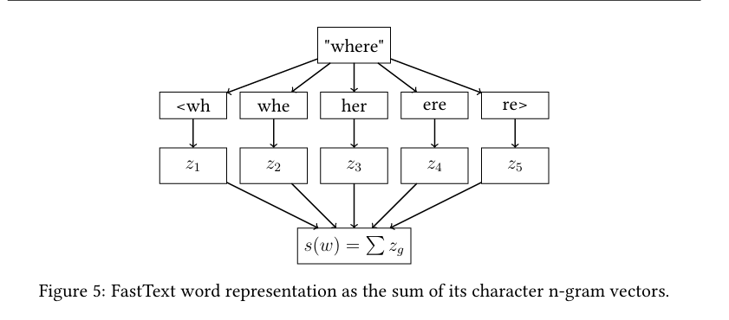
Figure 2. FastText word representation(Labrak, 2025)
1.3.7 Long Short-Term Memory (LSTM)
Long Short-Term Memory (LSTM) is a recurrent neural network architecture designed to model dependencies in sequential data. It uses a memory cell together with input, forget, and output gates to regulate which information is retained, updated, or released. This gating structure helps the network maintain relevant information over longer sequences and reduces the effect of the vanishing-gradient problem. LSTM networks have been used in applications including NLP, speech recognition, machine translation, sentiment analysis, and time-series prediction.(Hochreiter & Schmidhuber, 1997)
The LSTM model uses three gates to control the information stored, updated, and released by the memory cell:
$$f_{t}=σ\left(b_{f}\right)i_{t}=σ\left(b_{i}\right)c_{t}=f_{t}⊙c_{t-1}+i_{t}⊙tanh⁡\left(b_{c}\right)o_{t}=σ\left(b_{o}\right)h_{t}=o_{t}⊙tanh⁡(c_{t})$$
1.3.8 Gated Recurrent Unit (GRU)
Gated Recurrent Unit (GRU) is another recurrent neural network architecture for sequential data. It uses two main gates, the update gate and the reset gate, to control the information passed through the network. Compared with LSTM, GRU has a simpler structure and fewer parameters, which can reduce computational cost while still allowing the model to learn longer-term dependencies. GRU has been applied to NLP, speech recognition, machine translation, sentiment analysis, and time-series tasks.(Hochreiter & Schmidhuber, 1997)

1.4 Evaluation Metrics
Accuracy measures the proportion of correctly classified instances among all observations. It is calculated from the number of correct predictions relative to the total number of samples.

$$Accuracy=\frac{TP+TN}{TP+TN+FP+FN}$$

2 Related Work

[1] Abdelminaam et al. compared traditional machine learning and deep learning methods for Arabic opinion mining across several Arabic dialects and Modern Standard Arabic. Their study used three Twitter datasets: TEAD, containing 5,615,943 tweets; ATSAD, containing 58,751 tweets; and ASTD, containing 10,006 tweets. The datasets include MSA and dialects such as Egyptian, Gulf, Levantine, Maghrebi, Saudi, and Syrian Arabic. The preprocessing stage used the ISRI Stemmer, while TF-IDF with N-grams and AraVec embeddings were used for feature representation. The authors evaluated Decision Tree, Logistic Regression, KNN, Random Forest, SVM, and Naïve Bayes, together with LSTM, GRU, and mLSTM models. Using hold-out and 10-fold cross-validation, the mLSTM model obtained the strongest results, reaching 99.75% on TEAD, 97.52% on ATSAD, and 96.45% on ASTD.(Abdelminaam وآخرون, 2021)

[2] Brihi et al. investigated Yemeni Arabic sentiment analysis using a hybrid approach that combined machine learning and deep learning. The dataset contained 45,862 manually annotated Facebook comments collected from the official pages of four Yemeni telecommunications companies. The study applied a modified ISRI Stemmer during preprocessing and compared lexicon-based methods, several machine learning classifiers, deep learning models, and hybrid architectures. The hybrid stacking approach produced the highest reported accuracy, reaching 94.71% with Random Forest as the meta-learner and 94.28% with LinearSVC.(Brihi & Ghurab, 2025)

[3] Al–Anzi et al. presented a region-wise Arabic dialect identification framework for speech. Their dataset contained 4,071 Arabic audio clips collected from television and radio news broadcasts. The researchers applied DFT and MFCC-based feature extraction, followed by feature selection using ANOVA, Kendall’s Tau, Spearman’s correlation, and RFE. They also examined ADASYN, random oversampling, and SMOTE for handling class imbalance. The study compared ANN, 1D CNN, and 2D CNN architectures using the Klaam pre-trained speech classification model. The 1D CNN achieved 94.28% testing accuracy and 95.55% validation accuracy.(Al–Anzi & Thankaleela, 2025)

[4] Tibi et al. developed an Arabic dialect identification framework based on a Hamilton Neural Network (HNN). The experiments used the LDC and ADI speech datasets and covered eight dialects, including Tunisian, Algerian, Moroccan, Libyan, Egyptian, Gulf, Iraqi, and Levantine Arabic. The preprocessing stage extracted acoustic and prosodic features such as GCI, GOI, Oq, F0, and MFCCs using Multi-Scale Product Analysis. The proposed HNN was compared with RNN and CNN models. It achieved 91.34% accuracy, 90.72% precision, 88.27% recall, and 87.44% F1-score.(Tibi & Messaoud, 2025)

[5] Abdelali et al. introduced the QCRI Arabic Dialect Identification (QADI) dataset for country-level identification of Arabic dialects. The dataset contains approximately 540,000 tweets from 2,525 users representing 18 Arab countries, with about 30,000 tweets per country. The authors used users’ self-declared country information to assign country labels. Their preprocessing included filtering MSA tweets with fastText, removing offensive content, splitting hashtags, and normalizing mentions, URLs, and numbers. SVM with character and word n-grams, Mazajak embeddings, mBERT, and AraBERT were evaluated. AraBERT obtained the highest macro-average F1-score at 60.6%.(Ahmed وآخرون, 2020)
[6] Amjad Alsuwaylimi examined two hybrid architectures that combined BiLSTM with CAMeLBERT and ALBERT. The study compared these models with several machine learning approaches, including Logistic Regression, SVM, Random Forest, Decision Tree, KNN, Naïve Bayes, XGBoost, and SGD. TF-IDF, GloVe, and Word2Vec were used as representation methods. The dataset contained 198,233 comments covering Egyptian, Jordanian, Gulf, and Yemeni dialects. After preprocessing with regular expressions and the ar_corrector package, the CAMeLBERT + BiLSTM model achieved the highest accuracy at 87.67%, while ALBERT + BiLSTM reached 86.51%.(Alsuwaylimi, 2024)
[7] Tahani et al. investigated character-level Arabic dialect identification for four Saudi dialects: Hijazi, Najdi, Southern, and Hasawi. The study used 3,768 annotated short social-media sentences. A CNN was used to extract character-level features, followed by a BiLSTM to model sequential information. The reported accuracies were 40.9% for four-class classification, 47% for three classes, and 64.5% for two classes.(Alqurashi, 2022)

[8] Brahim et al. studied automatic identification of the Algiers dialect using NLP, machine learning, and deep learning techniques. The experiments used the PADIC corpus, which contains parallel texts in MSA and five Arabic dialects. The compared models included SVM, Logistic Regression, MNB, CNN, and LSTM. The LSTM model produced the strongest performance, with an average accuracy of 94%, increasing to 97% when the comparison was limited to Algerian Arabic and MSA.(Cherouati وآخرون, 2025)
[9] Hager et al. proposed a hybrid transformer framework that combined Bert-Base-Arabertv02 with Dialectal-Arabic-XLM-R-Base. The evaluation used the Shami dataset, containing 66,245 samples from four Levantine dialects, and the IADD dataset, containing 129,597 samples from five Arabic dialect groups. The preprocessing included tokenization, cleaning, normalization, stop-word removal, and Arabic stemming. The proposed hybrid model was compared with CNN, LSTM, GRU, and the individual transformer models. It achieved 89.73% accuracy on Shami and 93.06% on IADD.(Saleh وآخرون, 2025)

[10] Wael et al. proposed a hybrid approach for Arabic dialect detection on social media using LSTM, BiLSTM, and Logistic Regression. Their newly collected Twitter dataset contains 34,905 manually annotated tweets from Egyptian, Gulf, Jordanian, and Yemeni dialects. The preprocessing stage removed special characters, English text, numbers, and empty tweets, followed by Arabic stop-word removal. TF-IDF, Word2Vec, and GloVe were used for text representation. The hybrid model reported the highest accuracy at 88.73%.(Yafooz, 2024)
[11] Talafha et al. developed an Arabic dialect identification system using contextual representations from BERT. Their model, MDABERT, was evaluated on the NADI 2021 shared-task dataset, which contains more than 21,000 labeled Arabic tweets from 21 Arab countries. The preprocessing removed URLs, mentions, hashtags, emojis, and punctuation before Arabic normalization and BERT tokenization. The reported Micro F1-score was 26.78%.(Talafha وآخرون, 2020)
[12] El Mekki et al. proposed a multi-task learning framework for Arabic dialect identification. The approach uses a shared BERT encoder with task-specific classification heads so that related tasks can learn common representations. Evaluation was conducted on NADI 2021. After cleaning and normalization, the tweets were tokenized with the BERT tokenizer. The reported results showed higher F1-scores than the single-task baseline and improved robustness across dialects.(Dhleima وآخرون, 2024)
[13] Abdul-Mageed et al. introduced MARBERT, a transformer language model developed specifically for Arabic, with an emphasis on dialectal and informal text. The model was pretrained on more than one billion Arabic tweets covering a wide range of regional varieties. The study applied Arabic normalization, text cleaning, and WordPiece tokenization before pretraining. MARBERT was subsequently evaluated on several NLP tasks, including dialect identification, where it showed strong performance and demonstrated the value of large-scale pretraining on dialectal Arabic.(Abdul-Mageed وآخرون, 2021)
[14] Inoue et al. addressed Arabic dialect identification at both country and province levels, considering MSA and dialectal Arabic. Their Twitter-based dataset covered 21 Arab countries and 100 provinces, with labeled training, development, and test data, in addition to 10 million unlabeled tweets. Preprocessing included removing usernames, hyperlinks, and retweets; handling emojis; filtering non-Arabic content; and separating MSA from dialectal Arabic. Transformer models, particularly MARBERT, were prominent among the top-performing systems. The CairoSquad system achieved 32.26% macro-F1 and 51.66% accuracy for country-level dialect identification.(Solaligue & Santisteban, 2026)
[15] Antoun et al. developed AraBERT, a transformer-based model for Arabic language understanding. Pretraining used a large Arabic corpus drawn from Wikipedia, news sources, the 1.5 Billion Arabic Corpus, and the OSIAN Arabic News Corpus. The resulting corpus contained approximately 70 million sentences. The model was evaluated on several Arabic NLP tasks, including sentiment analysis, named entity recognition, and question answering. AraBERT was based on the BERT-Base architecture and used masked language modeling and next-sentence prediction. The reported results included 96.2% accuracy on HARD, 92.6% on ASTD, and 93.8% on AJGT, along with macro-F1 scores of 84.2% for NER and 62.7% for QA.(Antoun وآخرون, 2020)

Paper | Models | Dataset | Link | Limitation | Base Model | Result
[1] Abdelminaam et | ML: DT, LR, KNN, RF, SVM, NB. DL: LSTM, GRU, mLSTM (proposed) | TEAD, ATSAD, ASTD | IEEE Access, 2021. DOI: 10.1109/ACCESS.2021.3094173 | Performance decreases on imbalanced datasets (especially ASTD). The study is limited to recurrent models (LSTM, GRU, mLSTM) and does not investigate transformer-based architectures such as BERT or AraBERT. | AraVec (Word2Vec pretrained embeddings) | The proposed mLSTM achieved the best performance with 99.75% on TEAD, 97.52% on ATSAD, and 96.45% on ASTD, outperforming all ML models and the other DL models.
[2] Brihi et al. | Lexicon-Based, ML (LR, SVM, LinearSVC, SGD, RF, AdaBoost, XGBoost, MNB, BNB, KNN), DL (MLP, CNN, RNN, LSTM, GRU), Hybrid (CNN-LSTM, CNN-BiLSTM, CNN-GRU, CNN-BiGRU, Stacked DL-ML) | 45,862 manually annotated Facebook comments in the Yemeni Arabic Dialect (YAD) collected from Yemen Telecom, Yemen Mobile, YOU, and Sabafon | IEEE Access (2025). DOI: 10.1109/ACCESS.2025.3593204 | The study focuses only on the Yemeni dialect and one application domain (telecommunication Facebook comments). The authors also recommend using transformer-based models (e.g., BERT/AraBERT) in future work to capture deeper contextual information. | Word2Vec (CBOW + Skip-gram) with TF-IDF, Lexicon features, and Feature Stacking | The proposed Hybrid DL-ML Stacking model achieved the best performance with 94.71% accuracy using Random Forest (RF) as the meta-learner and 94.28% accuracy using LinearSVC, outperforming standalone Lexicon-Based, ML, and DL models.
[3] Al–Anzi et al. | ANN, 1D CNN, 2D CNN with feature selection (ANOVA, Kendall's Tau, Spearman's Correlation, RFE) and data augmentation (ADASYN, Random Oversampling, SMOTE) | 4,071 Arabic audio clips covering MSA, Egyptian, Gulf, Levantine, and North African dialects | https://www.mdpi.com/2076-3417/15/12/6516 | The study focuses only on speech-based dialect identification rather than text. The dataset covers five major dialects, while several low-resource dialects (e.g., Mauritanian, Bahraini, Sudanese) are not included. The authors recommend expanding the dataset and dialect coverage in future work. | Klaam Pre-trained Speech Classification Model | The proposed framework achieved 94.28% testing accuracy and 95.55% validation accuracy using the 1D CNN model, outperforming traditional ML models and AraBERT for Arabic dialect classification.
[4] Tibi et al | Hamilton Neural Network (HNN) (Proposed), Convolutional Neural Network (CNN), Recurrent Neural Network (RNN) | LDC (Linguistic Data Consortium) and ADI (Arabic Dialect Identification) datasets, covering 8 Arabic dialects (Tunisian, Algerian, Moroccan, Libyan, Egyptian, Gulf, Iraqi, and Levantine). Speech collected from telephone conversations and Al Jazeera TV broadcasts. | https://beei.org/index.php/EEI/article/view/8165/4121 | The model is evaluated only on speech-based dialect identification and depends on handcrafted acoustic/prosodic features (GCI, GOI, Oq, F0, MFCC). The authors recommend expanding the dataset with more speaker variations and developing additional multi-view features to improve performance. | Hamilton Neural Network (HNN) with Multi-Scale Product Analysis (MPA) feature extraction | The model achieved 91.34% Accuracy, 90.72% Precision, 88.27% Recall, and 87.44% F1-score, outperforming RNN, CNN, and several recent state-of-the-art dialect identification models.
[5] Abdelali, Ahmed, et al. | SVM, mBERT, AraBERT, Mazajak Embeddings | QADI dataset: 540,000 tweets from 2,525 Twitter users across 18 Arabic countries | arXiv:2005.06557 | Limited to Twitter data and 18 country-level dialects. Four Arab countries (Mauritania, Somalia, Djibouti, and Comoros) were excluded because sufficient Twitter data were unavailable. Performance also decreases geographically similar dialects due to linguistic overlap. | AraBERT | AraBERT achieved the best performance with a Macro-average F1-score of 60.6%, outperforming mBERT, SVM, and Mazajak embeddings on the QADI dataset.
[6] Amjad Alsuwaylimi | machine learning (SVM, LR, RF, DT, KNN  ) deep learning BiLSTM | Data set created by the researcher himself | Arabic Dialect Dataset | The study is limited to four Arabic dialects. | CAMeLBERT + BiLSTM | CAMeLBERT + BiLSTM achieved an accuracy of 87.67%, outperforming all machine learning and deep learning models.
[7] Tahani et al. | machine learning models (Logistic Regression, SVM, Bayesian models, and SGD) and a deep learning approach combining CNN and BiLSTM | 3,768 short sentences written in the Saudi dialect on social media | The data presented in this study are available upon request from the author | The great similarity between the dialects made the process of distinguishing between them difficult and reduced the accuracy of the models. | Logistic Regression, SVM, Bayesian models, and SGD | accuracies of 40.9% for four-class classification, 47% for three-class, and 64.5% for two-class tasks
[8] Brahim et al. | Machine Learning models (SVM, LR, MNB)  Deep Learning models (CNN, (LSTM) | PADIC (Parallel Arabic Dialect Corpus) | PADIC download | SourceForge.net | It relies on the PADIC database, which includes a limited number of Arabic dialects. | The LSTM and CNN models achieved the best performance | Deep learning models outperform traditional models in dialect recognition
[9] Hager et al. | Stacking-Transformer (Bert-Base-Arabertv02 + Dialectal-Arabic-XLM-R-Base + Random Forest Meta-Learner | Shami (66,245 samples) and IADD (129,597 samples) | https://short-url.cc/1tfqV  And  https://short-url.cc/1yMpg | data imbalance, high computational cost, and challenges in generalizing to underrepresented Arabic dialect | Bert-Base-Arabertv02 and Dialectal-Arabic-XLM-R-Base. | achieving 89.73% accuracy on Shami and 93.06% accuracy on IADD
[10] Wael et al. | Hybrid Deep Learning Model (LSTM + BiLSTM + Logistic Regression with Attention Mechanism | A newly collected Twitter dataset consisting of 34,905 manually annotated tweets | Arabic_dialect | The study was limited to four Arabic dialects and relied solely on data from the Twitter platform. | LSTM + BiLSTM + Logistic Regression (Hybrid Model with Attention Mechanism) | Achieved 88.73% accuracy, outperforming all baseline models.
Talafha et al. (2021)[11] | Multi-Dialect Arabic BERT, Ensemble | NADI 2021 | https://aclanthology.org/2021.vardial-1.38/ | Country-level difficulty | Ensemble Arabic BERT | Micro F1=26.78%
El Mekki et al. (2022)[12] | BERT+MTL | NADI 2021 | https://aclanthology.org/2022.wanlp-1.50/ | High computational cost | BERT+MTL | Higher F1 than single-task
Abdul-Mageed et al. (2021)[13] | MARBERT | 1B Arabic Tweets | https://aclanthology.org/2021.acl-long.551/ | Large model | MARBERT | State-of-the-art
[14] Inoue et al. | MARBERT, AraBERT, AraELECTRA, mBERT, Transformer-based models, Classical ML, Neural Networks | NADI 2021 Dataset collected from Twitter, containing MSA and Dialectal Arabic (DA) tweets from 21 Arab countries and 100 provinces. The labeled dataset includes 21,000 training, 5,000 development, and 5,000 test tweets for each of the MSA and DA datasets. An additional 10 million unlabeled Arabic tweets were provided for optional semi-supervised learning. | https://aclanthology.org/2021.vardial-1/ | The task is highly challenging due to the fine-grained distinction between dialects at the country and province levels. Labels were assigned based on users' geographical locations rather than manual linguistic annotation, which may introduce labeling noise. | MARBERT was the strongest base Transformer model used by the top-performing systems (especially CairoSquad and CS-UM6P). Other teams also employed AraBERT, AraELECTRA, and mBERT. | The CairoSquad system achieved the best overall performance, obtaining 22.38% Macro-F1 (35.72% Accuracy) for Country-level MSA, 32.26% Macro-F1 (51.66% Accuracy) for Country-level Dialect Identification, 6.43% Macro-F1 (6.66% Accuracy) for Province-level MSA, and 8.60% Macro-F1 (9.46% Accuracy) for Province-level Dialect Identification, outperforming all participating systems.
[15] Antoun et al. | AraBERT (v0.1 & v1) | Pre-training: Arabic Wikipedia, Arabic News Websites, 1.5 Billion Arabic Corpus, OSIAN Arabic News Corpus (≈70M sentences, 24GB). Evaluation: HARD, ASTD, ArSenTD-Lev, AJGT, LABR, ANERcorp, ARCD. | https://aclanthology.org/2020.osact-1.2/https://aclanthology.org/2020.lrec-1.115/ | The model was mainly pre-trained on Modern Standard Arabic (MSA), which may limit its understanding of some Arabic dialects. In addition, the first version required Farasa segmentation as an external preprocessing tool. | BERT-Base Transformer (12 layers, 768 hidden size, 12 attention heads, 110M parameters) | Best performance: HARD (96.2% Accuracy), ASTD (92.6% Accuracy), AJGT (93.8% Accuracy), NER (ANERcorp: 84.2% Macro F1), QA (ARCD: 62.7% Macro F1), outperforming multilingual BERT and previous state-of-the-art models.

Chapter 4 Proposed Approach (Methodology)

Chapter 5: Experimental Results and Discussion

Chapter 6 Conclusion and Future Work

References:
Abdelminaam, D. S., Neggaz, N., Gomaa, I. A. E., Ismail, F. H., & Elsawy, A. A. (2021). Arabicdialects: An efficient framework for arabic dialects opinion mining on twitter using optimized deep neural networks. Ieee Access, 9, 97079–97099.
Abdul-Mageed, M., Elmadany, A., & Nagoudi, E. M. B. (2021). ARBERT & MARBERT: Deep Bidirectional Transformers for Arabic. في C. Zong, F. Xia, W. Li, & R. Navigli (تحقيق), Proceedings of the 59th Annual Meeting of the Association for Computational Linguistics and the 11th International Joint Conference on Natural Language Processing (Volume 1: Long Papers) (ص 7088–7105). Association for Computational Linguistics. https://doi.org/10.18653/v1/2021.acl-long.551
Ahmed, A., Hamdy, M., Younes, S., Sabit, H., & Kareem, D. (2020). Arabic dialect identification in the wild. arXiv preprint arXiv:2005.06557.
Al–Anzi, F. S., & Thankaleela, B. S. S. (2025). Region-wise recognition and classification of arabic dialects and vocabulary: A deep learning approach. Applied Sciences, 15(12), 6516.
Alqurashi, T. (2022). Applying a character-level model to a short Arabic dialect sentence: A Saudi dialect as a case study. Applied Sciences, 12(23), 12435.
Alsuwaylimi, A. A. (2024). Arabic dialect identification in social media: A hybrid model with transformer models and BiLSTM. Heliyon, 10(17). https://www.cell.com/heliyon/fulltext/S2405-8440(24)12311-0
Antoun, W., Baly, F., & Hajj, H. (2020). Arabert: Transformer-based model for arabic language understanding. Proceedings of the 4th workshop on open-source arabic corpora and processing tools, with a shared task on offensive language detection, 9–15. https://aclanthology.org/2020.osact-1.2/
Brihi, A. A. H., & Ghurab, M. (2025). A hybrid deep learning-machine learning stacking model for yemeni arabic dialect sentiment analysis. IEEE Access. https://ieeexplore.ieee.org/abstract/document/11097878/
Cherouati, B., Fekir, Y., & Senouci, M. (2025). Automatic identification of Algiers dialect based on word-level machine learning and deep learning methods. Przegląd Elektrotechniczny, 101. https://yadda.icm.edu.pl/baztech/element/bwmeta1.element.baztech-e1126259-2c32-4079-8027-95e7c04b6866
Dhleima, M., Tourad, M. C., Telmoud, C. A. A., Abdelmounaim, A., & Nanne, M. F. (2024). Multitask learning for Arabic Dialects Identification and Machine Translation. في Y. M. Elhadj, M. F. Nanne, A. Koubaa, F. Meziane, & M. Deriche (تحقيق), Artificial Intelligence and Its Practical Applications in the Digital Economy (م 862, ص 284–292). Springer Nature Switzerland. https://doi.org/10.1007/978-3-031-71429-0_21
Hochreiter, S., & Schmidhuber, J. (1997). Long short-term memory. Neural computation, 9(8), 1735–1780.
Labrak, Y. (2025). Les Modèles de Langage au Carrefour du Texte et de la Parole pour les Applications de Santé [PhD Thesis, Université d’Avignon]. https://theses.hal.science/tel-05408270/
Mikolov, T., Chen, K., Corrado, G., & Dean, J. (2013). Efficient Estimation of Word Representations in Vector Space (arXiv:1301.3781). arXiv. https://doi.org/10.48550/arXiv.1301.3781
Saleh, H., AlMohimeed, A., Hassan, R., Ibrahim, M. M., Alsamhi, S. H., Hassan, M. R., & Mostafa, S. (2025). Advancing arabic dialect detection with hybrid stacked transformer models. Frontiers in Human Neuroscience, 19, 1498297.
Schütze, H., Manning, C. D., & Raghavan, P. (2008a). Introduction to information retrieval (م 39). Cambridge University Press Cambridge. https://web.cs.hacettepe.edu.tr/~pinar/courses/VBM681/lectures/Shutze-19web.pdf
Schütze, H., Manning, C. D., & Raghavan, P. (2008b). Introduction to information retrieval (م 39). Cambridge University Press Cambridge. https://web.cs.hacettepe.edu.tr/~pinar/courses/VBM681/lectures/Shutze-19web.pdf
Solaligue, C. A., & Santisteban, J. (2026). BERT-Based Approach for Quechua Dialect Identification. في J. A. Lossio-Ventura, R. Medina Rodriguez, J. Zilberman, F. A. Paz Espinoza, & H. Alatrista-Salas (تحقيق), Information Management and Big Data (م 2895, ص 154–166). Springer Nature Switzerland. https://doi.org/10.1007/978-3-032-20322-9_11
Talafha, B., Ali, M., Za’ter, M. E., Seelawi, H., Tuffaha, I., Samir, M., Farhan, W., & Al-Natsheh, H. (2020). Multi-dialect arabic bert for country-level dialect identification. proceedings of the fifth arabic natural language processing workshop, 111–118. https://aclanthology.org/2020.wanlp-1.10/
Tibi, N., & Messaoud, M. A. B. (2025). Arabic dialect classification using an adaptive deep learning model. Bulletin of Electrical Engineering and Informatics, 14(2), 1108–1116.
Wüthrich, M. V., & Merz, M. (2023). Statistical foundations of actuarial learning and its applications. Springer Nature. https://library.oapen.org/handle/20.500.12657/60157
Yafooz, W. M. (2024). Enhancing Arabic dialect detection on social media: A hybrid model with an attention mechanism. Information, 15(6), 316.

