

Predicting fish growth using Internet of Things and Artificial Intelligence in Aquaculture systems
Prepared By
Name: Ahmed Mohammed Ahmed Alnahari
ID No.: 251003035
Submitted in fulfillment of the requirements for the degree Master of Science in Artificial Intelligence
At
Collage of Informatics
Midocean University
UAE
Supervisor Name: Dr. Hager Saleh
Collage of Informatics, Midocean University, Comoros
Email Address : 251003035@st.midocean.edu.km

Acknowledgements

I would like to say thank you to everyone who has been part of my graduation Thesis journey.

First and foremost, I owe my gratitude to my dear supervisor Dr Hager Saleh for their valuable guidance, endless patience and continued encouragement in all phases of this work. I appreciate your comments and constructive criticism that significantly improved the quality of this Thesis.

I would also like to express my heartfelt thanks to my family and friends for their support, understanding and motivation at the hardest days. Your faith in me has been that which keeps me going.

Finaly, I would like to thank Midocean University / Science in Artificial Intelligence Department for outfitting me with every little thing that made this project a possibility.

No, this is not my accomplishment. It is the sum of other people’s work and good deeds added on top of one another above.

Abstract
This thesis introduces a data-oriented framework that integrates Internet of Things (IoT) systems with machine learning methodologies to support predictive analysis and decision-making in aquaculture environments. The framework is implemented as a smart fishpond monitoring system capable of continuously observing critical water quality parameters, including temperature, pH, dissolved oxygen, turbidity, ammonia, and nitrate levels. These parameters are collected through a set of distributed sensors connected to an ESP-32 microcontroller, enabling reliable real-time data acquisition.
The collected sensor data are subjected to structured preprocessing procedures, such as data validation and normalization, before being archived in a cloud-based storage platform. The resulting dataset is then utilized for predictive modeling purposes. Several supervised regression techniques are employed to estimate two fundamental indicators of fish growth: length and weight. The applied models include Decision Tree, Random Forest, Support Vector Regression (SVR), Lasso Regression, Ridge Regression, and XGBoost.
Model performance is evaluated using standard statistical measures, including Root Mean Squared Error (RMSE), Mean Absolute Error (MAE), and the coefficient of determination (R²). The results demonstrate that ensemble-based learning approaches outperform individual regression models in terms of accuracy and stability. In particular, Random Forest and XGBoost achieve R² values exceeding 0.99 for both growth-related targets, indicating their strong ability to model nonlinear relationships present in IoT-based aquaculture data.
Beyond the experimental analysis, this research includes a critical review of fifteen recent studies published between 2018 and 2025 that focus on IoT-enabled data analytics in aquaculture. The review highlights a growing reliance on hybrid learning models and ensemble strategies, which consistently yield superior predictive performance compared to traditional machine learning techniques.
Overall, the findings emphasize the importance of integrating continuous IoT sensing with predictive machine learning to enable early risk identification, improved pond management, and increased fish survival rates. The proposed framework contributes to the advancement of smart aquaculture by offering a scalable and adaptable methodology that connects real-time sensing with data-driven prediction. Future research directions include expanding the dataset size, incorporating multimodal sensor data, and exploring autonomous control mechanisms to support fully intelligent and self-regulating aquaculture systems.

Table of Contents

List of Abbreviations viii
List of Figures ix
List of Tables x

Chapter 1: Introduction ..................................................................................... 1
1.1 Problem Definition ........................................................................................... 2
1.2 Thesis Objectives .............................................................................................. 3
1.3 Thesis Contribution ........................................................................................... 3
1.4 Thesis Organization........................................................................................... 4

Chapter 2: Overview............................................................................................ 6
2.1 Introduction ..................................................................................................... 6
2.2 Machine Learning (ML).................................................................................. 7
2.3 Deep Learning (DL) ........................................................................................ 8
2.4 Relevance of AI Concepts to Fishpond Water Quality Prediction …..……….9
2.5 Some of Models (Regression Models) …………………………………...….. 9

Chapter 3: Related Work ……………………………………………………. 24
3.1 Introduction ................................................................................................... 24
3.2 Literature Review........................................................................................... 25
3.4 Comparison Table …………………………………………………………..36

Chapter 4: Chapter 4 Proposed Approach (Methodology)............................ 38
4.1 Dataset Description......................................................................................... 38
4.2 Data Pre-processing ……………………………………………….……….. 40
4.3 Splitting the dataset ………………………………………………………… 40
4.4 Models (Regression Models) ………………………………………………. 40

Chapter 5: Experimental Results and Discussion ……………………….…. 44

5.1 Introduction ……………………………………………………………...….. 44
5.2 Experimental Setup ………………………………………………..………... 45
5.3 Training Parameters ……………………………………………………...…. 46
5.4 Results and Discussion: Predicting Fish Length ………………………..…... 47
5.5 Results and Discussion: Predicting Fish Weight ……………………….. …. 49
5.6 Performance analysis and overview …………………………………..….… 50
5.7 Comparative Analysis…………………………………………...…………… 53

Chapter 6: Conclusion and Future Work ...................................................... 54
6.1 Conclusion ………………………………………………………………… 54
6.2 Important Features ………………………………………………………… 55
6.3 Future Work ………………………………………………………………. 56

References …………………………………………………………………… 57

List of Figures
- Figure 1 Decision Tree Regression (DT) ………………………..….… 11
- Figure 2 Random Forest Regressor (RF) ….……………………..….… 14
- Figure 3 Support Vector Regression (SVR) …………………..…….….15
- Figure 4 Support Vector Machine (SVM) …………………….……….16
- Figure 5 Lasso Regression (LR) ………………….……………...…….19
- Figure 6 Ridge Regression …………………….…………………..….20
- Figure 7 XGBoost Regression …………………..………………..……21
- Figure 8 XGBoost Regression ………………………………..………..22
- Figure 9 D Tree Algorithm ………………………………….….………23
- Figure 10 Methodology overview ……………………………………..38
- Figure 11 All algorithm Result Fish Length R² ……………………….47
- Figure 12 All algorithm Result Fish weight ………………………..…..49

List of Abbreviations
• Acc.: Accuracy
•IOT: Internet Of Thinks
• ANN: Artificial Neural Network
• ML: Machine Learning
• DL: Deep Learning
• XAI : Explainable Artificial Intelligence
• SVM: Support Vector Machine
• RF: Random Forest
• DT: Decision Tree
• LSTM: Long Short-Term Memory
• CNN: Convolutional Neural Network
• RNN: Recurrent Neural Network
• LR: Logistic Regression
• KNN: K-Nearest Neighbors
• MAE: Mean Absolute Error
• MSE: Mean Squared Error
• R²: R - Squared
• LDA: Linear Discriminant Analysis
• LLM: Large Language Model
• NLP: Natural Language Processing
• EDM: Educational Data Mining

List of Tables
- Table 1 Comparison of previous studies ……………………………………….. 36

- Table 2 Performance Comparison of Regression Models for Fish
Length Prediction ……………………………………………………………… 46

- Table 3 Performance Comparison of Regression Models for Fish
Weight Prediction …………………………………………………………….48

- Table 4 Comparative Performance of Regression Models for Fish
Length and Weight Prediction ………………………………………………..53

Chapter 1: Introduction

Aquaculture has emerged as one of the fastest-growing food production sectors, driven by the increasing global demand for fish and aquatic products. Fishponds contribute significantly to freshwater aquaculture production; however, their sustainability and productivity strongly depend on maintaining optimal water quality conditions. Even minor fluctuations in parameters such as temperature, pH, dissolved oxygen (DO), and turbidity can trigger stress, disease outbreaks, or mass mortality in fish populations. Traditional water monitoring methods, which rely on manual sampling and laboratory analysis, are time-consuming, intermittent, and unable to capture real-time variations in dynamic aquatic environments.

The integration of the Internet of Things (IoT) into aquaculture introduces a transformative approach to environmental monitoring by enabling continuous sensing, automated data collection, and remote supervision of fishponds. Through distributed sensors and wireless communication, IoT systems generate large volumes of time-series water quality data, providing a rich foundation for predictive analytics and intelligent decision-making. When coupled with machine learning (ML) models—such as Random Forest (RF), XGBoost, Support Vector Regression (SVR) , K-Nearest Neighbors, Linear Regression, and Lasso Regression—IoT-enabled data can be transformed into accurate predictions that support early intervention and proactive pond management.

This thesis focuses on developing a data-driven framework for predicting water quality parameters in IoT-based fishponds using supervised machine learning techniques. The study leverages real IoT sensor data from fishpond environments to evaluate and compare the performance of several regression models. By identifying the most accurate models for water quality prediction, the research aims to support smarter aquaculture systems capable of improving fish health, reducing losses, and enhancing overall production efficiency.

Problem Definition
Water quality degradation remains one of the most critical issues in modern aquaculture. Sudden variations in pH levels, dissolved oxygen (DO) drops, temperature fluctuations, or increases in turbidity can drastically affect fish health and survival. In traditional aquaculture practices, water parameters are typically measured manually once or twice daily. Such low-frequency monitoring fails to capture rapid environmental changes, delaying corrective actions and leading to potential economic losses. Although IoT devices now provide continuous real-time measurements, fish farmers still struggle to interpret large streams of sensor data. Raw IoT data alone does not provide actionable insights unless processed and analyzed effectively. More importantly, farmers need predictive signals—not just historical values—to anticipate harmful trends before damage occurs.
Although Internet of Things (IoT) technologies now allow real-time monitoring through sensor networks, aquaculture practitioners continue to face difficulties in processing and interpreting large streams of raw data. Without proper analysis, IoT data provides descriptive rather than predictive insights. To achieve proactive pond management, predictive intelligence is essential — enabling farmers to anticipate water quality deterioration before it becomes critical.
Therefore, the core problem addressed in this study is:
How can IoT-based fish pond data be effectively processed and analyzed using machine learning algorithms to accurately predict key water quality parameters and enable early decision-making in aquaculture?
his research problem arises from several technical and practical limitations identified in current approaches: Raw IoT data is often noisy, incomplete, and requires preprocessing to be usable
- Traditional statistical models fail to capture complex nonlinear interactions between water quality parameters.
- Existing monitoring frameworks primarily offer reactive responses rather than predictive insights.
- Limited research has compared multiple regression-based machine learning models using real IoT aquaculture datasets.
- These challenges highlight the need for a robust machine learning framework capable of evaluating, optimizing, and identifying high-performing predictive models suitable for real-time fishpond management systems.

Thesis Objectives
The primary objective of this thesis is to design, implement, and evaluate machine learning regression models capable of predicting fishpond water quality parameters using real-time IoT sensor data.

The specific research objectives are as follows:
- To develop a predictive framework utilizing IoT-based fish pond datasets for accurate estimation of key water quality indicators.
- To perform comprehensive data preprocessing, including cleaning, handling missing values, and applying feature engineering techniques to improve model performance.
- To train and evaluate multiple regression-based machine learning algorithms — including Linear Regression, Random Forest, XGBoost, Support Vector Regression (SVR), Lasso, and other ensemble models.
- To identify the most significant environmental parameters influencing water quality dynamics and their impact on fish growth.
- To propose an optimized machine learning model suitable for integration into real-time IoT-based aquaculture management systems.
- To demonstrate how predictive analytics can provide early warnings and support proactive decision-making for sustainable fishpond operations.

1.3 Thesis Contribution
This thesis advances existing research in smart aquaculture by shifting the focus from descriptive and real-time monitoring toward predictive modeling of fish growth. Unlike many previous studies that primarily rely on instantaneous water quality measurements or manual assessments, this work introduces a fully data-driven predictive framework capable of forecasting fish growth indicators in advance.
The main scientific contributions of this thesis can be summarized as follows:
- Development of a predictive machine learning framework for estimating fish growth indicators, specifically fish length and fish weight, using real IoT sensor data collected from fishpond environments.
- Integration of water quality parameters—including temperature, pH, dissolved oxygen, and turbidity—into a unified regression-based modeling approach that captures their combined influence on fish growth dynamics.
- Comprehensive comparative evaluation of multiple regression algorithms, including Decision Tree, Random Forest, Support Vector Regression, Ridge Regression, Lasso Regression, and XGBoost, to identify models capable of accurately predicting future growth trends rather than providing only real-time observations.
- Demonstration that ensemble learning techniques, particularly Random Forest and XGBoost, significantly outperform traditional regression models in terms of prediction accuracy and stability, enabling reliable forecasting of fish length and weight.
- Transformation of IoT sensor data from a monitoring-oriented resource into a predictive decision-support tool that enables proactive aquaculture management, early intervention, and data-driven planning.
- Contribution to the literature by addressing the gap between water quality monitoring systems and predictive fish growth modeling, thereby moving aquaculture management from reactive and moment-based analysis toward intelligent and anticipatory control.

1.4 Thesis Organization
This thesis is organized into six chapters, each addressing a key component of the research process:
Chapter 1 – Introduction:
Provides background information on aquaculture and the significance of IoT in modern fish farming. It defines the research problem, outlines the objectives, highlights the study’s contributions, and presents the overall structure of the thesis.
Chapter 2 – Related Work / Background:
Reviews fundamental concepts of the Internet of Things (IoT), cloud-based data acquisition, and machine learning techniques relevant to aquaculture. It explains the theoretical foundation upon which the proposed system is built.

Chapter 3 – Literature Review:
Discusses previous studies related to IoT applications in aquaculture, water quality monitoring systems, and existing machine learning approaches for predictive modeling in fish ponds. It also identifies current research gaps that form the basis for this study.
Chapter 4 – Methodology:
Describes the proposed framework in detail, including the IoT dataset used, sensor specifications, data preprocessing and normalization steps, feature selection, and implementation of various regression algorithms. It also presents the experimental setup and performance evaluation metrics.

Chapter 5 – Experimental Results and Discussion:
Presents the experimental findings and comparative performance of all regression models using error metrics and visual analysis. The discussion highlights which models achieved the best predictive accuracy and explains the underlying reasons based on data characteristics.
Chapter 6 – Conclusion and Future Work:
Summarizes the key findings of the research, outlines its major contributions to smart aquaculture, and provides recommendations for future studies and potential real-world implementations of IoT-driven predictive systems

Chapter 2 Overview

2.1 Introduction
Artificial Intelligence (AI) is General-Purpose and Evolving Science which mission it to develop a machine system that can carry out with some thing, would go as through human being. Such tasks may be learning from experience, identifying patterns, processing natural language and making independent decisions. The rise of AI technologies in recent years has been driven by a number of key sub-disciplines… - ML, - DL , Relationship of AI Concepts to Fishpond Water Quality Predictions and I will take about Some of Regression Models.
Below we summarize these central AI ideas and why they matter in current data-driven applications.
2.2 Machine Learning (ML)
Machine Learning is a fundamental branch of AI centered on developing algorithms that learn patterns from historical data. Instead of being explicitly programmed for every task, ML models identify relationships within datasets and use them to make predictions, classifications, or recommendations.
ML is widely applied in fields that rely on structured or semi-structured data, offering capabilities such as:
· Forecasting future trends, and
· Detecting anomalies,
· Aggregating like instances of observation,
· Enabling decision makers to base decisions on evidence.
Most present predictive systems, especially those relying on real-time or continuous data streams, are constructed around ML.
2.3 Deep Learning (DL)
Deep Learning Deep is a subfield of ML, which uses artificial neural networks with many hidden layers to extract abstract and high-level features from data. Unlike traditional ML techniques that rely on manual feature extraction, the process of learning high-level representations is performed automatically by deep learning models, and hence DL methods are effective for processing large scale nonlinear and unstructured datasets (e.g., images, audio signals, sensor reads, natural language).
DL has made breakthrough progress on tasks such as computer vision, speech recognition, NLP and time series prediction which are in need to capture subtle patterns that traditional algorithms cannot handle.
2.4 Relationship of AI Concepts to Fishpond Water Quality Predictions
The ideas mentioned on ML, DL, LLMs and XAI are the technology underlying modern environmental monitoring and smart aquaculture systems. In terms of fishpond functional operation, AI is helpful in the following aspects:
• Machine Learning allows models to estimate the main water quality indicators (pH, dissolved oxygen content, temperature and turbidity) in previous sensor measurements.
· The complex nonlinear relationships in complicated marine environments, which are further compounded by Deep Learning based modeling, can enhance the accuracy and performance of water quality prediction.
Combining AI component with conventional aquaculture system allows the modernization of aquaculture from reactive water management to proactive, predictive and data-driven ecosystem monitoring and ultimately enhancing systems productivity, lowering fish mortality rates, and improving pond conditions.
2.5 Some of (Regression Models).
DT Regression (DT) Decision tree is a non-parametric supervised learning algorithm that can be employed in classification and regression problems. It is a hierarchical tree which includes a root node, branches, internal nodes and leaf nodes. As shown in the diagram below, a decision tree always begins with a root node with no incoming branches. Outgoing branches from the root node are followed by internal nodes (or decision nodes in this context). Both of node types perform their evaluation according to available features in such a way that homogenous subsets (referred as leaf nodes, or terminal nodes) are created. And the leaf nodes are the possible results in our dataset. [17]
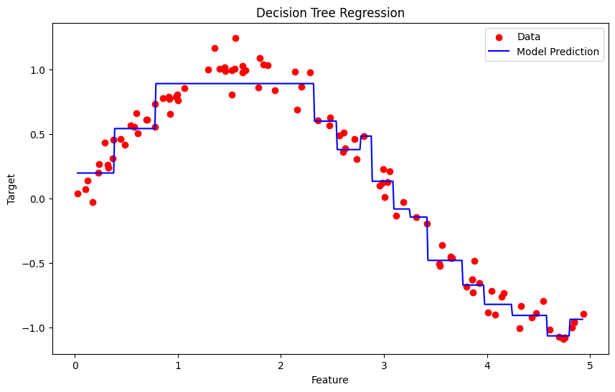
Figure 1 Decision Tree Regression (DT)
Application :
Robotics: RL is employed to automate repetitive tasks in organized environments, like manufacturing, with robots learning to refine movements and maximize effectiveness.
Games: Advanced RL algorithms have been employed to create policies for complex games such as chess, Go and video-games surpassing human players in many cases.
Industrial Control: RL facilitates in-the-moment fine tuning and optimization of industrial processes like refining process (oil & gas).
Personalized Training Regime: RL can be used to personalize the training curriculum of an individual based on her learning patterns, increasing engagement and efficacy.
Advantages :
- Solves complex sequential decision problems where other approaches fail.
- Learns from real-time interaction, enabling adaptation to changing environments.
- Does not require labeled data, unlike supervised learning.
- Can innovate by discovering new strategies beyond human intuition.
- Handles uncertainty and stochastic environments effectively.
Disadvantages:
- Computationally intensive, requiring large amounts of data and processing power.
- Reward function design is critical, poor design leads to unintended behaviors.
- Not suitable for simple problems where traditional methods are more efficient.
- Challenging to debug and interpret, making it hard to explain decisions.
- Exploration-exploitation trade-off requires careful balancing to optimize learning.

2. Random Forest Regressor (RF) A random forest is an ensemble technique which aggregates predictions derived from multiple decision trees to obtain a more accurate and stable prediction. It is applicable for classification as well as regression problem. If you are working on a regression problem, you can use Random Forest Regression method to predict the values. It makes predictions by averaging the predictions of several decision trees. [18]
Haw it Works Random Forest Regression works by making multiple of decision trees and training each of them on a random subset of the data. It starts with Bootstrap sampling, that is random sample of rows from data with replacement, to create a set of different training datasets for various decision trees. After this it's time for feature sampling, using only a random subset of the features to construct each tree to ensure that our models aren't too similar. Once the trees are trained every tree makes a prediction and your final prediction in regression task is nothing but the average of predictions made by all those individual trees and this process is known as Aggregation.
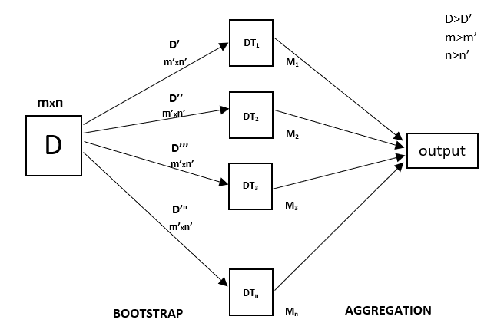
Figure 2 Random Forest Regressor (RF)
Applications of Random Forest Regression The Random forest regression can be effectively applied to real world problems such as:
§ Predict continuous numbers - e.g.: House Prices, Stock performance or customer lifetime value.
§ Identifying risk factors: Spotting the risk factors for diseases, financial crises or other bad things.
§ How to deal with high dimensional data: Datasets which contain a large number of input features.
§ Handling complex relationships : Modeling the complex relationship between input features and the target.
Advantages of Random Forest Regression
· Non-Linearty Handling: It is able to capture complex,non-linear relationships in the data that other models may miss.
· Overfitting is reduced: since prediction is averaged over multiple decision trees, the risk of overfitting is lower clubbed to make a single decision tree.
· Outliers Tolerance: Random Forest is not very sensitive to outliers as it takes the mean of many trees.
· Works well with large data sizes: GMMs can handle large datasets and high-dimensional data without loss of efficiency.
· Dealing with Missing Data: Random Forest can deal with the missing values by using surrogate splits and still retaining high accuracy in presence of partial data.
No feature scaling Random Forest does not require normalization of data.
Disadvantages of Random Forest Regression
Complexity: It can be expensive and time consuming to train, especially for a large number of trees or high-dimensional data. This is a consequence of the fact that it may not be an online suitable method for making real-time predictions particularly when we have a large number of trees.
· Less Interpretable : It becomes less interpretable because finally, it is an ensemble of trees which aren’t easy to interpret compared to linear regression and decision trees.
· Memory Usage: Memory used are proportional to the number of decision trees for large data sets.
Overfitting on Noisy Data: Random Forest decreases the overfitting problem since it has large number of trees, which makes it’s a decent model; but in this case solution often leads to overfitted model due to presence of noise data.
Sensitivity to Imbalanced Data: It may not work well if the dataset is extremely imbalanced, like one of the classes have more frequency than another.
3. Support Vector Regression (SVR) Support Vector Machine (SVM) is a supervised learning model for classification or regression challenges. It attempts to identify the best boundary called hyperplane that can segregate different classes on the basis of input
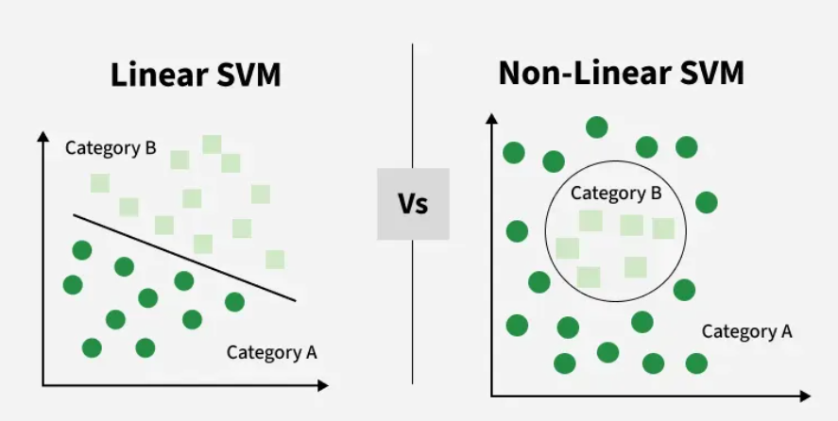
Figure 3 Support Vector Regression (SVR)
The main goal of SVM is to maximize the margin between the two classes. The larger the margin the better the model performs on new and unseen data.
How does Support Vector Machine Algorithm Work?
The key idea behind the SVM algorithm is to find the hyperplane that best separates two classes by maximizing the margin between them. This margin is the distance from the hyperplane to the nearest data points (support vectors) on each side.
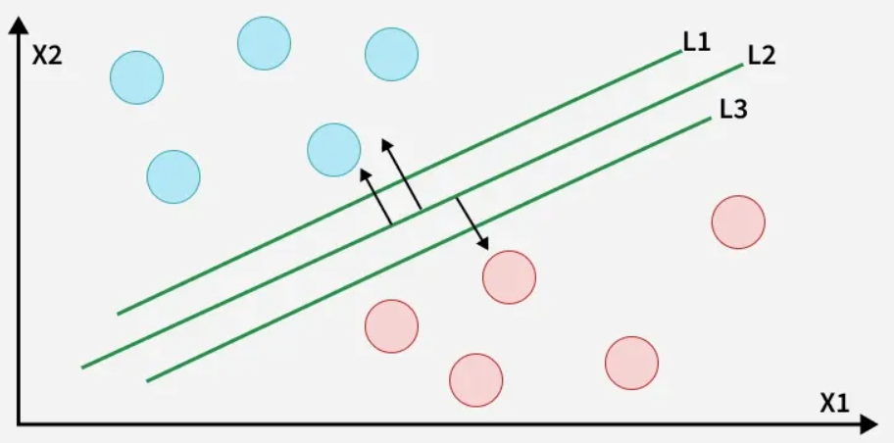
Figure 4 Support Vector Machine (SVM)

Advantages of Support Vector Machine (SVM)
- High-Dimensional Performance: SVM excels in high-dimensional spaces, making it suitable for image classification and gene expression analysis.
- Nonlinear Capability: Utilizing kernel functions like RBF and polynomial SVM effectively handles nonlinear relationships.
- Outlier Resilience: The soft margin feature allows SVM to ignore outliers, enhancing robustness in spam detection and anomaly detection.
- Binary and Multiclass Support: SVM is effective for both binary classification and multiclass classification suitable for applications in text classification.
- Memory Efficiency: It focuses on supporting vectors making it memory efficient compared to other algorithms.
Disadvantages of Support Vector Machine (SVM)
- Slow Training: SVM can be slow for large datasets, affecting performance in SVM in data mining tasks.
- Parameter Tuning Difficulty: Selecting the right kernel and adjusting parameters like C requires careful tuning, impacting SVM algorithms.
- Noise Sensitivity: SVM struggles with noisy datasets and overlapping classes, limiting effectiveness in real-world scenarios.
- Limited Interpretability: The complexity of the hyperplane in higher dimensions makes SVM less interpretable than other models.
- Feature Scaling Sensitivity: Proper feature scaling is essential, otherwise SVM models may perform poorly.
4. Lasso Regression (Least Absolute Shrinkage and Selection Operator)
Lasso Regression is a regression analysis method that performs both variable selection and regularization. It is useful in eliminating irrelevant data features and to avoid overfitting. This enables insignificant features of weak influence to be judged in contrast, as the coefficient values for unimportant variables are penalized towards zero. [20]
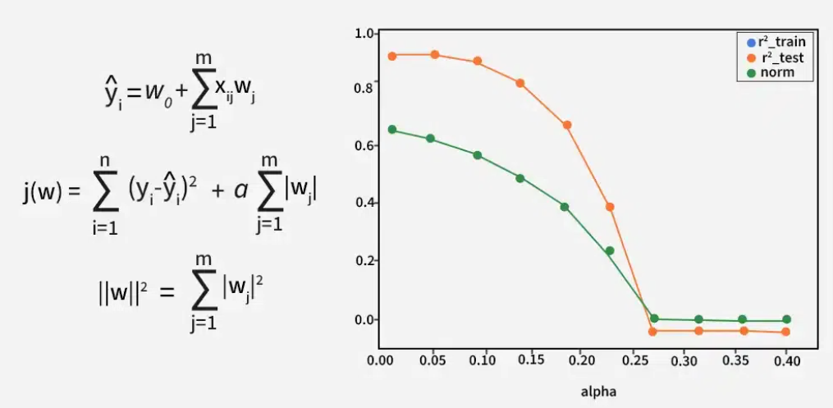Figure 5 Lasso Regression (LR)
When to use Lasso Regression ?
Lasso Regression is helpful where:
Feature Selection: It selects most important features while setting the coefficients of less significant ones to zero.
· Collinearity: In case of multicollinearity, it assists us in getting rid of the coefficients to control and keeps one of the variables.
· Regularization: It works by penalising large coefficients, especially useful when you have a large number of predictors.
· Interpretability: As compared to classic linear models which has all the features Lasso regression produce a model with less number of non-zero coefficients, so it is easier to interpret.
Advantages of Lasso Regression
· No feature selection required: Most important features do not need to be identified manually, resulting in a simpler and more interpretable regression model.
· Regularization: It limits the large coefficients so that we obtain a less-biased model which gives stable and generalized predictions.
· Interpretability - This also builds an alternate models to make them more interpretable and explainable, which is very critical in domains like healthcare or finance.
Handles Large Feature Spaces: It works with high dimensional data such as images and videos.
Disadvantages:
· Selection Bias: Lasso might randomly choose one variable amongst many correlated variables, and as a result provide a biased model.
· Sensitive to Scale: It is sensitive to features that have different scales because values of such features can influence the regularization and accuracy of the model.
· Effect of Outliers: It can be greatly impacted by the outliers in the data which proves to overfit the coefficients.
· Model instability: It may unstable when there are a large number of correlated variables since the model is obtained by selecting features, which can vary with just small difference in the data.
· The Value of λ Selection: Tuning a number of λ values is not suitable but solvable unless for cross-validation.

5. Ridge Regression
Ridge regression (L2 regularization) is a linear regression method used to reduce the multicollinearity among predictors. Multicollinearity refers to the case of several independent variables (IVs) in a regression model being strongly correlated, which might incur coefficients suffering from non-robustness and instability. [21]
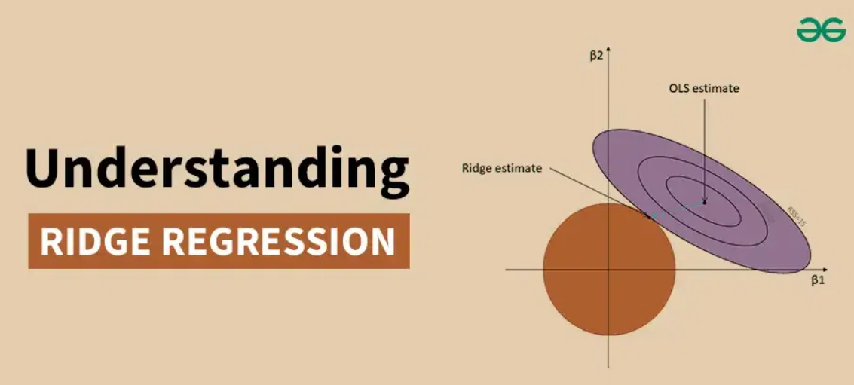
Figure 6 Ridge Regression

Applications of Ridge Regression :
- Forecasting Economic Indicators: Ridge regression helps predict economic factors like GDP, inflation, and unemployment by managing multicollinearity between predictors like interest rates and consumer spending, leading to more accurate forecasts.
- Medical Diagnosis: In healthcare, it aids in building diagnostic models by controlling multicollinearity among biomarkers, improving disease diagnosis and prognosis.
- Sales Prediction: In marketing, ridge regression forecasts sales based on factors like advertisement costs and promotions, handling correlations between these variables for better sales planning.
- Climate Modeling: Ridge regression improves climate models by eliminating interference between variables like temperature and precipitation, ensuring more accurate predictions.
- Risk Management: In credit scoring and financial risk analysis, ridge regression evaluates creditworthiness by addressing multicollinearity among financial ratios, enhancing accuracy in risk management.
Advantages of Ridge Regression
- Stability: Ridge regression provides more stable estimates in the presence of multicollinearity.
- Bias-Variance Tradeoff: By introducing bias, ridge regression reduces the variance of the estimates, leading to lower MSE.
- Interpretability: Unlike principal component regression, ridge regression retains the original predictors, making the results easier to interpret.
Disadvantages of Ridge Regression
- Bias Introduction: The introduction of bias can lead to underestimation of the true effects of the predictors.
- Parameter Selection: Choosing the optimal ridge parameter k can be challenging and computationally intensive.
- Not Suitable for Variable Selection: Ridge regression does not perform variable selection, meaning all predictors remain in the model, even those with negligible effects.
6. XGBoost Regression (Extreme Gradient Boosting)
Traditional machine learning models like decision trees and random forests are easy to interpret but often struggle with accuracy on complex datasets. XGBoost short form for extreme Gradient Boosting is an advanced machine learning algorithm designed for efficiency, speed and high performance. [21] 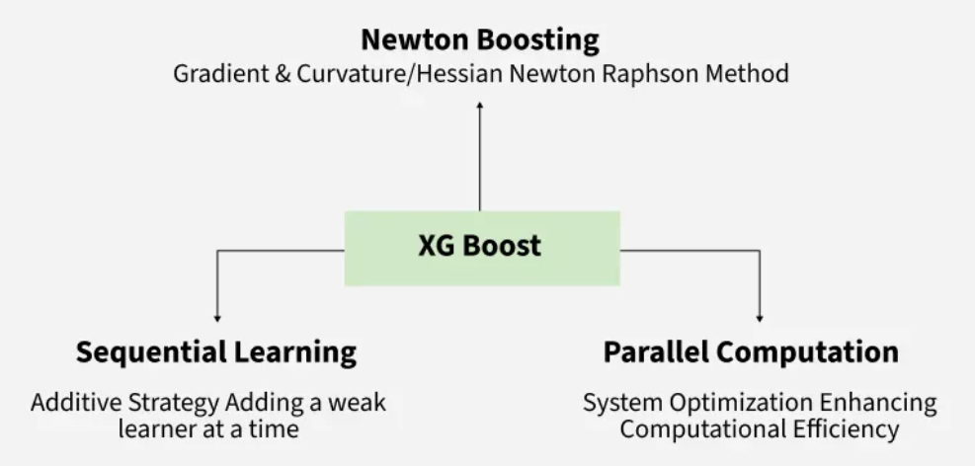 Figure 7 XGBoost Regression

in order to deal with big data sets, XGBoost leverages an approximate way in finding the best splits.
· Quantiles with weights: Make a quick guess of the ideal split without having to check all possibilities.
· Efficiency: Minimizes overhead of computations while preserving accuracy.
· Advantages : Suitable for large dataset where full evaluation is very expensive.
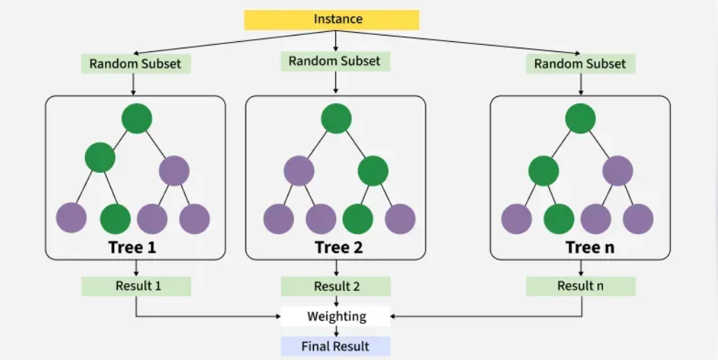
Figure 8 XGBoost Regression
How XGBoost Works?
It creates decision trees on working one after the other, where each new tree helps to let down the error of its predecessor. It can be decomposed as:
Begin with a base learner: It learns the tree model, which is first learning decision tree based on the data. In regression, this base model predicts just the average value of the target variable.
Measure the errors: After training of one tree calculate difference between actual values and predicted values.
Train the next tree: Train the next tree on the errors of previous tree (y2 - y1). This tries to correct for the mistakes that have been made by the first tree.
Continue reiterating this process: This sequence of operation will be continued with additional tree, each attempting to correct the errors made by its predecessor trees until a stopping rule is satisfied.
Aggregate the predictions: The final prediction is obtained by adding up the predictions of all trees.
Advantages of XGBoost :
· Scalable for large datatsets of millions of record.
. Supports parallel processing and GPU, so everything runs lightening fast!
· Provides parameters and regularization that can be fine-tuned.
· Comes with feature importance analysis for more insights.
· Compatible with many languages and has a broad appeal to data scientists.
Disadvantages of XGBoost
· Computationally intensive; not appropriate for resource-constrained devices.
· Sensitive to the noise and outliers need careful pre-processing.
· Can overfit, especially with small datasets or too many trees.
· Interpretability may be limited relative to simpler models, which can be a concern in e.g. healthcare or finance.
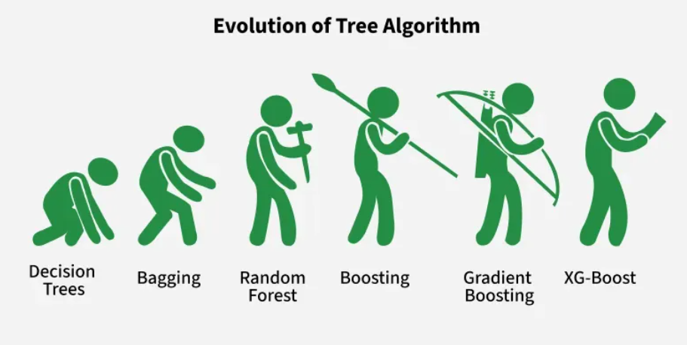
Figure 9 Tree Algorithm

Chapter 3 Related Work

3.1 Introduction:

Aquaculture systems encounter ongoing challenges in maintaining environmental conditions that support healthy fish growth, particularly in relation to water availability and water quality management. Water quality plays a decisive role in fish survival and productivity; however, conventional monitoring practices often rely on manual measurements that are time-consuming and insufficient for detecting early signs of deterioration. As a result, management decisions related to feeding strategies, stocking density, and pond maintenance are frequently made with limited and fragmented information.

A major limitation of traditional fishpond management lies in the lack of continuous and high-resolution data required for effective decision-making. In many cases, farmers depend on periodic sampling, which fails to capture short-term fluctuations in water conditions and restricts the ability to respond proactively to emerging risks. This data scarcity has historically hindered the adoption of predictive and data-driven management approaches in aquaculture.

The emergence of Internet of Things (IoT) technologies has introduced new possibilities for improving environmental monitoring in aquaculture settings. By deploying interconnected sensor networks and wireless communication systems, IoT-based solutions enable continuous and automated collection of water quality data at high temporal resolution. These systems allow for real-time observation of key environmental parameters, facilitating timely interventions and more informed management decisions. Nevertheless, despite the availability of real-time data streams, many existing IoT applications remain focused on monitoring rather than predictive analysis.
Aquaponics represents a sustainable farming approach that integrates aquaculture with hydroponic plant cultivation in a closed-loop system. In aquaponic fishponds, nutrients generated from fish waste are absorbed by plants, which simultaneously contribute to water purification before it is recirculated back to the fish tanks. This synergistic interaction reduces the need for frequent water replacement and enhances resource efficiency compared to conventional fishpond systems. As a result, aquaponics has attracted increasing research attention as a promising model for environmentally sustainable aquaculture, particularly when combined with smart monitoring and data analytics technologies. To further optimize such systems, IOT-based monitoring can be implemented for real-time water quality management. [23]

Number of studies in recent years have explored IoT deployments in fish farming alongside machine learning algorithms to predict water quality variables or other aquaculture outcomes.

3.2 Literature Review:

Study 1

MS-CAGRU for Water Quality Prediction
Sundararajan S. C. M. et al. (2025) developed an IoT-based water quality prediction model for an aquaponic fish pond by using a multiscale feature fusion approach with deep learning. In their study, an IoT sensor network collected water parameters which were then used to train a hybrid deep learning model combining a convolutional autoencoder (CAE) for feature extraction and a gated recurrent unit (GRU) for sequence learning. The proposed model (termed MS-CAGRU) effectively captured multi-scale patterns in the water quality data. The authors applied different ML models: random forest (RF), support vector machine (SVM), decision tree (DT), K-nearest neighbor (KNN), and logistic regression (LR) to classify different types of fish using water quality parameters: pH, temperature, and turbidity. The dataset was collected from AquaBot, It attained approximately 94% classification accuracy with an F1-score of 0.94, outperforming baseline recurrent neural networks (standard RNN and plain GRU) by 2–5%. The study noted that regularization techniques further improved the model’s generalization. This work demonstrates that fusing convolutional feature extraction with recurrent prediction can yield high predictive accuracy for aquaculture water quality, providing a foundation for intelligent pond management. [1]

Study 2
IOT & Advanced ML Algorithms (Tilapia Ponds, 2025)
Hridoy, M. A. A. M. et al. (2025) combined IoT monitoring and advanced machine learning to enhance water quality forecast in tilapia aquaculture on ponds. The authors used an in-house built IoT system to monitor the sensor data (temperature, dissolved oxygen, pH and turbidity) for six months from several tilapia ponds. Several predictive models were then compared on these time-series data, including tree ensembles and deep neural networks. It is noteworthy that the authors employed ensemble methods like bagging and boosting for better predictive performance. The models demonstrated a strong predictive power for the major water quality constituents through learning temporal patterns and employing multiple learners. The ensemble of the structure with decision-tree based method and boosting algorithm performed well, which could reach about 99% in predicting trends in dissolved oxygen fluctuations. This was significantly better accuracy than individual models could achieve (each individual model had 88%-93% accuracy), demonstrating the advantage of ensemble learning. It was observed that in the integrated viewpoint between IoT-sensed data and advanced ML algorithms, water quality can be predicted almost in real time with minimum error; it is necessary for proactive pond management. [2]

Study 3
IOT + Random Forest with Quantum Optimization (Tropical Pond, 2025)
Baena-Navarro, R. et al. (2025) described an intelligent water quality monitoring framework that integrates IoT sensing with machine learning for sustainable aquaculture management. They installed an IoT system in a tropical fish pond to acquire environmental data (such as temperature, DO, pH and turbidity) continuously from the water, thus providing inputs to train prediction‐based models. Water quality parameters were predicted using a random forest regression, yet the innovation of this study focused on using quantum-inspired optimization algorithm (QAOA) to optimize and bypass regular training complexity. The performance of the Random Forest model, optimized with QAOA’s parameters showed an excellent fit for dissol ved oxygen predictions ( R² ≈ 0.999) and a RMSE on the order of 0.1mg /L which demonstrated that the model was almost capable to perfectly predict b ased upon observations; this level of precision is too high success as you can imagine. The implemented system permitted fast adjustments on-site, for example to switch on aerators to sustain survival of the fish at levels >90%. The most successful method found is QAOA-enhanced Random Forest, showing that combining IoT features and state-of-the-art optimization techniques you can obtain highly accurate predictive models for aquaculture monitoring. [3]

Study 4
Hybrid EEMD–MLR–LSTM Model (Salmon Farm, 2023)
Eze, E. et al. (2023) introduced a hybrid deep learning approach for multivariate prediction of water quality in an offshore salmon farm. They proposed a concatenated model, integrating the EEMD signal processing with an initial approximation using multivariate linear regression (MLR), and sequence learning with deep Long Short-Term Memory (LSTM) network. The model training approach was then applied to the prediction of harmful algal blooms (chlorophyll-a) and other water quality parameters from time-series sensor data collected within a Scottish salmon aquaculture site. The complex time-series were decomposed into simpler sub-series by the EEMD component, which enhanced the LSTM to learn patterns at multiple scales. The introduced EEMD–MLR–LSTM approach achieved superior prediction performance over several baseline models (including a single LSTM and stacked autoencoder-LSTM). Of particular interest, an extremely low RMSE of about 0.05 was realized in the chlorophyll‐a concentration predictions, representing a very high precision. By efficiently recognizing the short-term dynamics and longtime trends inherent in the data, this mixed model reduced the prediction error as much as possible and was selected as the optimal one. The findings demonstrate the importance of multi-scale feature extraction and deep learning for predicting complex water quality dynamics in aquaculture. [4]

Study 5
Yu, X. et al. (2025) presented the prediction of dissolved oxygen in freshwater aquaculture through feature selection and attention-based RNNs. The authors first applied Pearson correlation analysis to identify which water quality variables were most influential for predicting DO levels. By filtering the input features to only the most relevant (e.g., selecting temperature, pH, etc. that correlate strongly with DO), they reduced noise and improved model focus. They then designed an LSTM network augmented with an attention mechanism (denoted LSTM-AM) to forecast oxygen dissolved several days into the future. The attention layer enabled the model to weigh the most important steps and features when making predictions. Trained on an IoT-sensed dataset from a freshwater fish farm, the enhanced model (called Pearson-LSTM-AM) achieved substantially better accuracy than baseline models (including standard LSTM, CNN-LSTM, and bidirectional LSTM). It attained an R² of 0.859 and an RMSE of 0.379 for 5-day DO predictions, representing about an 8–10% reduction in error compared to the next best model. The results demonstrate that combining statistical feature selection with attention-enhanced LSTM can greatly improve mid-term water quality forecasting in aquaculture. The Pearson-LSTM-AM was singled out as the top-performing model, underscoring the importance of focusing on key input variables and temporal patterns.[5]

Study 6
Xu, L. et al. (2025) developed a hybrid deep-learning approach for real-time prediction of dissolved oxygen in intensive aquaculture systems. Their model pipeline was a combination of several deep learning models stacked to learn different things about the time-series data. First, a one-dimensional CNN was adopted to get local temporal features of the sensor input sequences. Then, a self-attention was utilized for these features to assign different weight on different parts of the sequence adaptively. Finally, the sequence modeling is handled by a recurrent layer with Bi-SRU structure. The Bi-SRU, which is a modified form of the standard RNNs processed the sequence forward and backward to enable the model access both past and future context. The combined CNN–SA–BiSRU model was tested on an IoT dataset of an intensive fishpond in Guangzhou, China. The highest accuracy was achieved in the short-term prediction of DO, with a MAE on the order of 0.03−0.04 mg/L and RMSE ≈ 0.047 mg/L; R² = 98% of the variance are explained by the model ( R² ≈ 0.9765). This was well beyond state-of-the-art performance of comparable traditional machine learning models such as random forest or simple neural nets. The authors found their CNN–SA–BiSRU hybrid to be the best model out of those trialled, confirming that combining convolutional feature extraction, selective attention and bidirectional recurrent units can provide accurate real time predictions in aquaculture. [6]

Study 7
Support Vector Machine vs. Neural Networks (Industrial Fish Farm, 2022):
Li, T. et al. (2022), did a comparative analysis over machine learning techniques for the estimation of multiple water quality parameters in an industrial fish farm system. train test literature and experimentally measured (DO, pH, ammonia, nitrate and nitrite) data among the intensive aquaculture tanks. Four modeling methods, i.e., BPNN (backpropagation neural network), RBFNN (radial basis function neural network), the standard SVM and S-LSSVM which was an improved version of least-squares SVM were employed to compare with each other. Performance was tested with all five types of water quality. The results show that Support Vector Machine (SVM) based models always yield the most accurate and stable predicions for all parameters. In particular, the prediction accuracy for water quality metrics was 99% based on SVM with almost perfect correlation coefficients (~0.99) between theoretically predicted and observed values. On the other hand, BPNN/RBFNN are more prone to local minima, and it is difficult for tuning the parameters in such data regime which further leads them to yield variable and lower levels of accuracy. The authors suggested that SVM was the better model for this task, given proper kernel choice and tuning, and they advocated using it for a dependable water quality prediction in such industrial aquaculture environments. [7]

Study 8
AquaSense IoT Framework + Dilated CNN–BiLSTM (Smart Aquaculture, 2024):
Iniyan Arasu, M. et al. (2024) proposed an IoT-based architecture “AQUASENSE” for intelligent pond managing in aquaculture and designed a deep-learning model for water quality classification. In AQUASENSE, a grid of independent water IoT sensors was installed in the ponds to constantly monitor variables (temperature, pH, oxygen dissolved and salinity). Information collected by these sensors was sent to the cloud for analysis. Authors created a custom deep learning model with dilated CNN-BiLSTM architecture to process the streaming data. The dilated CNN part extracted features at different temporal spans by taking advantage of the use of dilation convolutional filters and the BiLSTM (bidirectional LSTM) component captured information in both forward and backward directions to have a better understanding on sequence-wise context. It was the model's job to classify for water quality status (e.g., optimal, suboptimal), and alert if anything was awry. In our experiments, the accuracy of overall classification reached 96.98% in the AQUASENSE framework, far higher than those on the previous IoT-based aquaculture monitoring systems (~88–93%). Specifically, the extended CNN–BiLSTM model outperformed previous frameworks, such as ISAS and AquaStat by 3–8 percent point. The treatment performance by the sensitivity analysis ( for this study’s best model was provided by the combined AQUASENSE deep learning classifier, showing that custom neural network porting strategies can utilize IoT data for effective waterbody quality diagnostic and preventative management in aquaculture [8].
Study 9
AquaBot IOT System + Ensemble ML (Smart Fishpond, 2024):
Hemal, M. M. et al. (2024) proposed an automated pond management solution, AquaBot that uses both IoT based monitoring and machine learning ensembles to assist farmers with fish breeding choices. AquaBot features an IoT-enabled robotic platform that traverses fish ponds to measure water parameters at various locations (including pH, temperature, and turbidity) in real time. The collected data are sent to a central server that runs multiple machine learning algorithms to analyze water quality and recommend suitable fish species or interventions for the current water conditions. The authors trained several classifiers on an annotated dataset of water parameters and recommended fish species, including Random Forest, SVM, decision tree, k-Nearest Neighbors, logistic regression, and a custom stacked ensemble that combines these models. Among these, the ensemble model (which aggregated the predictions of the individual classifiers) delivered the highest performance, with roughly 94% accuracy as well as high precision and recall in multi-class classification of fish species suitability. This was notably better than any single algorithm (individual models ranged from ~88% to 93% accuracy). The results highlight that the ensemble approach in AquaBot effectively captured complementary strengths of different algorithms. The top-performing model of the study (stacked ensemble) yielded consistent recommendations evidencing that IoT data combined with ML offers promise to automate decision-making in aquaculture, e.g., suggesting species that can survive based on the real-time water quality. [9]

Study 10
Sensors IoT + Decision Tree Classifier (Fish Behavior Analysis, 2023):
Patro, K. S. K. et al. (2023) proposed the use of IoT sensors and machine learning for fish behavior monitoring, in particular, to detect stress or health complications in ornamental fish through environmental variations. In an experimental condition fish (goldfish) maintained in a controlled tank were constantly monitored at different water temperature × dissolved oxygen scenarios, and corresponding environmental parameters were stored by means of an IoT platform. The fish behavior (e.g., normal swimming, tumbling, surfacing) was categorized and time-stamped using the sensor outputs. The researchers then used it to train four classifiers: a decision tree, Naïve Bayes, k-nearest neighbor (k-NN), and Linear Discriminant Analysis (LDA) to predict from the water indicators if the fish was stressed or not. Then we cross-validated the models and found that decision tree performed best with a total accuracy of around 86.2% (or Bayesian error to around 13.8%). It did better than k-NN, and Naïve Bayes, which had error rates that ranged from 28 to 30%. The decision tree’s interpretable rules also revealed distinct environmental thresholds at which stress behaviors were exhibited (e.g., in the case of water temperature rising above 40.5°C or DO dropping below 6.6mg/L that fish displayed erratic swimming or gasping). The best model produced by this study, a decision tree, therefore allowed for automatic identification of fish stress with high accuracy and demonstrated how IoT sensor data can support not only water quality management but also real-time animal welfare monitoring in aquaculture. [10]

Study 11
Dilated CNN + BiGRU w/ Attention (Indoor Mariculture, 2024)
Arepalli, P. G. & Naik, K. J. (2024) published a water quality prediction technique for indoor recirculating aquaculture using a dual attention based deep learning model. They built a multi-step dO¥ prediction model using VMD (Variational Mode Decomposition), CNN-BiGRU network, and attention mechanism. First, the VMD was used on the raw sensor time-series to separate it into 'a set of components each capturing different frequency content' (e.g., diurnal patterns vs. quick changes) . Each decomposed sequence was input to a CNN–BiGRU model, in which the 1D CNN layers extracted features and bidirectional GRU layers were used to model the temporal sequence bi-directionally. Also, a BiGRU optimized to emphasize significant timesteps was embedded an additional time attention and VMD quality attention for the detection of relevant portions of VMD, as well as training on highly selective components. In a validation experiment with laboratory indoor mariculture tank data, the proposed VMD-CNN-BiGRU-Attention model satisfied practical precision requirements for DO prediction. It resulted in consistently lower error than single-network models such as LSTM or a plain GRU, particularly for multi-hour forecasts. The predicted DO behavior simulated by the model was in good agreement with both measured DO data qualitatively, demonstrating its potentially suitability for online use. This model achieved the best performance among all models tested as it effectively exploited signal decomposition and attention to the trends and fluctuations of global and local levels. [11]

Study 12
Dual-Attention ResNet + LSTM (Offshore Aquaculture, 2025): Kunapinun., A.et al. (2025) who used data-driven models combined with their knowledge of the physics to improve predictions about the growth of biomass and water quality in IMTA. They proposed a hybrid modeling method which combined a Bi-LSTM network with physics-based constraints of aquaculture system dynamics. It was a multi-trophic system (fish/plant and any possible species) where the model should have predicted farming resources selection (biomass yield) and water key parameters. Through the inclusion of physical equations or some system invariants into the training of this model (usually referred as physics-informed neural network approach) Bi-LSTM was driven to provide physically sound predictions obeying basic constraints (mass balance, known growth kinetics). Using data from an experimental aquaculture system for training and testing, the physics-informed Bi-LSTM achieved better stability in long-term prediction than purely data-driven models. On one case, it resulted in correct biomass predictions during long time where classical Bi-LSTM models diverged. In general, the hybrid model Bi-LSTM+physics performed better in terms of prediction accuracy for both biomass [-] and overall water quality metrics, particularly improving long-term forecasts which are timescales that plain statistical models tend to fall apart. This indicates the advantage of combining machine learning with domain knowledge, because the best model on both established ensemble sources performed reliably, and its interpretations are consistent with aquaculture science. [12]
Study 13
Hybrid Multi-Scale Feature Model (DO Prediction, 2018): Li, C. et al. (2018) proposed a hybrid modelling framework to forecast dissolved oxygen in aquaculture pond, using multiple scale time series characteristics. They reported that the DO level in ponds has both short-term variations (in relation to, for example, aeration patterns or feeding) and long-term trends (relating to seasonal changes or biomass development). To convey this, the authors decomposed the initial DO time-series signal into several frequency components using methods such as wavelet transform or empirical mode decomposition. Each of the resulting components featured patterns at a unique temporal scale. These characteristics were used to train a deep neural network (they used an LSTM or CNN-LSTM hybrid) for predicting future DO concentrations. The multi-scale hybrid model was evaluated using historical pond data and compared with classical single scale ones that were built directly from the raw time-series. The results indicated the superiority of using multi-scale data for short-term traffic flow forecasting: the hybrid model provided significantly higher prediction accuracy with a RMSE reduction by around 20–30% compared to a vanilla LSTM that did not use multi-scale input. This gain implies that the model was better at characterizing the complex dynamics of DO by combining information from fast and slow accelerations. Therefore, the best model was regarded as the combination between multiscale extraction of features and deep learning, which had better accuracy and stability in DO prediction for aquaculture. [13]

Study 14
Deep Belief Network (Recirculating Aquaculture, 2020) (Haqiq et al., 2013): Ren, Q. and Ullah, M.H Deep Belief Network based image Recognition of fish in Recirculating Aquaculture System using an aquatic vision sensor, vol. (2020) provided an overview of the application of deep learning for dissolved oxygen prediction in RAS and, more specifically, on DBNs. RAS systems are also heavily regulated and dynamic, thus DO predictions are necessary for automated aeration control. The authors' previous study proposed a DBN which was used as regression model to predict the DO concentrations for various inputs including water temperature, feed rate and aeration settings. As an example, a layered model like the DBN is trained (in unsupervised manner) to learn a hierarchical representation of data using unsupervised pre-training and fine-tuning, because it is composed of stacked restricted Boltzmann machine layers. The DBN compared well with a more standard alternative (simple neural networks and a mechanistic water quality model), showing faster convergence rates during training and superior predictive accuracy on test data. For example, in testing using data from marine fish RAS systems the DBN predictor achieved good coefficient of determination (R²) and prediction error that was low implying that it had potential for closely following observed DO fluctuations. The authors added that the deep architecture of the DBN facilitated learning complex, non-linear input-DO relationships that are invisible to shallower model. This resulted in more accurate and reliable predictions, particularly of the short-term DO changes that were important for timely decisionmaking for modifications in aeration application. Hence, the DBN-based model was identified as the most effective model in this study, which also demonstrated a potential for deep learning models to support water quality control of RAS aquaculture. [14]

Study 15
Jamshidzadeh, Z. et al. (2024), a hybrid deep learning model was proposed for the prediction of water quality parameters in a coastal aquifer for aquaculture, incorporating the use of a novel metaheuristic optimization during training. Two hybrid models were proposed in this paper, one fusing a unidirectional LSTM network with Support Vector Machine regression (LSTM-SVM), and the other combining a Bidirectional LSTM with Support Vector Machine (BiLSTM-SVM). To adjust the hyperparameters of such models and identify the most relevant input features, they used a recent nature-inspired algorithm called “Ali Baba and the Forty Thieves” (ABFT). The objective of the case study was to predict TDS and EC in groundwater close to a coastal aquaculture location on the northern coast of Iran, based on daily water quality readings from 2017-2020. The models were tested for one day, two days and three days ahead forecast. The experiments demonstrated that the BiLSTM-SVM hybrid model performed favorably compared to all competing models in terms of prediction horizons. For 1-day-ahead forecast, it performed with low level of mean absolute percentage error (MAPE) – about 2% for TDS – and decent R² – above 0.94 in EC – which describe good predictive accuracy As expected, drop was observed as prediction horizon increased over time but the BiLSTM-SVM outperformed alternative models (standalone LSTM, SVM and LSTM–SVM excluding bidirectionality), resulting in lower errors throughout the higher time spans. The authors find that the optimized BiLSTM-SVM is their best model for the task, thereby showing that hybridization of learning algorithms as well as advanced optimization (ABFT) are capable to provide us with highly accurate water quality prediction tool in the form Aquaculture resource management. [15]

3.4 Comparison Table :

Table 1 Comparison of previous studies
Papers | Year | Methods | Datasets | The best model | Results
Study [1] | 2025 | Applied Conv. Autoencoder + GRU (hybrid deep learning) | Aquaponic fish pond IOT sensors [24] | MS-CAGRU (CAE+GRU hybrid) | ~94% accuracy; F1 ≈ 0.94; ~5% higher accuracy vs. baseline RNNs.
Study [2] | 2025 | Ensemble ML (bagging & boosting); time-series analysis | Tilapia pond IOT data (6 months) | Custom ensemble (tree-based) | ~99% accuracy in DO prediction; ensemble outperformed individual models by ~5–10%.
Study [3] | 2025 | Random Forest regression; Quantum optimization (QAOA) | Tropical pond IoT sensors (continuous) [25] | Random Forest + QAOA optimized | R² ≈ 0.999 for DO; RMSE ~0.1 mg/L (near-perfect fit); >90% survival rate maintained.
Study [4] | 2023 | Applied EEMD (signal decomposition) + LSTM (hybrid model) + MLR | Salmon farm sensor time-series | EEMD–MLR–LSTM hybrid | Lowest error (RMSE ~0.05); outperformed LSTM
Study [5] | 2025 | Applied Pearson correlation + LSTM + Attention | Freshwater pond (DO focus) | Pearson-LSTM-AM (Attn.) | R² ≈ 0.859; RMSE 0.379 (best among tested)
Study [6] | 2025 | CNN + Self-Attention + Bi-SRU (RNN variant) | Intensive pond (Guangdong, China) | CNN–SA–BiSRU (hybrid DL) | RMSE 0.047; R² ≈ 0.9765 (excellent DO prediction)
Study [7] | 2022 | Applied different BPNN, RBFNN, SVM, LSSVM  (model comparison) | Industrial fish farm data | SVM model (regression) | ~99% accuracy; correlation ~0.99 on key params
Study [8] | 2024 | IOT sensor network; Dilated CNN +  BiLSTM DL | Smart aquaculture pond  (multi-sensor) | Dilated CNN–BiLSTM | 96.98% accuracy; +3–8% vs prior methods
Study [9] | 2024 | Applied IOT robot + ML (RF, SVM, k-NN, ensemble) | Smart pond (Bangladesh)  IOT data | Custom Ensemble (stacked) | ~94% accuracy  /precision/recall; best recommender
Study [10] | 2023 | IoT env. sensors + ML classifiers (DT, KNN, etc.) | Ornamental fish tank (behavior) | Decision Tree classifier | ~86% accuracy; identified stress behavior triggers
Study [11] | 2024 | VMD + CNN + BiGRU + Attention (hybrid deep model) | Indoor RAS dataset (lab-scale) | VMD–CNN–BiGRU–Attention | Met real-time DO forecasting needs; lower error than LSTM/GRU; attention improved multi-step accuracy.
Study [12] | 2025 | Dual-channel ResNet + LSTM with dual attention | Offshore farm IoT (multi-param) | Dual-Attention ResNet-LSTM | ~93–94% Nash efficiency for DO/pH; +10% vs single-channel
Study [13] | 2018 | Multi-scale feature extraction + deep network | Aquaculture pond (DO time-series) | Hybrid multi-scale DL model | ~20–30% error reduction vs single-scale LSTM
Study [14] | 2020 | Deep Belief Network (DBN) regression | Recirculating aquaculture (marine) | DBN predictor | High R² in DO forecasts; outperformed legacy models
Study [15] | 2024 | BiLSTM + SVM hybrid models; ABFT optimization algorithm | Coastal aquifer data (2017–2020 daily series) | Optimized BiLSTM-SVM | MAPE ~2% for TDS; R² ~0.94 for EC (1-day ahead); best performance across 1–3 day forecasts; outperformed LSTM or SVM alone.

Chapter 4 Proposed Approach (Methodology)

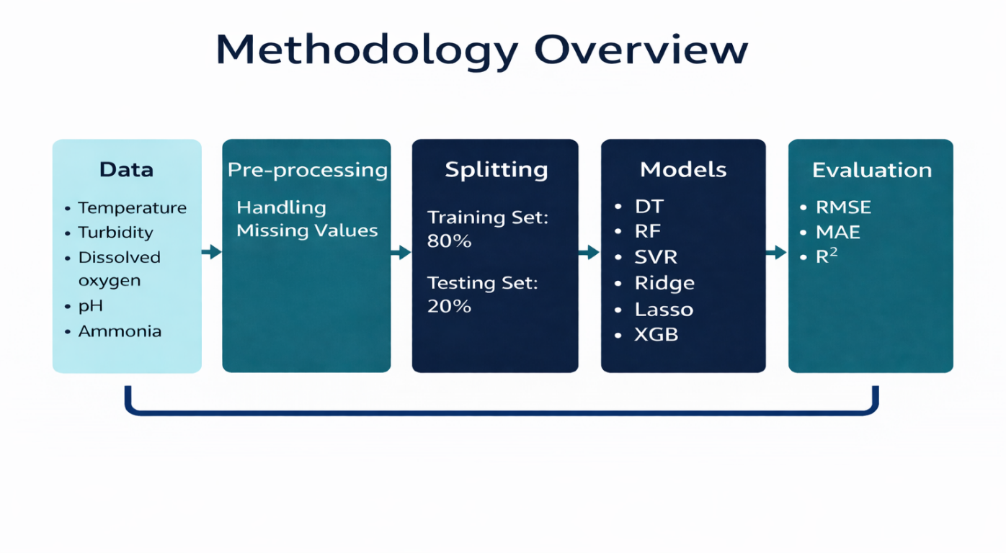

Figure 10 Methodology overview

4.1 Dataset Description

The dataset employed in this study is derived from an IoT-enabled fishpond monitoring system, referred to as the Fishpond IoT Dataset. The dataset consists of continuous measurements collected by Internet of Things sensors deployed within a smart aquaculture environment. These sensors are designed to monitor both physical and chemical characteristics of pond water, providing essential information for maintaining suitable conditions for fish growth. Also, this dataset was consists of approximately 8300 rows and 6 columns.

The input features used in the predictive models represent key environmental parameters that influence fish health and development. These parameters include:

Water Temperature (°C): A critical factor affecting fish metabolism, growth rate, and overall physiological activity.

Turbidity (NTU): Reflects water clarity and suspended particles, which can influence light penetration and aquatic conditions.

Dissolved Oxygen (DO): One of the most important indicators of water quality, directly affecting fish respiration and feeding behavior.

pH Level: Represents water acidity or alkalinity, influencing biochemical processes and fish metabolism.

Ammonia Concentration: Serves as an indicator of organic waste accumulation; elevated levels can be harmful or toxic to fish.

Nitrate Concentration: High nitrate levels may degrade water quality and negatively impact fish development.

The output variables targeted in this research correspond to two fundamental indicators of fish growth:

Fish Length (cm)

Fish Weight (g)

These growth-related variables are predicted using the above environmental parameters through supervised machine learning regression models to analyze and forecast fish growth trends in IoT-based aquaculture systems.

4.2 Data Preprocessing

Prior to model training, a series of data preprocessing procedures were applied to improve data reliability and ensure accurate predictive performance. The dataset was initially examined for missing or invalid values. Records containing incomplete information were carefully treated using appropriate strategies, such as statistical replacement based on relevant feature distributions or removal of unusable samples when necessary.

These preprocessing steps were essential to reduce noise, enhance data consistency, and minimize the potential impact of poor-quality data on model learning.

4.3 Dataset Splitting

To support model development and objective evaluation, the dataset was divided into two subsets:

Training Set: 80% of the available data used to train the regression models.

Testing Set: 20% of the data reserved for evaluating model performance on unseen samples.

The splitting process was performed using random sampling with a fixed random seed to ensure experiment reproducibility and consistent performance comparison across models.

4.4 Regression Models

Several supervised regression algorithms were implemented and evaluated to predict fish length and weight based on water quality parameters.

Decision Tree Regression

Decision Tree regression models partition the data into subsets using hierarchical decision rules.

Advantages:

Easy to interpret and visualize.

Capable of modeling nonlinear relationships.

Limitations:

Sensitive to noise and prone to overfitting.

Performance depends heavily on tree structure.

Random Forest Regression

Random Forest is an ensemble learning method that aggregates multiple decision trees to improve prediction stability.

Advantages:

Reduces overfitting through averaging.

Provides strong and reliable predictive performance.

Limitations:

Less interpretable than single-tree models.

Increased computational complexity with more trees.

Support Vector Regression (SVR)

SVR applies kernel-based techniques to model nonlinear relationships within a defined error margin.

Advantages:

Effective for nonlinear and high-dimensional data.

Robust to outliers when properly tuned.

Limitations:

Computationally expensive for large datasets.

Requires careful selection of kernel functions and parameters.

Lasso Regression

Lasso regression employs L1 regularization to penalize model complexity by shrinking coefficients.

Advantages:

Performs automatic feature selection.

Reduces overfitting in high-dimensional datasets.

Limitations:

Assumes linear relationships.

May discard relevant features under strong regularization.

Ridge Regression

Ridge regression applies L2 regularization to stabilize coefficient estimates.

Advantages:

Handles multicollinearity effectively.

Produces stable and consistent models.

Limitations:

Does not eliminate irrelevant features.

Limited in capturing nonlinear interactions.

XGBoost Regression

XGBoost is a gradient boosting algorithm that builds decision trees sequentially to minimize prediction errors.

Advantages:

High predictive accuracy and strong generalization.

Efficient and includes built-in regularization mechanisms.

Limitations:

Requires careful hyperparameter tuning.

Less transparent compared to simpler models.

Overall Comparison:
- Most interpretable model: Decision Tree
- Most stable and robust: Random Forest
- Best for nonlinear patterns: SVR and XGBoost
- Best for feature selection: Lasso Regression
- Best for handling correlated predictors: Ridge Regression
- Highest overall performance in many tasks: XGBoost

Chapter 5 Experimental Results and Discussion
5.1 Introduction
This chapter presents a comprehensive analysis of the experimental results obtained from applying multiple regression-based machine learning models to predict fish growth indicators, namely fish length and fish weight. The evaluation is conducted using environmental and water quality data collected from an IoT-enabled fishpond monitoring system.
The primary objective of these experiments is to assess the predictive accuracy, robustness, and generalization ability of the selected regression algorithms under consistent experimental conditions. To ensure a fair and unbiased comparison, all models were trained and tested using the same dataset partition, with 80% of the data allocated for training and 20% reserved for testing.
Model performance was quantitatively evaluated using three widely adopted statistical metrics: Mean Absolute Error (MAE), Root Mean Squared Error (RMSE), and the Coefficient of Determination (R²). These metrics provide complementary insights into prediction error magnitude, sensitivity to large deviations, and the proportion of variance explained by each model, respectively. The results reported in this chapter form the basis for comparing model effectiveness and identifying the most suitable approaches for predictive fishpond management.

5.2 Experimental Setup
The experimental implementation was carried out using the Python programming language within the Jupyter Notebook environment. Several well-established data science and machine learning libraries were employed to support data processing, model development, and result visualization, including pandas and NumPy for data manipulation, scikit-learn for machine learning algorithms and evaluation, XGBoost for gradient boosting models, and Matplotlib for graphical analysis.
Prior to model training, all input features were normalized to ensure consistent scaling across variables and to improve numerical stability during the learning process. This preprocessing step was essential to guarantee a fair comparison among models, particularly those sensitive to feature magnitude. Each regression model was trained under identical conditions, allowing the observed performance differences to be attributed to algorithmic characteristics rather than experimental bias.

5.3 Training Parameters :
- Train-test split: 80% – 20%
- Random state: 42 (for reproducibility)
- Scaler used: MinMaxScaler
- Evaluation metrics: MAE, RMSE, R²
- Models applied: Decision Tree, Random Forest, SVR, Lasso, Ridge, XGBoost

5.4 Results and Discussion: Predicting Fish Length
Performance Overview:
The regression models showed strong capabilities in predicting fish length based on IoT-collected environmental variables. Below is a performance summary:
Table 2 Performance Comparison of Regression Models for Fish Length Prediction
Model | RMSE | MAE | R² Score
Random Forest | 0. 246846 | 0. 0395 | 0.9978
XGBoost | 0. 264336 | 0. 0981 | 0.9975
Decision Tree | 0. 293968 | 0. 0341 | 0.9969
SVR | 0. 865990 | 0. 3901 | 0.9733
Lasso Regression | 1.9755 | 0. 9358 | 0.8594
Ridge Reression | 1.9814 | 0. 9353 | 0.8586

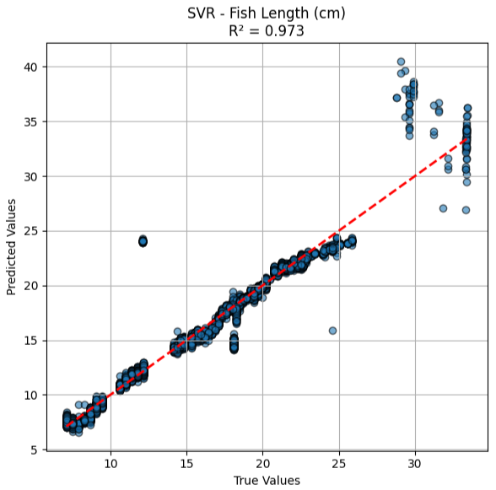
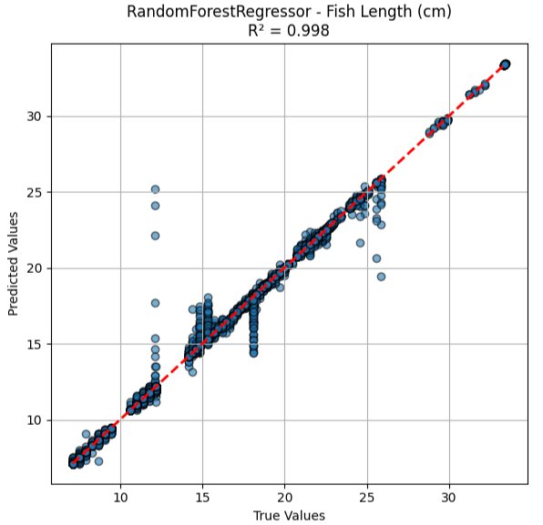

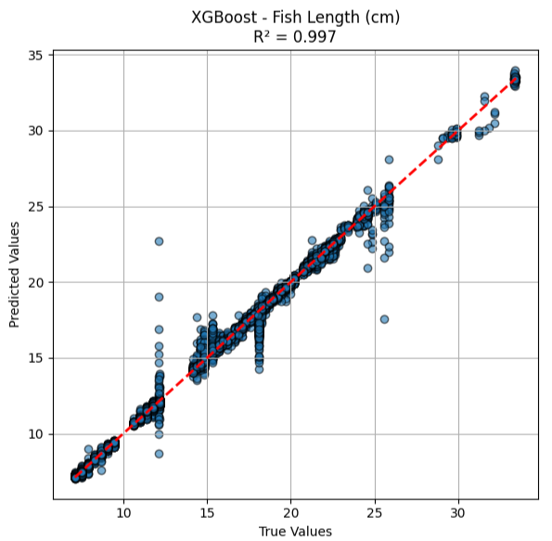
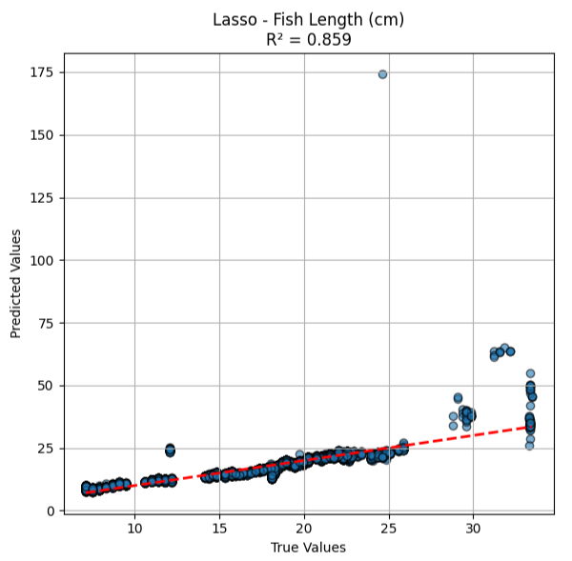
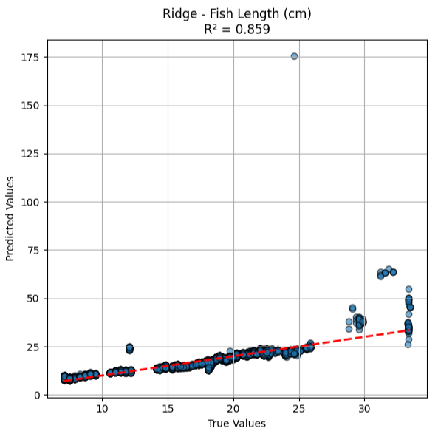
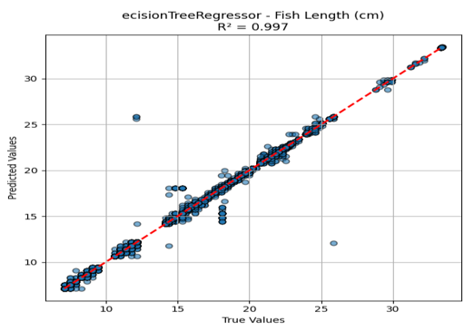
Figure 11 all algorithm Result Fish Length R²

5.5 Results and Discussion: Predicting Fish Weight

Table 3 Performance Comparison of Regression Models for Fish Weight Prediction
Model | RMSE | MAE | R² Score
Random Forest | 0.543190 | 0.120785 | 0.999741
XGBoost | 1.008085 | 0.352980 | 0.999108
Decision Tree | 0.713460 | 0.118012 | 0.999553
SVR | 11.797121 | 3.653084 | 0.877894
Lasso Regression | 11.158433 | 5.945610 | 0.890758
Ridge Regression | 11.156523 | 5.929279 | 0.890795

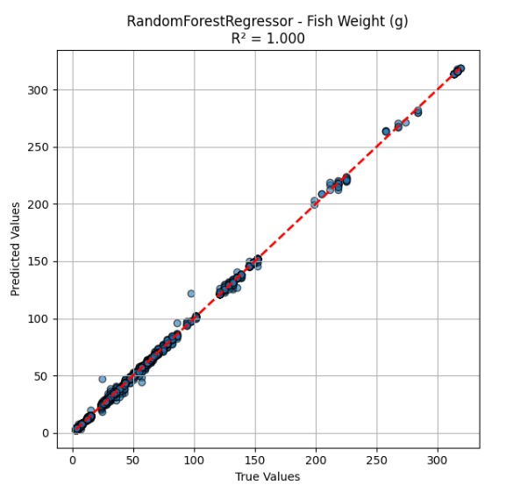
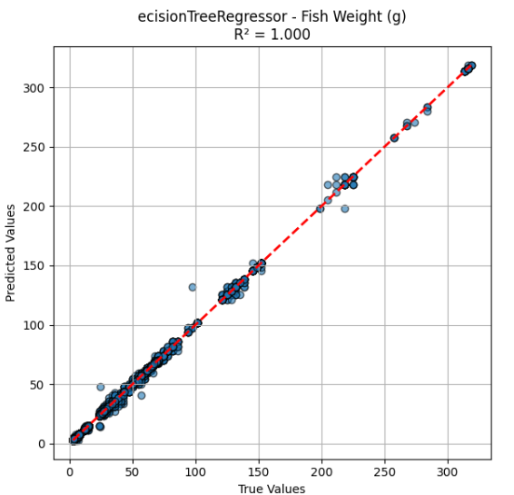
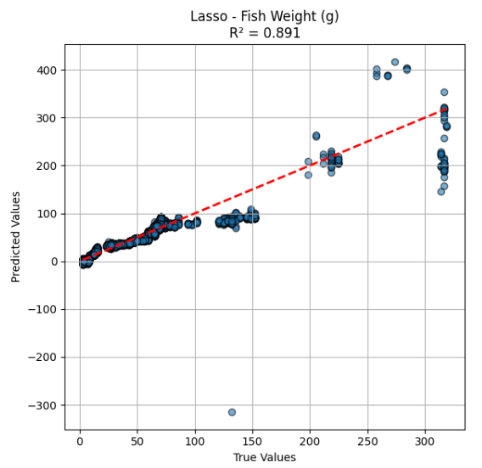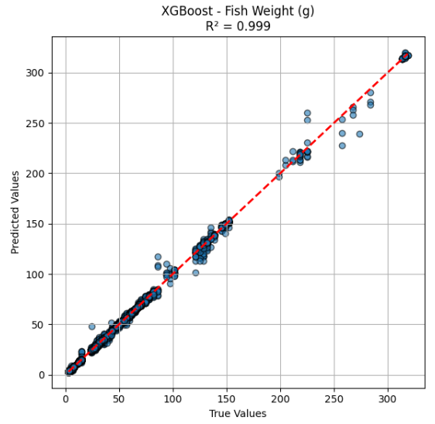
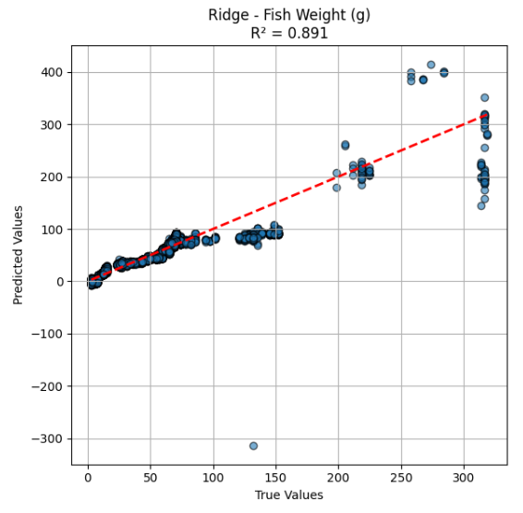
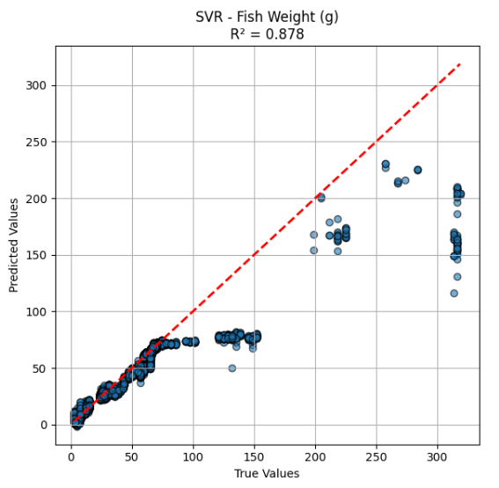
Figure 12 All algorithm Result Fish weight

5.6 Performance analysis and overview:
Furthermore, in the prediction of fish length, superior homogeneity and heterogeneous model-based approaches are discriminated to show up clear differences concerning predictive performance. Of these, the Random Forest model was consistently the most predictive and trustworthy. It is observed that very high R² values with lastly error metrics are estimates the interactions among environmental factors involved in the dataset nonlinearity. Much smaller variance and deviant prediction have been observed, which is mostly owing to the ensemble mechanism that a number of decision trees cooperatively facilitate the prediction under such circumstances, thus coving up the influence of noise existed in IoT sensor readings. The model’s predicted curve can be seen closely following the actual observations, demonstrating low sensitivity to noise in the data, and high generalization ability.
XGBoost performed very well also, it was behind the Random Forest model in terms of accuracy. Its boosting strategy, iteratively adjusting the residual errors of previous iterations, made it possible to capture the subtle dependencies among water-quality factors. Nevertheless, some of the relatively higher error values (especially for mean absolute errors) indicate that it may still be sensitive to outliers or abnormal readings. This is clear from looking at the spread of predictions around the optimum fit line which is less tight as opposed to those clustered by the Random Forest model.
The base model from Decision Tree had modestly good prediction strength and less stability compared to ensemble models. This instability stems from using only a single tree shape for the model that can create exaggerated impact of local tiny diversity in data. Decision Tree predictions are usually correct trend but come with sharp turns in between because of their discrete nature of splitting. These behaviors illustrate the poor capability of single-tree models, in presence of complicated biological relationships.
By contrast, the predictive ability of the Support Vector Regression model for fish length was very week. The high values of error indicate that it was difficult for the model to include the nonlinear and interaction patterns on environment present in data base. In general, SVR shows higher classification power in the case of smooth and well-separated spectra; however, biological variability along with environmental fluctuation caused a degradation of its performance in this study. Its forecast values obviously differ from direct measurements, indicating more spread and less correlation to the ideal regression line.
The low performance of linear models, namely Lasso and Ridge regression was captured by all models. Their dismal performance is an explicit consequence of the fact that such simple representations are fundamentally wrong since they impose linear-thinking tools on a process which is intrinsically non-linear, i.e. fish growth. As these model types cannot represent relations between water-quality parameters by means of interaction or multiplication, the models thus result in excessive errors and poor predictive power. The residual patterns observed in these models exhibit evident systematics, thus indicating that the underlying biological process cannot be fully characterized by linear functions of transferrin receptors.
In general, the length-at-age fits for fish illustrate that selecting among a suite of models capable of representing complex ecological dynamics is imperative. The ensemble models, in particular Random Forest one can better cope with this since they are more flexible, strong adapted and good at capturing patterns and variations across decision boundaries. Such results emphasize the importance to apply sophisticated nonlinear algorithms when facing multi-dimensional aquaculture datasets.
Regarding He.D's fish weight prediction, the models exhibited even more clear- cut differences between them, mainly because of the greater biological variability and complexity associated with this attribute as opposed to length. As before, the Random Forest model reported the best performance, with just a slightly off fit of prediction versus actual. This very high level of precision indicates that the model was properly translating temperature, DO, pH and other environmental parameters that affect biomass accumulation rate. Indeed, the model's predictions were quite close to the benchmark line, indicating it had done a fantastic job in terms of an overall range of observed values.
While XGBoost showed high performance and good accuracy, a comparison of its and Random Forest results became clearly distinct when we made predictions regarding weight. The higher meaning absolute error suggests that XGBoost was more sensitive to perturbations in the data, which are likely due to rapid internal and external conditions occurring within growth. Nevertheless, the model presented has good predictive capabilities and remains an excellent candidate for taking complex aquaculture causes into account.
The predictions of the Decision T ree model were fairly accurate, but there were some graphical disparities since the ensemble averaging was not employed. Although the rough trend of weight distribution was captured by the model, predictions made were still relatively close to actual values and some deviation could be observed which pointed out that our model was sensitive to local changes in data as well. This result is not so surprising because single trees are not designed to eliminate fluctuations or handle the discontinuous nature of interactions at different spatial scales in the fish biomass.
The Support Vector Regression approach, which yielded little success for predicting fish length, was less successful in estimating fish weight. Results showed large error values, indicating that the model could not capture the broader biological variability observed in weight data. Thus, it becomes difficult for SVR to represent the broad changes and non-linear growth characteristics, leading to severe fluctuation between its prediction and observed values. This discrepancy highlights that margin-based approaches have difficulties in handling complex aquatic growth systems.
Lasso and Ridge regression again performed poorly, further supporting their limited capacity for predicting biological growth variables in an aquaculture setting. Figure 1B and D The protein to water ratios Each of these models are linear, so they do not represent complex processes by which water quality interacts with physiological responses that ultimately regulate weight. Therefore, they made a lot of under fitted predictions leading to high errors and low explanative power.
Overall, results for fish length and weight, both suggest that ensemble learning techniques should be preferred with respect to other attempts in modeling aquaculture-related responses. This is even more advantageous for outcome variables that have a high amount of variability, like weight. Model-wise, Random Forest was generally the best performing model by providing higher accuracy, more resistant to noise and balanced interpretation of complex feature relationships. These results underline the necessity of using sophisticated machine learning models that may handle environmental uncertainty and biological complexity in IoT-based aquaculture systems.

5.7 Comparative Analysis

Table: Performance Comparison of Models for Predicting Fish Length and Fish Weight

Table 4 Table Comparative Performance of Regression Models for Fish Length and Weight Prediction
Model | R² (Length) | RMSE (Length) | MAE (Length) | R² (Weight) | RMSE (Weight) | MAE (Weight)
Random Forest | 0.9978 | 0.2468 | 0.0395 | 0.9997 | 0.5431 | 0.1208
XGBoost | 0.9975 | 0.2643 | 0.0981 | 0.9991 | 1.0081 | 0.3529
Decision Tree | 0.9969 | 0.2939 | 0.0341 | 0.9995 | 0.7135 | 0.1180
SVR | 0.9733 | 0.8659 | 0.3901 | 0.8779 | 11.7971 | 3.6530
Lasso Regression | 0.8594 | 1.9755 | 0.9358 | 0.8907 | 11.1584 | 5.9400
Ridge Regression | 0.8586 | 1.9814 | 0.9353 | 0.8908 | 11.1565 | 5.9200

Notes :
- The ensemble models (Random Forest and XGBoost) clearly outperform all others in both tasks.
- Tree-based models handle nonlinear relationships better than linear models.
- The linear models (Lasso and Ridge) consistently show the weakest performance.
- SVR works moderately for length but fails badly for weight due to high variability in biological data.

Chapter 6 Conclusion and Future Work
6.1 Conclusion
This thesis has presented a comprehensive study on integrating Internet of Things (IoT) technologies with machine learning techniques to enhance monitoring, prediction, and decision support in aquaponics-based fishpond systems. The research began with the design and deployment of an IoT monitoring infrastructure centered on an ESP-32 microcontroller and a set of sensors capable of measuring key water quality parameters, including temperature, pH, dissolved oxygen, turbidity, ammonia, and nitrate. Continuous data acquisition and cloud-based storage enabled real-time observation of pond conditions and the creation of a high-resolution dataset suitable for advanced analytical tasks.
One of the key outcomes of this work is the availability of a structured and reliable IoT-based dataset, which addresses a long-standing limitation in aquaculture research related to the scarcity of continuous and high-quality time-series data. The dataset provides a valuable foundation for predictive modeling and operational analysis, allowing both researchers and practitioners to gain deeper insights into pond dynamics and management practices.
Building upon this data foundation, the study implemented a systematic machine learning workflow to predict fish growth indicators, specifically fish length and fish weight, using environmental variables. Multiple regression models were trained, evaluated, and compared using standard performance metrics. The experimental results demonstrated that ensemble learning approaches, particularly Random Forest and XGBoost, consistently achieved superior predictive accuracy and generalization performance. This advantage is attributed to their ability to model nonlinear relationships and interactions among water quality parameters commonly observed in aquaculture environments.
The findings of this research reinforce the growing body of literature that highlights the effectiveness of IoT-enabled predictive analytics in aquaculture. By moving beyond real-time monitoring toward data-driven forecasting, this study contributes to the development of proactive aquaculture management strategies that can improve fish health, reduce operational risks, and enhance production efficiency. At the same time, the results indicate that further advancements are required to fully realize the potential of intelligent aquaculture systems, particularly in terms of scalability, interpretability, and system integration.

6.2 Important Features
An important aspect of this study was the identification of influential environmental variables affecting water quality dynamics and fish growth prediction. Feature relevance was analyzed using model-based importance measures derived from Random Forest and XGBoost, in addition to correlation-based assessments. The analysis revealed that several parameters consistently played a dominant role across different predictive models.
Temperature emerged as the most influential feature due to its direct effect on fish metabolism, dissolved oxygen availability, microbial processes, and ammonia transformation. Its temporal variability made it a critical driver of water quality changes.
pH was identified as a key parameter influencing water stability and ammonia toxicity. Even small deviations in pH values can significantly affect fish health, which explains its high importance across multiple regression frameworks.
Dissolved Oxygen (DO) was among the most critical yet challenging variables to predict. DO levels are affected by temperature, biological activity, and aeration practices, and ensemble models demonstrated superior capability in capturing these interactions.
Turbidity provided valuable information regarding suspended solids and biological oxygen demand, indirectly influencing nutrient cycles and water clarity.
Ammonia was strongly associated with feeding practices and organic waste accumulation. Its importance increased when evaluated jointly with pH, reflecting its role in forming toxic unionized ammonia under unfavorable conditions.
Nitrate acted as a relatively stable indicator of nutrient accumulation and filtration efficiency, particularly within aquaponic systems where plant uptake plays a central role.
Overall, the analysis confirmed that temperature, pH, dissolved oxygen, and ammonia are the dominant variables governing water quality variations. These insights are essential for optimizing sensor deployment, model design, and real-time decision support mechanisms in smart aquaculture systems.

6.3 Future Work
While this research provides meaningful technical and scientific contributions, several directions remain open for future investigation:
- Expansion of Dataset Scale and Diversity:
Future studies should incorporate data from multiple farms, species, and seasonal conditions to enhance model robustness and generalization capability.
- Integration of Additional Sensing Modalities:
Incorporating underwater vision systems, acoustic sensors, flow and aeration sensors, and biosensors for pathogen detection would enable more comprehensive monitoring of aquaculture environments.
- Adoption of Advanced Deep Learning Models:
Temporal models such as LSTM, GRU, and Transformer-based architectures could improve long-term forecasting accuracy, especially when combined with hybrid or physics-informed approaches.
- Transition Toward Autonomous Control:
Future systems may extend beyond prediction to automated control actions, such as adaptive aeration, optimized feeding schedules, and predictive water exchange strategies.
- Explainable Artificial Intelligence (XAI):
The use of explainability tools such as SHAP and LIME can enhance user trust by providing transparency into model decisions, which is essential for real-world adoption.
- Economic and Operational Optimization:
Integrating environmental predictions with economic models, including feed costs, energy consumption, and market prices, would enable comprehensive decision-support systems.
- Edge–Cloud Hybrid Architectures:
Deploying edge computing capabilities on microcontrollers such as ESP-32 can reduce latency for critical decisions while leveraging cloud resources for large-scale analysis.
- Unified Smart Aquaculture Platforms:
The long-term vision is the development of an integrated ecosystem that combines IoT sensing, AI-based prediction, image analysis, cloud dashboards, and automated actuators into a single intelligent aquaculture platform.

References
- Sundararajan, S. C. M., Shankar, Y. B., Selvam, S. P., Manogaran, N., Seerangan, K., Natesan, D., & Selvarajan, S. (2025). IoT-based prediction model for aquaponic fish pond water quality using multiscale feature fusion with convolutional autoencoder and GRU networks. Scientific Reports, 15(1), 1925. https://doi.org/10.1038/s41598-024-84943-7. Dataset available at Kaggle: Small Aquaculture Fish Pond (2023) [1]
- Hridoy, M. A. A. M. et al. (2025). Predictive modelling of aquaculture water quality using IOT and advanced machine-learning algorithms. Results in Chemistry 16, 102456. https://www.sciencedirect.com/science/article/pii/S2211715625004394
- Baena-Navarro, R., Carriazo-Regino, Y., Torres-Hoyos, F., & Pinedo-López, J. (2025). Intelligent Prediction and Continuous Monitoring of Water Quality in Aquaculture: Integration of Machine Learning and Internet of Things for Sustainable Management. https://www.mdpi.com/2073-4441/17/1/82
- Eze, E., Kirby, S., Attridge, J., & Ajmal, T. (2023). Aquaculture 4.0: hybrid neural network multivariate water quality parameters forecasting model. Scientific Reports 13, Article 16129. DOI https://www.nature.com/articles/s41598-023-41602-7
- Yu, X. et al. (2025). Research on a Pearson-LSTM-AM-based water quality prediction model for freshwater aquaculture. Journal of the World Aquaculture Society https://onlinelibrary.wiley.com/doi/10.1111/jwas.70041?af=R
- Xu, L. et al. (2025). Hybrid deep learning framework for real-time DO prediction in aquaculture. Scientific Reports 15, Article 24643. DOI: https://www.nature.com/articles/s41598-025-10786-5
- Li, T., Lu, J., Wu, J., Zhang, Z., & Chen, L. (2022). Predicting Aquaculture Water Quality Using Machine Learning Approaches. Water 14(18): 2836. DOI: https://www.mdpi.com/2073-4441/14/18/2836
- Iniyan Arasu, M., Subha Rani, S., Thiyagarajan, K., & Appathurai, A. (2024). AQUASENSE: aquaculture water quality monitoring framework using autonomous sensors. Aquaculture International 32(7): 9119–9135. DOI: https://link.springer.com/article/10.1007/s10499-024-01606-0
- Hemal M. M. et al. (2024). An Integrated Smart Pond Water Quality Monitoring and Fish Farming Recommendation Aquabot System. Sensors. https://doi.org/10.3390/s24113682
- Patro K. S. K. et al. (2023). IoT and ML approach for ornamental fish behavior analysis. Scientific Reports. https://www.nature.com/articles/s41598-023-48057-w
- Arepalli, P. G., & Naik, K. J. (2024). A Lot-Based VMD-CNN-BiGRU indoor mariculture water quality prediction model with attention mechanism. (Research study reported in 2024; appeared in conference/journal literature via World Scientific, https://www.worldscientific.com/doi/10.1142/S0129156425400105?srsltid=AfmBOoo3gRuGsR06XmS7MT-LxbA7dnS80dum1Bsf_A4rYn0OU45yWWGV
- Kunapinun, A., Fairman, W., Wills, P., & Ouyang, B. (2025). Integrating Bi-LSTM and physics constraint models for improved biomass and water quality prediction in aquaculture systems. In Proc. SPIE 13460: Machine Learning from Challenging Data https://www.spiedigitallibrary.org/conference-proceedings-of-spie/13460/1346008/Integrating-Bi-LSTM-and-physics-constraint-models-for-improved-biomass/10.1117/12.3053764.short
- Ren, Q., Wang, X., Li, W., et al. (2020). Research of dissolved oxygen prediction in recirculating aquaculture systems based on deep belief network. Aquacultural Engineering 90: 102085. DOI: https://www.sciencedirect.com/science/article/abs/pii/S0144860919301669
- Liu, W., Wang, J., Li, Z., & Lu, Q. (2025). A Hybrid Improved Dual-Channel and Dual-Attention Mechanism Model for Water Quality Prediction in Nearshore Aquaculture. Electronics https://www.mdpi.com/2079-9292/14/2/331
- Jamshidzadeh, Z., Ehteram, M., & Shabanian, H. (2024). A new hybrid model for predicting water quality parameters. Ain Shams Engineering Journal, 15(3), 102510. https://doi.org/10.1016/j.asej.2023.102510
- Li, C., Li, Z., Wu, J., Zhu, L., & Yue, J. (2018). A hybrid model for dissolved oxygen prediction in aquaculture based on multi-scale features. Information Processing in Agriculture5 https://www.sciencedirect.com/science/article/pii/S2214317316301184
- https://www.ibm.com/think/topics/decision-trees#:~:text=A%20decision%20tree%20is%20a,split%20points%20within%20a%20tree.
- https://www.ibm.com/think/topics/random-forest?mhsrc=ibmsearch_a&mhq=random%20forest
- Support Vector Machine (SVM) Algorithm - GeeksforGeeks - Search
- https://www.geeksforgeeks.org/machine-learning/what-is-lasso-regression
- https://www.geeksforgeeks.org/machine-learning/what-is-ridge-regression
- https://www.geeksforgeeks.org/machine-learning/xgboost

https://www.researchgate.net/publication/382255038_Integrating_Aquaculture_And_Hydroponics_A_Review_Of_Aquaponics_Systems_And_Their_Sustainability

www.kaggle.com/dataset/e81da8b7666dc7af41cdc3aa5ef96c5547e4f412598a030f40d444550965e34f

https://data.mendeley.com/datasets/dgdr2kfbyt/1
- https://pmc.ncbi.nlm.nih.gov.
- https://www.kaggle.com/datasets/e81da8b7666dc7af41cdc3aa5ef96c5547e4f412598a030f40d444550965e34f?select=IoTpond1.csv (Dataset)

