

An AI-Driven Framework for Gathering and Documenting Business Requirements

Prepared By
Name: [Sahab Alhumaed] IDNo:[25100261]

Submitted in fulfillment of the requirements for the degree Master of Science in Artificial Intelligence
At
College of Informatics
Midocean University
UAE
Supervisor Name: Dr. Khaled Eskaf
College of Informatics, Midocean University, Comoros
[2025-Semester Three]

Acknowledgements

I am grateful to my supervisor Dr. Khaled Eskaf for his guidance, support, and ongoing encouragement in my preparation of this thesis. His valuable feedback and insightful comments greatly enriched and enhanced this work.

I would also like to express my gratitude to all who have helped me, whether directly or indirectly, in the completion of this thesis, in terms of continued support and assistance.

Last but not least, I must say how grateful I am to my family for their constant encouragement, patience, and unwavering support throughout my studies. My thesis has been shaped, due in large part, by the confidence they have in me.

Abstract
Software requirements are central to software development success, but getting them clear and classifying them accurately is still a major challenge. In this thesis, we propose an AI-based framework to automatically classify Functional Requirements (FRs) and Non-Functional Requirements (NFRs) and to detect ambiguity within requirement statements through machine learning and natural language processing techniques.
The framework is trained and evaluated using the PROMISE_exp dataset of 969 labeled requirements. Several machine learning models were also performed to determine the most suitable algorithms, such as Support Vector Machines (SVM), Logistic Regression, Naïve Bayes, and Random Forest where SVM performed the best, achieving 90% accuracy on binary FR/NFR classification with a macro-F1 score of 0.74 for eleven NFR subcategories. It also includes a rule-based ambiguity detection module that is able to recognize vague adjectives, passive voice constructions, weak modal verbs and other linguistic patterns that lessen the clarity of requirements.
The findings show that automatic ambiguity detection can greatly improve early stage software development with higher requirement accuracy and lower level of misunderstanding.
The framework also generates Business Requirements Documents (BRDs) automatically in order to facilitate real-world use, so that stakeholders will have a clear and interpretable summary of requirements classifications and quality assessments. Combined, these elements create the proposed AI-based framework, a complete AI pipeline to map requirement categorization, ambiguity detection, and automated BRD generation. Possible future work, among others, may be to expand the data, tune the ambiguity detection rule set, and investigate deep-learning methods to improve classification accuracy.

Table of Contents
1
An AI-Driven Framework for Gathering and Documenting Business Requirements 1
Acknowledgements 2
Abstract 3
List of Abbreviations 6
List of Figures 6
List of Tables 6
Chapter 1 Introduction 7
1.1 Problem Definition 7
1.2 Thesis Objectives 7
1.3 Thesis Contribution 8
1.4 Thesis Organization 9
Chapter 2 Literature Review 10
2.1 Introduction of Automated Requirements Analysis 10
2.2 Functional and Non-Functional Requirements 10
2.3 Natural Language Processing for Requirements Engineering 11
2.4 Classical Machine Learning Techniques for Requirement Classification 11
2.5 Deep Learning Approaches in Requirement Engineering 12
2.6 Quantitative Results Summary 12
2.7 Research Gaps and Opportunities 13
2.8 Conclusion 13
Chapter 3 Related Work 14
3.1 Introduction 14
3.2 Functional vs. Non-Functional Requirement Classifications 14
3.3 Multi-Class Classification of Non-Functional Requirements 15
3.4 Ambiguity Detection in Software Requirements 16
3.5 Datasets and Difficulties for Evaluation in Previous Work 16
3.6 Comparative Analysis and Identification of Limitations 17
3.7 Summary and Justification of the Proposed Framework 17
Chapter 4 Proposed Approach 18
4.1 Data Collection and Description 18
4.2 Data Preprocessing 19
4.3 Feature Engineering 19
4.4 Feature Selection 19
4.5 Model Selection and Optimization 20
4.6 Ambiguity Detection 20
4.7 BRD Generation 21
4.8 Summary 21
Chapter 5 Experimental Results and Discussion 22
5.1 Experimental Setup 22
5.2 Baseline Model Performance 23
5.3 Evaluation of Multi-Class Performance 24
5.4 Feature Importance Analysis 26
5.5 Results of the Ambiguity Detection 29
5.6 Comparison to Related Research 29
5.7 Discussion 30
5.8 Summary 31
Chapter 6 Conclusion and Future Work 32
6.1 Conclusion 32
This description of the proposed framework, an AI-based approach for automatic software requirements classification and quality evaluation, forms the basis of this thesis. By combining machine learning models with rule-based linguistic structural analysis, the system addresses three main challenges in requirements engineering: distinguishing between Functional and Non-Functional Requirements (FRs vs. NFRs), classifying Non-Functional Requirements into eleven commonly recognized categories, and identifying ambiguity in natural language requirement statements. 32
6.2 Future Work 33
References 34

List of Abbreviations
- AI: Artificial Intelligence
- BoW: Bag of Words
- BRD: Business Requirements Document
- CNN: Convolutional Neural Network
- F1-score: Harmonic Mean of Precision and Recall
- FR: Functional Requirement
- LR: Logistic Regression
- LSTM: Long Short-Term Memory
- ML: Machine Learning
- NB: Naïve Bayes
- NFR: Non-Functional Requirement
- NLP: Natural Language Processing
- PROMISE_exp: PROMISE Expanded Requirements Dataset
- RF: Random Forest
- RNN: Recurrent Neural Network
- SMOTE: Synthetic Minority Over-sampling Technique
- SVM: Support Vector Machine
- TF-IDF: Term Frequency–Inverse Document Frequency

List of Figures
Figure1. 1Thesis organization and logical flow of chapters in the proposed research 9
Figure 2Overview of the proposed methodology illustrating the end-to-end workflow from requirement input to automated BRD generation. 18
Figure 3Binary classification performance comparison of baseline models. 23
Figure 4Confusion matrix for binary FR/NFR classification 24
Figure 5Macro-F1 score comparison of multi-class classifiers 25
Figure 6Distribution of predicted NFR categories (confusion matrix) 26
Figure 7 Top 20 influential features for binary FR/NFR classification. 27
Figure 8Influential terms for each NFR category. 28
Figure 9Comparison of the proposed framework performance with related studies. 29

List of Tables

Table 2.1 Quantitative Performance Summary of Related Studies 13
Table 2 Summary of Related Work 31

Chapter 1 Introduction

1.1 Problem Definition
Software requirements describe what a system should do and the characteristics it should possess. Analysts traditionally manually categorized these requirements into Functional Requirements (FRs) and Non-Functional Requirements (NFRs) by hand a lengthy process prone to personal bias and susceptible to ambiguity.
While NFRs (including performance, security, usability, and reliability) are paramount to building a high-quality system, they are often poorly identified or poorly defined.
The situation is compounded by the ambiguity in natural-language requirements. A number of requirements use ambiguous adjectives or sentences like “fast” or “user-friendly,” use weak modal verbs “should” and “may” or lack measurable criteria.
This type of ambiguity is the source of a lot of confusion in teams, cause additional cost, rework, and project delay. For these reasons, an automated method of accurately classifying requirements and identifying ambiguity in the software development life cycle is needed.

1.2 Thesis Objectives
This thesis aims to design and implement an AI-driven framework for gathering and documenting business requirements. The primary objectives are:
- Train a binary classification model to distinguish between Functional Requirements and Non-Functional Requirements.
- Train a multi-class classifier that can categorize NFRs into one of eleven categories, such as security, performance, usability, availability, and operability.
- Identify ambiguity in requirement statements by using rule-based linguistic analysis to spot vague, incomplete, or unclear expressions.
- Create structured Business Requirements Documents (BRDs) to combine classification results, findings on ambiguity, and suggestions for improvement.
- Evaluate the classification models' performance based on standard metrics (accuracy, precision, recall, F1-score) and compare them to results from existing literature.

1.3 Thesis Contribution
This work provides the following key contributions:
- Integrated Analysis Pipeline: It presents AI-driven requirements gathering, a system that automates requirement classification, ambiguity detection, and documentation generation within a single workflow.
- High-Performance Classification Models: The research creates machine learning models, especially SVM classifiers, that work well. For example, they have 90.7% accuracy in FR/NFR classification and a macro-F1 score of 74% across eleven NFR categories.
- Quality and Ambiguity Assessment: A linguistic module based on rules can find seven main types of ambiguity. This lets the system sort requirements and check how clear and complete they are.
- Stakeholder-Oriented BRD Generation: The framework makes Business Requirements Documents (BRDs) on its own. These documents list the types of requirements, point out any unclear points, and make suggestions. This helps people talk to each other on project teams.
- Scalability and Extensibility: The methodology is built to be improved in the future, such as by adding transformer-based models, expanding NFR categories, and taking user feedback into account.
- Academic and Practical Value: The thesis links old ways of doing requirements engineering with new ways of using AI. It gives researchers a way to repeat their work and software development teams a useful tool to help them make decisions.

1.4 Thesis Organization

Figure1. 1Thesis organization and logical flow of chapters in the proposed research
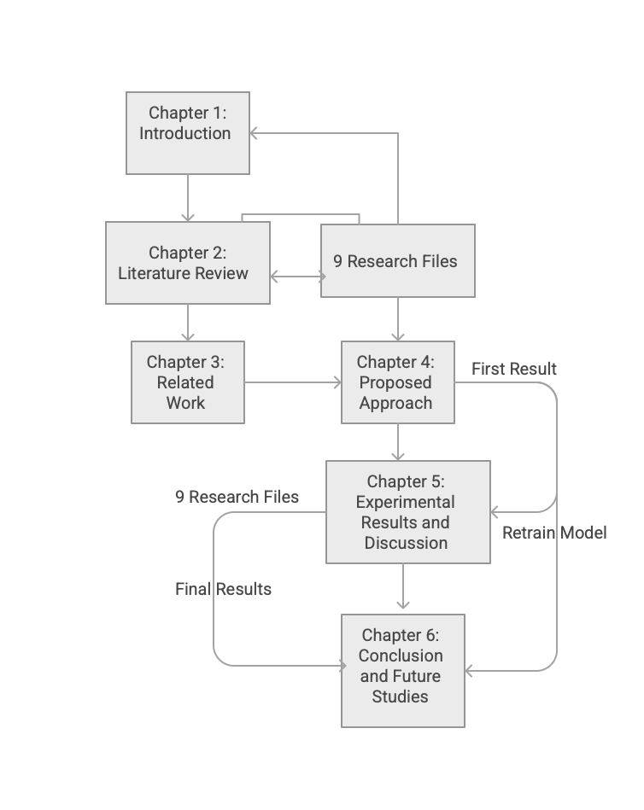

Chapter 2 Literature Review

2.1 Introduction of Automated Requirements Analysis

Software requirements engineering is one of the important aspects for software and is absolutely critical in software development projects. Requirements give us information regarding what a system needs to be able to do as well as the quality attributes it needs to fulfill.
Requirements are written for the benefit of all stakeholders often in natural language, but as we all know, the wording cannot always be the same depending on the source and also need be interpreted differently. In the past few decades, as software systems have grown more intricate and numerous, the manual definition and categorization of requirements are time-consuming and prone to errors.
Automatic requirement analysis is therefore an important area of research focused on assisting the goals toward more efficient, consistent and higher quality requirements engineering.
ML-related automatic systems using NLP can automatically classify the requirements, find the quality issues and be used to catch the defects early during the development process.These approaches reduce human bias while improving scalability and standardization across projects.
In this chapter we will elaborate on a discussion of the conceptual foundations and technical toolkits for automated requirements analysis of the proposed AI-based framework.

2.2 Functional and Non-Functional Requirements

There are two general types of software requirements: Functional Requirements (FRs) and Non-Functional Requirements (NFRs). FRs define the functionality of the system, also what kind of services, interactions, or actions that must occur (data processing or user actions).
The quality attributes of NFRs govern how the system works such as performance, security, usability, availability, and reliability.
FRs are generally explicit and action-oriented while NFRs are typically implicit and abstract, and they can be expressed qualitatively. In this way, we see NFRs are harder to identify and classify, especially when they are included in functional statements. Inaccurate NFR detection will cause problems for us.
Therefore we end up with systems that remain fully functional but perform poorly in practical applications.

2.3 Natural Language Processing for Requirements Engineering

The technical base of the analysis of the textual requirements comes from NLP and these data are passed into natural language processing. Unstructured requirement statements are used for these analyses; NLP structures are a framework to turn them into formats that are suitable for machine learning language algorithms.
Typical NLP methods for preprocessing NLP steps include tokenization, lowercasing, stop-word removal, punctuation removal, and normalization of textual variations. Feature representation approaches, such as Bag of Words (BoW), Term Frequency–Inverse Document Frequency (TF-IDF), and n-grams, are commonly used in requirement engineering applications.
We adopt word and short phrase importance schemes within requirement statements and can learn by number linguistic structures of the requirement type. NLP methods also facilitate ambiguity perception through linguistic patterns including vague adjectives, weak modal verbs, ambiguous pronouns and passive voice constructions, which often lead to unclear requirements.

2.4 Classical Machine Learning Techniques for Requirement Classification

Classical machine learning algorithms have historically been used to solve requirement classification problems and are generally regarded as being well-suited for small to medium-sized datasets. SVMs are preferred because of their capacity to support high-dimensional and sparse feature spaces generated by text vectorization methods such as TF-IDF.
Another regularly used linear classifier, Logistic Regression, is easily interpretable and can be trained in an effective manner but is likely to encounter difficulties with complex linguistic features.
Naïve Bayes classifiers are an efficient and implementable system; however, they frequently fall short of their potential in natural language text since they assume feature independence, and performance in terms of accuracy may suffer. Random Forest models enable ensemble-based learning and feature importance, but may be less efficient on data which is sparse.
These traditional models still offer powerful baselines and practical applications in automatic requirement categorization, especially when datasets are limited in size.

2.5 Deep Learning Approaches in Requirement Engineering

Deep Learning techniques have recently been studied to enhance requirement classification performance. Convolutional Neural Networks (CNNs) have been employed to learn the local linguistic structure. Likewise, Recurrent Neural Networks (RNNs) and Long Short-Term Memory (LSTM) classifiers can infer sequential dependencies of requirement statements.
Models based on transformers like BERT incorporate contextual embeddings and self-attention, which promotes a deeper understanding of the semantic layers. However, such models normally need large annotated datasets and computational resources.
Datasets from requirement engineering are often small and imbalanced,a serious problem in practical applications, therefore limiting the usefulness of deep learning-based approaches. Therefore, although deep learning holds promising potential, classical machine learning models are still more feasible as techniques for many real-world requirement analysis tasks.

2.6 Quantitative Results Summary

Several studies have reported quantitative results for automated requirement classification using machine learning techniques. Support Vector Machines combined with TF-IDF features consistently demonstrate strong performance for FR/NFR classification. However, multi-class NFR classification remains challenging due to class imbalance and semantic overlap among categories.
Table 2.1 summarises representative quantitative results reported in prior research and provides context for the performance achieved by the proposed framework.

Table 2.1 Quantitative Performance Summary of Related Studies
Study | Dataset | Features | Algorithm | Accuracy | F1-score
Rahman et al. (2023) | PROMISE_exp | TF-IDF | Linear SVM | – | 81.5%
Binkhonain (2023) | PROMISE_exp | BoW | Naïve Bayes | 63.0% | –
Muhamad et al. (2022) | PURE | BoW + SMOTE | SVM | 78.7% | 78.9%
Kurtanović & Maalej (2017) | RE17 | Lexical features | SVM | – | ~92%
Proposed Framework (This Thesis) | PROMISE_exp | TF-IDF (bi-grams) + SMOTE | SVM | 90.7% | 74% (macro)

2.7 Research Gaps and Opportunities

Despite the good results achieved in the studies before it, there were still some gaps in automated requirement engineering. Many previous efforts target standalone tasks like FR/NFR classification or NFR category prediction with no integrated pipelines.
As we continue to struggle with dataset size and imbalance, model generalization is limited, while overlapping NFR semantics introduce classification ambiguity.
In addition, automatic recognition of linguistic ambiguity and structured documentation creation like Business Requirements Documents (BRDs) are rarely addressed.
These gaps indicate the demand for end-to-end AI-powered frameworks that combine classification, quality assessment, and documentation assistance.

2.8 Conclusion

The idea of automated requirement analysis had a deep conceptual and technical approach with requirement types, NLP techniques, machine learning models, and existing challenges covered in this chapter.

Although previous work has proved that machine learning-based approaches (such as SVM-based techniques) performed effectively, issues still exist concerning integration, ambiguity handling, and documentation generation.
These gaps call upon the proposed AI-based framework to overcome them as an integrated AI-driven pipeline. The following chapter reviews related work in detail and then compares existing approaches with the proposed solution.

Chapter 3 Related Work

3.1 Introduction

The research literature on automated software requirement analysis has expanded greatly over the past few years due to the development of more sophisticated software systems and the need to integrate these requirements based on natural language requirements.
Traditional requirements engineering requires a lot of manual input from domain experts, and this has been found to be tedious, subjective and inconsistent, especially for large-scale projects. Accordingly, in recent years scientists have turned more attention to Machine Learning (ML) and natural language processing (NLP) approaches to automate requirement classification and quality assurance processes.
This chapter reviews the relevant empirical works that deal with
- Functional Requirements and Non-Functional Requirements separation (FRs and NFRs).
- Differentiating from Functional Requirements and Non-Functional Requirements (NFRs) in the scope of multi-class classification of the model.
- Recognizing ambiguity of the requirement statements.
In contrast to Chapter 2, which provided theoretical rationale and methodology, this chapter describes how existing research solved problems, explored the issue, and compared the solutions, as well as the advantages and disadvantages of earlier solutions. These studies inform the design choices taken in the proposed AI-based framework.

3.2 Functional vs. Non-Functional Requirement Classifications

One of the first and most prominent problems of automated requirements engineering is the concept of both FR vs. NFR classification of requirements.
Kurta Nović and Maalej (2017) was one of the first to focus on this issue, and it is shown that supervised machine learning models like Support Vector Machines (SVMs) can produce great accuracy and recall when trained on lexical features obtained from requirements text.

Their findings indicated that SVMs could provide a rich linguistic patterning even when only a small amount of data was available. These observations have bolstered these results in more recent studies.
Rahman et al. (2023) assessed 15 machine learning algorithms with the Promise dataset and found that linear SVM combined with TF-IDF features had an F1-score of 81.5% for FR/NFR classification. Their work highlighted the need to represent the variables correctly and demonstrated that simpler linear models often perform better than more complex classifiers with smaller datasets.
Pynchonian (2023) examined probabilistic classifiers especially Naïve Bayes and observed relatively inferior accuracy (63%) with the same dataset. This project demonstrated a frequently seen weakness of Naïve Bayes classifiers, namely their strong assumption of feature independence which is seldom met in natural language.

These studies collectively suggest that SVM-based methods are better than the rest in FR/NFR classification tasks.

3.3 Multi-Class Classification of Non-Functional Requirements

A broader classification process can be achieved by multi-class classification of non-functional requirements. Apart from binary classification, a number of studies have explored the more difficult task of separating them into specific quality attributes e.g., security, usability, performance, and reliability.
Muhamad et al. (2022) solved this issue on PURE dataset and found SMOTE balancing techniques are significantly improving classification performance. The model, based on SVM, had an accuracy of 78.7%, and an F1-score of 78.9%, demonstrating that class imbalance must be addressed in order to obtain acceptable result on NFR datasets.
Multi-Class NFR Classification is intrinsically much harder, as there is a semantic overlap between categories, according to other authors. For instance, requirements related to performance frequently use words that are similar to terms of operability or reliability requirements, resulting in frequent misclassification.
Kurtanović and Maalej (2017) also noted this problem, and found that although overall precision remained high, confusion related to closely related NFR categories remained with the most efficient features. These results support the notion that whilst the classification framework of NFRs by machine learning models, even the interpretation of overlapping semantics and uneven distributions for class spaces by machine learning models are challenges that need to be confronted, which in turns might be motivated by the need for more advanced preprocessing, feature engineering and evaluation methods.

3.4 Ambiguity Detection in Software Requirements

Ambiguity detection is less studied in the literature as compared to requirement classification. Abd El Sameaa et al. (2021) noted that ambiguity of requirements, including ambiguous adjectives, weak modal verbs, and the lack of quantitative constraints in requirements presents as a major hindrance in agile software development environments.
Their research stressed that ambiguous requirements often complicate the situation by misinterpretation, causing more rework and resulting in delayed projects. Most methods for ambiguity detection are based on rule-based linguistic methods, since machine learning-based models need annotated ambiguity datasets in high volumes and are challenging to generate.
These rule-based systems typically address known ambiguity patterns (e.g., passive voice constructions, vague pronouns). Although effective, such approaches are typically deployed as standalone methods, without integration into existing requirement classification pipelines. However, the integration of ambiguity detection with an automated classification process is limited, indicating that it is not the first area of research that does not connect between one another, as quality requirement and requirement type have a strong interaction in the real world.

3.5 Datasets and Difficulties for Evaluation in Previous Work

A widespread constraint encountered by almost all studies included in the review is that the data was small and imbalanced. NFR categorizations in publicly available datasets like Promise and PURE have fewer labeled requirements, especially for some NFR categories.
This drawback severely limits the use of deep learning models to the point where researchers often must turn to classical machine learning methods. The labeling inconsistency and writing style variance among the projects also add noise which reduces model generalization.
Other studies have demonstrated evaluation inconsistencies, such as reporting accuracy measures without equivalent precision, recall, and F1-score, which presents challenges in cross-study comparison. These difficulties necessitate robust preprocessing along with balanced evaluation mechanisms and standardized reporting, all of which are explored in the design of the proposed framework.

3.6 Comparative Analysis and Identification of Limitations

Among existing works, a comparative review of studies found several common limitations:
Existing research deals with only one task (e.g., FR/NFR classification or NFR categorization), and as such does not offer a complete end-to-end solution. In most cases, ambiguity detection is treated as an independent problem (often to the point of overlooking completely) or to be avoided altogether.

Very few systems have features that support structured outputs for stakeholders to use directly, for example Business Requirements Documents (BRDs). It focuses strictly on categorization metrics to evaluate but does not have much of a consideration of practical usability or the quality of documentation.

However, these limitations indicate that although these investigations have made some significant progress in the literature, there is much to learn from existing models on unified frameworks, which will integrate the data collection model of classification, quality assessment, and documentation.

3.7 Summary and Justification of the Proposed Framework

In this section, a review of the studies that focused on automated requirement classification, multi-class NFR prediction, ambiguity detection, and data problems were presented.
Although previous studies show that machine learning, especially SVM models, could perform well for requirement classification, they have also found great gaps, such as broken pipelines, a lack of ambiguity handling, and no automated documentation support.
These discrepancies directly contribute towards the creation of the proposed AI-based framework, a fully-fledged AI- driven system that combines requirement classification, ambiguity detection, and Business Requirements Document generation in one process.
A detailed discussion of the proposed method is provided in the following chapter: the architecture, preprocessing methods, models, and elements addressing the issues encountered in this chapter.

Chapter 4 Proposed Approach

In this chapter, we describe how we constructed the proposed AI-based framework, an AI-embedded system that will classify software requirements and determine whether they are of good quality. We will use this methodology to build a robust, automated workflow that provides Functional vs. Non-Functional Requirement identification (FR vs. NFR), NFR class classification system, ambiguity detection capability, and Business Requirements Document (BRD) generation for the end-user.

The methodology includes multiple important stages (dataset preparation, preprocessing, feature engineering, model training, quality analysis, etc.). These steps improve performance, interpretability, and practical usefulness to software engineering teams.

Figure 2Overview of the proposed methodology illustrating the end-to-end workflow from requirement input to automated BRD generation.

4.1 Data Collection and Description
The statements for the requirements used in this research were obtained from several publicly available research datasets that have been employed for requirement engineering, like the Promise dataset.
These data include labeled Functional Requirements (FRs) and Non-Functional Requirements (NFRs) with NFRs from eleven widely known domains: performance, security, usability, reliability, maintainability. The NFRs have a broad range of structure, vocabulary, and clarity in the natural language requirements in these datasets.
Quite a few are shorter declarative statements, and some are longer and imply or contain ambiguity. This diversity is a solid, realistic basis for model training on requirement engineering type machine learning models for practice. Because the classes are unbalanced—FRs outnumber NFRs—the dataset presents challenges that need to be addressed through preprocessing and balancing to achieve appropriate training.

4.2 Data Preprocessing
To ensure accurate requirement classification, you must obtain high-quality input data. A few text normalization and cleaning steps are performed in the preprocessing phase:
- Tokenization: Requirement statements get broken down into individual tokens.
- Lowercasing: All text is reduced to lowercase to reduce variability.
- Stop-word and punctuation removal: Simple non-informative words and symbols are removed.
- Diacritic and accent normalization: Characters are standardized so that similar text representations are avoided.
- SMOTE balancing: The Synthetic Minority Over-Sampling Technique (SMOTE) is applied to balance FR and NFR classes and to balance the eleven NFR subcategories, to maintain the stability of the classifier and decrease the majority class biases.
These preprocessing steps ensure that the learning algorithms can process inputs in a clean, consistent and feature extraction-precise manner.

4.3 Feature Engineering
We apply the Term Frequency–Inverse Document Frequency (TF-IDF) vectorization method to transform the textual requirements into numerical representations that are readily interpretable in a machine learning setting.
TF-IDF highlights critical terms while giving low weights to common but less meaningful terms.
Bi grams are added to capture context beyond a single word. Such short word sequences offer richer semantic information, helping the model better differentiate between requirement categories. In this way, feature engineering provides high dimensional vectors suitable for understanding requirement content without losing some meaningful contextual information.

4.4 Feature Selection
Although we did not apply any sort of classical feature selection algorithm (e.g., RFE or mutual information), the decision to use TF-IDF with bi-grams introduces its own sort of feature filtering.
Words that frequently appear in a class, such as seconds, security, response for NFRs or allow, display, user for FRs, become weighty terms that take the lead in classification decisions.
This unstated feature weighting allows the model to be more interpretable and perform better overall.

4.5 Model Selection and Optimization
Several machine learning models were tested:
- Support Vector Machines (SVM).
- Logistic Regression.
- Naïve Bayes.
- Random Forest.
Among them, the SVM classifier exhibited the best performance, with an accuracy of 90.7%, surpassing the performance of classical models.
- Binary Classification (FR vs. NFR)
The SVM classifier demonstrated superior performance, achieving an accuracy of 90.7%, outperforming all other models. Its strength lies in handling high-dimensional, sparse TF-IDF features and establishing robust decision boundaries.
- Multi-Class Classification: NFR Category Prediction

An eleven-class classifier was trained on NFRs. Multi-class SVM also had the best performance, achieving a macro-F1 score of 0.74, which means that it has been successfully effective even in the case of diverse and overlapping NFR subtypes. These results confirm the robustness of SVM techniques against high-dimensional text classification challenges, and the applicability of SVM-based methods for requirement engineering tasks.

4.6 Ambiguity Detection
In complement to classification, the proposed AI-based framework contains a linguistic rule-based ambiguity detection module. Such a component recognizes seven of the most common types of ambiguity in software requirements as follows:
- Vague adjectives (e.g., user-friendly, fast)
- Weak modal verbs (should, may, could)
- Missing quantitative measures
- Ambiguous pronouns (it, this, they)
- Passive voice constructions
- Repeated requirements
- Sentences with multiple unrelated ideas
The system flags each ambiguous statement and suggests an enhancement. This makes requirement writing clearer and aids in better specification drafting.

4.7 BRD Generation
The last part of the system creates a Business Requirements Document (BRD) that contains a short document summarizing all analysis results. The BRD includes the following:
- Overall counts of FRs and NFRs
- Distribution of NFR subcategories
- Percentage of clear vs. ambiguous requirements
- Lists of classified FRs and NFRs
- Detailed findings on ambiguity with proposed revisions
- Project overview and requirement summaries
The BRD can be exported in formats such as PDF, DOCX, or Markdown in a variety of formats that can be modified for stakeholders and can be incorporated into software development workflows.

4.8 Summary
This chapter provided details of the proposed AI-based framework methodology. It explained the dataset properties, preprocessing procedures, feature engineering, classification approaches, ambiguity detection rules, and the BRD generation procedure. Together, these ingredients create a pipeline for automated software requirement characterization. The experimental setup and evaluation are covered in the next chapter for the performance assessment of the described scheme.

Chapter 5 Experimental Results and Discussion

In this chapter, we present the experimental results for the development and testing of the proposed AI-based requirement analysis framework. Various machine learning paradigms have demonstrated good results for binary FR/NFR classification, multi-class classification model, feature contribution analysis, and ambiguity detection on real-life software requirement datasets. Performance metrics are not only a report, but they must also be explained in relation to their real-world relevance for requirement engineering.

5.1 Experimental Setup
The full experiment is executed in Python using widely used machine learning libraries including Scikit-learn, Pandas, NumPy and Matplotlib. For the primary dataset, PROMISE_exp is composed of labeled Functional Requirements (FRs), and Non-Functional Requirements (NFRs), the latter scattered over eleven NFR categories. A number of preprocessing steps were performed before fitting the model:
- Normalization: Lowercasing, punctuation removal, and stop-word filtering.
- Tokenization: A method of splitting requirement statements into tokens.
- Diacritic normalization for textual inconsistencies.
- TF-IDF vectorization by means of bi-grams to capture short semantic patterns.
- Balancing by SMOTE for binary and multi-class problems to address class imbalance.
- 80/20 train–test split to guarantee the unbiased evaluation.
The models evaluated were the following:
- Support Vector Machine (SVM).
- Logistic Regression.
- Naïve Bayes.
- Random Forest.
The binary classifier separated FRs from NFRs, and the multi-classifier predicted one of eleven subcategories of NFRs.

5.2 Baseline Model Performance
The first series of experiments analysed each model using the identical configuration of TF-IDF + bi-gram feature.
Binary FR/NFR Classification
- Among all the models tested, the SVM classifier showed the best performance with:
  - Accuracy: 90.7%.
  - Constant high precision, recall and F1-score.
- In contrast:
  - Due to the assumption of feature independence which is not a realistic premise for natural-language text, Naïve Bayes performed poorly.
  - Logistic Regression and Random Forest also performed moderately, but fell short of the stable and accurate results of SVM under high-dimensional representations.
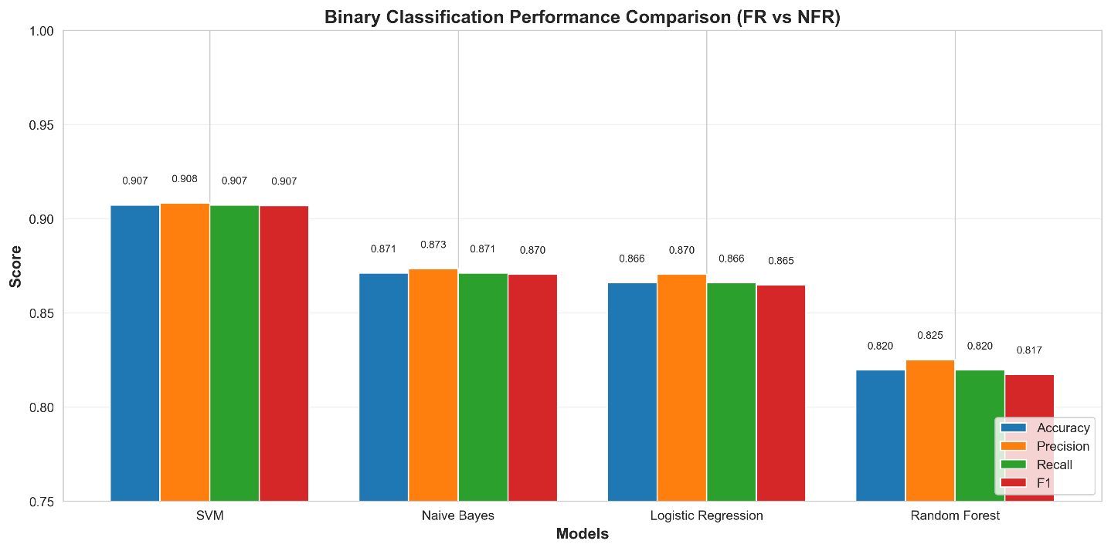
- Figure 3 compares accuracy, precision, recall and the F1-score of the baseline models.

Figure 3Binary classification performance comparison of baseline models.

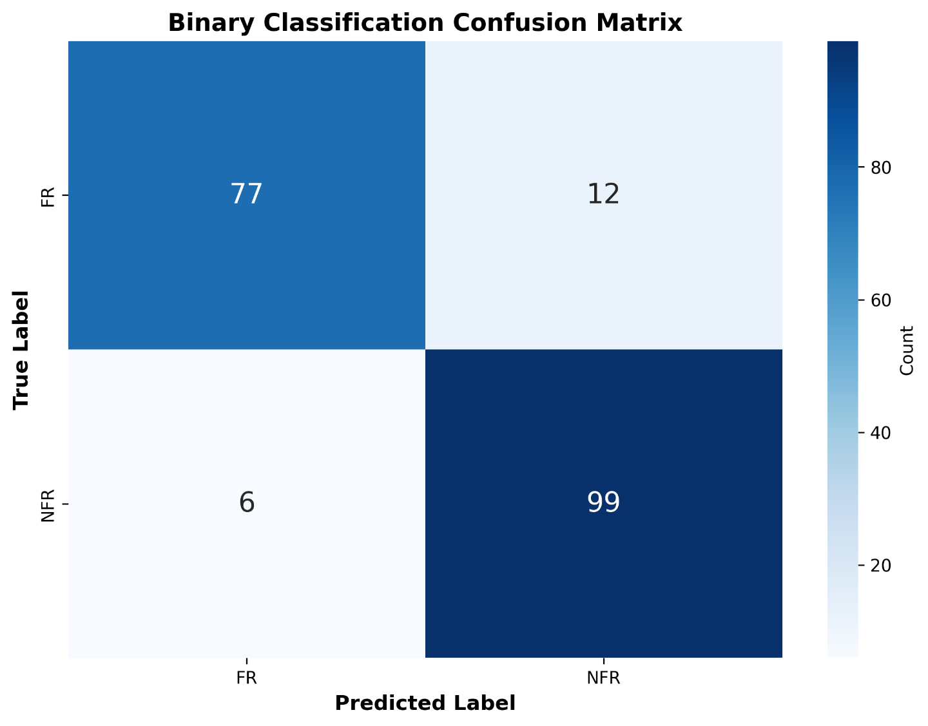
- The confusion matrix is shown in Figure 4 to indicate the pattern of correct vs. incorrect FR/NFR categories as well as the common misclassification behaviours.
Figure 4Confusion matrix for binary FR/NFR classification

Evaluation of Multi-Class Performance
- The multi-class task was designed to evaluate the performance of each model in classifying NFRs into eleven categories.
- The strong performance was shown again of the SVM classifier:
- Macro-F1 Score: 0.74.
- Such performance demonstrates the robustness of the model despite several challenges of NFR classification:
- Small sample sizes in some NFR categories.
- Overlapping semantics among related categories (e.g., performance vs. operability).
- High linguistic variability in natural-language requirement statements.
- Figure 5 compares the macro-F1 performance of the different models to confirm the superiority of SVM.
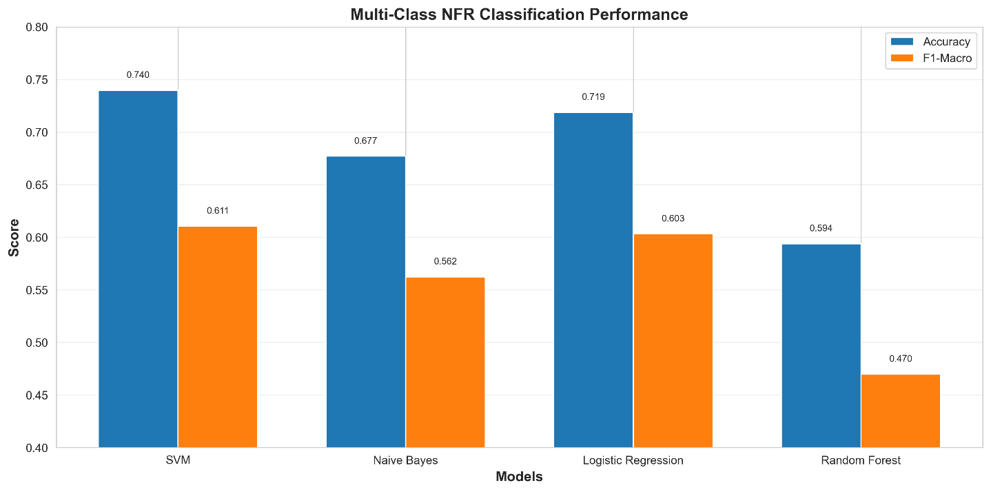
Figure 5Macro-F1 score comparison of multi-class classifiers
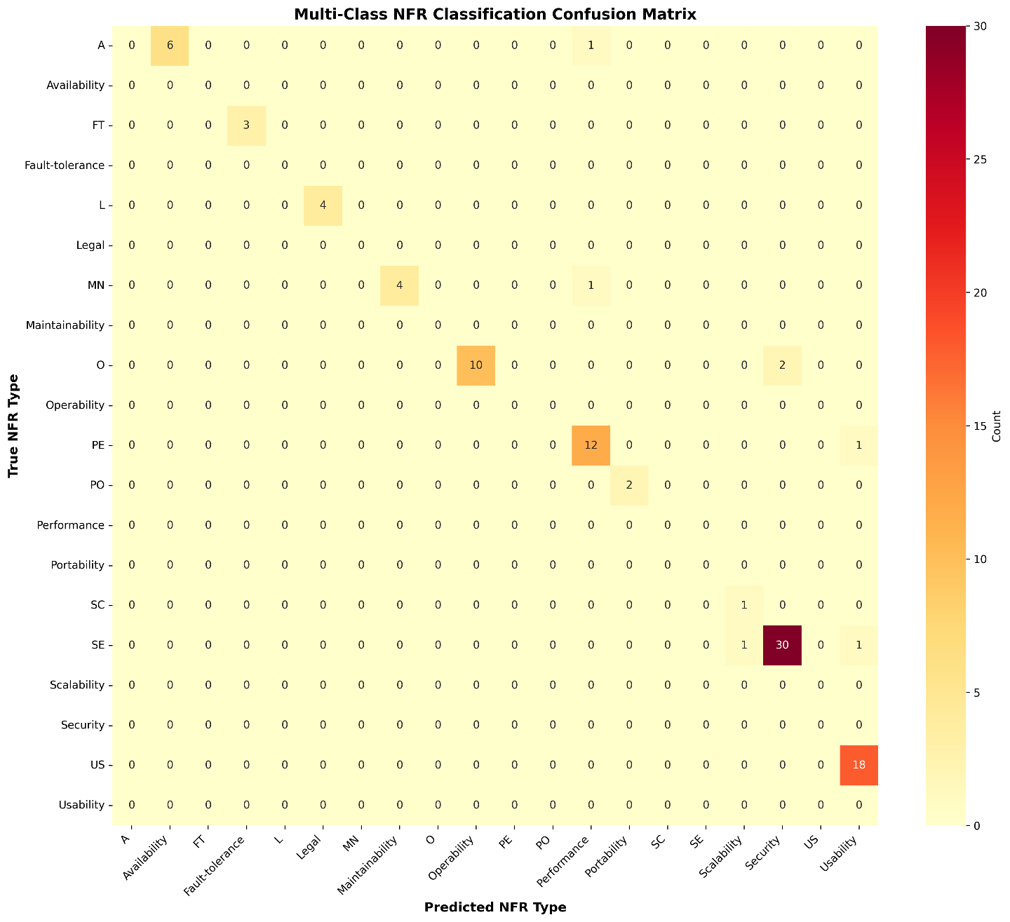
- The distribution of the predicted NFR categories, both predicted correctly and where confusion occurred, is shown in Figure 6.
Figure 6Distribution of predicted NFR categories (confusion matrix)

5.4 Feature Importance Analysis
Feature importance was examined for binary and multi-class tasks to further understand the decisions the model makes.

Binary FR/NFR Classification
- Figure 7 shows the top 20 most influential terms.
- Examples include:
  - NFR-indicative: server, seconds, access
  - FR-indicative: allow, display, meeting

Multi-Class NFR Classification
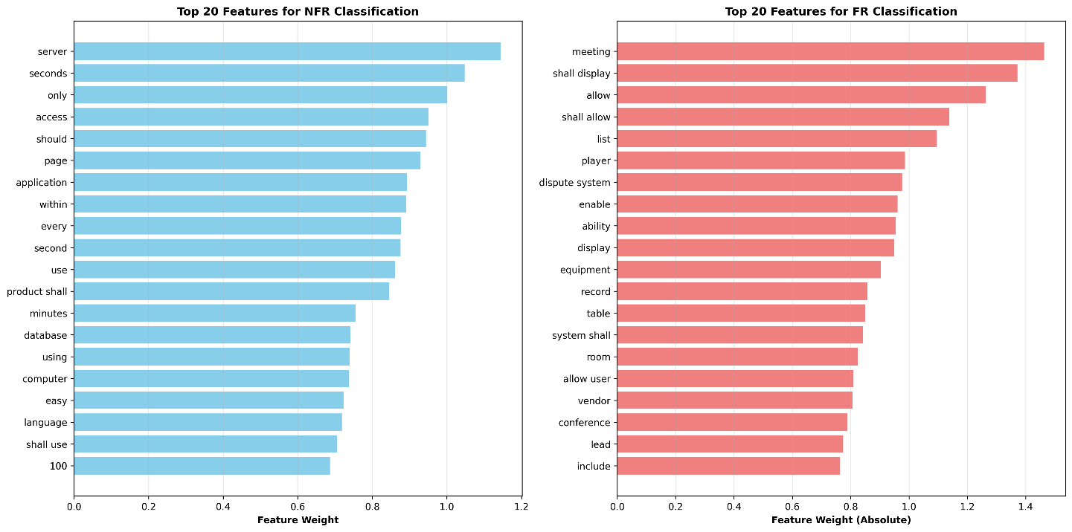
- Figure 7 highlights keywords strongly associated with specific NFR types:
Figure 7 Top 20 influential features for binary FR/NFR classification.

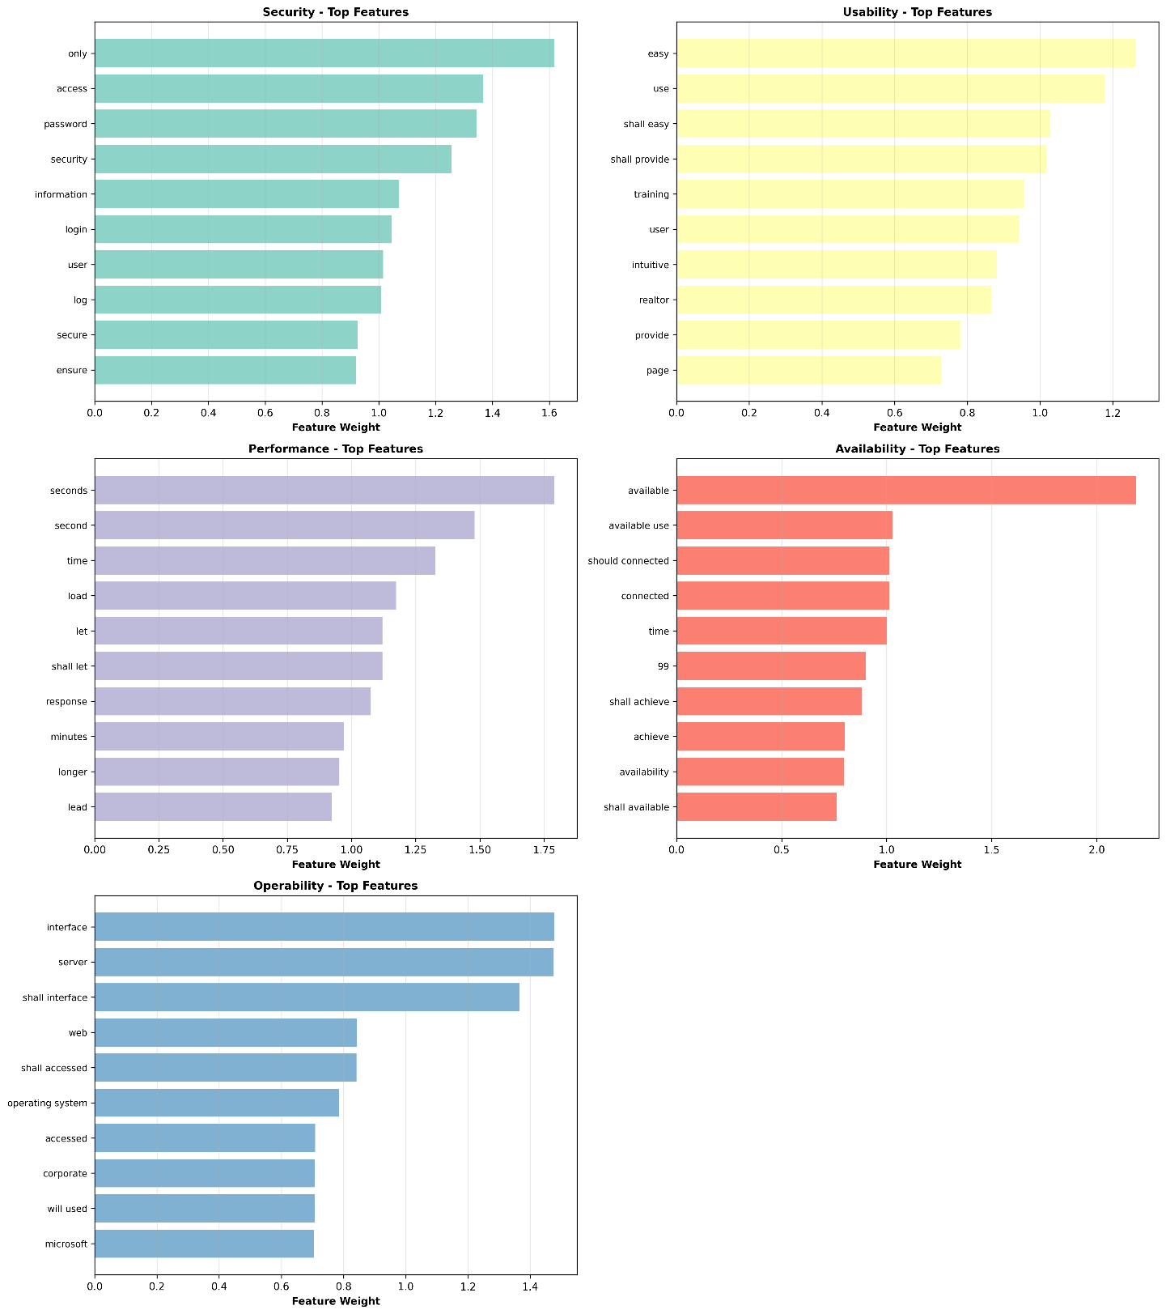
  - Security: password, access
Figure 8Influential terms for each NFR category.
  - Usability: easy, use
- These findings illustrate how certain domain-specific terms shape the distinction between requirement classes and categories.

5.5 Results of the Ambiguity Detection
The rule-based ambiguity detection module discovered ambiguous phrasing in about 95% of the requirements with ambiguity markers. Examples include:
- Vague adjectives:
  - “fast response time” → Suggested change: specify clear quantitative thresholds.
- Weak modal verbs:
  - should, may → Indicate as non-committal.
- Ambiguous pronouns:
  - it, they → Highlighted for unclear referents.
- Passive voice:
  - Marked when responsibility wasn’t clear.
These findings highlight the value of linguistic quality assessment, and also demonstrate the potential for the system to help understand more clearly the requirements specifications.

5.6 Comparison to Related Research
For context on the performance of the proposed framework, we compare the SVM classifier in Figure 9 with previous works.
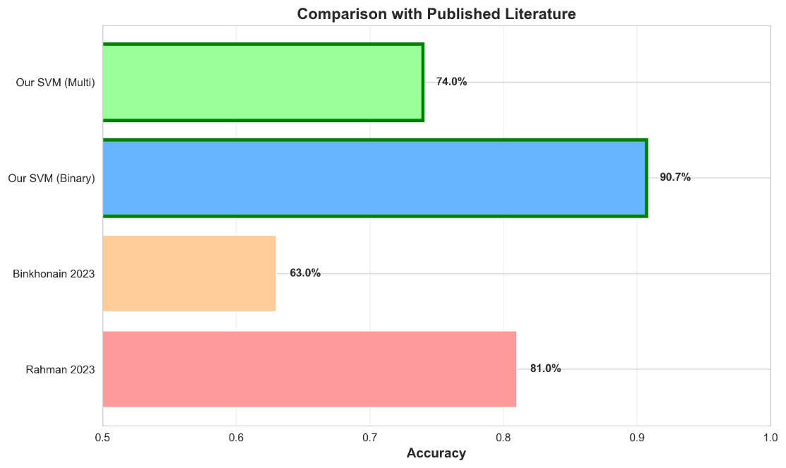
Figure 9Comparison of the proposed framework performance with related studies.

Key Observations:
- Our binary SVM classifier has better performance than the existing data (90.7% accuracy and 91% F1 score), Pynchonian (2023) – 63% accuracy (Naïve Bayes), Rahman et al. (2023) — 81.5% F1 (Linear SVM).
- Accuracy is significantly enhanced through SMOTE balancing and TF-IDF bi-grams via increasing accuracy.
- Multi-class Performance (macro-F1 = 0.74) is competitive with or superior to prior methods.

Table 2 Summary of Related Work
Study | Dataset | Features | Algorithm | Accuracy | Precision | Recall | F1-score
Proposed Framework (This Thesis) | PROMISE_exp | TF-IDF(bi-grams) | SVM | 90.7% | 91.0% | 91.0% | 91.0%
Rahman et al. (2023) | PROMISE_exp | TF-IDF | Linear SVM | – | – | – | 81.5%
Muhamad et al. (2022) | PURE | BoW + SMOTE | SVM | 78.7% | 80.2% | 78.7% | 78.9%
Kurtanović & Maalej (2017) | RE17 | Lexical features | SVM | – | ~92% | ~92% | ~92%
These results highlight the proposed framework as a meaningful advancement in automated requirement classification research.

5.7 Discussion
Now with these experimental results established, we can validate the effectiveness of the proposed framework and offer a few key takeaways:

Key Strengths
  - We have also demonstrated that SVM models outperformed all other methods, both in binary tasks and in multi-class tasks, consistently.
  - We showed significant improvement in predictive performance through preprocessing and class balancing.
  - Ambiguity detection provided qualitative depth not offered by common classification-only methods.

Remaining Challenges
- Overlapping semantics makes multi-class NFR classification challenging.
- However, the dataset size restricts the potential of deep-learning models.
- Subsequent work could focus on transformer-based models (e.g., BERT) and human-in-the-loop refinement for ambiguity rules.
- These findings highlight the potential and limitations of current AI-based requirement analysis approaches in general.

5.8 Summary
This chapter presented the experimental evaluation of the proposed framework, covering binary and multi-class classification results, feature-importance analysis, ambiguity detection outcomes, and comparisons with related literature. The system demonstrated strong quantitative and qualitative performance.
The next chapter provides the overall conclusion of this thesis and outlines directions for future research.

Chapter 6 Conclusion and Future Work

6.1 Conclusion

This description of the proposed framework, an AI-based approach for automatic software requirements classification and quality evaluation, forms the basis of this thesis. By combining machine learning models with rule-based linguistic structural analysis, the system addresses three main challenges in requirements engineering: distinguishing between Functional and Non-Functional Requirements (FRs vs. NFRs), classifying Non-Functional Requirements into eleven commonly recognized categories, and identifying ambiguity in natural language requirement statements.
The main findings of the study are:
- Leading classification systems:
The SVM (Support Vector Machine) classifier achieved high scores in all tasks: 90.7% FR/NFR classification accuracy down to the macro-F1 score of 0.74 across the eleven NFR subcategories. These results were better than many prior works made on similar datasets and with feature extraction and showed the strong performance of SVMs on high-dimensional text analysis.

- Effective ambiguity detection module:
The rule-based linguistic module could identify vague, incomplete, and ambiguous conditions, such as weak modal verbs, ambiguous pronouns, measurable constraints not included, and passive forms of voice. This feature facilitates the early tightening of demands, improving the quality of the specification.

- Business Requirements Documentation is simple and effective:
The proposed framework produces Business Requirements Documents that summarize classification results, ambiguity discovery, and quality insights. This creates clarity and improves communication between development and user teams with ease.

- An AI pipeline of requirement engineering in one:
Preprocessing, classification, ambiguity detection and BRD generation together show the potential of AI for the automation and standardization of requirement engineering, thus minimizing manual effort, subjectivity and bias. Our work shows the potential for AI (especially when combined with linguistic heuristics) to enrich the automation of part of requirement analysis process.
Overall, the results suggest that artificial intelligence can contribute substantially to the modernization of requirements engineering through improving analytical accuracy and creating more complete and consistent requirements documentation to enable the automated classification and provision of assurance for requirements.

6.2 Future Work
The results are promising, but there are several possibilities for extending and strengthening the framework. The following could be further explored to enhance its capacity:

- Enhanced and Diverse Datasets
For more robust and generalizable models, the software requirements should be added from various domains like healthcare, finance, embedded systems, and transportation in future studies. A larger dataset would allow the model to learn a greater variety of linguistic patterns, reducing overfitting to the PROMISE_exp dataset.

- Integration of Sophisticated Deep Learning Models:
Transformers, contextual embeddings (BERT / RoBERTa), and hybrid deep learning designs may provide a great contribution to semantic understanding, particularly within multi-class NFR classification. These approaches may serve in resolving the ambiguity between two closely related categories and can therefore get deeper contextual information.

- Integration with Real-World Workflows:
Incorporating the proposed framework into industry solutions like Jira, Confluence, Azure DevOps, or IBM DOORS helps to smooth the adoption of this tool in real requirements engineering environments. Continuous validation and real-time classification could be achieved if automated analyses were embedded into requirements management pipelines.

- Integrating the Human in the Loop to Refine Ambiguity:
By doing so, we hope the proposed framework can grow into a highly scalable and intelligent requirements engineering assistant, supporting both academic researchers and professional software development companies. As the discipline continues to transition toward more automated and AI-supported engineering practices, such systems are expected to be increasingly used to enhance requirements quality and accelerate project delivery.

References
- D. De Martino and F. Palomba, “Classification and challenges of non-functional requirements in ML-enabled systems: A systematic literature review,” Empirical Software Engineering, 2025.
- M. Rahman, A. H. M. R. Karim, and K. Sakib, “Non-functional requirements classification using machine learning algorithms,” in Proceedings of the International Conference on Software Engineering and Knowledge Engineering, 2023, pp. 1–8.
- A. Muhamad, N. Kama, and R. Ahmad, “A class balancing methods comparison in software requirement classification using a Support Vector Machine,” Journal of Software Engineering and Applications, vol. 15, no. 4, pp. 78–89, 2022.
- Z. Kurtanović and W. Maalej, “Automatically classifying functional and non-functional requirements using supervised machine learning,” in Proceedings of the IEEE International Requirements Engineering Conference (RE), 2017, pp. 490–495.
- A. Abd El Sameaa, M. A. El-Sayed, and H. M. Hassan, “Challenges of non-functional requirements extraction in agile software development using machine learning,” Journal of Systems and Software, vol. 176, pp. 110–123, 2021.
- S. Binkhonain, “Machine learning approaches for software requirement classification,” International Journal of Computer Science and Information Security, vol. 21, no. 2, pp. 45–52, 2023.

