A Comprehensive Review of Artificial Intelligence Approaches for Diabetic Retinopathy Classification
Asraa Alwattar – Rahaf Barakat
ORCID ID: 253001066 / 253002370
Master of Science in Artificial Intelligence – College of Informatics – Midocean University – Union of the Comoros
ماجستير ذكاء اصطناعي حديث – كلية المعلوماتية – جامعة ميدأوشن –جزر القمر
Email: esraawattar96@gmail.com – rahafmdbarakat@gmail.com
Supervisor: Dr. (Wesam Ahmed) College of Informatics – Midocean University – Union of the Comoros

Abstract:
Diabetic retinopathy (DR) is among the most frequent causes of preventable blindness; therefore, early detection and accurate automated screening are necessary to provide timely clinical treatment. Recently, with the help of advances in the field of artificial intelligence, specifically deep learning and transfer learning, the evaluation of retinal fundus images using convolutional neural networks, transformers, and hybrid architectures was significantly enhanced. This survey presents a systematic overview of deep learning approaches for diabetic retinopathy classification and critical analysis of previous works concerning the history of development, performance, advantages, and disadvantages of deep learning architectures. Vision transformers (ViTs), hybrid approaches, ensemble learning, and transfer learning methods are reviewed. Nevertheless, a number of problems still exist, such as class imbalance, lack of diversity of the datasets used for training, high computational cost, absence of external validation, and insufficient interpretability for clinical use. Future directions of research on the topic are described; namely, explainable artificial intelligence, lightweight models, multi-dataset validation, self-supervised learning, and clinically robust hybrid approaches.

Keywords: Diabetic Retinopathy, Deep Learning, Hybrid Deep Learning, Transfer Learning, Medical Image Classification

الملخص:
تعتبر اعتلال الشبكية السكري واحدة من أبرز الأمراض التي قد تؤدي إلى فقدان النظر بشكل يمكن الوقاية منه؛ لهذا السبب فإن إجراء فحص آلي دقيق ومتابعة طبية مبكرة يكون ضرورياً لتوفير العلاج اللازم لاعتلال الشبكية السكري في الوقت المناسب. وقد شهدت تقنيات تحليل صورة قاع العين باستخدام الشبكات العصبية الالتفافية والمحولات والبنى الهجينة تقدماً ملحوظاً في السنوات الأخيرة مع ظهور الذكاء الاصطناعي وبالأخص في تعلم العميق والتعلم بالنقل. ويتم في هذه الدراسة استعراض تطبيق أساليب التعلم العميق في تصنيف اعتلال الشبكية السكري بطريقة منهجية، إضافة إلى تقديم تحليل نقدي لأدبيات موضوع الدراسة من خلال استعراض تطور الأساليب، أدائها، مواصفاتها السلبية والإيجابية. كما يتم تقديم نظرة على أساليب المحولات البصرية، الأساليب الهجينة، التعلم التجميعي، والتعلم بالنقل. لكن حتى الآن لا تزال هناك بعض التحديات مثل توازن الفئات، التنوع المحدود لمجموعات التدريب، ارتفاع التكلفة الحاسوبية، عدم وجود تحقق باستخدام مجموعات البيانات الخارجية وقلة قابلية تفسير النتائج للاستخدام السريري.
الكلمات المفتاحية: اعتلال الشبكية السكري، التعلم العميق، التعلم العميق الهجين، التعلم بالنقل، تصنيف الصور الطبية

1. Introduction
Diabetic retinopathy (DR) is one of the most frequent complications associated with diabetes mellitus. DR is also among the major reasons for preventable blindness that people suffer from in their working age all over the world. The disease slowly starts to affect the blood vessels of the retina without any visible symptoms on early stages of the condition. Therefore, early screening and diagnostic are essential not to lose sight forever. Traditionally, the diagnostic process includes the visual examination of retinal fundus images done by experts and is quite time-consuming, expensive, and subjective, which makes large-scale screening impossible. Due to progress in artificial intelligence (AI) and machine learning (ML), in particular, there appeared an opportunity to perform automated medical image analysis. A range of neural networks was created for detection of retinal diseases. (Liu et al., 2022) Transfer learning has helped achieve significant success in retinal fundus image classification, as pretrained models are applied to small samples of labeled medical data. In more recent times, there has been an increased focus on transformer-based models due to their ability to learn both local and global contextual information using self-attention mechanisms, while hybrid models combining deep feature extractors and machine learning classifiers have demonstrated further improvements in performance and robustness. Although progress has been made in this regard, there are still some problems that should be resolved: most of the papers in this domain use just one data set, are characterized by an uneven class distribution, need considerable computational power, or do not have enough interpretability for clinical applications. Moreover, different techniques of data preprocessing, feature extraction, classifiers, and evaluation make comparison of different researches impossible. This paper gives a complete literature review of machine learning, deep learning, transfer learning, transformer models, and hybrid algorithms for the classification of diabetic retinopathy. Papers under analysis are assessed according to datasets used, image preprocessing, feature extraction, classifiers, performance metrics, and existing drawbacks.

2. Background and Theoretical Foundations
Diabetic Retinopathy (DR) is one of the main reasons for blindness worldwide, which demands timely detection to enable better treatment of patients. The recent developments in the field of Artificial Intelligence (AI), such as Deep Learning, Transfer Learning, Transformers, and Hybrid Models, have enabled greater accuracy in the classification of retinal images than was possible previously. Technological advancements in the past few years have helped increase the accuracy of feature extraction and image classification. This chapter explains some of the basic technologies utilized in the classification of diabetic retinopathy.
2.1 Diabetic Retinopathy Classification
Classification of DR is defined as the automatic determination of the stage of diabetic retinopathy using retinal fundus images. With respect to the ICDR Grading System (Wilkinson et al., 2003), diabetic retinopathy can be categorized into five types, which are referred to as no diabetic retinopathy, mild, moderate, severe, and proliferative diabetic retinopathy. It is very essential to classify the disease because it is crucial in the process of diagnosing and preventing blindness. In recent times, there has been increasing attention on diabetic retinopathy classification.
2.2 Machine Learning Approaches for DR
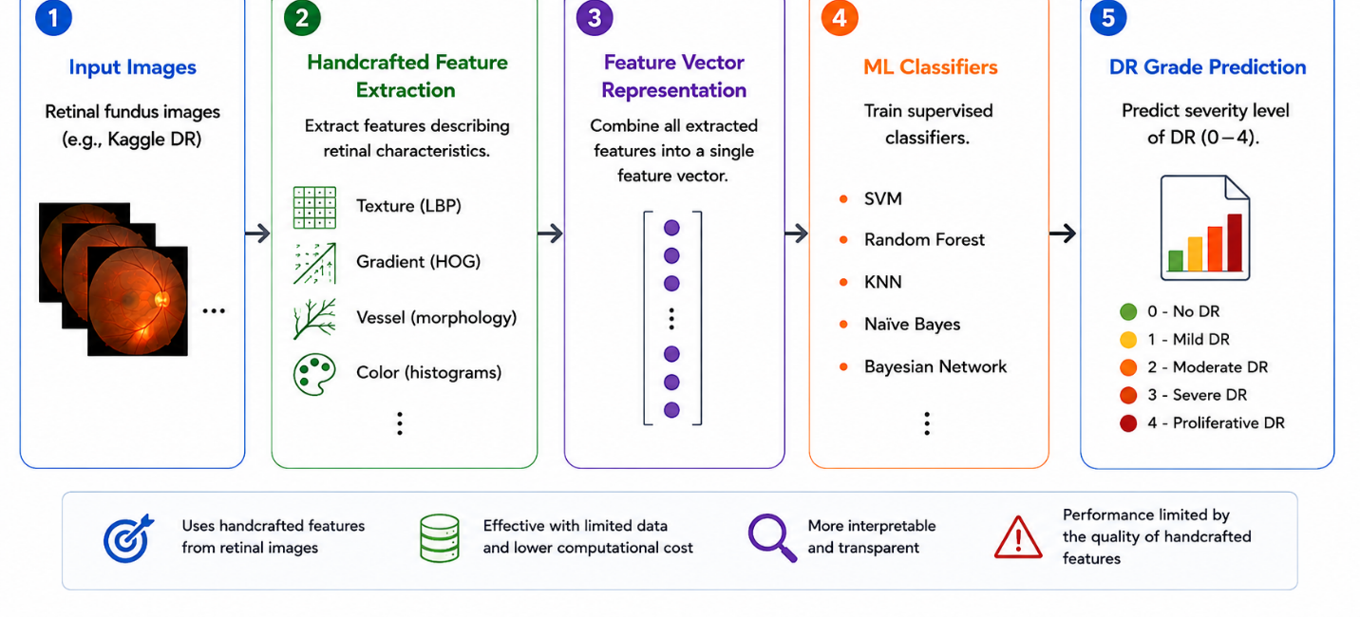
Before the development of deep learning approaches, classical machine learning (ML) methods with handcrafted image descriptors were widely applied in diabetic retinopathy classification problems. In general, classical ML-based frameworks for classification include the process of extracting retinal texture, blood vessels, and lesion shape descriptors such as LBP, HOG, and morphological or color descriptors, which serve as input to train a supervised classifier, such as SVM, Random Forest, K-Nearest Neighbor (KNN), and Naïve Bayes. For example, the research by Al Fahad and Khan (2025) examined the performance of a classical ML framework with classical handcrafted retinal texture and gradient features together with different supervised classifiers on the Kaggle DR dataset; it was shown that SVM, Random Forest, and Bayesian Network classifiers showed the best performance compared to other methods. Classical ML frameworks can be helpful in case when annotations are sparse, computational resources are limited, or interpretability is important because in some cases handcrafted features can be associated with specific retinal anomalies. Nevertheless, their performance depends on the discriminative ability of handcrafted descriptors. as shown at the figure 1 below:

Figure 1. Classical machine learning pipeline for diabetic retinopathy classification. (Al Fahad & Khan, 2025)
2.3 Deep Learning Approaches for DR
It is worth mentioning that the deep learning approaches, which include Convolutional Neural Network (CNN), have gained popularity in classifying diabetic retinopathy due to the ability of these models to learn discriminative features automatically from retinal fundus images, and no manual feature extraction has been done as mentioned earlier. Various CNN models, including ResNet (He et al., 2016), DenseNet, EfficientNet, and ConvNeXt (Liu et al., 2022) have been developed and shown potential for feature extraction through hierarchical design. Numerous CNN models have been employed in classifying diabetic retinopathy. For example, Ali & Dawood (2023) and Patil et al. (2023) fine-tuned the ResNet-50 on retinal fundus images, achieving classification accuracy more than 97%. These CNN models, among others, include the ConvNeXt which leverages the conventional CNN architecture and contemporary design motivated by Vision Transformers (ViTs).
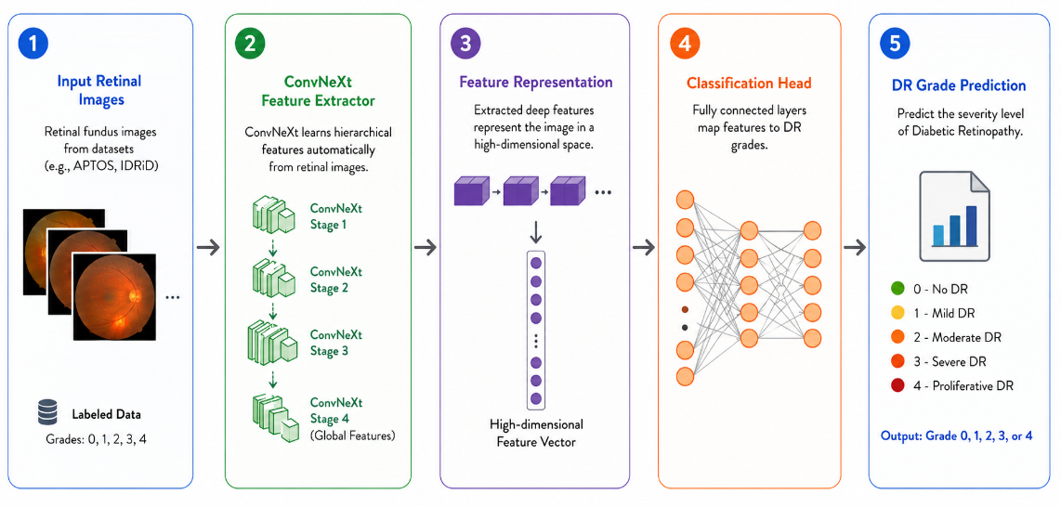

Figure 2. Deep learning pipeline for diabetic retinopathy classification using ConvNeXt. (Liu et al., 2022)
2.4 Transfer Learning in Medical Imaging
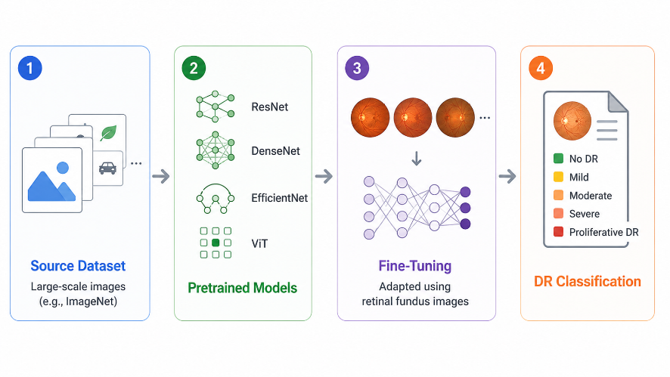
Transfer learning is currently the most powerful technique used for medical image classification, particularly where large amounts of retinal medical data sets cannot be obtained (Pan & Yang, 2010). Deep neural networks are not trained from the start; rather, pretrained models are fine-tuned using large-scale data sets like ImageNet. As a result, training becomes faster, convergence is achieved more quickly, feature extraction is improved, and high classification accuracy can be achieved even with limited medical data. Transfer learning has therefore become an essential component of most diabetic retinopathy classification frameworks that use modern CNN- and transformer-based models (Patil et al., 2023; Youldash et al., 2024), as shown in Figure 3 below:

Figure 3. Transfer Learning Workflow in Medical Image Analysis for Diabetic Retinopathy Classification. (Pan & Yang, 2010)
2.5 Transformer-Based Models
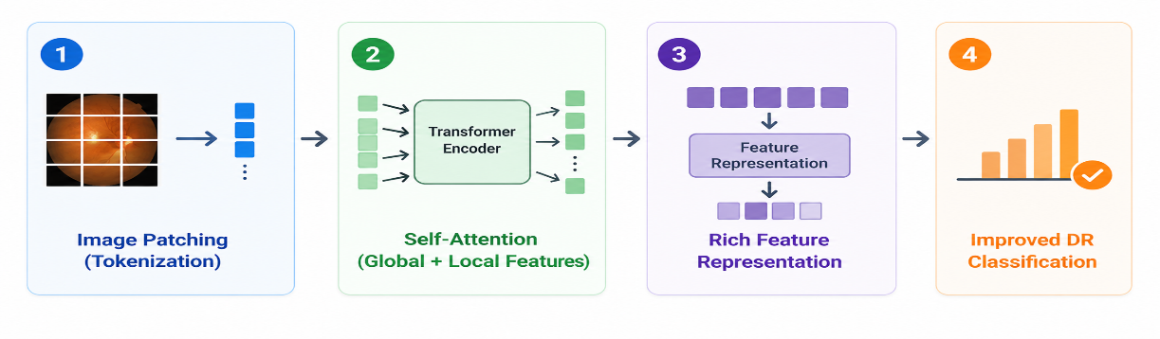
Transformer models have received much consideration in medical image processing thanks to their self-attention architecture (Vaswani et al., 2017), which allows extracting local as well as global features from the images. One of the most famous transformer architectures is Swin Transformer (Liu et al., 2021), whose fame is connected with its hierarchy and shifted-window self-attention mechanism, which makes it possible for the network to capture local retina lesions while retaining the global context. There are other effective transformers in diabetic retinopathy detection like ViT (Dosovitskiy et al., 2021) and DINOv2 (Oquab et al., 2023), as shown in Figure 4 below:
Figure 4. Transformer-Based Architecture for Diabetic Retinopathy Classification. (Liu et al., 2021)
2.6 Hybrid Deep Learning Frameworks
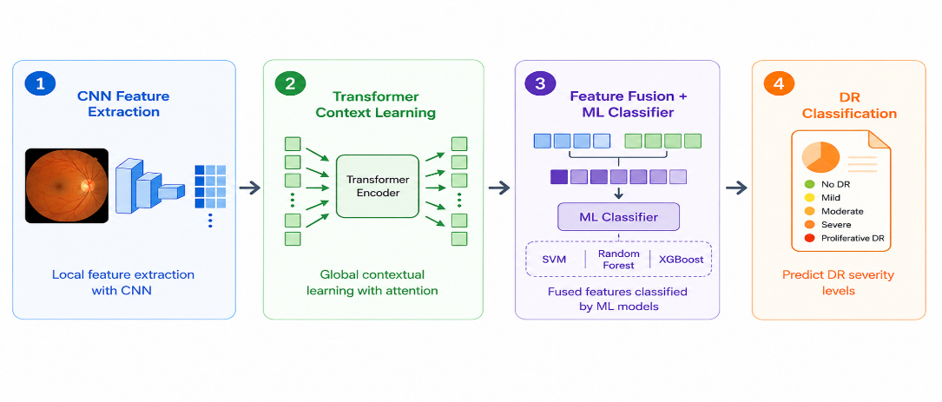
The concept of hybrid deep learning architecture comprises different types of AI algorithms to achieve improved classification of diabetic retinopathy cases. Hybridization of deep learning architecture consists of the use of CNN for local features, transformers for contextual understanding of features, and machine learning classifiers like SVM, Random Forest, or XGBoost for classification as demonstrated by Jabbar et al. (2024), Fayyaz et al. (2023), and Mohanty et al. (2023). The latest study shows that hybrid CNN-Transformer models can provide complementary feature representation through feature fusion resulting in increased robustness, generalizability, and accurate classification than single model architectures. Thus, hybrid frameworks have become one of the most researched topics in automated diabetic retinopathy classification, as demonstrated in Figure 5 below:
Figure 5. Hybrid Deep Learning Framework for Diabetic Retinopathy Classification. (Jabbar et al., 2024)
2.7 Evaluation Metrics

Model performance for diabetic retinopathy classification is usually assessed by different quantitative performance metrics, as illustrated in the works of Patil et al. (2023) and Akhtar et al. (2025). Accuracy is the ratio of correctly classified instances, whereas other performance metrics such as Precision, Recall (Sensitivity), Specificity, and F1-score offer more thorough insights into the performance of classification models, particularly in situations where the datasets are imbalanced. Also, other techniques such as Confusion Matrix and Area Under the Receiver Operating Characteristic Curve (AUC-ROC) are often used in assessing classification models' performance.

2.7.1 Confusion Matrix
The confusion matrix depicts classification accuracy by comparing the actual class labels with the predicted class labels. There are four different outcomes which are True Positive (TP), True Negative (TN), False Positive (FP) and False Negative (FN). It is helpful in calculating various measures of performance. The confusion matrix has a crucial importance in medical image classification because it helps in determining the type of error made during classification.
- TP: Positive samples correctly classified.
- TN: Negative samples correctly classified.
- FP: Negative samples incorrectly classified as positive.
- FN: Positive samples incorrectly classified as negative.

2.7.2 Performance Metrics
The effectiveness of the diabetic retinopathy classifier models is measured by using several metrics, which are computed based on the confusion matrix. Different metrics give different views about classifier efficiency, especially when working with an imbalanced dataset of medical data.
- Accuracy $Accuracy=\frac{TP+TN}{TP+TN+FP+FN}$
- Precision $Precision=\frac{TP}{TP+FP}$
- Recall (Sensitivity) $Recall=\frac{TP}{TP+FN}$
- Specificity $Specificity=\frac{TN}{TN+FP}$
- F1-score $F1=2×\frac{Precision×Recall}{Precision+Recall}$
Apart from that, there is one more widely-used criterion that allows evaluating the efficiency of classifying different categories and measuring how well a certain model performs – it is the Area Under the Receiver Operating Characteristic Curve (AUC-ROC).
3. Previous Studies
This section will give a summary of the most recent works in the field of the diagnosis of diabetic retinopathy based on the artificial intelligence approach including machine learning, deep learning, transfer learning, transformer, and hybrid approaches, described in Table 1. The examined studies include different data sets, image pre-processing, feature extraction, and classification methods, which could be used to improve the diagnostic results. The literature analysis has highlighted the main pros and cons of the considered techniques as well as their possible further developments.
Jiwani et al. (2022) proposed a simple CNN-based model for binary diabetic retinopathy classification using the IDRiD dataset, which, despite lower accuracy than other models, remains a valuable benchmark study with accuracy about 75%.
Fayyaz et al. (2023) came up with a combined method where AlexNet and ResNet101 models were used to extract features, while the ant colony algorithm was utilized for the selection of the features, followed by a support vector machine which was able to classify the data accurately, giving 93% success rate.
Lin & Wu (2023) developed an improved ResNet-50 model that could solve problems like overfitting and improve stability. Despite being robust, its test accuracy rate of 74.32% has been beaten by other newer models.
Mohanty et al. (2023) compared a hybrid VGG16 and XGBoost model with DenseNet121 for diabetic retinopathy detection and classification, concluding that DenseNet121 outperformed the hybrid model with an accuracy of about 74.3%.
Patil et al. (2023) used the ResNet-50 with Transfer Learning and TTA on the APTOS data set that has been tested on EyePACS data set and have shown the highly accurate results of 97.87% and highlighted the importance of augmentation for classifiers.
Ali & Dawood (2023) designed a transfer learning model for diabetic retinopathy using ResNet-50 architecture in APTOS 2019 dataset with 98.3% accuracy and proved the feasibility of using transfer learning for retinal images, but without any validation.
The DRFEC model was proposed by Das et al. (2023) and tested on the EyePACS dataset using 26 pre-trained deep learning models. In this case, EfficientNetB4 recorded the best validation accuracy of about 79.11%, but it faced overfitting challenges.
In Youldash et al.'s (2024) research, the authors used six different pretrained CNN architectures like EfficientNet and RegNet models for APTOS and Saudi clinical datasets with high accuracy of 96% in binary classification task, but lower performance in a multiclass problem. The most important thing about this study is its external validation in the clinical setting.
The research paper by Shamrat et al. (2024) presented a deep neural network known as DRNet13 that was designed for fundus image analysis with 96-97% accuracy, although it is worth noting that the algorithm performed better than fifteen pretrained CNNs on just one dataset.
Jabbar et al. (2024) proposed a model based on lesions using hybridization which used deep learning for features extraction along with machine learning classifiers like SVM, Random Forest, Decision Tree, and Linear Regression to achieve accuracy around 94%.
Guefrachi et al. (2024) have introduced a multi-stage process of training deep learning model for diabetic retinopathy detection by using transfer learning models including ResNet152-V2 and InceptionResNet-V2, where the final outcome is provided through a visual representation and an accuracy rate of approximately 97%, but at a possible cost of overfitting.
The research work by Akhtar et al. (2025) introduced a deep learning model named RSG-Net for grading diabetic retinopathy for four-stage multi-class classification as well as binary classification based on the Messidor-1 dataset. By incorporating image cropping, Gaussian blur noise removal, histogram equalization, rescaling, and augmentation in the model, the researchers obtained impressive accuracy in four-stage classification (99.36%) and binary classification (94.2%), despite poor generalizability beyond the evaluation dataset.
In their study, Wu et al. (2025) present mBRSET, a portable dataset for retinal fundus images captured in real-life scenarios using portable retinal cameras, where ConvNeXt V2, DINOv2, and Swin V2 were evaluated on the same, producing the highest F1 scores of 80.33 and 87.4 for the classification of the three-classes and binary class problem, respectively. What makes the work outstanding is the challenge in dealing with real-world noisy data.
Grzybowski & Jin (2026) conducted research on AI-based devices for screening of diabetic retinopathy in the European Union and used an approach which allowed improving the quality of the fundus image through resizing, normalization, and augmentation for class balancing, obtaining accuracy values of about 80%.

Table 1 Summarizes and compares the studies discussed above:
Authors | Year | Method / Model | Dataset | Results | Limitations
Jiwani et al. (2022) | 2022 | CNN (binary) | EyePACS / IDRiD | ~75% | Moderate accuracy
Fayyaz et al. (2023) | 2023 | AlexNet + ResNet101 + SVM | Fundus images | ~93% | Small feature set
Lin & Wu (2023) | 2023 | Revised ResNet-50 (CNN) | Kaggle DR images | 74.32% | Low test vs. train
Mohanty et al. (2023) | 2023 | ResNet-50 / DenseNet121 | Kaggle DR | ~74.3% | Low test accuracy
Patil et al. (2023) | 2023 | ResNet-50 + TTA | APTOS + EyePACS | 97.87% | Multi-class imbalance
Ali & Dawood (2023) | 2023 | ResNet-50 (transfer learning) | APTOS 2019 | 98.3% | No external validation
Das et al. (2023) | 2023 | 26 pretrained DL nets (DRFEC) | Kaggle EyePACS | ~79.11% | Low validation accuracy
Youldash et al. (2024) | 2024 | EfficientNetV2, RegNetX | Kaggle EyePACS | ~96% | Class imbalance
Shamrat et al. (2024) | 2024 | Deep Learning (DRNet13) | Fundus images | ~96-97% | Computational cost
Jabbar et al. (2024) | 2024 | GoogleNet + ResNet + ML | Fundus dataset | ~94% | Limited validation detail
Guefrachi et al. (2024) | 2024 | Deep Learning (ResNet152-V2) | Kaggle DR dataset | ~97% | Overfitting risk
Akhtar et al. (2025) | 2025 | Deep Learning (RSG-Net) | EyePACS | 94.2% | Limited generalization
Wu et al. (2025) | 2025 | ConvNeXt V2, DINOv2, SwinV2 | mBRSET | 80.33  87.4 | Limited dataset size
Grzybowski & Jin (2026) | 2026 | AI DR devices (CNN) | EU datasets | ~80% | Heterogeneous data and reporting

4. Challenges and Limitations
Despite the considerable advancements made in diabetic retinopathy classification, there are still many open challenges left unresolved. First, the problem of class imbalance exists when severe cases of diabetic retinopathy are rare and occur less often compared to normal or mild cases, making it harder to classify minority classes. Another issue relates to the limited diversity of retinal image data in public studies. Additionally, the variability of imaging parameters and processes still influences the accuracy of automated classifiers. Contemporary deep learning and transformer-based models need a lot of computational resources that limit their applicability in practice. Furthermore, some models are non-interpretable, limiting clinicians' trust in automated diagnostics. While hybrid methods have demonstrated success, the combination of modern transformers with classical machine learning classifiers has not been thoroughly researched yet.
5. Future Directions
In the future, the field of diabetic retinopathy classification needs to work on advancing the development of more intelligent and clinically useful artificial intelligence models. Hybrid models that can be created using CNN, transformer architecture, and machine learning classifiers can be considered one of such methods that can increase the efficiency of feature extraction and classification process. In addition, lightweight deep learning models that generate accurate outcomes but use less computational power can be used in the future. It should be noted that future studies should use larger and more diverse sets of retinal images. The use of multiple datasets in the process of external validation can improve the ability of the models to generalize, and the proper approach to class imbalance problem solution can help to classify minority classes better. Finally, the field of explainable artificial intelligence (XAI) can be expected to be an important part of the future classification systems due to improved interpretability.
6. Conclusion
The current survey examines the latest achievements in artificial intelligence techniques for classification of diabetic retinopathy with an emphasis on deep learning, transfer learning, transformers, and hybrid models. It can be seen from the presented literature that those techniques showed impressive progress in improving classification accuracy and reliability. At the same time, the literature shows the number of persistent problems such as class imbalance, lack of diversity of datasets, high computational cost, and poor model interpretability. In conclusion, the current survey gives a complete insight into the latest trends in diabetic retinopathy classification and potential research directions, including explainable AI (XAI).

References
Akhtar, S., Aftab, S., Ali, O., Ahmad, M., Khan, M. A., Abbas, S., & Ghazal, T. M. (2025). A deep learning based model for diabetic retinopathy grading. Scientific Reports, 15, 3763.
Al Fahad, N., & Khan, R. U. (2025). Classical machine learning based diabetic retinopathy detection using handcrafted features. Ingénierie des Systèmes d'Information, 30(12), 3201–3206.
Ali, A. A., & Dawood, F. A. A. (2023). Deep learning of diabetic retinopathy classification in fundus images. Journal of Engineering, 29(12), 139–152.
Das, D., Biswas, S. K., & Bandyopadhyay, S. (2023). Detection of diabetic retinopathy using convolutional neural networks for feature extraction and classification (DRFEC). Multimedia Tools and Applications, 82(19), 29943–30001.
Dosovitskiy, A., Beyer, L., Kolesnikov, A., Weissenborn, D., Zhai, X., Unterthiner, T., Dehghani, M., Minderer, M., Heigold, G., Gelly, S., Uszkoreit, J., & Houlsby, N. (2021). An image is worth 16x16 words: Transformers for image recognition at scale. In International Conference on Learning Representations (ICLR).
Fayyaz, A. M., Sharif, M. I., Azam, S., Karim, A., & El-Den, J. (2023). Analysis of diabetic retinopathy (DR) based on deep learning. Information, 14(1), 30.
Grzybowski, A., & Jin, K. (2026). Artificial intelligence-based medical devices for diabetic retinopathy screening in the European Union. Ophthalmology and Therapy, 15(2), 569–589.
Guefrachi, S., Echtioui, A., & Hamam, H. (2024). Diabetic retinopathy detection using deep learning multistage training method. Arabian Journal for Science and Engineering, 49(2), 1079–1096.
He, K., Zhang, X., Ren, S., & Sun, J. (2016). Deep residual learning for image recognition. In Proceedings of the IEEE Conference on Computer Vision and Pattern Recognition (CVPR)(pp. 770–778).
Jabbar, A., Liaqat, H. B., Akram, A., Sana, M. U., Azpíroz, I. D., de la Torre Díez, I., & Ashraf, I. (2024). A lesion-based diabetic retinopathy detection through hybrid deep learning model. IEEE Access, 12, 40019–40036.
Jiwani, N., Gupta, K., & Afreen, N. (2022). A convolutional neural network approach for diabetic retinopathy classification. In 2022 IEEE 11th International Conference on Communication Systems and Network Technologies (CSNT) (pp. 357–361). IEEE.
Lin, C.-L., & Wu, K.-C. (2023). Development of revised ResNet-50 for diabetic retinopathy detection. BMC Bioinformatics, 24, 157.
Liu, Z., Lin, Y., Cao, Y., Hu, H., Wei, Y., Zhang, Z., Lin, S., & Guo, B. (2021). Swin transformer: Hierarchical vision transformer using shifted windows. In Proceedings of the IEEE/CVF International Conference on Computer Vision (ICCV)(pp. 9992–10002).
Liu, Z., Mao, H., Wu, C.-Y., Feichtenhofer, C., Darrell, T., & Xie, S. (2022). A ConvNet for the 2020s. In Proceedings of the IEEE/CVF Conference on Computer Vision and Pattern Recognition (CVPR)(pp. 11966–11976).
Mohanty, C., Mahapatra, S., Acharya, B., Kokkoras, F., Gerogiannis, V. C., Karamitsos, I., & Kanavos, A. (2023). Using deep learning architectures for detection and classification of diabetic retinopathy. Sensors, 23(12), 5726.
Oquab, M., Darcet, T., Moutakanni, T., Vo, H., Szafraniec, M., Khalidov, V., Fernandez, P., Haziza, D., Massa, F., & El-Nouby, A. (2023). DINOv2: Learning robust visual features without supervision. arXiv preprint arXiv:2304.07193.
Pan, S. J., & Yang, Q. (2010). A survey on transfer learning. IEEE Transactions on Knowledge and Data Engineering, 22(10), 1345–1359.
Patil, M. S., Chickerur, S., Abhimalya, C., Naik, A., Kumari, N., & Maurya, S. (2023). Effective deep learning data augmentation techniques for diabetic retinopathy classification. Procedia Computer Science, 218, 1156–1165.
Shamrat, F. M. J. M., Shakil, R., Sharmin, S., Ovy, N. H., Akter, B., Ahmed, M. S., Ahmed, M. Z., Ahmed, K., Bui, F. M., & Moni, M. A. (2024). An advanced deep neural network for fundus image analysis and enhancing diabetic retinopathy detection. Healthcare Analytics, 5, 100303.
Vaswani, A., Shazeer, N., Parmar, N., Uszkoreit, J., Jones, L., Gomez, A. N., Kaiser, Ł., & Polosukhin, I. (2017). Attention is all you need. In Advances in Neural Information Processing Systems (NeurIPS)(pp. 5998–6008).
Wilkinson, C. P., Ferris, F. L., Klein, R. E., Lee, P. P., Agardh, C. D., Davis, M., Dills, D., Kampik, A., Pararajasegaram, R., & Verdaguer, J. T. (2003). Proposed international clinical diabetic retinopathy and diabetic macular edema disease severity scales. Ophthalmology, 110(9), 1677–1682.
Wu, C., Restrepo, D., Nakayama, L. F., Zago Ribeiro, L., Shuai, Z., Barboza, N. S., Sousa, M. L. V., Fitterman, R. D., Pereira, A. D. A., Regatieri, C. V. S., Stuchi, J. A., Malerbi, F. K., & Andrade, R. E. (2025). A portable retina fundus photos dataset for clinical, demographic, and diabetic retinopathy prediction. Scientific Data, 12, 323.
Youldash, M., Rahman, A., Alsayed, M., Sebiany, A., Alzayat, J., Aljishi, N., Alshammari, G., & Alqahtani, M. (2024). Early detection and classification of diabetic retinopathy: A deep learning approach. AI, 5(4), 2586–2617.

