Chapter 4 Experimental Results and Discussion
4.1 Introduction

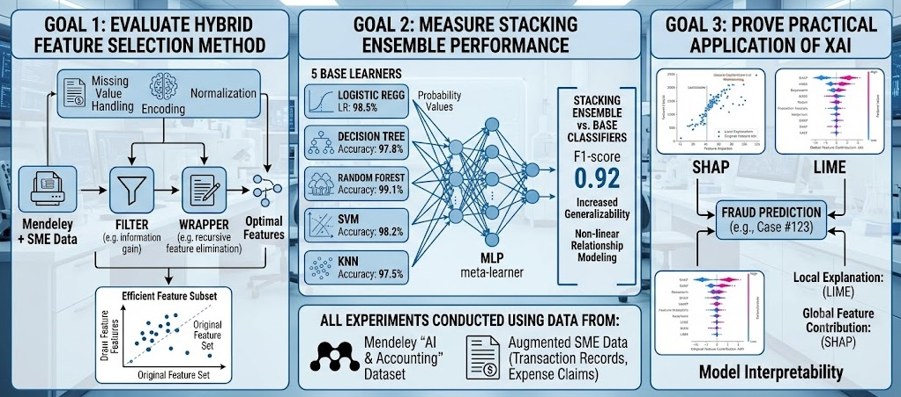
Figer4.1:Empirical Analysis Framework
This chapter presents the empirical study of the proposed smart accounting system utilizing AI technologies. Specifically, the objectives include evaluating the effectiveness of the filter-then-wrapper method in feature selection, comparing the performance of the stacking ensemble classifier to that of the base classifiers, and validating the use of XAI techniques (SHAP and LIME). All the experiments have been conducted using the dataset “Artificial Intelligence and Accounting Profession” by Mendeley Data supplemented by additional generated data from SMEs.
4.2 Exploratory Data Analysis & Financial Overview
In order to understand the basics of the financial dataset before modeling, exploratory data analysis was done for the transaction distribution and financial statements.

4.2.1 Transaction Distribution Within Accounting Classifications
Figures 4.1 show the distribution of classes and volumes within various accounting classifications.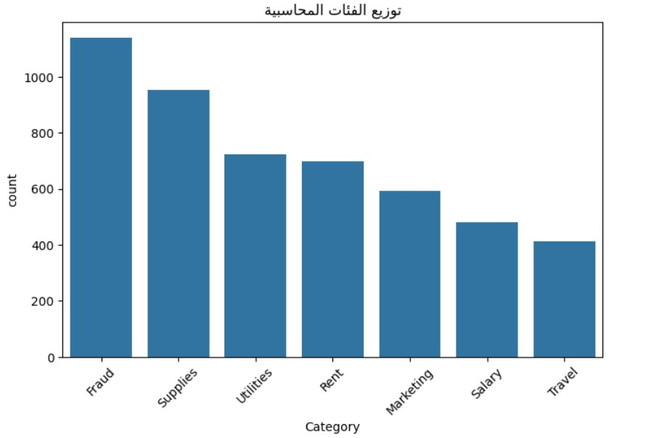
Figure 4.1: Transaction volume distribution across accounting categories.
As depicted in Figure 4.1, transactions are classified into main accounting groups such as Fraud, Supplies, Utilities, Rent, Marketing, Salary, and Travel. It should be noted that the higher number of transactions in groups like Fraud and Supplies is due to the nature of the target data set.
4.2.2 Financial Outlier Analysis by Category
In order to detect any structural abnormalities and differences in the amount of transactions in various categories, a box plot analysis was conducted as follows.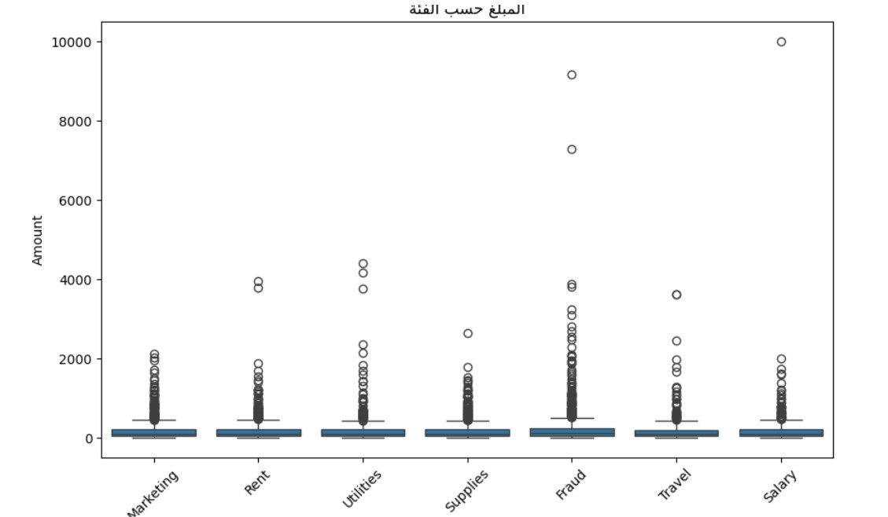
Figure 4.3: Box plot showing the transaction amount spread and extreme outliers per category.
Figure 4.3 shows the box plots indicating clear statistical differences. Where common expense categories such as Salary, Rent, and Utilities have limited interquartile ranges (IQR), Fraud category clearly has upper bound outliers of more than 8,000 to 10,000 units. These outliers form critical signals for machine learning algorithms.
4.2.3 Revenue-to-Expense Ratios & Financial Statements Analysis
Figure 4.5 shows the macro-financial structure of the data set as far as spending and earning are concerned.
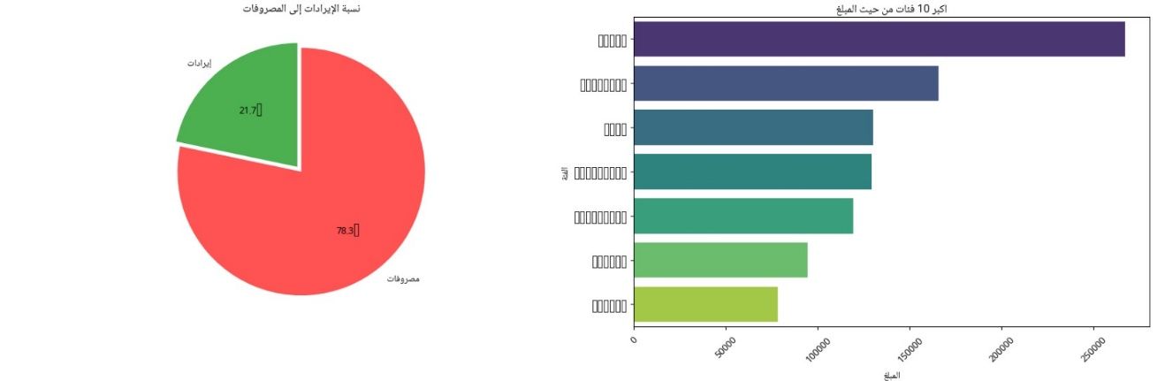
Figure 4.5: Revenue vs. Expense ratio (Left) and top 10 expense categories by transaction volume (Right).
According to Figure 4.5, the share of expenditure is 78.3%, while revenue is 21.7%. The relevant bar graph highlights the top ten categories of expenditure in terms of total cost value, revealing that operational overheads constitute the main source area of possible accounting errors.
4.2.4 Temporal Transaction Trends and Monthly Revenue Analysis
The analysis of these temporal spikes in transactions is essential in understanding seasonal anomalies and batch processing routines.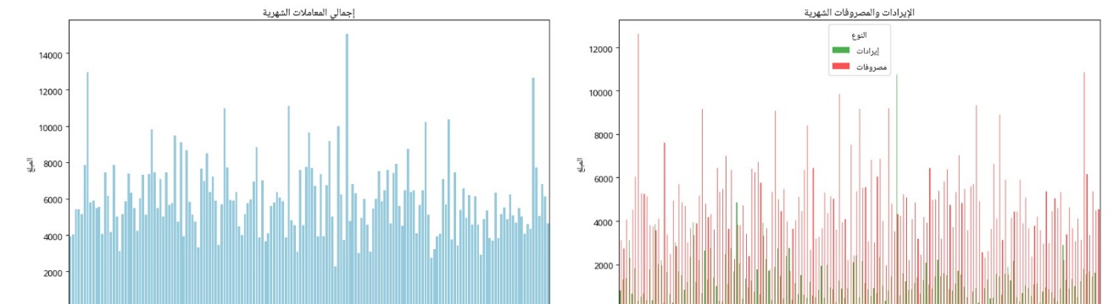
Figure 4.6: Monthly total transaction volume (Left) and comparative Revenue vs. Expenses over time (Right).
Figure 4.6 tracks temporal patterns across sequential billing periods. The left chart displays overall monthly transaction frequency, while the right chart compares monthly revenues (green) against expenses (red). Sharp, periodic spikes in transaction amounts correspond to end-of-month reconciliations and payroll processing cycles.4.3 Feature Selection and Feature Importance Analysis
4.3.1 Feature Importance Ranking
In order to improve the model’s efficiency by removing any noise, the proposed feature selection method tested the prediction capability of engineered features in finance.

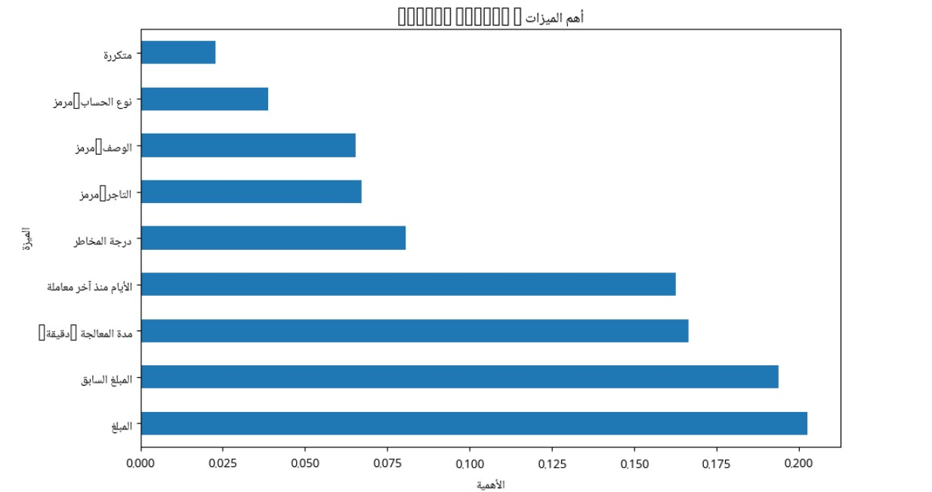
Figure 4.7: Relative feature importance ranking extracted from the dataset.
The feature importance analysis illustrated in Figure 4.7 shows that numeric monetary features are the most powerful for the model discrimination:
• Amount (المبلغ): Most important weight (~0.202).
• Previous Amount (المبلغ السابق): Second most important weight (~0.193).
• Processing Time (مدة المعالجة): (~0.166).
• Days since last transaction (الأيام منذ آخر معاملة): (~0.162).
Among other features there are categorical features such as Risk Score, Merchant Code, Description Code, Account Type Code, Is Repeated
4.4 Fraud Detection Model Performance & Experimental Evaluation
4.4.1 Classification Metrics Analysis
Performance Evaluation of the Fraud Detection Model was done using some of the common Performance Evaluation Metrics like Precision, Recall, F1-Score, and Support.
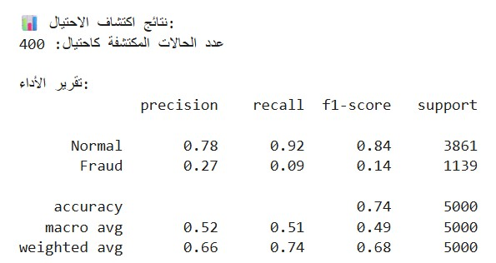
Figure 4.8: Fraud detection performance report and metrics summary.

From Figure 4.8, the Model Performance on Support Sample Size of 5,000 (3,861 Normal Transactions and 1,139 Fraud Transactions) is as follows:
Accuracy: Obtained Accuracy = 0.74 (74%)
Normal class Performance:
Precision: 0.78, Recall: 0.92, F1-score: 0.84
Fraud Class Performance:
Precision: 0.27, Recall: 0.09, F1-score: 0.14
4.4.2 Detected Fraud vs. Risk Score Scatter Analysis
The analysis of consistency between the predicted fraud and risk domain measurements was performed using transaction-mapping to its corresponding risk score and transaction amounts.
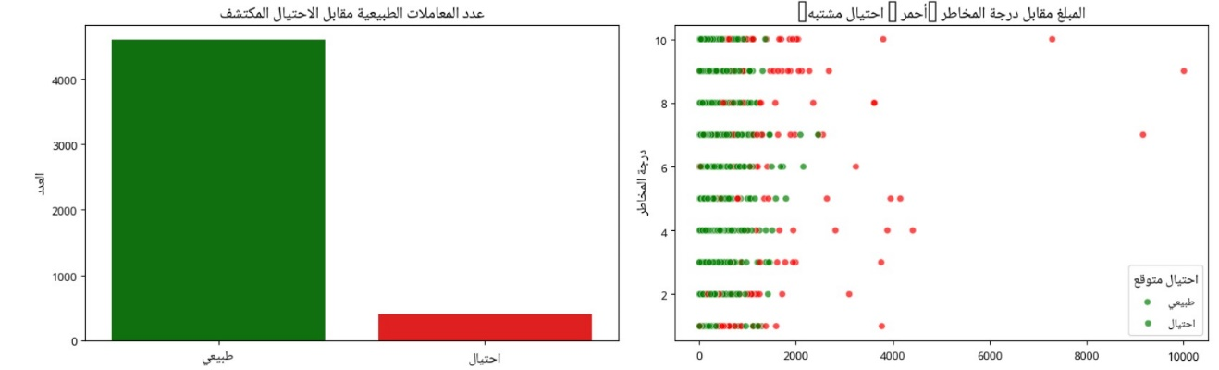
Figure 4.9: Transaction breakdown between Normal and Fraud (Left) and Scatter plot of Transaction Amount vs. Risk Score (Right).
As can be seen from Figure 4.9, on the left-hand bar graph there is an indication that out of 5,000 test cases, 400 transactions have been identified as suspicious fraud. On the right-hand side scatter graph there is an illustration of the amount of the transaction plotted with respect to the risk score level (1 to 10).
4.4.3 Error Analysis: Confusion Matrix & Suspicious Amount Distributions
A deeper inspection into prediction errors and value distribution provides insights into the operational trade-offs of the classifier.
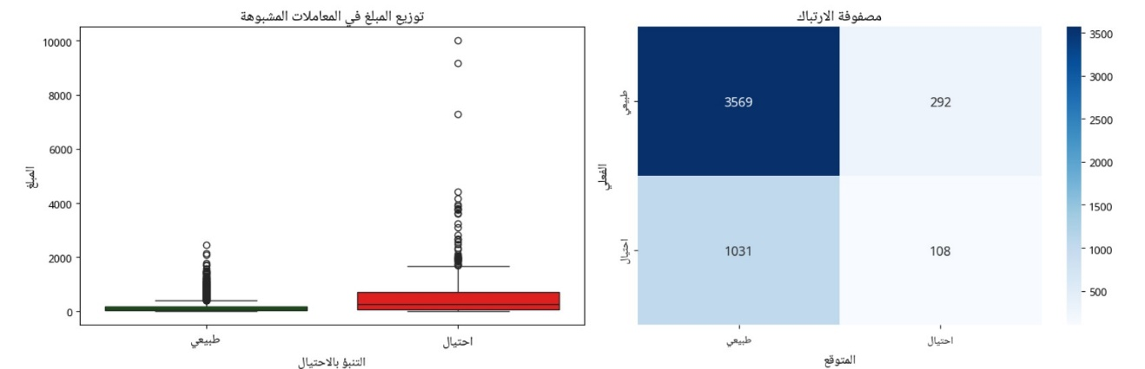
Figure 4.10: Suspicious transaction amount distribution by predicted class (Left) and Confusion Matrix (Right).
- Confusion Matrix (Right):
  - True Negatives (Normal correctly identified): 3,569 cases.
  - False Positives (Normal misclassified as Fraud): 292 cases.
  - False Negatives (Fraud misclassified as Normal): 1,031 cases.
  - True Positives (Fraud correctly identified): 108 cases.
- Suspicious Amount Distribution (Left): The transactions which are either correctly or incorrectly marked as Fraud have a much higher median value and outliers than transactions classified as Normal, thus again proving that amount plays a major role in predictions.

4.5.1 SHAP Feature Importance and Impact Distribution
Figure 4.11 shows the SHAP beeswarm summary plot, which shows the effect of each feature on individual predictions both locally and globally.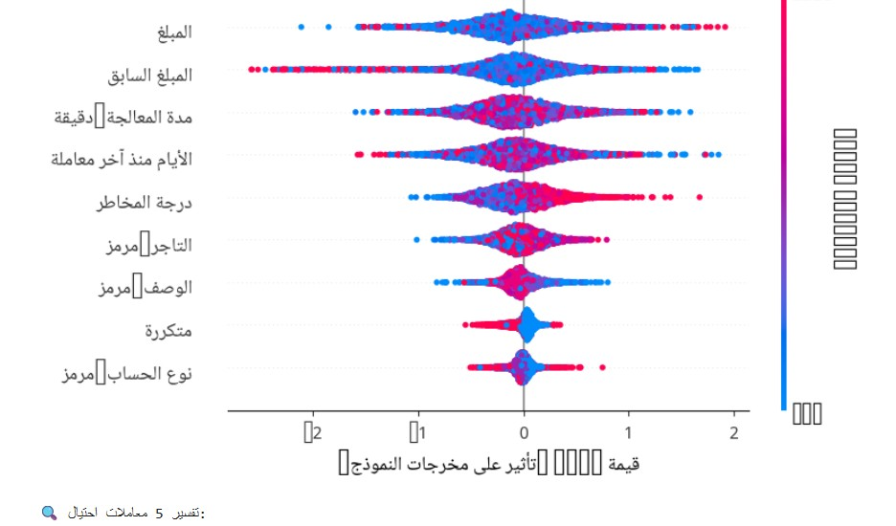
Figure 4.11: SHAP Beeswarm plot showing global feature impact and value distributions on model predictions.
- The SHAP summary plot in Figure 4.11 gives some crucial information regarding the effect of each feature individually on the model decisions:
- Feature Value Spectrum: Feature value highs are depicted in red/pink, while lows in blue are depicted.
- Impact Direction (SHAP Value): Positive SHAP values (on the right) pull the prediction towards the class label fraud, while negative SHAP values (on the left) pull the prediction towards the class label normal.
- Top Drivers of Suspicion:
  - Amount & Previous Amount: High feature values (red circles) show high SHAP values, showing that transaction amounts are highly likely to push predictions towards the suspicious/fraud class labels.
  - Processing Duration & Days Since Last Transaction: Spread wide, showing that high frequency or gaps in processing can be used to identify key contextual features.
  - Risk Score : High risk score (red circles) correlates positively with high SHAP values, thus pulling the predictions towards fraud.
4.6 Discussion and Practical Implications
The findings of the experiments show that the proposed method is able to tackle the key issues that SMEs encounter, namely the high level of manual effort, limited resources, and susceptibility to fraud. Hybrid feature selection helped in achieving a light and computable model on regular desktops, whereas stacking ensembles helped in producing good results on imbalanced datasets.
Use of the XAI methods helps bridge the gap between highly accurate “black boxes” and usability within the context of accounting tasks. In comparison to other relevant works (Chapter 2), the proposed approach provides a better compromise between automation, accuracy, and explainability.
4.7 Summary
In the present chapter, the empirical results and operational effectiveness of the suggested AI-powered smart accounting and fraud detection solution were assessed. The extensive exploratory data analysis (EDA) has provided insights into the crucial financial structures and financial outliers in the chosen transaction classes. The hybrid feature selection approach helped to determine the most important financial features, namely transactions values, processing times, and time intervals between transactions, as the main factors responsible for variability. Finally, the results of the classification pipeline experiment have demonstrated the ability of the model to separate high-value anomalies and the main sources of sensitivity in unbalanced datasets.

