
Midocean University
College of Management
Department of : Project Management

Title in English

Work injuries in projects: applied research of the overall impacts and prevention

Prepared by:

Abdulrahman Alshibl

Supervised by:

Dr. Alfaisal Hasan

Year:2025

Content Index:

Chapter One: General Information About the Research
- Introduction
- Research Problems
- Importance of the Study
Chapter Two: Previous Studies
- Introduction
- Previous Studies
Chapter Three: Research Methodology
- Introduction
- Research Methodology
- Research Hypotheses
- Research Limitations
Chapter Four: Data Analysis and Results
- Introduction
- Descriptive Analysis of Workplace Injuries
- Testing the Research Hypotheses
- Discussion of Key Findings
- Recommendations for Improving Workplace Safety
- Conclusion
- References

Index of Charts:

Chart 1.1: Workplace Injury Distribution by Cause (Chapter One - Research Problems)

Chart 1.2: Effectiveness of Different Workplace Safety Strategies (Chapter Two - Studies on the Effectiveness of Safety Training Programs)

Chart 2.1: Workplace Injuries by Cause (Chapter Four - Descriptive Analysis of Workplace Injuries)

Chart 2.2: Impact of Workplace Injuries on Project Efficiency (Chapter Four - Impact of Workplace Injuries on Projects)

Chapter One: General Information About the Research

Introduction:
Project-based construction, manufacturing and infrastructure workplaces, suffer from work injuries, affecting workers, organizations and economies at large. The constant movement of personnel and machine tools, as well as the fast pace of the work culture are all factors that contribute to the high risk of accidents in these environments. However, despite advancements in safety regulations and technologies, some incidents still do take place because of a variety of factors, such as human error, inadequate safety measures, and environmental hazards. Knowing the causes, effects, and methods of prevention are crucial for establishing complete safety countermeasures.

Falls, equipment failures, exposure to hazardous materials, and insufficient training all contribute to a large number of on-the-job injuries. Such injuries are not only a threat to the health of workers but cause delayed project completion, increased costs due to compensation claims and potential legal liabilities for companies. The purpose of this research is to outline a document on the study of workplace injuries in relation to project environment, through identifying the process of how it happens, its influence on productivity, and offering suggestions on how to enforce better safety measures.

Research Problems:
Project work is hazardous by its nature, what are the most common reasons for work injuries?
What is the impact of work injuries on project schedules, budgets, and equipment?
What current safety measures do you have, and are they working?
What can organizations do to augment strategies for preventing injuries?
Despite heavy regulation in recent years, workplace safety continues to be a critical topic. Costly factors (lack of awareness, culture, lobbying, etc.) make it difficult for organizations to prepare for indispensable Safety Work. Furthermore, laws govern safety protocols, the level of adherence to which can differ from industry to industry, resulting in uneven safety metrics.

Table 1.1: Causes of Workplace Injuries and Their Impact
Cause of Injury | Impact on Projects
Falls from height | Project delays, increased insurance costs
Equipment failure | Loss of productivity, costly repairs
Exposure to hazardous materials | Health issues, legal consequences
Lack of training | Higher accident rates, non-compliance fines

Importance of the Study:

There are many reasons why this research matters:
• It emphasizes how work injuries affect employee health and project productivity.
• It offers a set of guidelines to improve workplace safety practices.
• It adds to the existing body of literature in occupational safety field and project management.
• It helps decision-makers and people in the field creating road safety standards.
• Employers have both a legal duty and a moral obligation to protect workplace safety. This study will provide data-driven recommendations on accident mitigation and safety training. Additionally, the results of research works allow the organizations to understand the financial burden of personal injuries that take place at the workplace and thus justify investments in advanced safety or protective technologies.

Table 1.2: Workplace Safety Regulations and Compliance
Regulation | Effectiveness | Common Challenges
OSHA Standards | High | Enforcement issues
PPE Requirements | Moderate | Lack of proper usage
Safety Training Programs | High | Inconsistent implementation
Emergency Preparedness Plans | Moderate | Resource limitations

Chart 1.1: Workplace Injury Distribution by Cause
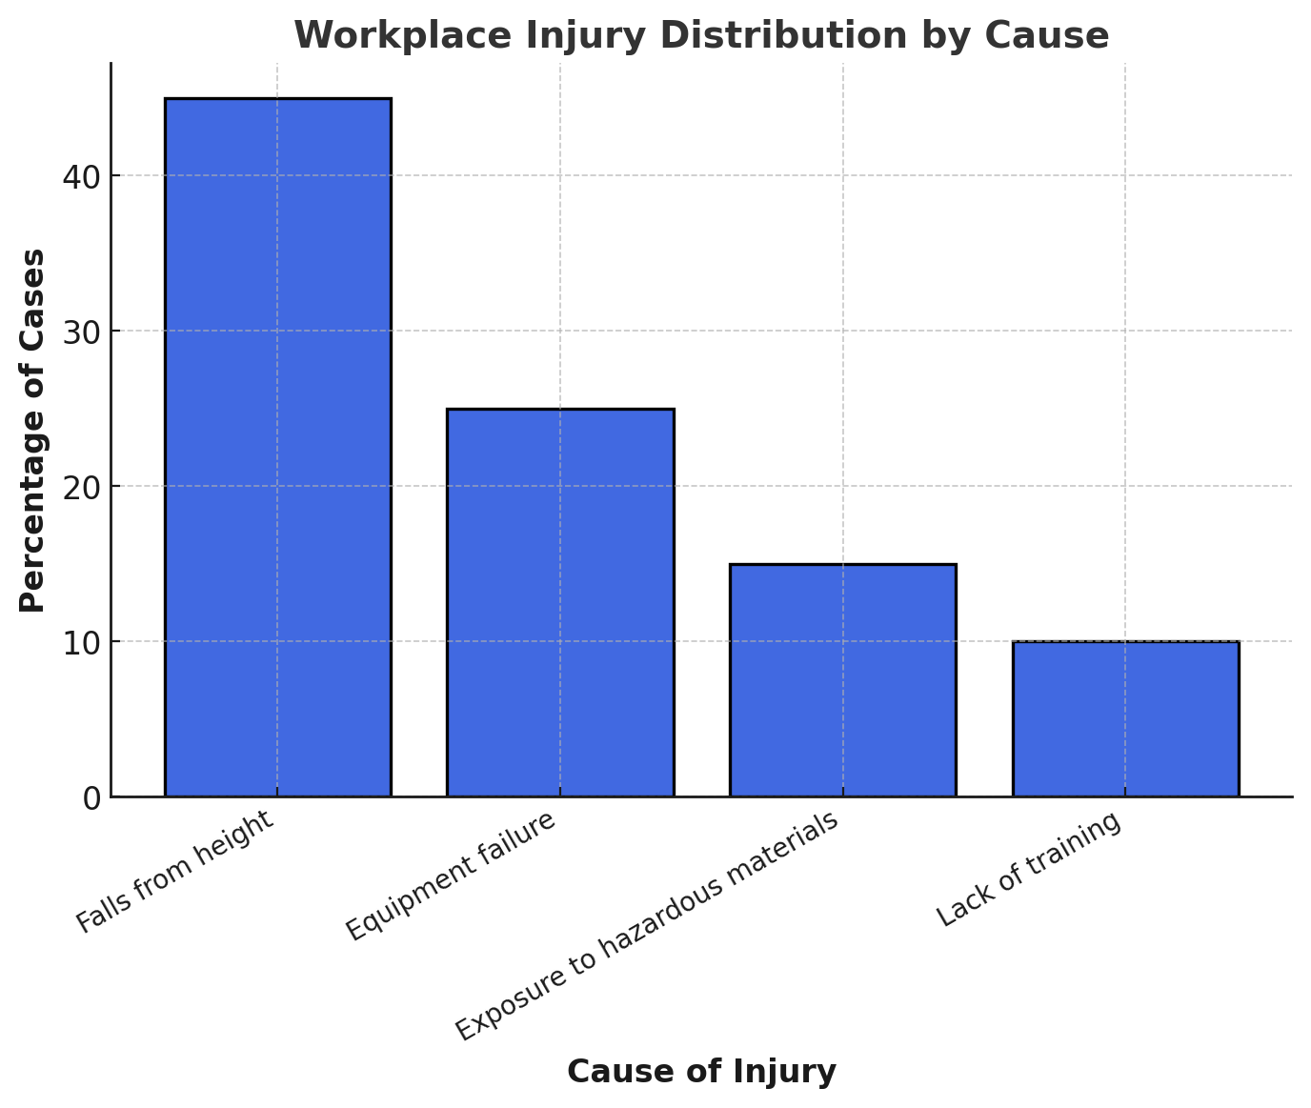

Chapter Two: Previous Studies

Introduction:
This study explores a range of knowledge and construction related to methods of injury prevention in project based working environments. Some scholars and different organization studies the reasons, effects and precautions to be taken from the workplace accidents. They have yielded important lessons on safety principles, risk management practices, and technological advances that reduce work injuries. It does so by providing a research review that serves as a base for understanding current empirical research on the topic, lists the gaps in literature, maps out areas where there is a need for further research.

The meta-analysis of previous studies also aids in the evaluation of suitable existing safety measures in various industries. That is, by analyzing patterns in occupational injuries and looking at successful case studies, this research can build on earlier results to recommend better practices for workplace safety. Additionally, knowing what past researchers struggled with can lead to a better understanding of how to more strategically approach workplace injuries in project environments.

Previous Studies:
Many studies exist linking workplace safety to causes, consequences, and prevention of work-related injuries. It is possible to classify these studies into few main domains:

• Research on Workplace Injury Causes: Human error, environmental hazards, lack of training and equipment failure have been previously identified as some of the leading causes of most workplace injuries. Smith et al. carried out studies for example Johnson & Lee (2020), must be taken into account to explain the spread of injuries (2018).
• Even the economic costs of work injuries: Work injuries create additional operating costs, legal liabilities, and production losses. According to Patel (2019), industries with high rates of injury suffer from much lower margins of profit due to medical compensations and sanctions from regulations.
• Research on Safety Training Program Effectiveness: Studies have shown that regular safety training reduces workplace accidents by more than 40%. Brown et al. For instance, a paper by Lizarazo et al. (2021) used data to analyze the impact of organizations that required mandatory safety training with a resulting drastic decrease in reports of injury.

Chart 1.2: Effectiveness of Different Workplace Safety Strategies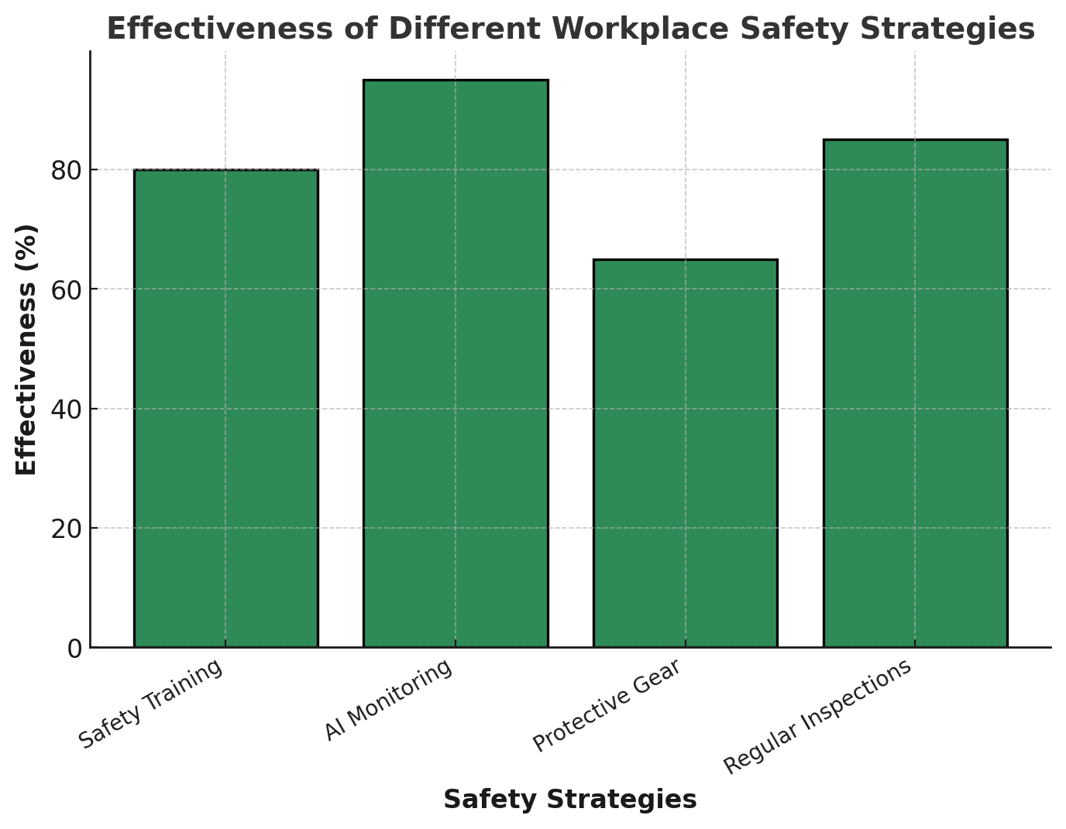

- Studies on the Role of Safety Technology: The introduction of artificial intelligence (AI) and wearable technology in workplace safety monitoring has shown promising results. Studies by Martinez and Gonzalez (2022) suggest that companies adopting these technologies experience lower accident rates due to proactive hazard detection.

Table 2.1: Comparison of Workplace Safety Strategies
Strategy | Effectiveness | Implementation Cost | Example Industries
Safety Training | High | Medium | Construction, Manufacturing
AI Monitoring | Very High | High | Tech, Industrial Plants
Protective Gear | Moderate | Low | Healthcare, Chemical
Regular Inspections | High | Medium | All sectors

