

College of Management

The Impact of Organizational Culture on Employee Satisfaction in Health Care Institution

Prepared by
Student Name
Muhannad Fawaz Al-Younis
243001724

Supervised by
Dr.

2025
Declaration
I, Muhannad Fawaz Al-Younis, hereby declare that this research titled “The Impact of Organizational Culture on Employee Satisfaction in Health Care Institution” is my original work and has not been submitted previously, in part or in full, to any university or institution for academic credit. All sources used have been properly acknowledged and referenced.

Dedication
This work is dedicated to my beloved family, whose unwavering support, encouragement, and prayers have been the foundation of my academic journey. I also dedicate this study to every healthcare professional striving to make a difference in patients’ lives every day.

Acknowledgment
First and foremost, I would like to thank Allah Almighty for granting me strength and perseverance throughout this research. I extend my sincere gratitude to my supervisor, for their invaluable guidance, feedback, and support at every stage of this study. I am also thankful to the management and nursing staff of Dr. Sulaiman Al Habib Hospitals for their cooperation and participation. Finally, I deeply appreciate my family and friends for their patience and constant encouragement.

Table of Contents
Content | Page
Dedication | i
Acknowledgment | ii
Declaration | iii
Abstract | iv
List of Tables | v
List of Figures | vi
Chapter One: Introduction | 1
1.1 Introduction | 5
1.2 Problem Statement | 7
1.3 Research Objectives | 9
1.4 Research Questions | 10
1.5 Significance of the Study | 11
Chapter Two: Literature Review | 12
2.1 Theoretical Framework | 12
2.2 Conceptual framework | 15
2.2 Review of Related Studies | 18
2.3 Critical Analysis and Summary | 22
Chapter Three: Methodology | 25
3.1 Research Design | 25
3.2 Study Setting and Population | 25
3.3 Sampling and Sample Size | 26
3.4 Data Collection Tool | 27
3.5 Data Collection Procedure | 27
3.6 Validity and Reliability | 28
3.7 Ethical Considerations | 29
3.8 Data Analysis Plan | 30
Chapter Four: Results | 31
4.1 Demographic and Professional Characteristics | 31
4.2 Organizational Culture Findings | 36
4.3 Job Satisfaction Findings | 40
4.4 Correlation Between Variables | 46
4.5 Analysis by Demographics | 51
Chapter Five: Discussion | 55
5.1 Discussion | 55
Chapter Six: Conclusion | 61
6.1 Conclusion | 61
6.2 Recommendations | 62
6.3 Study implications | 63
References | 64
Appendices | 68

Abstract
Background Organizational culture plays a pivotal role in shaping the work environment and influencing employee satisfaction, particularly in the healthcare sector where job demands are high and stress is common. A positive organizational culture has been associated with enhanced motivation, reduced burnout, and better job performance among healthcare workers. In contrast, toxic or weak cultures may result in dissatisfaction, high turnover, and compromised patient care. This study aimed to examine the impact of organizational culture on employee satisfaction among registered nurses in a private healthcare institution in Riyadh, Saudi Arabia.
Method: A cross-sectional quantitative study was conducted among 344 registered nurses at Dr. Sulaiman Al Habib Hospitals in Riyadh in 2025. Stratified random sampling was used, and data were collected using a structured questionnaire that included the Organizational Culture Assessment Instrument (OCAI) and the Job Satisfaction Survey (JSS). Descriptive statistics, Pearson’s correlation, and ANOVA were used to analyze the data via SPSS version 28.
Results: The overall mean score for organizational culture was moderate (2.98 ± 0.29), with the highest-rated elements being structured leadership (3.14 ± 1.39) and stable relationships (3.14 ± 1.41), while operational excellence (2.81 ± 1.38) and human development (2.86 ± 1.39) were the lowest. Job satisfaction also showed a moderate mean score (2.92 ± 0.55), with excessive workload (3.08 ± 1.48) being the top dissatisfaction factor. A strong and statistically significant positive correlation was found between organizational culture and job satisfaction (r = 0.687, p < 0.001). Age was the only demographic variable that significantly influenced perceptions of organizational culture (p = 0.033), with nurses aged 45–54 reporting the highest scores. No significant differences in job satisfaction were observed across demographic or professional variables.
Conclusion: The findings confirmed that a supportive and well-structured organizational culture significantly enhances job satisfaction among nurses. Leadership practices, workplace stability, and recognition were key cultural dimensions associated with higher satisfaction. These results suggest that healthcare managers should prioritize developing inclusive, development-focused, and engaging cultures to promote workforce stability and performance.
Keywords: Organizational Culture, Job Satisfaction, Nurses, Healthcare Institutions, Saudi Arabia, Employee Engagement, Leadership, Work Environment.

List of Tables
No. | Title
1 | Distribution of Participants by Age
2 | Distribution of Participants by Gender
3 | Distribution of Participants by Marital Status
4 | Distribution of Participants by Nationality
5 | Distribution of Participants by Educational Qualification
6 | Distribution of Participants by Years of Nursing Experience
7 | Distribution of Participants by Years of Experience at This Hospital
8 | Distribution of Participants by Department
9 | Distribution of Participants by Employment Type
10 | Distribution of Participants by Work Shift
11 | Distribution of Participants by Leadership Responsibility
12 | Distribution of Participants by Hospital Branch
13 | Descriptive Statistics of Organizational Culture Items
14 | Descriptive Statistics of Job Satisfaction Items
15 | Pearson Correlation Between Organizational Culture and Job Satisfaction
16 | Mean Differences in Organizational Culture and Job Satisfaction by Demographic Variables

List of Figures
No. | Title
1 | Distribution of Participants by Age
2 | Distribution of Participants by Gender
3 | Distribution of Participants by Marital Status
4 | Distribution of Participants by Nationality
5 | Distribution of Participants by Educational Qualification
6 | Distribution of Participants by Years of Nursing Experience
7 | Distribution of Participants by Years of Experience at This Hospital
8 | Distribution of Participants by Department
9 | Distribution of Participants by Employment Type
10 | Distribution of Participants by Work Shift
11 | Distribution of Participants by Leadership Responsibility
12 | Distribution of Participants by Hospital Branch
13 | Scatter Plot of the Correlation Between Organizational Culture and Job Satisfaction

Chapter One: Introduction
1.1 Introduction
Organizational culture has an important role in shaping the experiences of employees in healthcare institutions. It involves shared values, norms, beliefs, and behaviors that define the work environment and affect employee engagement and satisfaction. As showed by Belias and Koustelios (2021), organizational culture can affect employees perceptions of their workplace, affecting their motivation and commitment. In health sector, it is known that job demands are pressing, a strong positive organizational culture can be considered as motivation, increasing their commitment, reducing the rates of burnout, and promote overall job satisfaction (Hoxha et al., 2024). Conversely, a weak or toxic culture can lead to dissatisfaction, high turnover rates, and diminished quality of patient care. So, studying the effect of organizational culture on employee satisfaction is important for healthcare managers to create a supportive and productive workplace enviroment (Chaanine, 2025).
The healthcare industry is characterized by unique challenges, including long working hours, high levels of responsibility, emotional strain, and complex team dynamics. Within this demanding environment, organizational culture shapes the way employees interact, collaborate, and perceive their roles (Mokalu et al., 2019). Leadership style, communication, and institutional values are major determinants of workplace culture, influencing the morale and well-being of employees (Goldston, 2021). When healthcare facilities had a culture that support employee well-being, professional development, and achievement recognition, they create an environment with increased satisfaction. Employees who feel valued and supported are likely to involve in work, contributing to better patient outcomes and overall institutional success (Dadgar et al., 2019).
Several factors in organizational culture related to employee satisfaction in the health sector. Leadership plays a crucial role in setting the tone for workplace culture. Aldhuwaihi (2019) found that leadership that showed mentoring and support promote higher job satisfaction. Supportive and transparent leadership promote trust and motivation, while authoritarian or disengaged management can lead to dissatisfaction and high stress levels (Chaanine, 2025). Effective communication within the professional team can promote cooperation and reduce conflicts between them, while poor communication may lead to more frustration and conflicts between the team members (Belias & Koustelios, 2021). Work-life balance is another factor, as excessive workloads and high expectations can cause burnout. Also, a strong ethical consideration where employees feel their work agree with institutional systems and values strengthens their sense of purpose and fulfillment (Tannady et al., 2019). A culture that recognizes and rewards employee contributions further reinforces job satisfaction, making staff feel appreciated and motivated to perform at their best (Hoxha et al., 2024).
A positive organizational culture has many benefits for employee satisfaction. When employees feel supported and valued, their engagement levels increase, leading to improved job performance and enhanced patient care (Mokalu et al., 2019). A healthy work environment promote teamwork, reduces stress, and strengthens the emotional resilience of healthcare workers (Dadgar et al., 2019). Health facilities with strong cultures of respect and collaboration experience lower turnover rates, as employees are expected to remain working when they feel as a part of a cohesive and well-functioning team (Goldston, 2021). Furthermore, satisfied employees are more likely to develop a sense of professional pride and commitment, contributing to a culture of excellence within the organization (Aldhuwaihi, 2019).
On the other hand, a negative organizational culture can have poor consequences for both employees and patients. Poor management practices, lack of communication, and absence of support mechanisms lead to job dissatisfaction, low morale, and disengagement (Hoxha et al., 2024). Employees in toxic work places often have increased stress, burnout, and even mental health issues (Tannady et al., 2019). High turnover rates become a persistent problem, as dissatisfied employees seek better opportunities elsewhere (Mokalu et al., 2019). This continuous cycle of staff departures affects institutional stability, leading to understaffing, overworked teams, and compromised patient care (Dadgar et al., 2019). When staff feel undervalued and unappreciated, their productivity become low, lead for inefficiencies and a lower performance standard of service delivery (Belias & Koustelios, 2021).
Improving organizational culture in healthcare institutions need deliberate efforts from leadership and management teams. Investing in leadership development ensures that managers and supervisors possess the skills needed to create a positive and motivating work environment (Aldhuwaihi, 2019). Encouraging open communication and feedback push employees to voice concerns and contribute to decision-making processes, promoting a sense of inclusion and belonging (Chaanine, 2025). Promoting work-life balance through flexible scheduling, mental health support, and wellness programs enhances employee well-being (Hoxha et al., 2024). Additionally, recognizing and rewarding employee achievements by incentives and career advancement opportunities increase morale and motivation (Tannady et al., 2019). Creating a culture of teamwork and mutual respect strengthens collaboration, exposed them to a more cohesive and productive workforce (Mokalu et al., 2019).
Several healthcare institutions have successfully transformed their organizational culture to improve employee level of satisfaction. Case studies of hospitals that have implemented supportive leadership structures, effective communication channels, and comprehensive employee wellness programs demonstrate the impact of a positive work culture (Dadgar et al., 2019). Institutions that actively invest in staff development, continuous training, and recognition programs found measurable improvements in job satisfaction, retention rates, and thier overall performance (Goldston, 2021). Learning from these best practices experiences can guide other healthcare organizations in implementing similar strategies to promote a more engaged and satisfied workforce (Aldhuwaihi, 2019).
Evaluating the effect of organization culture change on employee satisfaction requires continuous evaluations and monitoring. Measuring improvements through employee surveys, feedback mechanisms, and performance evaluations helps identify areas that need further development (Chaanine, 2025). A growing organizational culture is characterized by high levels of employee engagement, lower absenteeism, and a strong sense of professional fulfillment among staff (Belias & Koustelios, 2021). Through prioritizing organizational culture as a key factor in employee satisfaction, healthcare institutions can create environments that support their workforce while ensuring high-quality patient care (Hoxha et al., 2024).
Ultimately, the link between organizational culture and employee satisfaction in healthcare institutions is undeniable. A positive culture promote motivation, loyalty, and productivity, whereas a negative one leads to dissatisfaction, burnout, and poor patient outcomes (Tannady et al., 2019). Investing in a strong organizational culture not only benefits healthcare workers but also enhances institutional reputation and overall service quality (Aldhuwaihi, 2019).

1.2 Problem Statement
​ Organizational culture significantly impacts employee satisfaction within healthcare institutions. A negative organizational culture can lead to increased work-related stress, burnout, and diminished quality of patient care. Belias and Koustelios (2021) showed that organizational culture influences employees' perceptions of their work environment, directly affecting job satisfaction and engagement. Globally, healthcare workers face substantial challenges due to adverse organizational environments. Hoxha et al. (2024) reported that poor workplace environments in healthcare contribute to increased stress and lower productivity, which in turn negatively affects patient care quality. For instance, work-related stress has compromised patient care quality and negatively affected nurses' quality of work life, posing a public health concern in healthcare systems worldwide (Tannady et al., 2019).
Regionally, similar issues persist. In a study examining the relationship between patient safety culture and healthcare workers' well-being in Taiwan, a negative correlation was found between patient safety culture and staff burnout. Goldston (2021) noted that a lack of a supportive and safe work environment leads to heightened levels of emotional exhaustion among healthcare workers. This suggests that poor organizational culture contributes to increased burnout among healthcare professionals, adversely affecting both staff well-being and patient safety (Mokalu et al., 2019).
In Saudi Arabia, the situation is equally concerning. A systematic review assessing job satisfaction among healthcare workers in primary healthcare settings revealed significant dissatisfaction, particularly among physicians, with a satisfaction rate as low as 7.3% (Aldhuwaihi, 2019). Factors such as inadequate salaries, lack of professional development opportunities, and poor management practices were identified as contributors to this dissatisfaction (Chaanine, 2025). Additionally, a study focusing on wound care professionals in Saudi Arabia reported alarming levels of burnout, with 79.7% of participants experiencing high levels of burnout (Dadgar et al., 2019). Job satisfaction scores were moderately low, showed the need to address both burnout and job satisfaction in this workforce (Hoxha et al., 2024).
These findings showed the urgent need for healthcare institutions to cultivate positive organizational cultures that support employee well-being, enhance job satisfaction, and ultimately improve patient care outcomes. Tannady et al. (2019) argued that workplace culture improvements, including leadership development and better communication strategies, can significantly enhance employee morale and retention. After addressing these issues, healthcare institutions can create a healthier and more sustainable work environment for their employees while ensuring the delivery of high-quality patient care (Aldhuwaihi, 2019).

1.3 Justification
A strong justification for this study is necessary given the increasing concerns surrounding employee dissatisfaction in healthcare institutions due to organizational culture. The healthcare sector is a high-stress environment, where job satisfaction is directly linked to workforce stability, quality of care, and overall institutional effectiveness. Despite the critical role of organizational culture in shaping workplace experiences, many healthcare institutions continue to struggle with issues such as poor leadership, lack of communication, inadequate employee recognition, and limited professional development opportunities. These factors contribute to high turnover rates, increased burnout, and declining job performance among healthcare professionals.
On a global level, burnout among healthcare workers has reached alarming levels. Studies indicate that nearly half of physicians in the United States report experiencing burnout, with female physicians being disproportionately affected. Belias and Koustelios (2021) showed that workplace dissatisfaction in healthcare is often linked to emotional exhaustion and poor institutional support. In the United Kingdom, surveys have revealed that approximately 71% of General Practitioners suffer from compassion fatigue, showing the widespread emotional and physical toll of negative workplace environments (Hoxha et al., 2024). Regionally, healthcare institutions across the Middle East, including Saudi Arabia, face similar challenges, with dissatisfaction among medical professionals attributed to poor organizational structures, ineffective management practices, and lack of work-life balance (Mokalu et al., 2019).
Saudi Arabia, in particular, presents a compelling case for this study due to the country’s ongoing efforts to enhance healthcare services as part of Vision 2030. Reports indicate that only 7.3% of physicians in Saudi primary healthcare centers express high job satisfaction, signaling an urgent need for reforms in workplace culture and management strategies (Aldhuwaihi, 2019). Additionally, with burnout rates among wound care professionals reaching nearly 80%, the issue extends beyond dissatisfaction to a critical workforce retention and performance challenge (Chaanine, 2025).
Given these concerns, this study is essential for identifying the negative aspects of organizational culture that contribute to employee dissatisfaction. Tannady et al. (2019) showed that improving workplace culture through leadership development and better communication can significantly enhance employee retention. Through examining these factors and proposing evidence-based strategies to improve workplace environments, this research aims to support healthcare institutions in promoting positive organizational cultures (Goldston, 2021). Ultimately, improving employee satisfaction in healthcare settings not only benefits medical professionals but also enhances patient care outcomes, institutional efficiency, and overall healthcare system resilience (Dadgar et al., 2019).

1.4 Study Objectives
1.4.1 General Objective:
To examine the effect of organizational culture on employee satisfaction in Dr. Sulaiman Al Habib Hospital in Riyadh, Saudi Arabia.

1.4.2 Specific Objectives:
- To assess the characteristics and dimensions of organizational culture in Dr. Sulaiman Al Habib Hospital.
- To evaluate the level of employee satisfaction in Dr. Sulaiman Al Habib Hospital and identify key influencing factors.
- To analyze the relationship between organizational culture and employee satisfaction in Dr. Sulaiman Al Habib Hospital.

1.5 Study Questions
1.5.1 General Research Question:
What is the impact of organizational culture on employee satisfaction in Dr. Sulaiman Al Habib Hospital in Riyadh, Saudi Arabia?

1.5.2 Specific Research Questions:
- What are the characteristics and dimensions of organizational culture in Dr. Sulaiman Al Habib Hospital?
- What is the level of employee satisfaction in Dr. Sulaiman Al Habib Hospital, and what are the key influencing factors?
- What is the relationship between organizational culture and employee satisfaction in Dr. Sulaiman Al Habib Hospital?

1.6 Study Hypothesis
Null Hypothesis (H₀):
There is no significant impact of organizational culture on employee satisfaction in Dr. Sulaiman Al Habib Hospital in Riyadh, Saudi Arabia.
Alternative Hypothesis (H₁):
There is a significant impact of organizational culture on employee satisfaction in Dr. Sulaiman Al Habib Hospital in Riyadh, Saudi Arabia.

Chapter Two: Literature review
2.1 Theoretical Foundations of the Study
This study is anchored in a set of foundational organizational and psychological theories that explain the relationship between organizational culture and employee satisfaction. These theories offer a multi-dimensional understanding of how workplace values, leadership styles, and employee perceptions interact to influence motivation, engagement, and retention—particularly in high-pressure settings such as healthcare institutions.
2.1.1 Cameron and Quinn’s Competing Values Framework (1999)
One of the central frameworks guiding this study is the Competing Values Framework (CVF) developed by Cameron and Quinn. This model identifies four dominant types of organizational culture: clan, adhocracy, market, and hierarchy, each characterized by a specific internal structure and managerial orientation.
The clan culture emphasizes teamwork, participation, and a family-like atmosphere, where interpersonal relationships and mentoring are highly valued. This culture has been associated with increased job satisfaction due to its supportive nature. The adhocracy culture, on the other hand, promotes innovation, risk-taking, and flexibility, which may lead to higher engagement among employees who value creativity and autonomy.
In contrast, the market culture is results-driven, competitive, and focused on targets and productivity, which may lead to stress and dissatisfaction if performance expectations outweigh organizational support. Similarly, hierarchy culture, which values structure, stability, and control, may offer operational efficiency but can suppress employee motivation due to its rigid systems. In healthcare settings, where adaptability, teamwork, and emotional support are critical, clan and adhocracy cultures are often seen as more conducive to staff satisfaction and performance (Cameron & Quinn, 1999).

2.1.2 Herzberg’s Two-Factor Theory (1959)
Herzberg’s Two-Factor Theory provides another critical foundation for understanding job satisfaction. The theory distinguishes between hygiene factors (such as salary, supervision, and working conditions) and motivational factors (including recognition, responsibility, and achievement). According to Herzberg, the absence of hygiene factors can cause dissatisfaction, but their presence alone does not lead to satisfaction. True job satisfaction stems from motivational factors.
Organizational culture plays a significant role in shaping both sets of factors. A culture that values fairness, transparency, and well-being ensures that hygiene factors are met. More importantly, cultures that recognize achievements, support growth, and empower staff directly contribute to motivation. In healthcare, where nurses face emotionally and physically demanding work, culture becomes a key determinant of whether they feel merely stable or genuinely fulfilled in their roles (Herzberg, 1959).
2.1.3 Social Exchange Theory – Blau (1964)
The Social Exchange Theory proposed by Blau provides a relational lens to understand how employees respond to their work environment. The theory posits that employee behavior is based on the principle of reciprocity: when individuals perceive that they are treated fairly, respected, and supported, they are more likely to return this with loyalty, trust, and discretionary effort.
In the context of organizational culture, a positive and inclusive culture fosters mutual respect and psychological safety. This, in turn, encourages employees to remain committed and productive. Conversely, when culture is perceived as authoritarian, discriminatory, or indifferent, employees may become disengaged and consider leaving. This theory is particularly relevant in healthcare, where emotional bonds, teamwork, and trust are essential components of clinical effectiveness (Blau, 1964).

2.1.3 Meyer and Allen’s Three-Component Model of Commitment (1991)
Meyer and Allen’s Three-Component Model of Organizational Commitment provides a comprehensive view of how employees relate to their organizations emotionally and behaviorally. The model includes:
- Affective commitment (emotional attachment to the organization),
- Continuance commitment (awareness of costs associated with leaving), and
- Normative commitment (a perceived obligation to stay). Organizational culture significantly influences these components. For example, a culture that emphasizes respect, ethical leadership, and employee development tends to enhance affective and normative commitment. Employees feel both emotionally connected and morally responsible to stay. In contrast, a negative culture may result in employees staying merely due to lack of alternatives or fear of loss, which may not translate into job satisfaction.
In healthcare institutions, especially in settings undergoing structural reforms such as in Saudi Arabia, understanding the drivers of commitment helps administrators design interventions that go beyond monetary incentives and address deeper cultural factors (Meyer & Allen, 1991).
2.1.4 Relevance to the Current Study
These theoretical models collectively establish the rationale for exploring how organizational culture impacts employee satisfaction in healthcare institutions. Cameron and Quinn’s framework offers a diagnostic tool for identifying cultural typologies; Herzberg explains the distinction between preventing dissatisfaction and achieving motivation; Blau highlights the reciprocal nature of employee-organization relationships; and Meyer and Allen reveal how culture affects long-term commitment and retention.
In the context of this study—conducted among nurses in a private healthcare setting in Saudi Arabia—these theories serve not only as interpretive lenses but also as guiding structures for the analysis of how cultural factors enhance or hinder satisfaction in demanding, high-stakes work environments.
2.2 Conceptual Framework
The conceptual framework guiding this study is grounded in the integration of organizational behavior theories and empirical evidence on workplace culture and employee satisfaction. The framework was designed to explore how organizational culture—characterized by shared values, norms, practices, and leadership styles—affects job satisfaction among nurses in healthcare institutions. Additionally, it incorporates the potential influence of demographic and professional characteristics as moderating variables.
2.2.1 Independent Variable: Organizational Culture
Organizational culture is conceptualized as the independent variable in this study. It encompasses the collective values, beliefs, assumptions, and behaviors that define the internal environment of an institution. Drawing upon Cameron and Quinn’s Competing Values Framework (1999), this variable includes four key dimensions:
- Clan Culture: Reflects a family-like, supportive environment with an emphasis on mentoring, participation, and trust.
- Adhocracy Culture: Prioritizes innovation, adaptability, and growth, encouraging creativity and autonomy.
- Market Culture: Focuses on competitiveness, goals, and external positioning, often emphasizing productivity and achievement.
- Hierarchy Culture: Characterized by formal procedures, control, and operational stability.
Each of these cultural types is expected to influence employee experiences differently, shaping their satisfaction either positively or negatively, depending on alignment with personal values and work expectations.

2.2.2 Dependent Variable: Employee Job Satisfaction
Job satisfaction is the dependent variable and refers to the degree to which nurses feel fulfilled, valued, and content with their work roles and environment. It is a multidimensional construct that includes intrinsic and extrinsic factors such as:
- Satisfaction with work tasks
- Relationships with colleagues
- Recognition and reward systems
- Workload balance
- Leadership support
This construct draws upon Herzberg’s Two-Factor Theory (1959), which differentiates between hygiene factors (e.g., pay, working conditions) and motivators (e.g., recognition, achievement). A positive organizational culture is assumed to strengthen both categories, thus enhancing overall job satisfaction.
2.2.3 Moderating Variables: Demographic and Professional Characteristics
Demographic and professional attributes of the participants (such as age, gender, marital status, education level, years of experience, department, shift type, and hospital branch) are treated as moderating variables. These variables may influence how organizational culture is perceived and how strongly it affects job satisfaction.
For example:
- Older nurses may value hierarchical or clan cultures more than younger nurses, who might prefer adhocracy environments.
- Experienced nurses may respond differently to organizational stability and autonomy compared to novice nurses.
This component of the framework is informed by Meyer and Allen’s (1991) model of organizational commitment and Blau’s (1964) Social Exchange Theory, which both highlight the personal and relational aspects of workplace behavior.
Hypothesized Relationships
Based on theoretical assumptions and prior research, the framework posits the following core relationships:
- There is a positive correlation between organizational culture and employee job satisfaction.
- Different cultural types (e.g., clan vs. market) have varying degrees of influence on satisfaction levels.
- Demographic and professional factors moderate the relationship between organizational culture and satisfaction, amplifying or attenuating the effects depending on personal background.
This conceptual model integrates both theoretical grounding and contextual relevance. The use of the Competing Values Framework allows the study to identify cultural typologies prevalent in healthcare settings. The application of Herzberg's theory enables differentiation between satisfaction sources. Meanwhile, Blau’s exchange theory and Meyer & Allen’s commitment model explain why culture leads to loyalty and satisfaction in a reciprocal dynamic.
In the context of Saudi Arabia’s healthcare sector, where organizational reforms and workforce retention are critical challenges, this framework provides a comprehensive lens to assess how cultural dynamics translate into employee outcomes, particularly among nursing staff who form the operational backbone of hospital services.
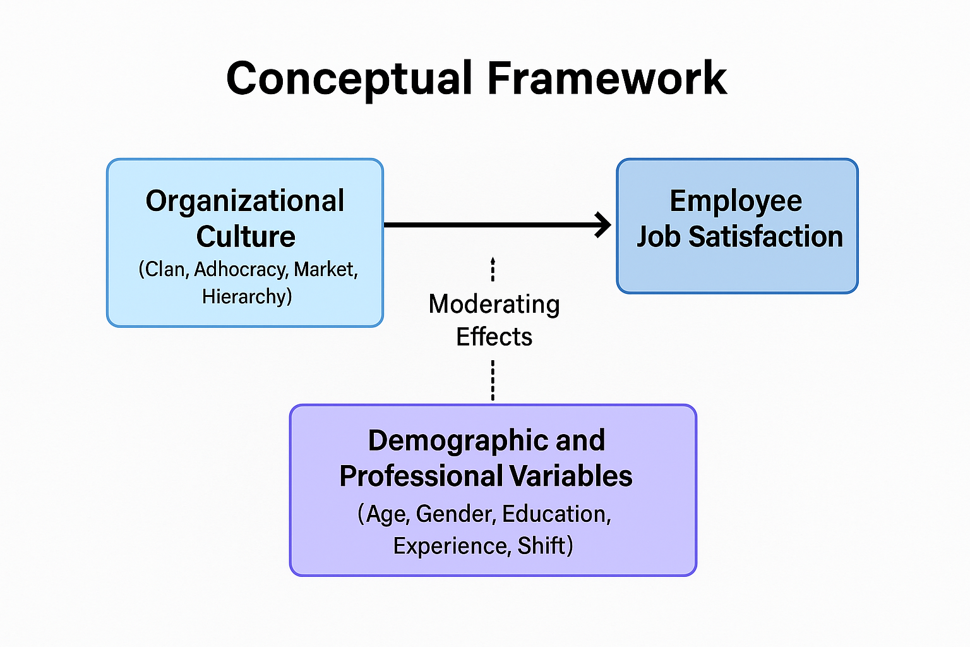
2.3 Previous studies
Organizational culture is a fundamental factor influencing employee satisfaction and workplace dynamics, particularly in healthcare institutions. A strong organizational culture promote teamwork, motivation, and commitment, ultimately enhancing job satisfaction and improving patient care. Conversely, a weak or toxic culture can contribute to stress, burnout, and high turnover rates among healthcare professionals. Leadership style, communication, recognition, and professional development opportunities play a crucial role in shaping organizational culture, directly impacting employee morale and engagement.
Given the demanding nature of the healthcare sector, where long working hours, emotional strain, and high levels of responsibility are common, understanding the relationship between organizational culture and job satisfaction is essential. Healthcare institutions that prioritize a positive work culture not only benefit their employees but also enhance institutional stability, workforce retention, and service quality. Despite growing awareness of the importance of organizational culture, many healthcare systems continue to struggle with issues such as poor leadership, lack of effective communication, and inadequate support mechanisms for employees. Addressing these challenges requires a deeper understanding of how workplace culture influences employee well-being, productivity, and long-term commitment.
Aldhuwaihi (2019) conducted a study in Saudi Arabia to explore how different types of organizational culture influence job satisfaction, organizational commitment, and turnover intention in the banking sector. The study aimed to assess the applicability of Quinn and Rohrbaugh's Competing Values Framework in the Saudi context, determine the dominant organizational culture type in Saudi banks, and examine the extent to which job satisfaction and commitment mediate the relationship between organizational culture and turnover intention. Data were collected from 258 front-line employees across 12 banks in Riyadh, including Islamic local banks, non-Islamic local banks, and partially foreign-owned banks. The study employed correlation and regression analyses using SPSS. The results indicated that the Competing Values Framework was applicable to the Saudi banking sector and that market culture was the most dominant type. Additionally, all organizational culture types positively influenced job satisfaction and organizational commitment, with clan, adhocracy, and hierarchy cultures having a stronger effect than market culture. Job satisfaction and organizational commitment significantly mediated the relationship between organizational culture and turnover intention, except for market culture, which showed no mediation effect. The study concluded that promoting a positive organizational culture is essential for enhancing employee satisfaction and reducing turnover in Saudi banks. It also provided valuable insights into the distinction between conventional and Islamic banks regarding employee behavior.
Hoxha et al. (2024) conducted a study in Greece to explore how organizational culture influences job satisfaction and sustainable healthcare quality. The study aimed to identify strategies that optimize work processes and create a supportive environment, ultimately enhancing employee well-being. The results indicated that reducing workplace stress through operational efficiency and waste minimization significantly improved job satisfaction. Furthermore, healthcare organizations that prioritized employee satisfaction were more likely to maintain high-quality patient care and sustainability. The study concluded that promoting a positive organizational culture is essential for sustainable healthcare systems, recommending approaches such as Green Lean Six Sigma to enhance workforce well-being and environmental sustainability.
Belias and Koustelios (2021) conducted a critical review in Greece on the relationship between organizational culture and job satisfaction. The study aimed to assess how workplace attitudes, behaviors, and organizational values influence employee perceptions of their work environment, interpersonal relations, earnings, and promotion opportunities. The results demonstrated that job satisfaction is closely linked to employees' perception of their organizational culture, with factors such as leadership style, institutional goals, and workplace relationships playing a significant role. Additionally, demographic factors, particularly gender, influenced employees' preferences for organizational culture. The study concluded that analyzing both organizational culture and employee characteristics is crucial for developing effective strategies to enhance job satisfaction.
Chaanine (2025) conducted a study in Lebanon examining the influence of organizational culture on employee loyalty, trust, and job satisfaction. The study aimed to explore the role of transparency, supportiveness, and ethical leadership in improving employee engagement and retention. Using a structured survey of 270 healthcare professionals, the study applied structural equation modeling (SEM) to validate the theoretical framework. The results indicated that a strong organizational culture significantly enhances employee trust and satisfaction, which in turn strengthens employee loyalty and reduces turnover. The study concluded that promoting a positive corporate culture is a crucial strategy for improving employee retention and healthcare performance, particularly in economically and politically unstable environments like Lebanon.
Tannady et al. (2019) examined the effect of organizational culture and employee engagement on job performance in Jakarta’s healthcare sector. The study aimed to determine the relationship between organizational culture and employee performance, using employee engagement as a mediating variable. Conducted across 23 hospitals, the study surveyed 1000 patients to assess their perceptions of healthcare workers' performance, revealing that 61% of respondents rated employee performance as poor. The findings showed that a strong organizational culture positively impacts employee engagement, which in turn enhances job performance. The study concluded that improving workplace culture and employee involvement is essential for delivering higher-quality healthcare services.
Mokalu et al. (2019) conducted a study in Indonesia to examine the impact of organizational culture and job satisfaction on employee performance in the emergency department of Prof. Dr. R. D. Kandow Hospital. The study aimed to analyze whether workplace culture and employee satisfaction directly influence job performance. The findings indicated that both organizational culture and job satisfaction significantly affected employee performance, with a strong cultural environment contributing to better teamwork and motivation. The study concluded that hospital administrators should focus on strengthening organizational culture and employee satisfaction policies to enhance overall healthcare performance.
Dadgar et al. (2019) investigated the relationship between organizational culture, job satisfaction, organizational commitment, and intention to stay among healthcare personnel at Zahedan University of Medical Sciences in Iran. The study aimed to identify how different organizational culture types influenced employees' intention to remain in their positions. The findings revealed that a clan culture (characterized by collaboration and support) had a significant positive relationship with job satisfaction and retention, whereas adhocracy and market cultures were negatively associated with the intention to stay. The study concluded that promoting a supportive workplace culture enhances employee commitment and reduces turnover rates.
Goldston (2021) conducted a doctoral dissertation study in the United States to investigate the relationship between traits of organizational culture and job satisfaction in healthcare settings. The study aimed to determine how different cultural traits—mission, involvement, adaptability, and consistency—affect job satisfaction. Data collected from 295 healthcare employees showed that organizational adaptability significantly predicted satisfaction with coworker relationships, while employee involvement had a strong influence on satisfaction with pay and overall job satisfaction. The study concluded that improving adaptability and involvement in healthcare organizations could enhance job satisfaction and ultimately improve patient care outcomes.
Wirdawati et al. (2021) investigated how organizational culture and work discipline influence patient satisfaction through the quality of healthcare services in Indonesia. The study aimed to analyze whether workplace culture directly impacts patient perceptions of care quality. Using survey data from 100 patients, the study found that corporate culture significantly affects patient satisfaction, with disciplined employees delivering higher-quality services. The study concluded that hospitals should enhance workplace culture and professionalism to improve patient satisfaction and healthcare service delivery.
2.4 Critical analysis
The reviewed literature presents a compelling consensus that organizational culture plays a pivotal role in shaping employee satisfaction, particularly in complex sectors like healthcare. In Saudi Arabia, Aldhuwaihi (2019) applied the Competing Values Framework (CVF) to the banking sector and found that although market culture was dominant, clan, adhocracy, and hierarchy cultures were more strongly associated with employee satisfaction and organizational commitment. Notably, job satisfaction and commitment mediated the link between culture and turnover intention, highlighting the value of fostering supportive internal environments. Similarly, Chaanine (2025) conducted a structural equation modeling study in Lebanon and confirmed that transparency, supportive leadership, and ethical practices enhance employee trust and satisfaction, leading to greater loyalty and reduced turnover. In Greece, Hoxha et al. (2024) emphasized that reducing workplace stress through operational efficiency improved staff well-being and healthcare quality, advocating for sustainability strategies like Green Lean Six Sigma. A critical review by Belias and Koustelios (2021) further revealed that leadership style, interpersonal relations, and institutional goals significantly influence job satisfaction, with demographic variables such as gender shaping employee preferences toward specific cultural attributes.
In the broader Asian and international contexts, several studies reinforce the organizational culture–satisfaction nexus through empirical evidence. In Indonesia, Tannady et al. (2019) surveyed hospital patients and found that employee engagement—driven by a strong workplace culture—significantly boosted job performance. Similarly, Mokalu et al. (2019) showed that both culture and satisfaction influenced nurse performance in emergency departments by enhancing motivation and teamwork. Another Indonesian study by Wirdawati et al. (2021) demonstrated that organizational culture and work discipline directly affect patient satisfaction, linking internal professionalism with external care quality. In Iran, Dadgar et al. (2019) found that clan culture positively influenced both job satisfaction and employees’ intention to stay, while adhocracy and market cultures were negatively associated with retention. In the United States, Goldston (2021) revealed that adaptability and employee involvement predicted higher satisfaction with peer relationships and pay, supporting the idea that inclusive and flexible cultures enhance workplace morale. Together, these findings underscore that while cultural preferences and outcomes may vary by context, supportive, adaptive, and values-driven cultures consistently contribute to higher satisfaction and reduced attrition—insights that are particularly relevant for healthcare institutions in Saudi Arabia undergoing workforce transformation under Vision 2030.
2.5 Literature Gap
While extensive research has explored the impact of organizational culture on job satisfaction, much of the existing literature focuses on general corporate environments rather than healthcare-specific challenges. Studies conducted in Western countries have primarily examined how leadership styles and workplace policies influence employee satisfaction, but few studies have thoroughly explored the mediating role of organizational commitment in healthcare institutions (Belias & Koustelios, 2021). Additionally, while research in the United States and Europe has linked workplace culture to employee retention and job performance, there remains a lack of empirical evidence on how cultural adaptability and institutional support systems affect long-term engagement in non-Western healthcare settings (Hoxha et al., 2024). Moreover, studies often fail to address how factors such as ethical workplace climates, job autonomy, and employee recognition influence job satisfaction in high-stress healthcare environments, leaving a critical gap in understanding effective organizational culture strategies for the healthcare workforce (Chaanine, 2025).
In Saudi Arabia, there is a significant gap in research examining the role of organizational culture in shaping job satisfaction among healthcare professionals. While Aldhuwaihi (2019) investigated organizational culture in the banking sector, there is a lack of similar studies focusing on the healthcare industry. Reports indicate that burnout rates among healthcare professionals in Saudi Arabia are alarmingly high, particularly among nurses and wound care specialists, yet research on how organizational culture contributes to this issue remains scarce (Dadgar et al., 2019). Furthermore, previous studies have identified job dissatisfaction in Saudi Arabia’s healthcare sector, with low levels of job satisfaction (as low as 7.3% among physicians), yet little attention has been given to the underlying organizational factors driving this dissatisfaction (Hoxha et al., 2024). Additionally, while Saudi Arabia is undergoing major healthcare transformations under Vision 2030, there is limited research on how organizational culture reforms can enhance employee satisfaction and retention (Tannady et al., 2019). Addressing these gaps will provide valuable insights into the specific cultural and managerial changes needed to create a more supportive and productive healthcare environment in Saudi Arabia.
2.6 The contribution of the current study
The This study contributes significantly to the existing literature by providing empirical evidence on the relationship between organizational culture and employee satisfaction within the private healthcare sector in Saudi Arabia—an area that remains underexplored despite the country's ongoing healthcare transformation under Vision 2030. Unlike previous research conducted in banking or public health settings, this study focused on registered nurses across multiple branches of Dr. Sulaiman Al Habib Hospitals, offering insights into how culture is perceived within a high-demand, multi-site clinical environment. By identifying specific cultural dimensions—such as leadership structure and human development—that correlate with job satisfaction, the study not only confirms theoretical frameworks like the Competing Values Model and Social Exchange Theory but also highlights context-specific patterns related to age, professional experience, and work settings. These findings provide a localized understanding of how workplace culture influences morale, which can inform managerial strategies aimed at improving retention, engagement, and overall healthcare quality in similar institutions across the Gulf region.

Chapter three: Methods
3.1 Study Design
This study was a quantitative, observational, cross-sectional hospital based research design
3.2 Study Setting
The study was conducted at Dr. Sulaiman Al Habib Hospital in Riyadh, a leading private healthcare institution in Saudi Arabia known for its advanced medical services and large nursing workforce. Dr. Sulaiman Al Habib Hospital in Riyadh is part of the Dr. Sulaiman Al Habib Medical Group, one of the leading healthcare providers in the Middle East. Established in 1995, the group has expanded to include multiple hospitals and medical centers across Saudi Arabia, the UAE, and Bahrain. The hospital in Riyadh is known for its state-of-the-art medical facilities, advanced technology, and highly skilled healthcare professionals.
3.3 Study Duration
The study was conducted over a period of six months, including survey development, data collection, analysis, and reporting.
3.4 Study Population
The target population consists of registered nurses employed at Dr. Sulaiman Al Habib Hospital. The study aims to include at least 250 nurses to ensure a representative sample.
3.4.1 Inclusion Criteria
- Registered nurses employed at Dr. Sulaiman Al Habib Hospital.
- Nurses with at least six months of work experience in the hospital.
- Nurses willing to participate in the study and provide informed consent.

3.4.2 Exclusion Criteria
- Nurses with less than six months of employment at the hospital.
- Administrative staff or healthcare professionals other than nurses.
- Nurses on extended leave (e.g., maternity leave, medical leave) during the study period.
- Nurses unwilling to participate or fail to provide informed consent.
3.5 Sampling
3.5.1 Sample size
The total population of registered nurses across the three selected hospitals—Dr. Sulaiman Al Habib Takhassusi (699 nurses), Sahafa (1,150 nurses), and Olaya (600 nurses)—is 2,449. Using Yamane’s formula for sample size calculation with a 95% confidence level and a margin of error (e) of 0.05, the required sample size is calculated as follows:
n = N/ (1 + N (e) ²)
- Where n is the sample size and N is the population size (number of students who fulfilled with the study criteria).
- So, the sample size (n) = 2449/ (1+2449 × (0.05×0.05)²) = 344 participants
Therefore, the total sample size was 344 nurses.
To ensure proportional representation, the sample is distributed among the three hospitals based on their share of the total nurse population:
- Takhassusi Hospital (28.5% of total nurses): 98 participants
- Sahafa Hospital (47.0%): 162 participants
- Olaya Hospital (24.5%): 84 participants
This stratified distribution ensured the representativeness of the sample and make that findings reflect the perspectives of nurses working in different organizational settings within the Dr. Sulaiman Al Habib Medical Group.
3.6 Data collection
3.6.1 Data collection tools
1. Personal and Professional Data Section (11 Questions) which Include demographic and professional details such as age, gender, marital status, nationality, education level, years of experience, department, employment type, and work shift.
2. Organizational Culture Assessment Instrument (OCAI) (24 Questions, 6 Sections)
    - Based on Cameron & Quinn’s (1999) Competing Values Framework (CVF).
    - Sections: Dominant Characteristics (4), Organizational Leadership (4), Management of Employees (4), Organizational Glue (4), Strategic Emphases (4), Criteria for Success (4).
    - Five-point Likert scale (1 = Strongly Disagree to 5 = Strongly Agree).
3. Job Satisfaction Survey (JSS) (36 Questions, 9 Sections)
    - Developed by Spector (1997) to assess key aspects of job satisfaction.
    - Sections: Pay (4), Promotion (4), Supervision (4), Fringe Benefits (4), Contingent Rewards (4), Operating Conditions (4), Co-workers (4), Nature of Work (4), Communication (4).
    - Five-point Likert scale (1 = Strongly Disagree to 5 = Strongly Agree).

3.6.2 Data Collection Procedure
  - The questionnaire was administered both electronically (Google Forms) and via printed copies to accommodate different accessibility preferences.
  - Nurses meeting the inclusion criteria (working ≥ six months, currently employed at Dr. Sulaiman Al Habib Hospital, Riyadh was invited to participate.
  - Participants received an informed consent form before starting the survey, ensuring voluntary participation and data confidentiality.
  - The survey was conducted over four weeks, with reminders sent periodically to maximize response rates.
  - Completed questionnaires were collected and securely stored.
  - Responses were analyzed using SPSS software to assess trends and relationships between organizational culture and job satisfaction.
3.7 Study Variables
Variable Type | Variable Name
Independent Variable | Organizational Culture
Dependent Variable | Job Satisfaction
Demographic Variables | Age, Gender, Marital Status, Nationality, Education Level, Work Experience, Department, Employment Type, Work Shift
3.8 Data Analysis
  - Descriptive Statistics: Mean, standard deviation, frequencies, and percentages for demographic data and study variables.
  - Inferential Statistics
    - Pearson’s Correlation to analyze relationships between organizational culture, job satisfaction, and organizational commitment.
    - Multiple Regression Analysis to assess the impact of organizational culture on job satisfaction.
    - Mediation Analysis to examine the role of organizational commitment between organizational culture and job satisfaction.
  - SPSS Version 28.0 was for statistical analysis.
3.9 Ethical Considerations
  - Ethical approval was obtained from the hospital's Institutional Review Board (IRB) before data collection.
  - Participants received an informed consent form explaining the study’s purpose, confidentiality, and voluntary participation.
  - Data was anonymous and stored securely to protect participant privacy.
  - No personal identifiers was collected.
  - Participants can withdraw at any stage without consequences.
  - Digital data was password-protected, and printed questionnaires was stored in a locked cabinet accessible only to the research team.
3.10 Budget
This study was self-funded by the researcher.

3.11 Study Scope and Limitations

3.11.1 Scope of the Study
  - This study focused on nurses working at Dr. Sulaiman Al Habib Hospital in Riyadh, Saudi Arabia.
  - It examined the relationship between organizational culture, job satisfaction, and organizational commitment using validated tools (OCAI, JSS, and OCQ).
  - A cross-sectional quantitative design was employed, collecting data at a single point in time.
  - The findings will help hospital administrators understand how workplace culture impacts nurse satisfaction and retention, providing recommendations for improving work environments.

3.11.2 Limitations of the Study
  - The study was limited to 3 hospital, which may affect the generalizability of findings to other healthcare institutions.
  - Responses may be affected by social desirability bias or personal perceptions.
  - The study captured data at one point in time, making it difficult to establish causal relationships between variables.
  - As a self-funded study, resource constraints may affect sample size and data collection methods.

Chapter four: Results
Demographic Characteristics of the Participants
The study sample consisted of 344 registered nurses employed at Dr. Sulaiman Al Habib Hospitals in Riyadh, Saudi Arabia, during 2025. Table (1) presented the distribution by age. The participants were relatively evenly distributed across all age groups. The most represented age category was 35–44 years (20.6%), followed closely by those aged 25–34 and 55 and above (each 20.1%). Nurses aged below 25 years accounted for 19.8%, while those aged 45–54 represented 19.5%.
Table (2) displayed the gender distribution. The sample was almost equally split between males (50.3%) and females (49.7%), indicating a balanced representation in terms of gender.
Regarding marital status, Table (3) showed that the highest proportion of nurses were widowed (29.1%), followed by married (24.4%), divorced (23.5%), and single individuals (23.0%).
Table (4) provided data on nationality. Non-Saudi nurses slightly outnumbered Saudi nationals, representing 51.2% and 48.8% of the sample, respectively.

Table (1): The distribution of the participants according to their age - years
(n = 344 registered nurses employed at Dr. Sulaiman Al Habib Hospitals, Riyadh, Saudi Arabia in 2025)
Age Category | Frequency | Percent (%)
Below 25 | 68 | 19.8
25–34 | 69 | 20.1
35–44 | 71 | 20.6
45–54 | 67 | 19.5
55 and above | 69 | 20.1
Total | 344 | 100.0

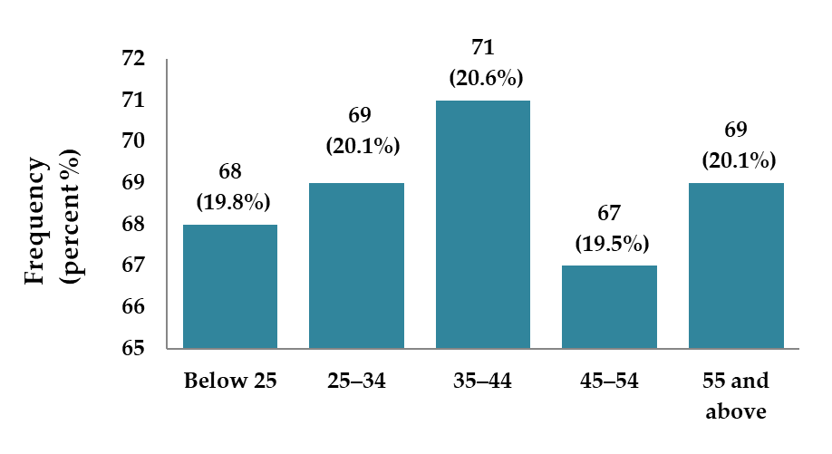

Figure (1): The distribution of the participants according to their age - years
(n = 344 registered nurses employed at Dr. Sulaiman Al Habib Hospitals, Riyadh, Saudi Arabia in 2025)

Table (2): The distribution of the participants according to their gender
(n = 344 registered nurses employed at Dr. Sulaiman Al Habib Hospitals, Riyadh, Saudi Arabia in 2025)
Gender | Frequency | Percent (%)
Male | 173 | 50.3
Female | 171 | 49.7
Total | 344 | 100.0

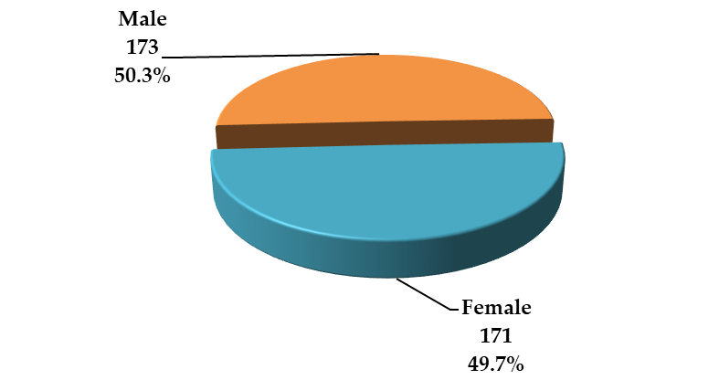

Figure (2): The distribution of the participants according to their gender
(n = 344 registered nurses employed at Dr. Sulaiman Al Habib Hospitals, Riyadh, Saudi Arabia in 2025)

Table (3): The distribution of the participants according to their marital status
(n = 344 registered nurses employed at Dr. Sulaiman Al Habib Hospitals, Riyadh, Saudi Arabia in 2025)
Marital Status | Frequency | Percent (%)
Single | 79 | 23.0
Married | 84 | 24.4
Divorced | 81 | 23.5
Widowed | 100 | 29.1
Total | 344 | 100.0

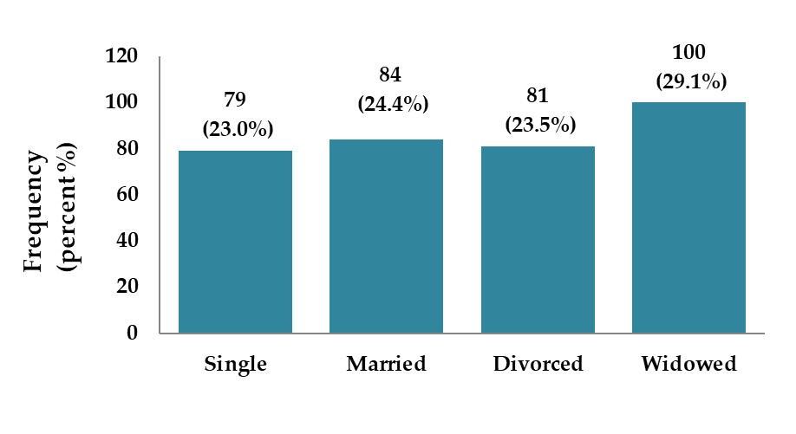

Figure (3): The distribution of the participants according to their marital status
(n = 344 registered nurses employed at Dr. Sulaiman Al Habib Hospitals, Riyadh, Saudi Arabia in 2025)

Table (4): The distribution of the participants according to their nationality
(n = 344 registered nurses employed at Dr. Sulaiman Al Habib Hospitals, Riyadh, Saudi Arabia in 2025)
Nationality | Frequency | Percent (%)
Saudi | 168 | 48.8
Non-Saudi | 176 | 51.2
Total | 344 | 100.0

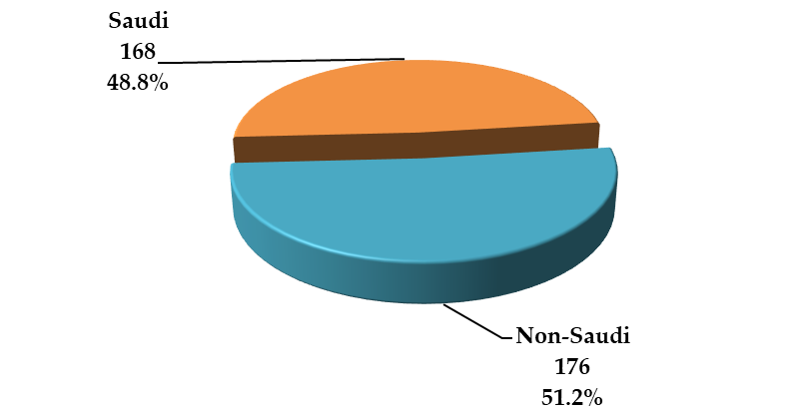

Figure (4): The distribution of the participants according to their nationality
(n = 344 registered nurses employed at Dr. Sulaiman Al Habib Hospitals, Riyadh, Saudi Arabia in 2025)

Educational and Professional Background
As shown in Table (5), participants held various levels of education. Bachelor’s degree holders formed the largest group (27.9%), followed by doctorate holders (26.5%), diploma holders (23.3%), and those with a master’s degree (22.4%).
In terms of overall nursing experience (Table 6), nurses with 6–10 years of experience constituted the largest group (28.2%), while those with less than one year represented 27.6%. The remaining participants were split equally between 1–5 years and more than 10 years of experience (22.1% each).
Table (7) reported years of experience at the current hospital. Nurses with less than 1 year and those with 6–10 years of service each made up 26.7% of the sample. Nurses with over 10 years accounted for 23.8%, while 22.7% had 1–5 years of experience.

Table (5): The distribution of the participants according to their highest educational qualification
(n = 344 registered nurses employed at Dr. Sulaiman Al Habib Hospitals, Riyadh, Saudi Arabia in 2025)
Qualification | Frequency | Percent (%)
Diploma | 80 | 23.2
Bachelor’s Degree | 96 | 27.9
Master’s Degree | 77 | 22.4
Doctorate | 91 | 26.5
Total | 344 | 100.0

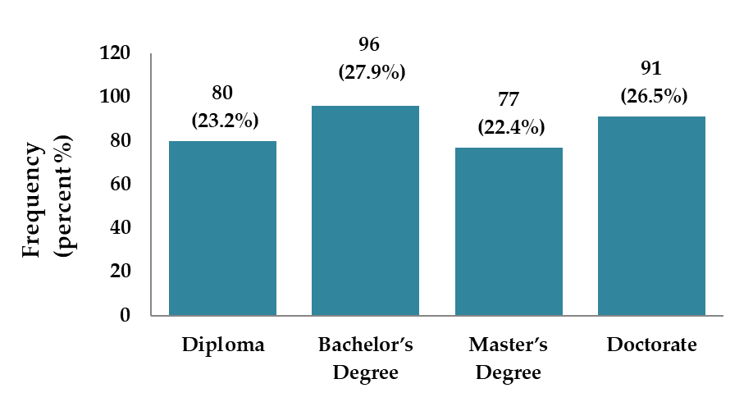

Figure (5): The distribution of the participants according to their highest educational qualification
(n = 344 registered nurses employed at Dr. Sulaiman Al Habib Hospitals, Riyadh, Saudi Arabia in 2025)

Table (6): The distribution of the participants according to their years of experience in nursing
(n = 344 registered nurses employed at Dr. Sulaiman Al Habib Hospitals, Riyadh, Saudi Arabia in 2025)
Years of Experience | Frequency | Percent (%)
Less than 1 year | 95 | 27.6
1–5 years | 76 | 22.1
6–10 years | 97 | 28.2
More than 10 years | 76 | 22.1
Total | 344 | 100.0

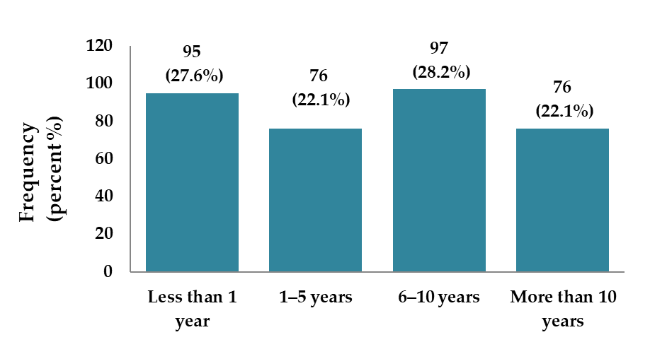

Figure (6): The distribution of the participants according to their years of experience in nursing
(n = 344 registered nurses employed at Dr. Sulaiman Al Habib Hospitals, Riyadh, Saudi Arabia in 2025)

Table (7): The distribution of the participants according to their years of experience at this hospital
(n = 344 registered nurses employed at Dr. Sulaiman Al Habib Hospitals, Riyadh, Saudi Arabia in 2025)
Years at Hospital | Frequency | Percent (%)
Less than 1 year | 92 | 26.7
1–5 years | 78 | 22.7
6–10 years | 92 | 26.7
More than 10 years | 82 | 23.9
Total | 344 | 100.0

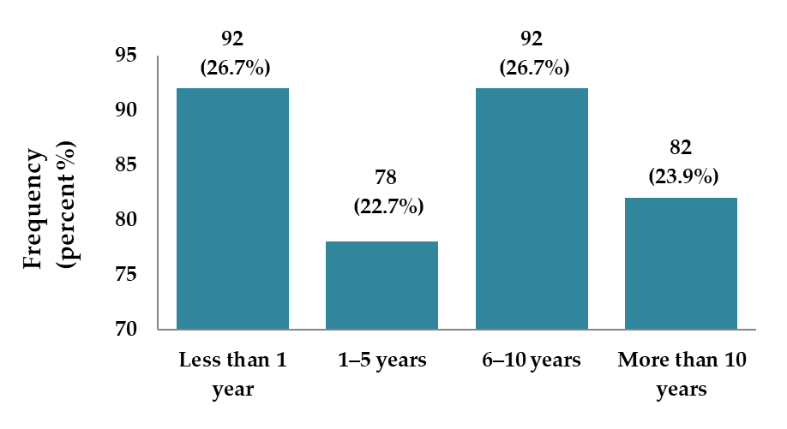

Figure (7): The distribution of the participants according to their years of experience at this hospital
(n = 344 registered nurses employed at Dr. Sulaiman Al Habib Hospitals, Riyadh, Saudi Arabia in 2025)

Work Settings and Roles
According to Table (8), participants were distributed across various departments, with the highest proportion working in "Other" departments (15.4%), followed by Surgery (14.5%) and Emergency (14.2%). Obstetrics & Gynecology (13.7%), Pediatrics (11.6%), ICU and Outpatient Services (10.5% each), and Internal Medicine (9.6%) made up the remainder.
Employment type (Table 9) was nearly evenly split, with 53.2% working full-time and 46.8% part-time. As for work shifts (Table 10), night shifts were the most common (28.8%), followed by rotating shifts (25.3%), morning (23.8%), and evening shifts (22.1%).
Leadership responsibilities were reported in Table (11). A slight majority of participants (53.5%) did not hold leadership roles, whereas 46.5% did.
The nurses were employed across three hospital branches, as detailed in Table (12). Sahafa Hospital accounted for the largest proportion (47.1%), followed by Takhassusi (28.5%) and Olaya Hospital (24.4%).

Table (8): The distribution of the participants according to their department
(n = 344 registered nurses employed at Dr. Sulaiman Al Habib Hospitals, Riyadh, Saudi Arabia in 2025)
Department | Frequency | Percent (%)
ICU | 36 | 10.5
Emergency | 49 | 14.2
Surgery | 50 | 14.5
Internal Medicine | 33 | 9.6
Pediatrics | 40 | 11.6
Obstetrics & Gynecology | 47 | 13.7
Outpatient Services | 36 | 10.5
Other | 53 | 15.4
Total | 344 | 100.0
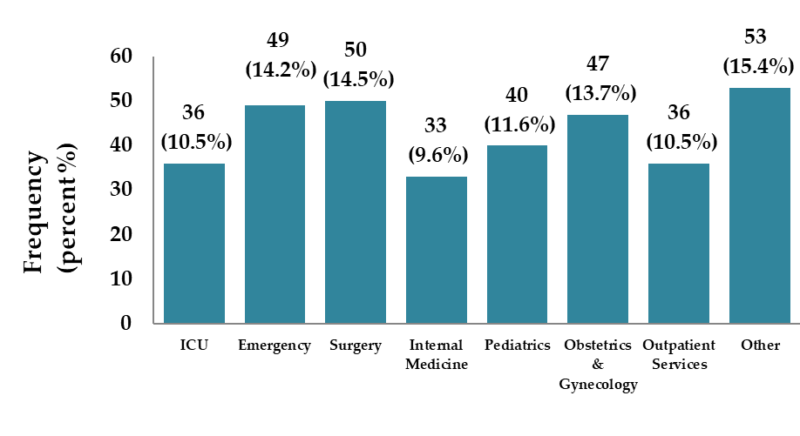

Figure (8): The distribution of the participants according to their department
(n = 344 registered nurses employed at Dr. Sulaiman Al Habib Hospitals, Riyadh, Saudi Arabia in 2025)

Table (9): The distribution of the participants according to their employment type
(n = 344 registered nurses employed at Dr. Sulaiman Al Habib Hospitals, Riyadh, Saudi Arabia in 2025)
Employment Type | Frequency | Percent (%)
Full-time | 183 | 53.2
Part-time | 161 | 46.8
Total | 344 | 100.0

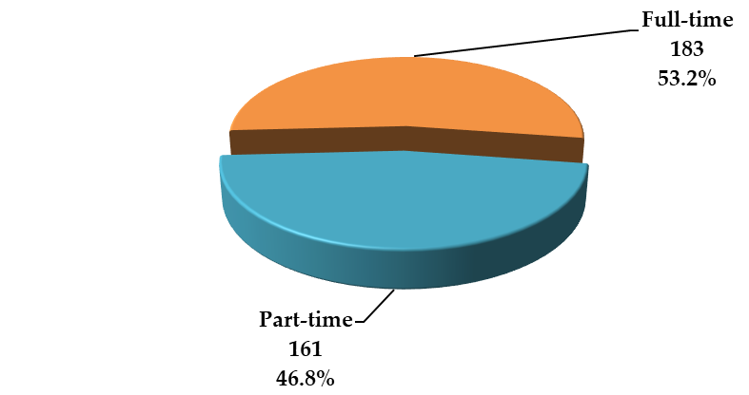

Figure (9): The distribution of the participants according to their employment type
(n = 344 registered nurses employed at Dr. Sulaiman Al Habib Hospitals, Riyadh, Saudi Arabia in 2025)

Table (10): The distribution of the participants according to their work shift
(n = 344 registered nurses employed at Dr. Sulaiman Al Habib Hospitals, Riyadh, Saudi Arabia in 2025)
Work Shift | Frequency | Percent (%)
Morning | 82 | 23.8
Evening | 76 | 22.1
Night | 99 | 28.8
Rotating Shifts | 87 | 25.3
Total | 344 | 100.0

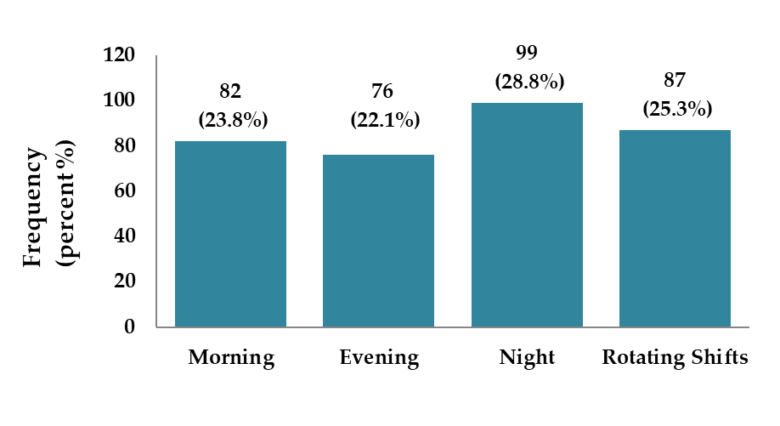

Figure (10): The distribution of the participants according to their work shift
(n = 344 registered nurses employed at Dr. Sulaiman Al Habib Hospitals, Riyadh, Saudi Arabia in 2025)

Table (11): The distribution of the participants according to their leadership responsibilities
(n = 344 registered nurses employed at Dr. Sulaiman Al Habib Hospitals, Riyadh, Saudi Arabia in 2025)
Leadership Responsibility | Frequency | Percent (%)
Yes | 160 | 46.5
No | 184 | 53.5
Total | 344 | 100.0

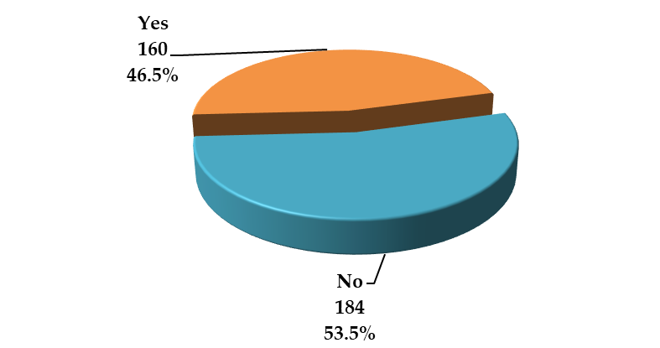

Figure (11): The distribution of the participants according to their leadership responsibilities
(n = 344 registered nurses employed at Dr. Sulaiman Al Habib Hospitals, Riyadh, Saudi Arabia in 2025)

Table (12): The distribution of the participants according to their hospital
(n = 344 registered nurses employed at Dr. Sulaiman Al Habib Hospitals, Riyadh, Saudi Arabia in 2025)
Hospital | Frequency | Percent (%)
Olaya Hospital | 84 | 24.4
Sahafa Hospital | 162 | 47.1
Takhassusi Hospital | 98 | 28.5
Total | 344 | 100.0

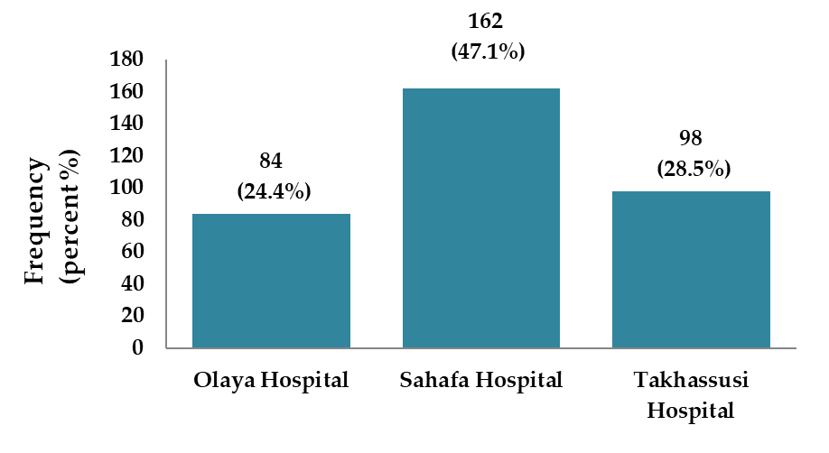

Figure (12): The distribution of the participants according to their hospital
(n = 344 registered nurses employed at Dr. Sulaiman Al Habib Hospitals, Riyadh, Saudi Arabia in 2025)

Organizational Culture Perceptions
Table (13) presented descriptive statistics of organizational culture items. The overall mean score for organizational culture was 2.98 ± 0.29. The highest-rated items included structured and efficient leadership (3.14 ± 1.39) and valuing stable relationships (3.14 ± 1.41). Conversely, items such as emphasis on human development (2.86 ± 1.39) and operational excellence (2.81 ± 1.38) received lower scores. These findings suggested a moderate level of perceived organizational culture, with a focus on structure and results rather than innovation or employee development.

Table (13): Descriptive statistics of the organizational culture scale (n = 344 registered nurses employed at Dr. Sulaiman Al Habib Hospitals, Riyadh, Saudi Arabia in 2025)
Item | Mean ± SD
The hospital is a very personal place. It is like an extended family. | 3.01 ± 1.38
The hospital is a very dynamic entrepreneurial place. People are willing to take risks. | 3.01 ± 1.45
The hospital is very results-oriented. A major concern is getting the job done. | 2.98 ± 1.46
The hospital is a very controlled and structured place. | 2.96 ± 1.43
The leadership exemplifies mentoring and nurturing. | 2.94 ± 1.39
The leadership exemplifies innovation or risk-taking. | 2.97 ± 1.41
The leadership is aggressive and results-oriented. | 3.07 ± 1.44
The leadership is structured and efficient. | 3.14 ± 1.39
Management style emphasizes teamwork and participation. | 2.99 ± 1.41
Management style emphasizes individual risk-taking. | 3.03 ± 1.41
Management style is achievement-oriented. | 2.98 ± 1.40
Management style values stability in relationships. | 3.14 ± 1.41
Loyalty and mutual trust hold the hospital together. | 2.92 ± 1.41
Commitment to innovation holds the hospital together. | 2.93 ± 1.41
Goal accomplishment holds the hospital together. | 2.97 ± 1.45
Formal rules and policies hold the hospital together. | 3.01 ± 1.45
The hospital emphasizes human development. | 2.86 ± 1.39
The hospital emphasizes acquiring resources and new challenges. | 3.00 ± 1.45
The hospital emphasizes competitive actions. | 2.99 ± 1.46
The hospital emphasizes stability, efficiency, and control. | 2.98 ± 1.40
Success is based on teamwork and employee commitment. | 3.04 ± 1.42
Success is based on product innovation and uniqueness. | 2.87 ± 1.39
Success is based on market competitiveness. | 2.97 ± 1.41
Success is based on operational excellence. | 2.81 ± 1.38
Overall Organizational Culture mean score | 2.98 ± 0.29

Job Satisfaction
Results for job satisfaction were summarized in Table (14). The overall job satisfaction mean score was 2.92 ± 0.55. The highest individual item score was for workload being excessive (3.08 ± 1.48), suggesting a potential stressor. Other relatively high ratings were given to enjoying working with colleagues (3.01 ± 1.40) and enjoyment of tasks (2.99 ± 1.39). However, issues such as infrequent raises (2.83 ± 1.40) and promotion dissatisfaction (2.85 ± 1.39) were evident.

Table (14): Descriptive statistics of the job satisfaction scale (n = 344 registered nurses employed at Dr. Sulaiman Al Habib Hospitals, Riyadh, Saudi Arabia in 2025)
Item | Mean ± SD
Communication within this hospital is good. | 2.91 ± 1.39
The benefits at this hospital are as good as in other hospitals. | 2.84 ± 1.39
The hospital’s goals are unclear to me. | 2.92 ± 1.40
I often do not know what is going on in the hospital. | 2.96 ± 1.44
I feel I am being paid fairly for my work. | 2.96 ± 1.42
There are too few promotion opportunities. | 2.88 ± 1.39
My supervisor is competent in doing their job. | 2.95 ± 1.44
I am dissatisfied with the benefits I receive. | 2.92 ± 1.37
When I do a good job, I receive the recognition I deserve. | 2.96 ± 1.45
Many rules and procedures make doing a good job difficult. | 3.00 ± 1.37
I like the people I work with. | 2.82 ± 1.36
Sometimes I feel my job is meaningless. | 3.00 ± 1.43
Raises are too infrequent. | 2.83 ± 1.40
Those who perform well have a fair chance of being promoted. | 2.88 ± 1.42
My supervisor is unfair to me. | 2.77 ± 1.37
My work is not appreciated. | 2.87 ± 1.42
My work is often blocked by red tape. | 2.95 ± 1.44
I must work harder because of the incompetence of colleagues. | 2.86 ± 1.35
I enjoy the tasks I perform at work. | 2.99 ± 1.39
I feel underappreciated when I think about my pay. | 2.89 ± 1.39
Promotions happen as fast as in other places. | 2.97 ± 1.47
My supervisor lacks interest in employee concerns. | 2.91 ± 1.36
The benefit package is equitable. | 2.96 ± 1.42
There are too few rewards for employees. | 2.99 ± 1.41
My workload is excessive. | 3.08 ± 1.48
I enjoy working with my colleagues. | 3.01 ± 1.40
I take pride in my job. | 2.85 ± 1.36
I am satisfied with salary increases. | 2.88 ± 1.36
Some benefits should be added. | 2.95 ± 1.37
I like my supervisor. | 2.83 ± 1.40
There is too much paperwork. | 2.96 ± 1.47
My efforts are not rewarded as they should be. | 2.97 ± 1.39
I am satisfied with my promotion opportunities. | 2.85 ± 1.39
There is too much workplace conflict. | 2.85 ± 1.38
My job is enjoyable. | 2.85 ± 1.42
Work assignments are not fully explained. | 2.98 ± 1.47
Overall Job satisfaction mean score | 2.92 ± 0.55

Correlation between Organizational Culture and Job Satisfaction
As shown in Table (15), a strong and statistically significant positive correlation (r = 0.687, p < 0.001) was observed between organizational culture and job satisfaction among the participants. This indicated that more favorable perceptions of organizational culture were associated with higher levels of job satisfaction.

Table (15): Pearson correlation between organizational culture and job satisfaction
(n = 344 registered nurses employed at Dr. Sulaiman Al Habib Hospitals, Riyadh, Saudi Arabia in 2025)
Variables | 1. Organizational Culture | 2. Job Satisfaction | p-value
1. Organizational Culture | 1.000 | 0.687 | < 0.001
2. Job Satisfaction | 0.687 | 1.000 | < 0.001
- Statistical test: Pearson correlation coefficient (2-tailed)
- Interpretation: There is a strong, statistically significant positive correlation (r = 0.687, p < 0.001) between organizational culture and job satisfaction among the sample.
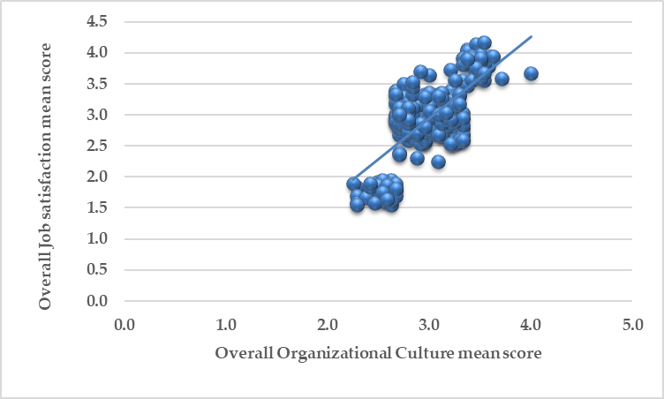

Figure (13): scatter plot graph for correlation between organizational culture and job satisfaction
(n = 344 registered nurses employed at Dr. Sulaiman Al Habib Hospitals, Riyadh, Saudi Arabia in 2025)
Mean Differences by Demographic Variables
Table (16) examined the mean differences in organizational culture and job satisfaction across various demographic subgroups. Significant differences in organizational culture were observed by age (p = 0.033), with nurses aged 45–54 reporting the highest mean (3.063). However, job satisfaction did not significantly differ across age groups (p = 0.221). No statistically significant differences in either organizational culture or job satisfaction were found across gender, marital status, nationality, education level, years of experience, department, employment type, work shift, or leadership responsibilities.
These results suggested that while organizational culture perceptions may vary slightly by age, job satisfaction remained relatively stable across the measured demographic categories. The findings further reinforced the positive relationship between a constructive organizational culture and enhanced satisfaction among nursing professionals.

Table (16): Mean Differences in Organizational Culture and Job Satisfaction by Demographic Variables
(n = 344 registered nurses employed at Dr. Sulaiman Al Habib Hospitals, Riyadh, Saudi Arabia in 2025)
Variable | Category | Org. Culture Mean | p-value (Culture) | Job Satisfaction Mean | p-value (Satisfaction)
Hospital | Olaya | 3.007 | 0.510 | 2.896 | 0.888
Hospital | Sahafa | 2.964 | 0.510 | 2.919 | 0.888
Hospital | Takhassusi | 2.991 | 0.510 | 2.937 | 0.888
Age | Below 25 | 2.977 | 0.033 | 2.974 | 0.221
Age | 25–34 | 2.961 | 0.033 | 2.886 | 0.221
Age | 35–44 | 2.911 | 0.033 | 2.805 | 0.221
Age | 45–54 | 3.063 | 0.033 | 3.007 | 0.221
Age | 55 and above | 3.002 | 0.033 | 2.927 | 0.221
Gender | Female | 2.985 | 0.857 | 2.917 | 0.968
Gender | Male | 2.980 | 0.857 | 2.920 | 0.968
Marital Status | Single | 3.025 | 0.192 | 2.995 | 0.345
Marital Status | Married | 2.993 | 0.192 | 2.952 | 0.345
Marital Status | Divorced | 2.989 | 0.192 | 2.878 | 0.345
Marital Status | Widowed | 2.934 | 0.192 | 2.863 | 0.345
Nationality | Saudi | 3.011 | 0.069 | 2.959 | 0.178
Nationality | Non-Saudi | 2.955 | 0.069 | 2.879 | 0.178
Education | Diploma | 2.982 | 0.842 | 2.952 | 0.265
Education | Bachelor | 3.003 | 0.842 | 2.982 | 0.265
Education | Master's | 2.975 | 0.842 | 2.910 | 0.265
Education | Doctorate | 2.967 | 0.842 | 2.829 | 0.265
Experience (Nursing) | <1 yr | 2.956 | 0.356 | 2.937 | 0.718
Experience (Nursing) | 1–5 yrs | 3.020 | 0.356 | 2.907 | 0.718
Experience (Nursing) | 6–10 yrs | 3.000 | 0.356 | 2.954 | 0.718
Experience (Nursing) | >10 yrs | 2.954 | 0.356 | 2.861 | 0.718
Experience (Hospital) | <1 yr | 2.983 | 0.487 | 2.857 | 0.577
Experience (Hospital) | 1–5 yrs | 2.941 | 0.487 | 2.907 | 0.577
Experience (Hospital) | 6–10 yrs | 3.007 | 0.487 | 2.957 | 0.577
Experience (Hospital) | >10 yrs | 2.993 | 0.487 | 2.955 | 0.577
Department | Emergency | 2.972 | 0.534 | 2.859 | 0.608
Department | ICU | 3.015 | 0.534 | 2.958 | 0.608
Department | Internal Medicine | 3.015 | 0.534 | 2.889 | 0.608
Department | Obstetrics & Gyn | 2.910 | 0.534 | 2.817 | 0.608
Department | Pediatrics | 2.948 | 0.534 | 2.948 | 0.608
Department | Surgery | 3.020 | 0.534 | 3.031 | 0.608
Department | OPD | 2.970 | 0.534 | 2.860 | 0.608
Department | Other | 3.013 | 0.534 | 2.967 | 0.608
Employment | Full-time | 2.967 | 0.284 | 2.871 | 0.087
Employment | Part-time | 3.000 | 0.284 | 2.973 | 0.087
Work Shift | Morning | 3.007 | 0.124 | 2.891 | 0.074
Work Shift | Evening | 3.036 | 0.124 | 3.064 | 0.074
Work Shift | Night | 2.957 | 0.124 | 2.875 | 0.074
Work Shift | Rotating | 2.941 | 0.124 | 2.867 | 0.074
Leadership | Yes | 2.983 | 0.976 | 2.941 | 0.482
Leadership | No | 2.982 | 0.976 | 2.899 | 0.482

Chapter five: Discussion
5.1 Discussion
This study investigated the impact of organizational culture on employee satisfaction among 344 registered nurses in Dr. Sulaiman Al Habib Hospitals in Riyadh, Saudi Arabia, and revealed significant findings regarding the demographics, work settings, and perceived organizational culture and job satisfaction. A particularly notable result was the strong, positive correlation between organizational culture and job satisfaction (r = 0.687, p < 0.001), which implies that a healthier work culture directly contributes to higher employee satisfaction levels. This outcome aligns closely with multiple studies conducted both locally and internationally, reinforcing the universality of this relationship in healthcare settings.
The correlation found in this study mirrors the findings of Aldhuwaihi (2019) in Saudi Arabia, who also identified a positive relationship between various types of organizational culture—especially clan and adhocracy cultures—and job satisfaction and organizational commitment in the banking sector. Though in a non-healthcare context, Aldhuwaihi’s study confirms that supportive, inclusive, and participatory organizational models are critical in the Saudi context, regardless of sector. Similarly, in the present study, the highest-rated aspects of culture were leadership structure (mean = 3.14) and stable relationships (mean = 3.14), suggesting the influence of clan-like characteristics even within the clinical setting.
In terms of the nurses’ job satisfaction, the overall mean score (2.92 ± 0.55) indicated a moderate level of satisfaction, with highest dissatisfaction reported regarding workload (mean = 3.08). These results resonate with the conclusions drawn by Chaanine (2025) in Lebanon, who found that ethical leadership, transparency, and organizational support played a crucial role in shaping job satisfaction and employee trust. The excessive workload observed in this study reflects the strain faced by nurses in high-demand environments and emphasizes the need for supportive leadership to mitigate burnout and dissatisfaction.
Demographically, the findings showed nearly equal gender representation and a fairly even age distribution, with age being the only variable showing statistically significant variation in perceptions of organizational culture (p = 0.033). Specifically, nurses aged 45–54 years rated organizational culture highest (mean = 3.063), possibly reflecting generational differences in expectations or resilience. In contrast, job satisfaction did not significantly differ across any demographic variables. This finding suggests a relatively consistent experience across different backgrounds, which is encouraging in terms of equity and inclusivity. It also aligns with Goldston (2021) in the U.S., who highlighted that while certain traits like adaptability and involvement influenced specific job satisfaction domains (e.g., pay or coworker relationships), overall satisfaction levels were not strongly determined by personal demographics.
In examining specific organizational culture traits, this study found relatively lower scores in aspects such as operational excellence (mean = 2.81) and human development (mean = 2.86). These findings indicate areas where institutional improvements could be made. Comparable concerns were raised in the Greek study by Hoxha et al. (2024), which emphasized that operational efficiency and stress minimization were key to improving job satisfaction and healthcare sustainability. Therefore, underperformance in these domains might not only diminish nurse satisfaction but also affect patient care outcomes in the long term.
The study workplace setting distribution also offered a valuable insight into staffing structures. Nurses were distributed across a range of departments, with the highest representation in surgery (14.5%) and emergency departments (14.2%). These departments are traditionally high-pressure environments, which could explain the elevated dissatisfaction with workload. This aligns with the findings of Mokalu et al. (2019) in Indonesia, who demonstrated that high-pressure environments like emergency departments require strong cultural cohesion to ensure staff motivation and performance.
Notably, the balance between part-time (46.8%) and full-time (53.2%) employment, and the dominance of night shifts (28.8%), suggest potential implications for nurse fatigue and satisfaction. Studies such as that by Tannady et al. (2019) in Jakarta showed that rotating shifts and poor engagement structures were associated with diminished performance and higher patient dissatisfaction. Thus, the shift patterns reported in this study could be re-evaluated in light of their possible influence on both staff morale and clinical care standards.
An encouraging result was the relatively strong cultural score reported by nurses at the 45–54 age group. This might reflect the appreciation of stability and leadership structure by more experienced professionals, as also reported by Dadgar et al. (2019) in Iran. Their study demonstrated that clan-oriented cultures—marked by collaboration, support, and experience appreciation—were positively linked to retention and job satisfaction. This finding is particularly relevant for retention strategies in Saudi hospitals where nursing turnover is often a concern.
The findings of this study revealed a strong, statistically significant positive correlation between organizational culture and job satisfaction among nurses at Dr. Sulaiman Al Habib Hospitals in Riyadh, Saudi Arabia (r = 0.687, p < 0.001). This result indicated that improvements in the organizational culture were directly associated with increased levels of employee satisfaction. The findings confirmed the widespread understanding in the literature that the work environment plays a decisive role in shaping employee morale, motivation, and long-term retention—particularly in high-pressure sectors such as healthcare.
Among the highest-rated elements of organizational culture in this study were the presence of structured and efficient leadership (mean = 3.14) and the value placed on stable interpersonal relationships (mean = 3.14). These characteristics reflect the traits of a “clan” culture, which emphasizes collaboration, mutual support, and team-oriented dynamics. This finding closely aligned with Dadgar et al. (2019) in Iran, who found that clan cultures had the strongest positive associations with job satisfaction and staff retention among healthcare employees. Their study concluded that a collaborative and supportive organizational environment helped foster commitment and reduce turnover intentions.
Similarly, Chaanine (2025) in Lebanon reported that ethical leadership, transparency, and supportive culture significantly enhanced employee trust and job satisfaction. These cultural components increased employee engagement and strengthened loyalty within the healthcare setting. The current study's emphasis on structured leadership and relationship stability thus fits well within the regional context of Middle Eastern healthcare institutions, where trust and group cohesion are often culturally shown.
Despite the positive aspects, certain dimensions of organizational culture in the current study received lower evaluations—particularly operational excellence (mean = 2.81) and human development (mean = 2.86). These areas signaled organizational weaknesses related to career advancement, efficiency, and talent management. A comparable observation was made by Hoxha et al. (2024) in Greece, who concluded that when healthcare institutions failed to emphasize operational efficiency and stress reduction, job satisfaction levels dropped. They emphasized the need for strategic frameworks like Green Lean Six Sigma to optimize staff well-being while maintaining sustainability in healthcare delivery.
The overall job satisfaction score in this study was moderate (mean = 2.92 ± 0.55), with excessive workload emerging as the most dissatisfying element (mean = 3.08). This concern echoed the findings of Mokalu et al. (2019) in Indonesia, who found that workplace stress and staff burnout were especially pronounced in emergency care settings. Their study showed that strengthening organizational culture could help buffer the effects of high work demands by fostering teamwork and improving communication. In this sense, the Saudi findings pointed to a broader need for rebalancing workloads and enhancing institutional support structures for frontline staff.
Interestingly, job satisfaction in this study did not significantly differ across demographic variables such as gender, nationality, marital status, or education. This consistency suggests that satisfaction levels were not influenced by individual traits but were shaped more by shared organizational conditions. This pattern matched the findings of Goldston (2021) in the United States, who found that while certain cultural traits—like adaptability and employee involvement—affected satisfaction with specific job aspects (e.g., compensation or interpersonal relationships), overall satisfaction levels were largely independent of personal demographics.
The only demographic variable that showed significant differences in perceptions of organizational culture in the current study was age (p = 0.033). Nurses aged 45–54 years reported the highest ratings of organizational culture (mean = 3.063). This may reflect the tendency of older and more experienced professionals to value institutional stability and leadership structures. Similarly, Aldhuwaihi (2019) in Saudi Arabia found that hierarchical and clan cultures—often appreciated by senior staff—positively influenced job satisfaction and organizational commitment in the banking sector. He emphasized that positive organizational cultures enhanced not only satisfaction but also long-term retention.
The Saudi context adds further depth to these findings. Although the private healthcare sector is often perceived as more performance-driven and less supportive than public institutions, the nearly equal representation of satisfaction across shifts, genders, and employment types in this study suggests that organizational values—rather than employment models—may be more critical in influencing satisfaction. This implication is supported by Belias and Koustelios (2021) in Greece, who emphasized that job satisfaction is fundamentally shaped by how employees perceive leadership, institutional goals, and interpersonal dynamics, rather than by demographic or contractual status.
Moreover, the prevalence of night shifts (28.8%) and rotating schedules (25.3%) among participants suggests a significant operational challenge. These shift patterns are known to contribute to fatigue and emotional exhaustion. Tannady et al. (2019) in Indonesia documented similar challenges in Jakarta hospitals, where rotating shifts and inconsistent staffing practices were linked to lower job performance and poor patient satisfaction. They concluded that strong organizational culture and staff engagement practices could mitigate these effects.
The positive correlation between organizational culture and job satisfaction observed in this study is well supported by extensive international evidence, underscoring the global relevance of fostering healthy workplace environments. For instance, Wahjoedi (2021) in Indonesia highlighted that job satisfaction and motivation mediated the impact of culture on performance, aligning with the current findings where supportive cultural elements (e.g., leadership and relationships) predicted satisfaction. Similarly, Shin (2022) demonstrated that effective internal communication—rooted in organizational culture—enhanced employee satisfaction, a pattern echoed in our study where communication and leadership were highly rated. In Mongolia, Jigjiddorj et al. (2021) emphasized the role of culture in shaping both satisfaction and commitment, reinforcing the current study’s argument for a comprehensive cultural strategy to improve retention. Meanwhile, Sapta et al. (2021) found that culture and technology together predicted performance during crises like COVID-19, suggesting that Saudi healthcare institutions could benefit from integrating cultural development with digital transformation. The relevance of culture to organizational loyalty and sustainability was also supported by Shahriari et al. (2023), who demonstrated that green organizational cultures enhanced job satisfaction and long-term commitment—further validating the sustainability concerns raised in our results regarding operational excellence and human development.
Additionally, the study’s findings regarding shift patterns, employment status, and age-related variations are consistent with broader empirical literature. Abdullahi et al. (2021) reported that organizational culture, through the mediating role of engagement, significantly influenced performance in the Malaysian education sector—mirroring the importance of staff involvement in shift-heavy hospital environments. Siswadi et al. (2023) emphasized that learning organizations and commitment mediate the relationship between culture and citizenship behaviors, underscoring the value of professional development—an area rated low in the current study. Iskamto (2023) also concluded that organizational culture directly shapes performance, reinforcing the importance of leadership-driven cultural improvements in high-demand clinical settings. Among healthcare workers in Norway, Mutonyi et al. (2022) confirmed that organizational attractiveness and innovation were enhanced by a strong culture and positive leadership climate—insights that complement our findings on leadership structure and retention. Furthermore, Ababneh (2021) stressed that engagement and individual values modulate the link between culture and total quality management, while Bhardwaj and Kalia (2021) confirmed the dual impact of culture and engagement on both contextual and task performance in hospitality—an industry with operational similarities to healthcare. Supporting this, Fathurahman (2022) showed that loyalty and satisfaction are shaped by the work environment and culture, while Rofifah et al. (2021) in an educational context demonstrated the motivational influence of culture on staff performance. Finally, Sorn et al. (2023) revealed that compensation—although external—interacts with internal culture to enhance retention, highlighting a potential avenue for integrated policy reform. Together, these studies reinforce the current research’s argument: that enhancing organizational culture is not merely a strategic goal, but a structural necessity for ensuring satisfaction, stability, and service quality in Saudi Arabia’s evolving healthcare landscape.

Chapter 6: Conclusion and Recommendations
6.1 Conclusion
This study examined the relationship between organizational culture and job satisfaction among 344 registered nurses in Dr. Sulaiman Al Habib Hospitals in Riyadh, Saudi Arabia. It was found that organizational culture had a strong and statistically significant positive correlation with job satisfaction, indicating that improvements in the workplace culture were associated with higher employee satisfaction levels. Structured leadership and stable interpersonal relationships were the most positively perceived cultural aspects, while operational excellence and human development received lower evaluations. Additionally, age was the only demographic variable that significantly influenced perceptions of organizational culture, with older nurses reporting higher scores. However, job satisfaction did not vary significantly across any demographic or professional variables, suggesting that the organizational environment had a uniform effect on all staff categories.

6.2 Recommendations
- Structured leadership development programs should be implemented to sustain the positive perceptions of organizational leadership.
- Employee workload should be regularly assessed and managed through evidence-based staffing models.
- Opportunities for professional growth and human capital development should be expanded across all departments.
- Operational efficiency should be enhanced by adopting lean healthcare practices and digital workflow solutions.
- Staff engagement initiatives should be designed to include diverse age groups and professional backgrounds.
- Continuous organizational culture assessments should be conducted to monitor progress and guide strategic interventions.
- Future studies should be conducted using a longitudinal design to examine how changes in organizational culture over time influence employee satisfaction and retention.

6.3 Implications of the Study

- The findings highlighted the critical role of organizational culture in shaping nurse satisfaction, emphasizing its strategic value in workforce retention and performance.
- The consistency of satisfaction across demographic variables suggested that culture-based interventions can have organization-wide benefits regardless of employee characteristics.
- The strong cultural ratings among older nurses indicated that generational perspectives must be considered in leadership training and organizational planning.

References
Ababneh, O. M. A. (2021). The impact of organizational culture archetypes on quality performance and total quality management: the role of employee engagement and individual values. International Journal of Quality & Reliability Management, 38(6), 1387-1408.
Abdullahi, M. S., Raman, K., & Solarin, S. A. (2021). Effect of organizational culture on employee performance: A mediating role of employee engagement in Malaysia educational sector. International Journal of Supply and Operations Management, 8(3), 232-246.
Aldhuwaihi, A. (2019). The influence of organisational culture on job satisfaction, organisational commitment, and turnover intention: A study on the banking sector in the Kingdom of Saudi Arabia (Doctoral dissertation, Victoria University, Melbourne, Australia).
Belias, D., & Koustelios, A. (2021). Organizational culture and job satisfaction: A review. International Review of Management and Business Research, 4(2), 132–149.
Bhardwaj, B., & Kalia, N. (2021). Contextual and task performance: role of employee engagement and organizational culture in hospitality industry. Vilakshan-XIMB Journal of Management, 18(2), 187-201.
Blau, P. M. (1964). Exchange and power in social life. Wiley.
Cameron, K. S., & Quinn, R. E. (1999). Diagnosing and changing organizational culture: Based on the competing values framework. Addison-Wesley.
Chaanine, J. (2025). Strengthening Lebanese healthcare: Exploring the impact of organizational culture on employee loyalty through trust and job satisfaction. Leadership in Health Services. https://doi.org/10.1108/LHS-09-2024-0114
Dadgar, H., Barahouei, F., Mohammadi, M., Ebrahimi, M., & Ganjali, A. (2019). The relationship between organizational culture, job satisfaction, organizational commitment, and intention to stay among healthcare personnel. World Applied Sciences Journal, 21(8), 1220–1228. https://doi.org/10.5829/idosi.wasj.2019.21.8.108
Fathurahman, M. (2022). Path Analysis Between Job Satisfaction And Loyalty With Work Environment And Culture As Explanatory Variables. PRODUKTIF: Jurnal Kepegawaian dan Organisasi, 1(1), 36-43.
Goldston, B. K. (2021). The relationship between traits of organizational culture and job satisfaction within the healthcare setting (Doctoral dissertation, Walden University).
Herzberg, F. (1959). The motivation to work. John Wiley & Sons.
Hoxha, G., Simeli, I., Theocharis, D., Vasileiou, A., & Tsekouropoulos, G. (2024). Sustainable healthcare quality and job satisfaction through organizational culture: Approaches and outcomes. Sustainability, 16(9), 3603. https://doi.org/10.3390/su16093603
Iskamto, D. (2023). Organizational culture and its impact on employee performance. International Journal of Management and Digital Business, 2(1), 47-55.
Jigjiddorj, S., Zanabazar, A., Jambal, T., & Semjid, B. (2021). Relationship between organizational culture, employee satisfaction and organizational commitment. In SHS Web of Conferences (Vol. 90, p. 02004). EDP Sciences.
Meyer, J. P., & Allen, N. J. (1991). A three-component conceptualization of organizational commitment. Human Resource Management Review, 1(1), 61–89.
Mokalu, V. B., Tambingon, H. N., & Lengkong, J. S. J. (2019). The effect of organizational culture and job satisfaction on employee performance in emergency departments. Journal of Education and Practice, 10(14), 31–42. https://doi.org/10.7176/JEP/10-14-02
Mutonyi, B. R., Slåtten, T., Lien, G., & González-Piñero, M. (2022). The impact of organizational culture and leadership climate on organizational attractiveness and innovative behavior: a study of Norwegian hospital employees. BMC health services research, 22(1), 637.
Mutonyi, B. R., Slåtten, T., Lien, G., & González-Piñero, M. (2022). The impact of organizational culture and leadership climate on organizational attractiveness and innovative behavior: a study of Norwegian hospital employees. BMC health services research, 22(1), 637.
Rofifah, S., Sirojuddin, A., Maarif, M. A., & Zuana, M. M. M. (2021). The influence of organizational culture and work motivation on teacher performance at the international standard school, Amanatul Ummah Mojokerto. Nidhomul Haq: Jurnal Manajemen Pendidikan Islam, 6(1), 27-40.
SAPTA, I., Muafi, M., & SETINI, N. M. (2021). The role of technology, organizational culture, and job satisfaction in improving employee performance during the Covid-19 pandemic. The Journal of Asian Finance, Economics and Business, 8(1), 495-505.
Shahriari, M., Tajmir Riahi, M., Azizan, O., & Rasti-Barzoki, M. (2023). The effect of green organizational culture on organizational commitment: The mediating role of job satisfaction. Journal of Human Behavior in the Social Environment, 33(2), 180-197.
SHIN, Y. (2022). The impact of organizational culture on employee communication satisfaction. East Asian Journal of Business Economics (EAJBE), 10(1), 23-34.
Siswadi, Y., Jufrizen, J., Saripuddin, J., Farisi, S., & Sari, M. (2023). Organizational culture and organizational citizenship behavior: The mediating role of learning organizations and organizational commitment. Jurnal Riset Bisnis Dan Manajemen, 16(1), 73-82.
Sorn, M. K., Fienena, A. R., Ali, Y., Rafay, M., & Fu, G. (2023). The effectiveness of compensation in maintaining employee retention. Open Access Library Journal, 10(7), 1-14.
Tannady, H., Tannady, H., Ismuhadjar, & Zami, A. (2019). The effect of organizational culture and employee engagement on job performance of healthcare industry in Jakarta. Quality - Access to Success, 20(169), 18.
Wahjoedi, T. (2021). The effect of organizational culture on employee performance mediated by job satisfaction and work motivation: Evident from SMEs in Indonesia. The effect of organizational culture on employee performance mediated by job satisfaction and work motivation: Evident from SMEs in Indonesia, 11(7), 2053-2060.

Study questionnaire

Part 1: Personal and Professional Characteristics
Question | Response
1. Age | ☐ Below 25 ☐ 25-34 ☐ 35-44 ☐ 45-54 ☐ 55 and above
2. Gender | ☐ Male ☐ Female
3. Marital Status | ☐ Single ☐ Married ☐ Divorced ☐ Widowed
4. Nationality | ☐ Saudi ☐ Non-Saudi (Specify): __________
5. Highest Educational Qualification | ☐ Diploma ☐ Bachelor's Degree ☐ Master's Degree ☐ Doctorate
6. Years of Experience in Nursing | ☐ Less than 1 year ☐ 1-5 years ☐ 6-10 years ☐ More than 10 years
7. Years of Experience at This Hospital | ☐ Less than 1 year ☐ 1-5 years ☐ 6-10 years ☐ More than 10 years
8. Department | ☐ ICU ☐ Emergency ☐ Surgery ☐ Internal Medicine ☐ Pediatrics ☐ Obstetrics & Gynecology ☐ Outpatient Services ☐ Other: __________
9. Employment Type | ☐ Full-time ☐ Part-time
10. Work Shift | ☐ Morning ☐ Evening ☐ Night ☐ Rotating Shifts
11. Do you have any leadership responsibilities? | ☐ Yes ☐ No

Part 2: Organizational Culture
Statement | Strongly Disagree (1) | Disagree (2) | Neutral (3) | Agree (4) | Strongly Agree (5)
Dominant Characteristics
The hospital is a very personal place. It is like an extended family. People seem to share a lot of themselves. | ☐ | ☐ | ☐ | ☐ | ☐
The hospital is a very dynamic entrepreneurial place. People are willing to take risks. | ☐ | ☐ | ☐ | ☐ | ☐
The hospital is very results-oriented. A major concern is getting the job done. People are competitive. | ☐ | ☐ | ☐ | ☐ | ☐
The hospital is a very controlled and structured place. Formal procedures generally govern what people do. | ☐ | ☐ | ☐ | ☐ | ☐
Organizational Leadership
The leadership in the hospital is generally considered to exemplify mentoring, facilitating, or nurturing. | ☐ | ☐ | ☐ | ☐ | ☐
The leadership in the hospital is considered to exemplify entrepreneurship, innovation, or risk-taking. | ☐ | ☐ | ☐ | ☐ | ☐
The leadership in the hospital is aggressive and results-oriented. | ☐ | ☐ | ☐ | ☐ | ☐
The leadership in the hospital is structured, coordinating, and efficient. | ☐ | ☐ | ☐ | ☐ | ☐
Management of Employees
The management style is characterized by teamwork and participation. | ☐ | ☐ | ☐ | ☐ | ☐
The management style is characterized by individual risk-taking and innovation. | ☐ | ☐ | ☐ | ☐ | ☐
The management style is competitive with high demands and achievement-oriented. | ☐ | ☐ | ☐ | ☐ | ☐
The management style is characterized by security, predictability, and stability in relationships. | ☐ | ☐ | ☐ | ☐ | ☐
Organizational Glue
The glue that holds the hospital together is loyalty and mutual trust. | ☐ | ☐ | ☐ | ☐ | ☐
The glue that holds the hospital together is commitment to innovation. | ☐ | ☐ | ☐ | ☐ | ☐
The glue that holds the hospital together is goal accomplishment and achievement. | ☐ | ☐ | ☐ | ☐ | ☐
The glue that holds the hospital together is formal rules and policies. | ☐ | ☐ | ☐ | ☐ | ☐
Strategic Emphases
The hospital emphasizes human development with trust and participation. | ☐ | ☐ | ☐ | ☐ | ☐
The hospital emphasizes acquiring new resources and creating new challenges. | ☐ | ☐ | ☐ | ☐ | ☐
The hospital emphasizes competitive actions and market leadership. | ☐ | ☐ | ☐ | ☐ | ☐
The hospital emphasizes stability, efficiency, and control. | ☐ | ☐ | ☐ | ☐ | ☐
Criteria of Success
Success is based on teamwork, employee commitment, and concern for people. | ☐ | ☐ | ☐ | ☐ | ☐
Success is based on product innovation and uniqueness. | ☐ | ☐ | ☐ | ☐ | ☐
Success is based on market competitiveness and performance. | ☐ | ☐ | ☐ | ☐ | ☐
Success is based on efficiency, low-cost production, and operational excellence. | ☐ | ☐ | ☐ | ☐ | ☐

Part 3: Job Satisfaction
Statement | Strongly Disagree (1) | Disagree (2) | Neutral (3) | Agree (4) | Strongly Agree (5)
I feel I am being paid fairly for my work. | ☐ | ☐ | ☐ | ☐ | ☐
There are too few promotion opportunities. | ☐ | ☐ | ☐ | ☐ | ☐
My supervisor is competent in doing their job. | ☐ | ☐ | ☐ | ☐ | ☐
I am dissatisfied with the benefits I receive. | ☐ | ☐ | ☐ | ☐ | ☐
When I do a good job, I receive the recognition I deserve. | ☐ | ☐ | ☐ | ☐ | ☐
Many rules and procedures make doing a good job difficult. | ☐ | ☐ | ☐ | ☐ | ☐
I like the people I work with. | ☐ | ☐ | ☐ | ☐ | ☐
Sometimes I feel my job is meaningless. | ☐ | ☐ | ☐ | ☐ | ☐
Communication within this hospital is good. | ☐ | ☐ | ☐ | ☐ | ☐
Raises are too infrequent. | ☐ | ☐ | ☐ | ☐ | ☐
Those who perform well have a fair chance of being promoted. | ☐ | ☐ | ☐ | ☐ | ☐
My supervisor is unfair to me. | ☐ | ☐ | ☐ | ☐ | ☐
The benefits at this hospital are as good as in other hospitals. | ☐ | ☐ | ☐ | ☐ | ☐
My work is not appreciated. | ☐ | ☐ | ☐ | ☐ | ☐
My work is often blocked by red tape. | ☐ | ☐ | ☐ | ☐ | ☐
I must work harder because of the incompetence of colleagues. | ☐ | ☐ | ☐ | ☐ | ☐
I enjoy the tasks I perform at work. | ☐ | ☐ | ☐ | ☐ | ☐
The hospital’s goals are unclear to me. | ☐ | ☐ | ☐ | ☐ | ☐
I feel underappreciated when I think about my pay. | ☐ | ☐ | ☐ | ☐ | ☐
Promotions happen as fast as in other places. | ☐ | ☐ | ☐ | ☐ | ☐
My supervisor lacks interest in employee concerns. | ☐ | ☐ | ☐ | ☐ | ☐
The benefit package is equitable. | ☐ | ☐ | ☐ | ☐ | ☐
There are too few rewards for employees. | ☐ | ☐ | ☐ | ☐ | ☐
My workload is excessive. | ☐ | ☐ | ☐ | ☐ | ☐
I enjoy working with my colleagues. | ☐ | ☐ | ☐ | ☐ | ☐
I often do not know what is going on in the hospital. | ☐ | ☐ | ☐ | ☐ | ☐
I take pride in my job. | ☐ | ☐ | ☐ | ☐ | ☐
I am satisfied with salary increases. | ☐ | ☐ | ☐ | ☐ | ☐
Some benefits should be added. | ☐ | ☐ | ☐ | ☐ | ☐
I like my supervisor. | ☐ | ☐ | ☐ | ☐ | ☐
There is too much paperwork. | ☐ | ☐ | ☐ | ☐ | ☐
My efforts are not rewarded as they should be. | ☐ | ☐ | ☐ | ☐ | ☐
I am satisfied with my promotion opportunities. | ☐ | ☐ | ☐ | ☐ | ☐
There is too much workplace conflict. | ☐ | ☐ | ☐ | ☐ | ☐
My job is enjoyable. | ☐ | ☐ | ☐ | ☐ | ☐
Work assignments are not fully explained. | ☐ | ☐ | ☐ | ☐ | ☐

