A Comparative Study of Deep Learning Models for American Sign Language Recognition: Towards a Swin Transformer-Based Approach
دراسة مقارنة لنماذج التعلم العميق للتعرف على لغة الإشارة الأمريكية باستخدام محول Swin

ANAS ABDULKADER MOHAMMED ALZAIN – MOHAMMED OMAR ABDULLAH AL-QATHMI

Abstract
Objectives: This study presents a controlled experimental comparison among four deep learning architectures — ResNet50, MobileNetV2, EfficientNetB0, and the Swin Transformer — for recognizing American Sign Language (ASL) letters and digits from static images, in order to identify the most reliable model for building an assistive ASL recognition system for the Deaf and Mute (D&M) community.
Study Location: Experiments were conducted in a cloud-based GPU computing environment (Google Colab), as part of a Master's thesis project at the College of Informatics, Midocean University.
Methodology: A dataset of 36 classes (digits 0–9 and letters a–z) was used, split into 70% training, 10% validation, and 20% testing. Three convolutional models (ResNet50, MobileNetV2, EfficientNetB0) were fine-tuned via transfer learning, alongside a Swin Transformer (swin-tiny). All models were evaluated using accuracy, precision, recall, F1-score, and inference time under a unified evaluation protocol.
Results: The Swin Transformer achieved the best overall performance, with 99.21% test accuracy and a 99.21% F1-score, followed by MobileNetV2 (87.92%), ResNet50 (87.33%), while EfficientNetB0 recorded the lowest accuracy (73.65%). The hierarchical shifted-window attention mechanism of the Swin Transformer captured both local and global hand-gesture features more effectively than the conventional CNNs, despite a relatively higher inference time.
Recommendations: The Swin Transformer is recommended as the core of a practical ASL recognition system, with future work directed towards model compression to reduce inference time, dataset expansion to cover dynamic gestures and full sentences, and integration into real-time communication and video-conferencing platforms.
Keywords: Deep Learning; Sign Language Recognition; Convolutional Neural Networks; Vision Transformers; Swin Transformer; American Sign Language.

المستخلص
الأهداف: تهدف هذه الدراسة إلى إجراء مقارنة تجريبية بين أربعة نماذج من نماذج التعلم العميق (ResNet50، وMobileNetV2، وEfficientNetB0، ومحول Swin Transformer) في مهمة التعرف على حروف وأرقام لغة الإشارة الأمريكية (ASL) من الصور الثابتة، بهدف تحديد النموذج الأنسب لبناء نظام تعرف موثوق يخدم فئة الصم والبكم.
مكان الدراسة: أُجريت التجارب ضمن بيئة حوسبة سحابية (Google Colab) باستخدام وحدات معالجة رسومية (GPU)، وذلك في إطار مشروع رسالة ماجستير بكلية المعلوماتية، جامعة ميدأوشن.
المنهجية: استُخدمت قاعدة بيانات تضم 36 فئة (الأرقام من 0 إلى 9 والحروف من a إلى z)، قُسّمت إلى 70% للتدريب و10% للتحقق و20% للاختبار. دُرّبت ثلاثة نماذج تلافيفية (ResNet50، MobileNetV2، EfficientNetB0) بأسلوب التعلم بالنقل (Transfer Learning)، إلى جانب محول Swin Transformer (الإصدار swin-tiny). قُيّمت النماذج باستخدام مقاييس الدقة (Accuracy) والضبط (Precision) والاسترجاع (Recall) ومقياس F1، إضافة إلى زمن الاستدلال.
النتائج: حقق نموذج Swin Transformer أفضل أداء بدقة اختبار بلغت 99.21% ومقياس F1 بلغ 99.21%، يليه MobileNetV2 بدقة 87.92%، ثم ResNet50 بدقة 87.33%، في حين سجل EfficientNetB0 أدنى أداء بدقة 73.65%. أظهرت النتائج تفوق آلية الانتباه الهرمية لمحول Swin في التقاط السمات المحلية والعامة لإشارات اليد مقارنة بالنماذج التلافيفية التقليدية، رغم ارتفاع زمن استدلاله النسبي.
التوصيات: يُوصى باعتماد محول Swin Transformer كنواة لنظام تعرف فعلي على لغة الإشارة، مع العمل مستقبلاً على ضغط النموذج لتقليل زمن الاستدلال، وتوسيع قاعدة البيانات لتشمل الإشارات الديناميكية والجمل الكاملة، ودمجه ضمن منصات الاجتماعات المرئية والتواصل.
الكلمات المفتاحية: التعلم العميق، التعرف على لغة الإشارة، الشبكات العصبية الالتفافية، محولات الرؤية، Swin Transformer، لغة الإشارة الأمريكية.

1. Introduction
Artificial intelligence is today one of the principal pillars of technological transformation across sectors. Among its most practical applications is computer vision, which enables machines to interpret visual data, including hand gestures and signs. Convolutional Neural Networks (CNNs) have substantially advanced gesture recognition systems over the past decade, and more recently Vision Transformers have demonstrated a superior ability to capture long-range contextual relationships within an image.
According to the World Health Organization, more than 1.5 billion people worldwide live with some degree of hearing loss, of whom around 430 million experience disabling hearing loss requiring intervention; this figure is projected to reach approximately 2.5 billion people (roughly one in four) by 2050. Sign languages, such as American Sign Language (ASL), are the primary mode of communication for the Deaf and Mute (D&M) community, yet most hearing people do not understand them, creating a genuine communication barrier that negatively affects education, employment, and social inclusion for this community.
Early sign-language recognition systems relied on costly and impractical wearable sensors (such as sensorised gloves), before research shifted towards vision-based approaches using an ordinary camera, simplifying acquisition while leaving challenges related to lighting, background, and hand pose. As CNNs matured, it became possible to extract complex visual features from raw images with high accuracy; however, most prior studies merely compared classical CNN architectures against one another, without adequately testing modern vision transformers — chief among them the Swin Transformer — on this task.
While assistive AI applications have expanded to cover speech recognition, text-to-speech, and image description for the visually impaired, automatic sign-language recognition still receives comparatively less research attention, despite its direct impact on the D&M community's quality of life — from educational inclusion to employment opportunities to everyday transactions without permanent reliance on a human interpreter.
Within this context, this paper conducts a comprehensive comparative study of four deep learning models: three pretrained convolutional models (ResNet50, MobileNetV2, EfficientNetB0) and a hierarchical Swin Transformer, to determine which is most efficient at recognising ASL letters and digits from static images. The study builds methodologically on recent work that successfully deployed the Swin Transformer in critical medical classification tasks, where it achieved high and stable accuracy across multiple datasets (Saleh et al., 2024).
The study methodology proceeds through four sequential stages: data collection and cleaning; data augmentation and splitting into training, validation, and test sets; training the four models under a unified protocol (image size, batch size, learning rate, epochs); and finally evaluating and comparing the models using consistent quantitative metrics (accuracy, precision, recall, F1-score, and inference time), ensuring that observed performance differences stem from the architecture itself rather than experimental conditions. The remainder of the paper is organised as follows: Section 2 presents the research problem; Section 3 outlines its importance; Section 4 states the objectives; Section 5 provides the theoretical literature; Section 6 reviews related work; Section 7 details the methodology; Section 8 presents the results; Section 9 discusses them; and the paper concludes with recommendations and references.

2. Research Problem
Despite growing research on automatic sign-language recognition using deep learning, most prior studies have focused on comparing traditional CNN architectures (e.g., AlexNet, VGG, ResNet) against one another, without including modern vision transformers in the comparison or adopting a unified evaluation protocol (identical split, preprocessing, and metrics) that allows a fair comparison across models. Most such studies also provide insufficient analysis of inference time alongside accuracy, despite its importance for real-world applications intended to assist the D&M community in instant communication.
The problem this study addresses, therefore, is the absence of a rigorous, unified experimental comparison evaluating the Swin Transformer against common CNN architectures (ResNet50, MobileNetV2, EfficientNetB0) on the same task, dataset, and evaluation protocol — evidence needed to make an informed decision when building practical sign-language recognition systems.
Accordingly, the research problem can be framed as the following main question: which of the four tested models (ResNet50, MobileNetV2, EfficientNetB0, Swin Transformer) achieves the best balance between accuracy and inference time for recognising ASL letters and digits from static images? This gives rise to the following sub-questions addressed in this paper:
- Does the hierarchical Swin Transformer outperform pretrained CNN models in classification accuracy on this specific task?
- Which classes (letters or digits) are most difficult for each model, and what might explain this?
- What is the magnitude of the accuracy–inference-time trade-off across the four models, and which model best suits resource-constrained applications?

3. Importance of the Study
- Scientific importance: the study provides a documented experimental comparison among four architecturally distinct deep learning models (CNNs vs. transformers) under a unified evaluation protocol, contributing to the still-limited literature applying vision transformers to sign-language recognition compared to medical applications.
- Practical importance: the findings help developers and researchers select the most suitable model when building real ASL recognition applications, facilitating communication between the D&M community and the rest of society, with positive implications for their educational and professional opportunities.
- Societal importance: the study contributes to global efforts to integrate people with hearing disabilities into society through the application of AI technologies.

This importance gains an additional dimension in contexts suffering from an acute shortage of qualified sign-language interpreters relative to the size of the D&M population, where automatic recognition systems can help close part of this gap in simple everyday situations (e.g., shopping or routine government transactions), while human interpreters remain essential in more complex contexts such as medical, legal, or advanced educational settings.

4. Study Objectives
- Prepare and split an ASL image dataset (36 classes) into training, validation, and test sets using a unified ratio.
- Train three pretrained CNN models (ResNet50, MobileNetV2, EfficientNetB0) using transfer learning.
- Train a hierarchical Swin Transformer model on the same task.
- Evaluate the four models using accuracy, precision, recall, F1-score, and inference time, under a unified evaluation protocol.
- Identify the most efficient model to serve as the core of a practical sign-language recognition system, and provide recommendations for future work.

5. Theoretical Literature

5.1 Artificial Intelligence and Computer Vision
Artificial intelligence is the branch of computer science concerned with building systems capable of performing tasks that typically require human intelligence, such as learning, perception, and decision-making. Computer vision is one of its most important applied branches, enabling machines to extract useful representations from raw image and video data, supporting tasks such as pattern recognition and object classification, including the recognition of hand gestures and sign language.

5.2 Deep Learning and Convolutional Neural Networks
Deep learning relies on multi-layered computational networks that progressively transform input data into increasingly abstract representations. CNNs are the most widely used model for image classification, exploiting the spatial correlation of pixels through learnable filters that extract hierarchical visual patterns — starting with simple edges and corners in early layers and ending with complex features in deeper layers. This study employs three CNN models pretrained on ImageNet: ResNet50, which uses skip connections to address the vanishing-gradient problem in very deep networks (He et al., 2016); MobileNetV2, designed for computational efficiency via depthwise-separable convolutions (Sandler et al., 2018); and EfficientNetB0, which uses compound scaling to balance accuracy and model size (Tan & Le, 2019).

5.3 Vision Transformers and the Swin Transformer
Vision Transformers draw on the self-attention mechanism originally used in natural language processing, applying it to image patches to capture contextual relationships across different parts of an image — over a wider range than local convolutional filters allow. The Swin Transformer is one of the most prominent developments of this approach, employing a hierarchical structure and shifted-window attention that computes attention within small local windows before progressively merging information across successive layers, combining the computational efficiency of local convolution with the transformer's ability to capture global context (Liu et al., 2021). This architecture has proven its superiority in several complex visual classification tasks, including critical medical applications such as monkeypox diagnosis, where a Swin-based hybrid model achieved over 95% accuracy (Saleh et al., 2024), as well as in sign-language recognition tasks (Applying Swin Architecture to Diverse Sign Language Datasets, 2024).

5.4 Inside Convolutional Networks
A typical CNN consists of a sequence of specialised layers: a convolutional layer passes small filters over the image to extract feature maps highlighting visual patterns such as edges, corners, and texture, followed by a non-linear activation function such as ReLU that accelerates convergence and mitigates vanishing gradients. Pooling layers, most commonly max pooling, then reduce the spatial dimensions of feature maps and increase the network's robustness to small shifts in hand position. Finally, the extracted features are merged through one or more fully connected layers to produce the final classification, typically via a Softmax function that converts outputs into a probability distribution over the 36 classes. Dropout is typically applied before the final layer to randomly deactivate a proportion of neurons during training, reducing overfitting and improving generalisation.
Transfer learning, applied to the three CNN models in this study, leverages the weights of a model pretrained on a large, general dataset such as ImageNet (over one million images across roughly 1,000 classes), freezing these weights (or part of them) and replacing only the top classification layers with new ones tailored to the current 36-class task. This substantially reduces the amount of data required to achieve good performance, partly explaining how the three models achieved over 70% accuracy despite the relatively small number of images used in this study (only 2,516).

5.5 Models Under Comparison
a) ResNet50: a 50-layer deep CNN that uses residual (skip) connections, allowing a layer's input to bypass intermediate layers directly to its output, resolving the vanishing-gradient problem in very deep networks and enabling effective training (He et al., 2016). The model used here has about 24.1 million parameters, with the convolutional base frozen and roughly 533,000 parameters trained in the added classification head.
b) MobileNetV2: a lightweight model designed for resource-constrained devices, using depthwise-separable convolutions and inverted residual blocks to reduce computation without significant accuracy loss (Sandler et al., 2018). The model used here has only about 2.6 million parameters, far fewer than ResNet50, explaining its relatively fast inference.
c) EfficientNetB0: uses compound scaling to systematically balance network depth, width, and input resolution via a single scaling coefficient, aiming for the best possible trade-off between accuracy and parameter count (Tan & Le, 2019). The model used here has about 4.4 million parameters.
d) Swin Transformer: employs a hierarchical structure of four successive stages, beginning with patch partitioning and progressively merging patches to reduce spatial resolution while increasing channel depth, mimicking the hierarchical structure of CNNs. Within each stage, window-based multi-head self-attention (W-MSA) and shifted-window MSA (SW-MSA) units alternate, allowing the model to capture fine local relationships between parts of the hand as well as broader contextual relationships across the image (Liu et al., 2021). The smaller swin-tiny variant, pretrained and with only its classification head replaced, was used in this study — which helps explain its superiority despite its relatively higher computational complexity.

5.6 Evaluation Metrics
Four standard metrics were used to evaluate model performance, where TP, TN, FP, and FN denote true positives, true negatives, false positives, and false negatives, respectively:
Accuracy = (TP + TN) / (TP + TN + FP + FN)
Precision = TP / (TP + FP)
Recall = TP / (TP + FN)
F1-score = 2 × (Precision × Recall) / (Precision + Recall)

6. Review of Previous Studies
Numerous recent studies have addressed ASL recognition using deep learning. Alsharif et al. (2023) compared five deep learning models — AlexNet, ConvNeXt, EfficientNet, ResNet-50, and a Vision Transformer — on a dataset of over 87,000 ASL alphabet images, finding that deeper, more modern models achieved noticeably better accuracy than traditional architectures.
In another study, Kasapbaşı et al. (2022) developed the DeepASLR model, a custom CNN, alongside a new ASL alphabet dataset that accounted for varying lighting and distance conditions; the proposed model achieved 99.38% accuracy on their dataset, underscoring the importance of data quality and diversity for model performance.
Closer to vision transformers, Aly and Fathi (2025) proposed a hybrid model combining CNNs and vision transformers to jointly extract local and global features, achieving 99.97% accuracy on the ASL Alphabet dataset with a high inference speed of 110 frames per second — consistent with the finding of the present study regarding the superiority of hybrid/hierarchical transformer models over standalone CNNs on this specific task.
It is also worth noting that the Swin Transformer itself, although originally proposed as a general-purpose computer-vision model (Liu et al., 2021), has proven effective specifically in sign-language recognition tasks in several recent studies (e.g., Applying Swin Architecture to Diverse Sign Language Datasets, 2024), as well as in critical medical applications such as monkeypox diagnosis, where it was used as a feature extractor within a hybrid model achieving 95.5% accuracy (Saleh et al., 2024) — the principal methodological inspiration for selecting the Swin Transformer as one of the models compared in this study.
In a study addressing two-stream visual information fusion for ASL recognition, Ma et al. (2022) proposed a two-stream mixed CNN that combines raw-image information with edge or depth maps, showing that fusing two streams improves classification accuracy compared to a single raw-image stream — supporting the notion that enriching the visual representation fed to the model, whether via multiple streams or via attention as in the Swin Transformer, positively affects classification accuracy.
A further recent study built a real-time ASL interpretation system combining a YOLO model for gesture detection with MediaPipe keypoint tracking, aiming for a practical balance between accuracy and real-time responsiveness — echoing this study's observation regarding the importance of balancing accuracy with inference time when selecting a model for a practical application.
Table 1 summarises the most relevant prior studies in terms of models used and key results achieved.

Table (1): Comparison of key prior studies on American Sign Language recognition
Reference | Models Used | Dataset Size | Best Reported Accuracy
Alsharif et al. (2023) | AlexNet, ConvNeXt, EfficientNet, ResNet-50, ViT | 87,000 images | Competitive across the five models
Kasapbaşı et al. (2022) | Custom CNN (DeepASLR) | New custom dataset | 99.38%
Aly & Fathi (2025) | Hybrid CNN + Vision Transformer | ASL Alphabet (87,000 images) | 99.97%
Liu et al. (2021) | Swin Transformer (general) | ImageNet-1K | 87.3% (Top-1)
This study | ResNet50, MobileNetV2, EfficientNetB0, Swin Transformer | 2,516 images (36 classes) | 99.21% (Swin Transformer)

7. Methodology

7.1 Study Type and Approach
This study adopted a comparative experimental approach: four deep learning models were trained on the same task and evaluated under a unified protocol, in order to determine which is statistically and practically the most efficient.

7.2 Dataset
An ASL image dataset comprising 36 classes — digits 0–9 and letters a–z — was used, totalling 2,516 images after cleaning. The data were split into 70% training (1,726–1,760 images depending on the model), 10% validation (251 images), and 20% testing (505–539 images), with a fixed random seed (42) to ensure reproducibility across all models.

7.3 Preprocessing and Data Augmentation
All images were resized to 224×224 pixels to match the input requirements of the pretrained models. Data augmentation — random rotation, shifting, zooming, and brightness/contrast adjustment — was applied to the training set only, to improve generalisation and reduce overfitting.

7.4 Models and Training Configuration
The three CNN models (ResNet50, MobileNetV2, EfficientNetB0) were used via transfer learning: the pretrained ImageNet convolutional weights were frozen, and a Global Average Pooling layer, a 256-unit Dense layer with 0.5 Dropout, and a 36-unit Softmax output layer were added on top. The Swin Transformer used the pretrained swin-tiny variant with only its classification head replaced for 36 classes. Table 2 summarises the unified training configuration.
Table (2): Training configuration used
Parameter | Value
Image Size | 224 × 224
Batch Size | 16
Epochs | 30 (with Early Stopping)
Learning Rate | 0.0001
Optimizer | Adam / AdamW
Loss Function | Categorical Cross-Entropy
Split Ratio | 70% Train / 10% Validation / 20% Test

7.5 Evaluation Metrics
The four models were evaluated on an independent test set using weighted accuracy, precision, recall, and F1-score, alongside total inference time, using the same computing environment for all models to ensure a fair comparison.

7.6 System Implementation Steps
The implementation steps for each model, from raw image input to final classification output, can be summarised as follows:
- Step 1: read the raw test image and resize it to 224×224 pixels.
- Step 2: apply each model's specific preprocessing function (normalising values according to the statistics it was originally pretrained on).
- Step 3: pass the preprocessed image through the backbone network to extract a dense feature map summarising the image content.
- Step 4: pass the extracted features through a global pooling layer (Global Average Pooling for CNNs, or the Swin classification head for the vision transformer).
- Step 5: pass the output through a 256-unit dense layer with ReLU activation and a 0.5 Dropout layer (for the three CNN models).
- Step 6: pass the output through the final 36-unit output layer with Softmax, selecting the highest-probability class as the final classification.
- Step 7: compare the predicted class against the ground truth for each test image, and compute accuracy, precision, recall, F1-score, and total inference time.

To ensure a fair comparison, all four experiments were run within the same cloud computing environment (Google Colab) equipped with a GPU accelerator, using Python and standard deep-learning libraries: PyTorch and the timm library for training the Swin Transformer, TensorFlow/Keras for training the three CNN models, scikit-learn for computing evaluation metrics, and Gradio for building a demo interface to visually test each model by uploading an image and viewing the resulting classification.

8. Results
Table 3 presents the final comparison results among the four models on the test set, ranked in descending order of accuracy.
Table (3): Performance comparison of the four models on the test set
Model | Test Images | Accuracy | Precision | Recall | F1-Score | Inference Time (s)
Swin Transformer | 505 | 99.21% | 99.28% | 99.21% | 99.21% | 275.58
MobileNetV2 | 505 | 87.92% | 89.08% | 87.92% | 87.76% | 143.83
ResNet50 | 505 | 87.33% | 88.90% | 87.33% | 87.32% | 208.56
EfficientNetB0 | 539 | 73.65% | 81.56% | 73.65% | 73.15% | 166.18

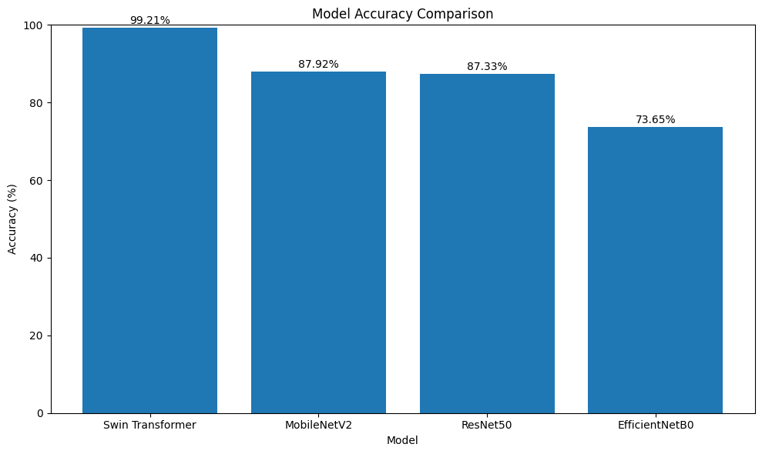
Figure (1): Accuracy comparison of the four models on the test set
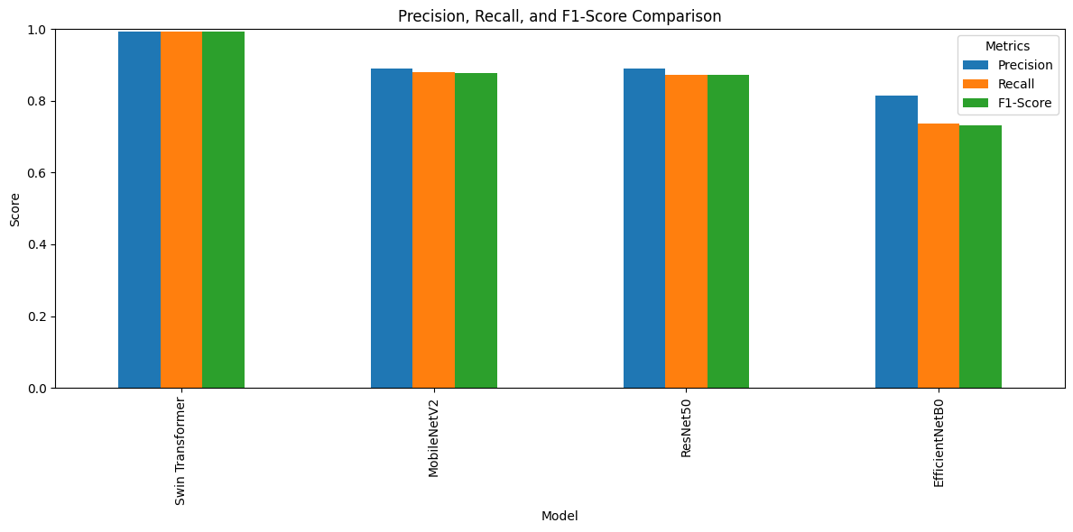
Figure (2): Precision, recall, and F1-score comparison of the four models
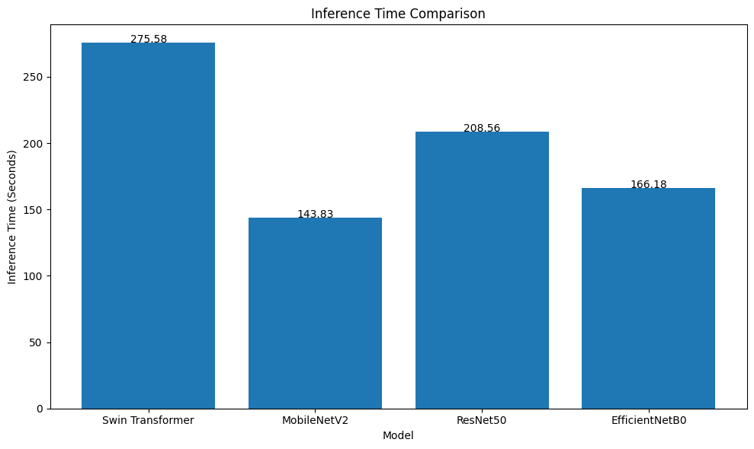
Figure (3): Inference-time comparison (seconds) of the four models on the full test set
The Swin Transformer achieved the highest performance on all metrics by a clear margin, reaching 99.21% accuracy and a 99.21% F1-score, reflecting its strong ability to distinguish between the 36 classes through hierarchical attention. MobileNetV2 ranked second at 87.92%, followed closely by ResNet50 at 87.33%, while EfficientNetB0 recorded the lowest performance at 73.65% — partly attributable to its specific preprocessing function not being applied during data preparation for that model, unlike the other two.
In terms of inference time, MobileNetV2 was fastest (143.83 seconds on the full test set), followed by EfficientNetB0 (166.18 seconds), then ResNet50 (208.56 seconds), while the Swin Transformer was relatively the slowest (275.58 seconds) due to its higher computational complexity compared to the lightweight CNNs. This highlights a practical accuracy–speed trade-off that must be considered when selecting a model for a specific application, especially in resource-constrained environments.
Confusion matrices for each model showed that most errors were concentrated in visually similar classes (e.g., letters with closely related hand poses), with the Swin Transformer making fewer such errors than the three CNN models.

8.1 Per-Class Error Analysis
Examining the classification reports for each model, the letter W proved among the most difficult classes for the CNN models, recording the lowest F1-score for MobileNetV2 (0.48) and ResNet50 (0.61), whereas the Swin Transformer maintained relatively high accuracy on this class. Similarly, the digit 6 showed notable weakness across all three CNN models (F1 between 0.30 and 0.57), likely due to its hand-pose similarity to other classes in the dataset. By contrast, the Swin Transformer maintained an F1-score of at least 0.92 across nearly all 36 classes, reflecting greater consistency across the entire class space rather than only in the overall average.
This superiority on difficult classes is likely attributable to the self-attention mechanism's ability to adaptively weight different parts of the hand according to their discriminative importance, unlike fixed convolutional filters applied uniformly across the entire image.
Table (4): Best and worst class by F1-score for each model on the test set
Model | Best Class (F1) | Worst Class (F1)
Swin Transformer | Most classes (F1 = 1.00) | Digit 6 / letters o / w (F1 ≈ 0.92–0.97)
MobileNetV2 | Several classes (F1 = 1.00) | Letter w (F1 = 0.48)
ResNet50 | Several classes (F1 = 1.00) | Digit 6 (F1 = 0.57)
EfficientNetB0 | Several classes (F1 = 1.00) | Digit 6 (F1 = 0.30)

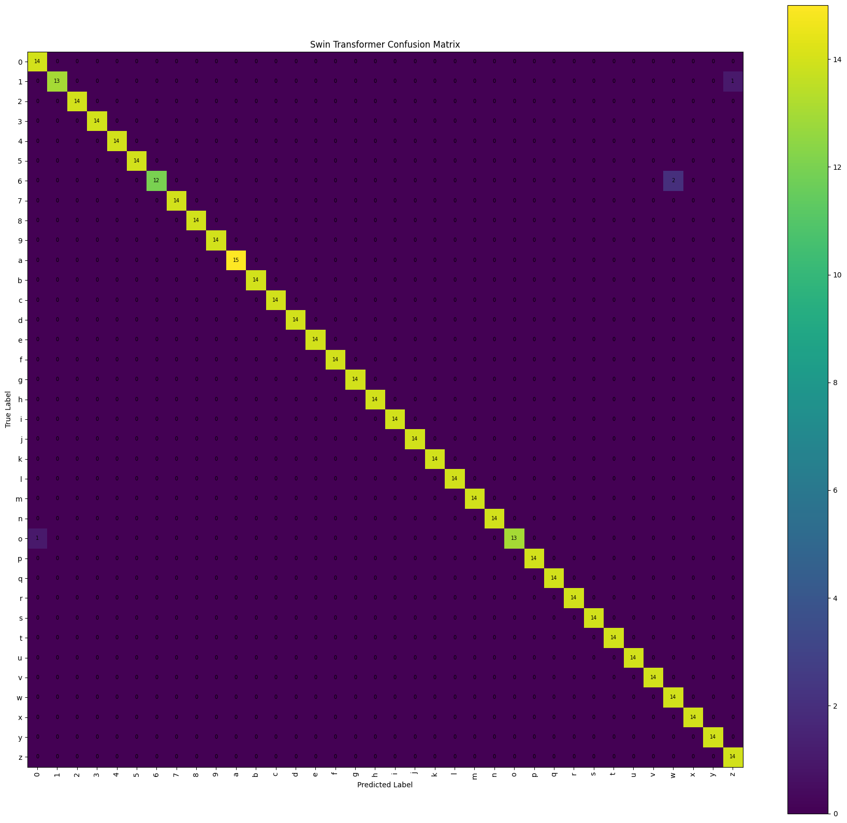
Figure (4): Confusion matrix of the Swin Transformer on the test set
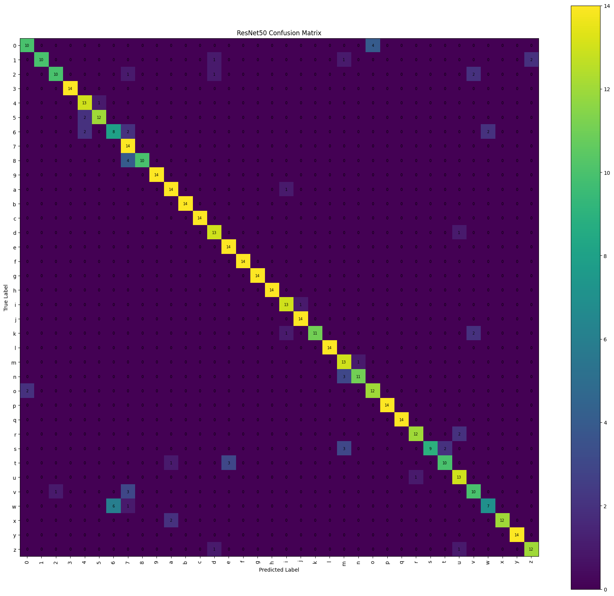
Figure (5): Confusion matrix of ResNet50 on the test set
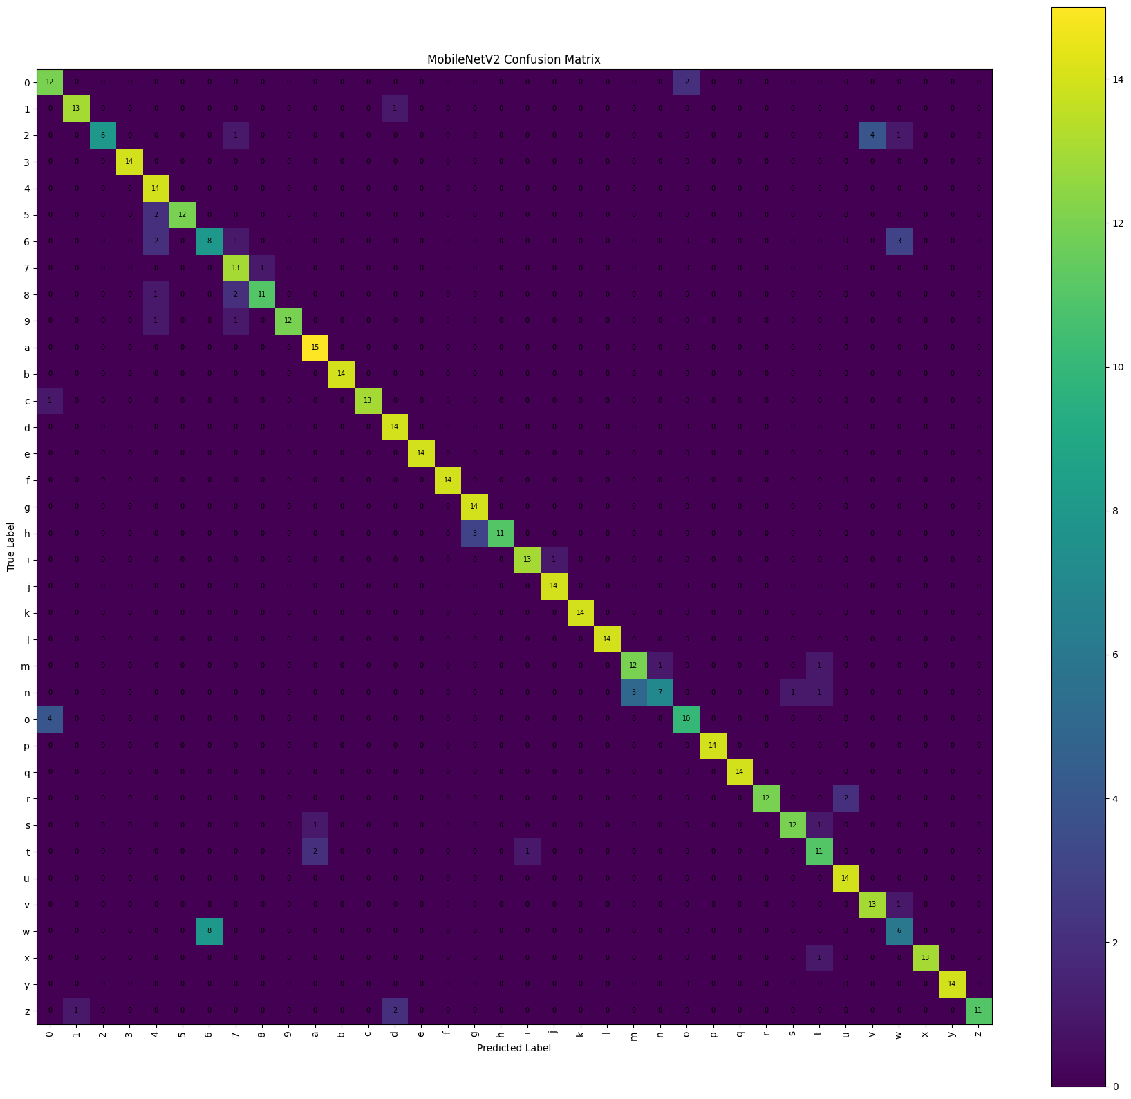
Figure (6): Confusion matrix of MobileNetV2 on the test set
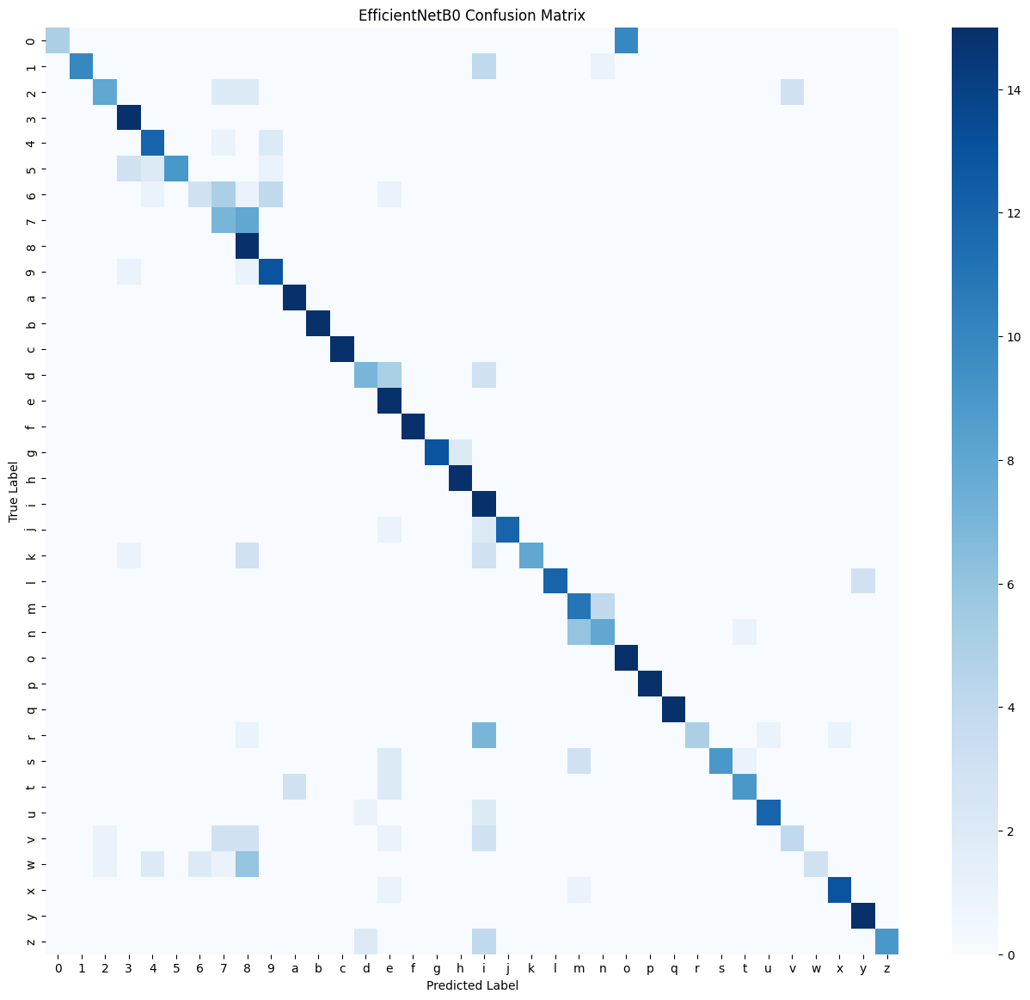
Figure (7): Confusion matrix of EfficientNetB0 on the test set

8.2 Limitations of the Study
- The study was limited to static fingerspelling images of ASL letters and digits, and did not address dynamic gestures or full sentences, which would require additional temporal modelling.
- The study relied on a relatively limited dataset (2,516 images), captured mostly under near-uniform lighting and background conditions, which may limit the generalisability of the results to diverse real-world environments (poor lighting, cluttered backgrounds, varying skin tones).
- The study did not include an actual field test of the models within an interactive real-time application; inference-time evaluation was limited to the cloud computing environment used during experimentation.
- No advanced hyperparameter tuning (e.g., grid search or evolutionary algorithms) was performed; uniform, fixed settings were adopted across the four models to ensure a fair comparison.

9. Discussion and Conclusion
The results obtained in this study align with a general trend in the recent literature indicating the superiority of vision transformers, particularly the Swin Transformer, over traditional CNNs in sign-language recognition and image classification tasks more broadly. For instance, Aly and Fathi (2025) found that combining CNNs with vision transformers achieves over 99% accuracy on a similar dataset, close to the accuracy achieved by the standalone Swin Transformer in the present study (99.21%), despite the difference in dataset size. This superiority is also consistent with what was observed when applying the Swin Transformer within a hybrid model for monkeypox diagnosis, where it clearly outperformed traditional CNNs such as DenseNet121, VGG16, ResNet18, and AlexNet (Saleh et al., 2024), suggesting that the Swin Transformer's ability to merge local and global features via shifted windows represents a structural advantage that extends beyond the medical domain to other vision tasks such as sign-language recognition.
By contrast, the three CNN models' results (87.92%, 87.33%, 73.65%) are noticeably lower than those achieved in prior studies using much larger datasets exceeding 87,000 images (Alsharif et al., 2023; Kasapbaşı et al., 2022), supporting the hypothesis that the small dataset size used in this study (only 2,516 images) may have limited the lighter-weight CNNs' ability to generalise sufficiently, while the Swin Transformer leveraged its pretrained representations more effectively despite the limited data.

9.1 Practical Applications
The most efficient model identified in this comparison can be deployed in several practical applications that directly serve the D&M community. In education, the model could be integrated into an interactive application for teaching the ASL alphabet to children and beginners, providing immediate feedback on the correctness of a performed sign. In public services, the model could serve as a front-end recognition layer within self-service kiosks at government and healthcare facilities, enabling the D&M community to communicate without requiring a human interpreter to be physically present. In mobile contexts, MobileNetV2 is the more practical choice for smartphone integration given its light weight and fast inference, even though its accuracy is lower than the Swin Transformer's.

9.2 Integration with Communication and Video-Conferencing Platforms
Integrating the proposed model into video-conferencing platforms and communication applications (such as Zoom, Microsoft Teams, and Google Meet) represents one of the most important practical extensions of this study, given the growing need for the D&M community to participate effectively in remote professional and educational meetings. This integration can be envisioned through a plugin/extension that operates as follows:
- Continuously capturing the Deaf participant's video frames directly from the webcam during the meeting, and feeding them to the trained model (the Swin Transformer, or a compressed variant) to recognise the letters and digits being formed in real time.
- Aggregating the recognised letter sequence and passing it through a simple language-processing layer (spell-checking and word assembly) to convert it into coherent, readable text.
- Displaying the resulting text as live captioning at the bottom of the screen for other meeting participants, similar to the live speech-translation feature already available on these platforms.
- Conversely, speech-to-text or text conversion of other participants' spoken contributions can be displayed to the Deaf participant, achieving bidirectional communication within the same meeting environment.

Realising this scenario in practice requires addressing several technical challenges beyond the scope of this study, most notably: the need for very low real-time inference latency (under 100 milliseconds per frame); moving from recognising isolated static letters to recognising a continuous, dynamic gesture sequence; and the need to automatically locate and isolate the hand from a changing video background. Nonetheless, the results obtained here — particularly the Swin Transformer's superior accuracy — represent a promising starting point for developing such an extension in the future, especially if combined with the model-compression techniques noted in the recommendations.

9.3 Summary of the Discussion
In summary, this study answers its three sub-questions posed in Section 2: in terms of accuracy, the Swin Transformer clearly outperforms the three CNN models; in terms of the most difficult classes, letters and digits with similar hand poses (such as w and the digit 6) are most error-prone specifically for the CNN models; and in terms of the accuracy–inference-time trade-off, MobileNetV2 remains the more practical choice for resource-constrained applications that can tolerate lower accuracy for higher speed. Together, these findings open the door to future work that seeks to combine the Swin Transformer's accuracy with the light weight of small CNNs through model compression and knowledge distillation techniques.

10. Recommendations
- Adopt the Swin Transformer as a baseline model when developing practical ASL recognition systems, given its clear accuracy advantage.
- Expand the dataset to include a larger number of images per class, with greater diversity in lighting, background, and skin tone, to improve generalisation to varied real-world environments.
- Investigate model compression / quantization techniques to reduce the Swin Transformer's inference time and enable deployment on resource-constrained devices such as smartphones.
- Extend the work in the future from recognising static fingerspelling to recognising dynamic gestures and full sentences, using models that jointly capture spatial and temporal features.
- Integrate natural language processing (NLP) techniques as a subsequent step to convert the recognised letter sequence into coherent, spell-checked text.
- Develop a plugin that integrates the proposed model into video-conferencing and communication platforms (such as Zoom, Teams, and Google Meet) to provide live translation of a Deaf speaker's signs, after addressing the real-time challenges discussed in Section 9.2.

References
Alsharif, B., Altaher, A. S., Altaher, A., Ilyas, M., & Alalwany, E. (2023). Deep learning technology to recognize American Sign Language alphabet. Sensors, 23(18), 7970. https://doi.org/10.3390/s23187970
Aly, M., & Fathi, I. S. (2025). Recognizing American Sign Language gestures efficiently and accurately using a hybrid transformer model. Scientific Reports, 15, 20253. https://doi.org/10.1038/s41598-025-06344-8
Applying Swin architecture to diverse sign language datasets. (2024). Electronics, 13(8), 1509. https://doi.org/10.3390/electronics13081509
He, K., Zhang, X., Ren, S., & Sun, J. (2016). Deep residual learning for image recognition. In Proceedings of the IEEE Conference on Computer Vision and Pattern Recognition (pp. 770–778).
Kasapbaşı, A., Elbushra, A. E. A., Al-Hardanee, O., & Yilmaz, A. (2022). DeepASLR: A CNN based human computer interface for American Sign Language recognition for hearing-impaired individuals. Computer Methods and Programs in Biomedicine Update, 2, 100048. https://doi.org/10.1016/j.cmpbup.2021.100048
Liu, Z., Lin, Y., Cao, Y., Hu, H., Wei, Y., Zhang, Z., Lin, S., & Guo, B. (2021). Swin Transformer: Hierarchical vision transformer using shifted windows. arXiv preprint arXiv:2103.14030.
Ma, Y., Xu, T., & Kim, K. (2022). Two-stream mixed convolutional neural network for American Sign Language recognition. Sensors, 22(16), 5959.
Saleh, H., Mostafa, S., Ismail, A. H., Srivastava, S., & Alsamhi, S. H. (2024). Swin-PSO-SVM: A novel hybrid model for monkeypox early detection. IEEE Access, 12, 187367–187385. https://doi.org/10.1109/ACCESS.2024.3513818
Sandler, M., Howard, A., Zhu, M., Zhmoginov, A., & Chen, L. C. (2018). MobileNetV2: Inverted residuals and linear bottlenecks. In Proceedings of the IEEE Conference on Computer Vision and Pattern Recognition (pp. 4510–4520).
Tan, M., & Le, Q. (2019). EfficientNet: Rethinking model scaling for convolutional neural networks. In Proceedings of the 36th International Conference on Machine Learning (pp. 6105–6114). PMLR.
World Health Organization. (2021). World report on hearing. WHO. https://www.who.int/publications/i/item/9789240020481

