

Industrial Fire and Accident Risk Prediction Using Explainable Machine Learning
Prepared By
Name: Abdullah Hadi Alfaifi ID No.: 261002804
Name: Zainah Alloush ID No.: 241002569

Submitted in fulfillment of the requirements for the degree Master of Science in Artificial Intelligence
At
College of Informatics
Midocean University
UAE
Supervisor Name: Dr. Mohamed Eassa
College of Informatics, Midocean University, Comoros
Email: abd.alfifi95@gmail.com
Email: s130017905@gmail.com

Acknowledgements

We would like to express our sincere gratitude to our supervisor, Dr. Mohamed Eassa, for his continuous guidance, valuable feedback, and support throughout this research. His expertise in artificial intelligence and machine learning has greatly influenced the direction of this work. His comments encouraged us to think critically and approach the research from both scientific and practical perspectives.
We are also thankful to the faculty members at the College of Informatics, Midocean University, for providing a supportive academic environment that encouraged independent thinking and research development.
Finally, we would like to express our appreciation to our families for their patience, encouragement, and continuous support throughout this journey.

Abstract

Industrial settings present myriad challenges to safety. Among the greatest are the exposure to fire and safety accidents from environmental, operational, and equipment and human factors. Traditionally fire and safety accident risk management rely heavily on periodic inspections and fixed thresholds and reporting of safety incidents. While important, these methods are reactive and often don't identify hazardous situations and conditions that develop and escalate to serious safety incidents. With the advancement of the Industrial Internet of Things (IIoT), industrial and connected sensors can be continuously monitored and associated unsafe conditions identified through machine learning.
This study aims at the first time to develop an explainable machine learning framework to predict the risk of industrial fires and workplace accidents. To achieve this, a machine learning operational model is proposed that draws on a rich, structured industrial dataset that encompasses environmental, operational, equipment, and human variables, such as vibration, gas concentration, temperature, and humidity, machine maintenance and age, the safety of workplace conditions, and worker safety training and experience.
Fundamentally, the framework will develop and test a variety of machine learning models, including but not limited to, Logistic Regression, Decision Trees, Random Forest, Support Vector Machine, and XGBoost. These will be assessed using the ROC-AUC, confusion matrix, and other common accuracy measures and metrics. Safety-related applications are fundamentally concerning, and serious incidents may arise from the omission of unsafe cases, so special emphasis will be placed on recall among the measures and metrics. Safety and fire prediction will be attained via the application of Explainable Artificial Intelligence and SHAP will be utilized to ascertain the predictors of fire and accident risk within the dataset. Global and local explanations within SHAP will define the risk factors of fire and accidents and the individual cases of predictions, respectively.
This research proposes an integrated system that merges fire-risk prediction, accident-risk prediction, and interpretability of models. The framework is designed to provide early alerts, enhance the comprehension of industrial-related risks, and enable safety engineers as well as decision makers to implement more targeted preventative measures.
The following keywords provide an overview of the content: Industrial Safety, Industrial Internet of Things, Machine Learning, Fire-Risk Prediction, Accident-Risk Prediction, Explainable Artificial Intelligence, SHAP, Early Warning.

Table of Contents
Acknowledgements ii
Abstract iii
Table of Contents v
List of Figures viii
List of Tables ix
Chapter 1: Introduction 1
1.1 Overview 1
1.2 Problem Definition 4
1.3 Thesis Objectives 4
1.4 Thesis Contribution 5
1.5 Thesis Organization 6
Chapter 2: Background and Related Work 7
2.1 Introduction 7
2.2 Background 7
2.2.1 Industrial Safety 8
2.2.2 Industrial Internet of Things (IIoT) for Safety Monitoring 8
2.2.3 Sensor Data and Data Preprocessing 9
2.2.4 Machine Learning Techniques 10
A. Logistic Regression 11
B. Decision Tree 12
C. Random Forest 13
D. Support Vector Machine 14
E. XGBoost 16
2.2.5 Deep Learning Techniques 17
2.2.6 Natural Language Processing for Accident Reports 18
2.2.7 Explainable Artificial Intelligence and SHAP 19
2.3 Related work 21
2.4 Related Work Summary 25
Table 2.1 Summary of related work 28
References: 32

List of Abbreviations
Abbreviation | Full Term
AI | Artificial Intelligence
ML | Machine Learning
DL | Deep Learning
IoT | Internet of Things
IIoT | Industrial Internet of Things
XAI | Explainable Artificial Intelligence
SHAP | Shapley Additive Explanations
CNN | Convolutional Neural Network
1D-CNN | One-Dimensional Convolutional Neural Network
LSTM | Long Short-Term Memory
Bi-LSTM | Bidirectional Long Short-Term Memory
RF | Random Forest
DT | Decision Tree
SVM | Support Vector Machine
XGBoost | Extreme Gradient Boosting
NLP | Natural Language Processing
TF-IDF | Term Frequency–Inverse Document Frequency
GloVe | Global Vectors for Word Representation
BN | Bayesian Network
ABM | Agent-Based Modeling
PPE | Personal Protective Equipment
FAS | Fire Alarm System
RGB | Red, Green, and Blue

List of Figures
Figure No. | Figure Title | Page
Figure 1.1 | Industrial IoT-Based Intelligent Safety Framework | 2
Figure 2.1 | IIoT-based Safety Monitoring Workflow | 9
Figure 2.2 | Sensor Data Preprocessing Pipeline | 10
Figure 2.3 | Supervised Machine Learning Workflow | 11
Figure 2.4 | Logistic Regression Decision Boundary for Binary Classification | 12
Figure 2.5 | Example Decision Tree for Industrial Risk Classification | 13
Figure 2.6 | Random Forest Majority Voting Concept | 14
Figure 2.7 | SVM Hyperplane and Maximum Margin | 15
Figure 2.8 | Implementation of XGBoost | 16
Figure 2.9 | Deep Learning for Sequential Sensor Data | 18
Figure 2.10 | NLP Pipeline for Accident Report Analysis | 19
Figure 2.11 | SHAP Feature Contribution Concept | 20

List of Tables

Table No. | Table Title | Page
Table 2.1 | Summary of Related Work | 28

Chapter 1: Introduction

1.1 Overview
The advent of Industry 4.0 has led to the reengineering of management and operation of industrial systems. Manufacturing processes and the overall management of Manufacturing Execution Systems (MES) are more efficient and effective with connected devices and the Industrial Internet of Things (IIoT) [1]. With the rapid advancement of connectivity and the ability to access real-time data from various sensors, industries are surpassing the traditional methods of monitoring industrial processes and making safety and efficiency decisions . [2]
When you have hazardous conditions, safety is always of great concern, particularly when the hazardous condition can potentially cause a fire or accident in the workplace. These office accidents, in different forms and the damage to the equipment can stop production for a considerable period of time and cause significant financial losses [3]. For many industries, the main concern is the safety of employees and the financial loss due to a reduction in productivity. [4]
Figure 1.1 shows the entire picture of the Industrial IoT-based intelligent safety framework, and how the sensor data from the industrial environment flows to the intelligent decision support systems
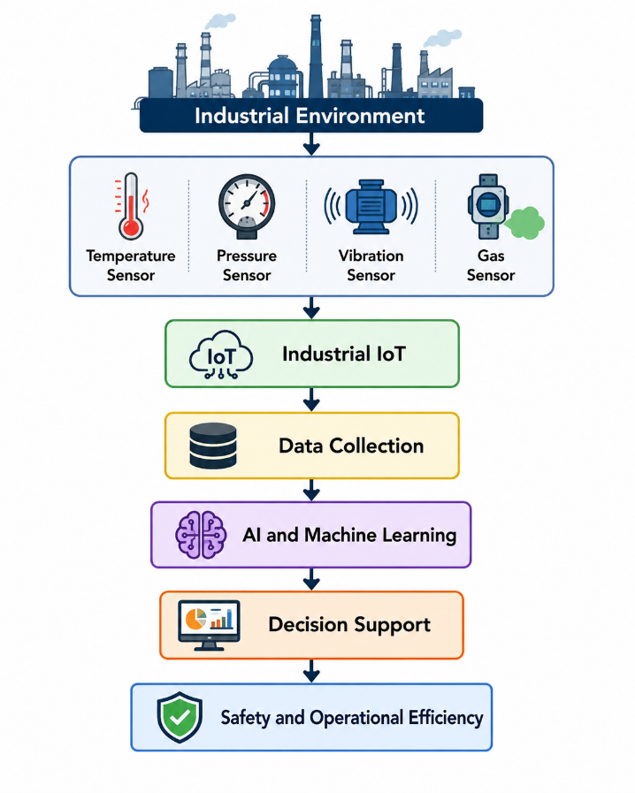
Figure 1.1: Industrial IoT-Based Intelligent Safety Framework

Most traditional methods of safety rely on periodic inspections and after-the-fact rules for reactive measures. While these methods have helped in the increase of safety standards, they lack the ability to identify safety concerns prior to an event [4]. With the surge in the volume of data generated by sensors, more advanced methods that support proactive risk are possible.
In the past few years, major advances in the integration of Artificial Intelligence (AI) and Machine Learning (ML) in industry have occurred. With AI and ML, one can handle complex data sets and identify complex patterns in a data set that might not be picked up in the traditional analysis framework. Because of this, the application of predictive models to aid in the identification of abnormal conditions has become more popular and is used to reduce the occurrence of accidents [5].
Apart from predicting risk, the proliferation of more accessible predictive analytics is enabling industries to create early warning systems to identify abnormal conditions prior to their escalation to serious incidents. They are cost effective and provide real-time information, which enables pro-active maintenance and reduces unexpected downtime and maximises business efficiency. Therefore, predictive analytics has become an integral part of the modern safety management system and the smart manufacturing intelligent safety management system [6].
Such a wide integration of IIoT systems brings additional benefits to an unlimited monitoring and measurement of safety parameters, which are critical for safety (temperature, pressure, humidity, vibration and even the concentration of gases). The data from these technologies creates a better understanding of the state of an industrial system, and facilitates the shift in safety practice from reactive to predictive risk management [7].
The addition of ML systems, especially for advanced and complex ML models, to safety management systems is generating a paradox. Although ML models provide great benefits and operational advantages, their low interpretability is a serious risk in safety management systems. In safety-critical applications, it is of great importance to understand and validate the predictive results. This, in turn, is driving the focus in Explainable AI (XAI) research, which aims to make safety management systems more transparent and predictable [8].
IIoT, AI, and machine learning can be used together to create sophisticated safety systems that predict industrial fires or accident hazards that can be "explained. These systems can contribute in optimizing the situational awareness and also in implementing other effective techniques of risk response in modern manufacturing systems. This integration of Explainable Machine Learning with Industrial IoT technologies, therefore, seems to be a new industrial safety improvement and to offer a preemptive risk management capability in intelligent manufacturing systems [9].

1.2 Problem Definition
Industrial accidents and fires at the workplace continue to be a problem in many industrial sectors, as the development of Industrial 4.0 and the growing adoption of systems based on the Industrial Internet of Things (IIoT) has been occurring. These events pose risks to employee safety, system damage, workflow/process disruption and costly financial losses [10].
Many industrial sites rely on routine checks and procedures that are preplanned and predictable for the management of safety. Advances have been made in safety but these still react to the event of an accident - they don't stop it from happening. As a result, workers might not be aware of safety hazards until after an incident has occurred [11].
With the greater access to the data from peripheral devices and the development of techniques for machine learning, it is becoming more common to use machine learning techniques in industrial applications. Some promising results have been shown for the detection of fires, the detection of anomalies, and the analysis of accidents. Most of the above techniques, however, address such problems separately and at times, only with the concern for predicting the problem instead of justifying the prediction capabilities of the prediction models [12].
Where safety is paramount, other factors may be more important than accurate prediction. Engineers and decision makers should also understand the logic behind the system's determination of the situation to be unsafe so that they can make the appropriate determination. This reflects the necessity of the development of more prediction based and justification oriented techniques [13].
There is still a strong requirement for a system that is extensible in its use of the Industrial IoT sensor data to forecast the risks of industrial fire and accidents to provide justifiable results for the advanced safety management of industrial systems, and to justify the results to improve the safety-related decision-making processes and management within contemporary industrial systems.

1.3 Thesis Objectives
- To build predictive models to assess risk of workplace accidents and industrial fires using Logistic Regression, Decision Tree, Random Forest, Support Vector Machine (SVM), and XGBoost.
- To compare performance of selected machine learning algorithms using evaluation metrics like Accuracy, Precision, Recall, F1-score, ROC-AUC and Confusion Matrix.
- To select the most appropriate machine learning model for structured industrial IIoT data in terms of predictive performance, robustness and computational efficiency.
- To apply Explainable Artificial Intelligence (XAI) with the SHAP approach to explain model results and determine the main underlying variables that affect risk of fire and accidents.
- To create an explanatory decision support system to improve the practice of industrial safety management proactively and help safety engineers make reliable decisions.

1.4 Thesis Contribution
- Use structured industrial data to predict fire and workplace accident risks.
- Provide a comparative evaluation of Logistic Regression, Decision Tree, Random Forest, Support Vector Machine (SVM), and XGBoost models for industrial fire and workplace accident risk prediction.
- Propose an integrated framework that combines IIoT data, machine learning, and explainable artificial intelligence.
- Support safety engineers and decision-makers by providing understandable risk predictions and early-warning information.

1.5 Thesis Organization
The rest of this thesis is organized as follows.
Chapter 2 discusses the theoretical background and relevant research areas.
Chapter 3 presents the proposed methodology.
Chapter 4 analyzes the experimental results.
Chapter 5 concludes the study and suggests directions for future work.

Chapter 2: Background and Related Work

2.1 Introduction
This chapter presents the background concepts and previous studies related to industrial fire and accident risk prediction using explainable machine learning. The main concepts discussed include industrial safety, the Industrial Internet of Things, sensor-based monitoring, data preprocessing, machine learning, model evaluation, and Explainable Artificial Intelligence.
As discussed in Chapter 1, modern industrial safety extends beyond scheduled inspections and responses taken after an incident. Connected sensors and industrial devices generate environmental and operational data that can be used to detect abnormal conditions and provide earlier warnings of potential fires and workplace accidents.
Machine learning plays an important role in this area because it can identify relationships that may be difficult to represent using fixed alarm rules. However, high predictive performance alone may not be sufficient. Engineers and decision-makers may hesitate to rely on a model if it does not explain why a particular condition has been classified as unsafe.
For this reason, this chapter also discusses how Explainable Artificial Intelligence can improve the transparency and practical value of predictive safety models. The related work reviews recent studies supported by relevant foundational research. The studies are compared in terms of their objectives, datasets, techniques, results, strengths, and limitations. The final section identifies the research gap addressed by the current study.

2.2 Background
This section presents major theoretical ideas that will underpin the proposed research on the prediction of industrial fires and workplace accidents. The background builds on industrial safety, IIoT-based oversight, preparation of sensor data, machine learning, deep learning, natural language processing, and explainable artificial intelligence. The objective is to describe the methods that will be employed and provide links to each method within the context of safety prediction.

2.2.1 Industrial Safety
The goal of industrial safety is to avoid the injury of employees, damage to equipment, loss of production, and other adverse events. In the industrial setting, the workplace can be made unsafe with high temperature, leakage of gas, electrical problems, machine breakdown, lack of maintenance, unsafe behavior of employees, and unsafe conditions in the environment [14]. Some unsafe conditions are easily recognized. Others may develop and remain safe until several conditions are met when they become unsafe. An example may be a gas leakage that when combined with poor ventilation, may represent a greater hazardous situation, [15].
Safety management of the past relied on inspections, safety procedures, incidents reporting, and the establishment of alarm thresholds. While these techniques are important, they tend to be reactive, identifying safety issues after a regulation is broken or a safety incident has already occurred [16]. In a modern dynamic industrial facility, the state of equipment, safety of the environment, and actions of employees are continuously changing so that fixed rules may be unable to identify unsafe situations [17]. Therefore, the continuous monitoring of safety in a workplace and the reliance upon predictive decision support is becoming essential to safety management.

2.2.2 Industrial Internet of Things (IIoT) for Safety Monitoring
Continuous monitoring of industrial safety is made possible due to technologies built on the Industrial Internet of Things (IIoT). IIoT networks are made to capture operational and environmental data through the combination of sensors, machines, edge devices, communication networks, and data platforms, especially in industrial settings [18]. These data can be used to prevent fire and accidents and can be temperature, humidity, concentration of gas, pressure and vibration of equipment, machine status and other safety-related factors [19].
In the safety system designed with the IIoT, data from the industrial environment are transferred for computing through gateways or edge devices to a data computing layer, and can be analyzed to determine the probability of safety being compromised using one of the ML techniques post the data has been precomputed. Various output formats, such as dashboards, alerts, or a support system for making decisions, can be used to display the findings of the analysis. The basic procedural flow is captured in Figure 2.1.

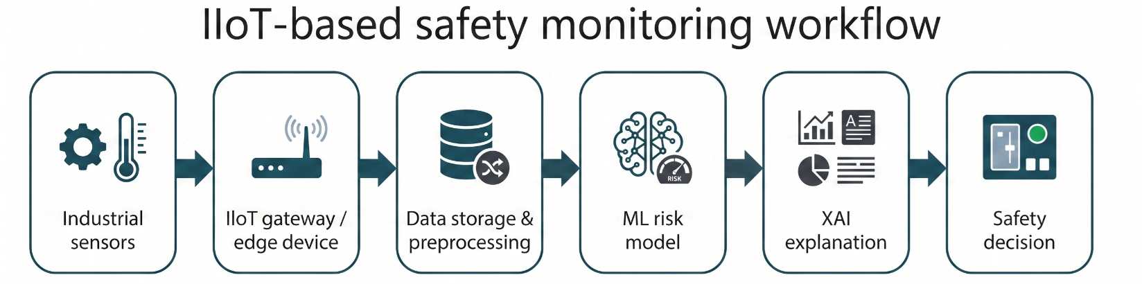

Figure 2.1: IIoT-based safety monitoring workflow.
The figure shows how industrial sensor data can move from physical devices to preprocessing, machine learning prediction, explainable AI, and safety decision support. Based on the IIoT safety monitoring concepts discussed in [7], [18], and [19].

One major benefit of integrating Industrial IoT for safety-related functions is the capacity for constant surveillance of operational shifts, as opposed to the traditional method of periodic inspections. However, the benefits of Industrial IoT are greatly diminished with poor or unreliable sensor data. Safety monitoring systems can be negatively impacted by sensor drift, loss of communication, issues with calibration, interference in the environment, and noisy data. Due to the reasons stated above, the data is prepared and cleaned prior to developing a prediction model.

2.2.3 Sensor Data and Data Preprocessing
Sensor data from industries rarely are direct inputs to ML models. Raw data frequently have missing values, duplicates, outliers, noise, inconsistent units, and require encoded categorical variables [20]. Failing to account for these data issues can lead to incorrect predictions, false positives and most critically, missed hazardous situations. The quality of the data especially matters in fire detection and accident prediction as one wrong prediction can cause the delay of an entire evacuation, machine shutdown and emergency measures.
Some of the usual preprocessing tasks include deduplication, outlier treatment, normalization, noise reduction, categorical variable encoding, splitting the dataset into training and test sets, and in some cases, time-signal filtering [21]. Preprocessing of sensor data that are fast time-dependent may require additional filtering or signal processing methods to reduce noise.
Normalizing the data and treating the outliers and noise are also critical preprocessing tasks. The main processes of the required sensor data preprocessing are charted in Figure 2.2.

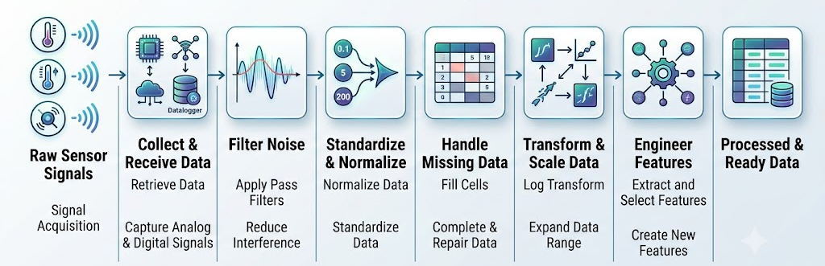
Figure 2.2: Sensor data preprocessing pipeline.
The figure summarizes the transformation from raw sensor readings to model-ready data through missing value handling, noise and outlier treatment, scaling, encoding, and data splitting. Based on data cleaning principles in [23] and sensor reliability issues discussed in [20].

Safety prediction model evaluations cannot rely solely on accuracy. When a system produces a false alarm, it implies there is a hazard risk, when actually there is none. This can cause disruption and reduce reliance on the alarm system [22]. In contrast, a false negative means a real threat goes undetected. Among the safety-critical environment hazards, this is the more severe of the two. The system is unable to detect the threat, and, as a result, no action can be made to intervene [23]. This is why the current study places focus on the recall value, as well as, precision, F1-score, ROC-AUC, and confusion matrix. This is especially true because the absence of a detection of a threat poses a risk to safety.

2.2.4 Machine Learning Techniques
Machine learning systems can identify the relationships between input elements and resultant safety outcomes. This study proposes using several structured variables captured in the industry for the input elements. These variables include temperature, humidity, gas concentration, smoke, and vibration, as well as maintenance status, machine age, and worker-related safety indicators. The output will be the classification of fire or accident risk. The general supervised learning method applicable for this prediction problem is illustrated in Figure 2.3.

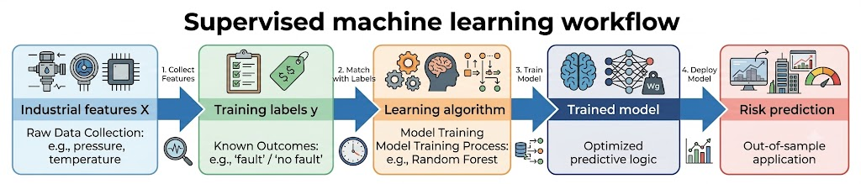
Figure 2.3: Supervised machine learning workflow.
Industrial features and known labels are used to train a model that can predict fire or accident risk for new observations. This workflow is consistent with the use of machine learning models for safety and risk prediction discussed in [25] and [29].

Logistic Regression
Logistic Regression is a supervised classification algorithm. Logistic Regression is a regression-based model available for both binary and multi-class classification problems. As a baseline model for classification algorithms, it’s tremendously useful in industrial safety paradigms. Logistic Regression predicts the probability an observation belongs to a given class, regression-based and achieved through the application of the logistic function to a linear combination of the features [25]. In the case of industrial safety, Logistic Regression aids in assessing the risk status of a variable through the prediction of maintenance, temperature, smoke level, and gas concentration, etc. Logistic Regression’s primary advantage is its interpretability. The influence of the feature can be determined by the magnitude and sign of the coefficients. The predicted risk probability is calculated using Equation (2.1)
$P=\frac{1}{1+e^{-y_{i}}}$ (2.1)
In Equation (2.1), (P) is understood as the expected likelihood of the input being classified to the risk class. The (y_i) refers to the score that the model assigns to the input, based on the input features and the learned coefficients. The higher (y_i) is, the closer (P) is to 1, and the higher likelihood of the input is to be classified to the risk class. The lower (y_i) is, the closer (P) is to 0, and the lower likelihood of the input is to be classified to the risk class. In this sense, (P) is the model score converted to a probability between 0 and 1. Logistic Regression, although simple and transparent, is unable to capture many complex, nonlinear relationships that seem to dominate the industrial safety data [25]. The resulting binary decision boundary is illustrated in Figure 2.4
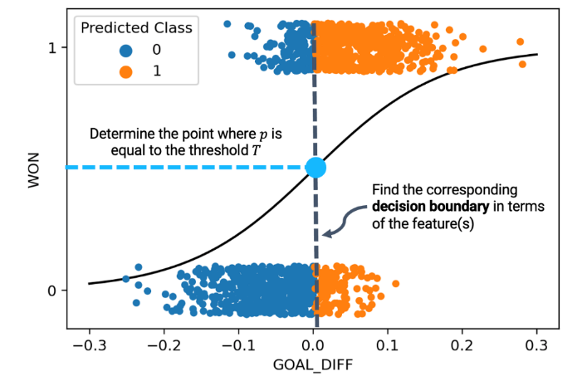
Figure 2.4: Logistic Regression decision boundary for binary classification

Decision Tree
A Decision Tree is a classification method in which repeated partitioning of data is done based on features. Each of the internal nodes is associated with some decision rule, branches represent the outcome of the rules, and leaf nodes represent class predictions. Decision Trees, for example, can develop rules in industrial safety that state whether gas concentration and temperature are in excess of established limits [26]. Decision Tree impurity is calculated using entropy in Equation (2.2), while the reduction in impurity after a split is measured using information gain in Equation (2.3).
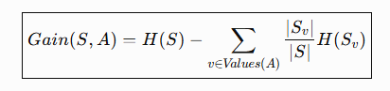 (2.2)

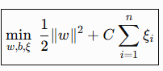 (2.3)

Entropy describes the level of impurity of a set of training samples, while the information gain is the measure that describes the level of impurity of a feature post split. The features that have a higher information gain are more important when classifying risk. Figure 2.5 represents a simple Decision Tree structure, which is created for the classification of Industrial risk.
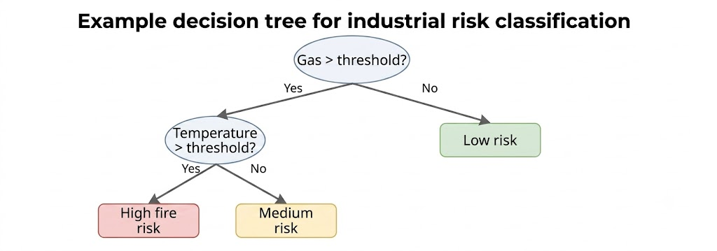
Figure 2.5: Example Decision Tree for industrial risk classification.
The tree shows how sensor thresholds can form interpretable safety rules. The concept is based on Decision Tree classification principles described in [26].

The primary advantage of Decision Trees is their transparency, as the pathway of a decision can be traced from the root to the leaf. However, a single tree can be subject to overfitting of the training data and can be rather sensitive to slight changes in the data, leading to even greater instability. This is why Random Forest is utilized.

Random Forest
Random Forest utilizes the concept of bagging by separating the data into random subsets, from which various Decision Trees are built, using random disjoint feature sets. In the case of classification, the final output is the class which is predicted by the majority of the trees. In comparison to a single Decision Tree, the robustness and overfitting of Random Forest is significantly improved [26]. The majority-voting process is illustrated in Figure 2.6.
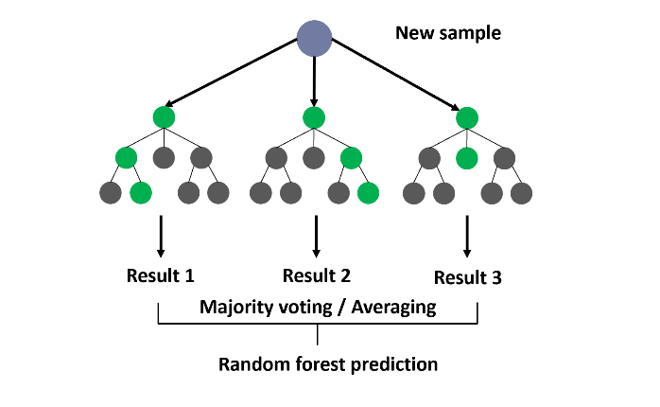
Figure 2.6: Random Forest majority voting concept
. Several Decision Trees generate predictions, and the final class is selected by combining their votes. This ensemble concept is based on the Decision Tree and Random Forest discussion in [26].

Random Forest is advantageous for industrial safety prediction. Contingent to the work environment, industrial safety predicts the many gas concentrations, smoke levels, and a variety of other factors. Because the Random Forest can describe the importance of the features in the prediction, it can also describe many of the influential variables. On the other hand, Random Forest can also be classified as a black box. This is primarily because the decisions are based on the aggregative output of many trees, as opposed to a single Decision Tree, which is transparent by nature of being a single set rule.
Mathematically, the Random Forest classifier predicts the final class by aggregating the predictions of all decision trees using a majority voting mechanism, as expressed in Equation (2.4):
$yˆ=mode\left\{h_{1}\left(x\right),h_{2}\left(x\right),...,h_{T}\left(x\right)\right\}$ (2.4)
In equation (2.4), ht(x)denotes the prediction of the t-th decision tree and Tis the total number of trees in the forest. This ensemble strategy reduces variance and improves generalization compared with a single Decision Tree

Support Vector Machine
A Support Vector Machine (SVM) is a supervised classification algorithm intended to identify the hyperplane which best differentiates classes. The best hyperplane is defined as the hyperplane which maximizes the margin between classes’ support vectors. Kernel functions, such as the Radial Basis Function, allow mapped representation of points in a higher dimensional space to identify a boundary when data is not linearly separable, The SVM optimization objective is formulated in Equation (2.5), subject to the classification constraint in Equation (2.6)
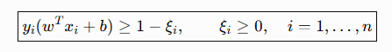 (2.5)
$subject to: y_{i}\left(w⋅x_{i}+b\right)≥1-ξ_{i}$ (2.6)
In Equations (2.5) and (2.6), w is used to represent the weight vector, b is the bias, and C is the penalty for misclassification, and the slack variables used when no perfect separation is possible is represented by ξi. The margin and hyperplane of SVMs is represented in Figure 2.7.
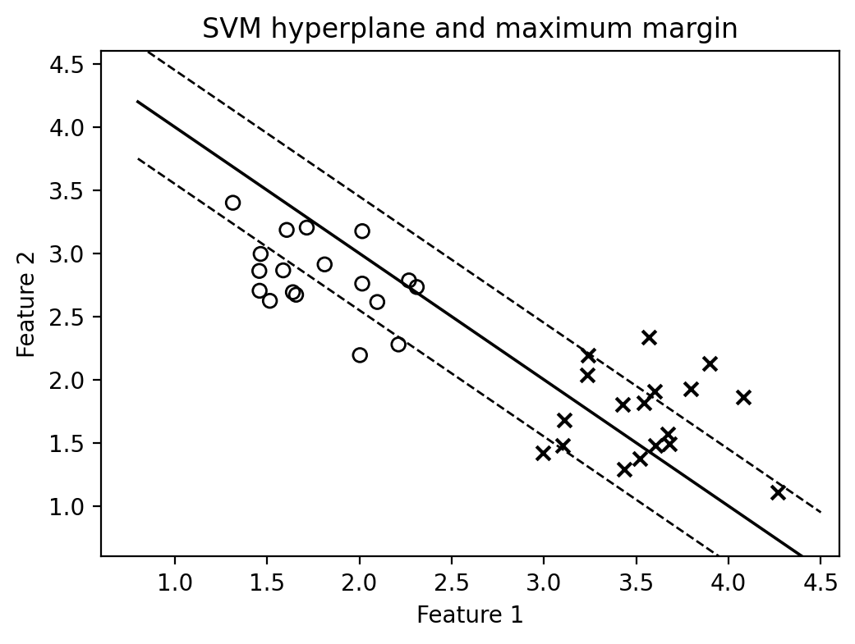
Figure 2.7: SVM hyperplane and maximum margin
. The figure illustrates how SVM separates classes by maximizing the margin between support vectors. The concept is based on SVM classification principles discussed in [27].

Although SVM is valuable for challenging classification problems, the use of nonlinear kernels reduces the model's interpretability. In safety-critical applications, this restriction poses a considerable obstacle. Engineers may need to justify the classification of certain cases as hazardous.

XGBoost
Extreme gradient boosting is one such boosting method.
XGBoost develops weak learners and builds upon them through each iteration. Typical weak learners used in XGBoost are Decision Trees. Each iteration, or tree, is built to correct errors made by its predecessors. There are many ways XGBoost optimizes conventional boosting methods, including incorporating regularization, optimizing construction of trees, pruning, and handling missing values along with other improvements in computation and efficiency. The XGBoost objective function is defined in Equation (2.7)
$Obj\left(θ\right)=∑_{i}l\left(y_{i},ŷ_{i}\right)+∑_{k}Ω\left(f_{k}\right)$ (2.7)
XGBoost combines loss and regularization to improve prediction and control for overfitting. Loss and regularization are combined in the objective function as a term for loss and a term for boosting, respectively. The general boosting method for XGBoost implemented models is described in Figure 2.8.
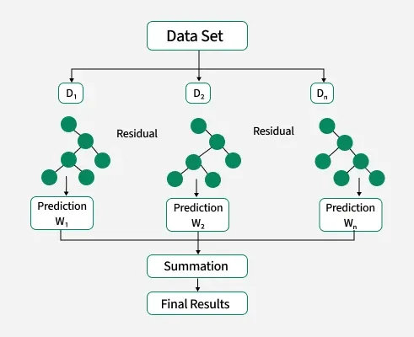
Figure 2.8: Implementation of XGBoost
XGBoost performs particularly well on structured, tabular data, which is likely the data format for the suggested industrial safety dataset. XGBoost is capable of identifying non-linear interactions among the feature variables and, as a result, is likely to maintain a high level of predictive performance. XGBoost is also inherently less interpretable than Logistic Regression or a single Decision Tree. As a result, XGBoost will likely be accompanied by interpretability techniques for explainability, such as SHAP, respectively. These techniques will support safety-related decision making.

2.2.5 Deep Learning Techniques
The utility of a given method in the presence of data that demonstrates complex and/or multi-dimensional patterns that are spatial, temporal, or sequential in nature is of great interest in the field of industrial safety. For example, in the context of industrial safety, deep learning can be used on images, videos, sounds, or long sequences of raw data given by industrial sensors [29]. For the majority of the proposed study, however, structured industrial variables are used. This means that the most appropriate main modeling methods are those offered by traditional machine learning. While deep learning will be used in the background, many related fire detection and accident analysis studies utilize 1D-CNN, LSTM, or Bi-LSTM models.
A One-Dimensional Convolutional Neural Network (1D-CNN) convolves filters on top of sequential data in order to capture local patterns in a more effective way [30]. This can be advantageous in the case of sensor streams, since the indication of anomalous behavior can be captured in small local changes. The 1D convolution operation is represented in Equation (2.8)
$y\left[t\right]=∑_{k}x\left[t+k\right]⋅w\left[k\right]+b$ (2.8)
In Equation (2.8), x is the input signal, w is the filter, b is the bias, and y[t] denotes the feature at time position t. LSTM networks leverage gates and memory cells to capture the time-dependent patterns present in the data [31]. The LSTM forget gate is calculated using Equation (2.9):
$f_{t}=sigmoid\left(W_{f}⋅\left[h_{\left(t-1\right)},x_{t}\right]+b_{f}\right)$ (2.9)
Equation (2.9) reveals that the forget gate ft regulates the deletion and retention of prior knowledge within the memory cell. Figure 2.9 illustrates how a deep learning model utilizes serial sensor data to provide a safety prediction.

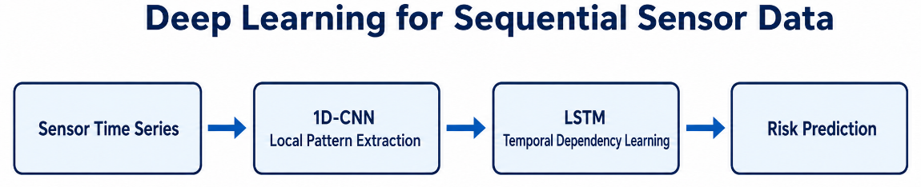
Figure 2.9: Deep learning for sequential sensor data.
A 1D-CNN may extract local patterns from sensor sequences, while LSTM can model longer temporal dependencies. The figure is based on the deep learning concepts discussed in [30] and [31].
1D-CNN and LSTM models have notable strengths. However, the demands of data and computational resources, along with increased training loads, are often prohibitive in contrast to standard machine learning techniques. Safety-critical applications require high interpretability, and these deep learning models may fall short of that need. Therefore, this study emphasizes structured IIoT safety data machine learning techniques and incorporates deep learning as an auxiliary resource in contextual comparisons to evaluation studies.

2.2.6 Natural Language Processing for Accident Reports
NLP has the potential to enhance industrial safety by analyzing accident reports, maintenance records, and incident descriptions. These records often contain accounts of the tasks, equipment, and environmental conditions associated with the accident, as well as the types of injuries and the proposed contributing factors to the accident [32]. The text data must be formed into numerical features, as machine learning models require data to be in a numerical format.
The representation of choice may be Term Frequency-Inverse Document Frequency (TF-IDF) [33]. Some advantages of the TF-IDF representation are, assigning a higher score to less frequent document term scores and assigning lower scores to terms that are not informative across documents. Thus, in task centric injury severity prediction and root cause analysis, the terms may be filtered and ranked based on their levels of informativeness. [33]. The TF-IDF weight is calculated using Equation (2.10)
$TF-IDF\left(t,d\right)=TF\left(t,d\right)⋅log\left(N/DF\left(t\right)\right)$ (2.10)
In Equation (2.10), TF(t, d) represents the frequency of term t in document d, N refers to the total number of documents, and DF(t) refers to the number of documents containing term t. GloVe is another representation that creates dense word embeddings that can capture the semantic relationship of words. Figure 2.10 presents a common NLP pipeline for the analysis of text in accident reports.

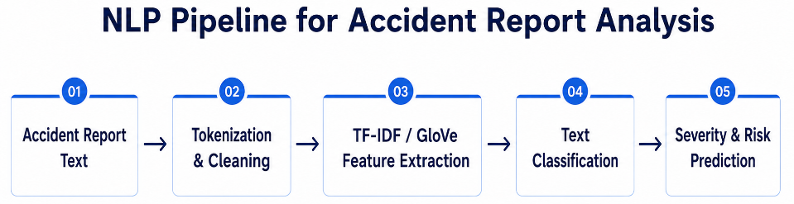
Figure 2.10: NLP pipeline for accident report analysis.
Textual accident narratives are cleaned and transformed into numerical features, such as TF-IDF or word embeddings, before being used by a classifier. The figure is based on NLP accident report analysis concepts in [32] and [33].
NLP is useful for deriving insights from descriptions of historical accidents, but more commonly is used after the incident is reported. For this reason, NLP is more appropriate for post-incident assessment, determining root causes, and predicting injury severity as opposed to preventing incidents or fires in real time. This research focuses on structured IIoT and safety variables. NLP is added to demonstrate the use of text in accident data in the related studies.

2.2.7 Explainable Artificial Intelligence and SHAP
Many advanced machine learning and deep learning models have low interpretability. This creates problems in safety-critical situations as engineers and managers need to know not only the predictions of the models, but also the justifications for the predictions. Explainable Artificial Intelligence (XAI) offers solutions to this problem by providing tools to build more transparent, interpretable, and trustworthy AI systems. [35]
Explanations provided by XAI can be either global or local. Global explanations captures the general behavior of the model and identifies the most influential variables. Local explanations, on the other hand, show a specific model prediction and illustrate why the model deemed a particular case safe or unsafe. Global and local explanations are both valued in the domain of industrial safety. Global explanations support managers in comprehending general safety risk concerns, while local explanations support engineers in analyzing a specific safety alarm.
SHAP is an XAI method built on the Shapley values of cooperative game theory. It is used to define the extent of each feature’s impact to a model prediction by comparing the feature’s value with an expected or reference value [36]. The SHAP value for feature i is calculated using Equation (2.11)
$SHAP_{i}=∑_{(}S⊆F\{i$ (2.11)
In Equation (2.11), SHAP_i represents the SHAP value for feature i, F is the total set of features, S is the set of features excluding i, and f is the model output. When a feature holds a positive SHAP value, it is interpreted as that feature increasing the prediction of higher risk. Conversely, it decreases risk prediction when a feature holds a negative SHAP value. [36]. The feature-contribution concept is illustrated in Figure 2.11. Here, f(S+i) denotes the model output after feature i is added to subset S.
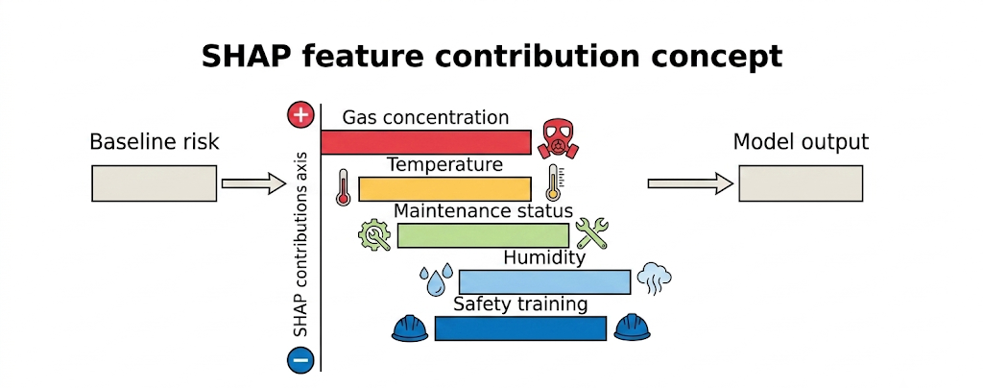
Figure 2.11: SHAP feature contribution concept.
The figure illustrates how individual features can increase or decrease the final predicted risk compared with a baseline prediction. The explanation concept is based on SHAP analysis described in [36].
Due to its ability to explain predictions made by complex models such as Random Forest and XGBoost while providing feature-level explainability, SHAP is the best fit for the proposed research. SHAP, for example, can help decision makers understand if higher predicted risk is a function of gas concentration, smoke level, temperature, the machine’s age, the condition of maintenance, or the level of training of the workers. This capability of SHAP, along with many others, responds to the aim of designing an explainable safety decision support system, and not a safety system that focuses solely on making predictions.

2.3 Related work
The literature demonstrates the ability of machine learning to assist with fire detection, decreasing false alarms, predicting injury severity, and performing a probabilistic risk assessment. However, the majority of the studies target a single safety issue or a single industrial domain.
Jia et al (2026) [37] created MmodalFire, a multimodal framework and dataset, to provide tools for the detection of indoor fire from video and physical sensor data. The framework relied on TSN-MobileNetV2, Transformer encoders, Multimodal Transfer Module (MMTM), and XFusionBlock to fuse visual and temperature, smoke, and measurement data of infrared and ultraviolet radiation and data of the fire detection sensors. The MmodalFire dataset included 65 aligned experimental videos, a total of 6 types of physical sensor data, and 700+ minutes of recordings and experiments of fires of wood, cotton, and fires of foam and n-heptane, as well as dry ice and water mist, as a non-fire samples. At a prediction threshold of 0.1, the Fusion Model obtained 93.2% of accuracy, 94.3% of precision, 96.1% of recall, and F1-score of 95.2%. Main strengths of the framework are a public multimodal dataset, and effective fusion of video and sensed data, and thus, enhanced reliability of fire detection when a certain modality of sensing fails. On the other side, the framework was tested only in a controlled, indoor lab, and thus, no validation was achieved for real world’s industrial IIoT ecosystems. Also, the framework does not address the prediction of workplace accidents and does not employ Explainable Artificial Intelligence methodologies.
Benderouach et al. (2026) [38] examines the performance of Logistic Regression, Decision Tree (DT), Random Forest (RF), Support Vector Machine (SVM), Gradient Boosted Decision Trees (GBDT), and XGBoost in predicting occupational accidents in the energy industry, using data from 4,739 occupational accident records from Kaggle. It showed that GBDT and XGBoost had the best predictive performance but without numerical evaluation metrics. Although the framework showed effective machine learning applications in predicting accidents, it did not include industrial fire prediction, sensor integration of IoT and EAI.
Tan et al. (2026) [39] suggested an explainable probabilistic framework for fire risk assessment in high-rise residential buildings, which is based on Bayesian Networks, Markov Chain Monte Carlo (MCMC), and SHAP. Seven residential buildings in five countries participated in the collection of fire safety data as a part of the framework. No prediction accuracy was reported but this study was able to identify critical factors for fire risk such as maintenance practices and organizational issues. However, the framework is only applicable to residential buildings and not for industrial accident prediction nor IIoT environments.
Manoah et al. (2026) [40] introduced an AI-based real-time industrial safety framework that combines the Internet of Things (IoT), Explainable Artificial Intelligence (XAI), SHAP, and machine learning for proactive fire accident prediction in the manufacture of fireworks. The framework continuously gathered data from temperature, humidity, gas concentration and motion sensor using IoT devices. The proposed model had a prediction accuracy of above 97.5%, and the dashboard built with Next.js was used to provide real time SHAP explanations. The design has been successful in merging prediction accuracy with explainability. It has only been validated in the field of fireworks production though and needs to be tested in other high-risk industries like oil/gas/chemicals.
Alsulamy et al. (2026) [41] created a machine learning framework that is explainable and predicts the nature and severity of safety incidents that occur in the construction field. This framework theoretically analyzed the K-Nearest Neighbor (KNN), Support Vector Machine (SVM), Decision Tree (DT), Random Forest (RF), Gradient Boosting (GB), and XGBoost. This framework also used SHAP to justify the predictions. This study derived a dataset containing 203 construction safety incidents collected in the Makkah and Riyadh regions of Saudi Arabia throughout the years 2018-2024. This dataset had 14 incident variables that related to construction workers, environmental variables, safety and emergency training sessions, safety and emergency protective equipment (PPE), and incident characteristics. Of all the models theorized and tested in this framework, XGBoost had the best performance by achieving an 89% accuracy in predicting the severity of the incidents. The uniqueness of this framework is that it is the first framework that combines the accurate prediction of construction incident severity and SHAP explanations that provide clarity in citing factors of construction incidents that people can act on, such as incident type, rain, construction workforce size, construction site location, PPE compliance, and the safety and emergency training sessions. However, the small dataset and its geographical restriction greatly limit the outcomes of this framework, plus the framework does not employ real-time IIoT sensor data or fire prediction systems in construction.
Desikan et al. (2025) [42] proposed a hybrid machine learning-based fault-tolerant sensor data fusion framework for fire risk mitigation in Industrial Internet of Things (IIoT) environments. The framework integrated MobileNet, EfficientNet, Random Forest (RF), Support Vector Machine (SVM), Decision Tree (DT), and Dempster–Shafer Theory using RGB, thermal, gas, smoke, and flame sensor data collected from oil and gas environments. The proposed model achieved 98.2% accuracy, 98.5% precision, and 98.3% recall. The main advantage of the framework is its effective multi-sensor fusion for accurate industrial fire prediction. However, it focuses only on fire prediction and does not address workplace accident prediction or incorporate Explainable Artificial Intelligence (XAI).
Millie and Milli (2025) [43] performed a comparative study of algorithms used in intelligent fire detection, such as machine learning and deep learning. The study compared the accuracy of Decision Tree (DT), Support Vector Machine (SVM), XGBoost, Logistic Regression, One-Dimensional Convolutional Neural Network (1D-CNN), and Long Short-Term Memory (LSTM) on a dataset of 12,030 sensor readings obtained from eight BME688 gas sensors. The deep learning model had an accuracy of 100% in the ability to differentiate between a cigarette smoke and fire smoke. The overall framework successfully achieved low false alarms with optimized preprocessing and classification. But the experiments were conducted in laboratory indoor environment which limited its application in actual industrial environment.
Obasi and Benson (2025) [44] introduced an explainable machine learning approach to the prediction of occupational injury severity. It incorporated Natural Language Processing (NLP), Singular Value Decomposition (SVD), Random Forest (RF), Gradient Boosting Machine (GBM), XGBoost, Logistic Regression and SHAP using a set of 2645 OSHA accident reports from 2015 to 2024. The best model was the Random Forest model, which had an accuracy of 0.94 and an AUC of 0.95. The framework was able to achieve a balance between prediction accuracy and model interpretability through the use of SHAP. But it doesn't cover industrial fire prediction or safety monitoring using the IIoT.
Sharma et al. (2025) [45] created a set of regression-based machine learning models for predicting urban fire risk based on historical fire incidents, emergency response data and proximity data. The framework was successful at estimating fire risk, but there were no quantitative accuracy metrics reported. The study can be useful to support Emergency Planning and Fire Management. It concentrates on urban setting and does not cover workplace accidents, IIoT sensor data and Explainable Artificial Intelligence techniques.
Pandey et al. (2025) [46] introduced a comprehensive framework for predicting industrial accidents in steel manufacturing. The framework combined Bayesian Networks (BN), Random Forest (RF), Gradient Boosting Machine (GBM)/XGBoost, Natural Language Processing (NLP), Agent-Based Modeling (ABM), and Survival Analysis using steel industry incident data collected between 2018 and 2023. The Random Forest model achieved the highest performance with an AUC of 0.71. The framework effectively analyzed accident causes and severity, but it did not incorporate Explainable Artificial Intelligence techniques.
Li et al. (2025) [47] studied a set of eight machine learning models for predicting unsafe behaviors in automated coal mining systems, and found that XGBoost model has the highest accuracy, using SHAP to interpret the model. Physiological data from simulated mining tasks was obtained from 50 participants and analyzed within the framework. The proposed model achieved 97.78% accuracy, 98.25% recall, and 97.86% F1-score. Integrating XGBoost and SHAP enhanced the accuracy and interpretability of their predictions. The study, however, was carried out with students from the university, and not industrial workers, thus restricting the generalizability of the findings in the real world.
Desikan et al. (2025) [48] introduced a multi-sensor fusion, anomaly detection, probabilistic machine learning, and Dempster–Shafer Theory-based hybrid fault-tolerant IIoT framework. The framework used RGB, infrared, smoke, gas and flame data from oil and gas IIoT environments. No quantitative accuracy was reported but the framework greatly enhanced the reliability of fire prediction when some sensors were faulty. It has strong probabilistic sensor fusion, and its weakness is that it is a lack of workplace accident prediction and Explainable Artificial Intelligence.
Alam et al. (2025) [49] developed FireNet-CNN which detects real time forest fires using a lightweight explainable deep learning model. The model includes a niche convolutional neural network (CNN), data augmentation with stable diffusion, Grad-CAM, and Saliency Maps. The performance was compared with VGG16, VGG19, and InceptionV3. The first set of experiments involved Dataset A which contains 2,974 images of forest fire and non-fire incidents, and Dataset B, which consists of 3,400 images from 25 fire and non-fire videos before data augmentation. FireNet-CNN returned 99.05% accuracy, 99.41% precision, 98.28% recall, and 98.84% F1-score. The benefit of the framework is the lightweight design and the ability to provide visual explanations (which will show which parts of an image that influenced the fire prediction), which makes the framework fit for real time, and for constrained devices. The drawback of this model is that the focus was on forest fire images, and the model partially relied on synthetically created data, and the model was not validated with Industrial IIoT sensor data and does not cover workplace accident prediction.
Khairuddin et al. (2024) [50] proposed a natural language processing system to predict severity of occupational injuries. The research has been performed on 83,294 OSHA injury narratives to differentiate TF-IDF, GloVe, optimized Bidirectional Long Short-Term Memory (Bi-LSTM), and some traditional machine learning algorithms. The optimized Bi-LSTM model performed with 95% accuracy in the hospitalization prediction task and 98% accuracy in the amputation prediction task. The proposed framework has shown good accuracy in textual injury analysis. But it only depends on reports after incidents and doesn't provide Real-Time monitoring in the IoT and industrial fire prediction.
Zhao et al. (2025) [51] reviewed the most recent research trends in SHAP applications in the Explainable Artificial Intelligence domain, categorized under healthcare, finance, computer vision and industrial systems. There was no experimental data used in the study and hence no predictive performance metrics were reported. The survey showed that SHAP works well in increasing the transparency of the model and the interpretation of the features. But it did not develop an IIoT-based industrial fire prediction framework that includes SHAP.

2.4 Related Work Summary
The reviewed literature revealed great benefits of using machine learning (ML), deep learning (DL), Explainable Artificial Intelligence (XAI) and Industrial Internet of Things (IIoT) for better industrial safety which includes intelligent fire detection, prediction of accidents, severity of injuries and risk analysis. Recent research has demonstrated that using sensor networks together with sophisticated ML algorithms can significantly enhance the predictive accuracy and decrease false alarms. Furthermore, XAI methods, like SHAP, have improved the interpretability and reliability of predictive models, helping safety engineers to understand the models' decisions. Although these advances have been made, the majority of the research to date tends to look at one safety issue (e.g., fire detection or injury severity and only validate it for one sector of industry. In addition, there are many frameworks that either focus on prediction without explanation or explanation without IIoT monitoring, which leaves a gap in creating a comprehensive industrial safety system that incorporates IIoT sensing, multiple accident prediction, high performance machine learning, and explainable decision making.
Specifically, Desikan et al. [48] introduced a hybrid IIoT fire prediction framework by multi-sensor fusion based on MobileNet, EfficientNet, Random Forest, Support Vector Machine, Decision Tree and Dempster–Shafer Theory, and excellent prediction accuracy of 98.2% was obtained. Likewise, Milli and Milli [43] have shown that deep learning models (1D-CNN and LSTM) when combined with measurements from gas sensors can greatly reduce false fire alarms in controlled environments. There were several studies that extended the use of machine learning in fire detection. Injury severity explainability was achieved by Obasi and Benson [44] with the use of the Random Forest and boosting algorithms combined with SHAP, while Pandey et al. [46] presented a holistic accident prediction system for the steel manufacturing industry using NLP, Survival Analysis, Random Forest, boosting algorithms, and Bayesian Networks. In addition, optimized Bi-LSTM models have been proved to be effective in occupational accident report analysis [43] and the use of XGBoost and SHAP have been shown to achieve high accuracy in predicting unsafe worker behavior [44].
Other researchers studied the fire risk assessment in other fields. In the context of urban fires, Sharma et al. [45] have worked with regression-based machine learning models to predict fires, while Tan et al. [39] have used Bayesian Networks, MCMC and SHAP to build an explainable probabilistic model for assessing residential fire safety. Benderouach et al. [38] applied several machine learning algorithms to a prediction model for occupational accidents in the energy industry and found the best predictive algorithms to be Gradient Boosted Decision Trees and XGBoost. Desikan et al. [48] presented a fault tolerant IIoT sensor fusion scheme that realizes the consistent fire prediction even when some sensor is faulty. In a recent study, Manoah et al. [40] developed an AI-, IoT- and SHAP-based real-time fire prediction framework for fireworks industries, which has a prediction accuracy above 97.5% and gives interpretable prediction explanations.
The literature also shows the increasing significance of Explainable Artificial Intelligence. Alsulamy et al. [41] integrated SHAP for the first time with KNN, SVM, Decision Tree, Random Forest, Gradient Boosting, and XGBoost topredict and provide an explanation for the severity of construction safety incidents. In a similar study, Alam et al. [49] designed FireNet-CNN and integrated Grad-CAM and Saliency Maps in order to give visual justification for predicting and detecting forest fire in real time. Zhao et al. [51] gave a comprehensive tutorial on SHAP and showed that it could be used to explain complex machine learning models in various fields, including healthcare, finance, computer vision and industrial applications. Alternatively, Jia et al. [37] created the MmodalFire dataset, which is publicly available, and a multimodal fusion framework for the integration of video, temperature, smoke density, infrared, and ultraviolet data pertaining to indoor fire detection. Even though the framework was able to successfully detect fire by fusing visual and physical sensors, it lacked XAI strategies and did not consider the prediction of workplace accidents.
In summary, the literature confirms that considerable advances have been made in the field of using machine learning, IIoT and explainable AI for industrial safety. However, there are still significant gaps in research. Existing research is mostly dedicated to either one aspect of the capabilities (fire detection, accident prediction, or explainability) or a combination of two, but not the three capabilities combined in one. Furthermore, a large number of studies are based on laboratory experiments, simulated environments, or sector specific data sets, which makes it difficult to apply their results in a large variety of industrial domains. Hence, there is a need for an integrated intelligent framework for industrial fire and workplace accident prediction based on the IIoT, powerful machine learning models, and explainable AI techniques to simultaneously predict industrial fire and workplace accidents and offer interpretable, credible safety advice to the safety manager.

Table 2.1 Summary of related work

Ref. | Author | Year | Technique Used | Dataset and availability | Accuracy | Main Limitation
[37] | Jia et al. | 2026 | TSN-MobileNetV2, Transformer Encoder, MMTM, XFusionBlock, and multimodal sensor–video fusion | MmodalFire (public; Springer Nature Figshare, DOI: 10.6084/m9.figshare.28804448): 65 synchronized videos, six physical-sensor streams, and more than 700 minutes of recordings. | 93.2% accuracy, 94.3% precision, 96.1% recall, and 95.2% F1-score | Conducted under controlled indoor laboratory conditions; not validated in actual industrial IIoT environments and does not incorporate XAI or workplace accident prediction
[38] | Benderouach et al. | 2026 | Logistic Regression, DT, RF, SVM, GBDT, XGBoost | OSHA Accident and Injury Data 15-17 (public; Kaggle): file OSHA HSE DATA_ALL ABSTRACTS 15-17_FINAL.csv; 4,739 records. | Performance: GBDT and XGBoost achieved the best predictive performance (Metrics not reported) | No industrial fire prediction, IIoT integration, or Explainable AI.
[39] | Tan et al. | 2026 | Bayesian Network, MCMC, SHAP | No formal dataset name. Fire safety data from seven high-rise residential buildings across five countries | Performance: Identified key fire-risk factors (No quantitative metrics reported) | Limited to residential buildings; not applicable to industrial environments.
[40] | Manoah et al. | 2026 | AI, IoT, SHAP, FastAPI-based ML prediction framework | No formal dataset name. Real-time temperature, humidity, gas concentration, and motion sensor data from the fireworks industry | Accuracy: >97.5% | Validated only in fireworks manufacturing; requires testing in other high-risk industrial sectors.
[41] | Alsulamy et al. | 2026 | KNN, SVM, DT, RF, GB, XGBoost, and SHAP | No formal dataset name. 203 construction safety incidents from Saudi Arabia, 2018–2024, with 14 variables | 89% | Small dataset limited to two Saudi regions; no real-time IIoT sensors or fire prediction
[42] | Desikan et al. | 2025 | MobileNet, EfficientNet, Random Forest (RF), Support Vector Machine (SVM), Decision Tree (DT), Dempster–Shafer Theory | No formal dataset name. RGB, IR, MQ-135 gas, MQ-2 smoke, and KY-026 flame-sensor data; | Accuracy: 98.2%, Precision: 98.5%, Recall: 98.3% | Focused only on industrial fire prediction; no workplace accident prediction or Explainable AI (XAI).
[43] | Milli and Milli | 2025 | DT, SVM, XGBoost, Logistic Regression, 1D-CNN, LSTM | No formal dataset name. 12,030 readings from eight BME688 gas sensors | Precision: 1.00, Recall: 1.00 | Evaluated only in controlled indoor laboratory conditions.
[44] | Obasi and Benson | 2025 | NLP, SVD, RF, GBM, XGBoost, Logistic Regression, SHAP | 2,645 OSHA accident reports (2015–2024) | F1-score: 0.94, Accuracy: 0.95 | Limited to occupational injury severity prediction; no IIoT integration or industrial fire prediction.
[45] | Sharma et al. | 2025 | Regression-based Machine Learning Models | No formal dataset name. Historical fire incidents, emergency response records, and proximity data | Performance: Effective fire-risk estimation (Accuracy not reported) | Designed for urban fire management only; excludes IIoT and industrial workplace safety.
[46] | Pandey et al. | 2025 | Bayesian Network (BN), RF, GBM/XGBoost, NLP, Agent-Based Modeling (ABM), Survival Analysis | No formal dataset name. Steel industry accident records (2018–2023) | Accuracy: 0.71 | Comprehensive framework but lacks dedicated Explainable AI techniques.
[47] | Li et al. | 2025 | Eight ML models, XGBoost, SHAP | No formal dataset name. Physiological data collected from 50 participants performing simulated coal-mining tasks | Accuracy: 97.78%, Recall: 98.25%, F1-score: 97.86% | Simulation involved university students rather than industrial workers, limiting generalizability.
[48] | Desikan et al. | 2025 | Multi-sensor fusion, anomaly detection, ML-based probabilistic adjustment, Dempster–Shafer Theory | No formal dataset name. RGB, infrared, smoke, gas, and flame sensor data from oil & gas IIoT environments | Performance: Improved fire prediction reliability under faulty sensor conditions (No quantitative metrics reported) | Focused only on industrial fire detection; no workplace accident prediction or SHAP explanations.
[49] | Alam et al. | 2025 | FireNet-CNN, Stable Diffusion, Grad-CAM, and Saliency Maps | Dataset A: 2,974 images; Dataset B: 3,400 images from 25 videos before augmentation | 99.05% | Focuses on forest-fire images and synthetic augmentation; no industrial IIoT sensors or accident prediction
[50] | Khairuddin et al. | 2024 | TF-IDF, GloVe, optimized Bi-LSTM, Naïve Bayes, KNN, DT, SVM, RF | 83,294 OSHA occupational injury narratives | Accuracy: 95% (Hospitalization), Accuracy: 98% (Amputation) | Uses post-incident textual reports only; no real-time IIoT monitoring or industrial fire prediction.
[51] | Zhao et al. | 2025 | SHAP (Shapley Value) | No formal dataset name, Literature survey across healthcare, finance, computer vision, and industrial applications | Performance: Demonstrated the effectiveness of SHAP for model interpretability | Methodological survey without an IIoT-based industrial implementation.

References:
[1] R. Md Zin, A. I. Che Ani, N. ‘A. Mhd Noh, F. W. Akashah, and Z. Mat Daud, “Integrating IoT technology in fire safety management: Addressing readiness, acceptance and implementation challenges,” paperASIA, vol. 41, no. 4b, pp. 11–23, 2025, doi: 10.59953/paperasia.v41i4b.399.
[2] S. Moosavi, M. Farajzadeh-Zanjani, R. Razavi-Far, V. Palade, and M. Saif, “Explainable AI in manufacturing and industrial cyber–physical systems: A survey,” Electronics, vol. 13, no. 17, Art. no. 3497, 2024, doi: 10.3390/electronics13173497.
[3] P. Ranganathan and S. Sujatha, "Occupational Accidents and Need for Worker Safety in Manufacturing and High Risk Industries – An Explorative Study With Solutions," International Journal of Professional Business Review, vol. 7, no. 6, Art. no. e0670, Dec. 2022, doi: 10.26668/businessreview/2022.v7i6.e670.
[4] A. J.-P. Tixier, M. R. Hallowell, B. Rajagopalan, and D. Bowman, “Application of machine learning to construction injury prediction,” Automation in Construction, vol. 69, pp. 102–114, 2016, doi: 10.1016/j.autcon.2016.04.012.
[5] D. Clever, "The Influence of Artificial Intelligence and Machine Learning Expertise on the Analytical Decision-Making Capabilities of Data Analysts in Complex Organizational Environments," Jan. 2026.
[6] N. Y. Hussain, B. Austin, A. B. Ige, P. A. Adepoju, O. O. Amoo, and A. I. Afolabi, "AI-driven predictive analytics for proactive security and optimization in critical infrastructure systems," Open Access Research Journal of Science and Technology, vol. 2, no. 2, pp. 6–15, Oct. 2021, doi: 10.53022/oarjst.2021.2.2.0059.
[7] S. Afrin, S. J. Rafa, M. Kabir, T. Farah, M. S. B. Alam, A. Lameesa, S. F. Ahmed, and A. H. Gandomi, "Industrial Internet of Things: Implementations, challenges, and potential solutions across various industries," Computers in Industry, vol. 170, Art. no. 104317, Sep. 2025, doi: 10.1016/j.compind.2025.104317.
[8] G. Sakthi Balan, V. Santhosh Kumar, and S. Aravind Raj, "Machine learning and artificial intelligence methods and applications for post-crisis supply chain resiliency and recovery," Supply Chain Analytics, vol. 10, Art. no. 100121, Jun. 2025, doi: 10.1016/j.sca.2025.100121.
[9] G. K. Amuah, G. E. Djanetey, B. B. Effah, J. Whajah, E. Attarbo, and G. E. Kpedzroku, "Integration of Artificial Intelligence (AI) and Internet of Things (IoT) for Hazard Detection and Accident Prevention in Mining," World Journal of Advanced Engineering Technology and Sciences, vol. 17, no. 2, Nov. 2025, doi: 10.30574/WJAETS.2025.17.2.1484.
[10] A. Haleem, M. Javaid, and R. P. Singh, "Encouraging Safety 4.0 to enhance industrial culture: An extensive study of its technologies, roles, and challenges," Green Technologies and Sustainability, vol. 3, no. 3, Art. no. 100158, Jul. 2025, doi: 10.1016/j.grets.2024.100158.
[11] S. S. Salvi, "Safety Management and Accident Prevention," International Journal for Research in Applied Science and Engineering Technology, vol. 9, no. 5, pp. 539–543, May 2021, doi: 10.22214/IJRASET.2021.34163.
[12] R. Göçmen, M. Çıbuk, and E. Akın, "Comparative Analysis of Deep Learning Algorithms in Fire Detection," Balkan Journal of Electrical and Computer Engineering, vol. 12, no. 3, pp. 255–261, Sep. 2024, doi: 10.17694/bajece.1533966.
[13] S. Alsulamy, M. Alshayeb, I. Inam, and A. Ahmed, "Machine learning applications for predicting safety incidents in construction industry," Scientific Reports, vol. 16, no. 1, Jan. 2026, doi: 10.1038/s41598-025-34763-0.
[14] International Labour Organization (ILO), "Safety and health at work," ILO, Geneva, Switzerland. [Online]. Available: Safety and health at work | International Labour Organization
[15] Canada Safety Training Centre, "Common Gas Hazards in the Workplace and How to Avoid." Accessed: Jul. 9, 2026. [Online]. Available Common Gas Hazards in the Workplace and How to Avoid
[16] D. Barragan, M. S. Peterson, and Y.-C. Lee, "Hazard Perception–Response: A Theoretical Framework to Explain Drivers' Interactions with Roadway Hazards," Safety, vol. 7, no. 2, Art. no. 29, Apr. 2021, doi: 10.3390/safety7020029.
[17] A. Srivastava, D. Das, P. Bhatnagar, J. R. Khatsurya, M. Kumar, V. Bhatkhande, and V. Chandrasekar, Safety Management System to Achieve Zero Harm. 40th DAE Safety and Occupational Health Professional Meet, Oct. 2024.
[18] A. Abid and M. Jazib, IoT Based Industrial Monitoring and Control System (Liquid Level), B.S. thesis, Dept. of Electrical Engineering, supervised by M. Riaz and A. Q. Khan, Jun. 2024. doi: 10.13140/RG.2.2.34952.23044.
[19] M. Dangrach, S. M. A. Shah, A. Z. ul Abdin, A. Ali, and M. Ahmed, "IOT Based Fire System," Journal of Applied Engineering & Technology (JAET), vol. 5, no. 1, pp. 19–30, Jun. 2021, doi: 10.55447/JAET.05.01.31.
[20] S. Chauhan, G. Vashishtha, and R. Zimroz, "Analysing Recent Breakthroughs in Fault Diagnosis through Sensor: A Comprehensive Overview," CMES – Computer Modeling in Engineering and Sciences, vol. 141, no. 3, pp. 1983–2020, Oct. 2024.
[21] A. M. Sharifnia, D. E. Kpormegbey, D. Thapa, and M. Cleary, "A Primer of Data Cleaning in Quantitative Research: Handling Missing Values and Outliers," Journal of Advanced Nursing, vol. 82, no. 1, pp. 970–975, Mar. 2025, doi: 10.1111/jan.16908.
[22] S. Festag, "False alarm ratio of fire detection and fire alarm systems in Germany—A meta analysis," Fire Safety Journal, vol. 79, pp. 119–126, Jan. 2016, doi: 10.1016/j.firesaf.2015.11.010.
[23] D. Issaka, Y. A. Sam-Okyere, and E. Osei-Kwame, "Internet of Things (IoT) Based Fire Detection and Suppression System," Applied Engineering Innovation and Technology, vol. 2, no. 2, pp. 43–60, Oct. 2025, doi: 10.62777/AEIT.V2I2.70.
[24] L. Deng, S. Wu, S. Zou, and Q. Liu, "Large-Space Fire Detection Technology: A Review of Conventional Detector Limitations and Image-Based Target Detection Techniques," Fire, vol. 8, no. 9, Art. no. 358, Sep. 2025,
[25] S. Badruddoza and M. Amin, "Machine Learning Models and Their Applications in Environmental Economics," International Review of Environmental and Resource Economics, vol. 19, no. 1, pp. 1–58, Mar. 2025, doi: 10.1561/101.00000173.
[26] M. Arifuzzaman, M. R. Hasan, T. J. Toma, S. B. Hassan, and A. K. Paul, "An Advanced Decision Tree-Based Deep Neural Network in Nonlinear Data Classification," Technologies, vol. 11, no. 1, Art. no. 24, Feb. 2023, doi: 10.3390/technologies11010024.
[27] Y.-J. Chang, Y.-L. Lin, and P.-F. Pai, "Support Vector Machines with Hyperparameter Optimization Frameworks for Classifying Mobile Phone Prices in Multi-Class," Electronics, vol. 14, no. 11, Art. no. 2173, May 2025, doi: 10.3390/electronics14112173.
[28] V. S. Stency, N. Mohanasundaram, and R. Santhosh, "Ensembled Gradient Boosting Technique with Decision Tree for Intrusion Detection System," International Journal of Intelligent Systems and Applications in Engineering, vol. 12, no. 21s, pp. 2571–2583, Mar. 2025.
[29] M. Khurram, C. Zhang, S. Muhammad, H. Kishnani, K. An, K. Abeywardena, U. Chadha, and K. Behdinan, "Artificial Intelligence in Manufacturing Industry Worker Safety: A New Paradigm for Hazard Prevention and Mitigation," Processes, vol. 13, no. 5, Art. no. 1312, Apr. 2025, doi: 10.3390/pr13051312.
[30] S. Kiranyaz, O. Avci, O. Abdeljaber, T. Ince, M. Gabbouj, and D. J. Inman, "1D Convolutional Neural Networks and Applications: A Survey," Mechanical Systems and Signal Processing, vol. 151, Art. no. 107398, Apr. 2021, doi: 10.1016/j.ymssp.2020.107398.
[31] P. Malhotra, L. Vig, G. Shroff, and P. Agarwal, "Long Short Term Memory Networks for Anomaly Detection in Time Series," in Proc. 23rd European Symposium on Artificial Neural Networks, Computational Intelligence and Machine Learning (ESANN), Bruges, Belgium, Apr. 2015, pp. 89–94.
[32] P. Sankarasubramanian and E. N. Ganesh, "Industrial Accident Report Analysis Using Natural Language Processing," International Journal of Scientific & Technology Research, vol. 9, no. 7, pp. 470–476, Jul. 2020.
[33] S. Agarwal, Y. P. Chugh, A. Singh, V. Sakinala, A. Mukherjee, B. Prasad, C. Dagli, and Y. Zou, "Application of natural language processing and machine learning for analyzing mining accident reports and automating the process of root cause analysis," International Journal of Coal Science & Technology, vol. 12, Art. no. 91, Sep. 2025, doi: 10.1007/s40789-025-00747-6.
[34] A. Sharma, S. Rani, and M. Shabaz, "A comprehensive review of explainable AI in cybersecurity: Decoding the black box," ICT Express, 2025, doi: 10.1016/j.icte.2025.10.004.
[35] S. Ali, T. Abuhmed, S. El-Sappagh, K. Muhammad, J. M. Alonso-Moral, R. Confalonieri, R. Guidotti, J. Del Ser, N. Díaz-Rodríguez, and F. Herrera, "Explainable Artificial Intelligence (XAI): What we know and what is left to attain Trustworthy Artificial Intelligence," Information Fusion, vol. 99, Art. no. 101805, Nov. 2023, doi: 10.1016/j.inffus.2023.101805.
[36] A. V. Ponce-Bobadilla, V. Schmitt, C. S. Maier, S. Mensing, and S. Stodtmann, "Practical guide to SHAP analysis: Explaining supervised machine learning model predictions in drug development," Clinical and Translational Science, vol. 17, no. 11, Art. no. e70056, Oct. 2024, doi: 10.1111/cts.70056
[37] Y. Jia, Y. Guo, Y. Chen, X. Zhang, G. Wang, and Q. Zhang, “MmodalFire: A Continuous Multimodal Dataset Comprising Video and Physical Sensing Data for Detecting Indoor Fires,” Scientific Data, vol. 13, Article 489, 2026. doi.org/10.1038/s41597-026-06810-6.
[38] K. Benderouach, I. Bennis, K. Mansouri, and A. Siadat, “Predicting human and environmental risk factors of accidents in the energy sector using machine learning,” Applied Sciences, vol. 16, no. 3, Art. no. 1203, 2026, doi: 10.3390/app16031203.
[39] S. Tan, T. T. Toe, P. Joseph, and K. Moinuddin, “Explainable Artificial Intelligence (XAI)-Enabled Probabilistic Fire Risk Prediction for High-Rise Residential Buildings: SHAP Attribution of Human and Organisational Risks,” Buildings, vol. 16, no. 13, Art. no. 2538, 2026.
[40] J. Manoah, J. Anitha, S. Immanuel Alex, and S. Stewart Kirubakaran, "Smart Accident Prediction in Fireworks Industry Using AI," in Proceedings of the 2026 4th International Conference, IEEE, 2026.
[41] S. Alsulamy, M. Alshayeb, I. Inam, and A. Ahmed, “Machine Learning Applications for Predicting Safety Incidents in Construction Industry,” Scientific Reports, vol. 16, Article 4673, 2026. doi.org/10.1038/s41598-025-34763-0.
[42] J. Desikan, S. K. Singh, A. Jayanthiladevi, S. Singh, and B. Yoon, “Dempster Shafer-empowered machine learning-based scheme for reducing fire risks in IoT-enabled industrial environments,” IEEE Access, vol. 13, pp. 46546–46567, 2025, doi: 10.1109/ACCESS.2025.3550413.
[43] M. Milli and M. Milli, “Reducing false positives in building fire detection systems via multiple metal oxide sensors,” IEEE Access, vol. 13, pp. 157537–157550, 2025, doi: 10.1109/ACCESS.2025.3606584.
[44] I. C. Obasi and C. Benson, “An explainable machine learning framework for predicting injury severity in the extractive industry using SHAP,” Results in Engineering, vol. 28, Art. no. 107552, 2025, doi: 10.1016/j.rineng.2025.107552.
[45] D. P. Sharma, N. Beigi-Mohammadi, P. S. Bodro, J. F. L. Leon-Garcia, and A. El-Emam, “A Machine Learning Framework for Fire Risk Prediction with Response and Proximity Insights,” IEEE Access, 2025, doi: 10.1109/ACCESS.2025.3602259.
[46] S. Pandey, A. K. Singh, S. Parhi, and S. K. Jha, “Towards safer steel operations with a multi-model framework for accident prediction and risk assessment simulation,” Scientific Reports, vol. 15, Art. no. 13293, 2025, doi: 10.1038/s41598-025-96028-0.
[47] X. Li, S. Zhang, X. Li, J. Zeng, Y. Long, B. Nie, and C. Zhao, “SHAP-driven insights into multimodal data: Behavior phase prediction for industrial safety applications,” Scientific Reports, vol. 15, Art. no. 34965, 2025, doi: 10.1038/s41598-025-18889-9.
[48] J. Desikan, S. K. Singh, A. Jayanthiladevi, S. Bhushan, V. Rishiwal, and M. Kumar, “Hybrid machine learning-based fault-tolerant sensor data fusion and anomaly detection for fire risk mitigation in IIoT environment,” Sensors, vol. 25, no. 7, Art. no. 2146, 2025, doi: 10.3390/s25072146.
[49] G. M. I. Alam et al., “Real-Time Detection of Forest Fires Using FireNet-CNN and Explainable AI Techniques,” IEEE Access, vol. 13, pp. 51150–51181, 2025. doi.org/10.1109/ACCESS.2025.3552352.
[50] M. Z. F. Khairuddin, S. Sankaranarayanan, K. Hasikin, N. A. Abd Razak, and R. Omar, “Contextualizing injury severity from occupational accident reports using an optimized deep learning prediction model,” PeerJ Computer Science, vol. 10, Art. no. e1985, 2024, doi: 10.7717/peerj-cs.1985.
[51] C. Zhao, J. Liu, and E. Parilina, "The Shapley Value Contribution to Explainable Artificial Intelligence: A Comprehensive Survey," Dynamic Games and Applications, vol. 16, no. 3, pp. 1–38, Oct. 2025, doi: 10.1007/s13235-025-00670-2.

